26 July 2018
EMA/717179/2011
Information Management

Detailed guidance on the electronic submission of information on medicinal products for human use by marketing authorisation holders to the European Medicines Agency in accordance with Article 57(2), second subparagraph of Regulation (EC) No. 726/2004
Chapter 2: Electronic submission of information on medicinal products by marketing authorisation holders
Version 3.1
Date of coming into force: 26 July 2018

Table of contents
Summary of changes 3
1. Electronic submission of information on medicinal products by marketing authorisation holders 4
2. How to Prepare for the electronic submission of XEVPRMs 4
2.1. EudraVigilance product report message (XEVPRM) submission methods 4
2.2. XEVPRM file constraints 5
2.2.1. File types allowed 5
2.2.2. File size limitations 6
2.2.3. Additional constraints 6
2.3. The EudraVigilance Product Report Message Acknowledgements (XEVPRM_ACKs) 6

Summary of changes
Following the publication of version 3.0 in March 2012 the content of the below listed sections was amended. The changes are highlighted in red and strikethrough text:
- 1. Electronic submission of information on medicinal products by marketing authorisation holders
- 2. How to Prepare for the electronic submission of XEVPRMs
- Electronic submission of information on medicinal products by marketing authorisation holders
Marketing authorisation holders shall electronically submit to the Agency information on all medicinal products for human use authorised in the Union and shall maintain this information using the eXtended EudraVigilance Medicinal Product Report Message (XEVPRM).
The Agency issued further guidance on the maintenance of medicinal products following further discussions with the EU Regulatory Network and European Pharmaceutical Industry Associations. Please refer to section 2. Maintenance of medicinal product data of the Detailed guidance on the electronic submission of information on medicinal products for human use by marketing-authorisation holders to the European Medicines Agency in accordance with Article 57(2), second subparagraph of Regulation (EC) No. 726/2004: Chapter 3.II: Extended EudraVigilance product report message (XEVPRM) user guidance.
- How to Prepare for the electronic submission of XEVPRMs
For initiating the electronic submission of XEVPRMs, marketing authorisation holders can use a Gateway to Gateway communication, the EudraVigilance Webtrader Post Function or the eXtended EudraVigilance Medicinal Product Dictionary (XEVMPD) data entry tool (EVWEB).
Before the electronic submission of XEVPRMs can be initiated, marketing authorisation holders need to register with the Agency. For further details on the registration process, please refer to http://eudravigilance.ema.europa.eu/human/HowToRegister.asp the EudraVigilance: how to register webpage. Please note especially the changes in the EudraVigilance registration process applicable as of 26 July 2018.
NOTE:
Marketing authorisation holders already registered with EudraVigilance (e.g. for the electronic transmission of Individual Case Safety Reports) need to update their EudraVigilance profile to be able to successfully submit the XEVPRMs. For this purpose, the marketing authorisation holders’ Qualified Person Responsible for Pharmacovigilance (QPPV) or its Deputy need to contact the Agency’s Registration Team at eudravigilanceregistration@ema.europa.eu EMA Service Desk portal (https://servicedesk.ema.europa.eu/) to request to be added to the XEVPRM Gateway community. The Organisation ID shall be specified in this request.
  - EudraVigilance product report message (XEVPRM) submission methods
An XEVPRM can be submitted to the Agency in three ways:
- using a pharmaceutical company’s Gateway to exchange with the EudraVigilance (ESTRI) Gateway. Please see the EudraVigilance: how to register webpage for further details;
- using the EVWEB Trader Post function;
- using the XEVMPD Data Entry Tool (EVWEB).
For all three submission methods, an XML file referred to as the eXtended EudraVigilance Product Report Message (XEVPRM) (Figure 1) has to be generated. This XML file, along with related attachments as specified in this detailed guidance are required to be contained within a ZIP file.
The XEVMPD data entry tool (EVWEB) offers the possibility to create and send an XEVPRM by entering information on medicinal products by means of a user-friendly interface. XEVMPD data entry tool (EVWEB) can also be used for maintaining the information based on different operation types. By using XEVMPD data entry tool (EVWEB), marketing authorisation holders will be able to include the required attachments and the submission of the message as a ZIP file will be performed automatically.
Further details about the XEVPRM are contained in chapter 3.
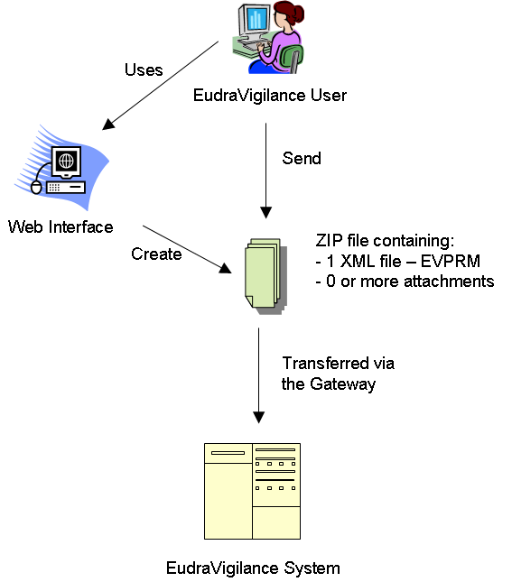

Figure 1 - Overview of the electronic submission of medicinal product information
  - XEVPRM file constraints
In the XEVPRM attachments are required to be provided with the XML file. This combination of a single XML file and zero or more attachments must be contained within a single ZIP file. XEVMPD data entry tool (EVWEB) users will be guided through the process of attaching files and referencing them within the product and/or substance reports. Non- XEVMPD data entry tool (EVWEB) users will need to create the ZIP file containing the XML file and associated attachments according to the following rules.
    - File types allowed
One ZIP file as the container for the following files, whereby the ZIP file must be compatible with PKWare’s and the ZIP file format specification v6.3.2:
- 1 XML file containing the XEVPRM
- Zero or more attachments which may be of the following formats: .PDF, .DOC, .DOCX, .XLS or .XLSX
- PDF file version 1.4 or 1.7 should be used
NOTE: Scanned versions of PDF documents should not be submitted
    - File size limitations
- The ZIP file can be of a maximum size of 60 MB
- Each file within the ZIP file can be a maximum size of 25 MB
    - Additional constraints
- The ZIP file must not contain folders
- File names must be less than 200 characters in length
  - The EudraVigilance Product Report Message Acknowledgements (XEVPRM_ACKs)
For each XEVPRM submitted to the EudraVigilance Gateway, an acknowledgement referred to as XEVPRM Acknowledgement (XEVPRM_ACK) is returned to the sender organisation. Further details are provided in the Detailed guidance on the electronic submission of information on medicinal products for human use by marketing authorisation holders to the European Medicines Agency in accordance with Article 57(2), second subparagraph of Regulation (EC) No. 726/2004 - Chapter 5: Extended EudraVigilance product report acknowledgement message.

