How to forward Incoming Calls from your EMA Phone

From your Lync Client

From the top right of your Lync Client, navigate to File, Tools Options

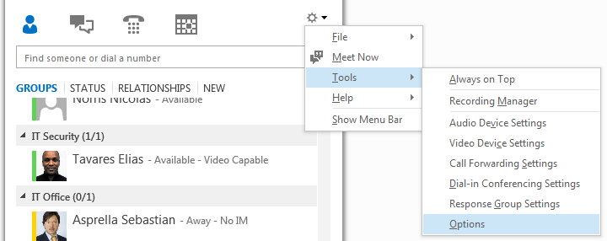

The following window will appear

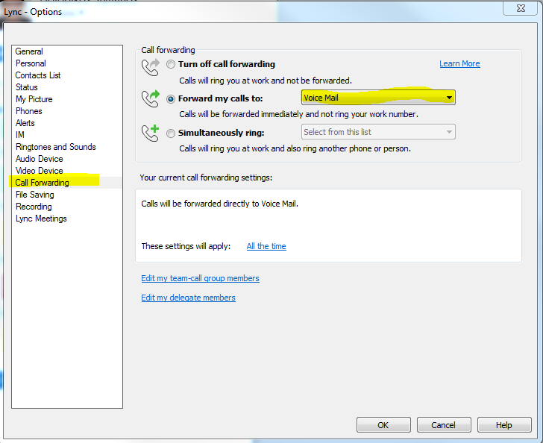
From the Forward my calls to Drop Down Menu, select New Number or Contact. Then, the following window will appear. Type the number that you want your incoming calls to be forwarded to

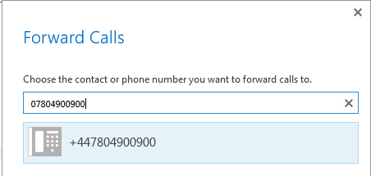

From your Phone Device

After Pressing the Forward button from the initial screen on the Phone,

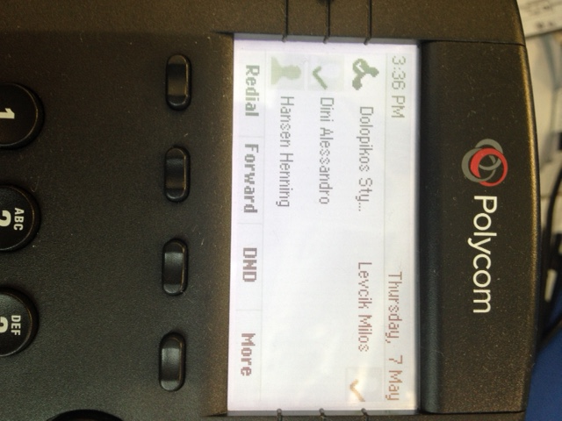

The following options will be presented to you.

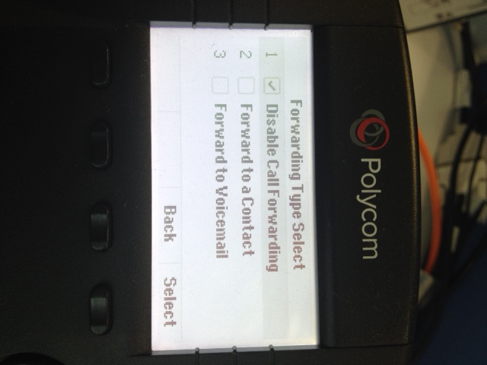

Select the second option and then add the desired number in the exact same way as above (07804900900 for example). Select OK and you are ready.

