This document is the approved product information for Abiraterone Krka, with the changes since the previous procedure affecting the product information (EMEA/H/C/005649/N/0007) tracked.

For more information, see the European Medicines Agency’s website:
https://www.ema.europa.eu/en/medicines/human/EPAR/abiraterone-krka

ANNEX I

SUMMARY OF PRODUCT CHARACTERISTICS
1. NAME OF THE MEDICINAL PRODUCT

Abiraterone Krka 500 mg film-coated tablets

2. QUALITATIVE AND QUANTITATIVE COMPOSITION

Each film-coated tablet contains 500 mg abiraterone acetate equivalent to 446 mg of abiraterone.

Excipient(s) with known effect:
Each film-coated tablet contains 253.2 mg lactose monohydrate.

For the full list of excipients, see section 6.1.

3. PHARMACEUTICAL form

Film-coated tablet (tablet)

Grey violet to violet, oval, biconvex film-coated tablets, with dimensions approximately of 20 mm long x 10 mm wide.

4. Clinical particulars

4.1 Therapeutic indications

Abiraterone Krka is indicated with prednisone or prednisolone for:
- the treatment of newly diagnosed high risk metastatic hormone sensitive prostate cancer (mHSPC) in adult men in combination with androgen deprivation therapy (ADT) (see section 5.1)
- the treatment of metastatic castration resistant prostate cancer (mCRPC) in adult men who are asymptomatic or mildly symptomatic after failure of androgen deprivation therapy in whom chemotherapy is not yet clinically indicated (see section 5.1)
- the treatment of mCRPC in adult men whose disease has progressed on or after a docetaxel-based chemotherapy regimen.

4.2 Posology and method of administration

This medicinal product should be prescribed by an appropriate healthcare professional.

Posology
The recommended dose is 1 000 mg (two 500 mg tablets) as a single daily dose that must not be taken with food (see “Method of administration” below). Taking the tablets with food increases systemic exposure to abiraterone (see sections 4.5 and 5.2).

Dosage of prednisone or prednisolone
For mHSPC, Abiraterone Krka is used with 5 mg prednisone or prednisolone daily.
For mCRPC, Abiraterone Krka is used with 10 mg prednisone or prednisolone daily.

Medical castration with luteinising hormone releasing hormone (LHRH) analogue should be continued during treatment in patients not surgically castrated.

Recommended monitoring
Serum transaminases should be measured prior to starting treatment, every two weeks for the first three months of treatment and monthly thereafter. Blood pressure, serum potassium and fluid retention should be monitored monthly. However, patients with a significant risk for congestive heart failure should be monitored every 2 weeks for the first three months of treatment and monthly thereafter (see section 4.4).

In patients with pre-existing hypokalaemia or those that develop hypokalaemia whilst being treated with Abiraterone Krka, consider maintaining the patient’s potassium level at ≥ 4.0 mM.
For patients who develop Grade ≥ 3 toxicities including hypertension, hypokalaemia, oedema and other non-mineralocorticoid toxicities, treatment should be withheld and appropriate medical management should be instituted. Treatment with Abiraterone Krka should not be reinitiated until symptoms of the toxicity have resolved to Grade 1 or baseline.
In the event of a missed daily dose of either Abiraterone Krka, prednisone or prednisolone, treatment should be resumed the following day with the usual daily dose.

Hepatotoxicity
For patients who develop hepatotoxicity during treatment (alanine aminotransferase [ALT] increases or aspartate aminotransferase [AST] increases above 5 times the upper limit of normal [ULN]), treatment should be withheld immediately (see section 4.4). Re-treatment following return of liver function tests to the patient’s baseline may be given at a reduced dose of 500 mg (one tablet) once daily. For patients being re-treated, serum transaminases should be monitored at a minimum of every two weeks for three months and monthly thereafter. If hepatotoxicity recurs at the reduced dose of 500 mg daily, treatment should be discontinued.

If patients develop severe hepatotoxicity (ALT or AST 20 times the ULN) anytime while on therapy, treatment should be discontinued and patients should not be re-treated.

Renal impairment
No dose adjustment is necessary for patients with renal impairment (see section 5.2). However, there is no clinical experience in patients with prostate cancer and severe renal impairment. Caution is advised in these patients (see section 4.4).

Hepatic impairment
No dose adjustment is necessary for patients with pre-existing mild hepatic impairment, Child-Pugh Class A.

Moderate hepatic impairment (Child-Pugh Class B) has been shown to increase the systemic exposure to abiraterone by approximately four-fold following single oral doses of abiraterone acetate 1 000 mg (see section 5.2). There are no data on the clinical safety and efficacy of multiple doses of abiraterone acetate when administered to patients with moderate or severe hepatic impairment (Child-Pugh Class B or C). No dose adjustment can be predicted. The use of Abiraterone Krka should be cautiously assessed in patients with moderate hepatic impairment, in whom the benefit clearly should outweigh the possible risk (see sections 4.2 and 5.2). Abiraterone Krka should not be used in patients with severe hepatic impairment (see sections 4.3, 4.4 and 5.2).

Paediatric population
There is no relevant use of Abiraterone Krka in the paediatric population.

Method of administration
Abiraterone Krka is for oral use.
The tablets must be taken as a single dose once daily on an empty stomach. Abiraterone Krka must be taken at least two hours after eating and food must not be eaten for at least one hour after taking Abiraterone Krka.
Abiraterone Krka tablets must be swallowed whole with water.

4.3 Contraindications

- Hypersensitivity to the active substance or to any of the excipients listed in section 6.1.
- Women who are or may potentially be pregnant (see section 4.6).
- Severe hepatic impairment [Child-Pugh Class C (see sections 4.2, 4.4 and 5.2)].
- Abiraterone Krka with prednisone or prednisolone is contraindicated in combination with Ra-223.

4.4 Special warnings and precautions for use

Hypertension, hypokalaemia, fluid retention and cardiac failure due to mineralocorticoid excess
Abiraterone Krka may cause hypertension, hypokalaemia and fluid retention (see section 4.8) as a consequence of increased mineralocorticoid levels resulting from CYP17 inhibition (see section 5.1). Co-administration of a corticosteroid suppresses adrenocorticotropic hormone (ACTH) drive, resulting in a reduction in incidence and severity of these adverse reactions. Caution is required in treating patients whose underlying medical conditions might be compromised by increases in blood pressure, hypokalaemia (e.g., those on cardiac glycosides), or fluid retention (e.g., those with heart failure, severe or unstable angina pectoris, recent myocardial infarction or ventricular arrhythmia and those with severe renal impairment).

Abiraterone Krka should be used with caution in patients with a history of cardiovascular disease. The Phase 3 studies conducted with abiraterone acetate excluded patients with uncontrolled hypertension, clinically significant heart disease as evidenced by myocardial infarction, or arterial thrombotic events in the past 6 months, severe or unstable angina, or New York Heart Association Class (NYHA) III or IV heart failure (study 301) or Class II to IV heart failure (studies 3011 and 302) or cardiac ejection fraction measurement of < 50%. In studies 3011 and 302, patients with atrial fibrillation, or other cardiac arrhythmia requiring medical therapy were excluded. Safety in patients with left ventricular ejection fraction (LVEF) < 50% or NYHA Class III or IV heart failure (in study 301) or NYHA Class II to IV heart failure (in studies 3011 and 302) was not established (see sections 4.8 and 5.1).

Before treating patients with a significant risk for congestive heart failure (e.g.a history of cardiac failure, uncontrolled hypertension, or cardiac events such as ischaemic heart disease), consider obtaining an assessment of cardiac function (e.g. echocardiogram). Before treatment with Abiraterone Krka, cardiac failure should be treated and cardiac function optimised. Hypertension, hypokalaemia and fluid retention should be corrected and controlled. During treatment, blood pressure, serum potassium, fluid retention (weight gain, peripheral oedema), and other signs and symptoms of congestive heart failure should be monitored every 2 weeks for 3 months, then monthly thereafter and abnormalities corrected. QT prolongation has been observed in patients experiencing hypokalaemia in association with abiraterone treatment. Assess cardiac function as clinically indicated, institute appropriate management and consider discontinuation of this treatment if there is a clinically significant decrease in cardiac function (see section 4.2).

Hepatotoxicity and hepatic impairment
Marked increases in liver enzymes leading to treatment discontinuation or dose modification occurred in controlled clinical studies (see section 4.8). Serum transaminase levels should be measured prior to starting treatment, every two weeks for the first three months of treatment, and monthly thereafter. If clinical symptoms or signs suggestive of hepatotoxicity develop, serum transaminases should be measured immediately. If at any time the ALT or AST rises above 5 times the ULN, treatment should be interrupted immediately and liver function closely monitored. Re-treatment may take place only after return of liver function tests to the patient’s baseline and at a reduced dose level (see section 4.2).

If patients develop severe hepatotoxicity (ALT or AST 20 times the ULN) anytime while on therapy, treatment should be discontinued and patients should not be re-treated.

Patients with active or symptomatic viral hepatitis were excluded from clinical studies; thus, there are no data to support the use of Abiraterone Krka in this population.

There are no data on the clinical safety and efficacy of multiple doses of abiraterone acetate when administered to patients with moderate or severe hepatic impairment (Child-Pugh Class B or C). The use of Abiraterone Krka should be cautiously assessed in patients with moderate hepatic impairment, in whom the benefit clearly should outweigh the possible risk (see sections 4.2 and 5.2). Abiraterone Krka should not be used in patients with severe hepatic impairment (see sections 4.2, 4.3 and 5.2).

There have been rare post-marketing reports of acute liver failure and hepatitis fulminant, some with fatal outcome (see section 4.8).

Corticosteroid withdrawal and coverage of stress situations
Caution is advised and monitoring for adrenocortical insufficiency should occur if patients are withdrawn from prednisone or prednisolone. If Abiraterone Krka is continued after corticosteroids are withdrawn, patients should be monitored for symptoms of mineralocorticoid excess (see information above).

In patients on prednisone or prednisolone who are subjected to unusual stress, an increased dose of corticosteroids may be indicated before, during and after the stressful situation.

Bone density
Decreased bone density may occur in men with metastatic advanced prostate cancer. The use of Abiraterone Krka in combination with a glucocorticoid could increase this effect.

Prior use of ketoconazole
Lower rates of response might be expected in patients previously treated with ketoconazole for prostate cancer.

Hyperglycaemia
The use of glucocorticoids could increase hyperglycaemia, therefore blood sugar should be measured frequently in patients with diabetes.

Hypoglycaemia
Cases of hypoglycaemia have been reported when abiraterone acetate plus prednisone/prednisolone was administered to patients with pre-existing diabetes receiving pioglitazone or repaglinide (see section 4.5); therefore, blood sugar should be monitored in patients with diabetes.

Use with chemotherapy
The safety and efficacy of concomitant use of abiraterone acetate with cytotoxic chemotherapy has not been established (see section 5.1).

Potential risks
Anaemia and sexual dysfunction may occur in men with metastatic prostate cancer including those undergoing treatment with Abiraterone Krka.

Skeletal muscle effects
Cases of myopathy and rhabdomyolysis have been reported in patients treated with abiraterone acetate. Most cases developed within the first 6 months of treatment and recovered after abiraterone acetate withdrawal. Caution is recommended in patients concomitantly treated with medicinal products known to be associated with myopathy/rhabdomyolysis.

Interactions with other medicinal products
Strong inducers of CYP3A4 during treatment are to be avoided unless there is no therapeutic alternative, due to risk of decreased exposure to abiraterone (see section 4.5).

Combination of abiraterone and prednisone/prednisolone with Ra-223
Treatment with abiraterone and prednisone/prednisolone in combination with Ra-223 is contraindicated (see section 4.3) due to an increased risk of fractures and a trend for increased mortality among asymptomatic or mildly symptomatic prostate cancer patients as observed in clinical studies.
It is recommended that subsequent treatment with Ra-223 is not initiated for at least 5 days after the last administration of Abiraterone Krka in combination with prednisone/prednisolone.

Excipient(s) with known effects:
This medicinal product contains lactose. Patients with rare hereditary problems of galactose intolerance, total lactase deficiency or glucose-galactose malabsorption should not take this medicinal product.

This medicinal product contains less than 1 mmol sodium (23 mg) per dose of two tablets, that is to say essentially ‘sodium-free’.

4.5 Interaction with other medicinal products and other forms of interaction

Effect of food on abiraterone acetate
Administration with food significantly increases the absorption of abiraterone. The efficacy and safety when given with food have not been established therefore this medicinal product must not be taken with food (see sections 4.2 and 5.2).

Interactions with other medicinal products
Potential for other medicinal products to affect abiraterone exposures
In a clinical pharmacokinetic interaction study of healthy subjects pretreated with a strong CYP3A4 inducer rifampicin, 600 mg daily for 6 days followed by a single dose of abiraterone acetate 1 000 mg, the mean plasma AUC∞ of abiraterone was decreased by 55%.

Strong inducers of CYP3A4 (e.g., phenytoin, carbamazepine, rifampicin, rifabutin, rifapentine, phenobarbital, St John's wort [Hypericum perforatum]) during treatment are to be avoided, unless there is no therapeutic alternative.

In a separate clinical pharmacokinetic interaction study of healthy subjects, co-administration of ketoconazole, a strong inhibitor of CYP3A4, had no clinically meaningful effect on the pharmacokinetics of abiraterone.

Potential to affect exposures to other medicinal products
Abiraterone is an inhibitor of the hepatic drug-metabolising enzymes CYP2D6 and CYP2C8.
In a study to determine the effects of abiraterone acetate (plus prednisone) on a single dose of the CYP2D6 substrate dextromethorphan, the systemic exposure (AUC) of dextromethorphan was increased approximately 2.9 fold. The AUC₂₄ for dextrorphan, the active metabolite of dextromethorphan, increased approximately 33%.

Caution is advised when administering with medicinal products activated by or metabolised by CYP2D6, particularly with medicinal products that have a narrow therapeutic index. Dose reduction of medicinal products with a narrow therapeutic index that are metabolised by CYP2D6 should be considered. Examples of medicinal products metabolised by CYP2D6 include metoprolol, propranolol, desipramine, venlafaxine, haloperidol, risperidone, propafenone, flecainide, codeine, oxycodone and tramadol (the latter three medicinal products requiring CYP2D6 to form their active analgesic metabolites).

In a CYP2C8 drug-drug interaction study in healthy subjects, the AUC of pioglitazone was increased by 46% and the AUCs for M-III and M-IV, the active metabolites of pioglitazone, each decreased by 10% when pioglitazone was given together with a single dose of 1 000 mg abiraterone acetate. Patients should be monitored for signs of toxicity related to a CYP2C8 substrate with a narrow therapeutic index if used concomitantly. Examples of medicinal products metabolised by CYP2C8 include pioglitazone and repaglinide (see section 4.4).

In vitro, the major metabolites abiraterone sulphate and N-oxide abiraterone sulphate were shown to inhibit the hepatic uptake transporter OATP1B1 and as a consequence it may increase the concentrations of medicinal products eliminated by OATP1B1. There are no clinical data available to confirm transporter based interaction.

Use with products known to prolong QT interval
Since androgen deprivation treatment may prolong the QT interval, caution is advised when administering Abiraterone Krka with medicinal products known to prolong the QT interval or medicinal products able to induce torsades de pointes such as class IA (e.g. quinidine, disopyramide) or class III (e.g. amiodarone, sotalol, dofetilide, ibutilide) antiarrhythmic medicinal products, methadone, moxifloxacin, antipsychotics, etc.

Use with spironolactone
Spironolactone binds to the androgen receptor and may increase prostate specific antigen (PSA) levels. Use with Abiraterone Krka is not recommended (see section 5.1).

4.6 Fertility, pregnancy and lactation

Women of childbearing potential
There are no human data on the use of abiraterone in pregnancy and this medicinal product is not for use in women of childbearing potential.

Contraception in males and females
It is not known whether abiraterone or its metabolites are present in semen. A condom is required if the patient is engaged in sexual activity with a pregnant woman. If the patient is engaged in sex with a woman of childbearing potential, a condom is required along with another effective contraceptive method. Studies in animals have shown reproductive toxicity (see section 5.3).

Pregnancy
Abiraterone Krka is not for use in women and is contraindicated in women who are or may potentially be pregnant (see section 4.3 and 5.3).

Breast-feeding
Abiraterone Krka is not for use in women.

Fertility
Abiraterone acetate affected fertility in male and female rats, but these effects were fully reversible (see section 5.3).

4.7 Effects on ability to drive and use machines

Abiraterone Krka has no or negligible influence on the ability to drive and use machines.

4.8 Undesirable effects

Summary of the safety profile
In an analysis of adverse reactions of composite Phase 3 studies with abiraterone acetate, adverse reactions that were observed in ≥10% of patients were peripheral oedema, hypokalaemia, hypertension urinary tract infection, and alanine aminotransferase increased and/or aspartate aminotransferase increased. Other important adverse reactions include, cardiac disorders, hepatotoxicity, fractures, and allergic alveolitis.

Abiraterone may cause hypertension, hypokalaemia and fluid retention as a pharmacodynamic consequence of its mechanism of action. In Phase 3 studies, anticipated mineralocorticoid adverse reactions were seen more commonly in patients treated with abiraterone acetate than in patients treated with placebo: hypokalaemia 18% vs.8%, hypertension 22% vs. 16% and fluid retention (peripheral oedema) 23% vs. 17%, respectively. In patients treated with abiraterone acetate versus patients treated with placebo, CTCAE (version 4.0) Grades 3 and 4 hypokalaemia were observed in 6% versus 1%, CTCAE (version 4.0) Grades 3 and 4 hypertension were observed in 7% versus 5%, and fluid retention (peripheral oedema) Grades 3 and 4 were observed in 1% versus 1% of patients, respectively. Mineralocorticoid reactions generally were able to be successfully managed medically. Concomitant use of a corticosteroid reduces the incidence and severity of these adverse reactions (see section 4.4).

Tabulated list of adverse reactions
In studies of patients with metastatic advanced prostate cancer who were using an LHRH analogue, or were previously treated with orchiectomy, abiraterone acetate was administered at a dose of 1 000 mg daily in combination with low dose prednisone or prednisolone (either 5 or 10 mg daily depending on the indication).

Adverse reactions observed during clinical studies and post-marketing experience are listed below by frequency category. Frequency categories are defined as follows: very common (≥ 1/10); common (≥ 1/100 to < 1/10); uncommon (≥ 1/1 000 to < 1/100); rare (≥ 1/10 000 to < 1/1 000); very rare (< 1/10 000) and not known (frequency cannot be estimated from the available data).

Within each frequency grouping, undesirable effects are presented in order of decreasing seriousness.

Table 1: Adverse reactions identified in clinical studies and post-marketing
System Organ Class | Adverse reaction and frequency
Infections and infestations | very common: urinary tract infection  common: sepsis
Immune system disorders | not known: anaphylactic reactions
Endocrine disorders | uncommon: adrenal insufficiency
Metabolism and nutrition disorders | very common: hypokalaemia  common: hypertriglyceridaemia
Cardiac disorders | common: cardiac failure*, angina pectoris, atrial fibrillation, tachycardia  uncommon: other arrhythmias  not known: myocardial infarction,  QT prolongation (see sections 4.4 and 4.5)
Vascular disorders | very common: hypertension
Respiratory, thoracic and mediastinal disorders | rare: allergic alveolitisª
Gastrointestinal disorders | very common: diarrhoea  common: dyspepsia
Hepatobiliary disorders | very common: alanine aminotransferase increased and/or aspartate aminotransferase increased ^{b}  rare: hepatitis fulminant, acute hepatic failure
Skin and subcutaneous tissue disorders | common: rash
Musculoskeletal and connective tissue disorders | uncommon: myopathy, rhabdomyolysis
Renal and urinary disorders | common: haematuria
General disorders and administration site conditions | very common: oedema peripheral
Injury, poisoning and procedural  complications | common: fractures**
* Cardiac failure also includes congestive heart failure, left ventricular dysfunction and ejection fraction decreased
** Fractures includes osteoporosis and all fractures with the exception of pathological fractures
    - Spontaneous reports from post-marketing experience
    - Alanine aminotransferase increased and/or aspartate aminotransferase increased includes ALT increased, AST increased, and hepatic function abnormal.

The following CTCAE (version 4.0) Grade 3 adverse reactions occurred in patients treated with abiraterone acetate: hypokalaemia 5%; urinary tract infection 2%; alanine aminotransferase increased and/or aspartate aminotransferase increased 4%; hypertension 6%; fractures 2%; peripheral oedema, cardiac failure, and atrial fibrillation 1% each. CTCAE (version 4.0) Grade 3 hypertriglyceridaemia and angina pectoris occurred in < 1% of patients. CTCAE (version 4.0) Grade 4 urinary tract infection, alanine aminotransferase increased and/or aspartate aminotransferase increased, hypokalemia, cardiac failure, atrial fibrillation, and fractures occurred in < 1% of patients.

A higher incidence of hypertension and hypokalemia was observed in the hormone sensitive population (study 3011). Hypertension was reported in 36.7% of patients in the hormone sensitive population (study 3011) compared to 11.8% and 20.2% in studies 301 and 302, respectively.
Hypokalemia was observed in 20.4% of patients in the hormone sensitive population (study 3011) compared to 19.2% and 14.9% in 301 and 302, respectively).

The incidence and severity of adverse events was higher in the subgroup of patients with baseline ECOG2 performance status grade and also in elderly patients (≥75 years).

Description of selected adverse reactions
Cardiovascular reactions
The three Phase 3 studies excluded patients with uncontrolled hypertension, clinically significant heart disease as evidenced by myocardial infarction, or arterial thrombotic events in the past 6 months, severe or unstable angina, or NYHA Class III or IV heart failure (study 301) or Class II to IV heart failure (studies 3011 and 302) or cardiac ejection fraction measurement of < 50%. All patients enrolled (both active and placebo-treated patients) were concomitantly treated with androgen deprivation therapy, predominantly with the use of LHRH analogues, which has been associated with diabetes, myocardial infarction, cerebrovascular accident and sudden cardiac death. The incidence of cardiovascular adverse reactions in the Phase 3 studies in patients taking abiraterone acetate versus patients taking placebo were as follows: atrial fibrillation 2.6% vs. 2.0%, tachycardia 1.9% vs. 1.0%, angina pectoris 1.7% vs. 0.8%, cardiac failure 0.7% vs. 0.2%, and arrhythmia 0.7% vs. 0.5%.

Hepatotoxicity
Hepatotoxicity with elevated ALT, AST and total bilirubin has been reported in patients treated with abiraterone acetate. Across Phase 3 clinical studies, hepatotoxicity grades 3 and 4 (e.g., ALT or AST increases of > 5 x ULN or bilirubin increases > 1.5 x ULN) were reported in approximately 6% of patients who received abiraterone acetate, typically during the first 3 months after starting treatment. In Study 3011, grade 3 or 4 hepatotoxicity was observed in 8.4% of patients treated with abiraterone. Ten patients who received abiraterone were discontinued because of hepatotoxicity; two had Grade 2 hepatotoxicity, six had Grade 3 hepatotoxicity, and two had Grade 4 hepatotoxicity. No patient died of hepatotoxicity in Study 3011. In the Phase 3 clinical studies, patients whose baseline ALT or AST were elevated were more likely to experience liver function test elevations than those beginning with normal values. When elevations of either ALT or AST > 5 x ULN, or elevations in bilirubin > 3 x ULN were observed, abiraterone acetate was withheld or discontinued. In two instances marked increases in liver function tests occurred (see section 4.4). These two patients with normal baseline hepatic function, experienced ALT or AST elevations 15 to 40 x ULN and bilirubin elevations 2 to 6 x ULN. Upon discontinuation of treatment, both patients had normalisation of their liver function tests and one patient was re-treated without recurrence of the elevations. In study 302, Grade 3 or 4 ALT or AST elevations were observed in 35 (6.5%) patients treated with abiraterone acetate. Aminotransferase elevations resolved in all but 3 patients (2 with new multiple liver metastases and 1 with AST elevation approximately 3 weeks after the last dose of abiraterone acetate). In Phase 3 clinical studies, treatment discontinuations due to ALT and AST increases or abnormal hepatic function were reported in 1.1% of patients treated with abiraterone acetate and 0.6% of patients treated with placebo; no deaths were reported due to hepatotoxicity events.

In clinical studies, the risk for hepatotoxicity was mitigated by exclusion of patients with baseline hepatitis or significant abnormalities of liver function tests. In the 3011 study, patients with baseline ALT and AST > 2.5 X ULN, bilirubin > 1.5 X ULN or those with active or symptomatic viral hepatitis or chronic liver disease; ascites or bleeding disorders secondary to hepatic dysfunction were excluded. In the 301 study, patients with baseline ALT and AST ≥ 2.5 x ULN in the absence of liver metastases and > 5 x ULN in the presence of liver metastases were excluded. In the 302 study, patients with liver metastases were not eligible and patients with baseline ALT and AST ≥ 2.5 x ULN were excluded. Abnormal liver function tests developing in patients participating in clinical studies were vigorously managed by requiring treatment interruption and permitting re-treatment only after return of liver function tests to the patient’s baseline (see section 4.2). Patients with elevations of ALT or AST > 20 x ULN were not re-treated. The safety of re-treatment in such patients is unknown. The mechanism for hepatotoxicity is not understood.

Reporting of suspected adverse reactions
Reporting suspected adverse reactions after authorisation of the medicinal product is important. It allows continued monitoring of the benefit/risk balance of the medicinal product. Healthcare professionals are asked to report any suspected adverse reactions via the national reporting system listed in Appendix V.

4.9 Overdose

Human experience of overdose with abiraterone is limited.

There is no specific antidote. In the event of an overdose, administration should be withheld and general supportive measures undertaken, including monitoring for arrhythmias, hypokalaemia and for signs and symptoms of fluid retention. Liver function also should be assessed.

5. PHARMACOLOGICAL PROPERTIES

5.1 Pharmacodynamic properties

Pharmacotherapeutic group: endocrine therapy, other hormone antagonists and related agents, ATC code: L02BX03

Mechanism of action
Abiraterone acetate is converted in vivo to abiraterone, an androgen biosynthesis inhibitor. Specifically, abiraterone selectively inhibits the enzyme 17α-hydroxylase/C17,20-lyase (CYP17). This enzyme is expressed in and is required for androgen biosynthesis in testicular, adrenal and prostatic tumour tissues. CYP17 catalyses the conversion of pregnenolone and progesterone into testosterone precursors, DHEA and androstenedione, respectively, by 17α-hydroxylation and cleavage of the C17,20 bond. CYP17 inhibition also results in increased mineralocorticoid production by the adrenals (see section 4.4).

Androgen-sensitive prostatic carcinoma responds to treatment that decreases androgen levels. Androgen deprivation therapies, such as treatment with LHRH analogues or orchiectomy, decrease androgen production in the testes but do not affect androgen production by the adrenals or in the tumour. Treatment with abiraterone acetate decreases serum testosterone to undetectable levels (using commercial assays) when given with LHRH analogues (or orchiectomy).

Pharmacodynamic effects
Abiraterone acetate decreases serum testosterone and other androgens to levels lower than those achieved by the use of LHRH analogues alone or by orchiectomy. This results from the selective inhibition of the CYP17 enzyme required for androgen biosynthesis. PSA serves as a biomarker in patients with prostate cancer. In a Phase 3 clinical study of patients who failed prior chemotherapy with taxanes, 38% of patients treated with abiraterone acetate, versus 10% of patients treated with placebo, had at least a 50% decline from baseline in PSA levels.

Clinical efficacy and safety
Efficacy was established in three randomised placebo-controlled multicentre Phase 3 clinical studies (studies 3011, 302 and 301) of patients with mHSPC and mCRPC. Study 3011 enrolled patients who were newly diagnosed (within 3 months of randomisation) mHSPC who had high-risk prognostic factors. High-risk prognosis was defined as having at least 2 of the following 3 risk factors: (1) Gleason score of ≥8; (2) presence of 3 or more lesions on bone scan; (3) presence of measurable visceral (excluding lymph node disease) metastasis. In the active arm, Abiraterone acetate was administered at a dose of 1 000 mg daily in combination with low dose prednisone 5 mg once daily in addition to ADT (LHRH agonist or orchiectomy), which was the standard of care treatment. Patients in the control arm received ADT and placebos for both abiraterone acetate and prednisone. Study 302 enrolled docetaxel naïve patients; whereas, study 301 enrolled patients who had received prior docetaxel. Patients were using an LHRH analogue or were previously treated with orchiectomy. In the active treatment arm, abiraterone acetate was administered at a dose of 1 000 mg daily in combination with low dose prednisone or prednisolone 5 mg twice daily. Control patients received placebo and low dose prednisone or prednisolone 5 mg twice daily.

Changes in PSA serum concentration independently do not always predict clinical benefit. Therefore, in all studies it was recommended that patients be maintained on their study treatments until discontinuation criteria were met as specified below for each study.

In all studies spironolactone use was not allowed as spironolactone binds to the androgen receptor and may increase PSA levels.

Study 3011 (patients with newly diagnosed high risk mHSPC)
In Study 3011, (n=1199) the median age of enrolled patients was 67 years. The number of patients treated with abiraterone acetate by racial group was Caucasian 832 (69.4%), Asian 246 (20.5%), Black or African American 25 (2.1%), other 80 (6.7%), unknown/not reported 13 (1.1%), and American Indian or Alaska Native 3 (0.3%). The ECOG performance status was 0 or 1 for 97% of patients. Patients with known brain metastasis, uncontrolled hypertension, significant heart disease, or NYHA Class II-IV heart failure were excluded. Patients that were treated with prior pharmacotherapy, radiation therapy, or surgery for metastatic prostate cancer were excluded with the exception of up to 3 months of ADT or 1 course of palliative radiation or surgical therapy to treat symptoms resulting from metastatic disease. Co-primary efficacy endpoints were overall survival (OS) and radiographic progression-free survival (rPFS). The median baseline pain score, as measured by the Brief Pain Inventory Short Form (BPI-SF) was 2.0 in both the treatment and Placebo groups. In addition to the co-primary endpoint measures, benefit was also assessed using time to skeletal-related event (SRE), time to subsequent therapy for prostate cancer, time to initiation of chemotherapy, time to pain progression, and time to PSA progression. Treatment continued until disease progression, withdrawal of consent, the occurrence of unacceptable toxicity, or death.

Radiographic progression-free survival was defined as the time from randomization to the occurrence of radiographic progression or death from any cause. Radiographic progression included progression by bone scan (according to modified PCWG2) or progression of soft tissue lesions by CT or MRI (according to RECIST 1.1).

A significant difference in rPFS between treatment groups was observed (see Table 2 and Figure 1).

Table 2: Radiographic progression-free survival - stratified analysis; intent-to-treat population (Study PCR3011)
 | AA-P | Placebo
Subjects randomised | 597 | 602
Event | 239 (40.0%) | 354 (58.8%)
Censored | 358 (60.0%) | 248 (41.2%)

Time to event (months)
Median (95% CI) | 33.02 (29.57, NE) | 14.78 (14.69, 18.27)
Range | (0.0+, 41.0+) | (0.0+, 40.6+)
p valueª | < 0.0001
Hazard ratio (95% CI)^{b} | 0.466 (0.394, 0.550)
Note: += censored observation, NE=not estimable. The radiographic progression and death are considered in defining the rPFS event. AA-P= subjects who received abiraterone acetate and prednisone.
a p value is from a log-rank test stratified by ECOG PS score (0/1 or 2) and visceral lesion (absent or present).
b Hazard ratio is from stratified proportional hazards model. Hazard ratio <1 favors AA-P.
Figure 1: Kaplan-Meier plot of radiographic progression-free survival; intent-to-treat population (Study PCR3011)

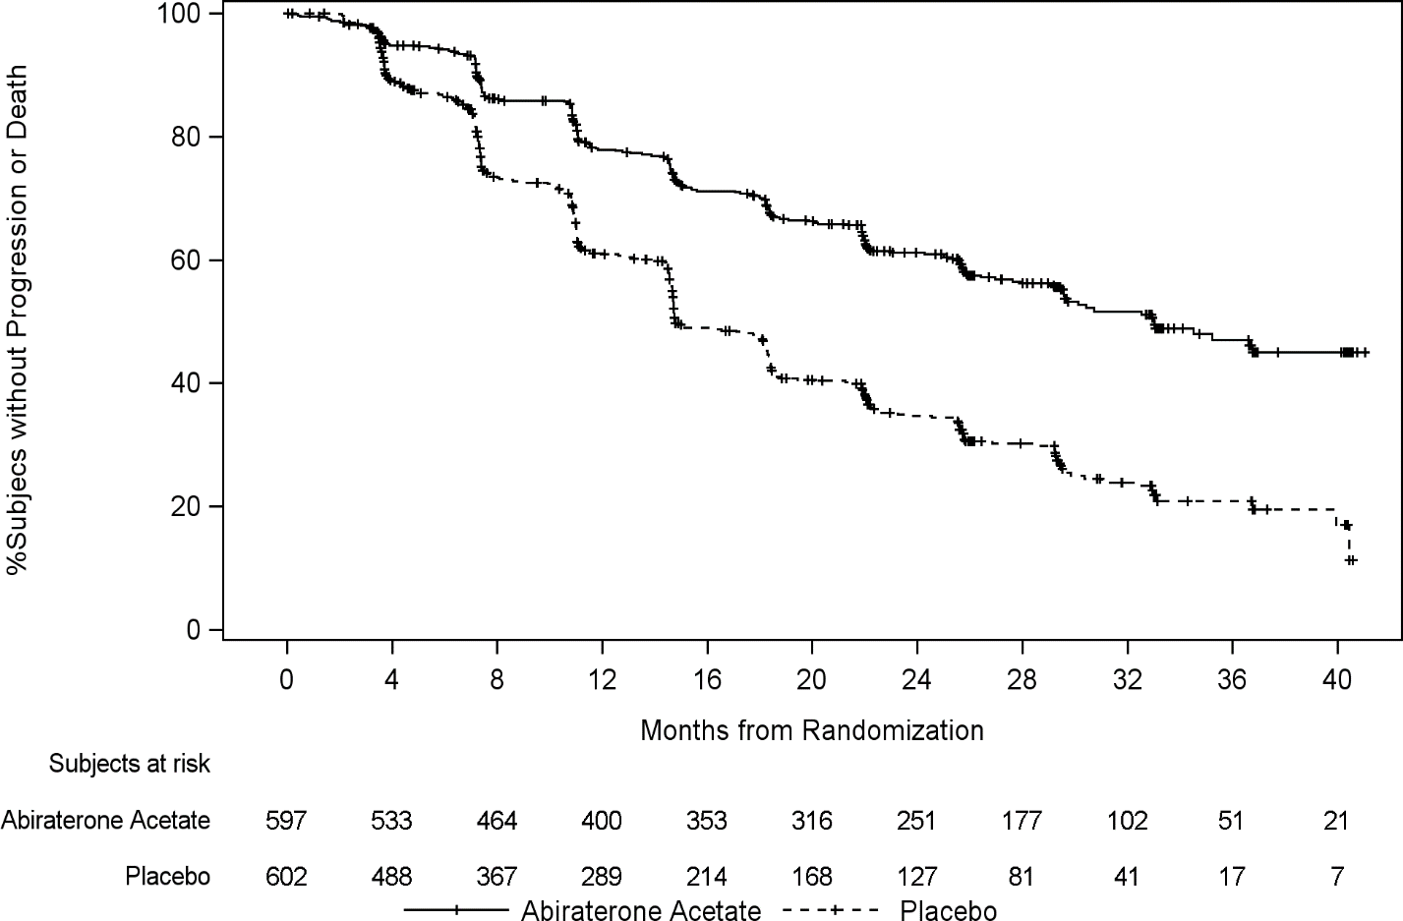

A statistically significant improvement in OS in favour of AA-P plus ADT was observed with a 34%
reduction in the risk of death compared to placebo plus ADT (HR=0.66; 95% CI: 0.56, 0.78;
p<0.0001), (see Table 3 and Figure 2).

Table 3: Overall survival of patients treated with either abiraterone acetate or placebos in Study PCR3011 (intent-to-treat analysis)
Overall Survival | Abiraterone acetate with Prednisone (N=597) | Placebos  (N=602)
Deaths (%) | 275 (46%) | 343 (57%)
Median survival (months) | 53.3 | 36.5
(95% CI) | (48.2, NE) | (33.5, 40.0)
Hazard ratio (95% CI)¹ | 0.66 (0.56, 0.78)
NE=Not estimable
¹ Hazard Ratio is derived from a stratified proportional hazards model. Hazard ratio <1 favours Abiraterone acetate with prednisone.

Figure 2: Kaplan-Meier plot of overall survival; intent-to-treat population in Study PCR3011 analysis
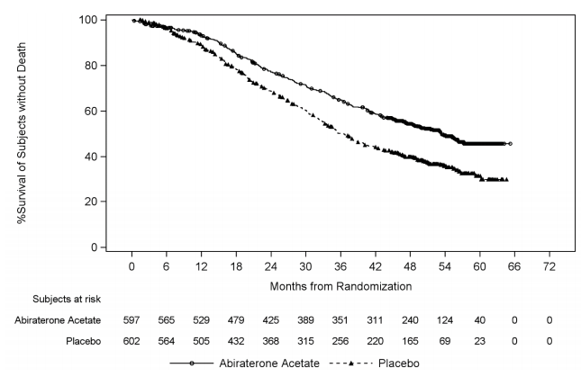
Subgroup analyses consistently favour treatment with abiraterone acetate. The treatment effect of AA-P on rPFS and OS across the pre-specified subgroups was favourable and consistent with the overall study population, except for the subgroup of ECOG score of 2 where no trend towards benefit was observed, however the small sample size (n=40) limits drawing any meaningful conclusion.

In addition to the observed improvements in overall survival and rPFS, benefit was demonstrated for abiraterone acetate vs. placebo treatment in all prospectively-defined secondary endpoints.

Study 302 (chemotherapy naïve patients)
This study enrolled chemotherapy naïve patients who were asymptomatic or mildly symptomatic and for whom chemotherapy was not yet clinically indicated. A score of 0-1 on Brief Pain Inventory-Short Form (BPI-SF) worst pain in last 24 hours was considered asymptomatic, and a score of 2-3 was considered mildly symptomatic.

In study 302, (n = 1,088) the median age of enrolled patients was 71 years for patients treated with abiraterone acetate plus prednisone or prednisolone and 70 years for patients treated with placebo plus prednisone or prednisolone. The number of patients treated with abiraterone acetate by racial group was Caucasian 520 (95.4%), Black 15 (2.8%), Asian 4 (0.7%) and other 6 (1.1%). The Eastern Cooperative Oncology Group (ECOG) performance status was 0 for 76% of patients, and 1 for 24% of patients in both arms. Fifty percent of patients had only bone metastases, an additional 31% of patients had bone and soft tissue or lymph node metastases and 19% of patients had only soft tissue or lymph node metastases. Patients with visceral metastases were excluded. Co-primary efficacy endpoints were overall survival and radiographic progression-free survival (rPFS). In addition to the co-primary endpoint measures, benefit was also assessed using time to opiate use for cancer pain, time to initiation of cytotoxic chemotherapy, time to deterioration in ECOG performance score by ≥ 1 point and time to PSA progression based on Prostate Cancer Working Group-2 (PCWG2) criteria. Study treatments were discontinued at the time of unequivocal clinical progression. Treatments could also be discontinued at the time of confirmed radiographic progression at the discretion of the investigator.

Radiographic progression free survival (rPFS) was assessed with the use of sequential imaging studies as defined by PCWG2 criteria (for bone lesions) and modified Response Evaluation Criteria In Solid Tumors (RECIST) criteria (for soft tissue lesions). Analysis of rPFS utilised centrally-reviewed radiographic assessment of progression.

At the planned rPFS analysis there were 401 events, 150 (28%) of patients treated with abiraterone acetate and 251 (46%) of patients treated with placebo had radiographic evidence of progression or had died. A significant difference in rPFS between treatment groups was observed (see Table 4 and Figure 3).

Table 4: Study 302: Radiographic progression-free survival of patients treated with either abiraterone acetate or placebo in combination with prednisone or prednisolone plus LHRH analogues or prior orchiectomy
 | Abiraterone acetate | Placebo
 | (N = 546) | (N = 542)
Radiographic progression-free survival
(rPFS)
Progression or death | 150 (28%) | 251 (46%)
Median rPFS in months | Not reached | 8.3
(95% CI) | (11.66; NE) | (8.12; 8.54)
p-value* | < 0.0001
Hazard ratio** (95% CI) | 0.425 (0.347; 0.522)
NE = Not estimated
* p-value is derived from a log-rank test stratified by baseline ECOG score (0 or 1)
** Hazard ratio < 1 favours abiraterone acetate

Figure 3: Kaplan Meier curves of radiographic progression-free survival in patients treated with either abiraterone acetate or placebo in combination with prednisone or prednisolone plus LHRH analogues or prior orchiectomy
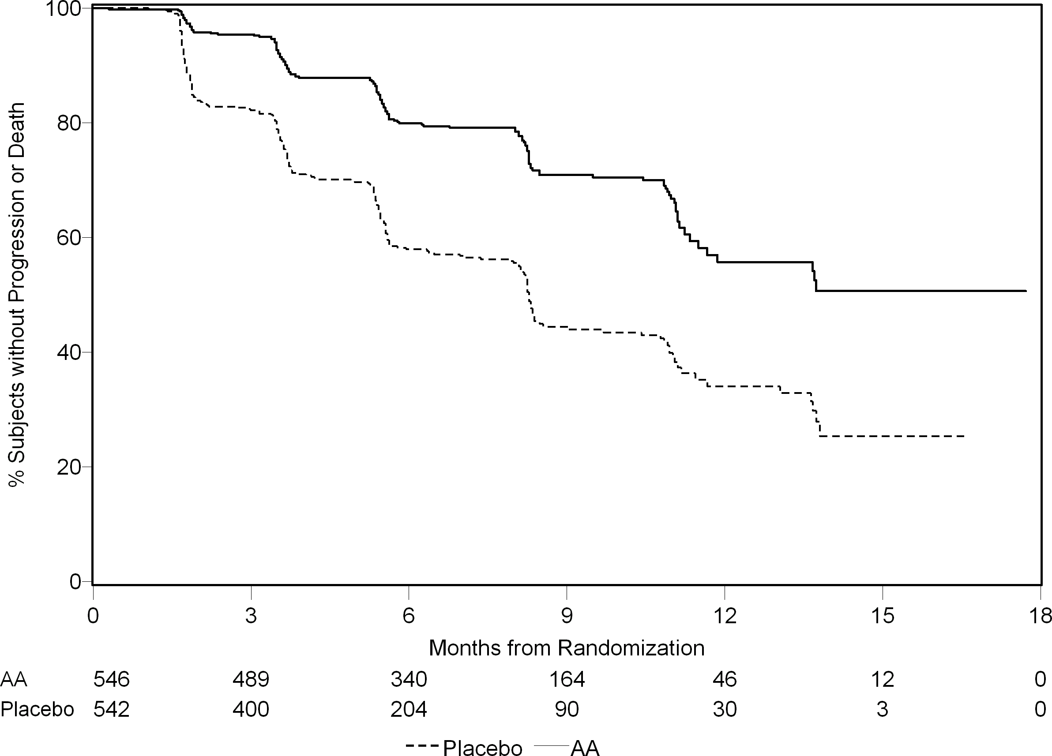
AA = abiraterone acetate

However, subject data continued to be collected through the date of the second interim analysis of Overall survival (OS). The investigator radiographic review of rPFS performed as a follow up sensitivity analysis is presented in Table 5 and Figure 4.

Six hundred and seven (607) subjects had radiographic progression or died: 271 (50%) in the abiraterone acetate group and 336 (62%) in the placebo group. Treatment with abiraterone acetate decreased the risk of radiographic progression or death by 47% compared with placebo (HR = 0.530; 95% CI: [0.451; 0.623], p < 0.0001). The median rPFS was 16.5 months in the abiraterone acetate group and 8.3 months in the placebo group.

Table 5: Study 302: Radiographic progression-free survival of patients treated with either abiraterone acetate or placebo in combination with prednisone or prednisolone plus LHRH analogues or prior orchiectomy (at second interim analysis of OS-investigator review)
 | Abiraterone acetate  (N = 546) | Placebo  (N = 542)
Radiographic Progression-free Survival
(rPFS)
Progression or death | 271 (50%) | 336 (62%)
Median rPFS in months | 16.5 | 8.3
(95% CI) | (13.80; 16.79) | (8.05; 9.43)
p-value* | < 0.0001
Hazard ratio** (95% CI) | 0.530 (0.451; 0.623)
* p-value is derived from a log-rank test stratified by baseline ECOG score (0 or 1)
** Hazard ratio < 1 favours abiraterone acetate

Figure 4: Kaplan Meier curves of radiographic progression-free survival in patients treated with either abiraterone acetate or placebo in combination with prednisone or prednisolone plus LHRH analogues or prior orchiectomy (at second interim analysis of OS-investigator review)
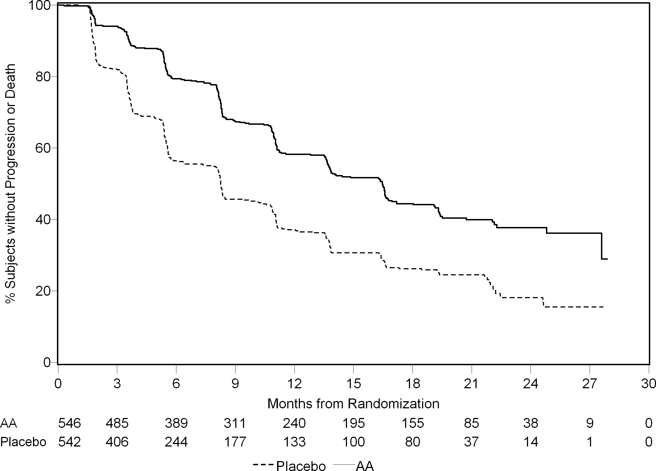
AA = abiraterone acetate

A planned interim analysis (IA) for OS was conducted after 333 deaths were observed. The study was unblinded based on the magnitude of clinical benefit observed and patients in the placebo group were offered treatment with abiraterone acetate. Overall survival was longer for abiraterone acetate than placebo with a 25% reduction in risk of death (HR = 0.752; 95% CI: [0.606; 0.934], p = 0.0097), but OS was not mature and interim results did not meet the pre-specified stopping boundary for statistical significance (see Table 6). Survival continued to be followed after this IA.

The planned final analysis for OS was conducted after 741 deaths were observed (median follow up of 49 months). Sixty-five percent (354 of 546) of patients treated with abiraterone acetate, compared with 71% (387 of 542) of patients treated with placebo, had died. A statistically significant OS benefit in favour of the abiraterone -treated group was demonstrated with a 19.4% reduction in risk of death (HR = 0.806; 95% CI: [0.697; 0.931], p = 0.0033) and an improvement in median OS of 4.4 months (abiraterone acetate 34.7 months, placebo 30.3 months) (see Table 6 and Figure 5). This improvement was demonstrated even though 44% of patients in the placebo arm received abiraterone acetate as subsequent therapy.

Table 6: Study 302: Overall survival of patients treated with either abiraterone acetate or placebo in combination with prednisone or prednisolone plus LHRH analogues or prior orchiectomy
 | Abiraterone acetate  (N = 546) | Placebo  (N = 542)
Interim survival analysis
Deaths (%) | 147 (27%) | 186 (34%)
Median survival (months) | Not reached | 27.2
(95% CI) | (NE; NE) | (25.95; NE)
p-value* | 0.0097
Hazard ratio** (95% CI) | 0.752 (0.606; 0.934)
Final survival analysis
Deaths (%) | 354 (65%) | 387 (71%)
Median overall survival in months (95% CI) | 34.7 (32.7; 36.8) | 30.3 (28.7; 33.3)
p-value* | 0.0033
Hazard ratio** (95% CI) | 0.806 (0.697; 0.931)
NE = Not Estimated
* p-value is derived from a log-rank test stratified by baseline ECOG score (0 or 1)
** Hazard ratio < 1 favours abiraterone acetate
Figure 5: Kaplan Meier survival curves of patients treated with either abiraterone acetate or placebo in combination with prednisone or prednisolone plus LHRH analogues or prior orchiectomy, final analysis
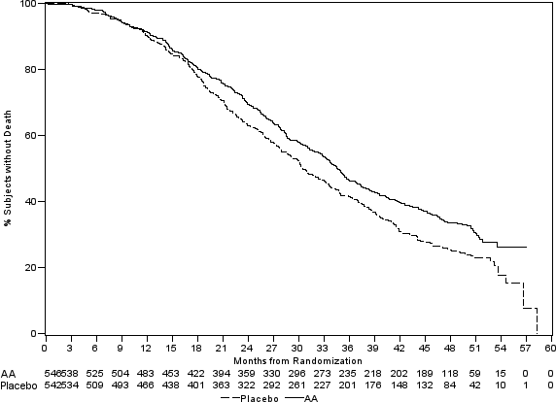
AA = abiraterone acetate

In addition to the observed improvements in overall survival and rPFS, benefit was demonstrated for abiraterone acetate vs. placebo treatment in all secondary endpoint measures as follows:

Time to PSA progression based on PCWG2 criteria: The median time to PSA progression was 11.1 months for patients receiving abiraterone acetate and 5.6 months for patients receiving placebo (HR = 0.488; 95% CI: [0.420; 0.568], p < 0.0001). The time to PSA progression was approximately doubled with abiraterone acetate treatment (HR = 0.488). The proportion of subjects with a confirmed PSA response was greater in the abiraterone group than in the placebo group (62% vs. 24%; p < 0.0001). In subjects with measurable soft tissue disease, significantly increased numbers of complete and partial tumor responses were seen with abiraterone acetate treatment.

Time to opiate use for cancer pain: The median time to opiate use for prostate cancer pain at the time of final analysis was 33.4 months for patients receiving abiraterone acetate and was 23.4 months for patients receiving placebo (HR = 0.721; 95% CI: [0.614; 0.846], p < 0.0001).

Time to initiation of cytotoxic chemotherapy: The median time to initiation of cytotoxic chemotherapy was 25.2 months for patients receiving abiraterone acetate and 16.8 months for patients receiving placebo (HR = 0.580; 95% CI: [0.487; 0.691], p < 0.0001).

Time to deterioration in ECOG performance score by ≥ 1 point: The median time to deterioration in ECOG performance score by ≥ 1 point was 12.3 months for patients receiving abiraterone acetate and 10.9 months for patients receiving placebo (HR = 0.821; 95% CI: [0.714; 0.943], p = 0.0053).

The following study endpoints demonstrated a statistically significant advantage in favour of abiraterone acetate treatment:

Objective response: Objective response was defined as the proportion of subjects with measurable disease achieving a complete or partial response according to RECIST criteria (baseline lymph node size was required to be ≥ 2 cm to be considered a target lesion). The proportion of subjects with measurable disease at baseline who had an objective response was 36% in the abiraterone group and 16% in the placebo group (p < 0.0001).

Pain: Treatment with abiraterone acetate significantly reduced the risk of average pain intensity progression by 18% compared with placebo (p = 0.0490). The median time to progression was 26.7 months in the abiraterone group and 18.4 months in the placebo group.

Time to degradation in the FACT-P (total score): Treatment with abiraterone acetate decreased the risk of FACT-P (Total Score) degradation by 22% compared with placebo (p = 0.0028). The median time to degradation in FACT-P (Total Score) was 12.7 months in the abiraterone group and 8.3 months in the placebo group.

Study 301 (patients who had received prior chemotherapy)
Study 301 enrolled patients who had received prior docetaxel. Patients were not required to show disease progression on docetaxel, as toxicity from this chemotherapy may have led to discontinuation. Patients were maintained on study treatments until there was PSA progression (confirmed 25% increase over the patient’s baseline/nadir) together with protocol-defined radiographic progression and symptomatic or clinical progression. Patients with prior ketoconazole treatment for prostate cancer were excluded from this study. The primary efficacy endpoint was overall survival.

The median age of enrolled patients was 69 years (range 39-95). The number of patients treated with abiraterone acetate by racial group was Caucasian 737 (93.2%), Black 28 (3.5%), Asian 11 (1.4%) and other 14 (1.8%). Eleven percent of patients enrolled had an ECOG performance score of 2; 70% had radiographic evidence of disease progression with or without PSA progression; 70% had received one prior cytotoxic chemotherapy and 30% received two. Liver metastasis was present in 11% of patients treated with abiraterone acetate.

In a planned analysis conducted after 552 deaths were observed, 42% (333 of 797) of patients treated with abiraterone acetate compared with 55% (219 of 398) of patients treated with placebo, had died. A statistically significant improvement in median overall survival was seen in patients treated with abiraterone acetate (see Table 7).

Table 7: Overall survival of patients treated with either abiraterone acetate or placebo in combination with prednisone or prednisolone plus LHRH analogues or prior orchiectomy
 | Abiraterone acetate  (N = 797) | Placebo  (N = 398)
Primary survival analysis
Deaths (%) | 333 (42%) | 219 (55%)
Median survival (months)  (95% CI) | 14.8  (14.1; 15.4) | 10.9  (10.2; 12.0)
p-valueª | < 0.0001
Hazard ratio (95% CI)^{b} | 0.646 (0.543; 0.768)
Updated survival analysis
Deaths (%) | 501 (63%) | 274 (69%)
Median survival (months)  (95% CI) | 15.8 (14.8; 17.0) | 11.2 (10.4; 13.1)
Hazard ratio (95% CI) ^{b} | 0.740 (0.638; 0.859)
    - p-value is derived from a log-rank test stratified by ECOG performance status score (0-1 vs. 2), pain score (absent vs. present), number of prior chemotherapy regimens (1 vs. 2), and type of disease progression (PSA only vs. radiographic).
    - Hazard ratio is derived from a stratified proportional hazards model. Hazard ratio < 1 favours abiraterone acetate

At all evaluation time points after the initial few months of treatment, a higher proportion of patients treated with abiraterone acetate remained alive, compared with the proportion of patients treated with placebo (see Figure 6).

Figure 6: Kaplan Meier survival curves of patients treated with either abiraterone acetate or placebo in combination with prednisone or prednisolone plus LHRH analogues or prior orchiectomy
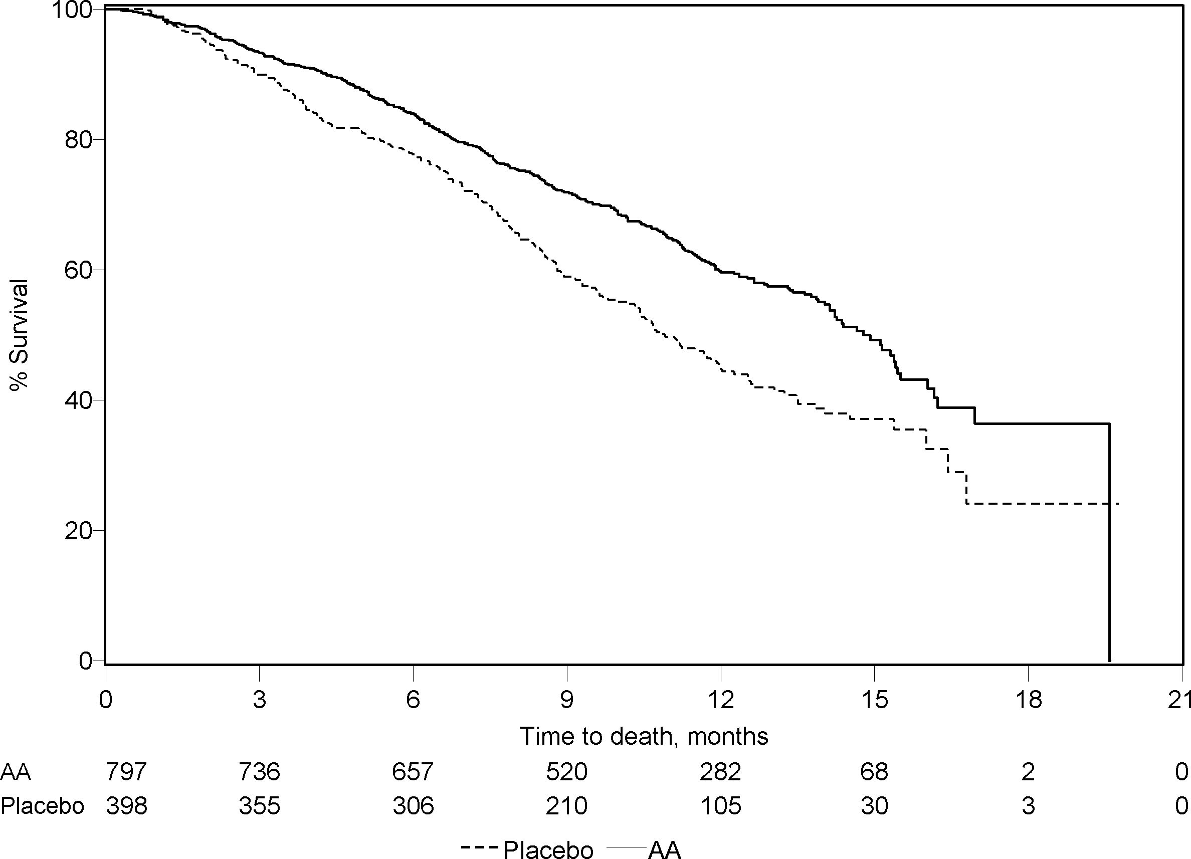
AA = abiraterone acetate

Subgroup survival analyses showed a consistent survival benefit for treatment with abiraterone acetate (see Figure 7).

Figure 7: Overall survival by subgroup: hazard ratio and 95% confidence interval

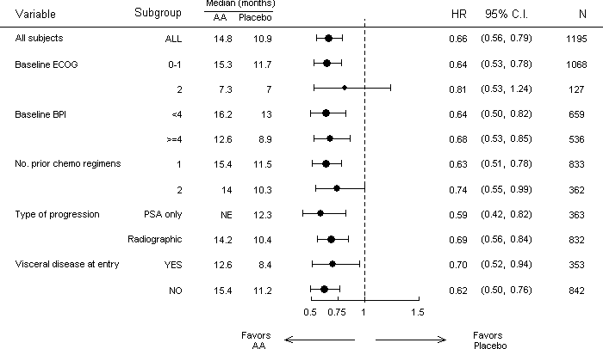
AA = abiraterone acetate; BPI = Brief Pain Inventory; C.I. = confidence interval; ECOG = Eastern Cooperative Oncology Group performance score; HR = hazard ratio; NE = not evaluable

In addition to the observed improvement in overall survival, all secondary study endpoints favoured abiraterone acetate and were statistically significant after adjusting for multiple testing as follows:

Patients receiving abiraterone acetate demonstrated a significantly higher total PSA response rate (defined as a ≥ 50% reduction from baseline), compared with patients receiving placebo, 38% vs. 10%, p < 0.0001.

The median time to PSA progression was 10.2 months for patients treated with abiraterone acetate and 6.6 months for patients treated with placebo (HR = 0.580; 95% CI: [0.462; 0.728], p < 0.0001).

The median radiographic progression-free survival was 5.6 months for patients treated with abiraterone acetate and 3.6 months for patients who received placebo (HR = 0.673; 95% CI: [0.585; 0.776], p < 0.0001).

Pain
The proportion of patients with pain palliation was statistically significantly higher in the abiraterone group than in the placebo group (44% vs. 27%, p = 0.0002). A responder for pain palliation was defined as a patient who experienced at least a 30% reduction from baseline in the BPI-SF worst pain intensity score over the last 24 hours without any increase in analgesic usage score observed at two consecutive evaluations four weeks apart. Only patients with a baseline pain score of ≥ 4 and at least one post-baseline pain score were analysed (N = 512) for pain palliation.

A lower proportion of patients treated with abiraterone acetate had pain progression compared to patients taking placebo at 6 (22% vs. 28%), 12 (30% vs. 38%) and 18 months (35% vs. 46%). Pain progression was defined as an increase from baseline of ≥ 30% in the BPI-SF worst pain intensity score over the previous 24 hours without a decrease in analgesic usage score observed at two consecutive visits, or an increase of ≥ 30% in analgesic usage score observed at two consecutive visits. The time to pain progression at the 25th percentile was 7.4 months in the abiraterone group, versus 4.7 months in the placebo group.

Skeletal-related events
A lower proportion of patients in the abiraterone group had skeletal-related events compared with the placebo group at 6 months (18% vs. 28%), 12 months (30% vs. 40%), and 18 months (35% vs. 40%). The time to first skeletal-related event at the 25th percentile in the abiraterone group was twice that of the control group at 9.9 months versus 4.9 months. A skeletal-related event was defined as a pathological fracture, spinal cord compression, palliative radiation to bone, or surgery to bone.

Paediatric population
The European Medicines Agency has waived the obligation to submit the results of studies with the reference medicinal product containing abiraterone acetate in all subsets of the paediatric population in advanced prostate cancer. See section 4.2 for information on paediatric use.

5.2 Pharmacokinetic properties

Following administration of abiraterone acetate, the pharmacokinetics of abiraterone has been studied in healthy subjects, patients with metastatic advanced prostate cancer and subjects without cancer with hepatic or renal impairment. Abiraterone acetate is rapidly converted in vivo to abiraterone, an androgen biosynthesis inhibitor (see section 5.1).

Absorption
Following oral administration of abiraterone acetate in the fasting state, the time to reach maximum plasma abiraterone concentration is approximately 2 hours.

Administration of abiraterone acetate with food, compared with administration in a fasted state, results in up to a 10-fold (AUC) and up to a 17-fold (C_{max}) increase in mean systemic exposure of abiraterone, depending on the fat content of the meal. Given the normal variation in the content and composition of meals, taking abiraterone acetate with meals has the potential to result in highly variable exposures. Therefore, Abiraterone Krka must not be taken with food. Abiraterone Krka tablets must be taken as a single dose once daily on an empty stomach. Abiraterone Krka must be taken at least two hours after eating and food must not be eaten for at least one hour after taking Abiraterone Krka. The tablets must be swallowed whole with water (see section 4.2).

Distribution
The plasma protein binding of ¹⁴C-abiraterone in human plasma is 99.8%. The apparent volume of distribution is approximately 5,630 L, suggesting that abiraterone extensively distributes to peripheral tissues.

Biotransformation
Following oral administration of ¹⁴C-abiraterone acetate as capsules, abiraterone acetate is hydrolysed to abiraterone, which then undergoes metabolism including sulphation, hydroxylation and oxidation primarily in the liver. The majority of circulating radioactivity (approximately 92%) is found in the form of metabolites of abiraterone. Of 15 detectable metabolites, 2 main metabolites, abiraterone sulphate and N-oxide abiraterone sulphate, each represents approximately 43% of total radioactivity.

Elimination
The mean half-life of abiraterone in plasma is approximately 15 hours based on data from healthy subjects. Following oral administration of ¹⁴C-abiraterone acetate 1 000 mg, approximately 88% of the radioactive dose is recovered in faeces and approximately 5% in urine. The major compounds present in faeces are unchanged abiraterone acetate and abiraterone (approximately 55% and 22% of the administered dose, respectively).

Renal impairment
The pharmacokinetics of abiraterone acetate was compared in patients with end-stage renal disease on a stable haemodialysis schedule versus matched control subjects with normal renal function. Systemic exposure to abiraterone after a single oral 1 000 mg dose did not increase in subjects with end-stage renal disease on dialysis. Administration in patients with renal impairment, including severe renal impairment, does not require dose reduction (see section 4.2). However, there is no clinical experience in patients with prostate cancer and severe renal impairment. Caution is advised in these patients.

Hepatic impairment
The pharmacokinetics of abiraterone acetate was examined in subjects with pre-existing mild or moderate hepatic impairment (Child-Pugh Class A and B, respectively) and in healthy control subjects. Systemic exposure to abiraterone after a single oral 1 000 mg dose increased by approximately 11% and 260% in subjects with mild and moderate pre-existing hepatic impairment, respectively. The mean half-life of abiraterone is prolonged to approximately 18 hours in subjects with mild hepatic impairment and to approximately 19 hours in subjects with moderate hepatic impairment.

In another study, the pharmacokinetics of abiraterone were examined in subjects with pre-existing severe (n = 8) hepatic impairment (Child-Pugh Class C) and in 8 healthy control subjects with normal hepatic function. The AUC to abiraterone increased by approximately 600% and the fraction of free drug increased by 80% in subjects with severe hepatic impairment compared to subjects with normal hepatic function.

No dose adjustment is necessary for patients with pre-existing mild hepatic impairment. The use of abiraterone acetate should be cautiously assessed in patients with moderate hepatic impairment in whom the benefit clearly should outweigh the possible risk (see sections 4.2 and 4.4). abiraterone acetate should not be used in patients with severe hepatic impairment (see sections 4.2, 4.3 and 4.4).

For patients who develop hepatotoxicity during treatment, suspension of treatment and dose adjustment may be required (see sections 4.2 and 4.4).

5.3 Preclinical safety data

In all animal toxicity studies, circulating testosterone levels were significantly reduced. As a result, reduction in organ weights and morphological and/or histopathological changes in the reproductive organs, and the adrenal, pituitary and mammary glands were observed. All changes showed complete or partial reversibility. The changes in the reproductive organs and androgen-sensitive organs are consistent with the pharmacology of abiraterone. All treatment-related hormonal changes reversed or were shown to be resolving after a 4-week recovery period.

In fertility studies in both male and female rats, abiraterone acetate reduced fertility, which was completely reversible in 4 to 16 weeks after abiraterone acetate was stopped.

In a developmental toxicity study in the rat, abiraterone acetate affected pregnancy including reduced foetal weight and survival. Effects on the external genitalia were observed though abiraterone acetate was not teratogenic.

In these fertility and developmental toxicity studies performed in the rat, all effects were related to the pharmacological activity of abiraterone.

Aside from reproductive organ changes seen in all animal toxicology studies, non-clinical data reveal no special hazard for humans based on conventional studies of safety pharmacology, repeated dose toxicity, genotoxicity and carcinogenic potential. Abiraterone acetate was not carcinogenic in a 6-month study in the transgenic (Tg.rasH2) mouse. In a 24-month carcinogenicity study in the rat, abiraterone acetate increased the incidence of interstitial cell neoplasms in the testes. This finding is considered related to the pharmacological action of abiraterone and rat specific. Abiraterone acetate was not carcinogenic in female rats.

Environmental risk assessment (ERA)
The active substance, abiraterone, shows an environmental risk for the aquatic environment, especially to fish.

6. PHARMACEUTICAL PARTICULARS

6.1 List of excipients

Tablet core:
Lactose monohydrate
Hypromellose (E 464)
Sodium laurilsulfate
Croscarmellose sodium (E 468)
Silicified microcrystalline cellulose
Silica colloidal anhydrous
Magnesium stearate (E 470b)

Film coating:
Macrogol
Poly(vinyl alcohol)
Talc (E 553b)
Titanium dioxide (E 171)
Red iron oxide (E 172)
Black iron oxide (E 172)

6.2 Incompatibilities

Not applicable.

6.3 Shelf life

3 years

6.4 Special precautions for storage

This medicinal product does not require any special storage conditions.

6.5 Nature and contents of container

Blister (PVC/PE/PVDC//Paper/Alu): 56, 60 film-coated tablets, in a box.
Blister (PVC/PE/PVDC//Paper/Alu), calendar pack: 56 film-coated tablets, in a box.

Not all pack sizes may be marketed.

6.6 Special precautions for disposal and other handling

Based on its mechanism of action, this medicinal product may harm a developing foetus; therefore, women who are pregnant or may be pregnant should not handle it without protection, e.g., gloves.

Any unused medicinal product or waste material should be disposed of in accordance with local requirements. This medicinal product may pose a risk to the aquatic environment (see section 5.3).

7. MARKETING AUTHORISATION HOLDER

KRKA, d.d., Novo mesto, Šmarješka cesta 6, 8501 Novo mesto, Slovenia

8. MARKETING AUTHORISATION NUMBER(S)

56 film-coated tablets: EU/1/21/1553/001
60 film-coated tablets: EU/1/21/1553/002
56 film-coated tablets (calendar pack): EU/1/21/1553/003

9. DATE OF FIRST AUTHORISATION/RENEWAL OF THE AUTHORISATION

Date of first authorisation: 24 June 2021
Date of latest renewal:

10. DATE OF REVISION OF THE TEXT

Detailed information on this medicinal product is available on the website of the European Medicines Agency https://www.ema.europa.eu.

ANNEX II

A. MANUFACTURER(S) RESPONSIBLE FOR BATCH RELEASE

B. CONDITIONS OR RESTRICTIONS REGARDING SUPPLY AND USE

C. OTHER CONDITIONS AND REQUIREMENTS OF THE MARKETING AUTHORISATION

D. CONDITIONS OR RESTRICTIONS WITH REGARD TO THE SAFE AND EFFECTIVE USE OF THE MEDICINAL PRODUCT

A. MANUFACTURER(S) RESPONSIBLE FOR BATCH RELEASE

Name and address of the manufacturer(s) responsible for batch release

KRKA, d.d., Novo mesto
Šmarješka cesta 6
8501 Novo mesto
Slovenia

TAD Pharma GmbH
Heinz-Lohmann-Straße 5
27472 Cuxhaven
Germany

KRKA-FARMA d.o.o.
V. Holjevca 20/E
10450 Jastrebarsko
Croatia

The printed package leaflet of the medicinal product must state the name and address of the manufacturer responsible for the release of the concerned batch.

B. CONDITIONS OR RESTRICTIONS REGARDING SUPPLY AND USE

Medicinal product subject to medical prescription.

C. OTHER CONDITIONS AND REQUIREMENTS OF THE MARKETING AUTHORISATION

- Periodic safety update reports (PSURs)

The requirements for submission of PSURs for this medicinal product are set out in the list of Union reference dates (EURD list) provided for under Article 107c(7) of Directive 2001/83/EC and any subsequent updates published on the European medicines web-portal.

D. CONDITIONS OR RESTRICTIONS WITH REGARD TO THE SAFE AND EFFECTIVE USE OF THE MEDICINAL PRODUCT

- Risk management plan (RMP)

The marketing authorisation holder (MAH) shall perform the required pharmacovigilance activities and interventions detailed in the agreed RMP presented in Module 1.8.2 of the marketing authorisation and any agreed subsequent updates of the RMP.

An updated RMP should be submitted:
- At the request of the European Medicines Agency;
- Whenever the risk management system is modified, especially as the result of new information being received that may lead to a significant change to the benefit/risk profile or as the result of an important (pharmacovigilance or risk minimisation) milestone being reached.

ANNEX III

LABELLING AND PACKAGE LEAFLET

A. LABELLING

PARTICULARS TO APPEAR ON THE OUTER PACKAGING

BOX

1. NAME OF THE MEDICINAL PRODUCT

Abiraterone Krka 500 mg film-coated tablets

abiraterone acetate

2. STATEMENT OF ACTIVE SUBSTANCE(S)

Each film-coated tablet contains 500 mg abiraterone acetate equivalent to 446 mg of abiraterone.

3. LIST OF EXCIPIENTS

Contains lactose.
See leaflet for further information.

4. PHARMACEUTICAL FORM AND CONTENTS

film-coated tablet

56 film-coated tablets
60 film-coated tablets

5. METHOD AND ROUTE(S) OF ADMINISTRATION

Take Abiraterone Krka at least two hours after eating and food must not be eaten for at least one hour after taking Abiraterone Krka.

Read the package leaflet before use.
Oral use

6. SPECIAL WARNING THAT THE MEDICINAL PRODUCT MUST BE STORED OUT OF THE SIGHT AND REACH OF CHILDREN

Keep out of the sight and reach of children.

7. OTHER SPECIAL WARNING(S), IF NECESSARY

Women who are or may be pregnant should not handle Abiraterone Krka without gloves.

8. EXPIRY DATE

EXP

9. SPECIAL STORAGE CONDITIONS

10. SPECIAL PRECAUTIONS FOR DISPOSAL OF UNUSED MEDICINAL PRODUCTS OR WASTE MATERIALS DERIVED FROM SUCH MEDICINAL PRODUCTS, IF APPROPRIATE

11. NAME AND ADDRESS OF THE MARKETING AUTHORISATION HOLDER

KRKA, d.d., Novo mesto, Šmarješka cesta 6, 8501 Novo mesto, Slovenia

12. MARKETING AUTHORISATION NUMBER(S)

EU/1/21/1553/001 56 film-coated tablets
EU/1/21/1553/002 60 film-coated tablets
EU/1/21/1553/003 56 film-coated tablets (calendar pack)

13. BATCH NUMBER

Lot

14. GENERAL CLASSIFICATION FOR SUPPLY

15. INSTRUCTIONS ON USE

16. INFORMATION IN BRAILLE

Abiraterone Krka 500 mg

17. UNIQUE IDENTIFIER – 2D BARCODE

2D barcode carrying the unique identifier included.

18. UNIQUE IDENTIFIER - HUMAN READABLE DATA

PC
SN
NN

MINIMUM PARTICULARS TO APPEAR ON BLISTERS OR STRIPS

BLISTER

1. NAME OF THE MEDICINAL PRODUCT

Abiraterone Krka 500 mg film-coated tablets

abiraterone acetate

2. NAME OF THE MARKETING AUTHORISATION HOLDER

KRKA

3. EXPIRY DATE

EXP

4. BATCH NUMBER

Lot

5. OTHER

Calendar pack
Mon.
Tue.
Wed.
Thu.
Fri.
Sat.
Sun.

B. PACKAGE LEAFLET
Package leaflet: Information for the patient

Abiraterone Krka 500 mg film-coated tablets
abiraterone acetate

Read all of this leaflet carefully before you start taking this medicine because it contains important information for you.
- Keep this leaflet. You may need to read it again.
- If you have any further questions, ask your doctor or pharmacist.
- This medicine has been prescribed for you only. Do not pass it on to others. It may harm them, even if their signs of illness are the same as yours.
- If you get any side effects, talk to your doctor or pharmacist. This includes any possible side effects not listed in this leaflet. See section 4.

What is in this leaflet

1. What Abiraterone Krka is and what it is used for
2. What you need to know before you take Abiraterone Krka
3. How to take Abiraterone Krka
4. Possible side effects
5. How to store Abiraterone Krka
6. Contents of the pack and other information

1. What Abiraterone Krka is and what it is used for

Abiraterone Krka contains a medicine called abiraterone acetate. It is used to treat prostate cancer in adult men that has spread to other parts of the body. Abiraterone Krka stops your body from making testosterone; this can slow the growth of prostate cancer.

When Abiraterone Krka is prescribed for the early stage of disease where it is still responding to hormone therapy, it is used with a treatment that lowers testosterone (androgen deprivation therapy).

When you take this medicine your doctor will also prescribe another medicine called prednisone or prednisolone. This is to lower your chances of getting high blood pressure, having too much water in your body (fluid retention), or having reduced levels of a chemical known as potassium in your blood.

2. What you need to know before you take Abiraterone Krka

Do not take Abiraterone Krka
- if you are allergic to abiraterone acetate or any of the other ingredients of this medicine (listed in section 6).
- if you are a woman, especially if pregnant. Abiraterone Krka is for use in male patients only.
- if you have severe liver damage.
- in combination with Ra-223 (which is used to treat prostate cancer).

Do not take this medicine if any of the above apply to you. If you are not sure, talk to your doctor or pharmacist before taking this medicine.

Warnings and precautions
Talk to your doctor or pharmacist before taking Abiraterone Krka:
- if you have liver problems.
- if you have been told you have high blood pressure or heart failure or low blood potassium (low blood potassium may increase the risk of heart rhythm problems).
- if you have had other heart or blood vessel problems,
- if you have an irregular or rapid heart rate.
- if you have shortness of breath.
- if you have gained weight rapidly.
- if you have swelling in the feet, ankles, or legs.
- if you have taken a medicine known as ketoconazole in the past for prostate cancer.
- about the need to take this medicine with prednisone or prednisolone.
- about possible effects on your bones.
- if you have high blood sugar.

Tell your doctor if you have been told you have any heart or blood vessel conditions, including heart rhythm problems (arrhythmia), or are being treated with medicines for these conditions.

Tell your doctor if you have yellowing of the skin or eyes, darkening of the urine, or severe nausea or vomiting, as these could be signs or symptoms of liver problems. Rarely, failure of the liver to function (called acute liver failure) may occur, which can lead to death.

Decrease in red blood cells, reduced sex drive (libido), muscle weakness and/or muscle pain may occur.

Abiraterone Krka must not be given in combination with Ra-223 due to a possible increase in the risk of bone fracture or death.

If you plan to take Ra-223 following treatment with Abiraterone Krka and prednisone/prednisolone, you must wait 5 days before starting treatment with Ra-223.

If you are not sure if any of the above apply to you, talk to your doctor or pharmacist before taking this medicine.

Blood monitoring
Abiraterone Krka may affect your liver, and you may not have any symptoms. When you are taking this medicine, your doctor will check your blood periodically to look for any effects on your liver.

Children and adolescents
This medicine is not for use in children and adolescents. If Abiraterone Krka is accidentally ingested by a child or adolescent, go to the hospital immediately and take the package leaflet with you to show to the emergency doctor.

Other medicines and Abiraterone Krka

Ask your doctor or pharmacist for advice before taking any medicine.

Tell your doctor or pharmacist if you are taking, have recently taken or might take any other medicines. This is important because Abiraterone Krka may increase the effects of a number of medicines including heart medicines, tranquilisers, some medicines for diabetes, herbal medicines (e.g., St John’s wort) and others. Your doctor may want to change the dose of these medicines. Also, some medicines may increase or decrease the effects of Abiraterone Krka. This may lead to side effects or to Abiraterone Krka not working as well as it should.

Androgen deprivation treatment may increase the risk of heart rhythm problems. Tell your doctor if you are receiving medicine
- used to treat heart rhythm problems (e.g. quinidine, procainamide, amiodarone and sotalol);
- known to increase the risk of heart rhythm problems [e.g. methadone (used for pain relief and part of drug addiction detoxification), moxifloxacin (an antibiotic), antipsychotics (used for serious mental illnesses)].

Tell your doctor if you are taking any of the medicines listed above.

Abiraterone Krka with food
- This medicine must not be taken with food (see section 3, “Taking this medicine”).
- Taking Abiraterone Krka with food may cause side effects.

Pregnancy and breast-feeding
Abiraterone Krka is not for use in women.
- This medicine may cause harm to the unborn child if it is taken by women who are pregnant.
- Women who are pregnant or who may be pregnant should wear gloves if they need to touch or handle Abiraterone Krka.
- If you are having sex with a woman who can become pregnant, use a condom and another effective birth control method.
- If you are having sex with a pregnant woman, use a condom to protect the unborn child.

Driving and using machines
This medicine is not likely to affect your being able to drive and use any tools or machines.

Abiraterone Krka contains lactose and sodium
This medicine contains lactose. If you have been told by your doctor that you have an intolerance to some sugars, contact your doctor before taking this medicine.
This medicine contains less than 1 mmol sodium (23 mg) per dose of two tablets, that is to say essentially ‘sodium-free’.

3. How to take Abiraterone Krka

Always take this medicine exactly as your doctor or pharmacist has told you. Check with your doctor or pharmacist if you are not sure.

How much to take
The recommended dose is 1 000 mg (two tablets) once a day.

Taking this medicine
- Take this medicine by mouth.
- Do not take Abiraterone Krka with food. Taking Abiraterone Krka with food may cause more of the medicine to be absorbed by the body than is needed and this may cause side effects.
- Take Abiraterone Krka tablets as a single dose once daily on an empty stomach. Abiraterone Krka must be taken at least two hours after eating and food must not be eaten for at least one hour after taking Abiraterone Krka (see section 2, “Abiraterone Krka with food”).
- Swallow the tablets whole with water.
- Do not break the tablets.
- Abiraterone Krka is taken with a medicine called prednisone or prednisolone. Take the prednisone or prednisolone exactly as your doctor has told you.
- You need to take prednisone or prednisolone every day while you are taking Abiraterone Krka.
- The amount of prednisone or prednisolone you take may need to change if you have a medical emergency. Your doctor will tell you if you need to change the amount of prednisone or prednisolone you take. Do not stop taking prednisone or prednisolone unless your doctor tells you to.

Your doctor may also prescribe other medicines while you are taking Abiraterone Krka and prednisone or prednisolone.

If you take more Abiraterone Krka than you should
If you take more than you should, talk to your doctor or go to a hospital immediately.

If you forget to take Abiraterone Krka
- If you forget to take Abiraterone Krka or prednisone or prednisolone, take your usual dose the following day.
- If you forget to take Abiraterone Krka or prednisone or prednisolone for more than one day, talk to your doctor without delay.

If you stop taking Abiraterone Krka
Do not stop taking Abiraterone Krka or prednisone or prednisolone unless your doctor tells you to.

If you have any further questions on the use of this medicine, ask your doctor or pharmacist.

4. Possible side effects

Like all medicines, this medicine can cause side effects, although not everybody gets them.

Stop taking Abiraterone Krka and see a doctor immediately if you notice any of the following:
- muscle weakness, muscle twitches or a pounding heart beat (palpitations). These may be signs that the level of potassium in your blood is low.

Other side effects include:
Very common (may affect more than 1 in 10 people):
- fluid in your legs or feet,
- low blood potassium,
- liver function test increases,
- high blood pressure,
- urinary tract infection,
- diarrhoea.

Common (may affect up to 1 in 10 people):
- high fat levels in your blood,
- chest pain,
- irregular heart beat (atrial fibrillation),
- heart failure,
- rapid heart rate,
- severe infections called sepsis,
- bone fractures,
- indigestion,
- blood in urine,
- rash.

Uncommon (may affect up to 1 in 100 people):
- adrenal gland problems (related to salt and water problems),
- abnormal heart rhythm (arrhythmia),
- muscle weakness and/or muscle pain.

Rare (may affect up to 1 in 1 000 people):
- lung irritation (also called allergic alveolitis),
- failure of the liver to function (also called acute liver failure).

Not known (frequency cannot be estimated from the available data):
- heart attack, changes in ECG - electrocardiogram (QT prolongation)
- serious allergic reactions with difficulty swallowing or breathing, swollen face, lips, tongue or throat, or an itchy rash.

Bone loss may occur in men treated for prostate cancer. Abiraterone Krka in combination with prednisone or prednisolone may increase bone loss.

Reporting of side effects
If you get any side effects, talk to your doctor or pharmacist. This includes any possible side effects not listed in this leaflet. You can also report side effects directly via the national reporting system listed in Appendix V. By reporting side effects you can help provide more information on the safety of this medicine.

5. How to store Abiraterone Krka

Keep this medicine out of the sight and reach of children.

Do not use this medicine after the expiry date which is stated on the box and blister after EXP. The expiry date refers to the last day of that month.

This medicine does not require any special storage conditions.

Do not throw away any medicines via wastewater or household waste. Ask your pharmacist how to throw away medicines you no longer use. These measures will help protect the environment.

6. Contents of the pack and other information

What Abiraterone Krka contains
- The active substance is abiraterone acetate. Each film-coated tablet contains 500 mg abiraterone acetate equivalent to 446 mg of abiraterone.
- The other ingredients are:
Tablet core: lactose monohydrate, hypromellose (E 464), sodium laurilsulfate, croscarmellose sodium (E 468), silicified microcrystalline cellulose, silica colloidal anhydrous, magnesium stearate (E 470b).
Film-coating: macrogol, poly(vinyl alcohol), talc (E 553b), titanium dioxide (E 171), red iron oxide (E 172), black iron oxide (E 172).
See section 2 "Abiraterone Krka contains lactose and sodium".

What Abiraterone Krka looks like and contents of the pack
Grey violet to violet, oval, biconvex, film-coated tablets (tablets), with dimensions approximately of 20 mm long x 10 mm wide.

Abiraterone Krka is available in boxes containing:
- 56 or 60 film-coated tablets in blisters,
- 56 film-coated tablets in blisters, calendar pack.

Not all pack sizes may be marketed.

Marketing Authorisation Holder
KRKA, d.d., Novo mesto, Šmarješka cesta 6, 8501 Novo mesto, Slovenia

Manufacturers
KRKA, d.d., Novo mesto, Šmarješka cesta 6, 8501 Novo mesto, Slovenia
TAD Pharma GmbH, Heinz-Lohmann-Straße 5, 27472 Cuxhaven, Germany
KRKA-FARMA d.o.o., V. Holjevca 20/E, 10450 Jastrebarsko, Croatia

For any information about this medicine, please contact the local representative of the Marketing Authorisation Holder:

België/Belgique/Belgien  KRKA Belgium, SA.  Tél/Tel: + 32 (0) 487 50 73 62 | Lietuva  UAB KRKA Lietuva  Tel: + 370 5 236 27 40
България  КРКА България ЕООД  Teл.: + 359 (02) 962 34 50 | Luxembourg/Luxemburg  KRKA Belgium, SA.  Tél/Tel: + 32 (0) 487 50 73 62 (BE)
Česká republika  KRKA ČR, s.r.o.  Tel: + 420 (0) 221 115 150 | Magyarország  KRKA Magyarország Kereskedelmi Kft.  Tel.: + 36 (1) 355 8490
Danmark  KRKA Sverige AB  Tlf.: + 46 (0)8 643 67 66 (SE) | Malta  E. J. Busuttil Ltd.  Tel: + 356 21 445 885
Deutschland  123 Acurae Pharma GmbH  Tel: + 49 (0) 4721 590910 | Nederland  KRKA Belgium, SA.  Tel: + 32 (0) 487 50 73 62 (BE)
Eesti  KRKA, d.d., Novo mesto Eesti filiaal  Tel: + 372 (0) 6 671 658 | Norge  KRKA Sverige AB  Tlf: + 46 (0)8 643 67 66 (SE)
Ελλάδα  ΒΙΑΝΕΞ Α.Ε.  Τηλ: + 30 210 8009111 | Österreich  KRKA Pharma GmbH, Wien  Tel: + 43 (0)1 66 24 300
España  KRKA Farmacéutica, S.L.  Tel: + 34 911 61 03 80 | Polska  KRKA-POLSKA Sp. z o.o.  Tel.: + 48 (0)22 573 7500
France  KRKA France Eurl  Tél: + 33 (0)1 57 40 82 25 | Portugal  KRKA Farmacêutica, Sociedade Unipessoal Lda.  Tel: + 351 (0)21 46 43 650
Hrvatska  KRKA - FARMA d.o.o.  Tel: + 385 1 6312 101 | România  KRKA Romania S.R.L., Bucharest  Tel: + 4 021 310 66 05
Ireland  KRKA Pharma Dublin, Ltd.  Tel: + 353 1 413 3710 | Slovenija  KRKA, d.d., Novo mesto  Tel: + 386 (0) 1 47 51 100
Ísland  LYFIS ehf.  Sími: + 354 534 3500 | Slovenská republika  KRKA Slovensko, s.r.o.  Tel: + 421 (0) 2 571 04 501
Italia  KRKA Farmaceutici Milano S.r.l.  Tel: + 39 02 3300 8841 | Suomi/Finland  KRKA Finland Oy  Puh/Tel: + 358 20 754 5330
Κύπρος  KI.PA. (PHARMACAL) LIMITED  Τηλ: + 357 24 651 882 | Sverige  KRKA Sverige AB  Tel: + 46 (0)8 643 67 66 (SE)
Latvija
KRKA Latvija SIA
Tel: + 371 6 733 86 10

This leaflet was last revised in

Detailed information on this medicine is available on the European Medicines Agency web site: https://www.ema.europa.eu.

