This document is the approved product information for Amgevita, with the changes since the previous procedure affecting the product information (EMA/N/0000248712) tracked.

For more information, see the European Medicines Agency’s website:
https://www.ema.europa.eu/en/medicines/human/EPAR/amgevita

ANNEX I

SUMMARY OF PRODUCT CHARACTERISTICS

1. NAME OF THE MEDICINAL PRODUCT

AMGEVITA 20 mg solution for injection in pre-filled syringe
AMGEVITA 40 mg solution for injection in pre-filled syringe
AMGEVITA 40 mg solution for injection in pre-filled pen

2. QUALITATIVE AND QUANTITATIVE COMPOSITION

AMGEVITA 20 mg solution for injection in pre-filled syringe

Each single dose pre-filled syringe contains 20 mg of adalimumab in 0.4 mL solution (50 mg/mL).

AMGEVITA 40 mg solution for injection in pre-filled syringe

Each single dose pre-filled syringe contains 40 mg of adalimumab in 0.8 mL solution (50 mg/mL).

AMGEVITA 40 mg solution for injection in pre-filled pen

Each single dose pre-filled pen contains 40 mg of adalimumab in 0.8 mL solution (50 mg/mL).

Adalimumab is a recombinant human monoclonal antibody produced in Chinese Hamster Ovary cells.

For the full list of excipients, see section 6.1.

3. PHARMACEUTICAL FORM

Solution for injection (injection)
Solution for injection (injection) in pre-filled pen (SureClick)

Clear and colourless to slightly yellow solution.

4. CLINICAL PARTICULARS

4.1 Therapeutic indications

Rheumatoid arthritis

AMGEVITA in combination with methotrexate, is indicated for:
- the treatment of moderate to severe, active rheumatoid arthritis in adult patients when the response to disease-modifying anti-rheumatic drugs (DMARDs) including methotrexate has been inadequate.
- the treatment of severe, active and progressive rheumatoid arthritis in adults not previously treated with methotrexate.

AMGEVITA can be given as monotherapy in case of intolerance to methotrexate or when continued treatment with methotrexate is inappropriate.

AMGEVITA reduces the rate of progression of joint damage as measured by x-ray and improves physical function, when given in combination with methotrexate.

Juvenile idiopathic arthritis

Polyarticular juvenile idiopathic arthritis

AMGEVITA in combination with methotrexate is indicated for the treatment of active polyarticular juvenile idiopathic arthritis, in patients from the age of 2 years who have had an inadequate response to one or more DMARDs. AMGEVITA can be given as monotherapy in case of intolerance to methotrexate or when continued treatment with methotrexate is inappropriate (for the efficacy in monotherapy see section 5.1). Adalimumab has not been studied in patients aged less than 2 years.

Enthesitis-related arthritis

AMGEVITA is indicated for the treatment of active enthesitis-related arthritis in patients, 6 years of age and older, who have had an inadequate response to, or who are intolerant of, conventional therapy (see section 5.1).

Axial spondyloarthritis

Ankylosing spondylitis (AS)

AMGEVITA is indicated for the treatment of adults with severe active ankylosing spondylitis who have had an inadequate response to conventional therapy.

Axial spondyloarthritis without radiographic evidence of AS

AMGEVITA is indicated for the treatment of adults with severe axial spondyloarthritis without radiographic evidence of AS but with objective signs of inflammation by elevated CRP and/or MRI, who have had an inadequate response to, or are intolerant to non-steroidal anti-inflammatory drugs.

Psoriatic arthritis

AMGEVITA is indicated for the treatment of active and progressive psoriatic arthritis in adults when the response to previous DMARD therapy has been inadequate. AMGEVITA reduces the rate of progression of peripheral joint damage as measured by x-ray in patients with polyarticular symmetrical subtypes of the disease (see section 5.1) and improves physical function.

Psoriasis

AMGEVITA is indicated for the treatment of moderate to severe chronic plaque psoriasis in adult patients who are candidates for systemic therapy.

Paediatric plaque psoriasis

AMGEVITA is indicated for the treatment of severe chronic plaque psoriasis in children and adolescents from 4 years of age who have had an inadequate response to or are inappropriate candidates for topical therapy and phototherapies.

Hidradenitis suppurativa (HS)

AMGEVITA is indicated for the treatment of active moderate to severe hidradenitis suppurativa (acne inversa) in adults and adolescents from 12 years of age with an inadequate response to conventional systemic HS therapy (see sections 5.1 and 5.2).

Crohn’s disease

AMGEVITA is indicated for treatment of moderately to severely active Crohn’s disease, in adult patients who have not responded despite a full and adequate course of therapy with a corticosteroid and/or an immunosuppressant; or who are intolerant to or have medical contraindications for such therapies.

Paediatric Crohn's disease

AMGEVITA is indicated for the treatment of moderately to severely active Crohn's disease in paediatric patients (from 6 years of age) who have had an inadequate response to conventional therapy including primary nutrition therapy and a corticosteroid and/or an immunomodulator, or who are intolerant to or have contraindications for such therapies.

Ulcerative colitis

AMGEVITA is indicated for treatment of moderately to severely active ulcerative colitis in adult patients who have had an inadequate response to conventional therapy including corticosteroids and 6-mercaptopurine (6-MP) or azathioprine (AZA), or who are intolerant to or have medical contraindications for such therapies.

Paediatric ulcerative colitis

AMGEVITA is indicated for the treatment of moderately to severely active ulcerative colitis in paediatric patients (from 6 years of age) who have had an inadequate response to conventional therapy including corticosteroids and/or 6-mercaptopurine (6-MP) or azathioprine (AZA), or who are intolerant to or have medical contraindications for such therapies.

Uveitis

AMGEVITA is indicated for the treatment of non-infectious intermediate, posterior and panuveitis in adult patients who have had an inadequate response to corticosteroids, in patients in need of corticosteroid-sparing, or in whom corticosteroid treatment is inappropriate.

Paediatric uveitis

AMGEVITA is indicated for the treatment of paediatric chronic non-infectious anterior uveitis in patients from 2 years of age who have had an inadequate response to or are intolerant to conventional therapy, or in whom conventional therapy is inappropriate.

4.2 Posology and method of administration

AMGEVITA treatment should be initiated and supervised by specialist physicians experienced in the diagnosis and treatment of conditions for which AMGEVITA is indicated. Ophthalmologists are advised to consult with an appropriate specialist before initiation of treatment with AMGEVITA (see section 4.4). Patients treated with AMGEVITA should be given the Patient Reminder Card.

After proper training in injection technique, patients may self-inject with AMGEVITA if their physician determines that it is appropriate and with medical follow-up as necessary.

During treatment with AMGEVITA, other concomitant therapies (e.g. corticosteroids and/or immunomodulatory agents) should be optimised.

Posology

Rheumatoid arthritis

The recommended dose of AMGEVITA for adult patients with rheumatoid arthritis is 40 mg adalimumab administered every other week as a single dose via subcutaneous injection. Methotrexate should be continued during treatment with AMGEVITA.

Glucocorticoids, salicylates, non-steroidal anti-inflammatory drugs, or analgesics can be continued during treatment with AMGEVITA. Regarding combination with disease-modifying anti-rheumatic drugs other than methotrexate see sections 4.4 and 5.1.

In monotherapy, some patients who experience a decrease in their response to AMGEVITA 40 mg every other week may benefit from an increase in dose to 40 mg adalimumab every week or 80 mg every other week.

Available adalimumab data suggest that the clinical response is usually achieved within 12 weeks of treatment. Continued therapy should be reconsidered in a patient not responding within this time period.

Dose interruption

There may be a need for dose interruption, for instance before surgery or if a serious infection occurs.

Available data suggest that re-introduction of adalimumab after discontinuation for 70 days or longer resulted in the same magnitudes of clinical response and similar safety profile as before dose interruption.

Ankylosing spondylitis, axial spondyloarthritis without radiographic evidence of AS and psoriatic arthritis

The recommended dose of AMGEVITA for patients with ankylosing spondylitis, axial spondyloarthritis without radiographic evidence of AS and for patients with psoriatic arthritis is 40 mg adalimumab administered every other week as a single dose via subcutaneous injection.

Available data suggest that the clinical response is usually achieved within 12 weeks of treatment. Continued therapy should be reconsidered in a patient not responding within this time period.

Psoriasis

The recommended dose of AMGEVITA for adult patients is an initial dose of 80 mg administered subcutaneously, followed by 40 mg subcutaneously given every other week starting one week after the initial dose.

Continued therapy beyond 16 weeks should be carefully reconsidered in a patient not responding within this time period.

Beyond 16 weeks, patients with inadequate response to AMGEVITA 40 mg every other week may benefit from an increase in dose to 40 mg every week or 80 mg every other week. The benefits and risks of continued 40 mg weekly or 80 mg every other week therapy should be carefully reconsidered in a patient with an inadequate response after the increase in dose (see section 5.1). If adequate response is achieved with 40 mg every week or 80 mg every other week, the dose may subsequently be reduced to 40 mg every other week.

Hidradenitis suppurativa

The recommended AMGEVITA dose regimen for adult patients with hidradenitis suppurativa (HS) is 160 mg initially at day 1 (given as four 40 mg injections in one day or as two 40 mg injections per day for two consecutive days), followed by 80 mg two weeks later at day 15 (given as two 40 mg injections in one day). Two weeks later (day 29) continue with a dose of 40 mg every week or 80 mg every other week (given as two 40 mg injections in one day). Antibiotics may be continued during treatment with AMGEVITA if necessary. It is recommended that the patient should use a topical antiseptic wash on their HS lesions on a daily basis during treatment with AMGEVITA.

Continued therapy beyond 12 weeks should be carefully reconsidered in a patient with no improvement within this time period.

Should treatment be interrupted, AMGEVITA 40 mg every week or 80 mg every other week may be re-introduced (see section 5.1).

The benefit and risk of continued long-term treatment should be periodically evaluated (see section 5.1).

Crohn’s disease

The recommended AMGEVITA induction dose regimen for adult patients with moderately to severely active Crohn’s disease is 80 mg at week 0 followed by 40 mg at week 2. In case there is a need for a more rapid response to therapy, the regimen 160 mg at week 0 (given as four 40 mg injections in one day or as two 40 mg injections per day for two consecutive days), followed by 80 mg at week 2 (given as two 40 mg injections in one day), can be used with the awareness that the risk for adverse events is higher during induction.

After induction treatment, the recommended dose is 40 mg every other week via subcutaneous injection. Alternatively, if a patient has stopped AMGEVITA and signs and symptoms of disease recur, AMGEVITA may be re-administered. There is little experience from re-administration after more than 8 weeks since the previous dose.

During maintenance treatment, corticosteroids may be tapered in accordance with clinical practice guidelines.

Some patients who experience decrease in their response to AMGEVITA 40 mg every other week may benefit from an increase in dose to 40 mg AMGEVITA every week or 80 mg every other week.

Some patients who have not responded by week 4 may benefit from continued maintenance therapy through week 12. Continued therapy should be carefully reconsidered in a patient not responding within this time period.

Ulcerative colitis

The recommended AMGEVITA induction dose regimen for adult patients with moderate to severe ulcerative colitis is 160 mg at week 0 (given as four 40 mg injections in one day or as two 40 mg injections per day for two consecutive days) and 80 mg at week 2 (given as two 40 mg injections in one day). After induction treatment, the recommended dose is 40 mg every other week via subcutaneous injection.

During maintenance treatment, corticosteroids may be tapered in accordance with clinical practice guidelines.

Some patients who experience decrease in their response to AMGEVITA 40 mg every other week may benefit from an increase in dose to 40 mg AMGEVITA every week or 80 mg every other week.

Available data suggest that clinical response is usually achieved within 2-8 weeks of treatment. AMGEVITA therapy should not be continued in patients failing to respond within this time period.

Uveitis

The recommended dose of AMGEVITA for adult patients with uveitis is an initial dose of 80 mg, followed by 40 mg given every other week starting one week after the initial dose. There is limited experience in the initiation of treatment with adalimumab alone. Treatment with AMGEVITA can be initiated in combination with corticosteroids and/or with other non-biologic immunomodulatory agents. Concomitant corticosteroids may be tapered in accordance with clinical practice starting two weeks after initiating treatment with AMGEVITA.

It is recommended that the benefit and risk of continued long-term treatment should be evaluated on a yearly basis (see section 5.1).

Special populations

Elderly

No dose adjustment is required.

Renal and/or hepatic impairment

Adalimumab has not been studied in these patient populations. No dose recommendations can be made.

Paediatric population

Juvenile idiopathic arthritis

Polyarticular juvenile idiopathic arthritis from 2 years of age

The recommended dose of AMGEVITA for patients with polyarticular juvenile idiopathic arthritis, from 2 years of age is based on body weight (table 1). AMGEVITA is administered every other week via subcutaneous injection.

Table 1. AMGEVITA dose for patients with polyarticular juvenile idiopathic arthritis

Patient weight | Dosing regimen
10 kg to < 30 kg | 20 mg every other week
≥ 30 kg | 40 mg every other week

Available clinical data suggest that clinical response is usually achieved within 12 weeks of treatment. Continued therapy should be carefully reconsidered in a patient not responding within this time period.

There is no relevant use of adalimumab in patients aged less than 2 years for this indication.

Enthesitis-related arthritis

The recommended dose of AMGEVITA for patients with enthesitis-related arthritis from 6 years of age is based on body weight (table 2). AMGEVITA is administered every other week via subcutaneous injection.

Table 2. AMGEVITA dose for patients with enthesitis-related arthritis

Patient weight | Dosing regimen
15 kg to < 30 kg | 20 mg every other week
≥ 30 kg | 40 mg every other week

Adalimumab has not been studied in patients with enthesitis-related arthritis aged less than 6 years.

Psoriatic arthritis and axial spondyloarthritis including ankylosing spondylitis

There is no relevant use of adalimumab in the paediatric population for the indications of ankylosing spondylitis and psoriatic arthritis.

Paediatric plaque psoriasis

The recommended AMGEVITA dose for patients with plaque psoriasis from 4 to 17 years of age is based on body weight (table 3). AMGEVITA is administered via subcutaneous injection.

Table 3. AMGEVITA dose for paediatric patients with plaque psoriasis

Patient weight | Dosing regimen
15 kg to < 30 kg | Initial dose of 20 mg, followed by 20 mg given every other week starting one week after the initial dose
≥ 30 kg | Initial dose of 40 mg, followed by 40 mg given every other week starting one week after the initial dose

Continued therapy beyond 16 weeks should be carefully considered in a patient not responding within this time period.

If retreatment with AMGEVITA is indicated, the above guidance on dose and treatment duration should be followed.

The safety of adalimumab in paediatric patients with plaque psoriasis has been assessed for a mean of 13 months.

There is no relevant use of adalimumab in children aged less than 4 years for this indication.

Adolescent hidradenitis suppurativa (from 12 years of age, weighing at least 30 kg)

There are no clinical trials with adalimumab in adolescent patients with HS. The posology of AMGEVITA in these patients has been determined from pharmacokinetic modelling and simulation (see section 5.2).

The recommended AMGEVITA dose is 80 mg at week 0 followed by 40 mg every other week starting at week 1 via subcutaneous injection.

In adolescent patients with inadequate response to AMGEVITA 40 mg every other week, an increase in dose to 40 mg every week or 80 mg every other week may be considered.

Antibiotics may be continued during treatment with AMGEVITA if necessary. It is recommended that the patient should use a topical antiseptic wash on their HS lesions on a daily basis during treatment with AMGEVITA.

Continued therapy beyond 12 weeks should be carefully reconsidered in a patient with no improvement within this time period.

Should treatment be interrupted, AMGEVITA may be re-introduced as appropriate.

The benefit and risk of continued long-term treatment should be periodically evaluated (see adult data in section 5.1).

There is no relevant use of AMGEVITA in children aged less than 12 years in this indication.

Paediatric Crohn's disease

The recommended dose of AMGEVITA for patients with Crohn’s disease from 6 to 17 years of age is based on body weight (table 4). AMGEVITA is administered via subcutaneous injection.

Table 4. AMGEVITA dose for paediatric patients with Crohn’s disease

Patient weight | Induction dose | Maintenance dose  starting at week 4
< 40 kg | - 40 mg at week 0 and 20 mg at week 2  In case there is a need for a more rapid response to therapy with the awareness that the risk for adverse events may be higher with use of the higher induction dose, the following dose may be used:  - 80 mg at week 0 and 40 mg at week 2 | 20 mg every other week
≥ 40 kg | - 80 mg at week 0 and 40 mg at week 2  In case there is a need for a more rapid response to therapy with the awareness that the risk for adverse events may be higher with use of the higher induction dose, the following dose may be used:  - 160 mg at week 0 and 80 mg at week 2 | 40 mg every other week

Patients who experience insufficient response may benefit from an increase in dose:
- < 40 kg: 20 mg every week
- ≥ 40 kg: 40 mg every week or 80 mg every other week

Continued therapy should be carefully considered in a subject not responding by week 12.

There is no relevant use of adalimumab in children aged less than 6 years for this indication.

Paediatric ulcerative colitis

The recommended dose of AMGEVITA for patients from 6 to 17 years of age with ulcerative colitis is based on body weight (table 5). AMGEVITA is administered via subcutaneous injection.

Table 5. AMGEVITA dose for paediatric patients with ulcerative colitis

Patient weight | Induction dose | Maintenance dose starting at week 4*
< 40 kg | - 80 mg at week 0 (given as two 40 mg injections in one day) and  - 40 mg at week 2 (given as one 40 mg injection) | 40 mg every other week
≥ 40 kg | - 160 mg at week 0 (given as four 40 mg injections in one day or two 40 mg injections per day for two consecutive days) and  - 80 mg at week 2 (given as two 40 mg injections in one day) | 80 mg every other week
* Paediatric patients who turn 18 years of age while on AMGEVITA should continue their prescribed maintenance dose.

Continued therapy beyond 8 weeks should be carefully considered in patients not showing signs of response within this time period.

There is no relevant use of AMGEVITA in children aged less than 6 years in this indication.

Paediatric uveitis

The recommended dose of AMGEVITA for paediatric patients with uveitis from 2 years of age is based on body weight (table 6). AMGEVITA is administered via subcutaneous injection.

In paediatric uveitis, there is no experience in the treatment with AMGEVITA without concomitant treatment with methotrexate.

Table 6. AMGEVITA dose for paediatric patients with uveitis

Patient weight | Dosing regimen
< 30 kg | 20 mg every other week in combination with methotrexate
≥ 30 kg | 40 mg every other week in combination with methotrexate

When AMGEVITA therapy is initiated, a loading dose of 40 mg for patients < 30 kg or 80 mg for patients ≥ 30 kg may be administered one week prior to the start of maintenance therapy. No clinical data are available on the use of a AMGEVITA loading dose in children < 6 years of age (see section 5.2).

There is no relevant use of AMGEVITA in children aged less than 2 years in this indication.

It is recommended that the benefit and risk of continued long-term treatment should be evaluated on a yearly basis (see section 5.1).

Method of administration

AMGEVITA is administered by subcutaneous injection. Full instructions for use are provided in the package leaflet.

4.3 Contraindications

Hypersensitivity to the active substance or to any of the excipients listed in section 6.1.

Active tuberculosis or other severe infections such as sepsis, and opportunistic infections (see section 4.4).

Moderate to severe heart failure (NYHA class III/IV) (see section 4.4).

4.4 Special warnings and precautions for use

Traceability

In order to improve the traceability of biological medicinal products, the name and the batch number of the administered product should be clearly recorded.

Infections

Patients taking TNF-antagonists are more susceptible to serious infections. Impaired lung function may increase the risk for developing infections. Patients must therefore be monitored closely for infections, including tuberculosis, before, during and after treatment with AMGEVITA. Because the elimination of adalimumab may take up to four months, monitoring should be continued throughout this period.

Treatment with AMGEVITA should not be initiated in patients with active infections including chronic or localised infections until infections are controlled. In patients who have been exposed to tuberculosis and patients who have travelled in areas of high risk of tuberculosis or endemic mycoses, such as histoplasmosis, coccidioidomycosis, or blastomycosis, the risk and benefits of treatment with AMGEVITA should be considered prior to initiating therapy (see Other opportunistic infections).

Patients who develop a new infection while undergoing treatment with AMGEVITA, should be monitored closely and undergo a complete diagnostic evaluation. Administration of AMGEVITA should be discontinued if a patient develops a new serious infection or sepsis, and appropriate antimicrobial or antifungal therapy should be initiated until the infection is controlled. Physicians should exercise caution when considering the use of AMGEVITA in patients with a history of recurring infection or with underlying conditions which may predispose patients to infections, including the use of concomitant immunosuppressive medications.

Serious infections

Serious infections, including sepsis, due to bacterial, mycobacterial, invasive fungal, parasitic, viral, or other opportunistic infections such as listeriosis, legionellosis and pneumocystis have been reported in patients receiving adalimumab.

Other serious infections seen in clinical trials include pneumonia, pyelonephritis, septic arthritis and septicaemia. Hospitalisation or fatal outcomes associated with infections have been reported.

Tuberculosis

Tuberculosis, including reactivation and new onset of tuberculosis, has been reported in patients receiving adalimumab. Reports included cases of pulmonary and extra-pulmonary (i.e. disseminated) tuberculosis.

Before initiation of therapy with AMGEVITA, all patients must be evaluated for both active or inactive (“latent”) tuberculosis infection. This evaluation should include a detailed medical assessment of patient history of tuberculosis or possible previous exposure to people with active tuberculosis and previous and/or current immunosuppressive therapy. Appropriate screening tests (i.e. tuberculin skin test and chest x-ray) should be performed in all patients (local recommendations may apply). It is recommended that the conduct and results of these tests are recorded in the Patient Reminder Card. Prescribers are reminded of the risk of false negative tuberculin skin test results, especially in patients who are severely ill or immunocompromised.

If active tuberculosis is diagnosed, AMGEVITA therapy must not be initiated (see section 4.3).

In all situations described below, the benefit/risk balance of therapy should be very carefully considered.

If latent tuberculosis is suspected, a physician with expertise in the treatment of tuberculosis should be consulted.

If latent tuberculosis is diagnosed, appropriate treatment must be started with anti-tuberculosis prophylaxis treatment before the initiation of AMGEVITA, and in accordance with local recommendations.

Use of anti-tuberculosis prophylaxis treatment should also be considered before the initiation of AMGEVITA in patients with several or significant risk factors for tuberculosis despite a negative test for tuberculosis and in patients with a past history of latent or active tuberculosis in whom an adequate course of treatment cannot be confirmed.

Despite prophylactic treatment for tuberculosis, cases of reactivated tuberculosis have occurred in patients treated with adalimumab. Some patients who have been successfully treated for active tuberculosis have redeveloped tuberculosis while being treated with adalimumab.

Patients should be instructed to seek medical advice if signs/symptoms suggestive of a tuberculosis infection (e.g. persistent cough, wasting/weight loss, low grade fever, listlessness) occur during or after therapy with AMGEVITA.

Other opportunistic infections

Opportunistic infections, including invasive fungal infections have been observed in patients receiving adalimumab. These infections have not consistently been recognised in patients taking TNF-antagonists and this has resulted in delays in appropriate treatment, sometimes resulting in fatal outcomes.

For patients who develop the signs and symptoms such as fever, malaise, weight loss, sweats, cough, dyspnoea, and/or pulmonary infiltrates or other serious systemic illness with or without concomitant shock an invasive fungal infection should be suspected and administration of AMGEVITA should be promptly discontinued. Diagnosis and administration of empiric antifungal therapy in these patients should be made in consultation with a physician with expertise in the care of patients with invasive fungal infections.

Hepatitis B reactivation

Reactivation of hepatitis B has occurred in patients receiving a TNF-antagonist including adalimumab, who are chronic carriers of this virus (i.e. surface antigen positive). Some cases have had a fatal outcome. Patients should be tested for HBV infection before initiating treatment with AMGEVITA. For patients who test positive for hepatitis B infection, consultation with a physician with expertise in the treatment of hepatitis B is recommended.

Carriers of HBV who require treatment with AMGEVITA should be closely monitored for signs and symptoms of active HBV infection throughout therapy and for several months following termination of therapy. Adequate data from treating patients who are carriers of HBV with anti-viral therapy in conjunction with TNF-antagonist therapy to prevent HBV reactivation are not available. In patients who develop HBV reactivation, AMGEVITA should be stopped and effective anti-viral therapy with appropriate supportive treatment should be initiated.

Neurological events

TNF-antagonists including adalimumab have been associated in rare instances with new onset or exacerbation of clinical symptoms and/or radiographic evidence of central nervous system demyelinating disease including multiple sclerosis and optic neuritis, and peripheral demyelinating disease, including Guillain-Barré syndrome. Prescribers should exercise caution in considering the use of AMGEVITA in patients with pre-existing or recent-onset central or peripheral nervous system demyelinating disorders; discontinuation of AMGEVITA should be considered if any of these disorders develop. There is a known association between intermediate uveitis and central demyelinating disorders. Neurologic evaluation should be performed in patients with non-infectious intermediate uveitis prior to the initiation of AMGEVITA therapy and regularly during treatment to assess for pre-existing or developing central demyelinating disorders.

Allergic reactions

Serious allergic reactions associated with adalimumab were rare during clinical trials. Non-serious allergic reactions associated with adalimumab were uncommon during clinical trials. Reports of serious allergic reactions including anaphylaxis have been received following adalimumab administration. If an anaphylactic reaction or other serious allergic reaction occurs, administration of AMGEVITA should be discontinued immediately and appropriate therapy initiated.

Immunosuppression

In a study of 64 patients with rheumatoid arthritis that were treated with adalimumab, there was no evidence of depression of delayed-type hypersensitivity, depression of immunoglobulin levels, or change in enumeration of effector T-, B-, NK-cells, monocyte/macrophages, and neutrophils.

Malignancies and lymphoproliferative disorders

In the controlled portions of adalimumab clinical trials of TNF-antagonists, more cases of malignancies including lymphoma have been observed among patients receiving a TNF-antagonist compared with control patients. However, the occurrence was rare. In the post-marketing setting, cases of leukaemia have been reported in patients treated with a TNF-antagonist. There is an increased background risk for lymphoma and leukaemia in rheumatoid arthritis patients with long-standing highly active, inflammatory disease, which complicates the risk estimation. With the current knowledge, a possible risk for the development of lymphomas, leukaemia, and other malignancies in patients treated with a TNF-antagonist cannot be excluded.

Malignancies, some fatal, have been reported among children, adolescents and young adults (up to 22 years of age) treated with TNF-antagonists (initiation of therapy ≤ 18 years of age), including adalimumab in the post-marketing setting. Approximately half the cases were lymphomas. The other cases represented a variety of different malignancies and included rare malignancies usually associated with immunosuppression. A risk for the development of malignancies in children and adolescents treated with TNF-antagonists cannot be excluded.

Rare post-marketing cases of hepatosplenic T-cell lymphoma have been identified in patients treated with adalimumab. This rare type of T-cell lymphoma has a very aggressive disease course and is usually fatal. Some of these hepatosplenic T-cell lymphomas with adalimumab have occurred in young adult patients on concomitant treatment with azathioprine or 6-mercaptopurine used for inflammatory bowel disease. The potential risk with the combination of azathioprine or 6-mercaptopurine and AMGEVITA should be carefully considered. A risk for the development of hepatosplenic T-cell lymphoma in patients treated with AMGEVITA cannot be excluded (see section 4.8).

No studies have been conducted that include patients with a history of malignancy or in whom treatment with adalimumab is continued following development of malignancy. Thus additional caution should be exercised in considering AMGEVITA treatment of these patients (see section 4.8).

All patients, and in particular patients with a medical history of extensive immunosuppressant therapy or psoriasis patients with a history of PUVA treatment should be examined for the presence of non-melanoma skin cancer prior to and during treatment with AMGEVITA. Melanoma and Merkel cell carcinoma have also been reported in patients treated with TNF-antagonists including adalimumab (see section 4.8).

In an exploratory clinical trial evaluating the use of another TNF-antagonist, infliximab, in patients with moderate to severe chronic obstructive pulmonary disease (COPD), more malignancies, mostly in the lung or head and neck, were reported in infliximab-treated patients compared with control patients. All patients had a history of heavy smoking. Therefore, caution should be exercised when using any TNF-antagonist in COPD patients, as well as in patients with increased risk for malignancy due to heavy smoking.

With current data it is not known if adalimumab treatment influences the risk for developing dysplasia or colon cancer. All patients with ulcerative colitis who are at increased risk for dysplasia or colon carcinoma (for example, patients with long-standing ulcerative colitis or primary sclerosing cholangitis), or who had a prior history of dysplasia or colon carcinoma should be screened for dysplasia at regular intervals before therapy and throughout their disease course. This evaluation should include colonoscopy and biopsies per local recommendations.

Haematologic reactions

Rare reports of pancytopenia including aplastic anaemia have been reported with TNF-antagonists. Adverse events of the haematologic system, including medically significant cytopenia (e.g. thrombocytopenia, leukopenia) have been reported with adalimumab. All patients should be advised to seek immediate medical attention if they develop signs and symptoms suggestive of blood dyscrasias (e.g. persistent fever, bruising, bleeding, pallor) while on AMGEVITA. Discontinuation of AMGEVITA therapy should be considered in patients with confirmed significant haematologic abnormalities.

Vaccinations

Similar antibody responses to the standard 23-valent pneumococcal vaccine and the influenza trivalent virus vaccination were observed in a study in 226 adult subjects with rheumatoid arthritis who were treated with adalimumab or placebo. No data are available on the secondary transmission of infection by live vaccines in patients receiving adalimumab.

It is recommended that paediatric patients, if possible, be brought up to date with all immunisations in agreement with current immunisation guidelines prior to initiating AMGEVITA therapy.

Patients on AMGEVITA may receive concurrent vaccinations, except for live vaccines. Administration of live vaccines (e.g., BCG vaccine) to infants exposed to AMGEVITA in utero is not recommended for 5 months following the mother’s last AMGEVITA injection during pregnancy.

Congestive heart failure

In a clinical trial with another TNF-antagonist worsening congestive heart failure and increased mortality due to congestive heart failure have been observed. Cases of worsening congestive heart failure have also been reported in patients receiving adalimumab. AMGEVITA should be used with caution in patients with mild heart failure (NYHA class I/II). AMGEVITA is contraindicated in moderate to severe heart failure (see section 4.3). Treatment with AMGEVITA must be discontinued in patients who develop new or worsening symptoms of congestive heart failure.

Autoimmune processes

Treatment with AMGEVITA may result in the formation of autoimmune antibodies. The impact of long-term treatment with AMGEVITA on the development of autoimmune diseases is unknown. If a patient develops symptoms suggestive of a lupus-like syndrome following treatment with AMGEVITA and is positive for antibodies against double-stranded DNA, further treatment with AMGEVITA should not be given (see section 4.8).

Concurrent administration of biologic DMARDs or TNF-antagonists

Serious infections were seen in clinical studies with concurrent use of anakinra and another TNF-antagonist, etanercept, with no added clinical benefit compared to etanercept alone. Because of the nature of the adverse events seen with the combination of etanercept and anakinra therapy, similar toxicities may also result from the combination of anakinra and other TNF-antagonists. Therefore, the combination of AMGEVITA and anakinra is not recommended (see section 4.5).

Concomitant administration of AMGEVITA with other biologic DMARDs (e.g. anakinra and abatacept) or other TNF-antagonists is not recommended based upon the possible increased risk for infections, including serious infections and other potential pharmacological interactions (see section 4.5).

Surgery

There is limited safety experience of surgical procedures in patients treated with adalimumab. The long half-life of adalimumab should be taken into consideration if a surgical procedure is planned. A patient who requires surgery while on AMGEVITA should be closely monitored for infections, and appropriate actions should be taken. There is limited safety experience in patients undergoing arthroplasty while receiving adalimumab.

Small bowel obstruction

Failure to respond to treatment for Crohn’s disease may indicate the presence of fixed fibrotic stricture that may require surgical treatment. Available data suggest that adalimumab does not worsen or cause strictures.

Elderly

The frequency of serious infections among adalimumab-treated subjects over 65 years of age (3.7%) was higher than for those under 65 years of age (1.5%). Some of those had a fatal outcome. Particular attention regarding the risk for infection should be paid when treating the elderly.

Paediatric population

See Vaccinations above.

Sodium contents

This medicinal product contains less than 1 mmol of sodium (23 mg) per 0.8 ml dose, that is to say essentially ‘sodium-free’.

4.5 Interaction with other medicinal products and other forms of interaction

Adalimumab has been studied in rheumatoid arthritis, polyarticular juvenile idiopathic arthritis and psoriatic arthritis patients taking adalimumab as monotherapy and those taking concomitant methotrexate. Antibody formation was lower when adalimumab was given together with methotrexate in comparison with use as monotherapy. Administration of adalimumab without methotrexate resulted in increased formation of antibodies, increased clearance and reduced efficacy of adalimumab (see section 5.1).

The combination of AMGEVITA and anakinra is not recommended (see section 4.4 “Concurrent administration of biologic DMARDs or TNF-antagonists”).

The combination of AMGEVITA and abatacept is not recommended (see section 4.4 “Concurrent administration of biologic DMARDs or TNF-antagonists”).

4.6 Fertility, pregnancy and lactation

Women of child bearing potential

Women of childbearing potential should consider the use of adequate contraception to prevent pregnancy and continue its use for at least five months after the last AMGEVITA treatment.

Pregnancy

A large number (approximately 2 100) of prospectively collected pregnancies exposed to adalimumab resulting in live birth with known outcomes, including more than 1 500 exposed during the first trimester, does not indicate an increase in the rate of malformation in the newborn.

In a prospective cohort registry, 257 women with rheumatoid arthritis (RA) or Crohn’s disease (CD) treated with adalimumab at least during the first trimester and 120 women with RA or CD not treated with adalimumab were enrolled. The primary endpoint was the birth prevalence of major birth defects. The rate of pregnancies ending with at least one live born infant with a major birth defect was 6/69 (8.7%) in the adalimumab-treated women with RA and 5/74 (6.8%) in the untreated women with RA (unadjusted OR 1.31, 95% CI 0.38-4.52) and 16/152 (10.5%) in the adalimumab-treated women with CD and 3/32 (9.4%) in the untreated women with CD (unadjusted OR 1.14, 95% CI 0.31-4.16). The adjusted OR (accounting for baseline differences) was 1.10 (95% CI 0.45-2.73) with RA and CD combined. There were no distinct differences between adalimumab-treated and untreated women for the secondary endpoints spontaneous abortions, minor birth defects, preterm delivery, birth size and serious or opportunistic infections and no stillbirths or malignancies were reported. The interpretation of data may be impacted due to methodological limitations of the study, including small sample size and non-randomised design.

In a developmental toxicity study conducted in monkeys, there was no indication of maternal toxicity, embryotoxicity or teratogenicity. Preclinical data on postnatal toxicity of adalimumab are not available (see section 5.3).

Due to its inhibition of TNFα, adalimumab administered during pregnancy could affect normal immune responses in the new born. AMGEVITA should only be used during pregnancy if clearly needed.

Adalimumab may cross the placenta into the serum of infants born to women treated with adalimumab during pregnancy. Consequently, these infants may be at increased risk for infection. Administration of live vaccines (e.g., BCG vaccine) to infants exposed to adalimumab in utero is not recommended for 5 months following the mother’s last adalimumab injection during pregnancy.

Breast-feeding

Limited information from the published literature indicates that adalimumab is excreted in breast milk at very low concentrations with the presence of adalimumab in human milk at concentrations of 0.1% to 1% of the maternal serum level. Given orally, immunoglobulin G proteins undergo intestinal proteolysis and have poor bioavailability. No effects on the breast-fed newborns/infants are anticipated. Consequently, AMGEVITA can be used during breast-feeding.

Fertility

Preclinical data on fertility effects of adalimumab are not available.

4.7 Effects on ability to drive and use machines

AMGEVITA may have a minor influence on the ability to drive and use machines. Vertigo and visual impairment may occur following administration of AMGEVITA (see section 4.8).

4.8 Undesirable effects

Summary of the safety profile

Adalimumab was studied in 9,506 patients in pivotal controlled and open-label trials for up to 60 months or more. These trials included rheumatoid arthritis patients with short term and long-standing disease, juvenile idiopathic arthritis (polyarticular juvenile idiopathic arthritis and enthesitis-related arthritis) as well as axial spondyloarthritis (ankylosing spondylitis and axial spondyloarthritis without radiographic evidence of AS), psoriatic arthritis, Crohn’s disease, ulcerative colitis, psoriasis, hidradenitis suppurativa and uveitis patients. The pivotal controlled studies involved 6,089 patients receiving adalimumab and 3,801 patients receiving placebo or active comparator during the controlled period.

The proportion of patients who discontinued treatment due to adverse events during the double-blind, controlled portion of pivotal studies was 5.9% for patients taking adalimumab and 5.4% for control treated patients.

The most commonly reported adverse reactions are infections (such as nasopharyngitis, upper respiratory tract infection and sinusitis), injection site reactions (erythema, itching, haemorrhage, pain or swelling), headache and musculoskeletal pain.

Serious adverse reactions have been reported for adalimumab. TNF-antagonists, such as AMGEVITA affect the immune system and their use may affect the body’s defence against infection and cancer.

Fatal and life-threatening infections (including sepsis, opportunistic infections and TB), HBV reactivation and various malignancies (including leukaemia, lymphoma and HSTCL) have also been reported with use of adalimumab.

Serious haematological, neurological and autoimmune reactions have also been reported. These include rare reports of pancytopenia, aplastic anaemia, central and peripheral demyelinating events and reports of lupus, lupus-related conditions and Stevens-Johnson syndrome.

Paediatric population

In general, the adverse events in paediatric patients were similar in frequency and type to those seen in adult patients.

Tabulated list of adverse reactions

The following list of adverse reactions is based on experience from clinical trials and on post-marketing experience and are displayed by system organ class and frequency in table 7 below: very common (≥ 1/10); common (≥ 1/100 to < 1/10); uncommon (≥ 1/1,000 to < 1/100); rare (≥ 1/10,000 to < 1/1,000); and not known (cannot be estimated from the available data). Within each frequency grouping, undesirable effects are presented in order of decreasing seriousness. The highest frequency seen among the various indications has been included. An asterisk (*) appears in the SOC column if further information is found elsewhere in sections 4.3, 4.4 and 4.8.

Table 7. Undesirable effects

System organ class | Frequency | Adverse reaction
Infections and infestations* | Very common | Respiratory tract infections (including lower and upper respiratory tract infection, pneumonia, sinusitis, pharyngitis, nasopharyngitis and pneumonia herpes viral)
Infections and infestations* | Common | Systemic infections (including sepsis, candidiasis and influenza),  Intestinal infections (including gastroenteritis viral),  Skin and soft tissue infections (including paronychia, cellulitis, impetigo, necrotising fasciitis and herpes zoster),  Ear infections,  Oral infections (including herpes simplex, oral herpes and tooth infections),  Reproductive tract infections (including vulvovaginal mycotic infection),  Urinary tract infections (including pyelonephritis),  Fungal infections,  Joint infections
Infections and infestations* | Uncommon | Neurological infections (including viral meningitis),  Opportunistic infections and tuberculosis (including coccidioidomycosis, histoplasmosis and mycobacterium avium complex infection),  Bacterial infections,  Eye infections,  Diverticulitis¹⁾
Neoplasms benign, malignant and unspecified (including cysts and polyps)* | Common | Skin cancer excluding melanoma (including basal cell carcinoma and squamous cell carcinoma),  Benign neoplasm
 | Uncommon | Lymphoma**,  Solid organ neoplasm (including breast cancer, lung neoplasm and thyroid neoplasm),  Melanoma**
 | Rare | Leukaemia¹⁾
 | Not known | Hepatosplenic T-cell lymphoma¹⁾,  Merkel cell carcinoma (neuroendocrine carcinoma of the skin)¹⁾,  Kaposi’s sarcoma
Blood and the lymphatic system disorders* | Very common | Leukopenia (including neutropenia and agranulocytosis),  Anaemia
Blood and the lymphatic system disorders* | Common | Leukocytosis,  Thrombocytopenia
Blood and the lymphatic system disorders* | Uncommon | Idiopathic thrombocytopenic purpura
Blood and the lymphatic system disorders* | Rare | Pancytopenia
Immune system disorders* | Common | Hypersensitivity,  Allergies (including seasonal allergy)
Immune system disorders* | Uncommon | Sarcoidosis¹⁾,  Vasculitis
Immune system disorders* | Rare | Anaphylaxis¹⁾
Metabolism and nutrition disorders | Very common | Lipids increased
Metabolism and nutrition disorders | Common | Hypokalaemia,  Uric acid increased,  Blood sodium abnormal,  Hypocalcaemia,  Hyperglycaemia,  Hypophosphataemia,  Dehydration
Psychiatric disorders | Common | Mood alterations (including depression),  Anxiety,  Insomnia
Nervous system disorders* | Very common | Headache
Nervous system disorders* | Common | Paraesthesia (including hypoaesthesia),  Migraine,  Nerve root compression
Nervous system disorders* | Uncommon | Cerebrovascular accident¹⁾,  Tremor,  Neuropathy
Nervous system disorders* | Rare | Multiple sclerosis,  Demyelinating disorders (e.g. optic neuritis, Guillain-Barré syndrome)¹⁾
Eye disorders | Common | Visual impairment,  Conjunctivitis,  Blepharitis,  Eye swelling
Eye disorders | Uncommon | Diplopia
Ear and labyrinth disorders | Common | Vertigo
Ear and labyrinth disorders | Uncommon | Deafness,  Tinnitus
Cardiac disorders* | Common | Tachycardia
Cardiac disorders* | Uncommon | Myocardial infarction¹⁾,  Arrhythmia,  Congestive heart failure
Cardiac disorders* | Rare | Cardiac arrest
Vascular disorders | Common | Hypertension,  Flushing,  Haematoma
Vascular disorders | Uncommon | Aortic aneurysm,  Vascular arterial occlusion,  Thrombophlebitis
Respiratory, thoracic and mediastinal disorders* | Common | Asthma,  Dyspnoea,  Cough
Respiratory, thoracic and mediastinal disorders* | Uncommon | Pulmonary embolism¹⁾,  Interstitial lung disease,  Chronic obstructive pulmonary disease,  Pneumonitis,  Pleural effusion¹⁾
Respiratory, thoracic and mediastinal disorders* | Rare | Pulmonary fibrosis¹⁾
Gastrointestinal disorders | Very common | Abdominal pain,  Nausea and vomiting
Gastrointestinal disorders | Common | GI haemorrhage,  Dyspepsia,  Gastroesophageal reflux disease,  Sicca syndrome
Gastrointestinal disorders | Uncommon | Pancreatitis,  Dysphagia,  Face oedema
Gastrointestinal disorders | Rare | Intestinal perforation¹⁾
Hepatobiliary disorders* | Very common | Elevated liver enzymes
Hepatobiliary disorders* | Uncommon | Cholecystitis and cholelithiasis,  Hepatic steatosis,  Bilirubin increased
Hepatobiliary disorders* | Rare | Hepatitis,  Reactivation of hepatitis B¹⁾,  Autoimmune hepatitis¹⁾
Hepatobiliary disorders* | Not known | Liver failure¹⁾
Skin and subcutaneous tissue disorders | Very common | Rash (including exfoliative rash)
Skin and subcutaneous tissue disorders | Common | Worsening or new onset of psoriasis (including palmoplantar pustular psoriasis)¹⁾,  Urticaria,  Bruising (including purpura),  Dermatitis (including eczema),  Onychoclasis,  Hyperhidrosis,  Alopecia¹⁾,  Pruritus
Skin and subcutaneous tissue disorders | Uncommon | Night sweats,  Scar
Skin and subcutaneous tissue disorders | Rare | Erythema multiforme¹⁾,  Stevens-Johnson syndrome¹⁾,  Angioedema¹⁾,  Cutaneous vasculitis¹⁾  Lichenoid skin reaction¹⁾
Skin and subcutaneous tissue disorders | Not known | Worsening of symptoms of dermatomyositis¹⁾
Musculoskeletal and connective tissue disorders | Very common | Musculoskeletal pain
Musculoskeletal and connective tissue disorders | Common | Muscle spasms (including blood creatine phosphokinase increased)
Musculoskeletal and connective tissue disorders | Uncommon | Rhabdomyolysis,  Systemic lupus erythematosus
Musculoskeletal and connective tissue disorders | Rare | Lupus-like syndrome¹⁾
Renal and urinary disorders | Common | Renal impairment,  Haematuria
Renal and urinary disorders | Uncommon | Nocturia
Reproductive system and breast disorders | Uncommon | Erectile dysfunction
General disorders and administration site conditions* | Very common | Injection site reaction (including injection site erythema)
General disorders and administration site conditions* | Common | Chest pain,  Oedema,  Pyrexia¹⁾
General disorders and administration site conditions* | Uncommon | Inflammation
Investigations* | Common | Coagulation and bleeding disorders (including activated partial thromboplastin time prolonged),  Autoantibody test positive (including double stranded DNA antibody),  Blood lactate dehydrogenase increased
Investigations* | Not known | Weight increased²⁾
Injury, poisoning and procedural complications | Common | Impaired healing
* further information is found elsewhere in sections 4.3, 4.4 and 4.8
** including open-label extension studies
¹⁾ including spontaneous reporting data
²⁾ The mean weight change from baseline for adalimumab ranged from 0.3 kg to 1.0 kg across adult indications compared to (minus) -0.4 kg to 0.4 kg for placebo over a treatment period of 4-6 months. Weight increase of 5-6 kg has also been observed in long-term extension studies with mean exposures of approximately 1-2 years without control group, particularly in patients with Crohn’s disease and ulcerative colitis. The mechanism behind this effect is unclear but could be associated with the anti-inflammatory effect of adalimumab.

Hidradenitis suppurativa

The safety profile for patients with HS treated with adalimumab weekly was consistent with the known safety profile of adalimumab.

Uveitis

The safety profile for patients with uveitis treated with adalimumab every other week was consistent with the known safety profile of adalimumab.

Description of selected adverse reactions

Injection site reactions

In the pivotal controlled trials in adults and children, 12.9% of patients treated with adalimumab developed injection site reactions (erythema and/or itching, haemorrhage, pain or swelling), compared to 7.2% of patients receiving placebo or active control. Injection site reactions generally did not necessitate discontinuation of the medicinal product.

Infections

In the pivotal controlled trials in adults and children, the rate of infection was 1.51 per patient year in the adalimumab-treated patients and 1.46 per patient year in the placebo and active control-treated patients. The infections consisted primarily of nasopharyngitis, upper respiratory tract infection, and sinusitis. Most patients continued on adalimumab after the infection resolved.

The incidence of serious infections was 0.04 per patient year in adalimumab-treated patients and 0.03 per patient year in placebo and active control-treated patients.

In controlled and open-label adult and paediatric studies with adalimumab, serious infections (including fatal infections, which occurred rarely) have been reported, which include reports of tuberculosis (including miliary and extra-pulmonary locations) and invasive opportunistic infections (e.g. disseminated or extrapulmonary histoplasmosis, blastomycosis, coccidioidomycosis, pneumocystis, candidiasis, aspergillosis and listeriosis). Most of the cases of tuberculosis occurred within the first eight months after initiation of therapy and may reflect recrudescence of latent disease.

Malignancies and lymphoproliferative disorders

No malignancies were observed in 249 paediatric patients with an exposure of 655.6 patient-years during adalimumab trials in patients with juvenile idiopathic arthritis (polyarticular juvenile idiopathic arthritis and enthesitis-related arthritis). In addition, no malignancies were observed in 192 paediatric patients with an exposure of 498.1 patient-years during an adalimumab trial in paediatric patients with Crohn’s disease. No malignancies were observed in 77 paediatric patients with an exposure of 80.0 patient-years during an adalimumab trial in paediatric patients with chronic plaque psoriasis. No malignancies were observed in 93 paediatric patients with an exposure of 65.3 patient years during an adalimumab trial in paediatric patients with ulcerative colitis. No malignancies were observed in 60 paediatric patients with an exposure of 58.4 patient years during an adalimumab trial in paediatric patients with uveitis.

During the controlled portions of pivotal adalimumab trials in adults of at least 12 weeks in duration in patients with moderately to severely active rheumatoid arthritis, ankylosing spondylitis, axial spondyloarthritis without radiographic evidence of AS, psoriatic arthritis, psoriasis, hidradenitis suppurativa, Crohn’s disease, ulcerative colitis and uveitis, malignancies, other than lymphoma and non-melanoma skin cancer, were observed at a rate (95% confidence interval) of 6.8 (4.4, 10.5) per 1,000 patient-years among 5,291 adalimumab-treated patients versus a rate of 6.3 (3.4, 11.8) per 1,000 patient-years among 3,444 control patients (median duration of treatment was 4.0 months for adalimumab and 3.8 months for control-treated patients). The rate (95% confidence interval) of non-melanoma skin cancers was 8.8 (6.0, 13.0) per 1,000 patient-years among adalimumab-treated patients and 3.2 (1.3, 7.6) per 1,000 patient-years among control patients. Of these skin cancers, squamous cell carcinomas occurred at rates (95% confidence interval) of 2.7 (1.4, 5.4) per 1,000 patient-years among adalimumab-treated patients and 0.6 (0.1, 4.5) per 1,000 patient-years among control patients. The rate (95% confidence interval) of lymphomas was 0.7 (0.2, 2.7) per 1,000 patient-years among adalimumab-treated patients and 0.6 (0.1, 4.5) per 1,000 patient-years among control patients.

When combining controlled portions of these trials and ongoing and completed open-label extension studies of adalimumab, with a median duration of approximately 3.3 years including 6,427 patients and over 26,439 patient-years of therapy, the observed rate of malignancies, other than lymphoma and non-melanoma skin cancers is approximately 8.5 per 1,000 patient-years. The observed rate of non-melanoma skin cancers is approximately 9.6 per 1,000 patient-years, and the observed rate of lymphomas is approximately 1.3 per 1,000 patient-years.

In post-marketing experience from January 2003 to December 2010, predominantly in patients with rheumatoid arthritis, the spontaneously reported rate of malignancies is approximately 2.7 per 1,000 patient treatment years. The spontaneously reported rates for non-melanoma skin cancers and lymphomas are approximately 0.2 and 0.3 per 1,000 patient treatment years, respectively (see section 4.4).

Rare post-marketing cases of hepatosplenic T-cell lymphoma have been reported in patients treated with adalimumab (see section 4.4).

Autoantibodies

Patients had serum samples tested for autoantibodies at multiple time points in rheumatoid arthritis studies I−V. In these trials, 11.9% of patients treated with adalimumab and 8.1% of placebo and active control-treated patients that had negative baseline anti-nuclear antibody titres reported positive titres at week 24. Two patients out of 3,441 treated with adalimumab in all rheumatoid arthritis and psoriatic arthritis studies developed clinical signs suggestive of new onset lupus-like syndrome. The patients improved following discontinuation of therapy. No patients developed lupus nephritis or central nervous system symptoms.

Hepatobiliary events

In controlled phase 3 trials of adalimumab in patients with rheumatoid arthritis and psoriatic arthritis with a control period duration ranging from 4 to 104 weeks, ALT elevations ≥ 3 x ULN occurred in 3.7% of adalimumab-treated patients and 1.6% of control-treated patients.

In controlled phase 3 trials of adalimumab in patients with polyarticular juvenile idiopathic arthritis who were 4 to 17 years and enthesitis-related arthritis who were 6 to 17 years, ALT elevations ≥ 3 x ULN occurred in 6.1% of adalimumab-treated patients and 1.3% of control-treated patients. Most ALT elevations occurred with concomitant methotrexate use. No ALT elevations ≥ 3 x ULN occurred in the phase 3 trial of adalimumab in patients with polyarticular juvenile idiopathic arthritis who were 2 to < 4 years.

In controlled phase 3 trials of adalimumab in patients with Crohn’s disease and ulcerative colitis with a control period ranging from 4 to 52 weeks. ALT elevations ≥ 3 x ULN occurred in 0.9% of adalimumab-treated patients and 0.9% of controlled-treated patients.

In the phase 3 trial of adalimumab in patients with paediatric Crohn’s disease which evaluated efficacy and safety of two body weight adjusted maintenance dose regimens following body weight adjusted induction therapy up to 52 weeks of treatment, ALT elevations ≥ 3 x ULN occurred in 2.6% (5/192) of patients of whom 4 were receiving concomitant immunosuppressants at baseline.

In controlled phase 3 trials of adalimumab in patients with plaque psoriasis with a control period duration ranging from 12 to 24 weeks, ALT elevations ≥ 3 x ULN occurred in 1.8% of adalimumab-treated patients and 1.8% of control-treated patients.

No ALT elevations ≥ 3 X ULN occurred in the phase 3 trial of adalimumab in paediatric patients with plaque psoriasis.

In controlled trials of adalimumab (initial doses of 160 mg at week 0 and 80 mg at week 2, followed by 40 mg every week starting at week 4), in patients with hidradenitis suppurativa with a control period duration ranging from 12 to 16 weeks, ALT elevations ≥ 3 x ULN occurred in 0.3% of adalimumab-treated patients and 0.6% of control-treated patients.

In controlled trials of adalimumab (initial doses of 80 mg at week 0 followed by 40 mg every other week starting at week 1) in adult patients with uveitis up to 80 weeks with a median exposure of 166.5 days and 105.0 days in adalimumab-treated and control-treated patients, respectively, ALT elevations ≥ 3 x ULN occurred in 2.4% of adalimumab-treated patients and 2.4% of control-treated patients.

In the controlled phase 3 trial of adalimumab in patients with paediatric ulcerative colitis (N=93) which evaluated efficacy and safety of a maintenance dose of 0.6 mg/kg (maximum of 40 mg) every other week (N=31) and a maintenance dose of 0.6 mg/kg (maximum of 40 mg) every week (N=32), following body weight adjusted induction dosing of 2.4 mg/kg (maximum of 160 mg) at week 0 and week 1, and 1.2 mg/kg (maximum of 80 mg) at week 2 (N=63), or an induction dose of 2.4 mg/kg (maximum of 160 mg) at week 0, placebo at week 1, and 1.2 mg/kg (maximum of 80 mg) at week 2 (N=30), ALT elevations ≥ 3 X ULN occurred in 1.1% (1/93) of patients.

Across all indications in clinical trials patients with raised ALT were asymptomatic and in most cases elevations were transient and resolved on continued treatment. However, there have also been post-marketing reports of liver failure as well as less severe liver disorders that may precede liver failure, such as hepatitis including autoimmune hepatitis in patients receiving adalimumab.

Concurrent treatment with azathioprine/6-mercaptopurine

In adult Crohn’s disease studies, higher incidences of malignant and serious infection-related adverse events were seen with the combination of adalimumab and azathioprine/6-mercaptopurine compared with adalimumab alone.

Reporting of suspected adverse reactions

Reporting suspected adverse reactions after authorisation of the medicinal product is important. It allows continued monitoring of the benefit/risk balance of the medicinal product. Healthcare professionals are asked to report any suspected adverse reactions via the national reporting system listed in Appendix V.

4.9 Overdose

No dose-limiting toxicity was observed during clinical trials. The highest dose level evaluated has been multiple intravenous doses of 10 mg/kg, which is approximately 15 times the recommended dose.

5. PHARMACOLOGICAL PROPERTIES

5.1 Pharmacodynamic properties

Pharmacotherapeutic group: Immunosuppressants, tumour necrosis factor alpha (TNFα) inhibitors. ATC code: L04AB04

AMGEVITA is a biosimilar medicinal product. Detailed information is available on the website of the European Medicines Agency http://www.ema.europa.eu.

Mechanism of action

Adalimumab binds specifically to TNF and neutralises the biological function of TNF by blocking its interaction with the p55 and p75 cell surface TNF receptors.

Adalimumab also modulates biological responses that are induced or regulated by TNF, including changes in the levels of adhesion molecules responsible for leukocyte migration (ELAM-1, VCAM-1, and ICAM-1 with an IC50 of 0.1-0.2 nM).

Pharmacodynamic effects

After treatment with adalimumab, a rapid decrease in levels of acute phase reactants of inflammation (C-reactive protein (CRP) and erythrocyte sedimentation rate (ESR)) and serum cytokines (IL-6) was observed, compared to baseline in patients with rheumatoid arthritis. Serum levels of matrix metalloproteinases (MMP-1 and MMP-3) that produce tissue remodelling responsible for cartilage destruction were also decreased after adalimumab administration. Patients treated with adalimumab usually experienced improvement in haematological signs of chronic inflammation.

A rapid decrease in CRP levels was also observed in patients with polyarticular juvenile idiopathic arthritis, Crohn's disease, ulcerative colitis and hidradenitis suppurativa after treatment with adalimumab. In patients with Crohn’s disease, a reduction of the number of cells expressing inflammatory markers in the colon including a significant reduction of expression of TNFα was seen. Endoscopic studies in intestinal mucosa have shown evidence of mucosal healing in adalimumab-treated patients.

Clinical efficacy and safety

Rheumatoid arthritis

Adalimumab was evaluated in over 3,000 patients in all rheumatoid arthritis clinical trials. The efficacy and safety of adalimumab were assessed in five randomised, double-blind and well-controlled studies. Some patients were treated for up to 120 months duration.

RA study I evaluated 271 patients with moderately to severely active rheumatoid arthritis who were ≥ 18 years old, had failed therapy with at least one disease-modifying, anti-rheumatic drug and had insufficient efficacy with methotrexate at doses of 12.5 to 25 mg (10 mg if methotrexate-intolerant) every week and whose methotrexate dose remained constant at 10 to 25 mg every week. Doses of 20, 40 or 80 mg of adalimumab or placebo were given every other week for 24 weeks.

RA study II evaluated 544 patients with moderately to severely active rheumatoid arthritis who were ≥ 18 years old and had failed therapy with at least one disease-modifying, anti-rheumatic drugs. Doses of 20 or 40 mg of adalimumab were given by subcutaneous injection every other week with placebo on alternative weeks or every week for 26 weeks; placebo was given every week for the same duration. No other disease-modifying anti-rheumatic drugs were allowed.

RA study III evaluated 619 patients with moderately to severely active rheumatoid arthritis who were ≥ 18 years old, and who had an ineffective response to methotrexate at doses of 12.5 to 25 mg or have been intolerant to 10 mg of methotrexate every week. There were three groups in this study. The first received placebo injections every week for 52 weeks. The second received 20 mg of adalimumab every week for 52 weeks. The third group received 40 mg of adalimumab every other week with placebo injections on alternate weeks. Upon completion of the first 52 weeks, 457 patients enrolled in an open-label extension phase in which 40 mg of adalimumab/MTX was administered every other week up to 10 years.

RA study IV primarily assessed safety in 636 patients with moderately to severely active rheumatoid arthritis who were ≥ 18 years old. Patients were permitted to be either disease-modifying, anti-rheumatic drug-naïve or to remain on their pre-existing rheumatologic therapy provided that therapy was stable for a minimum of 28 days. These therapies include methotrexate, leflunomide, hydroxychloroquine, sulfasalazine and/or gold salts. Patients were randomised to 40 mg of adalimumab or placebo every other week for 24 weeks.

RA study V evaluated 799 methotrexate-naïve, adult patients with moderate to severely active early rheumatoid arthritis (mean disease duration less than 9 months). This study evaluated the efficacy of adalimumab 40 mg every other week/methotrexate combination therapy, adalimumab 40 mg every other week monotherapy and methotrexate monotherapy in reducing the signs and symptoms and rate of progression of joint damage in rheumatoid arthritis for 104 weeks. Upon completion of the first 104 weeks, 497 patients enrolled in an open-label extension phase in which 40 mg of adalimumab was administered every other week up to 10 years.

The primary end point in RA studies I, II and III and the secondary endpoint in RA study IV was the percent of patients who achieved an ACR 20 response at week 24 or 26. The primary endpoint in RA study V was the percent of patients who achieved an ACR 50 response at week 52. RA studies III and V had an additional primary endpoint at 52 weeks of retardation of disease progression (as detected by x-ray results). RA study III also had a primary endpoint of changes in quality of life.

ACR response

The percent of adalimumab-treated patients achieving ACR 20, 50 and 70 responses was consistent across RA studies I, II and III. The results for the 40 mg every other week dose are summarised in table 8.

Table 8. ACR responses in placebo-controlled trials (percent of patients)

Response | RA study Iª** |  | RA study IIª** |  | RA study IIIª**
Response | Placebo/ MTX^{c}  n = 60 | Adalimumab^{b}/ MTX^{c}  n = 63 | Placebo  n = 110 | Adalimumab^{b}  n = 113 | Placebo/ MTX^{c}  n = 200 | Adalimumab^{b}/ MTX^{c}  n = 207
ACR 20
6 months | 13.3% | 65.1% | 19.1% | 46.0% | 29.5% | 63.3%
12 months | NA | NA | NA | NA | 24.0% | 58.9%
ACR 50
6 months | 6.7% | 52.4% | 8.2% | 22.1% | 9.5% | 39.1%
12 months | NA | NA | NA | NA | 9.5% | 41.5%
ACR 70
6 months | 3.3% | 23.8% | 1.8% | 12.4% | 2.5% | 20.8%
12 months | NA | NA | NA | NA | 4.5% | 23.2%
ª RA study I at 24 weeks, RA study II at 26 weeks, and RA study III at 24 and 52 weeks
^{b} 40 mg adalimumab administered every other week
^{c} MTX = methotrexate
** p < 0.01, adalimumab versus placebo

In RA studies I-IV, all individual components of the ACR response criteria (number of tender and swollen joints, physician and patient assessment of disease activity and pain, disability index (HAQ) scores and CRP (mg/dL) values) improved at 24 or 26 weeks compared to placebo. In RA study III, these improvements were maintained throughout 52 weeks.

In the open-label extension for RA study III, most patients who were ACR responders maintained response when followed for up to 10 years. Of 207 patients who were randomised to adalimumab 40 mg every other week, 114 patients continued on adalimumab 40 mg every other week for 5 years. Among those, 86 patients (75.4%) had ACR 20 responses; 72 patients (63.2%) had ACR 50 responses; and 41 patients (36%) had ACR 70 responses. Of 207 patients, 81 patients continued on adalimumab 40 mg every other week for 10 years. Among those, 64 patients (79.0%) had ACR 20 responses; 56 patients (69.1%) had ACR 50 responses; and 43 patients (53.1%) had ACR 70 responses.

In RA study IV, the ACR 20 response of patients treated with adalimumab plus standard of care was statistically significantly better than patients treated with placebo plus standard of care (p < 0.001).

In RA studies I-IV, adalimumab-treated patients achieved statistically significant ACR 20 and 50 responses compared to placebo as early as one to two weeks after initiation of treatment.

In RA study V with early rheumatoid arthritis patients who were methotrexate naïve, combination therapy with adalimumab and methotrexate led to faster and significantly greater ACR responses than methotrexate monotherapy and adalimumab monotherapy at week 52 and responses were sustained at week 104 (see table 9).

Table 9. ACR responses in RA study V (percent of patients)

Response | MTX  n = 257 | Adalimumab  n = 274 | Adalimumab /MTX  n = 268 | p-valueª | p-value^{b} | p-value^{c}
ACR 20
Week 52 | 62.6% | 54.4% | 72.8% | 0.013 | < 0.001 | 0.043
Week 104 | 56.0% | 49.3% | 69.4% | 0.002 | < 0.001 | 0.140
ACR 50
Week 52 | 45.9% | 41.2% | 61.6% | < 0.001 | < 0.001 | 0.317
Week 104 | 42.8% | 36.9% | 59.0% | < 0.001 | < 0.001 | 0.162
ACR 70
Week 52 | 27.2% | 25.9% | 45.5% | < 0.001 | < 0.001 | 0.656
Week 104 | 28.4% | 28.1% | 46.6% | < 0.001 | < 0.001 | 0.864
ª p-value is from the pairwise comparison of methotrexate monotherapy and adalimumab/methotrexate combination therapy using the Mann-Whitney U test
^{b} p-value is from the pairwise comparison of adalimumab monotherapy and adalimumab/methotrexate combination therapy using the Mann-Whitney U test
^{c} p-value is from the pairwise comparison of adalimumab monotherapy and methotrexate monotherapy using the Mann-Whitney U test

In the open-label extension for RA study V, ACR response rates were maintained when followed for up to 10 years. Of 542 patients who were randomised to adalimumab 40 mg every other week, 170 patients continued on adalimumab 40 mg every other week for 10 years. Among those, 154 patients (90.6%) had ACR 20 responses; 127 patients (74.7%) had ACR 50 responses; and 102 patients (60.0%) had ACR 70 responses.

At week 52, 42.9% of patients who received adalimumab/methotrexate combination therapy achieved clinical remission (DAS28 (CRP) < 2.6) compared to 20.6% of patients receiving methotrexate monotherapy and 23.4% of patients receiving adalimumab monotherapy. Adalimumab/methotrexate combination therapy was clinically and statistically superior to methotrexate (p < 0.001) and adalimumab monotherapy (p < 0.001) in achieving a low disease state in patients with recently diagnosed moderate to severe rheumatoid arthritis. The response for the two monotherapy arms was similar (p = 0.447). Of 342 subjects originally randomised to adalimumab monotherapy or adalimumab/methotrexate combination therapy who entered the open-label extension study, 171 subjects completed 10 years of adalimumab treatment. Among those, 109 subjects (63.7%) were reported to be in remission at 10 years.

Radiographic response

In RA study III, where adalimumab-treated patients had a mean duration of rheumatoid arthritis of approximately 11 years, structural joint damage was assessed radiographically and expressed as change in modified Total Sharp Score (TSS) and its components, the erosion score and joint space narrowing score. Adalimumab/methotrexate patients demonstrated significantly less radiographic progression than patients receiving methotrexate alone at 6 and 12 months (see table 10).

In the open-label extension of RA study III, the reduction in rate of progression of structural damage is maintained for 8 and 10 years in a subset of patients. At 8 years, 81 of 207 patients originally treated with 40 mg adalimumab every other week were evaluated radiographically. Among those, 48 patients showed no progression of structural damage defined by a change from baseline in the mTSS of 0.5 or less. At 10 years, 79 of 207 patients originally treated with 40 mg adalimumab every other week were evaluated radiographically. Among those, 40 patients showed no progression of structural damage defined by a change from baseline in the mTSS of 0.5 or less.

Table 10. Radiographic mean changes over 12 months in RA study III

 | Placebo/ MTXª | Adalimumab /MTX  40 mg every other week | Placebo/MTX- adalimumab /MTX (95% confidence interval^{b}) | p-value
Total Sharp Score | 2.7 | 0.1 | 2.6 (1.4, 3.8) | < 0.001^{c}
Erosion score | 1.6 | 0.0 | 1.6 (0.9, 2.2) | < 0.001
JSN^{d} score | 1.0 | 0.1 | 0.9 (0.3, 1.4) | 0.002
ª methotrexate
^{b} 95% confidence intervals for the differences in change scores between methotrexate and adalimumab
^{c} Based on rank analysis
^{d} Joint Space Narrowing

In RA study V, structural joint damage was assessed radiographically and expressed as change in modified Total Sharp Score (see table 11).

Table 11. Radiographic mean changes at week 52 in RA study V

 | MTX  n = 257 (95% confidence interval) | Adalimumab n = 274  (95% confidence interval) | Adalimumab/MTX  n = 268  (95% confidence interval) | p-valueª | p-value^{b} | p-value^{c}
Total sharp score | 5.7 (4.2-7.3) | 3.0 (1.7-4.3) | 1.3 (0.5-2.1) | < 0.001 | 0.0020 | < 0.001
Erosion score | 3.7 (2.7-4.7) | 1.7 (1.0-2.4) | 0.8 (0.4-1.2) | < 0.001 | 0.0082 | < 0.001
JSN score | 2.0 (1.2-2.8) | 1.3 (0.5-2.1) | 0.5 (0-1.0) | < 0.001 | 0.0037 | 0.151
ª p-value is from the pairwise comparison of methotrexate monotherapy and adalimumab/methotrexate combination therapy using the Mann-Whitney U test
^{b} p-value is from the pairwise comparison of adalimumab monotherapy and adalimumab/methotrexate combination therapy using the Mann-Whitney U test
^{c} p-value is from the pairwise comparison of adalimumab monotherapy and methotrexate monotherapy using the Mann-Whitney U test

Following 52 weeks and 104 weeks of treatment, the percentage of patients without progression (change from baseline in modified Total Sharp Score ≤ 0.5) was significantly higher with adalimumab/methotrexate combination therapy (63.8% and 61.2% respectively) compared to methotrexate monotherapy (37.4% and 33.5% respectively, p < 0.001) and adalimumab monotherapy (50.7%, p < 0.002 and 44.5%, p < 0.001 respectively).

In the open-label extension of RA study V, the mean change from baseline at year 10 in the modified Total Sharp Score was 10.8, 9.2 and 3.9 in patients originally randomised to methotrexate monotherapy, adalimumab monotherapy and adalimumab/methotrexate combination therapy, respectively. The corresponding proportions of patients with no radiographic progression were 31.3%, 23.7% and 36.7% respectively.

Quality of life and physical function

Health-related quality of life and physical function were assessed using the disability index of the Health Assessment Questionnaire (HAQ) in the four original adequate and well-controlled trials, which was a pre-specified primary endpoint at week 52 in RA study III. All doses/schedules of adalimumab in all four studies showed statistically significantly greater improvement in the disability index of the HAQ from baseline to month 6 compared to placebo and in RA study III the same was seen at week 52. Results from the Short Form Health Survey (SF 36) for all doses/schedules of adalimumab in all four studies support these findings, with statistically significant physical component summary (PCS) scores, as well as statistically significant pain and vitality domain scores for the 40 mg every other week dose. A statistically significant decrease in fatigue as measured by functional assessment of chronic illness therapy (FACIT) scores was seen in all three studies in which it was assessed (RA studies I, III, IV).

In RA study III, most subjects who achieved improvement in physical function and continued treatment maintained improvement through week 520 (120 months) of open-label treatment. Improvement in quality of life was measured up to week 156 (36 months) and improvement was maintained through that time.

In RA study V, the improvement in the HAQ disability index and the physical component of the SF 36 showed greater improvement (p < 0.001) for adalimumab/methotrexate combination therapy versus methotrexate monotherapy and adalimumab monotherapy at week 52, which was maintained through week 104. Among the 250 subjects who completed the open-label extension study, improvements in physical function were maintained through 10 years of treatment.

Axial spondyloarthritis

Ankylosing spondylitis (AS)

Adalimumab 40 mg every other week was assessed in 393 patients in two randomised, 24 week double-blind, placebo-controlled studies in patients with active ankylosing spondylitis (mean baseline score of disease activity [Bath Ankylosing Spondylitis Disease Activity Index (BASDAI)] was 6.3 in all groups) who have had an inadequate response to conventional therapy. Seventy-nine (20.1%) patients were treated concomitantly with disease-modifying anti-rheumatic drugs, and 37 (9.4%) patients with glucocorticoids. The blinded period was followed by an open-label period during which patients received adalimumab 40 mg every other week subcutaneously for up to an additional 28 weeks. Subjects (n = 215, 54.7%) who failed to achieve ASAS 20 at weeks 12, or 16 or 20 received early escape open-label adalimumab 40 mg every other week subcutaneously and were subsequently treated as non-responders in the double-blind statistical analyses.

In the larger AS study I with 315 patients, results showed statistically significant improvement of the signs and symptoms of ankylosing spondylitis in patients treated with adalimumab compared to placebo. Significant response was first observed at week 2 and maintained through 24 weeks (table 12).

Table 12. Efficacy responses in placebo-controlled AS study – study I reduction of signs and symptoms

Response | Placebo  N = 107 | Adalimumab  N = 208
ASASª 20
Week 2 | 16% | 42%***
Week 12 | 21% | 58%***
Week 24 | 19% | 51%***
ASAS 50
Week 2 | 3% | 16%***
Week 12 | 10% | 38%***
Week 24 | 11% | 35%***
ASAS 70
Week 2 | 0% | 7%**
Week 12 | 5% | 23%***
Week 24 | 8% | 24%***
BASDAI^{b} 50
Week 2 | 4% | 20%***
Week 12 | 16% | 45%***
Week 24 | 15% | 42%***
***, ** Statistically significant at p < 0.001, < 0.01 for all comparisons between adalimumab and placebo at weeks 2, 12 and 24
ª Assessments in Ankylosing Spondylitis
^{b} Bath Ankylosing Spondylitis Disease Activity Index

Adalimumab-treated patients had significantly greater improvement at week 12 which was maintained through week 24 in both the SF36 and Ankylosing Spondylitis Quality of Life Questionnaire (ASQoL).

Similar trends (not all statistically significant) were seen in the smaller randomised, double-blind, placebo controlled AS study II of 82 adult patients with active ankylosing spondylitis.

Axial spondyloarthritis without radiographic evidence of AS

The safety and efficacy of adalimumab were assessed in two randomised, double-blind placebo-controlled studies in patients with non-radiographic axial spondyloarthritis (nr-axSpA). Study nr-axSpA I evaluated patients with active nr-axSpA. Study nr-axSpA II was a treatment withdrawal study in active nr-axSpA patients who achieved remission during open-label treatment with adalimumab.

Study nr-axSpA I

In Study nr-axSpA I, adalimumab 40 mg every other week was assessed in 185 patients in a randomised, 12 week double-blind, placebo-controlled study in patients with active nr-axSpA (mean baseline score of disease activity [Bath Ankylosing Spondylitis Disease Activity Index (BASDAI)] was 6.4 for patients treated with adalimumab and 6.5 for those on placebo) who have had an inadequate response to or intolerance to ≥ 1 NSAIDs, or a contraindication for NSAIDs.

Thirty-three (18%) patients were treated concomitantly with disease-modifying anti-rheumatic drugs, and 146 (79%) patients with NSAIDs at baseline. The double-blind period was followed by an open-label period during which patients receive adalimumab 40 mg every other week subcutaneously for up to an additional 144 weeks. Week 12 results showed statistically significant improvement of the signs and symptoms of active nr-axSpA in patients treated with adalimumab compared to placebo (table 13).

Table 13. Efficacy response in placebo-controlled study nr-axSpA I

Double-blind response at week 12 | Placebo  N = 94 | Adalimumab  N = 91
ASASª 40 | 15% | 36%***
ASAS 20 | 31% | 52%**
ASAS 5/6 | 6% | 31%***
ASAS partial remission | 5% | 16%*
BASDAI^{b} 50 | 15% | 35%**
ASDAS^{c,d,e} | -0.3 | -1.0***
ASDAS Inactive Disease | 4% | 24%***
hs-CRP^{d,f,g} | -0.3 | -4.7***
SPARCC^{h} MRI Sacroiliac Joints^{d,i} | -0.6 | -3.2**
SPARCC MRI Spine^{d,j} | -0.2 | -1.8**
ª Assessment of SpondyloArthritis international Society
^{b} Bath Ankylosing Spondylitis Disease Activity Index
^{c} Ankylosing Spondylitis Disease Activity Score
^{d} mean change from baseline
^{e} n = 91 placebo and n = 87 adalimumab
^{f} high sensitivity C-Reactive Protein (mg/L)
^{g} n = 73 placebo and n = 70 adalimumab
^{h} Spondyloarthritis Research Consortium of Canada
^{i} n = 84 placebo and adalimumab
^{j} n = 82 placebo and n = 85 adalimumab
***, **, * Statistically significant at p < 0.001, < 0.01, and < 0.05, respectively, for all comparisons between adalimumab and placebo

In the open-label extension, improvement in the signs and symptoms was maintained with adalimumab therapy through week 156.

Inhibition of inflammation

Significant improvement of signs of inflammation as measured by hs-CRP and MRI of both Sacroiliac Joints and the Spine was maintained in adalimumab-treated patients through week 156 and week 104, respectively.

Quality of life and physical function

Health-related quality of life and physical function were assessed using the HAQ-S and the SF-36 questionnaires. Adalimumab showed statistically significantly greater improvement in the HAQ-S total score and the SF-36 Physical Component Score (PCS) from baseline to week 12 compared to placebo. Improvement in health-related quality of life and physical function was maintained during the open-label extension through week 156.

Study nr-axSpA II

673 patients with active nr-axSpA (mean baseline disease activity [BASDAI] was 7.0) who had an inadequate response to ≥ 2 NSAIDs, or an intolerance to or a contraindication for NSAIDs enrolled into the open-label period of Study nr-axSpA II during which they received adalimumab 40 mg every other week for 28 weeks. These patients also had objective evidence of inflammation in the sacroiliac joints or spine on MRI or elevated hs-CRP. Patients who achieved sustained remission for at least 12 weeks (N=305) (ASDAS < 1.3 at weeks 16, 20, 24, and 28) during the open-label period were then randomised to receive either continued treatment with adalimumab 40 mg every other week (N=152) or placebo (N=153) for an additional 40 weeks in a double-blind, placebo-controlled period (total study duration 68 weeks). Subjects who flared during the double-blind period were allowed adalimumab 40 mg every other week rescue therapy for at least 12 weeks.

The primary efficacy endpoint was the proportion of patients with no flare by week 68 of the study. Flare was defined as ASDAS ≥ 2.1 at two consecutive visits four weeks apart. A greater proportion of patients on adalimumab had no disease flare during the double-blind period, when compared with those on placebo (70.4% vs. 47.1%, p < 0.001) (figure 1).

Figure 1: Kaplan-Meier curves summarising time to flare in study nr-axSpA II

PROBABILITY OF NO FLARE | 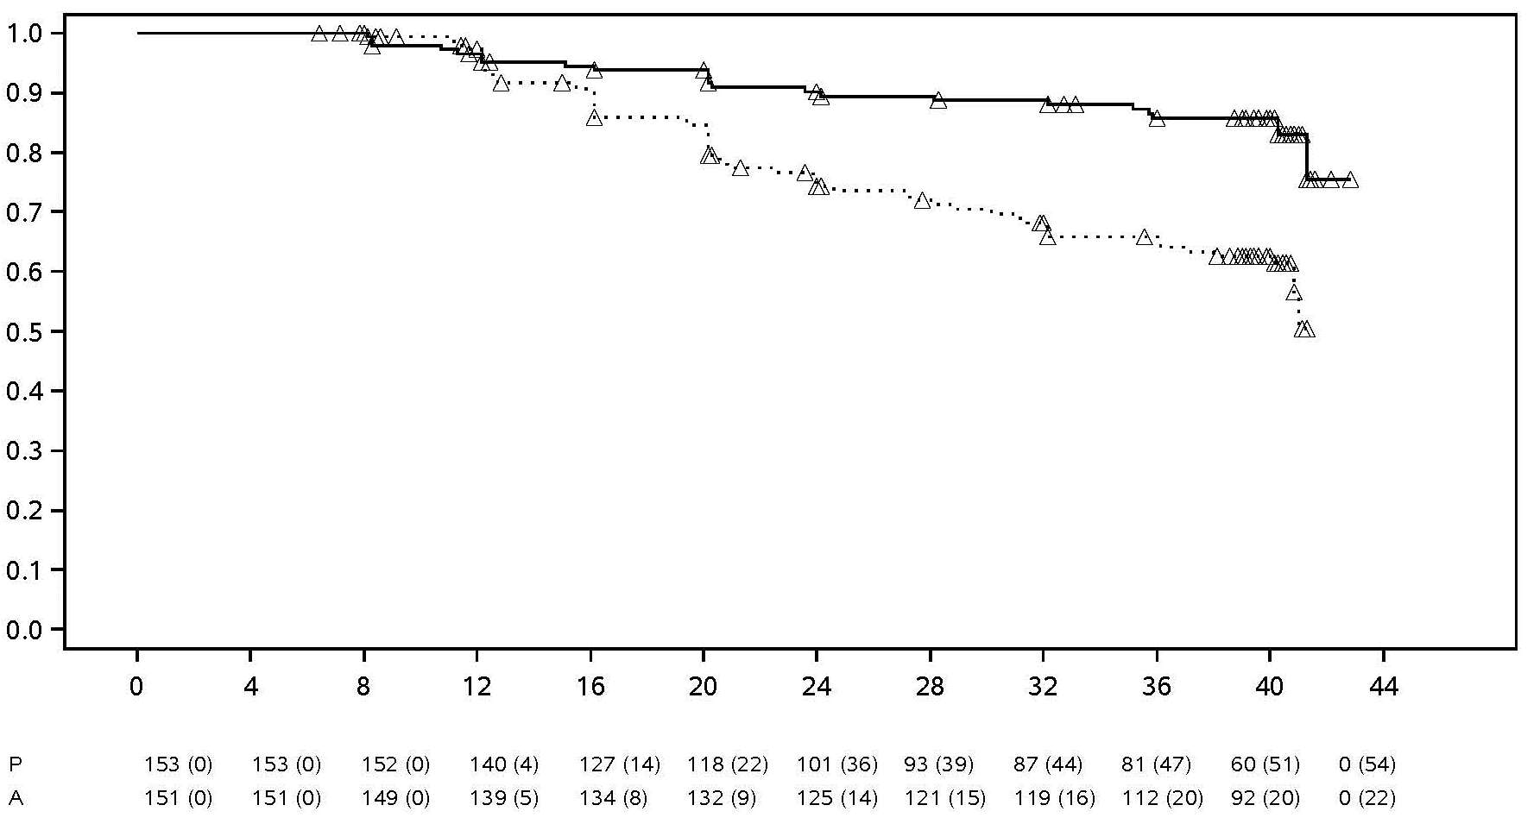
 | TIME (WEEKS)
Treatment Placebo Adalimumab ∆ Censored

Note: P = Placebo (number at risk (flared)); A = Adalimumab (number at risk (flared)).

Among the 68 patients who flared in the group allocated to treatment withdrawal, 65 completed 12 weeks of rescue therapy with adalimumab, out of which 37 (56.9%) had regained remission (ASDAS < 1.3) after 12 weeks of restarting the open-label treatment.

By week 68, patients receiving continuous adalimumab treatment showed statistically significant greater improvement of the signs and symptoms of active nr-axSpA as compared to patients allocated to treatment withdrawal during the double-blind period of the study (table 14).

Table 14. Efficacy response in placebo-controlled period for study nr-axSpA II

Double-blind  response at week 68 | Placebo  N=153 | Adalimumab  N=152
ASAS^{a,b} 20 | 47.1% | 70.4%***
ASAS^{a,b} 40 | 45.8% | 65.8%***
ASASª Partial Remission | 26.8% | 42.1%**
ASDAS^{c} Inactive Disease | 33.3% | 57.2%***
Partial Flare^{d} | 64.1% | 40.8%***
ª Assessment of SpondyloArthritis international Society
^{b} Baseline is defined as open label baseline when patients have active disease.
^{c} Ankylosing Spondylitis Disease Activity Score
^{d} Partial flare is defined as ASDAS ≥ 1.3 but < 2.1 at 2 consecutive visits.
***, ** Statistically significant at p < 0.001 and < 0.01, respectively, for all comparisons between adalimumab and placebo.

Psoriatic arthritis

Adalimumab, 40 mg every other week, was studied in patients with moderately to severely active psoriatic arthritis in two placebo-controlled studies, PsA studies I and II. PsA study I with 24 week duration, treated 313 adult patients who had an inadequate response to non-steroidal anti-inflammatory drug therapy and of these, approximately 50% were taking methotrexate. PsA study II with 12-week duration, treated 100 patients who had an inadequate response to DMARD therapy. Upon completion of both studies, 383 patients enrolled in an open-label extension study, in which 40 mg adalimumab was administered every other week.

There is insufficient evidence of the efficacy of adalimumab in patients with ankylosing spondylitis-like psoriatic arthropathy due to the small number of patients studied.

Table 15. ACR response in placebo-controlled psoriatic arthritis studies (percent of patients)

 |  |  | PsA study II
  PsA study I | PsA Study II
Response | Placebo  N = 162 | Adalimumab N = 151 | Placebo  N = 49 | Adalimumab  N = 51
ACR 20
Week 12 | 14% | 58%*** | 16% | 39%*
Week 24 | 15% | 57%*** | N/A | N/A
ACR 50
Week 12 | 4% | 36%*** | 2% | 25%***
Week 24 | 6% | 39%*** | N/A | N/A
ACR 70
Week 12 | 1% | 20%*** | 0% | 14%*
Week 24 | 1% | 23%*** | N/A | N/A
*** p < 0.001 for all comparisons between adalimumab and placebo
* p < 0.05 for all comparisons between adalimumab and placebo
N/A not applicable

ACR responses in PsA study I were similar with and without concomitant methotrexate therapy. ACR responses were maintained in the open-label extension study for up to 136 weeks.

Radiographic changes were assessed in the psoriatic arthritis studies. Radiographs of hands, wrists, and feet were obtained at baseline and week 24 during the double-blind period when patients were on adalimumab or placebo and at week 48 when all patients were on open-label adalimumab. A modified Total Sharp Score (mTSS), which included distal interphalangeal joints (i.e. not identical to the TSS used for rheumatoid arthritis), was used.

Adalimumab treatment reduced the rate of progression of peripheral joint damage compared with placebo treatment as measured by change from baseline in mTSS (mean ± SD) 0.8 ± 2.5 in the placebo group (at week 24) compared with 0.0 ± 1.9; (p < 0.001) in the adalimumab group (at week 48).

In subjects treated with adalimumab with no radiographic progression from baseline to week 48 (n = 102), 84% continued to show no radiographic progression through 144 weeks of treatment. Adalimumab-treated patients demonstrated statistically significant improvement in physical function as assessed by HAQ and Short Form Health Survey (SF 36) compared to placebo at week 24. Improved physical function continued during the open-label extension up to week 136.

Psoriasis

The safety and efficacy of adalimumab were studied in adult patients with chronic plaque psoriasis (≥ 10% BSA involvement and Psoriasis Area and Severity Index (PASI) ≥ 12 or ≥ 10) who were candidates for systemic therapy or phototherapy in randomised, double-blind studies. 73% of patients enrolled in psoriasis studies I and II had received prior systemic therapy or phototherapy. The safety and efficacy of adalimumab were also studied in adult patients with moderate to severe chronic plaque psoriasis with concomitant hand and/or foot psoriasis who were candidates for systemic therapy in a randomised double-blind study (psoriasis study III).

Psoriasis study I (REVEAL) evaluated 1,212 patients within three treatment periods. In period A, patients received placebo or adalimumab at an initial dose of 80 mg followed by 40 mg every other week starting one week after the initial dose. After 16 weeks of therapy, patients who achieved at least a PASI 75 response (PASI score improvement of at least 75% relative to baseline), entered period B and received open-label 40 mg adalimumab every other week. Patients who maintained ≥ PASI 75 response at week 33 and were originally randomised to active therapy in period A, were re-randomised in period C to receive 40 mg adalimumab every other week or placebo for an additional 19 weeks. Across all treatment groups, the mean baseline PASI score was 18.9 and the baseline Physician’s Global Assessment (PGA) score ranged from “moderate” (53% of subjects included) to “severe” (41%) to “very severe” (6%).

Psoriasis study II (CHAMPION) compared the efficacy and safety of adalimumab versus methotrexate and placebo in 271 patients. Patients received placebo, an initial dose of MTX 7.5 mg and thereafter dose increases up to week 12, with a maximum dose of 25 mg or an initial dose of 80 mg adalimumab followed by 40 mg every other week (starting one week after the initial dose) for 16 weeks. There are no data available comparing adalimumab and MTX beyond 16 weeks of therapy. Patients receiving MTX who achieved a ≥ PASI 50 response at week 8 and/or 12 did not receive further dose increases. Across all treatment groups, the mean baseline PASI score was 19.7 and the baseline PGA score ranged from “mild” (< 1%) to “moderate” (48%) to “severe” (46%) to “very severe” (6%).

Patients participating in all phase 2 and phase 3 psoriasis studies were eligible to enrol into an open-label extension trial, where adalimumab was given for at least an additional 108 weeks.

In psoriasis studies I and II, a primary endpoint was the proportion of patients who achieved a PASI 75 response from baseline at week 16 (see tables 16 and 17).

Table 16. Ps study I (REVEAL) - efficacy results at 16 weeks

 | Placebo  N = 398  n (%) | Adalimumab 40 mg  every other week  N = 814  n (%)
≥ PASI 75ª | 26 (6.5) | 578 (70.9)^{b}
PASI 100 | 3 (0.8) | 163 (20.0)^{b}
PGA: Clear/minimal | 17 (4.3) | 506 (62.2)^{b}
ª Percent of patients achieving PASI75 response was calculated as centre-adjusted rate
^{b} p < 0.001, adalimumab versus placebo

Table 17. Ps study II (CHAMPION) efficacy results at 16 weeks

 | Placebo  N = 53  n (%) | MTX  N = 110  n (%) | Adalimumab 40 mg  every other week  N = 108  n (%)
≥ PASI 75 | 10 (18.9) | 39 (35.5) | 86 (79.6) ^{a, b}
PASI 100 | 1 (1.9) | 8 (7.3) | 18 (16.7) ^{c, d}
PGA: Clear/minimal | 6 (11.3) | 33 (30.0) | 79 (73.1) ^{a, b}
ª p < 0.001 adalimumab versus placebo
^{b} p < 0.001 adalimumab versus methotrexate
^{c} p < 0.01 adalimumab versus placebo
^{d} p < 0.05 adalimumab versus methotrexate

In psoriasis study I, 28% of patients who were PASI 75 responders and were re-randomised to placebo at week 33 compared to 5% continuing on adalimumab, p < 0.001, experienced “loss of adequate response” (PASI score after week 33 and on or before week 52 that resulted in a < PASI 50 response relative to baseline with a minimum of a 6-point increase in PASI score relative to week 33). Of the patients who lost adequate response after re-randomisation to placebo who then enrolled into the open-label extension trial, 38% (25/66) and 55% (36/66) regained PASI 75 response after 12 and 24 weeks of retreatment, respectively.

A total of 233 PASI 75 responders at week 16 and week 33 received continuous adalimumab therapy for 52 weeks in psoriasis study I, and continued adalimumab in the open-label extension trial. PASI 75 and PGA of clear or minimal response rates in these patients were 74.7% and 59.0%, respectively, after an additional 108 weeks of open-label therapy (total of 160 weeks). In an analysis in which all patients who dropped out of the study for adverse events or lack of efficacy, or who dose-escalated, were considered non-responders, PASI 75 and PGA of clear or minimal response rates in these patients were 69.6% and 55.7%, respectively, after an additional 108 weeks of open-label therapy (total of 160 weeks).

A total of 347 stable responders participated in a withdrawal and retreatment evaluation in an open-label extension study. During the withdrawal period, symptoms of psoriasis returned over time with a median time to relapse (decline to PGA “moderate” or worse) of approximately 5 months. None of these patients experienced rebound during the withdrawal period. A total of 76.5% (218/285) of patients who entered the retreatment period had a response of PGA “clear” or “minimal” after 16 weeks of retreatment, irrespective of whether they relapsed during withdrawal (69.1%[123/178] and 88.8% [95/107] for patients who relapsed and who did not relapse during the withdrawal period, respectively). A similar safety profile was observed during retreatment as before withdrawal.

Significant improvements at week 16 from baseline compared to placebo (studies I and II) and MTX (study II) were demonstrated in the DLQI (Dermatology Life Quality Index). In study I, improvements in the physical and mental component summary scores of the SF-36 were also significant compared to placebo.

In an open-label extension study, for patients who dose escalated from 40 mg every other week to 40 mg weekly due to a PASI response below 50%, 26.4% (92/349) and 37.8% (132/349) of patients achieved PASI 75 response at week 12 and 24, respectively.

Psoriasis study III (REACH) compared the efficacy and safety of adalimumab versus placebo in 72 patients with moderate to severe chronic plaque psoriasis and hand and/or foot psoriasis. Patients received an initial dose of 80 mg adalimumab followed by 40 mg every other week (starting one week after the initial dose) or placebo for 16 weeks. At week 16, a statistically significantly greater proportion of patients who received adalimumab achieved PGA of 'clear' or 'almost clear' for the hands and/or feet compared to patients who received placebo (30.6% versus 4.3%, respectively [P = 0.014]).

Psoriasis study IV compared efficacy and safety of adalimumab versus placebo in 217 adult patients with moderate to severe nail psoriasis. Patients received an initial dose of 80 mg adalimumab followed by 40 mg every other week (starting one week after the initial dose) or placebo for 26 weeks followed by open-label adalimumab treatment for an additional 26 weeks. Nail psoriasis assessments included the Modified Nail Psoriasis Severity Index (mNAPSI), the Physician’s Global Assessment of Fingernail Psoriasis (PGA-F) and the Nail Psoriasis Severity Index (NAPSI) (see table 18). Adalimumab demonstrated a treatment benefit in nail psoriasis patients with different extents of skin involvement (BSA ≥ 10% (60% of patients) and BSA < 10% and ≥ 5% (40% of patients)).

Table 18. Ps study IV efficacy results at 16, 26 and 52 weeks

Endpoint | Week 16  Placebo-controlled |  | Week 26  Placebo-controlled |  | Week 52  Open-label
Endpoint | Placebo  N = 108 | Adalimumab40 mg  every other week  N = 109 | Placebo  N = 108 | Adalimumab  40 mg  every other week  N = 109 | Adalimumab  40 mg  every other week  N = 80
≥ mNAPSI 75 (%) | 2.9 | 26.0ª | 3.4 | 46.6ª | 65.0
PGA-F clear/minimal and ≥ 2-grade improvement (%) | 2.9 | 29.7ª | 6.9 | 48.9ª | 61.3
Percent change in total fingernail NAPSI (%) | -7.8 | -44.2 ª | -11.5 | -56.2ª | -72.2
ª p < 0.001, adalimumab versus placebo

Adalimumab treated patients showed statistically significant improvements at week 26 compared with placebo in the DLQI.

Hidradenitis suppurativa

The safety and efficacy of adalimumab were assessed in randomised, double-blind, placebo-controlled studies and an open-label extension study in adult patients with moderate to severe hidradenitis suppurativa (HS) who were intolerant, had a contraindication or an inadequate response to at least a 3-month trial of systemic antibiotic therapy. The patients in HS-I and HS-II had Hurley Stage II or III disease with at least 3 abscesses or inflammatory nodules.

Study HS-I (PIONEER I) evaluated 307 patients with 2 treatment periods. In Period A, patients received placebo or adalimumab at an initial dose of 160 mg at week 0, 80 mg at week 2, and 40 mg every week starting at week 4 to week 11. Concomitant antibiotic use was not allowed during the study. After 12 weeks of therapy, patients who had received adalimumab in Period A were re-randomised in Period B to 1 of 3 treatment groups (adalimumab 40 mg every week, adalimumab 40 mg every other week, or placebo from week 12 to week 35). Patients who had been randomised to placebo in Period A were assigned to receive adalimumab 40 mg every week in Period B.

Study HS-II (PIONEER II) evaluated 326 patients with 2 treatment periods. In Period A, patients received placebo or adalimumab at an initial dose of 160 mg at week 0 and 80 mg at week 2 and 40 mg every week starting at week 4 to week 11. 19.3% of patients had continued baseline oral antibiotic therapy during the study. After 12 weeks of therapy, patients who had received adalimumab in Period A were re-randomised in Period B to 1 of 3 treatment groups (adalimumab 40 mg every week, adalimumab 40 mg every other week, or placebo from week 12 to week 35). Patients who had been randomised to placebo in Period A were assigned to receive placebo in Period B.

Patients participating in Studies HS-I and HS-II were eligible to enrol into an open-label extension study in which adalimumab 40 mg was administered every week. Mean exposure in all adalimumab population was 762 days. Throughout all 3 studies patients used topical antiseptic wash daily.

Clinical response

Reduction of inflammatory lesions and prevention of worsening of abscesses and draining fistulas was assessed using Hidradenitis Suppurativa clinical response (HiSCR; at least a 50% reduction in total abscess and inflammatory nodule count with no increase in abscess count and no increase in draining fistula count relative to Baseline). Reduction in HS-related skin pain was assessed using a Numeric Rating Scale in patients who entered the study with an initial baseline score of 3 or greater on a 11 point scale.

At week 12, a significantly higher proportion of patients treated with adalimumab versus placebo achieved HiSCR. At week 12, a significantly higher proportion of patients in study HS-II experienced a clinically relevant decrease in HS-related skin pain (see table 19). Patients treated with adalimumab had significantly reduced risk of disease flare during the initial 12 weeks of treatment.

Table 19. Efficacy results at 12 weeks, HS studies I and II

 | HS study I |  | HS study II
 | Placebo | Adalimumab 40 mg weekly | Placebo | Adalimumab 40 mg weekly
Hidradenitis Suppurativa Clinical Response (HiSCR)ª | N = 154  40 (26.0%) | N = 153  64 (41.8%) * | N = 163  45 (27.6%) | N = 163  96 (58.9%)***
≥30% Reduction in Skin Pain^{b} | N = 109  27 (24.8%) | N = 122  34 (27.9%) | N = 111  23 (20.7%) | N = 105  48 (45.7%)***
*P < 0.05, ***P < 0.001, adalimumab versus placebo
ª Among all randomised patients
^{b} Among patients with baseline HS-related skin pain assessment ≥ 3, based on Numeric Rating Scale 0 – 10; 0 = no skin pain, 10 = skin pain as bad as you can imagine

Treatment with adalimumab 40 mg every week significantly reduced the risk of worsening of abscesses and draining fistulas. Approximately twice the proportion of patients in the placebo group in the first 12 weeks of Studies HS-I and HS-II, compared with those in the adalimumab group experienced worsening of abscesses (23.0% versus 11.4%, respectively) and draining fistulas (30.0% versus 13.9%, respectively).

Greater improvements at week 12 from baseline compared to placebo were demonstrated in skin-specific health-related quality of life, as measured by the Dermatology Life Quality Index (DLQI; Studies HS-I and HS-II), patient global satisfaction with medication treatment as measured by the Treatment Satisfaction Questionnaire-medication (TSQM; Studies HS-I and HS-II), and physical health as measured by the physical component summary score of the SF-36 (study HS-I).

In patients with at least a partial response to adalimumab 40 mg weekly at week 12, the HiSCR rate at week 36 was higher in patients who continued weekly adalimumab than in patients in whom dosing frequency was reduced to every other week, or in whom treatment was withdrawn (see table 20).

Table 20. Proportion of patientsª achieving HiSCR^{b} at weeks 24 and 36 after treatment reassignment from weekly adalimumab at week 12

 | Placebo (treatment withdrawal)  N = 73 | Adalimumab 40 mg every other week  N = 70 | Adalimumab 40 mg weekly  N = 70
Week 24 | 24 (32.9%) | 36 (51.4%) | 40 (57.1%)
Week 36 | 22 (30.1%) | 28 (40.0%) | 39 (55.7%)
ª Patients with at least a partial response to adalimumab 40 mg weekly after 12 weeks of treatment
^{b} Patients meeting protocol-specified criteria for loss of response or no improvement were required to discontinue from the studies and were counted as non-responders

Among patients who were at least partial responders at week 12, and who received continuous weekly adalimumab therapy, the HiSCR rate at week 48 was 68.3% and at week 96 was 65.1%. Longer term treatment with adalimumab 40 mg weekly for 96 weeks identified no new safety findings.

Among patients whose adalimumab treatment was withdrawn at week 12 in Studies HS-I and HS-II, the HiSCR rate 12 weeks after re-introduction of adalimumab 40 mg weekly returned to levels similar to that observed before withdrawal (56.0%).

Crohn’s disease

The safety and efficacy of adalimumab were assessed in over 1,500 patients with moderately to severely active Crohn’s disease (Crohn’s Disease Activity Index (CDAI) ≥ 220 and ≤ 450) in randomised, double-blind, placebo-controlled studies. Concomitant stable doses of aminosalicylates, corticosteroids, and/or immunomodulatory agents were permitted and 80% of patients continued to receive at least one of these medications.

Induction of clinical remission (defined as CDAI < 150) was evaluated in two studies, CD study I (CLASSIC I) and CD study II (GAIN). In CD study I, 299 TNF-antagonist naïve patients were randomised to one of four treatment groups; placebo at weeks 0 and 2, 160 mg adalimumab at week 0 and 80 mg at week 2, 80 mg at week 0 and 40 mg at week 2, and 40 mg at week 0 and 20 mg at week 2. In CD study II, 325 patients who had lost response or were intolerant to infliximab were randomised to receive either 160 mg adalimumab at week 0 and 80 mg at week 2 or placebo at weeks 0 and 2. The primary non-responders were excluded from the studies and therefore these patients were not further evaluated.

Maintenance of clinical remission was evaluated in CD study III (CHARM). In CD study III, 854 patients received open-label 80 mg at week 0 and 40 mg at week 2. At week 4 patients were randomised to 40 mg every other week, 40 mg every week, or placebo with a total study duration of 56 weeks. Patients in clinical response (decrease in CDAI ≥ 70) at week 4 were stratified and analysed separately from those not in clinical response at week 4. Corticosteroid taper was permitted after week 8.

CD study I and CD study II induction of remission and response rates are presented in table 21.

Table 21. Induction of clinical remission and response (percent of patients)

 | CD study I: infliximab naïve patients |  |  | CD study II: infliximab experienced patients
 | Placebo  N = 74 | Adalimumab 80/40 mg  N = 75 | Adalimumab 160/80 mg N = 76 | Placebo N = 166 | Adalimumab 160/80 mg  N = 159
Week 4
Clinical remission | 12% | 24% | 36%* | 7% | 21%*
Clinical response (CR-100) | 24% | 37% | 49%** | 25% | 38%**
All p-values are pairwise comparisons of proportions for adalimumab versus placebo
* p < 0.001
** p < 0.01

Similar remission rates were observed for the 160/80 mg and 80/40 mg induction regimens by week 8 and adverse events were more frequently noted in the 160/80 mg group.

In CD study III, at week 4, 58% (499/854) of patients were in clinical response and were assessed in the primary analysis. Of those in clinical response at week 4, 48% had been previously exposed to other TNF-antagonists. Maintenance of remission and response rates are presented in table 22. Clinical remission results remained relatively constant irrespective of previous TNF-antagonist exposure.

Disease-related hospitalisations and surgeries were statistically significantly reduced with adalimumab compared with placebo at week 56.

Table 22. Maintenance of clinical remission and response (percent of patients)

 | Placebo | 40 mg adalimumab every other week | 40 mg adalimumab every week
Week 26 | N = 170 | N = 172 | N = 157
Clinical remission | 17% | 40%* | 47%*
Clinical response (CR-100) | 27% | 52%* | 52%*
Patients in steroid-free remission for > = 90 daysª | 3% (2/66) | 19% (11/58)** | 15% (11/74)**
Week 56 | N = 170 | N = 172 | N = 157
Clinical remission | 12% | 36%* | 41%*
Clinical response (CR-100) | 17% | 41%* | 48%*
Patients in steroid-free remission for > = 90 daysª | 5% (3/66) | 29% (17/58)* | 20% (15/74)**
* p < 0.001 for adalimumab versus placebo pairwise comparisons of proportions
** p < 0.02 for adalimumab versus placebo pairwise comparisons of proportions
ª Of those receiving corticosteroids at baseline

Among patients who were not in response at week 4, 43% of adalimumab maintenance patients responded by week 12 compared to 30% of placebo maintenance patients. These results suggest that some patients who have not responded by week 4 benefit from continued maintenance therapy through week 12. Therapy continued beyond 12 weeks did not result in significantly more responses (see section 4.2).

117/276 patients from CD study I and 272/777 patients from CD studies II and III were followed through at least 3 years of open-label adalimumab therapy. 88 and 189 patients, respectively, continued to be in clinical remission. Clinical response (CR-100) was maintained in 102 and 233 patients, respectively.

Quality of life

In CD study I and CD study II, statistically significant improvement in the disease-specific inflammatory bowel disease questionnaire (IBDQ) total score was achieved at week 4 in patients randomised to adalimumab 80/40 mg and 160/80 mg compared to placebo and was seen at weeks 26 and 56 in CD study III as well among the adalimumab treatment groups compared to the placebo group.

Ulcerative colitis

The safety and efficacy of multiple doses of adalimumab were assessed in adult patients with moderately to severely active ulcerative colitis (Mayo score 6 to 12 with endoscopy subscore of 2 to 3) in randomised, double-blind, placebo-controlled studies.

In study UC-I, 390 TNF-antagonist naïve patients were randomised to receive either placebo at weeks 0 and 2, 160 mg adalimumab at week 0 followed by 80 mg at week 2, or 80 mg adalimumab at week 0 followed by 40 mg at week 2. After week 2, patients in both adalimumab arms received 40 mg every other week. Clinical remission (defined as Mayo score ≤ 2 with no subscore > 1) was assessed at week 8.

In study UC-II, 248 patients received 160 mg of adalimumab at week 0, 80 mg at week 2 and 40 mg every other week thereafter, and 246 patients received placebo. Clinical results were assessed for induction of remission at week 8 and for maintenance of remission at week 52.

Patients induced with 160/80 mg adalimumab achieved clinical remission versus placebo at week 8 in statistically significantly greater percentages in study UC-I (18% versus 9% respectively, p = 0.031) and study UC-II (17% versus 9% respectively, p = 0.019). In study UC-II, among those treated with adalimumab who were in remission at week 8, 21/41 (51%) were in remission at week 52.

Results from the overall UC-II study population are shown in table 23.

Table 23. Response, remission and mucosal healing in study UC-II (percent of patients)

 | Placebo | Adalimumab 40 mg  every other week
Week 52 | N = 246 | N = 248
Clinical response | 18% | 30%*
Clinical remission | 9% | 17%*
Mucosal healing | 15% | 25%*
Steroid-free remission for ≥ 90 daysª | 6%  (N = 140) | 13%*  (N = 150)
Week 8 and 52
Sustained response | 12% | 24%**
Sustained remission | 4% | 8%*
Sustained mucosal healing | 11% | 19%*
Clinical remission is Mayo score ≤ 2 with no subscore > 1;
Clinical response is decrease from baseline in Mayo score ≥ 3 points and ≥ 30% plus a decrease in the rectal bleeding subscore [RBS] ≥ 1 or an absolute RBS of 0 or 1;
* p < 0.05 for adalimumab versus placebo pairwise comparison of proportions
** p < 0.001 for adalimumab versus placebo pairwise comparison of proportions
ª Of those receiving corticosteroids at baseline

Of those patients who had a response at week 8, 47% were in response, 29% were in remission, 41% had mucosal healing, and 20% were in steroid-free remission for ≥ 90 days at week 52.

Approximately 40% of patients in study UC-II had failed prior anti-TNF treatment with infliximab. The efficacy of adalimumab in those patients was reduced compared to that in anti-TNF naïve patients. Among patients who had failed prior anti-TNF treatment, week 52 remission was achieved by 3% on placebo and 10% on adalimumab.

Patients from studies UC-I and UC-II had the option to roll over into an open-label long-term extension study (UC III). Following 3 years of adalimumab therapy, 75% (301/402) continued to be in clinical remission per partial Mayo score.

Hospitalisation rates

During 52 weeks of studies UC-I and UC-II, lower rates of all-cause hospitalisations and UC-related hospitalisations were observed for the adalimumab-treated arm compared to the placebo arm. The number of all cause hospitalisations in the adalimumab treatment group was 0.18 per patient year versus 0.26 per patient year in the placebo group and the corresponding figures for UC-related hospitalisations were 0.12 per patient year versus 0.22 per patient year.

Quality of life

In study UC-II, treatment with adalimumab resulted in improvements in the Inflammatory Bowel Disease Questionnaire (IBDQ) score.

Uveitis

The safety and efficacy of adalimumab were assessed in adult patients with non-infectious intermediate, posterior, and panuveitis, excluding patients with isolated anterior uveitis, in two randomised, double-masked, placebo-controlled studies (UV I and II). Patients received placebo or adalimumab at an initial dose of 80 mg followed by 40 mg every other week starting one week after the initial dose. Concomitant stable doses of one non-biologic immunosuppressant were permitted.

Study UV I evaluated 217 patients with active uveitis despite treatment with corticosteroids (oral prednisone at a dose of 10 to 60 mg/day). All patients received a 2 week standardised dose of prednisone 60 mg/day at study entry followed by a mandatory taper schedule, with complete corticosteroid discontinuation by week 15.

Study UV II evaluated 226 patients with inactive uveitis requiring chronic corticosteroid treatment (oral prednisone 10 to 35 mg/day) at baseline to control their disease. Patients subsequently underwent a mandatory taper schedule, with complete corticosteroid discontinuation by week 19.

The primary efficacy endpoint in both studies was ‘time to treatment failure’. Treatment failure was defined by a multi-component outcome based on inflammatory chorioretinal and/or inflammatory retinal vascular lesions, anterior chamber (AC) cell grade, vitreous haze (VH) grade and best corrected visual acuity (BCVA).

Patients who completed Studies UV I and UV II were eligible to enroll in an uncontrolled long-term
extension study with an originally planned duration of 78 weeks. Patients were allowed to continue on
study medication beyond week 78 until they had access to adalimumab.

Clinical response

Results from both studies demonstrated statistically significant reduction of the risk of treatment failure in patients treated with adalimumab versus patients receiving placebo (see table 24). Both studies demonstrated an early and sustained effect of adalimumab on the treatment failure rate versus placebo (see figure 2).

Table 24. Time to treatment failure in studies UV I and UV II

Analysis  Treatment | N | Failure  N (%) |  | Median time to failure (months) | HRª | CI 95%  for HRª | P Value ^{b}
Time to treatment failure at or after week 6 in study UV I
Primary analysis (ITT)

Placebo | 107 |  | 84 (78.5) | 3.0 | -- | -- | --
Adalimumab | 110 |  | 60 (54.5) | 5.6 | 0.50 | 0.36, 0.70 | < 0.001
Time to treatment failure at or after week 2 in study UV II
Primary analysis (ITT)

Placebo | 111 | 61 (55.0) |  | 8.3 | -- | -- | --
Adalimumab | 115 | 45 (39.1) |  | NE^{c} | 0.57 | 0.39, 0.84 | 0.004
Note: Treatment failure at or after week 6 (study UV I), or at or after week 2 (study UV II), was counted as event. Drop outs due to reasons other than treatment failure were censored at the time of dropping out.
ª HR of adalimumab versus placebo from proportional hazards regression with treatment as factor.
^{b} 2-sided P value from log rank test.
^{c} NE = not estimable. Fewer than half of at-risk subjects had an event.

Figure 2. Kaplan-Meier curves summarising time to treatment failure on or after week 6 (study UV I) or week 2 (study UV II)

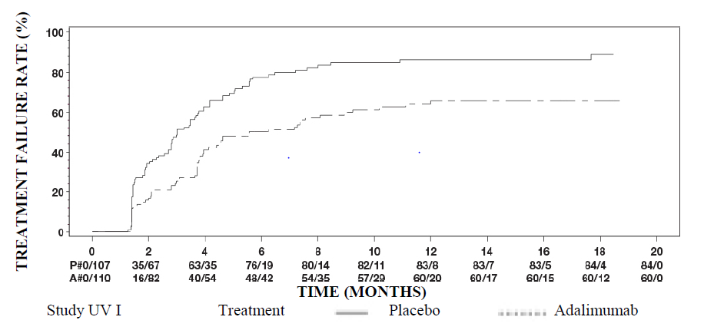
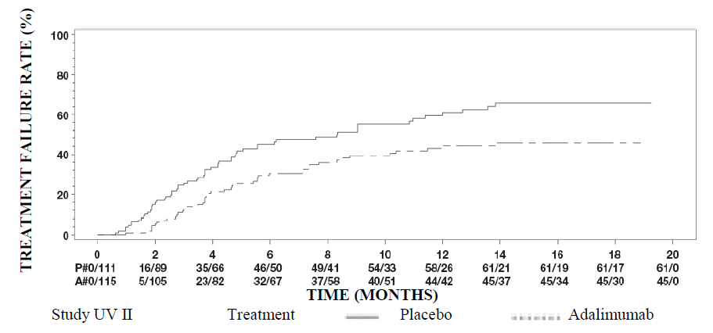Note: P# = Placebo (number of events/number at risk); A# = Adalimumab (number of events/number at risk).

In study UV I statistically significant differences in favour of adalimumab versus placebo were observed for each component of treatment failure. In study UV II, statistically significant differences were observed for visual acuity only, but the other components were numerically in favour of adalimumab.

Of the 424 subjects included in the uncontrolled long-term extension of Studies UV I and UV II, 60 subjects were regarded ineligible (e.g. due to deviations or due to complications secondary to diabetic retinopathy, due to cataract surgery or vitrectomy) and were excluded from the primary analysis of efficacy. Of the 364 remaining patients, 269 evaluable patients (74%) reached 78 weeks of open-label adalimumab treatment. Based on the observed data approach, 216 (80.3%) were in quiescence (no active inflammatory lesions, AC cell grade ≤ 0.5+, VH grade ≤ 0.5+) with a concomitant steroid dose ≤ 7.5 mg per day, and 178 (66.2%) were in steroid-free quiescence. BCVA was either improved or maintained (< 5 letters deterioration) in 88.6% of the eyes at week 78. Data beyond week 78 were generally consistent with these results but the number of enrolled subjects declined after this time. Overall, among the patients who discontinued the study, 18% discontinued due to adverse events, and 8% due to insufficient response to adalimumab treatment.

Quality of life

Patient reported outcomes regarding vision-related functioning were measured in both clinical studies, using the NEI VFQ-25. Adalimumab was numerically favoured for the majority of subscores with statistically significant mean differences for general vision, ocular pain, near vision, mental health, and total score in study UV I, and for general vision and mental health in study UV II. vision related effects were not numerically in favour of adalimumab for colour vision in study UVI and for colour vision, peripheral vision and near vision in study UV II.

Immunogenicity

Anti-adalimumab antibodies may develop during adalimumab treatment. Formation of anti-adalimumab antibodies is associated with increased clearance and reduced efficacy of adalimumab. There is no apparent correlation between the presence of anti-adalimumab antibodies and the occurrence of adverse events.

Paediatric population

Juvenile idiopathic arthritis (JIA)

Polyarticular juvenile idiopathic arthritis (pJIA)

The safety and efficacy of adalimumab was assessed in two studies (pJIA I and II) in children with active polyarticular or polyarticular course juvenile idiopathic arthritis, who had a variety of JIA onset types (most frequently rheumatoid-factor negative or positive polyarthritis and extended oligoarthritis).

pJIA-I

The safety and efficacy of adalimumab were assessed in a multicentre, randomised, double-blind, parallel-group study in 171 children (4-17 years old) with polyarticular JIA. In the open-label lead in phase (OL LI) patients were stratified into two groups, MTX (methotrexate)-treated or non-MTX-treated. Patients who were in the non-MTX stratum were either naïve to or had been withdrawn from MTX at least two weeks prior to study drug administration. Patients remained on stable doses of non-steroidal anti-inflammatory drugs (NSAIDs) and or prednisone (≤ 0.2 mg/kg/day or 10 mg/day maximum). In the OL LI phase all patients received 24 mg/m² up to a maximum of 40 mg adalimumab every other week for 16 weeks. The distribution of patients by age and minimum, median and maximum dose received during the OL LI phase is presented in table 25.

Table 25. Distribution of patients by age and adalimumab dose received during the OL LI phase

Age Group | Number of patients at baseline n (%) | Minimum, median and maximum dose
4 to 7 years | 31 (18.1) | 10, 20 and 25 mg
8 to 12 years | 71 (41.5) | 20, 25 and 40 mg
13 to 17 years | 69 (40.4) | 25, 40 and 40 mg

Patients demonstrating a paediatric ACR 30 response at week 16 were eligible to be randomised into the double blind (DB) phase and received either adalimumab 24 mg/m² up to a maximum of 40 mg, or placebo every other week for an additional 32 weeks or until disease flare. Disease flare criteria were defined as a worsening of ≥ 30% from baseline in ≥ 3 of 6 paediatric ACR core criteria, ≥ 2 active joints, and improvement of > 30% in no more than 1 of the 6 criteria. After 32 weeks or at disease flare, patients were eligible to enrol into the open-label extension phase.

Table 26. Paediatric ACR 30 responses in the JIA study

Stratum | MTX |  | Without MTX
Phase
OL-LI 16 weeks
Paediatric ACR 30 response (n/N) | 94.1% (80/85) |  | 74.4% (64/86)
Efficacy Outcomes
Double blind 32 weeks | Adalimumab / MTX  (N = 38) | Placebo / MTX  (N = 37) | Adalimumab (N = 30) | Placebo  (N = 28)
Disease flares at the end of 32 weeksª (n/N) | 36.8% (14/38) | 64.9% (24/37)^{b} | 43.3% (13/30) | 71.4% (20/28)^{c}
Median time to disease flare | > 32 weeks | 20 weeks | > 32 weeks | 14 weeks
ª Paediatric ACR 30/50/70 responses week 48 significantly greater than those of placebo treated patients
^{b} p = 0.015
^{c} p = 0.031

Amongst those who responded at week 16 (n = 144), the paediatric ACR 30/50/70/90 responses were maintained for up to six years in the OLE phase in patients who received adalimumab throughout the study. Over all 19 subjects, of which 11 of the baseline age group 4 to 12 and 8 of the baseline age group 13 to 17 years were treated 6 years or longer.

Overall responses were generally better and, fewer patients developed antibodies when treated with the combination of adalimumab and MTX compared to adalimumab alone. Taking these results into consideration, adalimumab is recommended for use in combination with MTX and for use as monotherapy in patients for whom MTX use is not appropriate (see section 4.2).

pJIA II

The safety and efficacy of adalimumab was assessed in an open-label, multicentre study in 32 children (2 - < 4 years old or aged 4 and above weighing < 15 kg) with moderately to severely active polyarticular JIA. The patients received 24 mg/m² body surface area (BSA) of adalimumab up to a maximum of 20 mg every other week as a single dose via SC injection for at least 24 weeks. During the study, most subjects used concomitant MTX, with fewer reporting use of corticosteroids or NSAIDs.

At week 12 and week 24, PedACR30 response was 93.5% and 90.0%, respectively, using the observed data approach. The proportions of subjects with PedACR50/70/90 at week 12 and week 24 were 90.3%/61.3%/38.7% and 83.3%/73.3%/36.7%, respectively. Amongst those who responded (paediatric ACR 30) at week 24 (n = 27 out of 30 patients), the paediatric ACR 30 responses were maintained for up to 60 weeks in the OLE phase in patients who received adalimumab throughout this time period. Overall, 20 subjects were treated for 60 weeks or longer.

Enthesitis-related arthritis

The safety and efficacy of adalimumab were assessed in a multicentre, randomised, double-blind study in 46 paediatric patients (6 to 17 years old) with moderate enthesitis-related arthritis. Patients were randomised to receive either 24 mg/m² body surface area (BSA) of adalimumab up to a maximum of 40 mg, or placebo every other week for 12 weeks. The double-blind period is followed by an open-label (OL) period during which patients received 24 mg/m² BSA of adalimumab up to a maximum of 40 mg every other week subcutaneously for up to an additional 192 weeks. The primary endpoint was the percent change from baseline to week 12 in the number of active joints with arthritis (swelling not due to deformity or joints with loss of motion plus pain and/or tenderness), which was achieved with mean percent decrease of -62.6% (median percent change -88.9%) in patients in the adalimumab group compared to -11.6% (median percent change -50.0%) in patients in the placebo group. Improvement in number of active joints with arthritis was maintained during the OL period through week 156 for the 26 of 31 (84%) patients in the adalimumab group who remained in the study. Although not statistically significant, the majority of patients demonstrated clinical improvement in secondary endpoints such as number of sites of enthesitis, tender joint count (TJC), swollen joint count (SJC), paediatric ACR 50 response, and paediatric ACR 70 response.

Paediatric plaque psoriasis

The efficacy of adalimumab was assessed in a randomised, double-blind, controlled study of 114 paediatric patients from 4 years of age with severe chronic plaque psoriasis (as defined by a PGA ≥ 4 or > 20% BSA involvement or > 10% BSA involvement with very thick lesions or PASI ≥ 20 or ≥ 10 with clinically relevant facial, genital, or hand/foot involvement) who were inadequately controlled with topical therapy and heliotherapy or phototherapy.

Patients received adalimumab 0.8 mg/kg every other week (up to 40 mg), 0.4 mg/kg every other week (up to 20 mg), or methotrexate 0.1–0.4 mg/kg weekly (up to 25 mg). At week 16, more patients randomised to adalimumab 0.8 mg/kg had positive efficacy responses (e.g. PASI 75) than those randomised to 0.4 mg/kg every other week or MTX.

Table 27. Paediatric plaque psoriasis efficacy results at 16 weeks

 | MTXª  N = 37 | Adalimumab 0.8 mg/kg  every other week  N = 38
PASI 75^{b} | 12 (32.4%) | 22 (57.9%)
PGA: Clear/minimal^{c} | 15 (40.5%) | 23 (60.5%)
ª MTX = methotrexate
^{b} P = 0.027, adalimumab 0.8 mg/kg versus MTX
^{c} P = 0.083, adalimumab 0.8 mg/kg versus MTX

Patients who achieved PASI 75 and PGA clear or minimal were withdrawn from treatment for up to 36 weeks and monitored for loss of disease control (i.e. a worsening of PGA by at least 2 grades). Patients were then retreated with adalimumab 0.8 mg/kg every other week for an additional 16 weeks and response rates observed during retreatment were similar to the previous double-blind period: PASI 75 response of 78.9% (15 of 19 subjects) and PGA clear or minimal of 52.6% (10 of 19 subjects).

In the open-label period of the study, PASI 75 and PGA clear or minimal responses were maintained for up to an additional 52 weeks with no new safety findings.

Adolescent hidradenitis suppurativa

There are no clinical trials with adalimumab in adolescent patients with HS. Efficacy of adalimumab for the treatment of adolescent patients with HS is predicted based on the demonstrated efficacy and exposure-response relationship in adult HS patients and the likelihood that the disease course, pathophysiology, and drug effects are substantially similar to that of adults at the same exposure levels. Safety of the recommended adalimumab dose in the adolescent HS population is based on cross-indication safety profile of adalimumab in both adults and paediatric patients at similar or more frequent doses (see section 5.2).

Paediatric Crohn’s disease

Adalimumab was assessed in a multicentre, randomised, double-blind clinical trial designed to evaluate the efficacy and safety of induction and maintenance treatment with doses dependent on body weight (< 40 kg or ≥ 40 kg) in 192 paediatric subjects between the ages of 6 and 17 (inclusive) years, with moderate to severe Crohn´s disease (CD) defined as Paediatric Crohn's Disease Activity Index (PCDAI) score > 30. Subjects had to have failed conventional therapy (including a corticosteroid and/or an immunomodulator) for CD. Subjects may also have previously lost response or been intolerant to infliximab.

All subjects received open-label induction therapy at a dose based on their baseline body weight: 160 mg at week 0 and 80 mg at week 2 for subjects ≥ 40 kg, and 80 mg and 40 mg, respectively, for subjects < 40 kg.

At week 4, subjects were randomised 1:1 based on their body weight at the time to either the low dose or standard dose maintenance regimens as shown in table 28.

Table 28. Maintenance regimen

Patient weight | Low dose | Standard dose
< 40 kg | 10 mg every other week | 20 mg every other week
≥ 40 kg | 20 mg every other week | 40 mg every other week

Efficacy results

The primary endpoint of the study was clinical remission at week 26, defined as PCDAI score ≤ 10.

Clinical remission and clinical response (defined as reduction in PCDAI score of at least 15 points from baseline) rates are presented in table 29. Rates of discontinuation of corticosteroids or immunomodulators are presented in table 30.

Table 29. Paediatric CD study PCDAI clinical remission and response

 | Standard dose  40/20 mg  every other week  N = 93 | Low dose  20/10 mg  every other week  N = 95 | P value*
Week 26
Clinical remission | 38.7% | 28.4% | 0.075
Clinical response | 59.1% | 48.4% | 0.073
Week 52
Clinical remission | 33.3% | 23.2% | 0.100
Clinical response | 41.9% | 28.4% | 0.038
* p value for standard dose versus low dose comparison

Table 30. Paediatric CD study discontinuation of corticosteroids or immunomodulators and fistula remission

 | Standard dose 40/20 mg  every other week | Low dose  20/10 mg  every other week | P value¹
Discontinued corticosteroids | N = 33 | N = 38
Week 26 | 84.8% | 65.8% | 0.066
Week 52 | 69.7% | 60.5% | 0.420
Discontinuation of Immunomodulators² | N = 60 | N = 57
Week 52 | 30.0% | 29.8% | 0.983
Fistula remission³ | N = 15 | N = 21
Week 26 | 46.7% | 38.1% | 0.608
Week 52 | 40.0% | 23.8% | 0.303
¹ p value for standard dose versus low dose comparison
² Immunosuppressant therapy could only be discontinued at or after week 26 at the investigator's discretion if the subject met the clinical response criterion
³ defined as a closure of all fistulas that were draining at baseline for at least 2 consecutive post-baseline visits

Statistically significant increases (improvement) from baseline to week 26 and 52 in body mass index and height velocity were observed for both treatment groups.

Statistically and clinically significant improvements from baseline were also observed in both treatment groups for quality of life parameters (including IMPACT III).

One hundred patients (n = 100) from the Paediatric CD Study continued in an open-label long-term extension study. After 5 years of adalimumab therapy, 74.0% (37/50) of the 50 patients remaining in the study continued to be in clinical remission, and 92.0% (46/50) of patients continued to be in clinical response per PCDAI.

Paediatric ulcerative colitis

The safety and efficacy of adalimumab was assessed in a multicenter, randomised, double-blind, trial in 93 paediatric patients from 5 to 17 years of age with moderate to severe ulcerative colitis (Mayo score 6 to 12 with endoscopy subscore of 2 to 3 points, confirmed by centrally read endoscopy) who had an inadequate response or intolerance to conventional therapy. Approximately 16% of patients in the study had failed prior anti-TNF treatment. Patients who received corticosteroids at enrollment were allowed to taper their corticosteroid therapy after week 4.

In the induction period of the study, 77 patients were randomised 3:2 to receive double-blind treatment
with adalimumab at an induction dose of 2.4 mg/kg (maximum of 160 mg) at week 0 and week 1, and 1.2 mg/kg (maximum of 80 mg) at week 2; or an induction dose of 2.4 mg/kg (maximum of 160 mg) at week 0, placebo at week 1, and 1.2 mg/kg (maximum of 80 mg) at week 2. Both groups received 0.6 mg/kg (maximum of 40 mg) at week 4 and week 6. Following an amendment to the study design, the remaining 16 patients who enrolled in the induction period received open-label treatment with adalimumab at the induction dose of 2.4 mg/kg (maximum of 160 mg) at week 0 and week 1, and 1.2 mg/kg (maximum of 80 mg) at week 2.

At week 8, 62 patients who demonstrated clinical response per Partial Mayo Score (PMS; defined as a
decrease in PMS ≥ 2 points and ≥ 30% from Baseline) were randomised equally to receive double-blind maintenance treatment with adalimumab at a dose of 0.6 mg/kg (maximum of 40 mg) every week, or a maintenance dose of 0.6 mg/kg (maximum of 40 mg) every other week. Prior to an amendment to the study design, 12 additional patients who demonstrated clinical response per PMS were randomised to receive placebo but were not included in the confirmatory analysis of efficacy.

Disease flare was defined as an increase in PMS of at least 3 points (for patients with PMS of 0 to 2 at
week 8), at least 2 points (for patients with PMS of 3 to 4 at week 8), or at least 1 point (for patients with PMS of 5 to 6 at week 8).

Patients who met criteria for disease flare at or after week 12 were randomised to receive a re-induction dose of 2.4 mg/kg (maximum of 160 mg) or a dose of 0.6 mg/kg (maximum of 40 mg) and continued to receive their respective maintenance dose regimen afterwards.

Efficacy Results

The co-primary endpoints of the study were clinical remission per PMS (defined as PMS ≤ 2 and no
individual subscore > 1) at week 8, and clinical remission per FMS (Full Mayo Score) (defined as a Mayo Score ≤ 2 and no individual subscore > 1) at week 52 in patients who achieved clinical response per PMS at Week 8.

Clinical remission rates per PMS at week 8 for patients in each of the adalimumab double-blind induction groups are presented in table 31.

Table 31. Clinical remission per PMS at 8 weeks

 | Adalimumabª  Maximum of 160 mg at week 0 / Placebo at week 1  N=30 | Adalimumab^{b, c}  Maximum of 160 mg at week 0 and week 1  N=47
Clinical remission | 13/30 (43.3%) | 28/47 (59.6%)
ª Adalimumab 2.4 mg/kg (maximum of 160 mg) at week 0, placebo at week 1, and 1.2 mg/kg (maximum of 80 mg) at week 2
^{b} Adalimumab 2.4 mg/kg (maximum of 160 mg) at week 0 and week 1, and 1.2 mg/kg (maximum of 80 mg) at week 2
^{c} Not including open-label Induction dose of adalimumab 2.4 mg/kg (maximum of 160 mg) at week 0 and week 1, and 1.2 mg/kg (maximum of 80 mg) at week 2
Note 1: Both induction groups received 0.6 mg/kg (maximum of 40 mg) at week 4 and week 6
Note 2: Patients with missing values at week 8 were considered as not having met the endpoint

At week 52, clinical remission per FMS in week 8 responders, clinical response per FMS (defined as a decrease in Mayo Score ≥ 3 points and ≥ 30% from Baseline) in week 8 responders, mucosal healing per FMS (defined as Mayo endoscopy score ≤ 1) in week 8 responders, clinical remission per FMS in week 8 remitters, and the proportion of subjects in corticosteroid-free remission per FMS in week 8 responders were assessed in patients who received adalimumab at the double-blind maximum 40 mg every other week (0.6 mg/kg) and maximum 40 mg every week (0.6 mg/kg) maintenance doses (table 32).

Table 32. Efficacy results at 52 weeks

 | Adalimumabª  Maximum of 40 mg  every other week  N=31 | Adalimumab^{b}  Maximum of 40 mg  every week  N=31
Clinical remission in week 8 PMS responders | 9/31 (29.0%) | 14/31 (45.2%)
Clinical response in week 8 PMS responders | 19/31 (61.3%) | 21/31 (67.7%)
Mucosal healing in week 8 PMS responders | 12/31 (38.7%) | 16/31 (51.6%)
Clinical remission in week 8 PMS remitters | 9/21 (42.9%) | 10/22 (45.5%)
Corticosteroid-free remission in week 8 PMS responders^{c} | 4/13 (30.8%) | 5/16 (31.3%)
ª Adalimumab 0.6 mg/kg (maximum of 40 mg) every other week
^{b} Adalimumab 0.6 mg/kg (maximum of 40 mg) every week
^{c} In patients receiving concomitant corticosteroids at baseline
Note: Patients with missing values at week 52 or who were randomised to receive re-induction or maintenance treatment were considered non-responders for week 52 endpoints

Additional exploratory efficacy endpoints included clinical response per the Paediatric Ulcerative Colitis Activity Index (PUCAI) (defined as a decrease in PUCAI ≥ 20 points from Baseline) and clinical remission per PUCAI (defined as PUCAI < 10) at week 8 and week 52 (table 33).

Table 33. Exploratory endpoints results per PUCAI

 | Week 8
 | Adalimumabª  Maximum of 160 mg at  week 0 / Placebo at week 1  N=30 | Adalimumab^{b,c}  Maximum of 160 mg at  week 0 and week 1  N=47
Clinical remission per PUCAI | 10/30 (33.3%) | 22/47 (46.8%)
Clinical response per PUCAI | 15/30 (50.0%) | 32/47 (68.1%)
 | Week 52
 | Adalimumab^{d}  Maximum of 40 mg  every other week  N=31 | Adalimumab^{e}  Maximum of 40 mg  every week  N=31
Clinical remission per PUCAI in week 8 PMS responders | 14/31 (45.2%) | 18/31 (58.1%)
Clinical response per PUCAI  in week 8 PMS responders | 18/31 (58.1%) | 16/31 (51.6%)
ª Adalimumab 2.4 mg/kg (maximum of 160 mg) at week 0, placebo at week 1, and 1.2 mg/kg (maximum of 80 mg) at week 2
^{b} Adalimumab 2.4 mg/kg (maximum of 160 mg) at week 0 and week 1, and 1.2 mg/kg (maximum of 80 mg) at week 2
^{c} Not including open-label Induction dose of adalimumab 2.4 mg/kg (maximum of 160 mg) at
week 0 and week 1, and 1.2 mg/kg (maximum of 80 mg) at week 2
^{d} Adalimumab 0.6 mg/kg (maximum of 40 mg) every other week
^{e} Adalimumab 0.6 mg/kg (maximum of 40 mg) every week
Note 1: Both induction groups received 0.6 mg/kg (maximum of 40 mg) at week 4 and week 6
Note 2: Patients with missing values at week 8 were considered as not having met the endpoints
Note 3: Patients with missing values at week 52 or who were randomised to receive re-induction
or maintenance treatment were considered non-responders for week 52 endpoints

Of the adalimumab-treated patients who received re-induction treatment during the maintenance period, 2/6 (33%) achieved clinical response per FMS at week 52.

Quality of life

Clinically meaningful improvements from Baseline were observed in IMPACT III and the caregiver Work Productivity and Activity Impairment (WPAI) scores for the groups treated with adalimumab.

Clinically meaningful increases (improvement) from Baseline in height velocity were observed for the
groups treated with adalimumab, and clinically meaningful increases (improvement) from Baseline in
Body Mass Index were observed for subjects on the high maintenance dose of maximum 40 mg (0.6 mg/kg) every week.

Paediatric uveitis

The safety and efficacy of adalimumab was assessed in a randomised, double-masked, controlled study of 90 paediatric patients from 2 to < 18 years of age with active JIA-associated noninfectious anterior uveitis who were refractory to at least 12 weeks of methotrexate treatment. Patients received either placebo or 20 mg adalimumab (if < 30 kg) or 40 mg adalimumab (if ≥ 30 kg) every other week in combination with their baseline dose of methotrexate.

The primary endpoint was ‘time to treatment failure’. The criteria determining treatment failure were
worsening or sustained non-improvement in ocular inflammation, partial improvement with development of sustained ocular co-morbidities or worsening of ocular co-morbidities, non-permitted use of concomitant medications, and suspension of treatment for an extended period of time.

Clinical Response

Adalimumab significantly delayed the time to treatment failure, as compared to placebo (see figure 3, P < 0.0001 from log rank test). The median time to treatment failure was 24.1 weeks for subjects treated with placebo, whereas the median time to treatment failure was not estimable for subjects treated with adalimumab because less than one-half of these subjects experienced treatment failure. Adalimumab significantly decreased the risk of treatment failure by 75% relative to placebo, as shown by the hazard ratio (HR = 0.25 [95% CI: 0.12, 0.49]).

Figure 3. Kaplan-Meier curves summarising time to treatment failure in the paediatric uveitis study

PROBABILITY OF FAILING TREATMENT | 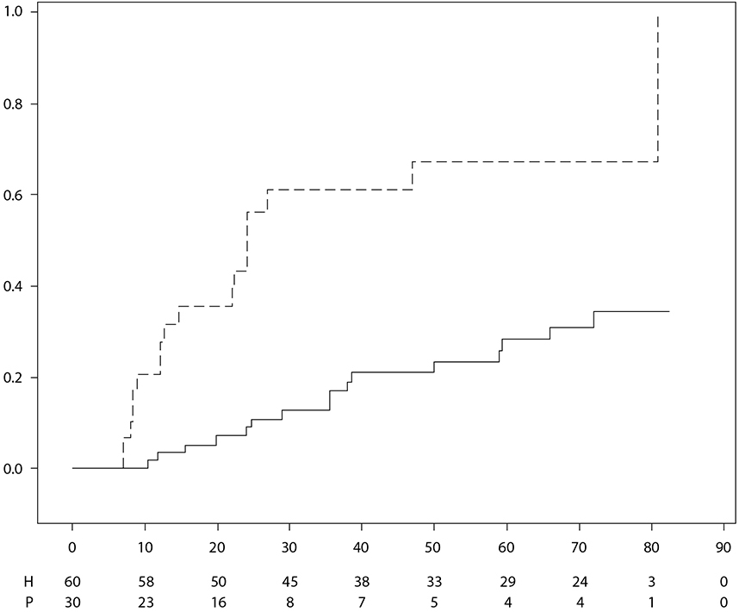
 | TIME (WEEKS)
 | Treatment |  | Placebo |  | Adalimumab
 | Note: P = Placebo (Number at Risk); H = Adalimumab (Number at Risk).

5.2 Pharmacokinetic properties

Absorption and distribution

After subcutaneous administration of a single 40 mg dose, absorption and distribution of adalimumab was slow, with peak serum concentrations being reached about 5 days after administration. The average absolute bioavailability of adalimumab estimated from three studies conducted with the reference product following a single 40 mg subcutaneous dose was 64%. After single intravenous doses ranging from 0.25 to 10 mg/kg, concentrations were dose proportional. After doses of 0.5 mg/kg (~40 mg), clearances ranged from 11 to 15 mL/hour, the distribution volume (V_{ss}) ranged from 5 to 6 litres and the mean terminal phase half-life was approximately two weeks. Adalimumab concentrations in the synovial fluid from several rheumatoid arthritis patients ranged from 31-96% of those in serum.

Following subcutaneous administration of 40 mg of adalimumab every other week in adult rheumatoid arthritis (RA) patients the mean steady-state trough concentrations were approximately 5 μg/mL (without concomitant methotrexate) and 8 to 9 μg/mL (with concomitant methotrexate), respectively. The serum adalimumab trough levels at steady-state increased roughly proportionally with dose following 20, 40 and 80 mg subcutaneous dosing every other week and every week.

Following the administration of 24 mg/m² (maximum of 40 mg) subcutaneously every other week to patients with polyarticular juvenile idiopathic arthritis (JIA) who were 4 to 17 years the mean trough steady-state (values measured from week 20 to 48) serum adalimumab concentration was 5.6 ± 5.6 μg/mL (102% CV) for adalimumab without concomitant methotrexate and 10.9 ± 5.2 μg/mL (47.7% CV) with concomitant methotrexate.

In patients with polyarticular JIA who were 2 to < 4 years old or aged 4 and above weighing < 15 kg dosed with adalimumab 24 mg/m², the mean trough steady-state serum adalimumab concentrations was 6.0 ± 6.1 µg/mL (101% CV) for adalimumab without concomitant methotrexate and 7.9 ± 5.6 µg/mL (71.2% CV) with concomitant methotrexate.

Following the administration of 24 mg/m² (maximum of 40 mg) subcutaneously every other week to patients with enthesitis-related arthritis who were 6 to 17 years, the mean trough steady-state (values measured at week 24) serum adalimumab concentrations were 8.8 ± 6.6 µg/mL for adalimumab without concomitant methotrexate and 11.8 ± 4.3 µg/mL with concomitant methotrexate.

Following subcutaneous administration of 40 mg of adalimumab every other week in adult non-radiographic axial spondyloarthritis patients, the mean (±SD) trough steady-state concentration at week 68 was 8.0 ± 4.6 μg/ml.

In adult patients with psoriasis, the mean steady-state trough concentration was 5 μg/mL during adalimumab 40 mg every other week monotherapy treatment.

Following the administration of 0.8 mg/kg (maximum of 40 mg) subcutaneously every other week to paediatric patients with chronic plaque psoriasis, the mean ± SD steady-state adalimumab trough concentration was approximately 7.4 ± 5.8 μg/mL (79% CV).

In adult patients with hidradenitis suppurativa, a dose of 160 mg adalimumab on week 0 followed by 80 mg on week 2 achieved serum adalimumab trough concentrations of approximately 7 to 8 μg/mL at week 2 and week 4. The mean steady-state trough concentration at week 12 through week 36 were approximately 8 to 10 μg/mL during adalimumab 40 mg every week treatment.

Adalimumab exposure in adolescent HS patients was predicted using population pharmacokinetic modelling and simulation based on cross-indication pharmacokinetics in other paediatric patients (paediatric psoriasis, juvenile idiopathic arthritis, paediatric Crohn’s disease, and enthesitis-related arthritis). The recommended adolescent HS dosing schedule is 40 mg every other week. Since exposure to adalimumab can be affected by body size, adolescents with higher body weight and inadequate response may benefit from receiving the recommended adult dose of 40 mg every week.

In patients with Crohn’s disease, the loading dose of 80 mg adalimumab on week 0 followed by 40 mg adalimumab on week 2 achieves serum adalimumab trough concentrations of approximately 5.5 μg/mL during the induction period. A loading dose of 160 mg adalimumab on week 0 followed by 80 mg adalimumab on week 2 achieves serum adalimumab trough concentrations of approximately 12 μg/mL during the induction period. Mean steady-state trough levels of approximately 7 μg/mL were observed in Crohn’s disease patients who received a maintenance dose of 40 mg adalimumab every other week.

In paediatric patients with moderate to severe CD, the open-label adalimumab induction dose was 160/80 mg or 80/40 mg at weeks 0 and 2, respectively, dependent on a body weight cut-off of 40 kg. At week 4, patients were randomised 1:1 to either the Standard Dose (40/20 mg every other week) or Low Dose (20/10 mg every other week) maintenance treatment groups based on their body weight. The mean (±SD) serum adalimumab trough concentrations achieved at week 4 were 15.7 ± 6.6 μg/mL for patients ≥ 40 kg (160/80 mg) and 10.6 ± 6.1 μg/mL for patients < 40 kg (80/40 mg).

For patients who stayed on their randomised therapy, the mean (±SD) adalimumab trough concentrations at week 52 were 9.5 ± 5.6 μg/mL for the standard dose group and 3.5 ± 2.2 μg/mL for the low dose group. The mean trough concentrations were maintained in patients who continued to receive adalimumab treatment every other week for 52 weeks. For patients who dose escalated from every other week to weekly regimen, the mean (±SD) serum concentrations of adalimumab at week 52 were 15.3 ± 11.4 μg/mL (40/20 mg, weekly) and 6.7 ± 3.5 μg/mL (20/10 mg, weekly).

In patients with ulcerative colitis, a loading dose of 160 mg adalimumab on week 0 followed by 80 mg adalimumab on week 2 achieves serum adalimumab trough concentrations of approximately 12 μg/mL during the induction period. Mean steady-state trough levels of approximately 8 μg/mL were observed in ulcerative colitis patients who received a maintenance dose of 40 mg adalimumab every other week.

Following the subcutaneous administration of body weight-based dosing of 0.6 mg/kg (maximum of
40 mg) every other week to paediatric patients with ulcerative colitis, the mean trough steady-state serum adalimumab concentration was 5.01 ± 3.28 μg/ml at week 52. For patients who received 0.6 mg/kg (maximum of 40 mg) every week, the mean (±SD) trough steady-state serum adalimumab concentration was 15.7 ± 5.60 μg/ml at week 52.

In adult patients with uveitis, a loading dose of 80 mg adalimumab on week 0 followed by 40 mg adalimumab every other week starting at week 1, resulted in mean steady-state concentrations of approximately 8 to 10 μg/mL.

Adalimumab exposure in paediatric uveitis patients was predicted using population pharmacokinetic modelling and simulation based on cross-indication pharmacokinetics in other paediatric patients (paediatric psoriasis, juvenile idiopathic arthritis, paediatric Crohn’s disease, and enthesitis-related arthritis). No clinical exposure data are available on the use of a loading dose in children < 6 years. The predicted exposures indicate that in the absence of methotrexate, a loading dose may lead to an initial increase in systemic exposure.

Population pharmacokinetic and pharmacokinetic/pharmacodynamic modelling and simulation predicted comparable adalimumab exposure and efficacy in patients treated with 80 mg every other week when compared with 40 mg every week (including adult patients with RA, HS, UC, CD or Ps, patients with adolescent HS, and paediatric patients ≥ 40 kg with CD and UC).

Exposure-response relationship in paediatric population

On the basis of clinical trial data in patients with JIA (pJIA and ERA), an exposure-response relationship was established between plasma concentrations and PedACR 50 response. The apparent adalimumab plasma concentration that produces half the maximum probability of PedACR 50 response (EC50) was 3 μg/ml (95% CI: 1-6 μg/ml).

Exposure-response relationships between adalimumab concentration and efficacy in paediatric patients with severe chronic plaque psoriasis were established for PASI 75 and PGA clear or minimal, respectively. PASI 75 and PGA clear or minimal increased with increasing adalimumab concentrations, both with a similar apparent EC50 of approximately 4.5 μg/mL (95% CI 0.4-47.6 and 1.9-10.5, respectively).

Elimination

Population pharmacokinetic analyses with data from over 1,300 RA patients revealed a trend toward higher apparent clearance of adalimumab with increasing body weight. After adjustment for weight differences, gender and age appeared to have a minimal effect on adalimumab clearance. The serum levels of free adalimumab (not bound to anti-adalimumab antibodies, AAA) were observed to be lower in patients with measurable AAA.

Hepatic or renal impairment

Adalimumab has not been studied in patients with hepatic or renal impairment.

5.3 Preclinical safety data

Non-clinical data reveal no special hazard for humans based on studies of single dose toxicity, repeated dose toxicity, and genotoxicity.

An embryo-foetal developmental toxicity/perinatal developmental study has been performed in Cynomolgus monkeys at 0, 30 and 100 mg/kg (9-17 monkeys/group) and has revealed no evidence of harm to the foetuses due to adalimumab. Neither carcinogenicity studies, nor a standard assessment of fertility and postnatal toxicity, were performed with adalimumab due to the lack of appropriate models for an antibody with limited cross-reactivity to rodent TNF and to the development of neutralising antibodies in rodents.

6. PHARMACEUTICAL PARTICULARS

6.1 List of excipients

Glacial acetic acid
Sucrose
Polysorbate 80
Sodium hydroxide (for pH adjustment)
Water for injections

6.2 Incompatibilities

In the absence of compatibility studies, this medicinal product must not be mixed with other medicinal products.

6.3 Shelf life

3 years

6.4 Special precautions for storage

Store in a refrigerator (2°C – 8°C).
Do not freeze.
Keep the pre-filled syringe or pre-filled pen in the outer carton in order to protect from light.

The pre-filled syringe or pre-filled pen may be stored at temperatures up to a maximum of 25°C for a period of up to 14 days. The pre-filled syringe or pre-filled pen must be protected from light, and discarded if not used within the 14-day period.

6.5 Nature and contents of container

AMGEVITA 20 mg solution for injection in pre-filled syringe

0.4 mL solution in pre-filled syringe (type I glass) with a plunger stopper (bromobutyl rubber) and a stainless-steel needle with a needle shield (thermoplastic elastomer).

Pack size of 1 pre-filled syringe.

AMGEVITA 40 mg solution for injection in pre-filled syringe

0.8 mL solution in pre-filled syringe (type I glass) with a plunger stopper (bromobutyl rubber) and a stainless-steel needle with a needle shield (thermoplastic elastomer).

Pack sizes of 1, 2, 4 or multipack of 6 (3 packs of 2) pre-filled syringes.
Not all pack sizes may be marketed.

AMGEVITA 40 mg solution for injection in pre-filled pen

0.8 mL solution for injection in pre-filled pen for patient use containing a pre-filled syringe (type I glass). The pen is a single use, disposable, handheld, mechanical injection device. The needle cover of the pre-filled pen is made from synthetic rubber.

Pack sizes of 1, 2, 4 or multipack of 6 (3packs of 2) pre-filled pens.
Not all pack sizes may be marketed.

6.6 Special precautions for disposal and other handling

Any unused medicinal product or waste material should be disposed of in accordance with local requirements.

7. MARKETING AUTHORISATION HOLDER

Amgen Europe B.V.
Minervum 7061
4817 ZK Breda
The Netherlands

8. MARKETING AUTHORISATION NUMBER(S)

AMGEVITA 20 mg solution for injection in pre-filled syringe

EU/1/16/1164/001 – 1 pack

AMGEVITA 40 mg solution for injection in pre-filled syringe

EU/1/16/1164/002 – 1 pack
EU/1/16/1164/003 – 2 pack
EU/1/16/1164/004 – 4 pack
EU/1/16/1164/005 – 6 (3x2) multipack

AMGEVITA 40 mg solution for injection in pre-filled pen

EU/1/16/1164/006 – 1 pack
EU/1/16/1164/007 – 2 pack
EU/1/16/1164/008 – 4 pack
EU/1/16/1164/009 – 6 (3x2) multipack

9. DATE OF FIRST AUTHORISATION/RENEWAL OF THE AUTHORISATION

Date of first authorisation: 22 March 2017
Date of latest renewal: 09 December 2021

10. DATE OF REVISION OF THE TEXT

Detailed information on this medicinal product is available on the website of the European Medicines Agency http://www.ema.europa.eu.
1. NAME OF THE MEDICINAL PRODUCT

AMGEVITA 20 mg solution for injection in pre-filled syringe
AMGEVITA 40 mg solution for injection in pre-filled syringe
AMGEVITA 80 mg solution for injection in pre-filled syringe
AMGEVITA 40 mg solution for injection in pre-filled pen
AMGEVITA 80 mg solution for injection in pre-filled pen

2. QUALITATIVE AND QUANTITATIVE COMPOSITION

AMGEVITA 20 mg solution for injection in pre-filled syringe

Each single-dose pre-filled syringe contains 20 mg of adalimumab in 0.2 mL solution (100 mg/mL).

AMGEVITA 40 mg solution for injection in pre-filled syringe

Each single-dose pre-filled syringe contains 40 mg of adalimumab in 0.4 mL solution (100 mg/mL).

AMGEVITA 80 mg solution for injection in pre-filled syringe

Each single-dose pre-filled syringe contains 80 mg of adalimumab in 0.8 mL solution (100 mg/mL).

AMGEVITA 40 mg solution for injection in pre-filled pen

Each single-dose pre-filled pen contains 40 mg of adalimumab in 0.4 mL solution (100 mg/mL).

AMGEVITA 80 mg solution for injection in pre-filled pen

Each single-dose pre-filled pen contains 80 mg of adalimumab in 0.8 mL solution (100 mg/mL).

Adalimumab is a recombinant human monoclonal antibody produced in Chinese Hamster Ovary cells.

For the full list of excipients, see section 6.1.

3. PHARMACEUTICAL FORM

Solution for injection (injection)
Solution for injection (injection) in pre-filled pen (SureClick)

Clear and colourless to slightly yellow solution.

4. CLINICAL PARTICULARS

4.1 Therapeutic indications

Rheumatoid arthritis

AMGEVITA in combination with methotrexate, is indicated for:
- the treatment of moderate to severe, active rheumatoid arthritis in adult patients when the response to disease-modifying anti-rheumatic drugs (DMARDs) including methotrexate has been inadequate.
- the treatment of severe, active and progressive rheumatoid arthritis in adults not previously treated with methotrexate.

AMGEVITA can be given as monotherapy in case of intolerance to methotrexate or when continued treatment with methotrexate is inappropriate.

AMGEVITA reduces the rate of progression of joint damage as measured by x-ray and improves physical function, when given in combination with methotrexate.

Juvenile idiopathic arthritis

Polyarticular juvenile idiopathic arthritis

AMGEVITA in combination with methotrexate is indicated for the treatment of active polyarticular juvenile idiopathic arthritis, in patients from the age of 2 years who have had an inadequate response to one or more DMARDs. AMGEVITA can be given as monotherapy in case of intolerance to methotrexate or when continued treatment with methotrexate is inappropriate (for the efficacy in monotherapy see section 5.1). Adalimumab has not been studied in patients aged less than 2 years.

Enthesitis-related arthritis

AMGEVITA is indicated for the treatment of active enthesitis-related arthritis in patients, 6 years of age and older, who have had an inadequate response to, or who are intolerant of, conventional therapy (see section 5.1).

Axial spondyloarthritis

Ankylosing spondylitis (AS)

AMGEVITA is indicated for the treatment of adults with severe active ankylosing spondylitis who have had an inadequate response to conventional therapy.

Axial spondyloarthritis without radiographic evidence of AS

AMGEVITA is indicated for the treatment of adults with severe axial spondyloarthritis without radiographic evidence of AS but with objective signs of inflammation by elevated CRP and/or MRI, who have had an inadequate response to, or are intolerant to non-steroidal anti-inflammatory drugs.

Psoriatic arthritis

AMGEVITA is indicated for the treatment of active and progressive psoriatic arthritis in adults when the response to previous DMARD therapy has been inadequate. AMGEVITA reduces the rate of progression of peripheral joint damage as measured by x-ray in patients with polyarticular symmetrical subtypes of the disease (see section 5.1) and improves physical function.

Psoriasis

AMGEVITA is indicated for the treatment of moderate to severe chronic plaque psoriasis in adult patients who are candidates for systemic therapy.

Paediatric plaque psoriasis

AMGEVITA is indicated for the treatment of severe chronic plaque psoriasis in children and adolescents from 4 years of age who have had an inadequate response to or are inappropriate candidates for topical therapy and phototherapies.

Hidradenitis suppurativa (HS)

AMGEVITA is indicated for the treatment of active moderate to severe hidradenitis suppurativa (acne inversa) in adults and adolescents from 12 years of age with an inadequate response to conventional systemic HS therapy (see sections 5.1 and 5.2).

Crohn’s disease

AMGEVITA is indicated for treatment of moderately to severely active Crohn’s disease, in adult patients who have not responded despite a full and adequate course of therapy with a corticosteroid and/or an immunosuppressant; or who are intolerant to or have medical contraindications for such therapies.

Paediatric Crohn's disease

AMGEVITA is indicated for the treatment of moderately to severely active Crohn's disease in paediatric patients (from 6 years of age) who have had an inadequate response to conventional therapy including primary nutrition therapy and a corticosteroid and/or an immunomodulator, or who are intolerant to or have contraindications for such therapies.

Ulcerative colitis

AMGEVITA is indicated for treatment of moderately to severely active ulcerative colitis in adult patients who have had an inadequate response to conventional therapy including corticosteroids and 6-mercaptopurine (6-MP) or azathioprine (AZA), or who are intolerant to or have medical contraindications for such therapies.

Paediatric ulcerative colitis

AMGEVITA is indicated for the treatment of moderately to severely active ulcerative colitis in paediatric patients (from 6 years of age) who have had an inadequate response to conventional therapy including corticosteroids and/or 6-mercaptopurine (6-MP) or azathioprine (AZA), or who are intolerant to or have medical contraindications for such therapies.

Uveitis

AMGEVITA is indicated for the treatment of non-infectious intermediate, posterior and panuveitis in adult patients who have had an inadequate response to corticosteroids, in patients in need of corticosteroid-sparing, or in whom corticosteroid treatment is inappropriate.

Paediatric uveitis

AMGEVITA is indicated for the treatment of paediatric chronic non-infectious anterior uveitis in patients from 2 years of age who have had an inadequate response to or are intolerant to conventional therapy, or in whom conventional therapy is inappropriate.

4.2 Posology and method of administration

AMGEVITA treatment should be initiated and supervised by specialist physicians experienced in the diagnosis and treatment of conditions for which AMGEVITA is indicated. Ophthalmologists are advised to consult with an appropriate specialist before initiation of treatment with AMGEVITA (see section 4.4). Patients treated with AMGEVITA should be given the Patient Reminder Card.

After proper training in injection technique, patients may self-inject with AMGEVITA if their physician determines that it is appropriate and with medical follow-up as necessary.

During treatment with AMGEVITA, other concomitant therapies (e.g. corticosteroids and/or immunomodulatory agents) should be optimised.

Posology

Rheumatoid arthritis

The recommended dose of AMGEVITA for adult patients with rheumatoid arthritis is 40 mg adalimumab administered every other week as a single dose via subcutaneous injection. Methotrexate should be continued during treatment with AMGEVITA.

Glucocorticoids, salicylates, non-steroidal anti-inflammatory drugs, or analgesics can be continued during treatment with AMGEVITA. Regarding combination with disease-modifying anti-rheumatic drugs other than methotrexate see sections 4.4 and 5.1.

In monotherapy, some patients who experience a decrease in their response to AMGEVITA 40 mg every other week may benefit from an increase in dose to 40 mg adalimumab every week or 80 mg every other week.

Available adalimumab data suggest that the clinical response is usually achieved within 12 weeks of treatment. Continued therapy should be reconsidered in a patient not responding within this time period.

AMGEVITA may be available in different strengths and/or presentations depending on the individual treatment needs.

Dose interruption

There may be a need for dose interruption, for instance before surgery or if a serious infection occurs.

Available data suggest that re-introduction of adalimumab after discontinuation for 70 days or longer resulted in the same magnitudes of clinical response and similar safety profile as before dose interruption.

Ankylosing spondylitis, axial spondyloarthritis without radiographic evidence of AS and psoriatic arthritis

The recommended dose of AMGEVITA for patients with ankylosing spondylitis, axial spondyloarthritis without radiographic evidence of AS and for patients with psoriatic arthritis is 40 mg adalimumab administered every other week as a single dose via subcutaneous injection.

Available data suggest that the clinical response is usually achieved within 12 weeks of treatment. Continued therapy should be reconsidered in a patient not responding within this time period.

Psoriasis

The recommended dose of AMGEVITA for adult patients is an initial dose of 80 mg administered subcutaneously, followed by 40 mg subcutaneously given every other week starting one week after the initial dose.

Continued therapy beyond 16 weeks should be carefully reconsidered in a patient not responding within this time period.

Beyond 16 weeks, patients with inadequate response to AMGEVITA 40 mg every other week may benefit from an increase in dose to 40 mg every week or 80 mg every other week. The benefits and risks of continued 40 mg weekly or 80 mg every other week therapy should be carefully reconsidered in a patient with an inadequate response after the increase in dose (see section 5.1). If adequate response is achieved with 40 mg every week or 80 mg every other week, the dose may subsequently be reduced to 40 mg every other week.

AMGEVITA may be available in different strengths and/or presentations depending on the individual treatment needs.

Hidradenitis suppurativa

The recommended AMGEVITA dose regimen for adult patients with hidradenitis suppurativa (HS) is 160 mg initially at day 1 (given as two 80 mg injections in one day or as one 80 mg injection per day for two consecutive days), followed by 80 mg two weeks later at day 15. Two weeks later (day 29) continue with a dose of 40 mg every week or 80 mg every other week. Antibiotics may be continued during treatment with AMGEVITA if necessary. It is recommended that the patient should use a topical antiseptic wash on their HS lesions on a daily basis during treatment with AMGEVITA.

Continued therapy beyond 12 weeks should be carefully reconsidered in a patient with no improvement within this time period.

Should treatment be interrupted, AMGEVITA 40 mg every week or 80 mg every other week may be re-introduced (see section 5.1).

The benefit and risk of continued long-term treatment should be periodically evaluated (see section 5.1).

AMGEVITA may be available in different strengths and/or presentations depending on the individual treatment needs.

Crohn’s disease

The recommended AMGEVITA induction dose regimen for adult patients with moderately to severely active Crohn’s disease is 80 mg at week 0 followed by 40 mg at week 2. In case there is a need for a more rapid response to therapy, the regimen 160 mg at week 0 (given as two 80 mg injections in one day or as one 80 mg injection per day for two consecutive days), followed by 80 mg at week 2, can be used with the awareness that the risk for adverse events is higher during induction.

After induction treatment, the recommended dose is 40 mg every other week via subcutaneous injection. Alternatively, if a patient has stopped AMGEVITA and signs and symptoms of disease recur, AMGEVITA may be re-administered. There is little experience from re-administration after more than 8 weeks since the previous dose.

During maintenance treatment, corticosteroids may be tapered in accordance with clinical practice guidelines.

Some patients who experience decrease in their response to AMGEVITA 40 mg every other week may benefit from an increase in dose to 40 mg AMGEVITA every week or 80 mg every other week.

Some patients who have not responded by week 4 may benefit from continued maintenance therapy through week 12. Continued therapy should be carefully reconsidered in a patient not responding within this time period.

AMGEVITA may be available in different strengths and/or presentations depending on the individual treatment needs.

Ulcerative colitis

The recommended AMGEVITA induction dose regimen for adult patients with moderate to severe ulcerative colitis is 160 mg at week 0 (given as two 80 mg injections in one day or as one 80 mg injection per day for two consecutive days) and 80 mg at week 2. After induction treatment, the recommended dose is 40 mg every other week via subcutaneous injection.

During maintenance treatment, corticosteroids may be tapered in accordance with clinical practice guidelines.

Some patients who experience decrease in their response to AMGEVITA 40 mg every other week may benefit from an increase in dose to 40 mg AMGEVITA every week or 80 mg every other week.

Available data suggest that clinical response is usually achieved within 2-8 weeks of treatment. AMGEVITA therapy should not be continued in patients failing to respond within this time period.

AMGEVITA may be available in different strengths and/or presentations depending on the individual treatment needs.

Uveitis

The recommended dose of AMGEVITA for adult patients with uveitis is an initial dose of 80 mg, followed by 40 mg given every other week starting one week after the initial dose. There is limited experience in the initiation of treatment with adalimumab alone. Treatment with AMGEVITA can be initiated in combination with corticosteroids and/or with other non-biologic immunomodulatory agents. Concomitant corticosteroids may be tapered in accordance with clinical practice starting two weeks after initiating treatment with AMGEVITA.

It is recommended that the benefit and risk of continued long-term treatment should be evaluated on a yearly basis (see section 5.1).

AMGEVITA may be available in different strengths and/or presentations depending on the individual treatment needs.

Special populations

Elderly

No dose adjustment is required.

Renal and/or hepatic impairment

Adalimumab has not been studied in these patient populations. No dose recommendations can be made.

Paediatric population

Juvenile idiopathic arthritis

Polyarticular juvenile idiopathic arthritis from 2 years of age

The recommended dose of AMGEVITA for patients with polyarticular juvenile idiopathic arthritis, from 2 years of age is based on body weight (table 1). AMGEVITA is administered every other week via subcutaneous injection.

Table 1. AMGEVITA dose for patients with polyarticular juvenile idiopathic arthritis

Patient weight | Dosing regimen
10 kg to < 30 kg | 20 mg every other week
≥ 30 kg | 40 mg every other week

Available clinical data suggest that clinical response is usually achieved within 12 weeks of treatment. Continued therapy should be carefully reconsidered in a patient not responding within this time period.

There is no relevant use of adalimumab in patients aged less than 2 years for this indication.

AMGEVITA may be available in different strengths and/or presentations depending on the individual treatment needs.

Enthesitis-related arthritis

The recommended dose of AMGEVITA for patients with enthesitis-related arthritis from 6 years of age is based on body weight (table 2). AMGEVITA is administered every other week via subcutaneous injection.

Table 2. AMGEVITA dose for patients with enthesitis-related arthritis

Patient weight | Dosing regimen
15 kg to < 30 kg | 20 mg every other week
≥ 30 kg | 40 mg every other week

Adalimumab has not been studied in patients with enthesitis-related arthritis aged less than 6 years.

AMGEVITA may be available in different strengths and/or presentations depending on the individual treatment needs.

Psoriatic arthritis and axial spondyloarthritis including ankylosing spondylitis

There is no relevant use of adalimumab in the paediatric population for the indications of ankylosing spondylitis and psoriatic arthritis.

Paediatric plaque psoriasis

The recommended AMGEVITA dose for patients with plaque psoriasis from 4 to 17 years of age is based on body weight (table 3). AMGEVITA is administered via subcutaneous injection.

Table 3. AMGEVITA dose for paediatric patients with plaque psoriasis

Patient weight | Dosing regimen
15 kg to < 30 kg | Initial dose of 20 mg, followed by 20 mg given every other week starting one week after the initial dose
≥ 30 kg | Initial dose of 40 mg, followed by 40 mg given every other week starting one week after the initial dose

Continued therapy beyond 16 weeks should be carefully considered in a patient not responding within this time period.

If retreatment with AMGEVITA is indicated, the above guidance on dose and treatment duration should be followed.

The safety of adalimumab in paediatric patients with plaque psoriasis has been assessed for a mean of 13 months.

There is no relevant use of adalimumab in children aged less than 4 years for this indication.

AMGEVITA may be available in different strengths and/or presentations depending on the individual treatment needs.

Adolescent hidradenitis suppurativa (from 12 years of age, weighing at least 30 kg)

There are no clinical trials with adalimumab in adolescent patients with HS. The posology of AMGEVITA in these patients has been determined from pharmacokinetic modelling and simulation (see section 5.2).

The recommended AMGEVITA dose is 80 mg at week 0 followed by 40 mg every other week starting at week 1 via subcutaneous injection.

In adolescent patients with inadequate response to AMGEVITA 40 mg every other week, an increase in dose to 40 mg every week or 80 mg every other week may be considered.

Antibiotics may be continued during treatment with AMGEVITA if necessary. It is recommended that the patient should use a topical antiseptic wash on their HS lesions on a daily basis during treatment with AMGEVITA.

Continued therapy beyond 12 weeks should be carefully reconsidered in a patient with no improvement within this time period.

Should treatment be interrupted, AMGEVITA may be re-introduced as appropriate.

The benefit and risk of continued long-term treatment should be periodically evaluated (see adult data in section 5.1).

There is no relevant use of AMGEVITA in children aged less than 12 years in this indication.

AMGEVITA may be available in different strengths and/or presentations depending on the individual treatment needs.

Paediatric Crohn's disease

The recommended dose of AMGEVITA for patients with Crohn’s disease from 6 to 17 years of age is based on body weight (table 4). AMGEVITA is administered via subcutaneous injection.

Table 4. AMGEVITA dose for paediatric patients with Crohn’s disease

Patient weight | Induction dose | Maintenance dose  starting at week 4
< 40 kg | - 40 mg at week 0 and 20 mg at week 2  In case there is a need for a more rapid response to therapy with the awareness that the risk for adverse events may be higher with use of the higher induction dose, the following dose may be used:  - 80 mg at week 0 and 40 mg at week 2 | 20 mg every other week
≥ 40 kg | - 80 mg at week 0 and 40 mg at week 2  In case there is a need for a more rapid response to therapy with the awareness that the risk for adverse events may be higher with use of the higher induction dose, the following dose may be used:  - 160 mg at week 0 and 80 mg at week 2 | 40 mg every other week

Patients who experience insufficient response may benefit from an increase in dose:
- < 40 kg: 20 mg every week
- ≥ 40 kg: 40 mg every week or 80 mg every other week

Continued therapy should be carefully considered in a subject not responding by week 12.

There is no relevant use of adalimumab in children aged less than 6 years for this indication.

AMGEVITA may be available in different strengths and/or presentations depending on the individual treatment needs.

Paediatric ulcerative colitis

The recommended dose of AMGEVITA for patients from 6 to 17 years of age with ulcerative colitis is based on body weight (table 5). AMGEVITA is administered via subcutaneous injection.

Table 5. AMGEVITA dose for paediatric patients with ulcerative colitis

Patient weight | Induction dose | Maintenance dose starting at week 4*
< 40 kg | - 80 mg at week 0 (given as one 80 mg injection in one day) and  - 40 mg at week 2 (given as one 40 mg injection) | 40 mg every other week
≥ 40 kg | - 160 mg at week 0 (given as two 80 mg injections in one day or one 80 mg injection per day for two consecutive days) and  - 80 mg at week 2 (given as one 80 mg injection in one day) | 80 mg every other week
* Paediatric patients who turn 18 years of age while on AMGEVITA should continue their prescribed maintenance dose.

Continued therapy beyond 8 weeks should be carefully considered in patients not showing signs of response within this time period.

There is no relevant use of AMGEVITA in children aged less than 6 years in this indication.

AMGEVITA may be available in different strengths and/or presentations depending on the individual treatment needs.

Paediatric uveitis

The recommended dose of AMGEVITA for paediatric patients with uveitis from 2 years of age is based on body weight (table 6). AMGEVITA is administered via subcutaneous injection.

In paediatric uveitis, there is no experience in the treatment with AMGEVITA without concomitant treatment with methotrexate.

Table 6. AMGEVITA dose for paediatric patients with uveitis

Patient weight | Dosing regimen
< 30 kg | 20 mg every other week in combination with methotrexate
≥ 30 kg | 40 mg every other week in combination with methotrexate

When AMGEVITA therapy is initiated, a loading dose of 40 mg for patients < 30 kg or 80 mg for patients ≥ 30 kg may be administered one week prior to the start of maintenance therapy. No clinical data are available on the use of a AMGEVITA loading dose in children < 6 years of age (see section 5.2).

There is no relevant use of AMGEVITA in children aged less than 2 years in this indication.

It is recommended that the benefit and risk of continued long-term treatment should be evaluated on a yearly basis (see section 5.1).

AMGEVITA may be available in different strengths and/or presentations depending on the individual treatment needs.

Method of administration

AMGEVITA is administered by subcutaneous injection. Full instructions for use are provided in the package leaflet.

4.3 Contraindications

Hypersensitivity to the active substance or to any of the excipients listed in section 6.1.

Active tuberculosis or other severe infections such as sepsis, and opportunistic infections (see section 4.4).

Moderate to severe heart failure (NYHA class III/IV) (see section 4.4).

4.4 Special warnings and precautions for use

Traceability

In order to improve the traceability of biological medicinal products, the name and the batch number of the administered product should be clearly recorded.

Infections

Patients taking TNF-antagonists are more susceptible to serious infections. Impaired lung function may increase the risk for developing infections. Patients must therefore be monitored closely for infections, including tuberculosis, before, during and after treatment with AMGEVITA. Because the elimination of adalimumab may take up to four months, monitoring should be continued throughout this period.

Treatment with AMGEVITA should not be initiated in patients with active infections including chronic or localised infections until infections are controlled. In patients who have been exposed to tuberculosis and patients who have travelled in areas of high risk of tuberculosis or endemic mycoses, such as histoplasmosis, coccidioidomycosis, or blastomycosis, the risk and benefits of treatment with AMGEVITA should be considered prior to initiating therapy (see Other opportunistic infections).

Patients who develop a new infection while undergoing treatment with AMGEVITA, should be monitored closely and undergo a complete diagnostic evaluation. Administration of AMGEVITA should be discontinued if a patient develops a new serious infection or sepsis, and appropriate antimicrobial or antifungal therapy should be initiated until the infection is controlled. Physicians should exercise caution when considering the use of AMGEVITA in patients with a history of recurring infection or with underlying conditions which may predispose patients to infections, including the use of concomitant immunosuppressive medications.

Serious infections

Serious infections, including sepsis, due to bacterial, mycobacterial, invasive fungal, parasitic, viral, or other opportunistic infections such as listeriosis, legionellosis and pneumocystis have been reported in patients receiving adalimumab.

Other serious infections seen in clinical trials include pneumonia, pyelonephritis, septic arthritis and septicaemia. Hospitalisation or fatal outcomes associated with infections have been reported.

Tuberculosis

Tuberculosis, including reactivation and new onset of tuberculosis, has been reported in patients receiving adalimumab. Reports included cases of pulmonary and extra-pulmonary (i.e. disseminated) tuberculosis.

Before initiation of therapy with AMGEVITA, all patients must be evaluated for both active or inactive (“latent”) tuberculosis infection. This evaluation should include a detailed medical assessment of patient history of tuberculosis or possible previous exposure to people with active tuberculosis and previous and/or current immunosuppressive therapy. Appropriate screening tests (i.e. tuberculin skin test and chest x-ray) should be performed in all patients (local recommendations may apply). It is recommended that the conduct and results of these tests are recorded in the Patient Reminder Card. Prescribers are reminded of the risk of false negative tuberculin skin test results, especially in patients who are severely ill or immunocompromised.

If active tuberculosis is diagnosed, AMGEVITA therapy must not be initiated (see section 4.3).

In all situations described below, the benefit/risk balance of therapy should be very carefully considered.

If latent tuberculosis is suspected, a physician with expertise in the treatment of tuberculosis should be consulted.

If latent tuberculosis is diagnosed, appropriate treatment must be started with anti-tuberculosis prophylaxis treatment before the initiation of AMGEVITA, and in accordance with local recommendations.

Use of anti-tuberculosis prophylaxis treatment should also be considered before the initiation of AMGEVITA in patients with several or significant risk factors for tuberculosis despite a negative test for tuberculosis and in patients with a past history of latent or active tuberculosis in whom an adequate course of treatment cannot be confirmed.

Despite prophylactic treatment for tuberculosis, cases of reactivated tuberculosis have occurred in patients treated with adalimumab. Some patients who have been successfully treated for active tuberculosis have redeveloped tuberculosis while being treated with adalimumab.

Patients should be instructed to seek medical advice if signs/symptoms suggestive of a tuberculosis infection (e.g. persistent cough, wasting/weight loss, low grade fever, listlessness) occur during or after therapy with AMGEVITA.

Other opportunistic infections

Opportunistic infections, including invasive fungal infections have been observed in patients receiving adalimumab. These infections have not consistently been recognised in patients taking TNF-antagonists and this has resulted in delays in appropriate treatment, sometimes resulting in fatal outcomes.

For patients who develop the signs and symptoms such as fever, malaise, weight loss, sweats, cough, dyspnoea, and/or pulmonary infiltrates or other serious systemic illness with or without concomitant shock an invasive fungal infection should be suspected and administration of AMGEVITA should be promptly discontinued. Diagnosis and administration of empiric antifungal therapy in these patients should be made in consultation with a physician with expertise in the care of patients with invasive fungal infections.

Hepatitis B reactivation

Reactivation of hepatitis B has occurred in patients receiving a TNF-antagonist including adalimumab, who are chronic carriers of this virus (i.e. surface antigen positive). Some cases have had a fatal outcome. Patients should be tested for HBV infection before initiating treatment with AMGEVITA. For patients who test positive for hepatitis B infection, consultation with a physician with expertise in the treatment of hepatitis B is recommended.

Carriers of HBV who require treatment with AMGEVITA should be closely monitored for signs and symptoms of active HBV infection throughout therapy and for several months following termination of therapy. Adequate data from treating patients who are carriers of HBV with anti-viral therapy in conjunction with TNF-antagonist therapy to prevent HBV reactivation are not available. In patients who develop HBV reactivation, AMGEVITA should be stopped and effective anti-viral therapy with appropriate supportive treatment should be initiated.

Neurological events

TNF-antagonists including adalimumab have been associated in rare instances with new onset or exacerbation of clinical symptoms and/or radiographic evidence of central nervous system demyelinating disease including multiple sclerosis and optic neuritis, and peripheral demyelinating disease, including Guillain-Barré syndrome. Prescribers should exercise caution in considering the use of AMGEVITA in patients with pre-existing or recent-onset central or peripheral nervous system demyelinating disorders; discontinuation of AMGEVITA should be considered if any of these disorders develop. There is a known association between intermediate uveitis and central demyelinating disorders. Neurologic evaluation should be performed in patients with non-infectious intermediate uveitis prior to the initiation of AMGEVITA therapy and regularly during treatment to assess for pre-existing or developing central demyelinating disorders.

Allergic reactions

Serious allergic reactions associated with adalimumab were rare during clinical trials. Non-serious allergic reactions associated with adalimumab were uncommon during clinical trials. Reports of serious allergic reactions including anaphylaxis have been received following adalimumab administration. If an anaphylactic reaction or other serious allergic reaction occurs, administration of AMGEVITA should be discontinued immediately and appropriate therapy initiated.

Immunosuppression

In a study of 64 patients with rheumatoid arthritis that were treated with adalimumab, there was no evidence of depression of delayed-type hypersensitivity, depression of immunoglobulin levels, or change in enumeration of effector T-, B-, NK-cells, monocyte/macrophages, and neutrophils.

Malignancies and lymphoproliferative disorders

In the controlled portions of adalimumab clinical trials of TNF-antagonists, more cases of malignancies including lymphoma have been observed among patients receiving a TNF-antagonist compared with control patients. However, the occurrence was rare. In the post-marketing setting, cases of leukaemia have been reported in patients treated with a TNF-antagonist. There is an increased background risk for lymphoma and leukaemia in rheumatoid arthritis patients with long-standing highly active, inflammatory disease, which complicates the risk estimation. With the current knowledge, a possible risk for the development of lymphomas, leukaemia, and other malignancies in patients treated with a TNF-antagonist cannot be excluded.

Malignancies, some fatal, have been reported among children, adolescents and young adults (up to 22 years of age) treated with TNF-antagonists (initiation of therapy ≤ 18 years of age), including adalimumab in the post-marketing setting. Approximately half the cases were lymphomas. The other cases represented a variety of different malignancies and included rare malignancies usually associated with immunosuppression. A risk for the development of malignancies in children and adolescents treated with TNF-antagonists cannot be excluded.

Rare post-marketing cases of hepatosplenic T-cell lymphoma have been identified in patients treated with adalimumab. This rare type of T-cell lymphoma has a very aggressive disease course and is usually fatal. Some of these hepatosplenic T-cell lymphomas with adalimumab have occurred in young adult patients on concomitant treatment with azathioprine or 6-mercaptopurine used for inflammatory bowel disease. The potential risk with the combination of azathioprine or 6-mercaptopurine and AMGEVITA should be carefully considered. A risk for the development of hepatosplenic T-cell lymphoma in patients treated with AMGEVITA cannot be excluded (see section 4.8).

No studies have been conducted that include patients with a history of malignancy or in whom treatment with adalimumab is continued following development of malignancy. Thus additional caution should be exercised in considering AMGEVITA treatment of these patients (see section 4.8).

All patients, and in particular patients with a medical history of extensive immunosuppressant therapy or psoriasis patients with a history of PUVA treatment should be examined for the presence of non-melanoma skin cancer prior to and during treatment with AMGEVITA. Melanoma and Merkel cell carcinoma have also been reported in patients treated with TNF-antagonists including adalimumab (see section 4.8).

In an exploratory clinical trial evaluating the use of another TNF-antagonist, infliximab, in patients with moderate to severe chronic obstructive pulmonary disease (COPD), more malignancies, mostly in the lung or head and neck, were reported in infliximab-treated patients compared with control patients. All patients had a history of heavy smoking. Therefore, caution should be exercised when using any TNF-antagonist in COPD patients, as well as in patients with increased risk for malignancy due to heavy smoking.

With current data it is not known if adalimumab treatment influences the risk for developing dysplasia or colon cancer. All patients with ulcerative colitis who are at increased risk for dysplasia or colon carcinoma (for example, patients with long-standing ulcerative colitis or primary sclerosing cholangitis), or who had a prior history of dysplasia or colon carcinoma should be screened for dysplasia at regular intervals before therapy and throughout their disease course. This evaluation should include colonoscopy and biopsies per local recommendations.

Haematologic reactions

Rare reports of pancytopenia including aplastic anaemia have been reported with TNF-antagonists. Adverse events of the haematologic system, including medically significant cytopenia (e.g. thrombocytopenia, leukopenia) have been reported with adalimumab. All patients should be advised to seek immediate medical attention if they develop signs and symptoms suggestive of blood dyscrasias (e.g. persistent fever, bruising, bleeding, pallor) while on AMGEVITA. Discontinuation of AMGEVITA therapy should be considered in patients with confirmed significant haematologic abnormalities.

Vaccinations

Similar antibody responses to the standard 23-valent pneumococcal vaccine and the influenza trivalent virus vaccination were observed in a study in 226 adult subjects with rheumatoid arthritis who were treated with adalimumab or placebo. No data are available on the secondary transmission of infection by live vaccines in patients receiving adalimumab.

It is recommended that paediatric patients, if possible, be brought up to date with all immunisations in agreement with current immunisation guidelines prior to initiating AMGEVITA therapy.

Patients on AMGEVITA may receive concurrent vaccinations, except for live vaccines. Administration of live vaccines (e.g. BCG vaccine) to infants exposed to AMGEVITA in utero is not recommended for 5 months following the mother’s last AMGEVITA injection during pregnancy.

Congestive heart failure

In a clinical trial with another TNF-antagonist worsening congestive heart failure and increased mortality due to congestive heart failure have been observed. Cases of worsening congestive heart failure have also been reported in patients receiving adalimumab. AMGEVITA should be used with caution in patients with mild heart failure (NYHA class I/II). AMGEVITA is contraindicated in moderate to severe heart failure (see section 4.3). Treatment with AMGEVITA must be discontinued in patients who develop new or worsening symptoms of congestive heart failure.

Autoimmune processes

Treatment with AMGEVITA may result in the formation of autoimmune antibodies. The impact of long-term treatment with AMGEVITA on the development of autoimmune diseases is unknown. If a patient develops symptoms suggestive of a lupus-like syndrome following treatment with AMGEVITA and is positive for antibodies against double-stranded DNA, further treatment with AMGEVITA should not be given (see section 4.8).

Concurrent administration of biologic DMARDs or TNF-antagonists

Serious infections were seen in clinical studies with concurrent use of anakinra and another TNF-antagonist, etanercept, with no added clinical benefit compared to etanercept alone. Because of the nature of the adverse events seen with the combination of etanercept and anakinra therapy, similar toxicities may also result from the combination of anakinra and other TNF-antagonists. Therefore, the combination of AMGEVITA and anakinra is not recommended (see section 4.5).

Concomitant administration of AMGEVITA with other biologic DMARDs (e.g. anakinra and abatacept) or other TNF-antagonists is not recommended based upon the possible increased risk for infections, including serious infections and other potential pharmacological interactions (see section 4.5).

Surgery

There is limited safety experience of surgical procedures in patients treated with adalimumab. The long half-life of adalimumab should be taken into consideration if a surgical procedure is planned. A patient who requires surgery while on AMGEVITA should be closely monitored for infections, and appropriate actions should be taken. There is limited safety experience in patients undergoing arthroplasty while receiving adalimumab.

Small bowel obstruction

Failure to respond to treatment for Crohn’s disease may indicate the presence of fixed fibrotic stricture that may require surgical treatment. Available data suggest that adalimumab does not worsen or cause strictures.

Elderly

The frequency of serious infections among adalimumab-treated subjects over 65 years of age (3.7%) was higher than for those under 65 years of age (1.5%). Some of those had a fatal outcome. Particular attention regarding the risk for infection should be paid when treating the elderly.

Paediatric population

See Vaccinations above.

Sodium contents

This medicinal product contains less than 1 mmol of sodium (23 mg) per 0.8 mL dose, that is to say essentially ‘sodium-free’.

4.5 Interaction with other medicinal products and other forms of interaction

Adalimumab has been studied in rheumatoid arthritis, polyarticular juvenile idiopathic arthritis and psoriatic arthritis patients taking adalimumab as monotherapy and those taking concomitant methotrexate. Antibody formation was lower when adalimumab was given together with methotrexate in comparison with use as monotherapy. Administration of adalimumab without methotrexate resulted in increased formation of antibodies, increased clearance and reduced efficacy of adalimumab (see section 5.1).

The combination of AMGEVITA and anakinra is not recommended (see section 4.4 “Concurrent administration of biologic DMARDs or TNF-antagonists”).

The combination of AMGEVITA and abatacept is not recommended (see section 4.4 “Concurrent administration of biologic DMARDs or TNF-antagonists”).

4.6 Fertility, pregnancy and lactation

Women of child bearing potential

Women of childbearing potential should consider the use of adequate contraception to prevent pregnancy and continue its use for at least five months after the last AMGEVITA treatment.

Pregnancy

A large number (approximately 2 100) of prospectively collected pregnancies exposed to adalimumab resulting in live birth with known outcomes, including more than 1 500 exposed during the first trimester, does not indicate an increase in the rate of malformation in the newborn.

In a prospective cohort registry, 257 women with rheumatoid arthritis (RA) or Crohn’s disease (CD) treated with adalimumab at least during the first trimester and 120 women with RA or CD not treated with adalimumab were enrolled. The primary endpoint was the birth prevalence of major birth defects. The rate of pregnancies ending with at least one live born infant with a major birth defect was 6/69 (8.7%) in the adalimumab-treated women with RA and 5/74 (6.8%) in the untreated women with RA (unadjusted OR 1.31, 95% CI 0.38-4.52) and 16/152 (10.5%) in the adalimumab-treated women with CD and 3/32 (9.4%) in the untreated women with CD (unadjusted OR 1.14, 95% CI 0.31-4.16). The adjusted OR (accounting for baseline differences) was 1.10 (95% CI 0.45-2.73) with RA and CD combined. There were no distinct differences between adalimumab-treated and untreated women for the secondary endpoints spontaneous abortions, minor birth defects, preterm delivery, birth size and serious or opportunistic infections and no stillbirths or malignancies were reported. The interpretation of data may be impacted due to methodological limitations of the study, including small sample size and non-randomised design.

In a developmental toxicity study conducted in monkeys, there was no indication of maternal toxicity, embryotoxicity or teratogenicity. Preclinical data on postnatal toxicity of adalimumab are not available (see section 5.3).

Due to its inhibition of TNFα, adalimumab administered during pregnancy could affect normal immune responses in the newborn. AMGEVITA should only be used during pregnancy if clearly needed.

Adalimumab may cross the placenta into the serum of infants born to women treated with adalimumab during pregnancy. Consequently, these infants may be at increased risk for infection. Administration of live vaccines (e.g. BCG vaccine) to infants exposed to adalimumab in utero is not recommended for 5 months following the mother’s last adalimumab injection during pregnancy.

Breast-feeding

Limited information from the published literature indicates that adalimumab is excreted in breast milk at very low concentrations with the presence of adalimumab in human milk at concentrations of 0.1% to 1% of the maternal serum level. Given orally, immunoglobulin G proteins undergo intestinal proteolysis and have poor bioavailability. No effects on the breast-fed newborns/infants are anticipated. Consequently, AMGEVITA can be used during breast-feeding.

Fertility

Preclinical data on fertility effects of adalimumab are not available.

4.7 Effects on ability to drive and use machines

AMGEVITA may have a minor influence on the ability to drive and use machines. Vertigo and visual impairment may occur following administration of AMGEVITA (see section 4.8).

4.8 Undesirable effects

Summary of the safety profile

Adalimumab was studied in 9 506 patients in pivotal controlled and open-label trials for up to 60 months or more. These trials included rheumatoid arthritis patients with short term and long-standing disease, juvenile idiopathic arthritis (polyarticular juvenile idiopathic arthritis and enthesitis-related arthritis) as well as axial spondyloarthritis (ankylosing spondylitis and axial spondyloarthritis without radiographic evidence of AS), psoriatic arthritis, Crohn’s disease, ulcerative colitis, psoriasis, hidradenitis suppurativa and uveitis patients. The pivotal controlled studies involved 6 089 patients receiving adalimumab and 3 801 patients receiving placebo or active comparator during the controlled period.

The proportion of patients who discontinued treatment due to adverse events during the double-blind, controlled portion of pivotal studies was 5.9% for patients taking adalimumab and 5.4% for control treated patients.

The most commonly reported adverse reactions are infections (such as nasopharyngitis, upper respiratory tract infection and sinusitis), injection site reactions (erythema, itching, haemorrhage, pain or swelling), headache and musculoskeletal pain.

Serious adverse reactions have been reported for adalimumab. TNF-antagonists, such as AMGEVITA affect the immune system and their use may affect the body’s defence against infection and cancer.

Fatal and life-threatening infections (including sepsis, opportunistic infections and TB), HBV reactivation and various malignancies (including leukaemia, lymphoma and HSTCL) have also been reported with use of adalimumab.

Serious haematological, neurological and autoimmune reactions have also been reported. These include rare reports of pancytopenia, aplastic anaemia, central and peripheral demyelinating events and reports of lupus, lupus-related conditions and Stevens-Johnson syndrome.

Paediatric population

In general, the adverse events in paediatric patients were similar in frequency and type to those seen in adult patients.

Tabulated list of adverse reactions

The following list of adverse reactions is based on experience from clinical trials and on post-marketing experience and are displayed by system organ class and frequency in table 7 below: very common (≥ 1/10); common (≥ 1/100 to < 1/10); uncommon (≥ 1/1 000 to < 1/100); rare (≥ 1/10 000 to < 1/1 000); and not known (cannot be estimated from the available data). Within each frequency grouping, undesirable effects are presented in order of decreasing seriousness. The highest frequency seen among the various indications has been included. An asterisk (*) appears in the SOC column if further information is found elsewhere in sections 4.3, 4.4 and 4.8.

Table 7. Undesirable effects

System organ class | Frequency | Adverse reactions
Infections and infestations* | Very common | Respiratory tract infections (including lower and upper respiratory tract infection, pneumonia, sinusitis, pharyngitis, nasopharyngitis and pneumonia herpes viral)
Infections and infestations* | Common | Systemic infections (including sepsis, candidiasis and influenza),  Intestinal infections (including gastroenteritis viral),  Skin and soft tissue infections (including paronychia, cellulitis, impetigo, necrotising fasciitis and herpes zoster),  Ear infections,  Oral infections (including herpes simplex, oral herpes and tooth infections),  Reproductive tract infections (including vulvovaginal mycotic infection),  Urinary tract infections (including pyelonephritis),  Fungal infections,  Joint infections
Infections and infestations* | Uncommon | Neurological infections (including viral meningitis),  Opportunistic infections and tuberculosis (including coccidioidomycosis, histoplasmosis and mycobacterium avium complex infection),  Bacterial infections,  Eye infections,  Diverticulitis¹⁾
Neoplasms benign, malignant and unspecified (including cysts and polyps)* | Common | Skin cancer excluding melanoma (including basal cell carcinoma and squamous cell carcinoma),  Benign neoplasm
 | Uncommon | Lymphoma**,  Solid organ neoplasm (including breast cancer, lung neoplasm and thyroid neoplasm),  Melanoma**
 | Rare | Leukaemia¹⁾
 | Not known | Hepatosplenic T-cell lymphoma¹⁾,  Merkel cell carcinoma (neuroendocrine carcinoma of the skin)¹⁾,  Kaposi’s sarcoma
Blood and the lymphatic system disorders* | Very common | Leukopenia (including neutropenia and agranulocytosis),  Anaemia
Blood and the lymphatic system disorders* | Common | Leukocytosis,  Thrombocytopenia
Blood and the lymphatic system disorders* | Uncommon | Idiopathic thrombocytopenic purpura
Blood and the lymphatic system disorders* | Rare | Pancytopenia
Immune system disorders* | Common | Hypersensitivity,  Allergies (including seasonal allergy)
Immune system disorders* | Uncommon | Sarcoidosis¹⁾,  Vasculitis
Immune system disorders* | Rare | Anaphylaxis¹⁾
Metabolism and nutrition disorders | Very common | Lipids increased
Metabolism and nutrition disorders | Common | Hypokalaemia,  Uric acid increased,  Blood sodium abnormal,  Hypocalcaemia,  Hyperglycaemia,  Hypophosphataemia,  Dehydration
Psychiatric disorders | Common | Mood alterations (including depression),  Anxiety,  Insomnia
Nervous system disorders* | Very common | Headache
Nervous system disorders* | Common | Paraesthesia (including hypoaesthesia),  Migraine,  Nerve root compression
Nervous system disorders* | Uncommon | Cerebrovascular accident¹⁾,  Tremor,  Neuropathy
Nervous system disorders* | Rare | Multiple sclerosis,  Demyelinating disorders (e.g. optic neuritis, Guillain-Barré syndrome)¹⁾
Eye disorders | Common | Visual impairment,  Conjunctivitis,  Blepharitis,  Eye swelling
Eye disorders | Uncommon | Diplopia
Ear and labyrinth disorders | Common | Vertigo
Ear and labyrinth disorders | Uncommon | Deafness,  Tinnitus
Cardiac disorders* | Common | Tachycardia
Cardiac disorders* | Uncommon | Myocardial infarction¹⁾,  Arrhythmia,  Congestive heart failure
Cardiac disorders* | Rare | Cardiac arrest
Vascular disorders | Common | Hypertension,  Flushing,  Haematoma
Vascular disorders | Uncommon | Aortic aneurysm,  Vascular arterial occlusion,  Thrombophlebitis
Respiratory, thoracic and mediastinal disorders* | Common | Asthma,  Dyspnoea,  Cough
Respiratory, thoracic and mediastinal disorders* | Uncommon | Pulmonary embolism¹⁾,  Interstitial lung disease,  Chronic obstructive pulmonary disease,  Pneumonitis,  Pleural effusion¹⁾
Respiratory, thoracic and mediastinal disorders* | Rare | Pulmonary fibrosis¹⁾
Gastrointestinal disorders | Very common | Abdominal pain,  Nausea and vomiting
Gastrointestinal disorders | Common | GI haemorrhage,  Dyspepsia,  Gastroesophageal reflux disease,  Sicca syndrome
Gastrointestinal disorders | Uncommon | Pancreatitis,  Dysphagia,  Face oedema
Gastrointestinal disorders | Rare | Intestinal perforation¹⁾
Hepatobiliary disorders* | Very common | Elevated liver enzymes
Hepatobiliary disorders* | Uncommon | Cholecystitis and cholelithiasis,  Hepatic steatosis,  Bilirubin increased
Hepatobiliary disorders* | Rare | Hepatitis,  Reactivation of hepatitis B¹⁾,  Autoimmune hepatitis¹⁾
Hepatobiliary disorders* | Not known | Liver failure¹⁾
Skin and subcutaneous tissue disorders | Very common | Rash (including exfoliative rash)
Skin and subcutaneous tissue disorders | Common | Worsening or new onset of psoriasis (including palmoplantar pustular psoriasis)¹⁾,  Urticaria,  Bruising (including purpura),  Dermatitis (including eczema),  Onychoclasis,  Hyperhidrosis,  Alopecia¹⁾,  Pruritus
Skin and subcutaneous tissue disorders | Uncommon | Night sweats,  Scar
Skin and subcutaneous tissue disorders | Rare | Erythema multiforme¹⁾,  Stevens-Johnson syndrome¹⁾,  Angioedema¹⁾,  Cutaneous vasculitis¹⁾,  Lichenoid skin reaction¹⁾
Skin and subcutaneous tissue disorders | Not known | Worsening of symptoms of dermatomyositis¹⁾
Musculoskeletal and connective tissue disorders | Very common | Musculoskeletal pain
Musculoskeletal and connective tissue disorders | Common | Muscle spasms (including blood creatine phosphokinase increased)
Musculoskeletal and connective tissue disorders | Uncommon | Rhabdomyolysis,  Systemic lupus erythematosus
Musculoskeletal and connective tissue disorders | Rare | Lupus-like syndrome¹⁾
Renal and urinary disorders | Common | Renal impairment,  Haematuria
Renal and urinary disorders | Uncommon | Nocturia
Reproductive system and breast disorders | Uncommon | Erectile dysfunction
General disorders and administration site conditions* | Very common | Injection site reaction (including injection site erythema)
General disorders and administration site conditions* | Common | Chest pain,  Oedema,  Pyrexia¹⁾
General disorders and administration site conditions* | Uncommon | Inflammation
Investigations* | Common | Coagulation and bleeding disorders (including activated partial thromboplastin time prolonged),  Autoantibody test positive (including double stranded DNA antibody),  Blood lactate dehydrogenase increased
Investigations* | Not known | Weight increased²⁾
Injury, poisoning and procedural complications | Common | Impaired healing
* further information is found elsewhere in sections 4.3, 4.4 and 4.8
** including open-label extension studies
¹⁾ Including spontaneous reporting data.
²⁾ The mean weight change from baseline for adalimumab ranged from 0.3 kg to 1.0 kg across adult indications compared to (minus) -0.4 kg to 0.4 kg for placebo over a treatment period of 4-6 months. Weight increase of 5-6 kg has also been observed in long-term extension studies with mean exposures of approximately 1-2 years without control group, particularly in patients with Crohn’s disease and ulcerative colitis. The mechanism behind this effect is unclear but could be associated with the anti-inflammatory effect of adalimumab.

Hidradenitis suppurativa

The safety profile for patients with HS treated with adalimumab weekly was consistent with the known safety profile of adalimumab.

Uveitis

The safety profile for patients with uveitis treated with adalimumab every other week was consistent with the known safety profile of adalimumab.

Description of selected adverse reactions

Injection site reactions

In the pivotal controlled trials in adults and children, 12.9% of patients treated with adalimumab developed injection site reactions (erythema and/or itching, haemorrhage, pain or swelling), compared to 7.2% of patients receiving placebo or active control. Injection site reactions generally did not necessitate discontinuation of the medicinal product.

Infections

In the pivotal controlled trials in adults and children, the rate of infection was 1.51 per patient year in the adalimumab-treated patients and 1.46 per patient year in the placebo and active control-treated patients. The infections consisted primarily of nasopharyngitis, upper respiratory tract infection, and sinusitis. Most patients continued on adalimumab after the infection resolved.

The incidence of serious infections was 0.04 per patient year in adalimumab-treated patients and 0.03 per patient year in placebo and active control-treated patients.

In controlled and open-label adult and paediatric studies with adalimumab, serious infections (including fatal infections, which occurred rarely) have been reported, which include reports of tuberculosis (including miliary and extra-pulmonary locations) and invasive opportunistic infections (e.g. disseminated or extrapulmonary histoplasmosis, blastomycosis, coccidioidomycosis, pneumocystis, candidiasis, aspergillosis and listeriosis). Most of the cases of tuberculosis occurred within the first eight months after initiation of therapy and may reflect recrudescence of latent disease.

Malignancies and lymphoproliferative disorders

No malignancies were observed in 249 paediatric patients with an exposure of 655.6 patient-years during adalimumab trials in patients with juvenile idiopathic arthritis (polyarticular juvenile idiopathic arthritis and enthesitis-related arthritis). In addition, no malignancies were observed in 192 paediatric patients with an exposure of 498.1 patient-years during an adalimumab trial in paediatric patients with Crohn’s disease. No malignancies were observed in 77 paediatric patients with an exposure of 80.0 patient-years during an adalimumab trial in paediatric patients with chronic plaque psoriasis. No malignancies were observed in 93 paediatric patients with an exposure of 65.3 patient years during an adalimumab trial in paediatric patients with ulcerative colitis. No malignancies were observed in 60 paediatric patients with an exposure of 58.4 patient years during an adalimumab trial in paediatric patients with uveitis.

During the controlled portions of pivotal adalimumab trials in adults of at least 12 weeks in duration in patients with moderately to severely active rheumatoid arthritis, ankylosing spondylitis, axial spondyloarthritis without radiographic evidence of AS, psoriatic arthritis, psoriasis, hidradenitis suppurativa, Crohn’s disease, ulcerative colitis and uveitis, malignancies, other than lymphoma and non-melanoma skin cancer, were observed at a rate (95% confidence interval) of 6.8 (4.4, 10.5) per 1 000 patient-years among 5 291 adalimumab-treated patients versus a rate of 6.3 (3.4, 11.8) per 1 000 patient-years among 3 444 control patients (median duration of treatment was 4.0 months for adalimumab and 3.8 months for control-treated patients). The rate (95% confidence interval) of non-melanoma skin cancers was 8.8 (6.0, 13.0) per 1 000 patient-years among adalimumab-treated patients and 3.2 (1.3, 7.6) per 1 000 patient-years among control patients. Of these skin cancers, squamous cell carcinomas occurred at rates (95% confidence interval) of 2.7 (1.4, 5.4) per 1 000 patient-years among adalimumab-treated patients and 0.6 (0.1, 4.5) per 1 000 patient-years among control patients. The rate (95% confidence interval) of lymphomas was 0.7 (0.2, 2.7) per 1 000 patient-years among adalimumab-treated patients and 0.6 (0.1, 4.5) per 1 000 patient-years among control patients.

When combining controlled portions of these trials and ongoing and completed open-label extension studies of adalimumab, with a median duration of approximately 3.3 years including 6 427 patients and over 26 439 patient-years of therapy, the observed rate of malignancies, other than lymphoma and non-melanoma skin cancers is approximately 8.5 per 1 000 patient-years. The observed rate of non-melanoma skin cancers is approximately 9.6 per 1 000 patient-years, and the observed rate of lymphomas is approximately 1.3 per 1 000 patient-years.

In post-marketing experience from January 2003 to December 2010, predominantly in patients with rheumatoid arthritis, the spontaneously reported rate of malignancies is approximately 2.7 per 1 000 patient treatment years. The spontaneously reported rates for non-melanoma skin cancers and lymphomas are approximately 0.2 and 0.3 per 1 000 patient treatment years, respectively (see section 4.4).

Rare post-marketing cases of hepatosplenic T-cell lymphoma have been reported in patients treated with adalimumab (see section 4.4).

Autoantibodies

Patients had serum samples tested for autoantibodies at multiple time points in rheumatoid arthritis studies I−V. In these trials, 11.9% of patients treated with adalimumab and 8.1% of placebo and active control-treated patients that had negative baseline anti-nuclear antibody titres reported positive titres at week 24. Two patients out of 3 441 treated with adalimumab in all rheumatoid arthritis and psoriatic arthritis studies developed clinical signs suggestive of new onset lupus-like syndrome. The patients improved following discontinuation of therapy. No patients developed lupus nephritis or central nervous system symptoms.

Hepatobiliary events

In controlled phase 3 trials of adalimumab in patients with rheumatoid arthritis and psoriatic arthritis with a control period duration ranging from 4 to 104 weeks, ALT elevations ≥ 3 × ULN occurred in 3.7% of adalimumab-treated patients and 1.6% of control-treated patients.

In controlled phase 3 trials of adalimumab in patients with polyarticular juvenile idiopathic arthritis who were 4 to 17 years and enthesitis-related arthritis who were 6 to 17 years, ALT elevations ≥ 3 × ULN occurred in 6.1% of adalimumab-treated patients and 1.3% of control-treated patients. Most ALT elevations occurred with concomitant methotrexate use. No ALT elevations ≥ 3 × ULN occurred in the phase 3 trial of adalimumab in patients with polyarticular juvenile idiopathic arthritis who were 2 to < 4 years.

In controlled phase 3 trials of adalimumab in patients with Crohn’s disease and ulcerative colitis with a control period ranging from 4 to 52 weeks. ALT elevations ≥ 3 × ULN occurred in 0.9% of adalimumab-treated patients and 0.9% of controlled-treated patients.

In the phase 3 trial of adalimumab in patients with paediatric Crohn’s disease which evaluated efficacy and safety of two body weight adjusted maintenance dose regimens following body weight adjusted induction therapy up to 52 weeks of treatment, ALT elevations ≥ 3 x ULN occurred in 2.6% (5/192) of patients of whom 4 were receiving concomitant immunosuppressants at baseline.

In controlled phase 3 trials of adalimumab in patients with plaque psoriasis with a control period duration ranging from 12 to 24 weeks, ALT elevations ≥ 3 × ULN occurred in 1.8% of adalimumab-treated patients and 1.8% of control-treated patients.

No ALT elevations ≥ 3 × ULN occurred in the phase 3 trial of adalimumab in paediatric patients with plaque psoriasis.

In controlled trials of adalimumab (initial doses of 160 mg at week 0 and 80 mg at week 2, followed by 40 mg every week starting at week 4), in patients with hidradenitis suppurativa with a control period duration ranging from 12 to 16 weeks, ALT elevations ≥ 3 × ULN occurred in 0.3% of adalimumab-treated patients and 0.6% of control-treated patients.

In controlled trials of adalimumab (initial doses of 80 mg at week 0 followed by 40 mg every other week starting at week 1) in adult patients with uveitis up to 80 weeks with a median exposure of 166.5 days and 105.0 days in adalimumab-treated and control-treated patients, respectively, ALT elevations ≥ 3 × ULN occurred in 2.4% of adalimumab-treated patients and 2.4% of control-treated patients.

In the controlled phase 3 trial of adalimumab in patients with paediatric ulcerative colitis (N = 93) which evaluated efficacy and safety of a maintenance dose of 0.6 mg/kg (maximum of 40 mg) every other week (N = 31) and a maintenance dose of 0.6 mg/kg (maximum of 40 mg) every week (N = 32), following body weight adjusted induction dosing of 2.4 mg/kg (maximum of 160 mg) at week 0 and week 1, and 1.2 mg/kg (maximum of 80 mg) at week 2 (N = 63), or an induction dose of 2.4 mg/kg (maximum of 160 mg) at week 0, placebo at week 1, and 1.2 mg/kg (maximum of 80 mg) at week 2 (N = 30), ALT elevations ≥ 3 × ULN occurred in 1.1% (1/93) of patients.

Across all indications in clinical trials patients with raised ALT were asymptomatic and in most cases elevations were transient and resolved on continued treatment. However, there have also been post-marketing reports of liver failure as well as less severe liver disorders that may precede liver failure, such as hepatitis including autoimmune hepatitis in patients receiving adalimumab.

Concurrent treatment with azathioprine/6-mercaptopurine

In adult Crohn’s disease studies, higher incidences of malignant and serious infection-related adverse events were seen with the combination of adalimumab and azathioprine/6-mercaptopurine compared with adalimumab alone.

Reporting of suspected adverse reactions

Reporting suspected adverse reactions after authorisation of the medicinal product is important. It allows continued monitoring of the benefit/risk balance of the medicinal product. Healthcare professionals are asked to report any suspected adverse reactions via the national reporting system listed in Appendix V.

4.9 Overdose

No dose-limiting toxicity was observed during clinical trials. The highest dose level evaluated has been multiple intravenous doses of 10 mg/kg, which is approximately 15 times the recommended dose.

5. PHARMACOLOGICAL PROPERTIES

5.1 Pharmacodynamic properties

Pharmacotherapeutic group: Immunosuppressants, tumour necrosis factor alpha (TNFα) inhibitors. ATC code: L04AB04

AMGEVITA is a biosimilar medicinal product. Detailed information is available on the website of the European Medicines Agency http://www.ema.europa.eu.

Mechanism of action

Adalimumab binds specifically to TNF and neutralises the biological function of TNF by blocking its interaction with the p55 and p75 cell surface TNF receptors.

Adalimumab also modulates biological responses that are induced or regulated by TNF, including changes in the levels of adhesion molecules responsible for leukocyte migration (ELAM-1, VCAM-1, and ICAM-1 with an IC50 of 0.1-0.2 nM).

Pharmacodynamic effects

After treatment with adalimumab, a rapid decrease in levels of acute phase reactants of inflammation (C-reactive protein (CRP) and erythrocyte sedimentation rate (ESR)) and serum cytokines (IL-6) was observed, compared to baseline in patients with rheumatoid arthritis. Serum levels of matrix metalloproteinases (MMP-1 and MMP-3) that produce tissue remodelling responsible for cartilage destruction were also decreased after adalimumab administration. Patients treated with adalimumab usually experienced improvement in haematological signs of chronic inflammation.

A rapid decrease in CRP levels was also observed in patients with polyarticular juvenile idiopathic arthritis, Crohn's disease, ulcerative colitis and hidradenitis suppurativa after treatment with adalimumab. In patients with Crohn’s disease, a reduction of the number of cells expressing inflammatory markers in the colon including a significant reduction of expression of TNFα was seen. Endoscopic studies in intestinal mucosa have shown evidence of mucosal healing in adalimumab-treated patients.

Clinical efficacy and safety

Rheumatoid arthritis

Adalimumab was evaluated in over 3 000 patients in all rheumatoid arthritis clinical trials. The efficacy and safety of adalimumab were assessed in five randomised, double-blind and well-controlled studies. Some patients were treated for up to 120 months duration.

RA study I evaluated 271 patients with moderately to severely active rheumatoid arthritis who were ≥ 18 years old, had failed therapy with at least one disease-modifying, anti-rheumatic drug and had insufficient efficacy with methotrexate at doses of 12.5 to 25 mg (10 mg if methotrexate-intolerant) every week and whose methotrexate dose remained constant at 10 to 25 mg every week. Doses of 20, 40 or 80 mg of adalimumab or placebo were given every other week for 24 weeks.

RA study II evaluated 544 patients with moderately to severely active rheumatoid arthritis who were ≥ 18 years old and had failed therapy with at least one disease-modifying, anti-rheumatic drugs. Doses of 20 or 40 mg of adalimumab were given by subcutaneous injection every other week with placebo on alternative weeks or every week for 26 weeks; placebo was given every week for the same duration. No other disease-modifying anti-rheumatic drugs were allowed.

RA study III evaluated 619 patients with moderately to severely active rheumatoid arthritis who were ≥ 18 years old, and who had an ineffective response to methotrexate at doses of 12.5 to 25 mg or have been intolerant to 10 mg of methotrexate every week. There were three groups in this study. The first received placebo injections every week for 52 weeks. The second received 20 mg of adalimumab every week for 52 weeks. The third group received 40 mg of adalimumab every other week with placebo injections on alternate weeks. Upon completion of the first 52 weeks, 457 patients enrolled in an open-label extension phase in which 40 mg of adalimumab/MTX was administered every other week up to 10 years.

RA study IV primarily assessed safety in 636 patients with moderately to severely active rheumatoid arthritis who were ≥ 18 years old. Patients were permitted to be either disease-modifying, anti-rheumatic drug-naïve or to remain on their pre-existing rheumatologic therapy provided that therapy was stable for a minimum of 28 days. These therapies include methotrexate, leflunomide, hydroxychloroquine, sulfasalazine and/or gold salts. Patients were randomised to 40 mg of adalimumab or placebo every other week for 24 weeks.

RA study V evaluated 799 methotrexate-naïve, adult patients with moderate to severely active early rheumatoid arthritis (mean disease duration less than 9 months). This study evaluated the efficacy of adalimumab 40 mg every other week/methotrexate combination therapy, adalimumab 40 mg every other week monotherapy and methotrexate monotherapy in reducing the signs and symptoms and rate of progression of joint damage in rheumatoid arthritis for 104 weeks. Upon completion of the first 104 weeks, 497 patients enrolled in an open-label extension phase in which 40 mg of adalimumab was administered every other week up to 10 years.

The primary end point in RA studies I, II and III and the secondary endpoint in RA study IV was the percent of patients who achieved an ACR 20 response at week 24 or 26. The primary endpoint in RA study V was the percent of patients who achieved an ACR 50 response at week 52. RA studies III and V had an additional primary endpoint at 52 weeks of retardation of disease progression (as detected by x-ray results). RA study III also had a primary endpoint of changes in quality of life.

ACR response

The percent of adalimumab-treated patients achieving ACR 20, 50 and 70 responses was consistent across RA studies I, II and III. The results for the 40 mg every other week dose are summarised in table 8.

Table 8. ACR responses in placebo-controlled trials (percent of patients)

Response | RA study Iª** |  | RA study IIª** |  | RA study IIIª**
Response | Placebo/ MTX^{c}  n = 60 | Adalimumab^{b}/ MTX^{c}  n = 63 | Placebo  n = 110 | Adalimumab^{b}  n = 113 | Placebo/ MTX^{c}  n = 200 | Adalimumab^{b}/ MTX^{c}  n = 207
ACR 20
6 months | 13.3% | 65.1% | 19.1% | 46.0% | 29.5% | 63.3%
12 months | NA | NA | NA | NA | 24.0% | 58.9%
ACR 50
6 months | 6.7% | 52.4% | 8.2% | 22.1% | 9.5% | 39.1%
12 months | NA | NA | NA | NA | 9.5% | 41.5%
ACR 70
6 months | 3.3% | 23.8% | 1.8% | 12.4% | 2.5% | 20.8%
12 months | NA | NA | NA | NA | 4.5% | 23.2%
ª RA study I at 24 weeks, RA study II at 26 weeks, and RA study III at 24 and 52 weeks
^{b} 40 mg adalimumab administered every other week
^{c} MTX = methotrexate
** p < 0.01, adalimumab versus placebo

In RA studies I-IV, all individual components of the ACR response criteria (number of tender and swollen joints, physician and patient assessment of disease activity and pain, disability index (HAQ) scores and CRP (mg/dL) values) improved at 24 or 26 weeks compared to placebo. In RA study III, these improvements were maintained throughout 52 weeks.

In the open-label extension for RA study III, most patients who were ACR responders maintained response when followed for up to 10 years. Of 207 patients who were randomised to adalimumab 40 mg every other week, 114 patients continued on adalimumab 40 mg every other week for 5 years. Among those, 86 patients (75.4%) had ACR 20 responses; 72 patients (63.2%) had ACR 50 responses; and 41 patients (36%) had ACR 70 responses. Of 207 patients, 81 patients continued on adalimumab 40 mg every other week for 10 years. Among those, 64 patients (79.0%) had ACR 20 responses; 56 patients (69.1%) had ACR 50 responses; and 43 patients (53.1%) had ACR 70 responses.

In RA study IV, the ACR 20 response of patients treated with adalimumab plus standard of care was statistically significantly better than patients treated with placebo plus standard of care (p < 0.001).

In RA studies I-IV, adalimumab-treated patients achieved statistically significant ACR 20 and 50 responses compared to placebo as early as one to two weeks after initiation of treatment.

In RA study V with early rheumatoid arthritis patients who were methotrexate naïve, combination therapy with adalimumab and methotrexate led to faster and significantly greater ACR responses than methotrexate monotherapy and adalimumab monotherapy at week 52 and responses were sustained at week 104 (see table 9).

Table 9. ACR responses in RA study V (percent of patients)

Response | MTX  n = 257 | Adalimumab  n = 274 | Adalimumab /MTX  n = 268 | p-valueª | p-value^{b} | p-value^{c}
ACR 20
Week 52 | 62.6% | 54.4% | 72.8% | 0.013 | < 0.001 | 0.043
Week 104 | 56.0% | 49.3% | 69.4% | 0.002 | < 0.001 | 0.140
ACR 50
Week 52 | 45.9% | 41.2% | 61.6% | < 0.001 | < 0.001 | 0.317
Week 104 | 42.8% | 36.9% | 59.0% | < 0.001 | < 0.001 | 0.162
ACR 70
Week 52 | 27.2% | 25.9% | 45.5% | < 0.001 | < 0.001 | 0.656
Week 104 | 28.4% | 28.1% | 46.6% | < 0.001 | < 0.001 | 0.864
ª p-value is from the pairwise comparison of methotrexate monotherapy and adalimumab/methotrexate combination therapy using the Mann-Whitney U test
^{b} p-value is from the pairwise comparison of adalimumab monotherapy and adalimumab/methotrexate combination therapy using the Mann-Whitney U test
^{c} p-value is from the pairwise comparison of adalimumab monotherapy and methotrexate monotherapy using the Mann-Whitney U test

In the open-label extension for RA study V, ACR response rates were maintained when followed for up to 10 years. Of 542 patients who were randomised to adalimumab 40 mg every other week, 170 patients continued on adalimumab 40 mg every other week for 10 years. Among those, 154 patients (90.6%) had ACR 20 responses; 127 patients (74.7%) had ACR 50 responses; and 102 patients (60.0%) had ACR 70 responses.

At week 52, 42.9% of patients who received adalimumab/methotrexate combination therapy achieved clinical remission (DAS28 (CRP) < 2.6) compared to 20.6% of patients receiving methotrexate monotherapy and 23.4% of patients receiving adalimumab monotherapy. Adalimumab/methotrexate combination therapy was clinically and statistically superior to methotrexate (p < 0.001) and adalimumab monotherapy (p < 0.001) in achieving a low disease state in patients with recently diagnosed moderate to severe rheumatoid arthritis. The response for the two monotherapy arms was similar (p = 0.447). Of 342 subjects originally randomised to adalimumab monotherapy or adalimumab/methotrexate combination therapy who entered the open-label extension study, 171 subjects completed 10 years of adalimumab treatment. Among those, 109 subjects (63.7%) were reported to be in remission at 10 years.

Radiographic response

In RA study III, where adalimumab-treated patients had a mean duration of rheumatoid arthritis of approximately 11 years, structural joint damage was assessed radiographically and expressed as change in modified Total Sharp Score (TSS) and its components, the erosion score and joint space narrowing score. Adalimumab/methotrexate patients demonstrated significantly less radiographic progression than patients receiving methotrexate alone at 6 and 12 months (see table 10).

In the open-label extension of RA study III, the reduction in rate of progression of structural damage is maintained for 8 and 10 years in a subset of patients. At 8 years, 81 of 207 patients originally treated with 40 mg adalimumab every other week were evaluated radiographically. Among those, 48 patients showed no progression of structural damage defined by a change from baseline in the mTSS of 0.5 or less. At 10 years, 79 of 207 patients originally treated with 40 mg adalimumab every other week were evaluated radiographically. Among those, 40 patients showed no progression of structural damage defined by a change from baseline in the mTSS of 0.5 or less.

Table 10. Radiographic mean changes over 12 months in RA study III

 | Placebo/ MTXª | Adalimumab /MTX  40 mg every other week | Placebo/MTX- adalimumab /MTX (95% confidence interval^{b}) | p-value
Total Sharp Score | 2.7 | 0.1 | 2.6 (1.4, 3.8) | < 0.001^{c}
Erosion score | 1.6 | 0.0 | 1.6 (0.9, 2.2) | < 0.001
JSN^{d} score | 1.0 | 0.1 | 0.9 (0.3, 1.4) | 0.002
ª Methotrexate
^{b} 95% confidence intervals for the differences in change scores between methotrexate and adalimumab
^{c} Based on rank analysis
^{d} Joint Space Narrowing

In RA study V, structural joint damage was assessed radiographically and expressed as change in modified Total Sharp Score (see table 11).

Table 11. Radiographic mean changes at week 52 in RA study V

 | MTX  n = 257 (95% confidence interval) | Adalimumab n = 274  (95% confidence interval) | Adalimumab/MTX  n = 268  (95% confidence interval) | p-valueª | p-value^{b} | p-value^{c}
Total sharp score | 5.7 (4.2-7.3) | 3.0 (1.7-4.3) | 1.3 (0.5-2.1) | < 0.001 | 0.0020 | < 0.001
Erosion score | 3.7 (2.7-4.7) | 1.7 (1.0-2.4) | 0.8 (0.4-1.2) | < 0.001 | 0.0082 | < 0.001
JSN score | 2.0 (1.2-2.8) | 1.3 (0.5-2.1) | 0.5 (0-1.0) | < 0.001 | 0.0037 | 0.151
ª p-value is from the pairwise comparison of methotrexate monotherapy and adalimumab/methotrexate combination therapy using the Mann-Whitney U test
^{b} p-value is from the pairwise comparison of adalimumab monotherapy and adalimumab/methotrexate combination therapy using the Mann-Whitney U test
^{c} p-value is from the pairwise comparison of adalimumab monotherapy and methotrexate monotherapy using the Mann-Whitney U test

Following 52 weeks and 104 weeks of treatment, the percentage of patients without progression (change from baseline in modified Total Sharp Score ≤ 0.5) was significantly higher with adalimumab/methotrexate combination therapy (63.8% and 61.2% respectively) compared to methotrexate monotherapy (37.4% and 33.5% respectively, p < 0.001) and adalimumab monotherapy (50.7%, p < 0.002 and 44.5%, p < 0.001 respectively).

In the open-label extension of RA study V, the mean change from baseline at year 10 in the modified Total Sharp Score was 10.8, 9.2 and 3.9 in patients originally randomised to methotrexate monotherapy, adalimumab monotherapy and adalimumab/methotrexate combination therapy, respectively. The corresponding proportions of patients with no radiographic progression were 31.3%, 23.7% and 36.7% respectively.

Quality of life and physical function

Health-related quality of life and physical function were assessed using the disability index of the Health Assessment Questionnaire (HAQ) in the four original adequate and well-controlled trials, which was a pre-specified primary endpoint at week 52 in RA study III. All doses/schedules of adalimumab in all four studies showed statistically significantly greater improvement in the disability index of the HAQ from baseline to month 6 compared to placebo and in RA study III the same was seen at week 52. Results from the Short Form Health Survey (SF 36) for all doses/schedules of adalimumab in all four studies support these findings, with statistically significant physical component summary (PCS) scores, as well as statistically significant pain and vitality domain scores for the 40 mg every other week dose. A statistically significant decrease in fatigue as measured by functional assessment of chronic illness therapy (FACIT) scores was seen in all three studies in which it was assessed (RA studies I, III, IV).

In RA study III, most subjects who achieved improvement in physical function and continued treatment maintained improvement through week 520 (120 months) of open-label treatment. Improvement in quality of life was measured up to week 156 (36 months) and improvement was maintained through that time.

In RA study V, the improvement in the HAQ disability index and the physical component of the SF 36 showed greater improvement (p < 0.001) for adalimumab/methotrexate combination therapy versus methotrexate monotherapy and adalimumab monotherapy at week 52, which was maintained through week 104. Among the 250 subjects who completed the open-label extension study, improvements in physical function were maintained through 10 years of treatment.

Axial spondyloarthritis

Ankylosing spondylitis (AS)

Adalimumab 40 mg every other week was assessed in 393 patients in two randomised, 24 week double-blind, placebo-controlled studies in patients with active ankylosing spondylitis (mean baseline score of disease activity [Bath Ankylosing Spondylitis Disease Activity Index (BASDAI)] was 6.3 in all groups) who have had an inadequate response to conventional therapy. Seventy-nine (20.1%) patients were treated concomitantly with disease-modifying anti-rheumatic drugs, and 37 (9.4%) patients with glucocorticoids. The blinded period was followed by an open-label period during which patients received adalimumab 40 mg every other week subcutaneously for up to an additional 28 weeks. Subjects (n = 215, 54.7%) who failed to achieve ASAS 20 at weeks 12, or 16 or 20 received early escape open-label adalimumab 40 mg every other week subcutaneously and were subsequently treated as non-responders in the double-blind statistical analyses.

In the larger AS study I with 315 patients, results showed statistically significant improvement of the signs and symptoms of ankylosing spondylitis in patients treated with adalimumab compared to placebo. Significant response was first observed at week 2 and maintained through 24 weeks (table 12).

Table 12. Efficacy responses in placebo-controlled AS study – study I reduction of signs and symptoms

Response | Placebo  N = 107 | Adalimumab  N = 208
ASASª 20
Week 2 | 16% | 42%***
Week 12 | 21% | 58%***
Week 24 | 19% | 51%***
ASAS 50
Week 2 | 3% | 16%***
Week 12 | 10% | 38%***
Week 24 | 11% | 35%***
ASAS 70
Week 2 | 0% | 7%**
Week 12 | 5% | 23%***
Week 24 | 8% | 24%***
BASDAI^{b} 50
Week 2 | 4% | 20%***
Week 12 | 16% | 45%***
Week 24 | 15% | 42%***
***, ** Statistically significant at p < 0.001, < 0.01 for all comparisons between adalimumab and placebo at weeks 2, 12 and 24
ª Assessments in Ankylosing Spondylitis
^{b} Bath Ankylosing Spondylitis Disease Activity Index

Adalimumab-treated patients had significantly greater improvement at week 12 which was maintained through week 24 in both the SF36 and Ankylosing Spondylitis Quality of Life Questionnaire (ASQoL).

Similar trends (not all statistically significant) were seen in the smaller randomised, double-blind, placebo controlled AS study II of 82 adult patients with active ankylosing spondylitis.

Axial spondyloarthritis without radiographic evidence of AS

The safety and efficacy of adalimumab were assessed in two randomised, double-blind placebo-controlled studies in patients with non-radiographic axial spondyloarthritis (nr-axSpA). Study nr-axSpA I evaluated patients with active nr-axSpA. Study nr-axSpA II was a treatment withdrawal study in active nr-axSpA patients who achieved remission during open-label treatment with adalimumab.

Study nr-axSpA I

In Study nr-axSpA I, adalimumab 40 mg every other week was assessed in 185 patients in a randomised, 12 week double-blind, placebo-controlled study in patients with active nr-axSpA (mean baseline score of disease activity [Bath Ankylosing Spondylitis Disease Activity Index (BASDAI)] was 6.4 for patients treated with adalimumab and 6.5 for those on placebo) who have had an inadequate response to or intolerance to ≥ 1 NSAIDs, or a contraindication for NSAIDs.

Thirty-three (18%) patients were treated concomitantly with disease-modifying anti-rheumatic drugs, and 146 (79%) patients with NSAIDs at baseline. The double-blind period was followed by an open-label period during which patients receive adalimumab 40 mg every other week subcutaneously for up to an additional 144 weeks. Week 12 results showed statistically significant improvement of the signs and symptoms of active nr-axSpA in patients treated with adalimumab compared to placebo (table 13).

Table 13. Efficacy response in placebo-controlled study nr-axSpA I

Double-blind response at week 12 | Placebo  N = 94 | Adalimumab  N = 91
ASASª 40 | 15% | 36%***
ASAS 20 | 31% | 52%**
ASAS 5/6 | 6% | 31%***
ASAS partial remission | 5% | 16%*
BASDAI^{b} 50 | 15% | 35%**
ASDAS^{c,d,e} | -0.3 | -1.0***
ASDAS Inactive Disease | 4% | 24%***
hs-CRP^{d,f,g} | -0.3 | -4.7***
SPARCC^{h} MRI Sacroiliac Joints^{d,i} | -0.6 | -3.2**
SPARCC MRI Spine^{d,j} | -0.2 | -1.8**
ª Assessment of SpondyloArthritis international Society
^{b} Bath Ankylosing Spondylitis Disease Activity Index
^{c} Ankylosing Spondylitis Disease Activity Score
^{d} mean change from baseline
^{e} n = 91 placebo and n = 87 adalimumab
^{f} high sensitivity C-Reactive Protein (mg/L)
^{g} n = 73 placebo and n = 70 adalimumab
^{h} Spondyloarthritis Research Consortium of Canada
^{i} n = 84 placebo and adalimumab
^{j} n = 82 placebo and n = 85 adalimumab
***, **, * Statistically significant at p < 0.001, < 0.01, and < 0.05, respectively, for all comparisons between adalimumab and placebo

In the open-label extension, improvement in the signs and symptoms was maintained with adalimumab therapy through week 156.

Inhibition of inflammation

Significant improvement of signs of inflammation as measured by hs-CRP and MRI of both Sacroiliac Joints and the Spine was maintained in adalimumab-treated patients through week 156 and week 104, respectively.

Quality of life and physical function

Health-related quality of life and physical function were assessed using the HAQ-S and the SF-36 questionnaires. Adalimumab showed statistically significantly greater improvement in the HAQ-S total score and the SF-36 Physical Component Score (PCS) from baseline to week 12 compared to placebo. Improvement in health-related quality of life and physical function was maintained during the open-label extension through week 156.

Study nr-axSpA II

673 patients with active nr-axSpA (mean baseline disease activity [BASDAI] was 7.0) who had an inadequate response to ≥ 2 NSAIDs, or an intolerance to or a contraindication for NSAIDs enrolled into the open-label period of Study nr-axSpA II during which they received adalimumab 40 mg every other week for 28 weeks. These patients also had objective evidence of inflammation in the sacroiliac joints or spine on MRI or elevated hs-CRP. Patients who achieved sustained remission for at least 12 weeks (N = 305) (ASDAS < 1.3 at weeks 16, 20, 24, and 28) during the open-label period were then randomised to receive either continued treatment with adalimumab 40 mg every other week (N = 152) or placebo (N = 153) for an additional 40 weeks in a double-blind, placebo-controlled period (total study duration 68 weeks). Subjects who flared during the double-blind period were allowed adalimumab 40 mg every other week rescue therapy for at least 12 weeks.

The primary efficacy endpoint was the proportion of patients with no flare by week 68 of the study. Flare was defined as ASDAS ≥ 2.1 at two consecutive visits four weeks apart. A greater proportion of patients on adalimumab had no disease flare during the double-blind period, when compared with those on placebo (70.4% vs. 47.1%, p < 0.001) (figure 1).

Figure 1. Kaplan-Meier curves summarising time to flare in study nr-axSpA II

PROBABILITY OF NO FLARE
TIME (WEEKS)
Treatment Placebo Adalimumab ∆ Censored

Note: P = Placebo (number at risk (flared)); A = Adalimumab (number at risk (flared)).

Among the 68 patients who flared in the group allocated to treatment withdrawal, 65 completed 12 weeks of rescue therapy with adalimumab, out of which 37 (56.9%) had regained remission (ASDAS < 1.3) after 12 weeks of restarting the open-label treatment.

By week 68, patients receiving continuous adalimumab treatment showed statistically significant greater improvement of the signs and symptoms of active nr-axSpA as compared to patients allocated to treatment withdrawal during the double-blind period of the study (table 14).

Table 14. Efficacy response in placebo-controlled period for study nr-axSpA II

Double-blind  response at week 68 | Placebo  N = 153 | Adalimumab  N = 152
ASAS^{a,b} 20 | 47.1% | 70.4%***
ASAS^{a,b} 40 | 45.8% | 65.8%***
ASASª Partial Remission | 26.8% | 42.1%**
ASDAS^{c} Inactive Disease | 33.3% | 57.2%***
Partial Flare^{d} | 64.1% | 40.8%***
ª Assessment of SpondyloArthritis international Society.
^{b} Baseline is defined as open label baseline when patients have active disease.
^{c} Ankylosing Spondylitis Disease Activity Score.
^{d} Partial flare is defined as ASDAS ≥ 1.3 but < 2.1 at 2 consecutive visits.
***, ** Statistically significant at p < 0.001 and < 0.01, respectively, for all comparisons between adalimumab and placebo.

Psoriatic arthritis

Adalimumab, 40 mg every other week, was studied in patients with moderately to severely active psoriatic arthritis in two placebo-controlled studies, PsA studies I and II. PsA study I with 24 week duration, treated 313 adult patients who had an inadequate response to non-steroidal anti-inflammatory drug therapy and of these, approximately 50% were taking methotrexate. PsA study II with 12-week duration, treated 100 patients who had an inadequate response to DMARD therapy. Upon completion of both studies, 383 patients enrolled in an open-label extension study, in which 40 mg adalimumab was administered every other week.

There is insufficient evidence of the efficacy of adalimumab in patients with ankylosing spondylitis-like psoriatic arthropathy due to the small number of patients studied.

Table 15. ACR response in placebo-controlled psoriatic arthritis studies (percent of patients)

 | PsA study I |  | PsA study II
Response | Placebo  N = 162 | Adalimumab N = 151 | Placebo  N = 49 | Adalimumab  N = 51
ACR 20
Week 12 | 14% | 58%*** | 16% | 39%*
Week 24 | 15% | 57%*** | N/A | N/A
ACR 50
Week 12 | 4% | 36%*** | 2% | 25%***
Week 24 | 6% | 39%*** | N/A | N/A
ACR 70
Week 12 | 1% | 20%*** | 0% | 14%*
Week 24 | 1% | 23%*** | N/A | N/A
*** p < 0.001 for all comparisons between adalimumab and placebo
* p < 0.05 for all comparisons between adalimumab and placebo
N/A not applicable

ACR responses in PsA study I were similar with and without concomitant methotrexate therapy. ACR responses were maintained in the open-label extension study for up to 136 weeks.

Radiographic changes were assessed in the psoriatic arthritis studies. Radiographs of hands, wrists, and feet were obtained at baseline and week 24 during the double-blind period when patients were on adalimumab or placebo and at week 48 when all patients were on open-label adalimumab. A modified Total Sharp Score (mTSS), which included distal interphalangeal joints (i.e. not identical to the TSS used for rheumatoid arthritis), was used.

Adalimumab treatment reduced the rate of progression of peripheral joint damage compared with placebo treatment as measured by change from baseline in mTSS (mean ± SD) 0.8 ± 2.5 in the placebo group (at week 24) compared with 0.0 ± 1.9; (p < 0.001) in the adalimumab group (at week 48).

In subjects treated with adalimumab with no radiographic progression from baseline to week 48 (n = 102), 84% continued to show no radiographic progression through 144 weeks of treatment. Adalimumab-treated patients demonstrated statistically significant improvement in physical function as assessed by HAQ and Short Form Health Survey (SF 36) compared to placebo at week 24. Improved physical function continued during the open-label extension up to week 136.

Psoriasis

The safety and efficacy of adalimumab were studied in adult patients with chronic plaque psoriasis (≥ 10% BSA involvement and Psoriasis Area and Severity Index (PASI) ≥ 12 or ≥ 10) who were candidates for systemic therapy or phototherapy in randomised, double-blind studies. 73% of patients enrolled in psoriasis studies I and II had received prior systemic therapy or phototherapy. The safety and efficacy of adalimumab were also studied in adult patients with moderate to severe chronic plaque psoriasis with concomitant hand and/or foot psoriasis who were candidates for systemic therapy in a randomised double-blind study (psoriasis study III).

Psoriasis study I (REVEAL) evaluated 1 212 patients within three treatment periods. In period A, patients received placebo or adalimumab at an initial dose of 80 mg followed by 40 mg every other week starting one week after the initial dose. After 16 weeks of therapy, patients who achieved at least a PASI 75 response (PASI score improvement of at least 75% relative to baseline), entered period B and received open-label 40 mg adalimumab every other week. Patients who maintained ≥ PASI 75 response at week 33 and were originally randomised to active therapy in period A, were re-randomised in period C to receive 40 mg adalimumab every other week or placebo for an additional 19 weeks. Across all treatment groups, the mean baseline PASI score was 18.9 and the baseline Physician’s Global Assessment (PGA) score ranged from “moderate” (53% of subjects included) to “severe” (41%) to “very severe” (6%).

Psoriasis study II (CHAMPION) compared the efficacy and safety of adalimumab versus methotrexate and placebo in 271 patients. Patients received placebo, an initial dose of MTX 7.5 mg and thereafter dose increases up to week 12, with a maximum dose of 25 mg or an initial dose of 80 mg adalimumab followed by 40 mg every other week (starting one week after the initial dose) for 16 weeks. There are no data available comparing adalimumab and MTX beyond 16 weeks of therapy. Patients receiving MTX who achieved a ≥ PASI 50 response at week 8 and/or 12 did not receive further dose increases. Across all treatment groups, the mean baseline PASI score was 19.7 and the baseline PGA score ranged from “mild” (< 1%) to “moderate” (48%) to “severe” (46%) to “very severe” (6%).

Patients participating in all phase 2 and phase 3 psoriasis studies were eligible to enrol into an open-label extension trial, where adalimumab was given for at least an additional 108 weeks.

In psoriasis studies I and II, a primary endpoint was the proportion of patients who achieved a PASI 75 response from baseline at week 16 (see tables 16 and 17).

Table 16. Ps study I (REVEAL) - efficacy results at 16 weeks

 | Placebo  N = 398  n (%) | Adalimumab 40 mg  every other week  N = 814  n (%)
≥ PASI 75ª | 26 (6.5) | 578 (70.9)^{b}
PASI 100 | 3 (0.8) | 163 (20.0)^{b}
PGA: Clear/minimal | 17 (4.3) | 506 (62.2)^{b}
ª Percent of patients achieving PASI 75 response was calculated as centre-adjusted rate
^{b} p < 0.001, adalimumab versus placebo

Table 17. Ps study II (CHAMPION) efficacy results at 16 weeks

 | Placebo  N = 53  n (%) | MTX  N = 110  n (%) | Adalimumab 40 mg  every other week  N = 108  n (%)
≥ PASI 75 | 10 (18.9) | 39 (35.5) | 86 (79.6) ^{a, b}
PASI 100 | 1 (1.9) | 8 (7.3) | 18 (16.7) ^{c, d}
PGA: Clear/minimal | 6 (11.3) | 33 (30.0) | 79 (73.1) ^{a, b}
ª p < 0.001 adalimumab versus placebo
^{b} p < 0.001 adalimumab versus methotrexate
^{c} p < 0.01 adalimumab versus placebo
^{d} p < 0.05 adalimumab versus methotrexate

In psoriasis study I, 28% of patients who were PASI 75 responders and were re-randomised to placebo at week 33 compared to 5% continuing on adalimumab, p < 0.001, experienced “loss of adequate response” (PASI score after week 33 and on or before week 52 that resulted in a < PASI 50 response relative to baseline with a minimum of a 6-point increase in PASI score relative to week 33). Of the patients who lost adequate response after re-randomisation to placebo who then enrolled into the open-label extension trial, 38% (25/66) and 55% (36/66) regained PASI 75 response after 12 and 24 weeks of retreatment, respectively.

A total of 233 PASI 75 responders at week 16 and week 33 received continuous adalimumab therapy for 52 weeks in psoriasis study I, and continued adalimumab in the open-label extension trial. PASI 75 and PGA of clear or minimal response rates in these patients were 74.7% and 59.0%, respectively, after an additional 108 weeks of open-label therapy (total of 160 weeks). In an analysis in which all patients who dropped out of the study for adverse events or lack of efficacy, or who dose-escalated, were considered non-responders, PASI 75 and PGA of clear or minimal response rates in these patients were 69.6% and 55.7%, respectively, after an additional 108 weeks of open-label therapy (total of 160 weeks).

A total of 347 stable responders participated in a withdrawal and retreatment evaluation in an open-label extension study. During the withdrawal period, symptoms of psoriasis returned over time with a median time to relapse (decline to PGA “moderate” or worse) of approximately 5 months. None of these patients experienced rebound during the withdrawal period. A total of 76.5% (218/285) of patients who entered the retreatment period had a response of PGA “clear” or “minimal” after 16 weeks of retreatment, irrespective of whether they relapsed during withdrawal (69.1% [123/178] and 88.8% [95/107] for patients who relapsed and who did not relapse during the withdrawal period, respectively). A similar safety profile was observed during retreatment as before withdrawal.

Significant improvements at week 16 from baseline compared to placebo (studies I and II) and MTX (study II) were demonstrated in the DLQI (Dermatology Life Quality Index). In study I, improvements in the physical and mental component summary scores of the SF-36 were also significant compared to placebo.

In an open-label extension study, for patients who dose escalated from 40 mg every other week to 40 mg weekly due to a PASI response below 50%, 26.4% (92/349) and 37.8% (132/349) of patients achieved PASI 75 response at week 12 and 24, respectively.

Psoriasis study III (REACH) compared the efficacy and safety of adalimumab versus placebo in 72 patients with moderate to severe chronic plaque psoriasis and hand and/or foot psoriasis. Patients received an initial dose of 80 mg adalimumab followed by 40 mg every other week (starting one week after the initial dose) or placebo for 16 weeks. At week 16, a statistically significantly greater proportion of patients who received adalimumab achieved PGA of 'clear' or 'almost clear' for the hands and/or feet compared to patients who received placebo (30.6% versus 4.3%, respectively [P = 0.014]).

Psoriasis study IV compared efficacy and safety of adalimumab versus placebo in 217 adult patients with moderate to severe nail psoriasis. Patients received an initial dose of 80 mg adalimumab followed by 40 mg every other week (starting one week after the initial dose) or placebo for 26 weeks followed by open-label adalimumab treatment for an additional 26 weeks. Nail psoriasis assessments included the Modified Nail Psoriasis Severity Index (mNAPSI), the Physician’s Global Assessment of Fingernail Psoriasis (PGA-F) and the Nail Psoriasis Severity Index (NAPSI) (see table 18). Adalimumab demonstrated a treatment benefit in nail psoriasis patients with different extents of skin involvement (BSA ≥ 10% (60% of patients) and BSA < 10% and ≥ 5% (40% of patients)).

Table 18. Ps study IV efficacy results at 16, 26 and 52 weeks

Endpoint | Week 16  Placebo-controlled |  | Week 26  Placebo-controlled |  | Week 52  Open-label
Endpoint | Placebo  N = 108 | Adalimumab  40 mg  every other week  N = 109 | Placebo  N = 108 | Adalimumab  40 mg  every other week  N = 109 | Adalimumab  40 mg  every other week  N = 80
≥ mNAPSI 75 (%) | 2.9 | 26.0ª | 3.4 | 46.6ª | 65.0
PGA-F clear/minimal and ≥ 2-grade improvement (%) | 2.9 | 29.7ª | 6.9 | 48.9ª | 61.3
Percent change in total fingernail NAPSI (%) | -7.8 | -44.2 ª | -11.5 | -56.2ª | -72.2
ª p < 0.001, adalimumab versus placebo

Adalimumab-treated patients showed statistically significant improvements at week 26 compared with placebo in the DLQI.

Hidradenitis suppurativa

The safety and efficacy of adalimumab were assessed in randomised, double-blind, placebo-controlled studies and an open-label extension study in adult patients with moderate to severe hidradenitis suppurativa (HS) who were intolerant, had a contraindication or an inadequate response to at least a 3-month trial of systemic antibiotic therapy. The patients in HS-I and HS-II had Hurley Stage II or III disease with at least 3 abscesses or inflammatory nodules.

Study HS-I (PIONEER I) evaluated 307 patients with 2 treatment periods. In Period A, patients received placebo or adalimumab at an initial dose of 160 mg at week 0, 80 mg at week 2, and 40 mg every week starting at week 4 to week 11. Concomitant antibiotic use was not allowed during the study. After 12 weeks of therapy, patients who had received adalimumab in Period A were re-randomised in Period B to 1 of 3 treatment groups (adalimumab 40 mg every week, adalimumab 40 mg every other week, or placebo from week 12 to week 35). Patients who had been randomised to placebo in Period A were assigned to receive adalimumab 40 mg every week in Period B.

Study HS-II (PIONEER II) evaluated 326 patients with 2 treatment periods. In Period A, patients received placebo or adalimumab at an initial dose of 160 mg at week 0 and 80 mg at week 2 and 40 mg every week starting at week 4 to week 11. 19.3% of patients had continued baseline oral antibiotic therapy during the study. After 12 weeks of therapy, patients who had received adalimumab in Period A were re-randomised in Period B to 1 of 3 treatment groups (adalimumab 40 mg every week, adalimumab 40 mg every other week, or placebo from week 12 to week 35). Patients who had been randomised to placebo in Period A were assigned to receive placebo in Period B.

Patients participating in Studies HS-I and HS-II were eligible to enrol into an open-label extension study in which adalimumab 40 mg was administered every week. Mean exposure in all adalimumab population was 762 days. Throughout all 3 studies patients used topical antiseptic wash daily.

Clinical response

Reduction of inflammatory lesions and prevention of worsening of abscesses and draining fistulas was assessed using Hidradenitis Suppurativa clinical response (HiSCR; at least a 50% reduction in total abscess and inflammatory nodule count with no increase in abscess count and no increase in draining fistula count relative to Baseline). Reduction in HS-related skin pain was assessed using a Numeric Rating Scale in patients who entered the study with an initial baseline score of 3 or greater on a 11 point scale.

At week 12, a significantly higher proportion of patients treated with adalimumab versus placebo achieved HiSCR. At week 12, a significantly higher proportion of patients in study HS-II experienced a clinically relevant decrease in HS-related skin pain (see table 19). Patients treated with adalimumab had significantly reduced risk of disease flare during the initial 12 weeks of treatment.

Table 19. Efficacy results at 12 weeks, HS studies I and II

 | HS study I |  | HS study II
 | Placebo | Adalimumab 40 mg weekly | Placebo | Adalimumab 40 mg weekly
Hidradenitis Suppurativa Clinical Response (HiSCR)ª | N = 154  40 (26.0%) | N = 153  64 (41.8%) * | N = 163  45 (27.6%) | N = 163  96 (58.9%)***
≥ 30% Reduction in Skin Pain^{b} | N = 109  27 (24.8%) | N = 122  34 (27.9%) | N = 111  23 (20.7%) | N = 105  48 (45.7%)***
*P < 0.05, ***P < 0.001, adalimumab versus placebo
ª Among all randomised patients
^{b} Among patients with baseline HS-related skin pain assessment ≥ 3, based on Numeric Rating Scale 0 – 10; 0 = no skin pain, 10 = skin pain as bad as you can imagine

Treatment with adalimumab 40 mg every week significantly reduced the risk of worsening of abscesses and draining fistulas. Approximately twice the proportion of patients in the placebo group in the first 12 weeks of Studies HS-I and HS-II, compared with those in the adalimumab group experienced worsening of abscesses (23.0% versus 11.4%, respectively) and draining fistulas (30.0% versus 13.9%, respectively).

Greater improvements at week 12 from baseline compared to placebo were demonstrated in skin-specific health-related quality of life, as measured by the Dermatology Life Quality Index (DLQI; Studies HS-I and HS-II), patient global satisfaction with medication treatment as measured by the Treatment Satisfaction Questionnaire-medication (TSQM; Studies HS-I and HS-II), and physical health as measured by the physical component summary score of the SF-36 (study HS-I).

In patients with at least a partial response to adalimumab 40 mg weekly at week 12, the HiSCR rate at week 36 was higher in patients who continued weekly adalimumab than in patients in whom dosing frequency was reduced to every other week, or in whom treatment was withdrawn (see table 20).

Table 20. Proportion of patientsª achieving HiSCR^{b} at weeks 24 and 36 after treatment reassignment from weekly adalimumab at week 12

 | Placebo (treatment withdrawal)  N = 73 | Adalimumab 40 mg every other week  N = 70 | Adalimumab 40 mg weekly  N = 70
Week 24 | 24 (32.9%) | 36 (51.4%) | 40 (57.1%)
Week 36 | 22 (30.1%) | 28 (40.0%) | 39 (55.7%)
ª Patients with at least a partial response to adalimumab 40 mg weekly after 12 weeks of treatment
^{b} Patients meeting protocol-specified criteria for loss of response or no improvement were required to discontinue from the studies and were counted as non-responders

Among patients who were at least partial responders at week 12, and who received continuous weekly adalimumab therapy, the HiSCR rate at week 48 was 68.3% and at week 96 was 65.1%. Longer term treatment with adalimumab 40 mg weekly for 96 weeks identified no new safety findings.

Among patients whose adalimumab treatment was withdrawn at week 12 in Studies HS-I and HS-II, the HiSCR rate 12 weeks after re-introduction of adalimumab 40 mg weekly returned to levels similar to that observed before withdrawal (56.0%).

Crohn’s disease

The safety and efficacy of adalimumab were assessed in over 1 500 patients with moderately to severely active Crohn’s disease (Crohn’s Disease Activity Index (CDAI) ≥ 220 and ≤ 450) in randomised, double-blind, placebo-controlled studies. Concomitant stable doses of aminosalicylates, corticosteroids, and/or immunomodulatory agents were permitted and 80% of patients continued to receive at least one of these medications.

Induction of clinical remission (defined as CDAI < 150) was evaluated in two studies, CD study I (CLASSIC I) and CD study II (GAIN). In CD study I, 299 TNF-antagonist naïve patients were randomised to one of four treatment groups; placebo at weeks 0 and 2, 160 mg adalimumab at week 0 and 80 mg at week 2, 80 mg at week 0 and 40 mg at week 2, and 40 mg at week 0 and 20 mg at week 2. In CD study II, 325 patients who had lost response or were intolerant to infliximab were randomised to receive either 160 mg adalimumab at week 0 and 80 mg at week 2 or placebo at weeks 0 and 2. The primary non-responders were excluded from the studies and therefore these patients were not further evaluated.

Maintenance of clinical remission was evaluated in CD study III (CHARM). In CD study III, 854 patients received open-label 80 mg at week 0 and 40 mg at week 2. At week 4 patients were randomised to 40 mg every other week, 40 mg every week, or placebo with a total study duration of 56 weeks. Patients in clinical response (decrease in CDAI ≥ 70) at week 4 were stratified and analysed separately from those not in clinical response at week 4. Corticosteroid taper was permitted after week 8.

CD study I and CD study II induction of remission and response rates are presented in table 21.

Table 21. Induction of clinical remission and response (percent of patients)

 | CD study I: infliximab naïve patients |  |  | CD study II: infliximab experienced patients
 | Placebo  N = 74 | Adalimumab 80/40 mg  N = 75 | Adalimumab 160/80 mg N = 76 | Placebo N = 166 | Adalimumab 160/80 mg  N = 159
Week 4
Clinical remission | 12% | 24% | 36%* | 7% | 21%*
Clinical response (CR-100) | 24% | 37% | 49%** | 25% | 38%**
All p-values are pairwise comparisons of proportions for adalimumab versus placebo
* p < 0.001
** p < 0.01

Similar remission rates were observed for the 160/80 mg and 80/40 mg induction regimens by week 8 and adverse events were more frequently noted in the 160/80 mg group.

In CD study III, at week 4, 58% (499/854) of patients were in clinical response and were assessed in the primary analysis. Of those in clinical response at week 4, 48% had been previously exposed to other TNF-antagonists. Maintenance of remission and response rates are presented in table 22. Clinical remission results remained relatively constant irrespective of previous TNF-antagonist exposure.

Disease-related hospitalisations and surgeries were statistically significantly reduced with adalimumab compared with placebo at week 56.

Table 22. Maintenance of clinical remission and response (percent of patients)

 | Placebo | 40 mg adalimumab every other week | 40 mg adalimumab every week
Week 26 | N = 170 | N = 172 | N = 157
Clinical remission | 17% | 40%* | 47%*
Clinical response (CR-100) | 27% | 52%* | 52%*
Patients in steroid-free remission for ≥ 90 daysª | 3% (2/66) | 19% (11/58)** | 15% (11/74)**
Week 56 | N = 170 | N = 172 | N = 157
Clinical remission | 12% | 36%* | 41%*
Clinical response (CR-100) | 17% | 41%* | 48%*
Patients in steroid-free remission for ≥ 90 daysª | 5% (3/66) | 29% (17/58)* | 20% (15/74)**
* p < 0.001 for adalimumab versus placebo pairwise comparisons of proportions
** p < 0.02 for adalimumab versus placebo pairwise comparisons of proportions
ª Of those receiving corticosteroids at baseline

Among patients who were not in response at week 4, 43% of adalimumab maintenance patients responded by week 12 compared to 30% of placebo maintenance patients. These results suggest that some patients who have not responded by week 4 benefit from continued maintenance therapy through week 12. Therapy continued beyond 12 weeks did not result in significantly more responses (see section 4.2).

117/276 patients from CD study I and 272/777 patients from CD studies II and III were followed through at least 3 years of open-label adalimumab therapy. 88 and 189 patients, respectively, continued to be in clinical remission. Clinical response (CR-100) was maintained in 102 and 233 patients, respectively.

Quality of life

In CD study I and CD study II, statistically significant improvement in the disease-specific inflammatory bowel disease questionnaire (IBDQ) total score was achieved at week 4 in patients randomised to adalimumab 80/40 mg and 160/80 mg compared to placebo and was seen at weeks 26 and 56 in CD study III as well among the adalimumab treatment groups compared to the placebo group.

Ulcerative colitis

The safety and efficacy of multiple doses of adalimumab were assessed in adult patients with moderately to severely active ulcerative colitis (Mayo score 6 to 12 with endoscopy subscore of 2 to 3) in randomised, double-blind, placebo-controlled studies.

In study UC-I, 390 TNF-antagonist naïve patients were randomised to receive either placebo at weeks 0 and 2, 160 mg adalimumab at week 0 followed by 80 mg at week 2, or 80 mg adalimumab at week 0 followed by 40 mg at week 2. After week 2, patients in both adalimumab arms received 40 mg every other week. Clinical remission (defined as Mayo score ≤ 2 with no subscore > 1) was assessed at week 8.

In study UC-II, 248 patients received 160 mg of adalimumab at week 0, 80 mg at week 2 and 40 mg every other week thereafter, and 246 patients received placebo. Clinical results were assessed for induction of remission at week 8 and for maintenance of remission at week 52.

Patients induced with 160/80 mg adalimumab achieved clinical remission versus placebo at week 8 in statistically significantly greater percentages in study UC-I (18% versus 9% respectively, p = 0.031) and study UC-II (17% versus 9% respectively, p = 0.019). In study UC-II, among those treated with adalimumab who were in remission at week 8, 21/41 (51%) were in remission at week 52.

Results from the overall UC-II study population are shown in table 23.

Table 23. Response, remission and mucosal healing in study UC-II (percent of patients)

 | Placebo | Adalimumab 40 mg  every other week
Week 52 | N = 246 | N = 248
Clinical response | 18% | 30%*
Clinical remission | 9% | 17%*
Mucosal healing | 15% | 25%*
Steroid-free remission for ≥ 90 daysª | 6%  (N = 140) | 13%*  (N = 150)
Week 8 and 52
Sustained response | 12% | 24%**
Sustained remission | 4% | 8%*
Sustained mucosal healing | 11% | 19%*
Clinical remission is Mayo score ≤ 2 with no subscore > 1;
Clinical response is decrease from baseline in Mayo score ≥ 3 points and ≥ 30% plus a decrease in the rectal bleeding subscore [RBS] ≥ 1 or an absolute RBS of 0 or 1;
* p < 0.05 for adalimumab versus placebo pairwise comparison of proportions
** p < 0.001 for adalimumab versus placebo pairwise comparison of proportions
ª Of those receiving corticosteroids at baseline

Of those patients who had a response at week 8, 47% were in response, 29% were in remission, 41% had mucosal healing, and 20% were in steroid-free remission for ≥ 90 days at week 52.

Approximately 40% of patients in study UC-II had failed prior anti-TNF treatment with infliximab. The efficacy of adalimumab in those patients was reduced compared to that in anti-TNF naïve patients. Among patients who had failed prior anti-TNF treatment, week 52 remission was achieved by 3% on placebo and 10% on adalimumab.

Patients from studies UC-I and UC-II had the option to roll over into an open-label long-term extension study (UC III). Following 3 years of adalimumab therapy, 75% (301/402) continued to be in clinical remission per partial Mayo score.

Hospitalisation rates

During 52 weeks of studies UC-I and UC-II, lower rates of all-cause hospitalisations and UC-related hospitalisations were observed for the adalimumab-treated arm compared to the placebo arm. The number of all cause hospitalisations in the adalimumab treatment group was 0.18 per patient year versus 0.26 per patient year in the placebo group and the corresponding figures for UC-related hospitalisations were 0.12 per patient year versus 0.22 per patient year.

Quality of life

In study UC-II, treatment with adalimumab resulted in improvements in the Inflammatory Bowel Disease Questionnaire (IBDQ) score.

Uveitis

The safety and efficacy of adalimumab were assessed in adult patients with non-infectious intermediate, posterior, and panuveitis, excluding patients with isolated anterior uveitis, in two randomised, double-masked, placebo-controlled studies (UV I and II). Patients received placebo or adalimumab at an initial dose of 80 mg followed by 40 mg every other week starting one week after the initial dose. Concomitant stable doses of one non-biologic immunosuppressant were permitted.

Study UV I evaluated 217 patients with active uveitis despite treatment with corticosteroids (oral prednisone at a dose of 10 to 60 mg/day). All patients received a 2 week standardised dose of prednisone 60 mg/day at study entry followed by a mandatory taper schedule, with complete corticosteroid discontinuation by week 15.

Study UV II evaluated 226 patients with inactive uveitis requiring chronic corticosteroid treatment (oral prednisone 10 to 35 mg/day) at baseline to control their disease. Patients subsequently underwent a mandatory taper schedule, with complete corticosteroid discontinuation by week 19.

The primary efficacy endpoint in both studies was ‘time to treatment failure’. Treatment failure was defined by a multi-component outcome based on inflammatory chorioretinal and/or inflammatory retinal vascular lesions, anterior chamber (AC) cell grade, vitreous haze (VH) grade and best corrected visual acuity (BCVA).

Patients who completed Studies UV I and UV II were eligible to enroll in an uncontrolled long-term extension study with an originally planned duration of 78 weeks. Patients were allowed to continue on study medication beyond week 78 until they had access to adalimumab.

Clinical response

Results from both studies demonstrated statistically significant reduction of the risk of treatment failure in patients treated with adalimumab versus patients receiving placebo (see table 24). Both studies demonstrated an early and sustained effect of adalimumab on the treatment failure rate versus placebo (see figure 2).

Table 24. Time to treatment failure in studies UV I and UV II

Analysis  Treatment | N | Failure  N (%) |  | Median time to failure (months) | HRª | CI 95%  for HRª | P Value^{b}
Time to treatment failure at or after week 6 in study UV I
Primary analysis (ITT)

Placebo | 107 |  | 84 (78.5) | 3.0 | -- | -- | --
Adalimumab | 110 |  | 60 (54.5) | 5.6 | 0.50 | 0.36, 0.70 | < 0.001
Time to treatment failure at or after week 2 in study UV II
Primary analysis (ITT)

Placebo | 111 | 61 (55.0) |  | 8.3 | -- | -- | --
Adalimumab | 115 | 45 (39.1) |  | NE^{c} | 0.57 | 0.39, 0.84 | 0.004
Note: Treatment failure at or after week 6 (study UV I), or at or after week 2 (study UV II), was counted as event. Drop outs due to reasons other than treatment failure were censored at the time of dropping out.
ª HR of adalimumab versus placebo from proportional hazards regression with treatment as factor.
^{b} 2-sided P value from log rank test.
^{c} NE = not estimable. Fewer than half of at-risk subjects had an event.

Figure 2. Kaplan-Meier curves summarising time to treatment failure on or after week 6 (study UV I) or week 2 (study UV II)

Note: P# = Placebo (number of events/number at risk); A# = Adalimumab (number of events/number at risk).

In study UV I statistically significant differences in favour of adalimumab versus placebo were observed for each component of treatment failure. In study UV II, statistically significant differences were observed for visual acuity only, but the other components were numerically in favour of adalimumab.

Of the 424 subjects included in the uncontrolled long-term extension of Studies UV I and UV II, 60 subjects were regarded ineligible (e.g. due to deviations or due to complications secondary to diabetic retinopathy, due to cataract surgery or vitrectomy) and were excluded from the primary analysis of efficacy. Of the 364 remaining patients, 269 evaluable patients (74%) reached 78 weeks of open-label adalimumab treatment. Based on the observed data approach, 216 (80.3%) were in quiescence (no active inflammatory lesions, AC cell grade ≤ 0.5+, VH grade ≤ 0.5+) with a concomitant steroid dose ≤ 7.5 mg per day, and 178 (66.2%) were in steroid-free quiescence. BCVA was either improved or maintained (< 5 letters deterioration) in 88.6% of the eyes at week 78. Data beyond week 78 were generally consistent with these results but the number of enrolled subjects declined after this time. Overall, among the patients who discontinued the study, 18% discontinued due to adverse events, and 8% due to insufficient response to adalimumab treatment.

Quality of life

Patient reported outcomes regarding vision-related functioning were measured in both clinical studies, using the NEI VFQ-25. Adalimumab was numerically favoured for the majority of subscores with statistically significant mean differences for general vision, ocular pain, near vision, mental health, and total score in study UV I, and for general vision and mental health in study UV II. vision related effects were not numerically in favour of adalimumab for colour vision in study UV I and for colour vision, peripheral vision and near vision in study UV II.

Immunogenicity

Anti-adalimumab antibodies may develop during adalimumab treatment. Formation of anti-adalimumab antibodies is associated with increased clearance and reduced efficacy of adalimumab. There is no apparent correlation between the presence of anti-adalimumab antibodies and the occurrence of adverse events.

Paediatric population

Juvenile idiopathic arthritis (JIA)

Polyarticular juvenile idiopathic arthritis (pJIA)

The safety and efficacy of adalimumab was assessed in two studies (pJIA I and II) in children with active polyarticular or polyarticular course juvenile idiopathic arthritis, who had a variety of JIA onset types (most frequently rheumatoid-factor negative or positive polyarthritis and extended oligoarthritis).

pJIA-I

The safety and efficacy of adalimumab were assessed in a multicentre, randomised, double-blind, parallel-group study in 171 children (4-17 years old) with polyarticular JIA. In the open-label lead in phase (OL LI) patients were stratified into two groups, MTX (methotrexate)-treated or non-MTX-treated. Patients who were in the non-MTX stratum were either naïve to or had been withdrawn from MTX at least two weeks prior to study drug administration. Patients remained on stable doses of non-steroidal anti-inflammatory drugs (NSAIDs) and or prednisone (≤ 0.2 mg/kg/day or 10 mg/day maximum). In the OL LI phase all patients received 24 mg/m² up to a maximum of 40 mg adalimumab every other week for 16 weeks. The distribution of patients by age and minimum, median and maximum dose received during the OL LI phase is presented in table 25.

Table 25. Distribution of patients by age and adalimumab dose received during the OL LI phase

Age Group | Number of patients at baseline n (%) | Minimum, median and maximum dose
4 to 7 years | 31 (18.1) | 10, 20 and 25 mg
8 to 12 years | 71 (41.5) | 20, 25 and 40 mg
13 to 17 years | 69 (40.4) | 25, 40 and 40 mg

Patients demonstrating a paediatric ACR 30 response at week 16 were eligible to be randomised into the double blind (DB) phase and received either adalimumab 24 mg/m² up to a maximum of 40 mg, or placebo every other week for an additional 32 weeks or until disease flare. Disease flare criteria were defined as a worsening of ≥ 30% from baseline in ≥ 3 of 6 paediatric ACR core criteria, ≥ 2 active joints, and improvement of > 30% in no more than 1 of the 6 criteria. After 32 weeks or at disease flare, patients were eligible to enrol into the open-label extension phase.

Table 26. Paediatric ACR 30 responses in the JIA study

Stratum | MTX |  | Without MTX
Phase
OL-LI 16 weeks
Paediatric ACR 30 response (n/N) | 94.1% (80/85) |  | 74.4% (64/86)
Efficacy Outcomes
Double blind 32 weeks | Adalimumab / MTX  (N = 38) | Placebo / MTX  (N = 37) | Adalimumab (N = 30) | Placebo  (N = 28)
Disease flares at the end of 32 weeksª (n/N) | 36.8% (14/38) | 64.9% (24/37)^{b} | 43.3% (13/30) | 71.4% (20/28)^{c}
Median time to disease flare | > 32 weeks | 20 weeks | > 32 weeks | 14 weeks
ª Paediatric ACR 30/50/70 responses week 48 significantly greater than those of placebo treated patients
^{b} p = 0.015
^{c} p = 0.031

Amongst those who responded at week 16 (n = 144), the paediatric ACR 30/50/70/90 responses were maintained for up to six years in the OLE phase in patients who received adalimumab throughout the study. Over all 19 subjects, of which 11 of the baseline age group 4 to 12 and 8 of the baseline age group 13 to 17 years were treated 6 years or longer.

Overall responses were generally better and, fewer patients developed antibodies when treated with the combination of adalimumab and MTX compared to adalimumab alone. Taking these results into consideration, adalimumab is recommended for use in combination with MTX and for use as monotherapy in patients for whom MTX use is not appropriate (see section 4.2).

pJIA II

The safety and efficacy of adalimumab was assessed in an open-label, multicentre study in 32 children (2 - < 4 years old or aged 4 and above weighing < 15 kg) with moderately to severely active polyarticular JIA. The patients received 24 mg/m² body surface area (BSA) of adalimumab up to a maximum of 20 mg every other week as a single dose via SC injection for at least 24 weeks. During the study, most subjects used concomitant MTX, with fewer reporting use of corticosteroids or NSAIDs.

At week 12 and week 24, PedACR30 response was 93.5% and 90.0%, respectively, using the observed data approach. The proportions of subjects with PedACR50/70/90 at week 12 and week 24 were 90.3%/61.3%/38.7% and 83.3%/73.3%/36.7%, respectively. Amongst those who responded (paediatric ACR 30) at week 24 (n = 27 out of 30 patients), the paediatric ACR 30 responses were maintained for up to 60 weeks in the OLE phase in patients who received adalimumab throughout this time period. Overall, 20 subjects were treated for 60 weeks or longer.

Enthesitis-related arthritis

The safety and efficacy of adalimumab were assessed in a multicentre, randomised, double-blind study in 46 paediatric patients (6 to 17 years old) with moderate enthesitis-related arthritis. Patients were randomised to receive either 24 mg/m² body surface area (BSA) of adalimumab up to a maximum of 40 mg, or placebo every other week for 12 weeks. The double-blind period is followed by an open-label (OL) period during which patients received 24 mg/m² BSA of adalimumab up to a maximum of 40 mg every other week subcutaneously for up to an additional 192 weeks. The primary endpoint was the percent change from baseline to week 12 in the number of active joints with arthritis (swelling not due to deformity or joints with loss of motion plus pain and/or tenderness), which was achieved with mean percent decrease of -62.6% (median percent change -88.9%) in patients in the adalimumab group compared to -11.6% (median percent change -50.0%) in patients in the placebo group. Improvement in number of active joints with arthritis was maintained during the OL period through week 156 for the 26 of 31 (84%) patients in the adalimumab group who remained in the study. Although not statistically significant, the majority of patients demonstrated clinical improvement in secondary endpoints such as number of sites of enthesitis, tender joint count (TJC), swollen joint count (SJC), paediatric ACR 50 response, and paediatric ACR 70 response.

Paediatric plaque psoriasis

The efficacy of adalimumab was assessed in a randomised, double-blind, controlled study of 114 paediatric patients from 4 years of age with severe chronic plaque psoriasis (as defined by a PGA ≥ 4 or > 20% BSA involvement or > 10% BSA involvement with very thick lesions or PASI ≥ 20 or ≥ 10 with clinically relevant facial, genital, or hand/foot involvement) who were inadequately controlled with topical therapy and heliotherapy or phototherapy.

Patients received adalimumab 0.8 mg/kg every other week (up to 40 mg), 0.4 mg/kg every other week (up to 20 mg), or methotrexate 0.1–0.4 mg/kg weekly (up to 25 mg). At week 16, more patients randomised to adalimumab 0.8 mg/kg had positive efficacy responses (e.g. PASI 75) than those randomised to 0.4 mg/kg every other week or MTX.

Table 27. Paediatric plaque psoriasis efficacy results at 16 weeks

 | MTXª  N = 37 | Adalimumab 0.8 mg/kg  every other week  N = 38
PASI 75^{b} | 12 (32.4%) | 22 (57.9%)
PGA: Clear/minimal^{c} | 15 (40.5%) | 23 (60.5%)
ª MTX = methotrexate
^{b} P = 0.027, adalimumab 0.8 mg/kg versus MTX
^{c} P = 0.083, adalimumab 0.8 mg/kg versus MTX

Patients who achieved PASI 75 and PGA clear or minimal were withdrawn from treatment for up to 36 weeks and monitored for loss of disease control (i.e. a worsening of PGA by at least 2 grades). Patients were then retreated with adalimumab 0.8 mg/kg every other week for an additional 16 weeks and response rates observed during retreatment were similar to the previous double-blind period: PASI 75 response of 78.9% (15 of 19 subjects) and PGA clear or minimal of 52.6% (10 of 19 subjects).

In the open-label period of the study, PASI 75 and PGA clear or minimal responses were maintained for up to an additional 52 weeks with no new safety findings.

Adolescent hidradenitis suppurativa

There are no clinical trials with adalimumab in adolescent patients with HS. Efficacy of adalimumab for the treatment of adolescent patients with HS is predicted based on the demonstrated efficacy and exposure-response relationship in adult HS patients and the likelihood that the disease course, pathophysiology, and drug effects are substantially similar to that of adults at the same exposure levels. Safety of the recommended adalimumab dose in the adolescent HS population is based on cross-indication safety profile of adalimumab in both adults and paediatric patients at similar or more frequent doses (see section 5.2).

Paediatric Crohn’s disease

Adalimumab was assessed in a multicentre, randomised, double-blind clinical trial designed to evaluate the efficacy and safety of induction and maintenance treatment with doses dependent on body weight (< 40 kg or ≥ 40 kg) in 192 paediatric subjects between the ages of 6 and 17 (inclusive) years, with moderate to severe Crohn´s disease (CD) defined as Paediatric Crohn's Disease Activity Index (PCDAI) score > 30. Subjects had to have failed conventional therapy (including a corticosteroid and/or an immunomodulator) for CD. Subjects may also have previously lost response or been intolerant to infliximab.

All subjects received open-label induction therapy at a dose based on their baseline body weight: 160 mg at week 0 and 80 mg at week 2 for subjects ≥ 40 kg, and 80 mg and 40 mg, respectively, for subjects < 40 kg.

At week 4, subjects were randomised 1:1 based on their body weight at the time to either the low dose or standard dose maintenance regimens as shown in table 28.

Table 28. Maintenance regimen

Patient weight | Low dose | Standard dose
< 40 kg | 10 mg every other week | 20 mg every other week
≥ 40 kg | 20 mg every other week | 40 mg every other week

Efficacy results

The primary endpoint of the study was clinical remission at week 26, defined as PCDAI score ≤ 10.

Clinical remission and clinical response (defined as reduction in PCDAI score of at least 15 points from baseline) rates are presented in table 29. Rates of discontinuation of corticosteroids or immunomodulators are presented in table 30.

Table 29. Paediatric CD study PCDAI clinical remission and response

 | Standard dose  40/20 mg  every other week  N = 93 | Low dose  20/10 mg  every other week  N = 95 | P value*
Week 26
Clinical remission | 38.7% | 28.4% | 0.075
Clinical response | 59.1% | 48.4% | 0.073
Week 52
Clinical remission | 33.3% | 23.2% | 0.100
Clinical response | 41.9% | 28.4% | 0.038
* p value for standard dose versus low dose comparison

Table 30. Paediatric CD study discontinuation of corticosteroids or immunomodulators and fistula remission

 | Standard dose 40/20 mg  every other week | Low dose  20/10 mg  every other week | P value¹
Discontinued corticosteroids | N = 33 | N = 38
Week 26 | 84.8% | 65.8% | 0.066
Week 52 | 69.7% | 60.5% | 0.420
Discontinuation of Immunomodulators² | N = 60 | N = 57
Week 52 | 30.0% | 29.8% | 0.983
Fistula remission³ | N = 15 | N = 21
Week 26 | 46.7% | 38.1% | 0.608
Week 52 | 40.0% | 23.8% | 0.303
¹ p value for standard dose versus low dose comparison
² Immunosuppressant therapy could only be discontinued at or after week 26 at the investigator's discretion if the subject met the clinical response criterion
³ defined as a closure of all fistulas that were draining at baseline for at least 2 consecutive post-baseline visits

Statistically significant increases (improvement) from baseline to week 26 and 52 in body mass index and height velocity were observed for both treatment groups.

Statistically and clinically significant improvements from baseline were also observed in both treatment groups for quality of life parameters (including IMPACT III).

One hundred patients (n = 100) from the Paediatric CD Study continued in an open-label long-term extension study. After 5 years of adalimumab therapy, 74.0% (37/50) of the 50 patients remaining in the study continued to be in clinical remission, and 92.0% (46/50) of patients continued to be in clinical response per PCDAI.

Paediatric ulcerative colitis

The safety and efficacy of adalimumab was assessed in a multicentre, randomised, double-blind, trial in 93 paediatric patients from 5 to 17 years of age with moderate to severe ulcerative colitis (Mayo score 6 to 12 with endoscopy subscore of 2 to 3 points, confirmed by centrally read endoscopy) who had an inadequate response or intolerance to conventional therapy. Approximately 16% of patients in the study had failed prior anti-TNF treatment. Patients who received corticosteroids at enrollment were allowed to taper their corticosteroid therapy after week 4.

In the induction period of the study, 77 patients were randomised 3:2 to receive double-blind treatment with adalimumab at an induction dose of 2.4 mg/kg (maximum of 160 mg) at week 0 and week 1, and 1.2 mg/kg (maximum of 80 mg) at week 2; or an induction dose of 2.4 mg/kg (maximum of 160 mg) at week 0, placebo at week 1, and 1.2 mg/kg (maximum of 80 mg) at week 2. Both groups received 0.6 mg/kg (maximum of 40 mg) at week 4 and week 6. Following an amendment to the study design, the remaining 16 patients who enrolled in the induction period received open-label treatment with adalimumab at the induction dose of 2.4 mg/kg (maximum of 160 mg) at week 0 and week 1, and 1.2 mg/kg (maximum of 80 mg) at week 2.

At week 8, 62 patients who demonstrated clinical response per Partial Mayo Score (PMS; defined as a decrease in PMS ≥ 2 points and ≥ 30% from Baseline) were randomised equally to receive double-blind maintenance treatment with adalimumab at a dose of 0.6 mg/kg (maximum of 40 mg) every week, or a maintenance dose of 0.6 mg/kg (maximum of 40 mg) every other week. Prior to an amendment to the study design, 12 additional patients who demonstrated clinical response per PMS were randomised to receive placebo but were not included in the confirmatory analysis of efficacy.

Disease flare was defined as an increase in PMS of at least 3 points (for patients with PMS of 0 to 2 at week 8), at least 2 points (for patients with PMS of 3 to 4 at week 8), or at least 1 point (for patients with PMS of 5 to 6 at week 8).

Patients who met criteria for disease flare at or after week 12 were randomised to receive a re-induction dose of 2.4 mg/kg (maximum of 160 mg) or a dose of 0.6 mg/kg (maximum of 40 mg) and continued to receive their respective maintenance dose regimen afterwards.

Efficacy Results

The co-primary endpoints of the study were clinical remission per PMS (defined as PMS ≤ 2 and no individual subscore > 1) at week 8, and clinical remission per FMS (Full Mayo Score) (defined as a Mayo Score ≤ 2 and no individual subscore > 1) at week 52 in patients who achieved clinical response per PMS at Week 8.

Clinical remission rates per PMS at week 8 for patients in each of the adalimumab double-blind induction groups are presented in table 31.

Table 31. Clinical remission per PMS at 8 weeks

 | Adalimumabª  Maximum of 160 mg at week 0 / Placebo at week 1  N = 30 | Adalimumab^{b, c}  Maximum of 160 mg at week 0 and week 1  N = 47
Clinical remission | 13/30 (43.3%) | 28/47 (59.6%)
ª Adalimumab 2.4 mg/kg (maximum of 160 mg) at week 0, placebo at week 1, and 1.2 mg/kg (maximum of 80 mg) at week 2
^{b} Adalimumab 2.4 mg/kg (maximum of 160 mg) at week 0 and week 1, and 1.2 mg/kg (maximum of 80 mg) at week 2
^{c} Not including open-label Induction dose of adalimumab 2.4 mg/kg (maximum of 160 mg) at week 0 and week 1, and 1.2 mg/kg (maximum of 80 mg) at week 2
Note 1: Both induction groups received 0.6 mg/kg (maximum of 40 mg) at week 4 and week 6
Note 2: Patients with missing values at week 8 were considered as not having met the endpoint

At week 52, clinical remission per FMS in week 8 responders, clinical response per FMS (defined as a decrease in Mayo Score ≥ 3 points and ≥ 30% from Baseline) in week 8 responders, mucosal healing per FMS (defined as Mayo endoscopy score ≤ 1) in week 8 responders, clinical remission per FMS in week 8 remitters, and the proportion of subjects in corticosteroid-free remission per FMS in week 8 responders were assessed in patients who received adalimumab at the double-blind maximum 40 mg every other week (0.6 mg/kg) and maximum 40 mg every week (0.6 mg/kg) maintenance doses (table 32).

Table 32. Efficacy results at 52 weeks

 | Adalimumabª  Maximum of 40 mg  every other week  N = 31 | Adalimumab^{b}  Maximum of 40 mg  every week  N = 31
Clinical remission in week 8 PMS responders | 9/31 (29.0%) | 14/31 (45.2%)
Clinical response in week 8 PMS responders | 19/31 (61.3%) | 21/31 (67.7%)
Mucosal healing in week 8 PMS responders | 12/31 (38.7%) | 16/31 (51.6%)
Clinical remission in week 8 PMS remitters | 9/21 (42.9%) | 10/22 (45.5%)
Corticosteroid-free remission in week 8 PMS responders^{c} | 4/13 (30.8%) | 5/16 (31.3%)
ª Adalimumab 0.6 mg/kg (maximum of 40 mg) every other week
^{b} Adalimumab 0.6 mg/kg (maximum of 40 mg) every week
^{c} In patients receiving concomitant corticosteroids at baseline
Note: Patients with missing values at week 52 or who were randomised to receive re-induction or maintenance treatment were considered non-responders for week 52 endpoints

Additional exploratory efficacy endpoints included clinical response per the Paediatric Ulcerative Colitis Activity Index (PUCAI) (defined as a decrease in PUCAI ≥ 20 points from Baseline) and clinical remission per PUCAI (defined as PUCAI < 10) at week 8 and week 52 (table 33).

Table 33. Exploratory endpoints results per PUCAI

 | Week 8
 | Adalimumabª  Maximum of 160 mg at  week 0 / Placebo at week 1  N = 30 | Adalimumab^{b,c}  Maximum of 160 mg at  week 0 and week 1  N = 47
Clinical remission per PUCAI | 10/30 (33.3%) | 22/47 (46.8%)
Clinical response per PUCAI | 15/30 (50.0%) | 32/47 (68.1%)
 | Week 52
 | Adalimumab^{d}  Maximum of 40 mg  every other week  N = 31 | Adalimumab^{e}  Maximum of 40 mg  every week  N = 31
Clinical remission per PUCAI in week 8 PMS responders | 14/31 (45.2%) | 18/31 (58.1%)
Clinical response per PUCAI  in week 8 PMS responders | 18/31 (58.1%) | 16/31 (51.6%)
ª Adalimumab 2.4 mg/kg (maximum of 160 mg) at week 0, placebo at week 1, and 1.2 mg/kg (maximum of 80 mg) at week 2
^{b} Adalimumab 2.4 mg/kg (maximum of 160 mg) at week 0 and week 1, and 1.2 mg/kg (maximum of 80 mg) at week 2
^{c} Not including open-label Induction dose of adalimumab 2.4 mg/kg (maximum of 160 mg) at week 0 and week 1, and 1.2 mg/kg (maximum of 80 mg) at week 2
^{d} Adalimumab 0.6 mg/kg (maximum of 40 mg) every other week
^{e} Adalimumab 0.6 mg/kg (maximum of 40 mg) every week
Note 1: Both induction groups received 0.6 mg/kg (maximum of 40 mg) at week 4 and week 6
Note 2: Patients with missing values at week 8 were considered as not having met the endpoints
Note 3: Patients with missing values at week 52 or who were randomised to receive re-induction or maintenance treatment were considered non-responders for week 52 endpoints

Of the adalimumab-treated patients who received re-induction treatment during the maintenance period, 2/6 (33%) achieved clinical response per FMS at week 52.

Quality of life

Clinically meaningful improvements from Baseline were observed in IMPACT III and the caregiver Work Productivity and Activity Impairment (WPAI) scores for the groups treated with adalimumab.

Clinically meaningful increases (improvement) from Baseline in height velocity were observed for the groups treated with adalimumab, and clinically meaningful increases (improvement) from Baseline in Body Mass Index were observed for subjects on the high maintenance dose of maximum 40 mg (0.6 mg/kg) every week.

Paediatric uveitis

The safety and efficacy of adalimumab was assessed in a randomised, double-masked, controlled study of 90 paediatric patients from 2 to < 18 years of age with active JIA-associated noninfectious anterior uveitis who were refractory to at least 12 weeks of methotrexate treatment. Patients received either placebo or 20 mg adalimumab (if < 30 kg) or 40 mg adalimumab (if ≥ 30 kg) every other week in combination with their baseline dose of methotrexate.

The primary endpoint was ‘time to treatment failure’. The criteria determining treatment failure were worsening or sustained non-improvement in ocular inflammation, partial improvement with development of sustained ocular co-morbidities or worsening of ocular co-morbidities, non-permitted use of concomitant medications, and suspension of treatment for an extended period of time.

Clinical Response

Adalimumab significantly delayed the time to treatment failure, as compared to placebo (see figure 3, P < 0.0001 from log rank test). The median time to treatment failure was 24.1 weeks for subjects treated with placebo, whereas the median time to treatment failure was not estimable for subjects treated with adalimumab because less than one-half of these subjects experienced treatment failure. Adalimumab significantly decreased the risk of treatment failure by 75% relative to placebo, as shown by the hazard ratio (HR = 0.25 [95% CI: 0.12, 0.49]).

Figure 3. Kaplan-Meier curves summarising time to treatment failure in the paediatric uveitis study

PROBABILITY OF FAILING TREATMENT
 | TIME (WEEKS)
 | Treatment |  | Placebo |  | Adalimumab
 | Note: P = Placebo (Number at Risk); H = Adalimumab (Number at Risk).

5.2 Pharmacokinetic properties

Absorption and distribution

After subcutaneous administration of a single 40 mg dose, absorption and distribution of adalimumab was slow, with peak serum concentrations being reached about 5 days after administration. The average absolute bioavailability of adalimumab estimated from three studies conducted with the reference product following a single 40 mg subcutaneous dose was 64%. After single intravenous doses ranging from 0.25 to 10 mg/kg, concentrations were dose proportional. After doses of 0.5 mg/kg (~40 mg), clearances ranged from 11 to 15 mL/hour, the distribution volume (V_{ss}) ranged from 5 to 6 litres and the mean terminal phase half-life was approximately two weeks. Adalimumab concentrations in the synovial fluid from several rheumatoid arthritis patients ranged from 31-96% of those in serum.

Following subcutaneous administration of 40 mg of adalimumab every other week in adult rheumatoid arthritis (RA) patients the mean steady-state trough concentrations were approximately 5 µg/mL (without concomitant methotrexate) and 8 to 9 µg/mL (with concomitant methotrexate), respectively. The serum adalimumab trough levels at steady-state increased roughly proportionally with dose following 20, 40 and 80 mg subcutaneous dosing every other week and every week.

Following the administration of 24 mg/m² (maximum of 40 mg) subcutaneously every other week to patients with polyarticular juvenile idiopathic arthritis (JIA) who were 4 to 17 years the mean trough steady-state (values measured from week 20 to 48) serum adalimumab concentration was 5.6 ± 5.6 µg/mL (102% CV) for adalimumab without concomitant methotrexate and 10.9 ± 5.2 µg/mL (47.7% CV) with concomitant methotrexate.

In patients with polyarticular JIA who were 2 to < 4 years old or aged 4 and above weighing < 15 kg dosed with adalimumab 24 mg/m², the mean trough steady-state serum adalimumab concentrations was 6.0 ± 6.1 µg/mL (101% CV) for adalimumab without concomitant methotrexate and 7.9 ± 5.6 µg/mL (71.2% CV) with concomitant methotrexate.

Following the administration of 24 mg/m² (maximum of 40 mg) subcutaneously every other week to patients with enthesitis-related arthritis who were 6 to 17 years, the mean trough steady-state (values measured at week 24) serum adalimumab concentrations were 8.8 ± 6.6 µg/mL for adalimumab without concomitant methotrexate and 11.8 ± 4.3 µg/mL with concomitant methotrexate.

Following subcutaneous administration of 40 mg of adalimumab every other week in adult non-radiographic axial spondyloarthritis patients, the mean (±SD) trough steady-state concentration at week 68 was 8.0 ± 4.6 μg/mL.

In adult patients with psoriasis, the mean steady-state trough concentration was 5 µg/mL during adalimumab 40 mg every other week monotherapy treatment.

Following the administration of 0.8 mg/kg (maximum of 40 mg) subcutaneously every other week to paediatric patients with chronic plaque psoriasis, the mean ± SD steady-state adalimumab trough concentration was approximately 7.4 ± 5.8 µg/mL (79% CV).

In adult patients with hidradenitis suppurativa, a dose of 160 mg adalimumab on week 0 followed by 80 mg on week 2 achieved serum adalimumab trough concentrations of approximately 7 to 8 µg/mL at week 2 and week 4. The mean steady-state trough concentration at week 12 through week 36 were approximately 8 to 10 µg/mL during adalimumab 40 mg every week treatment.

Adalimumab exposure in adolescent HS patients was predicted using population pharmacokinetic modelling and simulation based on cross-indication pharmacokinetics in other paediatric patients (paediatric psoriasis, juvenile idiopathic arthritis, paediatric Crohn’s disease, and enthesitis-related arthritis). The recommended adolescent HS dosing schedule is 40 mg every other week. Since exposure to adalimumab can be affected by body size, adolescents with higher body weight and inadequate response may benefit from receiving the recommended adult dose of 40 mg every week.

In patients with Crohn’s disease, the loading dose of 80 mg adalimumab on week 0 followed by 40 mg adalimumab on week 2 achieves serum adalimumab trough concentrations of approximately 5.5 µg/mL during the induction period. A loading dose of 160 mg adalimumab on week 0 followed by 80 mg adalimumab on week 2 achieves serum adalimumab trough concentrations of approximately 12 µg/mL during the induction period. Mean steady-state trough levels of approximately 7 µg/mL were observed in Crohn’s disease patients who received a maintenance dose of 40 mg adalimumab every other week.

In paediatric patients with moderate to severe CD, the open-label adalimumab induction dose was 160/80 mg or 80/40 mg at weeks 0 and 2, respectively, dependent on a body weight cut-off of 40 kg. At week 4, patients were randomised 1:1 to either the Standard Dose (40/20 mg every other week) or Low Dose (20/10 mg every other week) maintenance treatment groups based on their body weight. The mean (±SD) serum adalimumab trough concentrations achieved at week 4 were 15.7 ± 6.6 µg/mL for patients ≥ 40 kg (160/80 mg) and 10.6 ± 6.1 µg/mL for patients < 40 kg (80/40 mg).

For patients who stayed on their randomised therapy, the mean (±SD) adalimumab trough concentrations at week 52 were 9.5 ± 5.6 µg/mL for the standard dose group and 3.5 ± 2.2 µg/mL for the low dose group. The mean trough concentrations were maintained in patients who continued to receive adalimumab treatment every other week for 52 weeks. For patients who dose escalated from every other week to weekly regimen, the mean (±SD) serum concentrations of adalimumab at week 52 were 15.3 ± 11.4 µg/mL (40/20 mg, weekly) and 6.7 ± 3.5 µg/mL (20/10 mg, weekly).

In patients with ulcerative colitis, a loading dose of 160 mg adalimumab on week 0 followed by 80 mg adalimumab on week 2 achieves serum adalimumab trough concentrations of approximately 12 µg/mL during the induction period. Mean steady-state trough levels of approximately 8 µg/mL were observed in ulcerative colitis patients who received a maintenance dose of 40 mg adalimumab every other week.

Following the subcutaneous administration of body weight-based dosing of 0.6 mg/kg (maximum of 40 mg) every other week to paediatric patients with ulcerative colitis, the mean trough steady-state serum adalimumab concentration was 5.01 ± 3.28 µg/mL at week 52. For patients who received 0.6 mg/kg (maximum of 40 mg) every week, the mean (±SD) trough steady-state serum adalimumab concentration was 15.7 ± 5.60 µg/mL at week 52.

In adult patients with uveitis, a loading dose of 80 mg adalimumab on week 0 followed by 40 mg adalimumab every other week starting at week 1, resulted in mean steady-state concentrations of approximately 8 to 10 µg/mL.

Adalimumab exposure in paediatric uveitis patients was predicted using population pharmacokinetic modelling and simulation based on cross-indication pharmacokinetics in other paediatric patients (paediatric psoriasis, juvenile idiopathic arthritis, paediatric Crohn’s disease, and enthesitis-related arthritis). No clinical exposure data are available on the use of a loading dose in children < 6 years. The predicted exposures indicate that in the absence of methotrexate, a loading dose may lead to an initial increase in systemic exposure.

Population pharmacokinetic and pharmacokinetic/pharmacodynamic modelling and simulation predicted comparable adalimumab exposure and efficacy in patients treated with 80 mg every other week when compared with 40 mg every week (including adult patients with RA, HS, UC, CD or Ps, patients with adolescent HS, and paediatric patients ≥ 40 kg with CD and UC).

Exposure-response relationship in paediatric population

On the basis of clinical trial data in patients with JIA (pJIA and ERA), an exposure-response relationship was established between plasma concentrations and PedACR 50 response. The apparent adalimumab plasma concentration that produces half the maximum probability of PedACR 50 response (EC50) was 3 µg/mL (95% CI: 1-6 µg/mL).

Exposure-response relationships between adalimumab concentration and efficacy in paediatric patients with severe chronic plaque psoriasis were established for PASI 75 and PGA clear or minimal, respectively. PASI 75 and PGA clear or minimal increased with increasing adalimumab concentrations, both with a similar apparent EC50 of approximately 4.5 µg/mL (95% CI 0.4-47.6 and 1.9-10.5, respectively).

Elimination

Population pharmacokinetic analyses with data from over 1 300 RA patients revealed a trend toward higher apparent clearance of adalimumab with increasing body weight. After adjustment for weight differences, gender and age appeared to have a minimal effect on adalimumab clearance. The serum levels of free adalimumab (not bound to anti-adalimumab antibodies, AAA) were observed to be lower in patients with measurable AAA.

Hepatic or renal impairment

Adalimumab has not been studied in patients with hepatic or renal impairment.

5.3 Preclinical safety data

Non-clinical data reveal no special hazard for humans based on studies of single dose toxicity, repeated dose toxicity, and genotoxicity.

An embryo-foetal developmental toxicity/perinatal developmental study has been performed in Cynomolgus monkeys at 0, 30 and 100 mg/kg (9-17 monkeys/group) and has revealed no evidence of harm to the foetuses due to adalimumab. Neither carcinogenicity studies, nor a standard assessment of fertility and postnatal toxicity, were performed with adalimumab due to the lack of appropriate models for an antibody with limited cross-reactivity to rodent TNF and to the development of neutralising antibodies in rodents.

6. PHARMACEUTICAL PARTICULARS

6.1 List of excipients

L-lactic acid
Sucrose
Polysorbate 80
Sodium hydroxide (for pH adjustment)
Water for injections

6.2 Incompatibilities

In the absence of compatibility studies, this medicinal product must not be mixed with other medicinal products.

6.3 Shelf life

3 years

6.4 Special precautions for storage

Store in a refrigerator (2°C – 8°C).
Do not freeze.
Keep the pre-filled syringe or pre-filled pen in the outer carton in order to protect from light.

The pre-filled syringe or pre-filled pen may be stored at temperatures up to a maximum of 25°C for a period of up to 14 days. The pre-filled syringe or pre-filled pen must be protected from light, and discarded if not used within the 14-day period.

6.5 Nature and contents of container

AMGEVITA 20 mg solution for injection in pre-filled syringe

0.2 mL solution in pre-filled syringe (type I glass) with a plunger stopper (bromobutyl rubber) and a stainless-steel needle with a needle shield (thermoplastic elastomer).

Pack size of 1 pre-filled syringe.

AMGEVITA 40 mg solution for injection in pre-filled syringe

0.4 mL solution in pre-filled syringe (type I glass) with a plunger stopper (bromobutyl rubber) and a stainless-steel needle with a needle shield (thermoplastic elastomer).

Pack sizes of 1, 2 or multipack containing 6 (3 packs of 2) pre-filled syringes.
Not all pack sizes may be marketed.

AMGEVITA 80 mg solution for injection in pre-filled syringe

0.8 mL solution in pre-filled syringe (type I glass) with a plunger stopper (bromobutyl rubber) and a stainless-steel needle with a needle shield (thermoplastic elastomer).

Pack sizes of 1, 2 or multipack containing 3 (3 packs of 1) pre-filled syringes.
Not all pack sizes may be marketed.

AMGEVITA 40 mg solution for injection in pre-filled pen

0.4 mL solution for injection in pre-filled pen for patient use containing a pre-filled syringe (type I glass). The pen is a single use, disposable, handheld, mechanical injection device. The needle cover of the pre-filled pen is made from synthetic rubber.

Pack sizes of 1, 2 or multipack containing 6 (3 packs of 2) pre-filled pens.
Not all pack sizes may be marketed.

AMGEVITA 80 mg solution for injection in pre-filled pen

0.8 mL solution for injection in pre-filled pen for patient use containing a pre-filled syringe (type I glass). The pen is a single use, disposable, handheld, mechanical injection device. The needle cover of the pre-filled pen is made from synthetic rubber.

Pack sizes of 1, 2 or multipack containing 3 (3 packs of 1) pre-filled pens.
Not all pack sizes may be marketed.

6.6 Special precautions for disposal and other handling

Any unused medicinal product or waste material should be disposed of in accordance with local requirements.

7. MARKETING AUTHORISATION HOLDER

Amgen Europe B.V.
Minervum 7061
4817 ZK Breda
The Netherlands

8. MARKETING AUTHORISATION NUMBER(S)

AMGEVITA 20 mg solution for injection in pre-filled syringe

EU/1/16/1164/010 – 1 pack

AMGEVITA 40 mg solution for injection in pre-filled syringe

EU/1/16/1164/011 – 1 pack
EU/1/16/1164/012 – 2 pack
EU/1/16/1164/013 – 6 (3×2) multipack

AMGEVITA 80 mg solution for injection in pre-filled syringe

EU/1/16/1164/017 – 1 pack
EU/1/16/1164/018 – 2 pack
EU/1/16/1164/019 – 3 (3×1) multipack

AMGEVITA 40 mg solution for injection in pre-filled pen

EU/1/16/1164/014 – 1 pack
EU/1/16/1164/015 – 2 pack
EU/1/16/1164/016 – 6 (3×2) multipack

AMGEVITA 80 mg solution for injection in pre-filled pen

EU/1/16/1164/020 – 1 pack
EU/1/16/1164/021 – 2 pack
EU/1/16/1164/022 – 3 (3×1) multipack

9. DATE OF FIRST AUTHORISATION/RENEWAL OF THE AUTHORISATION

Date of first authorisation: 22 March 2017
Date of latest renewal: 09 December 2021

10. DATE OF REVISION OF THE TEXT

Detailed information on this medicinal product is available on the website of the European Medicines Agency http://www.ema.europa.eu.

ANNEX II

A. MANUFACTURERS OF THE BIOLOGICAL ACTIVE SUBSTANCE AND MANUFACTURERS RESPONSIBLE FOR BATCH RELEASE

B. CONDITIONS OR RESTRICTIONS REGARDING SUPPLY AND USE

C. OTHER CONDITIONS AND REQUIREMENTS OF THE MARKETING AUTHORISATION

D. CONDITIONS OR RESTRICTIONS WITH REGARD TO THE SAFE AND EFFECTIVE USE OF THE MEDICINAL PRODUCT

A. MANUFACTURERS OF THE BIOLOGICAL ACTIVE SUBSTANCE AND MANUFACTURERS RESPONSIBLE FOR BATCH RELEASE

Name and address of the manufacturers of the biological active substance
Amgen Inc
One Amgen Center Drive
Thousand Oaks, California
91320
United States

Immunex Rhode Island Corporation
40 Technology Way
West Greenwich
Rhode Island, 02817
United States

Name and address of the manufacturers responsible for batch release
Amgen Europe B.V.
Minervum 7061
4817 ZK Breda
The Netherlands
Amgen Technology Ireland UC
Pottery Road
Dun Laoghaire, Co Dublin
Ireland

Amgen NV
Telecomlaan 5-7
1831 Diegem
Belgium

The printed package leaflet of the medicinal product must state the name and address of the manufacturer responsible for the release of the concerned batch.

B. CONDITIONS OR RESTRICTIONS REGARDING SUPPLY AND USE

Medicinal product subject to restricted medical prescription (see Annex I: Summary of Product Characteristics, section 4.2).

C. OTHER CONDITIONS AND REQUIREMENTS OF THE MARKETING AUTHORISATION

- Periodic safety update reports (PSURs)

The requirements for submission of PSURs for this medicinal product are set out in the list of Union reference dates (EURD list) provided for under Article 107c(7) of Directive 2001/83/EC and any subsequent updates published on the European medicines web-portal.

D. CONDITIONS OR RESTRICTIONS WITH REGARD TO THE SAFE AND EFFECTIVE USE OF THE MEDICINAL PRODUCT

- Risk management plan (RMP)

The marketing authorisation holder (MAH) shall perform the required pharmacovigilance activities and interventions detailed in the agreed RMP presented in Module 1.8.2 of the marketing authorisation and any agreed subsequent updates of the RMP.

An updated RMP should be submitted:
- At the request of the European Medicines Agency;
- Whenever the risk management system is modified, especially as the result of new information being received that may lead to a significant change to the benefit/risk profile or as the result of an important (pharmacovigilance or risk minimisation) milestone being reached.

- Additional risk minimisation measures

The Patient Reminder Cards (adult and paediatric) contain the following key elements

- infections, including tuberculosis
- cancer
- nervous system problems
- vaccinations

ANNEX III

LABELLING AND PACKAGE LEAFLET

A. LABELLING

PARTICULARS TO APPEAR ON THE OUTER PACKAGING

CARTON PRE-FILLED SYRINGE

1. NAME OF THE MEDICINAL PRODUCT

AMGEVITA 20 mg solution for injection in pre-filled syringe
adalimumab

2. STATEMENT OF ACTIVE SUBSTANCE(S)

Each pre-filled syringe contains 20 mg of adalimumab in 0.4 mL of solution.

3. LIST OF EXCIPIENTS

Glacial acetic acid, sucrose, polysorbate 80, sodium hydroxide and water for injections.

4. PHARMACEUTICAL FORM AND CONTENTS

Solution for injection
20 mg/0.4 mL
1 pre-filled syringe.

5. METHOD AND ROUTE(S) OF ADMINISTRATION

For subcutaneous use.
Read the package leaflet before use.
Single use only.

6. SPECIAL WARNING THAT THE MEDICINAL PRODUCT MUST BE STORED OUT OF THE SIGHT AND REACH OF CHILDREN

Keep out of the sight and reach of children.

7. OTHER SPECIAL WARNING(S), IF NECESSARY

8. EXPIRY DATE

EXP

9. SPECIAL STORAGE CONDITIONS

Store in a refrigerator.
Do not freeze.
Store in the original carton in order to protect from light.

10. SPECIAL PRECAUTIONS FOR DISPOSAL OF UNUSED MEDICINAL PRODUCTS OR WASTE MATERIALS DERIVED FROM SUCH MEDICINAL PRODUCTS, IF APPROPRIATE

11. NAME AND ADDRESS OF THE MARKETING AUTHORISATION HOLDER

Amgen Europe B.V.
Minervum 7061,
4817 ZK Breda,
The Netherlands

12. MARKETING AUTHORISATION NUMBER(S)

EU/1/16/1164/001

13. BATCH NUMBER

Lot

14. GENERAL CLASSIFICATION FOR SUPPLY

15. INSTRUCTIONS ON USE

16. INFORMATION IN BRAILLE

AMGEVITA 20 mg/0.4 mL syringe

17. UNIQUE IDENTIFIER – 2D BARCODE

2D barcode carrying the unique identifier included.

18. UNIQUE IDENTIFIER - HUMAN READABLE DATA

PC
SN
NN

MINIMUM PARTICULARS TO APPEAR ON SMALL IMMEDIATE PACKAGING UNITS

SYRINGE LABEL

1. NAME OF THE MEDICINAL PRODUCT AND ROUTE(S) OF ADMINISTRATION

AMGEVITA 20 mg injection
adalimumab
SC

2. METHOD OF ADMINISTRATION

3. EXPIRY DATE

EXP

4. BATCH NUMBER

Lot

5. CONTENTS BY WEIGHT, BY VOLUME OR BY UNIT

0.4 mL

6. OTHER

PARTICULARS TO APPEAR ON THE OUTER PACKAGING

CARTON PRE-FILLED SYRINGE

1. NAME OF THE MEDICINAL PRODUCT

AMGEVITA 40 mg solution for injection in pre-filled syringe
adalimumab

2. STATEMENT OF ACTIVE SUBSTANCE(S)

Each pre-filled syringe contains 40 mg of adalimumab in 0.8 mL of solution.

3. LIST OF EXCIPIENTS

Glacial acetic acid, sucrose, polysorbate 80, sodium hydroxide and water for injections.

4. PHARMACEUTICAL FORM AND CONTENTS

Solution for injection
40 mg/0.8 mL
1 pre-filled syringe.
2 pre-filled syringes.
4 pre-filled syringes.

5. METHOD AND ROUTE(S) OF ADMINISTRATION

For subcutaneous use.
Read the package leaflet before use.
Single use only.

6. SPECIAL WARNING THAT THE MEDICINAL PRODUCT MUST BE STORED OUT OF THE SIGHT AND REACH OF CHILDREN

Keep out of the sight and reach of children.

7. OTHER SPECIAL WARNING(S), IF NECESSARY

8. EXPIRY DATE

EXP

9. SPECIAL STORAGE CONDITIONS

Store in a refrigerator.
Do not freeze.
Store in the original carton in order to protect from light.

10. SPECIAL PRECAUTIONS FOR DISPOSAL OF UNUSED MEDICINAL PRODUCTS OR WASTE MATERIALS DERIVED FROM SUCH MEDICINAL PRODUCTS, IF APPROPRIATE

11. NAME AND ADDRESS OF THE MARKETING AUTHORISATION HOLDER

Amgen Europe B.V.
Minervum 7061,
4817 ZK Breda,
The Netherlands

12. MARKETING AUTHORISATION NUMBER(S)

EU/1/16/1164/002 1 pack

EU/1/16/1164/003 2 pack

EU/1/16/1164/004 4 pack

13. BATCH NUMBER

Lot

14. GENERAL CLASSIFICATION FOR SUPPLY

15. INSTRUCTIONS ON USE

16. INFORMATION IN BRAILLE

AMGEVITA 40 mg/0.8 mL syringe

17. UNIQUE IDENTIFIER – 2D BARCODE

2D barcode carrying the unique identifier included.

18. UNIQUE IDENTIFIER - HUMAN READABLE DATA

PC
SN
NN

PARTICULARS TO APPEAR ON THE OUTER PACKAGING

OUTER CARTON FOR PRE-FILLED SYRINGE MULTIPACK (with blue box)

1. NAME OF THE MEDICINAL PRODUCT

AMGEVITA 40 mg solution for injection in pre-filled syringe
adalimumab

2. STATEMENT OF ACTIVE SUBSTANCE(S)

Each pre-filled syringe contains 40 mg of adalimumab in 0.8 mL of solution.

3. LIST OF EXCIPIENTS

Glacial acetic acid, sucrose, polysorbate 80, sodium hydroxide and water for injections.

4. PHARMACEUTICAL FORM AND CONTENTS

Solution for injection
40 mg/0.8 mL
Multipack: 6 (3 packs of 2) pre-filled syringes.

5. METHOD AND ROUTE(S) OF ADMINISTRATION

For subcutaneous use.
Read the package leaflet before use.
Single use only.

6. SPECIAL WARNING THAT THE MEDICINAL PRODUCT MUST BE STORED OUT OF THE SIGHT AND REACH OF CHILDREN

Keep out of the sight and reach of children.

7. OTHER SPECIAL WARNING(S), IF NECESSARY

8. EXPIRY DATE

EXP

9. SPECIAL STORAGE CONDITIONS

Store in a refrigerator.
Do not freeze.
Store in the original carton in order to protect from light.

10. SPECIAL PRECAUTIONS FOR DISPOSAL OF UNUSED MEDICINAL PRODUCTS OR WASTE MATERIALS DERIVED FROM SUCH MEDICINAL PRODUCTS, IF APPROPRIATE

11. NAME AND ADDRESS OF THE MARKETING AUTHORISATION HOLDER

Amgen Europe B.V.
Minervum 7061,
4817 ZK Breda,
The Netherlands

12. MARKETING AUTHORISATION NUMBER(S)

EU/1/16/1164/005

13. BATCH NUMBER

Lot

14. GENERAL CLASSIFICATION FOR SUPPLY

15. INSTRUCTIONS ON USE

16. INFORMATION IN BRAILLE

AMGEVITA 40 mg/0.8 mL syringe

17. UNIQUE IDENTIFIER – 2D BARCODE

2D barcode carrying the unique identifier included.

18. UNIQUE IDENTIFIER - HUMAN READABLE DATA

PC
SN
NN

PARTICULARS TO APPEAR ON THE OUTER PACKAGING

INTERMEDIATE CARTON OF PRE-FILLED SYRINGE MULTIPACK (without blue box)

1. NAME OF THE MEDICINAL PRODUCT

AMGEVITA 40 mg solution for injection in pre-filled syringe
adalimumab

2. STATEMENT OF ACTIVE SUBSTANCE(S)

Each pre-filled syringe contains 40 mg of adalimumab in 0.8 mL of solution.

3. LIST OF EXCIPIENTS

Glacial acetic acid, sucrose, polysorbate 80, sodium hydroxide and water for injections.

4. PHARMACEUTICAL FORM AND CONTENTS

Solution for injection
40 mg/0.8 mL
2 pre-filled syringes. Component of a multipack, can’t be sold separately.

5. METHOD AND ROUTE(S) OF ADMINISTRATION

For subcutaneous use.
Read the package leaflet before use.
Single use only.

6. SPECIAL WARNING THAT THE MEDICINAL PRODUCT MUST BE STORED OUT OF THE SIGHT AND REACH OF CHILDREN

Keep out of the sight and reach of children.

7. OTHER SPECIAL WARNING(S), IF NECESSARY

8. EXPIRY DATE

EXP

9. SPECIAL STORAGE CONDITIONS

Store in a refrigerator.
Do not freeze.
Store in the original carton in order to protect from light.

10. SPECIAL PRECAUTIONS FOR DISPOSAL OF UNUSED MEDICINAL PRODUCTS OR WASTE MATERIALS DERIVED FROM SUCH MEDICINAL PRODUCTS, IF APPROPRIATE

11. NAME AND ADDRESS OF THE MARKETING AUTHORISATION HOLDER

Amgen Europe B.V.
Minervum 7061,
4817 ZK Breda,
The Netherlands

12. MARKETING AUTHORISATION NUMBER(S)

EU/1/16/1164/005

13. BATCH NUMBER

Lot

14. GENERAL CLASSIFICATION FOR SUPPLY

15. INSTRUCTIONS ON USE

16. INFORMATION IN BRAILLE

AMGEVITA 40 mg/0.8 mL syringe

17. UNIQUE IDENTIFIER – 2D BARCODE

18. UNIQUE IDENTIFIER - HUMAN READABLE DATA

MINIMUM PARTICULARS TO APPEAR ON SMALL IMMEDIATE PACKAGING UNITS

SYRINGE LABEL

1. NAME OF THE MEDICINAL PRODUCT AND ROUTE(S) OF ADMINISTRATION

AMGEVITA 40 mg injection
adalimumab
SC

2. METHOD OF ADMINISTRATION

3. EXPIRY DATE

EXP

4. BATCH NUMBER

Lot

5. CONTENTS BY WEIGHT, BY VOLUME OR BY UNIT

0.8 mL

6. OTHER

PARTICULARS TO APPEAR ON THE OUTER PACKAGING

CARTON PRE-FILLED PEN

1. NAME OF THE MEDICINAL PRODUCT

AMGEVITA 40 mg solution for injection in pre-filled pen
adalimumab

2. STATEMENT OF ACTIVE SUBSTANCE(S)

Each pre-filled pen contains 40 mg of adalimumab in 0.8 mL of solution.

3. LIST OF EXCIPIENTS

Glacial acetic acid, sucrose, polysorbate 80, sodium hydroxide and water for injections.

4. PHARMACEUTICAL FORM AND CONTENTS

Solution for injection
40 mg/0.8 mL
1 SureClick pre-filled pen.
2 SureClick pre-filled pens.
4 SureClick pre-filled pens.

5. METHOD AND ROUTE(S) OF ADMINISTRATION

For subcutaneous use.
Read the package leaflet before use.
Single use only.

6. SPECIAL WARNING THAT THE MEDICINAL PRODUCT MUST BE STORED OUT OF THE SIGHT AND REACH OF CHILDREN

Keep out of the sight and reach of children.

7. OTHER SPECIAL WARNING(S), IF NECESSARY

8. EXPIRY DATE

EXP

9. SPECIAL STORAGE CONDITIONS

Store in a refrigerator.
Do not freeze.
Store in the original carton in order to protect from light.

10. SPECIAL PRECAUTIONS FOR DISPOSAL OF UNUSED MEDICINAL PRODUCTS OR WASTE MATERIALS DERIVED FROM SUCH MEDICINAL PRODUCTS, IF APPROPRIATE

11. NAME AND ADDRESS OF THE MARKETING AUTHORISATION HOLDER

Amgen Europe B.V.
Minervum 7061,
4817 ZK Breda,
The Netherlands

12. MARKETING AUTHORISATION NUMBER(S)

EU/1/16/1164/006 1 pack

EU/1/16/1164/007 2 pack

EU/1/16/1164/008 4 pack

13. BATCH NUMBER

Lot

14. GENERAL CLASSIFICATION FOR SUPPLY

15. INSTRUCTIONS ON USE

16. INFORMATION IN BRAILLE

AMGEVITA 40 mg/0.8 mL pen

17. UNIQUE IDENTIFIER – 2D BARCODE

2D barcode carrying the unique identifier included.

18. UNIQUE IDENTIFIER - HUMAN READABLE DATA

PC
SN
NN

PARTICULARS TO APPEAR ON THE OUTER PACKAGING

OUTER CARTON FOR PRE-FILLED PEN MULTIPACK (with blue box)

1. NAME OF THE MEDICINAL PRODUCT

AMGEVITA 40 mg solution for injection in pre-filled pen
adalimumab

2. STATEMENT OF ACTIVE SUBSTANCE(S)

Each pre-filled pen contains 40 mg of adalimumab in 0.8 mL of solution.

3. LIST OF EXCIPIENTS

Glacial acetic acid, sucrose, polysorbate 80, sodium hydroxide and water for injections.

4. PHARMACEUTICAL FORM AND CONTENTS

Solution for injection
40 mg/0.8 mL
Multipack: 6 (3 packs of 2) SureClick pre-filled pens.

5. METHOD AND ROUTE(S) OF ADMINISTRATION

For subcutaneous use.
Read the package leaflet before use.
Single use only.

6. SPECIAL WARNING THAT THE MEDICINAL PRODUCT MUST BE STORED OUT OF THE SIGHT AND REACH OF CHILDREN

Keep out of the sight and reach of children.

7. OTHER SPECIAL WARNING(S), IF NECESSARY

8. EXPIRY DATE

EXP

9. SPECIAL STORAGE CONDITIONS

Store in a refrigerator.
Do not freeze.
Store in the original carton in order to protect from light.

10. SPECIAL PRECAUTIONS FOR DISPOSAL OF UNUSED MEDICINAL PRODUCTS OR WASTE MATERIALS DERIVED FROM SUCH MEDICINAL PRODUCTS, IF APPROPRIATE

11. NAME AND ADDRESS OF THE MARKETING AUTHORISATION HOLDER

Amgen Europe B.V.
Minervum 7061,
4817 ZK Breda,
The Netherlands

12. MARKETING AUTHORISATION NUMBER(S)

EU/1/16/1164/009

13. BATCH NUMBER

Lot

14. GENERAL CLASSIFICATION FOR SUPPLY

15. INSTRUCTIONS ON USE

16. INFORMATION IN BRAILLE

AMGEVITA 40 mg/0.8 mL pen

17. UNIQUE IDENTIFIER – 2D BARCODE

2D barcode carrying the unique identifier included.

18. UNIQUE IDENTIFIER - HUMAN READABLE DATA

PC
SN
NN

PARTICULARS TO APPEAR ON THE OUTER PACKAGING

INTERMEDIATE CARTON OF PRE-FILLED PEN MULTIPACK (without blue box)

1. NAME OF THE MEDICINAL PRODUCT

AMGEVITA 40 mg solution for injection in pre-filled pen
adalimumab

2. STATEMENT OF ACTIVE SUBSTANCE(S)

Each pre-filled pen contains 40 mg of adalimumab in 0.8 mL of solution.

3. LIST OF EXCIPIENTS

Glacial acetic acid, sucrose, polysorbate 80, sodium hydroxide and water for injections.

4. PHARMACEUTICAL FORM AND CONTENTS

Solution for injection
40 mg/0.8 mL
2 SureClick pre-filled pens. Component of a multipack, can’t be sold separately.

5. METHOD AND ROUTE(S) OF ADMINISTRATION

For subcutaneous use.
Read the package leaflet before use.
Single use only.

6. SPECIAL WARNING THAT THE MEDICINAL PRODUCT MUST BE STORED OUT OF THE SIGHT AND REACH OF CHILDREN

Keep out of the sight and reach of children.

7. OTHER SPECIAL WARNING(S), IF NECESSARY

8. EXPIRY DATE

EXP

9. SPECIAL STORAGE CONDITIONS

Store in a refrigerator.
Do not freeze.
Store in the original carton in order to protect from light.

10. SPECIAL PRECAUTIONS FOR DISPOSAL OF UNUSED MEDICINAL PRODUCTS OR WASTE MATERIALS DERIVED FROM SUCH MEDICINAL PRODUCTS, IF APPROPRIATE

11. NAME AND ADDRESS OF THE MARKETING AUTHORISATION HOLDER

Amgen Europe B.V.
Minervum 7061,
4817 ZK Breda,
The Netherlands

12. MARKETING AUTHORISATION NUMBER(S)

EU/1/16/1164/009

13. BATCH NUMBER

Lot

14. GENERAL CLASSIFICATION FOR SUPPLY

15. INSTRUCTIONS ON USE

16. INFORMATION IN BRAILLE

AMGEVITA 40 mg/0.8 mL pen

17. UNIQUE IDENTIFIER – 2D BARCODE

18. UNIQUE IDENTIFIER - HUMAN READABLE DATA

MINIMUM PARTICULARS TO APPEAR ON SMALL IMMEDIATE PACKAGING UNITS

LABEL PRE-FILLED PEN

1. NAME OF THE MEDICINAL PRODUCT AND ROUTE(S) OF ADMINISTRATION

AMGEVITA 40 mg injection
adalimumab
SC

2. METHOD OF ADMINISTRATION

3. EXPIRY DATE

EXP

4. BATCH NUMBER

Lot

5. CONTENTS BY WEIGHT, BY VOLUME OR BY UNIT

0.8 mL

6. OTHER

PARTICULARS TO APPEAR ON THE OUTER PACKAGING

CARTON PRE-FILLED SYRINGE

1. NAME OF THE MEDICINAL PRODUCT

AMGEVITA 20 mg solution for injection in pre-filled syringe
adalimumab

2. STATEMENT OF ACTIVE SUBSTANCE(S)

Each pre-filled syringe contains 20 mg of adalimumab in 0.2 mL of solution.

3. LIST OF EXCIPIENTS

L-lactic acid, sucrose, polysorbate 80, sodium hydroxide and water for injections.

4. PHARMACEUTICAL FORM AND CONTENTS

Solution for injection
20 mg/0.2 mL
1 pre-filled syringe.

5. METHOD AND ROUTE(S) OF ADMINISTRATION

For subcutaneous use.
Read the package leaflet before use.
Single use only.

6. SPECIAL WARNING THAT THE MEDICINAL PRODUCT MUST BE STORED OUT OF THE SIGHT AND REACH OF CHILDREN

Keep out of the sight and reach of children.

7. OTHER SPECIAL WARNING(S), IF NECESSARY

8. EXPIRY DATE

EXP

9. SPECIAL STORAGE CONDITIONS

Store in a refrigerator.
Do not freeze.
Store in the original carton in order to protect from light.

10. SPECIAL PRECAUTIONS FOR DISPOSAL OF UNUSED MEDICINAL PRODUCTS OR WASTE MATERIALS DERIVED FROM SUCH MEDICINAL PRODUCTS, IF APPROPRIATE

11. NAME AND ADDRESS OF THE MARKETING AUTHORISATION HOLDER

Amgen Europe B.V.
Minervum 7061,
4817 ZK Breda,
The Netherlands

12. MARKETING AUTHORISATION NUMBER(S)

EU/1/16/1164/010

13. BATCH NUMBER

Lot

14. GENERAL CLASSIFICATION FOR SUPPLY

15. INSTRUCTIONS ON USE

16. INFORMATION IN BRAILLE

AMGEVITA 20 mg/0.2 mL syringe

17. UNIQUE IDENTIFIER – 2D BARCODE

2D barcode carrying the unique identifier included.

18. UNIQUE IDENTIFIER – HUMAN READABLE DATA

PC
SN
NN

MINIMUM PARTICULARS TO APPEAR ON SMALL IMMEDIATE PACKAGING UNITS

SYRINGE LABEL

- NAME OF THE MEDICINAL PRODUCT AND ROUTE(S) OF ADMINISTRATION

AMGEVITA 20 mg injection
adalimumab
SC

2. METHOD OF ADMINISTRATION

3. EXPIRY DATE

EXP

4. BATCH NUMBER

Lot

5. CONTENTS BY WEIGHT, BY VOLUME OR BY UNIT

0.2 mL

6. OTHER

PARTICULARS TO APPEAR ON THE OUTER PACKAGING

CARTON PRE-FILLED SYRINGE

- NAME OF THE MEDICINAL PRODUCT

AMGEVITA 40 mg solution for injection in pre-filled syringe
adalimumab

2. STATEMENT OF ACTIVE SUBSTANCE(S)

Each pre-filled syringe contains 40 mg of adalimumab in 0.4 mL of solution.

3. LIST OF EXCIPIENTS

L-lactic acid, sucrose, polysorbate 80, sodium hydroxide and water for injections

4. PHARMACEUTICAL FORM AND CONTENTS

Solution for injection
40 mg/0.4 mL
1 pre-filled syringe.
2 pre-filled syringes.

5. METHOD AND ROUTE(S) OF ADMINISTRATION

For subcutaneous use.
Read the package leaflet before use.
Single use only.

6. SPECIAL WARNING THAT THE MEDICINAL PRODUCT MUST BE STORED OUT OF THE SIGHT AND REACH OF CHILDREN

Keep out of the sight and reach of children.

7. OTHER SPECIAL WARNING(S), IF NECESSARY

8. EXPIRY DATE

EXP

9. SPECIAL STORAGE CONDITIONS

Store in a refrigerator.
Do not freeze.
Store in the original carton in order to protect from light.

10. SPECIAL PRECAUTIONS FOR DISPOSAL OF UNUSED MEDICINAL PRODUCTS OR WASTE MATERIALS DERIVED FROM SUCH MEDICINAL PRODUCTS, IF APPROPRIATE

11. NAME AND ADDRESS OF THE MARKETING AUTHORISATION HOLDER

Amgen Europe B.V.
Minervum 7061,
4817 ZK Breda,
The Netherlands

12. MARKETING AUTHORISATION NUMBER(S)

EU/1/16/1164/011 1 pack

EU/1/16/1164/012 2 pack

13. BATCH NUMBER

Lot

14. GENERAL CLASSIFICATION FOR SUPPLY

15. INSTRUCTIONS ON USE

16. INFORMATION IN BRAILLE

AMGEVITA 40 mg/0.4 mL syringe

17. UNIQUE IDENTIFIER – 2D BARCODE

2D barcode carrying the unique identifier included.

18. UNIQUE IDENTIFIER - HUMAN READABLE DATA

PC
SN
NN

PARTICULARS TO APPEAR ON THE OUTER PACKAGING

OUTER CARTON FOR PRE-FILLED SYRINGE MULTIPACK (with blue box)

1. NAME OF THE MEDICINAL PRODUCT

AMGEVITA 40 mg solution for injection in pre-filled syringe
adalimumab

2. STATEMENT OF ACTIVE SUBSTANCE(S)

Each pre-filled syringe contains 40 mg of adalimumab in 0.4 mL of solution.

3. LIST OF EXCIPIENTS

L-lactic acid, sucrose, polysorbate 80, sodium hydroxide and water for injections

4. PHARMACEUTICAL FORM AND CONTENTS

Solution for injection
40 mg/0.4 mL
Multipack: 6 (3 packs of 2) pre-filled syringes.

5. METHOD AND ROUTE(S) OF ADMINISTRATION

For subcutaneous use.
Read the package leaflet before use.
Single use only.

6. SPECIAL WARNING THAT THE MEDICINAL PRODUCT MUST BE STORED OUT OF THE SIGHT AND REACH OF CHILDREN

Keep out of the sight and reach of children.

7. OTHER SPECIAL WARNING(S), IF NECESSARY

8. EXPIRY DATE

EXP

9. SPECIAL STORAGE CONDITIONS

Store in a refrigerator.
Do not freeze.
Store in the original carton in order to protect from light.

10. SPECIAL PRECAUTIONS FOR DISPOSAL OF UNUSED MEDICINAL PRODUCTS OR WASTE MATERIALS DERIVED FROM SUCH MEDICINAL PRODUCTS, IF APPROPRIATE

11. NAME AND ADDRESS OF THE MARKETING AUTHORISATION HOLDER

Amgen Europe B.V.
Minervum 7061,
4817 ZK Breda,
The Netherlands

12. MARKETING AUTHORISATION NUMBER(S)

EU/1/16/1164/013

13. BATCH NUMBER

Lot

14. GENERAL CLASSIFICATION FOR SUPPLY

15. INSTRUCTIONS ON USE

16. INFORMATION IN BRAILLE

AMGEVITA 40 mg/0.4 mL syringe

17. UNIQUE IDENTIFIER – 2D BARCODE

2D barcode carrying the unique identifier included.

18. UNIQUE IDENTIFIER - HUMAN READABLE DATA

PC
SN
NN

PARTICULARS TO APPEAR ON THE OUTER PACKAGING

INTERMEDIATE CARTON OF PRE-FILLED SYRINGE MULTIPACK (without blue box)

1. NAME OF THE MEDICINAL PRODUCT

AMGEVITA 40 mg solution for injection in pre-filled syringe
adalimumab

2. STATEMENT OF ACTIVE SUBSTANCE(S)

Each pre-filled syringe contains 40 mg of adalimumab in 0.4 mL of solution.

3. LIST OF EXCIPIENTS

L-lactic acid, sucrose, polysorbate 80, sodium hydroxide and water for injections

4. PHARMACEUTICAL FORM AND CONTENTS

Solution for injection
40 mg/0.4 mL
2 pre-filled syringes. Component of a multipack, can’t be sold separately.

5. METHOD AND ROUTE(S) OF ADMINISTRATION

For subcutaneous use.
Read the package leaflet before use.
Single use only.

6. SPECIAL WARNING THAT THE MEDICINAL PRODUCT MUST BE STORED OUT OF THE SIGHT AND REACH OF CHILDREN

Keep out of the sight and reach of children.

7. OTHER SPECIAL WARNING(S), IF NECESSARY

8. EXPIRY DATE

EXP

9. SPECIAL STORAGE CONDITIONS

Store in a refrigerator.
Do not freeze.
Store in the original carton in order to protect from light.

10. SPECIAL PRECAUTIONS FOR DISPOSAL OF UNUSED MEDICINAL PRODUCTS OR WASTE MATERIALS DERIVED FROM SUCH MEDICINAL PRODUCTS, IF APPROPRIATE

11. NAME AND ADDRESS OF THE MARKETING AUTHORISATION HOLDER

Amgen Europe B.V.
Minervum 7061,
4817 ZK Breda,
The Netherlands

12. MARKETING AUTHORISATION NUMBER(S)

EU/1/16/1164/013

13. BATCH NUMBER

Lot

14. GENERAL CLASSIFICATION FOR SUPPLY

15. INSTRUCTIONS ON USE

16. INFORMATION IN BRAILLE

AMGEVITA 40 mg/0.4 mL syringe

17. UNIQUE IDENTIFIER – 2D BARCODE

18. UNIQUE IDENTIFIER - HUMAN READABLE DATA

MINIMUM PARTICULARS TO APPEAR ON SMALL IMMEDIATE PACKAGING UNITS

SYRINGE LABEL

1. NAME OF THE MEDICINAL PRODUCT AND ROUTE(S) OF ADMINISTRATION

AMGEVITA 40 mg injection
adalimumab
SC

2. METHOD OF ADMINISTRATION

3. EXPIRY DATE

EXP

4. BATCH NUMBER

Lot

5. CONTENTS BY WEIGHT, BY VOLUME OR BY UNIT

0.4 mL

6. OTHER

PARTICULARS TO APPEAR ON THE OUTER PACKAGING

CARTON PRE-FILLED PEN

1. NAME OF THE MEDICINAL PRODUCT

AMGEVITA 40 mg solution for injection in pre-filled pen
adalimumab

2. STATEMENT OF ACTIVE SUBSTANCE(S)

Each pre-filled pen contains 40 mg of adalimumab in 0.4 mL of solution.

3. LIST OF EXCIPIENTS

L-lactic acid, sucrose, polysorbate 80, sodium hydroxide and water for injections

4. PHARMACEUTICAL FORM AND CONTENTS

Solution for injection
40 mg/0.4 mL
1 SureClick pre-filled pen.
2 SureClick pre-filled pens.

5. METHOD AND ROUTE(S) OF ADMINISTRATION

For subcutaneous use.
Read the package leaflet before use.
Single use only.

6. SPECIAL WARNING THAT THE MEDICINAL PRODUCT MUST BE STORED OUT OF THE SIGHT AND REACH OF CHILDREN

Keep out of the sight and reach of children.

7. OTHER SPECIAL WARNING(S), IF NECESSARY

8. EXPIRY DATE

EXP

9. SPECIAL STORAGE CONDITIONS

Store in a refrigerator.
Do not freeze.
Store in the original carton in order to protect from light.

10. SPECIAL PRECAUTIONS FOR DISPOSAL OF UNUSED MEDICINAL PRODUCTS OR WASTE MATERIALS DERIVED FROM SUCH MEDICINAL PRODUCTS, IF APPROPRIATE

11. NAME AND ADDRESS OF THE MARKETING AUTHORISATION HOLDER

Amgen Europe B.V.
Minervum 7061,
4817 ZK Breda,
The Netherlands

12. MARKETING AUTHORISATION NUMBER(S)

EU/1/16/1164/014 1 pack

EU/1/16/1164/015 2 pack

13. BATCH NUMBER

Lot

14. GENERAL CLASSIFICATION FOR SUPPLY

15. INSTRUCTIONS ON USE

16. INFORMATION IN BRAILLE

AMGEVITA 40 mg/0.4 mL pen

17. UNIQUE IDENTIFIER – 2D BARCODE

2D barcode carrying the unique identifier included.

18. UNIQUE IDENTIFIER - HUMAN READABLE DATA

PC
SN
NN

PARTICULARS TO APPEAR ON THE OUTER PACKAGING

OUTER CARTON FOR PRE-FILLED PEN MULTIPACK (with blue box)

1. NAME OF THE MEDICINAL PRODUCT

AMGEVITA 40 mg solution for injection in pre-filled pen
adalimumab

2. STATEMENT OF ACTIVE SUBSTANCE(S)

Each pre-filled pen contains 40 mg of adalimumab in 0.4 mL of solution.

3. LIST OF EXCIPIENTS

L-lactic acid, sucrose, polysorbate 80, sodium hydroxide and water for injections

4. PHARMACEUTICAL FORM AND CONTENTS

Solution for injection
40 mg/0.4 mL
Multipack: 6 (3 packs of 2) SureClick pre-filled pens.

5. METHOD AND ROUTE(S) OF ADMINISTRATION

For subcutaneous use.
Read the package leaflet before use.
Single use only.

6. SPECIAL WARNING THAT THE MEDICINAL PRODUCT MUST BE STORED OUT OF THE SIGHT AND REACH OF CHILDREN

Keep out of the sight and reach of children.

7. OTHER SPECIAL WARNING(S), IF NECESSARY

8. EXPIRY DATE

EXP

9. SPECIAL STORAGE CONDITIONS

Store in a refrigerator.
Do not freeze.
Store in the original carton in order to protect from light.

10. SPECIAL PRECAUTIONS FOR DISPOSAL OF UNUSED MEDICINAL PRODUCTS OR WASTE MATERIALS DERIVED FROM SUCH MEDICINAL PRODUCTS, IF APPROPRIATE

11. NAME AND ADDRESS OF THE MARKETING AUTHORISATION HOLDER

Amgen Europe B.V.
Minervum 7061,
4817 ZK Breda,
The Netherlands

12. MARKETING AUTHORISATION NUMBER(S)

EU/1/16/1164/016

13. BATCH NUMBER

Lot

14. GENERAL CLASSIFICATION FOR SUPPLY

15. INSTRUCTIONS ON USE

16. INFORMATION IN BRAILLE

AMGEVITA 40 mg/0.4 mL pen

17. UNIQUE IDENTIFIER – 2D BARCODE

2D barcode carrying the unique identifier included.

18. UNIQUE IDENTIFIER - HUMAN READABLE DATA

PC
SN
NN

PARTICULARS TO APPEAR ON THE OUTER PACKAGING

INTERMEDIATE CARTON OF PRE-FILLED PEN MULTIPACK (without blue box)

1. NAME OF THE MEDICINAL PRODUCT

AMGEVITA 40 mg solution for injection in pre-filled pen
adalimumab

2. STATEMENT OF ACTIVE SUBSTANCE(S)

Each pre-filled pen contains 40 mg of adalimumab in 0.4 mL of solution.

3. LIST OF EXCIPIENTS

L-lactic acid, sucrose, polysorbate 80, sodium hydroxide and water for injections

4. PHARMACEUTICAL FORM AND CONTENTS

Solution for injection
40 mg/0.4 mL
2 SureClick pre-filled pens. Component of a multipack, can’t be sold separately.

5. METHOD AND ROUTE(S) OF ADMINISTRATION

For subcutaneous use.
Read the package leaflet before use.
Single use only.

6. SPECIAL WARNING THAT THE MEDICINAL PRODUCT MUST BE STORED OUT OF THE SIGHT AND REACH OF CHILDREN

Keep out of the sight and reach of children.

7. OTHER SPECIAL WARNING(S), IF NECESSARY

8. EXPIRY DATE

EXP

9. SPECIAL STORAGE CONDITIONS

Store in a refrigerator.
Do not freeze.
Store in the original carton in order to protect from light.

10. SPECIAL PRECAUTIONS FOR DISPOSAL OF UNUSED MEDICINAL PRODUCTS OR WASTE MATERIALS DERIVED FROM SUCH MEDICINAL PRODUCTS, IF APPROPRIATE

11. NAME AND ADDRESS OF THE MARKETING AUTHORISATION HOLDER

Amgen Europe B.V.
Minervum 7061,
4817 ZK Breda,
The Netherlands

12. MARKETING AUTHORISATION NUMBER(S)

EU/1/16/1164/016

13. BATCH NUMBER

Lot

14. GENERAL CLASSIFICATION FOR SUPPLY

15. INSTRUCTIONS ON USE

16. INFORMATION IN BRAILLE

AMGEVITA 40 mg/0.4 mL pen

17. UNIQUE IDENTIFIER – 2D BARCODE

18. UNIQUE IDENTIFIER - HUMAN READABLE DATA

MINIMUM PARTICULARS TO APPEAR ON SMALL IMMEDIATE PACKAGING UNITS

LABEL PRE-FILLED PEN

1. NAME OF THE MEDICINAL PRODUCT AND ROUTE(S) OF ADMINISTRATION

AMGEVITA 40 mg injection
adalimumab
SC

2. METHOD OF ADMINISTRATION

3. EXPIRY DATE

EXP

4. BATCH NUMBER

Lot

5. CONTENTS BY WEIGHT, BY VOLUME OR BY UNIT

0.4 mL

6. OTHER

PARTICULARS TO APPEAR ON THE OUTER PACKAGING

CARTON PRE-FILLED SYRINGE

1. NAME OF THE MEDICINAL PRODUCT

AMGEVITA 80 mg solution for injection in pre-filled syringe
adalimumab

2. STATEMENT OF ACTIVE SUBSTANCE(S)

Each pre-filled syringe contains 80 mg of adalimumab in 0.8 mL of solution.

3. LIST OF EXCIPIENTS

L-lactic acid, sucrose, polysorbate 80, sodium hydroxide and water for injections

4. PHARMACEUTICAL FORM AND CONTENTS

Solution for injection
80 mg/0.8 mL
1 pre-filled syringe.
2 pre-filled syringes.

5. METHOD AND ROUTE(S) OF ADMINISTRATION

For subcutaneous use.
Read the package leaflet before use.
Single use only.

6. SPECIAL WARNING THAT THE MEDICINAL PRODUCT MUST BE STORED OUT OF THE SIGHT AND REACH OF CHILDREN

Keep out of the sight and reach of children.

7. OTHER SPECIAL WARNING(S), IF NECESSARY

8. EXPIRY DATE

EXP

9. SPECIAL STORAGE CONDITIONS

Store in a refrigerator.
Do not freeze.
Store in the original carton in order to protect from light.

10. SPECIAL PRECAUTIONS FOR DISPOSAL OF UNUSED MEDICINAL PRODUCTS OR WASTE MATERIALS DERIVED FROM SUCH MEDICINAL PRODUCTS, IF APPROPRIATE

11. NAME AND ADDRESS OF THE MARKETING AUTHORISATION HOLDER

Amgen Europe B.V.
Minervum 7061,
4817 ZK Breda,
The Netherlands

12. MARKETING AUTHORISATION NUMBER(S)

EU/1/16/1164/017 1 pack

EU/1/16/1164/018 2 pack

13. BATCH NUMBER

Lot

14. GENERAL CLASSIFICATION FOR SUPPLY

15. INSTRUCTIONS ON USE

16. INFORMATION IN BRAILLE

AMGEVITA 80 mg/0.8 mL syringe

17. UNIQUE IDENTIFIER – 2D BARCODE

2D barcode carrying the unique identifier included.

18. UNIQUE IDENTIFIER - HUMAN READABLE DATA

PC
SN
NN

PARTICULARS TO APPEAR ON THE OUTER PACKAGING

OUTER CARTON FOR PRE-FILLED SYRINGE MULTIPACK (with blue box)

1. NAME OF THE MEDICINAL PRODUCT

AMGEVITA 80 mg solution for injection in pre-filled syringe
adalimumab

2. STATEMENT OF ACTIVE SUBSTANCE(S)

Each pre-filled syringe contains 80 mg of adalimumab in 0.8 mL of solution.

3. LIST OF EXCIPIENTS

L-lactic acid, sucrose, polysorbate 80, sodium hydroxide and water for injections

4. PHARMACEUTICAL FORM AND CONTENTS

Solution for injection
80 mg/0.8 mL
Multipack: 3 (3 packs of 1) pre-filled syringes.

5. METHOD AND ROUTE(S) OF ADMINISTRATION

For subcutaneous use.
Read the package leaflet before use.
Single use only.

6. SPECIAL WARNING THAT THE MEDICINAL PRODUCT MUST BE STORED OUT OF THE SIGHT AND REACH OF CHILDREN

Keep out of the sight and reach of children.

7. OTHER SPECIAL WARNING(S), IF NECESSARY

8. EXPIRY DATE

EXP

9. SPECIAL STORAGE CONDITIONS

Store in a refrigerator.
Do not freeze.
Store in the original carton in order to protect from light.

10. SPECIAL PRECAUTIONS FOR DISPOSAL OF UNUSED MEDICINAL PRODUCTS OR WASTE MATERIALS DERIVED FROM SUCH MEDICINAL PRODUCTS, IF APPROPRIATE

11. NAME AND ADDRESS OF THE MARKETING AUTHORISATION HOLDER

Amgen Europe B.V.
Minervum 7061,
4817 ZK Breda,
The Netherlands

12. MARKETING AUTHORISATION NUMBER(S)

EU/1/16/1164/019

13. BATCH NUMBER

Lot

14. GENERAL CLASSIFICATION FOR SUPPLY

15. INSTRUCTIONS ON USE

16. INFORMATION IN BRAILLE

AMGEVITA 80 mg/0.8 mL syringe

17. UNIQUE IDENTIFIER – 2D BARCODE

2D barcode carrying the unique identifier included.

18. UNIQUE IDENTIFIER - HUMAN READABLE DATA

PC
SN
NN

PARTICULARS TO APPEAR ON THE OUTER PACKAGING

INTERMEDIATE CARTON OF PRE-FILLED SYRINGE MULTIPACK (without blue box)

1. NAME OF THE MEDICINAL PRODUCT

AMGEVITA 80 mg solution for injection in pre-filled syringe
adalimumab

2. STATEMENT OF ACTIVE SUBSTANCE(S)

Each pre-filled syringe contains 80 mg of adalimumab in 0.8 mL of solution.

3. LIST OF EXCIPIENTS

L-lactic acid, sucrose, polysorbate 80, sodium hydroxide and water for injections

4. PHARMACEUTICAL FORM AND CONTENTS

Solution for injection
80 mg/0.8 mL
1 pre-filled syringe. Component of a multipack, can’t be sold separately.

5. METHOD AND ROUTE(S) OF ADMINISTRATION

For subcutaneous use.
Read the package leaflet before use.
Single use only.

6. SPECIAL WARNING THAT THE MEDICINAL PRODUCT MUST BE STORED OUT OF THE SIGHT AND REACH OF CHILDREN

Keep out of the sight and reach of children.

7. OTHER SPECIAL WARNING(S), IF NECESSARY

8. EXPIRY DATE

EXP

9. SPECIAL STORAGE CONDITIONS

Store in a refrigerator.
Do not freeze.
Store in the original carton in order to protect from light.

10. SPECIAL PRECAUTIONS FOR DISPOSAL OF UNUSED MEDICINAL PRODUCTS OR WASTE MATERIALS DERIVED FROM SUCH MEDICINAL PRODUCTS, IF APPROPRIATE

11. NAME AND ADDRESS OF THE MARKETING AUTHORISATION HOLDER

Amgen Europe B.V.
Minervum 7061,
4817 ZK Breda,
The Netherlands

12. MARKETING AUTHORISATION NUMBER(S)

EU/1/16/1164/019

13. BATCH NUMBER

Lot

14. GENERAL CLASSIFICATION FOR SUPPLY

15. INSTRUCTIONS ON USE

16. INFORMATION IN BRAILLE

AMGEVITA 80 mg/0.8 mL syringe

17. UNIQUE IDENTIFIER – 2D BARCODE

18. UNIQUE IDENTIFIER - HUMAN READABLE DATA

MINIMUM PARTICULARS TO APPEAR ON SMALL IMMEDIATE PACKAGING UNITS

SYRINGE LABEL

1. NAME OF THE MEDICINAL PRODUCT AND ROUTE(S) OF ADMINISTRATION

AMGEVITA 80 mg injection
adalimumab
SC

2. METHOD OF ADMINISTRATION

3. EXPIRY DATE

EXP

4. BATCH NUMBER

Lot

5. CONTENTS BY WEIGHT, BY VOLUME OR BY UNIT

0.8 mL

6. OTHER

PARTICULARS TO APPEAR ON THE OUTER PACKAGING

CARTON PRE-FILLED PEN

1. NAME OF THE MEDICINAL PRODUCT

AMGEVITA 80 mg solution for injection in pre-filled pen
adalimumab

2. STATEMENT OF ACTIVE SUBSTANCE(S)

Each pre-filled pen contains 80 mg of adalimumab in 0.8 mL of solution.

3. LIST OF EXCIPIENTS

L-lactic acid, sucrose, polysorbate 80, sodium hydroxide and water for injections

4. PHARMACEUTICAL FORM AND CONTENTS

Solution for injection
80 mg/0.8 mL
1 SureClick pre-filled pen.
2 SureClick pre-filled pens.

5. METHOD AND ROUTE(S) OF ADMINISTRATION

For subcutaneous use.
Read the package leaflet before use.
Single use only.

6. SPECIAL WARNING THAT THE MEDICINAL PRODUCT MUST BE STORED OUT OF THE SIGHT AND REACH OF CHILDREN

Keep out of the sight and reach of children.

7. OTHER SPECIAL WARNING(S), IF NECESSARY

8. EXPIRY DATE

EXP

9. SPECIAL STORAGE CONDITIONS

Store in a refrigerator.
Do not freeze.
Store in the original carton in order to protect from light.

10. SPECIAL PRECAUTIONS FOR DISPOSAL OF UNUSED MEDICINAL PRODUCTS OR WASTE MATERIALS DERIVED FROM SUCH MEDICINAL PRODUCTS, IF APPROPRIATE

11. NAME AND ADDRESS OF THE MARKETING AUTHORISATION HOLDER

Amgen Europe B.V.
Minervum 7061,
4817 ZK Breda,
The Netherlands

12. MARKETING AUTHORISATION NUMBER(S)

EU/1/16/1164/020 1 pack

EU/1/16/1164/021 2 pack

13. BATCH NUMBER

Lot

14. GENERAL CLASSIFICATION FOR SUPPLY

15. INSTRUCTIONS ON USE

16. INFORMATION IN BRAILLE

AMGEVITA 80 mg/0.8 mL pen

17. UNIQUE IDENTIFIER – 2D BARCODE

2D barcode carrying the unique identifier included.

18. UNIQUE IDENTIFIER - HUMAN READABLE DATA

PC
SN
NN

PARTICULARS TO APPEAR ON THE OUTER PACKAGING

OUTER CARTON FOR PRE-FILLED PEN MULTIPACK (with blue box)

1. NAME OF THE MEDICINAL PRODUCT

AMGEVITA 80 mg solution for injection in pre-filled pen
adalimumab

2. STATEMENT OF ACTIVE SUBSTANCE(S)

Each pre-filled pen contains 80 mg of adalimumab in 0.8 mL of solution.

3. LIST OF EXCIPIENTS

L-lactic acid, sucrose, polysorbate 80, sodium hydroxide and water for injections

4. PHARMACEUTICAL FORM AND CONTENTS

Solution for injection
80 mg/0.8 mL
Multipack: 3 (3 packs of 1) SureClick pre-filled pens.

5. METHOD AND ROUTE(S) OF ADMINISTRATION

For subcutaneous use.
Read the package leaflet before use.
Single use only.

6. SPECIAL WARNING THAT THE MEDICINAL PRODUCT MUST BE STORED OUT OF THE SIGHT AND REACH OF CHILDREN

Keep out of the sight and reach of children.

7. OTHER SPECIAL WARNING(S), IF NECESSARY

8. EXPIRY DATE

EXP

9. SPECIAL STORAGE CONDITIONS

Store in a refrigerator.
Do not freeze.
Store in the original carton in order to protect from light.

10. SPECIAL PRECAUTIONS FOR DISPOSAL OF UNUSED MEDICINAL PRODUCTS OR WASTE MATERIALS DERIVED FROM SUCH MEDICINAL PRODUCTS, IF APPROPRIATE

11. NAME AND ADDRESS OF THE MARKETING AUTHORISATION HOLDER

Amgen Europe B.V.
Minervum 7061,
4817 ZK Breda,
The Netherlands

12. MARKETING AUTHORISATION NUMBER(S)

EU/1/16/1164/022

13. BATCH NUMBER

Lot

14. GENERAL CLASSIFICATION FOR SUPPLY

15. INSTRUCTIONS ON USE

16. INFORMATION IN BRAILLE

AMGEVITA 80 mg/0.8 mL pen

17. UNIQUE IDENTIFIER – 2D BARCODE

2D barcode carrying the unique identifier included.

18. UNIQUE IDENTIFIER – HUMAN READABLE DATA

PC
SN
NN

PARTICULARS TO APPEAR ON THE OUTER PACKAGING

INTERMEDIATE CARTON OF PRE-FILLED PEN MULTIPACK (without blue box)

- NAME OF THE MEDICINAL PRODUCT

AMGEVITA 80 mg solution for injection in pre-filled pen
adalimumab

2. STATEMENT OF ACTIVE SUBSTANCE(S)

Each pre-filled pen contains 80 mg of adalimumab in 0.8 mL of solution.

3. LIST OF EXCIPIENTS

L-lactic acid, sucrose, polysorbate 80, sodium hydroxide and water for injections

4. PHARMACEUTICAL FORM AND CONTENTS

Solution for injection
80 mg/0.8 mL
1 SureClick pre-filled pen. Component of a multipack, can’t be sold separately.

5. METHOD AND ROUTE(S) OF ADMINISTRATION

For subcutaneous use.
Read the package leaflet before use.
Single use only.

6. SPECIAL WARNING THAT THE MEDICINAL PRODUCT MUST BE STORED OUT OF THE SIGHT AND REACH OF CHILDREN

Keep out of the sight and reach of children.

7. OTHER SPECIAL WARNING(S), IF NECESSARY

8. EXPIRY DATE

EXP

9. SPECIAL STORAGE CONDITIONS

Store in a refrigerator.
Do not freeze.
Store in the original carton in order to protect from light.

10. SPECIAL PRECAUTIONS FOR DISPOSAL OF UNUSED MEDICINAL PRODUCTS OR WASTE MATERIALS DERIVED FROM SUCH MEDICINAL PRODUCTS, IF APPROPRIATE

11. NAME AND ADDRESS OF THE MARKETING AUTHORISATION HOLDER

Amgen Europe B.V.
Minervum 7061,
4817 ZK Breda,
The Netherlands

12. MARKETING AUTHORISATION NUMBER(S)

EU/1/16/1164/022

13. BATCH NUMBER

Lot

14. GENERAL CLASSIFICATION FOR SUPPLY

15. INSTRUCTIONS ON USE

16. INFORMATION IN BRAILLE

AMGEVITA 80 mg/0.8 mL pen

17. UNIQUE IDENTIFIER – 2D BARCODE

18. UNIQUE IDENTIFIER - HUMAN READABLE DATA

MINIMUM PARTICULARS TO APPEAR ON SMALL IMMEDIATE PACKAGING UNITS

LABEL PRE-FILLED PEN

1. NAME OF THE MEDICINAL PRODUCT AND ROUTE(S) OF ADMINISTRATION

AMGEVITA 80 mg injection
adalimumab
SC

2. METHOD OF ADMINISTRATION

3. EXPIRY DATE

EXP

4. BATCH NUMBER

Lot

5. CONTENTS BY WEIGHT, BY VOLUME OR BY UNIT

0.8 mL

6. OTHER

B. PACKAGE LEAFLET

Package leaflet: Information for the user

AMGEVITA 20 mg solution for injection in pre-filled syringe

AMGEVITA 40 mg solution for injection in pre-filled syringe
adalimumab

Read all of this leaflet carefully before you start using this medicine because it contains important information for you.
- Keep this leaflet. You may need to read it again.
- Your doctor will also give you a Patient Reminder Card, which contains important safety information that you need to be aware of before you are given AMGEVITA and during treatment with AMGEVITA. Keep this Patient Reminder Card with you.
- If you have any further questions, ask your doctor or pharmacist.
- This medicine has been prescribed for you only. Do not pass it on to others. It may harm them, even if their signs of illness are the same as yours.
- If you get any side effects, talk to your doctor or pharmacist. This includes any possible side effects not listed in this leaflet (see section 4).

What is in this leaflet

1. What AMGEVITA is and what it is used for
2. What you need to know before you use AMGEVITA
3. How to use AMGEVITA
4. Possible side effects
5. How to store AMGEVITA
6. Contents of the pack and other information

1. What AMGEVITA is and what it is used for

AMGEVITA contains the active substance adalimumab, a medicine that acts on your body’s immune (defence) system.

AMGEVITA is intended for the treatment of the inflammatory diseases described below:
  - Rheumatoid arthritis
  - Polyarticular juvenile idiopathic arthritis
  - Enthesitis-related arthritis
  - Ankylosing spondylitis
  - Axial spondyloarthritis without radiographic evidence of ankylosing spondylitis
  - Psoriatic arthritis
  - Plaque psoriasis
  - Hidradenitis suppurativa
  - Crohn’s disease
  - Ulcerative colitis
  - Non-infectious uveitis

The active ingredient in AMGEVITA, adalimumab, is a human monoclonal antibody. Monoclonal antibodies are proteins that attach to a specific target.

The target of adalimumab is a protein called tumour necrosis factor (TNFα), which is involved in the immune (defence) system and is present at increased levels in the inflammatory diseases listed above. By attaching to TNFα, AMGEVITA decreases the process of inflammation in these diseases.

Rheumatoid arthritis

Rheumatoid arthritis is an inflammatory disease of the joints.

AMGEVITA is used to treat rheumatoid arthritis in adults. If you have moderate to severe active rheumatoid arthritis, you may first be given other disease-modifying medicines, such as methotrexate. If you do not respond well enough to these medicines, you will be given AMGEVITA to treat your rheumatoid arthritis.

AMGEVITA can also be used to treat severe, active and progressive rheumatoid arthritis without previous methotrexate treatment.

AMGEVITA slows down the damage to the cartilage and bone of the joints caused by the disease and to improve physical function.

Usually, AMGEVITA is used with methotrexate. If your doctor determines that methotrexate is inappropriate, AMGEVITA can be given alone.

Polyarticular juvenile idiopathic arthritis and enthesitis-related arthritis

Polyarticular juvenile idiopathic arthritis and enthesitis-related arthritis are inflammatory diseases of the joints that usually first appear in childhood.

AMGEVITA is used to treat polyarticular juvenile idiopathic arthritis in patients from 2 years and enthesitis-related arthritis in patients from 6 years. You may first be given other disease-modifying medicines, such as methotrexate. If you do not respond well enough to these medicines, you will be given AMGEVITA to treat your polyarticular juvenile idiopathic arthritis or enthesitis-related arthritis.

Ankylosing spondylitis and axial spondyloarthritis without radiographic evidence of ankylosing spondylitis

Ankylosing spondylitis and axial spondyloarthritis without radiographic evidence of ankylosing spondylitis, are inflammatory diseases of the spine.

AMGEVITA is used to treat ankylosing spondylitis and axial spondyloarthritis without radiographic evidence of ankylosing spondylitis in adults. If you have ankylosing spondylitis or axial spondyloarthritis without radiographic evidence of ankylosing spondylitis, you will first be given other medicines. If you do not respond well enough to these medicines, you will be given AMGEVITA to reduce the signs and symptoms of your disease.

Psoriatic arthritis

Psoriatic arthritis is an inflammation of the joints associated with psoriasis.

AMGEVITA is used to treat psoriatic arthritis in adults. AMGEVITA slows down the damage to the cartilage and bone of the joints caused by the disease and to improve physical function.

Plaque psoriasis in adults and children

Plaque psoriasis is a skin condition that causes red, flaky, crusty patches of skin covered with silvery scales. Plaque psoriasis can also affect the nails, causing them to crumble, become thickened and lift away from the nail bed which can be painful. Psoriasis is believed to be caused by a problem with the body’s immune system that leads to an increased production of skin cells.

AMGEVITA is used to treat moderate to severe plaque psoriasis in adults. AMGEVITA is also used to treat severe plaque psoriasis in children and adolescents aged 4 to 17 years for whom topical therapy and phototherapies have either not worked very well or are not suitable.

Hidradenitis suppurativa in adults and adolescents

Hidradenitis suppurativa (sometimes called acne inversa) is a chronic and often painful inflammatory skin disease. Symptoms may include tender nodules (lumps) and abscesses (boils) that may leak pus. It most commonly affects specific areas of the skin, such as under the breasts, the armpits, inner thighs, groin and buttocks. Scarring may also occur in affected areas.

AMGEVITA is used to treat hidradenitis suppurativa in adults and adolescents from 12 years of age. AMGEVITA can reduce the number of nodules and abscesses you have, and the pain that is often associated with the disease. You may first be given other medicines. If you do not respond well enough to these medicines, you will be given AMGEVITA.

Crohn’s disease in adults and children

Crohn’s disease is an inflammatory disease of the digestive tract.

AMGEVITA is used to treat Crohn’s disease in adults and children aged 6 to 17 years. If you have Crohn’s disease you will first be given other medicines. If you do not respond well enough to these medicines, you will be given AMGEVITA to reduce the signs and symptoms of your Crohn’s disease.

Ulcerative colitis in adults and children

Ulcerative colitis is an inflammatory disease of the large intestine.

AMGEVITA is used to treat moderate to severe ulcerative colitis in adults and children aged 6 to 17 years. If you have ulcerative colitis you may first be given other medicines. If you do not respond well enough to these medicines, you will be given AMGEVITA to reduce the signs and symptoms of your disease.

Non-infectious uveitis in adults and children

Non-infectious uveitis is an inflammatory disease affecting certain parts of the eye.

AMGEVITA is used to treat
- Adults with non-infectious uveitis with inflammation affecting the back of the eye.
- Children from 2 years of age with chronic non-infectious uveitis with inflammation affecting the front of the eye.

This inflammation may lead to a decrease of vision and/or the presence of floaters in the eye (black dots or wispy lines that move across the field of vision). AMGEVITA works by reducing this inflammation.

2. What you need to know before you use AMGEVITA

Do not use AMGEVITA:

- if you are allergic to adalimumab or any of the other ingredients of this medicine (listed in section 6).
- if you have a severe infection, including active tuberculosis, sepsis (blood infection) or other opportunistic infections (unusual infections associated with a weakened immune system) (see “Warnings and precautions”). It is important that you tell your doctor if you have symptoms of infections, e.g. fever, wounds, feeling tired, dental problems.
- if you have moderate or severe heart failure. It is important to tell your doctor if you have had or have a serious heart condition (see “Warnings and precautions”).

Warnings and precautions

Talk to your doctor or pharmacist before using AMGEVITA:

Allergic reactions

- If you experience allergic reactions with symptoms such as chest tightness, wheezing, dizziness, swelling or rash do not inject more AMGEVITA and contact your doctor immediately since, in rare cases, these reactions can be life threatening.

Infections

- If you have an infection, including long-term or localised infection (for example, leg ulcer) consult your doctor before starting AMGEVITA. If you are unsure, contact your doctor.
- You might get infections more easily while you are receiving AMGEVITA treatment. This risk may increase if your lung function is impaired. These infections may be serious and include tuberculosis, infections caused by viruses, fungi, parasites or bacteria, or other opportunistic infections and sepsis that may, in rare cases, be life-threatening. It is important to tell your doctor if you get symptoms such as fever, wounds, feeling tired or dental problems. Your doctor may recommend temporary discontinuation of AMGEVITA.

Tuberculosis

- As cases of tuberculosis have been reported in patients treated with adalimumab, your doctor will check you for signs and symptoms of tuberculosis before starting AMGEVITA. This will include a thorough medical evaluation including your medical history and appropriate screening tests (for example chest x-ray and a tuberculin test). The conduct and results of these tests should be recorded on your Patient Reminder Card. It is very important that you tell your doctor if you have ever had tuberculosis, or if you have been in close contact with someone who has had tuberculosis.
- Tuberculosis can develop during therapy even if you have received preventative treatment for tuberculosis.
- If symptoms of tuberculosis (persistent cough, weight loss, listlessness, mild fever), or any other infection appear during or after therapy, tell your doctor immediately.

Travel / recurrent infection

- Advise your doctor if you reside or travel in regions where fungal infections such as histoplasmosis, coccidioidomycosis or blastomycosis are endemic.
- Advise your doctor if you have a history of recurrent infections or other conditions that increase the risk of infections.

Hepatitis B virus

- Advise your doctor if you are a carrier of the hepatitis B virus (HBV), if you have active HBV or if you think you might be at risk of contracting HBV. Your doctor should test you for HBV. AMGEVITA can cause reactivation of HBV in people who carry this virus. In some rare cases, especially if you are taking other medicines that suppress the immune system, reactivation of HBV can be life-threatening.

Age over 65 years

- If you are over 65 years you may be more susceptible to infections while taking AMGEVITA. You and your doctor should pay special attention to signs of infection while you are being treated with AMGEVITA. It is important to tell your doctor if you get symptoms of infections, such as fever, wounds, feeling tired or dental problems.

Surgery or dental procedures

- If you are about to undergo surgery or dental procedures please inform your doctor that you are taking AMGEVITA. Your doctor may recommend temporary discontinuation of AMGEVITA.

Demyelinating disease

- If you have or develop demyelinating disease such as multiple sclerosis, your doctor will decide if you should receive or continue to receive AMGEVITA. Tell your doctor immediately if you experience symptoms like changes in your vision, weakness in your arms or legs or numbness or tingling in any part of your body.

Vaccinations

- Certain vaccines contain living but weakened forms of disease-causing bacteria or viruses that may cause infections and should not be given while receiving AMGEVITA. Please check with your doctor before you receive any vaccines. It is recommended that children, if possible, be brought up to date with all immunisations in agreement with current immunisation guidelines prior to initiating AMGEVITA therapy.
- If you received AMGEVITA while you were pregnant, your baby may be at higher risk for getting such an infection for up to approximately five months after the last dose you received during pregnancy. It is important that you tell your baby's doctors and other health care professionals about your AMGEVITA use during your pregnancy so they can decide when your baby should receive any vaccine.

Heart failure

- If you have mild heart failure and you are being treated with AMGEVITA, your heart failure status must be closely monitored by your doctor. It is important to tell your doctor if you have had or have a serious heart condition. If you develop new or worsening symptoms of heart failure (e.g. shortness of breath, or swelling of your feet), you must contact your doctor immediately. Your doctor will decide if you should receive AMGEVITA.

Fever, bruising, bleeding or looking pale

- In some patients the body may fail to produce enough of the blood cells that help your body fight infections or help you to stop bleeding. If you develop a fever that does not go away, bruise or bleed very easily or look very pale, call your doctor right away. Your doctor may decide to stop treatment.

Cancer

- There have been very rare cases of certain kinds of cancer in children and adult patients taking adalimumab or other TNF blockers. People with more serious rheumatoid arthritis that have had the disease for a long time may have a higher than average risk of getting lymphoma (a cancer that affects the lymph system), and leukaemia (a cancer that affects the blood and bone marrow).
- If you take AMGEVITA the risk of getting lymphoma, leukaemia, or other cancers may increase. On rare occasions, a specific and severe type of lymphoma has been observed in patients taking adalimumab. Some of those patients were also treated with azathioprine or 6-mercaptopurine. Tell your doctor if you are taking azathioprine or 6-mercaptopurine with AMGEVITA.
- In addition, cases of non-melanoma skin cancer have been observed in patients taking adalimumab. If new skin lesions appear during or after therapy or if existing lesions change appearance, tell your doctor.
- There have been cases of cancers, other than lymphoma in patients with a specific type of lung disease called Chronic Obstructive Pulmonary Disease (COPD) treated with another TNF blocker. If you have COPD, or are a heavy smoker, you should discuss with your doctor whether treatment with a TNF blocker is appropriate for you.

Autoimmune disease

- On rare occasions, treatment with AMGEVITA could result in lupus-like syndrome. Contact your doctor if symptoms such as persistent unexplained rash, fever, joint pain or tiredness occur.

In order to improve the traceability of this medicine, your doctor or pharmacist should record the name and the lot number of the product you have been given in your patient file. You may also wish to make a note of these details in case you are asked for this information in the future.

Children and adolescents

- Vaccinations: if possible children should be up to date with all vaccinations before using AMGEVITA.

- Do not give AMGEVITA to children with polyarticular juvenile idiopathic arthritis below the age of 2 years.

- Do not give AMGEVITA to children with plaque psoriasis below the age of 4 years.

- Do not give AMGEVITA to children with Crohn’s disease or ulcerative colitis below the age of 6 years.

Other medicines and AMGEVITA

Tell your doctor or pharmacist if you are taking, have recently taken or might take any other medicines.

AMGEVITA can be taken together with methotrexate or certain disease-modifying anti-rheumatic agents (sulfasalazine, hydroxychloroquine, leflunomide and injectable gold preparations), steroids or pain medications including non-steroidal anti-inflammatory drugs (NSAIDs).

You should not take AMGEVITA with medicines containing the active substances, anakinra or abatacept due to increased risk of serious infection. If you have questions, please ask your doctor.

Pregnancy and breast-feeding

- You should consider the use of adequate contraception to prevent pregnancy and continue its use for at least 5 months after the last AMGEVITA treatment.
- If you are pregnant, think you may be pregnant or are planning to have a baby, ask your doctor for advice about taking this medicine.
- AMGEVITA should only be used during a pregnancy if needed.
- According to a pregnancy study, there was no higher risk of birth defects when the mother had received AMGEVITA during pregnancy compared with mothers with the same disease who did not receive AMGEVITA.
- AMGEVITA can be used during breast-feeding.
- If you receive AMGEVITA during your pregnancy, your baby may have a higher risk for getting an infection.
- It is important that you tell your baby’s doctors and other health care professionals about your AMGEVITA use during your pregnancy before the baby receives any vaccine. For more information on vaccines see the “Warnings and precautions” section.

Driving and using machines

AMGEVITA may have a minor influence on your ability to drive, cycle or use machines. Room spinning sensation (vertigo) and vision disturbances may occur after taking AMGEVITA.

AMGEVITA contains sodium

This medicine contains less than 1 mmol of sodium (23 mg) per 0.8 mL dose, that is to say essentially ‘sodium-free’.

3. How to use AMGEVITA

Always use this medicine exactly as your doctor or pharmacist has told you. Check with your doctor or pharmacist if you are not sure.

Adults with rheumatoid arthritis, psoriatic arthritis, ankylosing spondylitis or axial spondyloarthritis without radiographic evidence of ankylosing spondylitis

AMGEVITA is injected under the skin (subcutaneous use). The usual dose for adults with rheumatoid arthritis, ankylosing spondylitis, axial spondyloarthritis without radiographic evidence of ankylosing spondylitis, and for patients with psoriatic arthritis is 40 mg given every other week as a single dose.

In rheumatoid arthritis, methotrexate is continued while using AMGEVITA. If your doctor determines that methotrexate is inappropriate, AMGEVITA can be given alone.

If you have rheumatoid arthritis and you do not receive methotrexate with your AMGEVITA therapy, your doctor may decide to give 40 mg every week or 80 mg every other week.

Children, adolescents and adults with polyarticular juvenile idiopathic arthritis

Children and adolescents from 2 years of age weighing 10 kg to less than 30 kg

The recommended dose of AMGEVITA is 20 mg every other week.

Children, adolescents and adults from 2 years of age weighing 30 kg or more

The recommended dose of AMGEVITA is 40 mg every other week.

Children, adolescents and adults with enthesitis-related arthritis

Children and adolescents from 6 years of age weighing 15 kg to less than 30 kg

The recommended dose of AMGEVITA is 20 mg every other week.

Children, adolescents and adults from 6 years of age weighing 30 kg or more

The recommended dose of AMGEVITA is 40 mg every other week.

Adults with plaque psoriasis

The usual dose for adults with plaque psoriasis is an initial dose of 80 mg (as two 40 mg injections in one day), followed by 40 mg given every other week starting one week after the initial dose. You should continue to inject AMGEVITA for as long as your doctor has told you. Depending on your response, your doctor may increase the dose to 40 mg every week or 80 mg every other week.

Children and adolescents with plaque psoriasis

Children and adolescents from 4 to 17 years of age weighing 15 kg to less than 30 kg

The recommended dose of AMGEVITA is an initial dose of 20 mg, followed by 20 mg one week later. Thereafter, the usual dose is 20 mg every other week.

Children and adolescents from 4 to 17 years of age weighing 30 kg or more

The recommended dose of AMGEVITA is an initial dose of 40 mg, followed by 40 mg one week later. Thereafter, the usual dose is 40 mg every other week.

Adults with hidradenitis suppurativa

The usual dose regimen for hidradenitis suppurativa is an initial dose of 160 mg (as four 40 mg injections in one day or two 40 mg injections per day for two consecutive days), followed by an 80 mg dose (as two 40 mg injections in one day) two weeks later. After two further weeks, continue with a dose of 40 mg every week or 80 mg every other week, as prescribed by your doctor. It is recommended that you use an antiseptic wash daily on the affected areas.

Adolescents with hidradenitis suppurativa from 12 to 17 years of age weighing 30 kg or more

The recommended dose of AMGEVITA is an initial dose of 80 mg (as two 40 mg injections in one day), followed by 40 mg every other week starting one week later. If you have an inadequate response to AMGEVITA 40 mg every other week, your doctor may increase the dose to 40 mg every week or 80 mg every other week.

It is recommended that you use an antiseptic wash daily on the affected areas.

Adults with Crohn’s disease

The usual dose regimen for Crohn’s disease is 80 mg (as two 40 mg injections in one day) initially followed by 40 mg every other week two weeks later. If a faster response is required, your doctor may prescribe an initial dose of 160 mg (as four 40 mg injections in one day or two 40 mg injections per day for two consecutive days), followed by 80 mg (as two 40 mg injections in one day) two weeks later, and thereafter as 40 mg every other week. Depending on your response, your doctor may increase the dose to 40 mg every week or 80 mg every other week.

Children and adolescents with Crohn's disease

Children and adolescents from 6 to 17 years of age weighing less than 40 kg

The usual dose regimen is 40 mg initially followed by 20 mg two weeks later. If a faster response is required, your doctor may prescribe an initial dose of 80 mg (as two 40 mg injections in one day) followed by 40 mg two weeks later.

Thereafter, the usual dose is 20 mg every other week. Depending on your response, your doctor may increase the dose frequency to 20 mg every week.

Children and adolescents from 6 to 17 years of age weighing 40 kg or more

The usual dose regimen is 80 mg (as two 40 mg injections in one day) initially followed by 40 mg two weeks later. If a faster response is required, your doctor may prescribe an initial dose of 160 mg (as four 40 mg injections in one day or as two 40 mg injections per day for two consecutive days) followed by 80 mg (as two 40 mg injections in one day) two weeks later.

Thereafter, the usual dose is 40 mg every other week. Depending on your response, your doctor may increase the dose to 40 mg every week or 80 mg every other week.

Adults with ulcerative colitis

The usual AMGEVITA dose for adults with ulcerative colitis is 160 mg initially (as four 40 mg injections in one day or as two 40 mg injections per day for two consecutive days) followed by 80 mg (as two 40 mg injections in one day) two weeks later, then 40 mg every other week. Depending on your response, your doctor may increase the dose to 40 mg every week or 80 mg every other week.

Children and adolescents with ulcerative colitis

Children and adolescents from 6 years of age weighing less than 40 kg

The usual AMGEVITA dose is 80 mg (as two 40 mg injections in one day) initially followed by 40 mg (as one 40 mg injection) two weeks later. Thereafter, the usual dose is 40 mg every other week.

Patients who turn 18 years of age while on 40 mg every other week, should continue their prescribed dose.

Children and adolescents from 6 years of age weighing 40 kg or more

The usual AMGEVITA dose is 160 mg (as four 40 mg injections in one day or two 40 mg injections per day for two consecutive days) initially, followed by 80 mg (as two 40 mg injections in one day) two weeks later. Thereafter the usual dose is 80 mg every other week.

Patients who turn 18 years of age while on 80 mg every other week, should continue their prescribed dose.

Adults with non-infectious uveitis

The usual dose for adults with non-infectious uveitis is an initial dose of 80 mg (as two 40 mg injections in one day), followed by 40 mg given every other week starting one week after the initial dose. You should continue to inject AMGEVITA for as long as your doctor has told you.

In non-infectious uveitis, corticosteroids or other medicines that influence the immune system may be continued while using AMGEVITA. AMGEVITA can also be given alone.

Children and adolescents with chronic non-infectious uveitis from 2 years of age

Children and adolescents from 2 years of age weighing less than 30 kg

The usual dose of AMGEVITA is 20 mg every other week with methotrexate.

Your doctor may also prescribe an initial dose of 40 mg which may be administered one week prior to the start of the usual dose.

Children and adolescents from 2 years of age weighing 30 kg or more

The usual dose of AMGEVITA is 40 mg every other week with methotrexate.

Your doctor may also prescribe an initial dose of 80 mg which may be administered one week prior to the start of the usual dose.

Method and route of administration

AMGEVITA is administered by injection under the skin (subcutaneous injection).

Detailed instructions on how to inject AMGEVITA are provided in “Instructions for use” section.

If you use more AMGEVITA than you should

If you accidentally inject AMGEVITA more frequently than told to by your doctor or pharmacist, call your doctor or pharmacist and tell him/her that you have taken more. Always take the outer carton of this medicine with you, even if it is empty.

If you forget to use AMGEVITA

If you forget to give yourself an injection, you should inject the next dose of AMGEVITA as soon as you remember. Then take your next dose as you would have on your originally scheduled day, had you not forgotten a dose.

If you stop using AMGEVITA

The decision to stop using AMGEVITA should be discussed with your doctor. Your symptoms may return upon discontinuation.

If you have any further questions on the use of this medicine, ask your doctor or pharmacist.

4. Possible side effects

Like all medicines, this medicine can cause side effects, although not everybody gets them. Most side effects are mild to moderate. However, some may be serious and require treatment. Side effects may occur at least up to 4 months after the last AMGEVITA injection.

Tell your doctor immediately if you notice any of the following signs of allergic reaction or heart failure:
- severe rash, hives or other signs of allergic reaction;
- swollen face, hands, feet;
- trouble breathing, swallowing;
- shortness of breath with exertion or upon lying down or swelling of the feet.

Tell your doctor as soon as possible if you notice any of the following:
- signs of infection such as fever, feeling sick, wounds, dental problems, burning on urination;
- feeling weak or tired;
- coughing;
- tingling;
- numbness;
- double vision;
- arm or leg weakness;
- signs of skin cancer such as a bump or open sore that doesn't heal;
- signs and symptoms suggestive of blood disorders such as persistent fever, bruising, bleeding, paleness.

The symptoms described above can be signs of the below listed side effects, which have been observed with adalimumab.

Very common (may affect more than 1 in 10 people)
- injection site reactions (including pain, swelling, redness or itching);
- respiratory tract infections (including cold, runny nose, sinus infection, pneumonia);
- headache;
- abdominal pain;
- nausea and vomiting;
- rash;
- musculoskeletal pain.

Common (may affect up to 1 in 10 people)
- serious infections (including blood poisoning and influenza);
- intestinal infections (including gastroenteritis);
- skin infections (including cellulitis and shingles);
- ear infections;
- oral infections (including tooth infections and cold sores);
- reproductive tract infections;
- urinary tract infection;
- fungal infections;
- joint infections;
- benign tumours;
- skin cancer;
- allergic reactions (including seasonal allergy);
- dehydration;
- mood swings (including depression);
- anxiety;
- difficulty sleeping;
- sensation disorders such as tingling, prickling or numbness;
- migraine;
- nerve root compression (including low back pain and leg pain);
- vision disturbances;
- eye inflammation;
- inflammation of the eye lid and eye swelling;
- vertigo (feeling of dizziness or spinning);
- sensation of heart beating rapidly;
- high blood pressure;
- flushing;
- haematoma;
- cough;
- asthma;
- shortness of breath;
- gastrointestinal bleeding;
- dyspepsia (indigestion, bloating, heart burn);
- acid reflux disease;
- sicca syndrome (including dry eyes and dry mouth);
- itching;
- itchy rash;
- bruising;
- inflammation of the skin (such as eczema);
- breaking of finger nails and toe nails;
- increased sweating;
- hair loss;
- new onset or worsening of psoriasis;
- muscle spasms;
- blood in urine;
- kidney problems;
- chest pain;
- oedema;
- fever;
- reduction in blood platelets which increases risk of bleeding or bruising;
- impaired healing.

Uncommon (may affect up to 1 in 100 people)
  - opportunistic infections (which include tuberculosis and other infections that occur when resistance to disease is lowered);
  - neurological infections (including viral meningitis);
  - eye infections;
  - bacterial infections;
  - diverticulitis (inflammation and infection of the large intestine);
  - cancer, including cancer that affects the lymph system (lymphoma) and melanoma (skin cancer);
  - immune disorders that could affect the lungs, skin and lymph nodes (most commonly presenting as sarcoidosis);
  - vasculitis (inflammation of blood vessels);
  - tremor;
  - neuropathy;
  - stroke;
  - hearing loss, buzzing;
  - sensation of heart beating irregularly such as skipped beats;
  - heart problems that can cause shortness of breath or ankle swelling;
  - heart attack;
  - a sac in the wall of a major artery, inflammation and clot of a vein, blockage of a blood vessel;
  - lung diseases causing shortness of breath (including inflammation);
  - pulmonary embolism (blockage in an artery of the lung);
  - pleural effusion (abnormal collection of fluid in the pleural space);
  - inflammation of the pancreas which causes severe pain in the abdomen and back;
  - difficulty in swallowing;
  - facial oedema;
  - gallbladder inflammation, gallbladder stones;
  - fatty liver;
  - night sweats;
  - scar;
  - abnormal muscle breakdown;
  - systemic lupus erythematosus (including inflammation of skin, heart, lung, joints and other organ systems);
  - sleep interruptions;
  - impotence;
  - inflammations.

Rare (may affect up to 1 in 1,000 people)
- leukaemia (cancer affecting the blood and bone marrow);
- severe allergic reaction with shock;
- multiple sclerosis;
- nerve disorders (such as eye nerve inflammation and Guillain-Barré syndrome that may cause muscle weakness, abnormal sensations, tingling in the arms and upper body);
- heart stops pumping;
- pulmonary fibrosis (scarring of the lung);
- intestinal perforation (hole in the wall of the gut);
- hepatitis (liver inflammation);
- reactivation of hepatitis B;
- autoimmune hepatitis (inflammation of the liver caused by the body's own immune system);
- cutaneous vasculitis (inflammation of blood vessels in the skin);
- Stevens-Johnson syndrome (life-threatening reaction with flu-like symptoms and blistering rash);
- facial oedema associated with allergic reactions;
- erythema multiforme (inflammatory skin rash);
- lupus-like syndrome;
- angioedema (localised swelling of the skin);
- lichenoid skin reaction (itchy reddish-purple skin rash).

Not known (frequency cannot be estimated from available data)
- hepatosplenic T-cell lymphoma (a rare blood cancer that is often fatal);
- Merkel cell carcinoma (a type of skin cancer);
- Kaposi’s sarcoma, a rare cancer related to infection with human herpes virus 8. Kaposi’s
- sarcoma most commonly appears as purple lesions on the skin;
- liver failure;
- worsening of a condition called dermatomyositis (seen as a skin rash accompanying muscle weakness);
- weight gain (for most patients, the weight gain was small).

Some side effects observed with adalimumab may not have symptoms and may only be discovered through blood tests. These include:

Very common (may affect more than 1 in 10 people)
- low blood measurements for white blood cells;
- low blood measurements for red blood cells;
- increased lipids in the blood;
- elevated liver enzymes.

Common (may affect up to 1 in 10 people)
- high blood measurements for white blood cells;
- low blood measurements for platelets;
- increased uric acid in the blood;
- abnormal blood measurements for sodium;
- low blood measurements for calcium;
- low blood measurements for phosphate;
- high blood sugar;
- high blood measurements for lactate dehydrogenase;
- autoantibodies present in the blood;
- low blood potassium.

Uncommon (may affect up to 1 in 100 people)
- elevated bilirubin measurement (liver blood test).

Rare (may affect up to 1 in 1,000 people)
- low blood measurements for white blood cells, red blood cells and platelet count.

Reporting of side effects

If you get any side effects, talk to your doctor or pharmacist. This includes any possible side effects not listed in this leaflet. You can also report side effects directly via the national reporting system listed in Appendix V. By reporting side effects you can help provide more information on the safety of this medicine.

5. How to store AMGEVITA

Keep this medicine out of the sight and reach of children.

Do not use this medicine after the expiry date which is stated on the label/blister and carton after EXP. The expiry date refers to the last day of that month.

Store in a refrigerator (2°C – 8°C). Do not freeze.

Store in the original carton in order to protect from light.

A single AMGEVITA pre-filled syringe may be stored at temperatures up to a maximum of 25°C for a period of up to 14 days. The pre-filled syringe must be protected from light, and discarded if not used within the 14-day period.

Do not throw away any medicines via wastewater or household waste. Ask your pharmacist how to throw away medicines you no longer use. These measures will help protect the environment.

6. Contents of the pack and other information

What AMGEVITA contains
- The active substance is adalimumab. Each pre-filled syringe contains 20 mg of adalimumab in 0.4 mL of solution or 40 mg of adalimumab in 0.8 mL of solution.
- The other ingredients are glacial acetic acid, sucrose, polysorbate 80, sodium hydroxide and water for injections.

What AMGEVITA looks like and contents of the pack

AMGEVITA is a clear and colourless to slightly yellow solution.

Each pack contains 1 single-use 20 mg pre-filled syringe (with yellow plunger rod).
Each pack contains 1, 2, 4 or 6 single-use 40 mg pre-filled syringes (with blue plunger rod).

Marketing Authorisation Holder and Manufacturer
Amgen Europe B.V.
Minervum 7061
4817 ZK Breda
The Netherlands

Marketing Authorisation Holder
Amgen Europe B.V.
Minervum 7061
4817 ZK Breda
The Netherlands

Manufacturer
Amgen Technology Ireland UC
Pottery Road
Dun Laoghaire
Co Dublin
Ireland

Manufacturer
Amgen NV
Telecomlaan 5-7
1831 Diegem
Belgium

For any information about this medicine, please contact the local representative of the Marketing Authorisation Holder:

België/Belgique/Belgien  s.a. Amgen n.v.  Tél/Tel: +32 (0)2 7752711 | Lietuva  Amgen Switzerland AG Vilniaus filialas  Tel. +370 5 219 7474
България  Амджен България ЕООД  Тел.: +359 (0)2 424 7440 | Luxembourg/Luxemburg  s.a. Amgen  Belgique/Belgien  Tél/Tel: +32 (0)2 7752711
Česká republika  Amgen s.r.o.  Tel: +420 221 773 500 | Magyarország  Amgen Kft.  Tel.: +36 1 35 44 700
Danmark  Amgen, filial af Amgen AB, Sverige  Tlf.: +45 39617500 | Malta  Amgen S.r.l.  Italy  Tel: +39 02 6241121
Deutschland  Amgen GmbH  Tel: +49 89 1490960 | Nederland  Amgen B.V.  Tel: +31 (0)76 5732500
Eesti  Amgen Switzerland AG Vilniaus filialas  Tel: +372 586 09553 | Norge  Amgen AB  Tlf: +47 23308000
Ελλάδα  Amgen Ελλάς Φαρμακευτικά Ε.Π.Ε.  Τηλ: +30 210 3447000 | Österreich  Amgen GmbH  Tel: +43 (0)1 50 217
España  Amgen S.A.  Tel: +34 93 600 18 60 | Polska  Amgen Biotechnologia Sp. z o.o.  Tel.: +48 22 581 3000
France  Amgen S.A.S.  Tél: +33 (0)9 69 363 363 | Portugal  Amgen Biofarmacêutica, Lda.  Tel: +351 21 4220606
Hrvatska  Amgen d.o.o.  Tel: +385 (0)1 562 57 20 | România  Amgen România SRL  Tel: +4021 527 3000
Ireland  Amgen Ireland Limited  Tel: +353 1 8527400 | Slovenija  AMGEN zdravila d.o.o.  Tel: +386 (0)1 585 1767
Ísland  Vistor  Sími: +354 535 7000 | Slovenská republika  Amgen Slovakia s.r.o.  Tel: +421 2 321 114 49
Italia  Amgen S.r.l.  Tel: +39 02 6241121 | Suomi/Finland  Amgen AB, sivuliike Suomessa/Amgen AB, filial i Finland  Puh/Tel: +358 (0)9 54900500
Kύπρος  C.A. Papaellinas Ltd  Τηλ: +357 22741 741 | Sverige  Amgen AB  Tel: +46 (0)8 6951100
Latvija
Amgen Switzerland AG Rīgas filiāle
Tel: +371 257 25888

This leaflet was last revised in

Other sources of information

Detailed information on this medicine is available on the European Medicines Agency web site: http://www.ema.europa.eu.

---------------------------------------------------------------------------------------------------------------------------

Instructions for use:
AMGEVITA single use pre-filled syringe
For subcutaneous use
Guide to parts

Before use |  | After use
 | 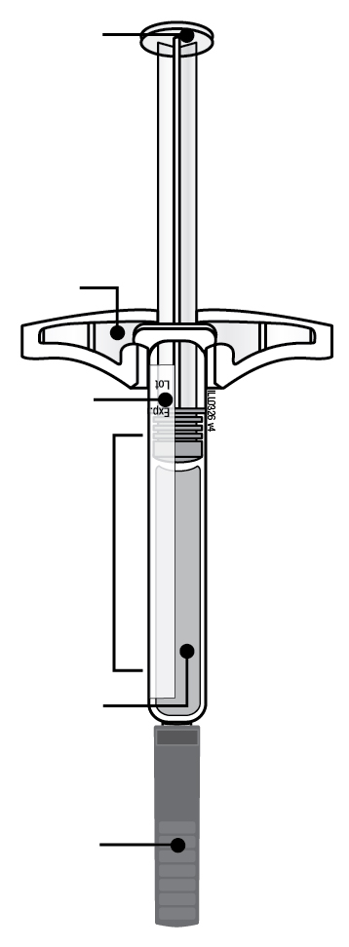 | 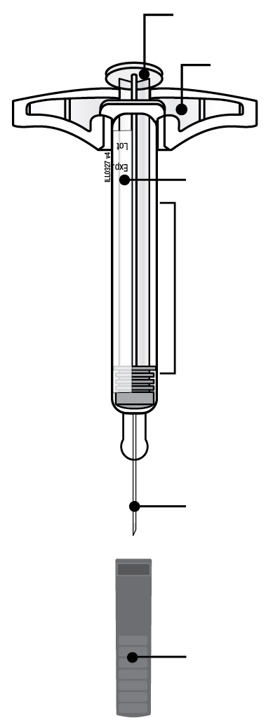
  Plunger rod
  Finger flange
  Label and expiry date
  Syringe barrel
  Medicine
  Needle
  cap on
  Used plunger rod
  Finger flange
  Label and expiry date
  Used syringe barrel
  Used needle
  Needle cap off
Important: Needle is inside

Important
Before you use an AMGEVITA pre-filled syringe, read this important information:

Using your AMGEVITA pre-filled syringe
● | It is important that you do not try to give the injection unless you or your caregiver has received training.
● | Do not use an AMGEVITA pre-filled syringe if it has been dropped on a hard surface. Part of the AMGEVITA pre-filled syringe may be broken even if you cannot see the break. Use a new AMGEVITA pre-filled syringe.

Step 1: Prepare

A. | Remove the number of AMGEVITA pre-filled syringes you need from the package.
Grab the syringe barrel to remove the syringe from the tray.  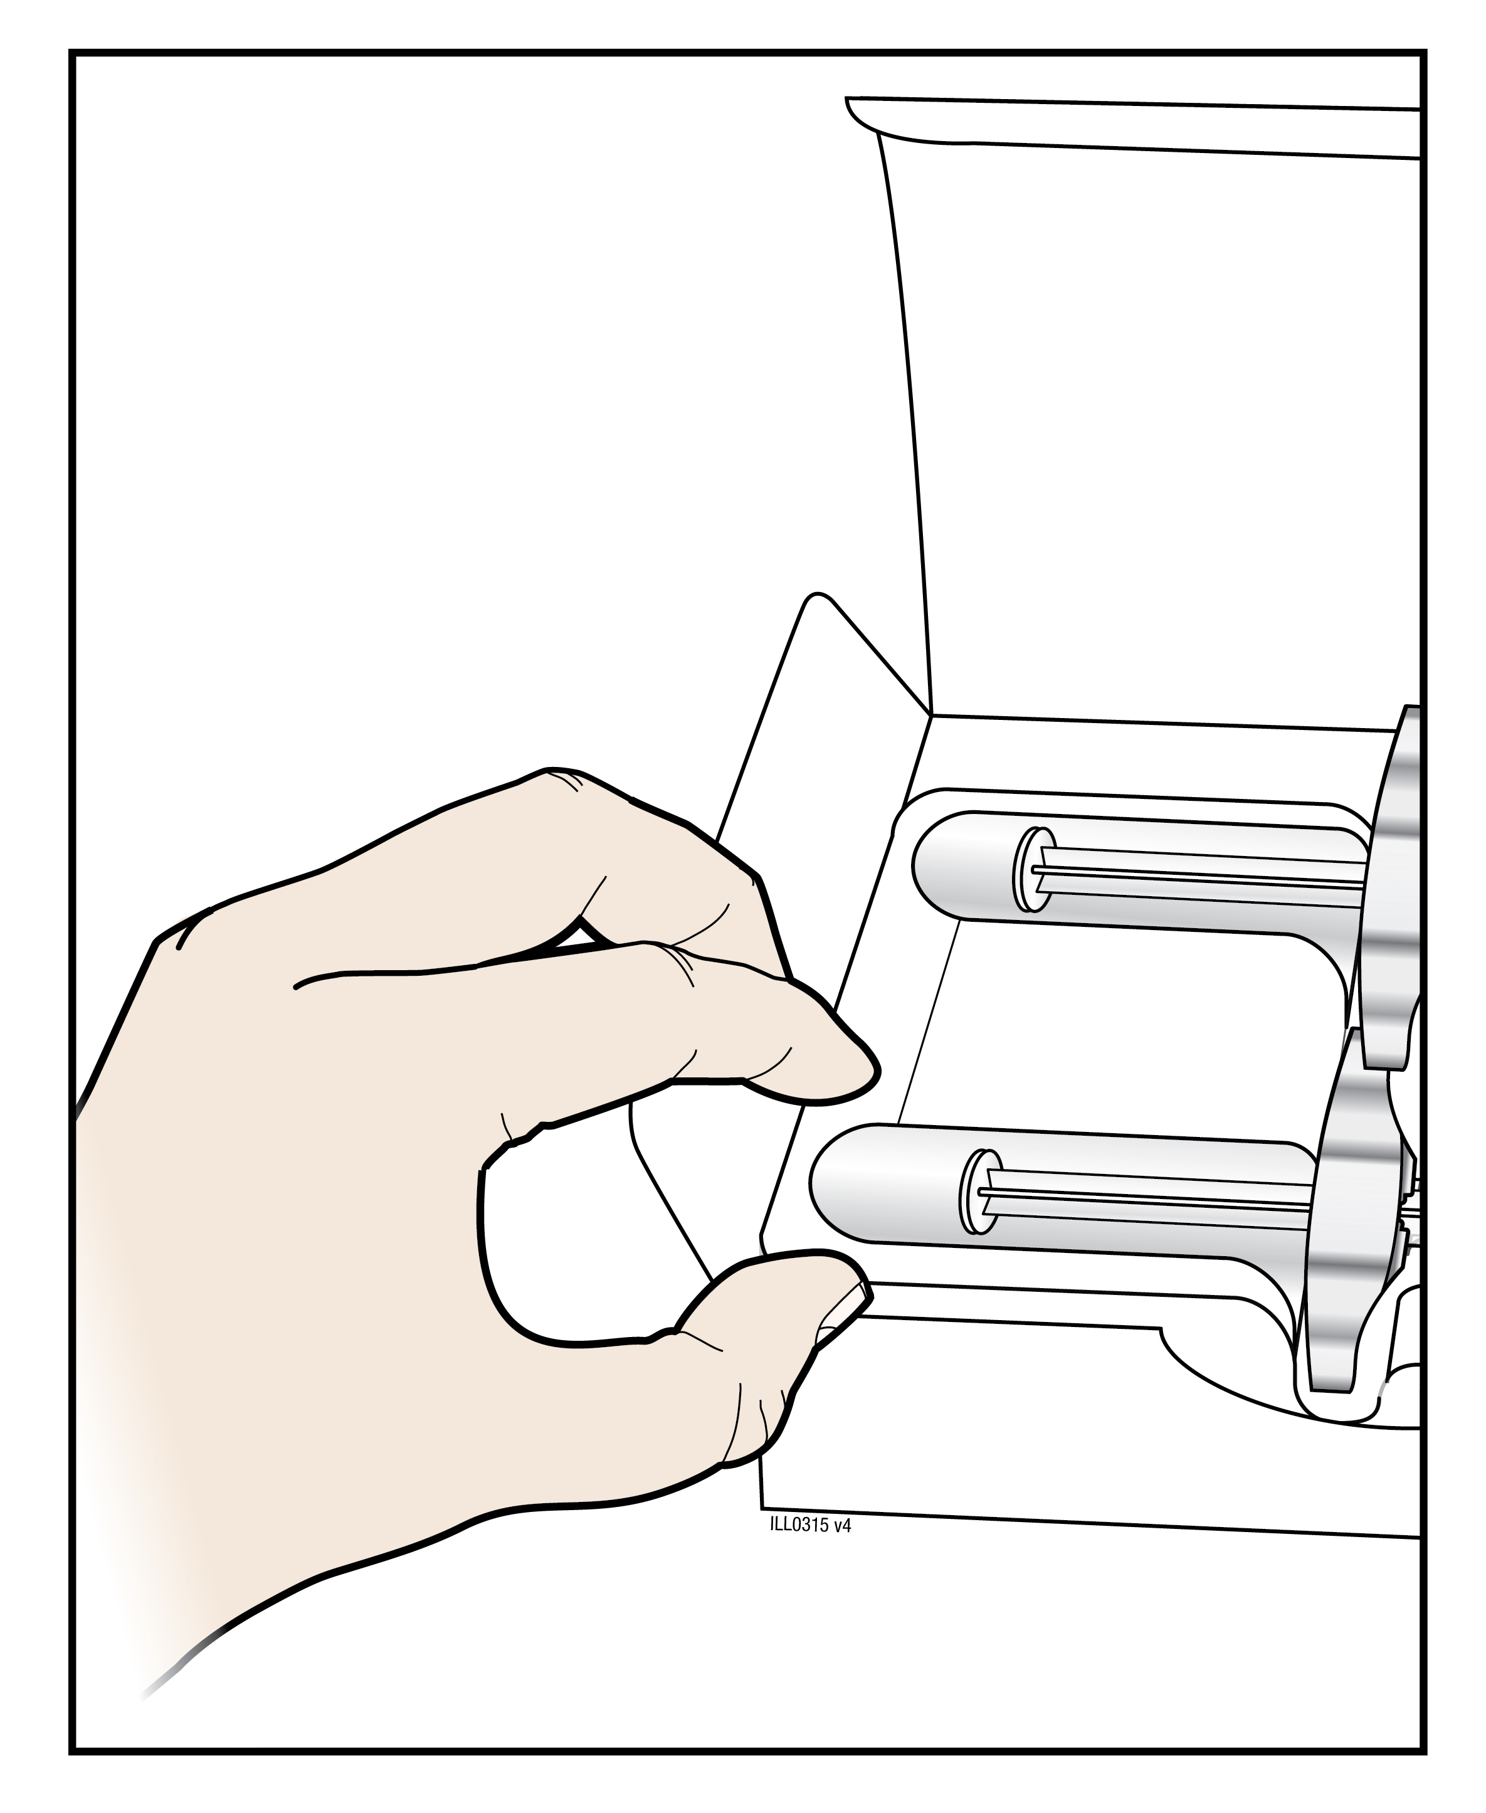 | 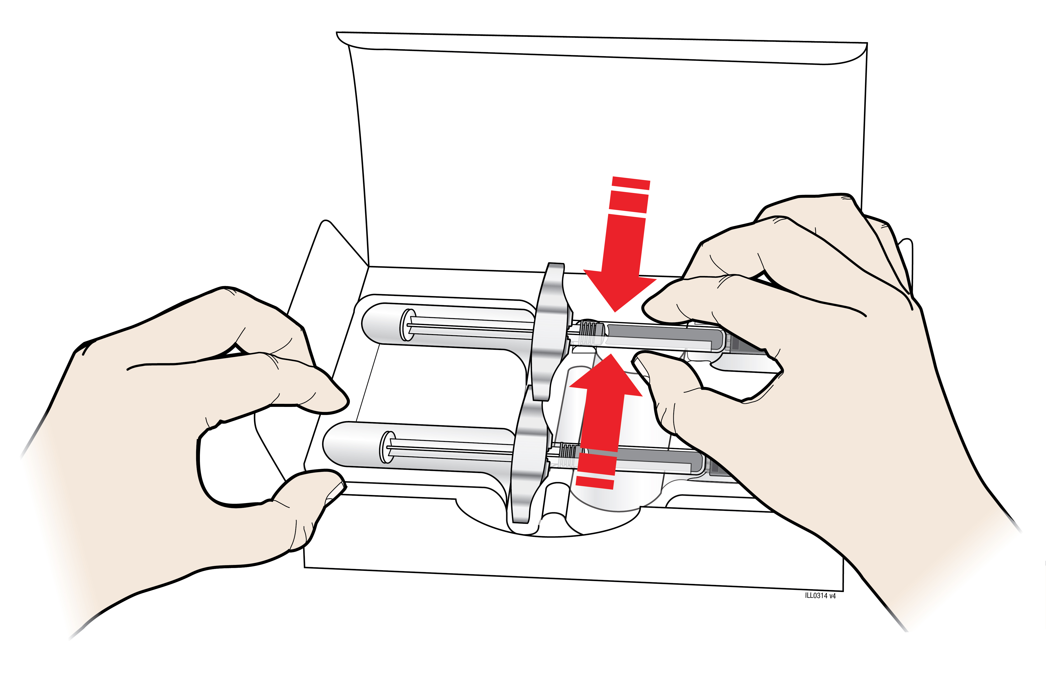

Place your finger or thumb on edge of tray to secure it while you remove the syringe. |  | Grab Here
Put the original package with any unused syringes back in the refrigerator.

For safety reasons:
● | Do not grasp the plunger rod.
● | Do not grasp the needle cap.
● | Do not remove the needle cap until you are ready to inject.
● | Do not remove the finger flange. This is part of the syringe.
For a more comfortable injection, leave the syringe at room temperature for 15 to 30 minutes before injecting.
● | Do not put the syringe back in the refrigerator once it has reached room temperature.
● | Do not try to warm the syringe by using a heat source such as hot water or microwave.
● | Do not leave the syringe in direct sunlight.
● | Do not shake the syringe.
Important: Always hold the pre-filled syringe by the syringe barrel.

B. | Inspect the AMGEVITA pre-filled syringe.
 | Syringe barrel |  | Label expiry date | Plunger rod
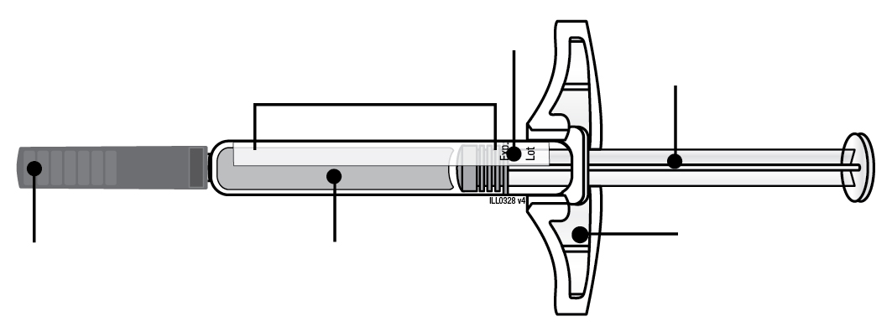
Needle cap on |  | Medicine |  | Finger flange

Always hold the syringe by the syringe barrel.

Make sure the medicine in the syringe is clear and colourless to slightly yellow.
● | Do not use the syringe if:
- The medicine is cloudy or discoloured or contains flakes, or particles.
- Any part appears cracked or broken.
- The needle cap is missing or not securely attached.
- The expiry date printed on the label has passed.
In all cases, use a new syringe.

C. | Gather all materials needed for your injection(s).
Wash your hands thoroughly with soap and water.
On a clean, well-lit work surface, place a new, pre-filled syringe.

You will also need these additional items, as they are not included in the carton:
● | Alcohol wipes
● | Cotton ball or gauze pad
● | Plaster
● | Sharps disposal container
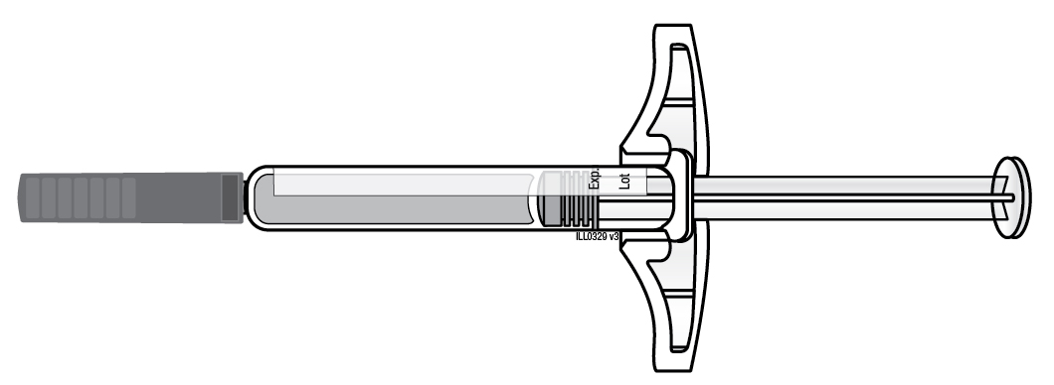 | 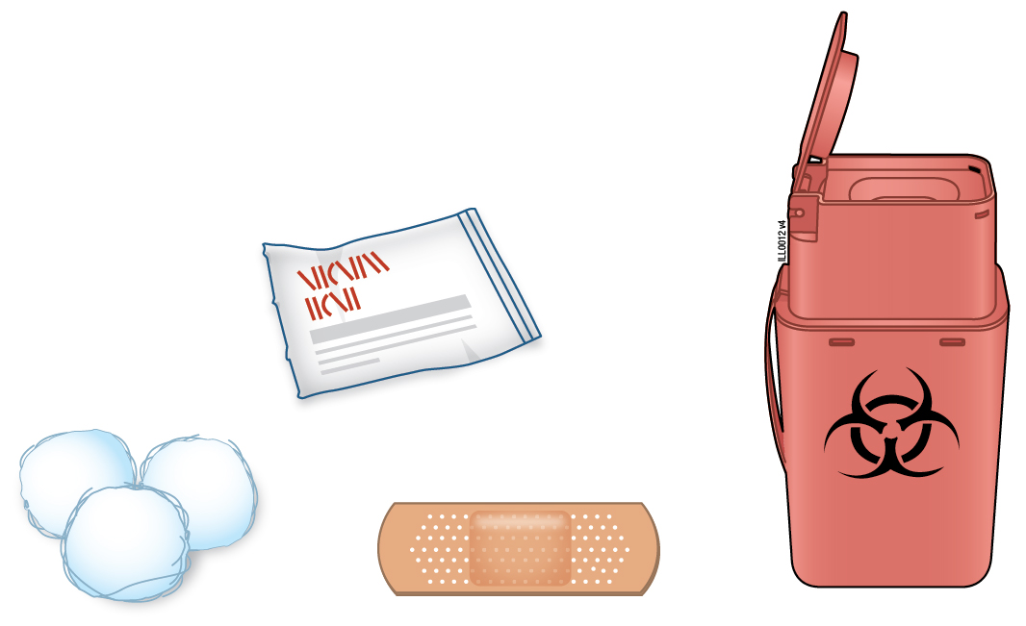

D. | Prepare and clean your injection site(s).
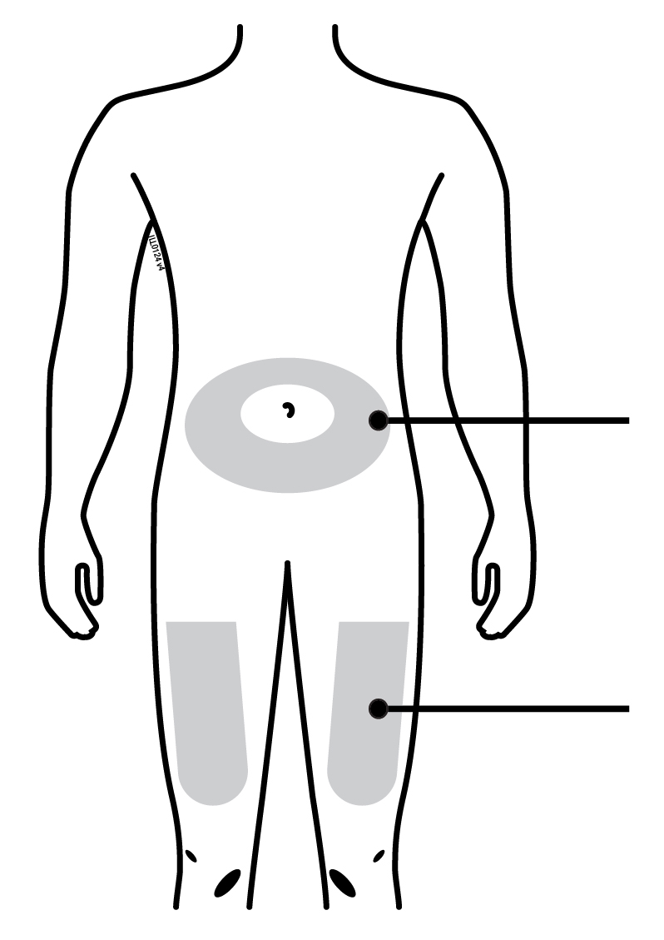 | Belly
 | Thigh

You can use:
● | Your thigh
● | Belly, except for a 2 inch (5 centimetres) area around your belly button
Clean your injection site with an alcohol wipe. Let your skin dry.
● | Do not touch this area again before injecting.
● | If you want to use the same injection site, make sure it is not the same spot on the injection site you used for a previous injection.
 | - Do not inject into areas where the skin is tender, bruised, red, or hard. Avoid injecting into areas with scars or stretch marks.
● | If you have psoriasis, you should avoid injecting directly into raised, thick, red, or scaly skin patch or lesion.

Step 2: Get ready

E. | Pull the needle cap straight out and away from your body when you are ready to inject.
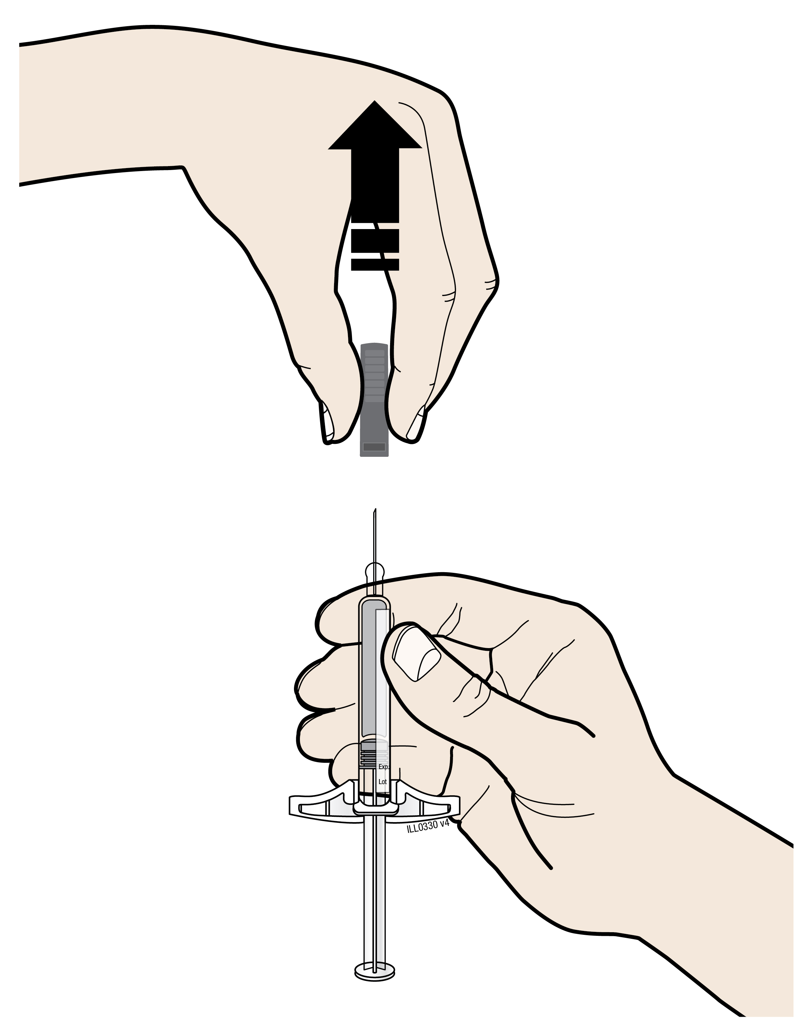
It is normal to see a drop of liquid at the end of the needle.
● | Do not twist or bend the needle cap.
● | Do not put the needle cap back onto the syringe.
● | Do not remove the needle cap from the syringe until you are ready to inject.
Important: Throw the needle cap into the sharps disposal container provided.

F. | Pinch your injection site to create a firm surface.
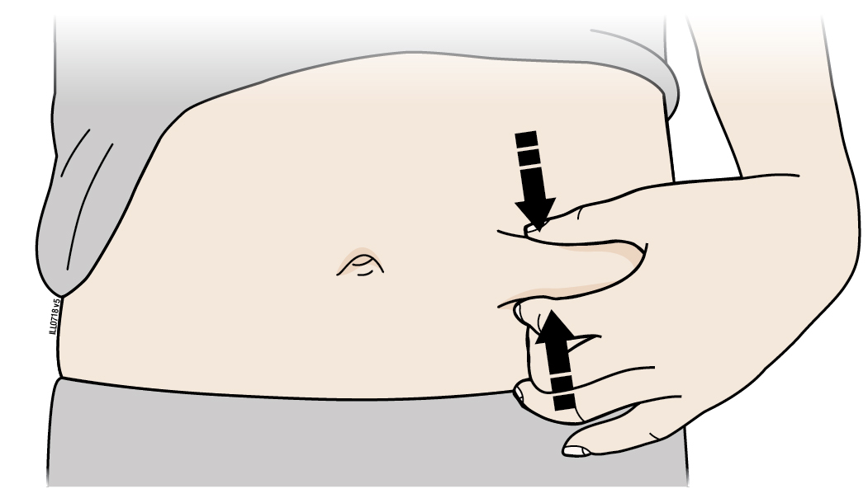
Pinch the skin firmly between your thumb and fingers, creating an area about 2 inch (5 centimetres) wide.
Important: Keep the skin pinched while injecting.

Step 3: Inject

G. | Hold the pinch. With the needle cap off, insert the syringe into your skin at 45 to 90 degrees.
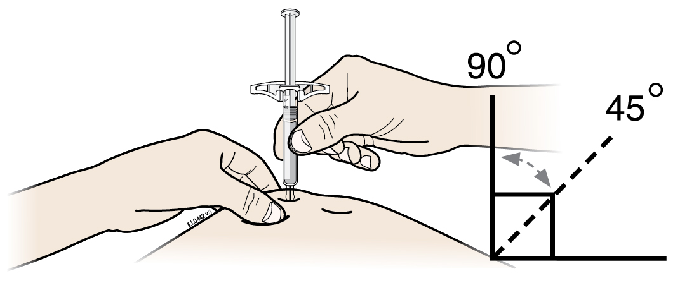
Do not place your finger on the plunger rod while inserting the needle.

H. | Using slow and constant pressure, push the plunger rod all the way down until it stops moving.
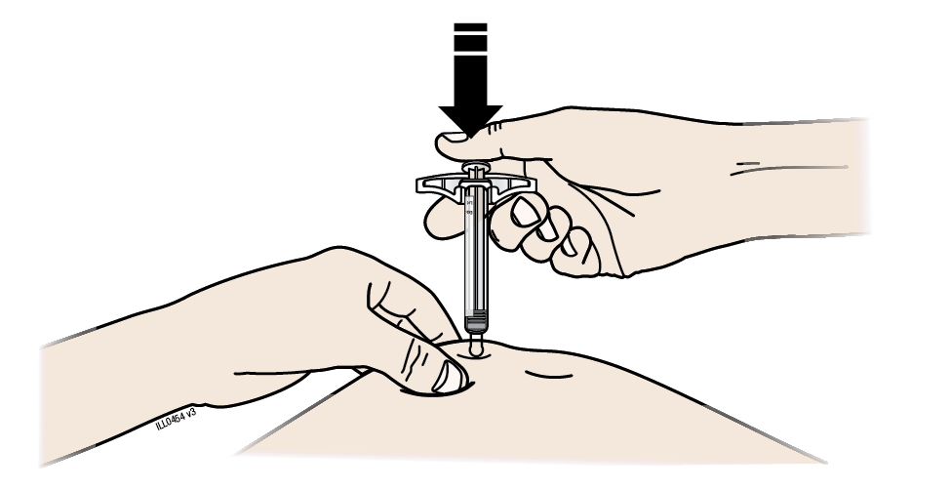

I. | When done, release your thumb, and gently lift the syringe off of your skin.
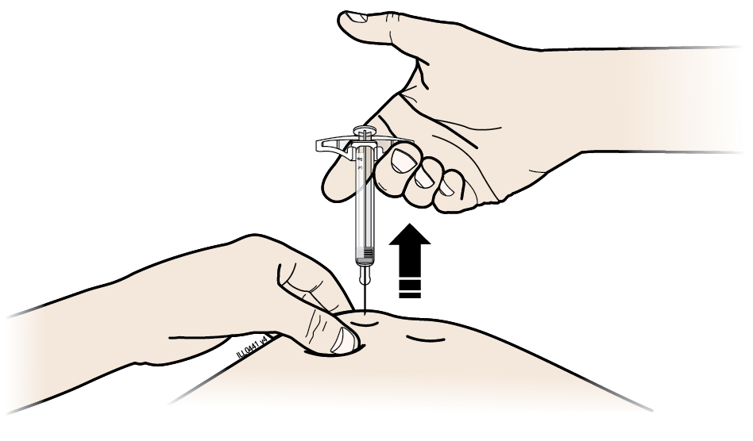

Step 4: Finish

J. | Discard the used syringe and the needle cap.
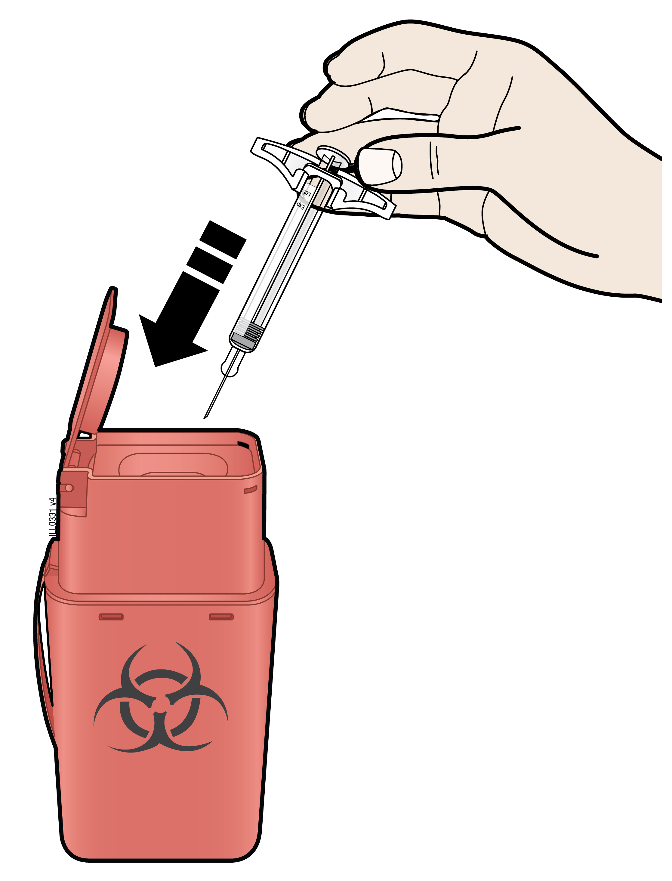
● |  | Do not reuse the used syringe.
● |  | Do not use any medicine that is left in the used syringe.
● |  | Put the used AMGEVITA syringe in a sharps disposal container immediately after use. Do not throw away (dispose of) the syringe in your household waste.
● |  | Talk with your doctor or pharmacist about proper disposal. There may be local guidelines for disposal.
● |  | Do not recycle the syringe or sharps disposal container or throw them into the household waste.
Important: Always keep the sharps disposal container out of the sight and reach of children.

K. | Examine the injection site.
If there is blood, press a cotton ball or gauze pad on your injection site. Do not rub the injection site. Apply a plaster if needed.

Package leaflet: Information for the user

AMGEVITA 40 mg solution for injection in pre-filled pen
adalimumab

Read all of this leaflet carefully before you start using this medicine because it contains important information for you.
- Keep this leaflet. You may need to read it again.
- Your doctor will also give you a Patient Reminder Card, which contains important safety information that you need to be aware of before you are given AMGEVITA and during treatment with AMGEVITA. Keep this Patient Reminder Card with you.
- If you have any further questions, ask your doctor or pharmacist.
- This medicine has been prescribed for you only. Do not pass it on to others. It may harm them, even if their signs of illness are the same as yours.
- If you get any side effects, talk to your doctor or pharmacist. This includes any possible side effects not listed in this leaflet (see section 4).

What is in this leaflet

1. What AMGEVITA is and what it is used for
2. What you need to know before you use AMGEVITA
3. How to use AMGEVITA
4. Possible side effects
5. How to store AMGEVITA
6. Contents of the pack and other information

1. What AMGEVITA is and what it is used for

AMGEVITA contains the active substance adalimumab, a medicine that acts on your body’s immune (defence) system.

AMGEVITA is intended for the treatment of the inflammatory diseases described below:
  - Rheumatoid arthritis
  - Polyarticular juvenile idiopathic arthritis
  - Enthesitis-related arthritis
  - Ankylosing spondylitis
  - Axial spondyloarthritis without radiographic evidence of ankylosing spondylitis
  - Psoriatic arthritis
  - Plaque psoriasis
  - Hidradenitis suppurativa
  - Crohn’s disease
  - Ulcerative colitis
  - Non-infectious uveitis

The active ingredient in AMGEVITA, adalimumab, is a human monoclonal antibody. Monoclonal antibodies are proteins that attach to a specific target.

The target of adalimumab is a protein called tumour necrosis factor (TNFα), which is involved in the immune (defence) system and is present at increased levels in the inflammatory diseases listed above. By attaching to TNFα, AMGEVITA decreases the process of inflammation in these diseases.

Rheumatoid arthritis

Rheumatoid arthritis is an inflammatory disease of the joints.

AMGEVITA is used to treat rheumatoid arthritis in adults. If you have moderate to severe active rheumatoid arthritis, you may first be given other disease-modifying medicines, such as methotrexate. If you do not respond well enough to these medicines, you will be given AMGEVITA to treat your rheumatoid arthritis.

AMGEVITA can also be used to treat severe, active and progressive rheumatoid arthritis without previous methotrexate treatment.

AMGEVITA slows down the damage to the cartilage and bone of the joints caused by the disease and to improve physical function.

Usually, AMGEVITA is used with methotrexate. If your doctor determines that methotrexate is inappropriate, AMGEVITA can be given alone.

Polyarticular juvenile idiopathic arthritis and enthesitis-related arthritis

Polyarticular juvenile idiopathic arthritis and enthesitis-related arthritis are inflammatory diseases of the joints that usually first appear in childhood.

AMGEVITA is used to treat polyarticular juvenile idiopathic arthritis in patients from 2 years and enthesitis-related arthritis in patients from 6 years. You may first be given other disease-modifying medicines, such as methotrexate. If you do not respond well enough to these medicines, you will be given AMGEVITA to treat your polyarticular juvenile idiopathic arthritis or enthesitis-related arthritis.

Ankylosing spondylitis and axial spondyloarthritis without radiographic evidence of ankylosing spondylitis

Ankylosing spondylitis and axial spondyloarthritis without radiographic evidence of ankylosing spondylitis, are inflammatory diseases of the spine.

AMGEVITA is used to treat ankylosing spondylitis and axial spondyloarthritis without radiographic evidence of ankylosing spondylitis in adults. If you have ankylosing spondylitis or axial spondyloarthritis without radiographic evidence of ankylosing spondylitis, you will first be given other medicines. If you do not respond well enough to these medicines, you will be given AMGEVITA to reduce the signs and symptoms of your disease.

Psoriatic arthritis

Psoriatic arthritis is an inflammation of the joints associated with psoriasis.

AMGEVITA is used to treat psoriatic arthritis in adults. AMGEVITA slows down the damage to the cartilage and bone of the joints caused by the disease and to improve physical function.

Plaque psoriasis in adults and children

Plaque psoriasis is a skin condition that causes red, flaky, crusty patches of skin covered with silvery scales. Plaque psoriasis can also affect the nails, causing them to crumble, become thickened and lift away from the nail bed which can be painful. Psoriasis is believed to be caused by a problem with the body’s immune system that leads to an increased production of skin cells.

AMGEVITA is used to treat moderate to severe plaque psoriasis in adults. AMGEVITA is also used to treat severe plaque psoriasis in children and adolescents aged 4 to 17 years for whom topical therapy and phototherapies have either not worked very well or are not suitable.

Hidradenitis suppurativa in adults and adolescents

Hidradenitis suppurativa (sometimes called acne inversa) is a chronic and often painful inflammatory skin disease. Symptoms may include tender nodules (lumps) and abscesses (boils) that may leak pus. It most commonly affects specific areas of the skin, such as under the breasts, the armpits, inner thighs, groin and buttocks. Scarring may also occur in affected areas.

AMGEVITA is used to treat hidradenitis suppurativa in adults and adolescents from 12 years of age. AMGEVITA can reduce the number of nodules and abscesses you have, and the pain that is often associated with the disease. You may first be given other medicines. If you do not respond well enough to these medicines, you will be given AMGEVITA.

Crohn’s disease in adults and children

Crohn’s disease is an inflammatory disease of the digestive tract.

AMGEVITA is used to treat Crohn’s disease in adults and children aged 6 to 17 years. If you have Crohn’s disease you will first be given other medicines. If you do not respond well enough to these medicines, you will be given AMGEVITA to reduce the signs and symptoms of your Crohn’s disease.

Ulcerative colitis in adults and children

Ulcerative colitis is an inflammatory disease of the large intestine.

AMGEVITA is used to treat moderate to severe ulcerative colitis in adults and children aged 6 to 17 years. If you have ulcerative colitis you may first be given other medicines. If you do not respond well enough to these medicines, you will be given AMGEVITA to reduce the signs and symptoms of your disease.

Non-infectious uveitis in adults and children

Non-infectious uveitis is an inflammatory disease affecting certain parts of the eye.

AMGEVITA is used to treat
- Adults with non-infectious uveitis with inflammation affecting the back of the eye.
- Children from 2 years of age with chronic non-infectious uveitis with inflammation affecting the front of the eye.

This inflammation may lead to a decrease of vision and/or the presence of floaters in the eye (black dots or wispy lines that move across the field of vision). AMGEVITA works by reducing this inflammation.

2. What you need to know before you use AMGEVITA

Do not use AMGEVITA:

- if you are allergic to adalimumab or any of the other ingredients of this medicine (listed in section 6).
- if you have a severe infection, including active tuberculosis, sepsis (blood infection) or other opportunistic infections (unusual infections associated with a weakened immune system) (see “Warnings and precautions”). It is important that you tell your doctor if you have symptoms of infections, e.g. fever, wounds, feeling tired, dental problems.
- if you have moderate or severe heart failure. It is important to tell your doctor if you have had or have a serious heart condition (see “Warnings and precautions”).

Warnings and precautions

Talk to your doctor or pharmacist before using AMGEVITA:

Allergic reactions

- If you experience allergic reactions with symptoms such as chest tightness, wheezing, dizziness, swelling or rash do not inject more AMGEVITA and contact your doctor immediately since, in rare cases, these reactions can be life threatening.

Infections

- If you have an infection, including long-term or localised infection (for example, leg ulcer) consult your doctor before starting AMGEVITA. If you are unsure, contact your doctor.
- You might get infections more easily while you are receiving AMGEVITA treatment. This risk may increase if your lung function is impaired. These infections may be serious and include tuberculosis, infections caused by viruses, fungi, parasites or bacteria, or other opportunistic infections and sepsis that may, in rare cases, be life-threatening. It is important to tell your doctor if you get symptoms such as fever, wounds, feeling tired or dental problems. Your doctor may recommend temporary discontinuation of AMGEVITA.

Tuberculosis

- As cases of tuberculosis have been reported in patients treated with adalimumab, your doctor will check you for signs and symptoms of tuberculosis before starting AMGEVITA. This will include a thorough medical evaluation including your medical history and appropriate screening tests (for example chest x-ray and a tuberculin test). The conduct and results of these tests should be recorded on your Patient Reminder Card. It is very important that you tell your doctor if you have ever had tuberculosis, or if you have been in close contact with someone who has had tuberculosis.
- Tuberculosis can develop during therapy even if you have received preventative treatment for tuberculosis.
- If symptoms of tuberculosis (persistent cough, weight loss, listlessness, mild fever), or any other infection appear during or after therapy, tell your doctor immediately.

Travel / recurrent infection

- Advise your doctor if you reside or travel in regions where fungal infections such as histoplasmosis, coccidioidomycosis or blastomycosis are endemic.
- Advise your doctor if you have a history of recurrent infections or other conditions that increase the risk of infections.

Hepatitis B virus

- Advise your doctor if you are a carrier of the hepatitis B virus (HBV), if you have active HBV or if you think you might be at risk of contracting HBV. Your doctor should test you for HBV. AMGEVITA can cause reactivation of HBV in people who carry this virus. In some rare cases, especially if you are taking other medicines that suppress the immune system, reactivation of HBV can be life-threatening.

Age over 65 years

- If you are over 65 years you may be more susceptible to infections while taking AMGEVITA. You and your doctor should pay special attention to signs of infection while you are being treated with AMGEVITA. It is important to tell your doctor if you get symptoms of infections, such as fever, wounds, feeling tired or dental problems.

Surgery or dental procedures

- If you are about to undergo surgery or dental procedures please inform your doctor that you are taking AMGEVITA. Your doctor may recommend temporary discontinuation of AMGEVITA.

Demyelinating disease

- If you have or develop demyelinating disease such as multiple sclerosis, your doctor will decide if you should receive or continue to receive AMGEVITA. Tell your doctor immediately if you experience symptoms like changes in your vision, weakness in your arms or legs or numbness or tingling in any part of your body.

Vaccinations

- Certain vaccines contain living but weakened forms of disease-causing bacteria or viruses that may cause infections and should not be given while receiving AMGEVITA. Please check with your doctor before you receive any vaccines. It is recommended that children, if possible, be brought up to date with all immunisations in agreement with current immunisation guidelines prior to initiating AMGEVITA therapy.
- If you received AMGEVITA while you were pregnant, your baby may be at higher risk for getting such an infection for up to approximately five months after the last dose you received during pregnancy. It is important that you tell your baby's doctors and other health care professionals about your AMGEVITA use during your pregnancy so they can decide when your baby should receive any vaccine.

Heart failure

- If you have mild heart failure and you are being treated with AMGEVITA, your heart failure status must be closely monitored by your doctor. It is important to tell your doctor if you have had or have a serious heart condition. If you develop new or worsening symptoms of heart failure (e.g. shortness of breath, or swelling of your feet), you must contact your doctor immediately. Your doctor will decide if you should receive AMGEVITA.

Fever, bruising, bleeding or looking pale

- In some patients the body may fail to produce enough of the blood cells that help your body fight infections or help you to stop bleeding. If you develop a fever that does not go away, bruise or bleed very easily or look very pale, call your doctor right away. Your doctor may decide to stop treatment.

Cancer

- There have been very rare cases of certain kinds of cancer in children and adult patients taking adalimumab or other TNF blockers. People with more serious rheumatoid arthritis that have had the disease for a long time may have a higher than average risk of getting lymphoma (a cancer that affects the lymph system), and leukaemia (a cancer that affects the blood and bone marrow).
- If you take AMGEVITA the risk of getting lymphoma, leukaemia, or other cancers may increase. On rare occasions, a specific and severe type of lymphoma has been observed in patients taking adalimumab. Some of those patients were also treated with azathioprine or 6-mercaptopurine. Tell your doctor if you are taking azathioprine or 6-mercaptopurine with AMGEVITA.
- In addition, cases of non-melanoma skin cancer have been observed in patients taking adalimumab. If new skin lesions appear during or after therapy or if existing lesions change appearance, tell your doctor.
- There have been cases of cancers, other than lymphoma in patients with a specific type of lung disease called Chronic Obstructive Pulmonary Disease (COPD) treated with another TNF blocker. If you have COPD, or are a heavy smoker, you should discuss with your doctor whether treatment with a TNF blocker is appropriate for you.

Autoimmune disease

- On rare occasions, treatment with AMGEVITA could result in lupus-like syndrome. Contact your doctor if symptoms such as persistent unexplained rash, fever, joint pain or tiredness occur.

In order to improve the traceability of this medicine, your doctor or pharmacist should record the name and the lot number of the product you have been given in your patient file. You may also wish to make a note of these details in case you are asked for this information in the future.

Children and adolescents

- Vaccinations: if possible children should be up to date with all vaccinations before using AMGEVITA.

- Do not give AMGEVITA to children with polyarticular juvenile idiopathic arthritis below the age of 2 years.

- Do not give AMGEVITA to children with plaque psoriasis below the age of 4 years.

- Do not give AMGEVITA to children with Crohn’s disease or ulcerative colitis below the age of 6 years.

Other medicines and AMGEVITA

Tell your doctor or pharmacist if you are taking, have recently taken or might take any other medicines.

AMGEVITA can be taken together with methotrexate or certain disease-modifying anti-rheumatic agents (sulfasalazine, hydroxychloroquine, leflunomide and injectable gold preparations), steroids or pain medications including non-steroidal anti-inflammatory drugs (NSAIDs).

You should not take AMGEVITA with medicines containing the active substances, anakinra or abatacept due to increased risk of serious infection. If you have questions, please ask your doctor.

Pregnancy and breast-feeding

- You should consider the use of adequate contraception to prevent pregnancy and continue its use for at least 5 months after the last AMGEVITA treatment.
- If you are pregnant, think you may be pregnant or are planning to have a baby, ask your doctor for advice about taking this medicine.
- AMGEVITA should only be used during a pregnancy if needed.
- According to a pregnancy study, there was no higher risk of birth defects when the mother had received AMGEVITA during pregnancy compared with mothers with the same disease who did not receive AMGEVITA.
- AMGEVITA can be used during breast-feeding.
- If you receive AMGEVITA during your pregnancy, your baby may have a higher risk for getting an infection.
- It is important that you tell your baby’s doctors and other health care professionals about your AMGEVITA use during your pregnancy before the baby receives any vaccine. For more information on vaccines see the “Warnings and precautions” section.

Driving and using machines

AMGEVITA may have a minor influence on your ability to drive, cycle or use machines. Room spinning sensation (vertigo) and vision disturbances may occur after taking AMGEVITA.

AMGEVITA contains sodium

This medicine contains less than 1 mmol of sodium (23 mg) per 0.8 mL dose, that is to say essentially ‘sodium-free’.

3. How to use AMGEVITA

Always use this medicine exactly as your doctor or pharmacist has told you. Check with your doctor or pharmacist if you are not sure.

Adults with rheumatoid arthritis, psoriatic arthritis, ankylosing spondylitis or axial spondyloarthritis without radiographic evidence of ankylosing spondylitis

AMGEVITA is injected under the skin (subcutaneous use). The usual dose for adults with rheumatoid arthritis, ankylosing spondylitis, axial spondyloarthritis without radiographic evidence of ankylosing spondylitis, and for patients with psoriatic arthritis is 40 mg given every other week as a single dose.

In rheumatoid arthritis, methotrexate is continued while using AMGEVITA. If your doctor determines that methotrexate is inappropriate, AMGEVITA can be given alone.

If you have rheumatoid arthritis and you do not receive methotrexate with your AMGEVITA therapy, your doctor may decide to give 40 mg every week or 80 mg every other week.

Children, adolescents and adults with polyarticular juvenile idiopathic arthritis

Children, adolescents and adults from 2 years of age weighing 30 kg or more

The recommended dose of AMGEVITA is 40 mg every other week.

Children, adolescents and adults with enthesitis-related arthritis

Children, adolescents and adults from 6 years of age weighing 30 kg or more

The recommended dose of AMGEVITA is 40 mg every other week.

Adults with plaque psoriasis

The usual dose for adults with plaque psoriasis is an initial dose of 80 mg (as two 40 mg injections in one day), followed by 40 mg given every other week starting one week after the initial dose. You should continue to inject AMGEVITA for as long as your doctor has told you. Depending on your response, your doctor may increase the dose to 40 mg every week or 80 mg every other week.

Children and adolescents with plaque psoriasis

Children and adolescents from 4 to 17 years of age weighing 30 kg or more

The recommended dose of AMGEVITA is an initial dose of 40 mg, followed by 40 mg one week later. Thereafter, the usual dose is 40 mg every other week.

Adults with hidradenitis suppurativa

The usual dose regimen for hidradenitis suppurativa is an initial dose of 160 mg (as four 40 mg injections in one day or two 40 mg injections per day for two consecutive days), followed by an 80 mg dose (as two 40 mg injections in one day) two weeks later. After two further weeks, continue with a dose of 40 mg every week or 80 mg every other week, as prescribed by your doctor. It is recommended that you use an antiseptic wash daily on the affected areas.

Adolescents with hidradenitis suppurativa from 12 to 17 years of age weighing 30 kg or more

The recommended dose of AMGEVITA is an initial dose of 80 mg (as two 40 mg injections in one day), followed by 40 mg every other week starting one week later. If you have an inadequate response to AMGEVITA 40 mg every other week, your doctor may increase the dose to 40 mg every week or 80 mg every other week.

It is recommended that you use an antiseptic wash daily on the affected areas.

Adults with Crohn’s disease

The usual dose regimen for Crohn’s disease is 80 mg (as two 40 mg injections in one day) initially followed by 40 mg every other week two weeks later. If a faster response is required, your doctor may prescribe an initial dose of 160 mg (as four 40 mg injections in one day or two 40 mg injections per day for two consecutive days), followed by 80 mg (as two 40 mg injections in one day) two weeks later, and thereafter as 40 mg every other week. Depending on your response, your doctor may increase the dose to 40 mg every week or 80 mg every other week.

Children and adolescents with Crohn's disease

Children and adolescents from 6 to 17 years of age weighing less than 40 kg

The usual dose regimen is 40 mg initially followed by 20 mg two weeks later. If a faster response is required, your doctor may prescribe an initial dose of 80 mg (as two 40 mg injections in one day) followed by 40 mg two weeks later.

Thereafter, the usual dose is 20 mg every other week. Depending on your response, your doctor may increase the dose frequency to 20 mg every week.

The 40 mg pre-filled pen cannot be used for the 20 mg dose. An AMGEVITA 20 mg pre-filled syringe is however available for the 20 mg dose.

Children and adolescents from 6 to 17 years of age weighing 40 kg or more

The usual dose regimen is 80 mg (as two 40 mg injections in one day) initially followed by 40 mg two weeks later. If a faster response is required, your doctor may prescribe an initial dose of 160 mg (as four 40 mg injections in one day or as two 40 mg injections per day for two consecutive days) followed by 80 mg (as two 40 mg injections in one day) two weeks later.

Thereafter, the usual dose is 40 mg every other week. Depending on your response, your doctor may increase the dose to 40 mg every week or 80 mg every other week.

Adults with ulcerative colitis

The usual AMGEVITA dose for adults with ulcerative colitis is 160 mg initially (as four 40 mg injections in one day or as two 40 mg injections per day for two consecutive days) followed by 80 mg (as two 40 mg injections in one day) two weeks later, then 40 mg every other week. Depending on your response, your doctor may increase the dose to 40 mg every week or 80 mg every other week.

Children and adolescents with ulcerative colitis

Children and adolescents from 6 years of age weighing less than 40 kg

The usual AMGEVITA dose is 80 mg (as two 40 mg injections in one day) initially followed by 40 mg (as one 40 mg injection) two weeks later. Thereafter, the usual dose is 40 mg every other week.

Patients who turn 18 years of age while on 40 mg every other week, should continue their prescribed dose.

Children and adolescents from 6 years of age weighing 40 kg or more

The usual AMGEVITA dose is 160 mg (as four 40 mg injections in one day or two 40 mg injections per day for two consecutive days) initially, followed by 80 mg (as two 40 mg injections in one day) two weeks later. Thereafter the usual dose is 80 mg every other week.

Patients who turn 18 years of age while on 80 mg every other week, should continue their prescribed dose.

Adults with non-infectious uveitis

The usual dose for adults with non-infectious uveitis is an initial dose of 80 mg (as two 40 mg injections in one day), followed by 40 mg given every other week starting one week after the initial dose. You should continue to inject AMGEVITA for as long as your doctor has told you.

In non-infectious uveitis, corticosteroids or other medicines that influence the immune system may be continued while using AMGEVITA. AMGEVITA can also be given alone.

Children and adolescents with chronic non-infectious uveitis from 2 years of age

Children and adolescents from 2 years of age weighing less than 30 kg

The usual dose of AMGEVITA is 20 mg every other week with methotrexate.

Your doctor may also prescribe an initial dose of 40 mg which may be administered one week prior to the start of the usual dose.

The 40 mg pre-filled pen cannot be used for the 20 mg dose. An AMGEVITA 20 mg pre-filled syringe is however available for the 20 mg dose.

Children and adolescents from 2 years of age weighing 30 kg or more

The usual dose of AMGEVITA is 40 mg every other week with methotrexate.

Your doctor may also prescribe an initial dose of 80 mg which may be administered one week prior to the start of the usual dose.

Method and route of administration

AMGEVITA is administered by injection under the skin (subcutaneous injection).

Detailed instructions on how to inject AMGEVITA are provided in “Instructions for use” section.

If you use more AMGEVITA than you should

If you accidentally inject AMGEVITA more frequently than told to by your doctor or pharmacist, call your doctor or pharmacist and tell him/her that you have taken more. Always take the outer carton of this medicine with you, even if it is empty.

If you forget to use AMGEVITA

If you forget to give yourself an injection, you should inject the next dose of AMGEVITA as soon as you remember. Then take your next dose as you would have on your originally scheduled day, had you not forgotten a dose.

If you stop using AMGEVITA

The decision to stop using AMGEVITA should be discussed with your doctor. Your symptoms may return upon discontinuation.

If you have any further questions on the use of this medicine, ask your doctor or pharmacist.

4. Possible side effects

Like all medicines, this medicine can cause side effects, although not everybody gets them. Most side effects are mild to moderate. However, some may be serious and require treatment. Side effects may occur at least up to 4 months after the last AMGEVITA injection.

Tell your doctor immediately if you notice any of the following signs of allergic reaction or heart failure:
- severe rash, hives or other signs of allergic reaction;
- swollen face, hands, feet;
- trouble breathing, swallowing;
- shortness of breath with exertion or upon lying down or swelling of the feet.

Tell your doctor as soon as possible if you notice any of the following:
- signs of infection such as fever, feeling sick, wounds, dental problems, burning on urination;
- feeling weak or tired;
- coughing;
- tingling;
- numbness;
- double vision;
- arm or leg weakness;
- signs of skin cancer such as a bump or open sore that doesn't heal;
- signs and symptoms suggestive of blood disorders such as persistent fever, bruising, bleeding, paleness.

The symptoms described above can be signs of the below listed side effects, which have been observed with adalimumab.

Very common (may affect more than 1 in 10 people)
- injection site reactions (including pain, swelling, redness or itching);
- respiratory tract infections (including cold, runny nose, sinus infection, pneumonia);
- headache;
- abdominal pain;
- nausea and vomiting;
- rash;
- musculoskeletal pain.

Common (may affect up to 1 in 10 people)
- serious infections (including blood poisoning and influenza);
- intestinal infections (including gastroenteritis);
- skin infections (including cellulitis and shingles);
- ear infections;
- oral infections (including tooth infections and cold sores);
- reproductive tract infections;
- urinary tract infection;
- fungal infections;
- joint infections;
- benign tumours;
- skin cancer;
- allergic reactions (including seasonal allergy);
- dehydration;
- mood swings (including depression);
- anxiety;
- difficulty sleeping;
- sensation disorders such as tingling, prickling or numbness;
- migraine;
- nerve root compression (including low back pain and leg pain);
- vision disturbances;
- eye inflammation;
- inflammation of the eye lid and eye swelling;
- vertigo (feeling of dizziness or spinning);
- sensation of heart beating rapidly;
- high blood pressure;
- flushing;
- haematoma;
- cough;
- asthma;
- shortness of breath;
- gastrointestinal bleeding;
- dyspepsia (indigestion, bloating, heart burn);
- acid reflux disease;
- sicca syndrome (including dry eyes and dry mouth);
- itching;
- itchy rash;
- bruising;
- inflammation of the skin (such as eczema);
- breaking of finger nails and toe nails;
- increased sweating;
- hair loss;
- new onset or worsening of psoriasis;
- muscle spasms;
- blood in urine;
- kidney problems;
- chest pain;
- oedema;
- fever;
- reduction in blood platelets which increases risk of bleeding or bruising;
- impaired healing.

Uncommon (may affect up to 1 in 100 people)
  - opportunistic infections (which include tuberculosis and other infections that occur when resistance to disease is lowered);
  - neurological infections (including viral meningitis);
  - eye infections;
  - bacterial infections;
  - diverticulitis (inflammation and infection of the large intestine);
  - cancer, including cancer that affects the lymph system (lymphoma) and melanoma (skin cancer);
  - immune disorders that could affect the lungs, skin and lymph nodes (most commonly presenting as sarcoidosis);
  - vasculitis (inflammation of blood vessels);
  - tremor;
  - neuropathy;
  - stroke;
  - hearing loss, buzzing;
  - sensation of heart beating irregularly such as skipped beats;
  - heart problems that can cause shortness of breath or ankle swelling;
  - heart attack;
  - a sac in the wall of a major artery, inflammation and clot of a vein, blockage of a blood vessel;
  - lung diseases causing shortness of breath (including inflammation);
  - pulmonary embolism (blockage in an artery of the lung);
  - pleural effusion (abnormal collection of fluid in the pleural space);
  - inflammation of the pancreas which causes severe pain in the abdomen and back;
  - difficulty in swallowing;
  - facial oedema;
  - gallbladder inflammation, gallbladder stones;
  - fatty liver;
  - night sweats;
  - scar;
  - abnormal muscle breakdown;
  - systemic lupus erythematosus (including inflammation of skin, heart, lung, joints and other organ systems);
  - sleep interruptions;
  - impotence;
  - inflammations.

Rare (may affect up to 1 in 1,000 people)
- leukaemia (cancer affecting the blood and bone marrow);
- severe allergic reaction with shock;
- multiple sclerosis;
- nerve disorders (such as eye nerve inflammation and Guillain-Barré syndrome that may cause muscle weakness, abnormal sensations, tingling in the arms and upper body);
- heart stops pumping;
- pulmonary fibrosis (scarring of the lung);
- intestinal perforation (hole in the wall of the gut);
- hepatitis (liver inflammation);
- reactivation of hepatitis B;
- autoimmune hepatitis (inflammation of the liver caused by the body's own immune system);
- cutaneous vasculitis (inflammation of blood vessels in the skin);
- Stevens-Johnson syndrome (life-threatening reaction with flu-like symptoms and blistering rash););
- facial oedema associated with allergic reactions;
- erythema multiforme (inflammatory skin rash);
- lupus-like syndrome;
- angioedema (localised swelling of the skin);
- lichenoid skin reaction (itchy reddish-purple skin rash).

Not known (frequency cannot be estimated from available data)
- hepatosplenic T-cell lymphoma (a rare blood cancer that is often fatal);
- Merkel cell carcinoma (a type of skin cancer);
- Kaposi’s sarcoma, a rare cancer related to infection with human herpes virus 8. Kaposi’s sarcoma most commonly appears as purple lesions on the skin;
- liver failure;
- worsening of a condition called dermatomyositis (seen as a skin rash accompanying muscle weakness);
- weight gain (for most patients, the weight gain was small).

Some side effects observed with adalimumab may not have symptoms and may only be discovered through blood tests. These include:

Very common (may affect more than 1 in 10 people)
- low blood measurements for white blood cells;
- low blood measurements for red blood cells;
- increased lipids in the blood;
- elevated liver enzymes.

Common (may affect up to 1 in 10 people)
- high blood measurements for white blood cells;
- low blood measurements for platelets;
- increased uric acid in the blood;
- abnormal blood measurements for sodium;
- low blood measurements for calcium;
- low blood measurements for phosphate;
- high blood sugar;
- high blood measurements for lactate dehydrogenase;
- autoantibodies present in the blood;
- low blood potassium.

Uncommon (may affect up to 1 in 100 people)
- elevated bilirubin measurement (liver blood test).

Rare (may affect up to 1 in 1,000 people)
- low blood measurements for white blood cells, red blood cells and platelet count.

Reporting of side effects

If you get any side effects, talk to your doctor or pharmacist. This includes any possible side effects not listed in this leaflet. You can also report side effects directly via the national reporting system listed in Appendix V. By reporting side effects you can help provide more information on the safety of this medicine.

5. How to store AMGEVITA

Keep this medicine out of the sight and reach of children.

Do not use this medicine after the expiry date which is stated on the label and carton after EXP. The expiry date refers to the last day of that month.

Store in a refrigerator (2°C – 8°C). Do not freeze.

Store in the original carton in order to protect from light.

A single AMGEVITA pre-filled pen may be stored at temperatures up to a maximum of 25°C for a period of up to 14 days. The pre-filled pen must be protected from light, and discarded if not used within the 14-day period.

Do not throw away any medicines via wastewater or household waste. Ask your pharmacist how to throw away medicines you no longer use. These measures will help protect the environment.

6. Contents of the pack and other information

What AMGEVITA contains
- The active substance is adalimumab. Each pre-filled pen contains 40 mg of adalimumab in 0.8 mL of solution.
- The other ingredients are glacial acetic acid, sucrose, polysorbate 80, sodium hydroxide and water for injections.

What AMGEVITA looks like and contents of the pack

AMGEVITA is a clear and colourless to slightly yellow solution.

Each pack contains 1, 2, 4 or 6 single use SureClick pre-filled pens.

Marketing Authorisation Holder and Manufacturer
Amgen Europe B.V.
Minervum 7061
4817 ZK Breda
The Netherlands

Marketing Authorisation Holder
Amgen Europe B.V.
Minervum 7061
4817 ZK Breda
The Netherlands

Manufacturer
Amgen Technology Ireland UC
Pottery Road
Dun Laoghaire
Co Dublin
Ireland

Manufacturer
Amgen NV
Telecomlaan 5-7
1831 Diegem
Belgium

For any information about this medicine, please contact the local representative of the Marketing Authorisation Holder:

België/Belgique/Belgien  s.a. Amgen n.v.  Tél/Tel: +32 (0)2 7752711 | Lietuva  Amgen Switzerland AG Vilniaus filialas  Tel. +370 5 219 7474
България  Амджен България ЕООД  Тел.: +359 (0)2 424 7440 | Luxembourg/Luxemburg  s.a. Amgen  Belgique/Belgien  Tél/Tel: +32 (0)2 7752711
Česká republika  Amgen s.r.o.  Tel: +420 221 773 500 | Magyarország  Amgen Kft.  Tel.: +36 1 35 44 700
Danmark  Amgen, filial af Amgen AB, Sverige  Tlf.: +45 39617500 | Malta  Amgen S.r.l.  Italy  Tel: +39 02 6241121
Deutschland  Amgen GmbH  Tel: +49 89 1490960 | Nederland  Amgen B.V.  Tel: +31 (0)76 5732500
Eesti  Amgen Switzerland AG Vilniaus filialas  Tel: +372 586 09553 | Norge  Amgen AB  Tlf: +47 23308000
Ελλάδα  Amgen Ελλάς Φαρμακευτικά Ε.Π.Ε.  Τηλ: +30 210 3447000 | Österreich  Amgen GmbH  Tel: +43 (0)1 50 217
España  Amgen S.A.  Tel: +34 93 600 18 60 | Polska  Amgen Biotechnologia Sp. z o.o.  Tel.: +48 22 581 3000
France  Amgen S.A.S.  Tél: +33 (0)9 69 363 363 | Portugal  Amgen Biofarmacêutica, Lda.  Tel: +351 21 4220606
Hrvatska  Amgen d.o.o.  Tel: +385 (0)1 562 57 20 | România  Amgen România SRL  Tel: +4021 527 3000
Ireland  Amgen Ireland Limited  Tel: +353 1 8527400 | Slovenija  AMGEN zdravila d.o.o.  Tel: +386 (0)1 585 1767
Ísland  Vistor  Sími: +354 535 7000 | Slovenská republika  Amgen Slovakia s.r.o.  Tel: +421 2 321 114 49
Italia  Amgen S.r.l.  Tel: +39 02 6241121 | Suomi/Finland  Amgen AB, sivuliike Suomessa/Amgen AB, filial i Finland  Puh/Tel: +358 (0)9 54900500
Kύπρος  C.A. Papaellinas Ltd  Τηλ: +357 22741 741 | Sverige  Amgen AB  Tel: +46 (0)8 6951100
Latvija
Amgen Switzerland AG Rīgas filiāle
Tel: +371 257 25888

This leaflet was last revised in

Other sources of information

Detailed information on this medicine is available on the European Medicines Agency web site: http://www.ema.europa.eu.

---------------------------------------------------------------------------------------------------------------------------

Instructions for use:
AMGEVITA single use SureClick pre-filled pen
For subcutaneous use
Guide to parts

Before use |  | After use
Blue start button
 | 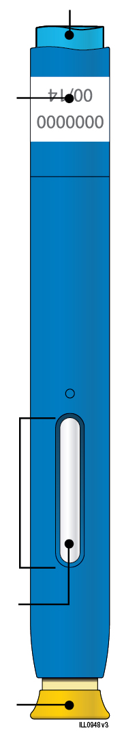 | 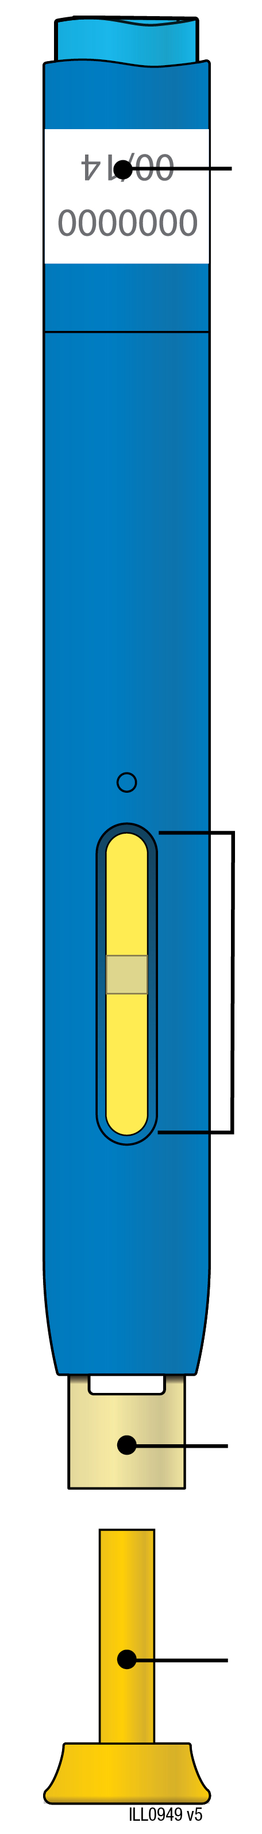
  Expiry date
  Window
  Medicine
  Yellow cap on
  Expiry date
  Yellow window (injection complete)
  Yellow safety guard
  Yellow cap off
Important: Needle is inside

Important
Before you use an AMGEVITA pre-filled pen, read this important information:

Using your AMGEVITA pre-filled pen
● | It is important that you do not try to give the injection unless you or your caregiver has received training.
● | Do not use an AMGEVITA pre-filled pen if it has been dropped on a hard surface. Part of the AMGEVITA pre-filled pen may be broken even if you cannot see the break. Use a new AMGEVITA pre-filled pen.

Step 1: Prepare

A. | Remove one AMGEVITA pre-filled pen from the package.
Carefully lift the pre-filled pen straight up out of the box.

Put the original package with any unused pre-filled pens back in the refrigerator.

For a more comfortable injection, leave the pre-filled pen at room temperature for 15 to 30 minutes before injecting.

● | Do not put the pre-filled pen back in the refrigerator once it has reached room temperature.
● | Do not try to warm the pre-filled pen by using a heat source such as hot water or microwave.
● | Do not shake the pre-filled pen.
● | Do not remove the yellow cap from the pre-filled pen yet.

B. | Inspect the AMGEVITA pre-filled pen.

Yellow cap on | Window | Medicine

Make sure the medicine in the window is clear and colourless to slightly yellow.

● | Do not use the pre-filled pen if:
- The medicine is cloudy or discoloured, or contains flakes or particles.
- Any part appears cracked or broken.
- The pre-filled pen has been dropped on a hard surface.
- The yellow cap is missing or not securely attached.
- The expiry date printed on the label has passed.
In all cases, use a new pre-filled pen.

C. | Gather all materials needed for your injection.
Wash your hands thoroughly with soap and water.
On a clean, well-lit work surface, place a new, pre-filled pen.

You will also need these additional items, as they are not included in the carton:
● | Alcohol wipes
● | Cotton ball or gauze pad
● | Plaster
● | Sharps disposal container


D. | Prepare and clean your injection site.
Belly
Thigh

You can use:
● | Your thigh
● | Belly, except for a 2-inch (5 centimetre) area right around your belly button
Clean your injection site with an alcohol wipe. Let your skin dry.
● | Do not touch this area again before injecting.
● | If you want to use the same injection site, make sure it is not the same spot on the injection site you used for a previous injection.
 | - Do not inject into areas where the skin is tender, bruised, red, or hard. Avoid injecting into areas with scars or stretch marks.
● | If you have psoriasis, you should avoid injecting directly into raised, thick, red, or scaly skin patch or lesion.

Step 2: Get ready

E. | Pull the yellow cap straight off when you are ready to inject.
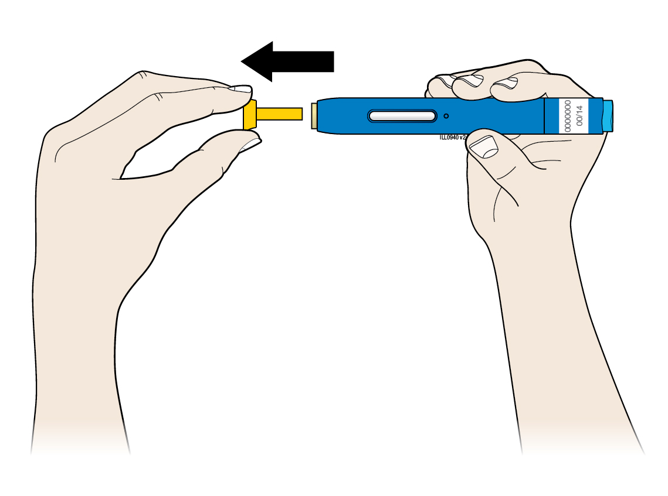
It is normal to see a drop of liquid at the end of the needle or yellow safety guard.
● | Do not twist or bend the yellow cap.
● | Do not put the yellow cap back onto the pre-filled pen.
● | Do not remove the yellow cap from the pre-filled pen until you are ready to inject.

F. | Stretch or pinch your injection site to create a firm surface.
Stretch method
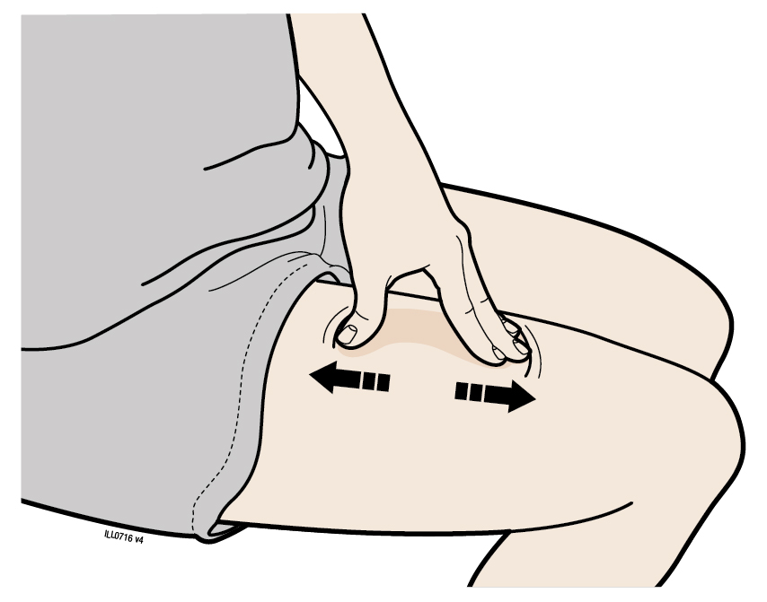
Stretch the skin firmly by moving your thumb and fingers in opposite directions, creating an area about 2 inches (5 centimetres) wide.
OR
Pinch method
Pinch the skin firmly between your thumb and fingers, creating an area about 2 inches (5 centimetres) wide.
Important: Keep the skin stretched or pinched while injecting.

Step 3: Inject

G. | Hold the stretch or pinch. With the yellow cap off, place the pre-filled pen on your skin at 90 degrees.
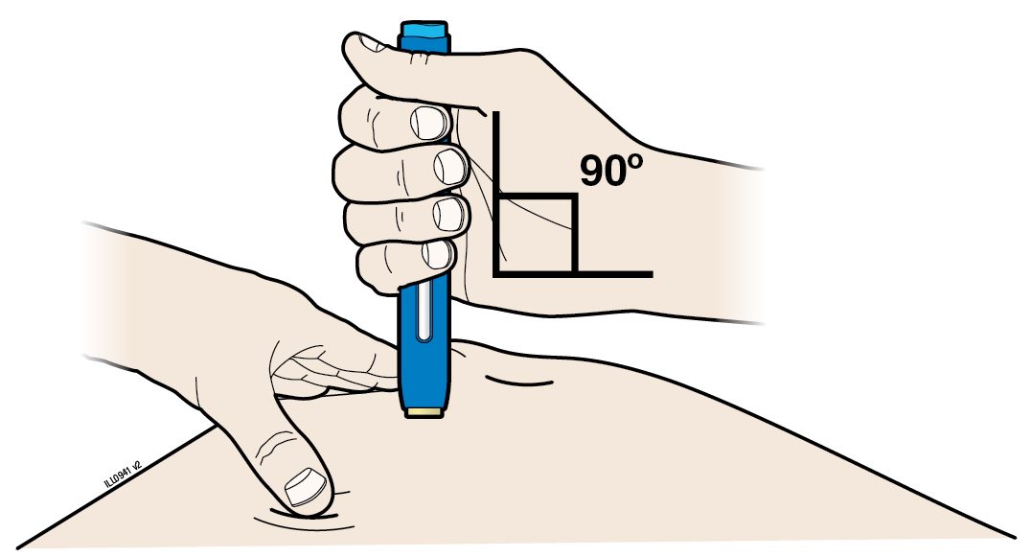
Important: Do not touch the blue start button yet.

H. | Firmly push the pre-filled pen down onto the skin until it stops moving.
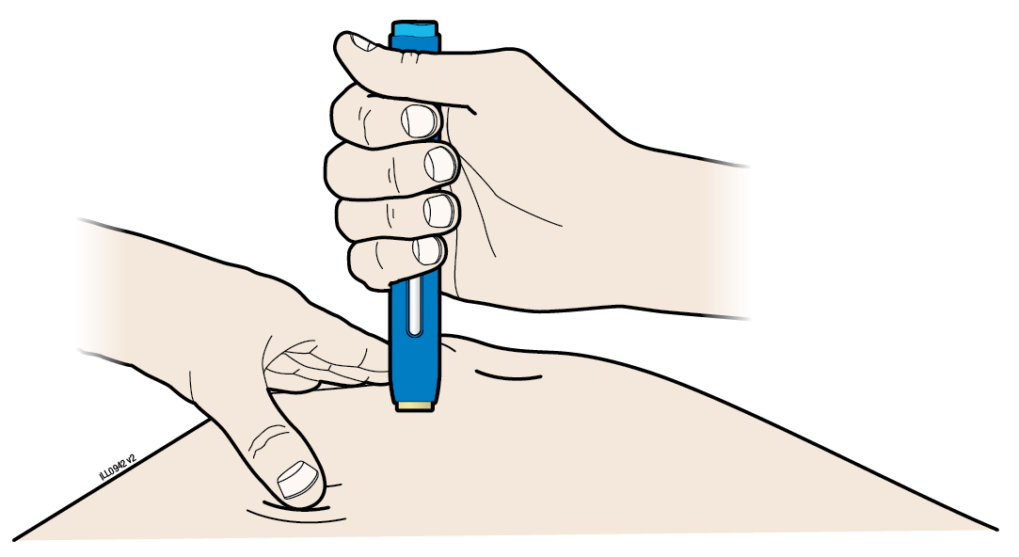 | 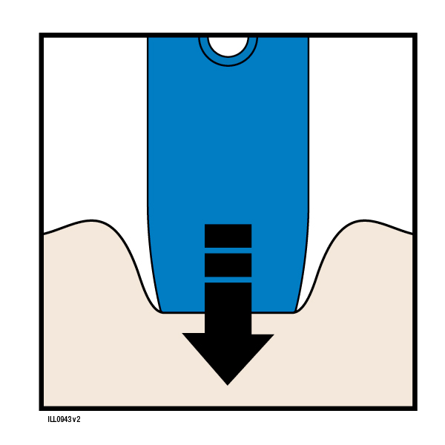Push down

Important: You must push all the way down but do not touch the blue start button until you are ready to inject.

I. | When you are ready to inject, press the blue start button. You will hear a click.
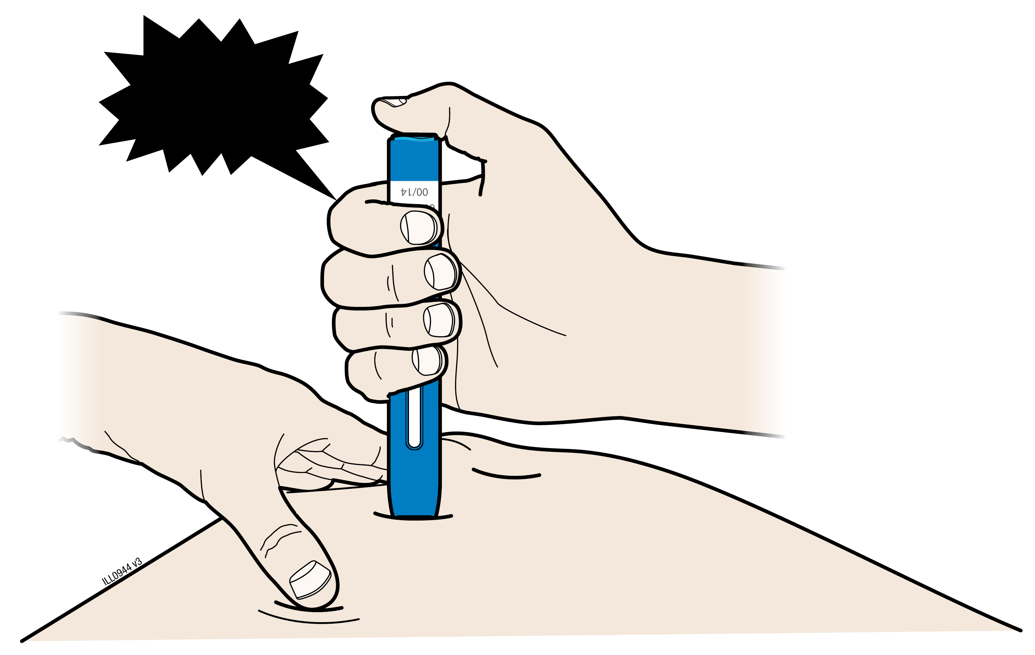
“Click”

J. | Keep pushing down on your skin. Your injection could take about 10 seconds.
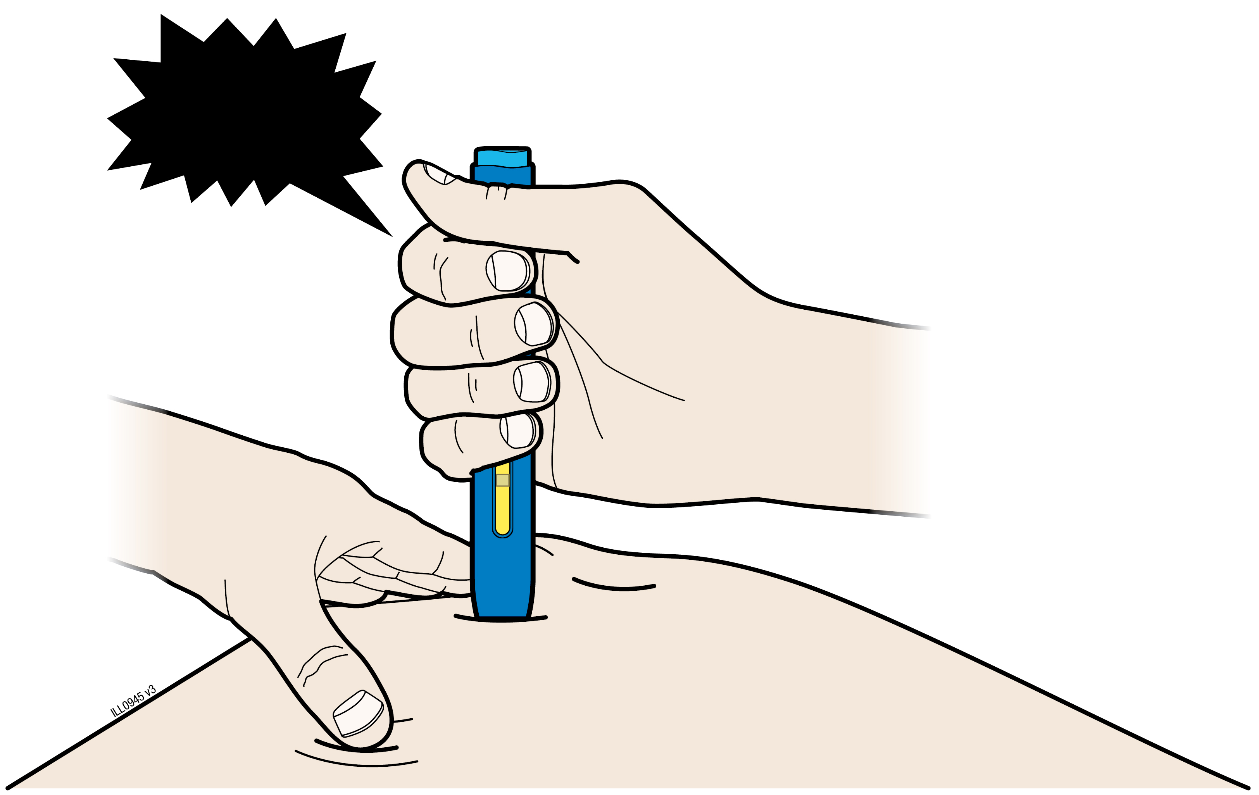  “Click” |  | ~10s
 |  |  | 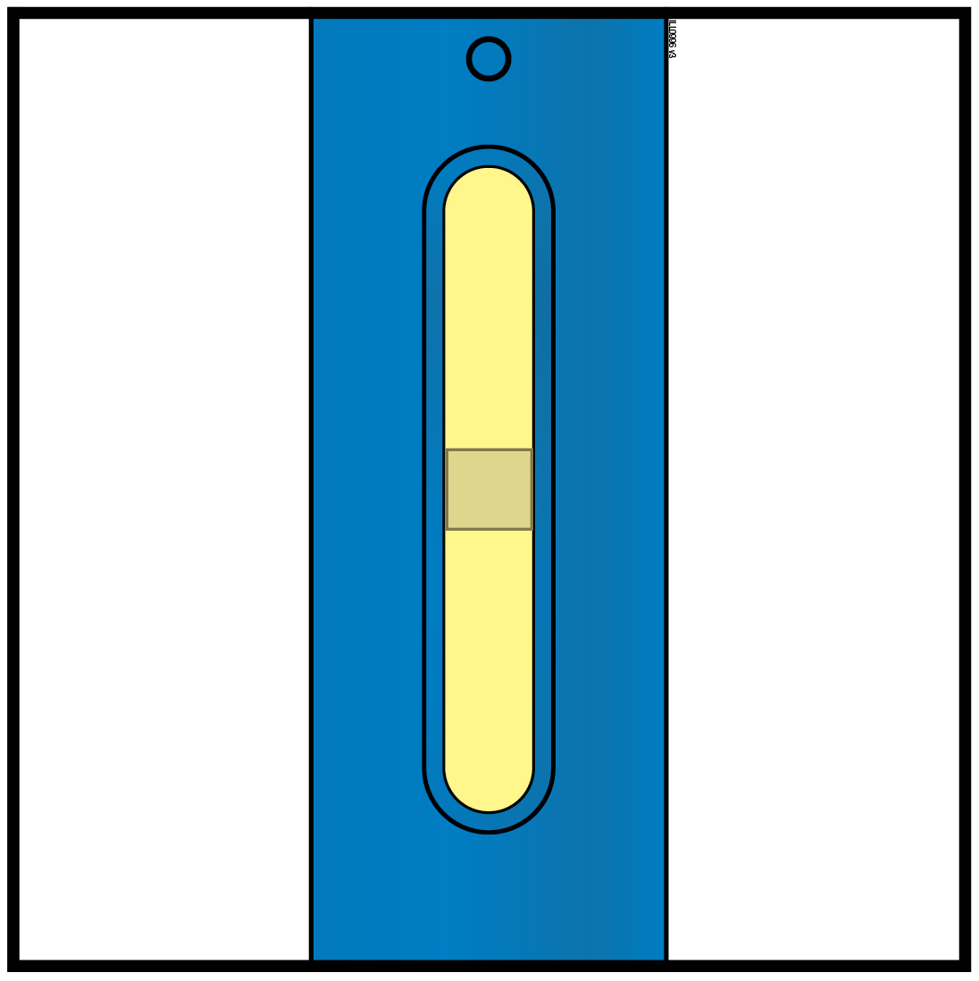
The window turns yellow when the injection is done.
You may hear a second click.
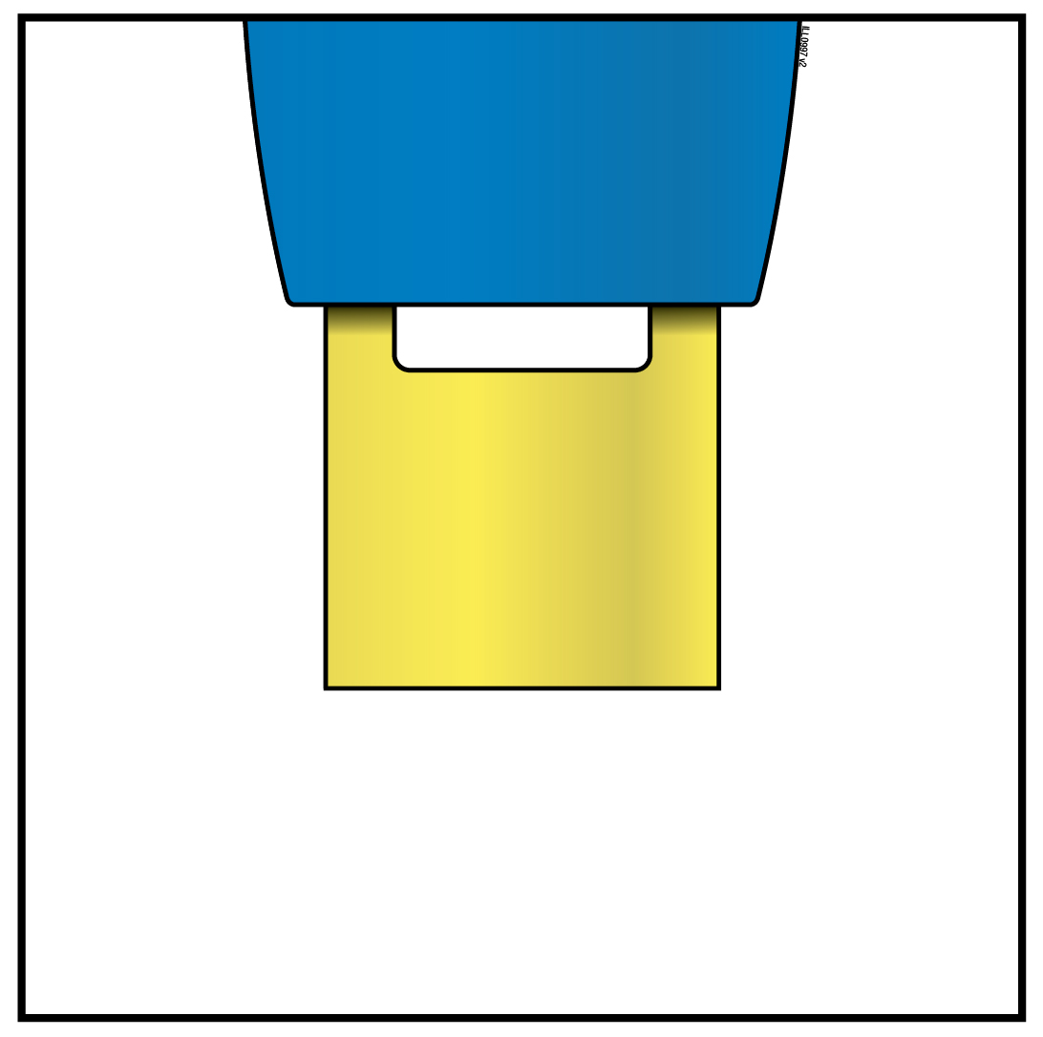 | Note: After you remove the pre-filled pen from your  skin, the needle will be automatically covered.
Important: When you remove the pre-filled pen, if the window has not turned yellow, or if it looks like the medicine is still injecting, this means you have not received a full dose. Call your doctor immediately.

Step 4: Finish

K. | Discard the used pre-filled pen and the yellow cap.
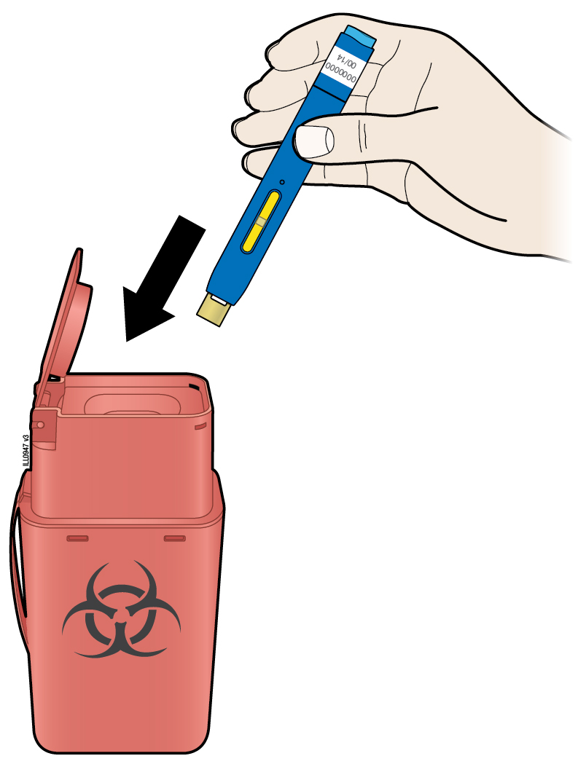
● |  | Put the used pre-filled pen in a sharps disposal container immediately after use. Do not throw away (dispose of) the pre-filled pen in your household waste.
● |  | Talk with your doctor or pharmacist about proper disposal. There may be local guidelines for disposal.
● |  | Do not reuse the pre-filled pen.
● |  | Do not recycle the pre-filled pen or sharps disposal container or throw them into the household waste.
Important: Always keep the sharps disposal container out of the sight and reach of children.

L. | Examine the injection site.
If there is blood, press a cotton ball or gauze pad on your injection site. Do not rub the injection site. Apply a plaster if needed.

Package leaflet: Information for the user

AMGEVITA 20 mg solution for injection in pre-filled syringe

AMGEVITA 40 mg solution for injection in pre-filled syringe

AMGEVITA 80 mg solution for injection in pre-filled syringe
adalimumab

Read all of this leaflet carefully before you start using this medicine because it contains important information for you.
- Keep this leaflet. You may need to read it again.
- Your doctor will also give you a Patient Reminder Card, which contains important safety information that you need to be aware of before you are given AMGEVITA and during treatment with AMGEVITA. Keep this Patient Reminder Card with you.
- If you have any further questions, ask your doctor or pharmacist.
- This medicine has been prescribed for you only. Do not pass it on to others. It may harm them, even if their signs of illness are the same as yours.
- If you get any side effects, talk to your doctor or pharmacist. This includes any possible side effects not listed in this leaflet (see section 4).

What is in this leaflet

1. What AMGEVITA is and what it is used for
2. What you need to know before you use AMGEVITA
3. How to use AMGEVITA
4. Possible side effects
5. How to store AMGEVITA
6. Contents of the pack and other information

1. What AMGEVITA is and what it is used for

AMGEVITA contains the active substance adalimumab, a medicine that acts on your body’s immune (defence) system.

AMGEVITA is intended for the treatment of the inflammatory diseases described below:
  - Rheumatoid arthritis
  - Polyarticular juvenile idiopathic arthritis
  - Enthesitis-related arthritis
  - Ankylosing spondylitis
  - Axial spondyloarthritis without radiographic evidence of ankylosing spondylitis
  - Psoriatic arthritis
  - Plaque psoriasis
  - Hidradenitis suppurativa
  - Crohn’s disease
  - Ulcerative colitis
  - Non-infectious uveitis

The active ingredient in AMGEVITA, adalimumab, is a human monoclonal antibody. Monoclonal antibodies are proteins that attach to a specific target.

The target of adalimumab is a protein called tumour necrosis factor (TNFα), which is involved in the immune (defence) system and is present at increased levels in the inflammatory diseases listed above. By attaching to TNFα, AMGEVITA decreases the process of inflammation in these diseases.

Rheumatoid arthritis

Rheumatoid arthritis is an inflammatory disease of the joints.

AMGEVITA is used to treat rheumatoid arthritis in adults. If you have moderate to severe active rheumatoid arthritis, you may first be given other disease-modifying medicines, such as methotrexate. If you do not respond well enough to these medicines, you will be given AMGEVITA to treat your rheumatoid arthritis.

AMGEVITA can also be used to treat severe, active and progressive rheumatoid arthritis without previous methotrexate treatment.

AMGEVITA slows down the damage to the cartilage and bone of the joints caused by the disease and to improve physical function.

Usually, AMGEVITA is used with methotrexate. If your doctor determines that methotrexate is inappropriate, AMGEVITA can be given alone.

Polyarticular juvenile idiopathic arthritis and enthesitis-related arthritis

Polyarticular juvenile idiopathic arthritis and enthesitis-related arthritis are inflammatory diseases of the joints that usually first appear in childhood.

AMGEVITA is used to treat polyarticular juvenile idiopathic arthritis in patients from 2 years and enthesitis-related arthritis in patients from 6 years. You may first be given other disease-modifying medicines, such as methotrexate. If you do not respond well enough to these medicines, you will be given AMGEVITA to treat your polyarticular juvenile idiopathic arthritis or enthesitis-related arthritis.

Ankylosing spondylitis and axial spondyloarthritis without radiographic evidence of ankylosing spondylitis

Ankylosing spondylitis and axial spondyloarthritis without radiographic evidence of ankylosing spondylitis, are inflammatory diseases of the spine.

AMGEVITA is used to treat ankylosing spondylitis and axial spondyloarthritis without radiographic evidence of ankylosing spondylitis in adults. If you have ankylosing spondylitis or axial spondyloarthritis without radiographic evidence of ankylosing spondylitis, you will first be given other medicines. If you do not respond well enough to these medicines, you will be given AMGEVITA to reduce the signs and symptoms of your disease.

Psoriatic arthritis

Psoriatic arthritis is an inflammation of the joints associated with psoriasis.

AMGEVITA is used to treat psoriatic arthritis in adults. AMGEVITA slows down the damage to the cartilage and bone of the joints caused by the disease and to improve physical function.

Plaque psoriasis in adults and children

Plaque psoriasis is a skin condition that causes red, flaky, crusty patches of skin covered with silvery scales. Plaque psoriasis can also affect the nails, causing them to crumble, become thickened and lift away from the nail bed which can be painful. Psoriasis is believed to be caused by a problem with the body’s immune system that leads to an increased production of skin cells.

AMGEVITA is used to treat moderate to severe plaque psoriasis in adults. AMGEVITA is also used to treat severe plaque psoriasis in children and adolescents aged 4 to 17 years for whom topical therapy and phototherapies have either not worked very well or are not suitable.

Hidradenitis suppurativa in adults and adolescents

Hidradenitis suppurativa (sometimes called acne inversa) is a chronic and often painful inflammatory skin disease. Symptoms may include tender nodules (lumps) and abscesses (boils) that may leak pus. It most commonly affects specific areas of the skin, such as under the breasts, the armpits, inner thighs, groin and buttocks. Scarring may also occur in affected areas.

AMGEVITA is used to treat hidradenitis suppurativa in adults and adolescents from 12 years of age. AMGEVITA can reduce the number of nodules and abscesses you have, and the pain that is often associated with the disease. You may first be given other medicines. If you do not respond well enough to these medicines, you will be given AMGEVITA.

Crohn’s disease in adults and children

Crohn’s disease is an inflammatory disease of the digestive tract.

AMGEVITA is used to treat Crohn’s disease in adults and children aged 6 to 17 years. If you have Crohn’s disease you will first be given other medicines. If you do not respond well enough to these medicines, you will be given AMGEVITA to reduce the signs and symptoms of your Crohn’s disease.

Ulcerative colitis in adults and children

Ulcerative colitis is an inflammatory disease of the large intestine.

AMGEVITA is used to treat moderate to severe ulcerative colitis in adults and children aged 6 to 17 years. If you have ulcerative colitis you may first be given other medicines. If you do not respond well enough to these medicines, you will be given AMGEVITA to reduce the signs and symptoms of your disease.

Non-infectious uveitis in adults and children

Non-infectious uveitis is an inflammatory disease affecting certain parts of the eye.

AMGEVITA is used to treat
- Adults with non-infectious uveitis with inflammation affecting the back of the eye.
- Children from 2 years of age with chronic non-infectious uveitis with inflammation affecting the front of the eye.

This inflammation may lead to a decrease of vision and/or the presence of floaters in the eye (black dots or wispy lines that move across the field of vision). AMGEVITA works by reducing this inflammation.

2. What you need to know before you use AMGEVITA

Do not use AMGEVITA:

- if you are allergic to adalimumab or any of the other ingredients of this medicine (listed in section 6).
- if you have a severe infection, including active tuberculosis, sepsis (blood infection) or other opportunistic infections (unusual infections associated with a weakened immune system) (see “Warnings and precautions”). It is important that you tell your doctor if you have symptoms of infections, e.g. fever, wounds, feeling tired, dental problems.
- if you have moderate or severe heart failure. It is important to tell your doctor if you have had or have a serious heart condition (see “Warnings and precautions”).

Warnings and precautions

Talk to your doctor or pharmacist before using AMGEVITA:

Allergic reactions

- If you experience allergic reactions with symptoms such as chest tightness, wheezing, dizziness, swelling or rash do not inject more AMGEVITA and contact your doctor immediately since, in rare cases, these reactions can be life threatening.

Infections

- If you have an infection, including long-term or localised infection (for example, leg ulcer) consult your doctor before starting AMGEVITA. If you are unsure, contact your doctor.
- You might get infections more easily while you are receiving AMGEVITA treatment. This risk may increase if your lung function is impaired. These infections may be serious and include tuberculosis, infections caused by viruses, fungi, parasites or bacteria, or other opportunistic infections and sepsis that may, in rare cases, be life-threatening. It is important to tell your doctor if you get symptoms such as fever, wounds, feeling tired or dental problems. Your doctor may recommend temporary discontinuation of AMGEVITA.

Tuberculosis

- As cases of tuberculosis have been reported in patients treated with adalimumab, your doctor will check you for signs and symptoms of tuberculosis before starting AMGEVITA. This will include a thorough medical evaluation including your medical history and appropriate screening tests (for example chest x-ray and a tuberculin test). The conduct and results of these tests should be recorded on your Patient Reminder Card. It is very important that you tell your doctor if you have ever had tuberculosis, or if you have been in close contact with someone who has had tuberculosis.
- Tuberculosis can develop during therapy even if you have received preventative treatment for tuberculosis.
- If symptoms of tuberculosis (persistent cough, weight loss, listlessness, mild fever), or any other infection appear during or after therapy, tell your doctor immediately.

Travel / recurrent infection

- Advise your doctor if you reside or travel in regions where fungal infections such as histoplasmosis, coccidioidomycosis or blastomycosis are endemic.
- Advise your doctor if you have a history of recurrent infections or other conditions that increase the risk of infections.

Hepatitis B virus

- Advise your doctor if you are a carrier of the hepatitis B virus (HBV), if you have active HBV or if you think you might be at risk of contracting HBV. Your doctor should test you for HBV. AMGEVITA can cause reactivation of HBV in people who carry this virus. In some rare cases, especially if you are taking other medicines that suppress the immune system, reactivation of HBV can be life-threatening.

Age over 65 years

- If you are over 65 years you may be more susceptible to infections while taking AMGEVITA. You and your doctor should pay special attention to signs of infection while you are being treated with AMGEVITA. It is important to tell your doctor if you get symptoms of infections, such as fever, wounds, feeling tired or dental problems.

Surgery or dental procedures

- If you are about to undergo surgery or dental procedures please inform your doctor that you are taking AMGEVITA. Your doctor may recommend temporary discontinuation of AMGEVITA.

Demyelinating disease

- If you have or develop demyelinating disease such as multiple sclerosis, your doctor will decide if you should receive or continue to receive AMGEVITA. Tell your doctor immediately if you experience symptoms like changes in your vision, weakness in your arms or legs or numbness or tingling in any part of your body.

Vaccinations

- Certain vaccines contain living but weakened forms of disease-causing bacteria or viruses that may cause infections and should not be given while receiving AMGEVITA. Please check with your doctor before you receive any vaccines. It is recommended that children, if possible, be brought up to date with all immunisations in agreement with current immunisation guidelines prior to initiating AMGEVITA therapy.
- If you received AMGEVITA while you were pregnant, your baby may be at higher risk for getting such an infection for up to approximately five months after the last dose you received during pregnancy. It is important that you tell your baby's doctors and other health care professionals about your AMGEVITA use during your pregnancy so they can decide when your baby should receive any vaccine.

Heart failure

- If you have mild heart failure and you are being treated with AMGEVITA, your heart failure status must be closely monitored by your doctor. It is important to tell your doctor if you have had or have a serious heart condition. If you develop new or worsening symptoms of heart failure (e.g. shortness of breath, or swelling of your feet), you must contact your doctor immediately. Your doctor will decide if you should receive AMGEVITA.

Fever, bruising, bleeding or looking pale

- In some patients the body may fail to produce enough of the blood cells that help your body fight infections or help you to stop bleeding. If you develop a fever that does not go away, bruise or bleed very easily or look very pale, call your doctor right away. Your doctor may decide to stop treatment.

Cancer

- There have been very rare cases of certain kinds of cancer in children and adult patients taking adalimumab or other TNF blockers. People with more serious rheumatoid arthritis that have had the disease for a long time may have a higher than average risk of getting lymphoma (a cancer that affects the lymph system), and leukaemia (a cancer that affects the blood and bone marrow).
- If you take AMGEVITA the risk of getting lymphoma, leukaemia, or other cancers may increase. On rare occasions, a specific and severe type of lymphoma has been observed in patients taking adalimumab. Some of those patients were also treated with azathioprine or 6-mercaptopurine. Tell your doctor if you are taking azathioprine or 6-mercaptopurine with AMGEVITA.
- In addition, cases of non-melanoma skin cancer have been observed in patients taking adalimumab. If new skin lesions appear during or after therapy or if existing lesions change appearance, tell your doctor.
- There have been cases of cancers, other than lymphoma in patients with a specific type of lung disease called Chronic Obstructive Pulmonary Disease (COPD) treated with another TNF blocker. If you have COPD, or are a heavy smoker, you should discuss with your doctor whether treatment with a TNF blocker is appropriate for you.

Autoimmune disease

- On rare occasions, treatment with AMGEVITA could result in lupus-like syndrome. Contact your doctor if symptoms such as persistent unexplained rash, fever, joint pain or tiredness occur.

In order to improve the traceability of this medicine, your doctor or pharmacist should record the name and the lot number of the product you have been given in your patient file. You may also wish to make a note of these details in case you are asked for this information in the future.

Children and adolescents

- Vaccinations: if possible children should be up to date with all vaccinations before using AMGEVITA.

- Do not give AMGEVITA to children with polyarticular juvenile idiopathic arthritis below the age of 2 years.

- Do not give AMGEVITA to children with plaque psoriasis below the age of 4 years.

- Do not give AMGEVITA to children with Crohn’s disease or ulcerative colitis below the age of 6 years.

Other medicines and AMGEVITA

Tell your doctor or pharmacist if you are taking, have recently taken or might take any other medicines.

AMGEVITA can be taken together with methotrexate or certain disease-modifying anti-rheumatic agents (sulfasalazine, hydroxychloroquine, leflunomide and injectable gold preparations), steroids or pain medications including non-steroidal anti-inflammatory drugs (NSAIDs).

You should not take AMGEVITA with medicines containing the active substances, anakinra or abatacept due to increased risk of serious infection. If you have questions, please ask your doctor.

Pregnancy and breast-feeding

- You should consider the use of adequate contraception to prevent pregnancy and continue its use for at least 5 months after the last AMGEVITA treatment.
- If you are pregnant, think you may be pregnant or are planning to have a baby, ask your doctor for advice about taking this medicine.
- AMGEVITA should only be used during a pregnancy if needed.
- According to a pregnancy study, there was no higher risk of birth defects when the mother had received AMGEVITA during pregnancy compared with mothers with the same disease who did not receive AMGEVITA.
- AMGEVITA can be used during breast-feeding.
- If you receive AMGEVITA during your pregnancy, your baby may have a higher risk for getting an infection.
- It is important that you tell your baby’s doctors and other health care professionals about your AMGEVITA use during your pregnancy before the baby receives any vaccine. For more information on vaccines see the “Warnings and precautions” section.

Driving and using machines

AMGEVITA may have a minor influence on your ability to drive, cycle or use machines. Room spinning sensation (vertigo) and vision disturbances may occur after taking AMGEVITA.

AMGEVITA contains sodium

This medicine contains less than 1 mmol of sodium (23 mg) per 0.8 mL dose, that is to say essentially ‘sodium-free’.

3. How to use AMGEVITA

Always use this medicine exactly as your doctor or pharmacist has told you. Check with your doctor or pharmacist if you are not sure.

Adults with rheumatoid arthritis, psoriatic arthritis, ankylosing spondylitis or axial spondyloarthritis without radiographic evidence of ankylosing spondylitis

AMGEVITA is injected under the skin (subcutaneous use). The usual dose for adults with rheumatoid arthritis, ankylosing spondylitis, axial spondyloarthritis without radiographic evidence of ankylosing spondylitis, and for patients with psoriatic arthritis is 40 mg given every other week as a single dose.

In rheumatoid arthritis, methotrexate is continued while using AMGEVITA. If your doctor determines that methotrexate is inappropriate, AMGEVITA can be given alone.

If you have rheumatoid arthritis and you do not receive methotrexate with your AMGEVITA therapy, your doctor may decide to give 40 mg every week or 80 mg every other week.

Children, adolescents and adults with polyarticular juvenile idiopathic arthritis

Children and adolescents from 2 years of age weighing 10 kg to less than 30 kg

The recommended dose of AMGEVITA is 20 mg every other week.

Children, adolescents and adults from 2 years of age weighing 30 kg or more

The recommended dose of AMGEVITA is 40 mg every other week.

Children, adolescents and adults with enthesitis-related arthritis

Children and adolescents from 6 years of age weighing 15 kg to less than 30 kg

The recommended dose of AMGEVITA is 20 mg every other week.

Children, adolescents and adults from 6 years of age weighing 30 kg or more

The recommended dose of AMGEVITA is 40 mg every other week.

Adults with plaque psoriasis

The usual dose for adults with plaque psoriasis is an initial dose of 80 mg, followed by 40 mg given every other week starting one week after the initial dose. You should continue to inject AMGEVITA for as long as your doctor has told you. Depending on your response, your doctor may increase the dose to 40 mg every week or 80 mg every other week.

Children and adolescents with plaque psoriasis

Children and adolescents from 4 to 17 years of age weighing 15 kg to less than 30 kg

The recommended dose of AMGEVITA is an initial dose of 20 mg, followed by 20 mg one week later. Thereafter, the usual dose is 20 mg every other week.

Children and adolescents from 4 to 17 years of age weighing 30 kg or more

The recommended dose of AMGEVITA is an initial dose of 40 mg, followed by 40 mg one week later. Thereafter, the usual dose is 40 mg every other week.

Adults with hidradenitis suppurativa

The usual dose regimen for hidradenitis suppurativa is an initial dose of 160 mg (two 80 mg injections in one day or one 80 mg injection per day for two consecutive days), followed by an 80 mg dose two weeks later. After two further weeks, continue with a dose of 40 mg every week or 80 mg every other week, as prescribed by your doctor. It is recommended that you use an antiseptic wash daily on the affected areas.

Adolescents with hidradenitis suppurativa from 12 to 17 years of age weighing 30 kg or more

The recommended dose of AMGEVITA is an initial dose of 80 mg, followed by 40 mg every other week starting one week later. If you have an inadequate response to AMGEVITA 40 mg every other week, your doctor may increase the dose to 40 mg every week or 80 mg every other week.

It is recommended that you use an antiseptic wash daily on the affected areas.

Adults with Crohn’s disease

The usual dose regimen for Crohn’s disease is 80 mg initially followed by 40 mg every other week two weeks later. If a faster response is required, your doctor may prescribe an initial dose of 160 mg (two 80 mg injections in one day or one 80 mg injection per day for two consecutive days), followed by 80 mg two weeks later, and thereafter as 40 mg every other week. Depending on your response, your doctor may increase the dose to 40 mg every week or 80 mg every other week.

Children and adolescents with Crohn's disease

Children and adolescents from 6 to 17 years of age weighing less than 40 kg

The usual dose regimen is 40 mg initially followed by 20 mg two weeks later. If a faster response is required, your doctor may prescribe an initial dose of 80 mg followed by 40 mg two weeks later.

Thereafter, the usual dose is 20 mg every other week. Depending on your response, your doctor may increase the dose frequency to 20 mg every week.

Children and adolescents from 6 to 17 years of age weighing 40 kg or more

The usual dose regimen is 80 mg initially followed by 40 mg two weeks later. If a faster response is required, your doctor may prescribe an initial dose of 160 mg (two 80 mg injections in one day or one 80 mg injection per day for two consecutive days) followed by 80 mg two weeks later.

Thereafter, the usual dose is 40 mg every other week. Depending on your response, your doctor may increase the dose to 40 mg every week or 80 mg every other week.

Adults with ulcerative colitis

The usual AMGEVITA dose for adults with ulcerative colitis is 160 mg initially (two 80 mg injections in one day or one 80 mg injection per day for two consecutive days) followed by 80 mg two weeks later, then 40 mg every other week. Depending on your response, your doctor may increase the dose to 40 mg every week or 80 mg every other week.

Children and adolescents with ulcerative colitis

Children and adolescents from 6 years of age weighing less than 40 kg

The usual AMGEVITA dose is 80 mg initially followed by 40 mg (as one 40 mg injection) two weeks later. Thereafter, the usual dose is 40 mg every other week.

Patients who turn 18 years of age while on 40 mg every other week, should continue their prescribed dose.

Children and adolescents from 6 years of age weighing 40 kg or more

The usual AMGEVITA dose is 160 mg (two 80 mg injections in one day or one 80 mg injection per day for two consecutive days) initially, followed by 80 mg two weeks later. Thereafter the usual dose is 80 mg every other week.

Patients who turn 18 years of age while on 80 mg every other week, should continue their prescribed dose.

Adults with non-infectious uveitis

The usual dose for adults with non-infectious uveitis is an initial dose of 80 mg, followed by 40 mg given every other week starting one week after the initial dose. You should continue to inject AMGEVITA for as long as your doctor has told you.

In non-infectious uveitis, corticosteroids or other medicines that influence the immune system may be continued while using AMGEVITA. AMGEVITA can also be given alone.

Children and adolescents with chronic non-infectious uveitis from 2 years of age

Children and adolescents from 2 years of age weighing less than 30 kg

The usual dose of AMGEVITA is 20 mg every other week with methotrexate.

Your doctor may also prescribe an initial dose of 40 mg which may be administered one week prior to the start of the usual dose.

Children and adolescents from 2 years of age weighing 30 kg or more

The usual dose of AMGEVITA is 40 mg every other week with methotrexate.

Your doctor may also prescribe an initial dose of 80 mg which may be administered one week prior to the start of the usual dose.

Method and route of administration

AMGEVITA is administered by injection under the skin (subcutaneous injection).

Detailed instructions on how to inject AMGEVITA are provided in “Instructions for use” section.

If you use more AMGEVITA than you should

If you accidentally inject AMGEVITA more frequently than told to by your doctor or pharmacist, call your doctor or pharmacist and tell him/her that you have taken more. Always take the outer carton of this medicine with you, even if it is empty.

If you forget to use AMGEVITA

If you forget to give yourself an injection, you should inject the next dose of AMGEVITA as soon as you remember. Then take your next dose as you would have on your originally scheduled day, had you not forgotten a dose.

If you stop using AMGEVITA

The decision to stop using AMGEVITA should be discussed with your doctor. Your symptoms may return upon discontinuation.

If you have any further questions on the use of this medicine, ask your doctor or pharmacist.

4. Possible side effects

Like all medicines, this medicine can cause side effects, although not everybody gets them. Most side effects are mild to moderate. However, some may be serious and require treatment. Side effects may occur at least up to 4 months after the last AMGEVITA injection.

Tell your doctor immediately if you notice any of the following signs of allergic reaction or heart failure:
- severe rash, hives or other signs of allergic reaction;
- swollen face, hands, feet;
- trouble breathing, swallowing;
- shortness of breath with exertion or upon lying down or swelling of the feet.

Tell your doctor as soon as possible if you notice any of the following:
- signs of infection such as fever, feeling sick, wounds, dental problems, burning on urination;
- feeling weak or tired;
- coughing;
- tingling;
- numbness;
- double vision;
- arm or leg weakness;
- signs of skin cancer such as a bump or open sore that doesn't heal;
- signs and symptoms suggestive of blood disorders such as persistent fever, bruising, bleeding, paleness.

The symptoms described above can be signs of the below listed side effects, which have been observed with adalimumab.

Very common (may affect more than 1 in 10 people)
- injection site reactions (including pain, swelling, redness or itching);
- respiratory tract infections (including cold, runny nose, sinus infection, pneumonia);
- headache;
- abdominal pain;
- nausea and vomiting;
- rash;
- musculoskeletal pain.

Common (may affect up to 1 in 10 people)
- serious infections (including blood poisoning and influenza);
- intestinal infections (including gastroenteritis);
- skin infections (including cellulitis and shingles);
- ear infections;
- oral infections (including tooth infections and cold sores);
- reproductive tract infections;
- urinary tract infection;
- fungal infections;
- joint infections;
- benign tumours;
- skin cancer;
- allergic reactions (including seasonal allergy);
- dehydration;
- mood swings (including depression);
- anxiety;
- difficulty sleeping;
- sensation disorders such as tingling, prickling or numbness;
- migraine;
- nerve root compression (including low back pain and leg pain);
- vision disturbances;
- eye inflammation;
- inflammation of the eye lid and eye swelling;
- vertigo (feeling of dizziness or spinning);
- sensation of heart beating rapidly;
- high blood pressure;
- flushing;
- haematoma;
- cough;
- asthma;
- shortness of breath;
- gastrointestinal bleeding;
- dyspepsia (indigestion, bloating, heart burn);
- acid reflux disease;
- sicca syndrome (including dry eyes and dry mouth);
- itching;
- itchy rash;
- bruising;
- inflammation of the skin (such as eczema);
- breaking of finger nails and toe nails;
- increased sweating;
- hair loss;
- new onset or worsening of psoriasis;
- muscle spasms;
- blood in urine;
- kidney problems;
- chest pain;
- oedema;
- fever;
- reduction in blood platelets which increases risk of bleeding or bruising;
- impaired healing.

Uncommon (may affect up to 1 in 100 people)
  - opportunistic infections (which include tuberculosis and other infections that occur when resistance to disease is lowered);
  - neurological infections (including viral meningitis);
  - eye infections;
  - bacterial infections;
  - diverticulitis (inflammation and infection of the large intestine);
  - cancer, including cancer that affects the lymph system (lymphoma) and melanoma (skin cancer);
  - immune disorders that could affect the lungs, skin and lymph nodes (most commonly presenting as sarcoidosis);
  - vasculitis (inflammation of blood vessels);
  - tremor;
  - neuropathy;
  - stroke;
  - hearing loss, buzzing;
  - sensation of heart beating irregularly such as skipped beats;
  - heart problems that can cause shortness of breath or ankle swelling;
  - heart attack;
  - a sac in the wall of a major artery, inflammation and clot of a vein, blockage of a blood vessel;
  - lung diseases causing shortness of breath (including inflammation);
  - pulmonary embolism (blockage in an artery of the lung);
  - pleural effusion (abnormal collection of fluid in the pleural space);
  - inflammation of the pancreas which causes severe pain in the abdomen and back;
  - difficulty in swallowing;
  - facial oedema;
  - gallbladder inflammation, gallbladder stones;
  - fatty liver;
  - night sweats;
  - scar;
  - abnormal muscle breakdown;
  - systemic lupus erythematosus (including inflammation of skin, heart, lung, joints and other organ systems);
  - sleep interruptions;
  - impotence;
  - inflammations.

Rare (may affect up to 1 in 1 000 people)
- leukaemia (cancer affecting the blood and bone marrow);
- severe allergic reaction with shock;
- multiple sclerosis;
- nerve disorders (such as eye nerve inflammation and Guillain-Barré syndrome that may cause muscle weakness, abnormal sensations, tingling in the arms and upper body);
- heart stops pumping;
- pulmonary fibrosis (scarring of the lung);
- intestinal perforation (hole in the wall of the gut);
- hepatitis (liver inflammation);
- reactivation of hepatitis B;
- autoimmune hepatitis (inflammation of the liver caused by the body's own immune system);
- cutaneous vasculitis (inflammation of blood vessels in the skin);
- Stevens-Johnson syndrome (life-threatening reaction with flu-like symptoms and blistering rash);
- facial oedema associated with allergic reactions;
- erythema multiforme (inflammatory skin rash);
- lupus-like syndrome;
- angioedema (localised swelling of the skin);
- lichenoid skin reaction (itchy reddish-purple skin rash).

Not known (frequency cannot be estimated from available data)
- hepatosplenic T-cell lymphoma (a rare blood cancer that is often fatal);
- Merkel cell carcinoma (a type of skin cancer);
- Kaposi’s sarcoma, a rare cancer related to infection with human herpes virus 8. Kaposi’s sarcoma most commonly appears as purple lesions on the skin;
- liver failure;
- worsening of a condition called dermatomyositis (seen as a skin rash accompanying muscle weakness);
- weight gain (for most patients, the weight gain was small).

Some side effects observed with adalimumab may not have symptoms and may only be discovered through blood tests. These include:

Very common (may affect more than 1 in 10 people)
- low blood measurements for white blood cells;
- low blood measurements for red blood cells;
- increased lipids in the blood;
- elevated liver enzymes.

Common (may affect up to 1 in 10 people)
- high blood measurements for white blood cells;
- low blood measurements for platelets;
- increased uric acid in the blood;
- abnormal blood measurements for sodium;
- low blood measurements for calcium;
- low blood measurements for phosphate;
- high blood sugar;
- high blood measurements for lactate dehydrogenase;
- autoantibodies present in the blood;
- low blood potassium.

Uncommon (may affect up to 1 in 100 people)
- elevated bilirubin measurement (liver blood test).

Rare (may affect up to 1 in 1 000 people)
- low blood measurements for white blood cells, red blood cells and platelet count.

Reporting of side effects

If you get any side effects, talk to your doctor or pharmacist. This includes any possible side effects not listed in this leaflet. You can also report side effects directly via the national reporting system listed in Appendix V. By reporting side effects you can help provide more information on the safety of this medicine.

5. How to store AMGEVITA

Keep this medicine out of the sight and reach of children.

Do not use this medicine after the expiry date which is stated on the label/blister and carton after EXP. The expiry date refers to the last day of that month.

Store in a refrigerator (2°C – 8°C). Do not freeze.

Store in the original carton in order to protect from light.

A single AMGEVITA pre-filled syringe may be stored at temperatures up to a maximum of 25°C for a period of up to 14 days. The pre-filled syringe must be protected from light, and discarded if not used within the 14-day period.

Do not throw away any medicines via wastewater or household waste. Ask your pharmacist how to throw away medicines you no longer use. These measures will help protect the environment.

6. Contents of the pack and other information

What AMGEVITA contains
- The active substance is adalimumab. Each pre-filled syringe contains 20 mg of adalimumab in 0.2 mL of solution, 40 mg of adalimumab in 0.4 mL of solution or 80 mg of adalimumab in 0.8 mL of solution.
- The other ingredients are L-lactic acid, sucrose, polysorbate 80, sodium hydroxide and water for injections.

What AMGEVITA looks like and contents of the pack

AMGEVITA is a clear and colourless to slightly yellow solution.

Each pack contains 1 single-use 20 mg pre-filled syringe (with yellow plunger rod).
Each pack contains 1, 2 or 6 single-use 40 mg pre-filled syringes (with blue plunger rod).
Each pack contains 1, 2 or 3 single-use 80 mg pre-filled syringes (with orange plunger rod).

Marketing Authorisation Holder and Manufacturer
Amgen Europe B.V.
Minervum 7061
4817 ZK Breda
The Netherlands

Marketing Authorisation Holder
Amgen Europe B.V.
Minervum 7061
4817 ZK Breda
The Netherlands

Manufacturer
Amgen Technology Ireland UC
Pottery Road
Dun Laoghaire
Co Dublin
Ireland

Manufacturer
Amgen NV
Telecomlaan 5-7
1831 Diegem
Belgium

For any information about this medicine, please contact the local representative of the Marketing Authorisation Holder:

België/Belgique/Belgien  s.a. Amgen n.v.  Tél/Tel: +32 (0)2 7752711 | Lietuva  Amgen Switzerland AG Vilniaus filialas  Tel. +370 5 219 7474
България  Амджен България ЕООД  Тел.: +359 (0)2 424 7440 | Luxembourg/Luxemburg  s.a. Amgen  Belgique/Belgien  Tél/Tel: +32 (0)2 7752711
Česká republika  Amgen s.r.o.  Tel: +420 221 773 500 | Magyarország  Amgen Kft.  Tel.: +36 1 35 44 700
Danmark  Amgen, filial af Amgen AB, Sverige  Tlf.: +45 39617500 | Malta  Amgen S.r.l.  Italy  Tel: +39 02 6241121
Deutschland  Amgen GmbH  Tel: +49 89 1490960 | Nederland  Amgen B.V.  Tel: +31 (0)76 5732500
Eesti  Amgen Switzerland AG Vilniaus filialas  Tel: +372 586 09553 | Norge  Amgen AB  Tlf: +47 23308000
Ελλάδα  Amgen Ελλάς Φαρμακευτικά Ε.Π.Ε.  Τηλ: +30 210 3447000 | Österreich  Amgen GmbH  Tel: +43 (0)1 50 217
España  Amgen S.A.  Tel: +34 93 600 18 60 | Polska  Amgen Biotechnologia Sp. z o.o.  Tel.: +48 22 581 3000
France  Amgen S.A.S.  Tél: +33 (0)9 69 363 363 | Portugal  Amgen Biofarmacêutica, Lda.  Tel: +351 21 4220606
Hrvatska  Amgen d.o.o.  Tel: +385 (0)1 562 57 20 | România  Amgen România SRL  Tel: +4021 527 3000
Ireland  Amgen Ireland Limited  Tel: +353 1 8527400 | Slovenija  AMGEN zdravila d.o.o.  Tel: +386 (0)1 585 1767
Ísland  Vistor  Sími: +354 535 7000 | Slovenská republika  Amgen Slovakia s.r.o.  Tel: +421 2 321 114 49
Italia  Amgen S.r.l.  Tel: +39 02 6241121 | Suomi/Finland  Amgen AB, sivuliike Suomessa/Amgen AB, filial i Finland  Puh/Tel: +358 (0)9 54900500
Kύπρος  C.A. Papaellinas Ltd  Τηλ: +357 22741 741 | Sverige  Amgen AB  Tel: +46 (0)8 6951100
Latvija
Amgen Switzerland AG Rīgas filiāle
Tel: +371 257 25888

This leaflet was last revised in

Other sources of information

Detailed information on this medicine is available on the European Medicines Agency web site: http://www.ema.europa.eu.

INSTRUCTIONS FOR USE
Getting to know your pre-filled syringe
 | 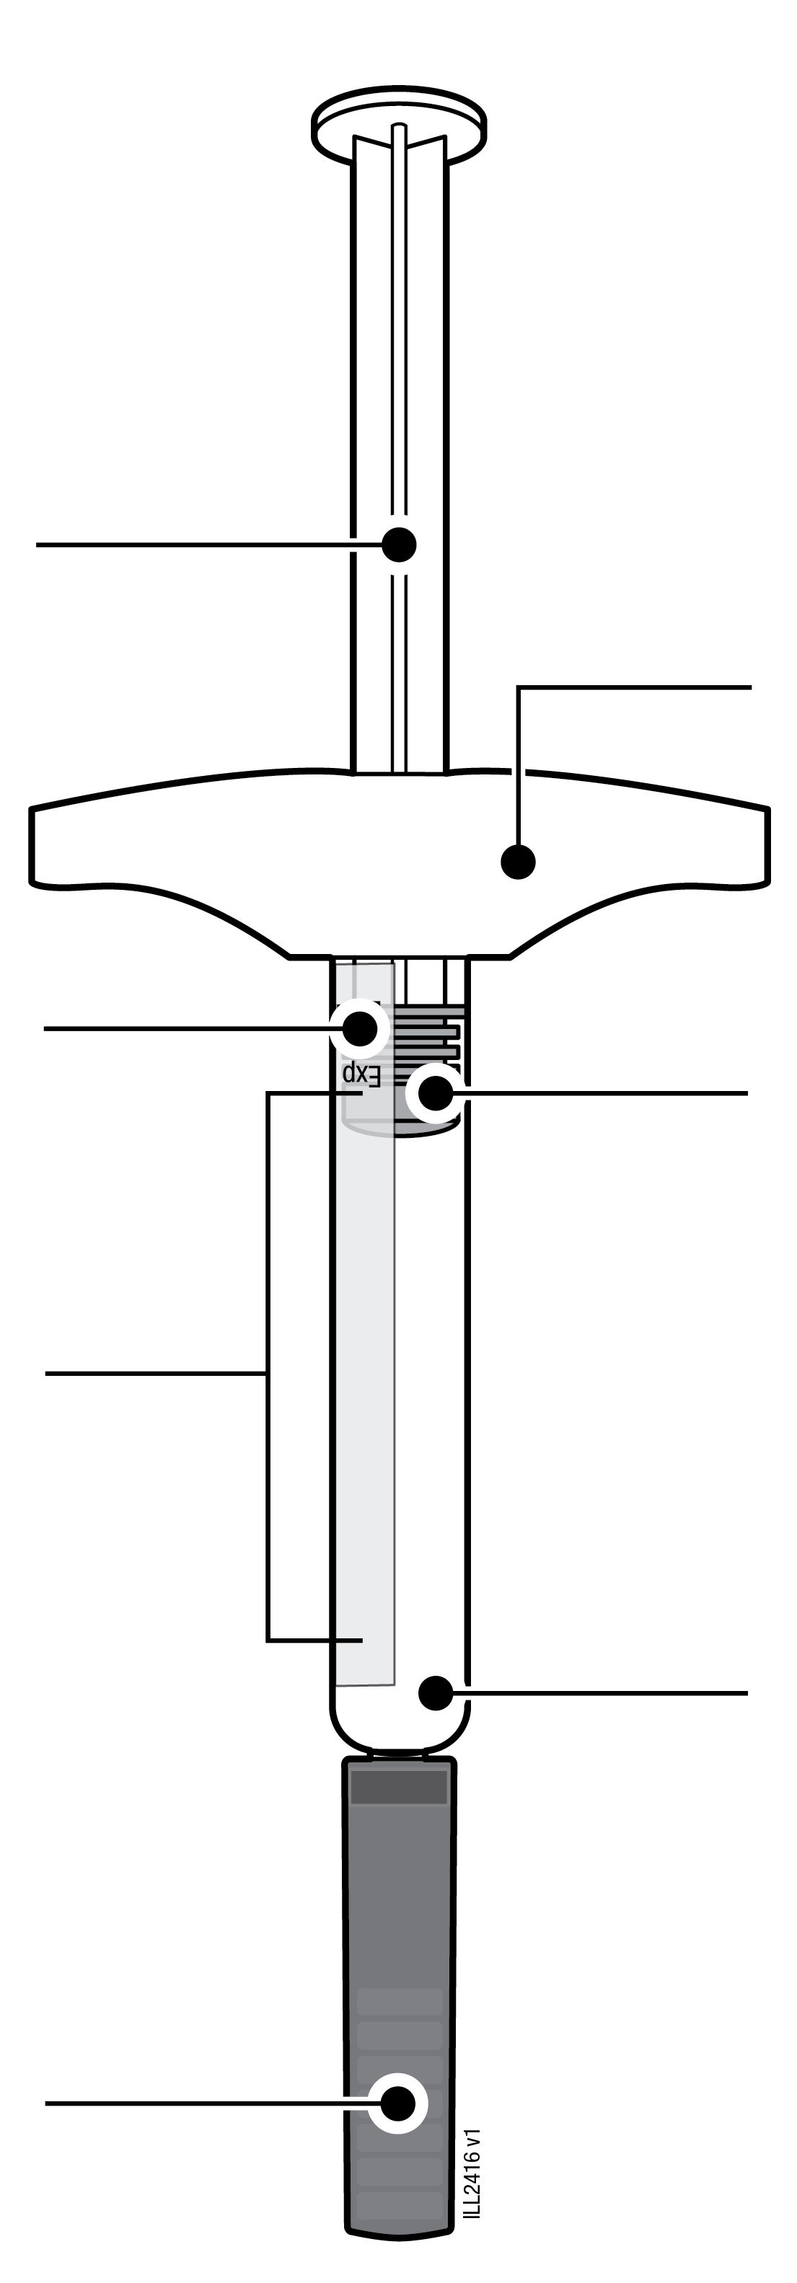
  Plunger rod
  Expiry date
  Syringe
  body
  Needle cap
  (needle inside)
  Finger grip
  Plunger (location may vary)
  Medicine

1 | Important information you need to know before injecting AMGEVITA
Dosing:
- AMGEVITA comes in three different doses: 20 mg/0.2 mL, 40 mg/0.4 mL, 80 mg/0.8 mL. Check your prescription to make sure you have the correct dose.
- The colour and look of the pre-filled syringe will be different for each dose. The amount of medicine in the pre-filled syringe will also be different for each dose.
- For example, it`s okay for the 20 mg/0.2 mL dose to have a small amount of medicine and the 80 mg/0.8 mL to have a large amount of medicine. Check the illustrations below to see what your dose looks like in the pre-filled syringe.

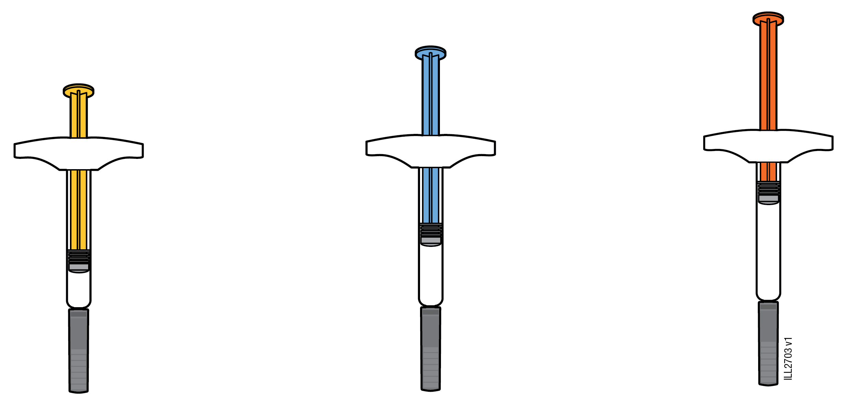

20 mg/0.2 mL 40 mg/0.4 mL 80 mg/0.8 mL

 | It is important that you do not try to give yourself the injection until you have fully read and understood this Instructions for Use and unless you have received training from your doctor or healthcare provider.
 | Do not use the pre-filled syringe if the carton is damaged or seal is broken.
 | Do not use the pre-filled syringe after the expiry date on the label.
 | Do not shake the pre-filled syringe.
 | Do not remove the needle cap from the pre-filled syringe until you are ready to inject.
 | Do not use the pre-filled syringe if it has been frozen.
 | Do not use the pre-filled syringe if it has been dropped on a hard surface. Part of the pre-filled syringe may be broken even if you cannot see the break. Use a new pre-filled syringe and call your doctor or healthcare provider.
Important: Keep the pre-filled syringe and sharps disposal container out of the sight and reach of children.

2 | Preparing to inject AMGEVITA
2a | Hold the pre-filled syringe by the body and remove it from the carton.
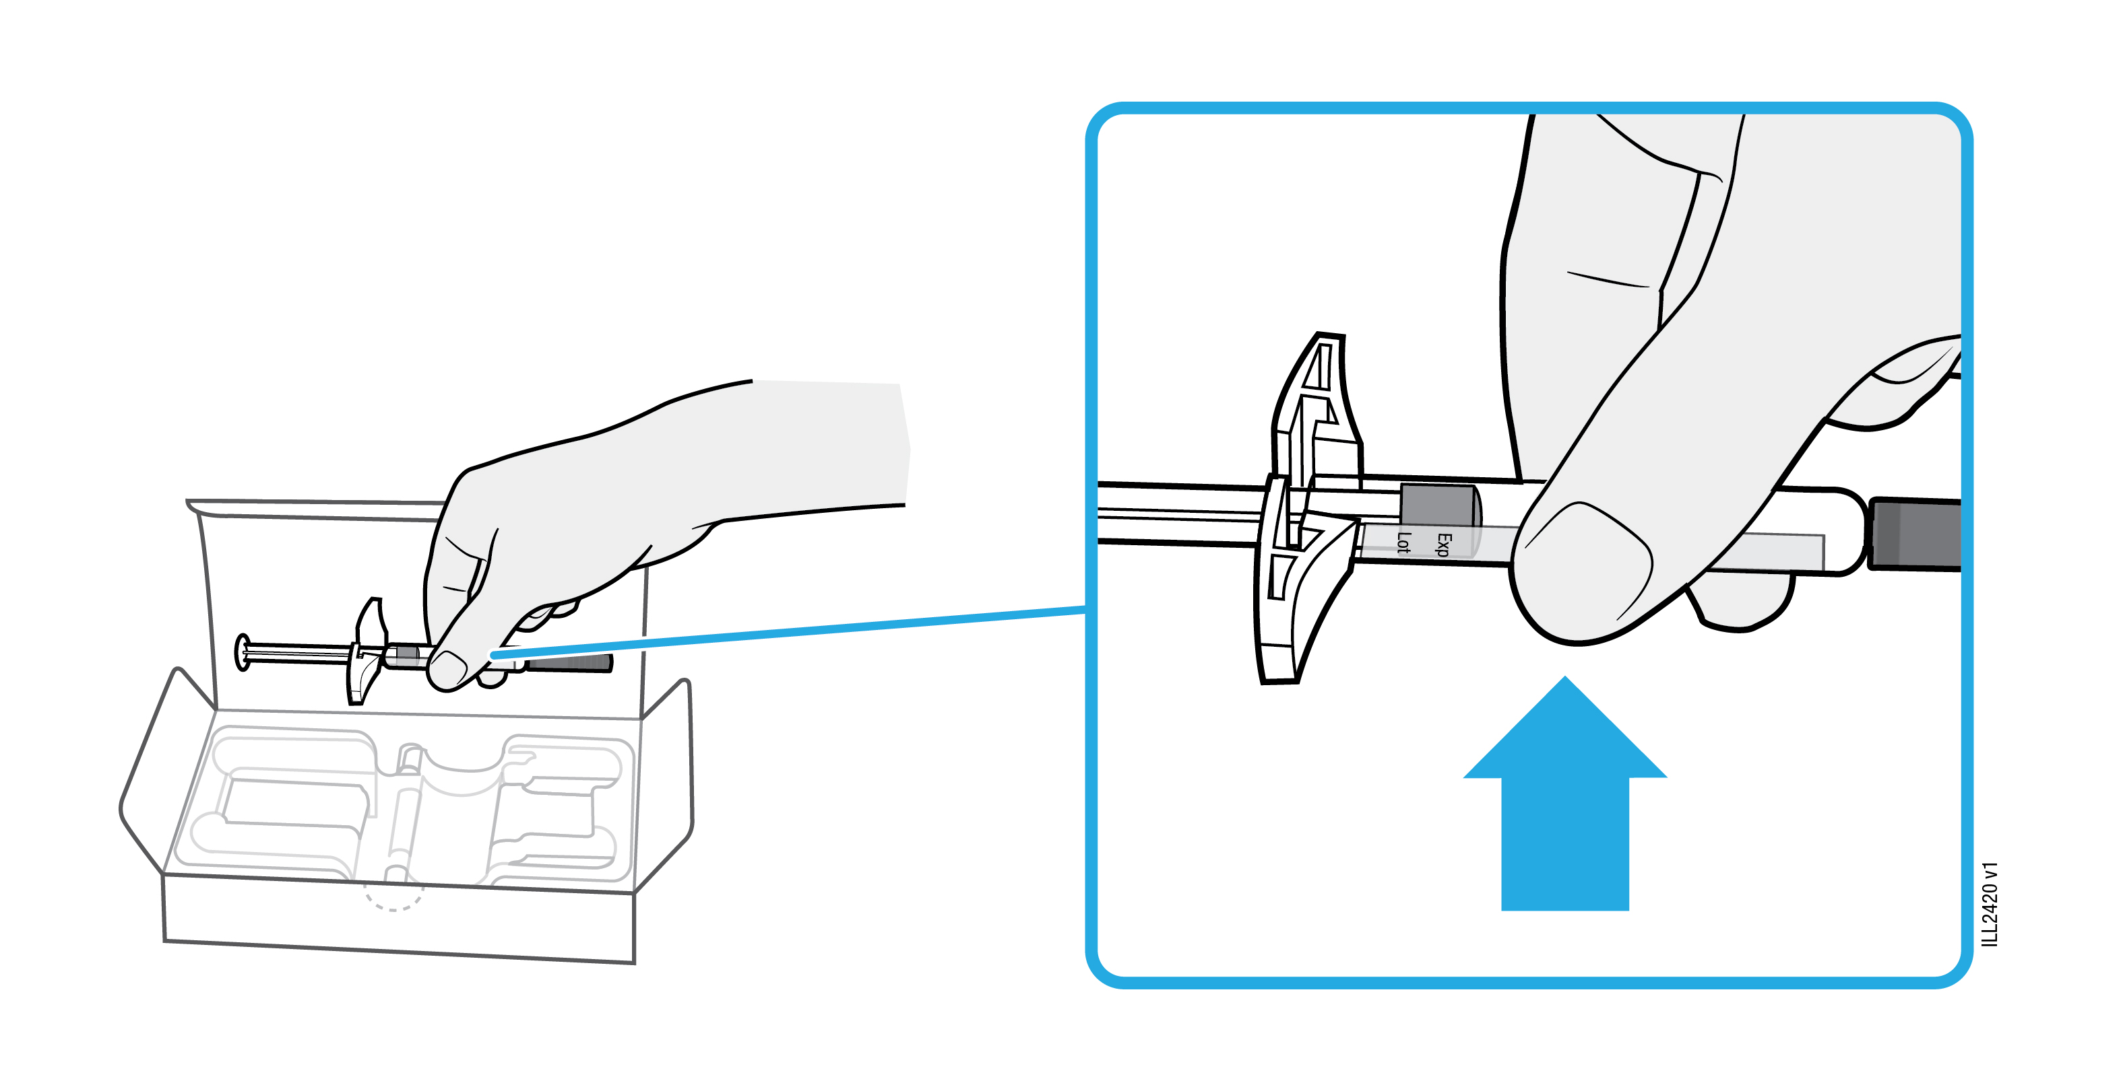
 | Do not grab the finger grip, plunger rod, or the needle cap.
 | Remove the number of pre-filled syringes you need for your injection.
 | Put any unused pre-filled syringes back into the refrigerator.

2b | Wait 15 to 30 minutes for the pre-filled syringe to reach room temperature.
WAIT
15 to 30
minutes

 | Let the pre-filled syringe warm up naturally.
 | Do not heat the pre-filled syringe with hot water, a microwave, or direct sunlight.
 | Do not shake the pre-filled syringe at any time.
 | Do not place pre-filled syringe back in refrigerator after it has reached room temperature.
 | Using the pre-filled syringe at room temperature allows for a more comfortable injection.

2c | Gather and place the following items for your injection on a clean, flat and well-lit surface.
Sharps disposal container |  | 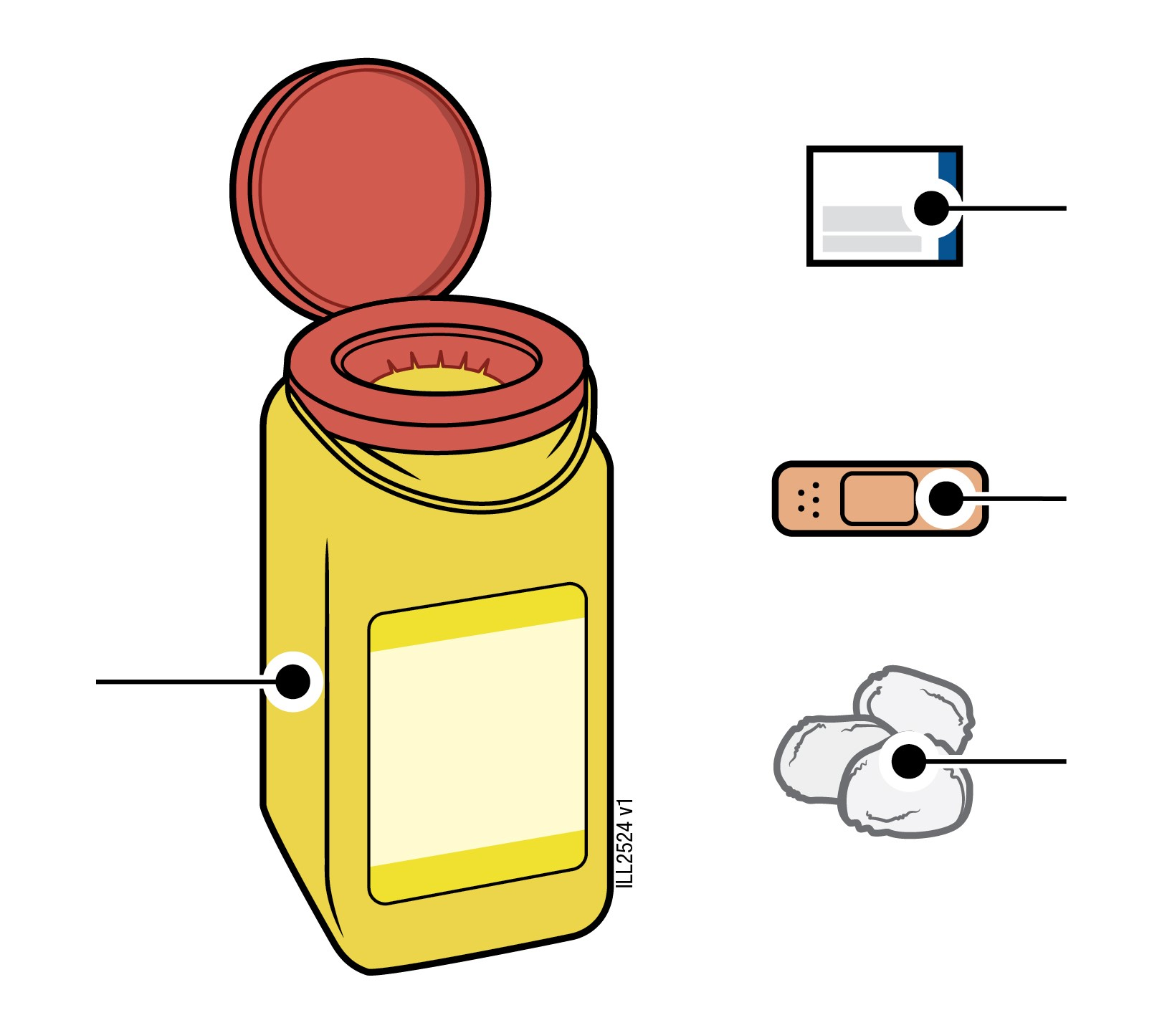 | Alcohol wipe  Plaster  Cotton ball or gauze pad
 | AMGEVITA pre-filled syringe (room temperature)
 | Sharps disposal container
 | Alcohol wipe
 | Plaster
 | Cotton ball or gauze pad

3 | Getting ready for your injection
3a | Inspect the medicine.
 |  | 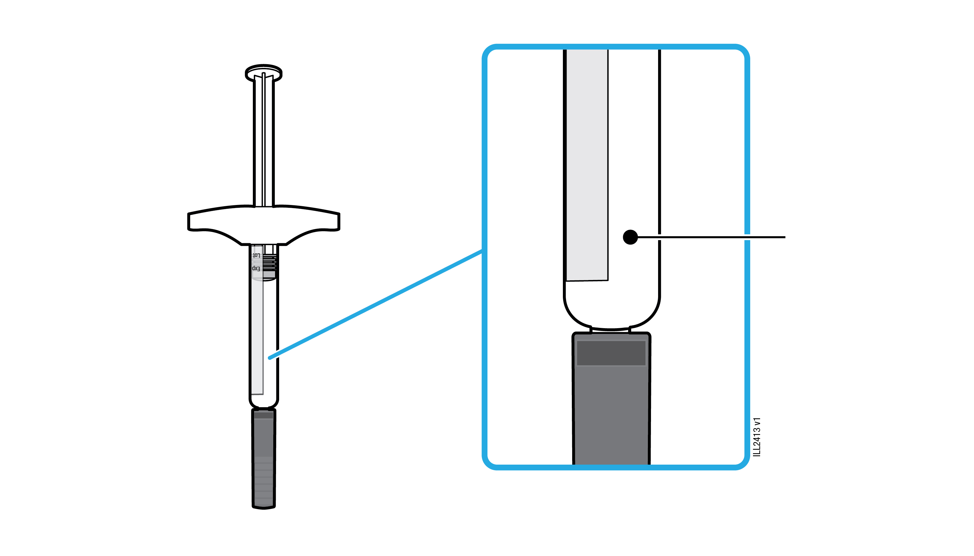 | Medicine
 | It should be clear and colourless to slightly yellow.
 | It is okay to see air bubbles in the pre-filled syringe.
 | Do not use AMGEVITA if the medicine is cloudy, discoloured, or contains flakes or particles
Important: If the medicine is cloudy, discoloured, or contains flakes or particles, call your doctor or healthcare provider.

3b | Check the expiry date (EXP) and inspect the pre-filled syringe for damage.

 |  | 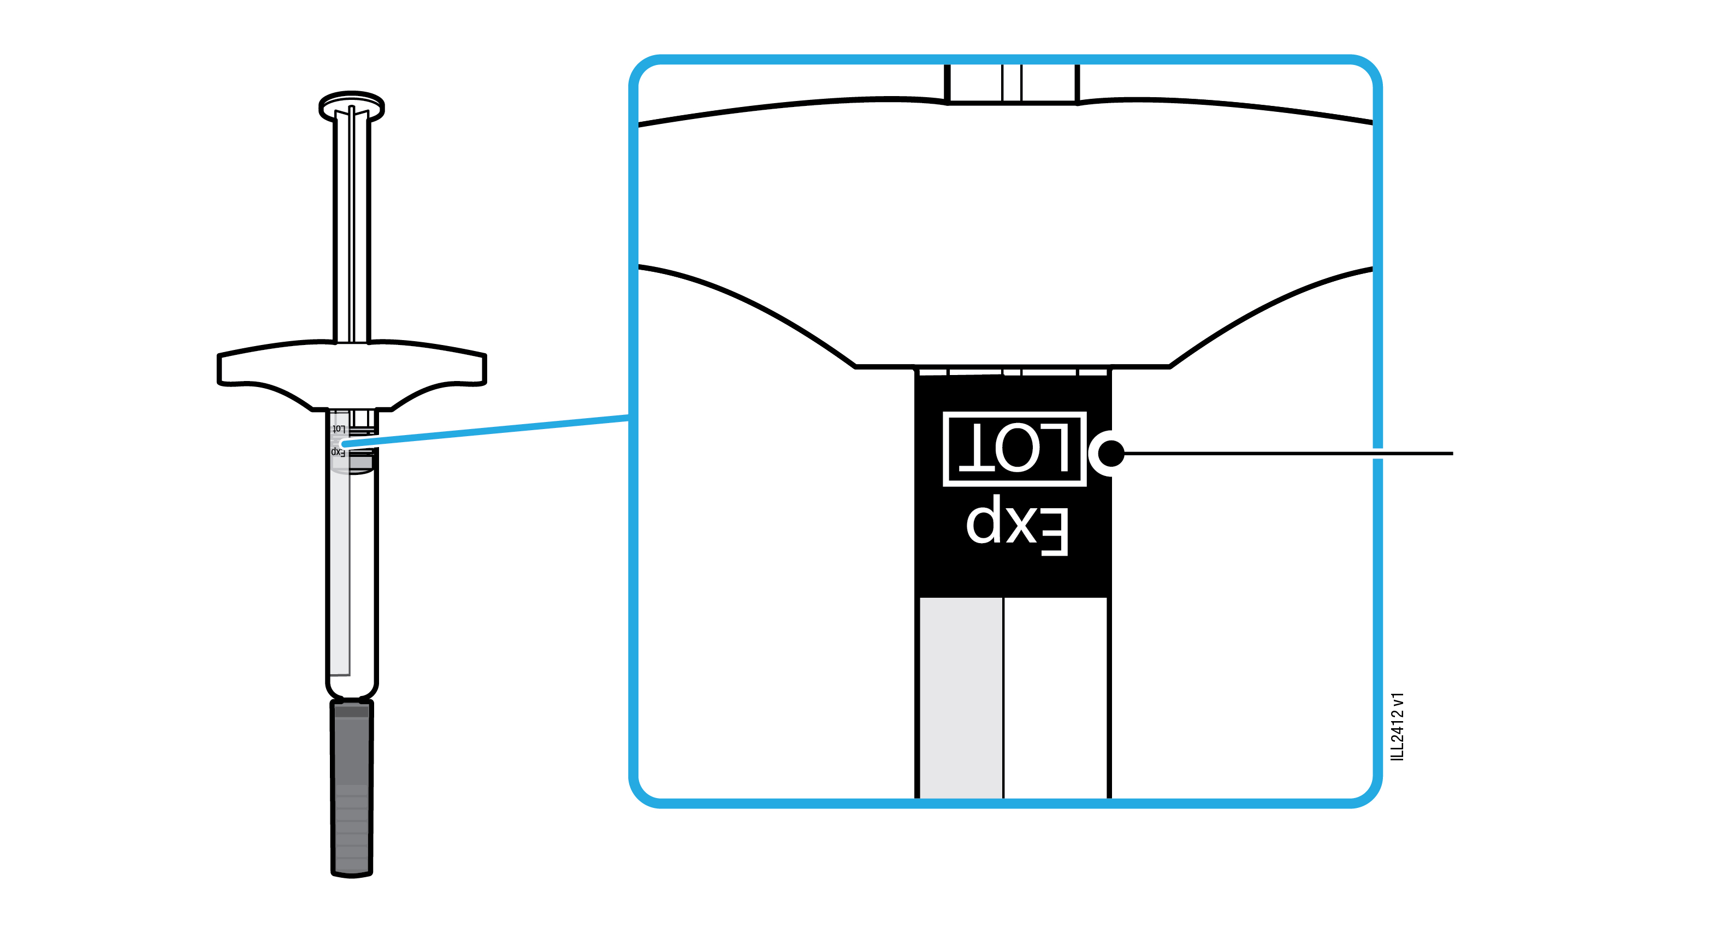 | Expiry date
 | Do not use the pre-filled syringe if the expiry date has passed.
 | Do not use the pre-filled syringe if:
- the needle cap is missing or not securely attached.
- it has cracks or broken parts.
- it has been dropped on a hard surface.
Important: If the pre-filled syringe is damaged or expired, call your doctor or healthcare provider.

3c | Inject into 1 of these sites.
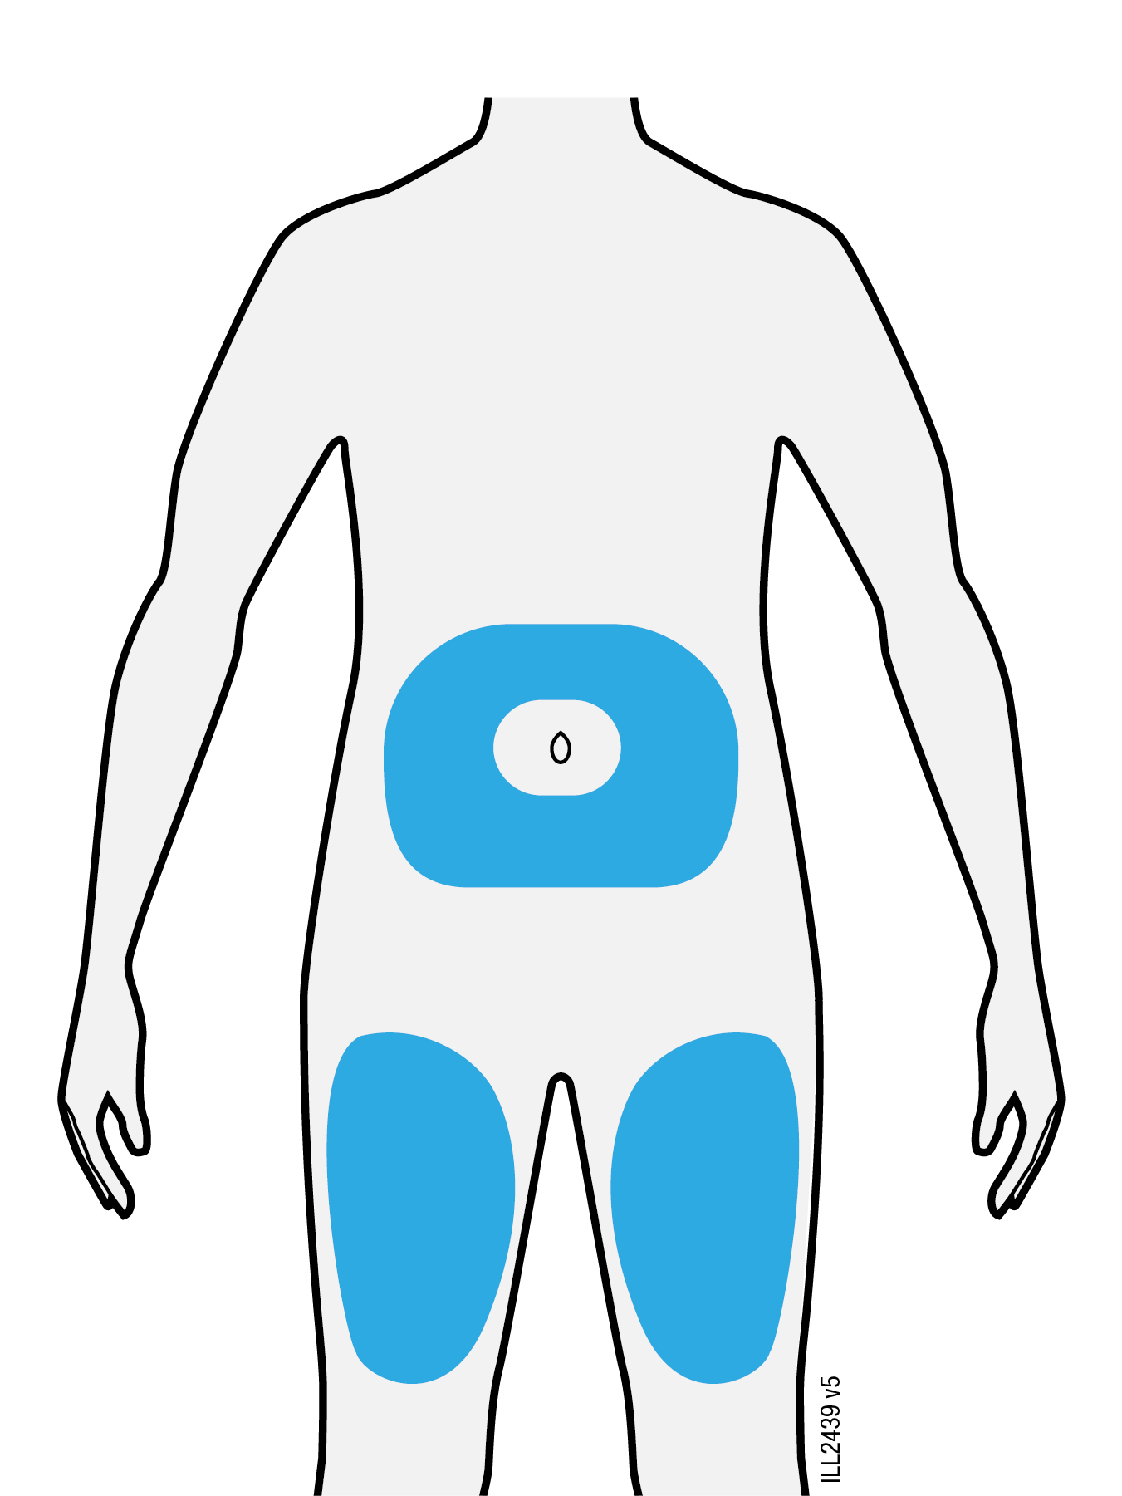
 | Inject into the front of your thigh or belly (except 5 centimetres around your belly button).
 | Choose a different site for each injection.
 | Wash your hands thoroughly with soap and water.
 | Clean the injection site with an alcohol wipe.
 | Let the skin dry on its own.
 | Do not touch this area again before injecting.
Important: Avoid areas with scars, stretch marks, or where the skin is tender, bruised, red or hard.

4 | Injecting AMGEVITA
Important: Only remove the needle cap when you can inject right away (within 5 minutes) because the medicine can dry out. Do not recap.
4a | Pull the needle cap straight off while holding the pre-filled syringe barrel.
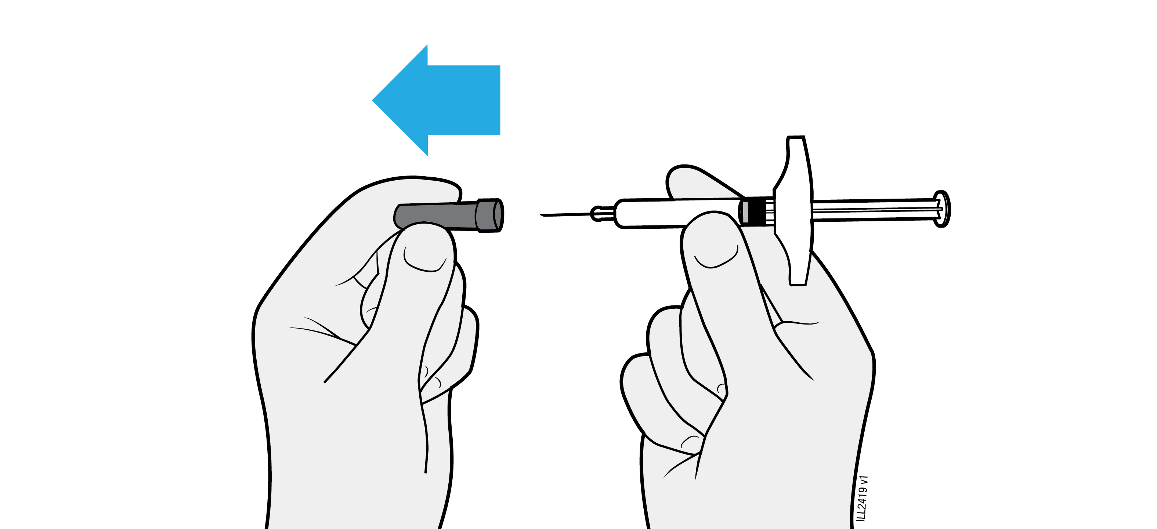
 | Do not twist or bend the needle cap.
 | Never put the needle cap back on. It may damage the needle.
 | Do not let anything touch the needle after you remove the needle cap.
 | Do not place the uncapped pre-filled syringe on any surface after you remove the needle cap.
 | Do not try to push air bubbles out of the pre-filled syringe. It is okay to see air bubbles.
 | It is normal to see a drop of medicine come out of the needle.

4b | Pinch the skin around the injection site before the injection.
PINCH skin at  injection site |  | 
 | Pinch the skin between the thumb and pointer (index) finger to create a bump for the injection.
 | If possible, the bump should be about 5 centimetres wide.
Important: Continue to pinch the skin until the injection is complete.

4c |  | Insert the needle into the pinched skin at a 45-degree angle.
INSERT
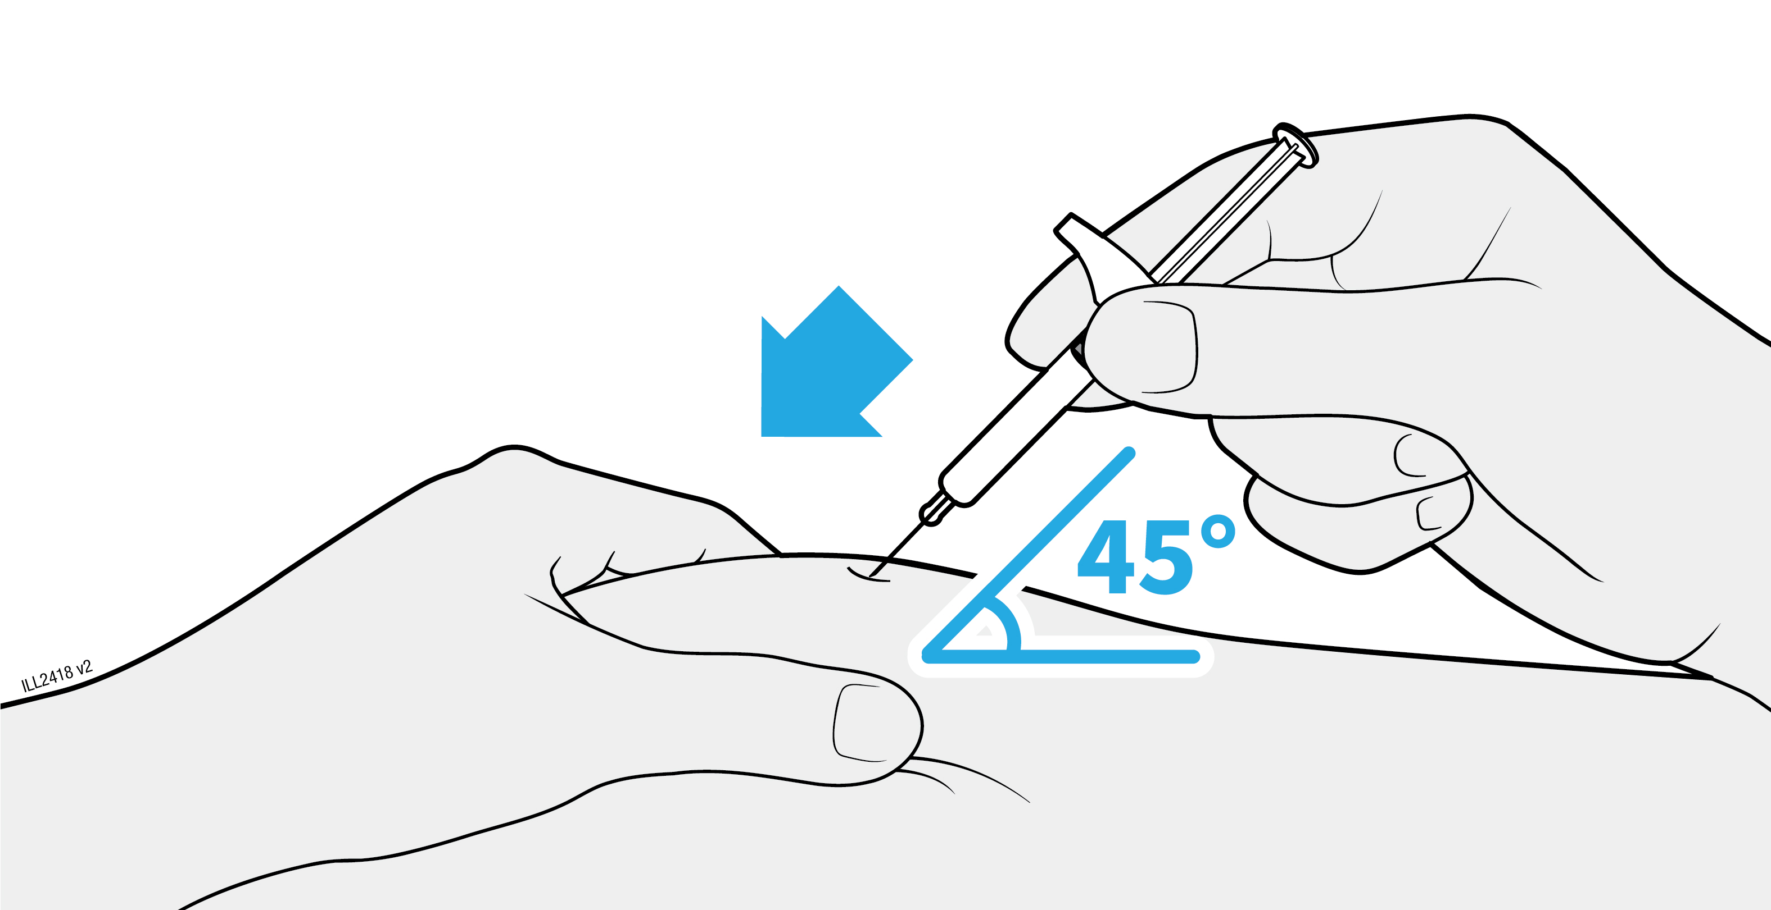
 |  | Do not place your finger on the plunger rod while inserting the needle, as this may result in loss of medicine.

4d |  | Slowly press the plunger rod all the way until it reaches the bottom of the pre-filled syringe to inject the medicine.
INJECT
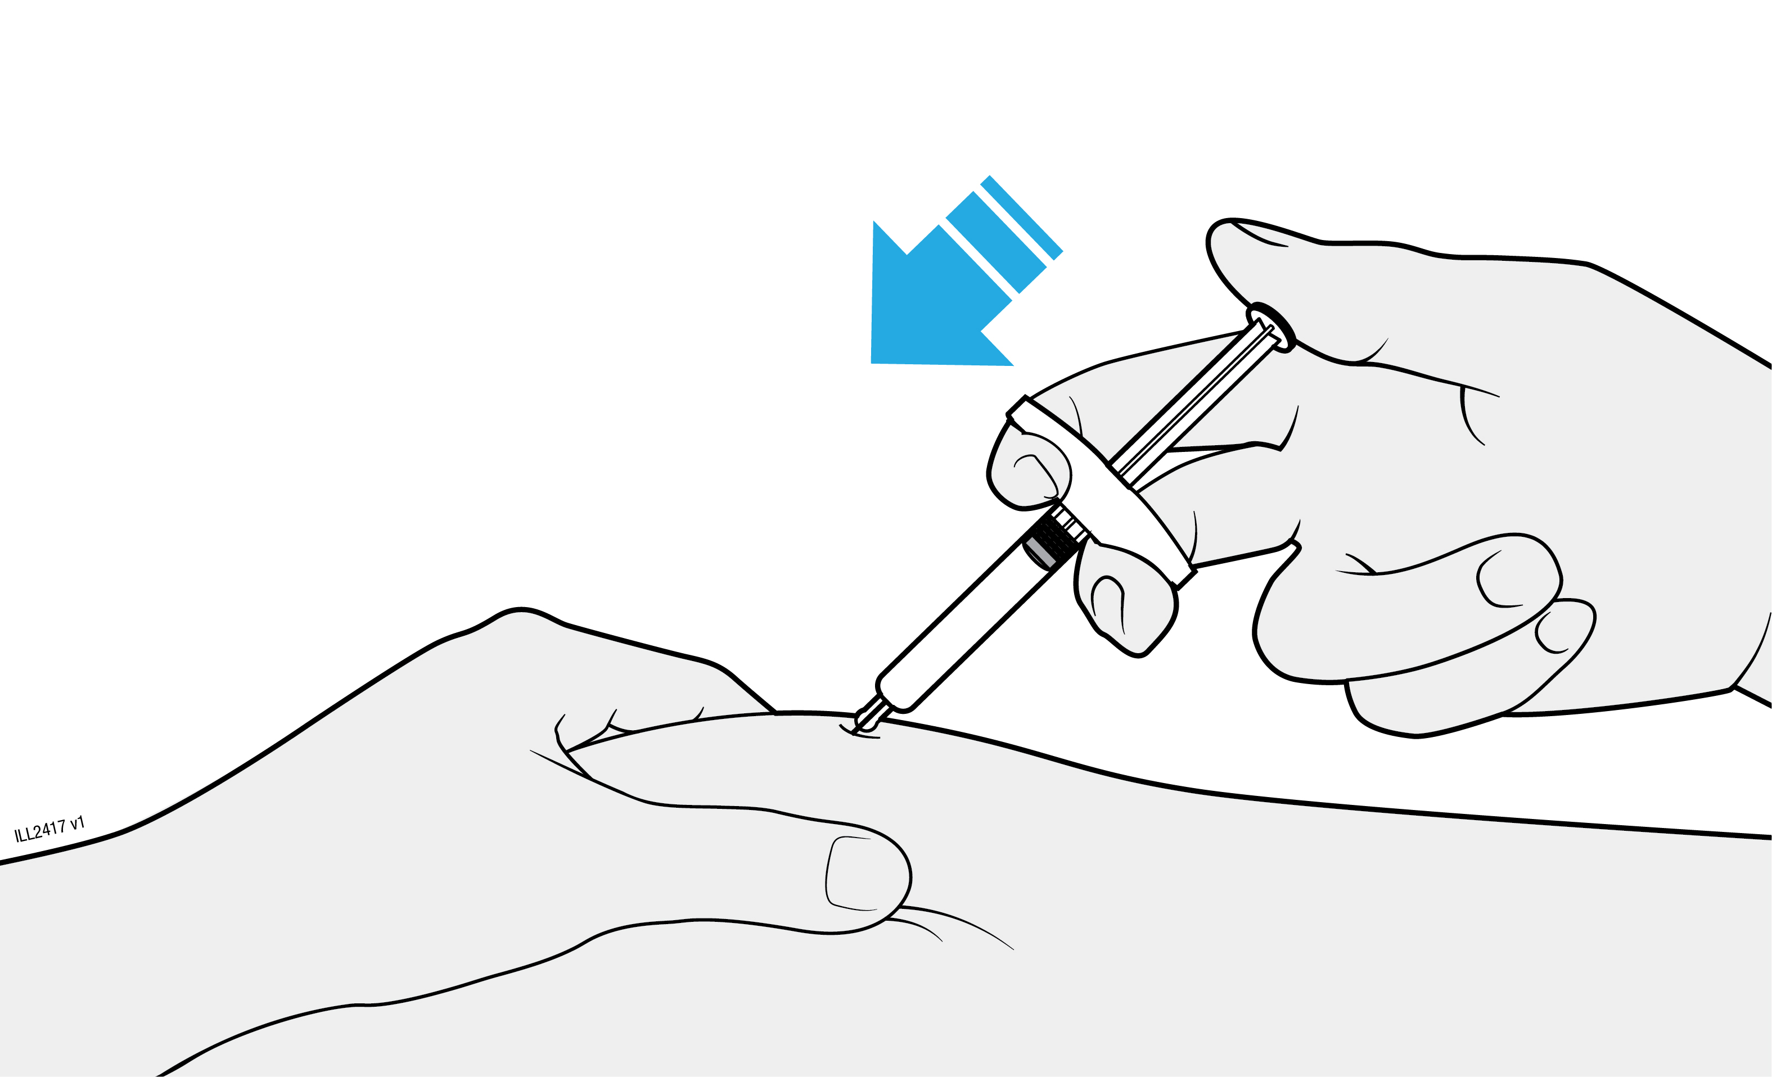
 |  | Do not pull back on the plunger rod at any time.
 |  | Do not remove the needle until all of the medicine has been injected.

5 | Disposing of AMGEVITA and checking the injection site
Important: Never put the needle cap back on.
5a | Place the used pre-filled syringe and needle cap in a sharps disposal container right away after use.
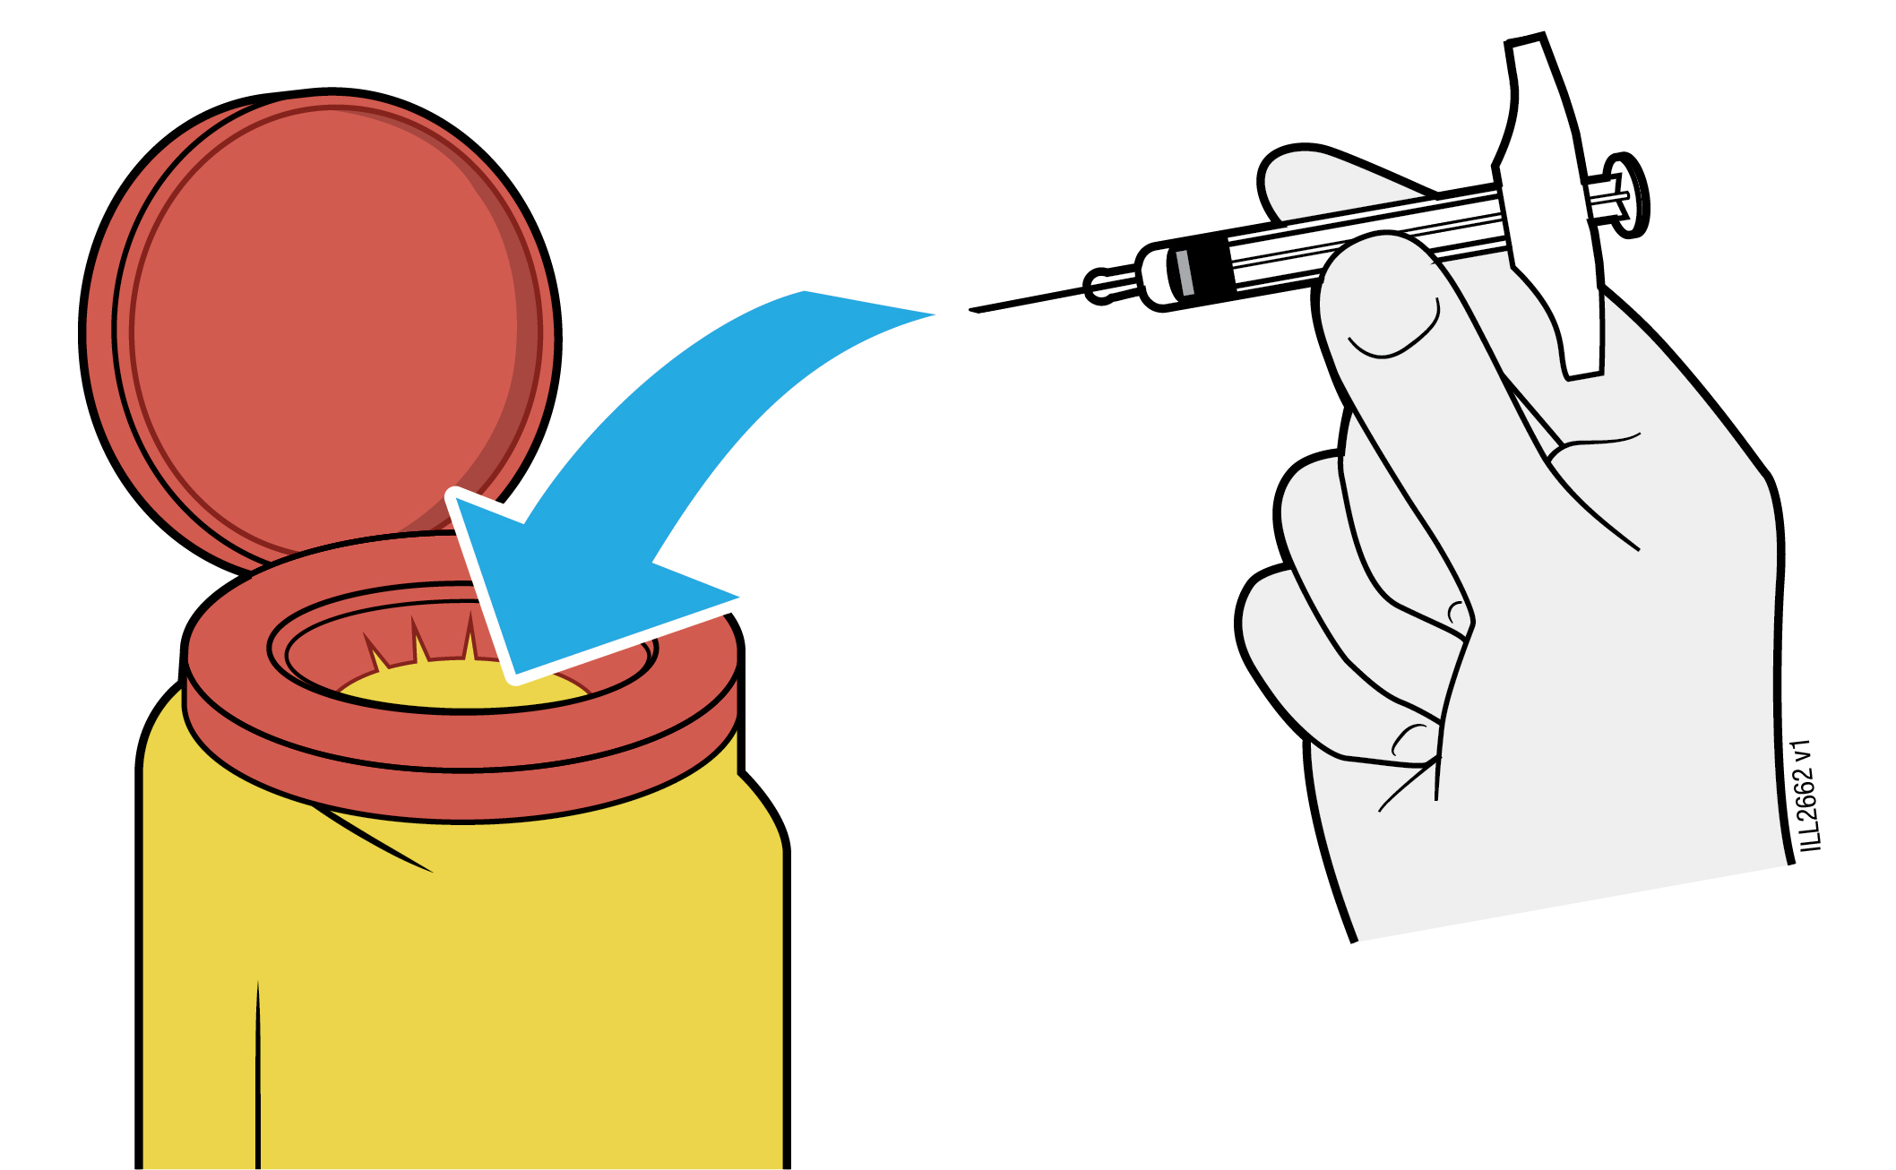
Do not recycle the pre-filled syringe or throw it into the household waste.
 | Do not reuse the pre-filled syringe.
 | Do not use any medicine that is left in the used pre-filled syringe.
Put the used AMGEVITA syringe in a sharps disposal container immediately after use.
Do not throw away (dispose of) the syringe in your household waste.
 | Talk with your doctor or pharmacist about proper disposal. There may be local guidelines for disposal.
 | Do not recycle the syringe or sharps disposal container or throw them into the household waste.
Important: Always keep the sharps disposal container out of the sight and reach of children.

5b | Check the injection site.
 | Do not rub the injection site.
 | If there is blood, press a cotton ball or gauze pad on your injection site. Apply a plaster if necessary.

Package leaflet: Information for the user

AMGEVITA 40 mg solution for injection in pre-filled pen
adalimumab

Read all of this leaflet carefully before you start using this medicine because it contains important information for you.
- Keep this leaflet. You may need to read it again.
- Your doctor will also give you a Patient Reminder Card, which contains important safety information that you need to be aware of before you are given AMGEVITA and during treatment with AMGEVITA. Keep this Patient Reminder Card with you.
- If you have any further questions, ask your doctor or pharmacist.
- This medicine has been prescribed for you only. Do not pass it on to others. It may harm them, even if their signs of illness are the same as yours.
- If you get any side effects, talk to your doctor or pharmacist. This includes any possible side effects not listed in this leaflet (see section 4).

What is in this leaflet

1. What AMGEVITA is and what it is used for
2. What you need to know before you use AMGEVITA
3. How to use AMGEVITA
4. Possible side effects
5. How to store AMGEVITA
6. Contents of the pack and other information

1. What AMGEVITA is and what it is used for

AMGEVITA contains the active substance adalimumab, a medicine that acts on your body’s immune (defence) system.

AMGEVITA is intended for the treatment of the inflammatory diseases described below:
  - Rheumatoid arthritis
  - Polyarticular juvenile idiopathic arthritis
  - Enthesitis-related arthritis
  - Ankylosing spondylitis
  - Axial spondyloarthritis without radiographic evidence of ankylosing spondylitis
  - Psoriatic arthritis
  - Plaque psoriasis
  - Hidradenitis suppurativa
  - Crohn’s disease
  - Ulcerative colitis
  - Non-infectious uveitis

The active ingredient in AMGEVITA, adalimumab, is a human monoclonal antibody. Monoclonal antibodies are proteins that attach to a specific target.

The target of adalimumab is a protein called tumour necrosis factor (TNFα), which is involved in the immune (defence) system and is present at increased levels in the inflammatory diseases listed above. By attaching to TNFα, AMGEVITA decreases the process of inflammation in these diseases.

Rheumatoid arthritis

Rheumatoid arthritis is an inflammatory disease of the joints.

AMGEVITA is used to treat rheumatoid arthritis in adults. If you have moderate to severe active rheumatoid arthritis, you may first be given other disease-modifying medicines, such as methotrexate. If you do not respond well enough to these medicines, you will be given AMGEVITA to treat your rheumatoid arthritis.

AMGEVITA can also be used to treat severe, active and progressive rheumatoid arthritis without previous methotrexate treatment.

AMGEVITA slows down the damage to the cartilage and bone of the joints caused by the disease and to improve physical function.

Usually, AMGEVITA is used with methotrexate. If your doctor determines that methotrexate is inappropriate, AMGEVITA can be given alone.

Polyarticular juvenile idiopathic arthritis and enthesitis-related arthritis

Polyarticular juvenile idiopathic arthritis and enthesitis-related arthritis are inflammatory diseases of the joints that usually first appear in childhood.

AMGEVITA is used to treat polyarticular juvenile idiopathic arthritis in patients from 2 years and enthesitis-related arthritis in patients from 6 years. You may first be given other disease-modifying medicines, such as methotrexate. If you do not respond well enough to these medicines, you will be given AMGEVITA to treat your polyarticular juvenile idiopathic arthritis or enthesitis-related arthritis.

Ankylosing spondylitis and axial spondyloarthritis without radiographic evidence of ankylosing spondylitis

Ankylosing spondylitis and axial spondyloarthritis without radiographic evidence of ankylosing spondylitis, are inflammatory diseases of the spine.

AMGEVITA is used to treat ankylosing spondylitis and axial spondyloarthritis without radiographic evidence of ankylosing spondylitis in adults. If you have ankylosing spondylitis or axial spondyloarthritis without radiographic evidence of ankylosing spondylitis, you will first be given other medicines. If you do not respond well enough to these medicines, you will be given AMGEVITA to reduce the signs and symptoms of your disease.

Psoriatic arthritis

Psoriatic arthritis is an inflammation of the joints associated with psoriasis.

AMGEVITA is used to treat psoriatic arthritis in adults. AMGEVITA slows down the damage to the cartilage and bone of the joints caused by the disease and to improve physical function.

Plaque psoriasis in adults and children

Plaque psoriasis is a skin condition that causes red, flaky, crusty patches of skin covered with silvery scales. Plaque psoriasis can also affect the nails, causing them to crumble, become thickened and lift away from the nail bed which can be painful. Psoriasis is believed to be caused by a problem with the body’s immune system that leads to an increased production of skin cells.

AMGEVITA is used to treat moderate to severe plaque psoriasis in adults. AMGEVITA is also used to treat severe plaque psoriasis in children and adolescents aged 4 to 17 years for whom topical therapy and phototherapies have either not worked very well or are not suitable.

Hidradenitis suppurativa in adults and adolescents

Hidradenitis suppurativa (sometimes called acne inversa) is a chronic and often painful inflammatory skin disease. Symptoms may include tender nodules (lumps) and abscesses (boils) that may leak pus. It most commonly affects specific areas of the skin, such as under the breasts, the armpits, inner thighs, groin and buttocks. Scarring may also occur in affected areas.

AMGEVITA is used to treat hidradenitis suppurativa in adults and adolescents from 12 years of age. AMGEVITA can reduce the number of nodules and abscesses you have, and the pain that is often associated with the disease. You may first be given other medicines. If you do not respond well enough to these medicines, you will be given AMGEVITA.

Crohn’s disease in adults and children

Crohn’s disease is an inflammatory disease of the digestive tract.

AMGEVITA is used to treat Crohn’s disease in adults and children aged 6 to 17 years. If you have Crohn’s disease you will first be given other medicines. If you do not respond well enough to these medicines, you will be given AMGEVITA to reduce the signs and symptoms of your Crohn’s disease.

Ulcerative colitis in adults and children

Ulcerative colitis is an inflammatory disease of the large intestine.

AMGEVITA is used to treat moderate to severe ulcerative colitis in adults and children aged 6 to 17 years. If you have ulcerative colitis you may first be given other medicines. If you do not respond well enough to these medicines, you will be given AMGEVITA to reduce the signs and symptoms of your disease.

Non-infectious uveitis in adults and children

Non-infectious uveitis is an inflammatory disease affecting certain parts of the eye.

AMGEVITA is used to treat
- Adults with non-infectious uveitis with inflammation affecting the back of the eye.
- Children from 2 years of age with chronic non-infectious uveitis with inflammation affecting the front of the eye.

This inflammation may lead to a decrease of vision and/or the presence of floaters in the eye (black dots or wispy lines that move across the field of vision). AMGEVITA works by reducing this inflammation.

2. What you need to know before you use AMGEVITA

Do not use AMGEVITA:

- if you are allergic to adalimumab or any of the other ingredients of this medicine (listed in section 6).
- if you have a severe infection, including active tuberculosis, sepsis (blood infection) or other opportunistic infections (unusual infections associated with a weakened immune system) (see “Warnings and precautions”). It is important that you tell your doctor if you have symptoms of infections, e.g. fever, wounds, feeling tired, dental problems.
- if you have moderate or severe heart failure. It is important to tell your doctor if you have had or have a serious heart condition (see “Warnings and precautions”).

Warnings and precautions

Talk to your doctor or pharmacist before using AMGEVITA:

Allergic reactions

- If you experience allergic reactions with symptoms such as chest tightness, wheezing, dizziness, swelling or rash do not inject more AMGEVITA and contact your doctor immediately since, in rare cases, these reactions can be life threatening.

Infections

- If you have an infection, including long-term or localised infection (for example, leg ulcer) consult your doctor before starting AMGEVITA. If you are unsure, contact your doctor.
- You might get infections more easily while you are receiving AMGEVITA treatment. This risk may increase if your lung function is impaired. These infections may be serious and include tuberculosis, infections caused by viruses, fungi, parasites or bacteria, or other opportunistic infections and sepsis that may, in rare cases, be life-threatening. It is important to tell your doctor if you get symptoms such as fever, wounds, feeling tired or dental problems. Your doctor may recommend temporary discontinuation of AMGEVITA.

Tuberculosis

- As cases of tuberculosis have been reported in patients treated with adalimumab, your doctor will check you for signs and symptoms of tuberculosis before starting AMGEVITA. This will include a thorough medical evaluation including your medical history and appropriate screening tests (for example chest x-ray and a tuberculin test). The conduct and results of these tests should be recorded on your Patient Reminder Card. It is very important that you tell your doctor if you have ever had tuberculosis, or if you have been in close contact with someone who has had tuberculosis.
- Tuberculosis can develop during therapy even if you have received preventative treatment for tuberculosis.
- If symptoms of tuberculosis (persistent cough, weight loss, listlessness, mild fever), or any other infection appear during or after therapy, tell your doctor immediately.

Travel / recurrent infection

- Advise your doctor if you reside or travel in regions where fungal infections such as histoplasmosis, coccidioidomycosis or blastomycosis are endemic.
- Advise your doctor if you have a history of recurrent infections or other conditions that increase the risk of infections.

Hepatitis B virus

- Advise your doctor if you are a carrier of the hepatitis B virus (HBV), if you have active HBV or if you think you might be at risk of contracting HBV. Your doctor should test you for HBV. AMGEVITA can cause reactivation of HBV in people who carry this virus. In some rare cases, especially if you are taking other medicines that suppress the immune system, reactivation of HBV can be life-threatening.

Age over 65 years

- If you are over 65 years you may be more susceptible to infections while taking AMGEVITA. You and your doctor should pay special attention to signs of infection while you are being treated with AMGEVITA. It is important to tell your doctor if you get symptoms of infections, such as fever, wounds, feeling tired or dental problems.

Surgery or dental procedures

- If you are about to undergo surgery or dental procedures please inform your doctor that you are taking AMGEVITA. Your doctor may recommend temporary discontinuation of AMGEVITA.

Demyelinating disease

- If you have or develop demyelinating disease such as multiple sclerosis, your doctor will decide if you should receive or continue to receive AMGEVITA. Tell your doctor immediately if you experience symptoms like changes in your vision, weakness in your arms or legs or numbness or tingling in any part of your body.

Vaccinations

- Certain vaccines contain living but weakened forms of disease-causing bacteria or viruses that may cause infections and should not be given while receiving AMGEVITA. Please check with your doctor before you receive any vaccines. It is recommended that children, if possible, be brought up to date with all immunisations in agreement with current immunisation guidelines prior to initiating AMGEVITA therapy.
- If you received AMGEVITA while you were pregnant, your baby may be at higher risk for getting such an infection for up to approximately five months after the last dose you received during pregnancy. It is important that you tell your baby's doctors and other health care professionals about your AMGEVITA use during your pregnancy so they can decide when your baby should receive any vaccine.

Heart failure

- If you have mild heart failure and you are being treated with AMGEVITA, your heart failure status must be closely monitored by your doctor. It is important to tell your doctor if you have had or have a serious heart condition. If you develop new or worsening symptoms of heart failure (e.g. shortness of breath, or swelling of your feet), you must contact your doctor immediately. Your doctor will decide if you should receive AMGEVITA.

Fever, bruising, bleeding or looking pale

- In some patients the body may fail to produce enough of the blood cells that help your body fight infections or help you to stop bleeding. If you develop a fever that does not go away, bruise or bleed very easily or look very pale, call your doctor right away. Your doctor may decide to stop treatment.

Cancer

- There have been very rare cases of certain kinds of cancer in children and adult patients taking adalimumab or other TNF blockers. People with more serious rheumatoid arthritis that have had the disease for a long time may have a higher than average risk of getting lymphoma (a cancer that affects the lymph system), and leukaemia (a cancer that affects the blood and bone marrow).
- If you take AMGEVITA the risk of getting lymphoma, leukaemia, or other cancers may increase. On rare occasions, a specific and severe type of lymphoma has been observed in patients taking adalimumab. Some of those patients were also treated with azathioprine or 6-mercaptopurine. Tell your doctor if you are taking azathioprine or 6-mercaptopurine with AMGEVITA.
- In addition, cases of non-melanoma skin cancer have been observed in patients taking adalimumab. If new skin lesions appear during or after therapy or if existing lesions change appearance, tell your doctor.
- There have been cases of cancers, other than lymphoma in patients with a specific type of lung disease called Chronic Obstructive Pulmonary Disease (COPD) treated with another TNF blocker. If you have COPD, or are a heavy smoker, you should discuss with your doctor whether treatment with a TNF blocker is appropriate for you.

Autoimmune disease

- On rare occasions, treatment with AMGEVITA could result in lupus-like syndrome. Contact your doctor if symptoms such as persistent unexplained rash, fever, joint pain or tiredness occur.

In order to improve the traceability of this medicine, your doctor or pharmacist should record the name and the lot number of the product you have been given in your patient file. You may also wish to make a note of these details in case you are asked for this information in the future.

Children and adolescents

- Vaccinations: if possible children should be up to date with all vaccinations before using AMGEVITA.

- Do not give AMGEVITA to children with polyarticular juvenile idiopathic arthritis below the age of 2 years.

- Do not give AMGEVITA to children with plaque psoriasis below the age of 4 years.

- Do not give AMGEVITA to children with Crohn’s disease or ulcerative colitis below the age of 6 years.

Other medicines and AMGEVITA

Tell your doctor or pharmacist if you are taking, have recently taken or might take any other medicines.

AMGEVITA can be taken together with methotrexate or certain disease-modifying anti-rheumatic agents (sulfasalazine, hydroxychloroquine, leflunomide and injectable gold preparations), steroids or pain medications including non-steroidal anti-inflammatory drugs (NSAIDs).

You should not take AMGEVITA with medicines containing the active substances, anakinra or abatacept due to increased risk of serious infection. If you have questions, please ask your doctor.

Pregnancy and breast-feeding

- You should consider the use of adequate contraception to prevent pregnancy and continue its use for at least 5 months after the last AMGEVITA treatment.
- If you are pregnant, think you may be pregnant or are planning to have a baby, ask your doctor for advice about taking this medicine.
- AMGEVITA should only be used during a pregnancy if needed.
- According to a pregnancy study, there was no higher risk of birth defects when the mother had received AMGEVITA during pregnancy compared with mothers with the same disease who did not receive AMGEVITA.
- AMGEVITA can be used during breast-feeding.
- If you receive AMGEVITA during your pregnancy, your baby may have a higher risk for getting an infection.
- It is important that you tell your baby’s doctors and other health care professionals about your AMGEVITA use during your pregnancy before the baby receives any vaccine. For more information on vaccines see the “Warnings and precautions” section.

Driving and using machines

AMGEVITA may have a minor influence on your ability to drive, cycle or use machines. Room spinning sensation (vertigo) and vision disturbances may occur after taking AMGEVITA.

AMGEVITA contains sodium

This medicine contains less than 1 mmol of sodium (23 mg) per 0.8 mL dose, that is to say essentially ‘sodium-free’.

3. How to use AMGEVITA

Always use this medicine exactly as your doctor or pharmacist has told you. Check with your doctor or pharmacist if you are not sure.

Adults with rheumatoid arthritis, psoriatic arthritis, ankylosing spondylitis or axial spondyloarthritis without radiographic evidence of ankylosing spondylitis

AMGEVITA is injected under the skin (subcutaneous use). The usual dose for adults with rheumatoid arthritis, ankylosing spondylitis, axial spondyloarthritis without radiographic evidence of ankylosing spondylitis, and for patients with psoriatic arthritis is 40 mg given every other week as a single dose.

In rheumatoid arthritis, methotrexate is continued while using AMGEVITA. If your doctor determines that methotrexate is inappropriate, AMGEVITA can be given alone.

If you have rheumatoid arthritis and you do not receive methotrexate with your AMGEVITA therapy, your doctor may decide to give 40 mg every week or 80 mg every other week.

Children, adolescents and adults with polyarticular juvenile idiopathic arthritis

Children, adolescents and adults from 2 years of age weighing 30 kg or more

The recommended dose of AMGEVITA is 40 mg every other week.

Children, adolescents and adults with enthesitis-related arthritis

Children, adolescents and adults from 6 years of age weighing 30 kg or more

The recommended dose of AMGEVITA is 40 mg every other week.

Adults with plaque psoriasis

The usual dose for adults with plaque psoriasis is an initial dose of 80 mg (as two 40 mg injections in one day), followed by 40 mg given every other week starting one week after the initial dose. You should continue to inject AMGEVITA for as long as your doctor has told you. Depending on your response, your doctor may increase the dose to 40 mg every week or 80 mg every other week.

Children and adolescents with plaque psoriasis

Children and adolescents from 4 to 17 years of age weighing 30 kg or more

The recommended dose of AMGEVITA is an initial dose of 40 mg, followed by 40 mg one week later. Thereafter, the usual dose is 40 mg every other week.

Adults with hidradenitis suppurativa

The usual dose regimen for hidradenitis suppurativa is an initial dose of 160 mg (as four 40 mg injections in one day or two 40 mg injections per day for two consecutive days), followed by an 80 mg dose (as two 40 mg injections in one day) two weeks later. After two further weeks, continue with a dose of 40 mg every week or 80 mg every other week, as prescribed by your doctor. It is recommended that you use an antiseptic wash daily on the affected areas.

Adolescents with hidradenitis suppurativa from 12 to 17 years of age weighing 30 kg or more

The recommended dose of AMGEVITA is an initial dose of 80 mg (as two 40 mg injections in one day), followed by 40 mg every other week starting one week later. If you have an inadequate response to AMGEVITA 40 mg every other week, your doctor may increase the dose to 40 mg every week or 80 mg every other week.

It is recommended that you use an antiseptic wash daily on the affected areas.

Adults with Crohn’s disease

The usual dose regimen for Crohn’s disease is 80 mg (as two 40 mg injections in one day) initially followed by 40 mg every other week two weeks later. If a faster response is required, your doctor may prescribe an initial dose of 160 mg (as four 40 mg injections in one day or two 40 mg injections per day for two consecutive days), followed by 80 mg (as two 40 mg injections in one day) two weeks later, and thereafter as 40 mg every other week. Depending on your response, your doctor may increase the dose to 40 mg every week or 80 mg every other week.

Children and adolescents with Crohn's disease

Children and adolescents from 6 to 17 years of age weighing less than 40 kg

The usual dose regimen is 40 mg initially followed by 20 mg two weeks later. If a faster response is required, your doctor may prescribe an initial dose of 80 mg (as two 40 mg injections in one day) followed by 40 mg two weeks later.

Thereafter, the usual dose is 20 mg every other week. Depending on your response, your doctor may increase the dose frequency to 20 mg every week.

The 40 mg pre-filled pen cannot be used for the 20 mg dose. An AMGEVITA 20 mg pre-filled syringe is however available for the 20 mg dose.

Children and adolescents from 6 to 17 years of age weighing 40 kg or more

The usual dose regimen is 80 mg (as two 40 mg injections in one day) initially followed by 40 mg two weeks later. If a faster response is required, your doctor may prescribe an initial dose of 160 mg (as four 40 mg injections in one day or as two 40 mg injections per day for two consecutive days) followed by 80 mg (as two 40 mg injections in one day) two weeks later.

Thereafter, the usual dose is 40 mg every other week. Depending on your response, your doctor may increase the dose to 40 mg every week or 80 mg every other week.

Adults with ulcerative colitis

The usual AMGEVITA dose for adults with ulcerative colitis is 160 mg initially (as four 40 mg injections in one day or as two 40 mg injections per day for two consecutive days) followed by 80 mg (as two 40 mg injections in one day) two weeks later, then 40 mg every other week. Depending on your response, your doctor may increase the dose to 40 mg every week or 80 mg every other week.

Children and adolescents with ulcerative colitis

Children and adolescents from 6 years of age weighing less than 40 kg

The usual AMGEVITA dose is 80 mg (as two 40 mg injections in one day) initially followed by 40 mg (as one 40 mg injection) two weeks later. Thereafter, the usual dose is 40 mg every other week.

Patients who turn 18 years of age while on 40 mg every other week, should continue their prescribed dose.

Children and adolescents from 6 years of age weighing 40 kg or more

The usual AMGEVITA dose is 160 mg (as four 40 mg injections in one day or two 40 mg injections per day for two consecutive days) initially, followed by 80 mg (as two 40 mg injections in one day) two weeks later. Thereafter the usual dose is 80 mg every other week.

Patients who turn 18 years of age while on 80 mg every other week, should continue their prescribed dose.

Adults with non-infectious uveitis

The usual dose for adults with non-infectious uveitis is an initial dose of 80 mg (as two 40 mg injections in one day), followed by 40 mg given every other week starting one week after the initial dose. You should continue to inject AMGEVITA for as long as your doctor has told you.

In non-infectious uveitis, corticosteroids or other medicines that influence the immune system may be continued while using AMGEVITA. AMGEVITA can also be given alone.

Children and adolescents with chronic non-infectious uveitis from 2 years of age

Children and adolescents from 2 years of age weighing less than 30 kg

The usual dose of AMGEVITA is 20 mg every other week with methotrexate.

Your doctor may also prescribe an initial dose of 40 mg which may be administered one week prior to the start of the usual dose.

The 40 mg pre-filled pen cannot be used for the 20 mg dose. An AMGEVITA 20 mg pre-filled syringe is however available for the 20 mg dose.

Children and adolescents from 2 years of age weighing 30 kg or more

The usual dose of AMGEVITA is 40 mg every other week with methotrexate.

Your doctor may also prescribe an initial dose of 80 mg which may be administered one week prior to the start of the usual dose.

Method and route of administration

AMGEVITA is administered by injection under the skin (subcutaneous injection).

Detailed instructions on how to inject AMGEVITA are provided in “Instructions for use” section.

If you use more AMGEVITA than you should

If you accidentally inject AMGEVITA more frequently than told to by your doctor or pharmacist, call your doctor or pharmacist and tell him/her that you have taken more. Always take the outer carton of this medicine with you, even if it is empty.

If you forget to use AMGEVITA

If you forget to give yourself an injection, you should inject the next dose of AMGEVITA as soon as you remember. Then take your next dose as you would have on your originally scheduled day, had you not forgotten a dose.

If you stop using AMGEVITA

The decision to stop using AMGEVITA should be discussed with your doctor. Your symptoms may return upon discontinuation.

If you have any further questions on the use of this medicine, ask your doctor or pharmacist.

4. Possible side effects

Like all medicines, this medicine can cause side effects, although not everybody gets them. Most side effects are mild to moderate. However, some may be serious and require treatment. Side effects may occur at least up to 4 months after the last AMGEVITA injection.

Tell your doctor immediately if you notice any of the following signs of allergic reaction or heart failure:
- severe rash, hives or other signs of allergic reaction;
- swollen face, hands, feet;
- trouble breathing, swallowing;
- shortness of breath with exertion or upon lying down or swelling of the feet.

Tell your doctor as soon as possible if you notice any of the following:
- signs of infection such as fever, feeling sick, wounds, dental problems, burning on urination;
- feeling weak or tired;
- coughing;
- tingling;
- numbness;
- double vision;
- arm or leg weakness;
- signs of skin cancer such as a bump or open sore that doesn't heal;
- signs and symptoms suggestive of blood disorders such as persistent fever, bruising, bleeding, paleness.

The symptoms described above can be signs of the below listed side effects, which have been observed with adalimumab.

Very common (may affect more than 1 in 10 people)
- injection site reactions (including pain, swelling, redness or itching);
- respiratory tract infections (including cold, runny nose, sinus infection, pneumonia);
- headache;
- abdominal pain;
- nausea and vomiting;
- rash;
- musculoskeletal pain.

Common (may affect up to 1 in 10 people)
- serious infections (including blood poisoning and influenza);
- intestinal infections (including gastroenteritis);
- skin infections (including cellulitis and shingles);
- ear infections;
- oral infections (including tooth infections and cold sores);
- reproductive tract infections;
- urinary tract infection;
- fungal infections;
- joint infections;
- benign tumours;
- skin cancer;
- allergic reactions (including seasonal allergy);
- dehydration;
- mood swings (including depression);
- anxiety;
- difficulty sleeping;
- sensation disorders such as tingling, prickling or numbness;
- migraine;
- nerve root compression (including low back pain and leg pain);
- vision disturbances;
- eye inflammation;
- inflammation of the eye lid and eye swelling;
- vertigo (feeling of dizziness or spinning);
- sensation of heart beating rapidly;
- high blood pressure;
- flushing;
- haematoma;
- cough;
- asthma;
- shortness of breath;
- gastrointestinal bleeding;
- dyspepsia (indigestion, bloating, heart burn);
- acid reflux disease;
- sicca syndrome (including dry eyes and dry mouth);
- itching;
- itchy rash;
- bruising;
- inflammation of the skin (such as eczema);
- breaking of finger nails and toe nails;
- increased sweating;
- hair loss;
- new onset or worsening of psoriasis;
- muscle spasms;
- blood in urine;
- kidney problems;
- chest pain;
- oedema;
- fever;
- reduction in blood platelets which increases risk of bleeding or bruising;
- impaired healing.

Uncommon (may affect up to 1 in 100 people)
  - opportunistic infections (which include tuberculosis and other infections that occur when resistance to disease is lowered);
  - neurological infections (including viral meningitis);
  - eye infections;
  - bacterial infections;
  - diverticulitis (inflammation and infection of the large intestine);
  - cancer, including cancer that affects the lymph system (lymphoma) and melanoma (skin cancer);
  - immune disorders that could affect the lungs, skin and lymph nodes (most commonly presenting as sarcoidosis);
  - vasculitis (inflammation of blood vessels);
  - tremor;
  - neuropathy;
  - stroke;
  - hearing loss, buzzing;
  - sensation of heart beating irregularly such as skipped beats;
  - heart problems that can cause shortness of breath or ankle swelling;
  - heart attack;
  - a sac in the wall of a major artery, inflammation and clot of a vein, blockage of a blood vessel;
  - lung diseases causing shortness of breath (including inflammation);
  - pulmonary embolism (blockage in an artery of the lung);
  - pleural effusion (abnormal collection of fluid in the pleural space);
  - inflammation of the pancreas which causes severe pain in the abdomen and back;
  - difficulty in swallowing;
  - facial oedema;
  - gallbladder inflammation, gallbladder stones;
  - fatty liver;
  - night sweats;
  - scar;
  - abnormal muscle breakdown;
  - systemic lupus erythematosus (including inflammation of skin, heart, lung, joints and other organ systems);
  - sleep interruptions;
  - impotence;
  - inflammations.

Rare (may affect up to 1 in 1 000 people)
- leukaemia (cancer affecting the blood and bone marrow);
- severe allergic reaction with shock;
- multiple sclerosis;
- nerve disorders (such as eye nerve inflammation and Guillain-Barré syndrome that may cause muscle weakness, abnormal sensations, tingling in the arms and upper body);
- heart stops pumping;
- pulmonary fibrosis (scarring of the lung);
- intestinal perforation (hole in the wall of the gut);
- hepatitis (liver inflammation);
- reactivation of hepatitis B;
- autoimmune hepatitis (inflammation of the liver caused by the body's own immune system);
- cutaneous vasculitis (inflammation of blood vessels in the skin);
- Stevens-Johnson syndrome (life-threatening reaction with flu-like symptoms and blistering rash);
- facial oedema associated with allergic reactions;
- erythema multiforme (inflammatory skin rash);
- lupus-like syndrome;
- angioedema (localised swelling of the skin);
- lichenoid skin reaction (itchy reddish-purple skin rash).

Not known (frequency cannot be estimated from available data)
- hepatosplenic T-cell lymphoma (a rare blood cancer that is often fatal);
- Merkel cell carcinoma (a type of skin cancer);
- Kaposi’s sarcoma, a rare cancer related to infection with human herpes virus 8. Kaposi’s sarcoma most commonly appears as purple lesions on the skin;
- liver failure;
- worsening of a condition called dermatomyositis (seen as a skin rash accompanying muscle weakness);
- weight gain (for most patients, the weight gain was small).

Some side effects observed with adalimumab may not have symptoms and may only be discovered through blood tests. These include:

Very common (may affect more than 1 in 10 people)
- low blood measurements for white blood cells;
- low blood measurements for red blood cells;
- increased lipids in the blood;
- elevated liver enzymes.

Common (may affect up to 1 in 10 people)
- high blood measurements for white blood cells;
- low blood measurements for platelets;
- increased uric acid in the blood;
- abnormal blood measurements for sodium;
- low blood measurements for calcium;
- low blood measurements for phosphate;
- high blood sugar;
- high blood measurements for lactate dehydrogenase;
- autoantibodies present in the blood;
- low blood potassium.

Uncommon (may affect up to 1 in 100 people)
- elevated bilirubin measurement (liver blood test).

Rare (may affect up to 1 in 1 000 people)
- low blood measurements for white blood cells, red blood cells and platelet count.

Reporting of side effects

If you get any side effects, talk to your doctor or pharmacist. This includes any possible side effects not listed in this leaflet. You can also report side effects directly via the national reporting system listed in Appendix V. By reporting side effects you can help provide more information on the safety of this medicine.

5. How to store AMGEVITA

Keep this medicine out of the sight and reach of children.

Do not use this medicine after the expiry date which is stated on the label and carton after EXP. The expiry date refers to the last day of that month.

Store in a refrigerator (2°C – 8°C). Do not freeze.

Store in the original carton in order to protect from light.

A single AMGEVITA pre-filled pen may be stored at temperatures up to a maximum of 25°C for a period of up to 14 days. The pre-filled pen must be protected from light, and discarded if not used within the 14-day period.

Do not throw away any medicines via wastewater or household waste. Ask your pharmacist how to throw away medicines you no longer use. These measures will help protect the environment.

6. Contents of the pack and other information

What AMGEVITA contains
- The active substance is adalimumab. Each pre-filled pen contains 40 mg of adalimumab in 0.4 mL of solution.
- The other ingredients are L-lactic acid, sucrose, polysorbate 80, sodium hydroxide and water for injections.

What AMGEVITA looks like and contents of the pack

AMGEVITA is a clear and colourless to slightly yellow solution.

Each pack contains 1, 2, or 6 single use 40 mg SureClick pre-filled pens.

Marketing Authorisation Holder and Manufacturer
Amgen Europe B.V.
Minervum 7061
4817 ZK Breda
The Netherlands

Marketing Authorisation Holder
Amgen Europe B.V.
Minervum 7061
4817 ZK Breda
The Netherlands

Manufacturer
Amgen Technology Ireland UC
Pottery Road
Dun Laoghaire
Co Dublin
Ireland

Manufacturer
Amgen NV
Telecomlaan 5-7
1831 Diegem
Belgium

For any information about this medicine, please contact the local representative of the Marketing Authorisation Holder:

België/Belgique/Belgien  s.a. Amgen n.v.  Tél/Tel: +32 (0)2 7752711 | Lietuva  Amgen Switzerland AG Vilniaus filialas  Tel. +370 5 219 7474
България  Амджен България ЕООД  Тел.: +359 (0)2 424 7440 | Luxembourg/Luxemburg  s.a. Amgen  Belgique/Belgien  Tél/Tel: +32 (0)2 7752711
Česká republika  Amgen s.r.o.  Tel: +420 221 773 500 | Magyarország  Amgen Kft.  Tel.: +36 1 35 44 700
Danmark  Amgen, filial af Amgen AB, Sverige  Tlf.: +45 39617500 | Malta  Amgen S.r.l.  Italy  Tel: +39 02 6241121
Deutschland  Amgen GmbH  Tel: +49 89 1490960 | Nederland  Amgen B.V.  Tel: +31 (0)76 5732500
Eesti  Amgen Switzerland AG Vilniaus filialas  Tel: +372 586 09553 | Norge  Amgen AB  Tlf: +47 23308000
Ελλάδα  Amgen Ελλάς Φαρμακευτικά Ε.Π.Ε.  Τηλ: +30 210 3447000 | Österreich  Amgen GmbH  Tel: +43 (0)1 50 217
España  Amgen S.A.  Tel: +34 93 600 18 60 | Polska  Amgen Biotechnologia Sp. z o.o.  Tel.: +48 22 581 3000
France  Amgen S.A.S.  Tél: +33 (0)9 69 363 363 | Portugal  Amgen Biofarmacêutica, Lda.  Tel: +351 21 4220606
Hrvatska  Amgen d.o.o.  Tel: +385 (0)1 562 57 20 | România  Amgen România SRL  Tel: +4021 527 3000
Ireland  Amgen Ireland Limited  Tel: +353 1 8527400 | Slovenija  AMGEN zdravila d.o.o.  Tel: +386 (0)1 585 1767
Ísland  Vistor  Sími: +354 535 7000 | Slovenská republika  Amgen Slovakia s.r.o.  Tel: +421 2 321 114 49
Italia  Amgen S.r.l.  Tel: +39 02 6241121 | Suomi/Finland  Amgen AB, sivuliike Suomessa/Amgen AB, filial i Finland  Puh/Tel: +358 (0)9 54900500
Kύπρος  C.A. Papaellinas Ltd  Τηλ: +357 22741 741 | Sverige  Amgen AB  Tel: +46 (0)8 6951100
Latvija
Amgen Switzerland AG Rīgas filiāle
Tel: +371 257 25888

This leaflet was last revised in

Other sources of information

Detailed information on this medicine is available on the European Medicines Agency web site: http://www.ema.europa.eu.

INSTRUCTIONS FOR USE 40 mg / 0.4 mL
Getting to know your SureClick pre-filled pen
 | 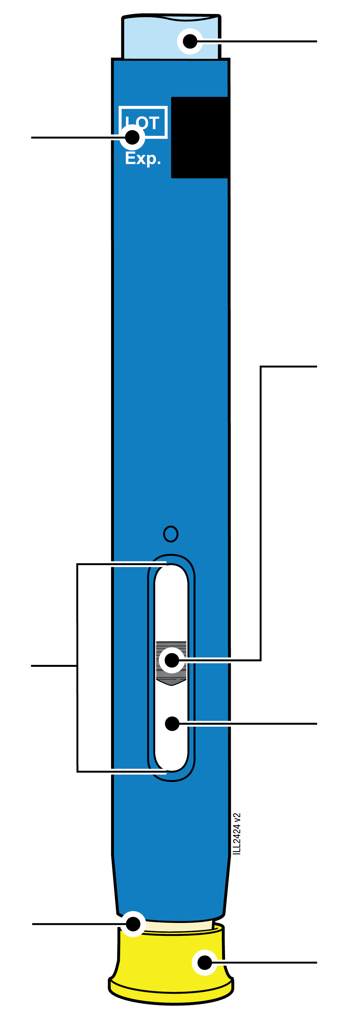40 mg/0.4 mL
  Expiry date
  Window
  Cream-coloured safety guard
  (needle inside)
  Light blue start button
  Plunger (may be visible in the window; location may vary)
  Medicine
  Yellow cap

1 |  | Important information you need to know before injecting AMGEVITA
 |  | It is important that you do not try to give yourself the injection until you have fully read and understood this Instructions for Use and unless you have received training from your doctor or healthcare provider.
 |  | Do not use the pre-filled pen if the carton is damaged or seal is broken.
 |  | Do not use the pre-filled pen after the expiry date on the label.
 |  | Do not shake the pre-filled pen.
 |  | Do not remove the yellow cap from the pre-filled pen until you are ready to inject.
 |  | Do not use the pre-filled pen if it has been frozen.
 |  | Do not use the pre-filled pen if it has been dropped on a hard surface. Part of the pre-filled pen may be broken even if you cannot see the break. Use a new pre-filled pen and call your doctor or healthcare provider.
Important: Keep the pre-filled pen and sharps disposal container out of the sight and reach of children.

2 | Preparing to inject AMGEVITA

2a | Wait 15 to 30 minutes for the pre-filled pen to reach room temperature.
WAIT
15 to 30
minutes

 |  | Remove the number of pre-filled pens you need for your injection and put any unused pre-filled pens back into the refrigerator.
 |  | Let the pre-filled pen warm up naturally.
 |  | Do not heat the pre-filled pen with hot water, a microwave, or direct sunlight.
 |  | Do not shake the pre-filled pen at any time.
 |  | Do not place the pre-filled pen back in refrigerator after it has reached room temperature.
 |  | Using the pre-filled pen at room temperature makes sure the full dose is delivered and allows for a more comfortable injection.

2b | Inspect the medicine. It should be clear and colourless to slightly yellow.
 | 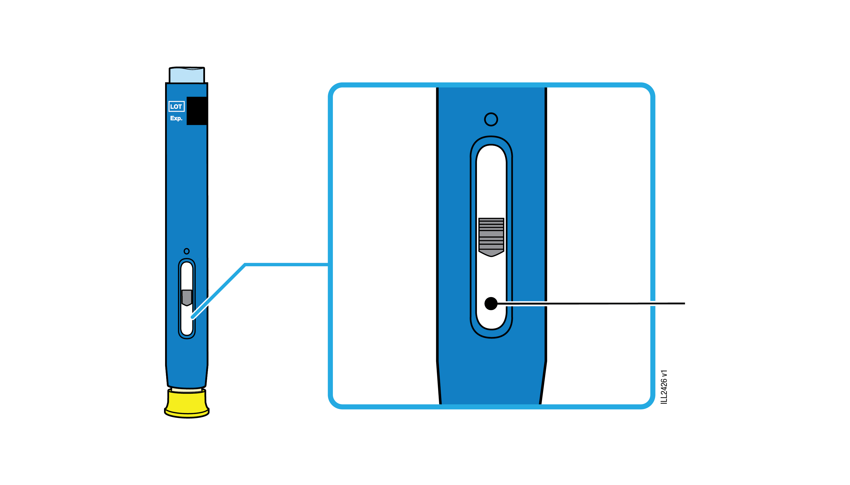 | Medicine
 | It is okay to see air bubbles in the pre-filled pen.
 | Do not use if the medicine is cloudy, discoloured or has flakes or particles.
Important: If the medicine is cloudy, discoloured, or contains flakes or particles, or if the pre-filled pen is damaged or expired, call your doctor or healthcare provider.

2c |  | Check the expiry date (EXP.) and inspect the pre-filled pen for damage.
 |  | 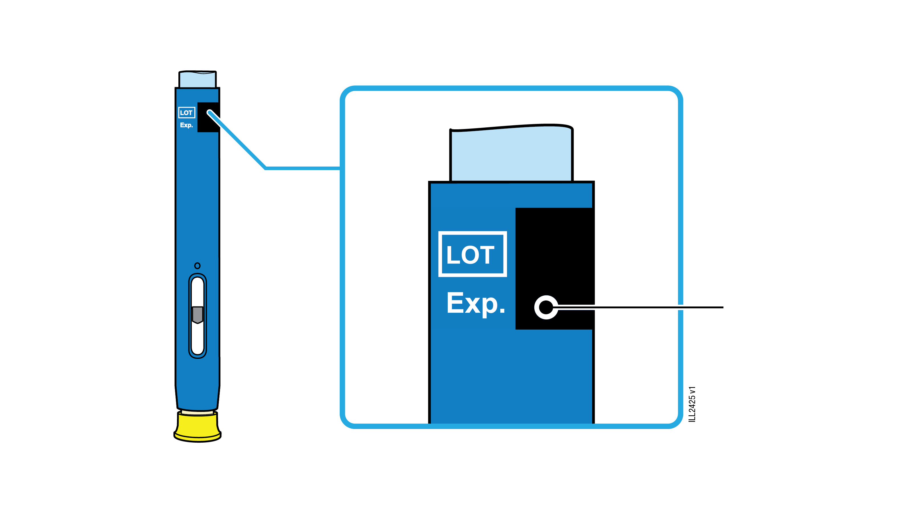 | Expiry date
 |  | Do not use the pre-filled pen if the expiry date has passed.
Do not use the pre-filled pen if:
- the yellow cap is missing or loose.
- it has cracks or broken parts.
- it has been dropped on a hard surface.
 |  | Make sure you have the right medicine and dose.

3 | Getting ready for your injection
3a | Gather and place the following items for your injection on a clean, flat and well-lit surface.
Sharps disposal container |  | 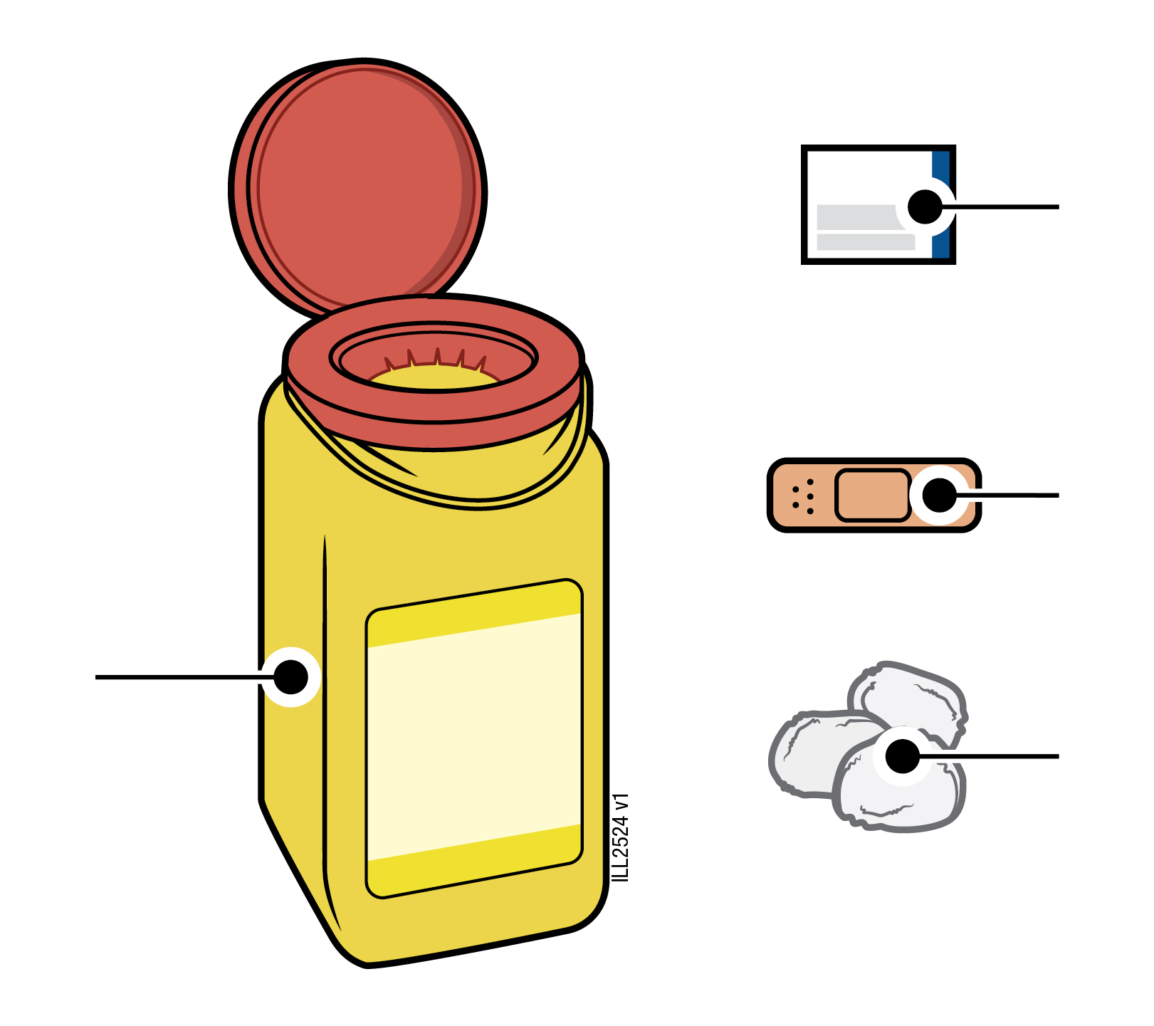 | Alcohol wipe  Plaster  Cotton ball or gauze pad
 | AMGEVITA pre-filled pen (room temperature)
 | Sharps disposal container
 | Alcohol wipe
 | Plaster
 | Cotton ball or gauze pad

3b | Inject into 1 of these sites.
 | Inject into the front of your thigh or belly (except 5 centimetres around your belly button).
 | Choose a different site for each injection.
 | Wash your hands thoroughly with soap and water.
 | Clean the injection site with an alcohol wipe.
 | Let the skin dry on its own.
 | Do not touch this area again before injecting.
Important: Avoid areas with scars, stretch marks, or where the skin is tender, bruised, red or hard.

4 | Injecting AMGEVITA
Important: Only remove the yellow cap when you can inject right away (within 5 minutes) because the medicine can dry out. Do not recap.
4a | Hold the pre-filled pen so you can see the window. Pull the yellow cap straight off.  You may need to pull hard.
Window should be visible |  | 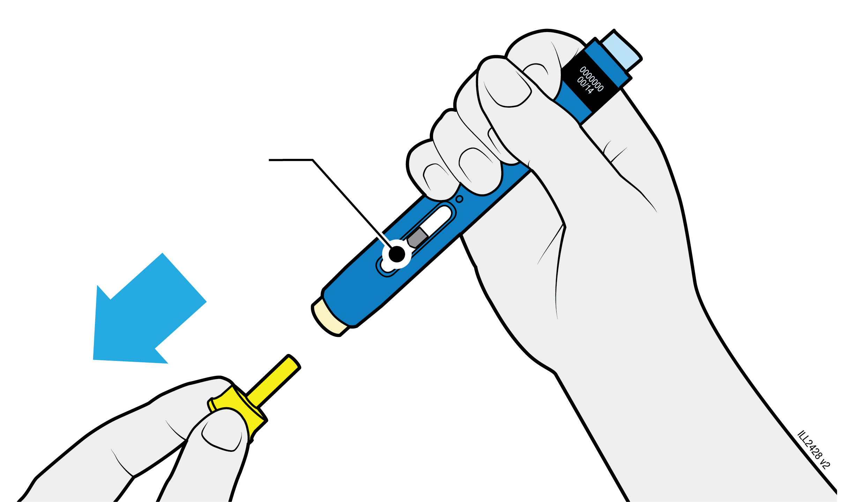
 | Do not twist, bend or wiggle the yellow cap to pull it off.
 | Never put the needle cap back on. It may damage the needle.
 | Do not put your finger inside the cream-coloured safety guard.
 | It is normal to see a drop of medicine at the end of the needle or cream-coloured safety guard.

4b | Pinch the skin to create a firm surface at the injection site. Place the cream-coloured safety guard straight against the pinched skin.
PINCH skin at  injection site |  |  | 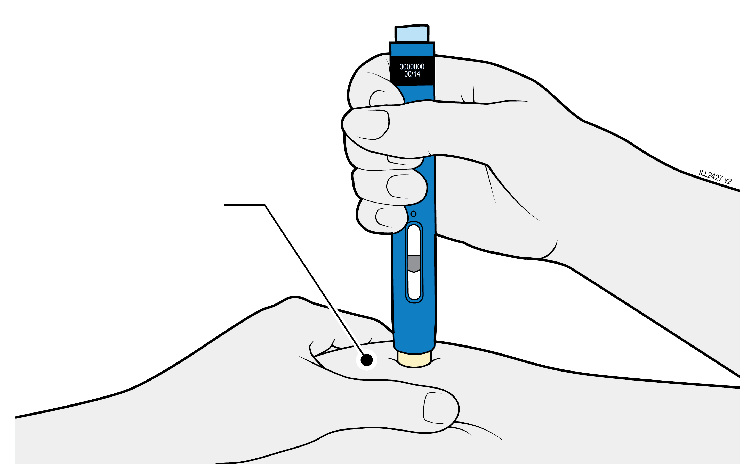
 | Keep the skin pinched until the injection is finished.
 | Make sure you can see the window.
 | Make sure the pre-filled pen is positioned straight on the injection site (at a 90 degree angle).
PUSH
and hold against skin
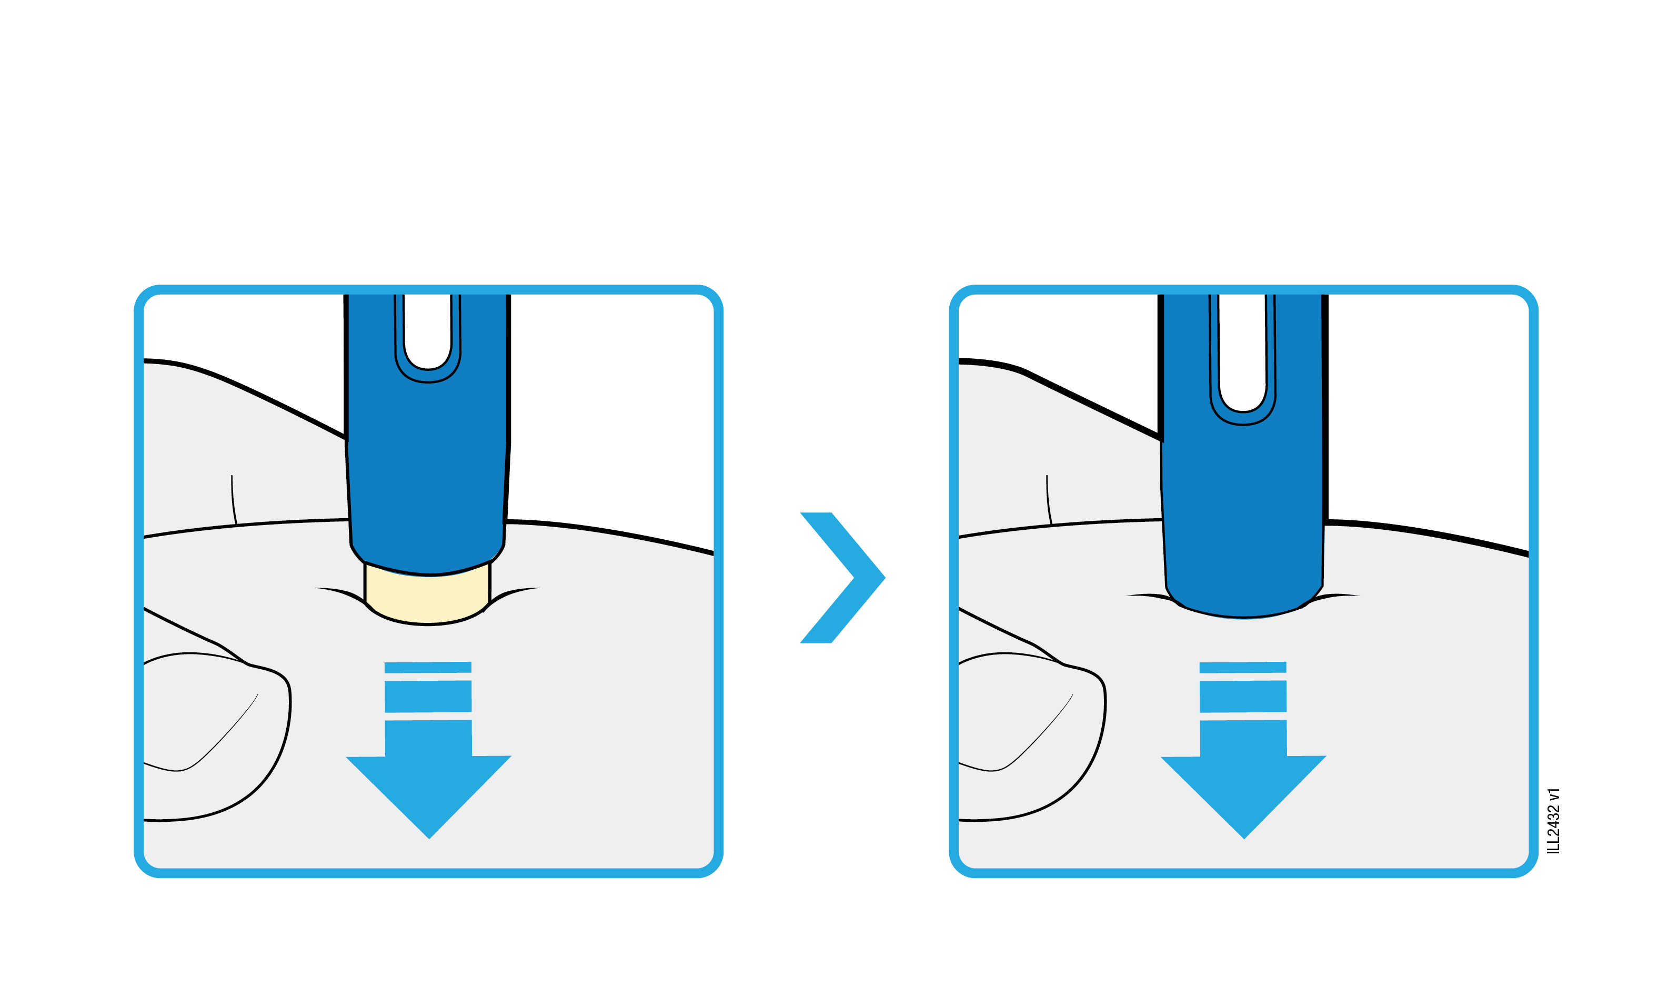
4c |  | Firmly push the pre-filled pen down until the cream-coloured safety guard stops moving. Hold the pre-filled pen down; do not lift.
 |  | The cream-coloured safety guard pushes in and unlocks the light blue start button.

PRESS
light blue start button
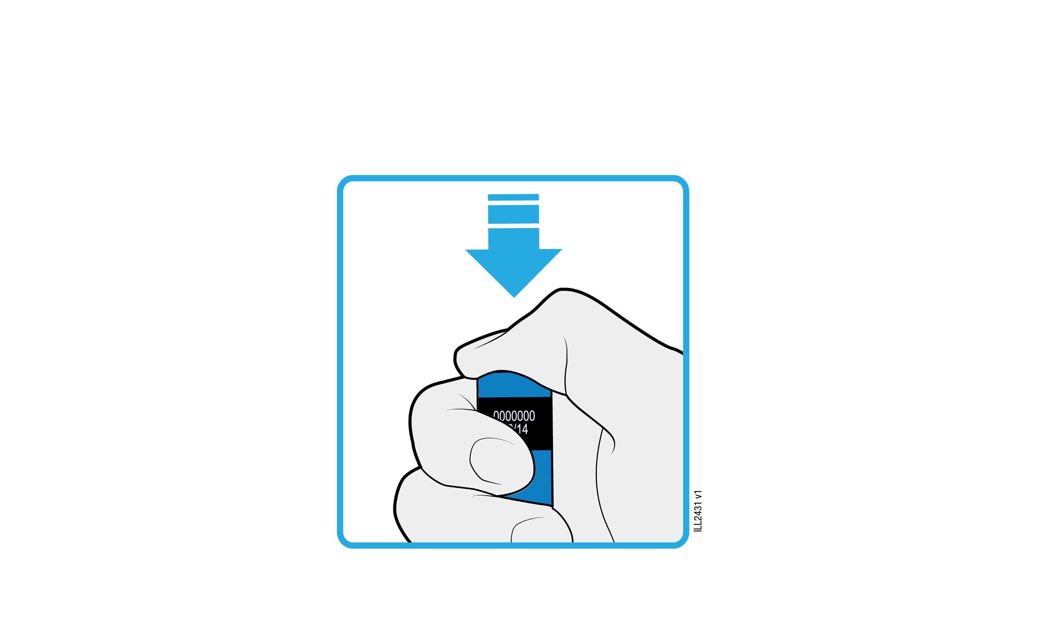
4d | Keep pushing the pre-filled pen down and press the light blue start button to start the injection.
 | You may hear or feel a click.
 | The window starts to turn yellow.
 | It is okay to let go of the light blue start button.

WATCH and CONFIRM
that the window turns fully yellow
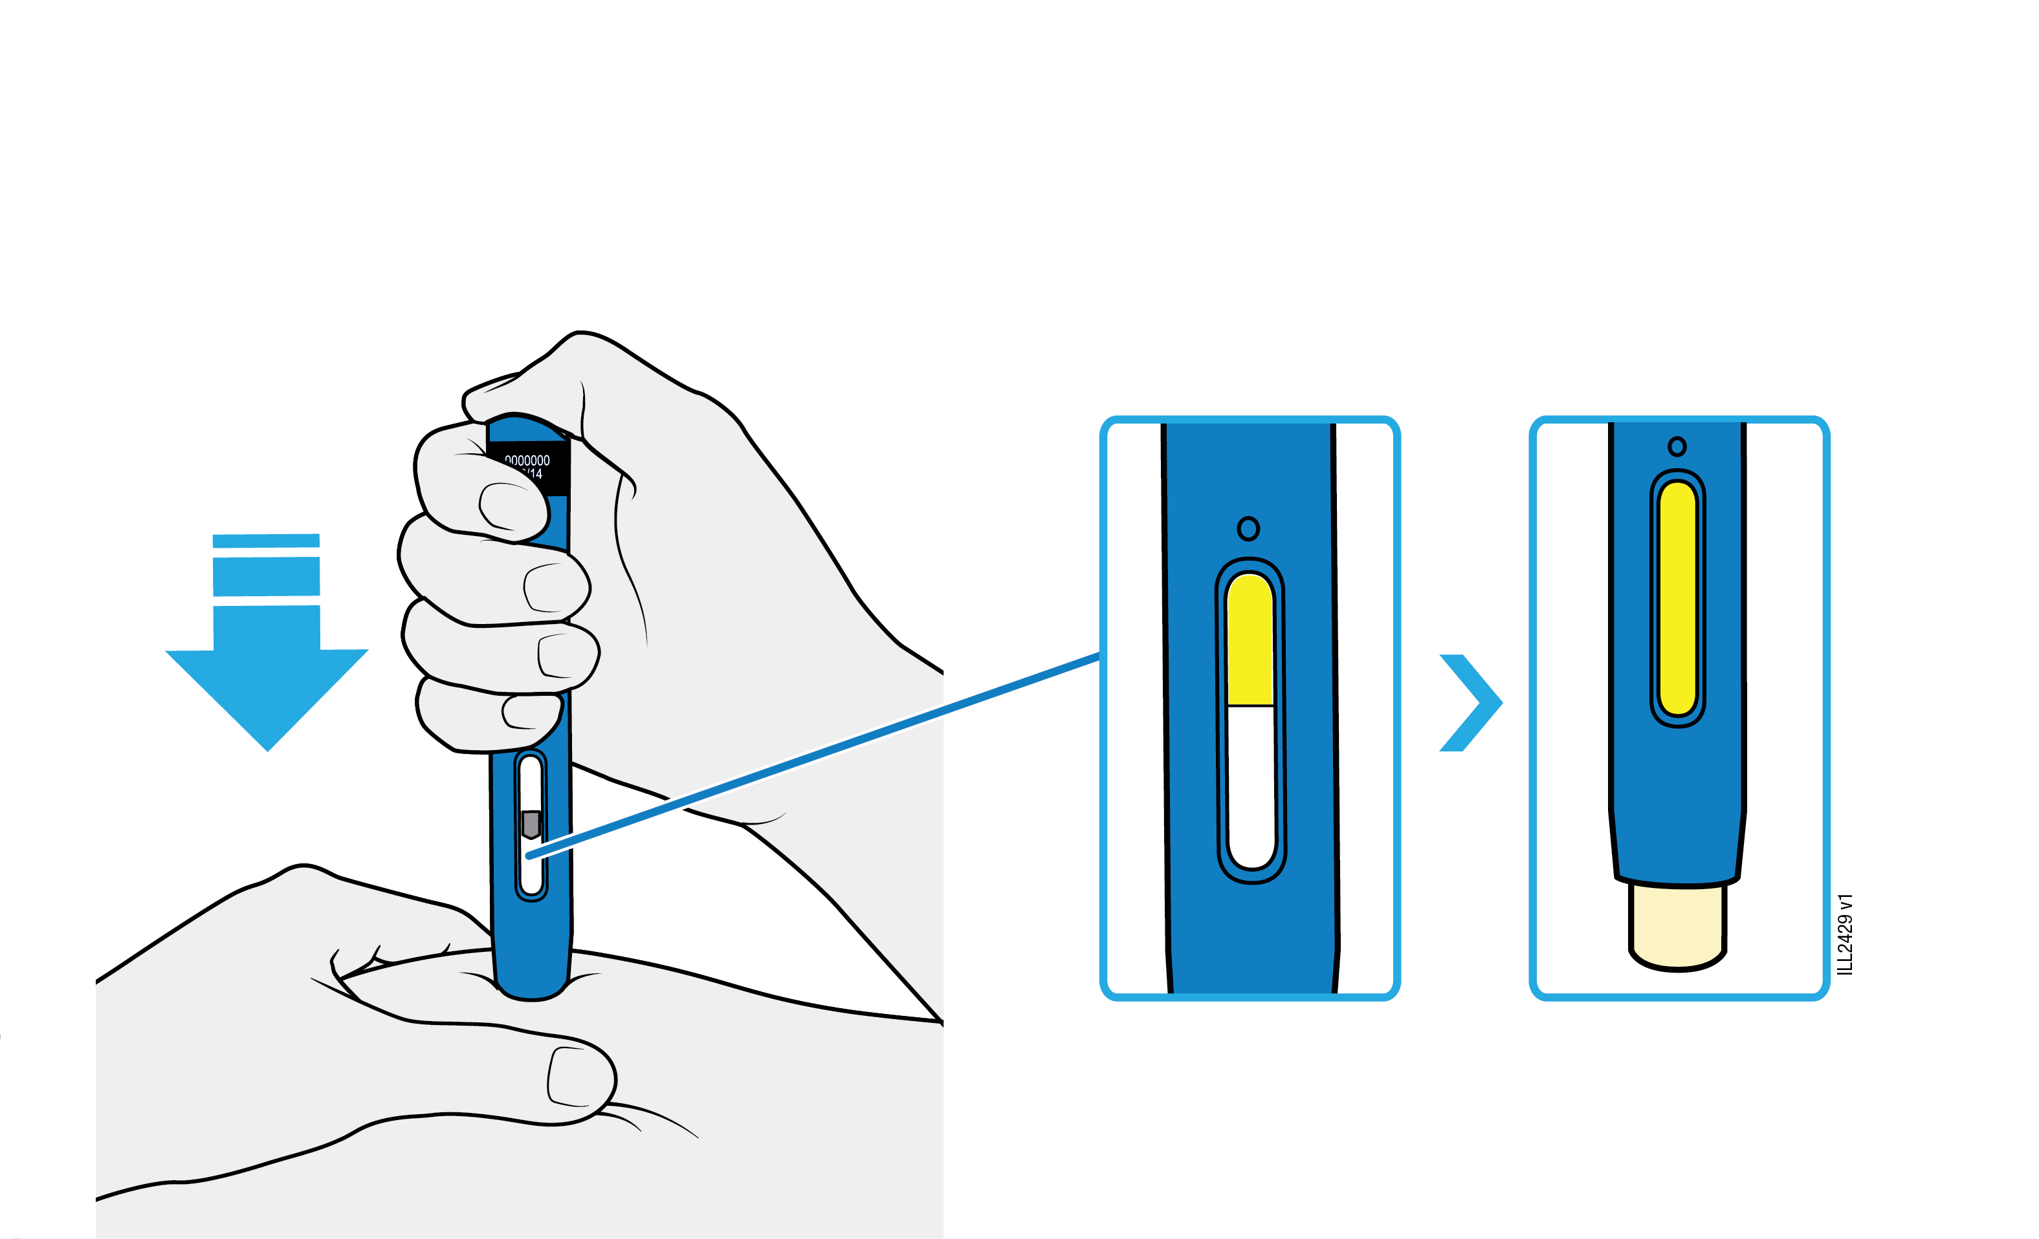

4e | Keep pushing the pre-filled pen down. When the window is fully yellow, the injection is complete.
 | The injection may take up to 10 seconds to complete.
 | You may hear or feel a click.
 | Lift the pre-filled pen away from your skin.
 | The cream-coloured safety guard locks around the needle.
Important: If the window has not turned fully yellow, or it looks like the medicine is still coming out, you have not received a full dose. Call your doctor or healthcare provider right away.

5 |  | Disposing of AMGEVITA and checking the injection site
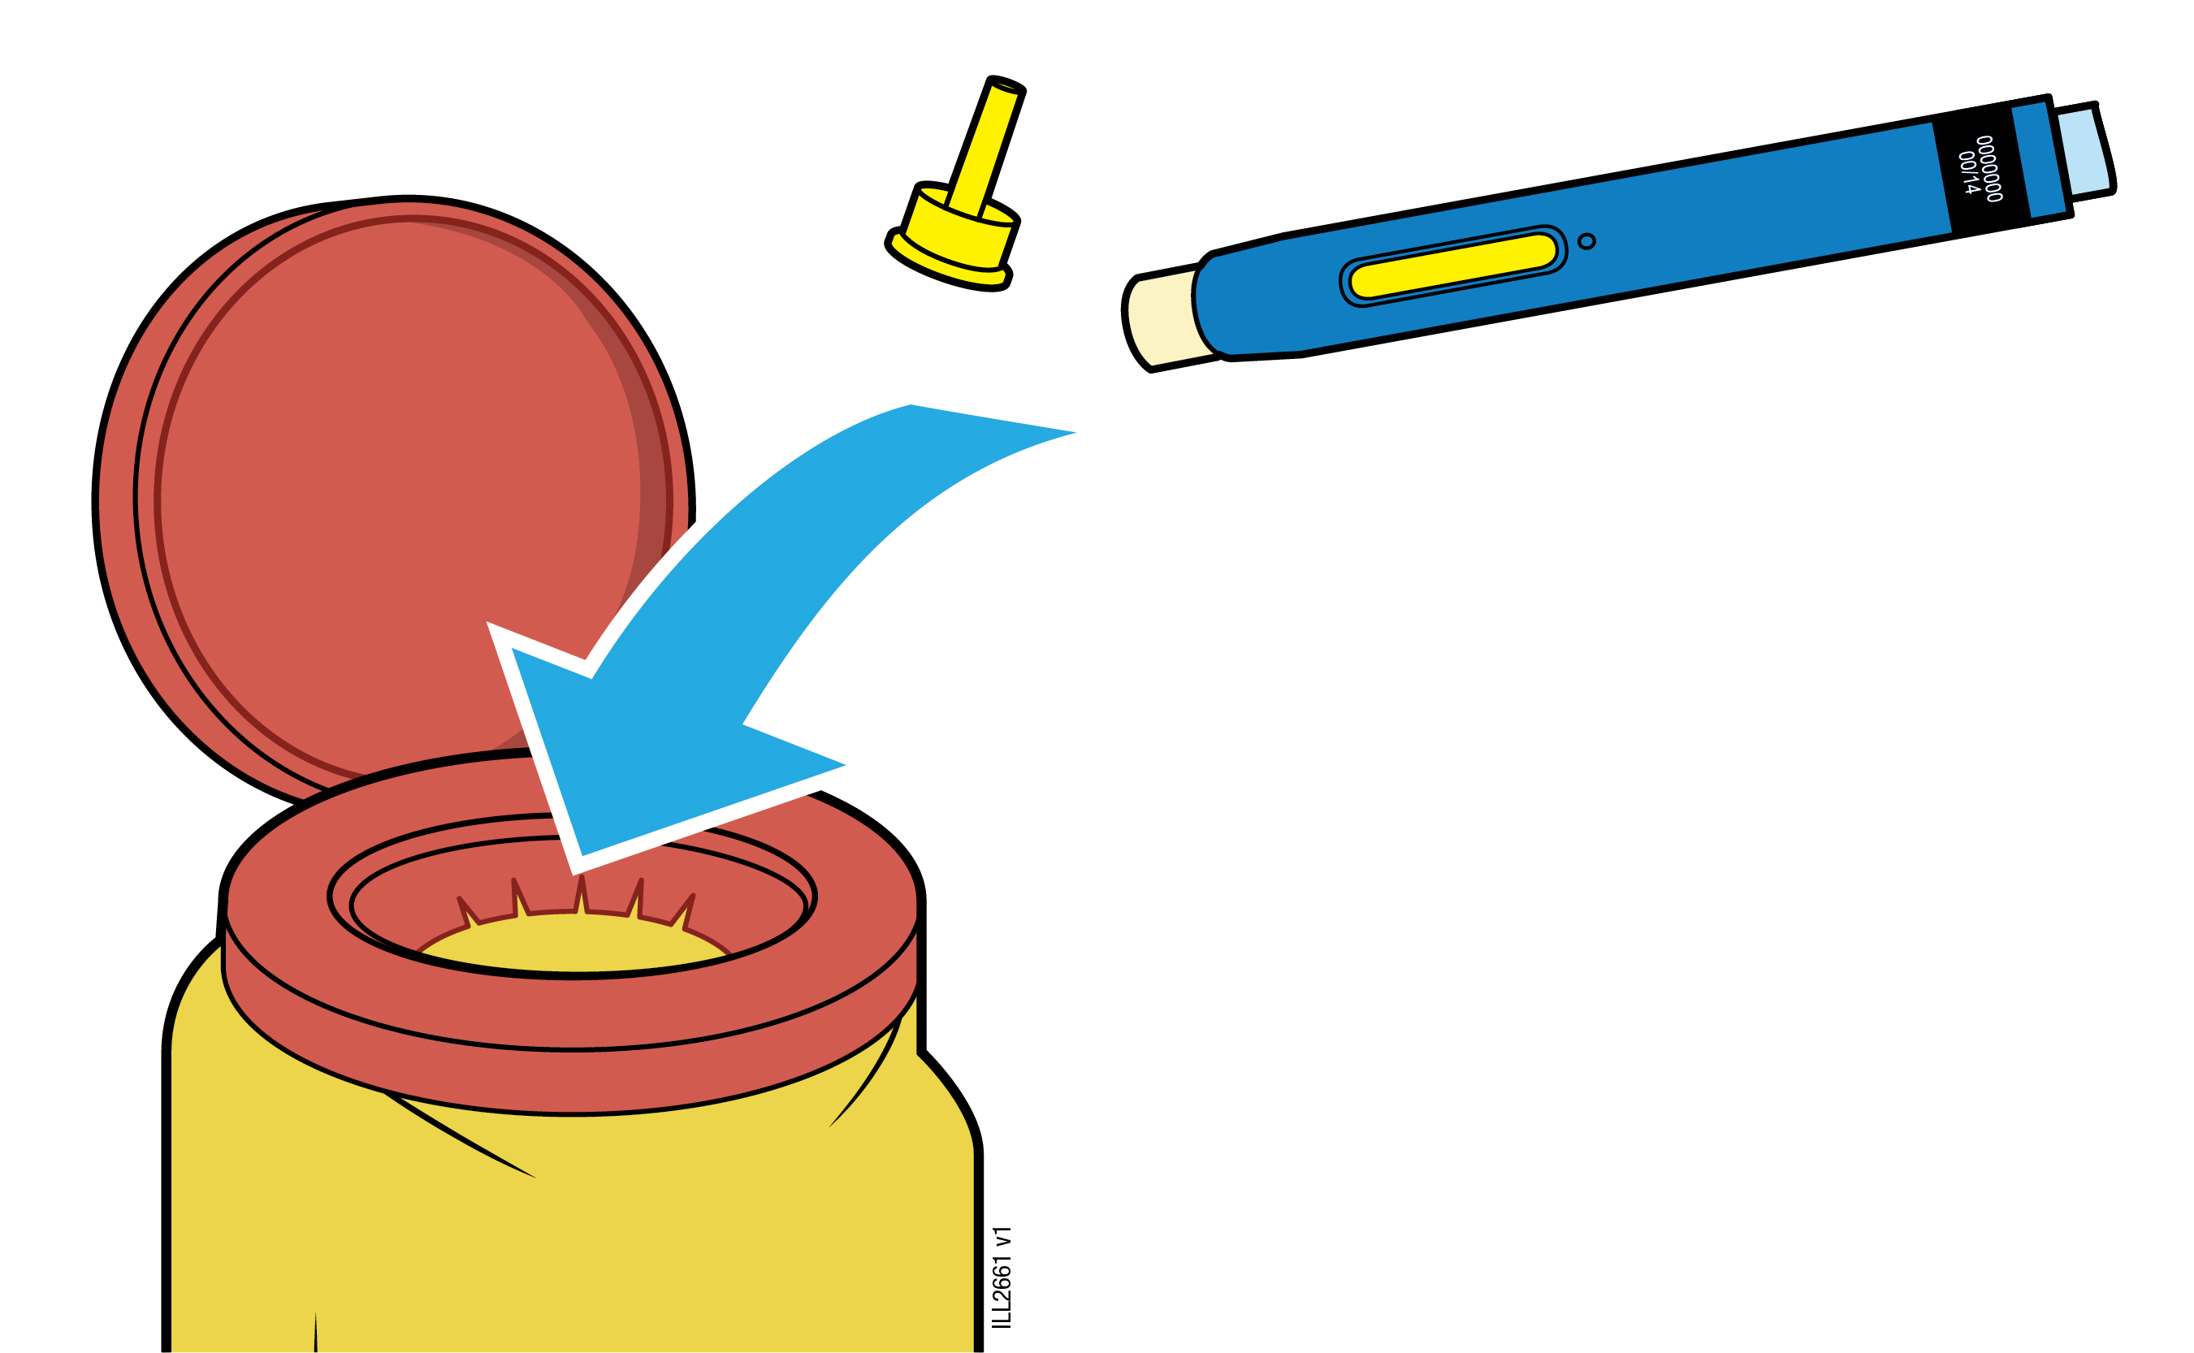
Important: Do not throw away the pre-filled pen into your household waste.
5a |  | Place the used pre-filled pen and yellow cap in a sharps disposal container right away after use.
 |  | Do not re-use the pre-filled pen.
 |  | Do not touch the cream-coloured safety guard.
5b |  | Check the injection site.
 |  | Do not rub the injection site.
 |  | If there is blood, press a cotton ball or gauze pad on your injection site. Apply a plaster if necessary.

Package leaflet: Information for the user

AMGEVITA 80 mg solution for injection in pre-filled pen
adalimumab

Read all of this leaflet carefully before you start using this medicine because it contains important information for you.
- Keep this leaflet. You may need to read it again.
- Your doctor will also give you a Patient Reminder Card, which contains important safety information that you need to be aware of before you are given AMGEVITA and during treatment with AMGEVITA. Keep this Patient Reminder Card with you.
- If you have any further questions, ask your doctor or pharmacist.
- This medicine has been prescribed for you only. Do not pass it on to others. It may harm them, even if their signs of illness are the same as yours.
- If you get any side effects, talk to your doctor or pharmacist. This includes any possible side effects not listed in this leaflet (see section 4).

What is in this leaflet

1. What AMGEVITA is and what it is used for
2. What you need to know before you use AMGEVITA
3. How to use AMGEVITA
4. Possible side effects
5. How to store AMGEVITA
6. Contents of the pack and other information

1. What AMGEVITA is and what it is used for

AMGEVITA contains the active substance adalimumab, a medicine that acts on your body’s immune (defence) system.

AMGEVITA is intended for the treatment of the inflammatory diseases described below:
  - Rheumatoid arthritis
  - Polyarticular juvenile idiopathic arthritis
  - Enthesitis-related arthritis
  - Ankylosing spondylitis
  - Axial spondyloarthritis without radiographic evidence of ankylosing spondylitis
  - Psoriatic arthritis
  - Plaque psoriasis
  - Hidradenitis suppurativa
  - Crohn’s disease
  - Ulcerative colitis
  - Non-infectious uveitis

The active ingredient in AMGEVITA, adalimumab, is a human monoclonal antibody. Monoclonal antibodies are proteins that attach to a specific target.

The target of adalimumab is a protein called tumour necrosis factor (TNFα), which is involved in the immune (defence) system and is present at increased levels in the inflammatory diseases listed above. By attaching to TNFα, AMGEVITA decreases the process of inflammation in these diseases.

Rheumatoid arthritis

Rheumatoid arthritis is an inflammatory disease of the joints.

AMGEVITA is used to treat rheumatoid arthritis in adults. If you have moderate to severe active rheumatoid arthritis, you may first be given other disease-modifying medicines, such as methotrexate. If you do not respond well enough to these medicines, you will be given AMGEVITA to treat your rheumatoid arthritis.

AMGEVITA can also be used to treat severe, active and progressive rheumatoid arthritis without previous methotrexate treatment.

AMGEVITA slows down the damage to the cartilage and bone of the joints caused by the disease and to improve physical function.

Usually, AMGEVITA is used with methotrexate. If your doctor determines that methotrexate is inappropriate, AMGEVITA can be given alone.

Polyarticular juvenile idiopathic arthritis and enthesitis-related arthritis

Polyarticular juvenile idiopathic arthritis and enthesitis-related arthritis are inflammatory diseases of the joints that usually first appear in childhood.

AMGEVITA is used to treat polyarticular juvenile idiopathic arthritis in patients from 2 years and enthesitis-related arthritis in patients from 6 years. You may first be given other disease-modifying medicines, such as methotrexate. If you do not respond well enough to these medicines, you will be given AMGEVITA to treat your polyarticular juvenile idiopathic arthritis or enthesitis-related arthritis.

Ankylosing spondylitis and axial spondyloarthritis without radiographic evidence of ankylosing spondylitis

Ankylosing spondylitis and axial spondyloarthritis without radiographic evidence of ankylosing spondylitis, are inflammatory diseases of the spine.

AMGEVITA is used to treat ankylosing spondylitis and axial spondyloarthritis without radiographic evidence of ankylosing spondylitis in adults. If you have ankylosing spondylitis or axial spondyloarthritis without radiographic evidence of ankylosing spondylitis, you will first be given other medicines. If you do not respond well enough to these medicines, you will be given AMGEVITA to reduce the signs and symptoms of your disease.

Psoriatic arthritis

Psoriatic arthritis is an inflammation of the joints associated with psoriasis.

AMGEVITA is used to treat psoriatic arthritis in adults. AMGEVITA slows down the damage to the cartilage and bone of the joints caused by the disease and to improve physical function.

Plaque psoriasis in adults and children

Plaque psoriasis is a skin condition that causes red, flaky, crusty patches of skin covered with silvery scales. Plaque psoriasis can also affect the nails, causing them to crumble, become thickened and lift away from the nail bed which can be painful. Psoriasis is believed to be caused by a problem with the body’s immune system that leads to an increased production of skin cells.

AMGEVITA is used to treat moderate to severe plaque psoriasis in adults. AMGEVITA is also used to treat severe plaque psoriasis in children and adolescents aged 4 to 17 years for whom topical therapy and phototherapies have either not worked very well or are not suitable.

Hidradenitis suppurativa in adults and adolescents

Hidradenitis suppurativa (sometimes called acne inversa) is a chronic and often painful inflammatory skin disease. Symptoms may include tender nodules (lumps) and abscesses (boils) that may leak pus. It most commonly affects specific areas of the skin, such as under the breasts, the armpits, inner thighs, groin and buttocks. Scarring may also occur in affected areas.

AMGEVITA is used to treat hidradenitis suppurativa in adults and adolescents from 12 years of age. AMGEVITA can reduce the number of nodules and abscesses you have, and the pain that is often associated with the disease. You may first be given other medicines. If you do not respond well enough to these medicines, you will be given AMGEVITA.

Crohn’s disease in adults and children

Crohn’s disease is an inflammatory disease of the digestive tract.

AMGEVITA is used to treat Crohn’s disease in adults and children aged 6 to 17 years. If you have Crohn’s disease you will first be given other medicines. If you do not respond well enough to these medicines, you will be given AMGEVITA to reduce the signs and symptoms of your Crohn’s disease.

Ulcerative colitis in adults and children

Ulcerative colitis is an inflammatory disease of the large intestine.

AMGEVITA is used to treat moderate to severe ulcerative colitis in adults and children aged 6 to 17 years. If you have ulcerative colitis you may first be given other medicines. If you do not respond well enough to these medicines, you will be given AMGEVITA to reduce the signs and symptoms of your disease.

Non-infectious uveitis in adults and children

Non-infectious uveitis is an inflammatory disease affecting certain parts of the eye.

AMGEVITA is used to treat
- Adults with non-infectious uveitis with inflammation affecting the back of the eye.
- Children from 2 years of age with chronic non-infectious uveitis with inflammation affecting the front of the eye.

This inflammation may lead to a decrease of vision and/or the presence of floaters in the eye (black dots or wispy lines that move across the field of vision). AMGEVITA works by reducing this inflammation.

2. What you need to know before you use AMGEVITA

Do not use AMGEVITA:

- if you are allergic to adalimumab or any of the other ingredients of this medicine (listed in section 6).
- if you have a severe infection, including active tuberculosis, sepsis (blood infection) or other opportunistic infections (unusual infections associated with a weakened immune system) (see “Warnings and precautions”). It is important that you tell your doctor if you have symptoms of infections, e.g. fever, wounds, feeling tired, dental problems.
- if you have moderate or severe heart failure. It is important to tell your doctor if you have had or have a serious heart condition (see “Warnings and precautions”).

Warnings and precautions

Talk to your doctor or pharmacist before using AMGEVITA:

Allergic reactions

- If you experience allergic reactions with symptoms such as chest tightness, wheezing, dizziness, swelling or rash do not inject more AMGEVITA and contact your doctor immediately since, in rare cases, these reactions can be life threatening.

Infections

- If you have an infection, including long-term or localised infection (for example, leg ulcer) consult your doctor before starting AMGEVITA. If you are unsure, contact your doctor.
- You might get infections more easily while you are receiving AMGEVITA treatment. This risk may increase if your lung function is impaired. These infections may be serious and include tuberculosis, infections caused by viruses, fungi, parasites or bacteria, or other opportunistic infections and sepsis that may, in rare cases, be life-threatening. It is important to tell your doctor if you get symptoms such as fever, wounds, feeling tired or dental problems. Your doctor may recommend temporary discontinuation of AMGEVITA.

Tuberculosis

- As cases of tuberculosis have been reported in patients treated with adalimumab, your doctor will check you for signs and symptoms of tuberculosis before starting AMGEVITA. This will include a thorough medical evaluation including your medical history and appropriate screening tests (for example chest x-ray and a tuberculin test). The conduct and results of these tests should be recorded on your Patient Reminder Card. It is very important that you tell your doctor if you have ever had tuberculosis, or if you have been in close contact with someone who has had tuberculosis.
- Tuberculosis can develop during therapy even if you have received preventative treatment for tuberculosis.
- If symptoms of tuberculosis (persistent cough, weight loss, listlessness, mild fever), or any other infection appear during or after therapy, tell your doctor immediately.

Travel / recurrent infection

- Advise your doctor if you reside or travel in regions where fungal infections such as histoplasmosis, coccidioidomycosis or blastomycosis are endemic.
- Advise your doctor if you have a history of recurrent infections or other conditions that increase the risk of infections.

Hepatitis B virus

- Advise your doctor if you are a carrier of the hepatitis B virus (HBV), if you have active HBV or if you think you might be at risk of contracting HBV. Your doctor should test you for HBV. AMGEVITA can cause reactivation of HBV in people who carry this virus. In some rare cases, especially if you are taking other medicines that suppress the immune system, reactivation of HBV can be life-threatening.

Age over 65 years

- If you are over 65 years you may be more susceptible to infections while taking AMGEVITA. You and your doctor should pay special attention to signs of infection while you are being treated with AMGEVITA. It is important to tell your doctor if you get symptoms of infections, such as fever, wounds, feeling tired or dental problems.

Surgery or dental procedures

- If you are about to undergo surgery or dental procedures please inform your doctor that you are taking AMGEVITA. Your doctor may recommend temporary discontinuation of AMGEVITA.

Demyelinating disease

- If you have or develop demyelinating disease such as multiple sclerosis, your doctor will decide if you should receive or continue to receive AMGEVITA. Tell your doctor immediately if you experience symptoms like changes in your vision, weakness in your arms or legs or numbness or tingling in any part of your body.

Vaccinations

- Certain vaccines contain living but weakened forms of disease-causing bacteria or viruses that may cause infections and should not be given while receiving AMGEVITA. Please check with your doctor before you receive any vaccines. It is recommended that children, if possible, be brought up to date with all immunisations in agreement with current immunisation guidelines prior to initiating AMGEVITA therapy.
- If you received AMGEVITA while you were pregnant, your baby may be at higher risk for getting such an infection for up to approximately five months after the last dose you received during pregnancy. It is important that you tell your baby's doctors and other health care professionals about your AMGEVITA use during your pregnancy so they can decide when your baby should receive any vaccine.

Heart failure

- If you have mild heart failure and you are being treated with AMGEVITA, your heart failure status must be closely monitored by your doctor. It is important to tell your doctor if you have had or have a serious heart condition. If you develop new or worsening symptoms of heart failure (e.g. shortness of breath, or swelling of your feet), you must contact your doctor immediately. Your doctor will decide if you should receive AMGEVITA.

Fever, bruising, bleeding or looking pale

- In some patients the body may fail to produce enough of the blood cells that help your body fight infections or help you to stop bleeding. If you develop a fever that does not go away, bruise or bleed very easily or look very pale, call your doctor right away. Your doctor may decide to stop treatment.

Cancer

- There have been very rare cases of certain kinds of cancer in children and adult patients taking adalimumab or other TNF blockers. People with more serious rheumatoid arthritis that have had the disease for a long time may have a higher than average risk of getting lymphoma (a cancer that affects the lymph system), and leukaemia (a cancer that affects the blood and bone marrow).
- If you take AMGEVITA the risk of getting lymphoma, leukaemia, or other cancers may increase. On rare occasions, a specific and severe type of lymphoma has been observed in patients taking adalimumab. Some of those patients were also treated with azathioprine or 6-mercaptopurine. Tell your doctor if you are taking azathioprine or 6-mercaptopurine with AMGEVITA.
- In addition, cases of non-melanoma skin cancer have been observed in patients taking adalimumab. If new skin lesions appear during or after therapy or if existing lesions change appearance, tell your doctor.
- There have been cases of cancers, other than lymphoma in patients with a specific type of lung disease called Chronic Obstructive Pulmonary Disease (COPD) treated with another TNF blocker. If you have COPD, or are a heavy smoker, you should discuss with your doctor whether treatment with a TNF blocker is appropriate for you.

Autoimmune disease

- On rare occasions, treatment with AMGEVITA could result in lupus-like syndrome. Contact your doctor if symptoms such as persistent unexplained rash, fever, joint pain or tiredness occur.

In order to improve the traceability of this medicine, your doctor or pharmacist should record the name and the lot number of the product you have been given in your patient file. You may also wish to make a note of these details in case you are asked for this information in the future.

Children and adolescents

- Vaccinations: if possible children should be up to date with all vaccinations before using AMGEVITA.

- Do not give AMGEVITA to children with polyarticular juvenile idiopathic arthritis below the age of 2 years.

- Do not give AMGEVITA to children with plaque psoriasis below the age of 4 years.

- Do not give AMGEVITA to children with Crohn’s disease or ulcerative colitis below the age of 6 years.

Other medicines and AMGEVITA

Tell your doctor or pharmacist if you are taking, have recently taken or might take any other medicines.

AMGEVITA can be taken together with methotrexate or certain disease-modifying anti-rheumatic agents (sulfasalazine, hydroxychloroquine, leflunomide and injectable gold preparations), steroids or pain medications including non-steroidal anti-inflammatory drugs (NSAIDs).

You should not take AMGEVITA with medicines containing the active substances, anakinra or abatacept due to increased risk of serious infection. If you have questions, please ask your doctor.

Pregnancy and breast-feeding

- You should consider the use of adequate contraception to prevent pregnancy and continue its use for at least 5 months after the last AMGEVITA treatment.
- If you are pregnant, think you may be pregnant or are planning to have a baby, ask your doctor for advice about taking this medicine.
- AMGEVITA should only be used during a pregnancy if needed.
- According to a pregnancy study, there was no higher risk of birth defects when the mother had received AMGEVITA during pregnancy compared with mothers with the same disease who did not receive AMGEVITA.
- AMGEVITA can be used during breast-feeding.
- If you receive AMGEVITA during your pregnancy, your baby may have a higher risk for getting an infection.
- It is important that you tell your baby’s doctors and other health care professionals about your AMGEVITA use during your pregnancy before the baby receives any vaccine. For more information on vaccines see the “Warnings and precautions” section.

Driving and using machines

AMGEVITA may have a minor influence on your ability to drive, cycle or use machines. Room spinning sensation (vertigo) and vision disturbances may occur after taking AMGEVITA.

AMGEVITA contains sodium

This medicine contains less than 1 mmol of sodium (23 mg) per 0.8 mL dose, that is to say essentially ‘sodium-free’.

3. How to use AMGEVITA

Always use this medicine exactly as your doctor or pharmacist has told you. Check with your doctor or pharmacist if you are not sure.

Adults with rheumatoid arthritis, psoriatic arthritis, ankylosing spondylitis or axial spondyloarthritis without radiographic evidence of ankylosing spondylitis

AMGEVITA is injected under the skin (subcutaneous use). The usual dose for adults with rheumatoid arthritis, ankylosing spondylitis, axial spondyloarthritis without radiographic evidence of ankylosing spondylitis, and for patients with psoriatic arthritis is 40 mg given every other week as a single dose.

In rheumatoid arthritis, methotrexate is continued while using AMGEVITA. If your doctor determines that methotrexate is inappropriate, AMGEVITA can be given alone.

If you have rheumatoid arthritis and you do not receive methotrexate with your AMGEVITA therapy, your doctor may decide to give 40 mg every week or 80 mg every other week.

Adults with plaque psoriasis

The usual dose for adults with plaque psoriasis is an initial dose of 80 mg, followed by 40 mg given every other week starting one week after the initial dose. You should continue to inject AMGEVITA for as long as your doctor has told you. Depending on your response, your doctor may increase the dose to 40 mg every week or 80 mg every other week.

Adults with hidradenitis suppurativa

The usual dose regimen for hidradenitis suppurativa is an initial dose of 160 mg (two 80 mg injections in one day or one 80 mg injection per day for two consecutive days), followed by an 80 mg dose (one 80 mg injection) two weeks later. After two further weeks, continue with a dose of 40 mg every week or 80 mg every other week, as prescribed by your doctor. It is recommended that you use an antiseptic wash daily on the affected areas.

Adolescents with hidradenitis suppurativa from 12 to 17 years of age weighing 30 kg or more

The recommended dose of AMGEVITA is an initial dose of 80 mg, followed by 40 mg every other week starting one week later. If you have an inadequate response to AMGEVITA 40 mg every other week, your doctor may increase the dose to 40 mg every week or 80 mg every other week.

It is recommended that you use an antiseptic wash daily on the affected areas.

Adults with Crohn’s disease

The usual dose regimen for Crohn’s disease is 80 mg initially followed by 40 mg every other week two weeks later. If a faster response is required, your doctor may prescribe an initial dose of 160 mg (two 80 mg injections in one day or one 80 mg injection per day for two consecutive days), followed by 80 mg two weeks later, and thereafter as 40 mg every other week. Depending on your response, your doctor may increase the dose to 40 mg every week or 80 mg every other week.

Children and adolescents with Crohn's disease

Children and adolescents from 6 to 17 years of age weighing less than 40 kg

The usual dose regimen is 40 mg initially followed by 20 mg two weeks later. If a faster response is required, your doctor may prescribe an initial dose of 80 mg followed by 40 mg two weeks later.

Thereafter, the usual dose is 20 mg every other week. Depending on your response, your doctor may increase the dose frequency to 20 mg every week.

The 40 mg pre-filled pen cannot be used for the 20 mg dose. An AMGEVITA 20 mg pre-filled syringe is however available for the 20 mg dose.

Children and adolescents from 6 to 17 years of age weighing 40 kg or more

The usual dose regimen is 80 mg initially followed by 40 mg two weeks later. If a faster response is required, your doctor may prescribe an initial dose of 160 mg (two 80 mg injections in one day or one 80 mg injection per day for two consecutive days) followed by 80 mg two weeks later.

Thereafter, the usual dose is 40 mg every other week. Depending on your response, your doctor may increase the dose to 40 mg every week or 80 mg every other week.

Adults with ulcerative colitis

The usual AMGEVITA dose for adults with ulcerative colitis is 160 mg initially (two 80 mg injections in one day or one 80 mg injection per day for two consecutive days) followed by 80 mg two weeks later, then 40 mg every other week. Depending on your response, your doctor may increase the dose to 40 mg every week or 80 mg every other week.

Children and adolescents with ulcerative colitis

Children and adolescents from 6 years of age weighing less than 40 kg

The usual AMGEVITA dose is 80 mg initially followed by 40 mg (as one 40 mg injection) two weeks later. Thereafter, the usual dose is 40 mg every other week.

Patients who turn 18 years of age while on 40 mg every other week, should continue their prescribed dose.

Children and adolescents from 6 years of age weighing 40 kg or more

The usual AMGEVITA dose is 160 mg (two 80 mg injections in one day or one 80 mg injection per day for two consecutive days) initially, followed by 80 mg two weeks later. Thereafter the usual dose is 80 mg every other week.

Patients who turn 18 years of age while on 80 mg every other week, should continue their prescribed dose.

Adults with non-infectious uveitis

The usual dose for adults with non-infectious uveitis is an initial dose of 80 mg, followed by 40 mg given every other week starting one week after the initial dose. You should continue to inject AMGEVITA for as long as your doctor has told you.

In non-infectious uveitis, corticosteroids or other medicines that influence the immune system may be continued while using AMGEVITA. AMGEVITA can also be given alone.

Children and adolescents with chronic non-infectious uveitis from 2 years of age

Children and adolescents from 2 years of age weighing less than 30 kg

The usual dose of AMGEVITA is 20 mg every other week with methotrexate.

Your doctor may also prescribe an initial dose of 40 mg which may be administered one week prior to the start of the usual dose.

The 40 mg pre-filled pen cannot be used for the 20 mg dose. An AMGEVITA 20 mg pre-filled syringe is however available for the 20 mg dose.

Children and adolescents from 2 years of age weighing 30 kg or more

The usual dose of AMGEVITA is 40 mg every other week with methotrexate.

Your doctor may also prescribe an initial dose of 80 mg which may be administered one week prior to the start of the usual dose.

Method and route of administration

AMGEVITA is administered by injection under the skin (subcutaneous injection).

Detailed instructions on how to inject AMGEVITA are provided in “Instructions for use” section.

If you use more AMGEVITA than you should

If you accidentally inject AMGEVITA more frequently than told to by your doctor or pharmacist, call your doctor or pharmacist and tell him/her that you have taken more. Always take the outer carton of this medicine with you, even if it is empty.

If you forget to use AMGEVITA

If you forget to give yourself an injection, you should inject the next dose of AMGEVITA as soon as you remember. Then take your next dose as you would have on your originally scheduled day, had you not forgotten a dose.

If you stop using AMGEVITA

The decision to stop using AMGEVITA should be discussed with your doctor. Your symptoms may return upon discontinuation.

If you have any further questions on the use of this medicine, ask your doctor or pharmacist.

4. Possible side effects

Like all medicines, this medicine can cause side effects, although not everybody gets them. Most side effects are mild to moderate. However, some may be serious and require treatment. Side effects may occur at least up to 4 months after the last AMGEVITA injection.

Tell your doctor immediately if you notice any of the following signs of allergic reaction or heart failure:
- severe rash, hives or other signs of allergic reaction;
- swollen face, hands, feet;
- trouble breathing, swallowing;
- shortness of breath with exertion or upon lying down or swelling of the feet.

Tell your doctor as soon as possible if you notice any of the following:
- signs of infection such as fever, feeling sick, wounds, dental problems, burning on urination;
- feeling weak or tired;
- coughing;
- tingling;
- numbness;
- double vision;
- arm or leg weakness;
- signs of skin cancer such as a bump or open sore that doesn't heal;
- signs and symptoms suggestive of blood disorders such as persistent fever, bruising, bleeding, paleness.

The symptoms described above can be signs of the below listed side effects, which have been observed with adalimumab.

Very common (may affect more than 1 in 10 people)
- injection site reactions (including pain, swelling, redness or itching);
- respiratory tract infections (including cold, runny nose, sinus infection, pneumonia);
- headache;
- abdominal pain;
- nausea and vomiting;
- rash;
- musculoskeletal pain.

Common (may affect up to 1 in 10 people)
- serious infections (including blood poisoning and influenza);
- intestinal infections (including gastroenteritis);
- skin infections (including cellulitis and shingles);
- ear infections;
- oral infections (including tooth infections and cold sores);
- reproductive tract infections;
- urinary tract infection;
- fungal infections;
- joint infections;
- benign tumours;
- skin cancer;
- allergic reactions (including seasonal allergy);
- dehydration;
- mood swings (including depression);
- anxiety;
- difficulty sleeping;
- sensation disorders such as tingling, prickling or numbness;
- migraine;
- nerve root compression (including low back pain and leg pain);
- vision disturbances;
- eye inflammation;
- inflammation of the eye lid and eye swelling;
- vertigo (feeling of dizziness or spinning);
- sensation of heart beating rapidly;
- high blood pressure;
- flushing;
- haematoma;
- cough;
- asthma;
- shortness of breath;
- gastrointestinal bleeding;
- dyspepsia (indigestion, bloating, heart burn);
- acid reflux disease;
- sicca syndrome (including dry eyes and dry mouth);
- itching;
- itchy rash;
- bruising;
- inflammation of the skin (such as eczema);
- breaking of finger nails and toe nails;
- increased sweating;
- hair loss;
- new onset or worsening of psoriasis;
- muscle spasms;
- blood in urine;
- kidney problems;
- chest pain;
- oedema;
- fever;
- reduction in blood platelets which increases risk of bleeding or bruising;
- impaired healing.

Uncommon (may affect up to 1 in 100 people)
  - opportunistic infections (which include tuberculosis and other infections that occur when resistance to disease is lowered);
  - neurological infections (including viral meningitis);
  - eye infections;
  - bacterial infections;
  - diverticulitis (inflammation and infection of the large intestine);
  - cancer, including cancer that affects the lymph system (lymphoma) and melanoma (skin cancer);
  - immune disorders that could affect the lungs, skin and lymph nodes (most commonly presenting as sarcoidosis);
  - vasculitis (inflammation of blood vessels);
  - tremor;
  - neuropathy;
  - stroke;
  - hearing loss, buzzing;
  - sensation of heart beating irregularly such as skipped beats;
  - heart problems that can cause shortness of breath or ankle swelling;
  - heart attack;
  - a sac in the wall of a major artery, inflammation and clot of a vein, blockage of a blood vessel;
  - lung diseases causing shortness of breath (including inflammation);
  - pulmonary embolism (blockage in an artery of the lung);
  - pleural effusion (abnormal collection of fluid in the pleural space);
  - inflammation of the pancreas which causes severe pain in the abdomen and back;
  - difficulty in swallowing;
  - facial oedema;
  - gallbladder inflammation, gallbladder stones;
  - fatty liver;
  - night sweats;
  - scar;
  - abnormal muscle breakdown;
  - systemic lupus erythematosus (including inflammation of skin, heart, lung, joints and other organ systems);
  - sleep interruptions;
  - impotence;
  - inflammations.

Rare (may affect up to 1 in 1 000 people)
- leukaemia (cancer affecting the blood and bone marrow);
- severe allergic reaction with shock;
- multiple sclerosis;
- nerve disorders (such as eye nerve inflammation and Guillain-Barré syndrome that may cause muscle weakness, abnormal sensations, tingling in the arms and upper body);
- heart stops pumping;
- pulmonary fibrosis (scarring of the lung);
- intestinal perforation (hole in the wall of the gut);
- hepatitis (liver inflammation);
- reactivation of hepatitis B;
- autoimmune hepatitis (inflammation of the liver caused by the body's own immune system);
- cutaneous vasculitis (inflammation of blood vessels in the skin);
- Stevens-Johnson syndrome (life-threatening reaction with flu-like symptoms and blistering rash);
- facial oedema associated with allergic reactions;
- erythema multiforme (inflammatory skin rash);
- lupus-like syndrome;
- angioedema (localised swelling of the skin);
- lichenoid skin reaction (itchy reddish-purple skin rash).

Not known (frequency cannot be estimated from available data)
- hepatosplenic T-cell lymphoma (a rare blood cancer that is often fatal);
- Merkel cell carcinoma (a type of skin cancer);
- Kaposi’s sarcoma, a rare cancer related to infection with human herpes virus 8. Kaposi’s sarcoma most commonly appears as purple lesions on the skin;
- liver failure;
- worsening of a condition called dermatomyositis (seen as a skin rash accompanying muscle weakness);
- weight gain (for most patients, the weight gain was small).

Some side effects observed with adalimumab may not have symptoms and may only be discovered through blood tests. These include:

Very common (may affect more than 1 in 10 people)
- low blood measurements for white blood cells;
- low blood measurements for red blood cells;
- increased lipids in the blood;
- elevated liver enzymes.

Common (may affect up to 1 in 10 people)
- high blood measurements for white blood cells;
- low blood measurements for platelets;
- increased uric acid in the blood;
- abnormal blood measurements for sodium;
- low blood measurements for calcium;
- low blood measurements for phosphate;
- high blood sugar;
- high blood measurements for lactate dehydrogenase;
- autoantibodies present in the blood;
- low blood potassium.

Uncommon (may affect up to 1 in 100 people)
- elevated bilirubin measurement (liver blood test).

Rare (may affect up to 1 in 1 000 people)
- low blood measurements for white blood cells, red blood cells and platelet count.

Reporting of side effects

If you get any side effects, talk to your doctor or pharmacist. This includes any possible side effects not listed in this leaflet. You can also report side effects directly via the national reporting system listed in Appendix V. By reporting side effects you can help provide more information on the safety of this medicine.

5. How to store AMGEVITA

Keep this medicine out of the sight and reach of children.

Do not use this medicine after the expiry date which is stated on the label and carton after EXP. The expiry date refers to the last day of that month.

Store in a refrigerator (2°C – 8°C). Do not freeze.

Store in the original carton in order to protect from light.

A single AMGEVITA pre-filled pen may be stored at temperatures up to a maximum of 25°C for a period of up to 14 days. The pre-filled pen must be protected from light, and discarded if not used within the 14-day period.

Do not throw away any medicines via wastewater or household waste. Ask your pharmacist how to throw away medicines you no longer use. These measures will help protect the environment.

6. Contents of the pack and other information

What AMGEVITA contains
- The active substance is adalimumab. Each pre-filled pen contains 80 mg of adalimumab in 0.8 mL of solution.
- The other ingredients are L-lactic acid, sucrose, polysorbate 80, sodium hydroxide and water for injections.

What AMGEVITA looks like and contents of the pack

AMGEVITA is a clear and colourless to slightly yellow solution.

Each pack contains 1, 2, or 3 single use 80 mg SureClick pre-filled pens.

Marketing Authorisation Holder and Manufacturer
Amgen Europe B.V.
Minervum 7061
4817 ZK Breda
The Netherlands

Marketing Authorisation Holder
Amgen Europe B.V.
Minervum 7061
4817 ZK Breda
The Netherlands

Manufacturer
Amgen Technology Ireland UC
Pottery Road
Dun Laoghaire
Co Dublin
Ireland

Manufacturer
Amgen NV
Telecomlaan 5-7
1831 Diegem
Belgium

For any information about this medicine, please contact the local representative of the Marketing Authorisation Holder:

België/Belgique/Belgien  s.a. Amgen n.v.  Tél/Tel: +32 (0)2 7752711 | Lietuva  Amgen Switzerland AG Vilniaus filialas  Tel. +370 5 219 7474
България  Амджен България ЕООД  Тел.: +359 (0)2 424 7440 | Luxembourg/Luxemburg  s.a. Amgen  Belgique/Belgien  Tél/Tel: +32 (0)2 7752711
Česká republika  Amgen s.r.o.  Tel: +420 221 773 500 | Magyarország  Amgen Kft.  Tel.: +36 1 35 44 700
Danmark  Amgen, filial af Amgen AB, Sverige  Tlf.: +45 39617500 | Malta  Amgen S.r.l.  Italy  Tel: +39 02 6241121
Deutschland  Amgen GmbH  Tel: +49 89 1490960 | Nederland  Amgen B.V.  Tel: +31 (0)76 5732500
Eesti  Amgen Switzerland AG Vilniaus filialas  Tel: +372 586 09553 | Norge  Amgen AB  Tlf: +47 23308000
Ελλάδα  Amgen Ελλάς Φαρμακευτικά Ε.Π.Ε.  Τηλ: +30 210 3447000 | Österreich  Amgen GmbH  Tel: +43 (0)1 50 217
España  Amgen S.A.  Tel: +34 93 600 18 60 | Polska  Amgen Biotechnologia Sp. z o.o.  Tel.: +48 22 581 3000
France  Amgen S.A.S.  Tél: +33 (0)9 69 363 363 | Portugal  Amgen Biofarmacêutica, Lda.  Tel: +351 21 4220606
Hrvatska  Amgen d.o.o.  Tel: +385 (0)1 562 57 20 | România  Amgen România SRL  Tel: +4021 527 3000
Ireland  Amgen Ireland Limited  Tel: +353 1 8527400 | Slovenija  AMGEN zdravila d.o.o.  Tel: +386 (0)1 585 1767
Ísland  Vistor  Sími: +354 535 7000 | Slovenská republika  Amgen Slovakia s.r.o.  Tel: +421 2 321 114 49
Italia  Amgen S.r.l.  Tel: +39 02 6241121 | Suomi/Finland  Amgen AB, sivuliike Suomessa/Amgen AB, filial i Finland  Puh/Tel: +358 (0)9 54900500
Kύπρος  C.A. Papaellinas Ltd  Τηλ: +357 22741 741 | Sverige  Amgen AB  Tel: +46 (0)8 6951100
Latvija
Amgen Switzerland AG Rīgas filiāle
Tel: +371 257 25888

This leaflet was last revised in

Other sources of information

Detailed information on this medicine is available on the European Medicines Agency web site: http://www.ema.europa.eu.

INSTRUCTIONS FOR USE 80 mg / 0.8 mL
Getting to know your SureClick pre-filled pen
 | 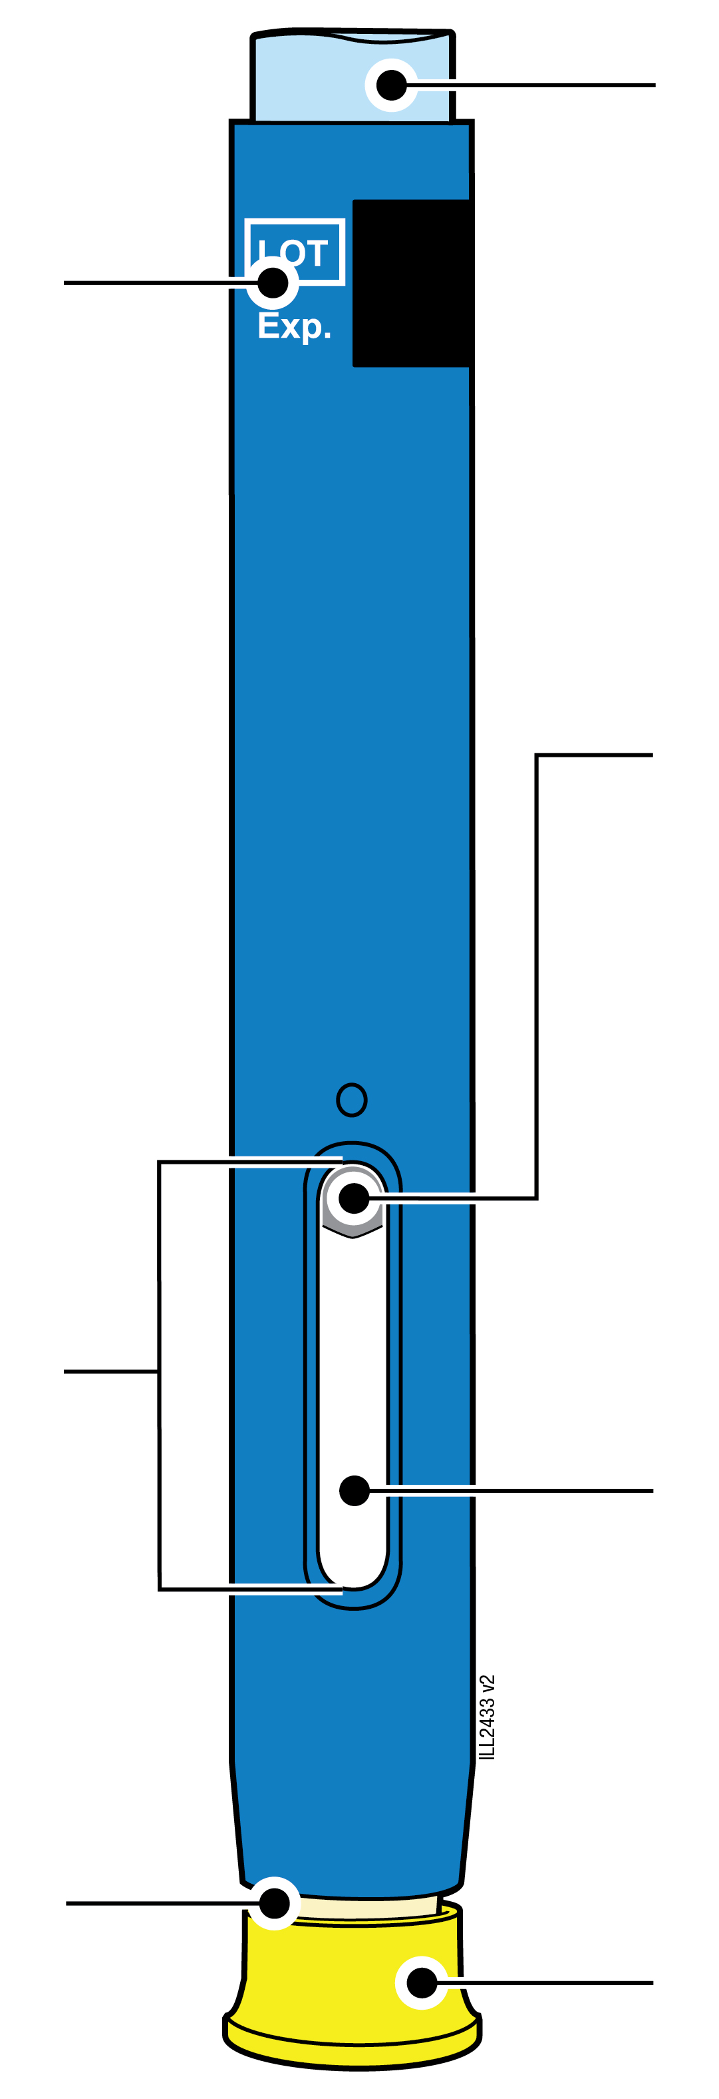  80 mg/0.8 mL
  Expiry date
  Window
  Cream-coloured safety guard
  (needle inside)
  Light blue start button
  Plunger (may be visible in the window; location may vary)
  Medicine
  Yellow cap

1 |  | Important information you need to know before injecting AMGEVITA
 |  | It is important that you do not try to give yourself the injection until you have fully read and understood this Instructions for Use and unless you have received training from your doctor or healthcare provider.
 |  | Do not use the pre-filled pen if the carton is damaged or seal is broken.
 |  | Do not use the pre-filled pen after the expiry date on the label.
 |  | Do not shake the pre-filled pen.
 |  | Do not remove the yellow cap from the pre-filled pen until you are ready to inject.
 |  | Do not use the pre-filled pen if it has been frozen.
 |  | Do not use the pre-filled pen if it has been dropped on a hard surface. Part of the pre-filled pen may be broken even if you cannot see the break. Use a new pre-filled pen and call your doctor or healthcare provider.
Important: Keep the pre-filled pen and sharps disposal container out of the sight and reach of children.

2 | Preparing to inject AMGEVITA

2a | Wait 15 to 30 minutes for the pre-filled pen to reach room temperature.
WAIT
15 to 30
minutes

 |  | Remove the number of pre-filled pens you need for your injection and put any unused pre-filled pens back into the refrigerator.
 |  | Let the pre-filled pen warm up naturally.
 |  | Do not heat the pre-filled pen with hot water, a microwave, or direct sunlight.
 |  | Do not shake the pre-filled pen at any time.
 |  | Do not place the pre-filled pen back in refrigerator after it has reached room temperature.
 |  | Using the pre-filled pen at room temperature makes sure the full dose is delivered and allows for a more comfortable injection.

2b | Inspect the medicine. It should be clear and colourless to slightly yellow.
 | 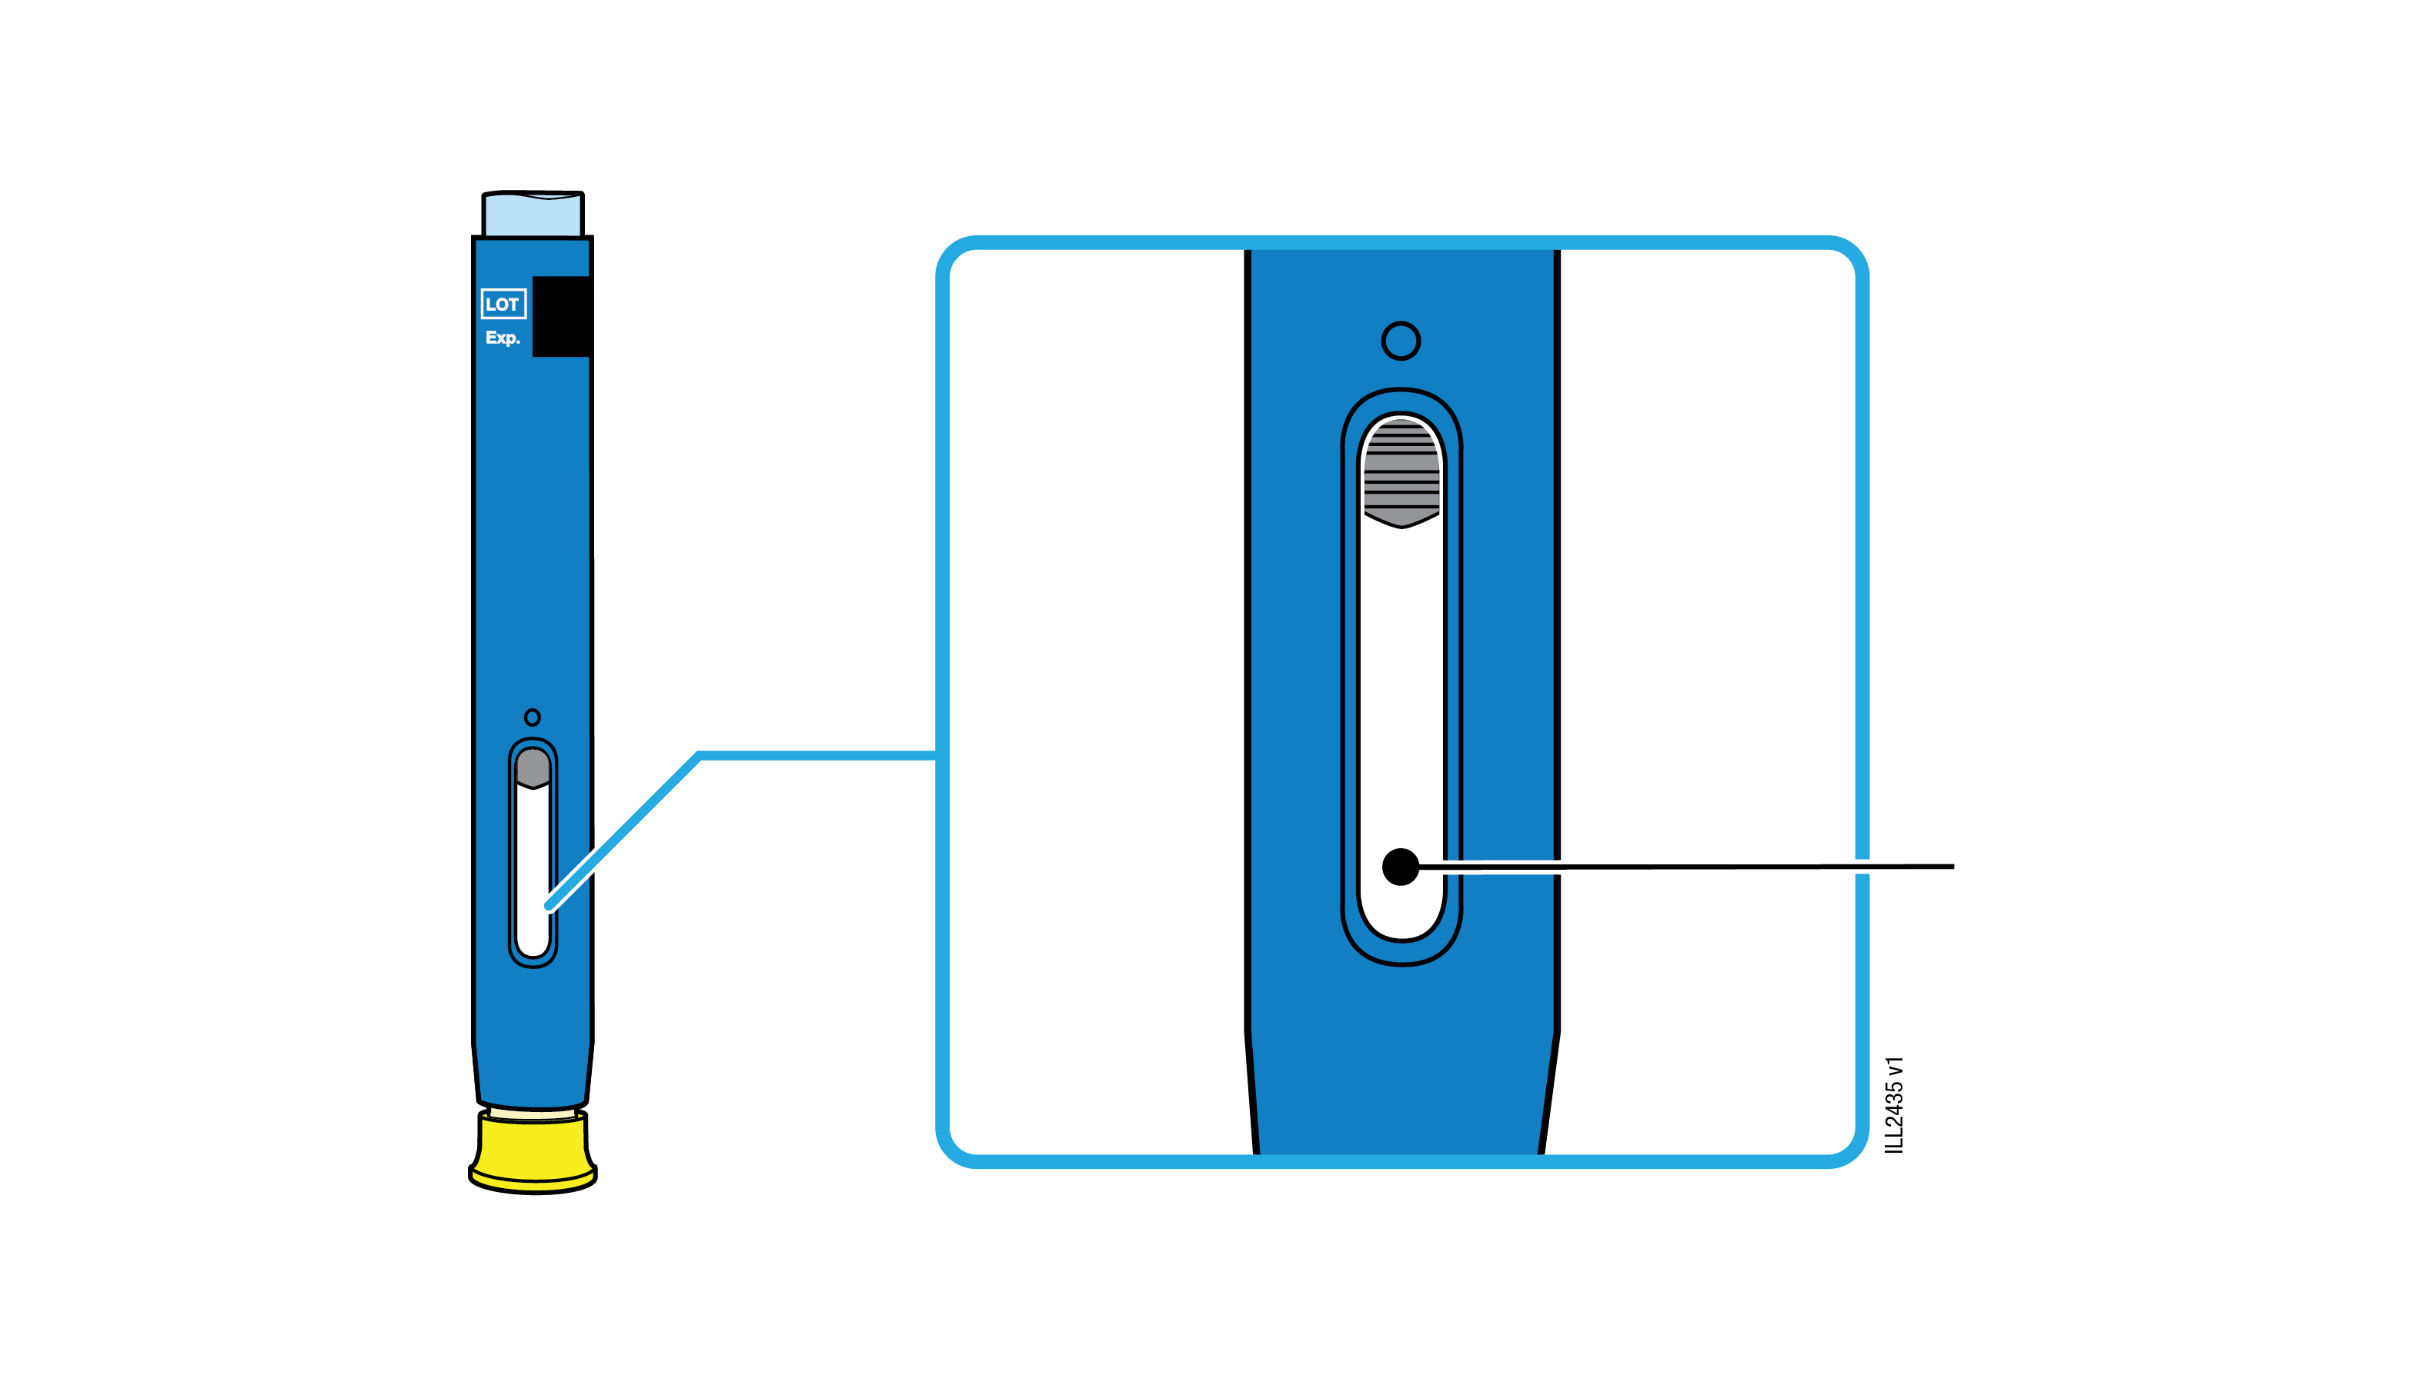 | Medicine
 | It is okay to see air bubbles in the pre-filled pen.
 | Do not use if the medicine is cloudy, discoloured or has flakes or particles.
Important: If the medicine is cloudy, discoloured, or contains flakes or particles, or if the pre-filled pen is damaged or expired, call your doctor or healthcare provider.

2c |  |  | Check the expiry date (EXP.) and inspect the pre-filled pen for damage.
 |  | 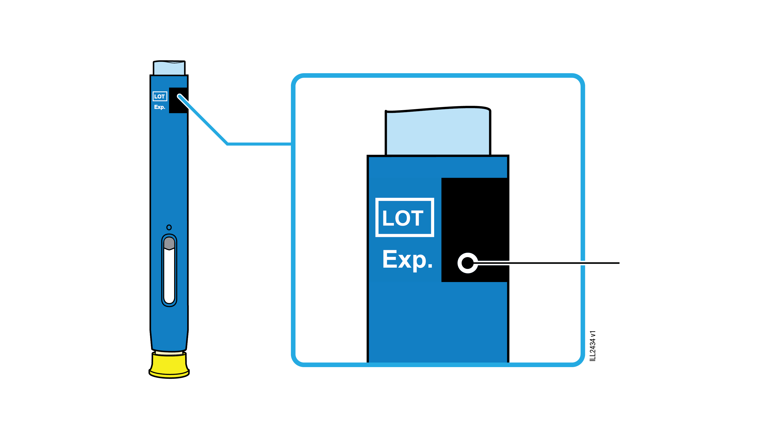 |  | Expiry date
 |  | Do not use the pre-filled pen if the expiry date has passed.
Do not use the pre-filled pen if:
- the yellow cap is missing or loose.
- it has cracks or broken parts.
- it has been dropped on a hard surface.
 |  | Make sure you have the right medicine and dose.

3 | Getting ready for your injection
3a | Gather and place the following items for your injection on a clean, flat and well-lit surface.
Sharps disposal container |  |  | Alcohol wipe  Plaster  Cotton ball or gauze pad
 | AMGEVITA pre-filled pen (room temperature)
 | Sharps disposal container
 | Alcohol wipe
 | Plaster
 | Cotton ball or gauze pad

3b | Inject into 1 of these sites.
 | Inject into the front of your thigh or belly (except 5 centimetres around your belly button).
 | Choose a different site for each injection.
 | Wash your hands thoroughly with soap and water.
 | Clean the injection site with an alcohol wipe.
 | Let the skin dry on its own.
 | Do not touch this area again before injecting.
Important: Avoid areas with scars, stretch marks, or where the skin is tender, bruised, red or hard.

4 | Injecting AMGEVITA
Important: Only remove the yellow cap when you can inject right away (within 5 minutes) because the medicine can dry out. Do not recap.
4a | Hold the pre-filled pen so you can see the window. Pull the yellow cap straight off.  You may need to pull hard.
Window should be visible |  | 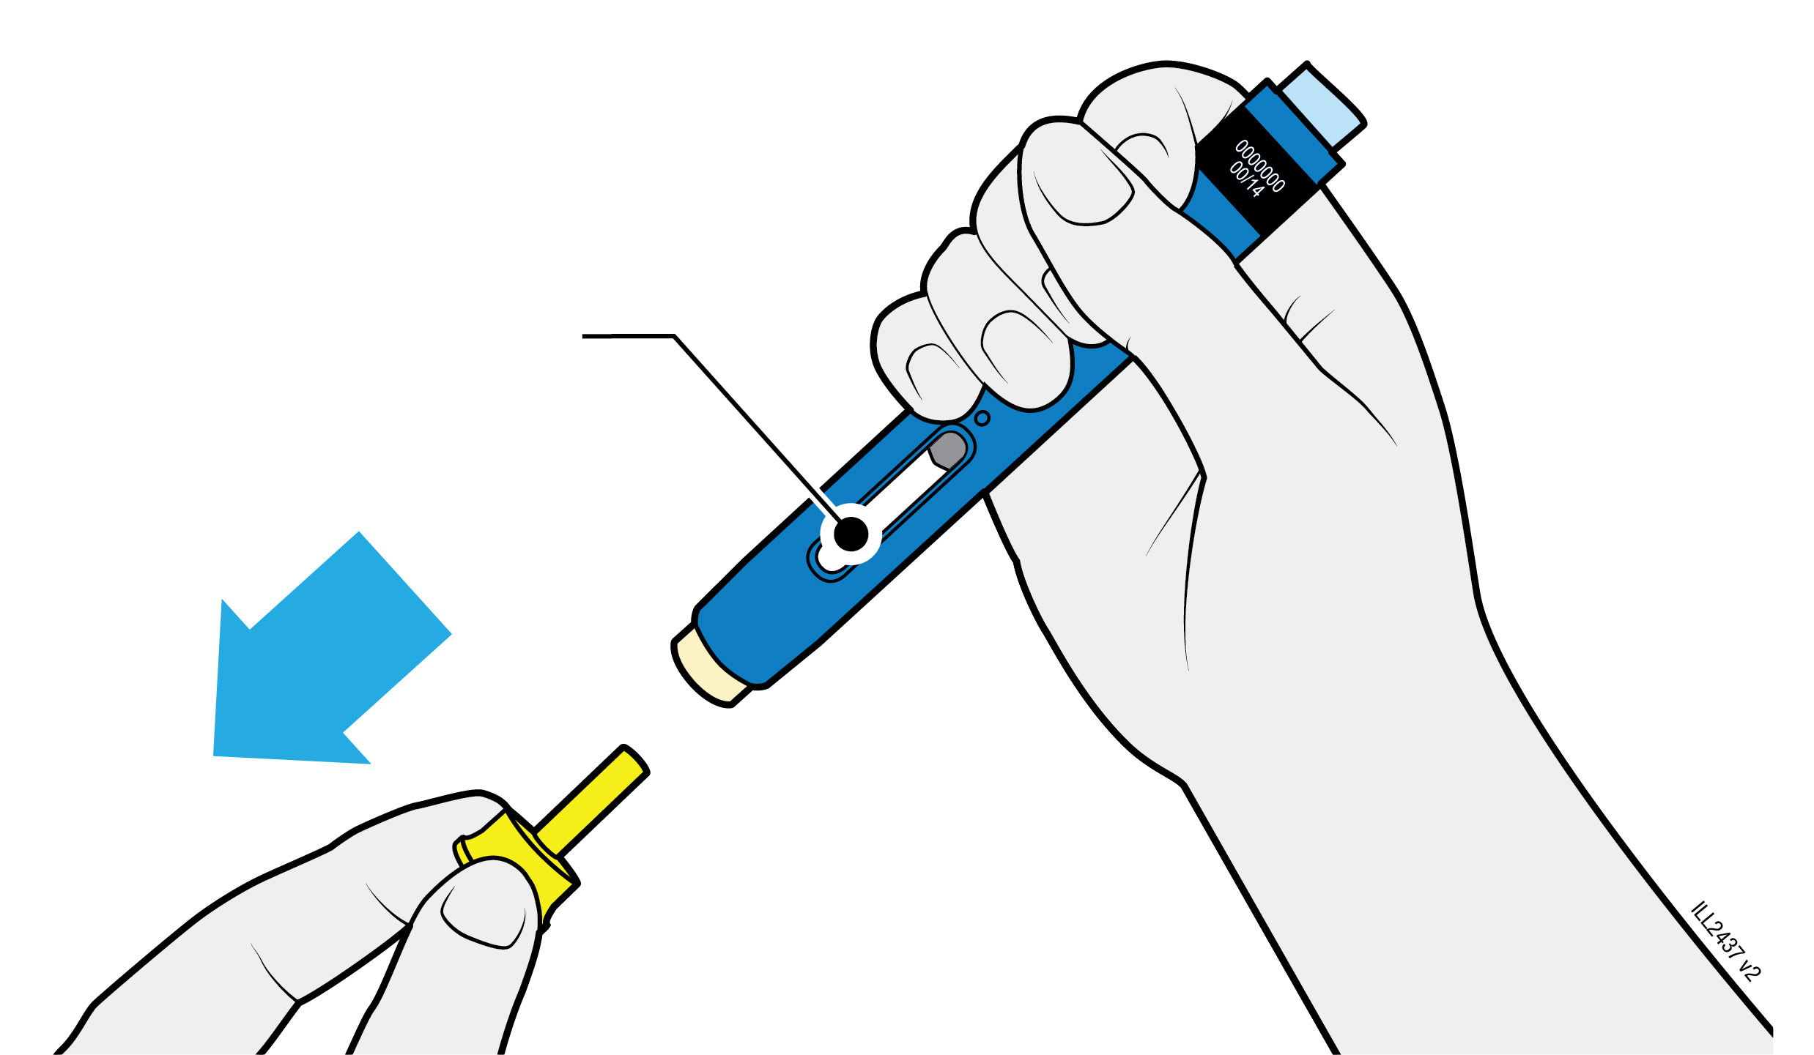
 | Do not twist, bend or wiggle the yellow cap to pull it off.
 | Never put the needle cap back on. It may damage the needle.
 | Do not put your finger inside the cream-coloured safety guard.
 | It is normal to see a drop of medicine at the end of the needle or cream-coloured safety guard.

4b | Pinch the skin to create a firm surface at the injection site. Place the cream-coloured safety guard straight against the pinched skin.
PINCH skin at  injection site |  |  | 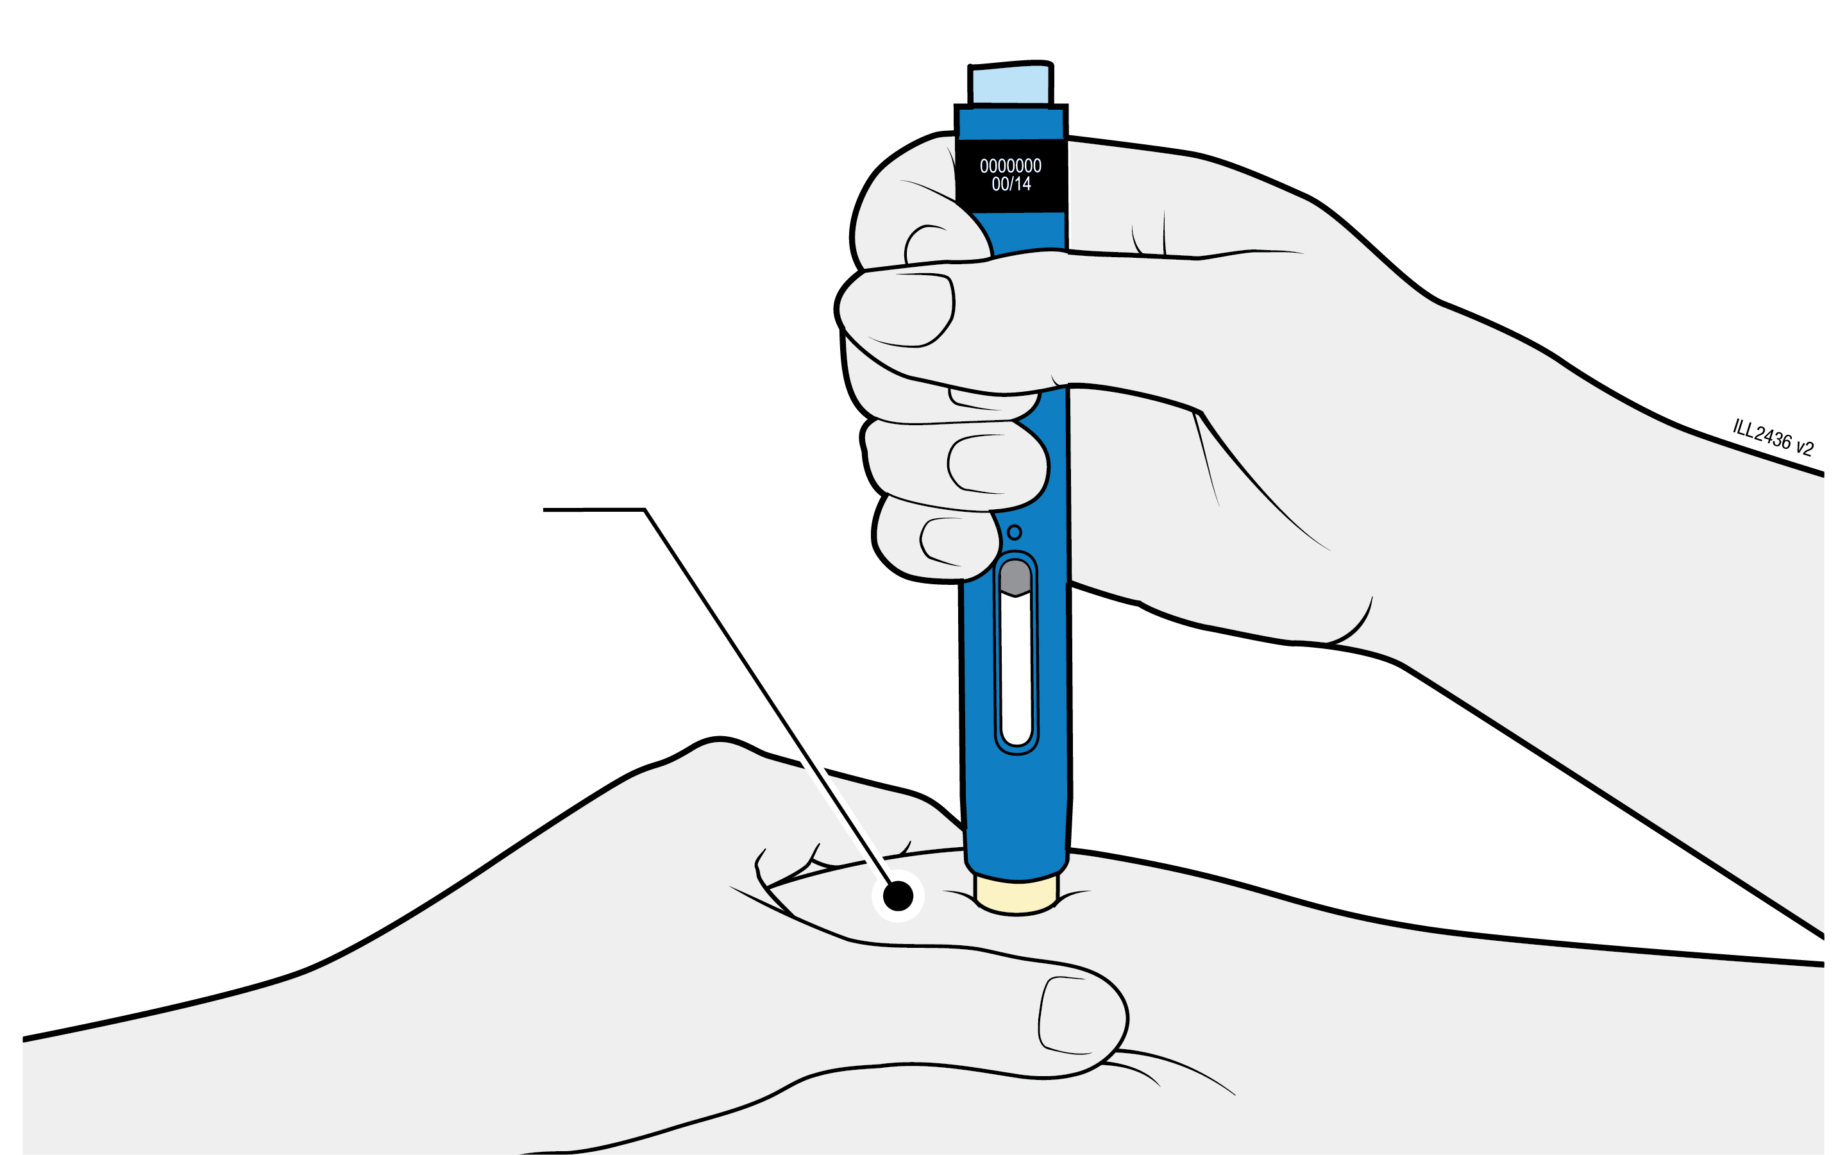
 | Keep the skin pinched until the injection is finished.
 | Make sure you can see the window.
 | Make sure the pre-filled pen is positioned straight on the injection site (at a 90 degree angle).
PUSH
and hold against skin
4c |  | Firmly push the pre-filled pen down until the cream-coloured safety guard stops moving. Hold the pre-filled pen down; do not lift.
 |  | The cream-coloured safety guard pushes in and unlocks the light blue start button.

PRESS
light blue start button
4d | Keep pushing the pre-filled pen down and press the light blue start button to start the injection.
 | You may hear or feel a click.
 | The window starts to turn yellow.
 | It is okay to let go of the light blue start button.

WATCH and CONFIRM
that the window turns fully yellow
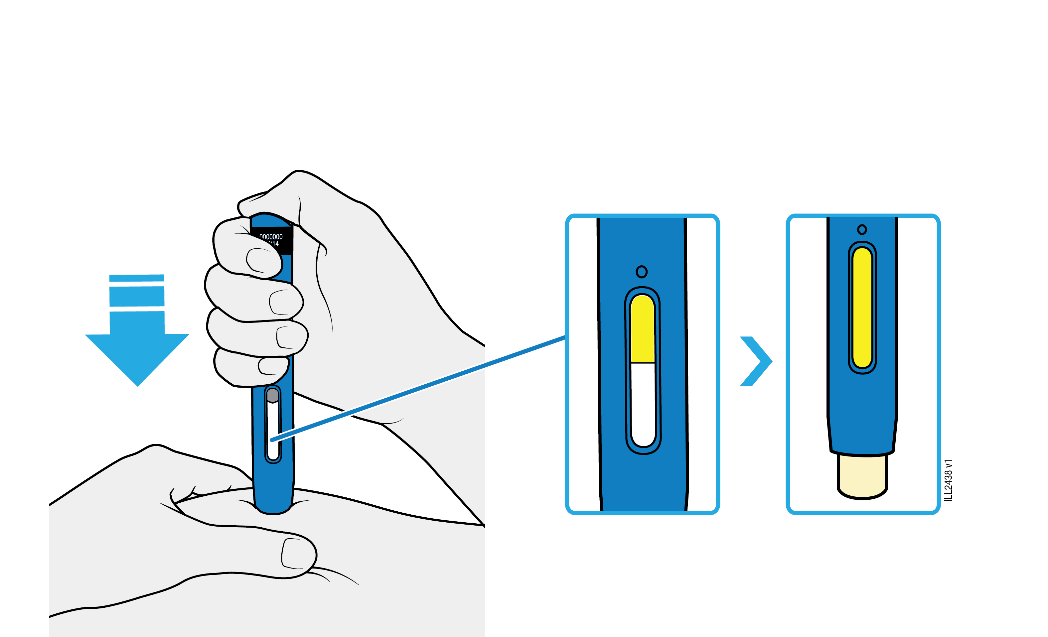

4e | Keep pushing the pre-filled pen down. When the window is fully yellow, the injection is complete.
 | The injection may take up to 15 seconds to complete.
 | You may hear or feel a click.
 | Lift the pre-filled pen away from your skin.
 | The cream-coloured safety guard locks around the needle.
Important: If the window has not turned fully yellow, or it looks like the medicine is still coming out, you have not received a full dose. Call your doctor or healthcare provider right away.

5 |  | Disposing of AMGEVITA and checking the injection site
Important: Do not throw away the pre-filled pen into your household waste.
5a |  | Place the used pre-filled pen and yellow cap in a sharps disposal container right away after use.
 |  | Do not re-use the pre-filled pen.
 |  | Do not touch the cream-coloured safety guard.
5b |  | Check the injection site.
 |  | Do not rub the injection site.
 |  | If there is blood, press a cotton ball or gauze pad on your injection site. Apply a plaster if necessary.

