This document is the approved product information for Buprenorphine Neuraxpharm with the changes since the previous procedure affecting the product information EMEA/H/C/006188 (initial MAA) tracked.

For more information, see the European Medicines Agency’s website: https://www.ema.europa.eu/en/medicines/human/EPAR/buprenorphine-neuraxpharm

ANNEX I

SUMMARY OF PRODUCT CHARACTERISTICS

1. NAME OF THE MEDICINAL PRODUCT

Buprenorphine Neuraxpharm 0.4 mg sublingual films
Buprenorphine Neuraxpharm 4 mg sublingual films
Buprenorphine Neuraxpharm 6 mg sublingual films
Buprenorphine Neuraxpharm 8 mg sublingual films

2. QUALITATIVE AND QUANTITATIVE COMPOSITION

Buprenorphine Neuraxpharm 0.4 mg sublingual films

Each sublingual film contains 0.4 mg buprenorphine (as hydrochloride).

Buprenorphine Neuraxpharm 4 mg sublingual films

Each sublingual film contains 4 mg buprenorphine (as hydrochloride).

Buprenorphine Neuraxpharm 6 mg sublingual films

Each sublingual film contains 6 mg buprenorphine (as hydrochloride).

Buprenorphine Neuraxpharm 8 mg sublingual films

Each sublingual film contains 8 mg buprenorphine (as hydrochloride).

For the full list of excipients, see section 6.1.

3. PHARMACEUTICAL form

Sublingual film

Buprenorphine Neuraxpharm 0.4 mg sublingual films
Light yellow coloured, square, opaque, with one or multiple “0.4” imprinted on one side sublingual films of nominal dimensions 15 mm ×15 mm.

Buprenorphine Neuraxpharm 4 mg sublingual films
White coloured, rectangular, opaque, with one or multiple “4” imprinted on one side sublingual films of nominal dimensions 15 mm × 15 mm.

Buprenorphine Neuraxpharm 6 mg sublingual films
White coloured, rectangular, opaque, with one or multiple “6” imprinted on one side sublingual films of nominal dimensions 20 mm × 17 mm.

Buprenorphine Neuraxpharm 8 mg sublingual films
White coloured, rectangular, opaque, with one or multiple “8” imprinted on one side sublingual films of nominal dimensions 20 mm × 22 mm.

4. Clinical particulars

4.1 Therapeutic indications

Substitution treatment of opioid drug dependence, within a comprehensive therapeutic monitoring framework of medical, social and psychological treatment.
Treatment is intended for use in adults and adolescents 15 years of age and older, who have agreed to be treated for addiction.

4.2 Posology and method of administration

Treatment should be under the supervision of a physician experienced in the management of opiate dependence/addiction.
It is recommended that buprenorphine treatment be prescribed as part of comprehensive management for opioid drug dependence. The result of the treatment depends on the dose prescribed as well as on the combined medical, psychological, social and educational measures taken in monitoring the patient.

Precautions to be taken before induction of treatment
Prior to treatment initiation, consideration should be given to the type of opioid dependence (i.e. long or short-acting opioid), the time since last opioid use and the degree of opioid dependence. To avoid precipitating withdrawal, induction with or buprenorphine only should be undertaken when objective and clear signs of withdrawal are evident (demonstrated by a score indicating mild to moderate withdrawal on the validated Clinical Opioid Withdrawal Scale, COWS).

For patients dependent upon heroin or short-acting opioids, the first dose of buprenorphine should be taken when signs of withdrawal appear, but not less than 6 hours after the patient last used opioids.

For patients receiving methadone, the dose of methadone should be reduced to a maximum of 30 mg/day before beginning buprenorphine therapy. The long half-life of methadone should be considered when starting buprenorphine. The first dose of buprenorphine should be taken only when signs of withdrawal appear, but not less than 24 hours after the patient last used methadone. Buprenorphine may precipitate symptoms of withdrawal in patients dependent upon methadone.

Posology

Initiation therapy (induction)
The recommended starting dose in adults and adolescents over 15 years of age is 2 to 4 mg as a single daily dose. An additional 2 to 4 mg may be administered on day one depending on the individual patient’s requirement. Buprenorphine Neuraxpharm can only be used for initiation therapy when a starting single daily dose of 4 mg is indicated.
During the initiation of treatment, daily supervision of dosing is recommended to ensure proper sublingual placement of the film and to observe patient response to treatment as a guide to effective dose titration according to clinical effect.

Dose adjustment and maintenance therapy
Following treatment induction on day one, the patient should be stabilised to a maintenance dose during the next few days by progressively adjusting the dose according to the clinical effect of the individual patient. Dose titration is guided by reassessment of the clinical and psychological status of the patient, and should not exceed a maximum single daily dose of 24 mg buprenorphine. Dose titration steps may can be achieved using combinations of 0.4 mg, 4 mg, 6 mg and 8 mg strengths.
Daily dispensing of buprenorphine is recommended, particularly during the initiation of treatment. Then, after stabilisation, the patient may be given a supply of the product sufficient for several days of treatment. However, it is recommended that the amount of the product dispensed be limited to a maximum of 7 days.

Less than daily dosing
After a satisfactory stabilisation has been achieved the frequency of dosing may be decreased to dosing every other day at twice the individually titrated daily dose. For example, a patient stabilised to receive a daily dose of 8 mg buprenorphine may be given 16 mg buprenorphine on alternate days, with no dose on the intervening days. In some patients, after a satisfactory stabilisation has been achieved, the frequency of dosing may be decreased to 3 times a week (for example on Monday, Wednesday and Friday). The dose on Monday and Wednesday should be twice the individually titrated daily dose, and the dose on Friday should be three times the individually titrated daily dose, with no dose on the intervening days. However, the dose given on any one day should not exceed 24 mg buprenorphine. Patients requiring a titrated daily dose superior to 8 mg buprenorphine /day may not find this regimen adequate.

Reducing dosage and stopping treatment (medical taper)
When clinical evaluation and the will of the patient lead to consider treatment discontinuation, it must be achieved with caution. The decision to discontinue therapy with buprenorphine after a period of maintenance or brief stabilisation should be made as part of a comprehensive treatment plan. To avoid withdrawal symptoms and potential relapse to illicit drug use, the buprenorphine dose may be progressively decreased over time in favourable cases until treatment can be discontinued. After a satisfactory period of stabilisation has been achieved, if the patient agrees, the dosage of buprenorphine may be reduced gradually; in some favourable cases, treatment may be discontinued. The availability of the sublingual films with doses of 0.4 mg, 4 mg, 6 mg and 8 mg, respectively, allows for a downward titration of dosage but alternative buprenorphine formulations may be needed. Patients should be monitored following termination of buprenorphine treatment because of the potential for relapse.

Switching between buprenorphine sublingual film and other buprenorphine medicinal products (where applicable)
In clinical studies, the pharmacokinetics of buprenorphine film 0.4 mg, 4 mg, 6 mg and 8 mg were shown to be similar to the respective dosage strengths of Subutex® buprenorphine sublingual tablets. If switching between film and sublingual tablets, the patient should nevertheless be monitored in case a need to readjust the dose occurs.
Interchangeability with other buprenorphine medicinal products (apart from sublingual tablets) has not been studied. Dose adjustments may be necessary when switching between medicinal products. Patients should be monitored for overdose, withdrawal or other indications of underdosing.

Special populations

Elderly
The safety and efficacy of buprenorphine in elderly patients over 65 years of age have not been established. No recommendation on posology can be made.

Hepatic impairment
Baseline liver function tests and documentation of viral hepatitis status are recommended prior to commencing therapy.
The effects of hepatic impairment on the pharmacokinetics of buprenorphine were evaluated in a postmarketing study. Buprenorphine is extensively metabolized in the liver, and plasma levels were found to be higher for buprenorphine in patients with liver impairment. Systemic exposure is marginally enhanced in mild liver impaired subjects and no dose adjustment is deemed to be necessary. After administration of a 2 mg single dose, overall systemic exposure is significantly increased in moderate (1.6 fold) and severe (2.8 fold) hepatic impairment compared to healthy subjects. Patients should be monitored for signs and symptoms of toxicity or overdose caused by increased levels of buprenorphine. Buprenorphine should be used with caution in patients with moderate hepatic impairment and reduction of initiation and maintenance doses should be considered. Considering the pronounced higher exposure in severe patients and the potential for more
accumulation after repeated dose administration Buprenorphine must not be used in severe hepatic impaired patients (see sections 4.3 and 5.2).
Patients who are positive for viral hepatitis, on concomitant medicinal products (see section 4.5) and/or have existing liver dysfunction are at greater risk of accelerated liver injury. Baseline liver function tests and documentation of viral hepatitis status are recommended prior to commencing therapy. Regular monitoring of liver function is recommended (see section 4.4).

Renal impairment
Modification of the buprenorphine dose is not generally required in patients with renal impairment. Caution is recommended when dosing patients with severe renal impairment (creatinine clearance <30 ml/min) (see sections 4.4 and 5.2).

Paediatric population
The safety and efficacy of buprenorphine in children and adolescents below the age of 15 years have not been established. No data are available.

Method of administration

Sublingual use.

Physicians must advise patients that the sublingual use is the only effective and safe use for this medicinal product.
The medicinal product should be administrated immediately after their removal from primary packaging.
The film is not to be swallowed. The film is to be placed under the tongue until completely dissolved, which usually occurs within 10 to 15 minutes. It is advised that patients moisten their mouths prior to dosing. Patients should not move the film after placing it under the tongue, nor consume food or drink until the film is completely dissolved. The film should not be moved after placement, and proper administration technique should be demonstrated to the patient.
If an additional film is necessary to achieve the prescribed dose, it should be placed under the tongue after the first film has been completely dissolved.
Films should not be split prior to administration for dose adjustment.

Treatment goals and discontinuation
Before initiating treatment with Buprenorphine Neuraxpharm, a treatment strategy including treatment duration and treatment goals, should be agreed together with the patient. During treatment, there should be frequent contact between the physician and the patient to evaluate the need for continued treatment, consider discontinuation and to adjust dosages if needed. When a patient no longer requires therapy with Buprenorphine Neuraxpharm it may be advisable to taper the dose gradually to prevent symptoms of withdrawal (see section 4.4).

4.3 Contraindications

- Hypersensitivity to the active substance or to any of the excipients listed in section 6.1
- Severe respiratory insufficiency
- Severe hepatic insufficiency
- Acute alcoholism or delirium tremens

4.4 Special warnings and precautions for use

Use in adolescents: Due to lack of data in adolescents aged 15 – 17 years, patients in this age group should be more closely monitored during treatment.

Misuse, abuse and diversion

Buprenorphine can be misused or abused in a manner similar to other opioids, legal or illicit. Some risks of misuse and abuse include overdose, spread of blood borne viral or localised and systemic infections, respiratory depression and hepatic injury. Buprenorphine misuse by someone other than the intended patient poses the additional risk of new drug dependent individuals using buprenorphine as the primary drug of abuse and may occur if the medicine is distributed for illicit use directly by the intended patient or if the medicine is not safeguarded against theft.
In cases of intravenous drug misuse, local reactions, sometimes septic (abscess, cellulitis) and potentially serious acute hepatitis and other acute infections, such as pneumonia and endocarditis have been reported.

Sub-optimal treatment with buprenorphine may prompt medicinal product misuse by the patient, leading to overdose or treatment dropout. A patient who is under-dosed with buprenorphine may continue responding to uncontrolled withdrawal symptoms and craving by self-medicating with opioids, alcohol or other sedative-hypnotics such as benzodiazepines.

To minimise the risk of misuse, abuse and diversion, physicians should take appropriate precautions when prescribing and dispensing buprenorphine, such as to avoid prescribing multiple refills early in treatment and to conduct patient follow-up visits with clinical monitoring that is appropriate to the patient’s level of stability.

Sleep-related breathing disorders

Opioids can cause sleep-related breathing disorders including central sleep apnoea (CSA) and sleep-related hypoxemia. Opioid use increases the risk of CSA in a dose-dependent fashion. In patients who present with CSA, consider decreasing the total opioid dosage.

Respiratory depression

A number of cases of death due to respiratory depression have been reported, particularly when buprenorphine was used in combination with benzodiazepines or gabapentinoids (see section 4.5) or when buprenorphine was not used according to the prescribing information. Deaths have also been reported in association with concomitant administration of buprenorphine and other depressants such as alcohol or other opioids. If buprenorphine is administered to some non-opioid dependent individuals, who are not tolerant to the effects of opioids, potentially fatal respiratory depression may occur.

This medicinal product should be used with care in patients with asthma or respiratory insufficiency (e.g. chronic obstructive pulmonary disease, cor pulmonale, decreased respiratory reserve, hypoxia, hypercapnia, pre-existing respiratory depression or kyphoscoliosis (curvature of spine leading to potential shortness of breath)).
Patients with the physical and/or pharmacological risk factors above should be monitored, and dose reduction may be considered.
Buprenorphine may cause severe, possibly fatal, respiratory depression in children and nondependent persons in case of accidental or deliberate ingestion. Patients must be warned to store the sachet safely, to never open the sachet in advance, to keep them out of the reach of children and other household members, and not to use this medicinal product in front of children. An emergency unit should be contacted immediately in case of accidental ingestion or suspicion of ingestion.

CNS depression

Buprenorphine may cause drowsiness, particularly when used together with alcohol or central nervous system depressants (such as benzodiazepines, tranquilisers, sedatives, or hypnotics) (see sections 4.5 and 4.7).

Risk from concomitant use of sedative medicinal products such as benzodiazepines, gabapentinoids or
related medicinal products.

Concomitant use of buprenorphine and sedative medicinal products such as benzodiazepines, gabapentinoids or related medicinal products may result in sedation, respiratory depression, coma and death. Because of these risks, concomitant prescribing with these sedative medicinal products should be reserved for patients for whom alternative treatment options are not possible. If a decision is made to prescribe buprenorphine concomitantly with sedative medicinal products, the lowest effective dose of the sedative medicines should be used, and the duration of treatment should be as short as possible. The patients should be followed closely for signs and symptoms of respiratory depression and sedation. In this respect, it is strongly recommended to inform patients and their caregivers to be aware of these symptoms (see section 4.5).

Tolerance and opioid use disorder (abuse and dependence)

Tolerance, physical and psychological dependence, and opioid use disorder (OUD) may develop upon repeated administration of opioids such as buprenorphine neuraxpharm Abuse or intentional misuse of buprenorphine neuraxpharm may result in overdose and/or death. The risk of developing OUD is increased in patients with a personal or a family history (parents or siblings) of substance use disorders (including alcohol use disorder), in current tobacco users or in patients with a personal history of other mental health disorders (e.g. major depression, anxiety and personality disorders).
Before initiating treatment with buprenorphine neuraxpharm and during the treatment, treatment goals and a discontinuation plan should be agreed with the patient (see section 4.2).
Patients will require monitoring for signs of drug-seeking behavior (e.g. too early requests for refills). This includes the review of concomitant opioids and psychoactive drugs (like benzodiazepines). For patients with signs and symptoms of OUD, consultation with an addiction specialist should be considered.

Serotonin syndrome

Concomitant administration of buprenorphine and other serotonergic agents, such as MAO inhibitors, selective serotonin re-uptake inhibitors (SSRIs), serotonin norepinephrine reuptake inhibitors (SNRIs) or tricyclic antidepressants may result in serotonin syndrome, a potentially life-threatening condition (see section 4.5).
If concomitant treatment with other serotonergic agents is clinically warranted, careful observation of the patient is advised, particularly during treatment initiation and dose increases.
Symptoms of serotonin syndrome may include mental-status changes, autonomic instability, neuromuscular abnormalities, and/or gastrointestinal symptoms.
If serotonin syndrome is suspected, a dose reduction or discontinuation of therapy should be considered depending on the severity of the symptoms.

Hepatitis and hepatic events

Serious cases of acute hepatic injury have been reported in a context of misuse, especially for intravenous use (see section 4.8). These hepatic injuries have mainly been observed at the high doses and could be due to a mitochondrial toxicity. In many cases the presence of pre-existing mitochondrial impairment (genetic diseases, liver enzyme abnormalities, infection with hepatitis B or hepatitis C virus, alcohol abuse, anorexia, concomitant use of other potentially hepatotoxic medicines), and ongoing injecting drug use may have a causative or contributory role. Patients who are positive for viral hepatitis, on concomitant medicinal products (see section 4.5) and/or have existing liver dysfunction are at greater risk of liver injury, and these underlying factors must be taken into consideration before prescribing buprenorphine and during treatment (see section 4.2).
When a hepatic event is suspected, further biological and etiological evaluation is required. Depending upon the findings, the medicinal product may be discontinued cautiously so as to prevent withdrawal syndrome and to prevent a return to illicit drug use. If the treatment is continued, hepatic function should be monitored closely.

Precipitation of opioid withdrawal syndrome

When initiating treatment with buprenorphine, the physician must be aware of the partial agonist profile of buprenorphine and that it can precipitate withdrawal in opioid-dependent patients, particularly if administered less than 6 hours after the last use of heroin or other short-acting opioid, or if administered less than 24 hours after the last dose of methadone (according to the long half-life of methadone). Patients should be clearly monitored during the switching period from methadone to buprenorphine since withdrawal symptoms have been reported. To avoid precipitating withdrawal, induction with buprenorphine should be undertaken when objective signs of moderate withdrawal are evident (see section 4.2).
Withdrawal symptoms may also be associated with sub-optimal dosing.

Allergic reactions

Cases of acute and chronic hypersensitivity to buprenorphine have been reported both in clinical trials and in the post-marketing experience. The most common signs and symptoms include rashes, urticaria, and pruritus. Cases of bronchospasm, angioedema, and anaphylactic shock have been reported. A history of hypersensitivity to buprenorphine is a contraindication to buprenorphine use.

Hepatic impairment

The effects of hepatic impairment on the pharmacokinetics of buprenorphine were evaluated in a single-dose postmarketing study. Since buprenorphine is extensively metabolized, plasma levels were found to be elevated for buprenorphine in patients with moderate and severe hepatic impairment. Patients should be monitored for signs and symptoms of toxicity or overdose caused by increased levels of buprenorphine. Buprenorphine should be used with caution in patients with moderate hepatic impairment. In patients with severe hepatic insufficiency the use of buprenorphine is contraindicated (See sections 4.3 and 5.2).

Renal impairment

Renal elimination may be prolonged since 30% of the administered dose is eliminated by the renal route. Metabolites of buprenorphine accumulate in patients with renal failure. Caution is recommended when dosing patients with severe renal impairment (creatinine clearance <30 ml/min) (see sections 4.2 and 5.2).

CYP3A4 inhibitors

Combination with potent CYP3A4 inhibitors such as ketoconazole and ritonavir can lead to
increased plasma concentrations of buprenorphine. Patients receiving buprenorphine should be closely monitored and may require dose-reduction if combined with potent CYP3A4 inhibitors (see section 4.5).

General opioid class warnings

Opioids can cause orthostatic hypotension.
Opioids may elevate cerebrospinal fluid pressure, which may cause seizures. As with other opioids, caution is requested in patients using buprenorphine and having head injury, intracranial lesions and increased cranial pressure, or history of seizure.
Opioid-induced miosis, changes in the level of consciousness, or changes in the perception of pain as a symptom of disease may interfere with patient evaluation or obscure the diagnosis or clinical course of concomitant disease.
Opioids should be used with caution in patients with myxoedema, hypothyroidism, or adrenal cortical insufficiency (e.g. Addison’s disease).
Opioids should be used with caution in patients with hypotension, prostatic hypertrophy or urethral stricture.
Opioids have been shown to increase intracholedochal pressure, and should be used with caution in patients with dysfunction of the biliary tract.
Opioids should be administered with caution to elderly or debilitated patients.

The following combinations are not recommended with buprenorphine: level II analgesics, ethylmorphine and alcohol (see section 4.5).

Excipients with known effect

Sodium
This medicine contains less than 1 mmol sodium (23 mg) per film, that is to say essentially ‘sodium free’.

4.5 Interaction with other medicinal products and other forms of interaction

Not recommended combinations
Alcohol
Alcohol increases the sedative effect of buprenorphine, which can make driving and using machines hazardous. Avoid taking buprenorphine together with alcoholic drinks or medicinal product containing alcohol.

Buprenorphine should be used cautiously when co-administered with

Sedatives such as benzodiazepines, gabapentinoids or related substances
The concomitant use of opioids with sedative medicinal products such as benzodiazepines (e.g. diazepam, temazepam, alprazolam), gabapentinoids (e.g. pregabalin, gabapentin) or related substances such as barbiturates (e.g. phenobarbital) or chloral hydrate increase the risk of sedation, respiratory depression, coma and death because of additive CNS depressant effect. The doses and duration of concomitant use should be limited (see section 4.4). Patients should be warned that it is extremely dangerous to self-administer non-prescribed benzodiazepines while taking this product and should also be cautioned to use benzodiazepines concurrently whit this product only as prescribed (see section 4.4).

Other central nervous system depressants, such as other opioid derivatives (e.g. methadone, analgesics and antitussives), certain antidepressants, sedative H1-receptors antagonists, benzodiazepines, anxiolytics other than benzodiazepines, neuroleptics, clonidine and related substances
The concomitant use with these substances increases central nervous system depression. The reduced level of alertness can make driving and using machines hazardous. Additionally, for barbiturates, increased risk of respiratory depression.

Naltrexone and nalmefene
Opioid antagonists that can block the pharmacological effects of buprenorphine. For opioid dependent patients currently receiving buprenorphine treatment, naltrexone or nalmefene may precipitate a sudden onset of prolonged and intense opioid withdrawal symptoms. For patients currently receiving naltrexone or nalmefene treatment, the intended therapeutic effects of buprenorphine administration may be blocked.

Opioid analgesics such as morphine
Adequate analgesia may be difficult to achieve when administering a full opioid agonist in patients receiving buprenorphine. The potential for overdose also exists with a full agonist, especially when attempting to overcome buprenorphine partial agonist effects, or when buprenorphine plasma levels are declining. Patients with a need for analgesia and opioid dependence treatments may be best managed by multidisciplinary teams that include both pain and opioid dependence treatment specialists.

Serotonergic medicinal products, such as MAO inhibitors, selective serotonin re-uptake inhibitors (SSRIs), serotonin norepinephrine re-uptake inhibitor (SNRIs) or tricyclic antidepressants
The risk of serotonin syndrome, a potentially life-threatening condition, is increased (see section 4.4).

CYP3A4 inhibitors
An interaction study of buprenorphine with ketoconazole (a potent inhibitor of CYP3A4) resulted in increased Cmax and AUC (area under the curve) of buprenorphine (approximately 50% and 70% respectively) and, to a lesser extent, of norbuprenorphine. Patients receiving buprenorphine should be closely monitored, and may require dose-reduction if combined with potent CYP3A4 inhibitors (e.g. protease inhibitors like ritonavir, nelfinavir or indinavir, or azole antifungals like ketoconazole, itraconazole, voriconazole or posaconazole)

CYP3A4 inducers
In a clinical study performed in healthy volunteers, the combination of buprenorphine with either rifampicin or rifabutin shows a 70% and 35% reduction, respectively, in plasma buprenorphine levels and onset of withdrawal symptoms in 50% of the 12 volunteers. Therefore, it is recommended that patients receiving buprenorphine should be closely monitored if inducers (e.g. phenobarbital, carbamazepine, phenytoin, rifampicin) are co-administered, and the dose of buprenorphine or CYP3A4 inducer may need to be adjusted accordingly.

Anticholinergics or medications with anticholinergic activity
Concomitant administration of buprenorphine with anticholinergics or medications with anticholinergic activity (e.g. tricyclic andidepressants, antihistamines, antipsycholtics, muscle relaxants, anti-parkinson drugs) may result in increased anticholinergic adverse effects.

4.6 Fertility, pregnancy and lactation

Pregnancy
There are no or limited data from the use of buprenorphine in pregnant women. Animal studies do not indicate reproductive toxicity (see section 5.3). Buprenorphine should be used during pregnancy only if the potential benefit outweighs the potential risk to the foetus.
Chronic use of buprenorphine by the mother at the end of pregnancy, at any dose, may cause a withdrawal syndrome (high-pitched cry, poor feeding, abnormal sleep, irritability, tremor, hypertonia, myoclonus, or convulsions) in the neonate. This syndrome can be delayed several hours to a few days after birth. Cases of respiratory disorders in neonates have also been reported. Consequently, if the mother is treated up to the end of pregnancy, neonatal monitoring should be considered during the first postnatal days.

Breast-feeding
Very small amounts of buprenorphine and its metabolite pass into mother’s milk. These amounts are not sufficient to prevent withdrawal syndrome which can be delayed in breastfed infants. After evaluation of individual risk factors, breast feeding can be considered in buprenorphine-treated patients.

Fertility
There are limited data on the effects of buprenorphine on human fertility.
In a study at pharmacological doses in mice, an atrophy and a tubular mineralisation of testis have been evidenced in treated animals. No adverse effects on fertility were seen in rat studies; however, difficulty in parturition was noted (see section 5.3).

4.7 Effects on ability to drive and use machines

Buprenorphine has minor to moderate influence on the ability to drive and use machines when administered to opioid-dependent patients. This medicinal product may cause drowsiness, dizziness, or impaired thinking, especially during treatment induction and dose adjustment. If taken together with alcohol or central nervous system depressants, the effect is likely to be more pronounced (see sections 4.4 and 4.5).
Patients should be cautioned about driving or operating hazardous machinery in case buprenorphine may adversely affect their ability to engage in such activities.

  - Undesirable effects

Summary of the safety profile
The most commonly reported treatment-related adverse reactions reported during the pivotal clinical studies were symptoms commonly associated with drug withdrawal (i.e. insomnia, headache, nausea, hyperhidrosis and pain).

Tabulated list of adverse reactions
Table 1 summarizes adverse reactions reported with a higher incidence in patients treated with buprenorphine (n=103) during a pivotal clinical study versus placebo (n=107).
The frequency of possible side effects listed below is defined using the following convention: Very common (≥ 1/10), Common (≥ 1/100 to < 1/10), Uncommon (≥ 1/1,000 to < 1/100), Rare (≥ 1/10, 000 to < 1/1, 000), Very rare (< 1/10, 000). And frequency not known (cannot be estimated from available data).
.
Table 1: Adverse reactions observed in pivotal clinical studies and / or post marketing surveillance listed by body system
System organ class | Very common | Common | Rare | Not known
Infections and infestations | Infection | Pharyngitis |  | Dental Caries
Immune system disorders |  |  |  | Hypersensitivity reactions
Psychiatric  disorders | Insomnia | Agitation  Anxiety  Nervousness | Hallucination | Drug dependence
Nervous system disorders | Headache | Migraine  Paraesthesia  Somnolence  Syncope  Vertigo  Hyperkinesia
Vascular disorders |  | Orthostatic hypotension
Respiratory, thoracic and mediastinal disorders |  | Dyspnoea | Respiratory depression
Gastrointestinal disorders | Nausea  Abdominal pain | Constipation, Vomiting
Hepatobiliary disorders |  |  |  | Transaminases increase,  Hepatitis  Jaundice
Skin and subcutaneous tissue disorders | Hyperhidrosis
Musculoskeletal and connective tissue disorders |  | Muscle spasms
Reproductive system and breast disorders |  | Dysmenorrhoea  Leukorrhea
General disorders and administration site conditions | Drug withdrawal syndrome, | Asthenia |  | Drug withdrawal syndrome neonatal

Description of selected adverse reactions

Drug dependence
Repeated use of buprenorphine neuraxpharm sublingual films can lead to drug dependence, even at therapeutic doses. The risk of drug dependence may vary depending on a patient's individual risk factors, dosage, and duration of opioid treatment (see section 4.4).

Respiratory depression
Respiratory depression has occurred. Death due to respiratory depression has been reported, particularly when buprenorphine was used in combination with benzodiazepines (see section 4.5), or when buprenorphine was not used according to prescribing information. Deaths have also been reported in association with concomitant administration of buprenorphine and other CNS depressants such as alcohol or other opioids (see sections 4.4 and 4.5).

Drug withdrawal syndrome neonatal
Neonatal withdrawal syndrome has been reported among newborns of women who have received buprenorphine during pregnancy. The syndrome may be milder and more protracted than that from short acting full μ-opioid agonists. The nature of the syndrome may vary depending upon the mother’s drug use history (see section 4.6).

Hypersensitivity reactions
The most common signs and symptoms of hypersensitivity include rashes, urticaria and pruritus. Cases of bronchospasm, respiratory depression, angioedema and anaphylactic shock have been reported.

Transaminases increase, hepatitis, jaundice
Hepatic transaminases increase and hepatitis with jaundice which generally have resolved favourably occurred (see section 4.4).

Reporting of suspected adverse reactions
Reporting suspected adverse reactions after authorisation of the medicinal product is important. It allows continued monitoring of the benefit/risk balance of the medicinal product. Healthcare professionals are asked to report any suspected adverse reactions via the national reporting system listed in Appendix V.

4.9 Overdose

Buprenorphine appears to have a theoretical wide margin of safety because of its partial opioid agonist properties.

Symptoms
Respiratory depression as a result of central nervous system depression is the primary symptom requiring intervention in the case of overdose because it may lead to respiratory arrest and death (see section 4.4). Signs of overdose may also include sedation, miosis, hypotension, nausea and vomiting.

Treatment/Management
In the event of overdose, general supportive measures should be instituted, including close monitoring of respiratory and cardiac status of the patient.
Symptomatic treatment of respiratory depression, and standard intensive care measures, should be performed. A patent airway and assisted or controlled ventilation should be implemented if necessary.
The patient should be transferred to an environment within which full resuscitation facilities are available.
If the patient vomits, care must be taken to prevent aspiration of the vomitus.
Use of an injectable opioid antagonist (i.e., naloxone) is recommended, despite the modest effect it may have in reversing the respiratory symptoms of buprenorphine; buprenorphine being highly bound to the morphinic receptors.
If naloxone is used, the long duration of action of buprenorphine should be taken into consideration when determining the length of treatment and medical surveillance needed to reverse the effects of an overdose. Naloxone can be cleared more rapidly than buprenorphine, allowing for a return of previously controlled buprenorphine overdose symptoms, so a continuing infusion may be necessary. Ongoing IV infusion rates should be titrated to patient response. If infusion is not possible, repeated dosing with naloxone may be required.

5. PHARMACOLOGICAL PROPERTIES

5.1 Pharmacodynamic properties

Pharmacotherapeutic group: Other nervous system drugs, drugs used in opioid dependence
ATC code: N07BC01

Mechanism of action
Buprenorphine is an opioid partial agonist/antagonist which attaches itself to the μ (mu) and k (kappa) receptors of the brain. Its activity in maintenance treatment of opioid dependence is attributed to its slowly reversible binding to the µ receptors which, over a prolonged period, might minimise the need of the addicted patients for drugs.

5.2 Pharmacokinetic properties

Absorption
When taken orally, buprenorphine undergoes first-pass hepatic metabolism with N-dealkylation and glucuroconjungation in the small intestine and the liver. The use of this medication by oral route is therefore inappropriate.

Peak plasma concentrations are achieved 90 minutes after sublingual administration and the maximal dose -concentration relationship is dose-dependent but not dose-proportional in the dose range between 2 mg and 24 mg buprenorphine.
Plasma levels of buprenorphine increased with increasing sublingual dose of buprenorphine.

Table 2: Buprenorphine mean (standard deviation) pharmacokinetic parameters
 | 0.4 mg | 8 mg
Cmax pg/ml | 604.65 (214) | 8191.85(2978)
Tmax*(h) | 1.38 | 1.00
AUC_{0-72 hrs} hr ×pg/ml | 3338.51 (992) | 48051.47 (13179)
*Median

Distribution
The absorption of buprenorphine is followed by a rapid distribution phase and a half-life of 2 to 5 hours.

Metabolism
Buprenorphine is metabolised by 14-N-dealkylation and glucuroconjugation of the parent molecule and the dealkylated metabolite. Clinical data confirm that CYP3A4 is responsible for the N-dealkylation of buprenorphine. The N-dealkybuprenorphine is a μ agonist with weak intrinsic activity.

Elimination
Elimination of buprenorphine is bi- or tri- exponential, with long terminal elimination phase of 20-25 hours, due in part to reabsorption of buprenorphine after intestinal hydrolysis of the conjugated derivative, and in part to the highly lipophilic nature of the molecule.
The median half-lives observed for doses of 0.4 mg, and 8 mg were 25.37and 26.45 hours, respectively.

Excretion
Buprenorphine is essentially eliminated in the faeces by biliary excretion of the glucuroconjugated metabolites (70%), the rest being eliminated in the urine.

Special populations

Hepatic impairment
Buprenorphine is extensively metabolized in the liver, and plasma levels were found to be higher for buprenorphine in patients with liver impairment. Table 3 summarizes the results from a clinical trial in which the exposure of buprenorphine was determined after administering a buprenorphine/naloxone 2 0/0.5 mg sublingual tablet in healthy subjects, and in subjects with varied degrees of hepatic impairment.

Table 3: Effect of hepatic impairment on pharmacokinetic parameters of buprenorphine following buprenorphine/ naloxone administration (change relative to healthy subjects)
PK parameters | Mild hepatic impairment (Child-Pugh Class A) (n=9) | Moderate hepatic impairment (Child-Pugh Class B) (n=8) | Severe hepatic impairment (Child-Pugh Class C) (n=8)
Buprenorphine
C_{max} | 1.2-fold increase | 1.1-fold increase | 1.7-fold increase
AUC_{last} | Similar to control | 1.6-fold increase | 2.8-fold increase

Overall, buprenorphine plasma exposure increased approximately 3-fold in patients with severely impaired hepatic function.

5.3 Preclinical safety data

Chronic toxicity studied in four species (rodents and non-rodents) by four different administration routes has not showed any clinically pertinent element. In one oral study of one year in dogs, a hepatic toxicity has been observed at very high dose (75 mg/kg).

Teratology studies conducted in rats and rabbits allow to conclude that buprenorphine is not embryotoxic nor teratogenic. No undesirable effect on fertility has been reported in rats, however a high peri- and post- natal mortality has been observed in this species by IM and oral administration routes, due to difficult parturition and impairment of maternal lactation.

In a standard series of tests, none proof of genotoxic potential has been evidenced.

Carcinogenicity studies in mice and rats show that there is no difference in the incidences of different tumour types between control and buprenorphine treated animals. However, in a study conducted with pharmacological doses in mice, an atrophy and a tubular mineralisation of testis have been evidenced in treated animals.

6. PHARMACEUTICAL PARTICULARS

6.1 List of excipients

Hypromellose
Maltodextrin
Polysorbate 20
Carbomer
Glycerol
Titanium dioxide (E 171)
Sodium citrate
Citric acid monohydrate
Partly dementholised mint oil
Sucralose
Butylated hydroxytoluene (E 321)
Butylated hydroxyanisole (E 320)
Printing ink (hypromellose, propylene glycol (E 1520), iron oxide black (E 172))

Buprenorphine Neuraxpharm 0.4 mg sublingual films

Iron oxide yellow (E 172)

6.2 Incompatibilities

Not applicable.

6.3 Shelf life

Buprenorphine Neuraxpharm 0.4 mgsublingual films
2 years

Buprenorphine Neuraxpharm 4 mg, 6 mg, 8 mg sublingual films
30 months

6.4 Special precautions for storage

Buprenorphine Neuraxpharm 0.4 mg sublingual films
Store below 30°C in the original package in order to protect from light.

Buprenorphine Neuraxpharm 4 mg, 6 mg, 8 mg sublingual films
Store in the original package in order to protect from light.
This medicinal product does not require any special temperature storage conditions.

  - Nature and contents of container

Each sublingual film is packed in a two layers of triple laminate foil thermosealed child-resistant individual sachet. Each triple laminate foil is composed of 12 micron polyethylene tetra phthalate, 12 micron aluminium foil and 60 micron peel able polyethylene.
One box contains 7, 28, 49 or 56 sublingual films packed in child-resistant individual sachets.
Pack sizes: 7 × 1, 28 × 1, 49 × 1, 56 × 1 sublingual films
Not all pack sizes may be marketed.

6.6 Special precautions for disposal

Store in a safe place securely to prevent misuse and accidental exposure, especially in children.

Any unused medicinal product or waste material should be disposed of in accordance with local requirements.

7. MARKETING AUTHORISATION HOLDER

Neuraxpharm Pharmaceuticals, S.L.
Avda. Barcelona 69
08970 Sant Joan Despí - Barcelona
Spain

8. MARKETING AUTHORISATION NUMBER(S)

EU/1/24/1809/001 (0.4 mg x 7)
EU/1/24/1809/002 (0.4 mg x 28)
EU/1/24/1809/003 (0.4 mg x 56)
EU/1/24/1809/004 (4 mg x 7)
EU/1/24/1809/005 (4 mg x 28)
EU/1/24/1809/006 (4 mg x 56)
EU/1/24/1809/007 (6 mg x 7)
EU/1/24/1809/008 (6 mg x 28)
EU/1/24/1809/009 (6 mg x 56)
EU/1/24/1809/010 (8 mg x 7)
EU/1/24/1809/011 (8 mg x 28)
EU/1/24/1809/012 (8 mg x 56)
EU/1/24/1809/013 (0.4 mg x 49)
EU/1/24/1809/014 (4 mg x 49)
EU/1/24/1809/015 (6 mg x 49)
EU/1/24/1809/016 (8 mg x 49)

9. DATE OF FIRST AUTHORISATION/RENEWAL OF THE AUTHORISATION

Date of first authorisation: 19 December 2024

10. DATE OF REVISION OF THE TEXT

Detailed information on this medicinal product is available on the website of the European Medicines Agency http://www.ema.europa.eu.

ANNEX II

A. MANUFACTURER(S) RESPONSIBLE FOR BATCH RELEASE

B. CONDITIONS OR RESTRICTIONS REGARDING SUPPLY AND USE

C. OTHER CONDITIONS AND REQUIREMENTS OF THE MARKETING AUTHORISATION

D. conditions or restrictions with regard to the safe and effective use of the medicinal product

A. MANUFACTURER(S) RESPONSIBLE FOR BATCH RELEASE

Name and address of the manufacturer(s) responsible for batch release

neuraxpharm Arzneimittel GmbH
Elisabeth-Selbert-Straße 23
40764 Langenfeld - Germany

B. CONDITIONS OR RESTRICTIONS REGARDING SUPPLY AND USE

Medicinal product subject to special and restricted medical prescription (see Annex I: Summary of Product Characteristics, section 4.2)

C. OTHER CONDITIONS AND REQUIREMENTS OF THE MARKETING AUTHORISATION

- Periodic safety update reports (PSURs)

The requirements for submission of PSURs for this medicinal product are set out in the list of Union reference dates (EURD list) provided for under Article 107c(7) of Directive 2001/83/EC and any subsequent updates published on the European medicines web-portal.

D. CONDITIONS OR RESTRICTIONS WITH REGARD TO THE SAFE AND EFFECTIVE USE OF THE MEDICINAL PRODUCT

- Risk management plan (RMP)

The marketing authorisation holder (MAH) shall perform the required pharmacovigilance activities and interventions detailed in the agreed RMP presented in Module 1.8.2 of the marketing authorisation and any agreed subsequent updates of the RMP.

An updated RMP should be submitted:
- At the request of the European Medicines Agency;
- Whenever the risk management system is modified, especially as the result of new information being received that may lead to a significant change to the benefit/risk profile or as the result of an important (pharmacovigilance or risk minimisation) milestone being reached.

ANNEX III

LABELLING AND PACKAGE LEAFLET

A. LABELLING

PARTICULARS TO APPEAR ON THE OUTER PACKAGING

Carton

1. NAME OF THE MEDICINAL PRODUCT

Buprenorphine Neuraxpharm 0.4 mg sublingual films
Buprenorphine Neuraxpharm 4 mg sublingual films
Buprenorphine Neuraxpharm 6 mg sublingual films
Buprenorphine Neuraxpharm 8 mg sublingual films

buprenorphine

2. STATEMENT OF ACTIVE SUBSTANCE(S)

Each sublingual film contains 0.4 mg buprenorphine (as hydrochloride)

Each sublingual film contains 4 mg buprenorphine (as hydrochloride)
Each sublingual film contains 6 mg buprenorphine (as hydrochloride)
Each sublingual film contains 8 mg buprenorphine (as hydrochloride)

3. LIST OF EXCIPIENTS

4. PHARMACEUTICAL FORM AND CONTENTS

Sublingual film

7 x 1 sublingual film
28 x 1 sublingual film
49 x 1 sublingual film
56 x 1 sublingual film

5. METHOD AND ROUTE(S) OF ADMINISTRATION

Read the package leaflet before use.
For sublingual use only.
Do not swallow or chew.
Keep the film under your tongue until it dissolves.

6. SPECIAL WARNING THAT THE MEDICINAL PRODUCT MUST BE STORED OUT OF THE SIGHT AND REACH OF CHILDREN

Keep out of the sight and reach of children.

7. OTHER SPECIAL WARNING(S), IF NECESSARY

8. EXPIRY DATE

EXP

9. SPECIAL STORAGE CONDITIONS

Buprenorphine Neuraxpharm 0.4 mg sublingual films
Store below 30°C in the original package in order to protect from light.

Buprenorphine Neuraxpharm 4 mg, 6 mg, 8 mg sublingual films
Store in the original package in order to protect from light.

10. SPECIAL PRECAUTIONS FOR DISPOSAL OF UNUSED MEDICINAL PRODUCTS OR WASTE MATERIALS DERIVED FROM SUCH MEDICINAL PRODUCTS, IF APPROPRIATE

11. NAME AND ADDRESS OF THE MARKETING AUTHORISATION HOLDER

Neuraxpharm Pharmaceuticals, S.L.
Avda. Barcelona 69
08970 Sant Joan Despí
Barcelona – Spain

12. MARKETING AUTHORISATION NUMBER(S)

EU/1/24/1809/001 (0.4 mg x 7)
EU/1/24/1809/002 (0.4 mg x 28)
EU/1/24/1809/003 (0.4 mg x 56)

EU/1/24/1809/004 (4 mg x 7)
EU/1/24/1809/005 (4 mg x 28)
EU/1/24/1809/006 (4 mg x 56)
EU/1/24/1809/007 (6 mg x 7)
EU/1/24/1809/008 (6 mg x 28)
EU/1/24/1809/009 (6 mg x 56)
EU/1/24/1809/010 (8 mg x 7)
EU/1/24/1809/011 (8 mg x 28)
EU/1/24/1809/012 (8 mg x 56)
EU/1/24/1809/013 (0.4 mg x 49)
EU/1/24/1809/014 (4 mg x 49)
EU/1/24/1809/015 (6 mg x 49)
EU/1/24/1809/016 (8 mg x 49)

13. BATCH NUMBER

Lot

14. GENERAL CLASSIFICATION FOR SUPPLY

15. INSTRUCTIONS ON USE

16. INFORMATION IN BRAILLE

Buprenorphine Neuraxpharm 0.4 mg

Buprenorphine Neuraxpharm 4 mg
Buprenorphine Neuraxpharm 6 mg
Buprenorphine Neuraxpharm 8 mg

17. UNIQUE IDENTIFIER – 2D BARCODE

2D barcode carrying the unique identifier included.

18. UNIQUE IDENTIFIER – HUMAN READABLE DATA

PC
SN
NN

MINIMUM PARTICULARS TO APPEAR ON SMALL IMMEDIATE PACKAGING UNITS

{Sachet}

1. NAME OF THE MEDICINAL PRODUCT AND ROUTE(S) OF ADMINISTRATION

Buprenorphine Neuraxpharm 0.4 mg sublingual films
Buprenorphine Neuraxpharm 4 mg sublingual films
Buprenorphine Neuraxpharm 6 mg sublingual films
Buprenorphine Neuraxpharm 8 mg sublingual films

buprenorphine
Sublingual use

2. METHOD OF ADMINISTRATION

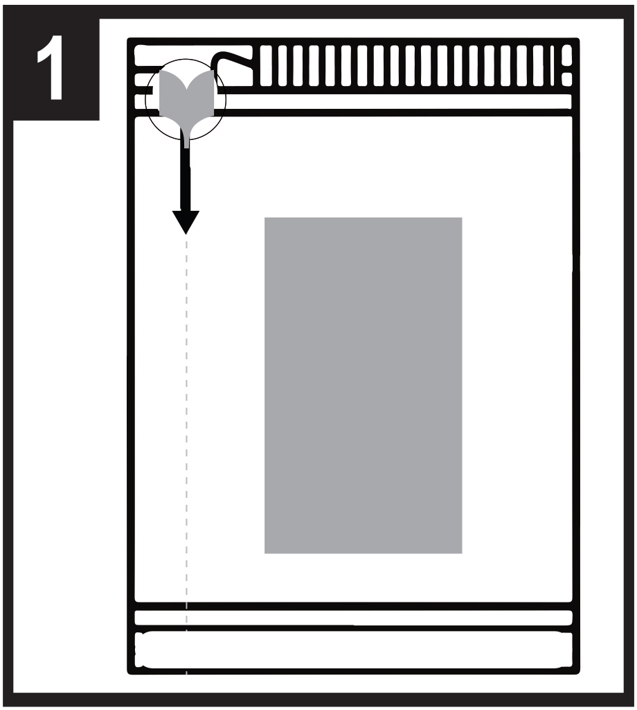 | 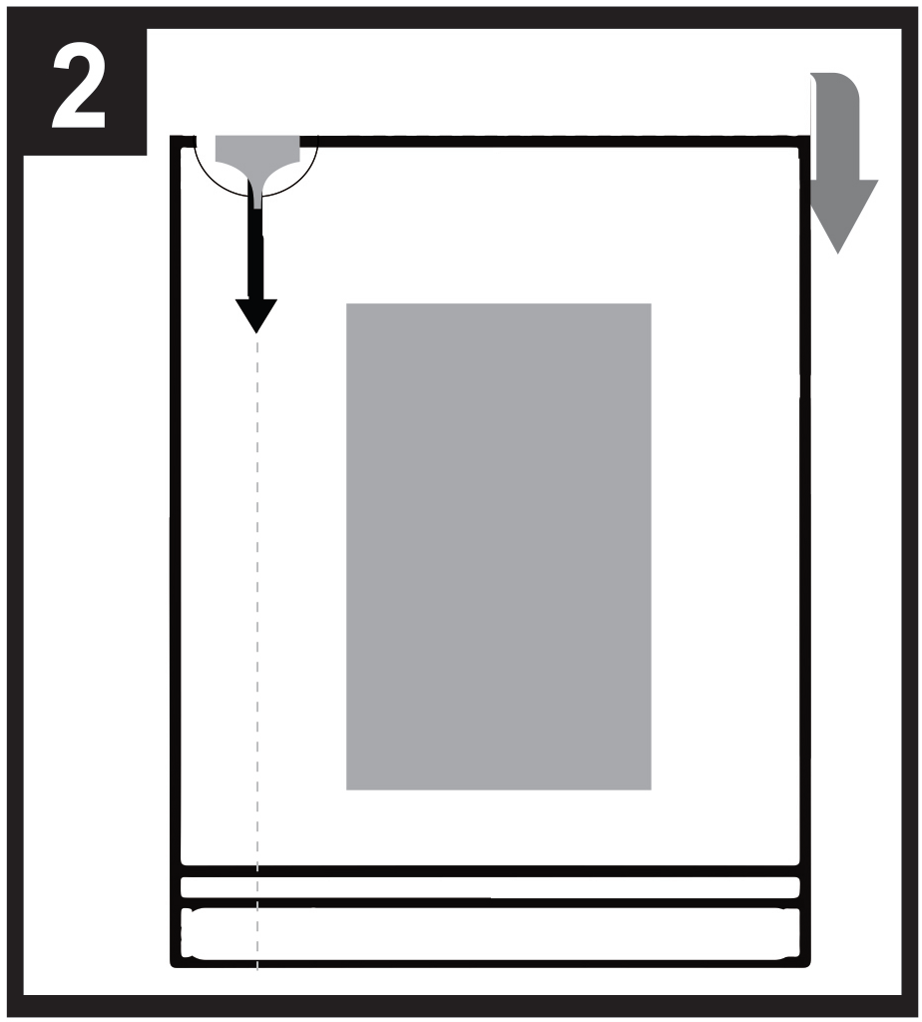 |   - - - - - - - - - - - - - - - - - - - - - - - -
1. Sachet Position
2. To open the sachet, start by folding the sachet backwards at the dotted line.
3. Hold at the circle and tear downwards to open the sachet.
Read the package leaflet before use.

3. EXPIRY DATE

EXP

4. BATCH NUMBER

Lot

5. CONTENTS BY WEIGHT, BY VOLUME OR BY UNIT

1 sublingual film

6. OTHER

PACKAGE LEAFLET

Package leaflet: Information for the patient

Buprenorphine Neuraxpharm 0.4 mg sublingual films
Buprenorphine Neuraxpharm 4 mg sublingual films
Buprenorphine Neuraxpharm 6 mg sublingual films
Buprenorphine Neuraxpharm 8 mg sublingual films
buprenorphine

Read all of this leaflet carefully before you start taking this medicine because it contains important information for you.
- Keep this leaflet. You may need to read it again.
- If you have any further questions, ask your doctor or pharmacist.
- This medicine has been prescribed for you only. Do not pass it on to others. It may harm them, even if their signs of illness are the same as yours.
- If you get any side effects, talk to your doctor, or pharmacist. This includes any possible side effects not listed in this leaflet. See section 4.

What is in this leaflet
1. What Buprenorphine Neuraxpharm is and what it is used for
2. What you need to know before you take Buprenorphine Neuraxpharm
3. How to take Buprenorphine Neuraxpharm
4. Possible side effects
- How to store Buprenorphine Neuraxpharm
- Contents of the pack and other information

- What Buprenorphine Neuraxpharm is and what it is used for

Buprenorphine Neuraxpharm contains the active substance, buprenorphine, a type of medicine known as an opioid. Buprenorphine is used to treat dependence on opioid (narcotic) drugs in adults and adolescents 15 years of age and older who are also receiving medical, social and psychological support. Buprenorphine Neuraxpharm is intended for patients who have agreed to be treated for their opioid dependence. Buprenorphine helps individuals addicted to opioids by preventing opioid withdrawal symptoms and reducing drug cravings.

- What you need to know before you take Buprenorphine Neuraxpharm

Do not take Buprenorphine Neuraxpharm
- if you are allergic to buprenorphine or any of the other ingredients of this medicine (listed in section 6),
- if you have serious breathing problems,
- if you have serious problems with your liver,
- if you are intoxicated due to alcohol or have delirium tremens (trembling, sweating, anxiety, confusion or hallucinations caused by alcohol).

Warnings and precautions
Talk to your doctor before using Buprenorphine Neuraxpharm.

- Misuse and abuse
This medicine can be a target for people who abuse prescription medicines and should be kept in a safe place to protect it from theft. Do not give this medicine to anyone else. It can kill or otherwise harm them.

- Sleep-related breathing disorders
Buprenorphine Neuraxpharm can cause sleep-related breathing disorders such as sleep apnoea (frequent interruption of breathing during sleep) and sleep related hypoxemia (low oxygen level in the blood). Symptoms can include breathing pauses during sleep, night awakening due to shortness of breath, difficulties staying asleep or excessive drowsiness during the day. If you or another person observe these symptoms, contact your doctor. A dose reduction may be considered by your doctor.

- Breathing problems and sleepiness
Some people have died from respiratory failure (inability to breathe) or have experienced increased sleepiness because they misused buprenorphine or have taken it in combination with other central nervous system depressants, such as alcohol, benzodiazepines (tranquilisers), gabapentinoids or other opioids or with inhibitors of the buprenorphine metabolism such as anti-retrovirals (used to treat AIDS) or certain antibiotics (used to treat bacterial infections) (See section 2 “Other medicines and Buprenorphine Neuraxpharm).
Tell your doctor if you suffer from asthma or other respiratory problems before you start treatment with Buprenorphine Neuraxpharm.

- Serotonin syndrome
Concomitant use with certain anti-depressants may cause serotonin syndrome (See section 2 “Other medicines and Buprenorphine Neuraxpharm).

Tolerance, dependence, and addiction

This medicine contains buprenorphine which is an opioid medicine. Repeated use of opioids can result in the drug being less effective (you become accustomed to it, known as tolerance). Repeated use of buprenorphine can also lead to dependence, abuse, and addiction, which may result in life-threatening overdose.

Dependence or addiction can make you feel that you are no longer in control of how much medicine you need to take or how often you need to take it.

The risk of becoming dependent or addicted varies from person to person. You may have a greater risk of becoming dependent on or addicted to buprenorphine if:
- You or anyone in your family have ever abused or been dependent on alcohol, prescription medicines or illegal drugs (“addiction”).
- You are a smoker.
- You have ever had problems with your mood (depression, anxiety, or a personality disorder) or have been treated by a psychiatrist for other mental illnesses.

If you notice any of the following signs whilst taking buprenorphine, it could be a sign that you have become dependent or addicted:
- You need to take the medicine for longer than advised by your doctor
- You need to take more than the recommended dose
- You are using the medicine for reasons other than prescribed, for instance, ‘to stay calm’ or ‘help you sleep’
- You have made repeated, unsuccessful attempts to quit or control the use of the medicine
- When you stop taking the medicine you feel unwell, and you feel better once taking the medicine again (‘withdrawal effects’)
If you notice any of these signs, speak to your doctor to discuss the best treatment pathway for you, including when it is appropriate to stop and how to stop safely (See section 3, If you stop taking
Buprenorphine neuraxpharm.

- Liver damage
Liver damage has been reported after taking buprenorphine, especially when buprenorphine is misused. This could also be due to viral infections (e.g. chronic hepatitis C), alcohol abuse, anorexia or use of other medicines with the ability to harm your liver (See section 4 “Possible side effects").
Regular blood tests may be conducted by your doctor to monitor the condition of your liver. Tell your doctor if you have any liver problems before you start treatment with Buprenorphine Neuraxpharm.

- Withdrawal symptoms
This medicine can cause opioid withdrawal symptoms if you take it too soon after taking opioids. You should leave at least 6 hours after you use a short-acting opioid (e.g. morphine, heroin) or at least 24 hours after you use a long-acting opioid such as methadone.

This medicine can also cause withdrawal symptoms if you stop taking it abruptly.

- Allergic reactions
Tell your doctor immediately or seek urgent medical attention if you experience side effects such as sudden wheezing, difficulty breathing, swelling of the eyelids, face, tongue, lips, throat or hands; rash or itching especially those covering your whole body. These may be signs of a life-threatening allergic reaction.

- General opioid class warnings

- This medicine may cause your blood pressure to drop suddenly, causing you to feel dizzy if you get up too quickly from sitting or lying down. Prescribing and dispensing for a short period of time are recommended especially at the beginning of the treatment.
- Tell your doctor if you recently suffered head injury, or brain disease or if you suffer from seizures. Opioids can cause an increase in pressure of the cerebrospinal fluid (fluid that surrounds the brain and the spinal cord).
- Opioids may induce constriction of the pupils and may mask pain symptoms that could assist in the diagnosis of some diseases.
- Opioids should be used with caution in patients with thyroid problems or adrenocortical disorder (e.g. Addison’s disease).
- Opioids should be used with caution in patients with low blood pressure, a urinary disorder (especially linked to enlarged prostate in men) or a dysfunction of the biliary tract (network of organs and vessels that make, store and transfer bile in the body).
- Opioids should be administered with caution to elderly or debilitated patients.
- The following combinations with Buprenorphine Neuraxpharm are not recommended: Tramadol, codeine, dihydrocodeine, ethylmorphine, alcohol or medications containing alcohol (see also section 2 “Other medicines and Buprenorphine Neuraxpharm”).

Children and adolescents
This medicinal product is not for use in children and adolescents below 15 years. For adolescents between 15 and 17 years, the doctor may decide to conduct regular blood tests.

Other medicines and Buprenorphine Neuraxpharm
Tell your doctor if you are taking, have recently taken or might take any other medicines.

Some medicines may increase the side effects of buprenorphine or cause very serious reactions.
Do not take any other medicines whilst taking Buprenorphine Neuraxpharm without first talking to your doctor, especially:

Benzodiazepines (used to treat anxiety or sleep disorders) such as diazepam, temazepam, or alprazolam, and gabapentinoids (used to treat neuropathic pain, epilepsy or anxiety) such as pregabalin or gabapentin. Concomitant use of Buprenorphine Neuraxpharm and sedative medicines such as benzodiazepines or related medicines increases the risk of drowsiness, difficulties in breathing (respiratory depression), coma and may be life-threatening. Because of this, concomitant use should only be considered when other treatment options are not possible.
However if your doctor does prescribe Buprenorphine Neuraxpharm together with sedative medicines the dose and duration of concomitant treatment should be limited by your doctor.
Please tell your doctor about all sedative medicines you are taking, and follow your doctor’s dose recommendation closely. It could be helpful to inform friends or relatives to be aware of the signs and symptoms stated above. Contact your doctor when experiencing such symptoms.

Other medicinal products that may make you feel sleepy which are used to treat illnesses such as anxiety, sleeplessness, convulsions/seizures or pain and reduce your alertness levels making it difficult for you to drive and use machines. They may also cause central nervous system depression, which is very serious and use of these medicines must be carefully monitored. Below is a list of examples of these types of medicines:
- other opioids such as morphine, certain pain killers and cough suppressants
- anti-convulsants (used to treat seizures) such as valproate - sedative H1 receptor antagonists (used to treat allergic reactions) such as diphenhydramine and chlorphenamine
- barbiturates (used to cause sleep or sedation) such as phenobarbital or chloral hydrate.

Anti-depressants (medicines to treat depression) such as isocarboxazide, moclobemide, tranylcypromine, citalopram, escitalopram, fluoxetine, fluvoxamine, paroxetine, sertraline, duloxetine, venlafaxine, amitriptyline, doxepine, or trimipramine. These medicines may interact with Buprenorphine Neuraxpharm and you may experience symptoms such as involuntary, rhythmic contractions of muscles, including the muscles, that control movement of the eye, agitation, hallucinations, coma, excessive sweating, tremor, exaggeration of reflexes, increased muscle tension, body temperature above 38°C (serotonin syndrome). Contact your doctor when experiencing such symptoms.

Clonidine (used to treat high blood pressure)

Anti-retrovirals (used to treat AIDS) such as ritonavir, nelfinavir or indinavir.Some antifungal agents (used to treat fungal infections) such as ketoconazole, itraconazole, voriconazole or posaconazole.

Certain antibiotics (used to treat bacterial infections) such as clarithromycin or erythromycin.

Medicines used to treat allergies, travel sickness or nausea (antihistamines or antiemetics).
Medicines to treat psychiatric disorders (antipsychotics or neuroleptics).
Muscle relaxants.
Medicines to treat Parkinson’s disease.

Opioid antagonists such as naltexone and nalmefene may prevent Buprenorphine Neuraxpharm from working. If you take naltrexone or nalmefene whilst you are taking Buprenorphine Neuraxpharm you may experience a sudden onset of prolonged and intense withdrawal symptoms.

Some medicines may decrease the effects of Buprenorphine Neuraxpharm and should be used cautiously when given together with Buprenorphine Neuraxpharm. These include:
- Medicines used to treat epilepsy (such as carbamazepine, phenobarbital and phenytoin),
- Medicines used to treat tuberculosis (rifampicin).
Concomitant use of the above mentioned medicines with Buprenorphine Neuraxpharm should be closely monitored and could require in some cases a dose adjustment by your doctor.

You must tell your doctor or pharmacist about all the medicines you are taking or have recently taken, including medicines obtained without a prescription.

Buprenorphine Neuraxpharm with food, drink and alcohol
Alcohol may increase drowsiness and may increase the risk of respiratory failure if taken with buprenorphine. Do not drink alcoholic beverages or take medicines that contain alcohol while you are being treated with Buprenorphine Neuraxpharm.

Pregnancy, breast-feeding

If you are pregnant of breastfeeding, think you may be pregnant or are planning to have a baby, ask your doctor or pharmacist for advice before taking this medicine.

There is no or limited data on the use of buprenorphine in pregnant women.

The use of Buprenorphine Neuraxpharm may be considered during pregnancy, if clinically needed. When taken during pregnancy, particularly at the end of pregnancy, medicines like buprenorphine may cause drug withdrawal symptoms including problems with breathing in your new born baby. These symptoms may occur several days after birth.

Before breast-feeding your baby, talk to your doctor: they will evaluate your individual risk factors and tell you if you can breast-feed your baby whilst taking this medicine.

Driving and using machines
Do not drive or use any tools or machines, or perform dangerous activities until you know how this medicine affects you. This medicine may cause drowsiness, dizziness and impaired thinking. This may happen more often in the first few weeks of treatment or when your dose is being changed, but can also happen if you drink alcohol or take sedative medicines when you take this medicine.
Ask your doctor or pharmacist for advice.

Buprenorphine Neuraxpharm contains Butylated hydroxytoluene and Butylated hydroxyanisole
Butylated hydroxytoluene and Butylated hydroxyanisole may cause local reactions (e.g., irritation to the mucous membranes)

Buprenorphine Neuraxpharm contains sodium

This medicine contains less than 1 mmol sodium (23 mg) per film, that is to say essentially ‘sodiumfree’.

- How to take Buprenorphine Neuraxpharm

Always take this medicine exactly as your doctor or pharmacist has told you. Check with your doctor or pharmacist if you are not sure.

Starting treatment
The recommended starting dose for adults and adolescents over the age of 15 years is 2 to 4 mg of Buprenorphine Neuraxpharm a day. An additional 2 to 4 mg of Buprenorphine Neuraxpharm may be given on day 1 depending on your needs.

You should take your first dose of Buprenorphine Neuraxpharm after you notice clear signs of withdrawal. A doctor’s assessment of your readiness for treatment will guide the timing of your first Buprenorphine Neuraxpharm dose.

If you are dependent upon heroin or a short acting opioid, your first dose of Buprenorphine Neuraxpharm should be taken when signs of withdrawal appear, but at least 6 hours after you last used opioids.

If you have been taking methadone or a long acting opioid, you should talk to your doctor before beginning Buprenorphine Neuraxpharm therapy. The first dose of Buprenorphine Neuraxpharm should be taken when signs of withdrawal appear, but at least 24 hours after you last used methadone.

Dosage adjustment and maintenance therapy
During the days after you start treatment, your doctor may increase your dose of Buprenorphine Neuraxpharm according to your needs. If you have the impression that the effect of Buprenorphine Neuraxpharm is too strong or too weak, talk to your doctor or pharmacist. The maximum daily dose is 24 mg.
If treatment is successful over a period of time, you may agree with your doctor to gradually reduce the dose to a lower maintenance dose. Depending on your condition, your dose of Buprenorphine Neuraxpharm may continue to be reduced under careful medical supervision, until eventually it may be stopped.

The duration of treatment will be determined individually by your doctor.

Liver dysfunction
In case of mild/moderate problems with your liver, your doctor may decide to decrease your dose and/or to perform regular blood tests to check your liver function. Do not take this medicine if you have serious problems with your liver (see section 2 “Do not take Buprenorphine Neuraxpharm”).

Kidney impairment
In case of severe problems with your kidney, your doctor may decrease the dose of buprenorphine.

Instructions for taking this medicine
This medicine is taken by mouth, as a film to be put under your tongue.
Take the dose once a day, at approximately the same time.
It is advisable to moisten your mouth before taking the film.

How to remove the film from the sachet:

- - - - - - - - - - - - - - - - - - - - - - - -
Step 1: Sachet Position
Step 2: To open the sachet, start by folding the sachet backwards at the dotted line.
Step 3: Hold at the circle and tear downwards to open the sachet.

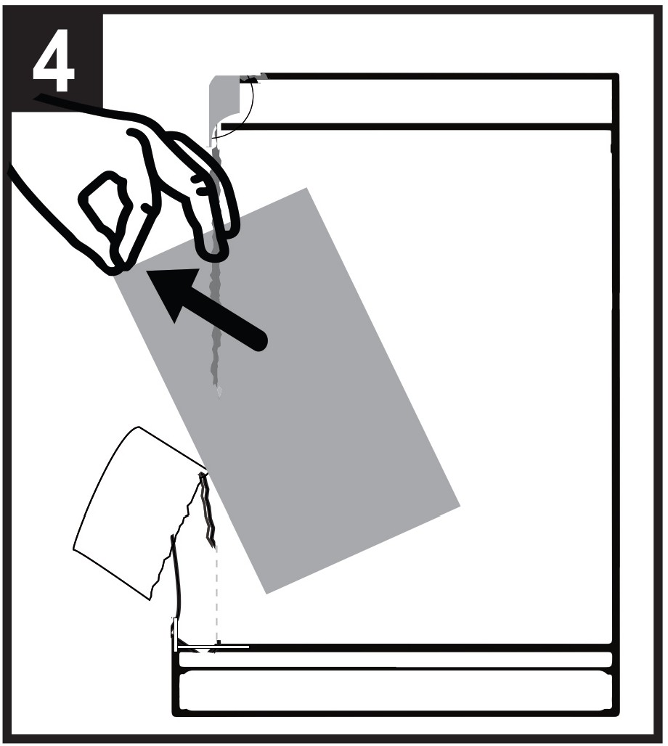 | 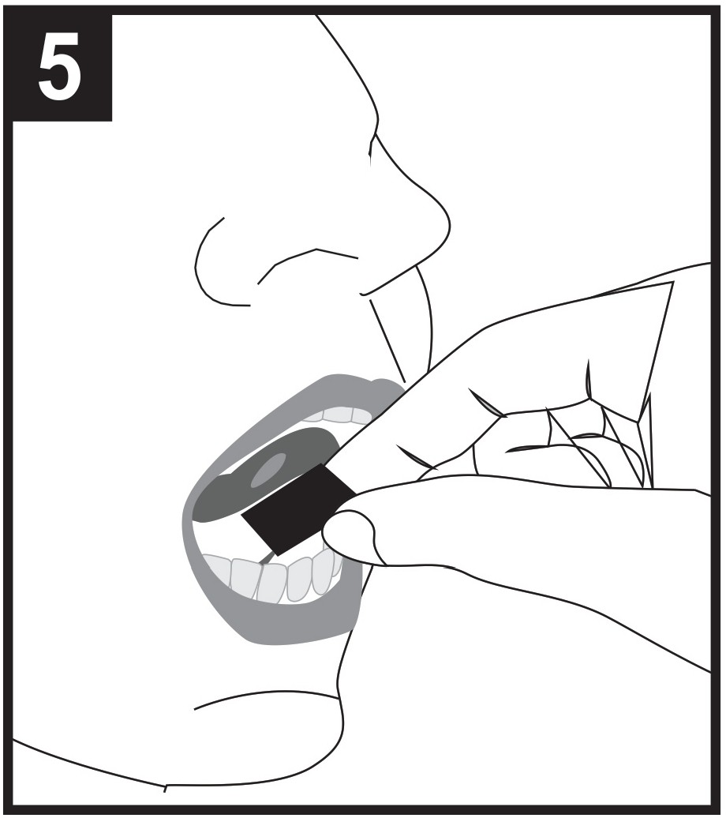 | 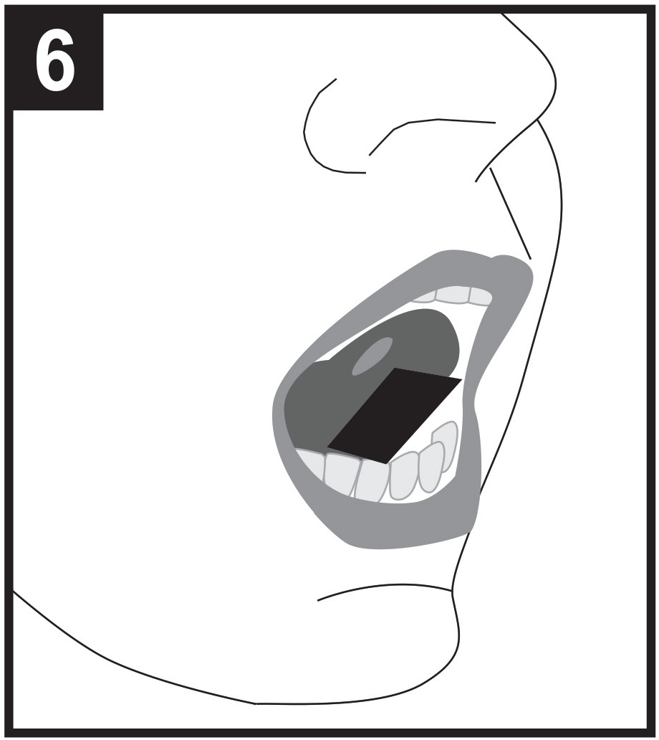
Step 4: Take out of the film from the open end of the sachet.
Step 5: Hold the film in between two fingers by the outside edges and place under the tongue.
Step 6: Place film either to the left or middle or right.

Place the sublingual film under the tongue (sublingual use) as advised by your doctor.

Keep the film in place under the tongue until it dissolves completely. This will take 10 to 15 minutes.

Do not chew or swallow the film, as the medicine will not work, and you may get withdrawal symptoms.

Do not consume any food or drink until the film has completely dissolved.

If an additional film is necessary to achieve the prescribed dose, place the additional film under the tongue only after the first film has been completely dissolved.

Do not split the film or subdivide into smaller doses.

If you take more Buprenorphine Neuraxpharm than you should
In case of overdose of buprenorphine, you must immediately go to an emergency center or hospital for treatment.
An overdose may cause serious and life-threatening breathing problems. Symptoms of overdose may include breathing more slowly and weakly, feeling more sleepy than normal, feeling sick, vomiting and/or having slurred speech or difficulty talking.
Immediately tell your doctor or your physician that you are using buprenorphine, or bring the box with you.

If you forget to take Buprenorphine Neuraxpharm
Tell your doctor as soon as possible if you miss a dose. Do not take a double dose to make up for a forgotten dose.

If you stop taking Buprenorphine Neuraxpharm
Do not change the treatment in any way or stop treatment without the agreement of the doctor who is treating you. Stopping treatment suddenly may cause withdrawal symptoms.

If you have any further questions on the use of this product, ask your doctor or pharmacist.

4. Possible side effects

Like all medicines, this medicine can cause side effects, although not everybody gets them.

Serious side effects

Tell your doctor immediately or seek urgent medical attention if you experience
Swelling of the face, lips, tongue or throat which may cause difficulty in swallowing or breathing, severe hives/nettle rash. These may be signs of a life-threatening allergic reaction.

Also tell your doctor immediately if you experience
Severe tiredness, itching with yellowing of skin or eyes. These may be symptoms of liver damage.

The frequency of these serious side effects is unknown (cannot be estimated from the available data).

The following side effects have also been reported with Buprenorphine Neuraxpharm

Very common (may affect more than 1 in 10 people)
- Infection (establishment of harmful microorganisms such as bacteria or viruses in the body)
- Insomnia (inability to sleep)
- Headache
- Nausea (feeling sick)
- Abdominal (belly) pain
- Hyperhidrosis (excessive sweating)
- Drug withdrawal syndrome (physical and psychological effects that occur when a person stops using a drug that their body has become dependent on, such as discomfort or mood swings)

Common (may affect up to 1 in 10 people)
- Pharyngitis (infection of the throat)
- Agitation (feeling disturbed and upset, being restless)
- Anxiety (feeling worried, with uneasiness of mind)
- Nervousness
- Migraine (moderate to severe headache with palpitating pain often accompanied by nausea, vomiting, and sensitivity to light or sound)
- Paraesthesia (sensations like numbness, tingling, pins and needles)
- Somnolence (sleepiness)
- Fainting (passing out)
- Vertigo (a spinning sensation)
- Hyperkinesia (hyperactivity)
- Orthostatic hypotension (a drop in blood pressure on changing position from sitting or lying down to standing)
- Dyspnoea (difficulty in breathing)
- Constipation
- Vomiting
- Muscle spasms (persistent involuntary muscle stiffness or twitching, often accompanied by pain)
- Dysmenorrhoea (painful menstruation)
- Leukorrhoea (vaginal discharge)
- Tiredness

Rare (may affect up to 1 in 1 000 people)
- Hallucination (seeing or hearing things that are not real)
- Respiratory depression (severe difficulty in breathing)

Not known (frequency cannot be estimated from the available data)
- Neonatal drug withdrawal syndrome
- Hypersensitivity (allergic) reactions
- Jaundice (yellowing of the skin and eyes)
- Increase in liver enzymes (transaminases) in the blood, which may indicate liver damage
- Dental caries
- Drug dependence

All opioids may cause the additional following side effects: seizures, miosis (pupil contraction),
changes in the level of consciousness.

If any of the side effects gets serious, or if you notice any side effects not listed in this leaflet, please
tell your doctor or pharmacist.

Reporting of side effects
If you get any side effects, talk to your doctor or pharmacist. This includes any possible side effects not listed in this leaflet. You can also report side effects directly via the national reporting system listed in Appendix V.* By reporting side effects you can help provide more information on the safety of this medicine.

5. How to store Buprenorphine Neuraxpharm

Keep this medicine out of the sight and reach of children.

Buprenorphine Neuraxpharm 0.4 mg sublingual films
Store below 30°C in the original package in order to protect from light.

Buprenorphine Neuraxpharm 4 mg, 6 mg, 8 mg sublingual films
Store in the original package in order to protect from light.
This medicinal product does not require any special temperature storge conditions.

Store this medicine in a safe and secure place, where other people cannot access it. It can cause serious harm and be fatal to people who may take this medicine by accident, or intentionally when it has not been prescribed for them. . However, this medicine can be a target for people who abuse prescription medicines. Always keep this medicine in a safe place to protect it from theft.
Do not use this medicine after the expiry date which is stated on the carton and sachet. The expiry date refers to the last day of that month. Do not open the sachet in advance.

Do not throw away any medicines via wastewater or household waste. Ask your pharmacist how to throw away medicines you no longer use. These measures will help protect the environment.

6. Contents of the pack and other information

What Buprenorphine Neuraxpharm contains

- The active substance is buprenorphine (as hydrochloride)
Each sublingual film contains 0.4 mg buprenorphine (as hydrochloride)
Each sublingual film contains 4 mg buprenorphine (as hydrochloride)
Each sublingual film contains 6 mg buprenorphine (as hydrochloride)
Each sublingual film contains 8 mg buprenorphine (as hydrochloride)
- The other excipients are hypromellose , maltodextrin, polysorbate 20, carbomer, glycerol, titanium dioxide (E 171), sodium citrate, citric acid monohydrate, partly dementholised mint oil, sucralose, butylhydroxytoluene (E 321), butylhydroxyanisole (E 320), printing ink (hypromellose, propylene glycol (E 1520), iron oxide black (E 172)).

Buprenorphine Neuraxpharm 0.4 mg sublingual films: iron oxide yellow (E 172)

See section 2, Buprenorphine Neuraxpharm contains sodium, butylhydroxytoluene and butylhydroxyanisole.

What Buprenorphine Neuraxpharm looks like and contents of the pack
Buprenorphine Neuraxpharm 0.4 mg sublingual films are light yellow coloured, square, opaque, with one or multiple “0.4” imprinted on one side, sublingual films of nominal dimensions 15 mm x 15 mm.

Buprenorphine Neuraxpharm 4 mg sublingual films are white coloured, rectangular, opaque, with one or multiple “4” imprinted on one side, sublingual films of nominal dimensions 15 mm x 15 mm.

Buprenorphine Neuraxpharm 6 mg sublingual films are white coloured, rectangular, opaque, with one or multiple “6” imprinted on one side, sublingual films of nominal dimensions 20 mm x 17 mm.

Buprenorphine Neuraxpharm 8 mg sublingual films are white coloured, rectangular, opaque, with one or multiple “8” imprinted on one side, sublingual films of nominal dimensions 20 mm x 22 mm.

The films are packed in child-resistant individual sachets.
Pack sizes: 7 × 1, 28 × 1, 49 × 1, 56 × 1 sublingual films
All pack sizes are applicable to all strengths.
Not all pack sizes may be marketed.

Marketing Authorisation Holder and Manufacturer
Marketing Authorisation Holder

Neuraxpharm Pharmaceuticals, S.L.
Avda. Barcelona 69
08970 Sant Joan Despí - Barcelona
Spain
Tel: +34 93 602 24 21
E-mail: medinfo@neuraxpharm.com

Manufacturer

Neuraxpharm Arzneimittel GmbH
Elisabeth-Selbert-Straße 23
40764 Langenfeld - Germany

For any information about this medicine, please contact the local representative of the Marketing Authorisation Holder:

België/Belgique/Belgien  Neuraxpharm Belgium  Tél/Tel: +32 (0)2 732 56 95 | Lietuva  Neuraxpharm Pharmaceuticals S.L.  Tel:+34 93 475 96 00
България  Neuraxpharm Pharmaceuticals, S.L.  Teл.: +34 93 475 96 00 | Luxembourg/Luxemburg  Neuraxpharm France  Tél/Tel: +32 474 62 24 24
Česká republika  Neuraxpharm Bohemia s.r.o.  Tel:+420 739 232 258 | Magyarország  Neuraxpharm Hungary, kft.  Tel.: +36 (30) 542 2071
Danmark  Neuraxpharm Sweden AB  Tlf: +46 (0)8 30 91 41  (Sverige) | Malta  Neuraxpharm Pharmaceuticals, S.L.  Tel.:+34 93 475 96 00
Deutschland  neuraxpharm Arzneimittel GmbH  Tel: +49 2173 1060 0 | Nederland  Neuraxpharm Netherlands B.V  Tel.: +31 70 208 5211
Eesti  Neuraxpharm Pharmaceuticals, S.L.  Tel: +34 93 475 96 001 | Norge  Neuraxpharm Sweden AB  Tlf:+46 (0)8 30 91 41  (Sverige)
Ελλάδα  Neuraxpharm Pharmaceuticals, S.L.  Τηλ: +34 93 602 24 21 | Österreich  Neuraxpharm Austria GmbH  Tel.: + 43 (0) 1 208 07 40
España  Neuraxpharm Spain, S.L.U.  Tel: +34 93 475 96 00 | Polska  Neuraxpharm Polska Sp. z.o.o.  Tel.: +48 783 423 453
France  Neuraxpharm France  Tél: +33 1.53.62.42.90 | Portugal  Neuraxpharm Portugal, Unipessoal Lda  Tel: +351 910 259 536
Hrvatska  Neuraxpharm Pharmaceuticals, S.L.  Tel: +34 93 602 24 21  Ireland  Neuraxpharm Ireland Ltd.  Tel: +353 1 428 7777 | România  Neuraxpharm Pharmaceuticals, S.L.  Tel: +34 93 602 24 21  Slovenija  Neuraxpharm Pharmaceuticals, S.L.  Tel: +34 93 602 24 21
Ísland  Neuraxpharm Sweden AB  Sími: +46 (0)8 30 91 41  (Svíþjóð) | Slovenská republika  Neuraxpharm Slovakia a.s.  Tel: +421 255 425 562
Italia  Neuraxpharm Italy S.p.A.  Tel: +39 0736 980619 | Suomi/Finland  Neuraxpharm Sweden AB  Puh/Tel: +46 (0)8 30 91 41  (Ruotsi/Sverige)
Κύπρος  Neuraxpharm Pharmaceuticals, S.L.  Τηλ: +34 93 602 24 21 | Sverige  Neuraxpharm Sweden AB  Tel: +46 (0)8 30 91 41
Latvija  Neuraxpharm Pharmaceuticals, S.L.  Tel: +34 93 475 96 00 | United Kingdom (Northern Ireland)  Neuraxpharm Ireland Ltd.  Tel: +353 1 428 7777

This leaflet was last revised in
Detailed information on this medicine is available on the European Medicines Agency web site:
http://www.ema.europa.eu.

