This document is the approved product information for Duaklir Genuair, with the changes since the previous procedure affecting the product information (EMEA/H/C/PSR/S/0047) tracked.

For more information, see the European Medicines Agency’s website: https://www.ema.europa.eu/en/medicines/human/epar/duaklir-genuair

ANNEX I

SUMMARY OF PRODUCT CHARACTERISTICS

1. NAME OF THE MEDICINAL PRODUCT

Duaklir Genuair 340 micrograms /12 micrograms inhalation powder

2. QUALITATIVE AND QUANTITATIVE COMPOSITION

Each delivered dose (the dose leaving the mouthpiece) contains 396 micrograms of aclidinium bromide (equivalent to 340 micrograms of aclidinium) and 11.8 micrograms of formoterol fumarate dihydrate. This corresponds to a metered dose of 400 micrograms of aclidinium bromide (equivalent to 343 micrograms of aclidinium) and a metered dose of 12 micrograms of formoterol fumarate dihydrate.

Excipients with known effect

Each delivered dose contains approximately 11 mg lactose (as monohydrate).

For the full list of excipients, see section 6.1.

3. PHARMACEUTICAL FORM

Inhalation powder.

White or almost white powder in a white inhaler with an integral dose indicator and an orange dosage button.

4. CLINICAL PARTICULARS

4.1 Therapeutic indications

Duaklir Genuair is indicated as a maintenance bronchodilator treatment to relieve symptoms in adult patients with chronic obstructive pulmonary disease (COPD).

4.2 Posology and method of administration

Posology

The recommended dose is one inhalation twice daily.

If a dose is missed, it should be taken as soon as possible and the next dose should be taken at the usual time. A double dose should not be taken to make up for a forgotten dose.

Elderly
No dose adjustments are required in elderly patients (see section 5.2).

Renal impairment
No dose adjustments are required in patients with renal impairment (see section 5.2).

Hepatic impairment
No dose adjustments are required in patients with hepatic impairment (see section 5.2).

Paediatric population
There is no relevant use of Duaklir Genuair in children and adolescents (under 18 years of age) for the indication of COPD.

Method of administration

For inhalation use.

Patients should be instructed on how to administer the product correctly as the Genuair inhaler may work differently from inhalers the patients may have used previously. It is important to instruct the patients to read the Instructions for Use in the Package Leaflet.
Before first use, the sealed bag should be teared open, and the inhaler removed. The bag and the desiccant should be thrown away.
For instructions for use, see section 6.6.

4.3 Contraindications

Hypersensitivity to the active substances or to the excipient listed in section 6.1.

4.4 Special warnings and precautions for use

Asthma

Duaklir Genuair should not be used in asthma; clinical studies of Duaklir Genuair in asthma have not been conducted.

Paradoxical bronchospasm

In clinical studies, paradoxical bronchospasm was not observed with Duaklir Genuair at its recommended dose. However, paradoxical bronchospasm has been observed with other inhalation therapies. If this occurs, medicinal product should be stopped and other treatment will be considered.

Not for acute use

Duaklir Genuair is not indicated for the treatment of acute episodes of bronchospasm.

Cardiovascular effects

β2-adrenergic agonists may produce increases in pulse rate and blood pressure, electrocardiogram (ECG) changes such as T wave flattening, ST segment depression and prolongation of the QTc-interval in some patients. In case such effects occur, treatment may need to be discontinued. Long-acting β2-adrenergic agonists should be used with caution in patients with history of or known prolongation of the QTc-interval or treated with medicinal products affecting the QTc interval (see section 4.5).

Cardiac arrhythmias, including atrial fibrillation and paroxysmal tachycardia were seen after the administration of Duaklir Genuair (see section 4.8). Therefore, Duaklir Genuair should be used with caution in patients with cardiac arrhythmias, a history of cardiac arrhythmias or with risk factors for cardiac arrhythmias.

Systemic effects

Duaklir Genuair should be used with caution in patients with severe cardiovascular disorders, convulsive disorders, thyrotoxicosis and phaeochromocytoma.

Metabolic effects of hyperglycaemia and hypokalaemia may be observed with high doses of β₂-adrenergic agonists. In Phase III clinical studies, the frequency of notable increases in blood glucose with Duaklir Genuair was low (0.1%) and similar to placebo. Hypokalaemia is usually transient, not requiring supplementation. In patients with severe COPD, hypokalaemia may be potentiated by hypoxia and concomitant treatment (see section 4.5). Hypokalaemia increases susceptibility to cardiac arrhythmias.

Due to its anticholinergic activity, Duaklir Genuair should be used with caution in patients with symptomatic prostatic hyperplasia, urinary retention or narrow-angle glaucoma (even though direct contact of the product with the eyes is very unlikely). Dry mouth, which has been observed with anticholinergic treatment, may in the long term be associated with dental caries.

Lactose content

Patients with rare hereditary problems of galactose intolerance, total lactase deficiency or glucose-galactose malabsorption should not take this medicinal product.

4.5 Interaction with other medicinal products and other forms of interaction

COPD medicinal products

Co-administration of Duaklir Genuair with other anticholinergic and/or long-acting β₂-adrenergic agonist containing medicinal products has not been studied and is not recommended.

Although no formal in vivo drug interaction studies have been performed with Duaklir Genuair, it has been used concomitantly with other COPD medicinal products including short-acting β₂-adrenergic bronchodilators, methylxanthines, and oral and inhaled steroids without clinical evidence of drug interactions.

Hypokalaemic treatment

Concomitant treatment with methylxanthine derivatives, steroids, or non-potassium-sparing diuretics may potentiate the possible hypokalaemic effect of β₂-adrenergic agonists, therefore caution is advised in their concomitant use (see section 4.4).

β-adrenergic blockers

β-adrenergic blockers may weaken or antagonise the effect of β₂-adrenergic agonists. If β-adrenergic blockers are required (including eye drops), cardioselective beta-adrenergic blockers are preferred, although they should also be administered with caution.

Other pharmacodynamic interactions

Duaklir Genuair should be administered with caution to patients being treated with medicinal products known to prolong the QTc interval such as monoamine oxidase inhibitors, tricyclic antidepressants, antihistamines or macrolides because the action of formoterol, a component of Duaklir Genuair, on the cardiovascular system may be potentiated by these medicinal products. Medicinal products that are known to prolong the QTc interval are associated with an increased risk of ventricular arrhythmias.

Metabolic interactions

In vitro studies have shown that aclidinium or its metabolites at the therapeutic dose are not expected to cause interactions with P-glycoprotein (P-gp) substrate drugs or drugs metabolised by cytochrome P450 (CYP450) enzymes and esterases. Formoterol does not inhibit the CYP450 enzymes at therapeutically relevant concentrations (see section 5.2).

4.6 Fertility, pregnancy and lactation

Pregnancy

There are no data available on the use of Duaklir Genuair in pregnant women.

Studies in animals have shown foetotoxicity only at dose levels much higher than the maximum human exposure to aclidinium and adverse effects in reproduction studies with formoterol at very high systemic exposure levels (see section 5.3).

Duaklir Genuair should only be used during pregnancy if the expected benefits outweigh the potential risks.

Breast-feeding

It is unknown whether aclidinium (and/or its metabolites) or formoterol are excreted in human milk. As studies in rats have shown excretion of small amounts of aclidinium (and/or its metabolites) and formoterol into milk, the use of Duaklir Genuair by breast-feeding women should only be considered if the expected benefit to the woman is greater than any possible risk to the infant.

Fertility

Studies in rats have shown slight reductions in fertility only at dose levels much higher than the maximum human exposure to aclidinium and formoterol (see section 5.3). Nevertheless, it is considered unlikely that Duaklir Genuair administered at the recommended dose will affect fertility in humans.

4.7 Effects on ability to drive and use machines

Duaklir Genuair has no or negligible influence on the ability to drive and use machines. The occurrence of blurred vision or dizziness may influence the ability to drive or to use machines.

4.8 Undesirable effects

The presentation of the safety profile is based on the experience with Duaklir Genuair and the individual components.

Summary of the safety profile

The safety experience with Duaklir Genuair comprised exposure in clinical trials at the recommended therapeutic dose for up to 12 months, and in post-marketing experience.

Adverse reactions associated with Duaklir Genuair were similar to those of the individual components. As Duaklir Genuair contains aclidinium and formoterol, the type and severity of adverse reactions associated with each of the components may be expected with Duaklir Genuair.

The most frequently reported adverse reactions with Duaklir Genuair were nasopharyngitis (7.9%) and headache (6.8%).

Tabulated summary of adverse reactions

The Duaklir Genuair clinical development programme was conducted in patients with moderate or severe COPD. A total of 1222 patients were treated with Duaklir Genuair 340 micrograms /12 micrograms. The frequencies assigned to the adverse reactions are based on crude incidence rates observed with Duaklir Genuair 340 micrograms /12 micrograms in the pooled analysis of randomised, placebo-controlled Phase III clinical studies of at least six months duration, or on experience with individual components or on post-marketing study results.
The frequency of adverse reactions is defined using the following convention: very common (≥1/10); common (≥1/100 to <1/10); uncommon (≥1/1,000 to <1/100); rare (≥1/10,000 to <1/1,000); very rare (<1/10,000) and not known (cannot be estimated from available data).
System organ class | Preferred term | Frequency
Infectious and infestations | Nasopharyngitis  Urinary tract infection  Sinusitis  Tooth abscess | Common
Immune system disorders | Hypersensitivity | Rare
Immune system disorders | Angioedema  Anaphylactic reaction | Not known
Metabolism and nutrition disorders | Hypokalaemia | Uncommon
Metabolism and nutrition disorders | Hyperglycaemia | Uncommon
Psychiatric disorders | Insomnia  Anxiety | Common
Psychiatric disorders | Agitation | Uncommon
Nervous system disorders | Headache  Dizziness  Tremor | Common
Nervous system disorders | Dysgeusia | Uncommon
Eye disorders | Blurred vision | Uncommon
Cardiac disorders | Cardiac arrhythmias, including atrial fibrillation and paroxysmal tachycardia  Tachycardia  Electrocardiogram QTc prolonged  Palpitations  Angina pectoris | Uncommon
Respiratory, Thoracic and mediastinal disorders | Cough | Common
Respiratory, Thoracic and mediastinal disorders | Dysphonia  Throat irritation | Uncommon
Respiratory, Thoracic and mediastinal disorders | Bronchospasm, including paradoxical | Rare
Gastrointestinal disorders | Diarrhoea  Nausea  Dry mouth | Common
Gastrointestinal disorders | Stomatitis | Uncommon
Skin and subcutaneous tissue disorders | Rash  Pruritus | Uncommon
Musculoskeletal and connective tissue disorders | Myalgia  Muscle spasms | Common
Renal and urinary disorders | Urinary retention | Uncommon
Investigations | Blood creatine phosphokinase increased | Common
Investigations | Blood pressure increased | Uncommon

Reporting of suspected adverse reactions

Reporting suspected adverse reactions after authorisation of the medicinal product is important. It allows continued monitoring of the benefit/risk balance of the medicinal product. Healthcare professionals are asked to report any suspected adverse reactions via the national reporting system listed in Appendix V.

4.9 Overdose

There is limited evidence on the management of overdose with Duaklir Genuair. High doses of Duaklir Genuair may lead to exaggerated anticholinergic and/or β₂-adrenergic signs and symptoms; the most frequent of which include blurred vision, dry mouth, nausea, muscle spasm, tremor, headache, palpitations and hypertension.

Duaklir Genuair should be discontinued in case of overdose. Supportive and symptomatic treatment is indicated.

5. PHARMACOLOGICAL PROPERTIES

5.1 Pharmacodynamic properties

Pharmacotherapeutic group: Drugs for obstructive airway diseases, adrenergics in combination with anticholinergics, ATC code: R03AL05

Mechanism of action

Duaklir Genuair contains two bronchodilators: aclidinium is a long-acting muscarinic antagonist (also known as an anticholinergic) and formoterol is a long-acting β₂-adrenergic agonist. The combination of these substances with different mechanisms of action results in additive efficacy compared to that achieved with either component alone. As a consequence of the differential density of muscarinic receptors and β₂-adrenoceptors in the central and peripheral airways of the lung, muscarinic antagonists should be more effective in relaxing central airways and β₂-adrenergic agonists should be more effective in relaxing peripheral airways; relaxation of both central and peripheral airways with combination treatment may contribute to its beneficial effects on lung function. Further information regarding these two substances is provided below.

Aclidinium is a competitive, selective muscarinic receptor antagonist, with a longer residence time at the M₃ receptors than the M₂ receptors. M₃ receptors mediate contraction of airway smooth muscle. Inhaled aclidinium bromide acts locally in the lungs to antagonise M₃ receptors of airway smooth muscle and induce bronchodilation. Aclidinium has also been shown to provide benefits to patients with COPD in terms of symptoms reduction, improvement in disease-specific health status, reduction in exacerbation rates and improvements in exercise tolerance. Since aclidinium bromide is quickly broken down in plasma, the level of systemic anticholinergic undesirable effects is low.

Formoterol is a potent selective β₂-adrenoceptor agonist. Bronchodilation is induced by causing direct relaxation of airway smooth muscle as a consequence of the increase in cyclic AMP through activation of adenylate cyclase. In addition to improving pulmonary function, formoterol has been shown to improve symptoms and quality of life in patients with COPD.

Pharmacodynamic effects

Clinical efficacy studies showed that Duaklir Genuair provides clinically meaningful improvements in lung function (as measured by the forced expiratory volume in 1 second [FEV₁]) over 12 hours following administration.

Duaklir Genuair demonstrated a rapid onset of action within 5 minutes of the first inhalation relative to placebo (p<0.0001). The onset of action of Duaklir Genuair was comparable to the effect of the fast-acting β₂-agonist formoterol 12 micrograms. Maximal bronchodilator effects (peak FEV₁) relative to baseline were evident from day one (304 ml) and were maintained over the 6-month treatment period (326 ml).

Cardiac electrophysiology
No clinically relevant effects of Duaklir Genuair on ECG parameters (including QT-interval) compared with aclidinium, formoterol and placebo were seen in Phase III studies of 6 to 12 months duration conducted in approximately 4,000 patients with COPD. No clinically significant effects of Duaklir Genuair on cardiac rhythm were observed on 24-hour Holter monitoring in a subset of 551 patients, of whom 114 received Duaklir Genuair twice daily.

Clinical Efficacy and Safety

The Phase III clinical development programme included approximately 4,000 patients with a clinical diagnosis of COPD and comprised two 6-month randomised, placebo- and active-controlled studies (ACLIFORM-COPD and AUGMENT), a 6-month extension of the AUGMENT study and a further 12-month randomised controlled study. During these studies, patients were permitted to continue their stable treatment with inhaled corticosteroids, low doses of oral corticosteroids, oxygen therapy (if less than 15h/day) or methylxanthines and to use salbutamol as rescue medication.

Efficacy was assessed by measures of lung function, symptomatic outcomes, disease-specific health status, rescue medication use, and exacerbations. In long-term safety studies, Duaklir Genuair was associated with sustained efficacy when administered over a one-year treatment period with no evidence of tachyphylaxis.

Effects on lung function
Duaklir Genuair 340/12 micrograms twice daily consistently provided clinically meaningful improvements in lung function (as assessed by FEV₁, forced vital capacity and inspiratory capacity) compared with placebo. In Phase III studies, clinically meaningful bronchodilator effects were seen within 5 minutes of the first dose and were maintained over the dosing interval. There was a sustained effect over time in the six-months and one-year Phase III studies.

FEV₁ at 1 hour post-dose and trough FEV₁ (compared to aclidinium 400 micrograms and formoterol 12 micrograms, respectively) were defined as co-primary endpoints in both 6-month pivotal Phase III studies to demonstrate the bronchodilator contributions of formoterol and aclidinium in Duaklir Genuair, respectively.

In study ACLIFORM-COPD, Duaklir Genuair showed improvements in FEV₁ at 1 hour post-dose relative to placebo and aclidinium of 299 ml and 125 ml, respectively (both p<0.0001) and improvements in trough FEV₁ relative to placebo and formoterol of 143 ml and 85 ml, respectively (both p<0.0001). In study AUGMENT, Duaklir Genuair showed improvements in FEV₁ at 1 hour post-dose relative to placebo and aclidinium of 284 ml and 108 ml (both p<0.0001), respectively, and improvements in trough FEV₁ relative to placebo and formoterol of 130 ml (p<0.0001) and 45 ml (p=0.01), respectively.

Symptom relief and disease-specific health status benefits

Breathlessness and other symptomatic outcomes:
Duaklir Genuair provided a clinically meaningful improvement in breathlessness (assessed by the Transition Dyspnoea Index [TDI]) with an improvement in the TDI focal score at 6 months compared to placebo of 1.29 units in study ACLIFORM-COPD (p<0.0001) and 1.44 units in study AUGMENT (p<0.0001). The percentages of patients with clinically meaningful improvements in TDI focal score (defined as an increase of at least 1 unit) were higher with Duaklir Genuair than with placebo in ACLIFORM-COPD (64.8% compared to 45.5%; p<0.001) and AUGMENT (58.1% compared to 36.6%; p<0.0001).

The pooled analysis of these two studies showed Duaklir Genuair to be associated with statistically significantly greater improvements in TDI focal score compared to aclidinium (0.4 units, p=0.016) or formoterol (0.5 units, p=0.009). In addition, a higher percentage of patients receiving Duaklir Genuair responded with a clinically meaningful improvement in TDI focal score compared to either aclidinium or formoterol (61.9% compared to 55.7% and 57.0%, respectively; p=0.056 and p=0.100, respectively).

Duaklir Genuair improved daily symptoms of COPD such as ‘breathlessness’, ‘chest symptoms’, ‘cough and sputum’ (assessed by E-RS total score) as well as overall night-time symptoms, overall early morning symptoms and symptoms limiting early morning activities compared to placebo, aclidinium and formoterol but the improvements were not always statistically significant. Aclidinium/formoterol did not statistically significantly reduce the average number of night-time awakenings due to COPD compared with placebo or formoterol.

Health-related quality of life:
Duaklir Genuair provided a clinically meaningful improvement in disease-specific health status (as assessed by the St. George’s Respiratory Questionnaire [SGRQ]) in study AUGMENT, with an improvement in the SGRQ total score compared to placebo of -4.35 units (p<0.0001). The percentage of patients in AUGMENT who achieved a clinically meaningful improvement from baseline in SGRQ total score (defined as a decrease of at least 4 units) was higher with Duaklir Genuair than with placebo (58.2% compared to 38.7%, respectively; p<0.001). In study ACLIFORM-COPD, only a small decrease in SGRQ total score compared to placebo was observed due to an unexpectedly large placebo response (p=0.598) and the percentages of patients who achieved clinically meaningful improvements from baseline were 55.3% with Duaklir Genuair and 53.2% with placebo (p=0.669).

In the pooled analysis of these two studies, Duaklir Genuair showed greater improvements in SGRQ total score compared to formoterol (-1.7 units; p=0.018) or aclidinium (-0.79 units, p=0.273). In addition, a higher percentage of patients receiving Duaklir Genuair responded with a clinically meaningful improvement in SGRQ total score compared to aclidinium and formoterol (56.6% compared to 53.9% and 52.2%, respectively; p=0.603 and p=0.270, respectively).

COPD exacerbation reductions
Pooled efficacy analysis of the two 6-month Phase III studies demonstrated a statistically significant reduction of 29% in the rate of moderate or severe exacerbations (requiring treatment with antibiotics or corticosteroids or resulting in hospitalisations) with Duaklir Genuair compared to placebo (rates per patient per year: 0.29 vs. 0.42, respectively; p=0.036).

In addition, Duaklir Genuair statistically significantly delayed the time to first moderate or severe exacerbation compared to placebo (hazard ratio=0.70; p=0.027).

Use of rescue medication
Duaklir Genuair reduced the use of rescue medication over 6 months compared to placebo (by 0.9 puffs per day [p<0.0001]), aclidinium (by 0.4 puffs/day [p<0.001]) and formoterol (by 0.2 puffs/day [p=0.062]).

Lung volumes, exercise endurance and physical activity
The effect of Duaklir Genuair on lung volumes, exercise endurance and physical activity was investigated in an 8-week parallel, randomised, placebo-controlled clinical study in COPD patients with hyperinflation (functional residual capacity [FRC] >120%).

After 4 weeks of treatment Duaklir Genuair implied improvement versus placebo in change
from baseline in morning pre-dose (trough) FRC, the primary endpoint, but the difference was not statistically significant (-0.125 L; 95% CI=(-0.259, 0.010); p=0.069*).

Duaklir Genuair showed improvements compared to placebo in lung volumes at 2-3h post dose (FRC=-0.366 L [95% CI=-0.515, -0.216; p<0.0001]; residual volume [RV]=-0.465 L [95% CI=-0.648, -0.281; p<0.0001] and inspiratory capacity [IC]= 0.293 L [95% CI=0.208, 0.378; p<0.0001]).

Duaklir Genuair also showed improvements in exercise endurance time compared to placebo after 8 weeks of treatment (55 seconds [95% CI=5.6, 104.8; p=0.0292]; baseline value: 456 seconds).

After 4 weeks of treatment, Duaklir Genuair improved the number of steps per day compared to placebo (731 steps/day; 95% CI=279, 1181; p=0.0016) and reduced the percentage of inactive patients (<6000 steps per day) [40.8% compared to 54.5%; p<0.0001]. Improvements in the PROactive total score were observed in patients treated with Duaklir Genuair compared with placebo (p=0.0002).

A behavioural intervention program was added to both treatment groups for an additional 4 weeks. The number of steps/day in the Duaklir Genuair treatment group was maintained resulting in a treatment effect compared to placebo of 510 steps/day (p=0.1588) and a reduction versus placebo in the percentage of inactive patients (<6000 steps per day) (41.5% compared to 50.4%; p=0.1134).

*As the primary endpoint did not achieve statistical significance, all p-values for secondary endpoints are tested at a nominal significance level of 0.05, and no formal statistical inference can be drawn.

Paediatric population

The European Medicines Agency has waived the obligation to submit the results of studies with Duaklir Genuair in all subsets of the paediatric population in COPD (see section 4.2 for information on paediatric use).

5.2 Pharmacokinetic properties

When aclidinium and formoterol were administered in combination by the inhaled route, the pharmacokinetics of each component showed no relevant differences from those observed when the medicinal products were administered separately.

Absorption

Following inhalation of a single dose of Duaklir Genuair 340/12 micrograms, aclidinium and formoterol were rapidly absorbed into plasma, reaching peak plasma concentrations within 5 minutes of inhalation in healthy subjects and within 24 minutes of inhalation in patients with COPD. The peak plasma concentrations at steady state of aclidinium and formoterol observed in patients with COPD treated with Duaklir Genuair twice daily for 5 days were reached within 5 minutes post-inhalation and were 128 pg/ml and 17 pg/ml, respectively.

Distribution

Whole lung deposition of inhaled aclidinium via Genuair averaged approximately 30% of the metered dose. The plasma protein binding of aclidinium determined in vitro most likely corresponded to the protein binding of the metabolites due to the rapid hydrolysis of aclidinium in plasma; plasma protein binding was 87% for the carboxylic acid metabolite and 15% for the alcohol metabolite. The main plasma protein that binds aclidinium is albumin.

The plasma protein binding of formoterol is 61% to 64% (34% primarily to albumin). There is no saturation of binding sites in the concentration range reached with therapeutic doses.

Biotransformation

Aclidinium is rapidly and extensively hydrolysed to its pharmacologically inactive alcohol- and carboxylic acid-derivatives. Plasma levels of the acid metabolite are approximately 100-fold greater than those of the alcohol metabolite and the unchanged active substance following inhalation. The hydrolysis occurs both chemically (non-enzymatically) and enzymatically by esterases, butyrylcholinesterase being the main human esterase involved in the hydrolysis. The low absolute bioavailability of inhaled aclidinium (<5%) is because aclidinium undergoes extensive systemic and pre-systemic hydrolysis whether deposited in the lung or swallowed. Biotransformation via CYP450 enzymes plays a minor role in the total metabolic clearance of aclidinium. In vitro studies have shown that aclidinium at the therapeutic dose or its metabolites do not inhibit or induce any of the cytochrome P450 (CYP450) enzymes and do not inhibit esterases (carboxylesterase, acetylcholinesterase and butyrylcholinesterase). In vitro studies have shown that aclidinium or its metabolites are not substrates or inhibitors of P-glycoprotein.

Formoterol is eliminated primarily by metabolism. The prominent pathway involves direct glucuronidation, with O-demethylation followed by glucuronide conjugation being a further metabolic pathway. Cytochrome P450 isoenzymes CYP2D6, CYP2C19, CYP2C9 and CYP2A6 are involved in the O-demethylation of formoterol. Formoterol does not inhibit CYP450 enzymes at therapeutically relevant concentrations.

Elimination

Following inhalation of Duaklir Genuair 340/12 micrograms, with plasma sampling up to 24 hours post-dose, the terminal elimination half-life observed for aclidinium bromide ranged from 11-33 hours and for formoterol from 12-18 hours.

Mean effective half-lives* observed for both aclidinium and formoterol (based on the accumulation ratio) are approximately 10 hours.
*Half-life consistent with product accumulation based on a known dose regimen.

Following intravenous administration of radiolabelled aclidinium 400 micrograms to healthy subjects, approximately 1% of the dose was excreted as unchanged aclidinium bromide in the urine. Up to 65% of the dose was eliminated as metabolites in the urine and up to 33% as metabolites in the faeces. Following inhalation of aclidinium 200 micrograms and 400 micrograms by healthy subjects or patients with COPD, the urinary excretion of unchanged aclidinium was very low at about 0.1% of the administered dose, indicating that renal clearance plays a minor role in the total aclidinium clearance from plasma.

The major part of a dose of formoterol is transformed by liver metabolism followed by renal elimination. After inhalation, 6% to 9% of the delivered dose of formoterol is excreted in the urine unchanged or as direct conjugates of formoterol.

Special populations

Elderly patients
No pharmacokinetics studies have been performed with aclidinium/formoterol in elderly subjects. Since no dosage adjustments are needed for either aclidinium or formoterol medicinal products in elderly patients, no dosage adjustment is warranted for aclidinium/formoterol in geriatric patients.

Renally and hepatically impaired patients
There are no data regarding the specific use of aclidinium/formoterol in patients with renal or hepatic impairment. Since no dosage adjustments are needed for either aclidinium or formoterol medicinal products in patients with renal or hepatic impairment, no dosage adjustment is warranted for aclidinium/formoterol.

Race
Following repeated inhalations of Duaklir Genuair 340/12 micrograms, the systemic exposure of aclidinium and formoterol, as measured by AUC, is similar in Japanese and Caucasian patients.

5.3 Preclinical safety data

Nonclinical data reveal no special hazard for humans with aclidinium and formoterol based on conventional studies of safety pharmacology, repeated dose toxicity, genotoxicity, and carcinogenic potential and toxicity to reproduction and development.

Effects of aclidinium in nonclinical studies with respect to reproductive toxicity (foetotoxic effects) and fertility (slight decreases in conception rate, number of corpora lutea, and pre- and post-implantation losses) were observed only at exposures considered sufficiently in excess of the maximum human exposure indication to be of little relevance to clinical use.

Formoterol showed reduced fertility (implantation losses) in rats, as well as decreased early postnatal survival and birth weight with high systemic exposure to formoterol. A slight increase in the incidence of uterine leiomyomas has been observed in rats and mice; an effect which is considered to be a class-effect in rodents after long-term exposure to high doses of β₂-adrenoreceptor agonists.

Nonclinical studies investigating the effects of aclidinium/formoterol on cardiovascular parameters showed increased heart rates and arrhythmias at exposures sufficiently in excess of the maximum human exposure indication to be of little relevance to clinical use. These effects are known exaggerated pharmacological responses observed with β₂-agonists.

6. PHARMACEUTICAL PARTICULARS

6.1 List of excipients

Lactose monohydrate.

6.2 Incompatibilities

Not applicable.

6.3 Shelf life

3 years.

To be used within 60 days of opening the bag.

6.4 Special precautions for storage

This medicinal product does not require any special temperature storage conditions.
Keep the Genuair inhaler protected inside the sealed bag until the administration period starts.

6.5 Nature and contents of container

The Genuair inhaler is a multicomponent device made of plastic (polycarbonate, acrylonitrile-butadiene-styrene, polyoxymethylene, polyester-butylene-terephthalate, polypropylene, polystyrene) and stainless steel. It is white-coloured with an integral dose indicator and an orange dosage button. The mouthpiece is covered with a removable orange protective cap. The inhaler is supplied sealed in a protective aluminium laminate bag containing a silica gel desiccant sachet, placed in a cardboard carton.

Carton containing 1 inhaler with 30 doses.
Carton containing 1 inhaler with 60 doses.
Carton containing 3 inhalers each with 60 doses.
Not all pack sizes may be marketed.

6.6 Special precautions for disposal and other handling

Any unused medicinal product or waste material should be disposed of in accordance with local requirements.

Instructions for Use

Getting Started

Read these Instructions for Use before you start using the medicine.

Become familiar with the parts of your Genuair inhaler.

Control window
Green = inhaler ready to use
Orange button
Dose
indicator
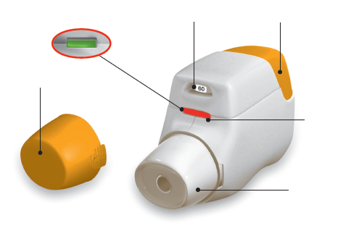
Protective
Cap

Control window
Red = confirms correct inhalation

Mouthpiece

Figure A
Before use:

- Before first use, tear open the sealed bag and remove the inhaler. Throw away the bag and the desiccant.
- Do not press the orange button until you are ready to take a dose.
- Pull off the cap by lightly squeezing the arrows marked on each side (Figure B).
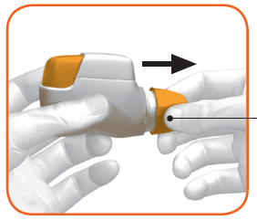
Squeeze here and pull

Figure B

STEP 1: Prepare your dose

- Look in the opening of the mouthpiece and make sure nothing is blocking it (Figure C).

- Look at the control window (should be red, Figure C).

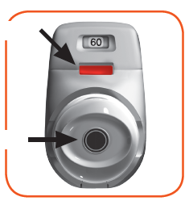
RED
Check mouthpiece opening

Figure C
- Hold the inhaler horizontally with the mouthpiece facing you and the orange button on top (Figure D).
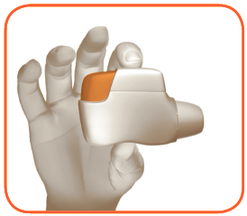

Figure D

- Press the orange button all the way down to load your dose (Figure E).

When you press the button all the way down, the control window changes from red to green.
Make sure the orange button is on top. Do not tilt.

- Release the orange button (Figure F).

Make sure you release the button so the inhaler can work correctly.
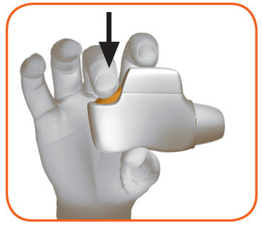
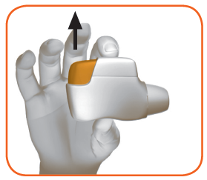

Figure E Figure F

Stop and Check:

- Make sure the control window is now green (Figure G).

Your medicine is ready to be inhaled.

Go to ‘STEP 2: Inhale your medicine’.
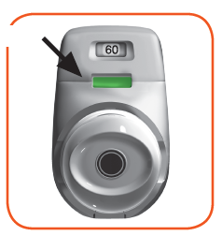
GREEN

Figure G

What to do if the control window is still red after pressing the button (Figure H).
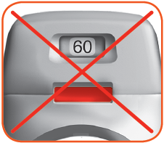

Figure H
The dose is not prepared. Go back to ‘STEP 1 Prepare your dose’ and repeat steps 1.1 to 1.6.
Step 2: Inhale your medicine
Read steps 2.1 to 2.7 fully before use. Do not tilt.
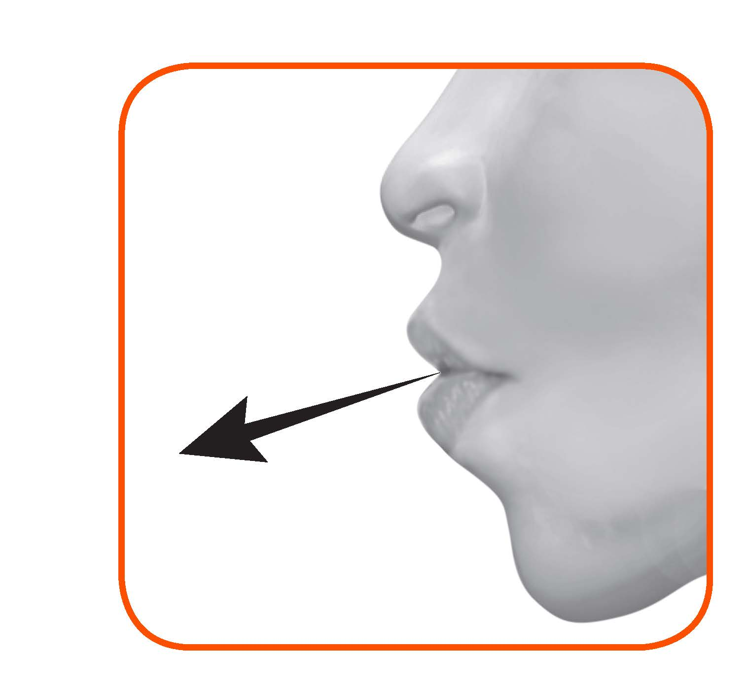
- Hold the inhaler away from your mouth, and breathe out completely. Never breathe out into the inhaler (Figure I).

Figure I
- Hold your head upright, put the mouthpiece between your lips, and close your lips tightly around it (Figure J).
Do not hold the orange button down while inhaling.

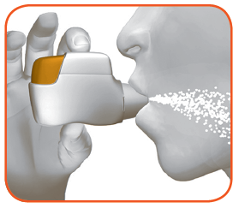

Figure J
- Take a strong, deep breath through your mouth. Keep breathing in for as long as possible.
A ‘click’ will let you know that you are inhaling correctly. Keep breathing in as long as possible after you hear the ‘click’. Some patients may not hear the ‘click’. Use the control window to ensure you have inhaled correctly.
- Take the inhaler out of your mouth.

- Hold your breath for as long as possible.

- Slowly breathe out away from the inhaler.

Some patients may experience a grainy sensation in their mouth, or a slightly sweet or bitter taste. Do not take an extra dose even if you do not taste or feel anything after inhaling.
Stop and Check:
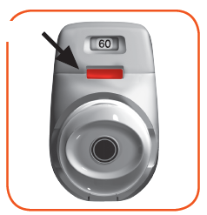
- Make sure the control window is now red (Figure K). This means you have inhaled your medicine correctly.
RED

Figure K

What to do if the control window is still green after inhalation (Figure L).
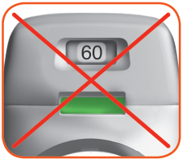

Figure L

This means you have not inhaled your medicine correctly. Go back to ‘STEP 2 Inhale your medicine’ and repeat steps 2.1 to 2.7.

If the control window still does not change to red, you may have forgotten to release the orange button before inhaling, or you may not have inhaled strongly enough. If this happens, try again. Make sure you have released the orange button, and you have breathed out completely. Then take a strong, deep breath through the mouthpiece.
Please contact your doctor if the control window is still green after repeated attempts.

Push the protective cap back onto the mouthpiece after each use (Figure M), to prevent contamination of the inhaler with dust and other materials. You should discard your inhaler if you lose the cap.
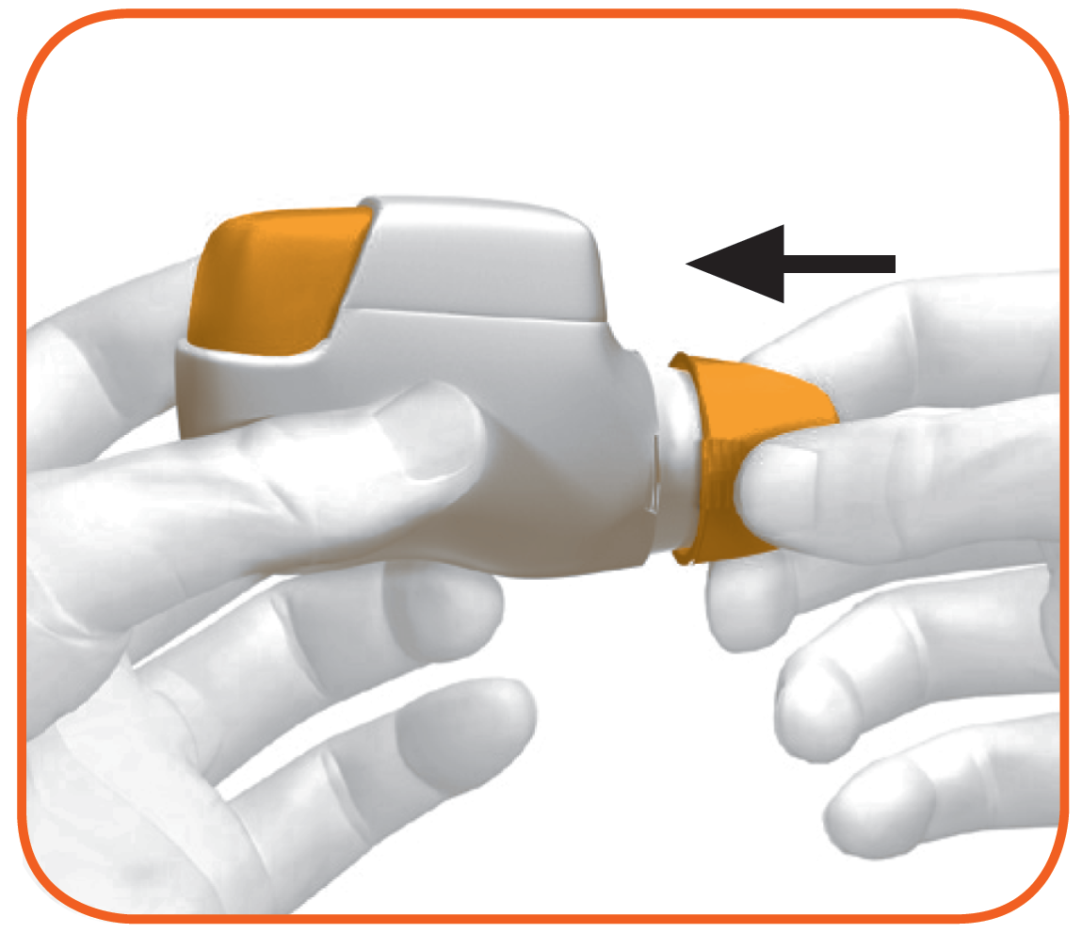

Figure M

Additional information:

What should you do if you accidently prepare a dose?

Store your inhaler with the protective cap in place until it is time to inhale your medicine, then remove the cap and start at Step 1.6.

How does the dose indicator work?

- The dose indicator shows the total number of doses left in the inhaler (Figure N).
- On first use, every inhaler contains at least 60 doses, or at least 30 doses, depending on the pack size.
- Each time you load a dose by pressing the orange button, the dose indicator moves by a small amount towards the next number (50, 40, 30, 20, 10, or 0).

When should you get a new inhaler?

You should get a new inhaler:

- If your inhaler appears to be damaged or if you lose the cap, or
- When a red band appears in the dose indicator, this means you are nearing your last dose (Figure N), or
- If your inhaler is empty (Figure O).
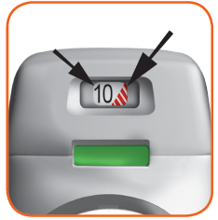
Dose indicator moves slowly from 60 to 0: 60, 50, 40, 30, 20, 10, 0.
Red band
Dose
indicator

Figure N

How do you know that your inhaler is empty?

When the orange button will not return to its full upper position and is locked in a middle position, you have reached the last dose (Figure O). Even though the orange button is locked, your last dose may still be inhaled. After that, the inhaler cannot be used again and you should start using a new inhaler.
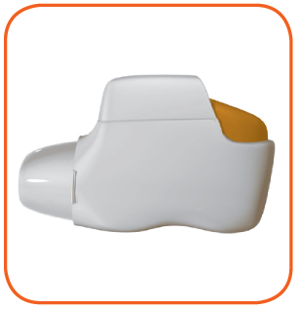
Locked

Figure O

How should you clean the inhaler?

NEVER use water to clean the inhaler, as this may damage your medicine.

If you wish to clean your inhaler, just wipe the outside of the mouthpiece with a dry tissue or paper towel.

7. MARKETING AUTHORISATION HOLDER

Covis Pharma Europe B.V.
Gustav Mahlerplein 2
1082MA Amsterdam
The Netherlands

8. MARKETING AUTHORISATION NUMBER(S)

EU/1/14/964/001
EU/1/14/964/002
EU/1/14/964/003

9. DATE OF FIRST AUTHORISATION/RENEWAL OF THE AUTHORISATION

Date of first authorisation: 19 November 2014
Date of latest renewal: 23 August 2019

10. DATE OF REVISION OF THE TEXT

Detailed information on this medicinal product is available on the website of the European Medicines Agency http://www.ema.europa.eu.

ANNEX II

A. MANUFACTURER(S) RESPONSIBLE FOR BATCH RELEASE

B. CONDITIONS OR RESTRICTIONS REGARDING SUPPLY AND USE

C. OTHER CONDITIONS AND REQUIREMENTS OF THE MARKETING AUTHORISATION

D. CONDITIONS OR RESTRICTIONS WITH REGARD TO THE SAFE AND EFFECTIVE USE OF THE MEDICINAL PRODUCT

A. MANUFACTURER RESPONSIBLE FOR BATCH RELEASE

Name and address of the manufacturer responsible for batch release
Industrias Farmacéuticas Almirall, S.A.
Ctra. de Martorell 41-61
08740 Sant Andreu de la Barca, Barcelona
Spain

B. CONDITIONS OR RESTRICTIONS REGARDING SUPPLY AND USE

Medicinal product subject to medical prescription

C. OTHER CONDITIONS AND REQUIREMENTS OF THE MARKETING AUTHORISATION

- Periodic safety update reports (PSURs)

The requirements for submission of PSURs for this medicinal product are set out in the list of Union reference dates (EURD list) provided for under Article 107c(7) of Directive 2001/83/EC and any subsequent updates published on the European medicines web-portal.

D. CONDITIONS OR RESTRICTIONS WITH REGARD TO THE SAFE AND EFFECTIVE USE OF THE MEDICINAL PRODUCT

- Risk Management Plan (RMP)

The marketing authorisation holder (MAH) shall perform the required pharmacovigilance activities and interventions detailed in the agreed RMP presented in Module 1.8.2 of the Marketing Authorisation and any agreed subsequent updates of the RMP.

An updated RMP should be submitted:
- At the request of the European Medicines Agency;
- Whenever the risk management system is modified, especially as the result of new information being received that may lead to a significant change to the benefit/risk profile or as the result of an important (pharmacovigilance or risk minimisation) milestone being reached.

ANNEX III

LABELLING AND PACKAGE LEAFLET

A. LABELLING

PARTICULARS TO APPEAR ON THE OUTER PACKAGING

OUTER CARTON

1. NAME OF THE MEDICINAL PRODUCT

Duaklir Genuair 340 micrograms/12 micrograms inhalation powder
aclidinium/formoterol fumarate dihydrate

2. STATEMENT OF ACTIVE SUBSTANCE(S)

Each delivered dose contains 396 micrograms aclidinium bromide (equivalent to 340 micrograms of aclidinium) and 11.8 micrograms of formoterol fumarate dihydrate.

3. LIST OF EXCIPIENTS

Also contains: Lactose
See leaflet for further information

4. PHARMACEUTICAL FORM AND CONTENTS

Inhalation powder
1 inhaler containing 30 doses
1 inhaler containing 60 doses
3 inhalers each containing 60 doses

5. METHOD AND ROUTE(S) OF ADMINISTRATION

Read the package leaflet before use.
Inhalation use

6. SPECIAL WARNING THAT THE MEDICINAL PRODUCT MUST BE STORED OUT OF THE SIGHT AND REACH OF CHILDREN

Keep out of the sight and reach of children.

7. OTHER SPECIAL WARNING(S), IF NECESSARY

8. EXPIRY DATE

EXP

To be used within 60 days of opening bag.

9. SPECIAL STORAGE CONDITIONS

Keep the Genuair inhaler protected inside the sealed bag until the administration period starts.

10. SPECIAL PRECAUTIONS FOR DISPOSAL OF UNUSED MEDICINAL PRODUCTS OR WASTE MATERIALS DERIVED FROM SUCH MEDICINAL PRODUCTS, IF APPROPRIATE

11. NAME AND ADDRESS OF THE MARKETING AUTHORISATION HOLDER

Covis Pharma Europe B.V.
Gustav Mahlerplein 2
1082MA Amsterdam
The Netherlands

Covis (Covis logo)

12. MARKETING AUTHORISATION NUMBER(S)

EU/1/14/964/001 1 inhaler with 60 doses
EU/1/14/964/002 3 inhalers each with 60 doses
EU/1/14/964/003 1 inhaler with 30 doses

13. BATCH NUMBER

Lot

14. GENERAL CLASSIFICATION FOR SUPPLY

15. INSTRUCTIONS ON USE

16. INFORMATION IN BRAILLE

duaklir genuair

17. UNIQUE IDENTIFIER – 2D BARCODE

2D barcode carrying the unique identifier included.

18. UNIQUE IDENTIFIER - HUMAN READABLE DATA

PC:
SN:
NN:

MINIMUM PARTICULARS TO APPEAR ON BLISTERS OR STRIPS

ALUMINIUM BAG

1. NAME OF THE MEDICINAL PRODUCT

Duaklir Genuair 340 micrograms/12 micrograms inhalation powder
aclidinium/formoterol fumarate dihydrate

2. NAME OF THE MARKETING AUTHORISATION HOLDER

Covis (Covis logo)

3. EXPIRY DATE

EXP

To be used within 60 days of opening the bag.

4. BATCH NUMBER

Lot

5. OTHER

Keep the Genuair inhaler protected inside the sealed bag until the administration period starts.

[arrow] Tear here

MINIMUM PARTICULARS TO APPEAR ON SMALL IMMEDIATE PACKAGING UNITS

INHALER LABEL

1. NAME OF THE MEDICINAL PRODUCT AND ROUTE(S) OF ADMINISTRATION

Duaklir Genuair 340 mcg/12 mcg inhalation powder
aclidinium/formoterol fumarate dihydrate

Inhalation use

2. METHOD OF ADMINISTRATION

3. EXPIRY DATE

To be used within 60 days of opening the bag.
EXP

4. BATCH NUMBER

Lot

5. CONTENTS BY WEIGHT, BY VOLUME OR BY UNIT

30 doses
60 doses

6. OTHER

Covis (Covis logo)

B. PACKAGE LEAFLET
Package leaflet: Information for the patient

Duaklir Genuair 340 micrograms /12 micrograms inhalation powder
aclidinium/formoterol fumarate dihydrate

Read all of this leaflet carefully before you start using this medicine because it contains important information for you.
- Keep this leaflet. You may need to read it again.
- If you have any further questions, ask your doctor, pharmacist or nurse.
- This medicine has been prescribed for you only. Do not pass it on to others. It may harm them, even if their signs of illness are the same as yours.
- If you get any side effects, talk to your doctor, pharmacist or nurse. This includes any possible side effects not listed in this leaflet. See section 4.

What is in this leaflet
1. What Duaklir Genuair is and what it is used for
2. What you need to know before you use Duaklir Genuair
3. How to use Duaklir Genuair
4. Possible side effects
5. How to store Duaklir Genuair
6. Contents of the pack and other information
Instructions for Use

1. What Duaklir Genuair is and what it is used for

What Duaklir Genuair is
This medicine contains two active ingredients called aclidinium and formoterol fumarate dihydrate. Both belong to a group of medicines called bronchodilators. Bronchodilators relax the muscles in your airways, which allows the airways to open more widely and helps you to breathe more easily. The Genuair inhaler delivers the active ingredients directly into your lungs as you breathe in.

What Duaklir Genuair is used for
Duaklir Genuair is used for adult patients who have breathing difficulties due to a lung disease called chronic obstructive pulmonary disease (COPD), in which the airways and air sacs in the lungs become damaged or blocked. By opening the airways, the medicine helps relieve symptoms such as shortness of breath. Taking Duaklir Genuair regularly will reduce the effects of COPD on your everyday life.

2. What you need to know before you use Duaklir Genuair

Do not use Duaklir Genuair:
- if you are allergic to aclidinium, formoterol fumarate dihydrate or to the other ingredient of this medicine (listed in section 6).

Warnings and precautions
Talk to your doctor, pharmacist or nurse before using Duaklir Genuair, if you have any of the following conditions/symptoms:
- If you have asthma. This medicine should not be used for the treatment of asthma.
- If you have heart problems.
- If you have epilepsy.
- If you have thyroid gland problems (thyrotoxicosis).
- If you have a tumour in one of your adrenal glands (phaeochromocytoma).
- If you have difficulty passing urine or problems due to an enlarged prostate.
- If you have an eye condition called narrow angle glaucoma, which results in high pressure in the eye.

Stop taking Duaklir Genuair and seek medical help immediately if you experience any of the following:

- If you get sudden tightness of the chest, coughing, wheezing or breathlessness immediately after using the medicine. See section 4.

Duaklir Genuair is used as a maintenance (long-term) treatment for COPD. You should not use this medicine to treat a sudden attack of breathlessness or wheezing.

If your usual COPD symptoms (breathlessness, wheezing, cough) do not improve or get worse while you are using Duaklir Genuair you should continue to use it, but go to see your doctor as soon as possible because you may need another medicine.

If you see halos around lights or coloured images, have eye pain or discomfort or suffer temporary blurring of vision, go to see your doctor for advice as soon as possible.

Dry mouth has been observed with medicines like Duaklir Genuair. In the long-term, dry mouth can be associated with tooth decay, so it is important to pay attention to oral hygiene.

Children and adolescents
Duaklir Genuair is not for use in children or adolescents below 18 years of age.

Other medicines and Duaklir Genuair
Tell your doctor or pharmacist if you are taking, have recently taken or might take any other medicines. If you use Duaklir Genuair with some other medicines, the effect of Duaklir Genuair or the other medicines may be altered.

Tell your doctor or pharmacist if you are taking:
- Any medicines that may be similar to Duaklir Genuair to treat breathing difficulties.
- Medicines that lower the amount of potassium in your blood. These include:
  - corticosteroids that you take by mouth (such as prednisolone),
  - diuretics (such as furosemide or hydrochlorothiazide),
  - certain medicines used to treat breathing conditions (such as theophylline).
- Medicines called beta blockers that may be used to treat high blood pressure or other heart problems (such as atenolol or propranolol) or to treat glaucoma (such as timolol).
- Medicines which can cause a type of change in the electrical activity of the heart known as QT interval prolongation (observed in an electrocardiogram). These include medicines for the treatment of:
  - depression (such as monoamine oxidase inhibitors or tricyclic antidepressants),
  - bacterial infections (such as erythromycin, clarithromycin, telithromycin),
  - allergic reactions (anti-histamines).

Pregnancy and breast-feeding
If you are pregnant or breast-feeding, think you may be pregnant or are planning to have a baby, ask your doctor, nurse or pharmacist for advice before using this medicine. You should not use Duaklir Genuair if you are pregnant or are breast-feeding unless your doctor tells you to do so.

Driving and using machines
Duaklir Genuair is unlikely to affect your ability to drive or use machines. In some patients, this medicine may cause blurred vision or dizziness. If you are affected by either of these side effects, do not drive or use machines until the dizziness has cleared or your vision has returned to normal.

Duaklir Genuair contains lactose
This medicine contains lactose. If you have been told by your doctor that you have an intolerance to some sugars, contact your doctor before taking this medicine.

3. How to use Duaklir Genuair

Always use this medicine exactly as your doctor or pharmacist has told you. Check with your doctor or pharmacist if you are not sure.

- The recommended dose is one inhalation in the morning and one inhalation in the evening.
- You can use Duaklir Genuair anytime before or after food or drink.
- The effects of Duaklir Genuair last for 12 hours; therefore, you should try to use Duaklir Genuair at the same time each morning and evening as this will ensure that there is always enough medicine in your body to help you breathe more easily throughout the day and night. Taking your medicine at regular times will also help you to remember to use it.
- The recommended dose can be used for elderly patients and for patients with kidney or liver problems. No dose adjustments are necessary in these patients.
- Duaklir Genuair is for inhalation use.
- Instructions for use: Refer to the Instructions for Use at the end of this leaflet for instructions on how to use the Genuair inhaler. If you are not sure of how to use Duaklir Genuair, contact your doctor or pharmacist.

COPD is a long-term disease; therefore, Duaklir Genuair is for long-term use. The medicine must be used every day, twice a day and not only when breathing problems or other symptoms of COPD are experienced.

If you use more Duaklir Genuair than you should
If you think you may have used more Duaklir Genuair than you should, you are more likely to experience some of its side effects, such as blurred vision, dry mouth, feeling sick, shaking/tremor, headache, palpitations or an increase in blood pressure, therefore you must immediately contact your doctor or go to the nearest emergency unit. Show the packaging of Duaklir Genuair. Medical attention may be needed.

If you forget to use Duaklir Genuair
If you forget a dose of Duaklir Genuair, just take it as soon as possible and take your next dose at the usual time. Do not take a double dose to make up for a forgotten dose.

If you stop using Duaklir Genuair
This medicine is for long-term use. If you want to stop treatment, first talk to your doctor, as your symptoms may worsen.

If you have any further questions on the use of this medicine, ask your doctor, pharmacist or nurse.

4. Possible side effects

Like all medicines, this medicine can cause side effects, although not everybody gets them.

Stop using the medicine and contact your doctor immediately if you:

- develop swelling of the face, throat, lips or tongue (with or without difficulty breathing or swallowing), severe itchy bumps on the skin (hives) as these may be symptoms of an allergic reaction. Frequency of this reaction cannot be estimated from the available data.

- develop tightness of the chest, coughing, wheezing or breathlessness immediately after using the medicine. These may be signs of a condition called “paradoxical bronchospasm”, which is an excessive and prolonged contraction of the airway muscles immediately following treatment with a bronchodilator. This reaction may rarely occur (may affect up to 1 in 1,000 people).

Some side effects may be serious: if you get any of these side effects, tell your doctor immediately.

Uncommon (may affect up to 1 in 100 people)
- Muscle weakness, twitching and/or abnormal heart rhythm, as these may be signs of a decrease in the amount of potassium in your blood
- Tiredness, increased thirst and/or a need to pass urine more frequently than usual, as these may be signs of an increase in the amount of sugar in your blood
- Palpitations, as these may be a sign of an unusually fast heart beat or an abnormal heart rhythm

Rare (may affect up to 1 in 1,000 people)
- Sudden difficulty in breathing or swallowing, swelling of the tongue, throat, lips or face, skin rash and/or itching - these may be signs of an allergic reaction

Other side effects which may occur while using Duaklir Genuair:

Common (may affect up to 1 in 10 people)
- Combination of sore throat and runny nose – these may be signs of nasopharyngitis
- Headache
- Painful and/or frequent urination – these may be signs of a urinary tract infection
- Cough
- Diarrhoea
- A blocked, runny or stuffy nose and/or pain or a feeling of pressure in the cheeks or forehead – these may be symptoms of sinusitis
- Dizziness
- Muscle cramps
- Nausea (feeling sick)
- Difficulty sleeping
- Dry mouth
- Muscle pain
- Abscess (infection) in the tissues at the base of a tooth
- Increased blood levels of a protein found in muscle called creatine phosphokinase
- Shaking/tremor
- Anxiety

Uncommon
- Fast heart beat (tachycardia)
- Abnormal or irregular heartbeat (cardiac arrhythmias)
- Chest pain or tightness in the chest (angina pectoris)
- Blurred vision
- Changes in the sound of the voice (dysphonia)
- Difficulty passing urine or a feeling that your bladder has not completely emptied (urinary retention)
- An abnormal heart trace (QT interval prolongation) potentially leading to an abnormal heart rhythm
- Distorted sense of taste (dysgeusia)
- Throat irritation
- Inflammation of the mouth (stomatitis)
- Increased blood pressure
- Agitation
- Rash
- Itching of the skin

Reporting of side effects
If you get any side effects, talk to your doctor, pharmacist or nurse. This includes any possible side effects not listed in this leaflet. You can also report side effects directly via the national reporting system listed in Appendix V. By reporting side effects you can help provide more information on the safety of this medicine.

5. How to store Duaklir Genuair

Keep this medicine out of the sight and reach of children.

Do not use this medicine after the expiry date which is stated on the inhaler label, carton and inhaler bag after “EXP”. The expiry date refers to the last day of that month.

This medicine does not require any special temperature storage conditions.

Keep the Genuair inhaler protected inside the sealed bag until the administration period starts.

To be used within 60 days of opening the bag.

Do not use Duaklir Genuair if you notice that the pack is damaged or shows signs of tampering.

After you have taken the last dose, the inhaler has to be disposed of. Do not throw away any medicines via household waste. Ask your pharmacist how to throw away medicines you no longer use. These measures will help protect the environment.

6. Contents of the pack and other information

What Duaklir Genuair contains
- The active substances are aclidinium and formoterol fumarate dihydrate. Each delivered dose (the dose leaving the mouthpiece) contains 396 micrograms aclidinium bromide equivalent to 340 micrograms of aclidinium and 11.8 micrograms of formoterol fumarate dihydrate.
- The other ingredient is lactose monohydrate (see end of section 2 under ‘Duaklir Genuair contains lactose’ for more information).

What Duaklir Genuair looks like and contents of the pack
Duaklir Genuair is a white or almost white inhalation powder.
The Genuair inhaler is a white device fitted with an integral dose indicator and an orange dosage button. The mouthpiece is covered with a removable orange protective cap. It is supplied in a sealed protective aluminium bag containing a desiccant sachet. After removing the inhaler from the bag, the bag and desiccant sachet should be thrown away.

Pack sizes supplied:

Carton containing 1 inhaler with 30 doses.
Carton containing 1 inhaler with 60 doses.
Carton containing 3 inhalers each with 60 doses.

Not all pack sizes may be marketed.

Marketing Authorisation Holder
Covis Pharma Europe B.V.
Gustav Mahlerplein 2
1082MA Amsterdam
The Netherlands

Manufacturer:
Industrias Farmacéuticas Almirall, S.A.
Ctra. de Martorell 41-61
08740 Sant Andreu de la Barca, Barcelona
Spain

For any information about this medicine, please contact the local representative of the Marketing Authorisation Holder:

 | België/Belgique/Belgien  Covis Pharma Europe B.V.  Tel: 80013067 | Lietuva  Covis Pharma Europe B.V.  Tel: 880000890
 | България  Covis Pharma Europe B.V.  Tel: 008002100654 | Luxembourg/Luxemburg  Covis Pharma Europe B.V.  Tel: 80024119
 | Česká republika  Covis Pharma Europe B.V.  Tel: 800144474 | Magyarország  Covis Pharma Europe B.V.  Tel.: 0680021540
 | Danmark  Zentiva Denmark ApS  Tlf.: +45 787 68 400 | Malta  Covis Pharma Europe B.V.  Tel: 80065149
 | Deutschland  Zentiva Pharma GmbH  Tel: +49 (0) 800 53 53 010 | Nederland  Covis Pharma Europe B.V.  Tel: 08000270008
 | Eesti  Covis Pharma Europe B.V  Tel: 8000100776 | Norge  Zentiva Denmark ApS  Tlf: +45 787 68 400
 | Ελλάδα  Specialty Therapeutics IKE  Τηλ: +30 213 02 33 913 | Österreich  Covis Pharma Europe B.V.  Tel: 0800006573
España  Zentiva Spain S.L.U.  Tel: +34 671 365 828 |  | Polska  Covis Pharma Europe B.V.  Tel.: 0800919353
France  Zentiva France  Tél: +33 (0) 800 089 219 |  | Portugal  Zentiva Portugal, Lda  Tel: +351210601360
Hrvatska  Covis Pharma Europe B.V.  Tel: 08004300 |  | România  Covis Pharma Europe B.V.  Tel: 0800410175
Ireland  Covis Pharma Europe B.V.  Tel: 1800937485 |  | Slovenija  Covis Pharma Europe B.V.  Tel: 080083003
Ísland  Zentiva Denmark ApS  Sími: +354 539 5025 |  | Slovenská republika  Covis Pharma Europe B.V.  Tel: 0800008203
Italia  Covis Pharma Europe B.V.  Tel: 800168094 |  | Suomi/Finland  Zentiva Denmark ApS  Puh/Tel: +358 942 598 648
Κύπρος  Specialty Therapeutics IKE  Τηλ: +30 213 02 33 913 |  | Sverige  Zentiva Denmark ApS  Tel: +46 840 838 822
Latvija
Covis Pharma Europe B.V.
Tel: 80005962

This leaflet was last revised in {month YYYY}.

Detailed information on this medicine is available on the European Medicines Agency web site: http://www.ema.europa.eu.

Instructions for Use
This section contains information on how to use your Genuair inhaler. It is important that you read this information as the Genuair may work differently from inhalers you have used previously. If you have any questions about how to use your inhaler, please ask your doctor, pharmacist or nurse for assistance.

The Instructions for Use is divided into the following sections:
- Getting started
- Step 1: Prepare your dose
- Step 2: Inhale your medicine
- Additional information

Getting Started

Read these Instructions for Use before you start using the medicine.

Become familiar with the parts of your Genuair inhaler.

Dose
indicator

Control window
Green = inhaler ready to use
Orange button

Protective
Cap

Control window
Red = confirms correct inhalation

Mouthpiece

Figure A

Before use:

- Before first use, tear open the sealed bag and remove the inhaler. Throw away the bag and the desiccant.
- Do not press the orange button until you are ready to take a dose.
- Pull off the cap by lightly squeezing the arrows marked on each side (Figure B).

Squeeze here and pull

Figure B

STEP 1: Prepare your dose

- Look in the opening of the mouthpiece and make sure nothing is blocking it (Figure C).

- Look at the control window (should be red, Figure C).
RED

Check mouthpiece opening

Figure C

- Hold the inhaler horizontally with the mouthpiece facing you and the orange button on top (Figure D).

Figure D

- Press the orange button all the way down to load your dose (Figure E).

When you press the button all the way down, the control window changes from red to green.
Make sure the orange button is on top. Do not tilt.
- Release the orange button (Figure F).
Make sure you release the button so the inhaler can work correctly.

Figure E Figure F

Stop and Check:

- Make sure the control window is now green (Figure G).

Your medicine is ready to be inhaled.

Go to ‘STEP 2: Inhale your medicine’.
GREEN

Figure G
What to do if the control window is still red after pressing the button (Figure H).

Figure H
The dose is not prepared. Go back to ‘STEP 1 Prepare your dose’ and repeat steps 1.1 to 1.6.
Step 2: Inhale your medicine
Read steps 2.1 to 2.7 fully before use. Do not tilt.
- Hold the inhaler away from your mouth, and breathe out completely. Never breathe out into the inhaler (Figure I).

Figure I
- Hold your head upright, put the mouthpiece between your lips, and close your lips tightly around it (Figure J).
Do not hold the orange button down while inhaling.

Figure J
- Take a strong, deep breath through your mouth. Keep breathing in for as long as possible.
A ‘click’ will let you know that you are inhaling correctly. Keep breathing in as long as possible after you hear the ‘click’. Some patients may not hear the ‘click’. Use the control window to ensure you have inhaled correctly.
- Take the inhaler out of your mouth.
- Hold your breath for as long as possible.
- Slowly breathe out away from the inhaler.
Some patients may experience a grainy sensation in their mouth, or a slightly sweet or bitter taste. Do not take an extra dose even if you do not taste or feel anything after inhaling.
Stop and Check:
- Make sure the control window is now red (Figure K). This means you have inhaled your medicine correctly.
RED

Figure K
What to do if the control window is still green after inhalation (Figure L).

Figure L

This means you have not inhaled your medicine correctly. Go back to ‘STEP 2 Inhale your medicine’ and repeat steps 2.1 to 2.7.

If the control window still does not change to red, you may have forgotten to release the orange button before inhaling, or you may not have inhaled strongly enough. If this happens, try again. Make sure you have released the orange button, and you have breathed out completely. Then take a strong, deep breath through the mouthpiece.
Please contact your doctor if the control window is still green after repeated attempts.
Push the protective cap back onto the mouthpiece after each use (Figure M), to prevent contamination of the inhaler with dust or other materials. You should discard your inhaler if you lose the cap.

Figure M
Additional information
What should you do if you accidently prepare a dose?

Store your inhaler with the protective cap in place until it is time to inhale your medicine, then remove the cap and start at Step 1.6.

How does the dose indicator work?

- The dose indicator shows the total number of doses left in the inhaler (Figure N).
- On first use, every inhaler contains at least 60 doses, or at least 30 doses, depending on the pack size.
- Each time you load a dose by pressing the orange button, the dose indicator moves by a small amount towards the next number (50, 40, 30, 20, 10, or 0).

When should you get a new inhaler?

You should get a new inhaler:

- If your inhaler appears to be damaged or if you lose the cap, or
- When a red band appears in the dose indicator, this means you are nearing your last dose (Figure N), or
- If your inhaler is empty (Figure O).
Dose indicator moves slowly from 60 to 0: 60, 50, 40, 30, 20, 10, 0.

Red band
Dose
indicator

Figure N

How do you know that your inhaler is empty?
When the orange button will not return to its full upper position and is locked in a middle position, you have reached the last dose (Figure O). Even though the orange button is locked, your last dose may still be inhaled. After that, the inhaler cannot be used again and you should start using a new inhaler.
Locked

Figure O
How should you clean the inhaler?
NEVER use water to clean the inhaler, as this may damage your medicine.
If you wish to clean your inhaler, just wipe the outside of the mouthpiece with a dry tissue or paper towel.

