This document is the approved product information for Eklira Genuair, with the changes since the previous procedure affecting the product information (EMEA/H/C/PSR/S/0047) tracked.

For more information, see the European Medicines Agency’s website: https://www.ema.europa.eu/en/medicines/human/epar/eklira-genuair

ANNEX I

SUMMARY OF PRODUCT CHARACTERISTICS

1. NAME OF THE MEDICINAL PRODUCT

Eklira Genuair 322 micrograms inhalation powder

2. QUALITATIVE AND QUANTITATIVE COMPOSITION

Each delivered dose (the dose leaving the mouthpiece) contains 375 µg aclidinium bromide equivalent to 322 µg of aclidinium. This corresponds to a metered dose of 400 µg aclidinium bromide equivalent to 343 µg aclidinium.

Excipients with known effect
Each delivered dose contains approximately 12 mg lactose (as monohydrate).

For the full list of excipients, see section 6.1.

3. PHARMACEUTICAL form

Inhalation powder.

White or almost white powder in a white inhaler with an integral dose indicator and a green dosage button.

4. Clinical particulars

4.1 Therapeutic indications

Eklira Genuair is indicated as a maintenance bronchodilator treatment to relieve symptoms in adult patients with chronic obstructive pulmonary disease (COPD) (see section 5.1).

4.2 Posology and method of administration

Posology
The recommended dose is one inhalation of 322 micrograms aclidinium twice daily.

If a dose is missed the next dose should be taken as soon as possible. However, if it is nearly time for the next dose, the missed dose should be skipped.

Elderly
No dose adjustments are required for elderly patients (see section 5.2).

Renal impairment
No dose adjustments are required for patients with renal impairment (see section 5.2).

Hepatic impairment
No dose adjustments are required for patients with hepatic impairment (see section 5.2).

Paediatric population
There is no relevant use of Eklira Genuair in children and adolescents (under 18 years of age) for the indication of COPD.

Method of administration
For inhalation use.
Patients should be instructed on how to administer the product correctly as the Genuair inhaler may work differently from inhalers the patients may have used previously. It is important to instruct the patients to carefully read the Instructions for Use in the Package Leaflet, which is packed together with each inhaler.
For Instructions for Use, see section 6.6.

4.3 Contraindications

Hypersensitivity to aclidinium bromide or to the excipients listed in section 6.1.

4.4 Special warnings and precautions for use

Paradoxical bronchospasm:
Administration of Eklira Genuair may cause paradoxical bronchospasm. If this occurs, treatment with Eklira Genuair should be stopped and other treatments considered.

Deterioration of disease:
Aclidinium bromide is a maintenance bronchodilator and should not be used for the relief of acute episodes of bronchospasm, i.e. as a rescue therapy. In the event of a change in COPD intensity while the patient is being treated with aclidinium bromide so that the patient considers additional rescue medication is required, a re-evaluation of the patient and the patients’ treatment regimen should be conducted.

Cardiovascular effects:
Cardiac arrhythmias, including atrial fibrillation and paroxysmal tachycardia were seen after the administration of Eklira Genuair (see section 4.8). Therefore, Eklira Genuair should be used with caution in patients with cardiac arrhythmias, a history of cardiac arrhythmias or with risk factors for cardiac arrhythmias.

Experience in patients with cardiovascular comorbidities in clinical trials is limited (see section 5.1). These conditions may be affected by the anticholinergic mechanism of action.

Anticholinergic activity:
Dry mouth, which has been observed with anticholinergic treatment, may in the long term be associated with dental caries.

Consistent with its anticholinergic activity, aclidinium bromide should be used with caution in patients with symptomatic prostatic hyperplasia or bladder-neck obstruction or with narrow-angle glaucoma (even though direct contact of the product with the eyes is very unlikely).

Excipients:
This medicinal product contains lactose. Patients with rare hereditary problems of galactose intolerance, total lactase deficiency or glucose-galactose malabsorption should not take this medicinal product.

4.5 Interaction with other medicinal products and other forms of interaction

Co-administration of aclidinium bromide with other anticholinergic-containing medicinal products has not been studied and is not recommended.

Although no formal in vivo drug interaction studies have been performed, inhaled aclidinium bromide has been used concomitantly with other COPD medicinal products including sympathomimetic bronchodilators, methylxanthines, and oral and inhaled steroids without clinical evidence of drug interactions.

In vitro studies have shown that aclidinium bromide or the metabolites of aclidinium bromide at the therapeutic dose are not expected to cause interactions with active substances that are substrates of P-glycoprotein (P-gp), or active substances metabolised by cytochrome P450 (CYP450) enzymes and esterases (see section 5.2).

4.6 Fertility, pregnancy and lactation

Pregnancy
There are no data available on the use of aclidinium bromide in pregnant women.

Studies in animals have shown foetotoxicity only at dose levels much higher than the maximum human exposure to aclidinium bromide (see section 5.3). Aclidinium bromide should only be used during pregnancy if the expected benefits outweigh the potential risks.

Breast-feeding
It is unknown whether aclidinium bromide/metabolites are excreted in human milk. Animal studies have shown excretion of small amounts of aclidinium bromide/metabolites into milk. A risk to newborns/infants cannot be excluded. A decision must be made whether to discontinue breast-feeding or to discontinue/abstain from Eklira Genuair therapy taking into account the benefit of breast-feeding for the child and the benefit of therapy for the woman.

Fertility
Studies in rats have shown slight reductions in fertility only at dose levels much higher than the maximum human exposure to aclidinium bromide (see section 5.3). It is considered unlikely that aclidinium bromide administered at the recommended dose will affect fertility in humans.

4.7 Effects on ability to drive and use machines

Aclidinium bromide may have minor influence on the ability to drive and use machines. The occurrence of headache, dizziness or blurred vision following administration of aclidinium bromide (see section 4.8) may influence the ability to drive or to use machinery.

4.8 Undesirable effects

Summary of the safety profile
The most frequently reported adverse reactions with Eklira Genuair were headache (6.6%) and nasopharyngitis (5.5%).

Tabulated summary of adverse reactions
The frequencies assigned to the undesirable effects listed below are based on crude incidence rates of adverse reactions (i.e. events attributed to Eklira Genuair) observed with Eklira Genuair 322 µg (636 patients) in the pooled analysis of one 6-month and two 3-month randomised, placebo-controlled clinical trials or on post-marketing study results.

A placebo-controlled trial in 1791 patients with moderate to very severe COPD treated with Eklira Genuair up to 36 months did not identify other adverse reactions.

The frequency of adverse reactions is defined using the following convention: very common (≥1/10); common (≥1/100 to <1/10); uncommon (≥1/1,000 to <1/100); rare (≥1/10,000 to <1/1,000); very rare (<1/10,000) and not known (cannot be estimated from the available data).

System organ class | Preferred term | Frequency
Infections and infestations | Sinusitis | Common
Infections and infestations | Nasopharyngitis | Common
Immune system disorders | Hypersensitivity | Rare
Immune system disorders | Angioedema | Not known
Immune system disorders | Anaphylactic reaction | Not known
Nervous system disorders | Headache | Common
Nervous system disorders | Dizziness | Uncommon
Eye disorders | Blurred vision | Uncommon
Cardiac disorders | Cardiac arrhythmias, including atrial fibrillation and paroxysmal tachycardia | Uncommon
Cardiac disorders | Tachycardia | Uncommon
Cardiac disorders | Palpitations | Uncommon
Respiratory, thoracic and mediastinal disorders | Cough | Common
Respiratory, thoracic and mediastinal disorders | Dysphonia | Uncommon
Gastrointestinal disorders | Diarrhoea | Common
Gastrointestinal disorders | Nausea | Common
Gastrointestinal disorders | Dry mouth | Uncommon
Gastrointestinal disorders | Stomatitis | Uncommon
Skin and subcutaneous tissue disorders | Rash | Uncommon
Skin and subcutaneous tissue disorders | Pruritus | Uncommon
Renal and urinary disorders | Urinary retention | Uncommon

Reporting of suspected adverse reactions
Reporting suspected adverse reactions after authorisation of the medicinal product is important. It allows continued monitoring of the benefit/risk balance of the medicinal product. Healthcare professionals are asked to report any suspected adverse reactions via the national reporting system listed in Appendix V.

4.9 Overdose

High doses of aclidinium bromide may lead to anticholinergic signs and symptoms.
However, single inhaled doses up to 6,000 µg aclidinium bromide have been administered to healthy subjects without systemic anticholinergic adverse reactions. Additionally, no clinically relevant adverse reactions were observed following 7-day twice daily dosing of up to 800 µg aclidinium bromide in healthy subjects.

Acute intoxication by inadvertent medicinal product ingestion of aclidinium bromide is unlikely, due to its low oral bioavailability and the breath-actuated dosing mechanism of the Genuair inhaler.

5. PHARMACOLOGICAL PROPERTIES

5.1 Pharmacodynamic properties

Pharmacotherapeutic group: Drugs for obstructive airway diseases, anticholinergics; ATC Code: R03BB05.

Mechanism of action
Aclidinium bromide is a competitive, selective muscarinic receptor antagonist (also known as an anticholinergic), with a longer residence time at the M₃ receptors than the M₂ receptors. M₃ receptors mediate contraction of airway smooth muscle. Inhaled aclidinium bromide acts locally in the lungs to antagonise M₃ receptors of airway smooth muscle and induce bronchodilation. Nonclinical in vitro and in vivo studies showed rapid, dose-dependent and long-lasting inhibition by aclidinium of acetylcholine-induced bronchoconstriction. Aclidinium bromide is quickly broken down in plasma, the level of systemic anticholinergic side effects is therefore low.

Pharmacodynamic effects
Clinical efficacy studies showed that Eklira Genuair provided clinically meaningful improvements in lung function (as measured by the forced expiratory volume in 1 second [FEV₁]) over 12 hours following morning and evening administration, which were evident within 30 minutes of the first dose (increases from baseline of 124-133 mL). Maximal bronchodilation was achieved within 1-3 hours after dosing with mean peak improvements in FEV₁ relative to baseline of 227-268 mL at steady-state.

Cardiac electrophysiology
No effects on QT interval (corrected using either the Fridericia or Bazett method or individually-corrected) were observed when aclidinium bromide (200 µg or 800 µg) was administered once daily for 3 days to healthy subjects in a thorough QT study.

In addition, no clinically significant effects of Eklira Genuair on cardiac rhythm were observed on 24-hour Holter monitoring after 3 months treatment of 336 patients (of whom 164 received Eklira Genuair 322 µg twice daily).

Clinical efficacy and safety
The Eklira Genuair Phase III clinical development programme included 269 patients treated with Eklira Genuair 322 µg twice daily in one 6-month randomised, placebo-controlled study and 190 patients treated with Eklira Genuair 322 µg twice daily in one 3-month randomised, placebo-controlled study. Efficacy was assessed by measures of lung function and symptomatic outcomes such as breathlessness, disease-specific health status, use of rescue medication and occurrence of exacerbations. In the long-term safety studies, Eklira Genuair was associated with bronchodilatory efficacy when administered over a 1-year treatment period.

Bronchodilation
In the 6-month study, patients receiving Eklira Genuair 322 µg twice daily experienced a clinically meaningful improvement in their lung function (as measured by FEV₁). Maximal bronchodilatory effects were evident from day one and were maintained over the 6-month treatment period. After 6 months treatment, the mean improvement in morning pre-dose (trough) FEV₁ compared to placebo was 128 mL (95% CI=85-170; p<0.0001).
Similar observations were made with Eklira Genuair in the 3 month study.

Disease-Specific Health Status and Symptomatic Benefits
Eklira Genuair provided clinically meaningful improvements in breathlessness (assessed using the Transition Dyspnoea Index [TDI]) and disease-specific health status (assessed using the St. George’s Respiratory Questionnaire [SGRQ]). The Table below shows symptom relief obtained after 6 months treatment with Eklira Genuair.

Variable | Treatment |  | Improvement over placebo | p-value
Variable | Eklira Genuair | Placebo | Improvement over placebo | p-value
TDI
Percentage of Patients who achieved MCIDª | 56.9 | 45.5 | 1.68-fold^{c} increase in likelihood | 0.004
Mean Change from baseline | 1.9 | 0.9 | 1.0 unit | <0.001
SGRQ
Percentage of Patients who achieved MCID^{b} | 57.3 | 41.0 | 1.87-fold^{c} increase in likelihood | <0.001
Mean Change from baseline | -7.4 | -2.8 | - 4.6 units | <0.0001
a Minimum clinically important difference (MCID) of at least 1 unit change in TDI.
b MCID of at least - 4 units change in SGRQ.
c Odds ratio, increase in the likelihood of achieving the MCID compared to placebo.

Patients treated with Eklira Genuair required less rescue medication than patients treated with placebo (a reduction of 0.95 puffs per day at 6 months [p=0.005]). Eklira Genuair also improved daily symptoms of COPD (dyspnoea, cough and sputum production) and night-time and early morning symptoms.

Pooled efficacy analysis of the 6-month and 3-month placebo controlled studies demonstrated a statistically significant reduction in the rate of moderate to severe exacerbations (requiring treatment with antibiotics or corticosteroids or resulting in hospitalisations) with aclidinium 322 µg twice daily compared to placebo (rate per patient per year: 0.31 vs 0.44 respectively; p=0.0149).

Long Term Safety and Efficacy Trial up to 3 years
The effect of aclidinium bromide on the occurrence of major adverse cardiovascular events (MACE) was assessed in a randomised, double-blind, placebo-controlled, parallel-group study in 3630 adult patients between 40 and 91 years of age with moderate to very severe COPD, treated for up to 36 months. 58.7% were male and 90.7% were Caucasian, with a mean postbronchodilator FEV1 of 47.9% of predicted value and a mean CAT (COPD Assessment Test) of 20.7. All patients had a history of cardiovascular or cerebrovascular disease and/or significant cardiovascular risk factors. 59.8% of patients had at least one COPD exacerbation within the past 12 months from the screening visit. Approximately 48% of enrolled patients had a prior history of at least 1 documented previous cardiovascular event; cerebrovascular disease (13.1%), coronary artery disease (35.4%), peripheral vascular disease or history of claudication (13.6%).

The study had an event-driven design and was terminated once sufficient MACE events for the primary safety analysis were observed. Patients discontinued treatment if they experienced a MACE event and entered into the post-treatment follow-up period during the study. 70.7% of patients completed the study per investigator assessment. The median time on-treatment in the Eklira Genuair and placebo groups was 1.1 and 1 year, respectively. The median time on-study in the Eklira Genuair and placebo groups was approximately 1.4 and 1.3 years, respectively.

The primary safety endpoint was the time to first occurrence of MACE, defined as any of the following adjudicated events: cardiovascular death, non-fatal myocardial infarction (MI), or non-fatal ischemic stroke. The frequency of patients with at least one MACE was 3.85% vs. 4.23% patients in the aclidinium and placebo groups, respectively. Eklira Genuair did not increase the MACE risk in patients with COPD compared to placebo when added to current background therapy (hazard ratio (HR) 0.89; 95% CI: 0.64, 1.23). The upper bound of the confidence interval excluded a pre-defined risk margin of 1.8.

The rate of moderate or severe COPD exacerbations per patient per year during the first year of treatment was evaluated as the primary efficacy endpoint in the study. Patients treated with Eklira Genuair showed a statistically significant reduction of 22% compared to placebo (rate ratio [RR] 0.78; 95% CI 0.68 to 0.89; p<0.001). In addition, Eklira Genuair showed a statistically significant reduction of 35% in the rate of hospitalisations due to COPD exacerbations while on-treatment during the first year compared with placebo (RR 0.65; 95% CI 0.48 to 0.89; p=0.006).

The Eklira Genuair group showed a statistically significant delay in the time to first moderate or severe exacerbation while on-treatment compared to the placebo group. Patients in the aclidinium bromide group had a 18% relative reduction of the risk of an exacerbation (HR 0.82; 95% CI [0.73, 0.92], p<0.001).

Exercise tolerance
In a 3-week crossover, randomised, placebo-controlled clinical study Eklira Genuair was associated with a statistically significant improvement in exercise endurance time in comparison to placebo of 58 seconds (95% CI=9-108; p=0.021; pre-treatment value: 486 seconds). Eklira Genuair statistically significantly reduced lung hyperinflation at rest (functional residual capacity [FRC]=0.197 L [95% CI=0.321, 0.072; p=0.002]; residual volume [RV]=0.238 L [95% CI=0.396, 0.079; p=0.004]) and also improved trough inspiratory capacity (by 0.078 L; 95% CI=0.01, 0.145; p=0.025) and reduced dyspnoea during exercise (Borg scale) (by 0.63 Borg units; 95% CI=1.11, 0.14; p=0.012).

Paediatric population
The European Medicines Agency has waived the obligation to submit the results of studies with Eklira Genuair in all subsets of the paediatric population in COPD (see section 4.2 for information on paediatric use).

5.2 Pharmacokinetic properties

Absorption
Aclidinium bromide is rapidly absorbed from the lung, achieving maximum plasma concentrations within 5 minutes of inhalation in healthy subjects, and normally within the first 15 minutes in COPD patients. The fraction of the inhaled dose that reaches the systemic circulation as unchanged aclidinium is very low at less than 5%.

Steady state peak plasma concentrations achieved after dry powder inhalation by COPD patients of 400 µg aclidinium bromide were approximately 224 pg/mL. Steady-state plasma levels were attained within seven days of twice daily dosing.

Distribution
Whole lung deposition of inhaled aclidinium bromide via the Genuair inhaler averaged approximately 30% of the metered dose.

The plasma protein binding of aclidinium bromide determined in vitro most likely corresponded to the protein binding of the metabolites due to the rapid hydrolysis of aclidinium bromide in plasma; plasma protein binding was 87% for the carboxylic acid metabolite and 15% for the alcohol metabolite. The main plasma protein that binds aclidinium bromide is albumin.

Biotransformation
Aclidinium bromide is rapidly and extensively hydrolysed to its pharmacologically inactive alcohol- and carboxylic acid-derivatives. The hydrolysis occurs both chemically (non-enzymatically) and enzymatically by esterases, butyrylcholinesterase being the main human esterase involved in the hydrolysis. Plasma levels of the acid metabolite are approximately 100-fold greater than those of the alcohol metabolite and the unchanged active substance following inhalation.

The low absolute bioavailability of inhaled aclidinium bromide (<5%) is because aclidinium bromide undergoes extensive systemic and pre-systemic hydrolysis whether deposited in the lung or swallowed.

Biotransformation via CYP450 enzymes plays a minor role in the total metabolic clearance of aclidinium bromide.

In vitro studies have shown that aclidinium bromide at the therapeutic dose or its metabolites do not inhibit or induce any of the cytochrome P450 (CYP450) enzymes and do not inhibit esterases (carboxylesterase, acetylcholinesterase and butyrylcholinesterase). In vitro studies have shown that aclidinium bromide or the metabolites of aclidinium bromide are not substrates or inhibitors of P-glycoprotein.

Elimination
The terminal elimination half-life and effective half-life of aclidinium bromide are approximately 14 hours and 10 hours, respectively, following inhalation of twice daily 400 µg doses in COPD patients.

Following intravenous administration of 400 µg radiolabelled aclidinium bromide to healthy subjects, approximately 1% of the dose was excreted as unchanged aclidinium bromide in the urine. Up to 65% of the dose was eliminated as metabolites in the urine and up to 33% as metabolites in the faeces.

Following inhalation of 200 µg and 400 µg of aclidinium bromide by healthy subjects or COPD patients, the urinary excretion of unchanged aclidinium was very low at about 0.1% of the administered dose, indicating that renal clearance plays a minor role in the total aclidinium clearance from plasma.

Linearity/non-linearity
Aclidinium bromide demonstrated kinetic linearity and a time-independent pharmacokinetic behaviour in the therapeutic range.

Special populations
Elderly patients
The pharmacokinetic properties of aclidinium bromide in patients with moderate to severe COPD appear to be similar in patients aged 40–59 years and in patients aged ≥70 years. Therefore, no dose adjustment is required for elderly COPD patients.

Hepatically-impaired patients
No studies have been performed on hepatically-impaired patients. As aclidinium bromide is metabolised mainly by chemical and enzymatic cleavage in the plasma, hepatic dysfunction is very unlikely to alter its systemic exposure. No dose adjustment is required for hepatically-impaired COPD patients.

Renally-impaired patients
No significant pharmacokinetic differences were observed between subjects with normal renal function and subjects with renal impairment. Therefore, no dose adjustment and no additional monitoring are required for renally-impaired COPD patients.

Race
Following repeated inhalations, the systemic exposure of aclidinium bromide has been observed to be similar in Japanese and Caucasian patients.

Pharmacokinetic/pharmacodynamic relationship
Because aclidinium bromide acts locally in the lungs and is quickly broken down in plasma there is no direct relationship between pharmacokinetics and pharmacodynamics.

5.3 Preclinical safety data

Nonclinical data reveal no special hazard for humans based on conventional studies of safety pharmacology, repeated dose toxicity, genotoxicity, carcinogenic potential, and toxicity to reproduction and development.

Effects in nonclinical studies with respect to cardiovascular parameters (increased heart rates in dogs), reproductive toxicity (foetotoxic effects), and fertility (slight decreases in conception rate, number of corpora lutea, and pre- and post-implantation losses) were observed only at exposures considered sufficiently in excess of the maximum human exposure indicating little relevance to clinical use.

The low toxicity observed in nonclinical toxicity studies is in part due to rapid metabolism of aclidinium bromide in plasma and the lack of significant pharmacological activity of the major metabolites. The safety margins for human systemic exposure with 400 µg twice daily over the no observed adverse effect levels in these studies ranged from 7- to 73-fold.

6. PHARMACEUTICAL PARTICULARS

6.1 List of excipients

Lactose monohydrate.

6.2 Incompatibilities

Not applicable.

6.3 Shelf life

3 years.

To be used within 90 days of opening the pouch.

6.4 Special precautions for storage

Keep the inhaler inside the pouch until the administration period starts.

  - Nature and contents of container

The inhaler device is a multicomponent device made of polycarbonate, acrylonitrile-butadiene-styrene, polyoxymethylene, polyester-butylene-terephthalate, polypropylene, polystyrene and stainless steel. It is white-coloured with an integral dose indicator and a green dosage button. The mouthpiece is covered with a removable green protective cap. The inhaler is supplied in a plastic laminate pouch, placed in a cardboard carton.

Carton containing 1 inhaler with 30 doses.
Carton containing 1 inhaler with 60 doses.
Carton containing 3 inhalers each with 60 doses.
Not all pack sizes may be marketed.

6.6 Special precautions for disposal and other handling

Any unused medicinal product or waste material should be disposed of in accordance with local requirements.

Instructions for Use

Getting Started

Read these Instructions for Use before you start using the medicine.

Become familiar with the parts of your Genuair inhaler.
Green button
Dose
indicator
Control window
Green = inhaler ready to use
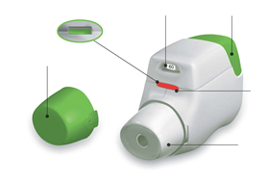
Control window
Red = confirms correct inhalation
Mouthpiece
Protective Cap
Figure A
Before use:
- Before first use, tear open the sealed bag and remove the inhaler. Throw away the bag.
- Do not press the green button until you are ready to take a dose.
- Pull off the cap by lightly squeezing the arrows marked on each side (Figure B).

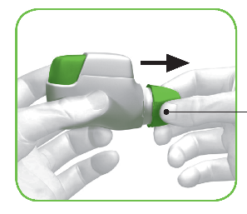
Squeeze here and pull

Figure B

STEP 1: Prepare your dose

- Look in the opening of the mouthpiece and make sure nothing is blocking it (Figure C).

- Look at the control window (should be red, Figure C).
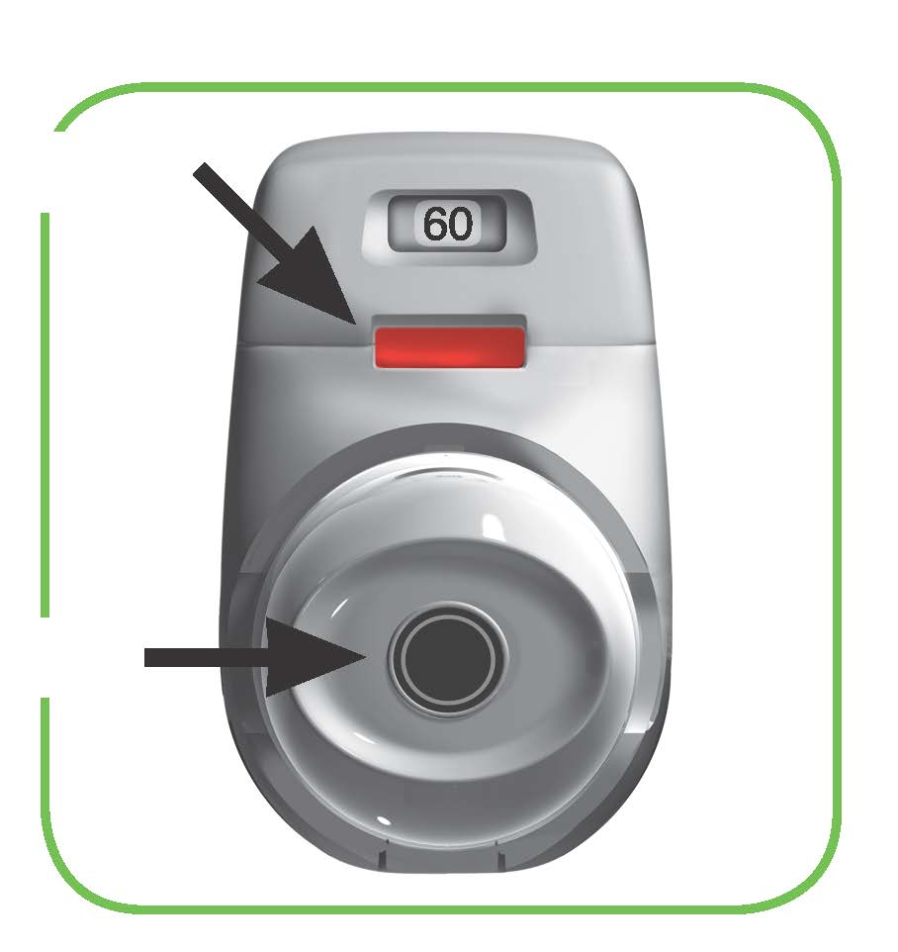
RED
Check mouthpiece
opening
Figure C
- Hold the inhaler horizontally with the mouthpiece facing you and the green button on top (Figure D).
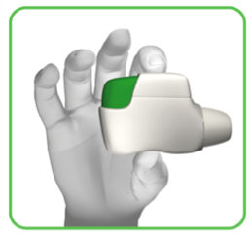

Figure D
- Press the green button all the way down to load your dose (Figure E).

When you press the button all the way down, the control window changes from red to green.

Make sure the green button is on top. Do not tilt.
- Release the green button (Figure F).
Make sure you release the button so the inhaler can work correctly.
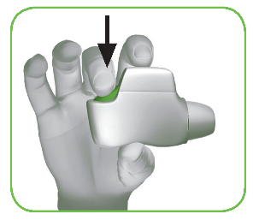
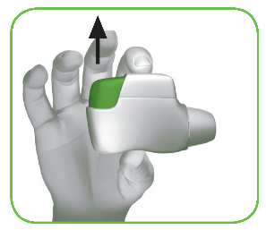

Figure E Figure F
Stop and Check:
- Make sure the control window is now green (Figure G).

Your medicine is ready to be inhaled.

Go to ‘STEP 2: Inhale your medicine’.
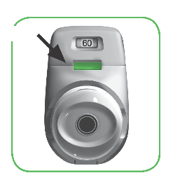
GREEN

Figure G

What to do if the control window is still red after pressing the button (Figure H).
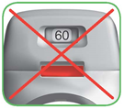
Figure H
The dose is not prepared. Go back to ‘STEP 1 Prepare your dose’ and repeat steps 1.1 to 1.6.
Step 2: Inhale your medicine
Read steps 2.1 to 2.7 fully before use. Do not tilt.
- Hold the inhaler away from your mouth, and breathe out completely. Never breathe out into the inhaler (Figure I).
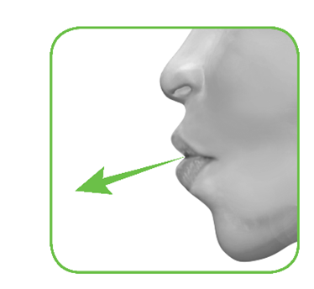
Figure I
- Hold your head upright, put the mouthpiece between your lips, and close your lips tightly around it (Figure J).
Do not hold the green button down while inhaling.
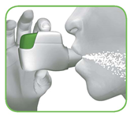

Figure J
- Take a strong, deep breath through your mouth. Keep breathing in for as long as possible.
A ‘click’ will let you know that you are inhaling correctly. Keep breathing in as long as possible after you hear the ‘click’. Some patients may not hear the ‘click’. Use the control window to ensure you have inhaled correctly.
- Take the inhaler out of your mouth.

- Hold your breath for as long as possible.

- Slowly breathe out away from the inhaler.

Some patients may experience a grainy sensation in their mouth, or a slightly sweet or bitter taste. Do not take an extra dose even if you do not taste or feel anything after inhaling.
Stop and Check:
- Make sure the control window is now red (Figure K). This means you have inhaled your medicine correctly.
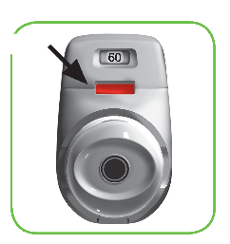
RED

Figure K

What to do if the control window is still green after inhalation (Figure L).

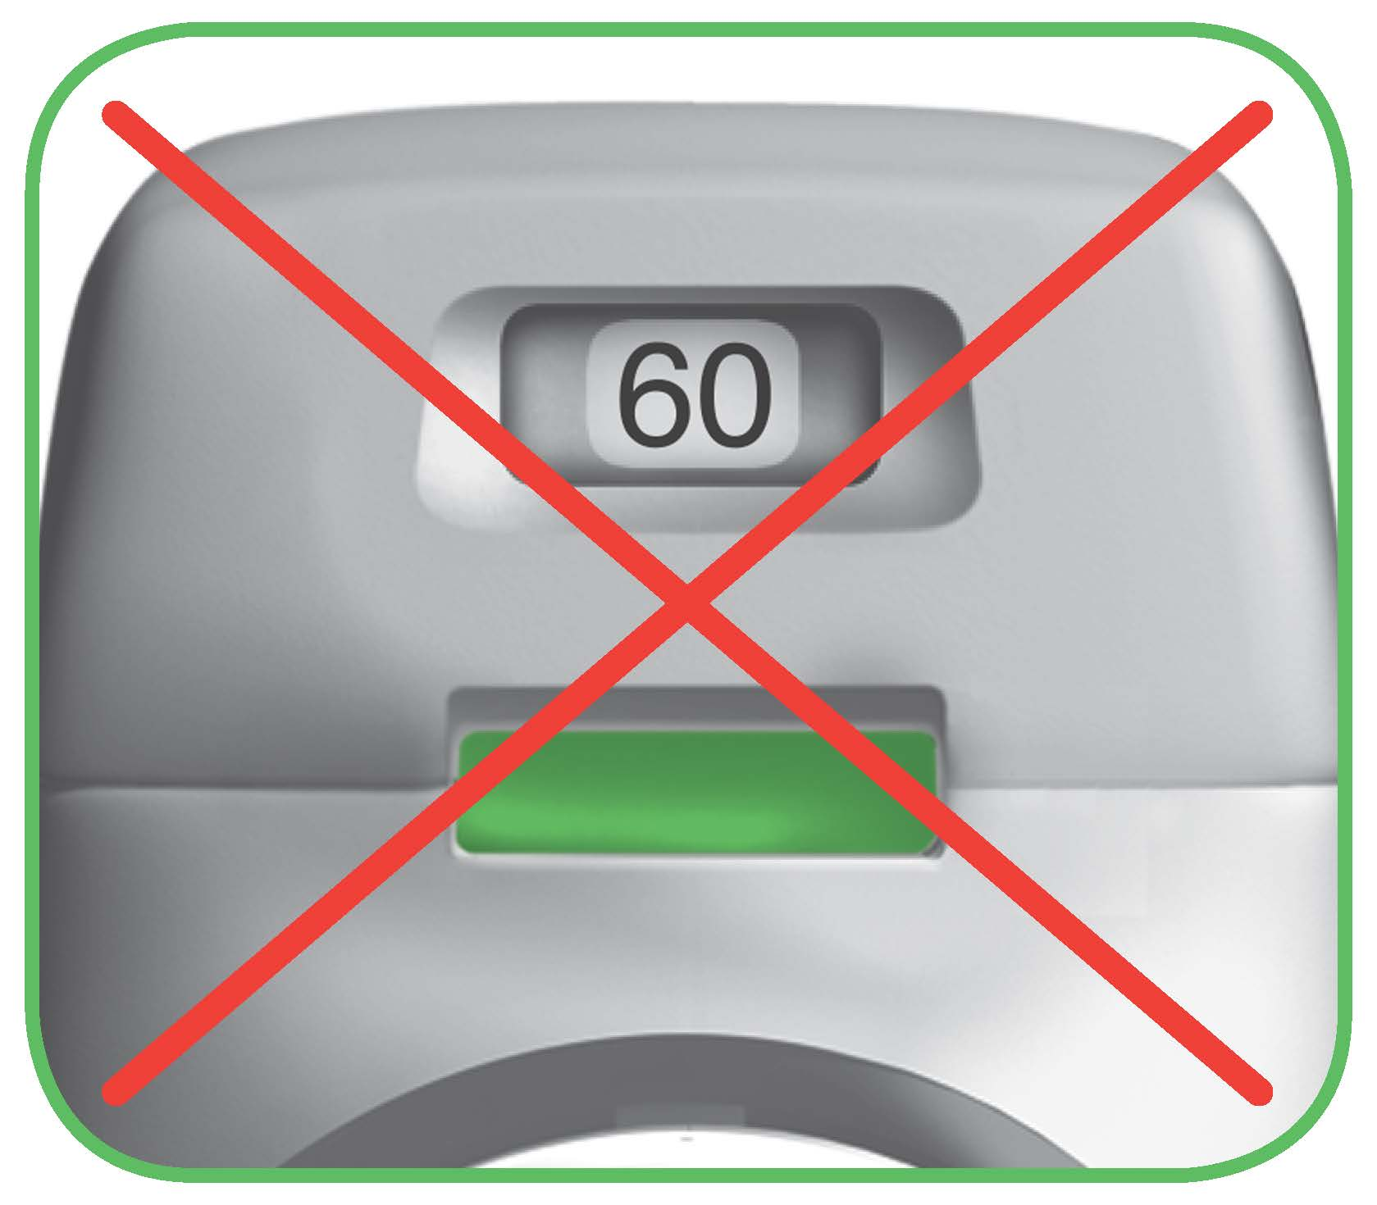
Figure L

This means you have not inhaled your medicine correctly. Go back to ‘STEP 2 Inhale your medicine’ and repeat steps 2.1 to 2.7.

If the control window still does not change to red, you may have forgotten to release the green button before inhaling, or you may not have inhaled strongly enough. If this happens, try again. Make sure you have released the green button, and you have breathed out completely. Then take a strong, deep breath through the mouthpiece.
Please contact your doctor if the control window is still green after repeated attempts.
Push the protective cap back onto the mouthpiece after each use (Figure M), to prevent contamination of the inhaler with dust or other materials. You should discard your inhaler if you lose the cap.
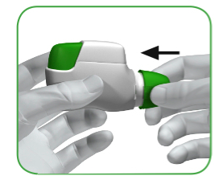
Figure M

Additional information

What should you do if you accidently prepare a dose?

Store your inhaler with the protective cap in place until it is time to inhale your medicine, then remove the cap and start at Step 1.6.
How does the dose indicator work?

- The dose indicator shows the total number of doses left in the inhaler (Figure N).
- On first use, every inhaler contains at least 60 doses, or at least 30 doses, depending on the pack size.
- Each time you load a dose by pressing the green button, the dose indicator moves by a small amount towards the next number (50, 40, 30, 20, 10, or 0).

When should you get a new inhaler?

You should get a new inhaler:
- If your inhaler appears to be damaged or if you lose the cap, or
- When a red band appears in the dose indicator, this means you are nearing your last dose (Figure N), or
- If your inhaler is empty (Figure O).
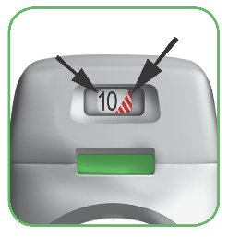
Dose
indicator

Red band
Dose indicator moves slowly from 60 to
0: 60, 50, 40, 30, 20, 10, 0.

Figure N
How do you know that your inhaler is empty?

When the green button will not return to its full upper position and is locked in a middle position, you have reached the last dose (Figure O). Even though the green button is locked, your last dose may still be inhaled. After that, the inhaler cannot be used again and you should start using a new inhaler.
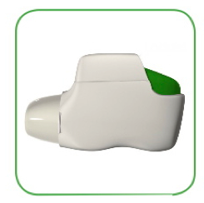
Figure O
Locked
How should you clean the inhaler?

NEVER use water to clean the inhaler, as this may damage your medicine.

If you wish to clean your inhaler, just wipe the outside of the mouthpiece with a dry tissue or paper towel.

7. MARKETING AUTHORISATION HOLDER

Covis Pharma Europe B.V.
Gustav Mahlerplein 2
1082MA Amsterdam
The Netherlands

8. MARKETING AUTHORISATION NUMBER(S)

EU/1/12/778/001
EU/1/12/778/002
EU/1/12/778/003

9. DATE OF FIRST AUTHORISATION/RENEWAL OF THE AUTHORISATION

Date of first authorisation: 20 July 2012
Date of last renewal: 20 April 2017

10. DATE OF REVISION OF THE TEXT

Detailed information on this medicinal product is available on the website of the European Medicines Agency http://www.ema.europa.eu

Annex II

A. manufacturer(S) responsible for batch release

B. Conditions or restrictions regarding supply and use

C. Other conditions and requirements of the marketing authorisation

D. conditions or restrictions with regard to the safe and effective use of the medicinal product

A. MANUFACTURER(S) RESPONSIBLE FOR BATCH RELEASE

Name and address of the manufacturer(s) responsible for batch release

Industrias Farmacéuticas Almirall, S.A.
Ctra. de Martorell 41-61
08740 Sant Andreu de la Barca
Barcelona
Spain

B. CONDITIONS OR RESTRICTIONS REGARDING SUPPLY AND USE

Medicinal product subject to medical prescription.

C. OTHER CONDITIONS AND REQUIREMENTS OF THE MARKETING AUTHORISATION

- Periodic safety update reports (PSURs)

The requirements for submission of PSURs for this medicinal product are set out in the list of Union reference dates (EURD list) provided for under Article 107c(7) of Directive 2001/83/EC and any subsequent updates published on the European medicines web-portal.

D. CONDITIONS OR RESTRICTIONS WITH REGARD TO THE SAFE AND EFFECTIVE USE OF THE MEDICINAL PRODUCT

• Risk management plan (RMP)

The marketing authorisation holder (MAH) shall perform the required pharmacovigilance activities and interventions detailed in the agreed RMP presented in Module 1.8.2 of the marketing authorisation and any agreed subsequent updates of the RMP.

An updated RMP should be submitted:
• At the request of the European Medicines Agency;
• Whenever the risk management system is modified, especially as the result of new information being received that may lead to a significant change to the benefit/risk profile or as the result of an important (pharmacovigilance or risk minimisation) milestone being reached.

ANNEX III

LABELLING AND PACKAGE LEAFLET

A. LABELLING

PARTICULARS TO APPEAR ON THE OUTER PACKAGING

Outer Carton

1. NAME OF THE MEDICINAL PRODUCT

Eklira Genuair 322 micrograms inhalation powder
aclidinium (aclidinium bromide)

2. STATEMENT OF ACTIVE SUBSTANCE(S)

Each delivered dose contains 375 micrograms aclidinium bromide equivalent to 322 micrograms of aclidinium.

3. LIST OF EXCIPIENTS

Also contains: Lactose

4. PHARMACEUTICAL FORM AND CONTENTS

1 inhaler containing 30 doses
1 inhaler containing 60 doses
3 inhalers each containing 60 doses

5. METHOD AND ROUTE(S) OF ADMINISTRATION

Read the package leaflet before use
Inhalation use

6. SPECIAL WARNING THAT THE MEDICINAL PRODUCT MUST BE STORED OUT OF THE SIGHT AND REACH OF CHILDREN

Keep out of the sight and reach of children

7. OTHER SPECIAL WARNING(S), IF NECESSARY

8. EXPIRY DATE

EXP
To be used within 90 days of opening the pouch

9. SPECIAL STORAGE CONDITIONS

Keep the Genuair inhaler inside the pouch until the administration period starts.

10. SPECIAL PRECAUTIONS FOR DISPOSAL OF UNUSED MEDICINAL PRODUCTS OR WASTE MATERIALS DERIVED FROM SUCH MEDICINAL PRODUCTS, IF APPROPRIATE

11. NAME AND ADDRESS OF THE MARKETING AUTHORISATION HOLDER

Covis Pharma Europe B.V.
Gustav Mahlerplein 2
1082MA Amsterdam
The Netherlands

Covis (Covis logo)

12. MARKETING AUTHORISATION NUMBER(S)

EU/1/12/778/001 30 doses
EU/1/12/778/002 60 doses
EU/1/12/778/003 3 inhalers each containing 60 doses

13. BATCH NUMBER

Lot

14. GENERAL CLASSIFICATION FOR SUPPLY

15. INSTRUCTIONS ON USE

16. INFORMATION IN BRAILLE

eklira genuair

17. UNIQUE IDENTIFIER – 2D BARCODE

2D barcode carrying the unique identifier included.

18. UNIQUE IDENTIFIER - HUMAN READABLE DATA

PC
SN
NN

MINIMUM PARTICULARS TO APPEAR ON SMALL IMMEDIATE PACKAGING UNITS

Inhaler label

1. NAME OF THE MEDICINAL PRODUCT AND ROUTE(S) OF ADMINISTRATION

Eklira Genuair 322 mcg inhalation powder
aclidinium (aclidinium bromide)
Inhalation use

2. METHOD OF ADMINISTRATION

3. EXPIRY DATE

EXP
To be used within 90 days of opening the pouch.

4. BATCH NUMBER

Lot

5. CONTENTS BY WEIGHT, BY VOLUME OR BY UNIT

30 doses
60 doses

6. OTHER

Covis (Covis logo)

B. PACKAGE LEAFLET
Package leaflet: Information for the patient

Eklira Genuair 322 micrograms inhalation powder
Aclidinium (aclidinium bromide)

Read all of this leaflet carefully before you start using this medicine because it contains important information for you.
- Keep this leaflet. You may need to read it again.
- If you have any further questions, ask your doctor, pharmacist or nurse.
- This medicine has been prescribed for you only. Do not pass it on to others. It may harm them, even if their signs of illness are the same as yours.
- If you get any side effects, talk to your doctor, pharmacist or nurse. This includes any possible side effects not listed in this leaflet. See section 4.

What is in this leaflet:
1. What Eklira Genuair is and what it is used for
2. What you need to know before you use Eklira Genuair
3. How to use Eklira Genuair
4. Possible side effects
- How to store Eklira Genuair
- Contents of the pack and other information
Instructions for Use

- What Eklira Genuair is and what it is used for

What Eklira Genuair is
The active ingredient of Eklira Genuair is aclidinium bromide, which belongs to a group of medicines called bronchodilators. Bronchodilators relax airways and help keep bronchioles open. Eklira Genuair is a dry powder inhaler that uses your breath to deliver the medicine directly into your lungs. This makes it easier for chronic obstructive pulmonary disease (COPD) patients to breathe.

What Eklira Genuair is used for
Eklira Genuair is indicated to help open the airways and relieve symptoms of COPD, a serious, long-term lung disease characterised by breathing difficulties. Regular use of Eklira Genuair can help you when you have ongoing shortness of breath related to your disease to help you minimise the effects of the disease on your everyday life and reduce the number of flare-ups (the worsening of your COPD symptoms for several days).

- What you need to know before you use Eklira Genuair

Do not use Eklira Genuair
- if you are allergic to aclidinium bromide or any of the other ingredients of this medicine (listed in section 6).

Warnings and precautions
Talk to your doctor, pharmacist or nurse before using Eklira Genuair:
- if you have heart problems.
- if you see halos around lights or coloured images (glaucoma).
- if you have an enlarged prostate, problems passing urine, or a blockage in your bladder.

Eklira Genuair is indicated for maintenance treatment and should not be used to treat a sudden attack of breathlessness or wheezing. If your COPD symptoms (breathlessness, wheezing, cough) do not improve or get worse you should contact your doctor for advice as soon as possible.

Dry mouth, which has been observed with medicines like Eklira Genuair, may after using your medicine for a long time, be associated with tooth decay. Therefore, please remember to pay attention to oral hygiene.

Stop taking Eklira Genuair and seek medical help immediately:
- if you get tightness of the chest, coughing, wheezing or breathlessness immediately after using the medicine. These may be signs of a condition called bronchospasm.

Children and adolescents
Eklira Genuair is not for use in children or adolescents below 18 years of age.

Other medicines and Eklira Genuair
Tell your doctor or pharmacist if you are taking, have recently taken or might take any other medicines.

Inform your doctor if you have been or are using similar medicines for breathing problems, such as medicines containing tiotropium, ipratropium. Ask your doctor or pharmacist if you are not sure. The use of Eklira Genuair with these medicines is not recommended.

Pregnancy and breast-feeding
If you are pregnant or breast-feeding, think you may be pregnant or are planning to have a baby, ask your doctor or pharmacist for advice before taking this medicine. You should not use Eklira Genuair if you are pregnant or are breast-feeding unless your doctor tells you so.

Driving and using machines
Eklira Genuair may have minor influence on the ability to drive and use machines. This medicine may cause headache, dizziness or blurred vision. If you are affected by any of these side effects do not drive or use machinery until the headache has cleared, the feeling of dizziness has passed and your vision has returned to normal.

Eklira Genuair contains lactose
If you have been told by your doctor that you have an intolerance to some sugars, contact your doctor before taking this medicinal product.

- How to use Eklira Genuair

Always use this medicine exactly as your doctor or pharmacist has told you. Check with your doctor or pharmacist if you are not sure.

The recommended dose is one inhalation twice a day in the morning and evening.
The effects of Eklira Genuair last for 12 hours; therefore, you should try to use your Eklira Genuair inhaler at the same time every morning and evening. This ensures that there is always enough medicine in your body to help you breathe more easily throughout the day and night. It will also help you to remember to use it.

The recommended dose can be used for elderly patients and for patients with kidney or liver problems. No dose adjustments are necessary.

COPD is a long-term disease; therefore, it is recommended that Eklira Genuair is used every day, twice a day and not only when breathing problems or other symptoms of COPD are experienced.

Route of administration
The medicine is for inhalation use.

Refer to the Instructions for Use for instructions on how to use the Genuair inhaler. If you are not sure of how to use Eklira Genuair, contact your doctor or pharmacist.

You can use Eklira Genuair any time before or after food or drink.

If you use more Eklira Genuair than you should
If you think you may have used more Eklira Genuair than you should, contact your doctor or pharmacist.

If you forget to use Eklira Genuair
If you forget a dose of Eklira Genuair, inhale the dose as soon as you remember. However, if it is nearly time for your next dose, skip the missed dose.
Do not take a double dose to make up for a forgotten dose.

If you stop using Eklira Genuair
This medicine is for long-term use. If you want to stop treatment, first talk to your doctor, as your symptoms may worsen.

If you have any further questions on the use of this medicine, ask your doctor, pharmacist or nurse.

4. Possible side effects

Like all medicines, this medicine can cause side effects, although not everybody gets them.

Allergic reactions may rarely occur (may affect up to 1 in 1,000 people). Stop using the medicine and contact your doctor immediately if you develop swelling of your face, throat, lips or tongue (with or without difficulty breathing or swallowing), dizziness or fainting, faster heart rate or if you get raised severely itchy bumps on your skin (hives) as these may be symptoms of an allergic reaction.

The following side effects may occur whilst using Eklira Genuair:
Common: may affect up to 1 in 10 people
- Headache
- Inflammation of the sinuses (sinusitis)
- Common cold (nasopharyngitis)
- Cough
- Diarrhoea
- Nausea

Uncommon: may affect up to 1 in 100 people
- Dizziness
- Dry mouth
- Inflammation of the mouth (stomatitis)
- Hoarseness (dysphonia)
- Faster heart beat (tachycardia)
- Sensation of heart beating (palpitations)
- Abnormal or irregular heartbeat (cardiac arrhythmias)
- Difficulty passing urine (urinary retention)
- Blurred vision
- Rash
- Itching of the skin

Reporting of side effects
If you get any side effects, talk to your doctor, pharmacist or nurse. This includes any possible side effects not listed in this leaflet. You can also report side effects directly via the national reporting system listed in Appendix V. By reporting side effects you can help provide more information on the safety of this medicine.

5. How to store Eklira Genuair

Keep this medicine out of the sight and reach of children.

Do not use this medicine after the expiry date which is stated on the inhaler label and carton after “EXP”. The expiry date refers to the last day of that month.

Keep the inhaler inside the pouch until the administration period starts.

To be used within 90 days of opening the pouch.

Do not use the Eklira Genuair if you notice that the pack is damaged or shows signs of tampering.

After you have taken the last dose, the inhaler has to be disposed of. Do not throw away any medicines via wastewater or household waste. Ask your pharmacist how to throw away medicines you no longer use. These measures will help protect the environment.

6. Contents of the pack and other information

What Eklira Genuair contains
- The active substance is aclidinium bromide. Each delivered dose contains 375 micrograms aclidinium bromide equivalent to 322 micrograms of aclidinium.
- The other ingredient is lactose monohydrate (refer to Section 2 “Eklira Genuair contains lactose”).

What Eklira Genuair looks like and contents of the pack
Eklira Genuair is a white or almost white powder.
The Genuair inhaler device is white coloured with an integral dose indicator and a green dosage button. The mouthpiece is covered with a removable green protective cap. It is supplied in a plastic pouch.

Pack sizes supplied:
Carton containing 1 inhaler with 30 doses.
Carton containing 1 inhaler with 60 doses.
Carton containing 3 inhalers each with 60 doses.

Not all pack sizes may be marketed.

Marketing Authorisation Holder
Covis Pharma Europe B.V.
Gustav Mahlerplein 2
1082MA Amsterdam
The Netherlands

Manufacturer
Industrias Farmacéuticas Almirall, S.A.
Ctra. de Martorell 41-61
08740 Sant Andreu de la Barca, Barcelona
Spain

For any information about this medicine, please contact the local representative of the Marketing Authorisation Holder:
 | België/Belgique/Belgien  Covis Pharma Europe B.V.  Tel: 80013067 | Lietuva  Covis Pharma Europe B.V.  Tel: 880000890
 | България  Covis Pharma Europe B.V.  Tel: 008002100654 | Luxembourg/Luxemburg  Covis Pharma Europe B.V.  Tel: 80024119
 | Česká republika  Covis Pharma Europe B.V.  Tel: 800144474 | Magyarország  Covis Pharma Europe B.V.  Tel.: 0680021540
 | Danmark  Zentiva Denmark ApS  Tlf.: +45 787 68 400 | Malta  Covis Pharma Europe B.V.  Tel: 80065149
 | Deutschland  Zentiva Pharma GmbH  Tel: +49 (0) 800 53 53 010 | Nederland  Covis Pharma Europe B.V.  Tel: 08000270008
 | Eesti  Covis Pharma Europe B.V  Tel: 8000100776 | Norge  Zentiva Denmark ApS  Tlf: +45 787 68 400
 | Ελλάδα  Specialty Therapeutics IKE  Τηλ: +30 213 02 33 913 | Österreich  Covis Pharma Europe B.V.  Tel: 0800006573
España  Zentiva Spain S.L.U.  Tel: +34 671 365 828 |  | Polska  Covis Pharma Europe B.V.  Tel.: 0800919353
France  Zentiva France  Tél: +33 (0) 800 089 219 |  | Portugal  Zentiva Portugal, Lda  Tel: +351210601360
Hrvatska  Covis Pharma Europe B.V.  Tel: 08004300 |  | România  Covis Pharma Europe B.V.  Tel: 0800410175
Ireland  A. Menarini Pharmaceuticals Ireland Ltd  Tel: +353 1 284 6744 |  | Slovenija  Covis Pharma Europe B.V.  Tel: 080083003
Ísland  Zentiva Denmark ApS  Sími: +354 539 5025 |  | Slovenská republika  Covis Pharma Europe B.V.  Tel: 0800008203
Italia  Covis Pharma Europe B.V.  Tel: 800168094 |  | Suomi/Finland  Zentiva Denmark ApS  Puh/Tel: +358 942 598 648
Κύπρος  Specialty Therapeutics IKE  Τηλ: +30 213 02 33 913 |  | Sverige  Zentiva Denmark ApS  Tel: +46 840 838 822
Latvija
Covis Pharma Europe B.V.
Tel: 80005962

This leaflet was last revised in <{month YYYY}>.

Detailed information on this medicine is available on the European Medicines Agency web site: http://www.ema.europa.eu.

Instructions for Use
This section contains information on how to use your Genuair inhaler. It is important that you read this information as the Genuair may work differently from inhalers you have used previously. If you have any questions about how to use your inhaler, please ask your doctor, pharmacist or nurse for assistance.
The Instructions for Use is divided into the following sections:
- Getting started
- Step 1: Prepare your dose
- Step 2: Inhale your medicine
- Additional information

Getting Started

Read these Instructions for Use before you start using the medicine.

Become familiar with the parts of your Genuair inhaler.

Green button
Dose indicator
Control window
Green = inhaler ready to use
Control window
Red = confirms correct inhalation
Mouthpiece
Protective Cap
Figure A

Before use:

- Before first use, tear open the sealed bag and remove the inhaler. Throw away the bag.
- Do not press the green button until you are ready to take a dose.
- Pull off the cap by lightly squeezing the arrows marked on each side (Figure B).

Squeeze here and pull

Figure B
STEP 1: Prepare your dose

- Look in the opening of the mouthpiece and make sure nothing is blocking it (Figure C).

- Look at the control window (should be red, Figure C).
RED
Check mouthpiece
opening
Figure C
- Hold the inhaler horizontally with the mouthpiece facing you and the green button on top (Figure D).

Figure D

- Press the green button all the way down to load your dose (Figure E).

When you press the button all the way down, the control window changes from red to green.

Make sure the green button is on top. Do not tilt.
- Release the green button (Figure F).
Make sure you release the button so the inhaler can work correctly.

Figure E Figure F

Stop and Check:

- Make sure the control window is now green (Figure G).

Your medicine is ready to be inhaled.

Go to ‘STEP 2: Inhale your medicine’.
GREEN

Figure G

What to do if the control window is still red after pressing the button (Figure H).
Figure H
The dose is not prepared. Go back to ‘STEP 1 Prepare your dose’ and repeat steps 1.1 to 1.6.

Step 2: Inhale your medicine
Read steps 2.1 to 2.7 fully before use. Do not tilt.
- Hold the inhaler away from your mouth, and breathe out completely. Never breathe out into the inhaler (Figure I).
Figure I

- Hold your head upright, put the mouthpiece between your lips, and close your lips tightly around it (Figure J).

Do not hold the green button down while inhaling.
Figure J

- Take a strong, deep breath through your mouth. Keep breathing in for as long as possible.

A ‘click’ will let you know that you are inhaling correctly. Keep breathing in as long as possible after you hear the ‘click’. Some patients may not hear the ‘click’. Use the control window to ensure you have inhaled correctly.
- Take the inhaler out of your mouth.

- Hold your breath for as long as possible.

- Slowly breathe out away from the inhaler.

Some patients may experience a grainy sensation in their mouth, or a slightly sweet or bitter taste. Do not take an extra dose even if you do not taste or feel anything after inhaling.

Stop and Check:

- Make sure the control window is now red (Figure K). This means you have inhaled your medicine correctly.

RED

Figure K

What to do if the control window is still green after inhalation (Figure L).

Figure L

This means you have not inhaled your medicine correctly. Go back to ‘STEP 2 Inhale your medicine’ and repeat steps 2.1 to 2.7.

If the control window still does not change to red, you may have forgotten to release the green button before inhaling, or you may not have inhaled strongly enough. If this happens, try again. Make sure you have released the green button, and you have breathed out completely. Then take a strong, deep breath through the mouthpiece.
Please contact your doctor if the control window is still green after repeated attempts.
Push the protective cap back onto the mouthpiece after each use (Figure M), to prevent contamination of the inhaler with dust or other materials. You should discard your inhaler if you lose the cap.
Figure M
Additional information
What should you do if you accidently prepare a dose?
Store your inhaler with the protective cap in place until it is time to inhale your medicine, then remove the cap and start at Step 1.6.
How does the dose indicator work?

- The dose indicator shows the total number of doses left in the inhaler (Figure N).
- On first use, every inhaler contains at least 60 doses, or at least 30 doses, depending on the pack size.
- Each time you load a dose by pressing the green button, the dose indicator moves by a small amount towards the next number (50, 40, 30, 20, 10, or 0).

When should you get a new inhaler?

You should get a new inhaler:

- If your inhaler appears to be damaged or if you lose the cap, or
- When a red band appears in the dose indicator, this means you are nearing your last dose (Figure N), or
- If your inhaler is empty (Figure O).

Dose indicator moves slowly from 60 to
0: 60, 50, 40, 30, 20, 10, 0.

Dose
indicator
Red band

Figure N

How do you know that your inhaler is empty?

When the green button will not return to its full upper position and is locked in a middle position, you have reached the last dose (Figure O). Even though the green button is locked, your last dose may still be inhaled. After that, the inhaler cannot be used again and you should start using a new inhaler.

Figure O
Locked

How should you clean the inhaler?

NEVER use water to clean the inhaler, as this may damage your medicine.

If you wish to clean your inhaler, just wipe the outside of the mouthpiece with a dry tissue or paper towel.

