This document is the approved product information for Enhertu, with the changes since the previous procedure affecting the product information (EMEA/H/C/005124/II/0048) tracked.

For more information, see the European Medicines Agency’s website: https://www.ema.europa.eu/en/medicines/human/epar/enhertu

ANNEX I

SUMMARY OF PRODUCT CHARACTERISTICS
This medicinal product is subject to additional monitoring. This will allow quick identification of new safety information. Healthcare professionals are asked to report any suspected adverse reactions. See section 4.8 for how to report adverse reactions.

1. NAME OF THE MEDICINAL PRODUCT

Enhertu 100 mg powder for concentrate for solution for infusion

2. QUALITATIVE AND QUANTITATIVE COMPOSITION

One vial of powder for concentrate for solution for infusion contains 100 mg of trastuzumab deruxtecan. After reconstitution, one vial of 5 mL solution contains 20 mg/mL of trastuzumab deruxtecan (see section 6.6).

Trastuzumab deruxtecan is an antibody-drug conjugate (ADC) that contains a humanised anti-HER2 IgG1 monoclonal antibody (mAb) with the same amino acid sequence as trastuzumab, produced by mammalian (Chinese Hamster Ovary) cells, covalently linked to DXd, an exatecan derivative and a topoisomerase I inhibitor, via a tetrapeptide-based cleavable linker. Approximately 8 molecules of deruxtecan are attached to each antibody molecule.

Excipient with known effect

Each 100 mg vial contains 1.5 mg of polysorbate 80 (E433).

For the full list of excipients, see section 6.1.

3. PHARMACEUTICAL FORM

Powder for concentrate for solution for infusion.

White to yellowish-white lyophilised powder.

4. CLINICAL PARTICULARS

4.1 Therapeutic indications

Breast cancer

HER2-positive breast cancer
Enhertu as monotherapy is indicated for the treatment of adult patients with unresectable or metastatic HER2-positive breast cancer who have received one or more prior anti-HER2-based regimens.

HER2-low and HER2-ultralow breast cancer
Enhertu as monotherapy is indicated for the treatment of adult patients with unresectable or metastatic
- hormone receptor (HR)-positive, HER2-low or HER2-ultralow breast cancer who have received at least one endocrine therapy in the metastatic setting and who are not considered suitable for endocrine therapy as the next line of treatment (see sections 4.2 and 5.1).
- HER2-low breast cancer who have received prior chemotherapy in the metastatic setting or developed disease recurrence during or within 6 months of completing adjuvant chemotherapy (see section 4.2).

Non-small cell lung cancer (NSCLC)

Enhertu as monotherapy is indicated for the treatment of adult patients with advanced NSCLC whose tumours have an activating HER2 (ERBB2) mutation and who require systemic therapy following platinum-based chemotherapy with or without immunotherapy.

Gastric cancer

Enhertu as monotherapy is indicated for the treatment of adult patients with advanced HER2-positive gastric or gastroesophageal junction (GEJ) adenocarcinoma who have received a prior trastuzumab-based regimen.

4.2 Posology and method of administration

Enhertu should be prescribed by a physician and administered under the supervision of a healthcare professional experienced in the use of anticancer medicinal products. In order to prevent medicinal product errors, it is important to check the vial labels to ensure that the medicinal product being prepared and administered is Enhertu (trastuzumab deruxtecan) and not trastuzumab or trastuzumab emtansine.

Enhertu should not be substituted with trastuzumab or trastuzumab emtansine.

Patient selection

HER2-positive breast cancer
Patients treated with trastuzumab deruxtecan for breast cancer should have documented HER2-positive tumour status, defined as a score of 3 + by immunohistochemistry (IHC) or a ratio of ≥ 2.0 by in situ hybridization (ISH) or by fluorescence in situ hybridization (FISH) assessed by a CE-marked in vitro diagnostic (IVD) medical device. If a CE-marked IVD is not available, the HER2 status should be assessed by an alternate validated test.

HER2-low or HER2-ultralow breast cancer
Patients treated with trastuzumab deruxtecan should have documented HER2-low tumour status, defined as a score of IHC 1+ or IHC 2+/ISH-, or HER2-ultralow tumour status, described as IHC 0 with membrane staining (IHC >0<1+), as assessed by a CE-marked IVD medical device. If a CE-marked IVD is not available, the HER2 status should be assessed by an alternate validated test (see section 5.1).

NSCLC
Patients treated with trastuzumab deruxtecan for advanced NSCLC should have an activating HER2 (ERBB2) mutation detected by a CE-marked in vitro diagnostic (IVD) medical device. If a CE-marked IVD is not available, the HER2 mutation status should be assessed by an alternate validated test.

Gastric cancer
Patients treated with trastuzumab deruxtecan for gastric or gastroesophageal junction cancer should have documented HER2-positive tumour status, defined as a score of 3 + by immunohistochemistry (IHC) or a ratio of ≥ 2 by in situ hybridization (ISH) or by fluorescence in situ hybridization (FISH), assessed by a CE-marked in vitro diagnostic (IVD) medical device. If a CE-marked IVD is not available, the HER2 status should be assessed by an alternate validated test.

Posology

Breast cancer
The recommended dose of Enhertu is 5.4 mg/kg body weight given as an intravenous infusion once every 3 weeks (21-day cycle) until disease progression or unacceptable toxicity.

NSCLC
The recommended dose of Enhertu is 5.4 mg/kg body weight given as an intravenous infusion once every 3 weeks (21-day cycle) until disease progression or unacceptable toxicity.

Gastric cancer
The recommended dose of Enhertu is 6.4 mg/kg body weight given as an intravenous infusion once every 3 weeks (21-day cycle) until disease progression or unacceptable toxicity.

The initial dose should be administered as a 90-minute intravenous infusion. If the prior infusion was well tolerated, subsequent doses of Enhertu may be administered as 30-minute infusions.

The infusion rate of Enhertu should be slowed or interrupted if the patient develops infusion-related symptoms (see section 4.8). Enhertu should be permanently discontinued in case of severe infusion reactions.

Premedication

Enhertu is emetogenic (see section 4.8), which includes delayed nausea and/or vomiting. Prior to each dose of Enhertu, patients should be premedicated with a combination regimen of two or three medicinal products (e.g., dexamethasone with either a 5-HT3 receptor antagonist and/or an NK1 receptor antagonist, as well as other medicinal products as indicated) for prevention of chemotherapy-induced nausea and vomiting.

Dose modifications

Management of adverse reactions may require temporary interruption, dose reduction, or treatment discontinuation of Enhertu per guidelines provided in Tables 1 and 2.

Enhertu dose should not be re-escalated after a dose reduction is made.

Table 1: Dose reduction schedule
Dose reduction schedule | Breast cancer and NSCLC | Gastric cancer
Recommended starting dose | 5.4 mg/kg | 6.4 mg/kg
First dose reduction | 4.4 mg/kg | 5.4 mg/kg
Second dose reduction | 3.2 mg/kg | 4.4 mg/kg
Requirement for further dose reduction | Discontinue treatment | Discontinue treatment

Table 2: Dose modifications for adverse reactions
Adverse reaction | Severity |  | Treatment modification
Interstitial lung disease (ILD)/pneumonitis | Asymptomatic ILD/pneumonitis (Grade 1) |  | Interrupt Enhertu until resolved to Grade 0, then:  - if resolved in 28 days or less from date of onset, maintain dose.  - if resolved in greater than 28 days from date of onset, reduce dose one level (see Table 1).  - consider corticosteroid treatment as soon as ILD/pneumonitis is suspected (see section 4.4).
Interstitial lung disease (ILD)/pneumonitis | Symptomatic ILD/pneumonitis (Grade 2 or greater) |  | - Permanently discontinue Enhertu.  - Promptly initiate corticosteroid treatment as soon as ILD/pneumonitis is suspected (see section 4.4).
Neutropenia | Grade 3 (less than 1.0-0.5 × 10⁹/L) |  | - Interrupt Enhertu until resolved to Grade 2 or less, then maintain dose.
Neutropenia | Grade 4 (less than 0.5 × 10⁹/L) |  | - Interrupt Enhertu until resolved to Grade 2 or less.  - Reduce dose by one level (see Table 1).
Febrile neutropenia | Absolute neutrophil count of less than 1.0 × 10⁹/L and temperature greater than 38.3 °C or a sustained temperature of 38 °C or greater for more than one hour. |  | - Interrupt Enhertu until resolved.  - Reduce dose by one level (see Table 1).
Left ventricular ejection fraction (LVEF) decreased | LVEF greater than 45% and absolute decrease from baseline is 10% to 20% |  | - Continue treatment with Enhertu.
Left ventricular ejection fraction (LVEF) decreased | LVEF 40% to 45% | And absolute decrease from baseline is less than 10% | - Continue treatment with Enhertu.  - Repeat LVEF assessment within 3 weeks.
Left ventricular ejection fraction (LVEF) decreased | LVEF 40% to 45% | And absolute decrease from baseline is 10% to 20% | - Interrupt Enhertu.  - Repeat LVEF assessment within 3 weeks.  - If LVEF has not recovered to within 10% from baseline, permanently discontinue Enhertu.  - If LVEF recovers to within 10% from baseline, resume treatment with Enhertu at the same dose.
Left ventricular ejection fraction (LVEF) decreased | LVEF less than 40% or absolute decrease from baseline is greater than 20% |  | - Interrupt Enhertu.  - Repeat LVEF assessment within 3 weeks.  - If LVEF of less than 40% or absolute decrease from baseline of greater than 20% is confirmed, permanently discontinue Enhertu.
Left ventricular ejection fraction (LVEF) decreased | Symptomatic congestive heart failure (CHF) |  | - Permanently discontinue Enhertu.
Toxicity grades are in accordance with National Cancer Institute Common Terminology Criteria for Adverse Events Version 5.0 (NCI-CTCAE v.5.0).

Delayed or missed dose

If a planned dose is delayed or missed, it should be administered as soon as possible without waiting until the next planned cycle. The schedule of administration should be adjusted to maintain a 3-week interval between doses. The infusion should be administered at the dose and rate the patient tolerated in the most recent infusion.

Special populations

Elderly
No dose adjustment of Enhertu is required in patients aged 65 years or older. Limited data are available in patients ≥ 75 years of age.

Renal impairment
No dose adjustment is required in patients with mild (creatinine clearance [CLcr] ≥ 60 and < 90 mL/min) or moderate (CLcr ≥ 30 and < 60 mL/min) renal impairment (see section 5.2). The potential need for dose adjustment in patients with severe renal impairment or end-stage renal disease cannot be determined as severe renal impairment was an exclusion criterion in clinical studies. A higher incidence of Grade 1 and 2 ILD/pneumonitis leading to an increase in discontinuation of therapy has been observed in patients with moderate renal impairment. In patients with moderate renal impairment at baseline who received Enhertu 6.4 mg/kg, a higher incidence of serious adverse reactions was observed compared to those with normal renal function. Patients with moderate or severe renal impairment should be monitored carefully for adverse reactions including ILD/pneumonitis (see section 4.4).

Hepatic impairment
No dose adjustment is required in patients with total bilirubin ≤ 1.5 times upper limit of normal (ULN), irrespective of aspartate transaminase (AST) value. The potential need for dose adjustment in patients with total bilirubin > 1.5 times ULN, irrespective of AST value, cannot be determined due to limited data; therefore, these patients should be monitored carefully (see sections 4.4 and 5.2).

Paediatric population
The safety and efficacy of Enhertu in children and adolescents below the age of 18 years have not been established. No data are available.

Method of administration

Enhertu is for intravenous use. It must be reconstituted and diluted by a healthcare professional and administered as an intravenous infusion. Enhertu must not be administered as an intravenous push or bolus.

For instructions on reconstitution and dilution of the medicinal product before administration, see section 6.6.

4.3 Contraindications

Hypersensitivity to the active substance or to any of the excipients listed in section 6.1.

4.4 Special warnings and precautions for use

In order to prevent medicinal product errors, it is important to check the vial labels to ensure that the medicinal product being prepared and administered is Enhertu (trastuzumab deruxtecan) and not trastuzumab or trastuzumab emtansine.

Traceability

In order to improve the traceability of biological medicinal products, the name and the batch number of the administered product should be clearly recorded.

Interstitial lung disease/pneumonitis

Cases of interstitial lung disease (ILD), and/or pneumonitis, have been reported with Enhertu (see section 4.8). Fatal outcomes have been observed. Patients should be advised to immediately report cough, dyspnoea, fever and/or any new or worsening respiratory symptoms. Patients should be monitored for signs and symptoms of ILD/pneumonitis. Evidence of ILD/pneumonitis should be promptly investigated. Patients with suspected ILD/pneumonitis should be evaluated by radiographic imaging, preferably a computed tomography (CT) scan. Consultation with a pulmonologist should be considered. For asymptomatic (Grade 1) ILD/pneumonitis, consider corticosteroid treatment (e.g., ≥ 0.5 mg/kg/day prednisolone or equivalent). Enhertu should be withheld until recovery to Grade 0 and may be resumed according to instructions in Table 2 (see section 4.2). For symptomatic ILD/pneumonitis (Grade 2 or greater), promptly initiate corticosteroid treatment (e.g., ≥ 1 mg/kg/day prednisolone or equivalent) and continue for at least 14 days followed by gradual taper for at least 4 weeks. Enhertu should be permanently discontinued in patients who are diagnosed with symptomatic (Grade 2 or greater) ILD/pneumonitis (see section 4.2). Patients with a history of ILD/pneumonitis or patients with moderate or severe renal impairment may be at increased risk of developing ILD/pneumonitis and should be monitored carefully (see section 4.2).

Neutropenia

Cases of neutropenia, including febrile neutropenia with a fatal outcome, were reported in clinical studies of Enhertu. Complete blood counts should be monitored prior to initiation of Enhertu and prior to each dose, and as clinically indicated. Based on the severity of neutropenia, Enhertu may require dose interruption or reduction (see section 4.2).

Left ventricular dysfunction

Left ventricular ejection fraction (LVEF) decrease has been observed with anti-HER2 therapies.
Standard cardiac function testing (echocardiogram or MUGA [multigated acquisition] scanning) should be performed to assess LVEF prior to initiation of Enhertu and at regular intervals during treatment as clinically indicated. LVEF decrease should be managed through treatment interruption. Enhertu should be permanently discontinued if LVEF of less than 40% or absolute decrease from baseline of greater than 20% is confirmed. Enhertu should be permanently discontinued in patients with symptomatic congestive heart failure (CHF) (see Table 2 in section 4.2).

Embryo-foetal toxicity

Enhertu can cause foetal harm when administered to a pregnant woman. In post-marketing reports, use of trastuzumab, a HER2 receptor antagonist, during pregnancy resulted in cases of oligohydramnios manifesting as fatal pulmonary hypoplasia, skeletal abnormalities and neonatal death. Based on findings in animals and its mechanism of action, the topoisomerase I inhibitor component of Enhertu, DXd, can also cause embryo-foetal harm when administered to a pregnant woman (see section 4.6).

The pregnancy status of females of reproductive potential should be verified prior to the initiation of Enhertu. The patient should be informed of the potential risks to the foetus. Females of reproductive potential should be advised to use effective contraception during treatment and for at least 7 months following the last dose of Enhertu. Male patients with female partners of reproductive potential should be advised to use effective contraception during treatment with Enhertu and for at least 4 months after the last dose of Enhertu (see section 4.6).

Patients with moderate or severe hepatic impairment

There are limited data in patients with moderate hepatic impairment and no data in patients with severe hepatic impairment. As metabolism and biliary excretion are the primary routes of elimination of the topoisomerase I inhibitor, DXd, Enhertu should be administered with caution in patients with moderate and severe hepatic impairment (see sections 4.2 and 5.2).

4.5 Interaction with other medicinal products and other forms of interaction

Co-administration with ritonavir, an inhibitor of OATP1B, CYP3A and P-gp, or with itraconazole, a strong inhibitor of CYP3A and P-gp, resulted in no clinically meaningful (approximately 10-20%) increase in exposures of trastuzumab deruxtecan or the released topoisomerase I inhibitor, DXd. No dose adjustment is required during co-administration of trastuzumab deruxtecan with medicinal products that are inhibitors of CYP3A or OATP1B or P-gp transporters (see section 5.2).

4.6 Fertility, pregnancy and lactation

Women of childbearing potential/Contraception in males and females

Pregnancy status of women of childbearing potential should be verified prior to initiation of Enhertu.

Women of childbearing potential should use effective contraception during treatment with Enhertu and for at least 7 months following the last dose.

Men with female partners of childbearing potential should use effective contraception during treatment with Enhertu and for at least 4 months following the last dose.

Pregnancy

There is no available data on the use of Enhertu in pregnant women. However, trastuzumab, a HER2 receptor antagonist, can cause foetal harm when administered to a pregnant woman. In post-marketing reports, use of trastuzumab during pregnancy resulted in cases of oligohydramnios in some cases manifested as fatal pulmonary hypoplasia, skeletal abnormalities and neonatal death. Based on findings in animals and its mechanism of action, the topoisomerase I inhibitor component of Enhertu, DXd, can be expected to cause embryo-foetal harm when administered to a pregnant woman (see section 5.3).

Administration of Enhertu to pregnant women is not recommended, and patients should be informed of the potential risks to the foetus before they become pregnant. Women who become pregnant must immediately contact their doctor. If a woman becomes pregnant during treatment with Enhertu or within 7 months following the last dose of Enhertu, close monitoring is recommended.

Breast-feeding

It is not known if trastuzumab deruxtecan is excreted in human milk. Human IgG is secreted in human milk, and the potential for absorption and serious adverse reactions to the infant is unknown. Therefore, women should not breast-feed during treatment with Enhertu or for 7 months after the last dose. A decision should be made to discontinue breast-feeding or to discontinue treatment taking into account the benefit of breast-feeding for the child and/or benefit of treatment with Enhertu for the mother.

Fertility

No dedicated fertility studies have been conducted with trastuzumab deruxtecan. Based on results from animal toxicity studies, Enhertu may impair male reproductive function and fertility. It is not known whether trastuzumab deruxtecan or its metabolites are found in seminal fluid. Before starting treatment, male patients should be advised to seek counselling on sperm storage. Male patients must not freeze or donate sperm throughout the treatment period, and for at least 4 months after the final dose of Enhertu.

4.7 Effects on ability to drive and use machines

Enhertu may have a minor influence on the ability to drive and use machines. Patients should be advised to use caution when driving or operating machinery in case they experience fatigue, headache or dizziness during treatment with Enhertu (see section 4.8).

4.8 Undesirable effects

Summary of the safety profile

Enhertu 5.4 mg/kg
The pooled safety population has been evaluated for patients who received at least one dose of Enhertu 5.4 mg/kg (n = 2335) across multiple tumour types in clinical studies. The median duration of treatment in this pool was 9.0 months (range: 0.7 to 45.1 months).

The most common adverse reactions were nausea (71.1%), fatigue (55.3%), vomiting (37.3%), alopecia (36.1%), anaemia (35.9%), neutropenia (35.1%), constipation (31.7%), decreased appetite (30.6%), diarrhoea (30.1%), transaminases increased (26.6%), musculoskeletal pain (23.6%), thrombocytopenia (23.1%), and leukopenia (21.5%).

The most common National Cancer Institute – Common Terminology Criteria for Adverse Events (NCI-CTCAE v.5.0) Grade 3 or 4 adverse reactions were neutropenia (18.0%), anaemia (10.5%), fatigue (7.8%), leukopenia (6.0%), thrombocytopenia (5.4%), nausea (4.9%), lymphopenia (3.9%), hypokalaemia (3.8%), transaminases increased (3.5%), diarrhoea (2.5%), vomiting (2.4%), decreased appetite (1.8%), pneumonia (1.3%), and ejection fraction decreased (1.0%). Grade 5 adverse reactions occurred in 1.4% of patients, including ILD/pneumonitis (1.1%).

Dose interruptions due to adverse reactions occurred in 32.6% of patients treated with Enhertu. The most frequent adverse reactions associated with dose interruption were neutropenia (12.4%), fatigue (4.7%), anaemia (4.6%), leukopenia (3.2%), upper respiratory tract infection (3.0%), ILD/pneumonitis (2.6%), thrombocytopenia (2.4%), and pneumonia (2.0%). Dose reductions occurred in 20.3% of patients treated with Enhertu. The most frequent adverse reactions associated with dose reduction were fatigue (5.1%), nausea (4.8%), neutropenia (3.5%), and thrombocytopenia (2.3%). Discontinuation of therapy due to an adverse reaction occurred in 11.7% of patients treated with Enhertu. The most frequent adverse reaction associated with permanent discontinuation was ILD/pneumonitis (8.4%).

Enhertu 6.4 mg/kg
The pooled safety population has been evaluated for patients who received at least one dose of Enhertu 6.4 mg/kg (n = 1133), across multiple tumour types in clinical studies. The median duration of treatment in this pool was 5.1 months (range: 0.4 to 41.0 months).

The most common adverse reactions were nausea (64.3%), fatigue (57.3%), anaemia (47.9%), decreased appetite (46.8%), neutropenia (45.9%), vomiting (34.7%), diarrhoea (33.0%), thrombocytopenia (32.9%), leukopenia (31.2%), alopecia (29.0%), constipation (28.2%), and transaminases increased (26.4%).

The most common National Cancer Institute – Common Terminology Criteria for Adverse Events Grade 3 or 4 adverse reactions were neutropenia (28.4%), anaemia (22.8%), leukopenia (12.3%), thrombocytopenia (10.8%), fatigue (8.6%), hypokalaemia (5.8%), pancytopenia (5.6%), nausea (5.6%), lymphopenia (5.5%), decreased appetite (5.3%), transaminases increased (3.6%), pneumonia (3.0%), febrile neutropenia (2.6%), vomiting (2.6%), diarrhoea (1.9%), weight decreased (1.7%), abdominal pain (1.5%), blood alkaline phosphatase increased (1.2%), blood bilirubin increased (1.2%), interstitial lung disease (ILD, 1.1%), and ejection fraction decreased (1.1%). Grade 5 adverse reactions occurred in 2.2% of patients, including ILD (1.6%).

Dose interruptions due to adverse reactions occurred in 40.7% of patients treated with Enhertu. The most frequent adverse reactions associated with dose interruption were neutropenia (14.7%), anaemia (8.5%), fatigue (6.0%), ILD (4.7%), leukopenia (3.9%), pneumonia (3.3%), thrombocytopenia (3.2%), decreased appetite (2.7%), upper respiratory tract infection (2.6%). Dose reductions occurred in 29.1% of patients treated with Enhertu. The most frequent adverse reactions associated with dose reduction were fatigue (8.4%), neutropenia (6.4%), nausea (5.6%), decreased appetite (4.1%), and thrombocytopenia (3.8%). Discontinuation of therapy due to an adverse reaction occurred in 13.8 % of patients treated with Enhertu. The most frequent adverse reaction associated with permanent discontinuation was ILD (10.1%).

In patients with gastric cancer treated with Enhertu 6.4 mg/kg (n = 546), 19.2% received a transfusion within 28 days after onset of anaemia or thrombocytopenia. Transfusions were primarily for anaemia.

Tabulated list of adverse reactions

The adverse reactions in patients who received at least one dose of Enhertu in clinical studies are presented in Table 3. The adverse reactions are listed by MedDRA system organ class (SOC) and categories of frequency. Frequency categories are defined as: very common (≥ 1/10), common (≥ 1/100 to < 1/10), uncommon (≥ 1/1,000 to < 1/100), rare (≥ 1/10,000 to < 1/1,000), very rare (< 1/10,000), and not known (cannot be estimated from the available data). Within each frequency grouping, adverse reactions are presented in the order of decreasing seriousness.

Table 3: Adverse reactions in patients treated with trastuzumab deruxtecan 5.4 mg/kg and 6.4 mg/kg in multiple tumour types
System organ class  Frequency category | 5.4 mg/kg  Adverse reaction | 6.4 mg/kg  Adverse reaction
Infections and infestations
Very common | upper respiratory tract infectionª | upper respiratory tract infectionª
Common | pneumonia | pneumonia
Blood and lymphatic system disorders
Very common | anaemia^{b}, neutropenia^{c}, thrombocytopenia^{d}, leukopenia^{e} | anaemia^{b}, neutropenia^{c}, thrombocytopenia^{d}, leukopenia^{e}, lymphopenia^{f}
Common | lymphopenia^{f}, febrile neutropenia, pancytopenia^{g} | febrile neutropenia, pancytopenia^{g}
Metabolism and nutrition disorders
Very common | hypokalaemia^{h}, decreased appetite | hypokalaemia^{h}, decreased appetite
Common | dehydration | dehydration
Nervous system disorders
Very common | headache^{i}
Common | dizziness, dysgeusia | dizziness, headache^{i}, dysgeusia
Eye disorders
Common | dry eye, vision blurred^{j} | dry eye, vision blurred^{j}
Respiratory, thoracic and mediastinal disorders
Very common | interstitial lung disease^{k}, cough | interstitial lung disease^{k}, cough
Common | dyspnoea, epistaxis | dyspnoea, epistaxis
Gastrointestinal disorders
Very common | nausea, vomiting, constipation, diarrhoea, abdominal pain^{l}, stomatitis^{m}, dyspepsia | nausea, vomiting, diarrhoea, constipation, abdominal pain^{l}, stomatitis^{m}
Common | abdominal distension, gastritis, flatulence | dyspepsia, abdominal distension, gastritis, flatulence
Hepatobiliary disorders
Very common | transaminases increased^{n} | transaminases increased^{n}
Skin and subcutaneous tissue disorders
Very common | alopecia | alopecia
Common | rashº, pruritus, skin hyperpigmentation^{p} | rashº, pruritus, skin hyperpigmentation^{p}
Musculoskeletal and connective tissue disorders
Very common | musculoskeletal pain^{q} | musculoskeletal pain^{q}
General disorders and administration site condition
Very common | fatigue^{r}, pyrexia | fatigue^{r}, pyrexia, oedema peripheral
Common | oedema peripheral
Investigations
Very common | ejection fraction decreased^{s}, weight decreased | ejection fraction decreased^{s}, weight decreased
Common | blood alkaline phosphatase increased, blood bilirubin increased^{t}, blood creatinine increased | blood alkaline phosphatase increased, blood bilirubin increased^{t}, blood creatinine increased
Injury, poisoning and procedural complications
Common | infusion-related reactions^{u}
Uncommon |  | infusion-related reactions^{u}
ª Includes influenza, influenza-like illness, nasopharyngitis, pharyngitis, sinusitis, rhinitis, laryngitis and upper respiratory tract infection.
^{b} For all tumour types at 5.4 mg/kg, includes anaemia, haemoglobin decreased, red blood cell count decreased and haematocrit decreased. For all tumour types at 6.4 mg/kg, includes anaemia, haemoglobin decreased, haematocrit decreased and red blood cell count decreased.
^{c} Includes neutropenia and neutrophil count decreased.
^{d} Includes thrombocytopenia and platelet count decreased.
^{e} Includes leukopenia and white blood cell count decreased.
^{f} Includes lymphopenia and lymphocyte count decreased.
^{g} Pancytopenia was defined as a subject that met all 3 criteria of Haemoglobin level < 100 g/L & CTCAE grade 2 or above, Neutrophils < 1.5x10⁹/L & CTCAE grade 1 or above, and Platelets < 100x10⁹/L & non-missing CTCAE grade based on the same lab sample collection date and/or the preferred term pancytopenia.
^{h} Includes hypokalaemia and blood potassium decreased.
^{i} For all tumour types at 5.4 mg/kg, includes headache, sinus headache and migraine. For all tumour types at 6.4 mg/kg, includes headache and migraine.
^{j} Includes vision blurred and visual impairment.
^{k} For all tumour types at 5.4 mg/kg, interstitial lung disease includes events that were adjudicated ILD: acute respiratory failure (n = 2), alveolitis (n = 2), bronchiectasis (n = 1), disease progression (n = 1), hypersensitivity pneumonitis (n = 1), idiopathic interstitial pneumonia (n = 1), interstitial lung disease (n = 109), lower respiratory tract infection (n = 1), lung disorder (n = 1), lung infiltration (n = 1), lung opacity (n = 4), lymphangitis (n = 1), organising pneumonia (n = 9), pneumonia (n = 9), pneumonia bacterial (n = 2), pneumonia fungal (n = 1), pneumonitis (n = 136), pulmonary fibrosis (n = 2), pulmonary mass (n = 1), pulmonary toxicity (n = 3), radiation pneumonitis (n = 4), respiratory failure (n = 5). For all tumour types at 6.4 mg/kg, interstitial lung disease includes events that were adjudicated ILD: alveolitis (n = 1), interstitial lung disease (n = 68), lung opacity (n = 2), organising pneumonia (n = 4), pneumonia (n = 1), pneumonitis (n = 98), pulmonary toxicitiy (n = 1), radiation pneumonitis (n = 1), and respiratory failure (n = 5).
^{l} Includes abdominal discomfort, gastrointestinal pain, abdominal pain, abdominal pain lower and abdominal pain upper.
^{m} For all tumour types at 5.4 mg/kg, includes stomatitis, aphthous ulcer, mouth ulceration, oral mucosa erosion and oral mucosal eruption. For all tumour types at 6.4 mg/kg, includes stomatitis, aphthous ulcer, and mouth ulceration.
^{n} Includes transaminases increased, alanine aminotransferase increased, aspartate aminotransferase increased, gamma-glutamyltransferase increased, hepatic function abnormal, liver function test abnormal, liver function test increased and hypertransaminasaemia.
º For all tumour types at 5.4 mg/kg, includes rash, rash pustular, rash maculo-papular, rash papular, rash macular and rash pruritic. For all tumour types at 6.4 mg/kg, includes rash, rash pustular, rash maculo-papular, rash papular, and rash pruritic.
^{p} For all tumour types at 5.4 mg/kg, includes skin hyperpigmentation, skin discolouration and pigmentation disorder. For all tumour types at 6.4 mg/kg, includes skin hyperpigmentation and pigmentation disorder.
^{q} Includes back pain, myalgia, pain in extremity, musculoskeletal pain, muscle spasms, bone pain, neck pain, musculoskeletal chest pain and limb discomfort.
^{r} Includes asthenia, fatigue, malaise and lethargy.
^{s} For all tumour types at 5.4 mg/kg, ejection fraction decreased includes laboratory parameters of LVEF decrease (n = 312) and/or preferred terms of ejection fraction decreased (n = 99), cardiac failure (n = 5), cardiac failure acute (n = 1), cardiac failure chronic (n = 1), cardiac failure congestive (n = 1) and left ventricular dysfunction (n = 3). For all tumour types at 6.4 mg/kg, ejection fraction decreased includes laboratory parameters of LVEF decrease (n = 125) and/or preferred terms of ejection fraction decreased (n = 20), left ventricular dysfunction (n = 1), cardiac failure (n = 2), cardiac failure acute (n = 1), and cardiac failure congestive (n = 1).
^{t} For all tumour types at 5.4 mg/kg, includes blood bilirubin increased, hyperbilirubinaemia, bilirubin conjugated increased and blood bilirubin unconjugated increased. For all tumour types at 6.4 mg/kg, includes blood bilirubin increased, hyperbilirubinaemia and bilirubin conjugated increased.
^{u} For all tumour types at 5.4 mg/kg, cases of infusion-related reactions include infusion-related reaction (n = 23) and hypersensitivity (n = 2). For all tumour types at 6.4 mg/kg, cases of infusion-related reactions include infusion-related reaction (n = 6) and hypersensitivity (n = 1). All cases of infusion-related reactions were Grade 1 and Grade 2.

Description of selected adverse reactions

Interstitial lung disease/pneumonitis
In patients treated with Enhertu 5.4 mg/kg in clinical studies across multiple tumour types (n = 2335), ILD, pneumonitis, organising pneumonia, and acute interstitial pneumonitis were reported by the investigator in 13.3% of patients. ILD/pneumonitis was confirmed by adjudication in 12.2% of patients, leading to drug discontinuation in 8.4% of patients and drug interruption in 2.6% of patients. Most ILD/pneumonitis cases were Grade 1 (2.9%) and Grade 2 (7.5%). Grade 3 cases occurred in 0.7% and one Grade 4 case occurred. Grade 5 (fatal) events occurred in 1.1% of patients. Median time to first onset was 5.5 months (range: -0.3 to 31.5 ), including two patients adjudicated as having pre-existing ILD. Recovery was not reported for 30.8% of patients with adjudicated ILD/pneumonitis at a median follow up of 280 days (see sections 4.2 and 4.4).

In patients treated with Enhertu 6.4 mg/kg in clinical studies across multiple tumour types (n = 1133), ILD, pneumonitis, organising pneumonia, and acute interstitial pneumonitis were reported by the investigator in 16.9% of patients. ILD/pneumonitis was confirmed by adjudication in 15.4% of patients, leading to drug discontinuation in 10.1% of patients and drug interruption in 4.7% of patients. Most ILD/pneumonitis cases were Grade 1 (4.1%) and Grade 2 (8.6%). Grade 3 cases occurred in 1.1% and one Grade 4 case occurred. Grade 5 (fatal) events occurred in 1.6% of patients. Median time to first onset was 4.1 months (range: -0.5 to 21.0), including two patients adjudicated as having pre-existing ILD. Recovery was not reported for 37.4% of patients with adjudicated ILD/pneumonitis at a median follow up of 251 days (see sections 4.2 and 4.4).

Neutropenia
In patients treated with Enhertu 5.4 mg/kg in clinical studies (n = 2335) across multiple tumour types, neutropenia was reported in 35.1% of patients and 18.0% had Grade 3 or 4 events. Median time to onset was 42 days (range: 1 day to 31.9 months), and median duration of the first event was 21 days (range: 1 day to 17.1 months). Febrile neutropenia was reported in 1.0% of patients and <0.1% were Grade 5 (see section 4.2).

In patients treated with Enhertu 6.4 mg/kg in clinical studies across multiple tumour types (n = 1133), neutropenia was reported in 45.9% of patients and 28.4% had Grade 3 or 4 events. Median time to onset was 16 days (range: 1 day to 24.8 months), and median duration of the first event was 9 days (range: 1 day to 17.2 months). Febrile neutropenia was reported in 2.6% of patients and 0.1% were Grade 5 (see section 4.2).

Left ventricular dysfunction
In patients treated with Enhertu 5.4 mg/kg in clinical studies across multiple tumour types (n = 2335), LVEF decrease was reported in 108 patients (4.6%), of which 14 (0.6%) were Grade 1, 80 (3.4%) were Grade 2, 13 (0.6%) were Grade 3 and 1 (<0.1%) were Grade 4. The observed frequency of LVEF decreased based on laboratory parameters (echocardiogram or MUGA scanning) was 296/2075 (14.3%) for Grade 2 and 15/2075 (0.7%) for Grade 3. Treatment with Enhertu has not been studied in patients with LVEF less than 50% prior to initiation of treatment (see section 4.2).

Left ventricular dysfunction led to treatment interruption in 27/2335 (1.2%) patients. The median time to worst grade LVEF was 4.8 months, and the median time to recovery (≥90% baseline) from worst grade LVEF was 6.3 months.

In patients treated with Enhertu 6.4 mg/kg in clinical studies across multiple tumour types (n = 1133), LVEF decrease was reported in 23 patients (2.0%), of which 1 (0.1%) was Grade 1, 16 (1.4%) were Grade 2, and 6 (0.5%) were Grade 3. The observed frequency of LVEF decreased based on laboratory parameters (echocardiogram or MUGA scanning) was 114/953 (12.0%) for Grade 2, and 11/953 (1.2%) for Grade 3.

Left ventricular dysfunction led to treatment interruption in 6/1133 (0.5%) patients. The median time to worst grade LVEF was 5.5 months, and the median time to recovery (≥90% baseline) from worst grade LVEF was 2.8 months.

Infusion-related reactions

In patients treated with Enhertu 5.4 mg/kg in clinical studies (n = 2335) across multiple tumour types, infusion-related reactions were reported in 25 patients (1.1%), the majority of which were Grade 1 or Grade 2 severity. Five events (0.2%) of infusion-related reactions led to dose interruptions, and 1 event (<0.1%) led to discontinuation.

In patients treated with Enhertu 6.4 mg/kg in clinical studies (n = 1133) across multiple tumour types, infusion-related reactions were reported in 7 patients (0.6%), all of which were Grade 1 or Grade 2 severity. No Grade 3 events were reported. One event (0.1%) of infusion-related reaction led to dose interruption, and no events led to discontinuation.

Immunogenicity

As with all therapeutic proteins, there is a potential for immunogenicity. Across 5.4 mg/kg and 6.4 mg/kg doses evaluated in clinical studies, 2.2% (70/3124) of evaluable patients developed antibodies against trastuzumab deruxtecan following treatment with Enhertu. The incidence of treatment-emergent neutralising antibodies against trastuzumab deruxtecan was 0.1% (3/3124). There was no apparent effect between development of antibodies on the pharmacokinetics, safety and/or effectiveness of Enhertu.

Paediatric population

Safety has not been established in this population.

Elderly

In patients treated with Enhertu 5.4 mg/kg in clinical studies across multiple tumour types (n = 2335), 28.9% were 65 years or older and 6.3% were 75 years or older. There was a higher incidence of Grade 3-4 adverse reactions observed in patients aged 65 years or older (48.4%) as compared to patients younger than 65 years old (43.2%), leading to more discontinuations due to adverse reactions. The incidence of fatal adverse reactions was 2.4% in patients aged 65 years or older and 1% in patients younger than 65 years of age.

Of the 1133 patients across multiple tumour types in clinical studies treated with Enhertu 6.4 mg/kg, 39.6% were 65 years or older and 7.9% were 75 years or older. The incidence of Grade 3-4 adverse reactions observed in patients 65 years or older was 60.8% and 61.1% in younger patients. There was a higher incidence of Grade 3-4 adverse reactions observed in patients 75 years of age or older (64.4%) compared to patients less than 75 years of age (60.7%). In patients 75 years or older, there was a higher incidence of serious adverse reactions (34.4%) and fatal events (4.4%) compared to patients less than 75 years (21.2% and 1.6%). Data are limited to establish the safety in patients 75 years or older.

Ethnic differences

In clinical studies, no relevant differences in exposure or efficacy were observed between patients of different ethnic groups. Asian patients receiving Enhertu 6.4 mg/kg had a higher incidence (≥ 10% difference) of neutropenia (58.3% vs. 29.4%), anaemia (55.2% vs. 38.3%), leukopenia (46.7% vs. 10.5%), and thrombocytopenia (43.1% vs. 19.3%) compared to non-Asian patients. In Asian patients, 3.4% experienced a bleeding event within 14 days after onset of thrombocytopenia compared to 0.8% of non-Asian patients.

Reporting of suspected adverse reactions

Reporting suspected adverse reactions after authorisation of the medicinal product is important. It allows continued monitoring of the benefit/risk balance of the medicinal product. Healthcare professionals are asked to report any suspected adverse reactions via the national reporting system listed in Appendix V.

4.9 Overdose

The maximum tolerated dose of trastuzumab deruxtecan has not been determined. In clinical studies, single doses higher than 8.0 mg/kg have not been tested. In case of overdose, patients must be closely monitored for signs or symptoms of adverse reactions and appropriate symptomatic treatment initiated.

5. PHARMACOLOGICAL PROPERTIES

5.1 Pharmacodynamic properties

Pharmacotherapeutic group: Antineoplastic agents, HER2 (Human Epidermal Growth Factor Receptor 2) inhibitors, ATC code: L01FD04

Mechanism of action

Enhertu, trastuzumab deruxtecan, is a HER2-targeted antibody-drug conjugate. The antibody is a humanised anti-HER2 IgG1 attached to deruxtecan, a topoisomerase I inhibitor (DXd) bound by a tetrapeptide-based cleavable linker. The antibody-drug conjugate is stable in plasma. The function of the antibody portion is to bind to HER2 expressed on the surface of certain tumour cells. After binding, the trastuzumab deruxtecan complex then undergoes internalisation and intracellular linker cleavage by lysosomal enzymes that are upregulated in cancer cells. Upon release, the membrane-permeable DXd causes DNA damage and apoptotic cell death. DXd, an exatecan derivative, is approximately 10 times more potent than SN-38, the active metabolite of irinotecan.

In vitro studies indicate that the antibody portion of trastuzumab deruxtecan, which has the same amino acid sequence as trastuzumab, also binds to FcγRIIIa and complement C1q. The antibody mediates antibody-dependent cellular cytotoxicity (ADCC) in human breast cancer cells that overexpress HER2. In addition, the antibody inhibits signalling through the phosphatidylinositol 3-kinase (PI3-K) pathway in human breast cancer cells that overexpress HER2.

Clinical efficacy

HER2-positive breast cancer

DESTINY-Breast03 (NCT03529110)
The efficacy and safety of Enhertu were studied in DESTINY-Breast03, a multicentre, open-label, active-controlled, randomised, two-arm phase 3 study that enrolled patients with HER2-positive, unresectable or metastatic breast cancer who received prior trastuzumab and taxane therapy for metastatic disease or developed disease recurrence during or within 6 months of completing adjuvant therapy.

Archival breast tumour samples were required to show HER2 positivity defined as HER2 IHC 3+ or ISH-positive. The study excluded patients with a history of ILD/pneumonitis requiring treatment with steroids or ILD/pneumonitis at screening, patients with untreated and symptomatic brain metastases, patients with a history of clinically significant cardiac disease and patients with prior treatment with an anti-HER2 antibody-drug conjugate in the metastatic setting. Patients were randomised 1:1 to receive either Enhertu 5.4 mg/kg (N = 261) or trastuzumab emtansine 3.6 mg/kg (N = 263) administered by intravenous infusion once every three weeks. Randomisation was stratified by hormone receptor status, prior treatment with pertuzumab, and history of visceral disease. Treatment was administered until disease progression, death, withdrawal of consent, or unacceptable toxicity.

The primary efficacy outcome measure was progression-free survival (PFS) as evaluated by blinded independent central review (BICR) according to Response Evaluation Criteria in Solid Tumours (RECIST v1.1). Overall survival (OS) was a key secondary efficacy outcome measure. PFS based on investigator assessment, confirmed objective response rate (ORR), and duration of response (DOR) were secondary endpoints.

Patient demographics and baseline disease characteristics were balanced between treatment arms. Of the 524 patients randomised, the baseline demographic and disease characteristics were: median age 54 years (range: 20 to 83); 65 years or older (20.2%); female (99.6%); Asian (59.9%), White (27.3%), Black or African American (3.6%); Eastern Cooperative Oncology Group (ECOG) performance status 0 (62.8%) or 1 (36.8%); hormone receptor status (positive: 51.9%); presence of visceral disease (73.3%); presence of brain metastases at baseline (15.6%); and 48.3% of patients received one line of prior systemic therapy in the metastatic setting. The percentage of patients who had not received prior treatment for metastatic disease was 9.5%. The percentage of patients who were previously treated with pertuzumab was 61.1%.

At the prespecified interim analysis for PFS based on 245 events (73% of total events planned for final analysis), the study showed a statistically significant improvement in PFS per BICR in patients randomised to Enhertu compared to trastuzumab emtansine. PFS by BICR data from the primary analysis (data cutoff 21 May 2021) and updated OS, ORR and DOR results from data cutoff 25 July 2022 are presented in Table 4.

Table 4: Efficacy results in DESTINY-Breast03
Efficacy parameter | Enhertu  N = 261 | trastuzumab emtansine N = 263
Progression-free survival (PFS) per BICRª
Number of events (%) | 87 (33.3) | 158 (60.1)
Median, months (95% CI) | NR (18.5, NE) | 6.8 (5.6, 8.2)
Hazard ratio (95% CI) | 0.28 (0.22, 0.37)
p-value | p < 0.000001†
Overall survival (OS)^{b}
Number of events (%) | 72 (27.6) | 97 (36.9)
Median, months (95% CI) | NR (40.5, NE) | NR (34.0, NE)
Hazard ratio (95% CI) | 0.64 (0.47, 0.87)
p-value^{c} | p = 0.0037
PFS per BICR (updated)^{b}
Number of events (%) | 117 (44.8) | 171 (65.0)
Median, months (95% CI) | 28.8 (22.4, 37.9) | 6.8 (5.6, 8.2)
Hazard ratio (95% CI) | 0.33 (0.26, 0.43)
Confirmed objective response rate (ORR) per BICR^{b}
n (%) | 205 (78.5) | 92 (35.0)
95% CI | (73.1, 83.4) | (29.2, 41.1)
Complete response n (%) | 55 (21.1) | 25 (9.5)
Partial response n (%) | 150 (57.5) | 67 (25.5)
Duration of response per BICR^{b}
Median, months (95% CI) | 36.6 (22.4, NE) | 23.8 (12.6, 34.7)
CI = confidence interval; NE = not estimable; NR = not reached
†Presented as 6 decimal places
ª Data cutoff 21 May 2021
^{b} Data cutoff 25 July 2022 for a pre-planned OS interim analysis
^{c} The p-value is based on a stratified log-rank test; crossed the efficacy boundary of 0.013.

Figure 1: Kaplan-Meier plot of overall survival (Data cutoff 25 July 2022)
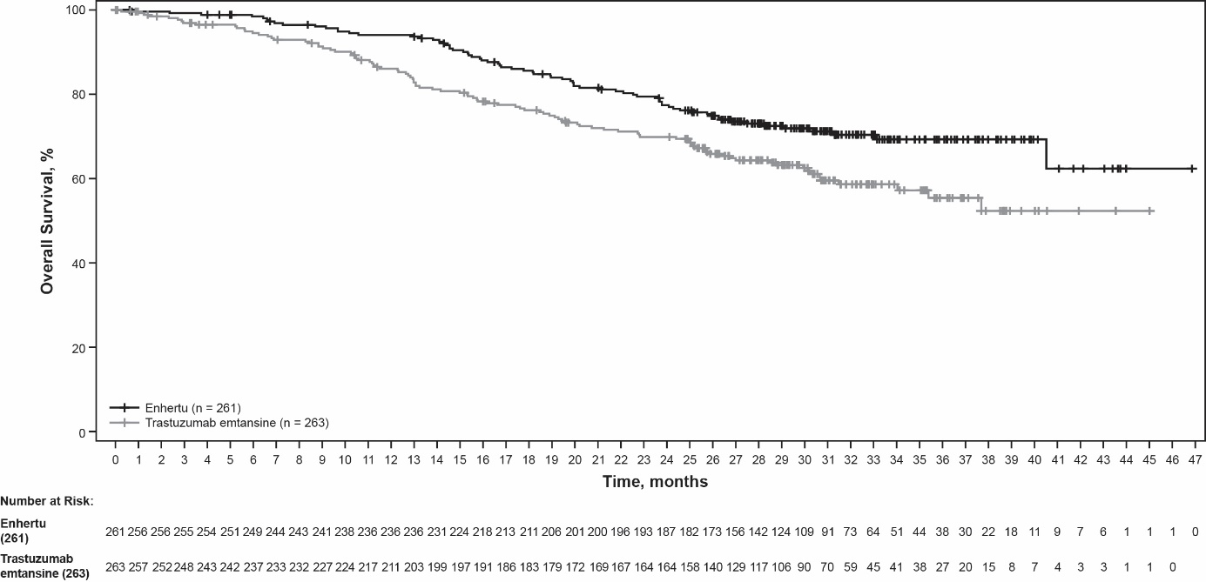

Figure 2: Kaplan-Meier plot of progression-free survival per BICR (Data cutoff 25 July 2022)
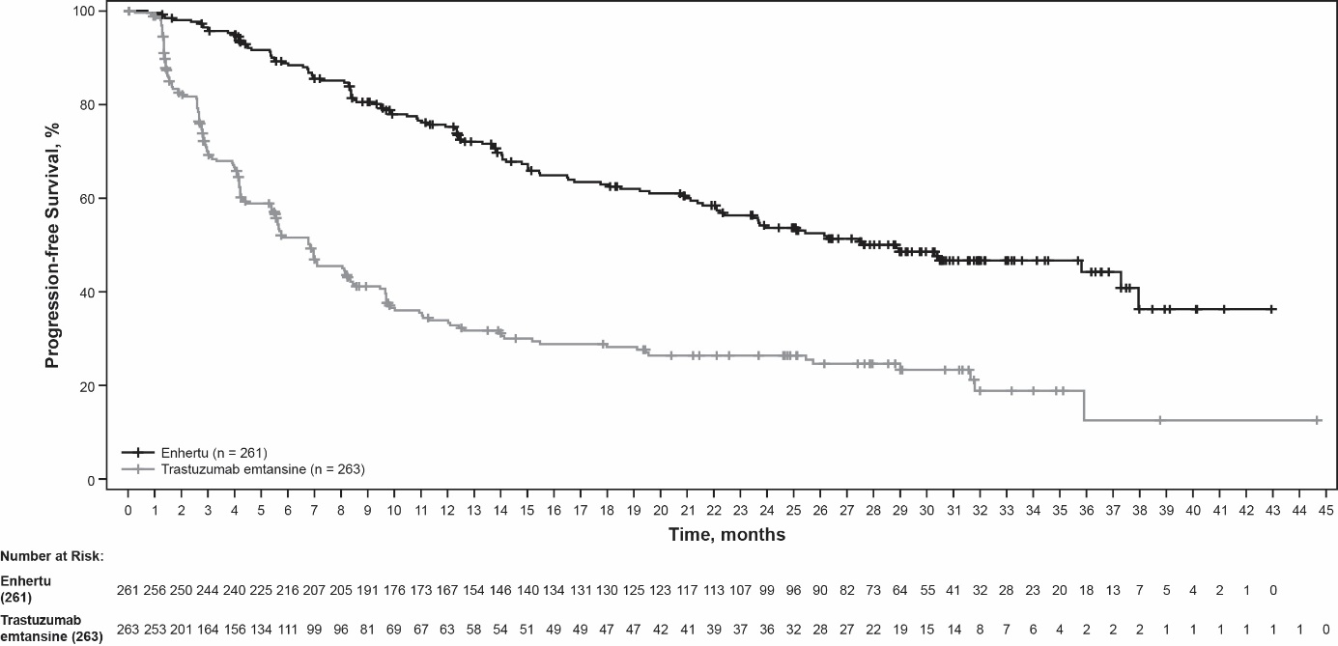

Similar PFS results were observed across prespecified subgroups including prior pertuzumab therapy, hormone receptor status, and presence of visceral disease.

DESTINY-Breast02 (NCT03523585)
The efficacy and safety of Enhertu were evaluated in study DESTINY-Breast02, a Phase 3, randomised, multicentre, open-label, active-controlled study that enrolled patients with unresectable or metastatic HER2-positive breast cancer, who were resistant or refractory to prior T-DM1 therapy. Archival breast tumour samples were required to show HER2 positivity defined as HER2 IHC 3+ or ISH-positive. The study excluded patients with a history of ILD/pneumonitis requiring treatment with steroids or ILD/pneumonitis at screening, patients with untreated and symptomatic brain metastases and patients with a history of clinically significant cardiac disease. Patients were randomised 2:1 to receive either Enhertu 5.4 mg/kg (n = 406) by intravenous infusion every three weeks, or treatment of physician’s choice (n = 202, trastuzumab plus capecitabine or lapatinib plus capecitabine). Randomisation was stratified by hormone receptor status, prior treatment with pertuzumab and history of visceral disease. Treatment was administered until disease progression, death, withdrawal of consent or unacceptable toxicity.

The primary efficacy outcome measure was progression-free survival (PFS) as assessed by blinded independent central review (BICR) based on RECIST v1.1. Overall survival (OS) was a key secondary efficacy outcome measure. PFS based on investigator assessment, confirmed objective response rate (ORR) and duration of response (DOR) were secondary objectives.

Demographic and baseline disease characteristics were similar between treatment arms. Of the 608 patients randomised, the median age was 54 years (range 22 to 88); female (99.2%); White (63.2%), Asian (29.3%), Black or African American (2.8%); Eastern Cooperative Oncology Group (ECOG) performance status 0 (57.4%) or 1 (42.4%); hormone receptor status (positive: 58.6%); presence of visceral disease (78.3%); presence of brain metastases at baseline (18.1%) and 4.9% of patients received one line of prior systemic therapy in the metastatic setting.

Efficacy results are summarised in Table 5 and Figures 3 and 4.

Table 5: Efficacy results in DESTINY-Breast02
Efficacy parameter | Enhertu  N = 406 | Treatment of physician’s choice  N = 202
PFS per BICR
Number of events (%) | 200 (49.3) | 125 (61.9)
Median, months (95% CI) | 17.8 (14.3, 20.8) | 6.9 (5.5, 8.4)
Hazard ratio (95% CI) | 0.36 (0.28, 0.45)
p-value | p < 0.000001†
Overall survival (OS)
Number of events (%) | 143 (35.2) | 86 (42.6)
Median, months (95% CI) | 39.2 (32.7, NE) | 26.5 (21.0, NE)
Hazard ratio (95% CI) | 0.66 (0.50, 0.86)
p-valuea | p = 0.0021
PFS per investigator assessment
Number of events (%) | 206 (50.7) | 152 (75.2)
Median, months (95% CI) | 16.7 (14.3, 19.6) | 5.5 (4.4, 7.0)
Hazard ratio (95% CI) | 0.28 (0.23, 0.35)
Confirmed objective response rate (ORR) per BICR
n (%) | 283 (69.7) | 59 (29.2)
95% CI | (65.0, 74.1) | (23.0, 36.0)
Complete response n (%) | 57 (14.0) | 10 (5.0)
Partial response n (%) | 226 (55.7) | 49 (24.3)
Duration of response per BICR
Median, months (95% CI) | 19.6 (15.9, NE) | 8.3 (5.8, 9.5)
CI = confidence interval; NE = not estimable
† Presented as 6 decimal places
ª The p-value is based on a stratified log-rank test; crossed the efficacy boundary of 0.004.

Figure 3: Kaplan-Meier plot of progression-free survival per BICR
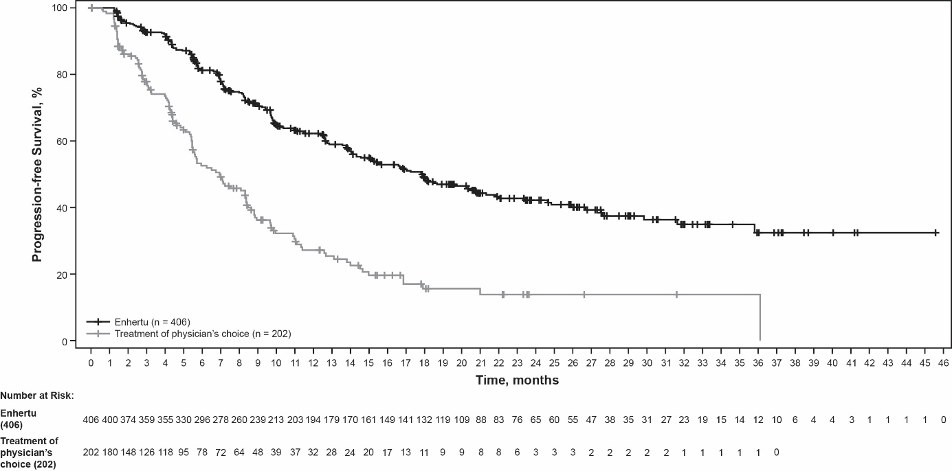

Figure 4: Kaplan-Meier plot of overall survival
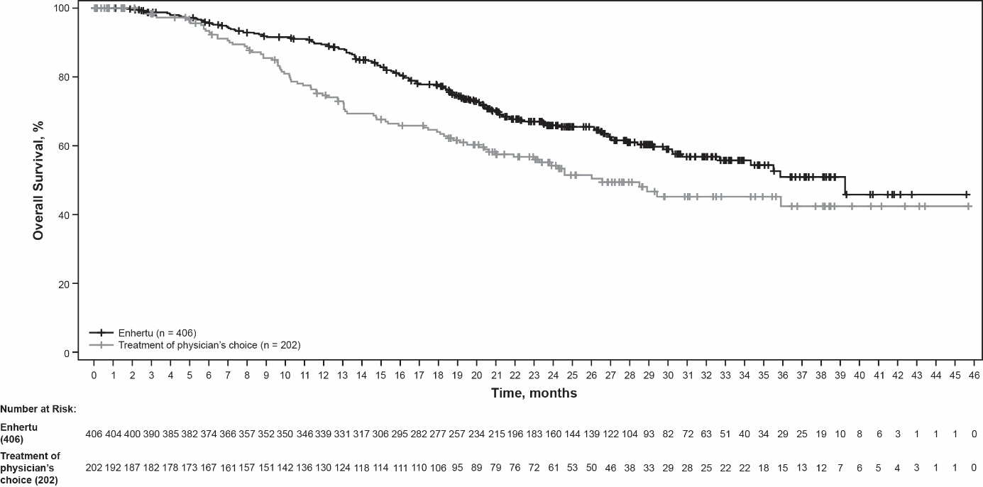

DESTINY-Breast01 (NCT03248492)
The efficacy and safety of Enhertu were studied in DESTINY-Breast01, a multicentre, open-label, single-arm Phase 2 study that enrolled patients with HER2-positive, unresectable and/or metastatic breast cancer who had received two or more prior anti-HER2-based regimens, including trastuzumab emtansine (100%), trastuzumab (100%) and pertuzumab (65.8%). Archival breast tumour samples were required to show HER2 positivity defined as HER2 IHC 3+ or ISH-positive. The study excluded patients with a history of treated ILD or ILD at screening, patients with untreated or symptomatic brain metastases, and patients with a history of clinically significant cardiac disease. Patients enrolled had at least 1 measurable lesion per RECIST v1.1. Enhertu was administered by intravenous infusion at 5.4 mg/kg once every three weeks until disease progression, death, withdrawal of consent, or unacceptable toxicity. The primary efficacy outcome measure was confirmed objective response rate (ORR) according to RECIST v1.1 in the intent-to-treat (ITT) population as evaluated by independent central review (ICR). The secondary efficacy outcome measure was duration of response (DOR).

Of the 184 patients enrolled in DESTINY-Breast01, baseline demographic and disease characteristics were: median age 55 years (range: 28 to 96); 65 years or older (23.9%); female (100%); White (54.9%), Asian (38.0%), Black or African American (2.2%); Eastern Cooperative Oncology Group (ECOG) performance status 0 (55.4%) or 1 (44.0%); hormone receptor status (positive: 52.7%); presence of visceral disease (91.8%); previously treated and stable brain metastases (13.0%); median number of prior therapies in the metastatic setting: 5 (range: 2 to 17); sum of diameters of target lesions (< 5 cm: 42.4%, ≥ 5 cm: 50.0%).

An earlier analysis (median duration of follow-up 11.1 months [range: 0.7 to 19.9 months]) showed a confirmed objective response rate of 60.9% (95% CI: 53.4, 68.0) with 6.0% being complete responders and 54.9% being partial responders; 36.4% had stable disease, 1.6% had progressive disease and 1.1% were not evaluable. Median duration of response at that time was 14.8 months (95% CI: 13.8, 16.9) with 81.3% of responders having a response of ≥ 6 months (95% CI: 71.9, 87.8). Efficacy results from an updated data cutoff with median duration of follow-up of 20.5 months (range: 0.7 to 31.4 months) are shown in Table 6.

Table 6: Efficacy results in DESTINY-Breast01 (intent-to-treat analysis set)
DESTINY-Breast01
N = 184
Confirmed objective response rate (95% CI)*† | 61.4% (54.0, 68.5)
Complete response (CR) | 6.5%
Partial response (PR) | 54.9%
Duration of response‡
Median, months (95% CI) | 20.8 (15.0, NR)
% with duration of response ≥ 6 months (95% CI)§ | 81.5% (72.2, 88.0)
ORR 95% CI calculated using Clopper-Pearson method
CI = confidence interval
95% CIs calculated using Brookmeyer-Crowley method
*Confirmed responses (by blinded independent central review) were defined as a recorded response of either CR/PR, confirmed by repeat imaging not less than 4 weeks after the visit when the response was first observed.
†Of the 184 patients, 35.9% had stable disease, 1.6% had progressive disease and 1.1% were not evaluable.
‡Includes 73 patients with censored data
§Based on Kaplan-Meier estimation
NR = not reached

Consistent anti-tumour activity was observed across prespecified subgroups based on prior pertuzumab therapy and hormone receptor status.

HER2-low and HER2-ultralow breast cancer

DESTINY-Breast06 (NCT04494425)
The efficacy and safety of Enhertu were evaluated in study DESTINY-Breast06, a randomised, multicentre, open-label Phase 3 study that randomised 866 adult patients with advanced or metastatic HR+ breast cancer with HER2-low (IHC 1+ or IHC 2+/ISH-) or HER2-ultralow expression as determined by the PATHWAY/VENTANA anti-HER2/neu (4B5) evaluated at a central laboratory. HER2-ultralow (IHC 0 with membrane staining, described as IHC >0<1+ in the study) is defined as faint and incomplete membrane HER2 staining that is seen in 10% or fewer tumour cells. Patients were eligible if they had disease progression on (a) at least 2 lines of endocrine therapy in the metastatic setting or (b) one line of endocrine therapy in the metastatic setting and demonstrated progression within 24 months of the start of adjuvant endocrine therapy, or within 6 months of starting first line endocrine therapy in combination with a CDK 4/6 inhibitor in the metastatic setting. Patients with prior chemotherapy in the neo-adjuvant or adjuvant setting were eligible if they had a disease-free interval greater than 12 months. The study excluded patients with prior chemotherapy for advanced or metastatic disease, patients with a history of ILD/pneumonitis requiring treatment with steroids or ILD/pneumonitis at screening, uncontrolled or significant cardiovascular disease, untreated and symptomatic brain metastases, or ECOG performance status >1.

Patients were randomised 1:1 to receive either Enhertu 5.4 mg/kg (N = 436) by intravenous infusion every three weeks or physician’s choice of single agent chemotherapy (N = 430, capecitabine 60%, nab-paclitaxel 24%, or paclitaxel 16%). Randomisation was stratified by prior CDK4/6 inhibitor use (yes or no), prior taxane use in the non-metastatic setting (yes or no), and HER2 IHC status of tumour samples (IHC 2+/ISH-, IHC 1+, IHC >0 <1+). Treatment with Enhertu was administered until disease progression, death, withdrawal of consent, or unacceptable toxicity.

The primary efficacy outcome measure was PFS in patients with HER2-low breast cancer assessed by BICR based on RECIST v1.1. Key secondary efficacy outcome measures were PFS assessed by BICR based on RECIST v1.1 in the overall population (HER2-low and HER2-ultralow), OS in HER2-low patients, and OS in the overall population. ORR and DOR were secondary endpoints.

In the overall population, demographics and baseline tumour characteristics were similar between treatment arms. Of the 866 patients randomised, the median age was 57 years (range: 28 to 87); 31% were age 65 or older; 99.9% were female; 53% were White, 35% were Asian, and 1% were Black or African American. Patients had an ECOG performance status of 0 (59%) or 1 (39%) at baseline; 18% were IHC >0<1+, 55% were IHC 1+, 27% were IHC 2+/ISH-; 67% had liver metastases, 32% had lung metastases, 8% had brain metastases, and 3% had bone-only metastases. Patients had a median of 2 prior lines of endocrine therapy in the metastatic setting (range: 1 to 5) with 17% having 1 and 68% having 2. Eighty-nine percent of patients had prior endocrine therapy in combination with CDK4/6i treatment in the metastatic setting, 47% had prior anthracycline use, and 41% had prior taxane use in the non-metastatic setting.

Efficacy results are summarised in Table 7 and Figures 5 and 6.

Table 7: Efficacy Results in DESTINY-Breast06
Efficacy Parameter | HER2-low |  | Overall Population  (HER2-low and HER2-ultralow)
Efficacy Parameter | Enhertu (N = 359) | Chemotherapy  (N = 354) | Enhertu (N = 436) | Chemotherapy  (N = 430)
Progression Free Survival per BICR
Number of events (%) | 225 (62.7) | 232 (65.5) | 269 (61.7) | 271 (63.0)
Median, months (95% CI) | 13.2 (11.4, 15.2) | 8.1 (7.0, 9.0) | 13.2 (12.0, 15.2) | 8.1 (7.0, 9.0)
Hazard ratio (95% CI) | 0.62 (0.52, 0.75) |  | 0.64 (0.54, 0.76)
p-value | <0.0001 |  | <0.0001
Overall Survival*
Number of events (%) | 136 (37.9) | 146 (41.2) | 161 (36.9) | 174 (40.5)
Median, months (95% CI) | 28.9 (25.7, 33.7) | 27.1 (23.5, 29.9) | 28.9 (26.4, 32.7) | 27.4 (23.9, 29.9)
Hazard ratio (95% CI) | 0.83 (0.66, 1.05) |  | 0.81 (0.66, 1.01)
Confirmed Objective Response Rate per BICR†
n (%) | 203 (56.5) | 114 (32.2) | 250 (57.3) | 134 (31.2)
95% CI | 51.2, 61.7 | 27.4, 37.3 | 52.5, 62.0 | 26.8, 35.8
Duration of Response per BICR†
Median, months (95% CI) | 14.1 (11.8, 15.9) | 8.6 (6.7, 11.3) | 14.3 (12.5, 15.9) | 8.6 (6.9, 11.5)
Data cutoff: 18 March 2024
CI = confidence interval
*First planned interim analysis
†Results were not controlled for type 1 error and should be interpreted descriptively

Consistent PFS benefit was observed across multiple prespecified subgroups, including HER2 expression (IHC >0 <1+, IHC 1+, IHC 2+/ISH-), prior CDK4/6 inhibitor use (yes or no), prior taxane use in the non-metastatic setting (yes or no), and number of prior lines of endocrine therapy in the metastatic setting.

In the HER2-ultralow subgroup (n = 152), median PFS was 13.2 months (95% CI: 9.8, 17.3) in patients randomised to Enhertu (N = 76) and 8.3 months (95% CI: 5.8, 15.2) in patients randomised to chemotherapy with a hazard ratio of 0.78 (95% CI: 0.50, 1.21). Median OS was 29.5 months (95% CI: 27.9, NE) in patients randomised to Enhertu and 27.4 months (95% CI: 19.4, NE) in patients randomised to chemotherapy with a hazard ratio of 0.75 (95% CI: 0.43, 1.29). Confirmed objective response rate was 61.8% (95% CI: 50.0, 72.8) and 26.3% (95% CI: 16.9, 37.7) in patients randomised to Enhertu and chemotherapy, respectively. Median duration of response was 14.3 months (95% CI: 9.2, 20.7) and 14.1 months (95% CI: 5.9, not estimable) in patients randomised to Enhertu and chemotherapy, respectively.

Figure 5: Kaplan-Meier Plot of Progression Free Survival (Overall Population)
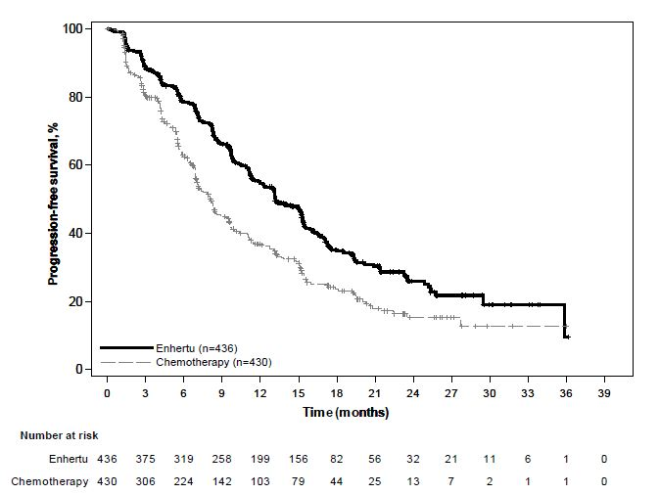

Figure 6: Kaplan-Meier Plot of Overall Survival (Overall Population)
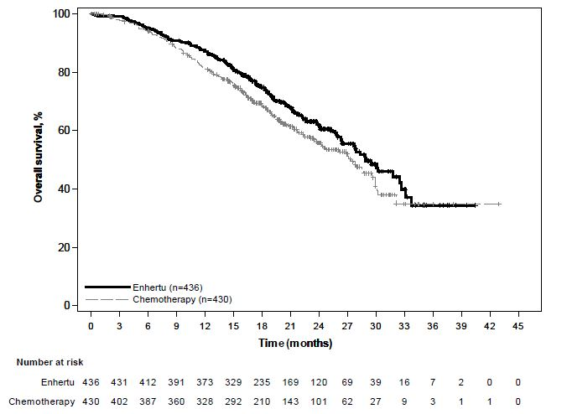

DESTINY-Breast04 (NCT03734029)
The efficacy and safety of Enhertu were studied in DESTINY-Breast04, a phase 3, randomised, multicentre, open-label study that enrolled 557 adult patients with unresectable or metastatic HER2-low breast cancer. The study included 2 cohorts: 494 hormone receptor positive (HR+) patients and 63 hormone receptor negative (HR-) patients. HER2-low expression was defined as IHC 1+ (defined as faint, partial staining of the membrane in greater than 10% of the cancer cells) or IHC 2+/ISH-, as determined by the PATHWAY/VENTANA anti-HER2/neu (4B5) evaluated at a central laboratory. Patients must have received chemotherapy in the metastatic setting or have developed disease recurrence during or within 6 months of completing adjuvant chemotherapy. According to the inclusion criteria, patients who were HR+ must have received at least one endocrine therapy and be ineligible for further endocrine therapy at the time of randomisation. Patients were randomised 2:1 to receive either Enhertu 5.4 mg/kg (N = 373) by intravenous infusion every three weeks or physician’s choice of chemotherapy (N = 184, eribulin 51.1%, capecitabine 20.1%, gemcitabine 10.3%, nab paclitaxel 10.3%, or paclitaxel 8.2%). Randomisation was stratified by HER2 IHC status of tumour samples (IHC 1+ or IHC 2+/ISH-), number of prior lines of chemotherapy in the metastatic setting (1 or 2) and HR status/prior CDK4/6i treatment (HR+ with prior CDK4/6 inhibitor treatment, HR+ without prior CDK4/6 inhibitor treatment, or HR-). Treatment was administered until disease progression, death, withdrawal of consent, or unacceptable toxicity. The study excluded patients with a history of ILD/pneumonitis requiring treatment with steroids or ILD/pneumonitis at screening and clinically significant cardiac disease. Patients were also excluded for untreated or symptomatic brain metastases or ECOG performance status > 1.

The primary efficacy endpoint was progression-free survival (PFS) in patients with HR+ breast cancer assessed by BICR based on RECIST v1.1. Key secondary efficacy endpoints were PFS assessed by BICR based on RECIST v1.1 in the overall population (all randomised HR+ and HR- patients), overall survival (OS) in HR+ patients and OS in the overall population. ORR, DOR and patient-reported outcomes (PROs) were secondary endpoints.

Demographics and baseline tumour characteristics were similar between treatment arms. Of the 557 patients randomised, the median age was 57 years (range: 28 to 81); 23.5% were age 65 or older; 99.6% were female and 0.4% were male; 47.9% were White, 40.0% were Asian and 1.8% were Black or African American. Patients had an ECOG performance status of 0 (54.8%) or 1 (45.2%) at baseline; 57.6% were IHC 1+, 42.4% were IHC 2+/ISH-; 88.7% were HR+ and 11.3% HR-; 69.8% had liver metastases, 32.9% had lung metastases, and 5.7% had brain metastases. The percentage of patients who had prior anthracycline use in the (neo)adjuvant setting was 46.3% and 19.4% in the locally advanced and/or metastatic setting. In the metastatic setting, patients had a median of 3 prior lines of systemic therapy (range: 1 to 9) with 57.6% having 1 and 40.9% having 2 prior chemotherapy regimens; 3.9% were early progressors (progression in the neo/adjuvant setting). In HR+ patients, the median number of prior lines of endocrine therapy was 2 (range: 0 to 9) and 70% had prior CDK4/6 inhibitor treatment.

Efficacy results are summarised in Table 8 and Figures 7 and 8.

Table 8: Efficacy results in DESTINY-Breast04
Efficacy parameter | HR+ cohort |  | Overall population  (HR+ and HR- cohort)
Efficacy parameter | Enhertu  (N = 331) | Chemotherapy  (N = 163) | Enhertu  (N = 373) | Chemotherapy  (N = 184)
Overall survival
Number of events (%) | 126 (38.1) | 73 (44.8) | 149 (39.9) | 90 (48.9)
Median, months (95% CI) | 23.9 (20.8, 24.8) | 17.5 (15.2, 22.4) | 23.4 (20.0, 24.8) | 16.8 (14.5, 20.0)
Hazard ratio (95% CI) | 0.64 (0.48, 0.86) |  | 0.64 (0.49, 0.84)
p-value | 0.0028 |  | 0.001
Progression-free survival per BICR
Number of events (%) | 211 (63.7) | 110 (67.5) | 243 (65.1) | 127 (69.0)
Median, months (95% CI) | 10.1 (9.5, 11.5) | 5.4 (4.4, 7.1) | 9.9 (9.0, 11.3) | 5.1 (4.2, 6.8)
Hazard ratio (95% CI) | 0.51 (0.40, 0.64) |  | 0.50 (0.40, 0.63)
p-value | < 0.0001 |  | < 0.0001
Confirmed objective response rate per BICR*
n (%) | 175 (52.6) | 27 (16.3) | 195 (52.3) | 30 (16.3)
95% CI | 47.0, 58.0 | 11.0, 22.8 | 47.1, 57.4 | 11.3, 22.5
Complete Response n (%) | 12 (3.6) | 1 (0.6) | 13 (3.5) | 2 (1.1)
Partial Response n (%) | 164 (49.2) | 26 (15.7) | 183 (49.1) | 28 (15.2)
Duration of response per BICR*
Median, months (95% CI) | 10.7 (8.5, 13.7) | 6.8 (6.5, 9.9) | 10.7 (8.5, 13.2) | 6.8 (6.0, 9.9)
CI = confidence interval
*Based on data from electronic case report form for the HR+ cohort: N = 333 for Enhertu arm and N = 166 chemotherapy arm.

Consistent OS and PFS benefit were observed across prespecified subgroups, including HR status, prior CDK4/6i treatment, number of prior chemotherapies and IHC 1+ and IHC 2+/ISH- status. In the HR- subgroup, median OS was 18.2 months (95% CI: 13.6, not estimable) in patients randomised to Enhertu compared to 8.3 months (95% CI: 5.6, 20.6) in patients randomised to chemotherapy with a hazard ratio of 0.48 (95% CI: 0.24, 0.95). Median PFS was 8.5 months (95% CI: 4.3, 11.7) in patients randomised to Enhertu and 2.9 months (95% CI: 1.4, 5.1) in patients randomised to chemotherapy with a hazard ratio of 0.46 (95% CI: 0.24, 0.89).

At an updated descriptive analysis with a median follow-up of 32 months, OS improvements were consistent with the primary analysis. The HR in the overall population was 0.69 (95% CI: 0.55, 0.86) with a median OS of 22.9 months (95% CI: 21.2, 24.5) in the Enhertu arm versus 16.8 months (95% CI: 14.1, 19.5) in the chemotherapy arm. The Kaplan-Meier curve for the updated OS analysis is shown in Figure 7.

Figure 7: Kaplan-Meier plot of overall survival (overall population) (updated analysis)
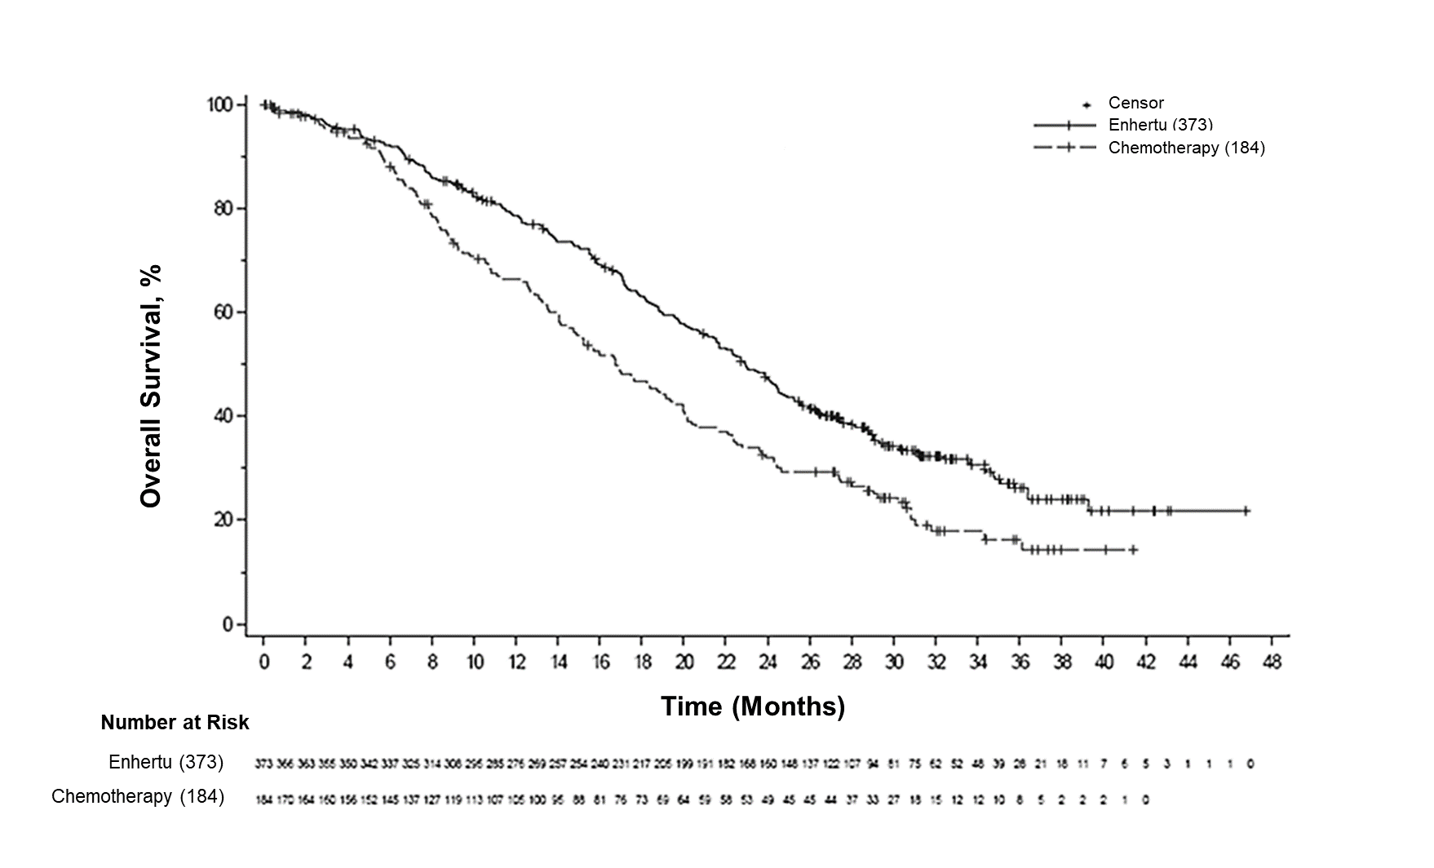

Figure 8: Kaplan-Meier plot of progression-free survival per BICR (overall population)
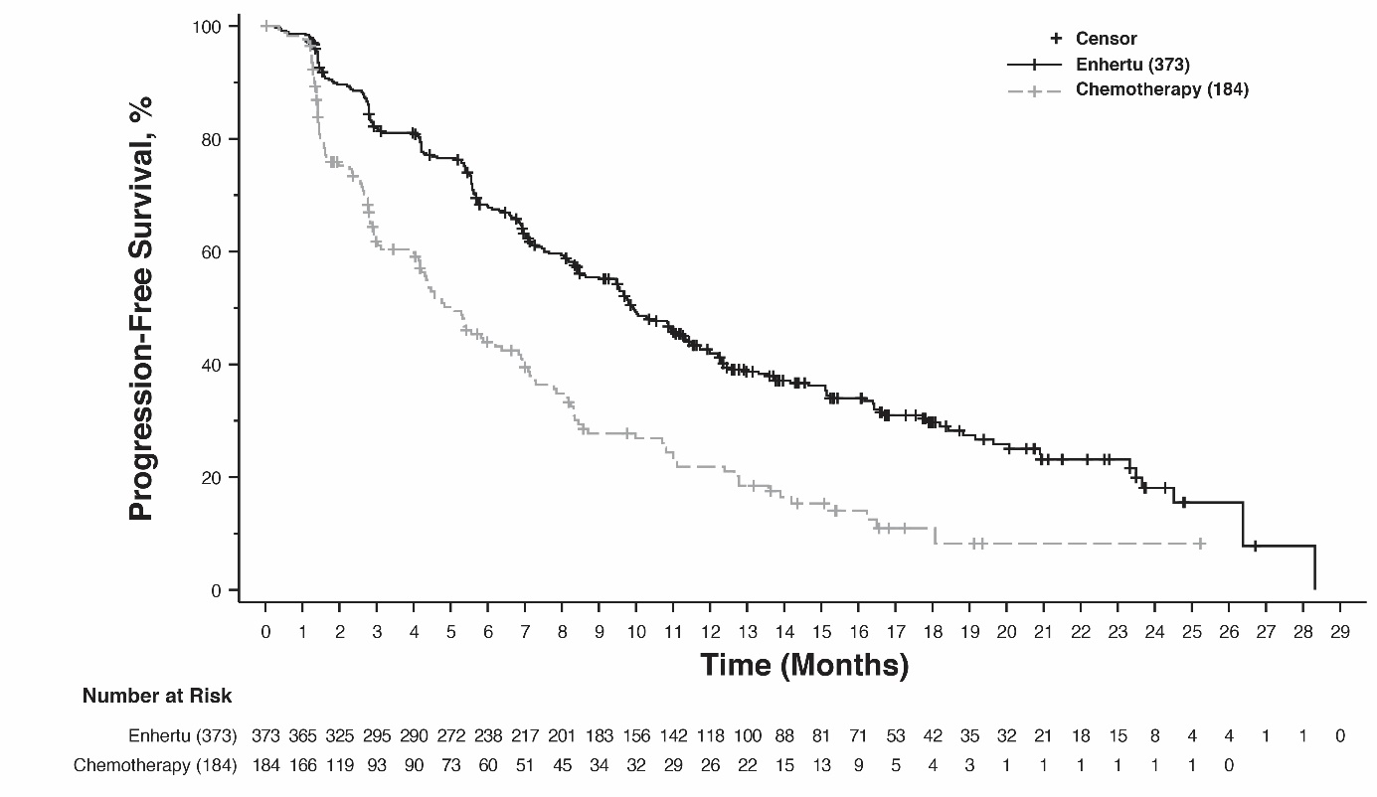

NSCLC

DESTINY-Lung02 (NCT04644237)
The efficacy and safety of Enhertu were studied in DESTINY-Lung02, a phase 2, randomised study evaluating two dose levels. The treatment dosage assignment was blinded to patients and investigators. The study included adult patients with metastatic HER2-mutant NSCLC who had received at least one regimen containing platinum-based chemotherapy. Identification of an activating HER2 (ERBB2) mutation was prospectively determined in tumour tissue by local laboratories using a validated test such as next generation sequencing, polymerase chain reaction or mass spectrometry. Patients were randomised 2:1 to receive Enhertu 5.4 mg/kg or 6.4 mg/kg every 3 weeks, respectively. Randomisation was stratified by prior anti-programmed cell death receptor-1 (PD-1) and/or anti-programmed cell death ligand 1 (PD-L1) treatment (yes versus no). Treatment was administered until disease progression, death, withdrawal of consent, or unacceptable toxicity. The study excluded patients with a history of ILD/pneumonitis requiring treatment with steroids or ILD/pneumonitis at screening and clinically significant cardiac disease. Patients were also excluded for untreated and symptomatic brain metastases or ECOG performance status >1.

The primary efficacy outcome measure was confirmed ORR as assessed by BICR using RECIST v1.1. The secondary efficacy outcome measure was DOR.

Demographic and baseline disease characteristics from the 102 patients enrolled in the 5.4 mg/kg arm were: median age 59.4 years (range 31 to 84); female (63.7%); Asian (63.7%), White (22.5%), or Other (13.7%); ECOG performance status 0 (28.4%) or 1 (71.6%); 97.1% had a mutation in the ERBB2 kinase domain, 2.9% in the extracellular domain; 96.1% had a HER2 mutation in exon 19 or exon 20; 34.3% had stable brain metastases; 46.1% were former smokers, none were current smokers; 21.6% had a prior lung resection. In the metastatic setting, 32.4% had greater than 2 prior systemic therapies, 100% received platinum-based therapy, 73.5% received anti-PD-1/PD-L1 therapy, and 50.0% had prior treatment with platinum therapy and anti-PD-1/PD-L1 therapy in combination.

Efficacy results are summarised in Table 9. The median duration of follow-up was 11.5 months (data cutoff: 23 December 2022).

Table 9: Efficacy results in DESTINY-Lung02
Efficacy parameter | DESTINY-Lung02  5.4 mg/kg  N = 102
Confirmed objective response rate (ORR) per BICR
n (%) | 50 (49.0)
(95% CI)* | (39.0, 59.1)
Complete response (CR) n (%) | 1 (1.0)
Partial response (PR) n (%) | 49 (48.0)
Duration of response
Median, months (95% CI) † | 16.8 (6.4, NE)
*95% CI calculated using Clopper-Pearson method
CI = confidence interval, NE = not estimable
†95% CI calculated using Brookmeyer-Crowley method

Gastric cancer

DESTINY-Gastric04 (NCT04704934)
The efficacy and safety of Enhertu were evaluated in DESTINY-Gastric04, a Phase 3, randomised, multicentre, open-label, active-controlled study. The study included adult patients with HER2-positive locally advanced, unresectable, or metastatic gastric or GEJ adenocarcinoma who had progressed on or after a trastuzumab-containing regimen. Patients were randomised 1:1 to receive either Enhertu (N=246) or ramucirumab plus paclitaxel (N=248). Randomisation was stratified by HER2 status (IHC 3+ or IHC 2+/ISH-positive), geographical region (Asia [excluding mainland China] versus Western Europe versus mainland China/rest of the world), and time to progression on first-line therapy (<6 months or ≥6 months). Tumour samples were required to have locally or centrally confirmed HER2 positivity defined as IHC 3+ or IHC 2+/ISH-positive. The study excluded patients with a history of ILD/pneumonitis requiring treatment with steroids or ILD/pneumonitis at screening, patients with a history of clinically significant cardiac disease, and patients with active brain metastases. Treatment was administered until disease progression, death, or unacceptable toxicity. The primary efficacy outcome measure was overall survival (OS). PFS, confirmed ORR, and DOR were secondary outcome measures.

Demographic and baseline disease characteristics were similar between treatment arms. Of the 494 patients enrolled in DESTINY-Gastric04, the median age was 63.7 years (range 21.1 to 87.0); 79.4% were male; 49.8% were White, 40.1% were Asian, and 0.4% were Black or African American. Patients had an ECOG performance status of either 0 (37.4%) or 1 (61.9%); 61.1% had gastric adenocarcinoma and 38.9% had GEJ adenocarcinoma; 84% were IHC 3+ and 16% were IHC 2+/ISH-positive; 70% of patients had two or more metastatic sites, 61.7% had liver metastases, 6.9% had brain metastases; 15.6% of patients previously received immunotherapy.

Efficacy results are summarised in Table 10 and Figure 9.

Table 10: Efficacy results in DESTINY-Gastric04
Efficacy Parameter | Enhertu  N=246 | Ramucirumab plus paclitaxel  N=248
Overall Survival (OS)
Number of events (%) | 124 (50.4) | 142 (57.3)
Median, months (95% CI) | 14.7 (12.1, 16.6) | 11.4 (9.9, 15.5)
Hazard ratio (95% CI)* | 0.70 (0.55, 0.90)
p-value† | P=0.0044
Progression-free Survival (PFS) per Investigator Assessment
Number of events (%) | 166 (67.5) | 156 (62.9)
Median, months (95% CI) | 6.7 (5.6, 7.1) | 5.6 (4.9, 5.8)
Hazard ratio (95% CI)* | 0.74 (0.59, 0.92)
p-value† | p=0.0074
Confirmed Objective Response Rate (ORR) per Investigator Assessment††
n (%) | 104 (44.3) | 69 (29.1)
95% CI | (37.8, 50.9) | (23.4, 35.3)
p-value§ | p=0.0006
Complete Response n (%) | 7 (3.0) | 3 (1.3)
Partial Response n (%) | 97 (41.3) | 66 (27.8)
Duration of Response (DOR) per Investigator Assessment
Median, months (95% CI) | 7.4 (5.7, 10.1) | 5.3 (4.1, 5.7)
CI=confidence interval
*Two-sided p-value from stratified log-rank test and stratified Cox proportional hazards model adjusted for IRT stratification factors: HER2 status (IHC 3+ or IHC 2+/ISH+).
†Based on log rank test stratified by HER2 status (IHC3+ or IHC2+/ISH+)
††ORR-eligible subjects are those who were randomised at least 77 days (i.e., 2 × 6 weeks - 1 week) before DCO date of interim analysis. Confirmed ORR is calculated using the eligible subjects as the denominator: Enhertu = 235, ramucirumab plus paclitaxel = 237
§p-value for the difference in ORR uses the Cochran-Mantel-Haenszel test adjusted for stratification factor: HER2 status (IHC 3+ or IHC 2+/ISH+).

Figure 9: Kaplan-Meier plot of overall survival (full analysis set)
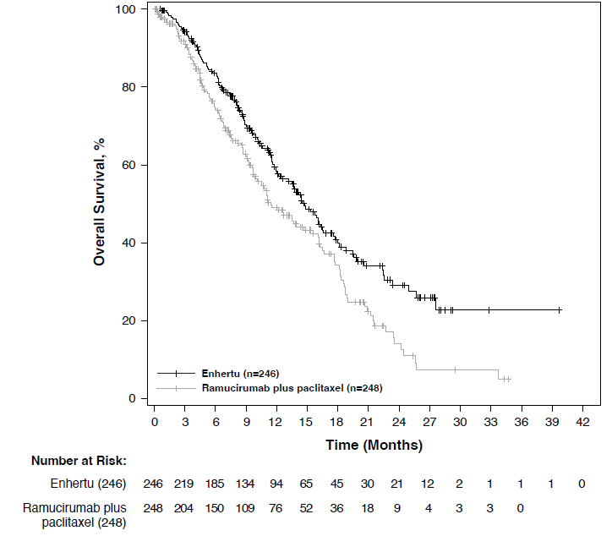

DESTINY-Gastric02 (NCT04014075)
The efficacy and safety of Enhertu were studied in DESTINY-Gastric02, a Phase 2, multicentre, open-label, single-arm study conducted at sites in Europe and the United States. The study enrolled patients with locally advanced or metastatic HER2-positive gastric or GEJ adenocarcinoma who had progressed on a prior trastuzumab-based regimen. Patients were required to have centrally confirmed HER2 positivity defined as IHC 3+ or IHC 2+/ISH-positive. The study excluded patients with a history of ILD/pneumonitis requiring treatment with steroids or ILD/pneumonitis at screening, patients with a history of clinically significant cardiac disease, and patients with active brain metastases. Enhertu was administered by intravenous infusion at 6.4 mg/kg every three weeks until disease progression, death, withdrawal of consent, or unacceptable toxicity. The primary efficacy outcome measure was confirmed ORR assessed by ICR based on RECIST v1.1. DOR and OS were secondary endpoints.

Of the 79 patients enrolled in DESTINY-Gastric02, demographic and baseline disease characteristics were: median age 61 years (range 20 to 78); 72% were male; 87% were White, 5.0% were Asian and 1.0% were Black or African American. Patients had an ECOG performance status of either 0 (37%) or 1 (63%); 34% had gastric adenocarcinoma and 66% had GEJ adenocarcinoma; 86% were IHC 3+ and 13% were IHC 2+/ISH-positive, and 63% had liver metastases.

Efficacy results for ORR and DOR are summarised in Table 11.

Table 11: Efficacy results in DESTINY-Gastric02 (full analysis set*)
Efficacy parameter | DESTINY-Gastric02  N = 79
Data cutoff date 08 November 2021
Confirmed objective response rate†  % (95% CI)‡ | 41.8 (30.8, 53.4)
Complete response n (%) | 4 (5.1)
Partial response n (%) | 29 (36.7)
Duration of response  Median§, months (95% CI)¶ | 8.1 (5.9, NE)
NE = Not estimable
*Includes all patients who received at least one dose of Enhertu
†Assessed by independent central review
‡Calculated using Clopper-Pearson method
§Based on Kaplan-Meier estimate
¶Calculated using the Brookmeyer and Crowley method

DESTINY-Gastric01 (NCT03329690)
The efficacy and safety of Enhertu were studied in DESTINY-Gastric01, a Phase 2, multicentre, open-label, randomised study conducted at sites in Japan and South Korea. This supportive study included adult patients with locally advanced or metastatic HER2-positive gastric or GEJ adenocarcinoma who had progressed on at least two prior regimens, including trastuzumab, a fluoropyrimidine agent, and a platinum agent. Patients were randomised 2:1 to receive either Enhertu (N = 126) or physician’s choice of chemotherapy: either irinotecan (N = 55) or paclitaxel (N = 7). Tumour samples were required to have centrally confirmed HER2 positivity defined as IHC 3+ or IHC 2+/ISH-positive. The study excluded patients with a history of ILD/pneumonitis requiring treatment with steroids or ILD/pneumonitis at screening, patients with a history of clinically significant cardiac disease, and patients with active brain metastases. Treatment was administered until disease progression, death, withdrawal of consent, or unacceptable toxicity. The primary efficacy outcome measure was unconfirmed ORR assessed by ICR based on RECIST v1.1. Overall survival (OS), progression-free survival (PFS), DOR, and confirmed ORR were secondary outcome measures.

Demographic and baseline disease characteristics were similar between treatment arms. Of the 188 patients, the median age was 66 years (range 28 to 82); 76% were male; 100% were Asian. Patients had an ECOG performance status of either 0 (49%) or 1 (51%); 87% had gastric adenocarcinoma and 13% had GEJ adenocarcinoma; 76% were IHC 3+ and 23% were IHC 2+/ISH-positive; 54% had liver metastases; 29% had lung metastases; the sum of diameters of target lesions was < 5 cm in 47%, ≥ 5 to < 10 cm in 30%, and ≥ 10 cm in 17%; 55% had two and 45% had three or more prior regimens in the locally advanced or metastatic setting.

Efficacy results (data cutoff date: 03 June 2020) for Enhertu (n = 126) vs. physician’s choice of chemotherapy (n = 62) were confirmed ORR 39.7% (95% CI: 31.1, 48.8) vs. 11.3% (95% CI: 4.7, 21.9). Complete response rate was 7.9% vs. 0% and partial response rate was 31.7% vs. 11.3%. Additional efficacy results for Enhertu vs. physician’s choice of chemotherapy were median DOR of 12.5 months (95% CI: 5.6, NE) vs. 3.9 months (95% CI: 3.0, 4.9). Median PFS was 5.6 months (95% CI: 4.3, 6.9) vs. 3.5 months (95% CI: 2.0, 4.3; hazard ratio = 0.47 [95% CI: 0.31, 0.71]). An OS analysis, prespecified at 133 deaths, showed survival benefit with Enhertu treatment compared to the physician’s choice group (hazard ratio = 0.60). The median OS was 12.5 months (95% CI: 10.3, 15.2) in the Enhertu group and 8.9 months (95% CI: 6.4, 10.4) in the physician’s choice group.

Paediatric population

The European Medicines Agency has waived the obligation to submit the results of studies in all subsets of the paediatric population in breast cancer, NSCLC and gastric cancer (see section 4.2 for information on paediatric use).

This medicinal product has been authorised under a so-called ‘conditional approval’ scheme. This means that further evidence on this medicinal product is awaited.
The European Medicines Agency will review new information on this medicinal product at least every year and this SmPC will be updated as necessary.

5.2 Pharmacokinetic properties

Absorption

Trastuzumab deruxtecan is administered intravenously. There have been no studies performed with other routes of administration.

Distribution

Based on population pharmacokinetic analysis, the volume of distribution of the central compartment (Vc) of trastuzumab deruxtecan and topoisomerase I inhibitor, DXd, were estimated to be 2.68 L and 28.0 L, respectively.

In vitro, the mean human plasma protein binding of DXd was approximately 97%.

In vitro, the blood to plasma concentration ratio of DXd was approximately 0.6.

Biotransformation

Trastuzumab deruxtecan undergoes intracellular cleavage by lysosomal enzymes to release the DXd.

The humanised HER2 IgG1 monoclonal antibody is expected to be degraded into small peptides and amino acids via catabolic pathways in the same manner as endogenous IgG.

In vitro metabolism studies in human liver microsomes indicate that DXd is metabolised mainly by CYP3A4 via oxidative pathways.

Elimination

Following intravenous administration of trastuzumab deruxtecan in patients with metastatic HER2-positive, HER2-low breast cancer or HER2-mutant NSCLC, the clearance of trastuzumab deruxtecan in population pharmacokinetic analysis was calculated to be 0.4 L/day and the clearance of DXd was 18.4 L/h. In patients with locally advanced or metastatic gastric or GEJ adenocarcinoma, trastuzumab deruxtecan clearance was approximately 20% higher than in patients with metastatic HER2-positive breast cancer. In cycle 3, the apparent elimination half-life (t_{1/2}) of trastuzumab deruxtecan and released DXd was approximately 7 days. Moderate accumulation (approximately 35% in cycle 3 compared to cycle 1) of trastuzumab deruxtecan was observed.

Following intravenous administration of DXd to rats, the major excretion pathway was faeces via the biliary route. DXd was the most abundant component in urine, faeces, and bile. Following single intravenous administration of trastuzumab deruxtecan (6.4 mg/kg) to monkeys, unchanged released DXd was the most abundant component in urine and faeces. DXd excretion was not studied in humans.

In vitro interactions

Effects of Enhertu on the pharmacokinetics of other medicinal products
In vitro studies indicate DXd does not inhibit major CYP450 enzymes including CYP1A2, 2B6, 2C8, 2C9, 2C19, 2D6 and 3A. In vitro studies indicate that DXd does not inhibit OAT1, OAT3, OCT1, OCT2, OATP1B1, OATP1B3, MATE1, MATE2-K, P-gp, BCRP, or BSEP transporters.

Effects of other medicinal products on the pharmacokinetics of Enhertu
In vitro, DXd was a substrate of P-gp, OATP1B1, OATP1B3, MATE2-K, MRP1, and BCRP.
No clinically meaningful interaction is expected with medicinal products that are inhibitors of MATE2-K, MRP1, P-gp, OATP1B, or BCRP transporters (see section 4.5).

Linearity/non-linearity

The exposure of trastuzumab deruxtecan and released DXd when administered intravenously increased in proportion to dose in the 3.2 mg/kg to 8.0 mg/kg dose range (approximately 0.6 to 1.5 times the recommended dose) with low to moderate inter-subject variability. Based on population pharmacokinetic analysis, inter-subject variability in trastuzumab deruxtecan and DXd elimination clearances were 24% and 28%, respectively, and for central volume of distribution were 16% and 55%, respectively. The intra-subject variability in trastuzumab deruxtecan and DXd AUC values (area under the serum concentration versus time curve) was approximately 8% and 14%, respectively.

Special populations

Based on population pharmacokinetic analysis, age (20-96 years), race, ethnicity, sex and body weight did not have a clinically meaningful effect on exposure of trastuzumab deruxtecan or released DXd.

Elderly
The population PK analysis showed that age (range: 20-96 years) did not affect the PK of trastuzumab deruxtecan.

Renal impairment
No dedicated renal impairment study was conducted. Based on population pharmacokinetic analysis including patients with mild (creatinine clearance [CLcr] ≥ 60 and < 90 mL/min) or moderate (CLcr ≥ 30 and < 60 mL/min) renal impairment (estimated by Cockcroft-Gault), the pharmacokinetics of the released DXd was not affected by mild or moderate renal impairment as compared to normal renal function (CLcr ≥ 90 mL/min).

Hepatic impairment
No dedicated hepatic impairment study was conducted. Based on population pharmacokinetic analysis, the impact of changes on pharmacokinetics of trastuzumab deruxtecan in patients with total bilirubin ≤ 1.5 times ULN, irrespective of AST level, is not clinically meaningful. There is limited data for patients with total bilirubin > 1.5 to 3 times ULN, irrespective of AST level, to draw conclusions, and no data is available for patients with total bilirubin > 3 times ULN, irrespective of AST level (see sections 4.2 and 4.4).

Paediatric population
No studies have been conducted to investigate the pharmacokinetics of trastuzumab deruxtecan in children or adolescents.

5.3 Preclinical safety data

In animals, toxicities were observed in lymphatic and haematopoietic organs, intestines, kidneys, lungs, testes and skin following the administration of trastuzumab deruxtecan at exposure levels of the topoisomerase I inhibitor (DXd) below clinical plasma exposure. In these animals, antibody-drug conjugate (ADC) exposure levels were similar or above clinical plasma exposure.

DXd was clastogenic in both an in vivo rat bone marrow micronucleus assay and an in vitro Chinese hamster lung chromosome aberration assay and was not mutagenic in an in vitro bacterial reverse mutation assay.

Carcinogenicity studies have not been conducted with trastuzumab deruxtecan.

Dedicated fertility studies have not been conducted with trastuzumab deruxtecan. Based on results from general animal toxicity studies, trastuzumab deruxtecan may impair male reproductive function and fertility.

There were no animal reproductive or developmental toxicity studies conducted with trastuzumab deruxtecan. Based on results from general animal toxicity studies, trastuzumab deruxtecan and DXd were toxic to rapidly dividing cells (lymphatic/haematopoietic organs, intestine, or testes), and DXd was genotoxic, suggesting the potential for embryotoxicity and teratogenicity.

6. PHARMACEUTICAL PARTICULARS

6.1 List of excipients

L-histidine
L-histidine hydrochloride monohydrate
Sucrose
Polysorbate 80 (E433)

6.2 Incompatibilities

In the absence of compatibility studies, this medicinal product must not be mixed with other medicinal products except those mentioned in section 6.6.

Sodium chloride solution for infusion must not be used for reconstitution or dilution since it may cause particulate formation.

6.3 Shelf life

Unopened vial

4 years.

Reconstituted solution

Chemical and physical in-use stability has been demonstrated for up to 48 hours at 2 ºC to 8 ºC.

From a microbiological point of view, the product should be used immediately. If not used immediately, in-use storage times and conditions prior to use are the responsibility of the user and would normally not be longer than 24 hours at 2 ºC to 8 ºC, unless reconstitution has taken place in controlled and validated aseptic conditions.

Diluted solution

It is recommended that the diluted solution be used immediately. If not used immediately, the reconstituted solution diluted in infusion bags containing 5% glucose solution may be stored at room temperature (≤ 30 ºC) for up to 4 hours including preparation and infusion or in a refrigerator at 2 ºC to 8 ºC for up to 24 hours, protected from light.

6.4 Special precautions for storage

Store in a refrigerator (2 ºC - 8 ºC).

Do not freeze.

For storage conditions after reconstitution and dilution of the medicinal product, see section 6.3.

6.5 Nature and contents of container

Enhertu is provided in 10 mL Type 1 amber borosilicate glass vial sealed with a fluoro-resin laminated butyl rubber stopper, and a polypropylene/aluminium yellow flip-off crimp cap.
Each carton contains 1 vial.

6.6 Special precautions for disposal and other handling

In order to prevent medicinal product errors, it is important to check the vial labels to ensure that the medicinal product being prepared and administered is Enhertu (trastuzumab deruxtecan) and not trastuzumab or trastuzumab emtansine.

Appropriate procedures for the preparation of chemotherapeutic medicinal products should be used. Appropriate aseptic technique should be used for the following reconstitution and dilution procedures.

Reconstitution

- Reconstitute immediately before dilution.
- More than one vial may be needed for a full dose. Calculate the dose (mg), the total volume of reconstituted Enhertu solution required, and the number of vial(s) of Enhertu needed (see section 4.2).
- Reconstitute each 100 mg vial using a sterile syringe to slowly inject 5 mL of water for injection into each vial to obtain a final concentration of 20 mg/mL.
- Swirl the vial gently until completely dissolved. Do not shake.
- From a microbiological point of view, the product should be used immediately. If not used immediately, chemical and physical in-use stability has been demonstrated for up to 48 hours at 2 ºC to 8 ºC. Store the reconstituted Enhertu vials in a refrigerator at 2 ºC to 8 ºC, protected from light. Do not freeze.
- The reconstituted product contains no preservative and is intended for single use only.

Dilution

- Withdraw the calculated amount from the vial(s) using a sterile syringe. Inspect the reconstituted solution for particulates and discolouration. The solution should be clear and colourless to light yellow. Do not use if visible particles are observed or if the solution is cloudy or discoloured.
- Dilute the calculated volume of reconstituted Enhertu in an infusion bag containing 100 mL of 5% glucose solution for infusion. Do not use sodium chloride solution (see section 6.2). An infusion bag made of polyvinylchloride or polyolefin (copolymer of ethylene and polypropylene) is recommended.
- Gently invert the infusion bag to thoroughly mix the solution. Do not shake.
- Cover the infusion bag to protect from light.
- If not used immediately, store at room temperature (≤ 30 ºC) for up to 4 hours including preparation and infusion or in a refrigerator at 2 ºC to 8 ºC for up to 24 hours, protected from light. Do not freeze.
- Discard any unused portion left in the vial.

Administration

- If the prepared infusion solution was stored refrigerated (2 ºC to 8 ºC), it is recommended that the solution be allowed to equilibrate to room temperature prior to administration, protected from light.
- Administer Enhertu as an intravenous infusion only with a 0.20 or 0.22 micron in-line polyethersulfone (PES) or polysulfone (PS) filter.
- The initial dose should be administered as a 90-minute intravenous infusion. If the prior infusion was well tolerated, subsequent doses of Enhertu may be administered as 30-minute infusions. Do not administer as an intravenous push or bolus (see section 4.2).
- Cover the infusion bag to protect from light.
- Do not mix Enhertu with other medicinal products or administer other medicinal products through the same intravenous line.

Disposal

Any unused medicinal product or waste material should be disposed of in accordance with local requirements.

7. MARKETING AUTHORISATION HOLDER

Daiichi Sankyo Europe GmbH
Zielstattstrasse 48
81379 Munich
Germany

8. MARKETING AUTHORISATION NUMBER

EU/1/20/1508/001

9. DATE OF FIRST AUTHORISATION/RENEWAL OF THE AUTHORISATION

Date of first authorisation: 18 January 2021
Date of latest renewal: 28 October 2024

10. DATE OF REVISION OF THE TEXT

{DD month YYYY}

Detailed information on this medicinal product is available on the website of the European Medicines Agency https://www.ema.europa.eu

ANNEX II

A. MANUFACTURER OF THE BIOLOGICAL ACTIVE SUBSTANCE AND MANUFACTURER RESPONSIBLE FOR BATCH RELEASE

B. CONDITIONS OR RESTRICTIONS REGARDING SUPPLY AND USE

C. OTHER CONDITIONS AND REQUIREMENTS OF THE MARKETING AUTHORISATION

D. CONDITIONS OR RESTRICTIONS WITH REGARD TO THE SAFE AND EFFECTIVE USE OF THE MEDICINAL PRODUCT

E. SPECIFIC OBLIGATION TO COMPLETE POST-AUTHORISATION MEASURES FOR THE CONDITIONAL MARKETING AUTHORISATION

A. MANUFACTURER OF THE BIOLOGICAL ACTIVE SUBSTANCE AND MANUFACTURER RESPONSIBLE FOR BATCH RELEASE

Name and address of the manufacturer of the biological active substance

Lonza AG
Lonzastrasse
3930 Visp
Switzerland

Name and address of the manufacturer responsible for batch release

Daiichi Sankyo Europe GmbH
Luitpoldstrasse 1
85276 Pfaffenhofen
Germany

B. CONDITIONS OR RESTRICTIONS REGARDING SUPPLY AND USE

Medicinal product subject to restricted medical prescription. (see Annex I: Summary of Product Characteristics, section 4.2).

C. OTHER CONDITIONS AND REQUIREMENTS OF THE MARKETING AUTHORISATION

- Periodic safety update reports (PSURs)

The requirements for submission of PSURs for this medicinal product are set out in Article 9 of Regulation (EC) No 507/2006 and, accordingly, the marketing authorisation holder (MAH) shall submit PSURs every 6 months.

The requirements for submission of PSURs for this medicinal product are set out in the list of Union reference dates (EURD list) provided for under Article 107c(7) of Directive 2001/83/EC and any subsequent updates published on the European medicines web-portal.

D. CONDITIONS OR RESTRICTIONS WITH REGARD TO THE SAFE AND EFFECTIVE USE OF THE MEDICINAL PRODUCT

- Risk management plan (RMP)

The marketing authorisation holder (MAH) shall perform the required pharmacovigilance activities and interventions detailed in the agreed RMP presented in Module 1.8.2 of the marketing authorisation and any agreed subsequent updates of the RMP.

An updated RMP should be submitted:
- At the request of the European Medicines Agency;
- Whenever the risk management system is modified, especially as the result of new information being received that may lead to a significant change to the benefit/risk profile or as the result of an important (pharmacovigilance or risk minimisation) milestone being reached.

Additional risk minimisation measures are necessary for the safe and effective use of the product.

Prior to the launch of trastuzumab deruxtecan in each member state, the Marketing Authorisation Holder (MAH) must agree on the content and format of the educational programme (Healthcare Professional [HCP] Guide, Patient Card for ILD/pneumonitis and HCP Guide for product confusion-related medication errors), including communication media, distribution modalities, and other aspects of the programme, with the National Competent Authority.

The educational programme is aimed at:
- ensuring early recognition of interstitial lung disease (ILD)/pneumonitis, to allow prompt appropriate treatment and to mitigate worsening of the condition.
- improving HCP awareness of the potential risk for product confusion-related medication errors due to the availability of multiple trastuzumab-containing products and trastuzumab emtansine

The MAH shall ensure that in each member state where trastuzumab deruxtecan is marketed, all HCPs and patients who are expected to administer/be administered trastuzumab deruxtecan are provided with the following educational materials:

I) Healthcare Professional (HCP) Guide for ILD/pneumonitis

The HCP Guide contains the following key elements:
- Summary of important findings of trastuzumab deruxtecan-induced ILD/pneumonitis (eg, frequency, grade, time to onset) observed in the clinical trial setting
- Description of the appropriate monitoring and evaluation of ILD/pneumonitis in patients receiving trastuzumab deruxtecan
- Detailed description of management of ILD/pneumonitis in patients treated with trastuzumab deruxtecan including guidance on drug interruption, reduction and treatment discontinuation for ILD/pneumonitis
- Reminder to HCP that they should repeat the information about signs and symptoms of ILD/pneumonitis at each patient visit, including when the patient should seek attention from an HCP (eg, the symptoms to watch for; the importance to adhere to scheduled appointments)
- Reminder to HCP to provide the patient with the Patient Card (PC), including advice that the PC should be kept with the patient at all times

II) Healthcare Professional Guide for prevention of medication errors

The HCP Guide contains the following key elements:
- Alert to HCPs about a potential risk of confusion between Enhertu (trastuzumab deruxtecan) and other trastuzumab-containing products and the HER2-targeted antibody-drug conjugate Kadcyla (trastuzumab emtansine)
- Mitigation measures for prescribing errors due to similarities in active ingredient names and measures to avoid errors during prescription phase by physicians
- Comparison of commercial appearance between Enhertu (trastuzumab deruxtecan) and other trastuzumab-containing products and the HER2-targeted antibody-drug conjugate Kadcyla (trastuzumab emtansine)
- Potential mitigation strategies to avoid errors during preparation phase by pharmacists
- Detailed Information about the dosage, method of administration and preparation as well as instructions to avoid medication errors during administration phase by nurses

III) Patient Card

The Patient Card contains the following key elements:
- Description of the important risks of ILD/pneumonitis associated with the use of trastuzumab deruxtecan
- Description of key signs and symptoms of ILD/pneumonitis and guidance on when to seek attention from an HCP
- Contact details of the trastuzumab deruxtecan prescriber
- Cross-reference to Patient Information Leaflet

E. SPECIFIC OBLIGATION TO COMPLETE POST-AUTHORISATION MEASURES FOR THE CONDITIONAL MARKETING AUTHORISATION

This being a conditional marketing authorisation and pursuant to Article 14-a of Regulation (EC) No 726/2004, the MAH shall complete, within the stated timeframe, the following measure:

Description | Due date
In order to confirm the efficacy and safety of Enhertu in the treatment of adult patients with advanced NSCLC whose tumours have an activating HER2 (ERBB2) mutation and who require systemic therapy following platinum-based chemotherapy with or without immunotherapy, the MAH should submit the results of the study DESTINY-Lung04, Open-label, Randomized, Multicenter, Phase 3 Study to Assess the Efficacy and Safety of Trastuzumab Deruxtecan as First-line Treatment of Unresectable, Locally Advanced, or Metastatic NSCLC Harboring HER2 Exon 19 or 20 Mutations. | 4Q 2026

ANNEX III

LABELLING AND PACKAGE LEAFLET

A. LABELLING

PARTICULARS TO APPEAR ON THE OUTER PACKAGING

OUTER CARTON

1. NAME OF THE MEDICINAL PRODUCT

Enhertu 100 mg powder for concentrate for solution for infusion
trastuzumab deruxtecan

2. STATEMENT OF ACTIVE SUBSTANCE

One vial of powder for concentrate for solution for infusion contains: 100 mg of trastuzumab deruxtecan.
After reconstitution, one vial of 5 mL solution contains 20 mg/mL of trastuzumab deruxtecan

3. LIST OF EXCIPIENTS

Excipients: L-histidine, L-histidine hydrochloride monohydrate, sucrose, polysorbate 80 (E433).

4. PHARMACEUTICAL FORM AND CONTENTS

1 vial

5. METHOD AND ROUTE OF ADMINISTRATION

For intravenous use after reconstitution and dilution.
Read the package leaflet before use.

6. SPECIAL WARNING THAT THE MEDICINAL PRODUCT MUST BE STORED OUT OF THE SIGHT AND REACH OF CHILDREN

Keep out of the sight and reach of children.

7. OTHER SPECIAL WARNINGS, IF NECESSARY

Cytotoxic

Enhertu should not be substituted with trastuzumab or trastuzumab emtansine.

8. EXPIRY DATE

EXP

9. SPECIAL STORAGE CONDITIONS

Store in a refrigerator.
Do not freeze.

10. SPECIAL PRECAUTIONS FOR DISPOSAL OF UNUSED MEDICINAL PRODUCTS OR WASTE MATERIALS DERIVED FROM SUCH MEDICINAL PRODUCTS, IF APPROPRIATE

11. NAME AND ADDRESS OF THE MARKETING AUTHORISATION HOLDER

Daiichi Sankyo Europe GmbH
Zielstattstrasse 48
81379 Munich
Germany

12. MARKETING AUTHORISATION NUMBER

EU/1/20/1508/001

13. BATCH NUMBER

Lot

14. GENERAL CLASSIFICATION FOR SUPPLY

15. INSTRUCTIONS ON USE

16. INFORMATION IN BRAILLE

Justification for not including Braille accepted.

17. UNIQUE IDENTIFIER – 2D BARCODE

2D barcode carrying the unique identifier included.

18. UNIQUE IDENTIFIER - HUMAN READABLE DATA

PC
SN
NN
MINIMUM PARTICULARS TO APPEAR ON SMALL IMMEDIATE PACKAGING UNITS

VIAL LABEL

1. NAME OF THE MEDICINAL PRODUCT AND ROUTE OF ADMINISTRATION

Enhertu 100 mg powder for concentrate for solution for infusion
trastuzumab deruxtecan
For i.v. use after reconstitution and dilution

2. METHOD OF ADMINISTRATION

3. EXPIRY DATE

EXP

4. BATCH NUMBER

Lot

5. CONTENTS BY WEIGHT, BY VOLUME OR BY UNIT

100 mg

6. OTHER

Cytotoxic

B. PACKAGE LEAFLET

Package leaflet: Information for the patient

Enhertu 100 mg powder for concentrate for solution for infusion
trastuzumab deruxtecan

This medicine is subject to additional monitoring. This will allow quick identification of new safety information. You can help by reporting any side effects you may get. See the end of section 4 for how to report side effects.

Read all of this leaflet carefully before you are given this medicine because it contains important information for you.
- Keep this leaflet. You may need to read it again.
- If you have any further questions, ask your doctor or nurse.
- If you get any side effects, talk to your doctor or nurse. This includes any possible side effects not listed in this leaflet. See section 4.

What is in this leaflet

1. What Enhertu is and what it is used for
2. What you need to know before you are given Enhertu
3. How you are given Enhertu
4. Possible side effects
5. How to store Enhertu
6. Contents of the pack and other information

1. What Enhertu is and what it is used for

What Enhertu is

Enhertu is a cancer medicine that contains the active substance trastuzumab deruxtecan. One part of the medicine is a monoclonal antibody that attaches specifically to cells that have the protein HER2 on their surface (HER2-positive), as some cancer cells do. The other active part of Enhertu is DXd, a substance that can kill cancer cells. Once the medicine has attached to HER2-positive cancer cells, the DXd enters the cells and kills them.

What Enhertu is used for

Enhertu is used to treat adults who have:
- HER2-positive breast cancer that has spread to other parts of the body (metastatic disease) or cannot be removed by surgery, and have tried one or more other treatments specifically for HER2-positive breast cancer.
- HER2-low or HER2-ultralow breast cancer that has spread to other parts of the body (metastatic disease) or cannot be removed by surgery and have received prior therapy. A test will be performed to make sure Enhertu is right for you.
- HER2-mutant non-small cell lung cancer that has spread to other parts of the body or cannot be removed by surgery and have tried a prior treatment. A test will be performed to make sure Enhertu is right for you.
- HER2-positive stomach cancer that has spread to other parts of the body or to areas near the stomach that cannot be removed by surgery and have also tried another treatment specifically for HER2-positive stomach cancer.

2. What you need to know before you are given Enhertu

You must not be given Enhertu

- if you are allergic to trastuzumab deruxtecan or any of the other ingredients of this medicine (listed in section 6).

If you are not sure if you are allergic, talk to your doctor or nurse before you are given Enhertu.

Warnings and precautions

Talk to your doctor or nurse before you are given Enhertu, or during treatment, if you have:
- cough, shortness of breath, fever, or other new or worsening breathing problems. These may be symptoms of a serious and potentially fatal lung disease called interstitial lung disease. A history of lung disease or kidney problems may increase the risk of developing interstitial lung disease. Your doctor may have to monitor your lungs while you are taking this medicine.
- chills, fever, sores in your mouth, stomach pain or pain when urinating. These may be symptoms of an infection caused by a reduced number of white blood cells called neutrophils.
- new or worsening shortness of breath, cough, tiredness, swelling of ankles or legs, irregular heartbeat, sudden weight gain, dizziness, or loss of consciousness. These may be symptoms of a condition in which your heart cannot pump blood well enough (decreased left ventricular ejection fraction).
- liver problems. Your doctor may have to monitor your liver while you are taking this medicine.

Your doctor will carry out tests before and during treatment with Enhertu.

Children and adolescents

Enhertu is not recommended for anyone under the age of 18 years. This is because there is no information on how well it works in this age group.

Other medicines and Enhertu

Tell your doctor or nurse if you are taking, have recently taken or might take any other medicines.

Pregnancy, breast-feeding, contraception and fertility

- Pregnancy
Enhertu is not recommended during pregnancy because this medicine may harm the unborn baby.
Speak with your doctor immediately if you are pregnant, think you may be pregnant or are planning to become pregnant before or during treatment.

- Breast-feeding
You should not breast-feed during treatment with Enhertu and for at least 7 months after your last dose. This is because it is not known whether Enhertu passes into breast milk. Talk to your doctor about this.

- Contraception
Use effective contraception (birth control) to avoid becoming pregnant while being treated with Enhertu.

Women taking Enhertu should continue contraception for at least 7 months after the last dose of Enhertu.

Men taking Enhertu whose partner may become pregnant should use effective contraception:
- during treatment and
- for at least 4 months after the last dose of Enhertu.

Talk to your doctor about the best contraception for you. Also talk to your doctor before you stop your contraception.

- Fertility
If you are a man being treated with Enhertu, you should not father a child for 4 months after treatment and take advice on conserving sperm before treatment because the medicine may reduce your fertility. Therefore, discuss this with your doctor before starting treatment.

Driving and using machines

Enhertu is not likely to reduce your ability to drive or use machines. Be careful if you feel tired, dizzy, or have a headache.

Enhertu contains polysorbate 80

This medicine contains 1.5 mg of polysorbate 80 in each 100 mg vial.
Polysorbates may cause allergic reactions. Tell your doctor if you have any known allergies.

3. How you are given Enhertu

Enhertu will be given to you in a hospital or clinic:
- The recommended dose of Enhertu for the treatment of:
  - HER2-positive, HER2-low, or HER2-ultralow breast cancer is 5.4 mg for every kilogram of your weight, every 3 weeks.
  - HER2-mutant non-small cell lung cancer is 5.4 mg for every kilogram of your weight, every 3 weeks.
  - HER2-positive stomach cancer is 6.4 mg for every kilogram of your weight, every 3 weeks.
- Your doctor or nurse will give you Enhertu by infusion (drip) into your vein.
- Your first infusion will be given over 90 minutes. If this goes well, the infusion on your next visits may be given over 30 minutes.
- Your doctor will decide how many treatments you need.
- Before each Enhertu infusion, your doctor may give you medicines to help prevent nausea and vomiting.
- If you get infusion-related symptoms, your doctor or nurse may slow down your infusion or interrupt or stop your treatment.
- Before and during treatment with Enhertu, your doctor will carry out tests that may include:
  - blood tests to check your blood cells, liver and kidneys.
  - testing to check your heart and lungs.
- Your doctor may lower your dose, or temporarily or permanently stop your treatment depending on your side effects.

If you miss an appointment to get Enhertu

Contact your doctor right away to reschedule your appointment.

It is very important that you do not miss a dose of this medicine.

If you stop receiving Enhertu

Do not stop treatment with Enhertu without checking with your doctor.

If you have any further questions on the use of this medicine, ask your doctor or nurse.

4. Possible side effects

Like all medicines, this medicine can cause side effects, although not everybody gets them. Tell your doctor if you get any side effects, including those not listed in this leaflet.

Speak with your doctor immediately if you notice any of the following symptoms. They may be signs of a serious, possibly fatal, condition. Getting medical treatment right away may help keep these problems from becoming more serious.

Very common (may affect more than 1 in 10 people)
- A lung disease called interstitial lung disease with symptoms that can include cough, shortness of breath, fever, or other new or worsening breathing problems
- An infection caused by reduced number of neutrophils (a type of white blood cell) with symptoms that can include chills, fever, sores in your mouth, stomach pain or pain when urinating
- A heart problem called left ventricular dysfunction with symptoms that can include new or worsening shortness of breath, cough, tiredness, swelling of ankles or legs, irregular heartbeat, sudden weight gain, dizziness or unconsciousness

Other side effects
The frequency and severity of side effects may vary with the dose you received. Tell your doctor or nurse if you notice any of the following side effects:

Very common (may affect more than 1 in 10 people)
- nausea (feeling sick), vomiting
- tiredness

- blood tests showing decreased red or white blood cells, or platelets
- decreased appetite
- hair loss
- diarrhoea
- constipation
- blood tests showing increased levels of the liver enzymes such as transaminases
- pain in muscles and bones
- abdominal (belly) pain

- weight loss

- fever
- infections of the nose and throat, including flu-like symptoms
- headache

- blood tests showing low blood potassium levels
- blisters in or around your mouth
- cough
- indigestion
- swelling of ankles and feet

Common (may affect up to 1 in 10 people)

- breathing difficulties
- infection of the lungs
- blood tests showing increased levels of bilirubin, alkaline phosphatase or creatinine
- nosebleed
- dizziness
- rash
- blood tests showing decreased red blood cells, white blood cells, and platelets (pancytopenia)
- altered/bad taste in mouth
- dry eye
- itching

- bloating
- blurred vision
- skin discolouration

- feeling thirsty, dry mouth

- fever along with a decreased number of white blood cells called neutrophils

- excessive gas in the stomach or intestine
- inflammation of the stomach
- reactions related to the infusion of the medicine which may include fever, chills, flushing, itching or rash

Reporting of side effects

If you get any side effects, talk to your doctor or nurse. This includes any possible side effects not listed in this leaflet. You can also report side effects directly via the national reporting system listed in Appendix V. By reporting side effects you can help provide more information on the safety of this medicine.

5. How to store Enhertu

Enhertu will be stored by healthcare professionals at the hospital or clinic where you receive treatment. The storage details are as follows:
- Keep this medicine out of the sight and reach of children.
- Do not use this medicine after the expiry date which is stated on the outer carton and vial after EXP. The expiry date refers to the last day of that month.
- Store in a refrigerator (2 °C - 8 °C). Do not freeze.
- The prepared solution for infusion is stable for up to 24 hours at 2 °C - 8 °C protected from light and must be discarded thereafter.

Do not throw away any medicines via wastewater or household waste. Ask your pharmacist how to throw away medicines you no longer use. These measures will help to protect the environment.

6. Contents of the pack and other information

What Enhertu contains

- The active substance is trastuzumab deruxtecan.
One vial of powder for concentrate for solution for infusion contains 100 mg of trastuzumab deruxtecan. After reconstitution, one vial of 5 mL solution contains 20 mg/mL of trastuzumab deruxtecan.
- The other ingredients are L-histidine, L-histidine hydrochloride monohydrate, sucrose, polysorbate 80 (E433).

What Enhertu looks like and contents of the pack

Enhertu is a white to yellowish-white lyophilised powder supplied in a clear amber vial with a rubber stopper, aluminium seal and plastic flip-off cap.
Each carton contains 1 vial.

Marketing Authorisation Holder
Daiichi Sankyo Europe GmbH
Zielstattstrasse 48
81379 Munich
Germany

Manufacturer
Daiichi Sankyo Europe GmbH
Luitpoldstrasse 1
85276 Pfaffenhofen
Germany

For any information about this medicine, please contact the local representative of the Marketing Authorisation Holder:

België/Belgique/Belgien  Daiichi Sankyo Belgium N.V.-S.A  Tél/Tel: +32-(0) 2 227 18 80 | Lietuva  UAB AstraZeneca Lietuva  Tel: +370 5 2660550
България  АстраЗенека България ЕООД  Тел.: +359 24455000 | Luxembourg/Luxemburg  Daiichi Sankyo Belgium N.V.-S.A  Tél/Tel: +32-(0) 2 227 18 80
Česká republika  AstraZeneca Czech Republic s.r.o.  Tel: +420 222 807 111 | Magyarország  AstraZeneca Kft.  Tel.: +36 1 883 6500
Danmark  Daiichi Sankyo Nordics ApS  Tlf.: +45 (0) 33 68 19 99 | Malta  Daiichi Sankyo Europe GmbH  Tel: +49-(0) 89 7808 0
Deutschland  Daiichi Sankyo Deutschland GmbH  Tel: +49-(0) 89 7808 0 | Nederland  Daiichi Sankyo Nederland B.V.  Tel: +31-(0) 20 4 07 20 72
Eesti  AstraZeneca  Tel: +372 6549 600 | Norge  Daiichi Sankyo Nordics ApS  Tlf: +47 (0) 21 09 38 29
Ελλάδα  AstraZeneca A.E.  Τηλ: +30 210 6871500 | Österreich  Daiichi Sankyo Austria GmbH  Tel: +43 (0) 1 485 86 42 0
España  Daiichi Sankyo España, S.A.  Tel: +34 91 539 99 11 | Polska  AstraZeneca Pharma Poland Sp. z o.o.  Tel: +48 22 245 73 00
France  Daiichi Sankyo France S.A.S.  Tél: +33 (0) 1 55 62 14 60 | Portugal  Daiichi Sankyo Portugal, Unip. LDA  Tel: +351 21 4232010
Hrvatska  AstraZeneca d.o.o.  Tel: +385 1 4628 000 | România  AstraZeneca Pharma SRL  Tel: +40 21 317 60 41
Ireland  Daiichi Sankyo Ireland Ltd  Tel: +353-(0) 1 489 3000 | Slovenija  AstraZeneca UK Limited  Tel: +386 1 51 35 600
Ísland  Icepharma hf  Sími: +354 540 8000 | Slovenská republika  AstraZeneca AB, o.z.  Tel: +421 2 5737 7777
Italia  Daiichi Sankyo Italia S.p.A.  Tel: +39-06 85 2551 | Suomi/Finland  Daiichi Sankyo Nordics ApS  Puh/Tel: +358 (0) 9 3540 7081
Κύπρος  Αλέκτωρ Φαρµακευτική Λτδ  Τηλ: +357 22490305 | Sverige  Daiichi Sankyo Nordics ApS  Tel: +46 (0) 40 699 2524
Latvija
SIA AstraZeneca Latvija
Tel: +371 67377100

This leaflet was last revised in {MM/YYYY}

This medicine has been given ‘conditional approval’. This means that there is more evidence to come about this medicine.
The European Medicines Agency will review new information on this medicine at least every year and this leaflet will be updated as necessary.

Other sources of information

Detailed information on this medicine is available on the European Medicines Agency web site: https://www.ema.europa.eu.

-------------------------------------------------------------------------------------------------------------------
The following information is intended for healthcare professionals only:

In order to prevent medicinal product errors, check the vial labels to ensure that the medicinal product being prepared and administered is Enhertu (trastuzumab deruxtecan) and not trastuzumab or trastuzumab emtansine.

Appropriate procedures for the preparation of chemotherapeutic medicinal products should be used. Appropriate aseptic technique should be used for the following reconstitution and dilution procedures.

Reconstitution
- Reconstitute immediately before dilution.
- More than one vial may be needed for a full dose. Calculate the dose (mg), the total volume of reconstituted Enhertu solution required, and the number of vial(s) of Enhertu needed.
- Reconstitute each 100 mg vial using a sterile syringe to slowly inject 5 mL of water for injection into each vial to obtain a final concentration of 20 mg/mL.
- Swirl the vial gently until completely dissolved. Do not shake.
- From a microbiological point of view, the product should be used immediately. If not used immediately, chemical and physical in-use stability has been demonstrated for up to 48 hours at 2 ºC to 8 ºC. Store the reconstituted Enhertu vials in a refrigerator at 2 °C to 8 °C, protected from light. Do not freeze.
- The reconstituted product contains no preservative and is intended for single use only.

Dilution
- Withdraw the calculated amount from the vial(s) using a sterile syringe. Inspect the reconstituted solution for particulates and discolouration. The solution should be clear and colourless to light yellow. Do not use if visible particles are observed or if the solution is cloudy or discoloured.
- Dilute the calculated volume of reconstituted Enhertu in an infusion bag containing 100 mL of 5% glucose solution for infusion. Do not use sodium chloride solution. An infusion bag made of polyvinylchloride or polyolefin (copolymer of ethylene and polypropylene) is recommended.
- Gently invert the infusion bag to thoroughly mix the solution. Do not shake.
- Cover the infusion bag to protect from light.
- If not used immediately, store at room temperature (≤ 30 ºC) for up to 4 hours including preparation and infusion or in a refrigerator at 2 °C to 8 °C for up to 24 hours, protected from light. Do not freeze.
- Discard any unused portion left in the vial.

Administration
- If the prepared infusion solution was stored refrigerated (2 ºC to 8 ºC), it is recommended that the solution be allowed to equilibrate to room temperature prior to administration, protected from light.
- Administer Enhertu as an intravenous infusion only with a 0.20 or 0.22 micron in-line polyethersulfone (PES) or polysulfone (PS) filter.
- The initial dose should be administered as a 90-minute intravenous infusion. If the prior infusion was well tolerated, subsequent doses of Enhertu may be administered as 30-minute infusions. Do not administer as an intravenous push or bolus.
- Cover the infusion bag to protect from light.
- Do not mix Enhertu with other medicinal products or administer other medicinal products through the same intravenous line.

Disposal
Any unused medicinal product or waste material should be disposed of in accordance with local requirements.

