This document is the approved product information for Imfinzi, with the changes since the previous procedure affecting the product information (EMEA/H/C/004771/II/0073) tracked.

For more information, see the European Medicines Agency’s website: https://www.ema.europa.eu/en/medicines/human/epar/imfinzi

ANNEX I

SUMMARY OF PRODUCT CHARACTERISTICS

1. NAME OF THE MEDICINAL PRODUCT

IMFINZI 50 mg/ml concentrate for solution for infusion.

2. QUALITATIVE AND QUANTITATIVE COMPOSITION

Each ml of concentrate for solution for infusion contains 50 mg of durvalumab.
One vial of 2.4 ml of concentrate contains 120 mg of durvalumab.
One vial of 10 ml of concentrate contains 500 mg of durvalumab.

Durvalumab is produced in mammalian (Chinese hamster ovary) cells by recombinant DNA technology.

For the full list of excipients, see section 6.1.

3. PHARMACEUTICAL FORM

Concentrate for solution for infusion (sterile concentrate).

Clear to opalescent, colourless to slightly yellow solution, free from visible particles. The solution has a pH of approximately 6.0 and an osmolality of approximately 400 mOsm/kg.

4. CLINICAL PARTICULARS

4.1 Therapeutic indications

Non-Small Cell Lung Cancer (NSCLC)
IMFINZI in combination with platinum-based chemotherapy as neoadjuvant treatment, followed by IMFINZI as monotherapy as adjuvant treatment, is indicated for the treatment of adults with resectable NSCLC at high risk of recurrence and no EGFR mutations or ALK rearrangements (for selection criteria, see section 5.1).

IMFINZI as monotherapy is indicated for the treatment of locally advanced, unresectable non-small cell lung cancer (NSCLC) in adults whose tumours express PD-L1 on ≥ 1% of tumour cells and whose disease has not progressed following platinum-based chemoradiation therapy (see section 5.1).

IMFINZI in combination with tremelimumab and platinum-based chemotherapy is indicated for the first-line treatment of adults with metastatic NSCLC with no sensitising EGFR mutations or ALK positive mutations.

Small Cell Lung Cancer (SCLC)
IMFINZI as monotherapy is indicated for the treatment of adults with limited-stage small cell lung cancer (LS-SCLC) whose disease has not progressed following platinum-based chemoradiation therapy.

IMFINZI in combination with etoposide and either carboplatin or cisplatin is indicated for the first-line treatment of adults with extensive-stage small cell lung cancer (ES-SCLC).

Biliary Tract Cancer (BTC)
IMFINZI in combination with gemcitabine and cisplatin is indicated for the first-line treatment of adults with unresectable or metastatic biliary tract cancer (BTC).

Hepatocellular Carcinoma (HCC)
IMFINZI as monotherapy is indicated for the first line treatment of adults with advanced or unresectable hepatocellular carcinoma (HCC).

IMFINZI in combination with tremelimumab is indicated for the first line treatment of adults with advanced or unresectable hepatocellular carcinoma (HCC).

Endometrial Cancer
IMFINZI in combination with carboplatin and paclitaxel is indicated for the first-line treatment of adults with primary advanced or recurrent endometrial cancer who are candidates for systemic therapy, followed by maintenance treatment with:
- IMFINZI as monotherapy in endometrial cancer that is mismatch repair deficient (dMMR)
- IMFINZI in combination with olaparib in endometrial cancer that is mismatch repair proficient (pMMR).

Muscle Invasive Bladder Cancer (MIBC)
IMFINZI in combination with gemcitabine and cisplatin as neoadjuvant treatment, followed by IMFINZI as monotherapy adjuvant treatment after radical cystectomy, is indicated for the treatment of adults with resectable muscle invasive bladder cancer (MIBC).

4.2 Posology and method of administration

Treatment must be initiated and supervised by a physician experienced in the treatment of cancer.

PD-L1 testing for patients with locally advanced NSCLC
Patients with locally advanced NSCLC should be evaluated for treatment based on the tumour expression of PD-L1 confirmed by a validated test (see section 5.1).

MMR testing for patients with endometrial cancer
Patients with endometrial cancer should be evaluated for treatment based on tumour MMR status confirmed by a validated test (see section 5.1).

Posology
The recommended dose for IMFINZI monotherapy and IMFINZI combination therapy is presented in Table 1. IMFINZI is administered as an intravenous infusion over 1 hour.

When IMFINZI is administered in combination with other therapeutic agents, refer to the summary of product characteristics (SmPC) of the therapeutic agents for further information.

Table 1. Recommended dose of IMFINZI monotherapy and combination therapy
Indication | Recommended IMFINZI dose | Duration of therapy
Monotherapy
Locally Advanced NSCLC | 10 mg/kg every 2 weeks or 1 500 mg every 4 weeksª | Until disease progression, unacceptable toxicity, or a maximum of 12 months^{b}
LS-SCLC | 1 500 mg every 4 weeksª | Until disease progression, unacceptable toxicity, or a maximum of 24 months
HCC | 1 500 mg every 4 weeksª | Until disease progression or until unacceptable toxicity
Combination therapy
Resectable NSCLC | 1 500 mg^{c} in combination with platinum-based chemotherapy every 3 weeks for up to 4 cycles prior to surgery,  followed by 1 500 mg monotherapy every 4 weeks for up to 12 cycles after surgery. | Neoadjuvant phase: until disease progression that precludes definitive surgery or unacceptable toxicity.  Adjuvant phase: until recurrence, unacceptable toxicity, or a maximum of 12 cycles after surgery.
Metastatic NSCLC | During platinum chemotherapy:  1 500 mg^{d} in combination with tremelimumab 75 mg^{d} and platinum-based chemotherapy every 3 weeks (21 days) for 4 cycles (12 weeks)  Post-platinum chemotherapy:  1 500 mg every 4 weeks as monotherapy and histology-based pemetrexed maintenance^{e} therapy every 4 weeks  A fifth dose of tremelimumab 75 mg^{f,g} should be given at week 16 alongside IMFINZI | Until disease progression or unacceptable toxicity
ES-SCLC | 1 500 mg^{h} in combination with chemotherapy every 3 weeks (21 days) for 4 cycles,  followed by 1 500 mg every 4 weeks as monotherapy | Until disease progression or unacceptable toxicity
BTC | 1 500 mg^{i} in combination with chemotherapy every 3 weeks (21 days) up to 8 cycles,  followed by 1 500 mg every 4 weeks as monotherapy | Until disease progression or until unacceptable toxicity
HCC | IMFINZI 1 500 mg^{j} administered in combination with 300 mg^{j} tremelimumab as a single dose at Cycle 1/Day 1,  followed by IMFINZI as monotherapy every 4 weeks | Until disease progression or unacceptable toxicity
Endometrial Cancer | 1 120 mg in combination with carboplatin and paclitaxel every 3 weeks (21 days) for a minimum of 4 and up to 6 cycles,  followed by IMFINZI 1 500 mg^{k} every 4 weeks as monotherapy (dMMR patients) or in combination with olaparib 300 mg twice daily (pMMR patients) | Until disease progression or unacceptable toxicity
MIBC | 1 500 mg^{l} in combination with chemotherapy every 3 weeks for 4 cycles prior to surgery,  followed by 1 500 mg^{l} every 4 weeks as monotherapy for up to 8 cycles after surgery | Neoadjuvant phase: until disease progression that precludes definitive surgery or unacceptable toxicity  Adjuvant phase: until recurrence, unacceptable toxicity, or a maximum of 8 cycles after surgery
ª Patients with a body weight of 30 kg or less must receive weight-based dosing, equivalent to IMFINZI 10 mg/kg every 2 weeks or 20 mg/kg every 4 weeks as monotherapy until weight increases to greater than 30 kg.
^{b} It is recommended to continue treatment for clinically stable patients with initial evidence of disease progression until disease progression is confirmed.
^{c} Resectable NSCLC patients with a body weight of 30 kg or less must receive weight-based dosing of IMFINZI at 20 mg/kg. In combination with platinum-based chemotherapy dose at 20 mg/kg every 3 weeks (21 days) prior to surgery, followed by monotherapy at 20 mg/kg every 4 weeks after surgery until weight increases to greater than 30 kg.
^{d} Metastatic NSCLC patients with a body weight of 30 kg or less must receive weight-based dosing, equivalent to IMFINZI 20 mg/kg until weight increases to greater than 30 kg. Patients with a body weight of 34 kg or less must receive weight-based dosing equivalent to tremelimumab 1 mg/kg until weight increases to greater than 34 kg.
^{e} Consider maintenance administration of pemetrexed for patients with non-squamous tumours who received treatment with pemetrexed and carboplatin/cisplatin during the platinum-based chemotherapy stage.
^{f} In the case of dose delay(s), a fifth dose of tremelimumab can be given after Week 16, alongside IMFINZI.
^{g} If patients receive fewer than 4 cycles of platinum-based chemotherapy, the remaining cycles of tremelimumab (up to a total of 5) alongside IMFINZI should be given during the post-platinum chemotherapy phase.
^{h} ES-SCLC patients with a body weight of 30 kg or less must receive weight-based dosing of IMFINZI at 20 mg/kg. In combination with chemotherapy dose every 3 weeks (21 days), followed by 20 mg/kg every 4 weeks as monotherapy until weight increases to greater than 30 kg.
^{i} BTC patients with a body weight of 36 kg or less must receive weight-based dosing of IMFINZI at 20 mg/kg. In combination with chemotherapy dose every 3 weeks (21 days), followed by 20 mg/kg every 4 weeks as monotherapy until weight increases to greater than 36 kg.
^{j} HCC patients with a body weight of 30 kg or less must receive weight-based dosing, equivalent to IMFINZI 20 mg/kg until weight increases to greater than 30 kg. Patients with a body weight of 40 kg or less must receive weight-based dosing, equivalent to tremelimumab 4 mg/kg until weight increases to greater than 40 kg.
^{k} Endometrial cancer patients with a body weight of 30 kg or less during maintenance phase must receive weight-based dosing equivalent to IMFINZI at 20 mg/kg, until weight increases to greater than 30 kg.
^{l} MIBC patients with a body weight of 30 kg or less must receive weight-based dosing of IMFINZI at 20 mg/kg.

Dose escalation or reduction is not recommended. Treatment withholding or discontinuation may be required based on individual safety and tolerability, see Table 2.

Guidelines for management of immune-mediated and non-immune-mediated adverse reactions are described in Table 2 (refer to section 4.4 for further management recommendations, monitoring and evaluation information).

Table 2. Treatment modifications for IMFINZI or IMFINZI in combination with other products
Adverse reactions | Severityª | Treatment modification
Immune-mediated adverse reactions
Immune-mediated pneumonitis/interstitial lung disease | Grade 2 | Withhold dose
Immune-mediated pneumonitis/interstitial lung disease | Grade 3 or 4 | Permanently discontinue
Immune-mediated hepatitis | ALT or AST > 3 - ≤ 5 x ULN  or  total bilirubin > 1.5 - ≤ 3 x ULN | Withhold dose
Immune-mediated hepatitis | ALT or AST > 5 - ≤ 10 x ULN | Withhold IMFINZI and permanently discontinue tremelimumab (where appropriate)
Immune-mediated hepatitis | Concurrent ALT or AST > 3 x ULN and total bilirubin > 2 x ULN^{b} | Permanently discontinue
Immune-mediated hepatitis | ALT or AST > 10 x ULN  or  total bilirubin > 3 x ULN | Permanently discontinue
Immune-mediated hepatitis in HCC (or secondary tumour involvement of the liver with abnormal baseline values)^{c} | ALT or AST > 2.5 - ≤ 5 x BLV and ≤ 20 x ULN | Withhold dose
 | ALT or AST > 5 - 7 x BLV and ≤ 20 x ULN  or  concurrent ALT or AST 2.5 - 5 x BLV and ≤ 20 x ULN and total bilirubin > 1.5 - < 2 x ULN^{b} | Withhold IMFINZI and permanently discontinue tremelimumab (where appropriate).
 | ALT or AST > 7 x BLV or > 20 ULN whichever occurs first  or bilirubin > 3 X ULN | Permanently discontinue
Immune-mediated colitis or diarrhoea | Grade 2 | Withhold dose
Immune-mediated colitis or diarrhoea | Grade 3 for IMFINZI monotherapy | Withhold dose
Immune-mediated colitis or diarrhoea | Grade 3 for IMFINZI + tremelimumab | Permanently discontinue tremelimumab^{d}
Immune-mediated colitis or diarrhoea | Grade 4 | Permanently discontinue
Intestinal perforation^{e} | Any grade | Permanently discontinue
Immune-mediated hyperthyroidism, thyroiditis | Grade 2-4 | Withhold dose until clinically stable
Immune-mediated  hypothyroidism | Grade 2-4 | No changes
Immune-mediated  adrenal insufficiency or  hypophysitis/hypopituitarism | Grade 2-4 | Withhold dose until clinically stable
Immune-mediated  type 1 diabetes mellitus | Grade 2-4 | No changes
Immune-mediated nephritis | Grade 2 with serum creatinine > 1.5 - 3 x (ULN or baseline) | Withhold dose
Immune-mediated nephritis | Grade 3 with serum creatinine > 3 x baseline or > 3-6 x ULN; Grade 4 with serum creatinine > 6 x ULN | Permanently discontinue
Immune-mediated rash or dermatitis (including pemphigoid) | Grade 2 for > 1 week | Withhold dose
Immune-mediated rash or dermatitis (including pemphigoid) | Grade 3 | Withhold dose
Immune-mediated rash or dermatitis (including pemphigoid) | Grade 4 | Permanently discontinue
Immune-mediated myocarditis | Grade 2-4 | Permanently discontinue
Immune-mediated myositis/polymyositis/rhabdomyolysis | Grade 2 or 3 | Withhold dose^{f}
Immune-mediated myositis/polymyositis/rhabdomyolysis | Grade 4 | Permanently discontinue
Infusion-related reactions | Grade 1 or 2 | Interrupt or slow the rate of infusion
Infusion-related reactions | Grade 3 or 4 | Permanently discontinue
Infection | Grade 3 or 4 | Withhold dose until clinically stable
Immune-mediated myasthenia gravis | Grade 2-4 | Permanently discontinue
Immune-mediated Myelitis transverse | Any grade | Permanently discontinue
Immune-mediated meningitis | Grade 2 | Withhold dose
Immune-mediated meningitis | Grade 3 or 4 | Permanently discontinue
Immune-mediated encephalitis | Grade 2-4 | Permanently discontinue
Immune-mediated Guillain-Barré syndrome | Grade 2-4 | Permanently discontinue
Other immune-mediated adverse reactions^{g} | Grade 2 or 3 | Withhold dose
Other immune-mediated adverse reactions^{g} | Grade 4 | Permanently discontinue
Non-immune-mediated adverse reactions
Pure red cell aplasia (PRCA)^{h} | Any Grade | Permanently discontinue
Other non-immune-mediated adverse reactions | Grade 2 and 3 | Withhold dose until ≤ Grade 1 or return to baseline
Other non-immune-mediated adverse reactions | Grade 4 | Permanently discontinue^{i}
ª Common Terminology Criteria for Adverse Events, version 4.03. ALT: alanine aminotransferase; AST: aspartate aminotransferase; ULN: upper limit of normal; BLV: baseline value.
^{b} For patients with alternative cause follow the recommendations for AST or ALT increases without concurrent bilirubin elevations.
^{c} If AST and ALT are less than or equal to ULN at baseline in patients with liver involvement, withhold or permanently discontinue durvalumab based on recommendations for hepatitis with no liver involvement.
^{d} Permanently discontinue tremelimumab for Grade 3; however, treatment with durvalumab can be resumed once event has resolved.
^{e} Adverse drug reaction is only associated with IMFINZI in combination with tremelimumab.
^{f} Permanently discontinue IMFINZI if adverse reaction does not resolve to ≤ Grade 1 within 30 days or if there are signs of respiratory insufficiency.
^{g} Includes immune thrombocytopenia, pancreatitis, immune-mediated arthritis, uveitis, cystitis noninfective and polymyalgia rheumatica.
^{h} Adverse drug reaction is only associated when olaparib maintenance treatment is used in combination with IMFINZI, following treatment with IMFINZI in combination with platinum-based chemotherapy.
^{i} With the exception of Grade 4 laboratory abnormalities, about which the decision to discontinue should be based on accompanying clinical signs/symptoms and clinical judgment.

Based on the severity of the adverse reaction, IMFINZI and/or tremelimumab should be withheld and corticosteroids administered (refer to section 4.4). After withhold, IMFINZI and/or tremelimumab can be resumed within 12 weeks if the adverse reactions improved to ≤ Grade 1 and the corticosteroid dose has been reduced to ≤ 10 mg prednisone or equivalent per day. IMFINZI and tremelimumab should be permanently discontinued for recurrent Grade 3 (severe) immune-mediated adverse reactions and for any Grade 4 (life-threatening) immune-mediated adverse reactions, except for endocrinopathies that are controlled with replacement hormones.

Special populations
Elderly
No dose adjustment is required for elderly patients (≥ 65 years of age) (see section 5.1).

Renal impairment
No dose adjustment of IMFINZI is recommended in patients with mild or moderate renal impairment. Data from patients with severe renal impairment are too limited to draw conclusions on this population (see section 5.2).

Hepatic impairment
No dose adjustment of IMFINZI is recommended for patients with mild or moderate hepatic impairment. Data from patients with severe hepatic impairment are too limited to draw conclusions on this population (see section 5.2).

Paediatric population
The safety and efficacy of IMFINZI in children and adolescents aged below 18 years of age has not been established with regard to NSCLC, SCLC, BTC and HCC. No data are available. Outside its authorised indications, IMFINZI in combination with tremelimumab has been studied in children aged 1 to 17 years with neuroblastoma, solid tumour and sarcoma, however the results of the study did not allow to conclude that the benefits of such use outweigh the risks. Currently available data are described in sections 5.1 and 5.2.

Method of administration
IMFINZI is for intravenous use. It is to be administered as an intravenous infusion solution over 1 hour (see section 6.6).

For instructions on dilution of the medicinal product before administration, see section 6.6.

IMFINZI in combination with chemotherapy
When IMFINZI is administered in combination with chemotherapy, administer IMFINZI prior to chemotherapy on the same day.

IMFINZI in combination with tremelimumab and platinum-based chemotherapy
When IMFINZI is administered in combination with tremelimumab and platinum-based chemotherapy, tremelimumab is given first, followed by IMFINZI and then platinum-based chemotherapy on the same day of dosing.

When IMFINZI is administered in combination with a fifth dose of tremelimumab and pemetrexed maintenance therapy at week 16, tremelimumab is given first, followed by IMFINZI and then pemetrexed maintenance therapy on the same day of dosing.

IMFINZI, tremelimumab, and platinum-based chemotherapy are administered as separate intravenous infusions. IMFINZI and tremelimumab are each given over 1 hour. For platinum-based chemotherapy, refer to the SmPC for administration information. For pemetrexed maintenance therapy, refer to the SmPC for administration information. Separate infusion bags and filters for each infusion should be used.

During cycle 1, tremelimumab is to be followed by IMFINZI starting approximately 1 hour (maximum 2 hours) after the end of the tremelimumab infusion. Platinum-based chemotherapy infusion should start approximately 1 hour (maximum 2 hours) after the end of the IMFINZI infusion. If there are no clinically significant concerns during cycle 1, then at the physician’s discretion, subsequent cycles of IMFINZI can be given immediately after tremelimumab and the time period between the end of the IMFINZI infusion and the start of chemotherapy can be reduced to 30 minutes.

IMFINZI in combination with tremelimumab
For uHCC, when IMFINZI is administered in combination with tremelimumab, administer tremelimumab prior to IMFINZI on the same day. IMFINZI and tremelimumab are administered as separate intravenous infusions. Refer to the SmPC for tremelimumab dosing information.

4.3 Contraindications

Hypersensitivity to the active substance(s) or to any of the excipients listed in section 6.1.

4.4 Special warnings and precautions for use

Refer to section 4.2, Table 2 for recommended treatment modifications.

For suspected immune-mediated adverse reactions, adequate evaluation should be performed to confirm etiology or exclude alternate etiologies. Based on the severity of the adverse reaction, IMFINZI or IMFINZI in combination with tremelimumab should be withheld or permanently discontinued. Treatment with corticosteroids or endocrine therapy should be initiated. For events requiring corticosteroid therapy, and upon improvement to ≤ Grade 1, corticosteroid taper should be initiated and continued over at least 1 month. Consider increasing dose of corticosteroids and/or using additional systemic immunosuppressants if there is worsening or no improvement.

Traceability
In order to improve the traceability of biological medicinal products, the tradename and the batch number of the administered product should be clearly recorded.

Immune-mediated pneumonitis
Immune-mediated pneumonitis or interstitial lung disease, defined as requiring use of systemic corticosteroids and with no clear alternate aetiology, occurred in patients receiving IMFINZI, IMFINZI in combination with tremelimumab, IMFINZI in combination with platinum-based chemotherapy followed by IMFINZI in combination with olaparib, or in combination with chemotherapy (see section 4.8). For Grade 2 events, an initial dose of 1-2 mg/kg/day prednisone or equivalent should be initiated followed by a taper. For Grade 3 or 4 events, an initial dose of 2-4 mg/kg/day methylprednisolone or equivalent should be initiated followed by a taper.

Pneumonitis and radiation pneumonitis
Radiation pneumonitis is frequently observed in patients receiving radiation therapy to the lung and the clinical presentation of pneumonitis and radiation pneumonitis is very similar. In the PACIFIC Study, in patients who had completed treatment with at least 2 cycles of concurrent chemoradiation within 1 to 42 days prior to initiation of study treatment, pneumonitis or radiation pneumonitis occurred in 161 (33.9%) patients in the IMFINZI-treated group and 58 (24.8%) in the placebo group, including Grade 3 (3.4% vs. 3.0%) and Grade 5 (1.1% vs. 1.7%). In the AEGEAN study, in patients who have received post-operative radiotherapy (PORT), pneumonitis and radiation pneumonitis occurred in 10 (33.3%) patients in the IMFINZI-treated group and 3 (11.1%) patients in the placebo group, including 2 patients with maximum Grade 3 (6.7%) in the IMFINZI-treated group.

In the ADRIATIC Study, in patients who had completed chemoradiation within 1 to 42 days prior to initiation of study treatment, pneumonitis or radiation pneumonitis occurred in 100 (38.2%) patients in the IMFINZI-treated group and 80 (30.2%) in the placebo group, including Grade 3 (3.1% vs. 2.3%), and Grade 5 (0.4% vs. 0.0).

Patients should be monitored for signs and symptoms of pneumonitis or radiation pneumonitis. Suspected pneumonitis should be confirmed with radiographic imaging and other infectious and disease-related aetiologies excluded, and managed as recommended in section 4.2.

Immune-mediated hepatitis
Immune-mediated hepatitis, defined as requiring use of systemic corticosteroids and with no clear alternate aetiology, occurred in patients receiving IMFINZI or IMFINZI in combination with tremelimumab, or in combination with chemotherapy (see section 4.8). Monitor alanine aminotransferase, aspartate aminotransferase, total bilirubin, and alkaline phosphatase levels prior to initiation of treatment and prior to each subsequent infusion. Additional monitoring is to be considered based on clinical evaluation. Immune-mediated hepatitis should be managed as recommended in section 4.2. Corticosteroids should be administered with an initial dose of 1-2 mg/kg/day prednisone or equivalent followed by taper for all grades.

Immune-mediated colitis
Immune-mediated colitis or diarrhoea, defined as requiring use of systemic corticosteroids and with no clear alternate aetiology, occurred in patients receiving IMFINZI or IMFINZI in combination with tremelimumab, or in combination with chemotherapy (see section 4.8). Adverse drug reactions of intestinal perforation and large intestine perforation were reported in patients receiving IMFINZI in combination with tremelimumab. Patients should be monitored for signs and symptoms of colitis/diarrhoea and intestinal perforation and managed as recommended in section 4.2. Corticosteroids should be administered at an initial dose of 1-2 mg/kg/day prednisone or equivalent followed by a taper for Grades 2-4. Consult a surgeon immediately if intestinal perforation of ANY grade is suspected.

Immune-mediated endocrinopathies
Immune-mediated hypothyroidism, hyperthyroidism and thyroiditis
Immune-mediated hypothyroidism, hyperthyroidism and thyroiditis occurred in patients receiving IMFINZI or IMFINZI in combination with tremelimumab, or in combination with chemotherapy and hypothyroidism may follow hyperthyroidism (see section 4.8). Patients should be monitored for abnormal thyroid function tests prior to and periodically during treatment and as indicated based on clinical evaluation. Immune-mediated hypothyroidism, hyperthyroidism, and thyroiditis should be managed as recommended in section 4.2. For immune-mediated hypothyroidism, initiate thyroid hormone replacement as clinically indicated for Grades 2-4. For immune-mediated hyperthyroidism/thyroiditis, symptomatic management can be implemented for Grades 2-4.

Immune-mediated adrenal insufficiency
Immune-mediated adrenal insufficiency occurred in patients receiving IMFINZI or IMFINZI in combination with tremelimumab, or in combination with chemotherapy (see section 4.8). Patients should be monitored for clinical signs and symptoms of adrenal insufficiency. For symptomatic adrenal insufficiency, patients should be managed as recommended in section 4.2. Corticosteroids should be administered with an initial dose of 1-2 mg/kg/day prednisone or equivalent followed by a taper and a hormone replacement as clinically indicated for Grades 2-4.

Immune-mediated type 1 diabetes mellitus
Immune-mediated type 1 diabetes mellitus, which can first present as diabetic ketoacidosis that can be fatal if not detected early, occurred in patients receiving IMFINZI or IMFINZI in combination with tremelimumab, or in combination with chemotherapy (see section 4.8). Patients should be monitored for clinical signs and symptoms of type 1 diabetes mellitus. For symptomatic type 1 diabetes mellitus, patients should be managed as recommended in section 4.2. Treatment with insulin can be initiated as clinically indicated for Grades 2-4.

Immune-mediated hypophysitis/hypopituitarism
Immune-mediated hypophysitis or hypopituitarism occurred in patients receiving IMFINZI or IMFINZI in combination with tremelimumab, or in combination with chemotherapy (see section 4.8). Patients should be monitored for clinical signs and symptoms of hypophysitis or hypopituitarism. For symptomatic hypophysitis or hypopituitarism, patients should be managed as recommended in section 4.2. Corticosteroids should be administered with an initial dose of 1-2 mg/kg/day prednisone or equivalent followed by a taper and a hormone replacement as clinically indicated for Grades 2-4.

Immune-mediated nephritis
Immune-mediated nephritis, defined as requiring use of systemic corticosteroids and with no clear alternate aetiology, occurred in patients receiving IMFINZI or IMFINZI in combination with tremelimumab, or in combination with chemotherapy (see section 4.8). Patients should be monitored for abnormal renal function tests prior to and periodically during treatment with IMFINZI or IMFINZI in combination with tremelimumab and managed as recommended in section 4.2. Corticosteroids should be administered with an initial dose of 1-2 mg/kg/day prednisone or equivalent followed by a taper for Grades 2-4.

Immune-mediated rash
Immune-mediated rash or dermatitis (including pemphigoid), defined as requiring use of systemic corticosteroids and with no clear alternate aetiology, occurred in patients receiving IMFINZI or IMFINZI in combination with tremelimumab, or in combination with chemotherapy (see section 4.8). Events of Stevens-Johnson Syndrome or toxic epidermal necrolysis have been reported in patients treated with PD-1 inhibitors. Patients should be monitored for signs and symptoms of rash or dermatitis and managed as recommended in section 4.2. Corticosteroids should be administered with an initial dose of 1-2 mg/kg/day prednisone or equivalent followed by a taper for Grade 2 > 1 week or Grade 3 and 4.

Immune-mediated myocarditis
Immune-mediated myocarditis, which can be fatal, occurred in patients receiving IMFINZI or IMFINZI in combination with tremelimumab, or in combination with chemotherapy (see section 4.8). Patients should be monitored for signs and symptoms of immune-mediated myocarditis and managed as recommended in section 4.2. Corticosteroids should be administered with an initial dose of 2-4 mg/kg/day prednisone or equivalent followed by taper for Grades 2-4. If no improvement within 2 to 3 days despite corticosteroids, promptly start additional immunosuppressive therapy. Upon resolution (Grade 0), corticosteroid taper should be initiated and continued over at least 1 month.

Immune-mediated pancreatitis
Immune-mediated pancreatitis occurred in patients receiving IMFINZI in combination with tremelimumab and chemotherapy, or in combination with chemotherapy (see section 4.8). Patients should be monitored for signs and symptoms of immune-mediated pancreatitis and managed as recommended in section 4.2.

Other immune-mediated adverse reactions
Given the mechanism of action of IMFINZI or IMFINZI in combination with tremelimumab, other potential immune-mediated adverse reactions may occur. The following immune-related adverse reactions have been observed in patients treated with IMFINZI monotherapy or IMFINZI in combination with tremelimumab, or in combination with chemotherapy: myasthenia gravis, myelitis transverse, myositis, polymyositis, rhabdomyolysis, meningitis, encephalitis, Guillain-Barré syndrome, immune thrombocytopenia, immune-mediated arthritis, uveitis, cystitis noninfective and polymyalgia rheumatica (see section 4.8). Patients should be monitored for signs and symptoms and managed as recommended in section 4.2. Corticosteroids should be administered with an initial dose of 1-2 mg/kg/day prednisone or equivalent followed by taper for Grades 2-4.

Infusion-related reactions
Patients should be monitored for signs and symptoms of infusion-related reactions. Severe infusion-related reactions have been reported in patients receiving IMFINZI or IMFINZI in combination with tremelimumab, or in combination with chemotherapy (see section 4.8). Infusion-related reactions should be managed as recommended in section 4.2. For Grade 1 or 2 severity, may consider pre-medications for prophylaxis of subsequent infusion reactions. For Grade 3 or 4, manage severe infusion-related reactions per institutional standard, appropriate clinical practice guidelines and/or society guidelines.

Patients with pre-existing autoimmune disease
In patients with pre-existing autoimmune disease (AID), data from observational studies suggest an increased risk of immune-related adverse reactions following immune-checkpoint inhibitor therapy as compared with patients without pre-existing AID. In addition, flares of the underlying AID were frequent, but the majority were mild and manageable.

Disease-specific precaution (BTC)
Cholangitis and biliary tract infections
Cholangitis and biliary tract infections are not uncommon in patients with advanced BTC. Cholangitis events were reported in TOPAZ-1 in both treatment groups (14.5% [IMFINZI + chemotherapy] vs. 8.2% [placebo + chemotherapy]); these were mostly in association with biliary stents and were not immune-mediated in aetiology. Patients with BTC (especially those with biliary stents) should be closely monitored for development of cholangitis or biliary tract infections before initiation of treatment and, regularly, thereafter.

Treatment-specific precaution (IMFINZI in combination with olaparib in endometrial cancer)
Haematological toxicity
Pure red cell aplasia (PRCA) (see section 4.8) was reported when olaparib maintenance treatment was used in combination with IMFINZI, following treatment with IMFINZI in combination with platinum-based chemotherapy. If PRCA is confirmed, treatment with IMFINZI and olaparib should be discontinued.

Autoimmune haemolytic anemia (AIHA) was reported when olaparib maintenance treatment was used in combination with IMFINZI, following treatment with IMFINZI in combination with platinum-based chemotherapy. If AIHA is confirmed, treatment with IMFINZI and olaparib should be discontinued.

Metastatic NSCLC
Limited data are available in elderly patients (≥ 75 years) treated with IMFINZI in combination with tremelimumab and platinum-based chemotherapy (see sections 4.8 and 5.1). Careful consideration of the potential benefit/risk of this regimen on an individual basis is recommended.

Patients excluded from clinical studies
Patients with the following were excluded from clinical studies: a baseline ECOG performance score ≥ 2; active or prior documented autoimmune disease within 2 years of initiation of the study; a history of immunodeficiency; a history of severe immune-mediated adverse reactions; medical conditions that required systemic immunosuppression, except physiological dose of systemic corticosteroids (≤ 10 mg/day prednisone or equivalent); uncontrolled intercurrent illnesses; active tuberculosis or hepatitis B or C or HIV infection or patients receiving live attenuated vaccine within 30 days before or after the start of IMFINZI. In the absence of data, durvalumab should be used with caution in these populations after careful consideration of the potential benefit/risk on an individual basis.
The safety of concurrent prophylactic cranial irradiation (PCI) with IMFINZI in patients with ES-SCLC is unknown.

For more information on exclusion criteria for each specific study see section 5.1.

4.5 Interaction with other medicinal products and other forms of interaction

The use of systemic corticosteroids or immunosuppressants before starting durvalumab, except physiological dose of systemic corticosteroids (≤ 10 mg/day prednisone or equivalent), is not recommended because of their potential interference with the pharmacodynamic activity and efficacy of durvalumab. However, systemic corticosteroids or other immunosuppressants can be used after starting durvalumab to treat immune-related adverse reactions (see section 4.4).

No formal pharmacokinetic (PK) drug-drug interaction studies have been conducted with durvalumab. Since the primary elimination pathways of durvalumab are protein catabolism via reticuloendothelial system or target-mediated disposition, no metabolic drug-drug interactions are expected. PK drug-drug interaction between durvalumab and chemotherapy was assessed in the CASPIAN study and showed concomitant treatment with durvalumab did not impact the PK of etoposide, carboplatin or cisplatin. Additionally, based on population PK analysis, concomitant chemotherapy treatment did not meaningfully impact the PK of durvalumab. PK drug-drug interactions between durvalumab in combination with tremelimumab and platinum-based chemotherapy were assessed in the POSEIDON study and showed no clinically meaningful PK interactions between tremelimumab, durvalumab, nab-paclitaxel, gemcitabine, pemetrexed, carboplatin or cisplatin in the concomitant treatment. Furthermore, in the DUO-E study, the exposure to durvalumab was similar in both treatment arms which indicates that there were no clinically meaningful PK drug-drug interactions between durvalumab and olaparib, although exposure to olaparib was not measured throughout the study.

4.6 Fertility, pregnancy and lactation

Women of childbearing potential/Contraception
Women of childbearing potential should use effective contraception during treatment with
durvalumab and for at least 3 months after the last dose of durvalumab.

Pregnancy
There are no data on the use of durvalumab in pregnant women. Based on its mechanism of action, durvalumab has the potential to impact maintenance of pregnancy, and in a mouse allogeneic pregnancy model, disruption of PD-L1 signaling was shown to result in an increase in foetal loss. Animal studies with durvalumab are not indicative of reproductive toxicity (see section 5.3). Human IgG1 is known to cross the placental barrier and placental transfer of durvalumab was confirmed in animal studies. Durvalumab may cause foetal harm when administered to a pregnant woman and is not recommended during pregnancy and in women of childbearing potential not using effective contraception during treatment and for at least 3 months after the last dose.

Breast-feeding
It is unknown whether durvalumab is secreted in human breast milk. Available toxicological data in cynomolgus monkeys have shown low levels of durvalumab in breast milk on day 28 after birth (see section 5.3). In humans, antibodies may be transferred to breast milk, but the potential for absorption and harm to the newborn is unknown. However, a potential risk to the breast-fed child cannot be excluded. A decision must be made whether to discontinue breast-feeding or to discontinue or abstain from durvalumab therapy taking into account the benefit of breast-feeding for the child and the benefit of therapy for the woman.

Fertility
There are no data on the potential effects of durvalumab on fertility in humans or animals.

4.7 Effects on ability to drive and use machines

Durvalumab has no or negligible influence on the ability to drive and use machines.

4.8 Undesirable effects

Summary of the safety profile
IMFINZI as monotherapy
The safety of IMFINZI as monotherapy is based on pooled data in 4 642 patients across multiple tumour types. IMFINZI was administered at a dose of 10 mg/kg every 2 weeks, 20 mg/kg every 4 weeks or 1 500 mg every 4 weeks. The most common (> 10%) adverse reactions were cough/productive cough (18.1%), diarrhoea (15.1%), rash (15.0%), arthralgia (12.4%), pyrexia (12.5%), abdominal pain (11.8%), upper respiratory tract infections (11.8%), pruritus (11.1%), and hypothyroidism (11.6%). The most common (> 2%) NCI CTCAE Grade ≥ 3 adverse reactions were pneumonia (3.4%) and aspartate aminotransferase increased/alanine aminotransferase increased (2.5%).

IMFINZI was discontinued due to adverse reactions in 3.9% of patients. The most common adverse reactions leading to treatment discontinuation were pneumonitis (1.1%) and pneumonia (0.8%).

IMFINZI was delayed or interrupted due to adverse reactions in 13.1% of patients. The most common adverse reactions leading to dose delay or interruption were pneumonia (2.3%) and aspartate aminotransferase increased/alanine aminotransferase increased (2.0%).

The safety of IMFINZI as monotherapy in patients treated for HCC is based on data in 492 patients and was consistent with the overall safety profile in the IMFINZI monotherapy pool (N=4 642). The most common (> 10%) adverse reactions were AST increased/ALT increased (20.3%), abdominal pain (17.9%), diarrhoea (15.9%), pruritus (15.4%), and rash (15.2%). The most common (> 2%) Grade ≥ 3 adverse reactions were AST increased/ALT increased (8.1%) and abdominal pain (2.2%).

IMFINZI was discontinued due to adverse reactions in 3.7% of patients. The most common adverse reactions leading to treatment discontinuation were AST increased/ALT increased (0.8%) and hepatitis (0.6%).

IMFINZI was delayed or interrupted due to adverse reactions in 11.6% of patients. The most common adverse reaction leading to dose delay or interruption was AST increased/ALT increased (5.9%).

IMFINZI in combination with chemotherapy
The safety of IMFINZI in combination with chemotherapy is based on pooled data in 1 769 patients from 5 studies (TOPAZ-1, CASPIAN, DUO-E, AEGEAN and NIAGARA). The most common (> 10%) adverse reactions were neutropenia (41.7%), anaemia (40.8%), nausea (40.1%), fatigue (39.6%), constipation (29.7%), decreased appetite (22.2%), thrombocytopenia (21.5%), alopecia (19.7%), rash (19.7%), diarrhoea (18.2%), vomiting (16.8%), abdominal pain (16.7%), neuropathy peripheral (16.3%), leukopenia (14.8%), pyrexia (14.0%), pruritus (13.0%), hypothyroidism (11.9%), arthralgia (11.5%), cough/productive cough (11.0%), and aspartate aminotransferase increased/alanine aminotransferase increased (10.7%). The most common (> 2%) NCI CTCAE Grade ≥ 3 adverse reactions were neutropenia (25.2%), anaemia (13.7%), thrombocytopenia (6.9%), leukopenia (4.5%), fatigue (2.8%), pneumonia (2.4%) and febrile neutropenia (2.1%).

IMFINZI was discontinued due to adverse reactions in 6.2% of patients. The most common adverse reactions leading to treatment discontinuation were rash (0.7%), pneumonitis (0.7%) and fatigue (0.6%).

IMFINZI was delayed or interrupted due to adverse reactions in 29.2% of patients. The most common adverse reactions leading to dose delay or interruption were neutropenia (12.6%), thrombocytopenia (4.5%), anaemia (3.9%) and leukopenia (2.1%).

IMFINZI in combination with tremelimumab 75 mg and platinum-based chemotherapy
The safety of IMFINZI given in combination with tremelimumab 75 mg and chemotherapy is based on data in 330 patients with metastatic NSCLC. The most common (> 20%) adverse reactions were anaemia (49.7%), nausea (41.5%), neutropenia (41.2%), fatigue (36.1%), rash (25.8%), thrombocytopenia (24.5%) and diarrhoea (21.5%). The most common (> 2%) NCI CTCAE Grade ≥ 3 adverse reactions were neutropenia (23.9%), anaemia (20.6%), pneumonia (9.4%), thrombocytopenia (8.2%), leukopenia (5.5%), fatigue (5.2%), lipase increased (3.9%), amylase increased (3.6%), febrile neutropenia (2.4%), colitis (2.1%) and aspartate aminotransferase increased/alanine aminotransferase increased (2.1%).

IMFINZI was discontinued due to adverse reactions in 8.5% of patients. The most common adverse reactions leading to treatment discontinuation were pneumonia (2.1%) and colitis (1.2%).

IMFINZI was interrupted due to adverse reactions in 49.4% of patients. The most common adverse reactions leading to dose interruption were neutropenia (16.1%), anaemia (10.3%), thrombocytopenia (7.3%), leukopenia (5.8%), pneumonia (5.2%), aspartate aminotransferase increased/alanine aminotransferase increased (4.8%), colitis (3.3%) and pneumonitis (3.3%).

IMFINZI in combination with tremelimumab 300 mg
The safety of IMFINZI given in combination with a single dose of tremelimumab 300 mg is based on pooled data (HCC pool) in 462 HCC patients from the HIMALAYA Study and another study in HCC patients, Study 22. The most common (> 10%) adverse reactions were rash (32.5%), pruritus (25.5%), diarrhoea (25.3%), abdominal pain (19.7%), aspartate aminotransferase increased/alanine aminotransferase increased (18.0%), pyrexia (13.9%), hypothyroidism (13.0%), cough/productive cough (10.8%), oedema peripheral (10.4%) and lipase increased (10.0%) (see Table 4). The most common severe adverse reactions (NCI CTCAE Grade ≥ 3) were aspartate aminotransferase increased/alanine aminotransferase increased (8.9%), lipase increased (7.1%), amylase increased (4.3%) and diarrhoea (3.9%).

The most common serious adverse reactions were colitis (2.6%), diarrhoea (2.4%), pneumonia (2.2%), and hepatitis (1.7%).

The frequency of treatment discontinuation due to adverse reactions was 6.5%. The most common adverse reactions leading to treatment discontinuation were hepatitis (1.5%) and aspartate aminotransferase increased/alanine aminotransferase increased (1.3%).

The severity of adverse drug reactions was assessed based on the CTCAE, defining grade 1=mild, grade 2=moderate, grade 3=severe, grade 4=life threatening and grade 5=death.

IMFINZI in combination with platinum-based chemotherapy followed by IMFINZI in combination with olaparib 300 mg twice daily
The safety of IMFINZI given in combination with platinum-based chemotherapy followed by IMFINZI in combination with olaparib 300 mg twice daily is based on data in 238 patients with endometrial cancer. The most common (> 20%) adverse reactions were anaemia (61.8%), nausea (54.6%), fatigue (54.2%), neuropathy peripheral (51.7%), alopecia (50.8%), neutropenia (39.5%), constipation (32.8%), thrombocytopenia (29.8%), diarrhoea (28.2%), vomiting (25.6%), arthralgia (24.4%), rash (23.5%), abdominal pain (23.5%), decreased appetite (23.1%) and leukopenia (20.2%).

The most common (> 2%) NCI CTCAE Grade ≥ 3 adverse reactions were neutropenia (25.2%), anaemia (23.5%), leukopenia (6.7%), thrombocytopenia (5.9%), fatigue (5.5%), febrile neutropenia (3.4%), nausea (2.9%), aspartate aminotransferase increased / alanine aminotransferase increased (2.9%) and neuropathy peripheral (2.5%).

IMFINZI was discontinued in 4.6% of patients. The most common adverse reaction leading to treatment discontinuation was pneumonitis (1.7%).

IMFINZI was interrupted in 38.2% of patients. The most common adverse reactions leading to dose interruption were anaemia (13.4%), thrombocytopenia (11.8%), neutropenia (10.1%), leukopenia (2.9%), hypothyroidism (2.1%) and upper respiratory tract infection (2.1%).

Tabulated list of adverse reactions
Table 3 lists the incidence of adverse reactions in the IMFINZI monotherapy pooled safety dataset (N=4 642), in patients treated with IMFINZI in combination with chemotherapy (N=1 769) and in patients treated with IMFINZI in combination with platinum-based chemotherapy followed by IMFINZI in combination with olaparib (platinum-based chemotherapy + IMFINZI + olaparib) (N=238). Unless otherwise stated, Table 4 lists the incidence of adverse reactions in patients treated with IMFINZI in combination with tremelimumab 75 mg and platinum-based chemotherapy in the POSEIDON study (N=330) and in patients treated with IMFINZI in combination with a single dose of tremelimumab 300 mg in the HCC pool (N=462). Adverse reactions are listed according to system organ class in MedDRA. Within each system organ class, the adverse reactions are presented in decreasing frequency. The corresponding frequency category for each ADR is defined as: very common (≥ 1/10); common (≥ 1/100 to < 1/10); uncommon (≥ 1/1 000 to < 1/100); rare (≥ 1/10 000 to < 1/1 000); very rare (< 1/10 000); not known (cannot be estimated from available data). Within each frequency grouping, adverse drug reactions are presented in order of decreasing seriousness.

Table 3. Adverse drug reactions in patients treated with IMFINZI
 | IMFINZI as monotherapy | IMFINZI in combination with chemotherapy | Platinum-based chemotherapy + IMFINZI + olaparib*
Infections and infestations
Very common | Upper respiratory tract infectionsª |  | Upper respiratory tract infectionª
Common | Pneumonia^{b,c}, Influenza, Oral candidiasis, Dental and oral soft tissue infections^{d} | Pneumonia^{b,c}, Upper respiratory tract infectionsª, Dental and oral soft tissue infections^{d} | Pneumonia, Oral candidiasis, Dental and oral soft tissue infections^{d}
Uncommon |  | Oral candidiasis, Influenza | Influenza
Blood and lymphatic system disorders
Very Common |  | Anaemia, Leukopenia^{e}, Neutropenia^{f}, Thrombocytopenia^{g} | Anaemia^{h}, Leukopenia^{h} Neutropenia^{h}, Thrombocytopenia^{h}
Common |  | Febrile neutropenia | Aplasia pure red cell, Febrile neutropenia^{h}, Lymphopenia^{i}
Uncommon | Immune thrombocytopenia^{c} | Pancytopenia^{c} | Pancytopenia^{h}
Rare |  | Immune thrombocytopenia
Immune system disorders
Common |  |  | Hypersensitivity^{i,j}
Endocrine disorders
Very common | Hypothyroidism^{k} | Hypothyroidism^{k} | Hypothyroidism
Common | Hyperthyroidism^{l} | Hyperthyroidism^{l} | Hyperthyroidism, Thyroiditis
Uncommon | Thyroiditis^{m}, Adrenal insufficiency, Hypophysitis/Hypopituitarism, Type 1 diabetes mellitus | Adrenal insufficiency, Type 1 diabetes mellitus, Hypophysitis/Hypopituitarism, Thyroiditis^{m}
Rare | Diabetes insipidus
Eye disorders
Uncommon |  | Uveitis | Uveitis
Rare | Uveitis
Metabolism and nutrition disorders
Very common |  | Decreased appetite | Decreased appetite^{h}
Nervous System Disorders
Very common |  | Neuropathy peripheral^{n} | Neuropathy peripheral, Dizziness^{i}, Headache^{i}, Dysgeusia^{i,o}
Uncommon | Myasthenia gravis, Encephalitis^{c,p} | Myasthenia gravis
Rare | Meningitis | Encephalitis^{p}
Not known | Guillain-Barré syndrome, Myelitis transverse^{q}
Vascular disorders
Common |  |  | Venous thromboembolic events^{i,r}
Cardiac disorders
Uncommon | Myocarditis | Myocarditis^{c}
Respiratory, thoracic and mediastinal disorders
Very common | Cough/Productive Cough | Cough/Productive Cough | Cough/Productive cough, Dyspnoea^{i,s}
Common | Pneumonitis^{c,t}, Dysphonia | Pneumonitis^{c,t}, Dysphonia | Pneumonitis, Dysphonia
Uncommon | Interstitial lung disease | Interstitial lung disease^{c} | Interstitial lung disease
Gastrointestinal disorders
Very common | Diarrhoea, Abdominal pain^{u} | Diarrhoea, Abdominal pain^{u}, Constipation, Nausea, Vomiting | Diarrhoea, Abdominal pain^{u}, Constipation^{h}, Nausea^{h}, Vomiting^{h}, Stomatitis^{h}
Common |  | Stomatitis^{v}, Colitis^{w} | Dyspepsia^{i}, Colitis^{w}
Uncommon | Colitis^{c,w}, Pancreatitis^{x} | Pancreatitis^{x}
Rare | Coeliac disease^{q},  Pancreatic exocrine insufficiency | Coeliac disease^{q},  Pancreatic exocrine insufficiency
Hepatobiliary disorders
Very common |  | Aspartate aminotransferase increased or Alanine aminotransferase increased^{y} | Aspartate aminotransferase increased or Alanine aminotransferase increased
Common | Hepatitis^{c,z}, Aspartate aminotransferase increased or Alanine aminotransferase increased^{c,y} | Hepatitis^{c,z}
Uncommon |  |  | Hepatitis^{z}
Skin and subcutaneous tissue disorders
Very common | Rash^{aa}, Pruritus | Rash^{aa}, Alopecia, Pruritus | Rash^{aa}, Alopecia^{h}, Pruritus
Common | Night sweats | Dermatitis | Dermatitis^{bb}
Uncommon | Dermatitis, Psoriasis, Pemphigoid^{cc} | Pemphigoid^{cc}, Night sweats, Psoriasis | Night sweats
Musculoskeletal and connective tissue disorders
Very common | Arthralgia | Arthralgia | Arthralgia^{h}, Myalgia
Common | Myalgia | Myalgia
Uncommon | Myositis^{dd}, Immune-mediated arthritis^{ee} | Immune-mediated arthritis^{ee}, Myositis^{dd} | Myositis
Rare | Polymyositis^{ff}, Polymyalgia rheumatica | Polymyalgia rheumatica^{gg} | Polymyalgia rheumatica^{gg}
Renal and urinary disorders
Very common |  |  | Blood creatinine increased
Common | Blood creatinine increased, Dysuria | Blood creatinine increased, Dysuria | Dysuria
Uncommon | Nephritis^{hh}, Cystitis noninfective | Cystitis noninfective, Nephritis^{hh} | Cystitis noninfective^{h}
General disorders and administration site conditions
Very common | Pyrexia | Pyrexia, Fatigue^{ii} | Pyrexia, Fatigue^{h}, Peripheral oedema^{jj}
Common | Peripheral oedema^{jj} | Peripheral oedema^{jj}
Injury, poisoning and procedural complications
Common | Infusion-related reaction^{kk} | Infusion-related reaction^{kk} | Infusion-related reaction
Adverse reaction frequencies may not be fully attributed to durvalumab alone but may contain contributions from the underlying disease or from other medicinal products used in a combination.
* overall study of treatment with up to six 21-day cycles with platinum-based chemotherapy in combination with IMFINZI, followed by IMFINZI in combination with olaparib.
ª includes laryngitis, nasopharyngitis, peritonsillar abscess, pharyngitis, rhinitis, sinusitis, tonsillitis, tracheobronchitis and upper respiratory tract infection.
^{b} includes pneumocystis jirovecii pneumonia, pneumonia, pneumonia adenoviral, pneumonia bacterial, pneumonia cytomegaloviral, pneumonia haemophilus, pneumonia pneumococcal, pneumonia streptococcal, candida pneumonia, pneumonia klebsiella, and pneumonia legionella.
^{c} including fatal outcome.
^{d} includes gingivitis, oral infection, periodontitis, pulpitis dental, tooth abscess and tooth infection.
^{e} includes leukopenia and white blood cell count decreased.
^{f} includes neutropenia and neutrophil count decreased.
^{g} includes thrombocytopenia and platelet count decreased.
^{h} adverse reaction only applies to chemotherapy ADRs in the DUO-E study.
^{i} adverse reaction only applies to olaparib ADRs in the DUO-E study.
^{j} includes drug hypersensitivity and hypersensitivity.
^{k} includes autoimmune hypothyroidism, hypothyroidism, immune-mediated hypothyroidism, blood thyroid stimulating hormone increased.
^{l} includes hyperthyroidism, Grave’s disease, immune-mediated hyperthyroidism and blood thyroid stimulating hormone decreased.
^{m} includes autoimmune thyroiditis, immune-mediated thyroiditis, thyroiditis, and thyroiditis subacute.
^{n} includes neuropathy peripheral, paraesthesia and peripheral sensory neuropathy.
º includes dysgeusia and taste disorder.
^{p} includes encephalitis, encephalitis autoimmune, immune-mediated encephalitis and noninfective encephalitis.
^{q} events were reported from post-marketing data.
^{r} includes deep vein thrombosis, embolism, embolism venous, pelvic venous thrombosis, superficial vein thrombosis and thrombosis.
^{s} includes dyspnoea and dyspnoea exertional.
^{t} includes pneumonitis and immune-mediated lung disease.
^{u} includes abdominal pain, abdominal pain lower, abdominal pain upper and flank pain.
^{v} includes stomatitis and mucosal inflammation.
^{w} includes colitis, enteritis, enterocolitis, immune-mediated enterocolitis and proctitis.
^{x} includes pancreatitis, pancreatitis acute, and immune-mediated pancreatitis.
^{y} includes alanine aminotransferase increased, aspartate aminotransferase increased, hepatic enzyme increased and transaminases increased.
^{z} includes hepatitis, autoimmune hepatitis, hepatitis toxic, hepatitis acute, hepatotoxicity, immune-mediated hepatitis, and hepatic cytolysis.
^{aa} includes rash erythematous, rash macular, rash maculopapular, rash papular, rash pruritic, rash pustular, erythema, eczema and rash.
^{bb} includes dermatitis and immune-mediated dermatitis.
^{cc} includes pemphigoid, dermatitis bullous and pemphigus. Reported frequency from completed and ongoing studies is uncommon.
^{dd} includes myositis and rhabdomyolysis.
^{ee} includes autoimmune arthritis, immune-mediate arthritis, polyarthritis, and rheumatoid arthritis.
^{ff} polymyositis (fatal) was observed in a patient treated with IMFINZI from an ongoing sponsored clinical study outside of the pooled dataset.
^{gg} not observed in the IMFINZI+Chemotherapy pool or the platinum-based chemotherapy+IMFINZI+olaparib dataset, but observed in other AstraZeneca-sponsored clinical studies.
^{hh} includes autoimmune nephritis, tubulointerstitial nephritis, nephritis, glomerulonephritis, glomerulonephritis membranous, and immune-mediated nephritis.
^{ii} includes fatigue and asthenia.
^{jj} includes oedema peripheral and peripheral swelling.
^{kk} includes infusion-related reaction and urticaria with onset on the day of dosing or 1 day after dosing.

Table 4. Adverse drug reactions in patients treated with IMFINZI in combination with tremelimumab
 | IMFINZI in combination with tremelimumab 75 mg and platinum-based chemotherapy | IMFINZI in combination with tremelimumab 300 mg
Infections and infestations
Very common | Upper respiratory tract infectionsª, Pneumonia^{b}
Common | Influenza, Oral candidiasis | Upper respiratory tract infectionsª, Pneumonia^{b}, Influenza, Dental and oral soft tissue infections^{c}
Uncommon | Dental and oral soft tissue infections^{c} | Oral candidiasis
Blood and lymphatic system disorders
Very Common | Anaemia^{d}, Neutropenia^{d,e}, Thrombocytopenia^{d,f}, Leukopenia^{d,g}
Common | Febrile neutropenia^{d}, Pancytopenia^{d}
Uncommon | Immune thrombocytopenia
Not known |  | Immune thrombocytopenia^{h}
Endocrine disorders
Very common | Hypothyroidism^{i} | Hypothyroidism^{i}
Common | Hyperthyroidism^{j}, Adrenal insufficiency, Hypopituitarism/ Hypophysitis, Thyroiditis^{k} | Hyperthyroidism^{j}, Thyroiditis^{k}, Adrenal insufficiency
Uncommon | Diabetes insipidus, Type 1 diabetes mellitus | Hypopituitarism/Hypophysitis
Not known |  | Diabetes insipidus^{h}, Type 1 diabetes mellitus^{h}
Eye disorders
Uncommon | Uveitis
Rare |  | Uveitis^{h}
Metabolism and nutrition disorders
Very common | Decreased appetite^{d}
Nervous system disorders
Common | Neuropathy peripheral^{d,l}
Uncommon | Encephalitis^{m}, | Myasthenia gravis, Meningitis
Not known | Myasthenia gravis^{n}, Guillain-Barre syndrome^{n}, Meningitis^{n}, Transverse myelitisº | Guillain-Barré syndrome^{h}, Encephalitis^{h}, Transverse myelitisº
Cardiac disorders
Uncommon | Myocarditis^{p} | Myocarditis
Respiratory, thoracic, and mediastinal disorders
Very common | Cough/Productive Cough | Cough/Productive cough
Common | Pneumonitis^{q}, Dysphonia | Pneumonitis^{q}
Uncommon | Interstitial lung disease | Dysphonia, Intersitial lung disease
Gastrointestinal disorders
Very common | Nausea^{d}, Diarrhoea, Constipation^{d}, Vomiting^{d} | Diarrhoea, Abdominal pain^{r}
Common | Stomatitis^{d,s}, Amylase increased, Abdominal pain^{r}, Lipase increased, Colitis^{t}, Pancreatitis^{u} | Lipase increased, Amylase increased, Colitis^{t}, Pancreatitis^{u}
Rare | Coeliac disease^{n} | Coeliac disease^{h}
Not known | Intestinal perforation^{n}, Large intestine perforation^{n} | Intestinal perforation^{h}, Large intestinal perforation^{h}
Hepatobiliary disorders
Very common | Aspartate aminotransferase increased/Alanine aminotransferase increased^{v} | Aspartate aminotransferase increased/Alanine aminotransferase increased^{v}
Common | Hepatitis^{w} | Hepatitis^{w}
Skin and subcutaneous tissue disorders
Very common | Alopecia^{d}, Rash^{x}, Pruritus | Rash^{x}, Pruritus
Common |  | Dermatitis^{y}, Night sweats,
Uncommon | Dermatitis, Night sweats, Pemphigoid | Pemphigoid
Musculoskeletal and connective tissue disorders
Very common | Arthralgia
Common | Myalgia | Myalgia
Uncommon | Myositis^{z}, Polymyositis^{z}, Immune-mediated arthritis^{n} | Myositis^{z}, Polymyositis^{z}, Immune-mediated arthritis, Polymyalgia rheumatica
Not known | Polymyalgia rheumatica^{n}
Renal and urinary disorders
Common | Blood creatinine increased, Dysuria | Blood creatinine increased, Dysuria
Uncommon | Nephritis, Cystitis noninfective | Nephritis^{aa}
Not known |  | Cystitis noninfective^{h}
General disorders and administration site conditions
Very common | Fatigue^{d}, Pyrexia | Pyrexia, Oedema peripheral^{bb}
Common | Oedema peripheral^{bb}
Injury, poisoning and procedural complications
Common | Infusion-related reaction^{cc} | Infusion-related reaction^{cc}
ª Includes laryngitis, nasopharyngitis, pharyngitis, rhinitis, sinusitis, tonsillitis, tracheobronchitis and upper respiratory tract infection.
^{b} Includes pneumocystis jirovecii pneumonia, pneumonia and pneumonia bacterial.
^{c} Includes periodontitis, pulpitis dental, tooth abscess and tooth infection.
^{d} Adverse reaction only applies to chemotherapy ADRs in the POSEIDON study.
^{e} Includes neutropenia and neutrophil count decreased.
^{f} Includes platelet count decreased and thrombocytopenia.
^{g} Includes leukopenia and white blood cell count decreased.
^{h} Adverse reaction was not observed in the HCC pool, but was reported in patients treated with IMFINZI or IMFINZI+tremelimumab in AstraZeneca-sponsored clinical studies.
^{i} Includes blood thyroid stimulating hormone increased, hypothyroidism and immune-mediated hypothyroidism.
^{j} Includes blood thyroid stimulating hormone decreased and hyperthyroidism.
^{k} Includes autoimmune thyroiditis, immune-mediated thyroiditis, thyroiditis and thyroiditis subacute.
^{l} Includes neuropathy peripheral, paraesthesia and peripheral sensory neuropathy.
^{m} Includes encephalitis and encephalitis autoimmune.
^{n} Adverse reaction was not observed in the POSEIDON study but was reported in patients treated with IMFINZI or IMFINZI+tremelimumab in clinical studies outside of the POSEIDON dataset.
º Reported in studies outside of the POSEIDON study and HCC pool.
^{p} Includes autoimmune myocarditis.
^{q} Includes immune-mediated pneumonitis and pneumonitis.
^{r} Includes abdominal pain, abdominal pain lower, abdominal pain upper and flank pain.
^{s} Includes mucosal inflammation and stomatitis.
^{t} Includes colitis, enteritis and enterocolitis.
^{u} Includes autoimmune pancreatitis, pancreatitis and pancreatitis acute.
^{v} Includes alanine aminotransferase increased, aspartate aminotransferase increased, hepatic enzyme increased and transaminases increased.
^{w} Includes autoimmune hepatitis, hepatitis, hepatocellular injury, hepatotoxicity, hepatitis acute and immune-mediated hepatitis.
^{x} Includes eczema, erythema, rash, rash macular, rash maculopapular, rash papular, rash pruritic and rash pustular.
^{y} Includes dermatitis and immune-mediated dermatitis.
^{z} Includes rhabdomyolysis, myositis, and polymyositis.
^{aa} Includes autoimmune nephritis and immune-mediated nephritis.
^{bb} Includes oedema peripheral and peripheral swelling.
^{cc} Includes infusion-related reaction and urticaria.

Description of selected adverse reactions
IMFINZI is associated with immune-mediated adverse reactions. Most of these, including severe reactions, resolved following initiation of appropriate medical therapy and/or treatment modifications. The data for the following immune-mediated adverse reactions reflect the IMFINZI monotherapy combined safety database of 4 642 patients which includes the PACIFIC, HIMALAYA and ADRIATIC studies and additional studies in patients with various solid tumours, in indications for which durvalumab is not approved. Across all studies, IMFINZI was administered at a dose of 10 mg/kg every 2 weeks, 20 mg/kg every 4 weeks or 1 500 mg every 3 or 4 weeks. Details for the significant adverse reactions for IMFINZI when given in combination with chemotherapy are presented if clinically relevant differences were noted in comparison to IMFINZI monotherapy.

The data for the following immune-mediated adverse reactions are also based on 2 280 patients who received IMFINZI 20 mg/kg every 4 weeks in combination with tremelimumab 1 mg/kg or IMFINZI 1 500 mg in combination with tremelimumab 75 mg every 4 weeks. Details for the significant adverse reactions for IMFINZI when given in combination with tremelimumab and platinum-based chemotherapy are presented if clinically relevant differences were noted in comparison to IMFINZI in combination with tremelimumab.

The data for the following immune-mediated adverse reactions also reflect the IMFINZI in combination with tremelimumab 300 mg combined safety database of 462 patients with HCC (the HCC pool). In these two studies, IMFINZI was administered at a dose of 1 500 mg in combination with tremelimumab 300 mg every 4 weeks.

The management guidelines for these adverse reactions are described in section 4.2 and 4.4.

Immune-mediated pneumonitis
In the combined safety database with IMFINZI monotherapy, (n=4 642 multiple tumour types), immune-mediated pneumonitis occurred in 147 (3.2%) patients, including Grade 3 in 37 (0.8%) patients, Grade 4 in 2 (< 0.1%) patients and Grade 5 in 10 (0.2%) patients. The median time to onset was 56 days (range: 1-1 308 days). One hundred and fourteen of the 147 patients received high-dose corticosteroid treatment (at least 40 mg prednisone or equivalent per day) and 4 patients also received other immunosuppressants including infliximab and cyclosporine. IMFINZI was discontinued in 60 patients. Resolution occurred in 85 patients.

Immune-mediated pneumonitis occurred more frequently in patients in the PACIFIC Study who had completed treatment with concurrent chemoradiation within 1 to 42 days prior to initiation of study treatment (10.7%), than in the other patients in the combined safety database (1.0%).

In the PACIFIC Study, (n=475 in the IMFINZI arm, and n=234 in the placebo arm) immune-mediated pneumonitis occurred in 47 (9.9%) patients in the IMFINZI-treated group and 14 (6.0%) patients in the placebo group, including Grade 3 in 9 (1.9%) patients on IMFINZI vs. 6 (2.6%) patients on placebo and Grade 5 (fatal) in 4 (0.8%) patients on IMFINZI vs. 3 (1.3%) patients on placebo. The median time to onset in the IMFINZI-treated group was 46 days (range: 2-342 days) vs. 57 days (range: 26-253 days) in the placebo group. In the IMFINZI-treated group, all patients received systemic corticosteroids, including 30 patients who received high-dose corticosteroid treatment (at least 40 mg prednisone or equivalent per day) and 2 patients also received infliximab. In the placebo group, all patients received systemic corticosteroids, including 12 patients who received high-dose corticosteroid treatment and 1 patient also received cyclophosphamide and tacrolimus. Resolution occurred for 29 patients in the IMFINZI treated group vs. 6 in placebo.

In the ADRIATIC Study, in patients with LS-SCLC (n=262 in the IMFINZI arm, and n=265 in the placebo arm), immune-mediated pneumonitis occurred in 31 (11.8%) patients in the IMFINZI-treated group and 8 (3.0%) patients in the placebo group, including Grade 3 in 5 (1.9%) patients on IMFINZI vs. 1 (0.4%) patient on placebo and Grade 5 (fatal) in 1 (0.4%) patient on IMFINZI. The median time to onset in the IMFINZI-treated group was 55 days (range: 1-375 days) vs. 65.5 days (range: 24-124 days) in the placebo group. In the IMFINZI-treated group all patients received systemic corticosteroids, including 25 patients who received high-dose corticosteroid treatment (at least 40 mg prednisone or equivalent per day) and 1 patient also received infliximab. In the placebo group all patients received systemic corticosteroids, including 7 patients who received high-dose corticosteroid treatment. Resolution occurred for 18 patients in the IMFINZI treated group vs. 3 in placebo.

In the combined safety database with IMFINZI in combination with tremelimumab (n=2 280), immune-mediated pneumonitis occurred in 86 (3.8%) patients, including Grade 3 in 30 (1.3%) patients, Grade 4 in 1 (< 0.1%) patient, and Grade 5 (fatal) in 7 (0.3%) patients. The median time to onset was 57 days (range: 8 - 912 days). All patients received systemic corticosteroids and 79 of the 86 patients received high-dose corticosteroid treatment (at least 40 mg prednisone or equivalent per day). Seven patients also received other immunosuppressants. Treatment was discontinued in 39 patients. Resolution occurred in 51 patients.

In the HCC pool (n=462), immune-mediated pneumonitis occurred in 6 (1.3%) patients, including Grade 3 in 1 (0.2%) patient and Grade 5 (fatal) in 1 (0.2%) patient. The median time to onset was 29 days (range: 5-774 days). Six patients received systemic corticosteroids, and 5 of the 6 patients received high-dose corticosteroid treatment (at least 40 mg prednisone or equivalent per day). One patient also received other immunosuppressants. Treatment was discontinued in 2 patients. Resolution occurred in 3 patients.

In the DUO-E Study, out of 238 patients treated with platinum-based chemotherapy in combination with IMFINZI, followed by IMFINZI in combination with olaparib (platinum-based chemotherapy + IMFINZI + olaparib arm) immune-mediated pneumonitis occurred in 5 2.1%) patients, including Grade 3 in 3 (1.3%) patients. The median time to onset was 85 days (range: 65-321 days). Five patients received systemic corticosteroids, including 4 patients who received high-dose corticosteroid treatment (at least 40 mg prednisone or equivalent per day). Resolution occurred in all 5 patients.

Immune-mediated hepatitis
In the combined safety database with IMFINZI monotherapy, immune-mediated hepatitis occurred in 120 (2.6%) patients, including Grade 3 in 70 (1.5%) patients, Grade 4 in 9 (0.2%) patients and Grade 5 (fatal) in 6 (0.1%) patients. The median time to onset was 36 days (range: 1-644 days). Ninety-four of the 120 patients received high-dose corticosteroid treatment (at least 40 mg prednisone or equivalent per day). Nine patients also received other immunosuppressants including mycophenolate treatment. IMFINZI was discontinued in 30 patients. Resolution occurred in 56 patients.

In the combined safety database with IMFINZI in combination with tremelimumab (n=2 280), immune-mediated hepatitis occurred in 80 (3.5%) patients, including Grade 3 in 48 (2.1%) patients, Grade 4 in 8 (0.4%) patients and Grade 5 (fatal) in 2 (< 0.1%) patients. The median time to onset was 36 days (range: 1 - 533 days). All patients received systemic corticosteroids and 68 of the 80 patients received high-dose corticosteroid treatment (at least 40 mg prednisone or equivalent per day). Eight patients also received other immunosuppressants. Treatment was discontinued in 27 patients. Resolution occurred in 47 patients.

In the HCC pool (n=462), immune-mediated hepatitis occurred in 34 (7.4%) patients, including Grade 3 in 20 (4.3%) patients, Grade 4 in 1 (0.2%) patient and Grade 5 (fatal) in 3 (0.6%) patients. The median time to onset was 29 days (range: 13-313 days). All patients received systemic corticosteroids, and 32 of the 34 patients received high-dose corticosteroid treatment (at least 40 mg prednisone or equivalent per day). Nine patients also received other immunosuppressants. Treatment was discontinued in 10 patients. Resolution occurred in 13 patients.

Immune-mediated colitis
In the combined safety database with IMFINZI monotherapy, immune-mediated colitis or diarrhoea occurred in 79 (1.7%) patients, including Grade 3 in 15 (0.3%) patients and Grade 4 in 2 (< 0.1%) patients. The median time to onset was 72 days (range: 1-920 days). Fifty-five of the 79 patients received high-dose corticosteroid treatment (at least 40 mg prednisone or equivalent per day). Five patients also received other immunosuppressants including infliximab treatment and mycophenolate. IMFINZI was discontinued in 15 patients. Resolution occurred in 54 patients.

In the combined safety database with IMFINZI in combination with tremelimumab (n=2 280), immune-mediated colitis or diarrhoea occurred in 167 (7.3%) patients, including Grade 3 in 76 (3.3%) patients and Grade 4 in 3 (0.1%) patients. The median time to onset was 57 days range: 3-906 days). All patients received systemic corticosteroids and 151 of the 167 patients received high-dose corticosteroid treatment (at least 40 mg prednisone or equivalent per day). Twenty-two patients also received other immunosuppressants. Treatment was discontinued in 54 patients. Resolution occurred in 141 patients.

Intestinal perforation and large intestine perforation were uncommonly reported in patients receiving IMFINZI in combination with tremelimumab.

In the HCC pool (n=462), immune-mediated colitis or diarrhoea occurred in 31 (6.7%) patients, including Grade 3 in 17 (3.7%) patients. The median time to onset was 23 days (range: 2-479 days). All patients received systemic corticosteroids, and 28 of the 31 patients received high-dose corticosteroid treatment (at least 40 mg prednisone or equivalent per day). Four patients also received other immunosuppressants. Treatment was discontinued in 5 patients. Resolution occurred in 29 patients.

Intestinal perforation was observed in patients receiving IMFINZI in combination with tremelimumab (rare) in studies outside of the HCC pool.

Immune-mediated endocrinopathies
Immune-mediated hypothyroidism
In the combined safety database with IMFINZI monotherapy, immune-mediated hypothyroidism occurred in 384 (8.3%) patients, including Grade 3 in 7 (0.2%) patients. The median time to onset was 90.5 days (range: 1-951 days). Of the 384 patients, 379 patients received hormone replacement therapy and 7 patients received high-dose corticosteroids (at least 40 mg prednisone or equivalent per day) for immune-mediated hypothyroidism. One patient discontinued IMFINZI due to immune-mediated hypothyroidism. Resolution occurred in 79 patients.

In the combined safety database with IMFINZI in combination with tremelimumab (n=2 280), immune-mediated hypothyroidism occurred in 209 (9.2%) patients, including Grade 3 in 6 (0.3%) patients. The median time to onset was 85 days (range: 1-624 days). Thirteen patients received systemic corticosteroids and 8 of the 13 received high-dose corticosteroid treatment (at least 40 mg prednisone or equivalent per day). Treatment discontinued in 3 patients. Resolution occurred in 52 patients. Immune-mediated hypothyroidism was preceded by immune-mediated hyperthyroidism in 25 patients or immune-mediated thyroiditis in 2 patients.

In the HCC pool (n=462), immune-mediated hypothyroidism occurred in 46 (10.0%) patients. The median time to onset was 85 days (range: 26-763 days). One patient received high-dose corticosteroid treatment (at least 40 mg prednisone or equivalent per day). All patients required other therapy including hormone replacement therapy. Resolution occurred in 6 patients. Immune-mediated hypothyroidism was preceded by immune-mediated hyperthyroidism in 4 patients.

Immune-mediated hyperthyroidism
In the combined safety database with IMFINZI monotherapy, immune-mediated hyperthyroidism occurred in 76 (1.6%) patients. The median time to onset was 43 days (range: 1-253 days). Seventy-one of the 76 patients received medical therapy (thiamazole, carbimazole, propylthiouracil, perchlorate, calcium channel blocker or beta-blocker), 15 patients received systemic corticosteroids and 8 of the 15 patients received high-dose systemic corticosteroid treatment (at least 40 mg prednisone or equivalent per day). One patient discontinued IMFINZI due to immune-mediated hyperthyroidism. Resolution occurred in 62 patients. Thirty-one patients experienced hypothyroidism following hyperthyroidism.

In the combined safety database with IMFINZI in combination with tremelimumab (n=2 280), immune-mediated hyperthyroidism occurred in 62 (2.7%) patients, including Grade 3 in 5 (0.2%) patients. The median time to onset was 33 days (range: 4-176 days). Eighteen patients received systemic corticosteroids, and 11 of the 18 patients received high-dose corticosteroid treatment (at least 40 mg prednisone or equivalent per day). Fifty-three patients required other therapy (thiamazole, carbimazole, propylthiouracil, perchlorate, calcium channel blocker or beta-blocker), One patient discontinued treatment due to hyperthyroidism. Resolution occurred in 47 patients.

In the HCC pool (n=462), immune-mediated hyperthyroidism occurred in 21 (4.5%) patients, including Grade 3 in 1 (0.2%) patient. The median time to onset was 30 days (range: 13-60 days). Four patients received systemic corticosteroids, and all of the four patients received high-dose corticosteroid treatment (at least 40 mg prednisone or equivalent per day). Twenty patients required other therapy (thiamazole, carbimazole, propylthiouracil, perchlorate, calcium channel blocker, or beta-blocker). One patient discontinued treatment due to hyperthyroidism. Resolution occurred in 17 patients.

Immune-mediated thyroiditis
In the combined safety database with IMFINZI monotherapy, immune-mediated thyroiditis occurred in 21 (0.5%) patients, including Grade 3 in 2 (< 0.1%) patients. The median time to onset was 57 days (range: 14-217 days). Of the 21 patients, 18 patients received hormone replacement therapy and 3 patients received high-dose corticosteroids (at least 40 mg prednisone or equivalent per day). One patient discontinued IMFINZI due to immune-mediated thyroiditis. Resolution occurred in 8 patients. Five patients experienced hypothyroidism following thyroiditis.

In the combined safety database with IMFINZI in combination with tremelimumab (n=2 280), immune-mediated thyroiditis occurred in 15 (0.7%) patients, including Grade 3 in 1 (< 0.1%) patient. The median time to onset was 57 days (range: 22-141 days). Five patients received systemic corticosteroids and 2 of the 5 patients received high-dose corticosteroid treatment (at least 40 mg prednisone or equivalent per day). Thirteen patients required other therapy including, hormone replacement therapy, thiamazole, carbimazole, propylthiouracil, perchlorate, calcium channel blocker, or beta-blocker. No patients discontinued treatment due to immune-mediated thyroiditis. Resolution occurred in 5 patients.

In the HCC pool (n=462), immune-mediated thyroiditis occurred in 6 (1.3%) patients. The median time to onset was 56 days (range: 7-84 days). Two patients received systemic corticosteroids, and 1 of the 2 patients received high-dose corticosteroid treatment (at least 40 mg prednisone or equivalent per day). All patients required other therapy including hormone replacement therapy. Resolution occurred in 2 patients.

Immune-mediated adrenal insufficiency
In the combined safety database with IMFINZI monotherapy, immune-mediated adrenal insufficiency occurred in 24 (0.5%) patients, including Grade 3 in 8 (0.2%) patients. The median time to onset was 157.5 days (range: 20-547 days). All 24 patients received systemic corticosteroids; 8 of the 24 patients received high-dose corticosteroid treatment (at least 40 mg prednisone or equivalent per day). One patient discontinued IMFINZI due to immune-mediated adrenal insufficiency. Resolution occurred in 6 patients.

In the combined safety database with IMFINZI in combination with tremelimumab (n=2 280), immune-mediated adrenal insufficiency occurred in 33 (1.4%) patients, including Grade 3 in 16 (0.7%) patients and Grade 4 in 1 (< 0.1%) patient. The median time to onset was 105 days (range: 20-428 days). Thirty-two patients received systemic corticosteroids, and 10 of the 32 patients received high-dose corticosteroid treatment (at least 40 mg prednisone or equivalent per day). Treatment was discontinued in one patient. Resolution occurred in 11 patients.

In the HCC pool (n=462), immune-mediated adrenal insufficiency occurred in 6 (1.3%) patients, including Grade 3 in 1 (0.2%) patient. The median time to onset was 64 days (range: 43-504 days). All patients received systemic corticosteroids, and 1 of the 6 patients received high-dose corticosteroid treatment (at least 40 mg prednisone or equivalent per day). Resolution occurred in 2 patients.

Immune-mediated type 1 diabetes mellitus
In the combined safety database with IMFINZI monotherapy, immune-mediated type 1 diabetes mellitus occurred in 5 (0.1%) patients, including Grade 3 in 3 (0.1%) patients and Grade 4 in 1 (< 0.1%) patient. The time to onset was 43 days (range: 29-631 days). All five patients required insulin therapy. IMFINZI was permanently discontinued in one patient. One patient recovered and one patient recovered with sequelae.

In the combined safety database with IMFINZI in combination with tremelimumab (n=2 280), immune-mediated type 1 diabetes mellitus occurred in 6 (0.3%) patients, including Grade 3 in 1 (< 0.1%) patient and Grade 4 in 2 (< 0.1%) patients. The median time to onset was 58 days (range: 7-220 days). All patients required insulin. Treatment was discontinued for 1 patient. Resolution occurred in 1 patient.

Immune mediated hypophysitis/hypopituitarism
In the combined safety database with IMFINZI monotherapy, immune-mediated hypophysitis/hypopituitarism occurred in 6 (0.1%) patients, including Grade 3 in 5 (0.1%) patients. The time to onset for the events was 85 days (range: 44-225 days). Three patients received high-dose corticosteroid treatment (at least 40 mg prednisone or equivalent per day), three patients discontinued IMFINZI due to immune-mediated hypophysitis/hypopituitarism and resolution occurred in 1 patient.

In the combined safety database with IMFINZI in combination with tremelimumab (n=2 280), immune-mediated hypophysitis/hypopituitarism occurred in 16 (0.7%) patients, including Grade 3 in 8 (0.4%) patients. The median time to onset for the events was 123 days (range: 63-388 days). All patients received systemic corticosteroids and 8 of the 16 patients received high-dose corticosteroid treatment (at least 40 mg prednisone or equivalent per day). Four patients also required endocrine therapy. Treatment was discontinued in 2 patients. Resolution occurred in 7 patients.

In the HCC pool (n=462), immune-mediated hypophysitis/hypopituitarism occurred in 5 (1.1%) patients. The median time to onset for the events was 149 days (range: 27-242 days). Four patients received systemic corticosteroids, and 1 of the 4 patients received high-dose corticosteroid treatment (at least 40 mg prednisone or equivalent per day). Three patients also required endocrine therapy. Resolution occurred in 2 patients.

Immune-mediated nephritis
In the combined safety database with IMFINZI monotherapy, immune-mediated nephritis occurred in 17 (0.4%) patients, including Grade 3 in 4 (0.1%) patients and Grade 4 in 1 (< 0.1%) patient. The median time to onset was 84 days (range: 4-393 days). Twelve patients received high-dose corticosteroid treatment (at least 40 mg prednisone or equivalent per day) and 1 patient also received mycophenolate. IMFINZI was discontinued in 7 patients. Resolution occurred in 8 patients.

In the combined safety database with IMFINZI in combination with tremelimumab (n=2 280), immune-mediated nephritis occurred in 9 (0.4%) patients, including Grade 3 in 1 (< 0.1%) patient. The median time to onset was 79 days (range: 39-183 days). All patients received systemic corticosteroids and 7 patients received high-dose corticosteroid treatment (at least 40 mg prednisone or equivalent per day). Treatment was discontinued in 3 patients. Resolution occurred in 5 patients.

In the HCC pool (n=462), immune-mediated nephritis occurred in 4 (0.9%) patients, including Grade 3 in 2 (0.4%) patients. The median time to onset was 53 days (range: 26-242 days). All patients received systemic corticosteroids, and 3 of the 4 received high-dose corticosteroid treatment (at least 40 mg prednisone or equivalent per day). Treatment was discontinued in 2 patients. Resolution occurred in 3 patients.

Immune-mediated rash
In the combined safety database with IMFINZI monotherapy, immune-mediated rash or dermatitis (including pemphigoid) occurred in 74 (1.6%) patients, including Grade 3 in 20 (0.4%) patients. The median time to onset was 56 days (range: 4-600 days). Thirty-seven of the 74 patients received high-dose corticosteroid treatment (at least 40 mg prednisone or equivalent per day). IMFINZI was discontinued in 5 patients. Resolution occurred in 46 patients.

In the combined safety database with IMFINZI in combination with tremelimumab (n=2 280), immune-mediated rash or dermatitis (including pemphigoid) occurred in 112 (4.9%) patients, including Grade 3 in 17 (0.7%) patients. The median time to onset was 35 days (range: 1-778 days). All patients received systemic corticosteroids, and 57 of the 112 patients received high-dose corticosteroid treatment (at least 40 mg prednisone or equivalent per day). Treatment was discontinued in 10 patients. Resolution occurred in 65 patients.

In the HCC pool (n=462), immune-mediated rash or dermatitis (including pemphigoid) occurred in 26 (5.6%) patients, including Grade 3 in 9 (1.9%) patients and Grade 4 in 1 (0.2%) patient. The median time to onset was 25 days (range: 2-933 days). All patients received systemic corticosteroids and 14 of the 26 patients received high-dose corticosteroid treatment (at least 40 mg prednisone or equivalent per day). One patient received other immunosuppressants. Treatment was discontinued in 3 patients. Resolution occurred in 19 patients.

In the DUO-E Study, out of 238 patients treated with platinum-based chemotherapy in combination with IMFINZI, followed by IMFINZI in combination with olaparib (platinum-based chemotherapy + IMFINZI + olaparib arm) immune-mediated rash occurred in 8 (3.4%) patients, including Grade 3 in 2 (0.8%) patients. The median time to onset was 155 days (range: 2-308 days). All patients received high-dose corticosteroid treatment (at least 40 mg prednisone or equivalent per day). Resolution occurred in all 8 patients.

Infusion-related reactions
In the combined safety database with IMFINZI monotherapy, infusion-related reactions occurred in 70 (1.5%) patients, including Grade 3 in 6 (0.1%) patients. There were no Grade 4 or 5 events.

In the combined safety database with IMFINZI in combination with tremelimumab (n=2 280), infusion-related reactions occurred in 45 (2.0%) patients, including Grade 3 in 2 (< 0.1%) patients. There were no Grade 4 or 5 events.

In the DUO-E Study, out of 238 patients treated with platinum-based chemotherapy in combination with IMFINZI, followed by IMFINZI in combination with olaparib (platinum-based chemotherapy + IMFINZI + olaparib arm), infusion-related reactions occurred in 13 (5.5%) patients, including Grade 3 in 1 (0.4%) patient. There were no Grade 4 or 5 events.

Pure Red Cell Aplasia
Pure Red Cell Aplasia (PRCA) has been reported when IMFINZI has been used in combination with olaparib. In a clinical study of patients with endometrial cancer treated with IMFINZI in combination with olaparib, the incidence of PRCA was 1.6%. All events were CTCAE Grade 3 or 4. Events were manageable following discontinuation of both IMFINZI and olaparib. The majority of events were managed with blood transfusion and immunosuppression and recovered; there were no fatal events. For management see section 4.4.

Laboratory abnormalities
In patients treated with IMFINZI monotherapy, the proportion of patients who experienced a shift from baseline to a Grade 3 or 4 laboratory abnormality was as follows: 3.7% for alanine aminotransferase increased, 5.7% for aspartate aminotransferase increased, 0.9% for blood creatinine increased, 4.8% for amylase increased and 8.2% for lipase increased. The proportion of patients who experienced a TSH shift from baseline that was ≤ ULN to any grade > ULN was 20% and a TSH shift from baseline that was ≥ LLN to any grade < LLN was 18.2%.

In patients treated with IMFINZI in combination with chemotherapy, the proportion of patients who experienced a shift from baseline to a Grade 3 or 4 laboratory abnormality was as follows: 4.6% for alanine aminotransferase increased, 3.9% for aspartate aminotransferase increased, 4.6% for blood creatinine increased, 5.7% for amylase increased, 10.2% for lipase increased, and 3.0% for bilirubin increased. The proportion of patients who experienced a TSH shift from baseline that was ≤ ULN to any grade > ULN was 23.1% and a TSH shift from baseline that was ≥ LLN to any grade < LLN was 21.6%.

In patients treated with IMFINZI in combination with tremelimumab and platinum-based chemotherapy, the proportion of patients who experienced a shift from baseline to a Grade 3 or 4 laboratory abnormality was as follows: 6.2% for alanine aminotransferase increased, 5.2% for aspartate aminotransferase increased, 4.0% for blood creatinine increased, 9.4% for amylase increased and 13.6% for lipase increased. The proportion of patients who experienced a TSH shift from baseline that was ≤ ULN to > ULN was 24.8% and a TSH shift from baseline that was ≥ LLN to < LLN was 32.9%.

In patients treated with IMFINZI in combination with tremelimumab, the proportion of patients who experienced a shift from baseline to a Grade 3 or 4 laboratory abnormality was as follows: 5.1% for alanine aminotransferase increased, 5.8% for aspartate aminotransferase, 1.0% for blood creatinine increased, 5.9% for amylase increased and 11.3% for lipase increased. The proportion of patients who experienced a TSH shift from baseline that was ≤ ULN to > ULN was 4.2% and a TSH shift from baseline that was ≥ LLN to < LLN was 17.2%.

In patients treated with platinum-based chemotherapy in combination with IMFINZI, followed by IMFINZI in combination with olaparib (platinum-based chemotherapy + IMFINZI + olaparib arm), the proportion of patients who experienced a shift from baseline to a Grade 3 or 4 laboratory abnormality was as follows: 3.8% for alanine aminotransferase increased, 3.4% for aspartate aminotransferase increased and 1.7% for blood creatinine increased. The proportion of patients who experienced a TSH shift from baseline that was ≤ ULN to > ULN was 28.6% and a TSH shift from baseline that was ≥ LLN to < LLN was 20.1%.

Immunogenicity
Immunogenicity of IMFINZI as monotherapy is based on pooled data in 3 069 patients who were treated with IMFINZI 10 mg/kg every 2 weeks, or 20 mg/kg every 4 weeks as a single-agent and evaluable for the presence of anti-drug antibodies (ADAs). Eighty-four patients (2.7%) tested positive for treatment emergent ADAs. Neutralising antibodies (nAb) against durvalumab were detected in 0.5% (16/3 069) of patients. The presence of ADAs did not have a clinically relevant effect on pharmacokinetics or safety. There are insufficient number of patients to determine ADA impact on efficacy.

Across multiple phase III studies, in patients treated with IMFINZI in combination with other therapeutic agents, 0% to 10.1% of patients developed treatment-emergent ADAs. Neutralizing antibodies against durvalumab were detected in 0% to 1.7% of patients treated with IMFINZI in combination with other therapeutic agents. The presence of ADAs did not have an apparent effect on pharmacokinetics or safety.

Elderly
No overall differences in safety were reported between elderly (≥ 65 years) and younger patients.

In studies PACIFIC, ADRIATIC, CASPIAN, TOPAZ-1, HIMALAYA and NIAGARA data on safety for patients 75 years and older are too limited to draw a conclusion on this population.

In first line metastatic NSCLC patients in the POSEIDON study, some differences in safety were reported between elderly (≥ 65 years) and younger patients. The safety data from patients 75 years of age or older are limited to a total of 74 patients. There was a higher frequency of serious adverse reactions and discontinuation rate of any study treatment due to adverse reactions in 35 patients aged 75 years of age or older treated with IMFINZI in combination with tremelimumab and platinum-based chemotherapy (45.7% and 28.6%, respectively) relative to 39 patients aged 75 years of age or older who received platinum-based chemotherapy only (35.9% and 20.5%, respectively).

In resectable NSCLC patients in the AEGEAN study, some differences in safety were reported between elderly (≥ 65 years) and younger patients. The safety data from patients 75 years of age or older are limited to 86 patients in both treatment arms. There was a higher frequency of serious adverse reactions in patients aged 75 years or older who received IMFINZI in combination with chemotherapy relative to patients who received chemotherapy only (26.5% vs. 10.8%, respectively). There was a higher frequency of discontinuation of any study treatment due to adverse reactions in patients aged 75 years or older who received IMFINZI in combination with chemotherapy relative to patients who received chemotherapy only (16.3% vs. 8.1%, respectively).

Reporting of suspected adverse reactions
Reporting suspected adverse reactions after authorisation of the medicinal product is important. It allows continued monitoring of the benefit/risk balance of the medicinal product. Healthcare professionals are asked to report any suspected adverse reactions via the national reporting system listed in Appendix V.

4.9 Overdose

There is no information on overdose with durvalumab. In case of overdose, patients should be closely monitored for signs or symptoms of adverse reactions, and appropriate symptomatic treatment instituted immediately.

5. PHARMACOLOGICAL PROPERTIES

5.1 Pharmacodynamic properties

Pharmacotherapeutic group: Antineoplastic agents, monoclonal antibodies and antibody drug conjugates, PD-1/PDL-1 (Programmed cell death protein 1/death ligand 1) inhibitors. ATC code: L01FF03.

Mechanism of action
Expression of programmed cell death ligand-1 (PD-L1) protein is an adaptive immune response that helps tumours evade detection and elimination by the immune system. PD-L1 can be induced by inflammatory signals (e.g., IFN-gamma) and can be expressed on both tumour cells and tumour-associated immune cells in tumour microenvironment. PD-L1 blocks T-cell function and activation through interaction with PD-1 and CD80 (B7.1). By binding to its receptors, PD-L1 reduces cytotoxic T-cell activity, proliferation and cytokine production.

Durvalumab is a fully human, immunoglobulin G1 kappa (IgG1κ) monoclonal antibody that selectively blocks the interaction of PD-L1 with PD-1 and CD80 (B7.1). Durvalumab does not induce antibody dependent cell-mediated cytotoxicity (ADCC). Selective blockade of PD-L1/PD-1 and PD-L1/CD80 interactions enhances antitumour immune responses and increases T-cell activation.

The combination of tremelimumab, a CTLA-4 inhibitor and durvalumab, a PD-L1 inhibitor functions to enhance anti-tumour T-cell activation and function at multiple stages of the immune response resulting in improved anti-tumour responses. In murine syngeneic tumour models, dual blockade of PD-L1 and CTLA-4 resulted in enhanced anti-tumour activity.

Clinical efficacy and safety
Durvalumab doses of 10 mg/kg every 2 weeks, 1 120 mg every 3 weeks or 1 500 mg every 4 weeks were evaluated in NSCLC, ES-SCLC and endometrial cancer clinical studies. Based on the modeling and simulation of exposure, exposure-safety relationships and exposure-efficacy data comparisons, there are no anticipated clinically significant differences in efficacy and safety between durvalumab doses of 10 mg/kg every 2 weeks, 1 120 mg every 3 weeks or 1 500 mg every 4 weeks.

Resectable NSCLC – AEGEAN Study
AEGEAN was a randomised, double-blind, placebo-controlled, multicentre, Phase III study designed to evaluate the efficacy of IMFINZI in combination with platinum-based chemotherapy as neoadjuvant treatment, then continued as IMFINZI monotherapy after surgery, in patients with resectable NSCLC.

The following selection criteria define patients with high risk of recurrence who are included in the therapeutic indication and are reflective of a patient population with Stage IIA to select Stage IIIB as per the AJCC/UICC, 8th edition staging system:
- any patient with a tumour size ≥ 4 cm;
- any patient with N1 or N2 disease (regardless of primary tumour size), including multi-station N2 disease;
- patients with multiple tumour nodules in the same lobe or tumours that involve the main bronchus or tumours that invade visceral pleura, chest wall (including the parietal pleura and superior sulcus tumours), phrenic nerve or parietal pericardium; or tumours that are associated with atelectasis or obstructive pneumonitis that extends to the hilar region or involves part or all of the lung.

The study enrolled previously untreated patients with documented squamous or non-squamous NSCLC and no prior exposure to immune-mediated therapy, a WHO/ECOG Performance status of 0 or 1, and at least one RECIST 1.1 target lesion. Prior to randomisation, patients had tumour PD-L1 expression status confirmed using the VENTANA PD-L1 (SP263) Assay.

The study excluded patients with active or prior documented autoimmune disease, or use of immunosuppressive medication within 14 days of the first dose of durvalumab. The study population for efficacy analysis (modified intent-to-treat [mITT]) excluded patients with known EGFR mutations or ALK rearrangements. Following a protocol amendment, local ALK testing (unless squamous histology) and central EGFR testing was mandated. There were 51 patients with EGFR mutations and 11 patients with ALK rearrangements randomised into and treated within the study; however, these patients were not included in the mITT efficacy analysis and robust conclusions cannot be drawn regarding patients with EGFR mutations or ALK rearrangements.

Randomisation was stratified by disease stage (Stage II vs. Stage III) and by PD-L1 expression (TC < 1% vs. TC ≥ 1%) status.

Post-operative radiotherapy (PORT) was permitted for patients for whom it was indicated according to local guidance. PORT was to be started within 8 weeks of surgery and adjuvant durvalumab/placebo must then have been started within 3 weeks of the completion of PORT.

The AEGEAN study randomised 802 patients in a 1:1 ratio to receive perioperative IMFINZI (Arm 1) or placebo (Arm 2) in combination with neoadjuvant chemotherapy. Crossover between the study arms was not permitted.
- Arm 1: IMFINZI 1 500 mg + chemotherapy every 3 weeks for up to 4 cycles prior to surgery, followed by IMFINZI 1 500 mg every 4 weeks for up to 12 cycles after surgery.
- Arm 2: Placebo + chemotherapy every 3 weeks for up to 4 cycles prior to surgery, followed by Placebo every 4 weeks for up to 12 cycles after surgery.

In the 2 treatment arms, patients received one of the following histology-based chemotherapy regimens:
- Squamous NSCLC
  - Carboplatin + paclitaxel: carboplatin AUC 6 and paclitaxel 200 mg/m² via IV infusion on Day 1 of each 3-week cycle, for 4 cycles.
- Squamous NSCLC
  - Cisplatin + gemcitabine: cisplatin 75 mg/m² via IV infusion on Day 1 of each 3-week cycle, for 4 cycles, and gemcitabine 1250 mg/m2 via IV infusion on Day 1 and Day 8 of each 3-week cycle, for 4 cycles.
- Non-squamous NSCLC
  - Pemetrexed + cisplatin: pemetrexed 500 mg/m² and cisplatin 75 mg/m² via IV infusion on Day 1 of each 3-week cycle, for 4 cycles.
- Non-squamous NSCLC
  - Pemetrexed + carboplatin: pemetrexed 500 mg/m² and carboplatin AUC 5 via IV infusion on Day 1 of each 3-week cycle, for 4 cycles.

In the event of unfavourable tolerability, patients could switch from cisplatin to carboplatin therapy at any point and in patients with comorbidities or unable to tolerate cisplatin per Investigators judgement, carboplatin AUC 5 could be administered from cycle 1.

A RECIST 1.1 tumour assessment was performed at baseline, and upon completion of the neoadjuvant period (prior to surgery). The first post-surgical CT/MRI scan of the chest and abdomen (including the entire liver and both adrenals) was acquired 5 weeks ± 2 weeks after surgery and prior to, but as close as possible to the start of adjuvant therapy. Tumour assessments were then conducted every 12 weeks (relative to the date of surgery) until week 48, every 24 weeks (relative to the date of surgery) until week 192 (approximately 4 years), and then every 48 weeks (relative to the date of surgery) thereafter until RECIST 1.1 defined radiological PD, consent withdrawal, or death. Survival assessments were conducted at month 2, 3, and 4 following treatment discontinuation and then every 2 months until month 12 followed by every 3 months.

The primary endpoints of the study were pathological complete response (pCR) by blinded central pathology review, and event-free survival (EFS) by blinded independent central review (BICR) assessment. OS was a key secondary endpoint.
Efficacy analysis was conducted based on 740 patients in the mITT population: 366 patients in Arm 1 and 374 patients in Arm 2. Baseline demographics and disease characteristics of the population were as follows: male (71.6%), female (28.4%), age ≥ 65 years (51.6%), median age 65 years (range: 30 to 88), WHO/ECOG PS 0 (68.4%), WHO/ECOG PS 1 (31.6), White (53.6%), Asian (41.5%), Black or African American (0.9%), American Indian or Alaska Native (1.4%), Other Race (2.6%), Hispanic or Latino (16.1%), Not Hispanic or Latino (83.9%), current or past smokers (85.5%), never smoker (14.5%), squamous histology (48.6%) and non-squamous histology (50.7%), Stage II (28.4%), Stage III (71.6%), PD-L1 expression status TC ≥ 1% (66.6%), PD-L1 expression status TC < 1% (33.4%).

In the mITT population, there were 295 (80.6%) patients in Arm 1 who underwent curative intent surgery compared to 302 (80.7%) patients in Arm 2. The number of patients who underwent PORT were 26 (7.1%) in Arm 1 and 24 (6.4%) in Arm 2.

At the primary (pre-specified) EFS analysis (DCO: 10 November 2022), with a maturity of 31.9% and a median EFS follow-up in censored patients of 11.7 months, the study showed a statistically significant improvement in the IMFINZI arm compared to the placebo arm [HR=0.68 (95% CI: 0.53, 0.88), p=0.003902].

At the updated (pre-specified) EFS analysis (DCO: 10 May 2024), the median EFS follow-up in censored patients was 25.9 months. At this analysis, OS was not formally tested for statistical significance; the HR for OS was 0.89 (95% CI: 0.70, 1.14) for IMFINZI arm compared to the placebo arm.

Table 5. Efficacy Results for the AEGEAN Study (mITT)
 | IMFINZI + chemotherapy  (N=366) | Placebo + chemotherapy  (N=374)
EFS^{a,c}
Number of events, n (%) | 124 (33.9) | 165 (44.1)
Median EFS (95% CI) (months) | NR (42.3, NR) | 30 (20.6, NR)
Hazard ratio (95% CI) | 0.69 (0.55, 0.88)
pCR^{a,b,c}
Number of patients with response | 63 | 16
Response rate, % (95% CI) | 17.21 (13.49, 21.48) | 4.28 (2.46, 6.85)
Difference in proportions, % (95% CI) | 12.96 (8.67, 17.57)
ª Results are based on updated (pre-specified) EFS analysis (DCO: 10 May 2024) and pCR final analysis (DCO: 10 November 2022).
^{b} Based on a pre-specified pCR interim analysis (DCO: 14 January 2022) in n=402, the pCR rate was statistically significant (p=0.000036) compared to significance level of 0.0082%.
^{c} The 2-sided p-value for pCR was calculated based on a stratified CMH test. The 2-sided p-value for EFS was calculated based on a stratified log-rank test. Stratification factors included baseline PD-L1 and disease stage. The boundary for declaring statistical significance for each of the efficacy endpoints were determined by a Lan-DeMets alpha spending function that approximates an O’Brien Fleming approach (EFS=0.9899%, pCR=0.0082%, 2-sided).

Figure 1. Kaplan-Meier Curve of updated EFS analysis (DCO: 10 May 2024)

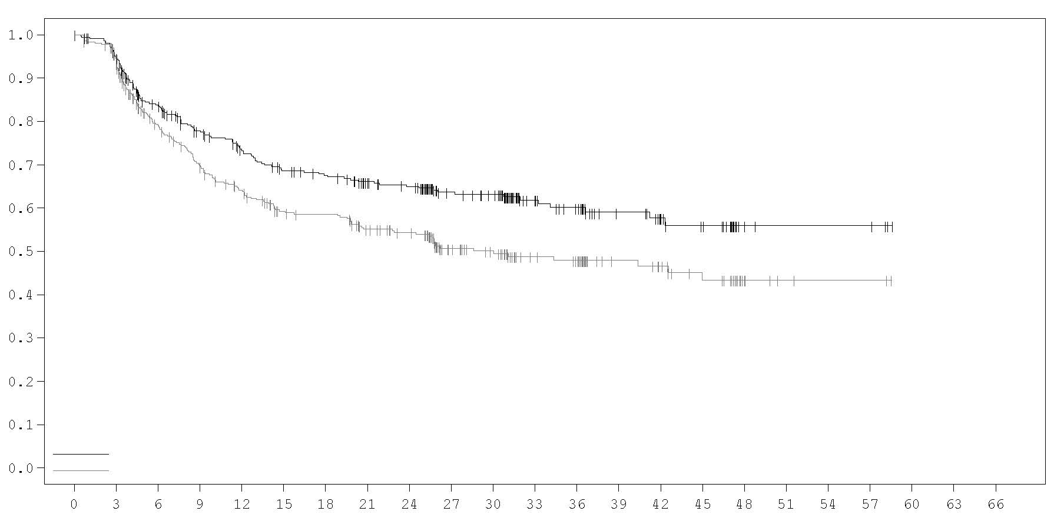
Median EFS in months (95% CI)
IMFINZI + SoC NR (42.3, NR)
Placebo + SoC 30 (20.6, NR)
HR (95% CI): 0.69 (0.55, 0.88)
IMFINZI + SoC
Placebo + SoC

Probability of event-free survival

IMFINZI + SoC
Placebo + SoC

Number of patients at risk

Time from randomisation (months)

366 | 337 | 276 | 240 | 219 | 201 | 194 | 179 | 172 | 128 | 121 | 76 | 67 | 48 | 36 | 29 | 6 | 4 | 4 | 4 | 0 | 0 | 0
374 | 338 | 261 | 225 | 201 | 176 | 172 | 151 | 142 | 93 | 83 | 57 | 53 | 36 | 32 | 25 | 8 | 3 | 2 | 2 | 0 | 0 | 0

NSCLC – PACIFIC Study
The efficacy of IMFINZI was evaluated in the PACIFIC Study, a randomised, double-blind, placebo-controlled, multicentre study in 713 patients with locally advanced, unresectable NSCLC. Patients had completed at least 2 cycles of definitive platinum-based chemotherapy with radiation therapy within 1 to 42 days prior to initiation of the study and had a ECOG performance status of 0 or 1. Ninety-two percent of patients had received a total dose of 54 to 66 Gy of radiation. The study excluded patients who had progressed following chemoradiation therapy, patients with prior exposure to any anti-PD-1 or anti-PD-L1 antibody, patients with active or prior documented autoimmune disease within 2 years of initiation of the study; a history of immunodeficiency; a history of severe immune-mediated adverse reactions; medical conditions that required systemic immunosuppression, except physiological dose of systemic corticosteroids; active tuberculosis or hepatitis B or C or HIV infection or patients receiving live attenuated vaccine within 30 days before or after the start of IMFINZI. Patients were randomised 2:1 to receive 10 mg/kg IMFINZI (n=476) or 10 mg/kg placebo (n=237) via intravenous infusion every 2 weeks for up to 12 months or until unacceptable toxicity or confirmed disease progression. Randomisation was stratified by gender, age (< 65 years vs. ≥ 65 years) and smoking status (smoker vs. non-smoker). Patients with disease control at 12 months were given the option to be re-treated upon disease progression. Tumour assessments were conducted every 8 weeks for the first 12 months and then every 12 weeks thereafter.

Patients were enrolled regardless of their tumour PD-L1 expression level. Where available, archival tumour tissue specimens taken prior to chemoradiation therapy were retrospectively tested for PD-L1 expression on tumour cells (TC) using the VENTANA PD-L1 (SP263) IHC assay. Of the 713 patients randomised, 63% of patients provided a tissue sample of sufficient quality and quantity to determine PD-L1 expression and 37% were unknown.

The demographics and baseline disease characteristics were well balanced between study arms. Baseline demographics of the overall study population were as follows: male (70%), age ≥ 65 years (45%), age ≥ 75 years (8%), White (69%), Asian (27%), other (4%), current smoker (16%), past-smoker (75%), never smoker (9%), ECOG Performance Status 0 (49%), ECOG Performance Status 1 (51%). Disease characteristics were as follows: Stage IIIA (53%), Stage IIIB (45%), histological sub-groups of squamous (46%), non-squamous (54%). Of 451 patients with PD-L1 expression available, 67% were TC ≥ 1% [PD-L1 TC 1-24% (32%), PD-L1 TC ≥ 25% (35%)] and 33% were TC < 1%.

The two primary endpoints of the study were progression-free survival (PFS) and overall survival (OS) of IMFINZI vs. placebo. Secondary efficacy endpoints included PFS at 12 months (PFS 12) and 18 months (PFS 18) from randomisation and Time from Randomisation to Second Progression (PFS2). PFS was assessed by Blinded Independent Central Review (BICR) according to RECIST v1.1.

The study demonstrated a statistically significant improvement in PFS in the IMFINZI-treated group compared with the placebo group [hazard ratio (HR)=0.52 (95% CI: 0.42, 0.65), p < 0.0001]. The study demonstrated a statistically significant improvement in OS in the IMFINZI-treated group compared with the placebo group [HR=0.68 (95% CI: 0.53, 0.87), p=0.00251].

In the 5-year follow-up analysis, with a median follow-up of 34.2 months, IMFINZI continued to demonstrate improved OS and PFS compared to placebo. The OS and PFS results from the primary analysis and the follow-up analysis are summarized in Table 6.

Table 6. Efficacy results for the PACIFIC Study
 | Primary analysisª |  | 5-year follow-up analysis^{b}
 | IMFINZI  (n=476) | Placebo  (n=237) | IMFINZI  (n=476) | Placebo  (n=237)
OS
Number of deaths (%) | 183 (38.4%) | 116 (48.9%) | 264 (55.5%) | 155 (65.4%)
Median (months)  (95% CI) | NR  (34.7, NR) | 28.7  (22.9, NR) | 47.5  (38.1, 52.9) | 29.1  (22.1, 35.1)
HR (95% CI) | 0.68 (0.53, 0.87) |  | 0.72 (0.59, 0.89)
2- sided p-value | 0.00251
OS at 24 months (%)  (95% CI) | 66.3%  (61.7%, 70.4%) | 55.6%  (48.9%, 61.3%) | 66.3%  (61.8%, 70.4%) | 55.3%  (48.6%, 61.4%)
p-value | 0.005
OS at 48 months (%)  (95% CI) |  |  | 49.7%  (45.0%, 54.2%) | 36.3%  (30.1%, 42.6%)
OS at 60 months (%)  (95% CI) |  |  | 42.9%  (38.2%, 47.4%) | 33.4%  (27.3%, 39.6%)
PFS
Number of events (%) | 214 (45.0%) | 157 (66.2%) | 268 (56.3%) | 175 (73.8%)
Median PFS (months)  (95% CI) | 16.8  (13.0, 18.1) | 5.6  (4.6, 7.8) | 16.9  (13.0, 23.9) | 5.6  (4.8, 7.7)
HR (95% CI) | 0.52 (0.42, 0.65) |  | 0.55 (0.45, 0.68)
p-value | p < 0.0001
PFS at 12 months (%)  (95% CI) | 55.9%  (51.0%, 60.4%) | 35.3%  (29.0%, 41.7%) | 55.7%  (51.0%, 60.2%) | 34.5%  (28.3%, 40.8%)
PFS at 18 months (%)  (95% CI) | 44.2%  (37.7%, 50.5%) | 27.0%  (19.9%, 34.5%) | 49.1%  (44.2%, 53.8%) | 27.5%  (21.6%, 33.6%)
PFS at 48 months (%)  (95% CI) |  |  | 35.0%  (29.9%, 40.1%) | 19.9%  (14.4%, 26.1%)
PFS at 60 months (%)  (95% CI) |  |  | 33.1%  (28.0%, 38.2%) | 19.0%  (13.6%, 25.2%)
PFS2^{c}
Median PFS2 (months)  (95% CI) | 28.3  (25.1, 34.7) | 17.1  (14.5, 20.7)
HR (95% CI) | 0.58 (0.46, 0.73)
p-value | p < 0.0001
ª Primary analysis of PFS at data cut-off 13 February 2017. Primary analysis of OS and PFS2 at data cut-off 22 March 2018.
^{b} Follow-up OS and PFS analysis at data cut-off 11 January 2021.
^{c} PFS2 is defined as the time from the date of randomisation until the date of second progression (defined by local standard clinical practice) or death.
NR: Not Reached

Kaplan-Meier curves for OS and PFS from the 5-year follow-up analysis are presented in Figures 2 and 3.

Figure 2. Kaplan-Meier curve of OS

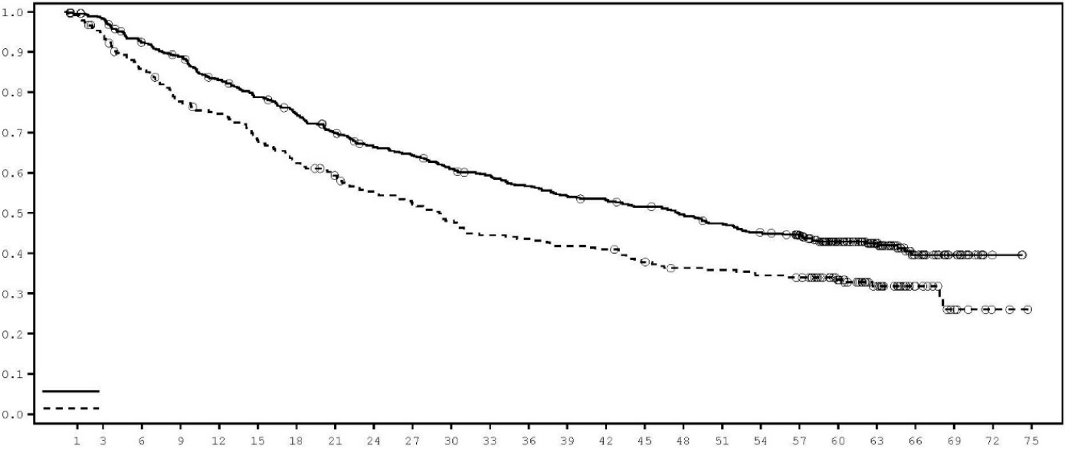
IMFINZI
Placebo
Median OS (95% CI)
IMFINZI 47.5 (38.1, 52.9)
Placebo 29.1 (22.1, 35.1)
Hazard ratio (95% CI): 0.72 (0.59, 0.89)
Probability of OS
Time from randomisation (months)

Number of patients at risk
Month | 0 | 3 | 6 | 9 | 12 | 15 | 18 | 21 | 24 | 27 | 30 | 33 | 36 | 39 | 42 | 45 | 48 |  | 51 |  | 54 | 57 | 60 | 63 | 66 | 69 | 72 | 75
IMFINZI | 476 | 464 | 431 | 414 | 385 | 364 | 343 | 319 | 298 | 289 | 273 | 264 | 252 | 241 | 236 | 227 | 218 |  | 207 |  | 196 | 183 | 134 | 91 | 40 | 18 | 2 | 0
Placebo | 237 | 220 | 199 | 179 | 171 | 156 | 143 | 133 | 123 | 116 | 107 | 99 | 97 | 93 | 91 | 83 | 78 |  | 77 |  | 74 | 72 | 56 | 33 | 16 | 7 | 2 | 0

Figure 3. Kaplan-Meier curve of PFS

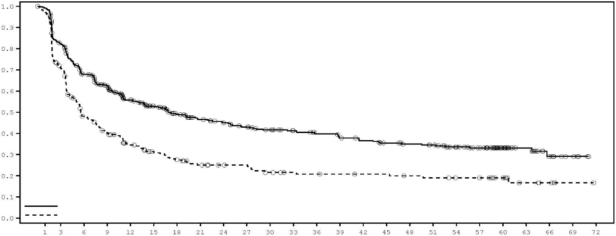
IMFINZI
Placebo
Median PFS (95% CI)
IMFINZI 16.9 (13.0, 23.9)
Placebo 5.6 (4.8, 7.7)
Hazard ratio (95% CI): 0.55 (0.45, 0.68)
Probability of PFS

Time from randomisation (months)

Number of patients at risk
Month | 0 | 3 | 6 | 9 | 12 | 15 | 18 | 21 | 24 | 27 | 30 | 33 | 36 | 39 | 42 | 45 | 48 |  | 51 |  | 54 |  | 57 |  | 60 |  | 63 |  | 66 |  | 69 |  | 72
IMFINZI | 476 | 377 | 301 | 267 | 215 | 190 | 165 | 147 | 137 | 128 | 119 | 110 | 103 | 97 | 92 | 85 | 81 |  | 78 |  | 67 |  | 57 |  | 34 |  | 22 |  | 11 |  | 5 |  | 0
Placebo | 237 | 164 | 105 | 87 | 68 | 56 | 48 | 41 | 37 | 36 | 30 | 27 | 26 | 25 | 24 | 24 | 22 |  | 21 |  | 19 |  | 19 |  | 14 |  | 6 |  | 4 |  | 1 |  | 0

The improvements in PFS and OS in favour of patients receiving IMFINZI compared to those receiving placebo were consistently observed in all predefined subgroups analysed, including ethnicity, age, gender, smoking history, EGFR mutation status and histology.

Post-hoc subgroup analysis by PD-L1 expression
Additional subgroup analyses were conducted to evaluate the efficacy by tumour PD-L1 expression (≥ 25%, 1-24%, ≥ 1%, < 1%) and for patients whose PD-L1 status cannot be established (PD-L1 unknown). PFS and OS results from the 5-year follow-up analysis are summarised in Figures 4, 5, 6 and 7.

Figure 4. Kaplan-Meier curve of OS for PD-L1 TC ≥ 1%
Probability of OS
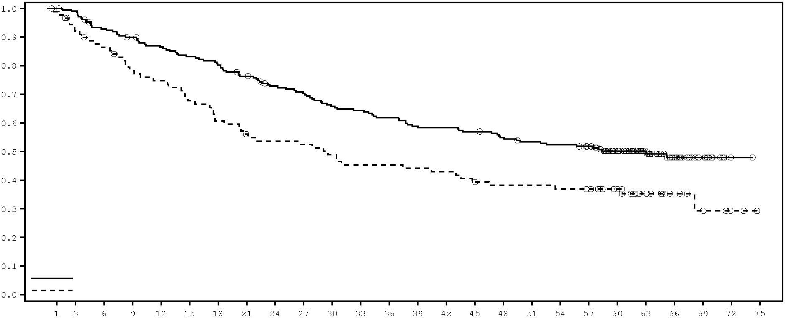
IMFINZI
Placebo
Median OS (95% CI)
IMFINZI 63.1 (43.7, NR)
Placebo 29.6 (17.7, 44.7)
Hazard ratio (95% CI): 0.61 (0.44, 0.85)
Time from randomisation (months)
Number of patients at risk
Month | 0 | 3 | 6 | 9 | 12 | 15 | 18 | 21 | 24 | 27 | 30 | 33 | 36 | 39 | 42 | 45 | 48 | 51 | 54 | 57 | 60 | 63 | 66 | 69 | 72 | 75
IMFINZI | 212 | 208 | 193 | 186 | 178 | 171 | 165 | 156 | 146 | 141 | 132 | 129 | 124 | 118 | 117 | 114 | 109 | 105 | 103 | 98 | 74 | 52 | 29 | 14 | 1 | 0
Placebo | 91 | 81 | 75 | 67 | 64 | 58 | 52 | 47 | 45 | 44 | 41 | 38 | 38 | 37 | 36 | 33 | 31 | 31 | 30 | 29 | 24 | 14 | 8 | 5 | 2 | 0

Figure 5. Kaplan-Meier curve of PFS for PD-L1 TC ≥ 1%

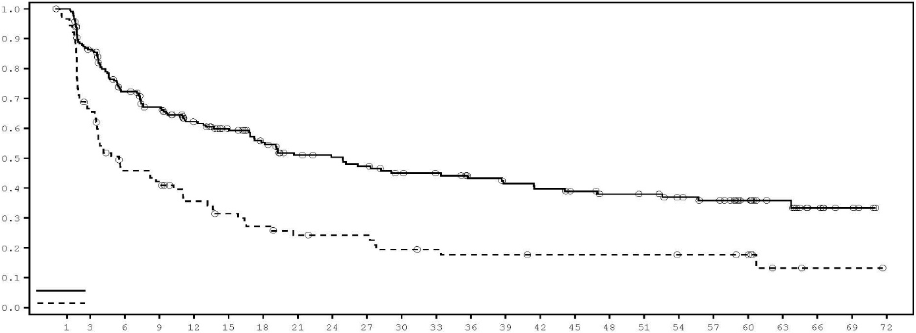
IMFINZI
Placebo
Median PFS (95% CI)
IMFINZI 24.9 (16.9, 38.7)
Placebo 5.5 (3.6, 10.3)
Hazard ratio (95% CI): 0.47 (0.35, 0.64)
Probability of PFS
Time from randomisation (months)

Number of patients at risk
Month | 0 | 3 | 6 | 9 | 12 | 15 | 18 | 21 | 24 | 27 | 30 | 33 | 36 | 39 | 42 | 45 | 48 |  | 51 |  | 54 |  | 57 |  | 60 |  | 63 |  | 66 |  | 69 |  | 72
IMFINZI | 212 | 175 | 142 | 127 | 107 | 95 | 82 | 70 | 67 | 63 | 57 | 55 | 50 | 47 | 45 | 42 | 39 |  | 38 |  | 34 |  | 31 |  | 22 |  | 15 |  | 8 |  | 4 |  | 0
Placebo | 91 | 59 | 38 | 34 | 26 | 22 | 19 | 16 | 15 | 15 | 12 | 11 | 10 | 10 | 9 | 9 | 9 |  | 9 |  | 8 |  | 8 |  | 7 |  | 2 |  | 1 |  | 1 |  | 0

Figure 6. Forest plot of OS by PD-L1 expression
Events/N (%)
IMFINZI Placebo

264/476 (55.5%) 155/237 (65.4%)

103/212 (48.6%) 56/91 (61.5%)

51/115 (44.3%) 27/44 (61.4%)

52/97 (53.6%) 29/47 (61.7%)

59/90 (65.6%) 35/58 (60.3%)

102/174 (58.6%) 64/88 (72.7%)
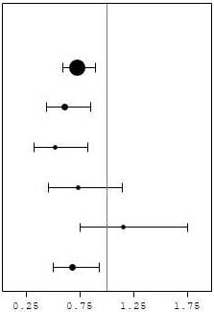
All Patients

PD-L1 TC ≥ 1%

PD-L1 TC ≥ 25%

PD-L1 TC 1-24%

PD-L1 TC < 1%

PD-L1 Unknown

Figure 7. Forest plot of PFS by PD-L1 expression
Events/N (%)
IMFINZI Placebo

268/476 (56.3%) 175/237 (73.8%)

111/212 (52.4%) 69/91 (75.8%)

61/115 (53.0%) 33/44 (75.0%)

50/97 (51.5%) 36/47 (76.6%)

55/90 (61.1%) 41/58 (70.7%)

102/174 (58.6%) 65/88 (73.9%)
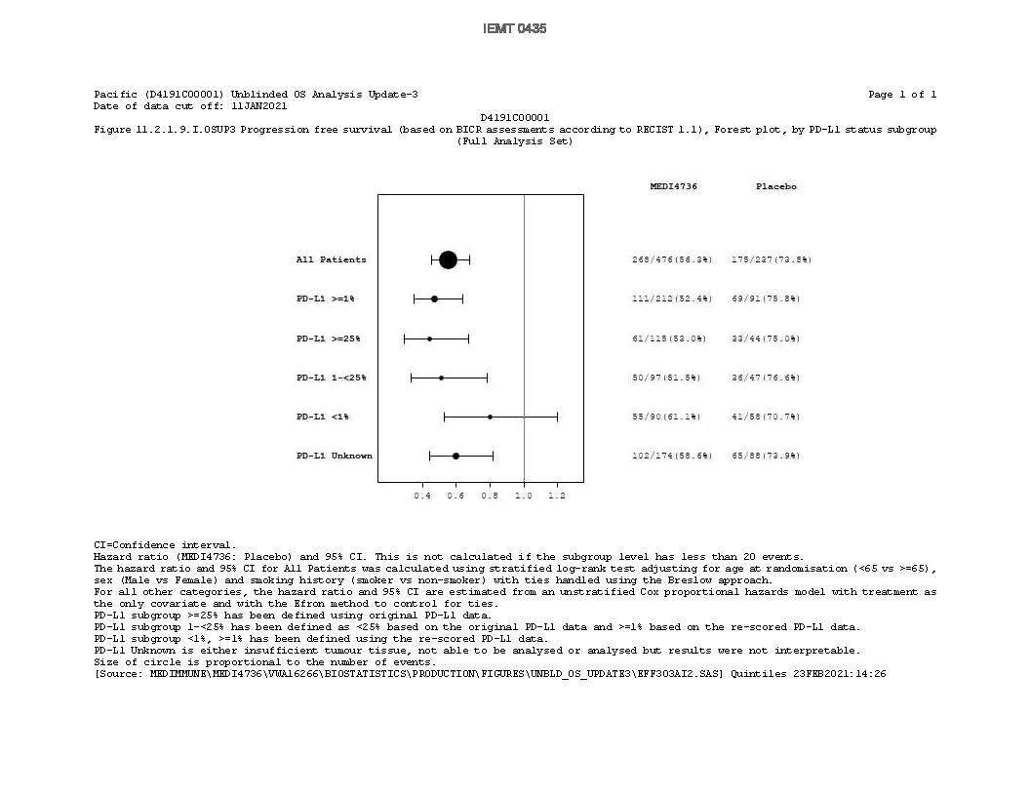
All Patients

PD-L1 TC ≥ 1%

PD-L1 TC ≥ 25%

PD-L1 TC 1-24%

PD-L1 TC < 1%

PD-L1 Unknown

Overall the safety profile of durvalumab in PD-L1 TC ≥ 1% subgroup was consistent with the intent to treat population, as was the PD-L1 TC < 1% subgroup.

Patient-reported outcomes (PRO)
Patient-reported symptoms, function and health-related quality of life (HRQoL) were collected using the EORTC QLQ-C30 and its lung cancer module (EORTC QLQ-LC13). The LC13 and C30 were assessed at baseline, every 4 weeks for the first 8 weeks, followed by every 8 weeks until completion of the treatment period or discontinuation of IMFINZI due to toxicity or disease progression. Compliance was similar between the IMFINZI and placebo treatment groups (83% vs. 85.1% overall of evaluable forms completed).

At baseline, no differences in patient-reported symptoms, function and HRQoL were observed between IMFINZI and placebo groups. Throughout the duration of the study to Week 48, there was no clinically meaningful difference between IMFINZI and placebo groups in symptoms, functioning and HRQoL (as assessed by a difference of greater than or equal to 10 points).

NSCLC – POSEIDON Study
POSEIDON was a study designed to evaluate the efficacy of IMFINZI with or without tremelimumab in combination with platinum-based chemotherapy. POSEIDON was a randomised, open-label, multi-centre study in 1013 metastatic NSCLC patients with no sensitising epidermal growth factor receptor (EGFR) mutation or anaplastic lymphoma kinase (ALK) genomic tumour aberrations. Patients with histologically or cytologically documented metastatic NSCLC were eligible for enrolment. Patients had no prior chemotherapy or any other systemic therapy for metastatic NSCLC. Prior to randomisation, patients had tumour PD-L1 status confirmed by using the Ventana PD-L1 (SP263) assay. Patients had a World Health Organization (WHO)/Eastern Cooperative Oncology Group (ECOG) performance status of 0 or 1 at enrolment.

The study excluded patients with active or prior documented autoimmune disease; active and/or untreated brain metastases; a history of immunodeficiency; administration of systemic immunosuppression within 14 days before the start of IMFINZI or tremelimumab, except physiological dose of systemic corticosteroids; active tuberculosis or hepatitis B or C or HIV infection; or patients receiving live attenuated vaccine within 30 days before or after the start of IMFINZI and/or tremelimumab (see section 4.4).

Randomisation was stratified by tumour cells (TC) PD-L1 expression (TC ≥ 50% vs. TC < 50%), disease stage (Stage IVA vs. Stage IVB, per the 8th edition of American Joint Committee on Cancer), and histology (non-squamous vs. squamous).

Patients were randomised 1:1:1 to receive:
- Arm 1: IMFINZI 1 500 mg with tremelimumab 75 mg and platinum-based chemotherapy every 3 weeks for 4 cycles followed by, IMFINZI 1 500 mg every 4 weeks as monotherapy. A fifth dose of tremelimumab 75 mg was given at Week 16 alongside IMFINZI dose 6.
- Arm 2: IMFINZI 1 500 mg and platinum-based chemotherapy every 3 weeks for 4 cycles, followed by IMFINZI 1 500 mg every 4 weeks as monotherapy.
- Arm 3: Platinum-based chemotherapy every 3 weeks for 4 cycles. Patients could receive 2 additional cycles (a total of 6 cycles post-randomisation), as clinically indicated, at the Investigator’s discretion.

In the 3 treatment arms, patients received one of the following histology-based chemotherapy regimens:
- Non-squamous NSCLC
  - Pemetrexed 500 mg/m² with carboplatin AUC 5-6 or cisplatin 75 mg/m² every 3 weeks. Unless contraindicated by the investigator, pemetrexed maintenance could be given.
- Squamous NSCLC
  - Gemcitabine 1 000 or 1 250 mg/m² on Days 1 and 8 with cisplatin 75 mg/m² or carboplatin AUC 5-6 on Day 1 every 3 weeks.
- Non-squamous or squamous NSCLC
  - Nab-paclitaxel 100 mg/m² on Days 1, 8, and 15 with carboplatin AUC 5-6 on Day 1 every 3 weeks.

Tremelimumab was given up to a maximum of 5 doses unless there was disease progression or unacceptable toxicity. IMFINZI and histology-based pemetrexed maintenance therapy (when applicable) was continued until disease progression or unacceptable toxicity.

Tumour assessments were conducted at Week 6 and Week 12 from the date of randomisation, and then every 8 weeks until confirmed objective disease progression. Survival assessments were conducted every 2 months following treatment discontinuation.

The dual primary endpoints of the study were PFS and OS for IMFINZI + platinum-based chemotherapy vs. platinum-based chemotherapy alone. The key secondary endpoints of the study were PFS and OS for IMFINZI + tremelimumab + platinum-based chemotherapy and platinum-based chemotherapy alone. The secondary endpoints included objective response rate (ORR) and Duration of Response (DoR). PFS, ORR, and DoR, were assessed using BICR according to RECIST v1.1.

The demographics and baseline disease characteristics were well-balanced between study arms. Baseline demographics of the overall study population were as follows: male (76.0%), age ≥ 65 years (47.1%), age ≥ 75 years (11.3%) median age 64 years (range: 27 to 87 years), White (55.9%), Asian (34.6%), Black or African American (2.0%), Other (7.6%), non-Hispanic or Latino (84.2%), current smoker or past-smoker (78.0%), WHO/ECOG PS 0 (33.4%), WHO/ECOG PS 1 (66.5%). Disease characteristics were as follows: Stage IVA (50.0%), Stage IVB (49.6%), histological sub-groups of squamous (36.9%), non-squamous (62.9%), brain metastases (10.5%), PD-L1 expression TC≥ 50% (28.8%), PD-L1 expression TC < 50% (71.1%).

The study showed a statistically significant improvement in OS with IMFINZI + tremelimumab + platinum-based chemotherapy vs. platinum-based chemotherapy. IMFINZI + tremelimumab + platinum-based chemotherapy showed a statistically significant improvement in PFS vs. platinum-based chemotherapy alone. The results are summarised below.

Table 7. Efficacy results for the POSEIDON study
 | Arm 1: IMFINZI+tremelimumab +platinum-based chemotherapy (n=338) | Arm 3: Platinum-based chemotherapy  (n=337)
OSª
Number of deaths (%) | 251 (74.3) | 285 (84.6)
Median OS (months)  (95% CI) | 14.0  (11.7, 16.1) | 11.7  (10.5, 13.1)
HR (95% CI) ^{b} | 0.77 (0.650, 0.916)
p-value^{c} | 0.00304
PFSª
Number of events (%) | 238 (70.4) | 258 (76.6)
Median PFS (months)  (95% CI) | 6.2  (5.0, 6.5) | 4.8  (4.6, 5.8)
HR (95% CI)^{b} | 0.72 (0.600, 0.860)
p-value^{c} | 0.00031
ORR n (%)^{d,e} | 130 (38.8) | 81 (24.4)
Complete Response n (%) | 2 (0.6) | 0
Partial Response n (%) | 128 (38.2) | 81 (24.4)
Median DoR (months)  (95% CI)^{d,e} | 9.5  (7.2, NR) | 5.1  (4.4, 6.0)
ª Analysis of PFS at data cut off 24 July 2019 (median follow-up 10.15 months). Analysis of OS at data cut off 12 March 2021 (median follow-up 34.86 months). The boundaries for declaring efficacy (Arm 1 vs. Arm 3: PFS 0.00735, OS 0.00797; 2-sided) were determined by a Lan-DeMets alpha spending function that approximates an O’Brien Fleming approach. PFS was assessed by BICR according to RECIST v1.1.
^{b} HR are derived using a Cox pH model stratified by PD-L1, histology and disease stage.
^{c} 2-sided p-value based on a log-rank test stratified by PD-L1, histology and disease stage.
^{d} Confirmed Objective Response.
^{e} Post-hoc analysis.
NR=Not Reached, CI=Confidence Interval

Figure 8. Kaplan-Meier curve of OS
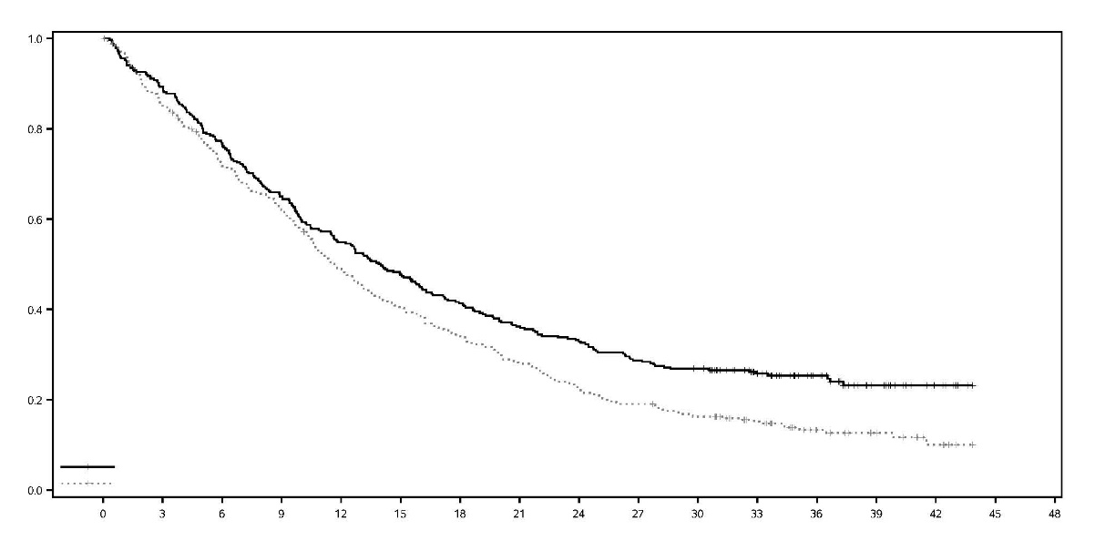
 | Median OS | (95% CI)
IMFINZI + tremelimumab+platinum-based chemotherapy | 14.0 | (11.7, 16.1)
Platinum-based chemotherapy | 11.7 | (10.5, 13.1)
Hazard Ratio (95% CI)
IMFINZI + tremelimumab + platinum-based chemotherapy | 0.77 | (0.650, 0.916)

Time from randomisation (months)

IMFINZI + tremelimumab + platinum-based chemotherapy
Platinum-based chemotherapy
Probability of OS

Number of patients at risk
Month
 | 0 | 3 | 6 | 9 | 12 | 15 | 18 | 21 | 24 | 27 | 30 | 33 | 36 | 39 | 42 | 45
IMFINZI + tremelimumab + platinum-based chemotherapy
 | 338 | 298 | 256 | 217 | 183 | 159 | 137 | 120 | 109 | 95 | 88 | 64 | 41 | 20 | 9 | 0
Platinum-based chemotherapy
 | 337 | 284 | 236 | 204 | 160 | 132 | 111 | 91 | 72 | 62 | 52 | 38 | 21 | 13 | 6 | 0

Figure 9. Kaplan-Meier curve of PFS
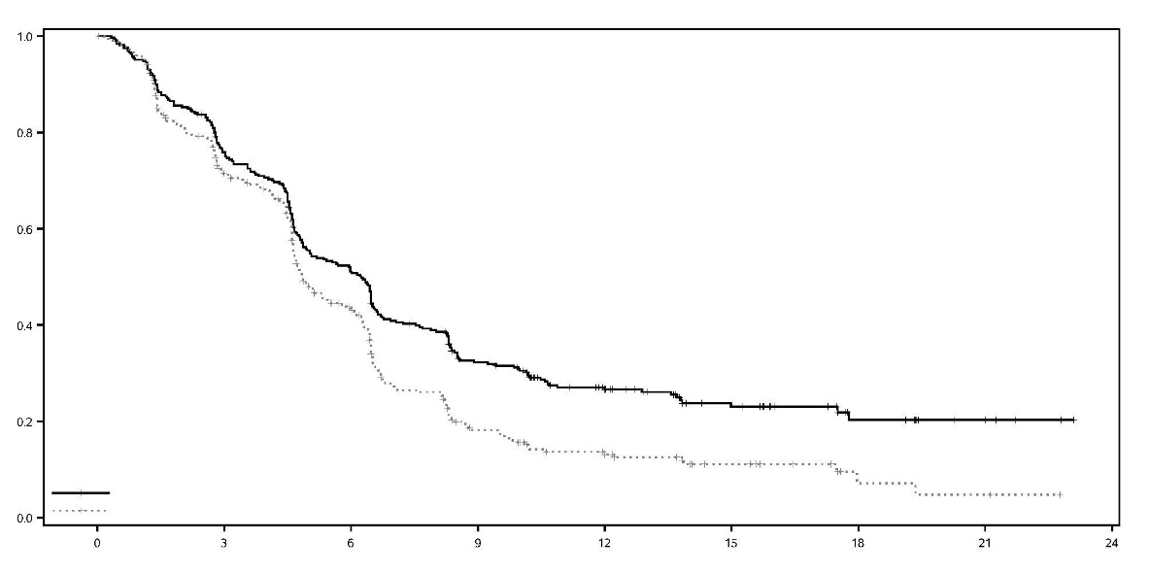
Time from randomisation (months)
 | Median PFS | (95% CI
IMFINZI + tremelimumab+platinum-based chemotherapy | 6.2 | (5.0, 6.5)
Platinum-based chemotherapy | 4.8 | (4.6, 5.8)
Hazard Ratio (95% CI)
IMFINZI + tremelimumab+platinum-based chemotherapy | 0.72 | (0.600, 0.860)

IMFINZI + tremelimumab+platinum-based chemotherapy
Platinum-based chemotherapy
Probability of PFS

Number of patients at risk
Month
 | 0 | 3 | 6 | 9 | 12 | 15 | 18 | 21 | 24
IMFINZI + tremelimumab + platinum-based chemotherapy
 | 338 | 243 | 161 | 94 | 56 | 32 | 13 | 5 | 0
Platinum-based chemotherapy
 | 337 | 219 | 121 | 43 | 23 | 12 | 3 | 2 | 0

Figure 10 summarises efficacy results of OS by tumour PD-L1 expression in prespecified subgroup analyses.

Figure 10. Forest plot of OS by PD-L1 expression for IMFINZI+tremelimumab+platinum-based chemotherapy vs. platinum-based chemotherapy
No of events/patients (%)
IMFINZI+tremelimumab+platinum-based chemotherapy | Platinum-based chemotherapy | HR (95% CI)
251 /338 (74.3%) | 285 /337 (84.6%) | 0.77 (0.65, 0.92)
69 /101 (68.3%) | 80 / 97 (82.5%) | 0.65 (0.47, 0.89)
182 /237 (76.8%) | 205 /240 (85.4%) | 0.82 (0.67, 1.00)
151 /213 (70.9%) | 170 /207 (82.1%) | 0.76 (0.61, 0.95)
100 /125 (80.0%) | 115 /130 (88.5%) | 0.77 (0.58, 1.00)

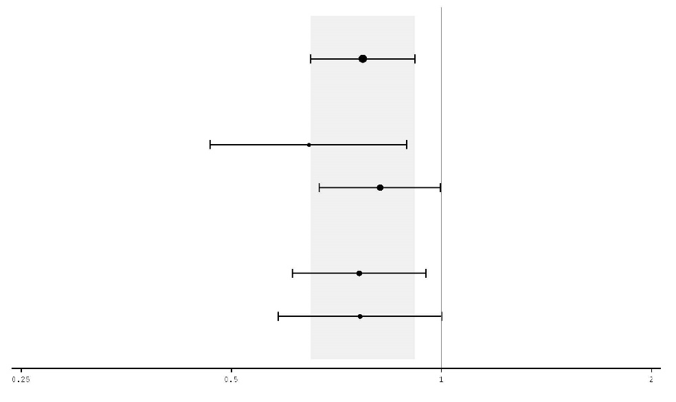
All Patients

PD-L1 ≥ 50%

PD-L1 < 50%

PD-L1 ≥ 1%

PD-L1 < 1%

Hazard Ratio (95% CI)

Elderly population

A total of 75 patients aged ≥ 75 years were enrolled in the IMFINZI in combination with tremelimumab and chemotherapy (n=35) and platinum-based chemotherapy only (n=40) arms of the POSEIDON study. An exploratory HR of 1.05 (95% CI: 0.64, 1.71) for OS was observed for the IMFINZI in combination with tremelimumab and platinum-based chemotherapy vs. platinum-based chemotherapy within this study subgroup. Due to the exploratory nature of this subgroup analysis no definitive conclusions can be drawn, but caution is suggested when considering this regimen for elderly patients.

SCLC – ADRIATIC Study
ADRIATIC was a study designed to evaluate the efficacy of IMFINZI with or without tremelimumab. ADRIATIC was a randomised, double-blind, placebo-controlled, multicentre study in 730 patients with histologically or cytologically confirmed LS-SCLC (Stage I to III according to AJCC, 8th edition) who had not progressed following concurrent chemoradiation therapy. Patients who were Stage I or II had to be medically inoperable as determined by the investigator. Patients completed 4 cycles of definitive platinum-based chemoradiation, 60-66 Gy once daily (QD) over 6 weeks or 45 Gy twice daily (BID) over 3 weeks, within 1 to 42 days prior to the first dose of study treatment. Prophylactic cranial irradiation (PCI) could be delivered at the discretion of the investigator after chemoradiation therapy and within 1 to 42 days prior to the first dose of study treatment. Patients had a WHO/ECOG performance status of 0 or 1 at enrolment.

The study excluded patients with active or prior documented autoimmune disease within 5 years of initiation of the study; a history of active primary immunodeficiency; a history of Grade ≥ 2 pneumonitis or active tuberculosis or hepatitis B or C or HIV infection and patients with active interstitial lung disease. Patients with mixed SCLC and NSCLC histology were also excluded.

Randomisation was stratified by stage (I/II vs. III) and receipt of PCI (yes vs. no). Patients were randomised 1:1:1 to receive:

- Arm 1: IMFINZI 1 500 mg + placebo every 4 weeks for 4 cycles, followed by IMFINZI 1 500 mg every 4 weeks.
- Arm 2: Placebo + a second placebo every 4 weeks for 4 cycles, followed by a single placebo every 4 weeks.
- Arm 3: IMFINZI 1 500 mg + tremelimumab 75 mg every 4 weeks for 4 cycles, followed by IMFINZI 1 500 mg every 4 weeks.

Once 600 patients had been randomised across all three arms, randomisation to arm 3 was complete and the subsequent 130 patients were randomised 1:1 to either arm 1 or 2, and received either IMFINZI 1 500 mg every 4 weeks or placebo every 4 weeks.

Treatment continued until disease progression, until unacceptable toxicity, or for a maximum of 24 months. Tumour assessments were conducted every 8 weeks for the first 72 weeks, then every 12 weeks up to 96 weeks and then every 24 weeks thereafter.

The demographics and baseline disease characteristics were well balanced between study arms. Baseline demographics and disease characteristics of the IMFINZI and placebo arms were as follows: male (69.1%), age ≥ 65 years (39.2%), White (50.4%), Black or African-American (0.8%), Asian (47.5%), other (1.3%), Hispanic or Latino (4.2%), current smoker (22.3%), past-smoker (68.5%), never smoker (9.2%), WHO/ECOG PS 0 (48.7%), WHO/ECOG PS 1 (51.3%), Stage I (3.6%), Stage II (9.1%), Stage III (87.4%).

Prior to randomisation, all patients received platinum-based chemotherapy (66.2% cisplatin-etoposide, 33.8% carboplatin-etoposide); 72.1% of patients received RT QD (of which 92.4% received ≥ 60-≤ 66 Gy QD); 27.9% received RT BID (of which 96.6% received 45 Gy BID) and 53.8% of patients received PCI. Response to CRT was as follows: complete response (12.3%), partial response (73.8%), stable disease (14.0%).

The dual primary endpoints of the study were OS and PFS of IMFINZI vs. placebo. Secondary efficacy endpoints included ORR of IMFINZI vs. placebo. PFS and ORR were assessed by BICR according to RECIST v1.1.

At a planned interim analysis, the study demonstrated a statistically significant improvement in OS and PFS for IMFINZI compared with placebo. See Table 8 and Figures 11 and 12.

Table 8. Efficacy results for the ADRIATIC study
 | Arm 1: IMFINZI (n=264) | Arm 2: Placebo (n=266)
OSª
Number of deaths (%) | 115 (43.6) | 146 (54.9)
Median OS (months) (95% CI)^{b} | 55.9 (37.3, NR) | 33.4 (25.5, 39.9)
HR (95% CI)^{c} | 0.73 (0.569, 0.928)
p-value^{d} | 0.01042
PFS^{e}
Number of events (%) | 139 (52.7) | 169 (63.5)
Median PFS (months) (95% CI)^{b} | 16.6 (10.2, 28.2) | 9.2 (7.4, 12.9)
HR (95% CI)^{f} | 0.76 (0.606, 0.950)
p-value^{d} | 0.01608
ª Median duration of OS follow-up in censored patients was 37.19 months in the IMFINZI arm and 37.24 months in the placebo arm.
^{b} Calculated using the Kaplan Meier technique. CI for median derived based on Brookmeyer-Crowley method.
^{c} The analysis for HR was performed using a stratified Cox proportional hazards model and the 2-sided p-value is based on a stratified log-rank test, both are adjusted for receipt of PCI.
^{d} p-value based on the results from the pre-planned interim analysis. Based on a Lan-DeMets alpha spending function O'Brien Fleming type boundary and the actual number of events observed, the boundary for declaring statistical significance for OS was 0.01679 for a 4.5% overall alpha and for PFS was 0.02805 for a 5% overall alpha (Lan◦and◦DeMets 1983).
^{e} Assessed by BICR according to RECIST v1.1.
^{f} The analysis for HR was performed using a stratified Cox proportional hazards model and the 2-sided p-value is based on a stratified log-rank test, both are adjusted for TNM stage and receipt of PCI.

Figure 11: Kaplan-Meier Curve of OS
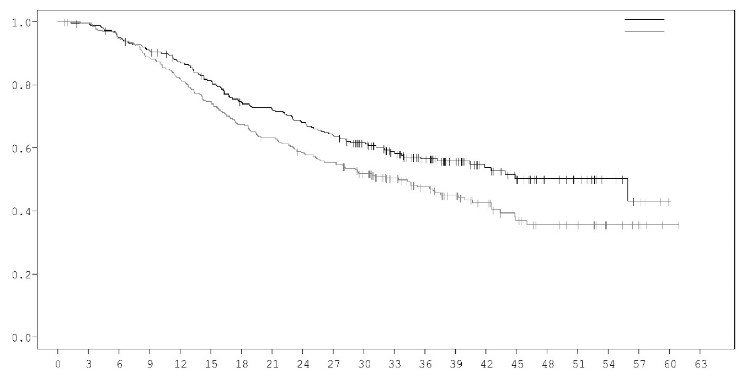
Probability of OS
Time from randomisation (months)
IMFINZI
Placebo

Number of patients at risk
 | 0 | 3 | 6 | 9 | 12 | 15 | 18 | 21 | 24 | 27 | 30 | 33 | 36 | 39 | 42 | 45 | 48 | 51 | 54 | 57 | 60 | 63
IMFINZI | 264 | 261 | 248 | 236 | 223 | 207 | 189 | 183 | 172 | 162 | 141 | 110 | 90 | 68 | 51 | 39 | 27 | 19 | 11 | 5 | 1 | 0
Placebo | 266 | 260 | 247 | 231 | 214 | 195 | 175 | 164 | 151 | 143 | 123 | 97 | 80 | 62 | 44 | 31 | 23 | 19 | 8 | 5 | 1 | 0

Figure 12: Kaplan-Meier Curve of PFS
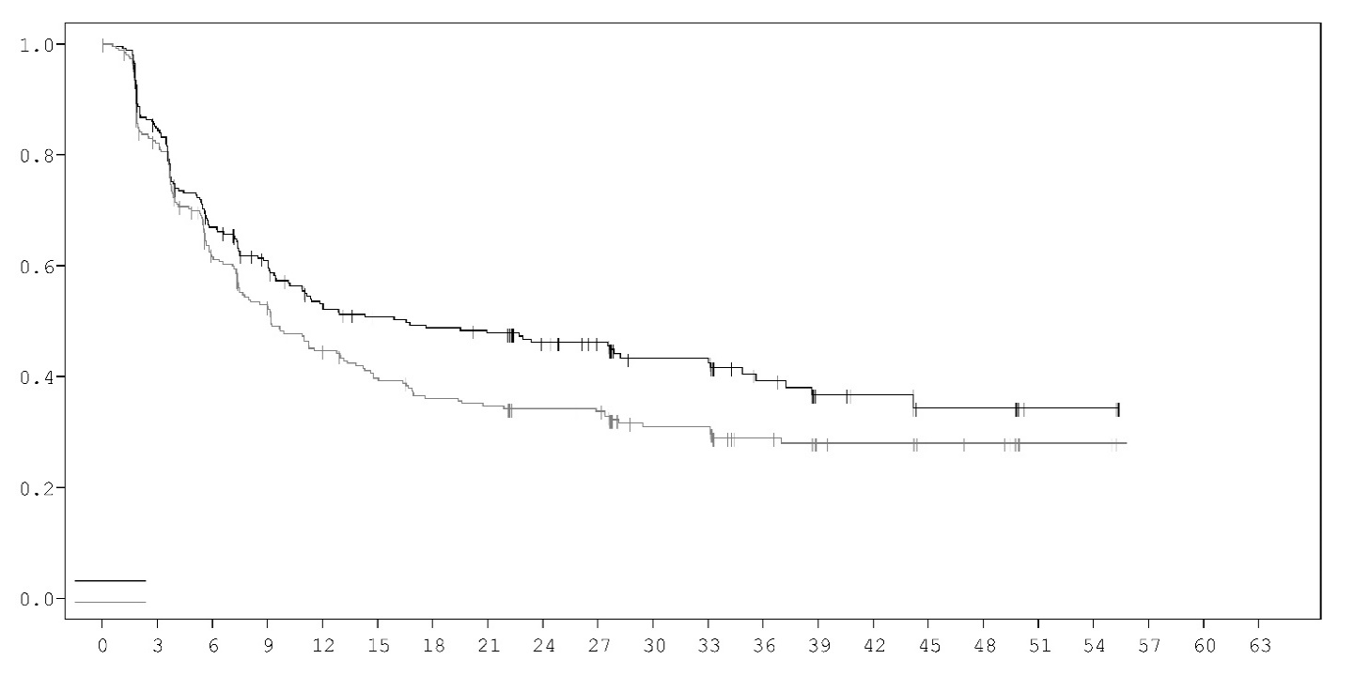
Time from randomisation (months)
Probability of PFS
IMFINZI
Placebo

Number of patients at risk
 | 0 | 3 | 6 | 9 | 12 | 15 | 18 | 21 | 24 | 27 | 30 | 33 | 36 | 39 | 42 | 45 | 48 | 51 | 54 | 57 | 60 | 63
IMFINZI | 264 | 212 | 161 | 135 | 113 | 105 | 101 | 98 | 84 | 78 | 51 | 51 | 33 | 21 | 19 | 10 | 10 | 4 | 4 | 0 | 0 | 0
Placebo | 266 | 208 | 146 | 122 | 100 | 88 | 79 | 76 | 71 | 69 | 47 | 47 | 34 | 23 | 22 | 15 | 14 | 5 | 5 | 0 | 0 | 0

SCLC – CASPIAN Study
CASPIAN was a study designed to evaluate the efficacy of IMFINZI with or without tremelimumab in combination with etoposide and either carboplatin or cisplatin. CASPIAN was a randomised, open-label, multicentre study in 805 treatment naïve ES-SCLC patients with WHO/ECOG Performance status of 0 or 1, body weight > 30 kg, suitable to receive a platinum-based chemotherapy regimen as first-line treatment for SCLC, with life expectancy ≥ 12 weeks, at least one target lesion by RECIST 1.1 and adequate organ and bone marrow function. Patients with asymptomatic or treated brain metastases were eligible. The study excluded patients with a history of chest radiation therapy; a history of active primary immunodeficiency; autoimmune disorders including paraneoplastic syndrome (PNS); active or prior documented autoimmune or inflammatory disorders; use of systemic immunosuppressants within 14 days before the first dose of the treatment except physiological dose of systemic corticosteroids; active tuberculosis or hepatitis B or C or HIV infection; or patients receiving live attenuated vaccine within 30 days before or after the start of IMFINZI.

Randomisation was stratified by the planned platinum-based (carboplatin or cisplatin) therapy in cycle 1.

Patients were randomised 1:1:1 to receive:

- Arm 1: IMFINZI 1 500 mg + tremelimumab 75 mg + etoposide and either carboplatin or cisplatin.
- Arm 2: IMFINZI 1 500 mg + etoposide and either carboplatin or cisplatin.
- Arm 3: Either carboplatin (AUC 5 or 6 mg/ml/min) or cisplatin (75-80 mg/m²) on Day 1 and etoposide (80-100 mg/m²) intravenously on Days 1, 2, and 3 of each 21-day cycle for between 4 – 6 cycles.

For patients randomised to Arm 1 and 2, etoposide and either carboplatin or cisplatin was limited to 4 cycles on an every 3-week schedule subsequent to randomisation. IMFINZI monotherapy continued every 4 weeks until disease progression or unacceptable toxicity. Administration of IMFINZI monotherapy was permitted beyond disease progression if the patient was clinically stable and deriving clinical benefit as determined by the investigator.

Patients randomised to Arm 3 were permitted to receive a total of up to 6 cycles of etoposide and either carboplatin or cisplatin. After completion of etoposide + platinum, PCI was permitted only in Arm 3 per investigator discretion.
Tumour assessments were conducted at Week 6 and Week 12 from the date of randomisation, and then every 8 weeks until confirmed objective disease progression. Survival assessments were conducted every 2 months following treatment discontinuation.

The primary endpoints of the study were OS of IMFINZI + etoposide + platinum (Arm 2) vs. etoposide + platinum alone (Arm 3) and IMFINZI + tremelimumab + etoposide + platinum (Arm 1) vs. etoposide + platinum alone (Arm 3). The key secondary endpoint was PFS. Other secondary endpoints were ORR, OS and PFS landmarks and PRO. PFS and ORR were assessed using Investigator assessments according to RECIST v1.1.

The demographics and baseline disease characteristics were well balanced between the two study arms (268 patients in Arm 2 and 269 patients in Arm 3). Baseline demographics of the overall study population were as follows: male (69.6%), age ≥ 65 years (39.6%), median age 63 years (range: 28 to 82 years), white (83.8%), Asian (14.5%), Black or African American (0.9%), other (0.6 %), non-Hispanic or Latino (96.1%), current or past-smoker (93.1%), never smoker (6.9%), WHO/ECOG PS 0 (35.2%), WHO/ECOG PS 1 (64.8%), Stage IV 90.3%, 24.6% of the patients received cisplatin and 74.1% of the patients received carboplatin. In Arm 3, 56.8% of the patients received 6 cycles of etoposide + platinum and 7.8% of the patients received PCI.

At a planned interim (primary) analysis the study demonstrated a statistically significant improvement in OS with IMFINZI + etoposide + platinum (Arm 2) vs. etoposide + platinum alone (Arm 3) [HR=0.73 (95% CI: 0.591, 0.909), p=0.0047]. Although not formally tested for significance, IMFINZI + etoposide + platinum demonstrated an improvement in PFS vs. etoposide + platinum alone [HR=0.78 (95% CI: 0.645, 0.936)].

The PFS, ORR and DoR results from the planned final analysis (DCO: 27 Jan 2020) are summarized in Table 9. Kaplan-Meier curve for PFS is presented in Figure 14.

The OS results with the planned long-term OS follow-up analysis (DCO: 22 March 2021) (median follow-up: 39.3 months) are presented in Table 9. IMFINZI + etoposide + platinum (Arm 2) vs. etoposide + platinum (Arm 3) continued to demonstrate sustained improvement in OS. Kaplan-Meier curve for OS is presented in Figure 13.

Table 9. Efficacy Results for the CASPIAN Study
 | Final analysisª |  | Long-term follow-up analysis^{b}
 | Arm 2: IMFINZI + etoposide and either carboplatin or cisplatin  (n=268) | Arm 3: etoposide + and either carboplatin or cisplatin  (n=269) | Arm 2: IMFINZI + etoposide and either carboplatin or cisplatin  (n=268) | Arm 3: etoposide + and either carboplatin or cisplatin  (n=269)
OS
Number of deaths (%) | 210 (78.4) | 231 (85.9) | 221 (82.5) | 248 (92.2)
Median OS (months)  (95% CI) | 12.9  (11.3, 14.7) | 10.5  (9.3, 11.2) | 12.9  (11.3, 14.7) | 10.5  (9.3, 11.2)
HR (95% CI)^{b,c} | 0.75 (0.625, 0.910) |  | 0.71 (0.595, 0.858)
p-value^{d} | 0.0032 |  | 0.0003
OS at 18 months (%) (95% CI) | 32.0  (26.5, 37.7) | 24.8  (19.7, 30.1) | 32.0  (26.5, 37.7) | 24.8  (19.7, 30.1)
OS at 36 months (%) (95% CI) |  |  | 17.6  (13.3, 22.4) | 5.8  (3.4, 9.1)
PFS
Number of events (%) | 234 (87.3) | 236 (87.7)
Median PFS (months)  (95% CI) | 5.1  (4.7, 6.2) | 5.4  (4.8, 6.2)
HR (95% CI)^{c} | 0.80 (0.665, 0.959)
PFS at 6 months (%)  (95% CI) | 45.4  (39.3, 51.3) | 45.8  (39.5, 51.9)
PFS at 12 months (%) (95% CI) | 17.9  (13.5, 22.8) | 5.3  (2.9, 8.8)
ORR n (%)  (95% CI)^{e} | 182 (67.9)  (62.0, 73.5) | 156 (58.0)  (51.8, 64.0)
Complete Response n (%) | 7 (2.6) | 2 (0.7)
Partial Response n (%) | 175 (65.3) | 154 (57.2)
Median DoR (months)  (95% CI)^{e,f} | 5.1  (4.9, 5.3) | 5.1  (4.8, 5.3)
ª Final PFS, ORR and DoR analysis at data cut-off 27 January 2020.
^{b} Long-term follow-up OS analysis at data cut-off 22 March 2021.
^{c} The analysis was performed using the stratified log-rank test, adjusting for planned platinum therapy in Cycle 1 (carboplatin or cisplatin), and using the rank tests of association approach.
^{d} At the interim analysis (data cut-off 11 March 2019) the OS p-value was 0.0047, which met the boundary for declaring statistical significance of 0.0178 for a 4% overall 2-sided alpha, based on a Lan-DeMets alpha spending function with O'Brien Fleming type boundary with the actual number of events observed.
^{e} Confirmed Objective Response.
^{f} Post-hoc analysis.

Figure 13. Kaplan-Meier curve of OS

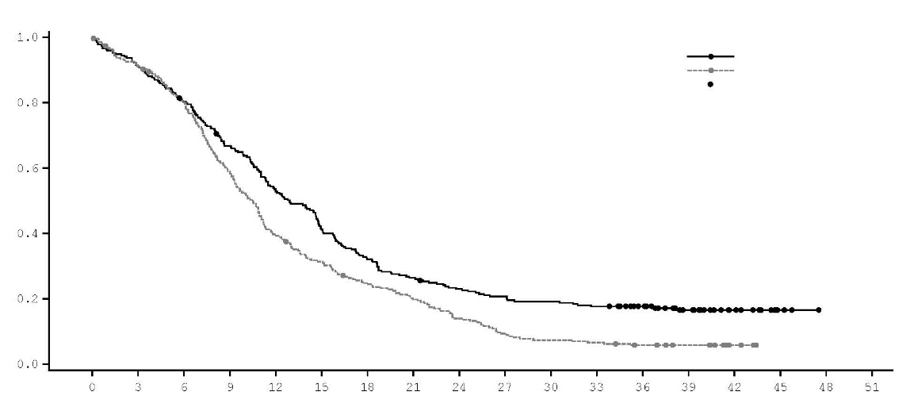
IMFINZI+etoposide+platinum
etoposide+platinum
censored

 | Median OS | (95% CI)
IMFINZI + etoposide + platinum | 12.9 | (11.3, 14.7)
etoposide + platinum | 10.5 | (9.3, 11.2)

Hazard Ratio (95% CI)
IMFINZI + etoposide + platinum vs. etoposide + platinum: 0.71 (0.595, 0.858)

Time from randomisation (months)
Probability of OS
Number of patients at risk | 0 | 3 | 6 | 9 | 12 | 15 | 18 | 21 | 24 | 27 | 30 | 33 | 36 | 39 | 42 | 45 | 48 | 51
IMFINZI + etoposide + platinum | 268 | 244 | 214 | 177 | 140 | 109 | 85 | 70 | 60 | 54 | 50 | 46 | 39 | 25 | 13 | 3 | 0 | 0
etoposide + platinum | 269 | 243 | 212 | 156 | 104 | 82 | 64 | 51 | 36 | 24 | 19 | 17 | 13 | 10 | 3 | 0 | 0 | 0

Figure 14. Kaplan-Meier curve of PFS

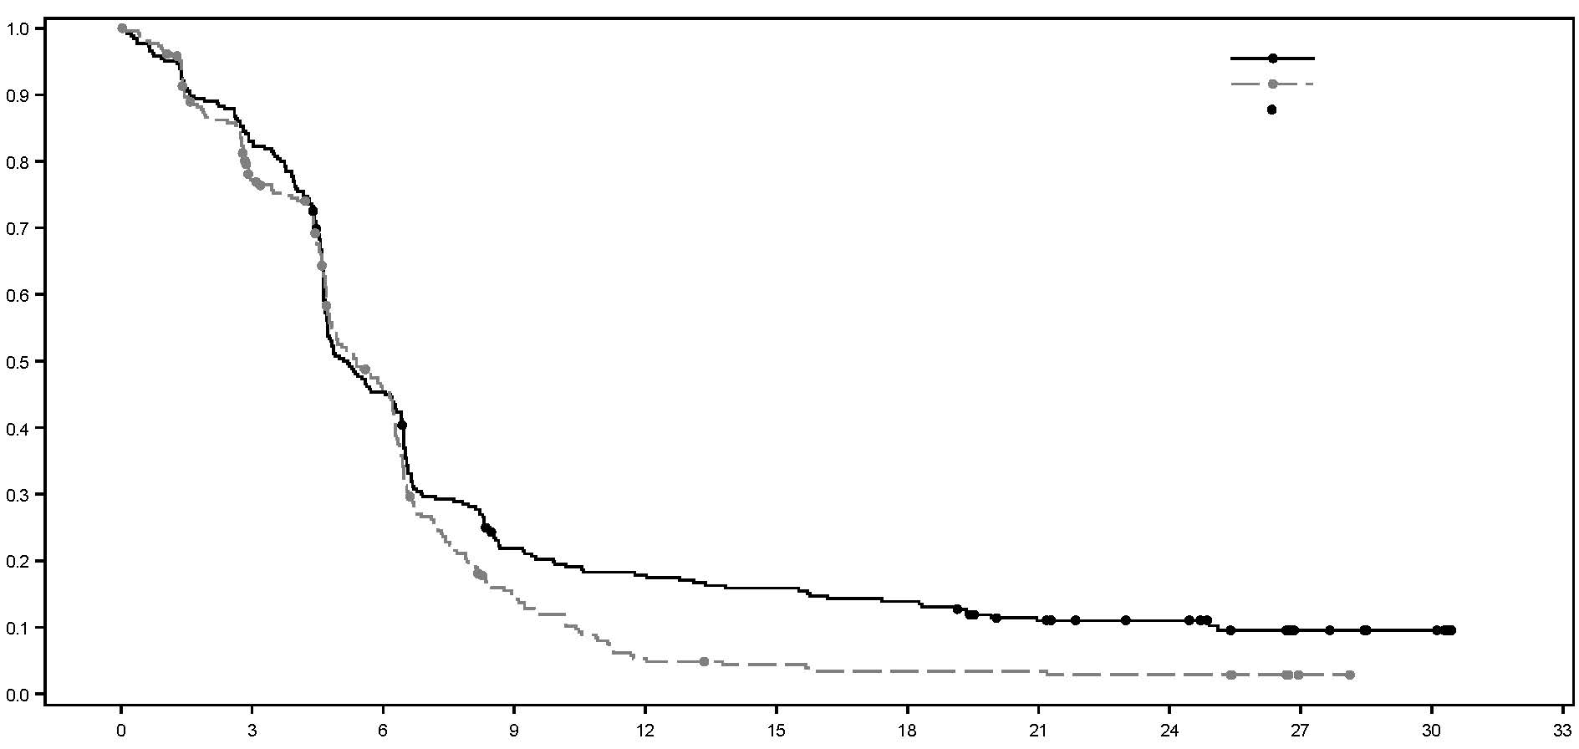
censored
etoposide+platinum
Hazard Ratio (95% CI)
IMFINZI + etoposide + platinum vs. etoposide + platinum: 0.80 (0.665, 0.959)

 | Median PFS | (95% CI)
IMFINZI + etoposide + platinum | 5.1 | (4.7, 6.2)
etoposide + platinum | 5.4 | (4.8, 6.2)

IMFINZI+etoposide+platinum
Probability of PFS
Time from randomisation (months)
Number of patients at risk | 0 | 3 | 6 | 9 | 12 | 15 | 18 | 21 | 24 | 27 | 30 | 33
IMFINZI + etoposide + platinum | 268 | 220 | 119 | 55 | 45 | 40 | 35 | 24 | 18 | 8 | 5 | 0
etoposide + platinum | 269 | 195 | 110 | 33 | 12 | 9 | 7 | 7 | 6 | 1 | 0 | 0

Subgroup analysis
The improvements in OS in favour of patients receiving IMFINZI + etoposide + platinum compared to those receiving etoposide + platinum alone, were consistently observed across the prespecified subgroups based on demographics, geographical region, carboplatin or cisplatin use and disease characteristics.

BTC – TOPAZ-1 Study
TOPAZ-1 was a study designed to evaluate the efficacy of IMFINZI in combination with gemcitabine and cisplatin. TOPAZ-1 was a randomised, double-blind, placebo-controlled, multicentre study in 685 patients with unresectable or metastatic BTC (including intrahepatic and extrahepatic cholangiocarcinoma and gallbladder carcinoma) and ECOG Performance status of 0 or 1. Patients had not received previous therapy in the advanced/unresectable setting. Patients who developed recurrent disease > 6 months after surgery and/or completion of adjuvant therapy were included. Patients must have had an adequate organ and bone marrow function, and have had acceptable serum bilirubin levels (≤ 2.0 x the upper limit of normal (ULN)), and any clinically significant biliary obstruction had to be resolved before randomisation.

The study excluded patients with ampullary carcinoma, with brain metastases, active or prior documented autoimmune or inflammatory disorders, HIV infection or active infections, including tuberculosis or hepatitis C or patients with current or prior use of immunosuppressive medication within 14 days before the first dose of IMFINZI. Patients with active HBV were allowed to participate if they were on antiviral therapy.

Randomisation was stratified by disease status (initially unresectable vs. recurrent) and primary tumour location (intrahepatic cholangiocarcinoma vs. extrahepatic cholangiocarcinoma vs. gallbladder carcinoma).

Patients were randomised 1:1 to receive:

- Arm 1: IMFINZI 1 500 mg administered on Day 1 + gemcitabine 1 000 mg/m² and cisplatin 25 mg/m² (each administered on Days 1 and 8) every 3 weeks (21 days) for up to 8 cycles, followed by IMFINZI 1 500 mg every 4 weeks until disease progression or unacceptable toxicity, or
- Arm 2: Placebo administered on Day 1 + gemcitabine 1 000 mg/m² and cisplatin 25 mg/m² (each administered on Days 1 and 8) every 3 weeks (21 days) for up to 8 cycles, followed by placebo every 4 weeks until disease progression or unacceptable toxicity.

Tumour assessments were conducted every 6 weeks for the first 24 weeks after the date of randomisation, and then every 8 weeks until confirmed objective disease progression.

The primary endpoint of the study was OS, the key secondary endpoint was PFS. Other secondary endpoints were ORR, DoR and PRO. PFS, ORR and DoR were investigator-assessed according to RECIST v1.1.

The demographics and baseline disease characteristics were well balanced between the two study arms (341 patients in Arm 1 and 344 patients in Arm 2). Baseline demographics of the overall study population were as follows: male (50.4%), age < 65 years (53.3%), white (37.2%), Asian (56.4%), Black or African American (2.0%), other (4.2%), non-Hispanic or Latino (93.1%), ECOG PS 0 (49.1%), vs. PS 1 (50.9%), primary tumour location (intrahepatic bile duct 55.9%, extrahepatic bile duct 19.1% and gallbladder 25.0%), disease status [recurrent (19.1%) vs. unresectable (80.7%), metastatic (86.0%) vs. locally advanced (13.9%)]. PD-L1 expression was evaluated on tumour and immune cells using the Ventana PD-L1 (SP263) assay and the TAP (tumour area positivity) algorithm, 58.7% patients had TAP ≥ 1% and 30.1% TAP < 1%.

OS and PFS were formally tested at a pre-planned interim analysis (data cut-off 11 Aug 2021) after a median follow-up of 9.8 months. Efficacy results are shown in Table 10 and Figure 16. The maturity for OS was 62% and the maturity for PFS was 84%. IMFINZI + chemotherapy (Arm 1) showed statistically significant improvement vs. placebo + chemotherapy (Arm 2) in OS and in PFS.

Table 10. Efficacy Results for the TOPAZ-1 Studyª
 | IMFINZI + gemcitabine and cisplatin  (n=341) | Placebo + gemcitabine and cisplatin  (n=344)
OS
Number of deaths (%) | 198 (58.1) | 226 (65.7)
Median OS (months)  (95% CI)^{b} | 12.8  (11.1, 14.0) | 11.5  (10.1, 12.5)
HR (95% CI)^{c} | 0.80 (0.66, 0.97)
p-value^{c,d} | 0.021
Median follow-up in all patients (months) | 10.2 | 9.5
PFS
Number of events (%) | 276 (80.9) | 297 (86.3)
Median PFS (months)  (95% CI)^{b} | 7.2  (6.7, 7.4) | 5.7  (5.6, 6.7)
HR (95% CI)^{c} | 0.75 (0.63, 0.89)
p-value^{c,e} | 0.001
Median follow-up in all patients (months) | 7.2 | 5.6
ORR^{f} | 91 (26.7) | 64 (18.7)
Complete Response n (%) | 7 (2.1) | 2 (0.6)
Partial Response n (%) | 84 (24.6) | 62 (18.1)
DoR
Median DoR (months)  (95% CI)^{b} | 6.4 (5.9, 8.1) | 6.2 (4.4, 7.3)
ª Analysis at data cut-off 11 August 2021.
^{b} Calculated using the Kaplan-Meier technique. CI for median derived based on Brookmeyer-Crowley method.
^{c} The analysis for HR was performed using a stratified Cox proportional hazards model and 2-sided p-value is based on a stratified log-rank test, both are adjusted for disease status and primary tumour location.
^{d} At the interim analysis (data cut-off 11 August 2021) the OS p-value was 0.021, which met the boundary for declaring statistical significance of 0.03 for a 4.9% overall 2-sided alpha, based on a Lan-DeMets alpha spending function with O'Brien Fleming type boundary with the actual number of events observed.
^{e} At the interim analysis (data cut-off 11 August 2021) the PFS p-value was 0.001, which met the boundary for declaring statistical significance of 0.0481 for a 4.9% overall 2-sided alpha, based on a Lan-DeMets alpha spending function with Pocock-type boundary with the actual number of events observed.
^{f} Confirmed objective response.

An additional planned follow-up analysis of OS (data cut-off 25 Feb 2022) was performed 6.5 months after the interim analysis with an OS maturity of 77%. IMFINZI + chemotherapy continued to demonstrate improved OS vs. chemotherapy alone [HR=0.76, (95% CI: 0.64, 0.91)] and the median follow-up increased to 12 months.

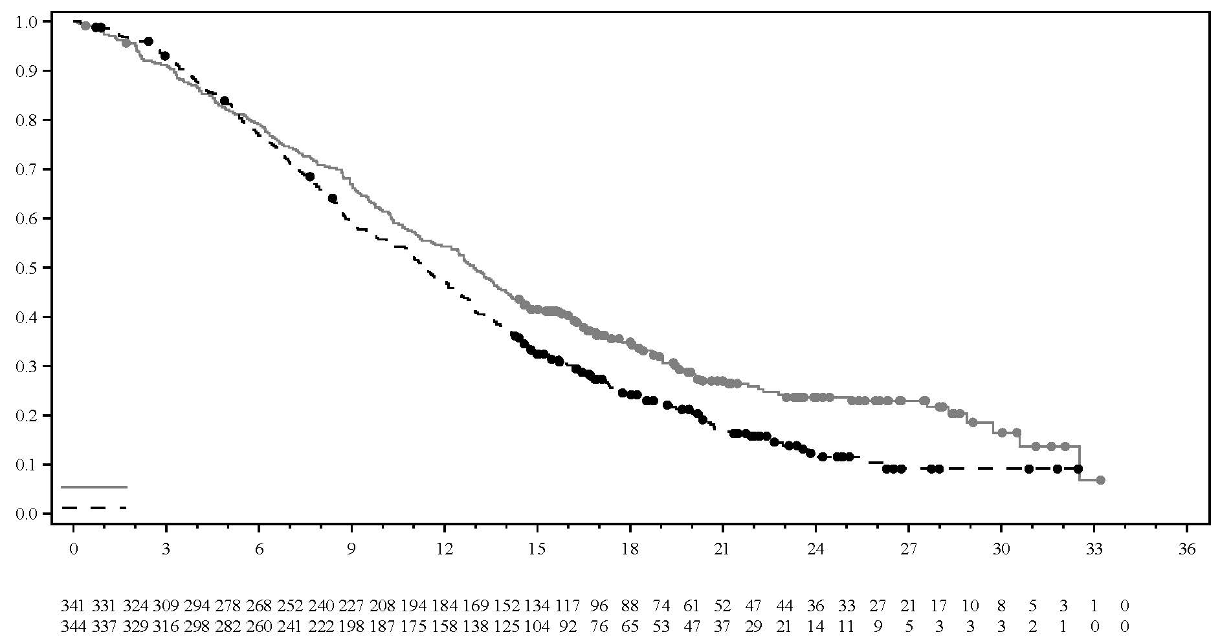
Figure 15: Kaplan-Meier curve of OS, follow-up OS analysis at data cut-off 25 February 2022
Median OS in months (95% CI)
IMFINZI + Chemotherapy 12.9 (11.6, 14.1)
Placebo + Chemotherapy 11.3 (10.1, 12.5)
Hazard Ratio (95% CI)
IMFINZI + chemotherapy vs chemotherapy 0..76 (0.64, 0.91)

Time from randomisation (months)
Number of subjects at risk
IMFINZI + Chemotherapy:
Chemotherapy:
IMFINZI + Chemotherapy (N=341)
Chemotherapy (N=344)

Probability of Overall Survival
Figure 16: Kaplan-Meier curve of PFS, inferential (primary) analysis at data cut-off 11 August 2021
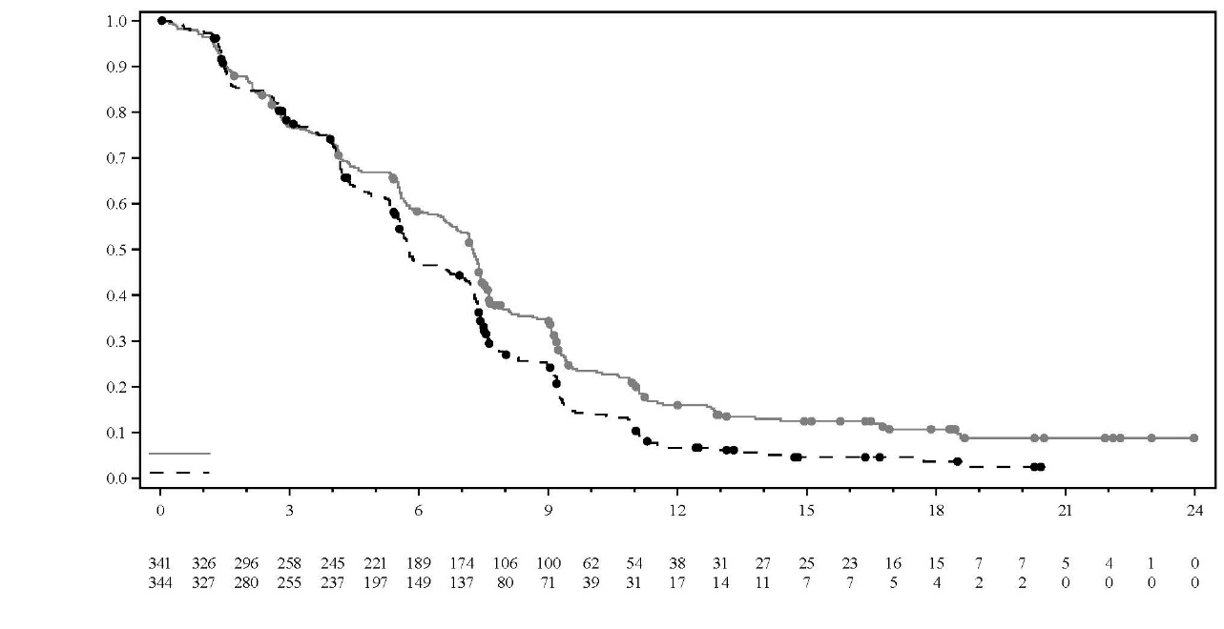
Number of subjects at risk
IMFINZI + Chemotherapy
Chemotherapy
Probability of progression free survival
Time from randomisation in months
Median PFS in months (95% CI)
IMFINZI + Chemotherapy 7.2 (6.7, 7.4)
Placebo + Chemotherapy 5.7 (5.6, 6.7)
Hazard Ratio (95% CI):
IMFINZI + chemotherapy vs chemotherapy 0.75 (0.63, 0.89)

IMFINZI + Chemotherapy (N=341)
Chemotherapy (N=344)

HCC - HIMALAYA Study
The efficacy of IMFINZI as monotherapy and given in combination with a single dose of tremelimumab 300 mg was evaluated in the HIMALAYA Study, a randomised, open-label, multicentre study in patients with confirmed uHCC who did not receive prior systemic treatment for HCC. The study included patients with Barcelona Clinic Liver Cancer (BCLC) Stage C or B (not eligible for locoregional therapy) and Child-Pugh Score Class A.

The study excluded patients with brain metastases or a history of brain metastases, co-infection of viral hepatitis B and hepatitis C; active or prior documented gastrointestinal (GI) bleeding within 12 months; ascites requiring non-pharmacologic intervention within 6 months; hepatic encephalopathy within 12 months before the start of treatment; active or prior documented autoimmune or inflammatory disorders.

Patients with oesophageal varices were included except those with active or prior documented GI bleeding within 12 months prior to study entry.

Randomisation was stratified by macrovascular invasion (MVI) (yes vs. no), aetiology of liver disease (confirmed hepatitis B virus vs. confirmed hepatitis C virus vs. others) and ECOG performance status (0 vs. 1). The HIMALAYA study randomised 1 171 patients 1:1:1 to receive:

- IMFINZI: durvalumab 1 500 mg every 4 weeks.
- Tremelimumab 300 mg as a single dose + IMFINZI 1 500 mg; followed by IMFINZI 1 500 mg every 4 weeks.
- Sorafenib 400 mg twice daily.

Tumour assessments were conducted every 8 weeks for the first 12 months and then every 12 weeks thereafter. Survival assessments were conducted every month for the first 3 months following treatment discontinuation and then every 2 months.

The primary endpoint was OS superiority for the comparison of IMFINZI given in combination with a single dose of tremelimumab vs. Sorafenib. The key secondary objectives were OS non-inferiority followed by superiority for the comparison of IMFINZI vs. Sorafenib. Other secondary endpoints included PFS, Investigator-assessed ORR and DoR according to RECIST v1.1.

The demographics and baseline disease characteristics were well balanced among study arms. The baseline demographics of the overall study population were as follows: male (83.7%), age < 65 years (50.4%) White (44.6%), Asian (50.7%), Black or African American (1.7%), Other race (2.3%), ECOG PS 0 (62.6%); Child-Pugh Class score A (99.5%), macrovascular invasion (25.2%), extrahepatic spread (53.4%), baseline AFP < 400 ng/ml (63.7%), baseline AFP ≥ 400 ng/ml (34.5%), viral aetiology; hepatitis B (30.6%), hepatitis C (27.2%), uninfected (42.2%), evaluable PD-L1 data (86.3%), PD-L1 Tumour area positivity (TAP) ≥ 1% (38.9%), PD-L1 TAP < 1% (48.3%) [Ventana PD-L1 (SP263) assay].

Results are presented in Table 11, Figure 17 and Figure 18.

Table 11. Efficacy Results for the HIMALAYA Study for IMFINZI given in combination with a single dose of tremelimumab 300 mg and IMFINZI as monotherapy vs. Sorafenib
 | IMFINZI + tremelimumab 300 mg  (n=393) | Sorafenib  (n=389) | IMFINZI  (n=389)
Follow-up duration
Median follow up (months)ª | 33.2 | 32.2 | 32.6
OS
Number of deaths (%) | 262 (66.7) | 293 (75.3) | 280 (72.0)
Median OS (months)  (95% CI) | 16.4  (14.2, 19.6) | 13.8  (12.3, 16.1) | 16.6  (14.1, 19.1)
HR (95% CI)^{b,c} | 0.78 (0.66, 0.92) |  | -
p-value^{d} | 0.0035 |  | -
HR (95% CI)^{b,c,e} | - | 0.86 (0.73, 1.03)
PFS
Number of events (%) | 335 (85.2) | 327 (84.1) | 345 (88.7)
Median PFS (months)  (95% CI) | 3.78  (3.68-5.32) | 4.07  (3.75-5.49) | 3.65  (3.19-3.75)
HR (95% CI) | 0.90 (0.77, 1.05) |  | -
HR (95% CI) | - | 1.02 (0.88, 1.19)
ORR
ORR n (%)^{f} | 79 (20.1) | 20 (5.1) | 66 (17.0)
Complete Response n (%) | 12 (3.1) | 0 | 6 (1.5)
Partial Response n (%) | 67 (17.0) | 20 (5.1) | 60 (15.4)
DoR
Median DoR (months) | 22.3 | 18.4 | 16.8
ª Calculated using reverse the Kaplan-Meier technique (with censor indicator reversed).
^{b} Based on stratified Cox-model adjusting for treatment, etiology of liver disease (HBV vs. HCV vs. others), ECOG (0 vs. 1).
^{c} Performed using stratified log-rank test adjusting for treatment, etiology of liver disease (HBV vs. HCV vs. others), ECOG (0 vs. 1), and macro-vascular invasion (yes vs. no).
^{d} Based on a Lan-DeMets alpha spending function with O'Brien Fleming type boundary and the actual number of events observed, the boundary for declaring statistical significance for IMFINZI + tremelimumab 300 mg vs. Sorafenib was 0.0398 (Lan◦and◦DeMets 1983).
^{e} Non-inferiority margin for HR (IMFINZI vs. Sorafenib) is 1.08 using a 95.67% confidence interval based on a Lan-DeMets alpha spending function with O'Brien Fleming type boundary and the actual number of events observed (Lan◦and◦DeMets 1983). P-value based on superiority testing of IMFINZI vs. Sorafenib was 0.0674 and did not reach statistical significance.
^{f} Confirmed complete response.
CI=Confidence Interval

Figure 17. Kaplan-Meier curve of OS of IMFINZI given in combination with a single dose of tremelimumab 300 mg
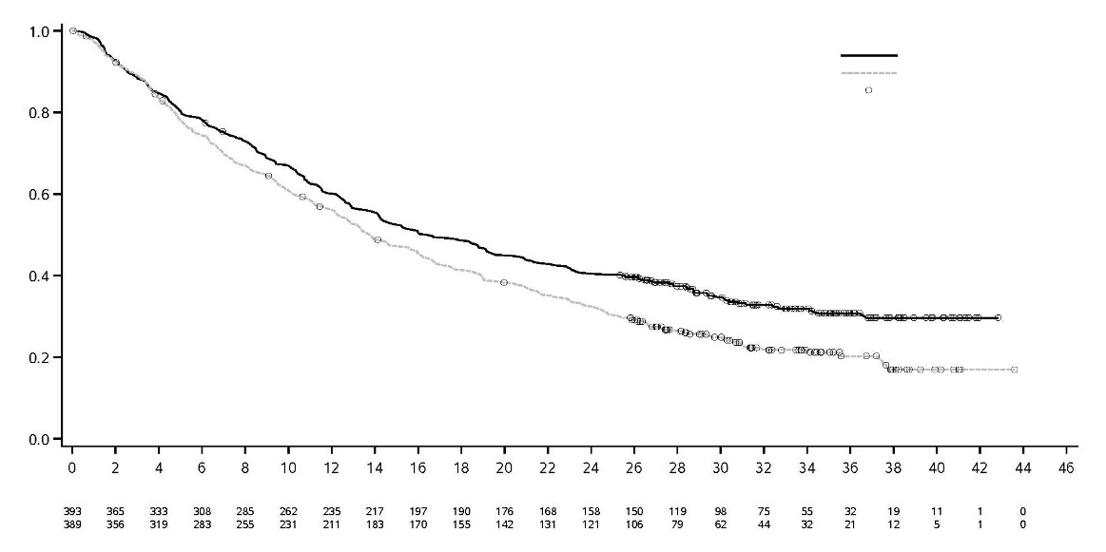
Sorafenib
IMFINZI + T300mg
IMFINZI + T300mg
Censored
Sorafenib
 | Median OS | (95% CI)
IMFINZI + T300mg | 16.4 | (14.2-19.6)
Sorafenib | 13.8 | (12.3-16.1)
Hazard Ratio (95% CI) |  | 0.78 (0.66, 0.92)

Probability of Overall Survival
Time from randomisation (months)

Figure 18. Kaplan-Meier curve of OS of IMFINZI given as monotherapy

 | Median OS | (95% CI)
IMFINZI | 16.6 | (14.1-19.1)
Sorafenib | 13.8 | (12.3-16.1)
Hazard Ratio (95% CI) |  | 0.86 (0.73, 1.02)

S

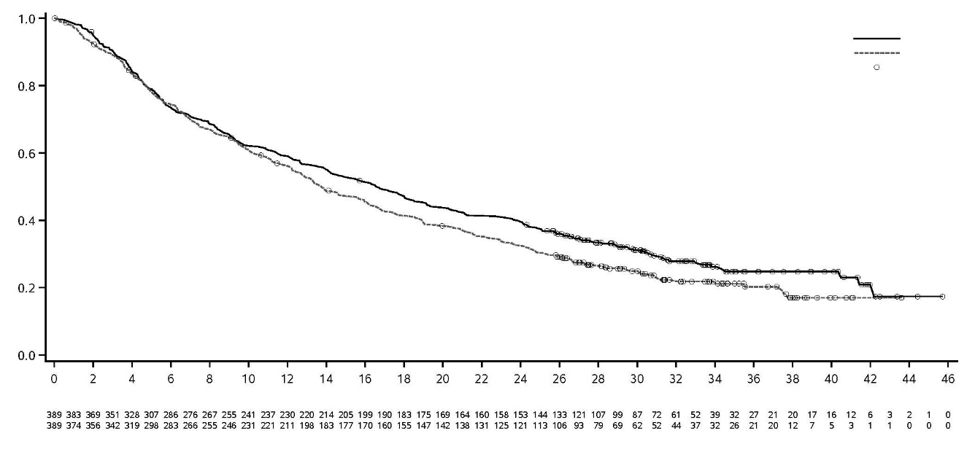
IMFINZI
Sorafenib
Censored
IMFINZI
Sorafenib
Probability of Overall Survival
Time from randomisation (months)

Endometrial Cancer – DUO-E Study
DUO-E was a randomised, multicentre, double-blind, placebo-controlled Phase III study of first-line platinum-based chemotherapy in combination with IMFINZI, followed by IMFINZI with or without olaparib in patients with advanced or recurrent endometrial cancer. Patients had to have endometrial cancer in one of the following categories: newly diagnosed Stage III disease (measurable disease per RECIST v1.1 following surgery or diagnostic biopsy), newly diagnosed Stage IV disease (with or without disease following surgery or diagnostic biopsy), or recurrence of disease (measurable or non-measurable disease per RECIST v1.1) where the potential for cure by surgery alone or in combination is poor. For patients with recurrent disease, prior chemotherapy was allowed only if it was administered in the adjuvant setting and there was at least 12 months from the date of last dose of chemotherapy administered to the date of subsequent relapse. The study included patients with epithelial endometrial carcinomas of all histologies, including carcinosarcomas. Patients with endometrial sarcoma were excluded.

Randomisation was stratified by tumour tissue’s mismatch repair (MMR) status (proficient versus deficient), disease status (recurrent versus newly diagnosed), and geographic region (Asia versus rest of the world). Patients were randomised 1:1:1 to one of the following arms:

- Arm 1 (Platinum-based chemotherapy): Platinum-based chemotherapy (paclitaxel and carboplatin) every 3 weeks for a maximum of 6 cycles with durvalumab placebo every 3 weeks. Following completion of chemotherapy treatment, patients without objective disease progression received durvalumab placebo every 4 weeks and olaparib placebo tablets twice daily as maintenance treatment until disease progression.
- Arm 2 (Platinum-based chemotherapy + IMFINZI): Platinum-based chemotherapy (paclitaxel and carboplatin) every 3 weeks for a maximum of 6 cycles with 1 120 mg durvalumab every 3 weeks. Following completion of chemotherapy treatment, patients without objective disease progression received 1 500 mg durvalumab every 4 weeks with olaparib placebo tablets twice daily as maintenance treatment until disease progression.
- Arm 3 (Platinum-based chemotherapy + IMFINZI + olaparib): Platinum-based chemotherapy (paclitaxel and carboplatin) every 3 weeks for a maximum of 6 cycles with 1 120 mg durvalumab every 3 weeks. Following completion of chemotherapy treatment, patients without objective disease progression received 1 500 mg durvalumab every 4 weeks with 300 mg olaparib tablets twice daily as maintenance treatment until disease progression.

Patients who discontinued either product (IMFINZI/placebo or olaparib/placebo) for reasons other than disease progression could continue treatment with the other product if appropriate based on toxicity considerations and investigator discretion.

Treatment was continued until RECIST v1.1-defined progression of disease or unacceptable toxicity. Assessment of tumour status was performed every 9 weeks for the first 18 weeks relative to randomisation and every 12 weeks thereafter.

The primary endpoint was PFS, determined by investigator assessment using RECIST v1.1. Secondary efficacy endpoints included OS, ORR and DoR.

The study demonstrated a statistically significant improvement in PFS in the ITT population, for patients treated with platinum-based chemotherapy + IMFINZI + olaparib compared to platinum-based chemotherapy [HR=0.55 (95% CI: 0.43, 0.69), p=<0.0001], and for patients treated with platinum-based chemotherapy + IMFINZI compared to platinum-based chemotherapy [HR=0.71 (95% CI: 0.57, 0.89), p=0.003]. At the time of PFS analysis, interim OS data were 28% mature with events in 199 of 718 patients.

Mismatch repair (MMR) status was determined centrally using an MMR immunohistochemistry panel assay. Of a total of 718 patients randomised in the study, 575 (80%) patients had MMR-proficient (pMMR) tumour status and 143 (20%) patients had MMR-deficient (dMMR) tumour status.

Patients with MMR-deficient (dMMR) endometrial cancer
Among patients with dMMR tumour status, demographic and baseline characteristics were generally well balanced between the treatment arms. Baseline demographics across all three arms were as follows: median age of 62 years (range: 34 to 85), 41% age 65 or older, 1.5% age 75 or older, 62% White, 29% Asian, and 2% Black or African American. Disease characteristics were as follows: ECOG PS of 0 (58%) or 1 (42%), 46% newly diagnosed and 54% recurrent disease. The histologic subtypes were endometrioid (83%), mixed epithelial (5%), serous (3%), carcinosarcoma (3%), undifferentiated (2%), and other (3%).

In patients with dMMR tumour status, the results are summarised in Table 12 and Figure 19. The median follow-up time for PFS in censored patients with dMMR tumour status was 15.5 months in the platinum-based chemotherapy + IMFINZI arm and 10.2 months in the platinum-based chemotherapy arm. At the time of PFS analysis, interim OS data were 26% mature with events in 25 of 95 patients treated with platinum-based chemotherapy + IMFINZI and platinum-based chemotherapy.

Table 12. Efficacy results for the DUO-E Study (Patients with dMMR tumour status)
 | Platinum-based chemotherapy + IMFINZI  N=46 | Platinum-based chemotherapy  N=49
PFS^{a,b}
Number of events (%) | 15 (32.6) | 25 (51.0)
Median PFS (months) (95% CI)^{c} | NR (NR, NR) | 7.0 (6.7, 14.8)
HR (95% CI) | 0.42 (0.22, 0.80) | -
OS^{b}
Number of events (%) | 7 (15.2) | 18 (36.7)
Median OS (months) (95% CI)^{c} | NR (NR, NR) | 23.7 (16.9, NR)
HR (95% CI) | 0.34 (0.13, 0.79) | -
ORR^{b}
ORR^{d} n (%) | 30 (71.4) | 17 (40.5)
DoR^{b}
Median DoR (months) (95% CI)^{c} | NR (NR, NR) | 10.5 (4.3, NR)
ª Investigator assessed.
^{b} Results are based on the first interim analysis (DCO: 12 April 2023).
^{c} Calculated using the Kaplan-Meier technique.
^{d} Response: Best objective response as confirmed complete response or partial response. Based on number of patients in treatment group with measurable disease at baseline (N=42 in platinum-based chemotherapy + IMFINZI arm, N=42 in platinum-based chemotherapy arm).
CI=Confidence Interval, HR=Hazard Ratio, NR=Not Reached

Figure 19. Kaplan-Meier curve of PFS in DUO-E (Patients with dMMR tumour status)

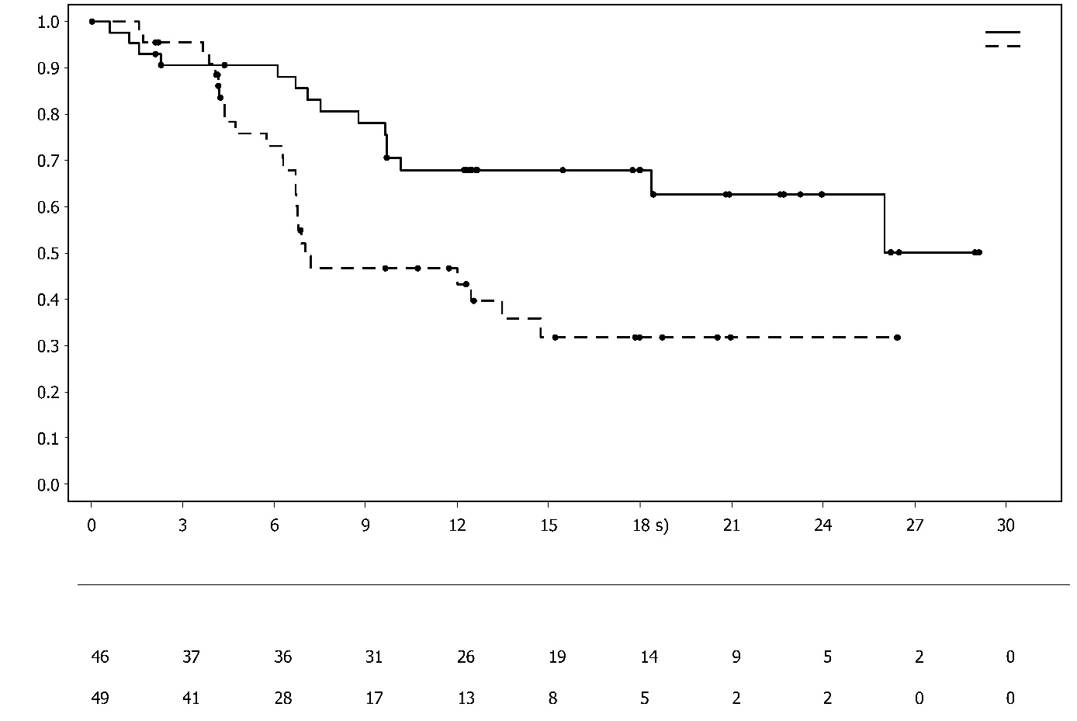
Number of patients at risk:
Platinum-based chemotherapy + IMFINZI
Platinum-based chemotherapy

Time from randomisation (months)

 | Median PFS | (95% CI)
Chemotherapy + IMFINZI | NR | (NR-NR)
Chemotherapy | 7.0 | (6.7-14.8)
 | Hazard Ratio | (95% CI)
Chemotherapy + IMFINZI vs. Chemotherapy | 0.42 | (0.22, 0.80)

Proportion of patients event free
Platinum-based chemotherapy + IMFINZI
Platinum-based chemotherapy

Patients with MMR-proficient (pMMR) endometrial cancer
Among patients with pMMR tumour status, demographic and baseline characteristics were generally well balanced between the treatment arms. Baseline demographics across all three arms were as follows: median age of 64 years (range: 22 to 86), 48% age 65 or older, 8.1% age 75 or older, 56% White, 30% Asian, and 6% Black or African American. Disease characteristics were as follows: ECOG PS of 0 (69%) or 1 (31%), 47% newly diagnosed and 53% recurrent disease. The histologic subtypes were endometrioid (54%), serous (26%), carcinosarcoma (8%), mixed epithelial (4%), clear cell (3%), undifferentiated (2%), mucinous (< 1%), and other (3%).

Results in patients with pMMR tumour status are summarised in Table 13 and Figure 20. The median follow-up time in censored patients with pMMR tumour status was 15.2 months in the platinum-based chemotherapy + IMFINZI + olaparib arm, and 12.8 months in the platinum-based chemotherapy arm.

At the time of PFS analysis, interim OS data were 29% mature with events in 110 of 383 patients treated with platinum-based chemotherapy + IMFINZI + olaparib and platinum-based chemotherapy.

Table 13. Efficacy results for the DUO-E Study (Patients with pMMR tumour status)
 | Platinum-based chemotherapy + IMFINZI + olaparib  N=191 |  | Platinum-based chemotherapy  N=192
PFS^{a,b}
Number of events (%) | 108 (56.5) |  | 148 (77.1)
Median PFS (months) (95% CI)^{c} | 15.0 (12.4, 18.0) |  | 9.7 (9.2, 10.1)
HR (95% CI) | 0.57 (0.44, 0.73) |  | -
OS^{b}
Number of events (%) | 46 (24.1) |  | 64 (33.3)
Median OS (months) (95% CI)^{c} | NR (NR, NR) |  | 25.9 (25.1, NR)
HR (95% CI) | 0.69 (0.47, 1.00) |  | -
ORR^{b}
ORR^{d} n (%) |  | 90 (61.2) | 92 (59.0)
DoR^{b}
Median DoR (months) (95% CI)^{c} |  | 18.7 (10.5, NR) | 7.6 (7.1, 10.2)
ª Investigator assessed.
^{b} Results are based on the first interim analysis (DCO: 12 April 2023).
^{c} Calculated using the Kaplan-Meier technique.
^{d} Response: Best objective response as confirmed complete response or partial response. Based on number of patients in treatment group with measurable disease at baseline (N=147 in platinum-based chemotherapy + IMFINZI + olaparib arm, N=156 in platinum-based chemotherapy arm).
CI=Confidence Interval, HR=Hazard Ratio, NR=Not Reached

Figure 20. Kaplan-Meier curve of PFS in DUO-E (Patients with pMMR tumour status)

Platinum-based chemotherapy + IMFINZI + olaparib
Platinum-based chemotherapy

 | Median PFS | (95% CI)
Chemotherapy + IMFINZI + olaparib | 15.0 | (12.4-18.0)
Chemotherapy | 9.7 | (9.2-10.1)
 | Hazard Ratio | (95% CI)
Chemotherapy + IMFINZI + olaparib vs. Chemotherapy | 0.57 | (0.44, 0.73)

Proportion of patients event free

Time from randomisation (months)

Number of patients at risk:
Platinum-based chemotherapy + IMFINZI + olaparib
Platinum-based chemotherapy

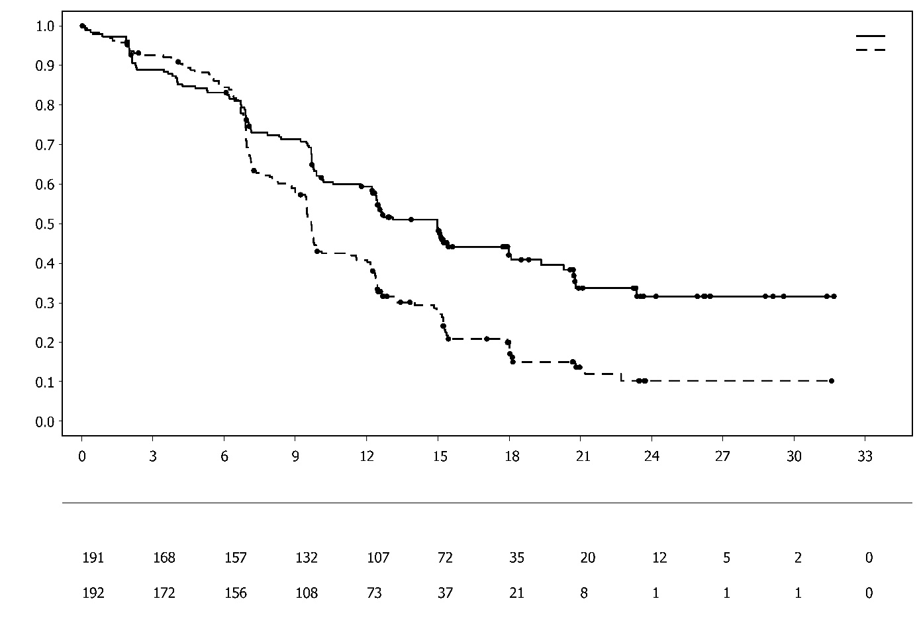
Among patients with pMMR tumour status, the PFS HRs were 0.44 (95% CI: 0.31, 0.61) in patients with PD-L1 expression positive status (236/383; 62%) and 0.87 (95% CI: 0.59, 1.28) in patients with PD-L1 expression negative status (140/383; 37%), for the platinum-based chemotherapy + IMFINZI + olaparib arm compared to the platinum-based chemotherapy arm. PD-L1 expression positive was defined as tumour area positive (TAP) ≥ 1%.

Muscle invasive bladder cancer (MIBC) – NIAGARA Study
NIAGARA was a randomised, open-label, multicentre Phase III study designed to evaluate the efficacy of neoadjuvant IMFINZI in combination with gemcitabine and cisplatin followed by adjuvant IMFINZI monotherapy in patients with MIBC. The study randomised 1 063 patients who were candidates for radical cystectomy and had not received prior systemic chemotherapy or immune-mediated therapy for the treatment of MIBC with clinical tumour stage T2-T4aN0/1M0. The study excluded patients with pure non-urothelial histology, any small cell histology and primary non-bladder (i.e, ureter, urethral, or renal pelvis) cancer of the urothelium, active or prior documented autoimmune disease, active tuberculosis or hepatitis B or C or HIV infection, or use of immuno-suppressive medication within 14 days of the first dose of durvalumab except systemic corticosteroids when used at physiological doses or as premedication.

Randomisation was stratified by clinical tumour stage T2N0 vs. > T2N0 (including T2N1, T3, and T4a), renal function (adequate renal function: creatinine clearance [CrCl] ≥ 60 mL/min vs. borderline renal function: CrCl ≥ 40 mL/min to < 60 mL/min), and PD-L1 expression (high vs. low/negative) status. Patients were randomised 1:1 to receive perioperative IMFINZI with neoadjuvant chemotherapy (Arm 1) or neoadjuvant chemotherapy alone (Arm 2):

- Arm 1 (IMFINZI + chemotherapy): IMFINZI 1 500 mg + gemcitabine 1 000 mg/m² and cisplatin 70 mg/m² every 3 weeks for 4 cycles prior to surgery, followed by IMFINZI 1 500 mg every 4 weeks for up to 8 cycles after surgery, or
- Arm 2 (Chemotherapy): Gemcitabine 1 000 mg/m² and cisplatin 70 mg/m² every 3 weeks for 4 cycles prior to surgery, without post-surgery treatment.

Patients with borderline renal function received split dose cisplatin of 35 mg/m² on days 1 and 8 of each cycle.

A RECIST 1.1 tumour assessment was performed at baseline and upon completion of neoadjuvant therapy (prior to surgery). After surgery, RECIST 1.1 tumour assessments were performed every 12 weeks for the first 24 months, then every 24 weeks for 36 months, and then every 52 weeks thereafter until progression, the end of study, or death.

The primary endpoints were pathological complete response (pCR) by blinded central pathology review and event-free survival (EFS) which included blinded independent central review (BICR) assessment. Overall survival (OS) was a key secondary endpoint.

The demographics and baseline disease characteristics were generally well-balanced between the 533 patients in Arm 1 and 530 patients in Arm 2. Baseline demographics were as follows: male (81.8%), age <65 years (46.9%), white (67%), Asian (27.9%), black or African American (0.9%), other (0.8%), Hispanic or Latino (8.0%), and ECOG PS 0 (78%) vs. PS 1 (22%). Disease characteristics were as follows: Tumour Stage T2N0 (40.3%) and > T2N0a (59.7%), regional lymph nodes N0 (94.5%) and N1 (5.5%), adequate renal function (81.1%) and borderline renal function (18.9%), and PD-L1 expression status high (73.1%) and low/negative (26.9%). The histologic subtypes included urothelial carcinoma (84.5%), urothelial carcinoma with squamous differentiation (8.2%), urothelial carcinoma with variant histology (5.0%), and urothelial carcinoma with glandular differentiation (2.4%).

In the overall population, 469 (88.0%) patients in Arm 1 and 441 (83.2%) patients in Arm 2 underwent radical cystectomy.

Results are presented in Table 14, Figure 21 and Figure 22.

Table 14: Efficacy Results for the NIAGARA Study
 | IMFINZI + chemotherapy  (N=533) |  |  | Chemotherapy  (N=530)
EFSª
Number of events (%) | 187 (35.1) |  |  | 246 (46.4)
Median EFS (months) (95% CI)^{b} | NR (NR, NR) |  |  | 46.1 (32.2, NR)
HR (95% CI)^{c} | 0.68 (0.56, 0.82)
2-sided p-value^{d,e} | < 0.0001
pCR^{f}
Number of patients with response | 180 |  | 137
Response rate, % (95% CI)^{g} | 33.8 (29.8, 38.0) |  | 25.8 (22.2, 29.8)
Odds ratio (95% CI)^{h} | 1.49 (1.14, 1.96)
2-sided p-value^{h} | 0.0038
OSª
Number of events (%) |  | 136 (25.5) |  | 169 (31.9)
Median OS (months) (95% CI)^{b} |  | NR (NR, NR) |  | NR (NR, NR)
HR (95% CI)^{c} |  | 0.75 (0.59, 0.93)
2-sided p-value^{d,e} |  | 0.0106
ª Results are based on a pre-planned interim analysis (DCO: 29 April 2024) which occurred 68 months after study initiation.
^{b} Calculated using the Kaplan-Meier technique.
^{c} Based on stratified Cox proportional hazard model with tumour stage [T2N0 vs. > T2N0], renal function [adequate vs. borderline], and PD-L1 status [high vs. low/negative] as stratification factors.
^{d} Based on stratified log-rank test with tumour stage [T2N0 vs. > T2N0], renal function [adequate vs borderline], and PD-L1 status [high vs low/negative] as stratification factors.
^{e} The boundary for declaring statistical significance for the primary efficacy endpoints pCR rate, EFS and the key secondary endpoint OS were determined by a multiple test procedure with an alpha-exhaustive recycling strategy. Alpha allocated to EFS and OS at the interim analysis was based on a Lan-DeMets alpha spending function with O'Brien Fleming approach (pCR = 0.001, EFS = 0.0412, OS = 0.0154, 2-sided).
^{f} Based on the final analysis of pCR (DCO: 14 Jan 2022).
^{g} CI was calculated using the Clopper Pearson method.
^{h} Obtained using logistic regression adjusted for the stratification factors (renal function [adequate vs. borderline], tumour stage [T2N0 vs. > T2N0] and PD-L1 status [high vs. low/negative] per IVRS).
CI=Confidence Interval, HR=Hazard Ratio, NR=Not Reached

Figure 21. Kaplan-Meier Curve of EFS
Number of patients at risk:
IMFINZI+Chemotherapy
Chemotherapy

Median EFS in months (95% CI)
IMFINZI+Chemotherapy NR (NR, NR)
Chemotherapy 46.1 (32.2, NR)
Hazard Ratio (95% CI)
IMFINZI+Chemotherapy vs Chemotherapy 0.68 (0.56, 0.82)

Probability of EFS

Time from randomisation (months)

IMFINZI + Chemotherapy
Chemotherapy

Figure 22. Kaplan-Meier Curve of OS
Number of patients at risk:
IMFINZI+Chemotherapy
Chemotherapy

Median OS in months (95% CI)
IMFINZI+Chemotherapy NR (NR, NR)
Chemotherapy NR (NR, NR)
Hazard Ratio (95% CI)
IMFINZI+Chemotherapy vs Chemotherapy 0.75 (0.59, 0.93)

Probability of OS

Time from randomisation (months)

IMFINZI + Chemotherapy
Chemotherapy
IMFINZI + Chemotherapy
Chemotherapy

Subgroup analysis
In an exploratory analysis by tumour stage, the EFS HR was 0.61 (95% CI: 0.48, 0.78) in the subgroup of patients with clinical stage > T2N0 (N=635) and 0.81 (95% CI: 0.60, 1.10) in the subgroup of patients with clinical stage T2N0 (N=428). The OS HR was 0.67 (95% CI: 0.50, 0.89) in the subgroup of patients with clinical stage > T2N0 and 0.89 (95% CI: 0.62, 1.29) in patients with clinical stage T2N0.

Paediatric population
The safety and efficacy of IMFINZI in combination with tremelimumab in children and adolescents aged less than 18 years has not been established. Study D419EC00001 was a multi-centre, open-label dose finding and dose expansion study to evaluate the safety, preliminary efficacy and pharmacokinetics of IMFINZI in combination with tremelimumab followed by IMFINZI monotherapy, in paediatric patients with advanced malignant solid tumours (except primary central nervous system tumours) who had disease progression and for whom no standard of care treatment exists. The study enrolled 50 paediatric patients with an age range from 1 to 17 years with primary tumour categories: neuroblastoma, solid tumour and sarcoma. Patients received either IMFINZI 20 mg/kg in combination with tremelimumab 1 mg/kg or IMFINZI 30 mg/kg in combination with tremelimumab 1 mg/kg intravenously every 4 weeks for 4 cycles, followed by IMFINZI as monotherapy every 4 weeks. In the dose finding phase, IMFINZI and tremelimumab combination therapy was preceded by a single cycle of IMFINZI monotherapy; 8 patients in this phase however discontinued treatment prior to receiving tremelimumab. Thus, of the 50 patients enrolled in the study, 42 received IMFINZI in combination with tremelimumab and 8 received IMFINZI only. In the dose-expansion phase, an ORR of 5.0% (1/20 patients) was reported in the evaluable for response analysis set. No new safety signals were observed relative to the known safety profiles of IMFINZI and tremelimumab in adults. See section 4.2 for information on paediatric use.

5.2 Pharmacokinetic properties

The pharmacokinetics (PK) of durvalumab was assessed for IMFINZI as a single agent, in combination with chemotherapy, in combination with tremelimumab and platinum-based chemotherapy, in combination with tremelimumab and in combination with platinum-based chemotherapy followed by IMFINZI in combination with olaparib.
The PK of durvalumab was studied in 2903 patients with solid tumours with doses ranging from 0.1 to 20 mg/kg administered intravenously once every two, three or four weeks as monotherapy. PK exposure increased more than dose-proportionally (non-linear PK) at doses < 3 mg/kg, and dose proportionally (linear PK) at doses ≥ 3 mg/kg. Steady state was achieved at approximately 16 weeks. Based on population PK analysis that included 1878 patients who received durvalumab monotherapy in the dose range of ≥ 10 mg/kg every 2 weeks, the geometric mean steady state volume of distribution (V_{ss}) was 5.64 L. Durvalumab clearance (CL) decreased over time resulting in a geometric mean steady state clearance (CL_{ss}) of 8.16 ml/h at Day 365; the decrease in CL_{ss} was not considered clinically relevant. The terminal half-life (t_{1/2}), based on baseline CL, was approximately 18 days. There was no clinically meaningful difference between the PK of durvalumab as a single agent, in combination with chemotherapy, in combination with tremelimumab and platinum-based chemotherapy, in combination with tremelimumab and in combination with platinum-based chemotherapy followed by IMFINZI in combination with olaparib. The primary elimination pathways of durvalumab are protein catabolism via reticuloendothelial system or target mediated disposition.

Special populations
Age (19-96 years), body weight (31-149 kg), gender, positive anti-drug antibody (ADA) status, albumin levels, LDH levels, creatinine levels, soluble PD-L1, tumour type, race or ECOG status had no clinically significant effect on the PK of durvalumab.

Renal impairment
Mild (creatinine clearance (CrCL) 60 to 89 ml/min) and moderate renal impairment (creatinine clearance (CrCL) 30 to 59 ml/min) had no clinically significant effect on the PK of durvalumab. The effect of severe renal impairment (CrCL 15 to 29 ml/min) on the PK of durvalumab is unknown; however, as IgG monoclonal antibodies are not primarily cleared via renal pathways, a change in renal function is not expected to influence durvalumab exposure.

Hepatic impairment
Mild hepatic impairment (bilirubin ≤ ULN and AST > ULN or bilirubin > 1.0 to 1.5 x ULN and any AST) or moderate hepatic impairment (bilirubin > 1.5 to 3 x ULN and any AST) had no clinically significant effect on the PK of durvalumab. The effect of severe hepatic impairment (bilirubin > 3.0 x ULN and any AST) on the pharmacokinetics of durvalumab is unknown; however, as IgG monoclonal antibodies are not primarily cleared via hepatic pathways, a change in hepatic function is not expected to influence durvalumab exposure.

Paediatric population
The PK of durvalumab in combination with tremelimumab was evaluated in a study of 50 paediatric patients with an age range from 1 to 17 years in study D419EC00001. Patients received either durvalumab 20 mg/kg in combination with tremelimumab 1 mg/kg or durvalumab 30 mg/kg in combination with tremelimumab 1 mg/kg intravenously every 4 weeks for 4 cycles, followed by durvalumab as monotherapy every 4 weeks. Based on population PK analysis, durvalumab systemic exposure in paediatric patients ≥ 35kg receiving durvalumab 20 mg/kg every 4 weeks was similar to exposure in adults receiving durvalumab 20 mg/kg every 4 weeks, whereas in paediatric patients (≥ 35kg) receiving durvalumab 30mg/kg every 4 weeks, exposure was approximately 1.5-fold higher compared to exposure in adults receiving durvalumab 20 mg/kg every 4 weeks. In paediatric patients < 35kg receiving durvalumab 30 mg/kg every 4 weeks, the systemic exposure was similar to exposure in adults receiving durvalumab 20 mg/kg every 4 weeks.

5.3 Preclinical safety data

Carcinogenicity and mutagenicity
The carcinogenic and genotoxic potential of durvalumab has not been evaluated.

Reproductive toxicology
As reported in the literature, the PD-1/PD-L1 pathway plays a central role in preserving pregnancy by maintaining maternal immune tolerance to the foetus, and in mouse allogeneic pregnancy models disruption of PD-L1 signalling was shown to result in an increase in foetal loss. In animal reproduction studies, administration of durvalumab to pregnant cynomolgus monkeys from the confirmation of pregnancy through delivery, at exposure levels approximately 18-times higher than those observed at the clinical dose of 10 mg/kg of durvalumab (based on AUC), was associated with placental transfer but not with maternal toxicity or effects on embryofoetal development, pregnancy outcome or postnatal development. Negligible levels of durvalumab was found in milk of cynomolgous monkey on Day 28 after birth.

6. PHARMACEUTICAL PARTICULARS

6.1 List of excipients

Histidine
Histidine hydrochloride monohydrate
Trehalose dihydrate
Polysorbate 80 (E 433)
Water for injections

6.2 Incompatibilities

In the absence of compatibility studies, this medicinal product must not be mixed with other medicinal products.

6.3 Shelf life

Unopened vial
3 years.

Diluted solution

Chemical and physical in-use stability has been demonstrated for up to 30 days at 2 °C to 8 °C and for up to 24 hours at room temperature (up to 25 °C) from the time of preparation.

From a microbiological point of view, the prepared solution for infusion should be used immediately. If not used immediately, in-use storage times and conditions prior to use are the responsibility of the user and would normally not be longer than 24 hours at 2 °C to 8 °C or 12 hours at room temperature (up to 25 °C), unless dilution has taken place in controlled and validated aseptic conditions.

6.4 Special precautions for storage

Store in a refrigerator (2 °C – 8 °C).

Do not freeze.

Store in the original package in order to protect from light.

For storage conditions after dilution of the medicinal product, see section 6.3.

6.5 Nature and contents of container

Two pack sizes of IMFINZI are available:

2.4 ml (a total of 120 mg durvalumab) of concentrate in a Type 1 glass vial with an elastomeric stopper and a gray flip-off aluminium seal. Pack size of 1 vial.

10 ml (a total of 500 mg durvalumab) of concentrate in a Type 1 glass vial with an elastomeric stopper and a white flip-off aluminium seal. Pack size of 1 vial.

Not all pack sizes may be marketed.

6.6 Special precautions for disposal and other handling

Preparation of solution
IMFINZI is supplied as a single-dose vial and does not contain any preservatives, aseptic technique must be observed.

- Visually inspect the medicinal product for particulate matter and discolouration. IMFINZI is clear to opalescent, colourless to slightly yellow solution. Discard the vial if the solution is cloudy, discoloured or visible particles are observed. Do not shake the vial.

- Withdraw the required volume from the vial(s) of IMFINZI and transfer into an intravenous (IV) bag containing sodium chloride 9 mg/ml (0.9%) solution for injection, or glucose 50 mg/ml (5%) solution for injection. Mix diluted solution by gentle inversion. The final concentration of the diluted solution should be between 1 mg/ml and 15 mg/ml. Do not freeze or shake the solution.

- Discard any unused portion left in the vial.

Administration
- Administer the infusion solution intravenously over 1 hour through an intravenous line containing a sterile, low-protein binding 0.2 or 0.22 micron in-line filter.

- Do not co-administer other medicinal products through the same infusion line.

Any unused medicinal product or waste material should be disposed of in accordance with local requirements.

7. MARKETING AUTHORISATION HOLDER

AstraZeneca AB
SE-151 85 Södertälje
Sweden

8. MARKETING AUTHORISATION NUMBER(S)

EU/1/18/1322/002 120 mg vial
EU/1/18/1322/001 500 mg vial

9. DATE OF FIRST AUTHORISATION/RENEWAL OF THE AUTHORISATION

Date of first authorisation: 21 September 2018
Date of latest renewal: 24 April 2023

10. DATE OF REVISION OF THE TEXT

Detailed information on this medicinal product is available on the website of the European Medicines Agency https://www.ema.europa.eu.

ANNEX II

A. MANUFACTURERS OF THE BIOLOGICAL ACTIVE SUBSTANCE AND MANUFACTURERS RESPONSIBLE FOR BATCH RELEASE
B. CONDITIONS OR RESTRICTIONS REGARDING SUPPLY AND USE
C. OTHER CONDITIONS AND REQUIREMENTS OF THE MARKETING AUTHORISATION
D. conditions or restrictions with regard to the safe and effective use of the medicinal product

A. MANUFACTURERs OF THE BIOLOGICAL ACTIVE SUBSTANCE AND MANUFACTURERS RESPONSIBLE FOR BATCH RELEASE

Name and address of the manufacturers of the biological active substance
AstraZeneca Pharmaceuticals LP
Frederick Manufacturing Center (FMC)
633 Research Court
Frederick,
Maryland
21703
United States

Samsung Biologics Co. Ltd
300, Songdo bio-daero
Yeonsu-gu,
Incheon, 21987
Korea, Republic of

Boehringer Ingelheim Pharma GmbH & Co. KG
Birkendorfer Strasse 65
88397 Biberach An Der Riss
Germany

Name and address of the manufacturers responsible for batch release
AstraZeneca AB
Gärtunavägen
SE-152 57 Södertälje
Sweden

B. CONDITIONS OR RESTRICTIONS REGARDING SUPPLY AND USE

Medicinal product subject to restricted medical prescription (see Annex I: Summary of Product Characteristics, section 4.2).

C. OTHER CONDITIONS AND REQUIREMENTS OF THE MARKETING AUTHORISATION
- Periodic safety update reports (PSURs)

The requirements for submission of PSURs for this medicinal product are set out in the list of Union reference dates (EURD list) provided for under Article 107c(7) of Directive 2001/83/EC and any subsequent updates published on the European medicines web-portal.

D. CONDITIONS OR RESTRICTIONS WITH REGARD TO THE SAFE AND EFFECTIVE USE OF THE MEDICINAL PRODUCT
- Risk management plan (RMP)

The marketing authorisation holder (MAH) shall perform the required pharmacovigilance activities and interventions detailed in the agreed RMP presented in Module 1.8.2 of the marketing authorisation and any agreed subsequent updates of the RMP.

An updated RMP should be submitted:
- At the request of the European Medicines Agency;
- Whenever the risk management system is modified, especially as the result of new information being received that may lead to a significant change to the benefit/risk profile or as the result of an important (pharmacovigilance or risk minimisation) milestone being reached.

- Obligation to conduct post-authorisation measures
The MAH shall complete, within the stated timeframe, the below measures:

Description | Due date
Post-authorisation efficacy study (PAES): In order to further characterise the long-term efficacy of durvalumab in combination with carboplatin and paclitaxel for the first line treatment of adults with primary advanced or recurrent endometrial cancer who are candidates for systemic therapy, followed by maintenance treatment with durvalumab as monotherapy in endometrial cancer that is mismatch repair deficient (dMMR) or in combination with olaparib in endometrial cancer that is mismatch repair proficient (pMMR), the MAH should submit the results of the second interim OS analysis and the final OS analysis from study D9311C00001 (DUO-E), a phase III randomised double-blind placebo-controlled multicentre study. | Second interim OS analysis: March 2027  Final OS analysis: November 2028
Post-authorisation efficacy study (PAES): In order to further characterise the long-term efficacy of IMFINZI in combination with platinum-based chemotherapy as neoadjuvant treatment, followed by IMFINZI as monotherapy as adjuvant treatment, for the treatment of adults with resectable NSCLC at high risk of recurrence, the MAH should submit the results of the final OS analysis from the study D9106C00001 (AEGEAN), a phase III, double-blind, placebo-controlled multicentre international study. | Final OS analysis:  Q2 2029

ANNEX III

LABELLING AND PACKAGE LEAFLET

A. LABELLING

PARTICULARS TO APPEAR ON THE OUTER PACKAGING

OUTER CARTON

1. NAME OF THE MEDICINAL PRODUCT

IMFINZI 50 mg/ml concentrate for solution for infusion
durvalumab

2. STATEMENT OF ACTIVE SUBSTANCE(S)

One ml of concentrate contains 50 mg of durvalumab.
One vial of 2.4 ml of concentrate contains 120 mg of durvalumab.
One vial of 10 ml of concentrate contains 500 mg of durvalumab.

3. LIST OF EXCIPIENTS

Excipients: histidine, histidine hydrochloride monohydrate, trehalose dihydrate, polysorbate 80, water for injections.

4. PHARMACEUTICAL FORM AND CONTENTS

Concentrate for solution for infusion

120 mg/2.4 ml
500 mg/10 ml
1 vial

5. METHOD AND ROUTE(S) OF ADMINISTRATION

Intravenous use.
Read the package leaflet before use.
For single use only.

6. SPECIAL WARNING THAT THE MEDICINAL PRODUCT MUST BE STORED OUT OF THE SIGHT AND REACH OF CHILDREN

Keep out of the sight and reach of children.

7. OTHER SPECIAL WARNING(S), IF NECESSARY

8. EXPIRY DATE

EXP

9. SPECIAL STORAGE CONDITIONS

Store in a refrigerator.
Do not freeze.
Store in the original package in order to protect from light.

10. SPECIAL PRECAUTIONS FOR DISPOSAL OF UNUSED MEDICINAL PRODUCTS OR WASTE MATERIALS DERIVED FROM SUCH MEDICINAL PRODUCTS, IF APPROPRIATE

11. NAME AND ADDRESS OF THE MARKETING AUTHORISATION HOLDER

AstraZeneca AB
SE-151 85 Södertälje
Sweden

12. MARKETING AUTHORISATION NUMBER(S)

EU/1/18/1322/002 120 mg vial
EU/1/18/1322/001 500 mg vial

13. BATCH NUMBER

Lot

14. GENERAL CLASSIFICATION FOR SUPPLY

15. INSTRUCTIONS ON USE

16. INFORMATION IN BRAILLE

Justification for not including Braille accepted.

17. UNIQUE IDENTIFIER – 2D BARCODE

2D barcode carrying the unique identifier included.

18. UNIQUE IDENTIFIER – HUMAN READABLE DATA

PC
SN
NN

MINIMUM PARTICULARS TO APPEAR ON SMALL IMMEDIATE PACKAGING UNITS

VIAL LABEL

1. NAME OF THE MEDICINAL PRODUCT AND ROUTE(S) OF ADMINISTRATION

IMFINZI 50 mg/ml sterile concentrate
durvalumab
IV

2. METHOD OF ADMINISTRATION

3. EXPIRY DATE

EXP

4. BATCH NUMBER

Lot

5. CONTENTS BY WEIGHT, BY VOLUME OR BY UNIT

120 mg/2.4 ml
500 mg/10 ml

6. OTHER

AstraZeneca AB

B. PACKAGE LEAFLET
Package leaflet: Information for the patient

IMFINZI 50 mg/ml concentrate for solution for infusion
durvalumab

Read all of this leaflet carefully before you are given this medicine because it contains important information for you.
- Keep this leaflet. You may need to read it again.
- If you have any further questions, ask your doctor.
- If you get any side effects, talk to your doctor. This includes any possible side effects not listed in this leaflet. See section 4.

What is in this leaflet

1. What IMFINZI is and what it is used for
2. What you need to know before you are given IMFINZI
3. How you are given IMFINZI
4. Possible side effects
5. How to store IMFINZI
6. Contents of the pack and other information

1. What IMFINZI is and what it is used for

IMFINZI contains the active substance durvalumab which is a monoclonal antibody, a type of protein designed to recognise a specific target substance in the body. IMFINZI works by helping your immune system fight your cancer.

IMFINZI is used to treat a type of lung cancer called non-small cell lung cancer (NSCLC) in adults. It is used alone when your NSCLC:
- has spread within your lung and cannot be removed by surgery, and
- has responded or stabilised after initial treatment with chemotherapy and radiotherapy.
It is used in combination with tremelimumab and chemotherapy when your NSCLC:
- has spread within both your lungs (and/or to other parts of the body), cannot be removed by surgery and
- has shown no changes (mutations) in genes called EGFR (epidermal growth factor receptor) or ALK (anaplastic lymphoma kinase).
It is used in combination with platinum-based chemotherapy prior to surgery (neoadjuvant treatment) and alone after surgery (adjuvant treatment) when your NSCLC:
- has spread within your lung and is able to be removed by surgery.

IMFINZI is used to treat a type of lung cancer called limited-stage small cell lung cancer (LS-SCLC) in adults. It is used when your SCLC:
- has not been removed by surgery, and
- has responded or stabilised after initial treatment with chemotherapy and radiotherapy.

IMFINZI in combination with chemotherapy is used to treat a type of lung cancer called extensive-stage small cell lung cancer (ES-SCLC) in adults. It is used when your SCLC:
- has spread within your lungs (or to other parts of the body) and
- has not previously been treated.

IMFINZI in combination with chemotherapy is used in adults to treat a type of cancer of the bile ducts (cholangiocarcinoma) and gallbladder that are collectively referred to as biliary tract cancers (BTC). It is used when your BTC:
- has spread within your bile ducts and gallbladder (or to other parts of the body).

IMFINZI is used alone or in combination with tremelimumab to treat a type of liver cancer called advanced or unresectable hepatocellular carcinoma (HCC) in adults. It is used when your HCC:
- cannot be removed by surgery (unresectable), and
- may have spread within your liver or to other parts of the body.

IMFINZI is used to treat a type of uterine cancer (endometrial cancer) that has spread beyond the original tumour or come back (recurred) in adults. It is used in combination with chemotherapy (carboplatin and paclitaxel), followed by:
- IMFINZI alone when your tumour is MMR-deficient, or
- IMFINZI in combination with olaparib when your tumour is MMR-proficient.
A test is used to find out the MMR status of your endometrial cancer.

IMFINZI is used to treat a type of bladder cancer called muscle invasive bladder cancer (MIBC) which is when your bladder cancer has spread into the muscle layer of the bladder but not to other parts of the body. It is used in combination with chemotherapy (neoadjuvant treatment) prior to the surgical removal of your bladder followed by IMFINZI alone after surgery (adjuvant treatment).
If you have any questions about how IMFINZI works or why this medicine has been prescribed for you, ask your doctor or pharmacist.

When IMFINZI is given in combination with other anti-cancer medicines, it is important that you also read the package leaflet for these other medicines. If you have any questions about these medicines, ask your doctor.

2. What you need to know before you are given IMFINZI

You should not be given IMFINZI
- if you are allergic to durvalumab or any of the other ingredients of this medicine (listed in section 6 “Contents of the pack and other information”). Talk to your doctor if you are not sure.

Warnings and precautions
Talk to your doctor before you are given IMFINZI if:

- you have an autoimmune disease (an illness where the body’s immune system attacks its own cells);
- you have had an organ transplant;
- you have lung problems or breathing problems;
- you have liver problems.

If any of the above apply to you (or you are not sure), talk to your doctor before you are given IMFINZI.

When you are given IMFINZI, you can have some serious side effects.

If you have any of the following, call or see your doctor straight away. Your doctor may give you other medicines that prevent more severe complications and to help reduce your symptoms. Your doctor may delay the next dose of IMFINZI or stop your treatment with IMFINZI, if you have:

- inflammation of the lungs: symptoms may include new or worsening cough, shortness of
breath or chest pain;
- inflammation of the liver: symptoms may include nausea or vomiting, feeling less hungry,
pain on the right side of your stomach, yellowing of skin or whites of eyes, drowsiness, dark urine or bleeding or bruising more easily than normal;
- inflammation of the intestines: symptoms may include diarrhoea or more bowel movements than usual, or stools that are black, tarry or sticky with blood or mucus, severe stomach pain or tenderness, hole in the bowel;
- inflammation of glands (especially the thyroid, adrenal, pituitary and pancreas): symptoms may include fast heart rate, extreme tiredness, weight gain or weight loss, dizziness or fainting, hair loss, feeling cold, constipation, headaches that will not go away or unusual headaches, abdominal pain, nausea and vomiting;
- type 1 diabetes: symptoms may include high blood sugar, feeling more hungry or thirsty than usual, passing urine more often than usual, fast and deep breathing, confusion, or a sweet smell to your breath, a sweet or metallic taste in your mouth or a different odour to your urine or sweat;
- inflammation of the kidneys: symptoms may include decrease in the amount of urine you pass;
- inflammation of the skin: symptoms may include rash, itching, skin blistering or ulcers in the mouth or on other moist surfaces;
- inflammation of the heart muscle: symptoms may include chest pain, shortness of breath, or irregular heartbeat;
- inflammation or problems of the muscles: symptoms may include muscle pain, stiffness or weakness or rapid fatigue of the muscles;
- inflammation of the spinal cord (transverse myelitis): symptoms may include pain, numbness, tingling, or weakness in the arms or legs; bladder or bowel problems including needing to urinate more frequently, urinary incontinence, difficulty urinating and constipation;
- infusion-related reactions: symptoms may include chills or shaking, itching or rash, flushing, shortness of breath or wheezing, dizziness or fever;
- inflammation of the brain (encephalitis) or inflammation of the membrane around the spinal cord and brain (meningitis): symptoms may include seizures, neck stiffness, headache, fever, chills, vomiting, eye sensitivity to light, confusion and sleepiness;
- inflammation of the nerves: symptoms may include pain, weakness, and paralysis in the extremities (Guillain-Barré syndrome);
- inflammation of the joints: signs and symptoms include joint pain, swelling, and/or stiffness (immune-mediated arthritis);
- inflammation of the eye: signs and symptoms include eye redness, eye pain, light sensitivity, and/or changes in vision (uveitis);
- low number of blood platelets: symptoms may include bleeding (nose or gum bleeding) and/or bruising.
- low number of red blood cell counts on testing: symptoms may include shortness of breath, fatigue, pale skin and/or fast heartbeat. When IMFINZI is used in combination with another anti-cancer medicine (olaparib), low red blood cell counts could be a sign of ‘pure red cell aplasia’ (PRCA), a condition in which no red blood cells are produced, or ‘auto-immune haemolytic anaemia’ (AIHA), an excessive breakdown of red blood cells.

If you have any of the symptoms listed above, call or see your doctor straight away.

IMFINZI acts on your immune system. It may cause inflammation in parts of your body. Your risk of these side effects may be higher if you already have an autoimmune disease (a condition where the body attacks its own cells). You may also experience frequent flares of your autoimmune disease, which in the majority of cases are mild.

Children and adolescents
IMFINZI should not be used in children and adolescents below 18 years of age as it has not been studied in these patients.

Other medicines and IMFINZI
Tell your doctor if you are taking, have recently taken or might take any other medicines. This includes herbal medicines and medicines obtained without a prescription.

Pregnancy
- This medicine is not recommended during pregnancy.
- Tell your doctor if you are pregnant, think you may be pregnant or are planning to have a baby.
- If you are a woman who could become pregnant you must use effective birth control while you are being treated with IMFINZI and for at least 3 months after your last dose.

Breast-feeding
- Tell your doctor if you are breast-feeding.
- Ask your doctor if you can breast-feed during or after treatment with IMFINZI.
- It is not known if IMFINZI passes into human breast milk.

Driving and using machines
IMFINZI is not likely to affect you being able to drive and use machines.
However, if you have side effects that affect your ability to concentrate and react, you should be careful when driving or operating machines.

IMFINZI contains Polysorbate 80
This medicine contains 2 mg of polysorbate 80 in each 10 ml of concentrate which is equivalent to 0.2 mg/ml. Polysorbates may cause allergic reactions. Tell your doctor if you have any known allergies.

3. How you are given IMFINZI

IMFINZI will be given to you in a hospital or clinic under the supervision of an experienced doctor.
- The recommended dose of IMFINZI is 10 mg per kg of your body weight every 2 weeks, 20 mg per kg every 4 weeks, 1 120 mg every 3 weeks or 1 500 mg every 3 or 4 weeks.
- Your doctor will give you IMFINZI through an infusion (drip) into your vein for about 1 hour.
- Your doctor will decide how many treatments you need.
- Depending on your type of cancer, IMFINZI may be given in combination with other anti-cancer medicines.
- When IMFINZI is given in combination with tremelimumab and chemotherapy for your lung cancer, you will first be given tremelimumab followed by IMFINZI and then chemotherapy.
- When IMFINZI is given in combination with chemotherapy for your lung cancer or endometrial cancer, you will first be given IMFINZI followed by chemotherapy.
- When IMFINZI is given in combination with tremelimumab for your liver cancer, you will first be given tremelimumab followed by IMFINZI.
- Please refer to the package leaflet of the other anti-cancer medicines in order to understand the use of these other medicines. If you have questions about these medicines, ask your doctor.

If you miss an appointment to get IMFINZI
- Call your doctor straight away to reschedule your appointment.
- It is very important that you do not miss a dose of this medicine.
If you have any further questions about your treatment, ask your doctor.

4. Possible side effects

Like all medicines, this medicine can cause side effects, although not everybody gets them.

When you get IMFINZI, you can have some serious side effects (see section 2).

Talk to your doctor straight away if you get any of the following side effects, that have been reported in clinical studies with patients receiving IMFINZI alone:

Very common (may affect more than 1 in 10 people)
- infections of the upper respiratory tract
- underactive thyroid gland that can cause tiredness or weight gain
- cough
- diarrhoea
- stomach pain
- skin rash or itchiness
- joint pain (arthralgia)
- fever

Common (may affect up to 1 in 10 people)
- serious lung infections (pneumonia)
- flu-like illness
- fungal infection in the mouth
- tooth and mouth soft tissue infections
- overactive thyroid gland that can cause fast heart rate or weight loss
- inflammation of the lungs (pneumonitis)
- hoarse voice (dysphonia)
- inflammation of the liver that can cause nausea or feeling less hungry (hepatitis)
- abnormal liver tests (aspartate aminotransferase increased; alanine aminotransferase increased)
- night sweats
- muscle pain (myalgia)
- abnormal kidney function tests (blood creatinine increased)
- painful urination (dysuria)
- swelling of the legs (oedema peripheral)
- reaction to the infusion of the medicine that can cause fever or flushing

Uncommon (may affect up to 1 in 100 people)
- low number of blood platelets caused by an immune reaction (immune thrombocytopenia)
- inflammation of thyroid gland (thyroiditis)
- decreased secretion of hormones produced by the adrenal glands that can cause tiredness
- underactive pituitary gland; inflammation of pituitary gland
- a condition leading to high blood sugar levels (type 1 diabetes mellitus)
- a condition in which the muscles become weak and there is a rapid fatigue of the muscles (myasthenia gravis)
- inflammation of the brain (encephalitis)
- inflammation of the heart (myocarditis)
- scarring of lung tissue
- inflammation of the gut or intestine (colitis)
- inflammation of the pancreas (pancreatitis)
- inflammation of the skin (dermatitis)
- red, itchy, dry, scaly patches of thickened skin (psoriasis)
- blistering of the skin (pemphigoid)
- inflammation of the muscle (myositis)
- inflammation of the joints (immune-mediated arthritis)
- inflammation of the kidneys (nephritis) that can decrease the amount of your urine
- inflammation of the bladder (cystitis). Signs and symptoms may include frequent and/or painful urination, urge to pass urine, blood in urine, pain or pressure in lower abdomen

Rare (may affect up to 1 in 1 000 people)
- diabetes insipidus
- inflammation of the eye (uveitis)
- inflammation of the membrane around the spinal cord and brain (meningitis)
- coeliac disease (characterized by symptoms such as stomach pain, diarrhoea, and bloating after consuming gluten-containing foods)
- Inflammation of the muscles causing pain or stiffness (polymyalgia rheumatica)
- inflammation of the muscles and vessels (polymyositis)
- lack or reduction of digestive enzymes made by the pancreas (pancreatic exocrine insufficiency)

Other side effects that have been reported with frequency not known (cannot be estimated from the available data)
- inflammation of the nerves: (Guillain-Barré syndrome)
- inflammation of part of the spinal cord (transverse myelitis)

The following additional side effects to receiving IMFINZI alone have been reported in clinical studies in patients taking IMFINZI in combination with chemotherapy (the frequency and severity of side effects may vary depending on chemotherapeutic agents received):

Very common (may affect more than 1 in 10 people)
- low number of white blood cells
- low number of red blood cells
- low number of blood platelets
- nausea; vomiting; constipation
- hair loss
- feeling less hungry
- feeling tired or weak
- inflammation of the nerves causing numbness, weakness, tingling or burning pain of the arms and legs (neuropathy peripheral)

Common (may affect up to 1 in 10 people)
- low number of white blood cells with signs of fever (febrile neutropenia)
- inflammation of the mouth or lips (stomatitis)

Uncommon (may affect up to 1 in 100 people)
- low number of red blood cells, white blood cells, and platelets (pancytopenia)

The following additional side effects to receiving IMFINZI alone have been reported in clinical studies in patients taking IMFINZI in combination with tremelimumab and platinum-based chemotherapy (the frequency and severity of side effects may vary depending on chemotherapeutic agents received):

Very common (may affect more than 1 in 10 people)
- low number of red blood cells
- low number of white blood cells
- low number of blood platelets
- feeling less hungry
- nausea; vomiting; constipation
- hair loss
- feeling tired or weak

Common (may affect up to 1 in 10 people)
- low number of white blood cells with signs of fever (febrile neutropenia)
- low number of red blood cells, white blood cells, and platelets (pancytopenia)
- inflammation of the nerves causing numbness, weakness, tingling or burning pain of the arms and legs (neuropathy peripheral)
- inflammation of the mouth or lips (stomatitis)
- abnormal pancreas function tests

Other side effects that have been reported with frequency not known (cannot be estimated from the available data)
- hole in the bowel (intestinal perforation)

The following additional side effects to receiving IMFINZI alone have been reported in clinical studies in patients taking IMFINZI in combination with tremelimumab:

Common (may affect up to 1 in 10 people)
- abnormal pancreas function tests

Other side effects that have been reported with frequency not known (cannot be estimated from the available data)
- hole in the bowel (intestinal perforation)

The following additional side effects to receiving IMFINZI alone have been reported in clinical studies in patients taking IMFINZI in combination with platinum-based chemotherapy followed by IMFINZI with olaparib:

Very common (may affect more than 1 in 10 people)
- low number of red blood cells
- low number of white blood cells (neutropenia and leukopenia)
- low number of blood platelets
- feeling less hungry
- inflammation of the nerves causing numbness, weakness, tingling or burning pain of the arms and legs (neuropathy peripheral)
- nausea; vomiting; constipation
- dizziness
- headache
- changes in taste of foods (dysgeusia)
- shortness of breath (dyspnoea)
- inflammation of the mouth or lips (stomatitis)
- hair loss
- feeling tired or weak

Common (may affect up to 1 in 10 people)
- low number of white blood cells with fever (febrile neutropenia)
- low levels of lymphocytes, a type of white blood cell
- allergic reactions
- indigestion or heartburn (dyspepsia)
- blood clot in a deep vein, usually in the leg (venous thrombosis) that may cause symptoms such as pain or swelling of the legs
- failure to produce red blood cells (pure red cell aplasia) that may cause symptoms such as shortness of breath, fatigue, pale skin or fast heart beat

Uncommon (may affect up to 1 in 100 people)
- low number of red blood cells, white blood cells, and platelets (pancytopenia)

Talk to your doctor straight away if you get any of the side effects listed above.

Reporting of side effects
If you get any side effects, talk to your doctor. This includes any possible side effects not listed in this leaflet. You can also report side effects directly via the national reporting system listed in Appendix V. By reporting side effects you can help provide more information on the safety of this medicine.

5. How to store IMFINZI

IMFINZI will be given to you in a hospital or clinic and the healthcare professional will be responsible for its storage. The storage details are as follows:
Keep this medicine out of the sight and reach of children.
Do not use this medicine after the expiry date which is stated on the carton and vial label after EXP. The expiry date refers to the last day of that month.

Store in a refrigerator (2 °C to 8 °C).
Do not freeze.
Store in the original package in order to protect from light.
Do not use if this medicine is cloudy, discoloured or contains visible particles.

Do not store any unused portion of the infusion solution for re-use. Any unused medicine or waste material should be disposed of in accordance with local requirements.

6. Contents of the pack and other information

What IMFINZI contains
The active substance is durvalumab.

Each ml of concentrate for solution for infusion contains 50 mg of durvalumab.

Each vial contains either 500 mg of durvalumab in 10 ml of concentrate or 120 mg of durvalumab in 2.4 ml of concentrate.

The other ingredients are: histidine, histidine hydrochloride monohydrate, trehalose dihydrate, polysorbate 80 (E 433), water for injections.

What IMFINZI looks like and contents of the pack
IMFINZI concentrate for solution for infusion (sterile concentrate) is a preservative-free, clear to opalescent, colourless to slightly yellow solution, free from visible particles.

It is available in packs containing either 1 glass vial of 2.4 ml of concentrate or 1 glass vial of 10 ml of concentrate.

Marketing Authorisation Holder
AstraZeneca AB
SE-151 85 Södertälje
Sweden

Manufacturer
AstraZeneca AB
Gärtunavägen
SE-152 57 Södertälje
Sweden

For any information about this medicine, please contact the local representative of the Marketing Authorisation Holder:

 | België/Belgique/Belgien  AstraZeneca S.A./N.V.  Tel: +32 2 370 48 11 |  | Lietuva  UAB AstraZeneca Lietuva  Tel: +370 5 2660550
 | България  АстраЗенека България ЕООД  Тел.: +359 24455000 |  | Luxembourg/Luxemburg  AstraZeneca S.A./N.V.  Tél/Tel: +32 2 370 48 11
 | Česká republika  AstraZeneca Czech Republic s.r.o.  Tel: +420 222 807 111 |  | Magyarország  AstraZeneca Kft.  Tel.: +36 1 883 6500
 | Danmark  AstraZeneca A/S  Tlf.: +45 43 66 64 62 |  | Malta  Associated Drug Co. Ltd  Tel: +356 2277 8000
 | Deutschland  AstraZeneca GmbH  Tel: +49 40 809034100 |  | Nederland  AstraZeneca BV  Tel: +31 85 808 9900
 | Eesti  AstraZeneca  Tel: +372 6549 600 |  | Norge  AstraZeneca AS  Tlf: +47 21 00 64 00
 | Ελλάδα  AstraZeneca A.E.  Τηλ: +30 210 6871500 |  | Österreich  AstraZeneca Österreich GmbH  Tel: +43 1 711 31 0
España  AstraZeneca Farmacéutica Spain, S.A.  Tel: +34 91 301 91 00 |  | Polska  AstraZeneca Pharma Poland Sp. z o.o.  Tel.: +48 22 245 73 00
France  AstraZeneca  Tél: +33 1 41 29 40 00 |  | Portugal  AstraZeneca Produtos Farmacêuticos, Lda.  Tel: +351 21 434 61 00
Hrvatska  AstraZeneca d.o.o.  Tel: +385 1 4628 000 |  | România  AstraZeneca Pharma SRL  Tel: +40 21 317 60 41
Ireland  AstraZeneca Pharmaceuticals (Ireland) DAC  Tel: +353 1609 7100 |  | Slovenija  AstraZeneca UK Limited  Tel: +386 1 51 35 600
Ísland  Vistor  Sími: +354 535 7000 |  | Slovenská republika  AstraZeneca AB, o.z.  Tel: +421 2 5737 7777
Italia  AstraZeneca S.p.A.  Tel: +39 02 00704500 |  | Suomi/Finland  AstraZeneca Oy  Puh/Tel: +358 10 23 010
Κύπρος  Αλέκτωρ Φαρµακευτική Λτδ  Τηλ: +357 22490305 |  | Sverige  AstraZeneca AB  Tel: +46 8 553 26 000
Latvija
SIA AstraZeneca Latvija
Tel: +371 67377100

This leaflet was last revised in

Other sources of information

Detailed information on this medicine is available on the European Medicines Agency web site: https://www.ema.europa.eu

------------------------------------------------------------------------------------------------------------------------

The following information is intended for healthcare professionals only:

Preparation and administration of the infusion
- Parenteral medicinal products should be inspected visually for particulate matter and discolouration prior to administration. The concentrate is a clear to opalescent, colourless to slightly yellow solution, free from visible particles. Discard the vial if the solution is cloudy, discoloured or visible particles are observed.
- Do not shake the vial.
- Withdraw the required volume of concentrate from the vial(s) and transfer into an intravenous bag containing sodium chloride 9 mg/ml (0.9%) solution for injection, or glucose 50 mg/ml (5%) solution for injection, to prepare a diluted solution with a final concentration ranging from 1 to 15 mg/ml. Mix diluted solution by gentle inversion.
- The medicinal product, once diluted, should be used immediately. The diluted solution must not be frozen. Chemical and physical in-use stability has been demonstrated for up to 30 days at 2 ºC to 8 ºC and for up to 24 hours at room temperature (up to 25 ºC) from the time of preparation.
- From a microbiological point of view, the prepared solution for infusion should be used immediately. If not used immediately, in-use storage times and conditions prior to use are the responsibility of the user and would normally not be longer than 24 hours at 2 ºC to 8 ºC or 12 hours at room temperature (up to 25 ºC), unless dilution has taken place in controlled and validated aseptic conditions.
- If refrigerated, intravenous bags must be allowed to come to room temperature prior to use. Administer the infusion solution intravenously over 1 hour using a sterile, low-protein binding 0.2 or 0.22 micron in-line filter.
- Do not co-administer other medicinal products through the same infusion line.
- IMFINZI is single-dose. Discard any unused portion left in the vial.
Any unused medicinal product or waste material should be disposed of in accordance with local requirements.

