This document is the approved product information for Izamby, with the changes since the previous procedure affecting the product information EMEA/H/C/006152/0000 tracked.

For more information, see the European Medicines Agency’s website: https://www.ema.europa.eu/en/medicines/human/epar/Izamby

ANNEX I

SUMMARY OF PRODUCT CHARACTERISTICS

This medicinal product is subject to additional monitoring. This will allow quick identification of new safety information. Healthcare professionals are asked to report any suspected adverse reactions. See section 4.8 for how to report adverse reactions

1. NAME OF THE MEDICINAL PRODUCT

Izamby 60 mg solution for injection in pre-filled syringe

2. QUALITATIVE AND QUANTITATIVE COMPOSITION

Each pre-filled syringe contains 60 mg of denosumab in 1 mL of solution (60 mg/mL).

Denosumab is a human monoclonal IgG2 antibody produced in a mammalian cell line (Chinese hamster ovary cells) by recombinant DNA technology.

Excipient with known effect
This medicine contains 46 mg sorbitol (E 420) and 0.1 mg polysorbate 20 (E 432) in each mL of solution.

For the full list of excipients, see section 6.1.

3. PHARMACEUTICAL FORM

Solution for injection (injection).

Colourless to yellowish liquid.

4. CLINICAL PARTICULARS

4.1 Therapeutic indications

Treatment of osteoporosis in postmenopausal women and in men at increased risk of fractures. In postmenopausal women, denosumab significantly reduces the risk of vertebral, non-vertebral and hip fractures.

Treatment of bone loss associated with hormone ablation in men with prostate cancer at increased risk of fractures (see section 5.1). In men with prostate cancer receiving hormone ablation, Izamby significantly reduces the risk of vertebral fractures.

Treatment of bone loss associated with long-term systemic glucocorticoid therapy in adult patients at increased risk of fracture (see section 5.1).

4.2 Posology and method of administration

Posology

The recommended dose is 60 mg Izamby administered as a single subcutaneous injection once every 6 months into the thigh, abdomen or upper arm.

Patients must be adequately supplemented with calcium and vitamin D (see section 4.4).

Patients treated with Izamby should be given the package leaflet and the patient reminder card.

The optimal total duration of antiresorptive treatment for osteoporosis (including both denosumab and bisphosphonates) has not been established. The need for continued treatment should be re-evaluated periodically based on the benefits and potential risks of denosumab on an individual patient basis, particularly after 5 or more years of use (see section 4.4).

Elderly (age ≥ 65)
No dose adjustment is required in elderly patients.

Renal impairment
No dose adjustment is required in patients with renal impairment (see section 4.4 for recommendations relating to monitoring of calcium).

No data is available in patients with long-term systemic glucocorticoid therapy and severe renal impairment (GFR < 30 mL/min).

Hepatic impairment
The safety and efficacy of denosumab have not been studied in patients with hepatic impairment (see section 5.2).

Paediatric population
Izamby should not be used in children aged < 18 years because of safety concerns of serious hypercalcaemia, and potential inhibition of bone growth and lack of tooth eruption (see sections 4.4 and 5.3). Currently available data for children aged 2 to 17 years are described in sections 5.1 and 5.2.

Method of administration

For subcutaneous use.

Administration should be performed by an individual who has been adequately trained in injection techniques.

The instructions for use, handling and disposal are given in section 6.6.

4.3 Contraindications

Hypersensitivity to the active substance or to any of the excipients listed in section 6.1.

Hypocalcaemia (see section 4.4).

4.4 Special warnings and precautions for use

Traceability

In order to improve the traceability of biological medicinal products, the name and the batch number of the administered product should be clearly recorded.

Calcium and vitamin D supplementation

Adequate intake of calcium and vitamin D is important in all patients.

Precautions for use

Hypocalcaemia
It is important to identify patients at risk for hypocalcaemia. Hypocalcaemia must be corrected by adequate intake of calcium and vitamin D before initiating therapy. Clinical monitoring of calcium levels is recommended before each dose and, in patients predisposed to hypocalcaemia within two weeks after the initial dose. If any patient presents with suspected symptoms of hypocalcaemia during treatment (see section 4.8 for symptoms) calcium levels should be measured. Patients should be encouraged to report symptoms indicative of hypocalcaemia.

In the post-marketing setting, severe symptomatic hypocalcaemia (resulting in hospitalisation, life-threatening events, and fatal cases) have been reported. While most cases ocurred in the first few weeks of initiating therapy, it has also ocurred later.

Concomitant glucocorticoid treatment is an additional risk factor for hypocalcaemia.

Renal impairment
Patients with severe renal impairment (creatinine clearance < 30 mL/min) or receiving dialysis are at greater risk of developing hypocalcaemia. The risks of developing hypocalcaemia and accompanying parathyroid hormone elevations increase with increasing degree of renal impairment. Severe and fatal cases have been reported. Adequate intake of calcium, vitamin D and regular monitoring of calcium is especially important in these patients, see above.

Skin infections
Patients receiving denosumab may develop skin infections (predominantly cellulitis) leading to hospitalisation (see section 4.8). Patients should be advised to seek prompt medical attention if they develop signs or symptoms of cellulitis.

Osteonecrosis of the jaw (ONJ)
ONJ has been reported rarely in patients receiving denosumab for osteoporosis (see section 4.8).

The start of treatment/new treatment course should be delayed in patients with unhealed open soft tissue lesions in the mouth. A dental examination with preventive dentistry and an individual benefit-risk assessment is recommended prior to treatment with denosumab in patients with concomitant risk factors.

The following risk factors should be considered when evaluating a patient’s risk of developing ONJ:
- potency of the medicinal product that inhibits bone resorption (higher risk for highly potent compounds), route of administration (higher risk for parenteral administration) and cumulative dose of bone resorption therapy.
- cancer, co-morbid conditions (e.g. anaemia, coagulopathies, infection), smoking.
- concomitant therapies: corticosteroids, chemotherapy, angiogenesis inhibitors, radiotherapy to head and neck.
- poor oral hygiene, periodontal disease, poorly fitting dentures, history of dental disease, invasive dental procedures (e.g. tooth extractions).

All patients should be encouraged to maintain good oral hygiene, receive routine dental check-ups, and immediately report any oral symptoms such as dental mobility, pain or swelling or non-healing of sores or discharge during treatment with denosumab. While on treatment, invasive dental procedures should be performed only after careful consideration and be avoided in close proximity to denosumab administration.

The management plan of the patients who develop ONJ should be set up in close collaboration between the treating physician and a dentist or oral surgeon with expertise in ONJ. Temporary interruption of treatment should be considered until the condition resolves and contributing risk factors are mitigated where possible.

Osteonecrosis of the external auditory canal
Osteonecrosis of the external auditory canal has been reported with denosumab. Possible risk factors for osteonecrosis of the external auditory canal include steroid use and chemotherapy and/or local risk factors such as infection or trauma. The possibility of osteonecrosis of the external auditory canal should be considered in patients receiving denosumab who present with ear symptoms including chronic ear infections.

Atypical fractures of the femur
Atypical femoral fractures have been reported in patients receiving denosumab (see section 4.8). Atypical femoral fractures may occur with little or no trauma in the subtrochanteric and diaphyseal regions of the femur. Specific radiographic findings characterise these events. Atypical femoral fractures have also been reported in patients with certain co-morbid conditions (e.g. vitamin D deficiency, rheumatoid arthritis, hypophosphatasia) and with use of certain medicinal products (e.g. bisphosphonates, glucocorticoids, proton pump inhibitors). These events have also occurred without antiresorptive therapy. Similar fractures reported in association with bisphosphonates are often bilateral; therefore, the contralateral femur should be examined in denosumab-treated patients who have sustained a femoral shaft fracture. Discontinuation of denosumab therapy in patients suspected to have an atypical femur fracture should be considered pending evaluation of the patient based on an individual benefit-risk assessment. During denosumab treatment, patients should be advised to report new or unusual thigh, hip, or groin pain. Patients presenting with such symptoms should be evaluated for an incomplete femoral fracture.

Long-term antiresorptive treatment
Long-term antiresorptive treatment (including both denosumab and bisphosphonates) may contribute to an increased risk for adverse outcomes such as osteonecrosis of the jaw and atypical femur fractures due to significant suppression of bone remodelling (see section 4.2).

Concomitant treatment with other denosumab-containing medicinal products
Patients being treated with Izamby should not be treated concomitantly with other denosumab-containing medicinal products (for prevention of skeletal related events in adults with bone metastases from solid tumours).

Hypercalcaemia in paediatric patients
Izamby should not be used in paediatric patients (age < 18). Serious hypercalcaemia has been reported. Some clinical trial cases were complicated by acute renal injury.

Excipients

This medicinal product contains 0.1 mg of polysorbate 20 (E 432) in each syringe . Polysorbates may cause allergic reactions. In this context, patients with known allergies shall be considered.

This medicine contains 46 mg sorbitol in each mL of solution. The additive effect of concomitantly administered products containing sorbitol (or fructose) and dietary intake of sorbitol (or fructose) should be taken into account.

This medicinal product contains less than 1 mmol sodium (23 mg) per 60 mg that is to say essentially ‘sodium-free’.

4.5 Interaction with other medicinal products and other forms of interaction

In an interaction study, denosumab did not affect the pharmacokinetics of midazolam, which is metabolised by cytochrome P450 3A4 (CYP3A4). This indicates that denosumab should not alter the pharmacokinetics of medicinal products metabolised by CYP3A4.

There are no clinical data on the co-administration of denosumab and hormone replacement therapy (oestrogen), however the potential for a pharmacodynamic interaction is considered to be low.

In postmenopausal women with osteoporosis the pharmacokinetics and pharmacodynamics of denosumab were not altered by previous alendronate therapy, based on data from a transition study (alendronate to denosumab).

4.6 Fertility, pregnancy and lactation

Pregnancy

There are no or limited amount of data from the use of denosumab in pregnant women. Studies in animals have shown reproductive toxicity (see section 5.3).

Izamby is not recommended for use in pregnant women and women of child-bearing potential not using contraception. Women should be advised not to become pregnant during and for at least 5 months after treatment with denosumab. Any effects of denosumab are likely to be greater during the second and third trimesters of pregnancy since monoclonal antibodies are transported across the placenta in a linear fashion as pregnancy progresses, with the largest amount transferred during the third trimester.

Breast-feeding

It is unknown whether denosumab is excreted in human milk. In genetically engineered mice in which RANKL has been turned off by gene removal (a “knockout mouse”), studies suggest absence of RANKL (the target of denosumab see section 5.1) during pregnancy may interfere with maturation of the mammary gland leading to impaired lactation post-partum (see section 5.3). A decision on whether to abstain from breast-feeding or to abstain from therapy with Izamby should be made, taking into account the benefit of breast-feeding to the newborn/infant and the benefit of denosumab therapy to the woman.

Fertility

No data are available on the effect of denosumab on human fertility. Animal studies do not indicate direct or indirect harmful effects with respect to fertility (see section 5.3).

4.7 Effects on ability to drive and use machines

Izamby has no or negligible influence on the ability to drive and use machines.

4.8 Undesirable effects

Summary of the safety profile

The most common side effects with denosumab (seen in more than one patient in ten) are musculoskeletal pain and pain in the extremity. Uncommon cases of cellulitis, rare cases of hypocalcaemia, hypersensitivity, osteonecrosis of the jaw and atypical femoral fractures (see sections 4.4 and 4.8 - description of selected adverse reactions) have been observed in patients taking denosumab.

Tabulated list of adverse reactions

The data in table 1 below describe adverse reactions reported from phase II and III clinical trials in patients with osteoporosis and breast or prostate cancer patients receiving hormone ablation; and/or spontaneous reporting.

The following convention has been used for the classification of the adverse reactions (see table 1): very common (≥ 1/10), common (≥ 1/100 to < 1/10), uncommon (≥ 1/1,000 to < 1/100), rare (≥ 1/10,000 to < 1/1,000), very rare (< 1/10,000) and not known (cannot be estimated from the available data). Within each frequency grouping and system organ class, adverse reactions are presented in order of decreasing seriousness.

Table 1. Adverse reactions reported in patients with osteoporosis and breast or prostate cancer patients receiving hormone ablation

MedDRA system organ class | Frequency category | Adverse reactions
Infections and infestations | Common | Urinary tract infection
 | Common | Upper respiratory tract infection
 | Uncommon | Diverticulitis¹
 | Uncommon | Cellulitis¹
 | Uncommon | Ear infection
Immune system disorders | Rare | Drug hypersensitivity¹
 | Rare | Anaphylactic reaction¹
Metabolism and nutrition disorders | Rare | Hypocalcaemia¹
Nervous system disorders | Common | Sciatica
Gastrointestinal disorders | Common | Constipation
 | Common | Abdominal discomfort
Skin and subcutaneous tissue disorders | Common | Rash
 | Common | Eczema
 | Common | Alopecia
 | Uncommon | Lichenoid drug eruptions¹
 | Very rare | Hypersensitivity vasculitis
Musculoskeletal and connective tissue disorders | Very common | Pain in extremity
 | Very common | Musculoskeletal pain¹
 | Rare | Osteonecrosis of the jaw¹
 | Rare | Atypical femoral fractures¹
 | Not Known | Osteonecrosis of the external auditory canal²
¹ See section Description of selected adverse reactions.
² See section 4.4.

In a pooled analysis of data from all phase II and phase III placebo-controlled studies, influenza-like illness was reported with a crude incidence rate of 1.2% for denosumab and 0.7% for placebo. Although this imbalance was identified via a pooled analysis, it was not identified via a stratified analysis.

Description of selected adverse reactions

Hypocalcaemia
In two phase III placebo-controlled clinical trials in postmenopausal women with osteoporosis, approximately 0.05% (2 out of 4,050) of patients had declines of serum calcium levels (less than 1.88 mmol/L) following denosumab administration. Declines of serum calcium levels (less than 1.88 mmol/L) were not reported in either the two phase III placebo-controlled clinical trials in patients receiving hormone ablation or the phase III placebo-controlled clinical trial in men with osteoporosis.

In the post-marketing setting, rare cases of severe symptomatic hypocalcaemia resulting in hospitalisation, life-threatening events, and fatal cases have been reported, predominantly in patients at increased risk of hypocalcaemia receiving denosumab, with most cases occurring in the first weeks of initiating therapy. Examples of the clinical manifestations of severe symptomatic hypocalcaemia have included QT interval prolongation, tetany, seizures and altered mental status (see section 4.4). Symptoms of hypocalcaemia in denosumab clinical studies included paraesthesias or muscle stiffness, twitching, spasms and muscle cramps.

Skin infections
In phase III placebo-controlled clinical trials, the overall incidence of skin infections was similar in the placebo and the denosumab groups: in postmenopausal women with osteoporosis (placebo [1.2%, 50 out of 4,041] versus denosumab [1.5%, 59 out of 4,050]); in men with osteoporosis (placebo [0.8%, 1 out of 120] versus denosumab [0%, 0 out of 120]); in breast or prostate cancer patients receiving hormone ablation (placebo [1.7%, 14 out of 845] versus denosumab [1.4%, 12 out of 860]). Skin infections leading to hospitalisation were reported in 0.1% (3 out of 4,041) of postmenopausal women with osteoporosis receiving placebo versus 0.4% (16 out of 4,050) of women receiving denosumab. These cases were predominantly cellulitis. Skin infections reported as serious adverse reactions were similar in the placebo (0.6%, 5 out of 845) and the denosumab (0.6%, 5 out of 860) groups in the breast and prostate cancer studies.

Osteonecrosis of the jaw
ONJ has been reported rarely, in 16 patients, in clinical trials in osteoporosis and in breast or prostate cancer patients receiving hormone ablation including a total of 23,148 patients (see section 4.4). Thirteen of these ONJ cases occurred in postmenopausal women with osteoporosis during the phase III clinical trial extension following treatment with denosumab for up to 10 years. Incidence of ONJ was 0.04% at 3 years, 0.06% at 5 years and 0.44% at 10 years of denosumab treatment. The risk of ONJ increased with duration of exposure to denosumab.

The risk of ONJ has also been assessed in a retrospective cohort study among 76,192 postmenopausal women newly initiating treatment with denosumab. The incidence of ONJ was 0.32% (95% confidence interval [CI]: 0.26, 0.39) among patients using denosumab up to 3 years and 0.51% (95% CI: 0.39, 0.65) among patients using denosumab up to 5 years of follow-up.

Atypical fractures of the femur
In the osteoporosis clinical trial program, atypical femoral fractures were reported rarely in patients treated with denosumab (see section 4.4).

Diverticulitis
In a single phase III placebo-controlled clinical trial in patients with prostate cancer receiving androgen deprivation therapy (ADT), an imbalance in diverticulitis adverse events was observed (1.2% denosumab, 0% placebo). The incidence of diverticulitis was comparable between treatment groups in postmenopausal women or men with osteoporosis and in women undergoing aromatase inhibitor therapy for non-metastatic breast cancer.

Drug-related hypersensitivity reactions
In the post-marketing setting, rare events of drug-related hypersensitivity, including rash, urticaria, facial swelling, erythema, and anaphylactic reactions have been reported in patients receiving denosumab.

Musculoskeletal pain
Musculoskeletal pain, including severe cases, has been reported in patients receiving denosumab in the post-marketing setting. In clinical trials, musculoskeletal pain was very common in both denosumab and placebo groups. Musculoskeletal pain leading to discontinuation of study treatment was uncommon.

Lichenoid drug eruptions
Lichenoid drug eruptions (e.g. lichen planus-like reactions) have been reported in patients in the post-marketing setting.

Other special populations

Paediatric population
Denosumab should not be used in paediatric patients (age < 18). Serious hypercalcaemia has been reported (see section 5.1). Some clinical trial cases were complicated by acute renal injury.

Renal impairment
In clinical studies, patients with severe renal impairment (creatinine clearance < 30 mL/min) or receiving dialysis were at greater risk of developing hypocalcaemia in the absence of calcium supplementation. Adequate intake of calcium and vitamin D is important in patients with severe renal impairment or receiving dialysis (see section 4.4).

Reporting of suspected adverse reactions

Reporting suspected adverse reactions after authorisation of the medicinal product is important. It allows continued monitoring of the benefit/risk balance of the medicinal product. Healthcare professionals are asked to report any suspected adverse reactions via the national reporting system listed in Appendix V.

4.9 Overdose

There is no experience with overdose in clinical studies. Denosumab has been administered in clinical studies using doses up to 180 mg every 4 weeks (cumulative doses up to 1,080 mg over 6 months), and no additional adverse reactions were observed.

5. PHARMACOLOGICAL PROPERTIES

5.1 Pharmacodynamic properties

Pharmacotherapeutic group: Drugs for treatment of bone diseases – Other drugs affecting bone structure and mineralisation, ATC code: M05BX04

Izamby is a biosimilar medicinal product. Detailed information is available on the website of the European Medicines Agency http://www.ema.europa.eu.

Mechanism of action

Denosumab is a human monoclonal antibody (IgG2) that targets and binds with high affinity and specificity to RANKL, preventing activation of its receptor, RANK, on the surface of osteoclast precursors and osteoclasts. Prevention of the RANKL/RANK interaction inhibits osteoclast formation, function and survival, thereby decreasing bone resorption in cortical and trabecular bone.

Pharmacodynamic effects

Denosumab treatment rapidly reduced the rate of bone turnover, reaching a nadir for the bone resorption marker serum type 1 C-telopeptides (CTX) (85% reduction) by 3 days, with reductions maintained over the dosing interval. At the end of each dosing interval, CTX reductions were partially attenuated from maximal reduction of ≥ 87% to approximately ≥ 45% (range 45-80%), reflecting the reversibility of denosumab’s effects on bone remodelling once serum levels diminish. These effects were sustained with continued treatment. Bone turnover markers generally reached pre-treatment levels within 9 months after the last dose. Upon re-initiation, reductions in CTX by denosumab were similar to those observed in patients initiating primary denosumab treatment.

Immunogenicity

Anti-denosumab antibodies may develop during denosumab treatment. No apparent correlation of antibody development with pharmacokinetics, clinical response or adverse event has been observed.

Clinical efficacy and safety in postmenopausal women with osteoporosis

Efficacy and safety of denosumab administered once every 6 months for 3 years were investigated in postmenopausal women (7,808 women aged 60-91 years, of which 23.6% had prevalent vertebral fractures) with baseline bone mineral density (BMD) T-scores at the lumbar spine or total hip between –2.5 and –4.0 and a mean absolute 10-year fracture probability of 18.60% (deciles: 7.9-32.4%) for major osteoporotic fracture and 7.22% (deciles: 1.4-14.9%) for hip fracture. Women with other diseases or on therapies that may affect bone were excluded from this study. Women received calcium (at least 1,000 mg) and vitamin D (at least 400 IU) supplementation daily.

Effect on vertebral fractures
Denosumab significantly reduced the risk of new vertebral fractures at 1, 2 and 3 years (p < 0.0001) (see table 2).

Table 2. The effect of denosumab on the risk of new vertebral fractures

 | Proportion of women with fracture (%) |  | Absolute risk reduction (%)  (95% CI) | Relative risk reduction (%)  (95% CI)
 | Placebo  n = 3,906 | Denosumab  n = 3,902
0-1 year | 2.2 | 0.9 | 1.4 (0.8, 1.9) | 61 (42, 74)**
0-2 years | 5.0 | 1.4 | 3.5 (2.7, 4.3) | 71 (61, 79)**
0-3 years | 7.2 | 2.3 | 4.8 (3.9, 5.8) | 68 (59, 74)*
*p < 0.0001, **p < 0.0001 – exploratory analysis

Effect on hip fractures
Denosumab demonstrated a 40% relative reduction (0.5% absolute risk reduction) in the risk of hip fracture over 3 years (p < 0.05). The incidence of hip fracture was 1.2% in the placebo group compared to 0.7% in the denosumab group at 3 years.

In a post-hoc analysis in women > 75 years, a 62% relative risk reduction was observed with denosumab (1.4% absolute risk reduction, p < 0.01).

Effect on all clinical fractures
Denosumab significantly reduced fractures across all fracture types/groups (see table 3).

Table 3. The effect of denosumab on the risk of clinical fractures over 3 years

 | Proportion of women with fracture (%)⁺ |  | Absolute risk reduction (%)  (95% CI) | Relative risk reduction (%)  (95% CI)
 | Placebo  n = 3,906 | Denosumab  n = 3,902
Any clinical fracture¹ | 10.2 | 7.2 | 2.9 (1.6, 4.2) | 30 (19, 41)***
Clinical vertebral fracture | 2.6 | 0.8 | 1.8 (1.2, 2.4) | 69 (53, 80)***
Non-vertebral fracture² | 8.0 | 6.5 | 1.5 (0.3, 2.7) | 20 (5, 33)**
Major non-vertebral fracture³ | 6.4 | 5.2 | 1.2 (0.1, 2.2) | 20 (3, 34)*
Major osteoporotic fracture⁴ | 8.0 | 5.3 | 2.7 (1.6, 3.9) | 35 (22, 45)***
*p ≤ 0.05, **p = 0.0106 (secondary endpoint included in multiplicity adjustment), ***p ≤ 0.0001
⁺ Event rates based on Kaplan-Meier estimates at 3 years.
¹ Includes clinical vertebral fractures and non-vertebral fractures.
² Excludes those of the vertebrae, skull, facial, mandible, metacarpus, and finger and toe phalanges.
³ Includes pelvis, distal femur, proximal tibia, ribs, proximal humerus, forearm, and hip.
⁴ Includes clinical vertebral, hip, forearm, and humerus fractures, as defined by the WHO.

In women with baseline femoral neck BMD ≤ -2.5, denosumab reduced the risk of non-vertebral fracture (35% relative risk reduction, 4.1% absolute risk reduction, p < 0.001, exploratory analysis).

The reduction in the incidence of new vertebral fractures, hip fractures and non-vertebral fractures by denosumab over 3 years were consistent regardless of the 10-year baseline fracture risk.

Effect on bone mineral density
Denosumab significantly increased BMD at all clinical sites measured, versus placebo at 1, 2 and 3 years. Denosumab increased BMD by 9.2% at the lumbar spine, 6.0% at the total hip, 4.8% at the femoral neck, 7.9% at the hip trochanter, 3.5% at the distal 1/3 radius and 4.1% at the total body over 3 years (all p < 0.0001).

In clinical studies examining the effects of discontinuation of denosumab, BMD returned to approximately pre-treatment levels and remained above placebo within 18 months of the last dose. These data indicate that continued treatment with denosumab is required to maintain the effect of the medicinal product. Re-initiation of denosumab resulted in gains in BMD similar to those when denosumab was first administered.

Open-label extension study in the treatment of postmenopausal osteoporosis
A total of 4,550 women (2,343 denosumab & 2,207 placebo) who missed no more than one dose of investigational product in the pivotal study described above and completed the month 36 study visit agreed to enrol in a 7-year, multinational, multicentre, open-label, single-arm extension study to evaluate the long-term safety and efficacy of denosumab. All women in the extension study were to receive denosumab 60 mg every 6 months, as well as daily calcium (at least 1 g) and vitamin D (at least 400 IU). A total of 2,626 subjects (58% of the women included in the extension study i.e. 34% of the women included in the pivotal study) completed the extension study.

In patients treated with denosumab for up to 10 years, BMD increased from the pivotal study baseline by 21.7% at the lumbar spine, 9.2% at the total hip, 9.0% at the femoral neck, 13.0% at the trochanter and 2.8% at the distal 1/3 radius. The mean lumbar spine BMD T-score at the end of the study was −1.3 in patients treated for 10 years.

Fracture incidence was evaluated as a safety endpoint but efficacy in fracture prevention cannot be estimated due to high number of discontinuations and open-label design. The cumulative incidence of new vertebral and non-vertebral fractures were approximately 6.8% and 13.1% respectively, in patients who remained on denosumab treatment for 10 years (n = 1,278). Patients who did not complete the study for any reason had higher on-treatment fracture rates.

Thirteen adjudicated cases of osteonecrosis of the jaw (ONJ) and two adjudicated cases of atypical fractures of the femur occurred during the extension study.

Clinical efficacy and safety in men with osteoporosis

Efficacy and safety of denosumab once every 6 months for 1 year were investigated in 242 men aged 31-84 years. Subjects with an eGFR < 30 mL/min/1.73 m² were excluded from the study. All men received calcium (at least 1,000 mg) and vitamin D (at least 800 IU) supplementation daily.

The primary efficacy variable was percent change in lumbar spine BMD, fracture efficacy was not evaluated. Denosumab significantly increased BMD at all clinical sites measured, relative to placebo at 12 months: 4.8% at lumbar spine, 2.0% at total hip, 2.2% at femoral neck, 2.3% at hip trochanter, and 0.9% at distal 1/3 radius (all p < 0.05). Denosumab increased lumbar spine BMD from baseline in 94.7% of men at 1 year. Significant increases in BMD at lumbar spine, total hip, femoral neck and hip trochanter were observed by 6 months (p < 0.0001).

Bone histology in postmenopausal women and men with osteoporosis

Bone histology was evaluated in 62 postmenopausal women with osteoporosis or with low bone mass who were either naïve to osteoporosis therapies or had transitioned from previous alendronate therapy following 1-3 years treatment with denosumab. Fifty nine women participated in the bone biopsy sub-study at month 24 (n = 41) and/or month 84 (n = 22) of the extension study in postmenopausal women with osteoporosis. Bone histology was also evaluated in 17 men with osteoporosis following 1 year treatment with denosumab. Bone biopsy results showed bone of normal architecture and quality with no evidence of mineralisation defects, woven bone or marrow fibrosis. Histomorphometry findings in the extension study in postmenopausal women with osteoporosis showed that the antiresorptive effects of denosumab, as measured by activation frequency and bone formation rates, were maintained over time.

Clinical efficacy and safety in patients with bone loss associated with androgen deprivation

Efficacy and safety of denosumab once every 6 months for 3 years were investigated in men with histologically confirmed non-metastatic prostate cancer receiving ADT (1,468 men aged 48-97 years) who were at increased risk of fracture (defined as > 70 years, or < 70 years with a BMD T-score at the lumbar spine, total hip, or femoral neck < -1.0 or a history of an osteoporotic fracture.) All men received calcium (at least 1,000 mg) and vitamin D (at least 400 IU) supplementation daily.

Denosumab significantly increased BMD at all clinical sites measured, relative to treatment with placebo at 3 years: 7.9% at the lumbar spine, 5.7% at the total hip, 4.9% at the femoral neck, 6.9% at the hip trochanter, 6.9% at the distal 1/3 radius and 4.7% at the total body (all p < 0.0001). In a prospectively planned exploratory analysis, significant increases in BMD were observed at the lumbar spine, total hip, femoral neck and the hip trochanter 1 month after the initial dose.

Denosumab demonstrated a significant relative risk reduction of new vertebral fractures: 85% (1.6% absolute risk reduction) at 1 year, 69% (2.2% absolute risk reduction) at 2 years and 62% (2.4% absolute risk reduction) at 3 years (all p < 0.01).

Clinical efficacy and safety in patients with bone loss associated with adjuvant aromatase inhibitor therapy

Efficacy and safety of denosumab once every 6 months for 2 years were investigated in women with non-metastatic breast cancer (252 women aged 35-84 years) and baseline BMD T-scores between -1.0 to -2.5 at the lumbar spine, total hip or femoral neck. All women received calcium (at least 1,000 mg) and vitamin D (at least 400 IU) supplementation daily.

The primary efficacy variable was percent change in lumbar spine BMD, fracture efficacy was not evaluated. Denosumab significantly increased BMD at all clinical sites measured, relative to treatment with placebo at 2 years: 7.6% at lumbar spine, 4.7% at total hip, 3.6% at femoral neck, 5.9% at hip trochanter, 6.1% at distal 1/3 radius and 4.2% at total body (all p < 0.0001).

Treatment of bone loss associated with systemic glucocorticoid therapy

Efficacy and safety of denosumab were investigated in 795 patients (70% women and 30% men) aged 20 to 94 years treated with ≥ 7.5 mg daily oral prednisone (or equivalent).

Two subpopulations were studied: glucocorticoid-continuing (≥ 7.5 mg daily prednisone or its equivalent for ≥ 3 months prior to study enrolment; n = 505) and glucocorticoid-initiating (≥ 7.5 mg daily prednisone or its equivalent for < 3 months prior to study enrolment; n = 290). Patients were randomised (1:1) to receive either denosumab 60 mg subcutaneously once every 6 months or oral risedronate 5 mg once daily (active control) for 2 years. Patients received calcium (at least 1,000 mg) and vitamin D (at least 800 IU) supplementation daily.

Effect on Bone Mineral Density (BMD)
In the glucocorticoid-continuing subpopulation, denosumab demonstrated a greater increase in lumbar spine BMD compared to risedronate at 1 year (Denosumab 3.6%, risedronate 2.0%; p < 0.001) and 2 years (Denosumab 4.5%, risedronate 2.2%; p < 0.001). In the glucocorticoid-initiating subpopulation, denosumab demonstrated a greater increase in lumbar spine BMD compared to risedronate at 1 year (Denosumab 3.1%, risedronate 0.8%; p < 0.001) and 2 years (Denosumab 4.6%, risedronate 1.5%; p < 0.001).

In addition, denosumab demonstrated a significantly greater mean percent increase in BMD from baseline compared to risedronate at the total hip, femoral neck, and hip trochanter.

The study was not powered to show a difference in fractures. At 1 year, the subject incidence of new radiological vertebral fracture was 2.7% (denosumab) versus 3.2% (risedronate). The subject incidence of non-vertebral fracture was 4.3% (denosumab) versus 2.5% (risedronate). At 2 years, the corresponding numbers were 4.1% versus 5.8% for new radiological vertebral fractures and 5.3% versus 3.8% for non-vertebral fractures. Most of the fractures occurred in the GC-C subpopulation.

Paediatric population

A single-arm phase 3 study evaluated the efficacy, safety, and pharmacokinetics was conducted in children with osteogenesis imperfecta, aged 2 to 17 years, 52.3% male, 88.2% Caucasian. A total of 153 subjects initially received subcutaneous (SC) denosumab 1 mg/kg, up to a maximum of 60 mg, every 6 months for 36 months. Sixty subjects transitioned to every 3 months dosing.

At month 12 of every 3 months dosing, the least squares (LS) mean (standard error, SE) change from baseline in lumbar spine BMD Z-score was 1.01 (0.12).

The most common adverse events reported during every 6 months dosing were arthralgia (45.8%), pain in extremity (37.9%), back pain (32.7%), and hypercalciuria (32.0%). Hypercalcaemia was reported during every 6 months (19%) and every 3 months (36.7%) dosing. Serious adverse events of hypercalcaemia (13.3%) were reported during every 3 months dosing.

In an extension study (N = 75), serious adverse events of hypercalcaemia (18.5%) were observed during every 3 months dosing.

The studies were terminated early due to the occurrence of life-threatening events and hospitalisations due to hypercalcaemia (see section 4.2).

The European Medicines Agency has waived the obligation to submit the results of studies with denosumab in all subsets of the paediatric population in the treatment of bone loss associated with sex hormone ablative therapy, and in subsets of the paediatric population below the age of 2 in the treatment of osteoporosis (see section 4.2 for information on paediatric use).

5.2 Pharmacokinetic properties

Absorption

Following subcutaneous administration of a 1.0 mg/kg dose, which approximates the approved 60 mg dose, exposure based on AUC was 78% as compared to intravenous administration at the same dose level. For a 60 mg subcutaneous dose, maximum serum denosumab concentrations (C_{max}) of 6 mcg/mL (range 1-17 mcg/mL) occurred in 10 days (range 2-28 days).

Biotransformation

Denosumab is composed solely of amino acids and carbohydrates as native immunoglobulin and is unlikely to be eliminated via hepatic metabolic mechanisms. Its metabolism and elimination are expected to follow the immunoglobulin clearance pathways, resulting in degradation to small peptides and individual amino acids.

Elimination

After C_{max}, serum levels declined with a half-life of 26 days (range 6-52 days) over a period of 3 months (range 1.5-4.5 months). Fifty-three percent (53%) of patients had no measurable amounts of denosumab detected at 6 months post-dose.

No accumulation or change in denosumab pharmacokinetics with time was observed upon subcutaneous multiple-dosing of 60 mg once every 6 months. Denosumab pharmacokinetics were not affected by the formation of binding antibodies to denosumab and were similar in men and women. Age (28-87 years), race and disease state (low bone mass or osteoporosis; prostate or breast cancer) do not appear to significantly affect the pharmacokinetics of denosumab.

A trend was observed between higher body weight and lower exposure based on AUC and Cmax. However, the trend is not considered clinically important, since pharmacodynamic effects based on bone turnover markers and BMD increases were consistent across a wide range of body weight.

Linearity/non-linearity
In dose ranging studies, denosumab exhibited non-linear, dose-dependent pharmacokinetics, with lower clearance at higher doses or concentrations, but approximately dose-proportional increases in exposures for doses of 60 mg and greater.

Renal impairment

In a study of 55 patients with varying degrees of renal function, including patients on dialysis, the degree of renal impairment had no effect on the pharmacokinetics of denosumab.

Hepatic impairment

No specific study in patients with hepatic impairment was performed. In general, monoclonal antibodies are not eliminated via hepatic metabolic mechanisms. The pharmacokinetics of denosumab is not expected to be affected by hepatic impairment.

Paediatric population

Izamby should not be used in paediatric populations (see sections 4.2 and 5.1).

In a phase 3 study of paediatric patients with osteogenesis imperfecta (N = 153), maximum serum denosumab concentrations were observed on day 10 across all age groups. For every 3 months and every 6 months dosing, mean serum denosumab trough concentrations were observed to be higher for children 11 to 17 years of age, while children 2 to 6 years of age had the lowest mean trough concentrations.

5.3 Preclinical safety data

In single and repeated dose toxicity studies in cynomolgus monkeys, denosumab doses resulting in 100 to 150 times greater systemic exposure than the recommended human dose had no impact on cardiovascular physiology, male or female fertility, or produced specific target organ toxicity.

Standard tests to investigate the genotoxicity potential of denosumab have not been evaluated, since such tests are not relevant for this molecule. However, due to its character it is unlikely that denosumab has any potential for genotoxicity.

The carcinogenic potential of denosumab has not been evaluated in long-term animal studies.

In preclinical studies conducted in knockout mice lacking RANK or RANKL, impairment of lymph node formation was observed in the foetus. An absence of lactation due to inhibition of mammary gland maturation (lobulo-alveolar gland development during pregnancy) was also observed in knockout mice lacking RANK or RANKL.

In a study of cynomolgus monkeys dosed with denosumab during the period equivalent to the first trimester at AUC exposures up to 99-fold higher than the human dose (60 mg every 6 months), there was no evidence of maternal or foetal harm. In this study, foetal lymph nodes were not examined.

In another study of cynomolgus monkeys dosed with denosumab throughout pregnancy at AUC exposures 119-fold higher than the human dose (60 mg every 6 months), there were increased stillbirths and postnatal mortality; abnormal bone growth resulting in reduced bone strength, reduced haematopoiesis, and tooth malalignment; absence of peripheral lymph nodes; and decreased neonatal growth. A no observed adverse effect level for reproductive effects was not established. Following a 6 month period after birth, bone related changes showed recovery and there was no effect on tooth eruption. However, the effects on lymph nodes and tooth malalignment persisted, and minimal to moderate mineralisation in multiple tissues was seen in one animal (relation to treatment uncertain). There was no evidence of maternal harm prior to labour; adverse maternal effects occurred infrequently during labour. Maternal mammary gland development was normal.

In preclinical bone quality studies in monkeys on long-term denosumab treatment, decreases in bone turnover were associated with improvement in bone strength and normal bone histology. Calcium levels were transiently decreased and parathyroid hormone levels transiently increased in ovariectomised monkeys treated with denosumab.

In male mice genetically engineered to express huRANKL (knock-in mice), which were subjected to a transcortical fracture, denosumab delayed the removal of cartilage and remodelling of the fracture callus compared to control, but biomechanical strength was not adversely affected.

Knockout mice (see section 4.6) lacking RANK or RANKL exhibited decreased body weight, reduced bone growth and lack of tooth eruption. In neonatal rats, inhibition of RANKL (target of denosumab therapy) with high doses of a construct of osteoprotegerin bound to Fc (OPG-Fc) was associated with inhibition of bone growth and tooth eruption. These changes were partially reversible in this model when dosing with RANKL inhibitors was discontinued. Adolescent primates dosed with denosumab at 27 and 150 times (10 and 50 mg/kg dose) the clinical exposure had abnormal growth plates. Therefore, treatment with denosumab may impair bone growth in children with open growth plates and may inhibit eruption of dentition.

6. PHARMACEUTICAL PARTICULARS

6.1 List of excipients

Acetic acid, glacial*
Sodium hydroxide (for pH adjustment)*
Sorbitol (E420)
Polysorbate 20
Water for injections
* Acetate buffer is formed by mixing acetic acid with sodium hydroxide
Solution with pH between 5.0 – 5.5.

6.2 Incompatibilities

In the absence of compatibility studies, this medicinal product must not be mixed with other medicinal products.

6.3 Shelf life

2 years.

Once removed from the refrigerator, Izamby may be stored at room temperature (up to 25°C) for up to 30 days in the original container. It must be used within this 30 days period.

6.4 Special precautions for storage

Store in a refrigerator (2°C – 8°C).

Do not freeze.

Keep the pre-filled syringe in the outer carton in order to protect from light.

6.5 Nature and contents of container

One mL solution in a single use pre-filled syringe made from type I glass with stainless steel 29 gauge needle, with bromobutyl plunger stoper coated with fluoropolymer film and with needle guard.

Pack size of one pre-filled syringe, presented in carton box (pre-filled syringe with a needle guard).

6.6 Special precautions for disposal and other handling

- Before administration, the solution should be inspected. Do not inject the solution if it contains particles, or is cloudy or discoloured.
- Do not shake.
- To avoid discomfort at the site of injection, allow the pre-filled syringe to reach room temperature (up to 25°C) before injecting and inject slowly.
- Inject the entire contents of the pre-filled syringe.

Any unused medicinal product or waste material should be disposed of in accordance with local requirements.

7. MARKETING AUTHORISATION HOLDER

Mabxience Research SL
C/ Manuel Pombo Angulo 28
28050 Madrid
Spain

8. MARKETING AUTHORISATION NUMBER(S)

EU/1/25/1935/001

9. DATE OF FIRST AUTHORISATION/RENEWAL OF THE AUTHORISATION

Date of first authorisation: 26 June 2025

10. DATE OF REVISION OF THE TEXT

Detailed information on this medicinal product is available on the website of the European Medicines Agency http://www.ema.europa.eu.

ANNEX II

A. MANUFACTURER(S) OF THE BIOLOGICAL ACTIVE SUBSTANCE(S) AND MANUFACTURER(S) RESPONSIBLE FOR BATCH RELEASE

B. CONDITIONS OR RESTRICTIONS REGARDING SUPPLY AND USE

C. OTHER CONDITIONS AND REQUIREMENTS OF THE MARKETING AUTHORISATION

D. conditions or restrictions with regard to the safe and effective use of the medicinal product

A. MANUFACTURER(S) OF THE BIOLOGICAL ACTIVE SUBSTANCE(S) AND MANUFACTURER(S) RESPONSIBLE FOR BATCH RELEASE

Name and address of the manufacturer(s) of the biological active substance(s)

GH GENHELIX S.A.
Parque Tecnológico de León
Edifício GENHELIX
C/Julia Morros, s/n
Armunia, 24009 León, Spain

Name and address of the manufacturer(s) responsible for batch release

GH GENHELIX S.A.
Parque Tecnológico de León
Edifício GENHELIX
C/Julia Morros, s/n
Armunia, 24009 León, Spain

The printed package leaflet of the medicinal product must state the name and address of the manufacturer responsible for the release of the concerned batch.

B. CONDITIONS OR RESTRICTIONS REGARDING SUPPLY AND USE

Medicinal product subject to medical prescription.

C. OTHER CONDITIONS AND REQUIREMENTS OF THE MARKETING AUTHORISATION

- Periodic safety update reports (PSURs)

The requirements for submission of PSURs for this medicinal product are set out in the list of Union reference dates (EURD list) provided for under Article 107c(7) of Directive 2001/83/EC and any subsequent updates published on the European medicines web-portal.

D. CONDITIONS OR RESTRICTIONS WITH REGARD TO THE SAFE AND EFFECTIVE USE OF THE MEDICINAL PRODUCT

- Risk management plan (RMP)

The marketing authorisation holder (MAH) shall perform the required pharmacovigilance activities and interventions detailed in the agreed RMP presented in Module 1.8.2 of the marketing authorisation and any agreed subsequent updates of the RMP.

An updated RMP should be submitted:
- At the request of the European Medicines Agency;
- Whenever the risk management system is modified, especially as the result of new information being received that may lead to a significant change to the benefit/risk profile or as the result of an important (pharmacovigilance or risk minimisation) milestone being reached.

- Additional risk minimisation measures

The MAH shall ensure that a patient reminder card regarding osteonecrosis of the jaw is implemented.

ANNEX III

LABELLING AND PACKAGE LEAFLET

A. LABELLING

PARTICULARS TO APPEAR ON THE OUTER PACKAGING

PRE-FILLED SYRINGE CARTON

1. NAME OF THE MEDICINAL PRODUCT

Izamby 60 mg solution for injection in pre-filled syringe
denosumab

2. STATEMENT OF ACTIVE SUBSTANCE(S)

Each pre-filled syringe contains 60 mg of denosumab in 1 mL of solution (60 mg/mL).

3. LIST OF EXCIPIENTS

Acetic acid, glacial, sodium hydroxide, sorbitol (E420), polysorbate 20, water for injections.

4. PHARMACEUTICAL FORM AND CONTENTS

One pre-filled syringe with a needle guard.

5. METHOD AND ROUTE(S) OF ADMINISTRATION

Subcutaneous use.
Read the package leaflet before use.
Do not shake.

6. SPECIAL WARNING THAT THE MEDICINAL PRODUCT MUST BE STORED OUT OF THE SIGHT AND REACH OF CHILDREN

Keep out of the sight and reach of children.

7. OTHER SPECIAL WARNING(S), IF NECESSARY

8. EXPIRY DATE

EXP

9. SPECIAL STORAGE CONDITIONS

Store in a refrigerator.
Do not freeze.
Keep the pre-filled syringe in the outer carton in order to protect from light.

10. SPECIAL PRECAUTIONS FOR DISPOSAL OF UNUSED MEDICINAL PRODUCTS OR WASTE MATERIALS DERIVED FROM SUCH MEDICINAL PRODUCTS, IF APPROPRIATE

11. NAME AND ADDRESS OF THE MARKETING AUTHORISATION HOLDER

Mabxience Research SL
C/ Manuel Pombo Angulo 28
28050 Madrid
Spain

12. MARKETING AUTHORISATION NUMBER(S)

EU/1/25/1935/001

13. BATCH NUMBER

Lot

14. GENERAL CLASSIFICATION FOR SUPPLY

15. INSTRUCTIONS ON USE

16. INFORMATION IN BRAILLE

Izamby

17. UNIQUE IDENTIFIER – 2D BARCODE

2D barcode carrying the unique identifier included.

18. UNIQUE IDENTIFIER - HUMAN READABLE DATA

PC
SN
NN

MINIMUM PARTICULARS TO APPEAR ON SMALL IMMEDIATE PACKAGING UNITS

PRE-FILLED SYRINGE WITH NEEDLE GUARD

1. NAME OF THE MEDICINAL PRODUCT AND ROUTE(S) OF ADMINISTRATION

Izamby 60 mg, injection
denosumab
SC

2. METHOD OF ADMINISTRATION

3. EXPIRY DATE

EXP

4. BATCH NUMBER

Lot

5. CONTENTS BY WEIGHT, BY VOLUME OR BY UNIT

1 mL

6. OTHER

REMINDER CARD TEXT (included in pack)

Izamby 60 mg injection
denosumab

SC

Next injection in 6 months:

Use Izamby for as long as your doctor prescribes it for you

Mabxience Research SL

B. PACKAGE LEAFLET
Package leaflet: Information for the user

Izamby 60 mg solution for injection in pre-filled syringe
denosumab
This medicine is subject to additional monitoring. This will allow quick identification of new safety information. You can help by reporting any side effects you may get. See the end of section 4 for how to report side effects.

Read all of this leaflet carefully before you start using this medicine because it contains important information for you.
- Keep this leaflet. You may need to read it again.
- If you have any further questions, ask your doctor or pharmacist.
- This medicine has been prescribed for you only. Do not pass it on to others. It may harm them, even if their signs of illness are the same as yours.
- If you get any side effects, talk to your doctor or pharmacist. This includes any possible side effects not listed in this leaflet. See section 4.
- Your doctor will give you a patient reminder card, which contains important safety information you need to be aware of before and during your treatment with Izamby.

What is in this leaflet
1. What Izamby is and what it is used for
2. What you need to know before you use Izamby
3. How to use Izamby
4. Possible side effects
5. How to store Izamby
6. Contents of the pack and other information

1. What Izamby is and what it is used for

What Izamby is and how it works

Izamby contains denosumab, a protein (monoclonal antibody) that interferes with the action of another protein, in order to treat bone loss and osteoporosis. Treatment with denosumab makes bone stronger and less likely to break.

Bone is a living tissue and is renewed all the time. Oestrogen helps keep bones healthy. After the menopause, oestrogen level drops which may cause bones to become thin and fragile. This can eventually lead to a condition called osteoporosis. Osteoporosis can also occur in men due to a number of causes including ageing and/or a low level of the male hormone, testosterone. It can also occur in patients receiving glucocorticoids. Many patients with osteoporosis have no symptoms, but they are still at risk of breaking bones, especially in the spine, hips and wrists.

Surgery or medicines that stop the production of oestrogen or testosterone used to treat patients with breast or prostate cancer can also lead to bone loss. The bones become weaker and break more easily.

What Izamby is used for

Izamby is used to treat:
- osteoporosis in women after the menopause (postmenopausal) and men who have an increased risk of fracture (broken bones), reducing the risk of spinal, non-spinal and hip fractures.
- bone loss that results from a reduction in hormone (testosterone) level caused by surgery or treatment with medicines in patients with prostate cancer.
- bone loss that results from long-term treatment with glucocorticoids in patients who have an increased risk of fracture.

2. What you need to know before you use Izamby
Do not use Izamby
- if you have low calcium levels in the blood (hypocalcaemia).
- if you are allergic to desnosumab or any of the other ingredients of this medicine (listed in section 6).

Warnings and precautions
Talk to your doctor or pharmacist before using Izamby.

Whilst being treated with Izamby you may develop a skin infection with symptoms such as a swollen, red area of skin, most commonly in the lower leg, that feels hot and tender (cellulitis), and possibly with symptoms of fever. Please tell your doctor immediately if you develop any of these symptoms.
You should also take calcium and vitamin D supplements while being on treatment with Izamby. Your doctor will discuss this with you.

You may have low levels of calcium in your blood while receiving Izamby. Please tell your doctor immediately if you notice any of the following symptoms: spasms, twitches, or cramps in your muscle, and/or numbness or tingling in your fingers, toes or around your mouth, and/or seizures, confusion, or loss of consciousness.

Severe low blood calcium levels leading to hospitalisation and even life-threatening reactions have been reported in rare cases. Before each dose and in patients predisposed to hypocalcaemia within two weeks after initial dose, the calcium levels in your blood will therefore be checked (via blood test).

Tell your doctor if you have or have ever had severe kidney problems, kidney failure or have needed dialysis or are taking medicines called glucocorticoids (such as prednisolone or dexamethasone), which may increase your risk of getting low blood calcium if you do not take calcium supplements.

Problems with your mouth, teeth or jaw
A side effect called osteonecrosis of the jaw (ONJ) (bone damage in the jaw) has been reported rarely (may affect up to 1 in 1,000 people) in patients receiving denosumab for osteoporosis. The risk of ONJ increases in patients treated for a long time (may affect up to 1 in 200 people if treated for 10 years). ONJ can also occur after stopping treatment. It is important to try to prevent ONJ developing as it may be a painful condition that can be difficult to treat. In order to reduce the risk of developing ONJ, take the following precautions:

Before receiving treatment, tell your doctor or nurse (healthcare professional) if you:
- have any problems with your mouth or teeth such as poor dental health, gum disease, or a planned tooth extraction.
- don’t receive routine dental care or have not had a dental check-up for a long time.
- are a smoker (as this may increase the risk of dental problems).
- have previously been treated with a bisphosphonate (used to treat or prevent bone disorders).
- are taking medicines called corticosteroids (such as prednisolone or dexamethasone).
- have cancer.

Your doctor may ask you to undergo a dental examination before you start treatment with Izamby.

While being treated, you should maintain good oral hygiene and receive routine dental check-ups. If you wear dentures you should make sure these fit properly. If you are under dental treatment or will undergo dental surgery (e.g. tooth extractions), inform your doctor about your dental treatment and tell your dentist that you are being treated with Izamby.

Contact your doctor and dentist immediately if you experience any problems with your mouth or teeth such as loose teeth, pain or swelling, or non-healing of sores or discharge, as these could be signs of ONJ.

Unusual thigh bone fractures
Some people have developed unusual fractures in their thigh bone while being treated with denosumab. Contact your doctor if you experience new or unusual pain in your hip, groin, or thigh.

Children and adolescents

Izamby should not be used in children and adolescents under 18 years of age.

Other medicines and Izamby
Tell your doctor or pharmacist if you are taking, have recently taken or might take any other medicines. It is especially important that you tell your doctor if you are being treated with another medicine containing denosumab.

You should not take Izamby together with another medicine containing denosumab.

Pregnancy and breast-feeding
Izamby has not been tested in pregnant women. If you are pregnant, think you may be pregnant or are planning to have a baby, ask your doctor for advice before taking this medicine. Izamby is not recommended for use if you are pregnant. Women of child-bearing potential should use effective methods of contraception while being treated with Izamby and for at least 5 months after stopping treatment with Izamby.

If you become pregnant during treatment with Izamby or less than 5 months after stopping treatment with Izamby, please inform your doctor.
It is not known whether Izamby is excreted in breast milk. It is important to tell your doctor if you are breast-feeding or plan to do so. Your doctor will then help you decide whether to stop breast-feeding, or whether to stop taking Izamby, considering the benefit of breast-feeding to the baby and the benefit of Izamby to the mother.

If you are breast-feeding during Izamby treatment, please inform your doctor.

Ask your doctor or pharmacist for advice before taking any medicine.

Driving and using machines

Izamby has no or negligible influence on the ability to drive and use machines.

Izamby contains sorbitol

This medicine contains 46 mg of sorbitol in each mL of solution.

Izamby contains sodium

This medicine contains less than 1 mmol sodium (23 mg) per 60 mg, that is to say essentially ‘sodium-free’.

Izamby contains polysorbate

This medicine contains 0.1 mg of polysorbate 20 (E 432) in each syringe which is equivalent to 0.1 mg/mL. Polysorbates may cause allergic reactions. Tell your doctor if you have any known allergies.

3. How to use Izamby

Always use this medicine exactly as your doctor has told you. Check with your doctor if you are not sure.

The recommended dose is one pre-filled syringe of 60 mg administered once every 6 months, as a single injection under the skin (subcutaneous). The best places to inject are the top of your thighs and the abdomen. Your carer can also use the outer area of your upper arm. Please consult your doctor on the date for a potential next injection. Each pack of Izamby contains a reminder card that can be used to keep a record of the next injection date.

You should also take calcium and vitamin D supplements while being on treatment with Izamby. Your doctor will discuss this with you.

Your doctor may decide that it is best for you or a carer to inject Izamby. Your doctor or healthcare provider will show you or your carer how to use Izamby. For instructions on how to inject Izamby, please read the section at the end of this leaflet.

Do not shake.

Before administration, the solution should be inspected. Do not inject the solution if it contains particles, or is cloudy or discoloured.

If you forget to use Izamby

If a dose of Izamby is missed, the injection should be administered as soon as possible. Thereafter, injections should be scheduled every 6 months from the date of the last injection.

If you stop using Izamby

To get the most benefit from your treatment in reducing the risk of fractures, it is important to use Izamby for as long as your doctor prescribes it for you. Do not stop your treatment without contacting your doctor.

4. Possible side effects

Like all medicines, this medicine can cause side effects, although not everybody gets them.

Uncommonly, patients receiving Izamby may develop skin infections (predominantly cellulitis). Please tell your doctor immediately if you develop any of these symptoms while being on treatment with Izamby: swollen, red area of skin, most commonly in the lower leg, that feels hot and tender, and possibly with symptoms of fever.

Rarely, patients receiving Izamby may develop pain in the mouth and/or jaw, swelling or non-healing of sores in the mouth or jaw, discharge, numbness or a feeling of heaviness in the jaw, or loosening of a tooth. These could be signs of bone damage in the jaw (osteonecrosis). Tell your doctor and dentist immediately if you experience such symptoms while being treated with Izamby or after stopping treatment.

Rarely, patients receiving Izamby may have low calcium levels in the blood (hypocalcaemia); severely low blood calcium levels may lead to hospitalisation and may even be life-threatening. Symptoms include spasms, twitches, or cramps in your muscles, and/or numbness or tingling in your fingers, toes or around your mouth and/or seizures, confusion, or loss of consciousness. If any of these apply to you, tell your doctor immediately. Low calcium in the blood may also lead to a change in heart rhythm called QT prolongation which is seen by electrocardiogram (ECG).

Rarely unusual fractures of the thigh bone may occur in patients receiving Izamby. Contact your doctor if you experience new or unusual pain in your hip, groin or thigh as this may be an early indication of a possible fracture of the thigh bone.

Rarely, allergic reactions may occur in patients receiving Izamby. Symptoms include swelling of the face, lips, tongue, throat or other parts of the body; rash, itching or hives on the skin, wheezing or difficulty breathing. Please tell your doctor if you develop any of these symptoms while being treated with Izamby.

Very common side effects (may affect more than 1 in 10 people):
- bone, joint, and/or muscle pain which is sometimes severe,
- arm or leg pain (pain in extremity).

Common side effects (may affect up to 1 in 10 people):
- painful urination, frequent urination, blood in the urine, inability to hold your urine,
- upper respiratory tract infection,
- pain, tingling or numbness that moves down your leg (sciatica),
- constipation,
- abdominal discomfort,
- rash,
- skin condition with itching, redness and/or dryness (eczema),
- hair loss (alopecia).

Uncommon side effects (may affect up to 1 in 100 people):
- fever, vomiting and abdominal pain or discomfort (diverticulitis),
- ear infection,
- rash that may occur on the skin or sores in the mouth (lichenoid drug eruptions).

Very rare side effects (may affect up to 1 in 10,000 people):
- allergic reaction that can damage blood vessels mainly in the skin (e.g. purple or brownish-red spots, hives or skin sores) (hypersensitivity vasculitis).

Not known (frequency cannot be estimated from the available data):
- talk to your doctor if you have ear pain, discharge from the ear and/or an ear infection. These could be signs of bone damage in the ear.

Reporting of side effects
If you get any side effects, talk to your doctor or pharmacist. This includes any possible side effects not listed in this leaflet. You can also report side effects directly via the national reporting system listed in Appendix V. By reporting side effects you can help provide more information on the safety of this medicine.

5. How to store Izamby

Keep this medicine out of the sight and reach of children.

Do not use this medicine after the expiry date which is stated on the label and carton after EXP. The expiry date refers to the last day of that month.

Store in a refrigerator (2°C – 8°C).
Do not freeze.
Keep the pre-filled syringe in the outer carton in order to protect from light.

Your pre-filled syringe may be left outside the refrigerator to reach room temperature (up to 25° C) before injection. This will make the injection more comfortable. Once your syringe has been left to reach room temperature (up to 25° C), it must be used within 30 days.

Do not throw away any medicines via wastewater or household waste. Ask your pharmacist how to throw away medicines you no longer use. These measures will help protect the environment.

6. Contents of the pack and other information

What Izamby contains
- The active substance is denosumab. Each 1 mL pre-filled syringe contains 60 mg of denosumab (60 mg/mL).
- The other ingredients are acetic acid, glacial, sodium hydroxide, sorbitol (E420), polysorbate 20 and water for injections

What Izamby looks like and contents of the pack

Izamby is a colourless to yellowish liquid for injection provided in a ready to use pre-filled syringe.

Each pack contains one pre-filled syringe with a needle guard.

Marketing Authorisation Holder
Mabxience Research SL
C/ Manuel Pombo Angulo 28
28050 Madrid
Spain

Manufacturer
GH GENHELIX S.A.
Parque Tecnológico de León
Edifício GENHELIX
C/Julia Morros, s/n
Armunia, 24009 León, Spain

For any information about this medicine, please contact the local representative of the Marketing Authorisation Holder:

 | België/Belgique/Belgien  Mabxience Research SL  Tél/Tel: + 34 917 711 500 | Lietuva  UAB EGIS Lithuania  Tel: + 370 5 231 4658
 | България  EGIS Bulgaria  Teл.: + 359 2 987 60 40 | Luxembourg/Luxemburg  Mabxience Research SL  Tél/Tel: + 34 917 711 500
 | Česká republika  EGIS Praha, spol. s r.o  Tel: + 420 227 129 111 | Magyarország  Egis Gyógyszergyár Zrt.  Tel.: + 36 1 803 5555
 | Danmark  Medical Valley Invest AB  Tlf: + 46 40 122131 | Malta  Mabxience Research SL  Tel: + 34 917 711 500
 | Deutschland  Heumann Pharma GmbH & Co. Generica KG  Tel: +49 911 4302 0 | Nederland  Medical Valley Invest AB  Tel: + 46 40 122131
 | Eesti  Mabxience Research SL  Tel: + 34 917 711 500 | Norge  Medical Valley Invest AB  Tlf: + 46 40 122131
 | Ελλάδα  ELPEN Pharmaceutical Co. Inc  Τel: + 30 210 6039326-9 | Österreich  Gebro Pharma GmbH  Tel: + 43 (0)5453 5300-0
España  Laboratorios Gebro Pharma S.A  Tel: + 34 93 205 86 86 |  | Polska  Egis Polska sp. z o.o.  Tel.: + 48 22 417 92 00
France  Laboratoires Biogaran  Tél: + 33 (0) 800 970 109 |  | Portugal  Mabxience Research SL  Tel: + 34 917 711 500
Hrvatska  CORAPHARM d.o.o.  Tel: +385 1 4870688 |  | România  Egis Rompharma SRL  Tel: + 40 21 412 00 17
Ireland  Mabxience Research SL  Tel: + 34 917 711 500 |  | Slovenija  CORAPHARM d.o.o.  Tel: +385 1 4870688
Ísland  Mabxience Research SL  Sími: + 34 917 711 500 |  | Slovenská republika  EGIS SLOVAKIA spol. s r.o.,  Tel: + 421 2 3240 9422
Italia  Abiogen Pharma S.p.A  Tel: + 39 050 315 4101 |  | Suomi/Finland  Medical Valley Invest AB  Puh/Tel: + 46 40 122131
Κύπρος  Mabxience Research SL  Τηλ: + 34 917 711 500 |  | Sverige  Medical Valley Invest AB  Tel: + 46 40 122131
Latvija
Egis Latvia SIA
Tel: + 371 676 13859

This leaflet was last revised in

Other sources of information

Detailed information on this medicine is available on the European Medicines Agency web site: http://www.ema.europa.eu.

Instructions for Use

Read these instructions before you start using Izamby pre-filled syringes with needle guard and each time you get a new package. There may be new information. You should also talk to your healthcare professional about your medical condition or your treatment.

Keep this Instructions for Use so you can read them again if necessary.

IMPORTANT INFORMATION
Important information you need to know before injecting Izamby:
- It is important that you do not try to give yourself the injection unless you have received training on the right way to inject Izamby from your doctor or healthcare professional.
- Izamby is for subcutaneous injection only (inject directly under the skin).
- Do not open the outer box until you are ready to use this medicine.
- Do not remove the needle cap from the pre-filled syringe until you are ready to inject.
- Do not use the pre-filled syringe if it has been dropped on a hard surface. Use a new pre-filled syringe and call your doctor or healthcare professional.
- Do not attempt to activate the pre-filled syringe prior to injection.
- Do not attempt to remove the needle guard from the pre-filled syringe.

Call your doctor or healthcare professional if you or your caregiver have any questions about the right way to inject Izamby.

Figure 1 shows what the pre-filled syringe with needle guard looks like before (a) and after (b) use.

- Before use | - After use
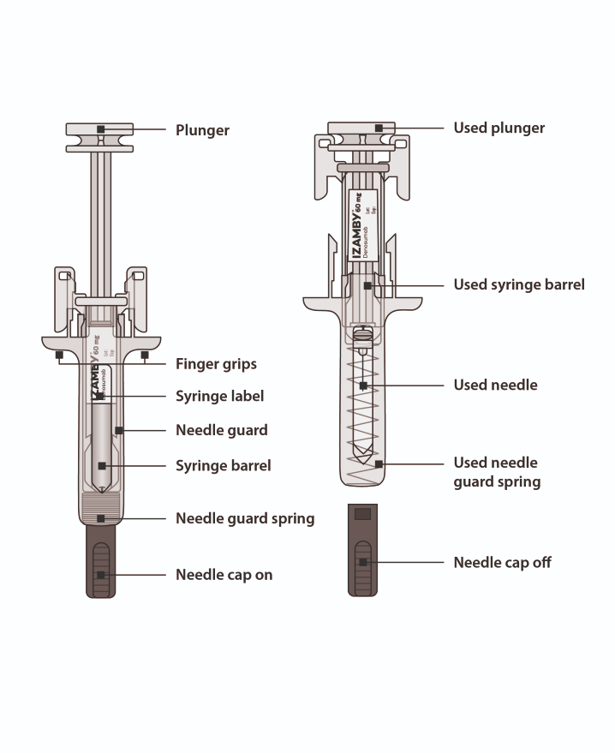

Figure 1

- Prepare to Inject Izamby

Gather supplies
- On a clean, well-lit work surface, gather the supplies needed for your injection:
  - Izamby carton with pre-filled syringe
  - Alcohol wipes
  - Cotton ball or gauze pad
  - Plaster
  - Sharps disposal container

Acclimate to room temperature
- For a more comfortable injection, leave the carton with pre-filled syringe inside at room temperature for about 30 minutes before injecting (Figure A).
  - Do not try to warm the pre-filled syringe by using a heat source such as hot water or microwave.
  - Do not leave the pre-filled syringe exposed to direct sunlight.
  - Do not shake the pre-filled syringe.
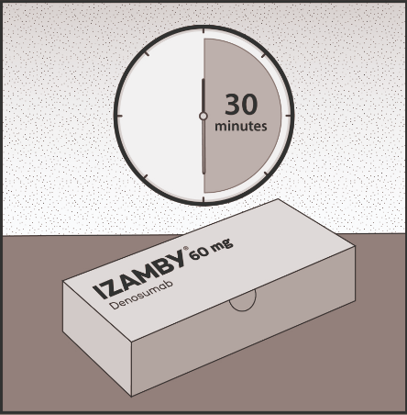
  - Keep the pre-filled syringe out of the sight and reach of children.
Figure A
Wash hands
- Wash your hands thoroughly with soap and water (Figure B).
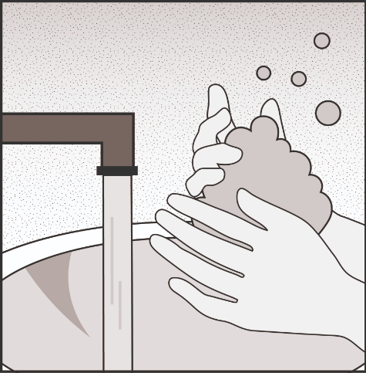
Figure B

Remove the pre-filled syringe from the carton
- Open the carton.
- Grab the pre-filled syringe by the body (Figure C).
- Lift the syringe straight out of the carton.
- Put the syringe on a clean and flat work surface.
For safety reasons:
- Do not grasp the plunger.
- Do not grasp the needle cap.

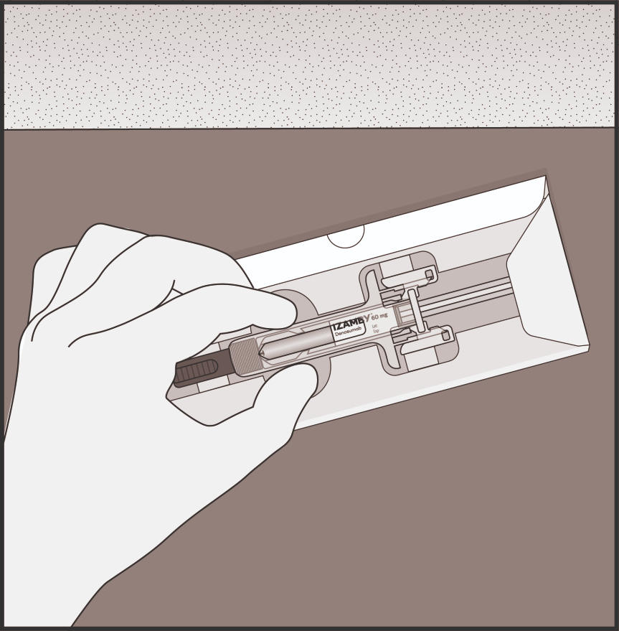

Figure C

Check medicine and pre-filled syringe
- Check the product name “Izamby” is printed on the label (Figure D).
- Check the expiry date printed on the label (Figure D).
- Check the medicine to be a clear, colorless to slightly yellow solution (Figure D).
- Check the pre-filled syringe for any damage.

Do not use the pre-filled syringe if:
- The medicine is cloudy or there are particles in it.
- Any part appears cracked or broken.
- The needle cap is missing or not securely attached.
- The expiry date printed on the label has passed the last day of the month shown.

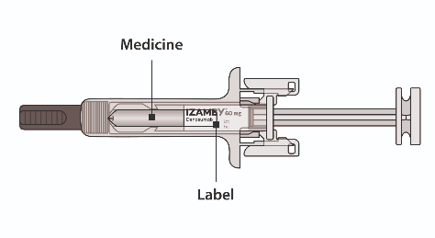
In all cases included above, call your doctor or healthcare professional.
Figure D

- Get Ready

Prepare injection site
- Select your injection site (Figure E):
You can use:
- Upper part of your thigh.
- Belly, except for a 5 cm area right around your belly button.
- Outer area of upper arm (only if someone else is giving you the injection).
- Do not inject into areas where the skin is tender, bruised, red, or hard. Avoid injecting into areas with scars or stretch marks.

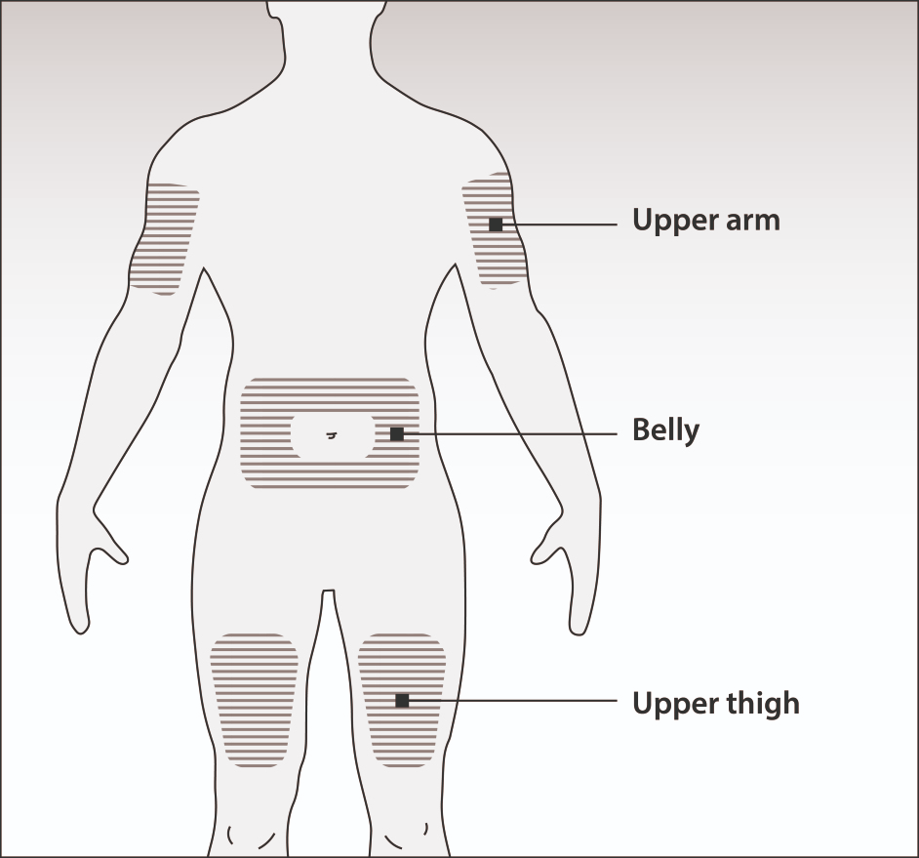
Figure E

Clean injection site
- Clean the injection site with an alcohol wipe (Figure F).
- Let the skin dry.
- Do not touch the injection site before injecting.
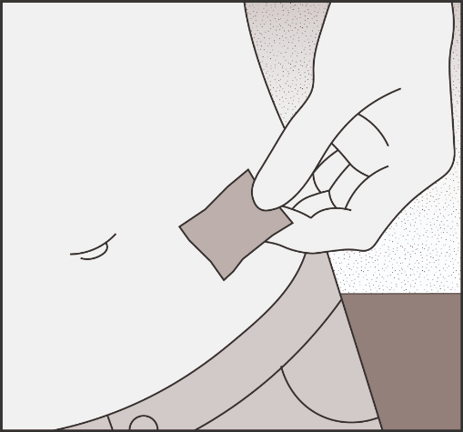
Figure F

Remove needle cap
- Carefully pull the needle cap straight off and away from your body (Figure G).
- Throw away the needle cap.
- Do not attempt to re-cap the needle.
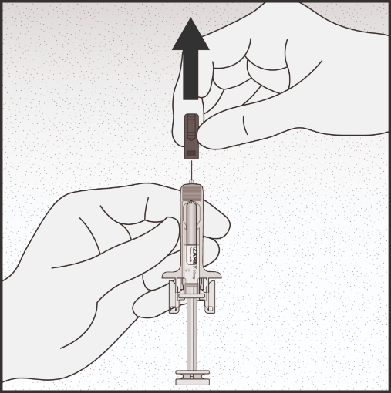
Figure G
- Inject Izamby

Insert the needle
- Pinch your injection site to create a firm surface (Figure H).
- Do not touch the cleaned area of the skin.
Note: It is important to keep the skin pinched when injecting.
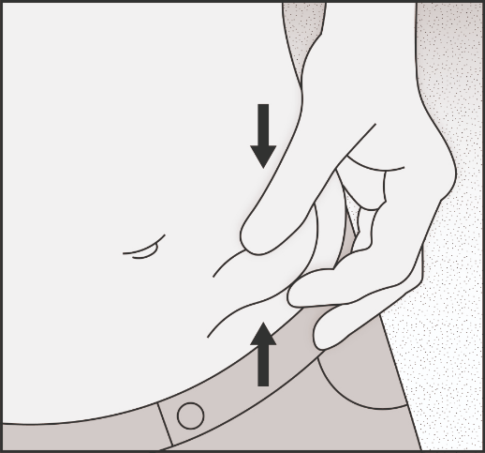
- Insert the needle at 45 to 90-degree angle into the pinched skin (Figure I).
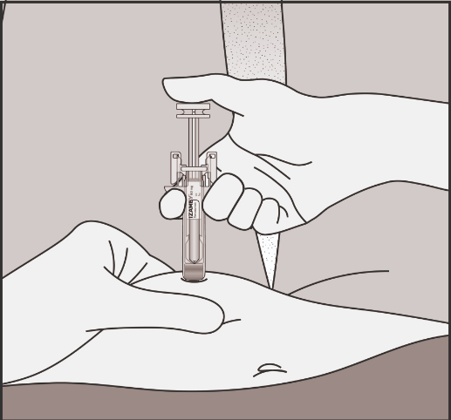
Figure H
Figure I

Inject Izamby
- Slowly push the plunger all the way in until all the liquid is injected, and the syringe is empty (Figure J).
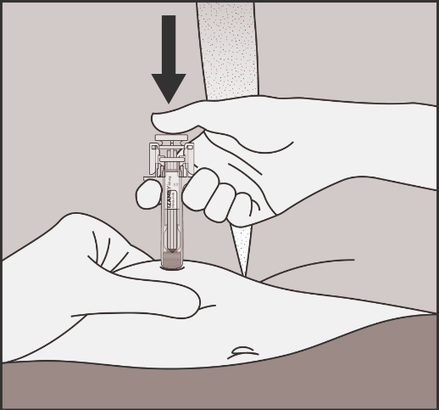
Note: The plunger must be pushed all the way down to be sure the full dose has been injected and the needle guard will activate.
Figure J

Release your thumb
- Take your thumb off the plunger to allow the needle guard to cover the needle (Figure K).
- Then lift the syringe off the skin (Figure L).
- Release the pinched skin.

Call your doctor or healthcare professional right away if:
- You did not inject the full dose or
- The needle guard does not activate after injecting.
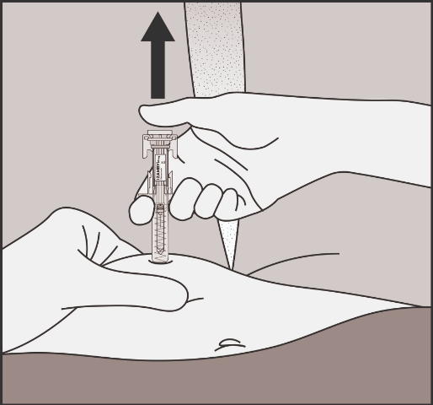
Figure K

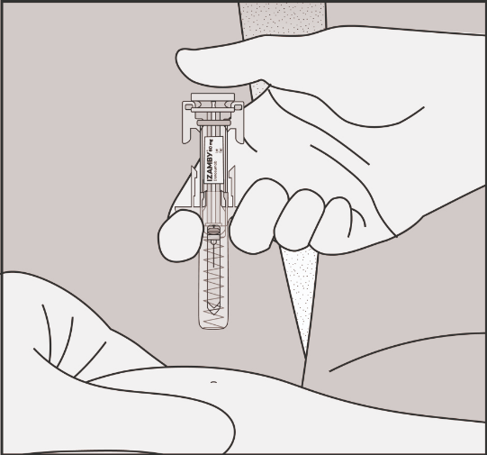
Figure L

- Dispose of Izamby

Dispose of the syringe
- Discard the used pre-filled syringe and other supplies in a sharps disposal container (Figure M).
Note: Medicines should be disposed of in accordance with local requirements. Ask your doctor or healthcare professional how to dispose of medicines no longer required. These measures will help to protect the environment.
- Do not put the needle cap back on used pre-filled syringes.
- Do not reuse the pre-filled syringe even if all of the medicine was not injected.
- Do not recycle pre-filled syringes or throw them into household waste.
- Keep the syringe and sharps disposal container out of the sight and reach of children.

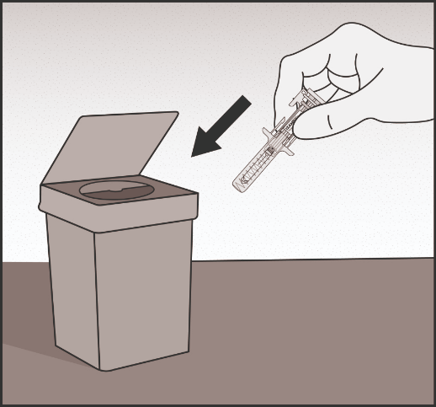
Figure M

Examine the injection site
- If there is blood, press a cotton ball or gauze pad on your injection site.
- Do not rub the injection site. Apply a plaster if needed.

Record date of next injection
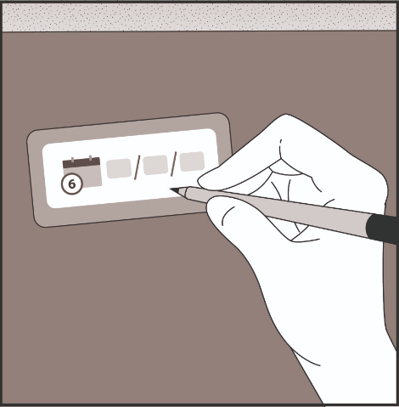
- Record the date of your next injection on the reminder card included in the pack (Figure N).
Figure N

