ANNEX I

SUMMARY OF PRODUCT CHARACTERISTICS

1. NAME OF THE MEDICINAL PRODUCT

Livogiva 20 micrograms/80 microliters solution for injection in pre-filled pen

2. QUALITATIVE AND QUANTITATIVE COMPOSITION

Each dose of 80 microliters contains 20 micrograms of teriparatide*.
Each pre-filled pen of 2.7 mL contains 675 micrograms of teriparatide (corresponding to 250 micrograms per mL).

*Teriparatide, rhPTH(1-34), produced in P. fluorescens, using recombinant DNA technology, is identical to the 34 N-terminal amino acid sequence of endogenous human parathyroid hormone.

For the full list of excipients, see section 6.1.

3. PHARMACEUTICAL FORM

Solution for injection.

Colourless, clear solution.

4. CLINICAL PARTICULARS

4.1 Therapeutic indications

Livogiva is indicated in adults.

Treatment of osteoporosis in postmenopausal women and in men at increased risk of fracture (see section 5.1). In postmenopausal women, a significant reduction in the incidence of vertebral and non-vertebral fractures but not hip fractures have been demonstrated.

Treatment of osteoporosis associated with sustained systemic glucocorticoid therapy in women and men at increased risk for fracture (see section 5.1).

4.2 Posology and method of administration

Posology

The recommended dose of Livogiva is 20 micrograms administered once daily.

The maximum total duration of treatment with Livogiva should be 24 months (see section 4.4).
The 24-month course of Livogiva should not be repeated over a patient’s lifetime.

Patients should receive supplemental calcium and vitamin D supplements if dietary intake is inadequate.

Following cessation of Livogiva therapy, patients may be continued on other osteoporosis therapies.

Special populations

Elderly patients
Dose adjustment based on age is not required (see section 5.2).

Renal impairment
Teriparatide must not be used in patients with severe renal impairment (see section 4.3). In patients with moderate renal impairment, teriparatide should be used with caution (see section 4.4). No special caution is required for patients with mild renal impairment.

Hepatic impairment
No data are available in patients with impaired hepatic function (see section 5.3). Therefore, teriparatide should be used with caution.

Paediatric population and young adults with open epiphyses
The safety and efficacy of teriparatide in children and adolescents less than 18 years have not been established. Teriparatide should not be used in paediatric patients (less than 18 years), or young adults with open epiphyses.

Method of administration

Livogiva should be administered once daily by subcutaneous injection in the thigh or abdomen.

Patients must be trained to use the proper injection techniques (see section 6.6).
Please also refer to the user manual for instructions on the correct use of the pen.

4.3 Contraindications

- Hypersensitivity to the active substance or to any of the excipients listed in section 6.1.
- Pregnancy and breast-feeding (see sections 4.4 and 4.6)
- Pre-existing hypercalcaemia
- Severe renal impairment
- Metabolic bone diseases (including hyperparathyroidism and Paget’s disease of the bone) other than primary osteoporosis or glucocorticoid-induced osteoporosis.
- Unexplained elevations of alkaline phosphatase
- Prior external beam or implant radiation therapy to the skeleton
- Patients with skeletal malignancies or bone metastases should be excluded from treatment with teriparatide.

4.4 Special warnings and precautions for use

Traceability

In order to improve the traceability of biological medicinal products, the name and the batch number of the administered product should be clearly recorded.

Serum and urine calcium

In normocalcaemic patients, slight and transient elevations of serum calcium concentrations have been observed following teriparatide injection. Serum calcium concentrations reach a maximum between 4 and 6 hours and return to baseline by 16 to 24 hours after each dose of teriparatide. Therefore, if blood samples for serum calcium measurements are taken, this should be done at least 16 hours after the most recent Livogiva injection. Routine calcium monitoring during therapy is not required.

Teriparatide may cause small increases in urinary calcium excretion, but the incidence of hypercalciuria did not differ from that in the placebo-treated patients in clinical trials.

Urolithiasis

Teriparatide has not been studied in patients with active urolithiasis. Livogiva should be used with caution in patients with active or recent urolithiasis because of the potential to exacerbate this condition.

Orthostatic hypotension

In short-term clinical studies with teriparatide, isolated episodes of transient orthostatic hypotension were observed. Typically, an event began within 4 hours of dosing and spontaneously resolved within a few minutes to a few hours. When transient orthostatic hypotension occurred, it happened within the first several doses, was relieved by placing subjects in a reclining position, and did not preclude continued treatment.

Renal impairment

Caution should be exercised in patients with moderate renal impairment (see section 4.2).

Younger adult population

Experience in the younger adult population, including premenopausal women, is limited (see section 5.1). Treatment should only be initiated if the benefit clearly outweighs risks in this population.

Women of childbearing potential should use effective methods of contraception during use of Livogiva. If pregnancy occurs, Livogiva should be discontinued.

Duration of treatment

Studies in rats indicate an increased incidence of osteosarcoma with long-term administration of teriparatide (see section 5.3). Until further clinical data become available, the recommended treatment time of 24 months should not be exceeded.

Excipients

This medicinal product contains less than 1 mmol sodium (23 mg) per dose, that is to say essentially ‘sodium-free’.

4.5 Interaction with other medicinal products and other forms of interaction

In a study of 15 healthy subjects administered digoxin daily to steady state, a single teriparatide dose did not alter the cardiac effect of digoxin. However, sporadic case reports have suggested that hypercalcaemia may predispose patients to digitalis toxicity. Because teriparatide transiently increases serum calcium, Livogiva should be used with caution in patients taking digitalis.

Teriparatide has been evaluated in pharmacodynamic interaction studies with hydrochlorothiazide. No clinically significant interactions were noted.

Co-administration of raloxifene or hormone replacement therapy with teriparatide did not alter the effects of teriparatide on serum or urine calcium or on clinical adverse events.

4.6 Fertility, pregnancy and lactation

Women of childbearing potential/Contraception in females

Women of childbearing potential should use effective methods of contraception during use of Livogiva. If pregnancy occurs, Livogiva should be discontinued.

Pregnancy

Livogiva is contraindicated for use during pregnancy (see section 4.3).

Breast-feeding

Livogiva is contraindicated for use during breast-feeding (see section 4.3). It is not known whether teriparatide is excreted in human milk.

Fertility

Studies in rabbits have shown reproductive toxicity (see section 5.3). The effect of teriparatide on human foetal development has not been studied. The potential risk for humans is unknown.

4.7 Effects on ability to drive and use machines

Livogiva has no or negligible influence on the ability to drive and use machines. Transient, orthostatic hypotension or dizziness was observed in some patients. These patients should refrain from driving or the use of machines until symptoms have subsided.

4.8 Undesirable effects

Summary of the safety profile

The most commonly reported adverse reactions in patients treated with teriparatide are nausea, pain in limb, headache and dizziness.

Tabulated list of adverse reactions

Of patients in the teriparatide trials, 82.8% of the teriparatide patients and 84.5% of the placebo patients reported at least 1 adverse event.

The adverse reactions associated with the use of teriparatide in osteoporosis clinical trials and post-marketing exposure are summarised in the table below.

The following convention has been used for the classification of the adverse reactions: very common (≥1/10), common (≥1/100 to <1/10), uncommon (≥1/1,000 to <1/100), rare (≥1/10,000 to <1/1,000), very rare (<1/10,000).

Table 1. Adverse reactions
MedDRA system organ class | Frequency | Adverse reactions
Blood and lymphatic system disorders | Common | Anaemia
Immune system disorder | Rare | Anaphylaxis
Metabolism and nutrition disorders | Common | Hypercholesterolaemia
Metabolism and nutrition disorders | Uncommon | Hypercalcaemia greater than 2.76 mmol/L, hyperuricemia
Metabolism and nutrition disorders | Rare | Hypercalcaemia greater than 3.25 mmol/L
Psychiatric disorders | Common | Depression
Nervous system disorders | Common | Dizziness, headache, sciatica, syncope
Ear and labyrinth disorders | Common | Vertigo
Cardiac disorders | Common | Palpitations
Cardiac disorders | Uncommon | Tachycardia
Vascular disorders | Common | Hypotension
Respiratory, thoracic and mediastinal disorders | Common | Dyspnoea
Respiratory, thoracic and mediastinal disorders | Uncommon | Emphysema
Gastrointestinal disorders | Common | Nausea, vomiting, hiatus hernia, gastroesophageal reflux disease
Gastrointestinal disorders | Uncommon | Haemorrhoids
Skin and subcutaneous tissue disorders | Common | Sweating increased
Musculoskeletal and connective tissue disorders | Very common | Pain in limb
Musculoskeletal and connective tissue disorders | Common | Muscle cramps
Musculoskeletal and connective tissue disorders | Uncommon | Myalgia, arthralgia, back cramp/pain*
Renal and urinary disorders | Uncommon | Urinary incontinence, polyuria, micturition urgency, nephrolithiasis
Renal and urinary disorders | Rare | Renal failure/impairment
General disorders and administration site conditions | Common | Fatigue, chest pain, asthenia, mild and transient injection site events, including pain, swelling, erythema, localised bruising, pruritis and minor bleeding at injection site.
General disorders and administration site conditions | Uncommon | Injection site erythema, injection site reaction
General disorders and administration site conditions | Rare | Possible allergic events soon after injection: acute dyspnoea, oro/facial oedema, generalised urticaria, chest pain, oedema (mainly peripheral).
Investigations | Uncommon | Weight increased, cardiac murmur, alkaline phosphatase increase
*Serious cases of back cramp or pain have been reported within minutes of the injection.

Description of selected adverse reactions

In clinical trials, the following reactions were reported at a ≥1% difference in frequency from placebo: vertigo, nausea, pain in limb, dizziness, depression, dyspnoea.

Teriparatide increases serum uric acid concentrations. In clinical trials, 2.8% of teriparatide patients had serum uric acid concentrations above the upper limit of normal compared with 0.7% of placebo patients. However, the hyperuricemia did not result in an increase in gout, arthralgia, or urolithiasis.

Anti-drug antibodies were observed in line with other teriparatide containing medicinal products. There was no evidence of hypersensitivity reactions, allergic reactions, effects on serum calcium, or effects on Bone Mineral Density (BMD) response.

Reporting of suspected adverse reactions

Reporting suspected adverse reactions after authorisation of the medicinal product is important. It allows continued monitoring of the benefit/risk balance of the medicinal product. Healthcare professionals are asked to report any suspected adverse reactions via the national reporting system listed in Appendix V.

4.9 Overdose

Signs and symptoms

Teriparatide has been administered in single doses of up to 100 micrograms and in repeated doses of up to 60 micrograms/day for 6 weeks.

The effects of overdose that might be expected include delayed hypercalcaemia and risk of orthostatic hypotension. Nausea, vomiting, dizziness, and headache can also occur.

Overdose experience based on post-marketing spontaneous reports

In post-marketing spontaneous reports, there have been cases of medicinal product error where the entire contents (up to 800 mcg) of the teriparatide pen have been administered as a single dose. Transient events reported have included nausea, weakness/lethargy and hypotension. In some cases, no adverse events occurred as a result of the overdose. No fatalities associated with overdose have been reported.

Overdose management

There is no specific antidote for teriparatide. Treatment of suspected overdose should include transitory discontinuation of Livogiva, monitoring of serum calcium, and implementation of appropriate supportive measures, such as hydration.

5. PHARMACOLOGICAL PROPERTIES

5.1 Pharmacodynamic properties

Pharmacotherapeutic group: Calcium homeostasis, parathyroid hormones and analogues, ATC code: H05AA02.

Livogiva is a biosimilar medicinal product. Detailed information is available on the website
of the European Medicines Agency http://www.ema.europa.eu.

Mechanism of action

Endogenous 84-amino-acid parathyroid hormone (PTH) is the primary regulator of calcium and phosphate metabolism in bone and kidney. Teriparatide (rhPTH(1-34)) is the active fragment (1-34) of endogenous human parathyroid hormone. Physiological actions of PTH include stimulation of bone formation by direct effects on bone forming cells (osteoblasts) indirectly increasing the intestinal absorption of calcium and increasing the tubular re-absorption of calcium and excretion of phosphate by the kidney.

Pharmacodynamic effects

Teriparatide is a bone formation agent to treat osteoporosis. The skeletal effects of teriparatide depend upon the pattern of systemic exposure. Once-daily administration of teriparatide increases apposition of new bone on trabecular and cortical bone surfaces by preferential stimulation of osteoblastic activity over osteoclastic activity.

Clinical efficacy and safety

Risk factors

Independent risk factors, for example, low BMD, age, the existence of previous fracture, family history of hip fractures, high bone turnover and low body mass index should be considered in order to identify women and men at increased risk of osteoporotic fractures who could benefit from treatment.

Premenopausal women with glucocorticoid-induced osteoporosis should be considered at high risk for fracture if they have a prevalent fracture or a combination of risk factors that place them at high risk for fracture (e.g., low bone density [e.g., T score ≤−2], sustained high dose glucocorticoid therapy [e.g., ≥7.5 mg/day for at least 6 months], high underlying disease activity, low sex steroid levels).

Postmenopausal osteoporosis

The pivotal study included 1,637 postmenopausal women (mean age 69.5 years). At baseline, ninety percent of the patients had one or more vertebral fractures, and on average, vertebral BMD was 0.82 g/cm² (equivalent to a T score = - 2.6). All patients were offered 1,000 mg calcium per day and at least 400 IU vitamin D per day. Results from up to 24 months (median: 19 months) treatment with teriparatide demonstrate statistically significant fracture reduction (Table 1). To prevent one or more new vertebral fractures, 11 women had to be treated for a median of 19 months.

Table 2. Fracture incidence in postmenopausal women
 | Placebo  (N = 544) (%) | Teriparatide  (N = 541) (%) | Relative risk  (95% CI)  vs. placebo
New vertebral fracture (≥1)ª | 14.3 | 5.0^{b} | 0.35  (0.22, 0.55)
Multiple vertebral fractures (≥2)ª | 4.9 | 1.1^{b} | 0.23  (0.09, 0.60)
Non-vertebral fragility fractures^{c} | 5.5% | 2.6%^{d} | 0.47  (0.25, 0.87)
Major non-vertebral fragility fractures^{c} (hip, radius, humerus, ribs and pelvis) | 3.9% | 1.5%^{d} | 0.38  (0.17, 0.86)
Abbreviations: N = number of patients randomly assigned to each treatment group; CI = Confidence Interval.
ªThe incidence of vertebral fractures was assessed in 448 placebo and 444 teriparatide patients who had baseline and follow-up spine radiographs.
^{b}p≤0.001 compared with placebo
^{c}A significant reduction in the incidence of hip fractures has not been demonstrated
^{d}p≤0.025 compared with placebo.

After 19 months (median) treatment, bone mineral density (BMD) had increased in the lumbar spine and total hip, respectively, by 9% and 4% compared with placebo (p<0.001).

Post-treatment management: Following treatment with teriparatide, 1,262 postmenopausal women from the pivotal trial enrolled in a post-treatment follow-up study. The primary objective of the study was to collect safety data of teriparatide. During this observational period, other osteoporosis treatments were allowed and additional assessment of vertebral fractures was performed.

During a median of 18 months following discontinuation of teriparatide, there was a 41% reduction (p=0.004) compared with placebo in the number of patients with a minimum of one new vertebral fracture.

In an open-label study, 503 postmenopausal women with severe osteoporosis and a fragility fracture within the previous 3 years (83% had received previous osteoporosis therapy) were treated with teriparatide for up to 24 months. At 24 months, the mean increase from baseline in lumbar spine, total hip and femoral neck BMD was 10.5%, 2.6% and 3.9% respectively. The mean increase in BMD from 18 to 24 months was 1.4%, 1.2%, and 1.6% at the lumbar spine, total hip and femoral neck, respectively.

A 24-month, randomised, double-blind, comparator-controlled Phase 4 study included 1,360 postmenopausal women with established osteoporosis. 680 subjects were randomised to teriparatide and 680 subjects were randomised to oral risedronate 35 mg/week. At baseline, the women had a mean age of 72.1 years and a median of 2 prevalent vertebral fractures; 57.9% of patients had received previous bisphosphonate therapy and 18.8% took concomitant glucocorticoids during the study. 1,013 (74.5%) patients completed the 24-month follow-up. The mean (median) cumulative dose of glucocorticoid was 474.3 (66.2) mg in the teriparatide arm and 898.0 (100.0) mg in the risedronate arm. The mean (median) vitamin D intake for the teriparatide arm was 1,433 IU/day (1,400 IU/day) and for the risedronate arm was 1,191 IU/day (900 IU/day). For those subjects who had baseline and follow-up spine radiographs, the incidence of new vertebral fractures was 28/516 (5.4%) in teriparatide- and 64/533 (12.0%) in risedronate-treated patients, relative risk (95% CI) = 0.44 (0.29-0.68), P<0.0001. The cumulative incidence of pooled clinical fractures (clinical vertebral and non-vertebral fractures) was 4.8% in teriparatide and 9.8% in risedronate-treated patients, hazard ratio (95% CI) = 0.48 (0.32-0.74), P=0.0009

Male osteoporosis

437 patients (mean age 58.7 years) were enrolled in a clinical trial for men with hypogonadal (defined as low morning free testosterone or an elevated FSH or LH) or idiopathic osteoporosis. Baseline spinal and femoral neck bone mineral density mean T-scores were -2.2 and -2.1, respectively. At baseline, 35% of patients had a vertebral fracture and 59% had a non-vertebral fracture.

All patients were offered 1,000 mg calcium per day and at least 400 IU vitamin D per day. Lumbar spine BMD significantly increased by 3 months. After 12 months, BMD had increased in the lumbar spine and total hip by 5% and 1%, respectively, compared with placebo. However, no significant effect on fracture rates was demonstrated.

Glucocorticoid-induced osteoporosis

The efficacy of teriparatide in men and women (N=428) receiving sustained systemic glucocorticoid therapy (equivalent to 5 mg or greater of prednisone for at least 3 months) was demonstrated in the 18-month primary phase of a 36 month, randomised, double-blind, comparator-controlled study (alendronate 10 mg/day). Twenty-eight percent of patients had one or more radiographic vertebral fractures at baseline. All patients were offered 1,000 mg calcium per day and 800 IU vitamin D per day.
This study included postmenopausal women (N=277), premenopausal women (N=67), and men (N=83). At baseline, the postmenopausal women had a mean age of 61 years, mean lumbar spine BMD T score of −2.7, median prednisone equivalent dose of 7.5 mg/day, and 34% had one or more radiographic vertebral fractures; premenopausal women had a mean age of 37 years, mean lumbar spine BMD T score of −2.5, median prednisone equivalent dose of 10 mg/day, and 9% had one or more radiographic vertebral fractures; and men had a mean age of 57 years, mean lumbar spine BMD T score of −2.2, median prednisone equivalent dose of 10 mg/day, and 24% had one or more radiographic vertebral fractures.

Sixty-nine percent of patients completed the 18-month primary phase. At the 18-month endpoint, teriparatide significantly increased lumbar spine BMD (7.2%) compared with alendronate (3.4%) (p<0.001). Teriparatide increased BMD at the total hip (3.6%) compared with alendronate (2.2%) (p<0.01), as well as at the femoral neck (3.7%) compared with alendronate (2.1%) (p<0.05). In patients treated with teriparatide, lumbar spine, total hip and femoral neck BMD increased between 18 and 24 months by an additional 1.7%, 0.9%, and 0.4%, respectively.

At 36 months, analysis of spinal X-rays from 169 alendronate patients and 173 teriparatide patients showed that 13 patients in the alendronate group (7.7%) had experienced a new vertebral fracture compared with 3 patients in the teriparatide group (1.7%) (p=0.01). In addition, 15 of 214 patients in the alendronate group (7.0%) had experienced a non-vertebral fracture compared with 16 of 214 patients in the teriparatide group (7.5%) (p=0.84).

In premenopausal women, the increase in BMD from baseline to 18 months endpoint was significantly greater in the teriparatide group compared with the alendronate group at the lumbar spine (4.2% versus −1.9%; p<0.001) and total hip (3.8% versus 0.9%; p=0.005). However, no significant effect on fracture rates was demonstrated.

5.2 Pharmacokinetic properties

Distribution

The volume of distribution is approximately 1.7 L/kg. The half-life of teriparatide is approximately 1 hour when administered subcutaneously, which reflects the time required for absorption from the injection site.

Biotransformation

No metabolism or excretion studies have been performed with teriparatide but the peripheral metabolism of parathyroid hormone is believed to occur predominantly in liver and kidney.

Elimination

Teriparatide is eliminated through hepatic and extra-hepatic clearance (approximately 62 L/hr in women and 94 L/hr in men).

Elderly

No differences in teriparatide pharmacokinetics were detected with regard to age (range 31 to 85 years). Dosage adjustment based on age is not required.

5.3 Preclinical safety data

Teriparatide was not genotoxic in a standard battery of tests. It produced no teratogenic effects in rats, mice or rabbits. There were no important effects observed in pregnant rats or mice administered teriparatide at daily doses of 30 to 1,000 μg/kg. However, fetal resorption and reduced litter size occurred in pregnant rabbits administered daily doses of 3 to 100 μg/kg. The embryotoxicity observed in rabbits may be related to their much greater sensitivity to the effects of PTH on blood ionised calcium compared with rodents.

Rats treated with near-life time daily injections had dose-dependent exaggerated bone formation and increased incidence of osteosarcoma most probably due to an epigenetic mechanism. Teriparatide did not increase the incidence of any other type of neoplasia in rats. Due to the differences in bone physiology in rats and humans, the clinical relevance of these findings is probably minor. No bone tumours were observed in ovariectomised monkeys treated for 18 months or during a 3-year follow-up period after treatment cessation. In addition, no osteosarcomas have been observed in clinical trials or during the post treatment follow-up study.

Animal studies have shown that severely reduced hepatic blood flow decreases exposure of PTH to the principal cleavage system (Kupffer cells) and consequently clearance of PTH (1-84).

6. PHARMACEUTICAL PARTICULARS

6.1 List of excipients

Glacial acetic acid
Sodium acetate trihydrate
Mannitol
Metacresol
Water for injections

6.2 Incompatibilities

In the absence of compatibility studies, this medicinal product must not be mixed with other medicinal products.

6.3 Shelf life

2 years

Chemical, physical and microbiological in-use stability has been demonstrated for 28 days at 2-8°C. Once opened, the medicinal product may be stored for a maximum of 28 days at 2°C to 8°C. Other in-use storage times and conditions are the responsibility of the user.

6.4 Special precautions for storage

Store in a refrigerator (2°C - 8°C) at all times. The pen injector should be returned to the refrigerator immediately after use.

Do not freeze.

Do not store the pen injector with the needle attached.

Always store the pen injector with the white cap on after use, in order to protect from light.

6.5 Nature and contents of container

2.7 mL solution in cartridge (siliconised Type I glass) sealed at one end with a bromobutyl rubber plunger and at the other end crimp-sealed with a bi-layer combi-seal (polyisoprene/ bromobutyl rubber laminate with aluminium over cap). The cartridges are an integral and non-replaceable part of the pen injector.

The pen injector is composed of a clear cartridge holder, white protective cap to cover the cartridge holder and injector body with a black injection button.

Livogiva is available in pack sizes of 1 or 3 pre-filled pens. Each pre-filled pen contains 28 doses of 20 micrograms (per 80 microliters).

Not all pack sizes may be marketed.

6.6 Special precautions for disposal and other handling

Each pen should be used by only one patient. A new, sterile needle must be used for every injection. No needles are supplied with the medicinal product. The device can be used with insulin pen injection needles. After each injection, the Livogiva pen should be returned to the refrigerator.

Livogiva should not be used if the solution is cloudy, coloured or contains particles.

Any unused product or waste material should be disposed of in accordance with local requirements.

7. MARKETING AUTHORISATION HOLDER

Theramex Ireland Limited
3rd Floor Kilmore House, Park Lane, Spencer Dock
DO1 YE64 Dublin 1
Ireland

8. MARKETING AUTHORISATION NUMBER(S)

EU/1/20/1462/001-002

9. DATE OF FIRST AUTHORISATION/RENEWAL OF THE AUTHORISATION

Date of first authorisation:

10. DATE OF REVISION OF THE TEXT

Detailed information is available on the website of the European Medicines Agency http://www.ema.europa.eu.

ANNEX II

A. MANUFACTURER OF THE BIOLOGICAL ACTIVE SUBSTANCE AND MANUFACTURER RESPONSIBLE FOR BATCH RELEASE

B. CONDITIONS OR RESTRICTIONS REGARDING SUPPLY AND USE

C. OTHER CONDITIONS AND REQUIREMENTS OF THE MARKETING AUTHORISATION

D. conditions or restrictions with regard to the safe and effective use of the medicinal product

A. MANUFACTURER OF THE BIOLOGICAL ACTIVE SUBSTANCE AND MANUFACTURER RESPONSIBLE FOR BATCH RELEASE

Name and address of the manufacturer of the biological active substance

Cytovance Biologics Inc.
3500 North Santa Fe Ave
Oklahoma City, OK 73118
United States

Name and address of the manufacturer responsible for batch release

Eurofins PROXY Laboratories (PRX)
Archimedesweg 25 2333 CM Leiden
Netherlands

B. CONDITIONS OR RESTRICTIONS REGARDING SUPPLY AND USE

Medicinal product subject to medical prescription.

C. OTHER CONDITIONS AND REQUIREMENTS OF THE MARKETING AUTHORISATION

- Periodic safety update reports (PSURs)

The requirements for submission of PSURs for this medicinal product are set out in the list of Union reference dates (EURD list) provided for under Article 107c(7) of Directive 2001/83/EC and any subsequent updates published on the European medicines web-portal.

D. CONDITIONS OR RESTRICTIONS WITH REGARD TO THE SAFE AND EFFECTIVE USE OF THE MEDICINAL PRODUCT

- Risk management plan (RMP)

The marketing authorisation holder (MAH) shall perform the required pharmacovigilance activities and interventions detailed in the agreed RMP presented in Module 1.8.2 of the marketing authorisation and any agreed subsequent updates of the RMP.

An updated RMP should be submitted:
- At the request of the European Medicines Agency;
- Whenever the risk management system is modified, especially as the result of new information being received that may lead to a significant change to the benefit/risk profile or as the result of an important (pharmacovigilance or risk minimisation) milestone being reached.

ANNEX III

LABELLING AND PACKAGE LEAFLET

A. LABELLING

PARTICULARS TO APPEAR ON THE OUTER PACKAGING

OUTER CARTON

1. NAME OF THE MEDICINAL PRODUCT

Livogiva 20 micrograms/80 microliters solution for injection in pre-filled pen
teriparatide

2. STATEMENT OF ACTIVE SUBSTANCE

Each mL contains 250 micrograms of teriparatide.
Each pre-filled pen of 2.7 mL contains 675 micrograms of teriparatide (corresponding to 250 micrograms per mL).

3. LIST OF EXCIPIENTS

Glacial acetic acid, sodium acetate trihydrate, mannitol, metacresol, water for injections. See leaflet for further information.

4. PHARMACEUTICAL FORM AND CONTENTS

Solution for injection.
1 pen of 2.7 mL solution.
3 pens of 2.7 mL solution.

Each pre-filled pen contains 28 doses of 20 micrograms (per 80 microliters).

5. METHOD AND ROUTE(S) OF ADMINISTRATION

Read the package leaflet before use.
Subcutaneous use

6. SPECIAL WARNING THAT THE MEDICINAL PRODUCT MUST BE STORED OUT OF THE SIGHT AND REACH OF CHILDREN

Keep out of the sight and reach of children.

7. OTHER SPECIAL WARNING(S), IF NECESSARY

To open, lift and pull

8. EXPIRY DATE

EXP
The pen should be discarded 28 days after the first use.
Date of first use:

9. SPECIAL STORAGE CONDITIONS

Store in a refrigerator.
Do not freeze.

10. SPECIAL PRECAUTIONS FOR DISPOSAL OF UNUSED MEDICINAL PRODUCTS OR WASTE MATERIALS DERIVED FROM SUCH MEDICINAL PRODUCTS, IF APPROPRIATE

11. NAME AND ADDRESS OF THE MARKETING AUTHORISATION HOLDER

Theramex Ireland Limited
3rd Floor Kilmore House, Park Lane, Spencer Dock
DO1 YE64 Dublin 1
Ireland

12. MARKETING AUTHORISATION NUMBER(S)

EU/1/20/1462/001

EU/1/20/1462/002

13. BATCH NUMBER

Batch

14. GENERAL CLASSIFICATION FOR SUPPLY

15. INSTRUCTIONS ON USE

16. INFORMATION IN BRAILLE

Livogiva

17. UNIQUE IDENTIFIER – 2D BARCODE

2D barcode carrying the unique identifier included.

18. UNIQUE IDENTIFIER - HUMAN READABLE DATA

PC
SN
NN

MINIMUM PARTICULARS TO APPEAR ON SMALL IMMEDIATE PACKAGING UNITS

LABEL

1. NAME OF THE MEDICINAL PRODUCT AND ROUTE(S) OF ADMINISTRATION

Livogiva 20 micrograms/80 microliters solution for injection in pre-filled pen
teriparatide
Subcutaneous use

2. METHOD OF ADMINISTRATION

3. EXPIRY DATE

EXP

4. BATCH NUMBER

Batch

5. CONTENTS BY WEIGHT, BY VOLUME OR BY UNIT

2.7 mL

6. OTHER

Store in a refrigerator

B. PACKAGE LEAFLET

Package leaflet: Information for the user

Livogiva 20 micrograms/80 microliters solution for injection in pre-filled pen
teriparatide

Read all of this leaflet carefully before you start using this medicine because it contains important information for you.
- Keep this leaflet. You may need to read it again.
- If you have any further questions, ask your doctor or pharmacist.
- This medicine has been prescribed for you only. Do not pass it on to others. It may harm them, even if their signs of illness are the same as yours.
- If you get any side effects, talk to your doctor or pharmacist. This includes any possible side effects not listed in this leaflet. See section 4.

What is in this leaflet

1. What Livogiva is and what it is used for
2. What you need to know before you use Livogiva
3. How to use Livogiva
4. Possible side effects
5. How to store Livogiva
6. Contents of the pack and other information

1. What Livogiva is and what it is used for

Livogiva contains the active substance teriparatide that is used to make the bones stronger, and to reduce the risk of fractures by stimulating bone formation.

Livogiva is used to treat osteoporosis in adults. Osteoporosis is a disease that causes your bones to become thin and fragile. This disease is especially common in women after the menopause, but it can also occur in men. Osteoporosis is also common in patients receiving corticosteroids.

2. What you need to know before you use Livogiva

Do not use Livogiva
- if you are allergic to teriparatide or any of the other ingredients of this medicine (listed in section 6).
- if you suffer from high calcium levels (pre-existing hypercalcaemia).
- if you suffer from serious kidney problems.
- if you have ever been diagnosed with bone cancer or other cancers that have spread (metastasised) to your bones.
- if you have certain bone diseases. If you have a bone disease, tell your doctor.
- if you have unexplained high levels of alkaline phosphatase in your blood, which means you might have Paget’s disease of bone (disease with abnormal bone changes). If you are not sure, ask your doctor.
- if you have had radiation therapy involving your bones.
- if you are pregnant or breast-feeding.

Warnings and precautions
Livogiva may cause an increase in the amount of calcium in your blood or urine.

Talk to your doctor or pharmacist before or while using Livogiva:
- if you have continuing nausea, vomiting, constipation, low energy, or muscle weakness. These may be signs there is too much calcium in your blood.
- if you suffer from kidney stones or have a history of kidney stones.
- if you suffer from kidney problems (moderate renal impairment).

Some patients get dizzy or get a fast heartbeat after the first few doses. For the first doses, inject Livogiva where you can sit or lie down right away if you get dizzy.
The recommended treatment time of 24 months should not be exceeded.

Livogiva should not be used in growing adults.

Children and adolescents
Livogiva should not be used in children and adolescents (less than 18 years).

Other medicines and Livogiva
Tell your doctor or pharmacist if you are taking, have recently taken or might take any other medicines, because occasionally they may interact (e.g. digoxin/digitalis, a medicine used to treat heart disease).

Pregnancy and breast-feeding
Do not use Livogiva if you are pregnant or breast-feeding. If you are a woman of child-bearing potential, you should use effective methods of contraception during use of Livogiva. If you become pregnant, Livogiva should be discontinued. Ask your doctor or pharmacist for advice before taking any medicine.

Driving and using machines

Some patients may feel dizzy after injecting Livogiva. If you feel dizzy you should not drive or use machines until you feel better

Livogiva contains sodium
This medicine contains less than 1 mmol sodium (23 mg) per dose, that is to say essentially ‘sodium-free’.

3. How to use Livogiva

Always use this medicine exactly as your doctor has told you to. Check with your doctor or pharmacist if you are not sure.

The recommended dose is 20 micrograms given once daily by injection under the skin (subcutaneous injection) in the thigh or abdomen. To help you remember to use your medicine, inject it at about the same time each day.

Inject Livogiva each day for as long as your doctor prescribes it for you. The total duration of treatment with Livogiva should not exceed 24 months. You should not receive more than one treatment course of 24 months over your lifetime.

Your doctor may advise you to use Livogiva with calcium and vitamin D. Your doctor will tell you how much you should take each day.

Read the user manual, which is included in the carton for instructions on how to use the Livogiva pen.

Injection needles are not included with the pen. Pen needles 29 to 31 gauge (diameter 0.25-0.33 mm) can be used.
You should use your Livogiva injection shortly after you take the pen out of the refrigerator as described in the user manual. Put the pen back into the refrigerator immediately after you have used it.
Use a new injection needle for each injection and dispose of it after each use. Never store your pen with the needle attached. Never share your Livogiva pen with others.

Livogiva can be given with or without food.

If you use more Livogiva than you should
If, by mistake, you have used more Livogiva than you should, contact your doctor or pharmacist.

The effects of overdose that might be expected include nausea, vomiting, dizziness, and headache.

If you forget or cannot take Livogiva at your usual time, use it as soon as possible on that day. Do not use a double dose to make up for a forgotten dose. Do not use more than one injection in the same day. Do not try to make up for a missed dose.

If you stop taking Livogiva
If you are considering stopping Livogiva treatment, please discuss this with your doctor. Your doctor will advise you and decide how long you should be treated with Livogiva.

If you have any further questions on the use of this medicine, ask your doctor or pharmacist.

4. Possible side effects

Like all medicines, this medicine can cause side effects, although not everybody gets them.

The most common side effects are pain in limb (frequency is very common, may affect more than 1 in 10 people) and feeling sick, headache and dizziness (frequency is common). If you become dizzy (light-headed) after your injection, you should sit or lie down until you feel better. If you do not feel better, you should call a doctor before you continue treatment. Cases of fainting have been reported in association with teriparatide use.
If you experience discomfort such as redness of the skin, pain, swelling, itching, bruising or minor bleeding around the area of the injection (frequency is common), this should clear up in a few days or weeks. Otherwise tell your doctor as soon as possible.
Some patients may have experienced allergic reactions soon after injection, consisting of breathlessness, swelling of the face, rash and chest pain (frequency is rare). In rare cases, serious and potentially life-threatening allergic reactions including anaphylaxis can occur.

Other side effects include:
Common: may affect up to 1 in 10 people
- increase in blood cholesterol levels
- depression
- neuralgic pain in the leg
- feeling faint
- irregular heart beats
- breathlessness
- increased sweating
- muscle cramps
- loss of energy
- tiredness
- chest pain
- low blood pressure
- heartburn (painful or burning sensation just below the breast bone)
- being sick (vomiting)
- a hernia of the tube that carries food to your stomach
- low haemoglobin or red blood cell count (anaemia)

Uncommon: may affect up to 1 in 100 people
- increased heart rate
- abnormal heart sound
- shortness of breath
- haemorrhoids (piles)
- accidental loss or leakage of urine
- increased need to pass water
- weight increase
- kidney stones
- pain in the muscles and pain in the joints. Some patients have experienced severe back cramps or pain which lead to hospitalization.
- increase in blood calcium level
- increase in blood uric acid level
- increase in an enzyme called alkaline phosphatase.

Rare: may affect up to 1 in 1,000 people
- reduced kidney function, including renal failure
- swelling, mainly in the hands, feet and legs.

Reporting of side effects
If you get any side effects, talk to your doctor or pharmacist. This includes any possible side effects not listed in this leaflet. You can also report side effects directly via the national reporting system listed in Appendix V. By reporting side effects you can help provide more information on the safety of this medicine.

5. How to store Livogiva

Keep this medicine out of the sight and reach of children.

Do not use this medicine after the expiry date which is stated on the carton and pen after EXP. The expiry date refers to the last day of that month.

Livogiva should be stored in a refrigerator (2°C to 8°C) at all times. You can use Livogiva for up to 28 days after the first injection, as long as the pen is stored in a refrigerator (2°C to 8°C).

Avoid placing the pens close to the ice compartment of the refrigerator to prevent freezing. Do not use Livogiva if it is, or has been, frozen.

Each pen should be properly disposed of after 28 days, even if it is not completely empty.

Livogiva contains a clear and colourless solution. Do not use Livogiva if solid particles appear or if the solution is cloudy or coloured.

Do not throw away any medicines via wastewater or household waste. Ask your pharmacist how to throw away medicines you no longer use. These measures will help to protect the environment.

6. Contents of the pack and other information

What Livogiva contains
- The active substance is teriparatide. Each milliliter of the solution for injection contains 250 micrograms of teriparatide. Each pre-filled pen of 2.7 mL contains 675 micrograms of teriparatide (corresponding to 250 micrograms per mL).
- The other ingredients are glacial acetic acid, sodium acetate trihydrate, mannitol, metacresol, and water for injections. See section 2.

What Livogiva looks like and contents of the pack
Livogiva is a colourless and clear solution. It is supplied in a cartridge contained in a pre-filled disposable pen. Each pen contains 2.7 mL of solution enough for 28 doses. Livogiva is available in packs containing one or three pre-filled pens.

Not all pack sizes may be available.

Marketing Authorisation Holder
Theramex Ireland Limited
3rd Floor Kilmore House, Park Lane, Spencer Dock
DO1 YE64 Dublin 1
Ireland

Manufacturer
Eurofins PROXY Laboratories (PRX)
Archimedesweg 25 2333 CM Leiden
Netherlands

This leaflet was last revised in

Other sources of information
Detailed information on this medicine is available on the European Medicines Agency web site: http://www.ema.europa.eu.

USER MANUAL

Livogiva 20 micrograms/80 microliters solution for injection in pre-filled pen

IMPORTANT INFORMATION

DO NOT start the administration procedure until you have read the Package leaflet and this User Manual contained in your Livogiva carton thoroughly. Follow the instructions carefully whenever using the Livogiva pen.

Livogiva pen and parts
Pen needles 29 to 31 gauge (diameter 0.25-0.33 mm) can be used.
Needles not included.
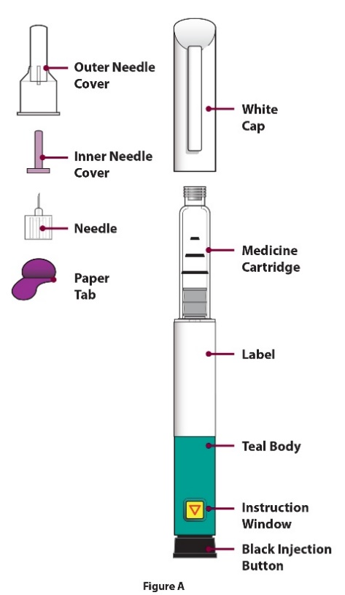

Instructions for use

Prepare for injection

Step 1  Prepare site  and remove the  white cap | - Wash your hands before every injection.  - Prepare the injection site (thigh or abdomen) as recommended by your doctor or pharmacist.  - Remove the white cap by pulling it straight off the device (Figure B). | 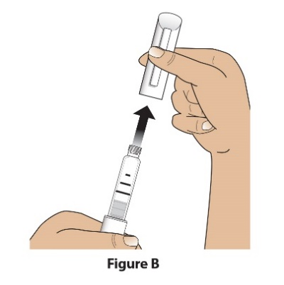

Step 2  Check pen, pen label and medicine | - Check the pen.  DO NOT use the Livogiva pen if it is damaged.  - Check the label on the pen.  DO NOT use if the pen contains the incorrect medicine or if the medicine has expired (Figure C).  - Check the medicine cartridge. The liquid medication should be clear and colourless.  DO NOT use the medicine if it is cloudy, coloured, or has floating particles. (Figure C). | 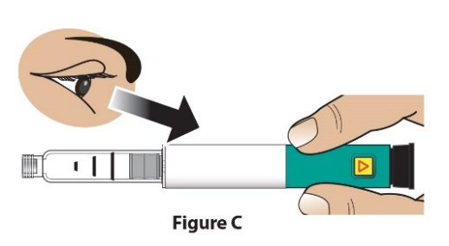

Step 3  Attach new needle | - Peel off the paper tab (Figure D). | 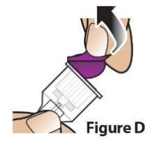
Step 3  Attach new needle | - Push needle straight onto medicine cartridge (Figure E).  Screw on needle clockwise until firmly attached (Figure F).  Do not over-tighten the needle. | 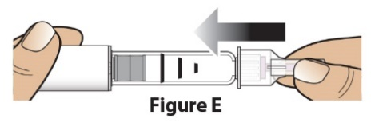  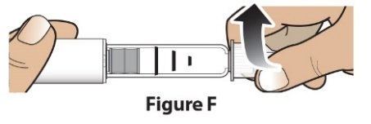

Step 4  Remove outer needle cover | Pull off large outer needle cover (Figure G) and save it for later (see Step 9). | 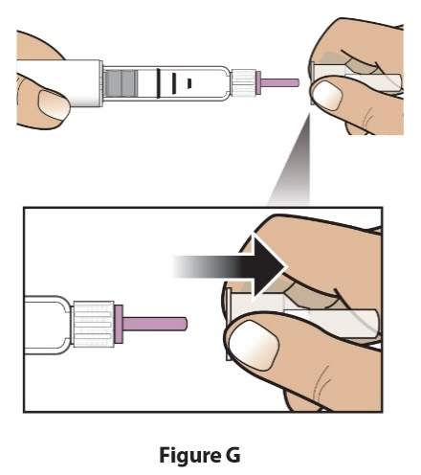

Step 5  Set dose | Pull out the black injection button until it stops. (Figure H). | 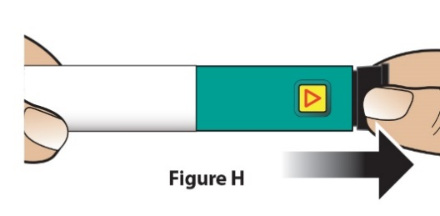
Step 5  Set dose | Check to make sure red stripe shows.  Additionally, the instruction window will show an arrow pointing towards the needle end of the pen (Figure I). | 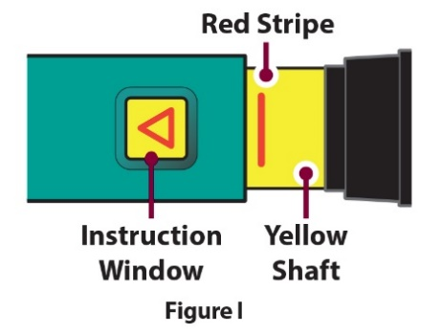
Troubleshooting when setting the dose

If the pen does not set fully or if you cannot pull back on the black injection button refer to Troubleshooting Problem E.

Administer injection

Step 6  Remove inner needle cover | Pull off small inner needle protector and throw it away (Figure J). The needle will be exposed. |  | 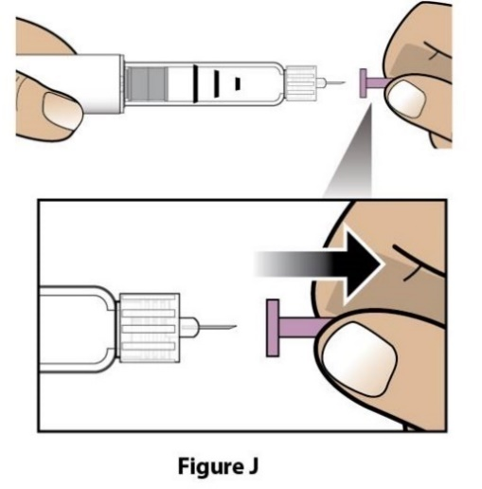

Step 7  Inject dose | - Gently hold a fold of skin on your thigh or abdomen and insert the needle straight into the folded skin (Figure K). | 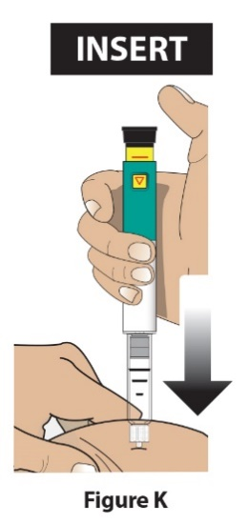
Step 7  Inject dose | B) Press the black injection button down until it stops and hold (Figure L). | 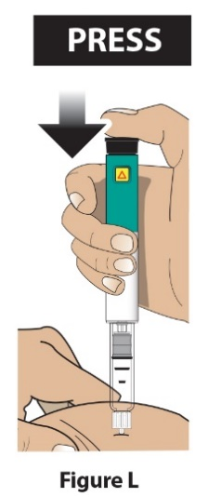
Step 7  Inject dose | C) Hold it in and count to 5 s-l-o-w-l-y to make sure the full dose has been delivered (Figure M). You may not see the black injection button moving. To confirm that your dose has been delivered, see step 8 “Confirm dose”. | 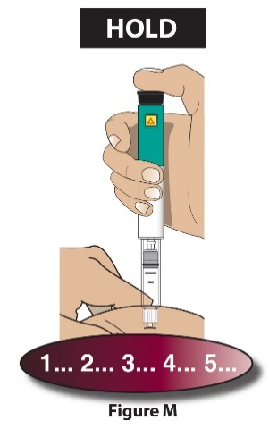
Step 7  Inject dose | D) Remove the needle from the skin (Figure N). Once needle is removed from skin, take your thumb off the black injection button. | 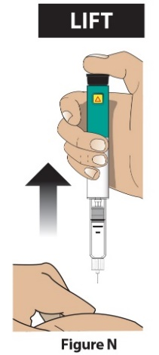

After injection

Step 8  Confirm dose | Check to make sure the black injection button is all the way down. The instruction window will show an arrow pointing TOWARDS the black button.  If the yellow shaft does not show, you have finished the injection steps the right way. (Figure O)  Important  You should NOT see any of the yellow shaft. If you do and have already injected the medicine, DO NOT inject yourself a second time in the same day.  Instead, you MUST reset the pen. Go to Troubleshooting Problem A | 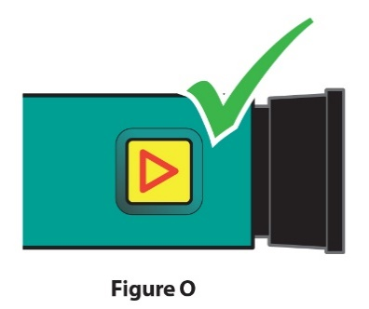

Step 9  Remove needle and dispose | - Put the large outer needle cover on the needle by scooping it up and pressing it on (Figure P and Q). Do not try to put the needle cover back on with your hands. | 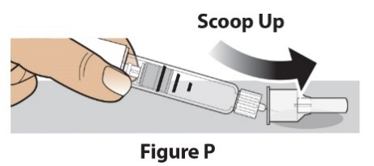  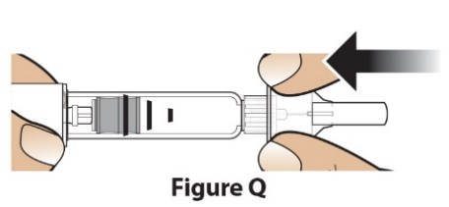
Step 9  Remove needle and dispose | - Unscrew the covered needle all the way by giving the large needle cover 3-5 counter-clockwise turns. (Figure R)  Pull the needle straight off. (Figure S) | 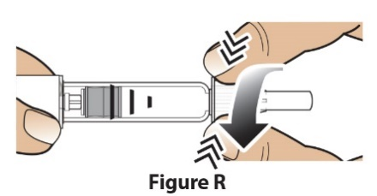  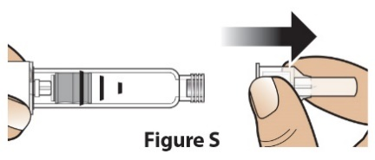
Step 9  Remove needle and dispose | - Dispose of the needle into a puncture resistant container according to local regulations (Figure T).  DO NOT reuse needle. | 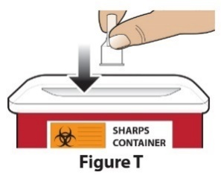
Disposal of needles
For more information about how to correctly dispose of the needle refer to the Disposal information section

Step 10  Recap pen and store | - Push white cap back on (Figure U). | 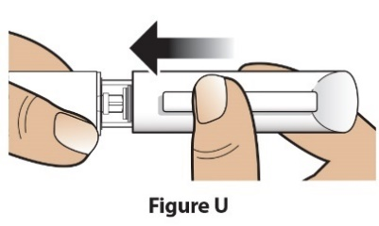
Step 10  Recap pen and store | - Always store the pen in the refrigerator with the white cap on after use. (Figure V)  DO NOT store the pen with a needle attached. | 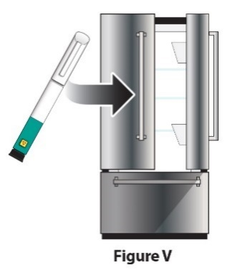

Troubleshooting

Problem |  | Solution
A | The yellow shaft is still showing after pushing in the black injection button. How do I reset my Livogiva? | To reset the Livogiva pen follow the steps below:  1) If you have already injected, DO NOT inject yourself a second time on the same day. Use a new needle for your injection on the following day.  2) Remove the needle.  3) Attach a new needle, pull off the large needle cover and save it.  4) Pull off the inner needle cover and throw away.  5) Point the needle down into an empty container. Push in the black injection button until it stops. Hold it in and slowly count to 5 s-l-o-w-l-y. You may see a small stream or drop of fluid. When you have finished, the black injection button should be all the way in.  6) If you still see the yellow shaft showing, do not use this pen; contact your doctor or pharmacist.  7) Put the large needle cover on needle. Unscrew the needle all the way by giving the needle cover 3 to 5 complete turns. Pull off needle cover and throw away as directed by your doctor or pharmacist. Push the white cap back on, and put your Livogiva in the refrigerator.  You can prevent this problem by always using a NEW needle for each injection, and by pushing the black injection button all the way in and slowly counting to 5 s-l-o-w-l-y.
B | How can I tell if my Livogiva works? | The Livogiva is designed to inject the full dose every time it is used according to the directions in the section Instructions for Use.  The black injection button should be all the way in to show that the full dose of medicine has been injected from the Livogiva. Use a new needle every time you inject to be sure your Livogiva will work properly.
C | I see an air bubble in my Livogiva. | A small air bubble will not affect your dose and it will not harm you. You can continue to use your dose as usual.
D | I cannot get the needle off. | 1) Put the large needle cover on the needle.  2) Use the large needle cover to unscrew the needle.  3) Unscrew the needle all the way by giving the large needle cover 3 to 5 counter-clockwise turns.  4) If you still cannot get the needle off, ask someone to help you.  See step 9 “Remove needle and dispose”.
E | What should I do if I cannot pull out the black injection button? | Change to a new Livogiva pen to use your dose as instructed by your doctor or pharmacist.  When the black injection button becomes hard to pull out, this means there is not enough medicine in your Livogiva pen for another dose. You may still see some medicine left in the cartridge.

Cleaning and storage
Cleaning your Livogiva pen
- Wipe the outside of the Livogiva with a damp cloth.
- Do not place the Livogiva in water, or wash or clean it with any liquid.

Storing your Livogiva pen
- Read and follow the instructions in the Information for the Patient leaflet on how to store your pen.
- DO NOT store the Livogiva with a needle attached. Doing this may affect the sterility of the medicine during subsequent injections.
- Store the Livogiva with the white cap on.
If the Livogiva has been left out of the refrigerator, do not throw the pen away. Place the pen back in the refrigerator and contact your doctor or pharmacist.

Disposal information
Disposal of pen needles and Livogiva pen
- Before disposing of the Livogiva pen, be sure to remove the pen needle.
- Put used needles in a sharps container or a hard-plastic container with a secure lid. Do not throw needles directly into your household waste.
- Do not recycle the filled sharps container.

Other important notes
- DO NOT transfer the medicine into a syringe.
- During injection, you may hear one or more clicks – this is normal pen operation
- The Livogiva is not recommended for use by the blind or visually impaired persons without the assistance from a person trained in the proper use of the pen.

This user manual was last revised in:

