This document is the approved product information for Lynparza, with the changes since the previous procedure affecting the product information (EMA/VR/0000246964) tracked.

For more information, see the European Medicines Agency’s website:
https://www.ema.europa.eu/en/medicines/human/EPAR/lynparza

ANNEX I

SUMMARY OF PRODUCT CHARACTERISTICS

1. NAME OF THE MEDICINAL PRODUCT

Lynparza 100 mg film-coated tablets

Lynparza 150 mg film-coated tablets

2. QUALITATIVE AND QUANTITATIVE COMPOSITION

Lynparza 100 mg film-coated tablets
Each film-coated tablet contains 100 mg olaparib.

Lynparza 150 mg film-coated tablets
Each film-coated tablet contains 150 mg olaparib.

Excipient with known effect:
This medicinal product contains 0.24 mg sodium per 100 mg tablet and 0.35 mg sodium per 150 mg tablet.

For the full list of excipients, see section 6.1.

3. PHARMACEUTICAL FORM

Film-coated tablet (tablet).

Lynparza 100 mg film-coated tablets
Yellow to dark yellow, oval, bi-convex tablet, debossed with ‘OP100’ on one side and plain on the other side.

Lynparza 150 mg film-coated tablets
Green to green/grey, oval, bi-convex tablet, debossed with ‘OP150’ on one side and plain on the other side.

4. CLINICAL PARTICULARS

4.1 Therapeutic indications

Ovarian cancer
Lynparza is indicated as monotherapy for the:
- maintenance treatment of adult patients with advanced (FIGO stages III and IV) BRCA1/2-mutated (germline and/or somatic) high-grade epithelial ovarian, fallopian tube or primary peritoneal cancer who are in response (complete or partial) following completion of first-line platinum-based chemotherapy.
- maintenance treatment of adult patients with platinum-sensitive relapsed high-grade epithelial ovarian, fallopian tube, or primary peritoneal cancer who are in response (complete or partial) to platinum-based chemotherapy.

Lynparza in combination with bevacizumab is indicated for the:
- maintenance treatment of adult patients with advanced (FIGO stages III and IV) high-grade epithelial ovarian, fallopian tube or primary peritoneal cancer who are in response (complete or partial) following completion of first-line platinum-based chemotherapy in combination with bevacizumab and whose cancer is associated with homologous recombination deficiency (HRD) positive status defined by either a BRCA1/2 mutation and/or genomic instability (see section 5.1).

Breast cancer
Lynparza is indicated as:
- monotherapy or in combination with endocrine therapy for the adjuvant treatment of adult patients with germline BRCA1/2-mutations who have HER2-negative, high risk early breast cancer previously treated with neoadjuvant or adjuvant chemotherapy (see sections 4.2 and 5.1).
- monotherapy for the treatment of adult patients with germline BRCA1/2-mutations, who have HER2 negative locally advanced or metastatic breast cancer. Patients should have previously been treated with an anthracycline and a taxane in the (neo)adjuvant or metastatic setting unless patients were not suitable for these treatments (see section 5.1). Patients with hormone receptor (HR)-positive breast cancer should also have progressed on or after prior endocrine therapy, or be considered unsuitable for endocrine therapy.

Adenocarcinoma of the pancreas
Lynparza is indicated as monotherapy for the maintenance treatment of adult patients with germline BRCA1/2-mutations who have metastatic adenocarcinoma of the pancreas and have not progressed after a minimum of 16 weeks of platinum treatment within a first-line chemotherapy regimen.

Prostate cancer
Lynparza is indicated:
- as monotherapy for the treatment of adult patients with metastatic castration-resistant prostate cancer (mCRPC) and BRCA1/2-mutations (germline and/or somatic) who have progressed following prior therapy that included a new hormonal agent.
- in combination with abiraterone and prednisone or prednisolone for the treatment of adult patients with mCRPC in whom chemotherapy is not clinically indicated (see section 5.1).

Endometrial cancer
Lynparza in combination with durvalumab is indicated for the maintenance treatment of adult patients with primary advanced or recurrent endometrial cancer that is mismatch repair proficient (pMMR) whose disease has not progressed on first-line treatment with durvalumab in combination with carboplatin and paclitaxel.

4.2 Posology and method of administration

Treatment with Lynparza should be initiated and supervised by a physician experienced in the use of anticancer medicinal products.

Patient selection

First-line maintenance treatment of BRCA-mutated advanced ovarian cancer:
Before Lynparza treatment is initiated for first-line maintenance treatment of high-grade epithelial ovarian cancer (EOC), fallopian tube cancer (FTC) or primary peritoneal cancer (PPC), patients must have confirmation of deleterious or suspected deleterious germline and/or somatic mutations in the breast cancer susceptibility genes (BRCA) 1 or 2 using a validated test.

Maintenance treatment of platinum-sensitive relapsed ovarian cancer:
There is no requirement for BRCA1/2 testing prior to using Lynparza for the monotherapy maintenance treatment of relapsed EOC, FTC or PPC who are in a complete or partial response to platinum-based therapy.

First-line maintenance treatment of HRD positive advanced ovarian cancer in combination with bevacizumab:
Before Lynparza with bevacizumab treatment is initiated for the first-line maintenance treatment of EOC, FTC or PPC, patients must have confirmation of either deleterious or suspected deleterious BRCA1/2 mutation and/or genomic instability determined using a validated test (see section 5.1).

Adjuvant treatment of germline BRCA-mutated high risk early breast cancer
Before Lynparza treatment is initiated for adjuvant treatment of HER2 negative high risk early breast cancer, patients must have confirmation of deleterious or suspected deleterious gBRCA1/2 mutation using a validated test (see section 5.1).

Monotherapy treatment of gBRCA1/2-mutated HER2-negative metastatic breast cancer:
For germline breast cancer susceptibility genes (gBRCA1/2) mutated human epidermal growth factor receptor 2 (HER2)-negative locally advanced or metastatic breast cancer, patients must have confirmation of a deleterious or suspected deleterious gBRCA1/2 mutation before Lynparza treatment is initiated. gBRCA1/2 mutation status should be determined by an experienced laboratory using a validated test method. Data demonstrating clinical validation of tumour BRCA1/2 tests in breast cancer are not currently available.

First-line maintenance treatment of gBRCA-mutated metastatic adenocarcinoma of the pancreas:
For first-line maintenance treatment of germline BRCA1/2-mutated metastatic adenocarcinoma of the pancreas, patients must have confirmation of a deleterious or suspected deleterious gBRCA1/2 mutation before Lynparza treatment is initiated. gBRCA1/2 mutation status should be determined by an experienced laboratory using a validated test method. Data demonstrating clinical validation of tumour BRCA1/2 tests in adenocarcinoma of the pancreas are not currently available.

Monotherapy treatment of BRCA1/2-mutated metastatic castration-resistant prostate cancer:
For BRCA1/2-mutated metastatic castration-resistant prostate cancer (mCRPC), patients must have confirmation of a deleterious or suspected deleterious BRCA1/2 mutation (using either tumour or blood sample) before Lynparza treatment is initiated (see section 5.1). BRCA1/2 mutation status should be determined by an experienced laboratory using a validated test method.
Treatment of mCRPC in combination with abiraterone and prednisone or prednisolone:
No genomic testing is required prior to using Lynparza in combination with abiraterone and prednisone or prednisolone for the treatment of patients with mCRPC.

First-line maintenance treatment of MMR-Proficient (pMMR) advanced or recurrent endometrial cancer in combination with durvalumab:
Before treatment is initiated, patients must have confirmation of proficient mismatch repair (pMMR) tumour status using a validated test (see section 5.1).

Genetic counselling for patients tested for mutations in BRCA1/2 genes should be performed according to local regulations.

Posology

Lynparza is available as 100 mg and 150 mg tablets.

The recommended dose of Lynparza in monotherapy or in combination with other agents is 300 mg (two 150 mg tablets) taken twice daily, equivalent to a total daily dose of 600 mg. The 100 mg tablet is available for dose reduction.

Lynparza monotherapy
Patients with platinum-sensitive relapsed (PSR) high-grade epithelial ovarian, fallopian tube, or primary peritoneal cancer who are in response (complete or partial) to platinum-based chemotherapy should start treatment with Lynparza no later than 8 weeks after completion of their final dose of the platinum-containing regimen.

Lynparza in combination with bevacizumab
When Lynparza is used in combination with bevacizumab for the first-line maintenance treatment of high-grade epithelial ovarian, fallopian tube, or primary peritoneal cancer following completion of first-line platinum-based therapy with bevacizumab, the dose of bevacizumab is 15 mg/kg once every 3 weeks. Please refer to the full product information for bevacizumab (see section 5.1).

Lynparza in combination with endocrine therapy
Please refer to the full product information of the endocrine therapy combination partner(s) (aromatase inhibitor/anti-oestrogen agent and/or LHRH) for the recommended posology.

Lynparza in combination with abiraterone and prednisone or prednisolone
When Lynparza is used in combination with abiraterone for the treatment of patients with mCRPC, the dose of abiraterone is 1000 mg orally once daily (see section 5.1). Abiraterone should be given with prednisone or prednisolone 5 mg orally twice daily. Please refer to the full product information for abiraterone.

Lynparza in combination with durvalumab
When Lynparza is used in combination with durvalumab for the maintenance treatment of patients with MMR-Proficient (pMMR) primary advanced or recurrent endometrial cancer whose disease has not progressed on first-line treatment with durvalumab in combination with carboplatin and paclitaxel, the dose of durvalumab is 1500 mg every 4 weeks (see section 5.1). Please refer to the full product information for durvalumab.

Duration of treatment

First-line maintenance treatment of BRCA-mutated advanced ovarian cancer:
Patients can continue treatment until radiological disease progression, unacceptable toxicity or for up to 2 years if there is no radiological evidence of disease after 2 years of treatment. Patients with evidence of disease at 2 years, who in the opinion of the treating physician can derive further benefit from continuous treatment, can be treated beyond 2 years.

Maintenance treatment of platinum-sensitive relapsed ovarian cancer:
For patients with platinum-sensitive relapsed high-grade epithelial ovarian, fallopian tube or primary peritoneal cancer, it is recommended that treatment be continued until progression of the underlying disease or unacceptable toxicity.

First-line maintenance treatment of HRD positive advanced ovarian cancer in combination with bevacizumab:
Patients can continue treatment with Lynparza until radiological disease progression, unacceptable toxicity or for up to 2 years if there is no radiological evidence of disease after 2 years of treatment. Patients with evidence of disease at 2 years, who in the opinion of the treating physician can derive further benefit from continuous Lynparza treatment, can be treated beyond 2 years. Please refer to the product information for bevacizumab for the recommended overall duration of treatment of a maximum of 15 months including the periods in combination with chemotherapy and as maintenance (see section 5.1).

Adjuvant treatment of germline BRCA-mutated high risk early breast cancer
It is recommended that patients are treated for up to 1 year, or until disease recurrence, or unacceptable toxicity, whichever occurs first.

Monotherapy treatment of gBRCA1/2-mutated HER2-negative metastatic breast cancer:
It is recommended that treatment be continued until progression of the underlying disease or unacceptable toxicity.

The efficacy and safety of maintenance retreatment with Lynparza following first or subsequent relapse in ovarian cancer patients has not been established. There are no efficacy or safety data on retreatment of breast cancer patients (see section 5.1).

First-line maintenance treatment of gBRCA-mutated metastatic adenocarcinoma of the pancreas:
It is recommended that treatment be continued until progression of the underlying disease or unacceptable toxicity.

Monotherapy treatment of BRCA1/2-mutated metastatic castration-resistant prostate cancer:
It is recommended that treatment be continued until progression of the underlying disease or unacceptable toxicity. Medical castration with luteinising hormone releasing hormone (LHRH) analogue should be continued during treatment in patients not surgically castrated.

Treatment of mCRPC in combination with abiraterone and prednisone or prednisolone:
It is recommended that treatment be continued until progression of the underlying disease or unacceptable toxicity when Lynparza is used in combination with abiraterone and prednisone or prednisolone. Treatment with a gonadotropin-releasing hormone (GnRH) analogue should be continued during treatment in all patients, or patients should have had prior bilateral orchiectomy. Please refer to the product information for abiraterone.

There are no efficacy or safety data on retreatment with Lynparza in prostate cancer patients (see section 5.1).

First-line maintenance treatment of MMR-Proficient (pMMR) advanced or recurrent endometrial cancer in combination with durvalumab:
It is recommended that treatment be continued until progression of the underlying disease or unacceptable toxicity. Please refer to the product information for durvalumab.

Missing dose
If a patient misses a dose of Lynparza, they should take their next normal dose at its scheduled time.

Dose adjustments for adverse reactions
Treatment may be interrupted to manage adverse reactions such as nausea, vomiting, diarrhoea, and anaemia and dose reduction can be considered (see section 4.8).

The recommended dose reduction is to 250 mg (one 150 mg tablet and one 100 mg tablet) twice daily (equivalent to a total daily dose of 500 mg).

If a further dose reduction is required, then reduction to 200 mg (two 100 mg tablets) twice daily (equivalent to a total daily dose of 400 mg) is recommended.

Dose adjustments for co-administration with CYP3A inhibitors
Concomitant use of strong or moderate CYP3A inhibitors is not recommended and alternative agents should be considered. If a strong CYP3A inhibitor must be co-administered, the recommended Lynparza dose reduction is to 100 mg (one 100 mg tablet) taken twice daily (equivalent to a total daily dose of 200 mg). If a moderate CYP3A inhibitor must be co-administered, the recommended Lynparza dose reduction is to 150 mg (one 150 mg tablet) taken twice daily (equivalent to a total daily dose of 300 mg) (see sections 4.4 and 4.5).

Special populations

Elderly
No adjustment in starting dose is required for elderly patients.

Renal impairment
For patients with moderate renal impairment (creatinine clearance 31 to 50 ml/min) the recommended dose of Lynparza is 200 mg (two 100 mg tablets) twice daily (equivalent to a total daily dose of 400 mg) (see section 5.2).

Lynparza can be administered in patients with mild renal impairment (creatinine clearance 51 to 80 ml/min) with no dose adjustment.

Lynparza is not recommended for use in patients with severe renal impairment or end-stage renal disease (creatinine clearance ≤30 ml/min), as safety and pharmacokinetics have not been studied in these patients. Lynparza may only be used in patients with severe renal impairment if the benefit outweighs the potential risk, and the patient should be carefully monitored for renal function and adverse events.

Hepatic impairment
Lynparza can be administered to patients with mild or moderate hepatic impairment (Child-Pugh classification A or B) with no dose adjustment (see section 5.2). Lynparza is not recommended for use in patients with severe hepatic impairment (Child-Pugh classification C), as safety and pharmacokinetics have not been studied in these patients.

Non-Caucasian patients
There are limited clinical data available in non-Caucasian patients. However, no dose adjustment is required on the basis of ethnicity (see section 5.2).

Paediatric population

The safety and efficacy of Lynparza in children and adolescents have not been established.
No data are available.

Method of administration

Lynparza is for oral use.

Lynparza tablets should be swallowed whole and not chewed, crushed, dissolved or divided. Lynparza tablets may be taken without regard to meals.

4.3 Contraindications

Hypersensitivity to the active substance or to any of the excipients listed in section 6.1.
Breast-feeding during treatment and for 1 month after the last dose (see section 4.6).

4.4 Special warnings and precautions for use

Haematological toxicity
Haematological toxicity has been reported in patients treated with Lynparza, including clinical diagnoses and/or laboratory findings of generally mild or moderate (CTCAE grade 1 or 2) anaemia, neutropenia, thrombocytopenia and lymphopenia. Pure red cell aplasia (PRCA) (see Section 4.8) and/or autoimmune haemolytic anaemia (AIHA) have been reported when Lynparza has been used in combination with durvalumab.

Patients should not start treatment with Lynparza until they have recovered from haematological toxicity caused by previous anticancer therapy (haemoglobin, platelet and neutrophil levels should be ≤CTCAE grade 1). Baseline testing, followed by monthly monitoring, of complete blood counts is recommended for the first 12 months of treatment and periodically after this time to monitor for clinically significant changes in any parameter during treatment (see section 4.8).

If a patient develops severe haematological toxicity or blood transfusion dependence, treatment with Lynparza should be interrupted and appropriate haematological testing should be initiated. If the blood parameters remain clinically abnormal after 4 weeks of Lynparza dose interruption, bone marrow analysis and/or blood cytogenetic analysis are recommended. If PRCA or AIHA are confirmed, treatment with Lynparza and durvalumab should be discontinued.

Myelodysplastic syndrome/Acute myeloid leukaemia
Myelodysplastic syndrome (MDS)/acute myeloid leukaemia (AML) has occurred in patients treated with Lynparza (see section 4.8). The majority of events had a fatal outcome. Patients with BRCAm platinum-sensitive relapsed ovarian cancer who had received at least two prior lines of platinum chemotherapy were at higher risk to experience MDS/AML. The duration of therapy with olaparib in patients who developed MDS/AML varied from < 6 months to > 4 years.

If MDS/AML is suspected, the patient should be referred to a haematologist for further investigations, including bone marrow analysis and blood sampling for cytogenetics. If, following investigation for prolonged haematological toxicity, MDS/AML is confirmed, Lynparza should be discontinued and the patient treated appropriately.

Venous Thromboembolic Events
Venous thromboembolic events, predominantly events of pulmonary embolism, have occurred in patients treated with Lynparza and had no consistent clinical pattern. A higher incidence was observed in patients with metastatic castration-resistant prostate cancer, who also received androgen deprivation therapy, compared with other approved indications (see section 4.8). Monitor patients for clinical signs and symptoms of venous thrombosis and pulmonary embolism and treat as medically appropriate. Patients with a prior history of VTE may be more at risk of a further occurrence and should be monitored appropriately.

Pneumonitis
Pneumonitis, including events with a fatal outcome, has been reported in patients treated with Lynparza in clinical studies (see section 4.8). If patients present with new or worsening respiratory symptoms such as dyspnoea, cough and fever, or an abnormal chest radiologic finding is observed, Lynparza treatment should be interrupted and prompt investigation initiated. If pneumonitis is confirmed, Lynparza treatment should be discontinued and the patient treated appropriately.

Hepatotoxicity
Cases of hepatotoxicity have been reported in patients treated with olaparib (see section 4.8). If clinical symptoms or signs suggestive of hepatotoxicity develop, prompt clinical evaluation of the patient and measurement of liver function tests should be performed. In case of suspected drug-induced liver injury (DILI), treatment should be interrupted. In case of severe DILI treatment discontinuation should be considered as clinically appropriate.

Embryofoetal toxicity
Based on its mechanism of action (PARP inhibition), Lynparza could cause foetal harm when administered to a pregnant woman. Nonclinical studies in rats have shown that olaparib causes adverse effects on embryofoetal survival and induces major foetal malformations at exposures below those expected at the recommended human dose of 300 mg twice daily.

Pregnancy/contraception
Lynparza should not be used during pregnancy. Women of childbearing potential must use two forms of reliable contraception before starting Lynparza treatment, during therapy and for 6 months after receiving the last dose of Lynparza. Two highly effective and complementary forms of contraception are recommended. Male patients and their female partners of childbearing potential should use reliable contraception during therapy and for 3 months after receiving the last dose of Lynparza (see section 4.6).

Interactions
Lynparza co-administration with strong or moderate CYP3A inhibitors is not recommended (see section 4.5). If a strong or moderate CYP3A inhibitor must be co-administered, the dose of Lynparza should be reduced (see sections 4.2 and 4.5).

Lynparza co-administration with strong or moderate CYP3A inducers is not recommended. In the event that a patient already receiving Lynparza requires treatment with a strong or moderate CYP3A inducer, the prescriber should be aware that the efficacy of Lynparza may be substantially reduced (see section 4.5).

Sodium
This medicinal product contains less than 1 mmol sodium (23 mg) per 100 mg or 150 mg tablet, that is to say essentially “sodium-free”.

4.5 Interaction with other medicinal products and other forms of interaction

Pharmacodynamic interactions
Clinical studies of olaparib in combination with other anticancer medicinal products, including DNA damaging agents, indicate a potentiation and prolongation of myelosuppressive toxicity. The recommended Lynparza monotherapy dose is not suitable for combination with myelosuppressive anticancer medicinal products.

Combination of olaparib with vaccines or immunosuppressant agents has not been studied. Therefore, caution should be taken if these medicinal products are co-administered with Lynparza and patients should be closely monitored.

Pharmacokinetic interactions
Effect of other medicinal products on olaparib
CYP3A4/5 are the isozymes predominantly responsible for the metabolic clearance of olaparib.

A clinical study to evaluate the impact of itraconazole, a known CYP3A inhibitor, has shown that co-administration with olaparib increased mean olaparib C_{max} by 42% (90% CI: 33-52%) and mean AUC by 170% (90% CI: 144-197%). Therefore, known strong (e.g. itraconazole, telithromycin, clarithromycin, protease inhibitors boosted with ritonavir or cobicistat, boceprevir, telaprevir) or moderate (e.g. erythromycin, diltiazem, fluconazole, verapamil) inhibitors of this isozyme are not recommended with Lynparza (see section 4.4). If strong or moderate CYP3A inhibitors must be co-administered, the dose of Lynparza should be reduced. The recommended Lynparza dose reduction is to 100 mg taken twice daily (equivalent to a total daily dose of 200 mg) with a strong CYP3A inhibitor or 150 mg taken twice daily (equivalent to a total daily dose of 300 mg) with a moderate CYP3A inhibitor (see sections 4.2 and 4.4). It is also not recommended to consume grapefruit juice while on Lynparza therapy as it is a CYP3A inhibitor.

A clinical study to evaluate the impact of rifampicin, a known CYP3A inducer, has shown that co-administration with olaparib decreased olaparib mean C_{max} by 71% (90% CI: 76-67%) and mean AUC by 87% (90% CI: 89-84%). Therefore, known strong inducers of this isozyme (e.g. phenytoin, rifampicin, rifapentine, carbamazepine, nevirapine, phenobarbital and St John’s Wort) are not recommended with Lynparza, as it is possible that the efficacy of Lynparza could be substantially reduced. The magnitude of the effect of moderate to strong inducers (e.g. efavirenz, rifabutin) on olaparib exposure is not established, therefore the co-administration of Lynparza with these medicinal products is also not recommended (see section 4.4).

Effect of olaparib on other medicinal products
Olaparib inhibits CYP3A4 in vitro and is predicted to be a mild CYP3A inhibitor in vivo. Therefore, caution should be exercised when sensitive CYP3A substrates or substrates with a narrow therapeutic margin (e.g. simvastatin, cisapride, cyclosporine, ergot alkaloids, fentanyl, pimozide, sirolimus, tacrolimus and quetiapine) are combined with olaparib. Appropriate clinical monitoring is recommended for patients receiving CYP3A substrates with a narrow therapeutic margin concomitantly with olaparib.

Induction of CYP1A2, 2B6 and 3A4 has been shown in vitro with CYP2B6 being most likely to be induced to a clinically relevant extent. The potential for olaparib to induce CYP2C9, CYP2C19 and P-gp can also not be excluded. Therefore, olaparib upon co-administration may reduce the exposure to substrates of these metabolic enzymes and transport protein. The efficacy of some hormonal contraceptives may be reduced if co-administered with olaparib (see sections 4.4 and 4.6).
In vitro, olaparib inhibits the efflux transporter P-gp (IC50=76 µM), therefore it cannot be excluded that olaparib may cause clinically relevant drug interactions with substrates of P-gp (e.g. simvastatin, pravastatin, dabigatran, digoxin and colchicine). Appropriate clinical monitoring is recommended for patients receiving this type of medicinal product concomitantly.

In vitro, olaparib has been shown to be an inhibitor of BCRP, OATP1B1, OCT1, OCT2, OAT3, MATE1 and MATE2K. It cannot be excluded that olaparib may increase the exposure to substrates of BCRP (e.g. methotrexate, rosuvastatin), OATP1B1 (e.g. bosentan, glibenclamide, repaglinide, statins and valsartan), OCT1 (e.g. metformin), OCT2 (e.g. serum creatinine), OAT3 (e.g. furosemide and methotrexate), MATE1 (e.g. metformin) and MATE2K (e.g. metformin). In particular, caution should be exercised if olaparib is administered in combination with any statin.

Combination with anastrozole, letrozole and tamoxifen
A clinical study has been performed to assess the combination of olaparib with anastrozole, letrozole or tamoxifen. No clinically relevant interactions were observed.

4.6 Fertility, pregnancy and lactation

Women of childbearing potential/contraception in females
Women of childbearing potential should not become pregnant while on Lynparza and not be pregnant at the beginning of treatment. A pregnancy test should be performed on all women of childbearing potential prior to treatment and considered regularly throughout treatment.

Women of childbearing potential must use two forms of reliable contraception before starting Lynparza therapy, during therapy and for 6 months after receiving the last dose of Lynparza, unless abstinence is the chosen method of contraception (see section 4.4). Two highly effective and complementary forms of contraception are recommended.

Since it cannot be excluded that olaparib may reduce exposure to substrates of CYP2C9 through enzyme induction, the efficacy of some hormonal contraceptives may be reduced if co-administered with olaparib. Therefore, an additional non-hormonal contraceptive method should be considered during treatment (see section 4.5). For women with hormone dependent cancer, two non-hormonal contraceptive methods should be considered.

Contraception in males
It is not known whether olaparib or its metabolites are found in seminal fluid. Male patients must use a condom during therapy and for 3 months after receiving the last dose of Lynparza when having sexual intercourse with a pregnant woman or with a woman of childbearing potential. Female partners of male patients must also use highly effective contraception if they are of childbearing potential (see section 4.4). Male patients should not donate sperm during therapy and for 3 months after receiving the last dose of Lynparza.

Pregnancy
Studies in animals have shown reproductive toxicity including serious teratogenic effects and effects on embryofoetal survival in the rat at maternal systemic exposures lower than those in humans at therapeutic doses (see section 5.3). There are no data from the use of olaparib in pregnant women, however, based on the mode of action of olaparib, Lynparza should not be used during pregnancy and in women of childbearing potential not using reliable contraception during therapy and for 6 months after receiving the last dose of Lynparza. (See previous paragraph: “Women of childbearing potential/contraception in females” for further information about birth control and pregnancy testing.)

Breast-feeding
There are no animal studies on the excretion of olaparib in breast milk. It is unknown whether olaparib or its metabolites are excreted in human milk. Lynparza is contraindicated during breast-feeding and for 1 month after receiving the last dose, given the pharmacologic property of the product (see section 4.3).

Fertility
There are no clinical data on fertility. In animal studies, no effect on conception was observed but there are adverse effects on embryofoetal survival (see section 5.3).

4.7 Effects on ability to drive and use machines

Lynparza has moderate influence on the ability to drive and use machines. Patients who take Lynparza may experience fatigue, asthenia or dizziness. Patients who experience these symptoms should observe caution when driving or using machines.

4.8 Undesirable effects

Summary of the safety profile
Lynparza has been associated with adverse reactions generally of mild or moderate severity (CTCAE grade 1 or 2) and generally not requiring treatment discontinuation. The most frequently observed adverse reactions across clinical trials in patients receiving Lynparza monotherapy (≥10%) were nausea, fatigue/asthenia, anaemia, vomiting, diarrhoea, decreased appetite, headache, neutropenia, dysgeusia, cough, leukopenia, dizziness, dyspnoea and dyspepsia.

The Grade ≥3 adverse reactions occurring in > 2% of patients were anaemia (14%), neutropenia (5%), fatigue/asthenia (4%), leukopenia (2%) and thrombocytopenia (2%).

Adverse reactions that most commonly led to dose interruptions and/ or reductions in monotherapy were anaemia (16%), nausea (7%), fatigue/asthenia (6%), neutropenia (6%) and vomiting (6%). Adverse reactions that most commonly led to permanent discontinuation were anaemia (1.7%), nausea (0.9%), fatigue/asthenia (0.8%), thrombocytopenia (0.7%), neutropenia (0.6%) and vomiting (0.5%).

When Lynparza is used in combination with bevacizumab for ovarian cancer, in combination with abiraterone and prednisone or prednisolone for prostate cancer, or in combination with durvalumab following treatment with durvalumab in combination with platinum-based chemotherapy for endometrial cancer, the safety profile is generally consistent with that of the individual therapies.

When used in combination with bevacizumab, adverse events led to dose interruption and/ or reduction of olaparib in 57% of patients and led to permanent discontinuation of treatment with olaparib and placebo in 21% and 6% of patients, respectively. The adverse reactions that most commonly led to dose interruption and/or reduction of olaparib were anaemia (21.7%), nausea (9.5%), fatigue/asthenia (5.4%), vomiting (3.7%), neutropenia (3.6%), thrombocytopenia (3.0%) and diarrhoea (2.6%). The adverse reactions that most commonly led to permanent discontinuation were anaemia (3.7%), nausea (3.6%) and fatigue/asthenia (1.5%).

When used in combination with abiraterone, adverse events led to dose interruption and/or reduction of olaparib in 50.7% of patients and led to permanent discontinuation of treatment with olaparib and placebo in 19.0% and 8.8% of patients, respectively. The adverse reactions that most commonly led to dose interruption and/or reduction of olaparib were anaemia (17.1%), fatigue/asthenia (5.5%), nausea (4.1%), neutropenia (3.4%), vomiting (2.3%), diarrhoea (2.1%) and venous thrombotic events (2.1%). The adverse reactions that most commonly led to permanent discontinuation were anaemia (4.5%) and fatigue/asthenia (1.3%).

When used in combination with durvalumab following treatment with durvalumab in combination with platinum-based chemotherapy, adverse events led to dose interruption and/or reduction of olaparib in 59.9% of patients and led to permanent discontinuation of treatment with olaparib in 10.9% of patients. The adverse reactions that most commonly led to dose interruption and/or reduction of olaparib were anaemia (20.8%), nausea (8.3%), neutropenia (7.3%), fatigue/asthenia (5.7%), thrombocytopenia (4.2%), vomiting (4.2%), blood creatinine increased (3.1%), leukopenia (3.1%), and decreased appetitive (2.6%), diarrhoea (2.1%). The adverse reactions that most commonly led to permanent discontinuation of olaparib were anaemia (3.6%) and neutropenia (1%).

Tabulated list of adverse reactions
The safety profile is based on pooled data from 4499 patients with solid tumours treated with Lynparza monotherapy in clinical trials at the recommended dose.

The following adverse reactions have been identified in clinical trials with patients receiving Lynparza monotherapy where patient exposure is known. Adverse drug reactions are listed by MedDRA System Organ Class (SOC) and then by MedDRA preferred term in Table 1. Within each SOC, preferred terms are arranged by decreasing frequency and then by decreasing seriousness. Frequencies of occurrence of adverse reactions are defined as: very common (≥1/10); common (≥1/100 to <1/10); uncommon (≥1/1,000 to <1/100); rare (≥1/10,000 to <1/1000); very rare (<1/10,000); not known (cannot be estimated from available data).

Table 1 Tabulated list of adverse reactions
 | Adverse reactions
MedDRA System Organ Class | Frequency of All CTCAE grades | Frequency of CTCAE grade 3 and above
Neoplasms benign, malignant and unspecified (including cysts and polyps) | Uncommon  Myelodysplastic syndrome/ Acute myeloid leukaemiaª | Uncommon  Myelodysplastic syndrome/ Acute myeloid leukaemia
Blood and lymphatic system disorders^{b} | Very common  Anaemiaª, Neutropeniaª, Leukopeniaª  Common  Lymphopeniaª, Thrombocytopeniaª | Very common  Anaemiaª  Common  Neutropeniaª, Thrombocytopeniaª, Leukopeniaª, Lymphopeniaª
Immune system disorders | Uncommon  Hypersensitivityª  Rare  Angioedema* | Rare  Hypersensitivityª
Hepatobiliary disorders | Common  Transaminases increasedª  Not known  Drug-induced liver injury*
Metabolism and nutrition disorders | Very common  Decreased appetite | Uncommon  Decreased appetite
Nervous system disorders | Very common  Dizziness, Headache, Dysgeusiaª | Uncommon  Dizziness, Headache
Respiratory, thoracic and mediastinal disorders | Very common  Coughª, Dyspnoeaª  Uncommon  Pneumonitisª | Common  Dyspnoeaª  Uncommon  Coughª, Pneumonitisª
Gastrointestinal disorders | Very common  Vomiting, Diarrhoea, Nausea, Dyspepsia  Common  Stomatitisª, Upper abdominal pain | Common  Vomiting, Nausea  Uncommon  Stomatitisª, Diarrhoea  Rare  Dyspepsia, Upper abdominal pain
Skin and subcutaneous tissue disorders | Common  Rashª  Uncommon  Dermatitisª  Rare  Erythema nodosum | Uncommon  Rashª  Rare  Dermatitisª
General disorders and administration site conditions | Very common  Fatigue (including asthenia) | Common  Fatigue (including asthenia)
Investigations^{b} | Common  Blood creatinine increased  Uncommon  Mean cell volume increased | Rare  Blood creatinine increased
Vascular disorders | Common  Venous thromboembolismª | Common  Venous thromboembolismª
ª MDS/AML includes preferred terms (PTs) of acute myeloid leukaemia, myelodysplastic syndrome and myeloid leukaemia.
Anaemia includes PTs of anaemia, anaemia macrocytic, erythropenia, haematocrit decreased, haemoglobin decreased, normocytic anaemia and red blood cell count decreased.
Neutropenia includes PTs of febrile neutropenia, neutropenia, neutropenic infection, neutropenic sepsis and neutrophil count decreased.
Thrombocytopenia includes PTs of platelet count decreased and thrombocytopenia.
Leukopenia includes PTs of leukopenia and white blood cell count decreased.
Lymphopenia includes PTs of lymphocyte count decreased and lymphopenia.
Hypersensitivity includes PTs of drug hypersensitivity and hypersensitivity.
Transaminases increased includes PTs of alanine aminotransferase increased, aspartate aminotransferase increased, hepatic enzyme increased, and hypertransaminasaemia
Dysgeusia includes PTs of dysgeusia and taste disorder.
Cough includes PTs of cough and productive cough.
Dyspnoea includes PTs of dyspnoea and dyspnoea exertional.
Pneumonitis includes PTs of pneumonitis, interstitial lung disease, acute interstitial pneumonitis, eosinophilic pneumonia, eosinophilic pneumonia acute and hypersensitivity pneumonitis.
Stomatitis includes PTs of aphthous ulcer, mouth ulceration and stomatitis.
Rash includes PTs of erythema, exfoliative rash, rash, rash erythematous, rash macular, rash maculopapular, rash papular and rash pruritic.
Dermatitis includes PTs of dermatitis and dermatitis allergic.
Venous thromboembolism includes PTs of embolism, pulmonary embolism, thrombosis, deep vein thrombosis, vena cava thrombosis and venous thrombosis.
b Registered laboratory data are presented below under Haematological toxicity and Other laboratory findings.
* As observed in the post-marketing setting.

For patients receiving Lynparza in combination with durvalumab following treatment with durvalumab in combination with platinum-based chemotherapy, most adverse reactions occurred at the same or lower frequency (all grades and CTCAE Grade ≥ 3 AEs) as those shown in the tabulated list of adverse reactions for Lynparza monotherapy above. Adverse reactions reported at a higher frequency in patients receiving Lynparza in combination with durvalumab were thrombocytopenia and rash (Very Common) and hypersensitivity (Common). The following additional adverse reaction was also identified:

Table 2 Additional adverse drug reaction reported in a clinical trial with Lynparza in combination with durvalumab
MedDRA SOC | MedDRA Term | CIOMS descriptor/ Overall Frequency  (All CTCAE grades) | Frequency of CTCAE grade 3 and above
Blood and lymphatic system disorders | Pure red cell aplasia | Common | Common

Description of selected adverse reactions

Haematological toxicity
Anaemia and other haematological toxicities were generally low grade (CTCAE grade 1 or 2), however, there were reports of CTCAE grade 3 and higher events. Anaemia was the most common CTCAE grade ≥3 adverse reaction reported in clinical studies. Median time to first onset of anaemia was approximately 4 weeks (approximately 7 weeks for CTCAE grade ≥3 events). Anaemia was managed with dose interruptions and dose reductions (see section 4.2), and where appropriate with blood transfusions. In clinical studies with the tablet formulation, the incidence of anaemia adverse reactions was 35.2% (CTCAE grade ≥3 14.8%) and the incidences of dose interruptions, reductions and discontinuations for anaemia were 16.4%, 11.1% and 2.1%, respectively; 15.6% of patients treated with olaparib needed one or more blood transfusions. An exposure-response relationship between olaparib and decreases in haemoglobin has been demonstrated. In clinical studies with Lynparza the incidence of CTCAE grade ≥ 2 shifts (decreases) from baseline in haemoglobin was 21%, absolute neutrophils 17%, platelets 5%, lymphocytes 26% and leucocytes 19% (all % approximate).

The incidence of elevations in mean corpuscular volume from low or normal at baseline to above the ULN was approximately 51%. Levels appeared to return to normal after treatment discontinuation and did not appear to have any clinical consequences.

Baseline testing, followed by monthly monitoring of complete blood counts is recommended for the first 12 months of treatment and periodically after this time to monitor for clinically significant changes in any parameter during treatment which may require dose interruption or reduction and/or further treatment (see sections 4.2 and 4.4).

Myelodysplastic syndrome/Acute myeloid leukaemia
MDS/AML are serious adverse reactions that occurred uncommonly in monotherapy clinical studies at the therapeutic dose, across all indications (0.9%). The incidence was 0.5% including events reported during the long term safety follow up (rate calculated based on overall safety population of 18576 patients exposed to at least one dose of oral olaparib in clinical studies). All patients had potential contributing factors for the development of MDS/AML, having received previous chemotherapy with platinum agents. Many had also received other DNA damaging agents and radiotherapy. The majority of reports were in germline breast cancer susceptibility gene 1 or 2 (gBRCA1/2) mutation carriers. The incidence of MDS/AML cases was similar among gBRCA1m and gBRCA2m patients (1.6% and 1.2%, respectively). Some of the patients had a history of previous cancer or of bone marrow dysplasia.
In patients with BRCAm platinum-sensitive relapsed ovarian cancer who had received at least two prior lines of platinum chemotherapy and received study treatment until disease progression (SOLO2 study, with olaparib treatment ≥2 years in 45% of patients), the incidence of MDS/AML was 8% in patients receiving olaparib and 4% in patients receiving placebo at a follow-up of 5 years. In the olaparib arm, 9 out of 16 MDS/AML cases occurred after discontinuation of olaparib during the survival follow-up. The incidence of MDS/AML was observed in the context of extended overall survival in the olaparib arm and late onset of MDS/AML. The risk of MDS/AML remains low in the first-line setting when olaparib maintenance treatment is given after one line of platinum chemotherapy for a duration of 2 years (1.5%) in SOLO1 study at 7 year follow up and 1.1% in PAOLA-1 study at 5 year follow up. For risk mitigation and management (see section 4.4).

Pure Red Cell Aplasia
Pure Red Cell Aplasia (PRCA) has been reported when Lynparza has been used in combination with durvalumab. In a clinical study of patients with endometrial cancer treated with Lynparza in combination with durvalumab, the incidence of PRCA was 1.6%. All events were CTCAE Grade 3 or 4. Events were manageable following discontinuation of both Lynparza and durvalumab. The majority of events were managed with blood transfusion and immunosuppression and recovered; there were no fatal events. For risk mitigation and management see section 4.4.

Venous Thromboembolic Events
In men who received olaparib plus abiraterone as first line therapy for mCRPC (PROpel study), the incidence of venous thromboembolic events was 8% in the olaparib plus abiraterone arm, and 3.3% in the placebo plus abiraterone arm. The median time to onset in this study was 170 days (range: 12 to 906 days). The majority of patients recovered from the event and were able to continue olaparib with standard medical treatment.

Patients with significant cardiovascular disease were excluded. Please refer to the product information for abiraterone for cardiovascular exclusion criteria (section 4.4).

Other laboratory findings
In clinical studies with Lynparza the incidence of CTCAE grade ≥2 shifts (elevations) from baseline in blood creatinine was approximately 11%. Data from a double-blind placebo-controlled study showed median increase up to 23% from baseline remaining consistent over time and returning to baseline after treatment discontinuation, with no apparent clinical sequelae. 90% of patients had creatinine values of CTCAE grade 0 at baseline and 10% were CTCAE grade 1 at baseline.

Gastrointestinal toxicities
Nausea was generally reported very early, with first onset within the first month of Lynparza treatment in the majority of patients. Vomiting was reported early, with first onset within the first two months of Lynparza treatment in the majority of patients. Both nausea and vomiting were reported to be intermittent for the majority of patients and can be managed by dose interruption, dose reduction and/or antiemetic therapy. Antiemetic prophylaxis is not required.

In first-line ovarian cancer maintenance treatment, patients experienced nausea events (77% on olaparib, 38% on placebo), vomiting (40% on olaparib, 15% on placebo), diarrhoea (34% on olaparib, 25% on placebo) and dyspepsia (17% on olaparib, 12% on placebo). Nausea events led to discontinuation in 2.3% of olaparib-treated patients (CTCAE Grade 2) and 0.8% of placebo-treated patients (CTCAE Grade 1); 0.8% and 0.4% of olaparib-treated patients discontinued treatment due to low grade (CTCAE Grade 2) vomiting and dyspepsia, respectively. No olaparib or placebo-treated patients discontinued due to diarrhoea. No placebo-treated patients discontinued due to vomiting or dyspepsia. Nausea events led to dose interruption and dose reductions in 14% and 4%, respectively, of olaparib-treated patients. Vomiting events led to interruption in 10% of olaparib-treated patients; no olaparib-treated patients experienced a vomiting event leading to dose reduction.

Paediatric population
No studies have been conducted in paediatric patients.

Other special populations
Limited safety data are available in non-Caucasian patients.

Reporting of suspected adverse reactions
Reporting suspected adverse reactions after authorisation of the medicinal product is important. It allows continued monitoring of the benefit/risk balance of the medicinal product. Healthcare professionals are asked to report any suspected adverse reactions via the national reporting system listed in Appendix V.

4.9 Overdose

There is limited experience of overdose with olaparib. No unexpected adverse reactions were reported in a small number of patients who took a daily dose of up to 900 mg of olaparib tablets over two days. Symptoms of overdose are not established and there is no specific treatment in the event of Lynparza overdose. In the event of an overdose, physicians should follow general supportive measures and should treat the patient symptomatically.

5. PHARMACOLOGICAL PROPERTIES

5.1 Pharmacodynamic properties

Pharmacotherapeutic group: Other antineoplastic agents, ATC code: L01XK01

Mechanism of action and pharmacodynamic effects
Olaparib is a potent inhibitor of human poly (ADP-ribose) polymerase enzymes (PARP-1, PARP-2, and PARP-3), and has been shown to inhibit the growth of selected tumour cell lines in vitro and tumour growth in vivo either as a standalone treatment or in combination with established chemotherapies or new hormonal agents (NHA).

PARPs are required for the efficient repair of DNA single strand breaks and an important aspect of PARP-induced repair requires that after chromatin modification, PARP auto-modifies itself and dissociates from the DNA to facilitate access for base excision repair (BER) enzymes. When olaparib is bound to the active site of DNA-associated PARP it prevents the dissociation of PARP and traps it on the DNA, thus blocking repair. In replicating cells this also leads to the formation of DNA double-strand breaks (DSBs) when replication forks meet the PARP-DNA adducts. In normal cells, homologous recombination repair (HRR) pathway is effective at repairing these DNA DSBs. In cancer cells lacking critical functional components for efficient HRR such as BRCA1 or 2, DNA DSBs cannot be repaired accurately or effectively, leading to substantial homologous recombination deficiency (HRD). Instead, alternative and error-prone pathways are activated, such as the classical non-homologous end joining (NHEJ) pathway, leading to a high degree of genomic instability. After a number of rounds of replication, genomic instability can reach insupportable levels and result in cancer cell death, as cancer cells already have a high DNA damage load relative to normal cells. HRR pathway may be compromised by other mechanisms, although the causative aberrancy and penetrance are not fully elucidated. Absence of fully functional HRR pathway is one of the key determinants of platinum sensitivity in ovarian and possibly other cancers.

In BRCA1/2-deficient in vivo models, olaparib given after platinum treatment resulted in a delay in tumour progression and an increase in overall survival compared to platinum treatment alone that correlated with the period of olaparib maintenance treatment.

Combined anti-tumour effect with NHAs
Pre-clinical studies in prostate cancer models reported a combined anti-tumour effect when PARP inhibitors and next-generation hormonal agents are administered together. PARP is involved in positive co-regulation of androgen receptor (AR) signalling, which leads to enhanced AR target gene suppression when PARP/AR signalling is co-inhibited. Other pre-clinical studies reported that treatment with NHAs inhibit the transcription of some HRR genes, therefore, inducing HRR deficiency and increased sensitivity to PARP inhibitors via non-genetic mechanisms.

Detection of BRCA1/2 mutations
Genetic testing should be conducted by an experienced laboratory using a validated test. Local or central testing of blood and/or tumour samples for germline and/or somatic BRCA1/2 mutations have been used in different studies. DNA obtained from a tissue or blood sample has been tested in most of the studies, with testing of ctDNA being used for exploratory purposes. Depending on the test used and the international classification consensus, the BRCA1/2 mutations have been classified as deleterious/suspected deleterious or pathogenic/likely pathogenic. Homologous recombination deficiency (HRD) positive status can be defined by detection of a BRCA1/2 mutation classified as deleterious/suspected deleterious or pathogenic/likely pathogenic. Detection of these mutations could be combined with positive HRD score (below) to determine HRD positive status.

Detection of genomic instability
HR deficiency-associated genomic alterations that have been investigated in Paola-1 include genome-wide loss of heterozygosity, telomeric allelic imbalance and large-scale transition, which are continuous measures with pre-defined criteria and score. Composite genomic instability score (GIS, also called HRD score) is determined when the combined measures and respective scores are used to assess the extent of specific genomic aberrations accumulated in tumour cells. Lower score defines lower likelihood of HR deficiency of tumour cells and higher score determines higher likelihood of HR deficiency of tumour cells at the time of the sample collection relative to exposure to DNA damaging agents. Validated cut-offs should be used to determine GIS positive status.

HRD positive status can be defined by a composite GIS score for HR deficiency-associated genomic alterations tested by an experienced laboratory using a validated test.

Clinical efficacy and safety

First-line maintenance treatment of BRCA-mutated advanced ovarian cancer
SOLO1 Study

The safety and efficacy of olaparib as maintenance therapy were studied in patients with newly diagnosed advanced (FIGO Stage III-IV) high-grade serous or endometrioid BRCA1/2 mutated (BRCA1/2m) ovarian cancer following completion of first-line platinum-based chemotherapy in a Phase III randomised, double-blind, placebo-controlled, multicentre trial. In this study 391 patients were randomised 2:1 to receive either Lynparza (300 mg [2 x 150 mg tablets] twice daily) or placebo. Patients were stratified by response to first-line platinum chemotherapy; complete response (CR) or partial response (PR). Treatment was continued until radiological progression of the underlying disease, unacceptable toxicity or for up to 2 years. For patients who remained in complete clinical response (i.e. no radiological evidence of disease), the maximum duration of treatment was 2 years; however, patients who had evidence of disease that remained stable (i.e. no evidence of disease progression) could continue to receive Lynparza beyond 2 years.

Patients with germline or somatic BRCA1/2 mutations were identified prospectively either from germline testing in blood via a local test (n=208) or central test (n=181) or from testing a tumour sample using a local test (n=2). By central germline testing, deleterious or suspected deleterious mutations were identified in 95.3% (365/383) and 4.7% (18/383) of patients, respectively. Large rearrangements in the BRCA1/2 genes were detected in 5.5% (21/383) of the randomised patients. The gBRCAm status of patients enrolled via local testing was confirmed retrospectively by central testing. Retrospective testing of patients with available tumour samples was performed using central testing and generated successful results in 341 patients, of which 95% had an eligible mutation (known [n=47] or likely pathogenic [n=277]) and 2 gBRCAwt patients were confirmed to have sBRCAm only. There were 389 patients who were germline BRCA1/2m and 2 who were somatic BRCA1/2m in SOLO1.

Demographic and baseline characteristics were generally well balanced between the olaparib and placebo treatment arms. Median age was 53 years in both arms. Ovarian cancer was the primary tumour in 85% of the patients. The most common histological type was serous (96%), endometrioid histology was reported in 2% of the patients. Most patients were ECOG performance status 0 (78%), there are no data in patients with performance status 2 to 4. Sixty-three percent (63%) of the patients had upfront debulking surgery and of these the majority (75%) had no macroscopic residual disease. Interval debulking surgery was performed in 35% of the patients and of these 82% had no macroscopic residual disease reported. Seven patients, all stage IV, had no cytoreductive surgery. All patients had received first-line platinum-based therapy. There was no evidence of disease at study entry (CR), defined by the investigator as no radiological evidence of disease and cancer antigen 125 (CA-125) within normal range, in 73% and 77% of patients in the olaparib and placebo arms, respectively. PR, defined as the presence of any measurable or non-measurable lesions at baseline or elevated CA-125, was reported in 27% and 23% of patients in the olaparib and placebo arms, respectively. Ninety three percent (93%) of patients were randomised within 8 weeks of their last dose of platinum-based chemotherapy. Patients who had been treated with bevacizumab were excluded from the study, therefore there are no safety and efficacy data on olaparib patients who had previously received bevacizumab. There are very limited data in patients with a somatic BRCA mutation.

The primary endpoint was progression-free survival (PFS) defined as time from randomisation to progression determined by investigator assessment using modified Response Evaluation Criteria in Solid Tumors (RECIST) 1.1, or death. Secondary efficacy endpoints included time from randomisation to second progression or death (PFS2), overall survival (OS), time from randomisation to discontinuation of treatment or death (TDT), time from randomisation to first subsequent anti-cancer therapy or death (TFST) and health related quality of life (HRQoL). Patients had tumour assessments at baseline and every 12 weeks for 3 years, and then every 24 weeks relative to date of randomisation, until objective radiological disease progression.

The study demonstrated a clinically relevant and statistically significant improvement in investigator assessed PFS for olaparib compared to placebo. The investigator assessment of PFS was supported with a blinded independent central radiological (BICR) review of PFS. A descriptive analysis performed at seven years after the last patient was randomized demonstrated a clinically meaningful benefit in OS that numerically favoured the olaparib arm. Efficacy results are presented in Table 3 and Figures 1 and 2.

Table 3 Efficacy results for newly diagnosed patients with BRCA1/2m advanced ovarian cancer in SOLO1
 | Olaparib 300 mg bd | Placebo^{c}
PFS (51% maturity)ª
Number of events: Total number of patients (%) | 102:260 (39) | 96:131 (73)
Median time (months) | NR | 13.8
HR (95% CI)^{b} | 0.30 (0.23-0.41)
P value (2-sided) | p<0.0001
PFS2 (31% maturity)
Number of events: Total number of patients (%) | 69:260 (27) | 52:131 (40)
Median time (months) | NR | 41.9
HR (95% CI) ^{c} | 0.50 (0.35-0.72)
P value (2-sided) | p=0.0002
OS (38% maturity)^{d}
Number of events: Total number of patients (%) | 84:260 (32) | 65:131 (50)
Median time (months) | NR | 75.2
HR (95% CI)^{b} | 0.55 (0.40-0.76)
TFST (60% maturity)
Number of events: Total number of patients (%) | 135:260 (52) | 98:131 (75)
Median time (months) | 64.0 | 15.1
HR (95% CI) ^{c} | 0.37 (0.28-0.48)
ª Based on Kaplan-Meier estimates, the proportion of patients that were progression free at 24 and 36 months were 74% and 60% for olaparib versus 35% and 27% for placebo; the median follow-up time was 41 months for both the olaparib and placebo arms.^{b} A value <1 favours olaparib. The analysis was performed using a Cox proportional hazards model including response to previous platinum chemotherapy (CR or PR) as a covariate.
^{c} Of the 97 patients on the placebo arm who received subsequent therapy, 58 (60%) received a PARP inhibitor.
^{d} Based on Kaplan-Meier estimates, the proportion of patients that were alive 84 months was 67% for olaparib versus 47% for placebo.
bd Twice daily; NR Not reached; CI Confidence interval; PFS Progression-free survival; PFS2 Time to second progression or death; OS Overall survival; TFST Time from randomisation to first subsequent anti-cancer therapy or death.

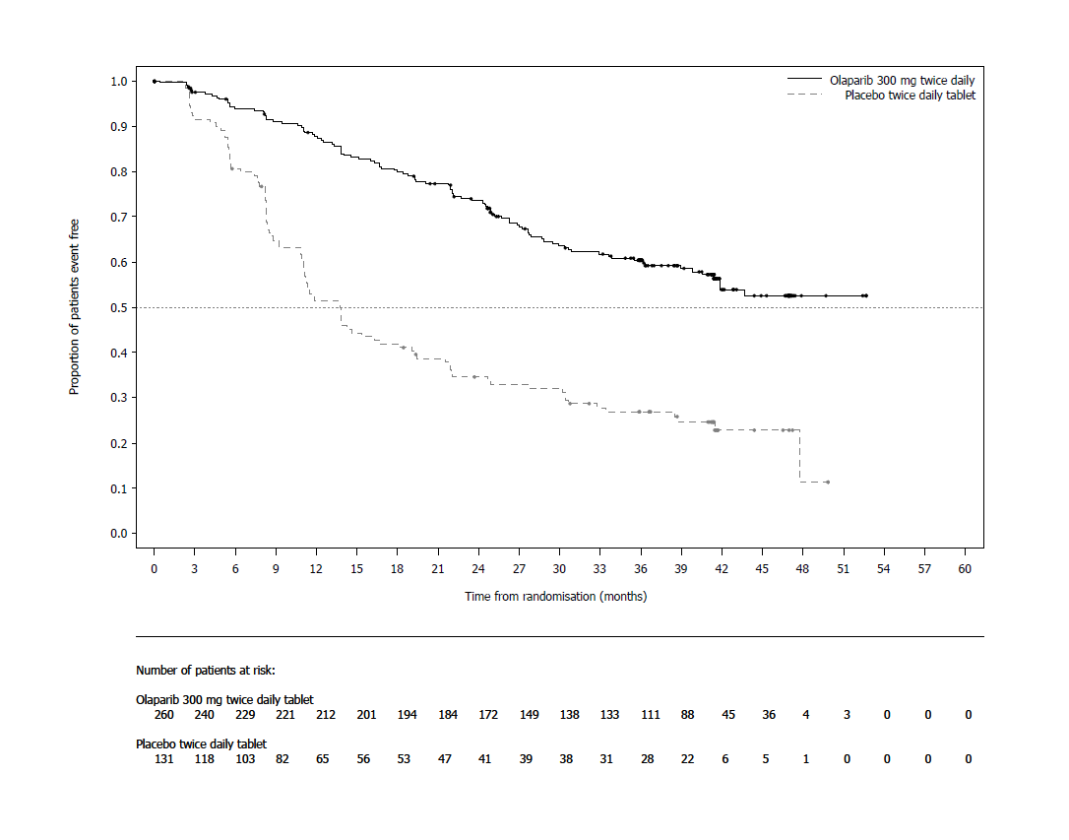
Figure 1 SOLO1: Kaplan-Meier plot of PFS in newly diagnosed patients with BRCA1/2m advanced ovarian cancer (51% maturity - investigator assessment)

Figure 2 SOLO1: Kaplan-Meier plot of OS in newly diagnosed patients with BRCA1/2m advanced ovarian cancer (38% maturity)
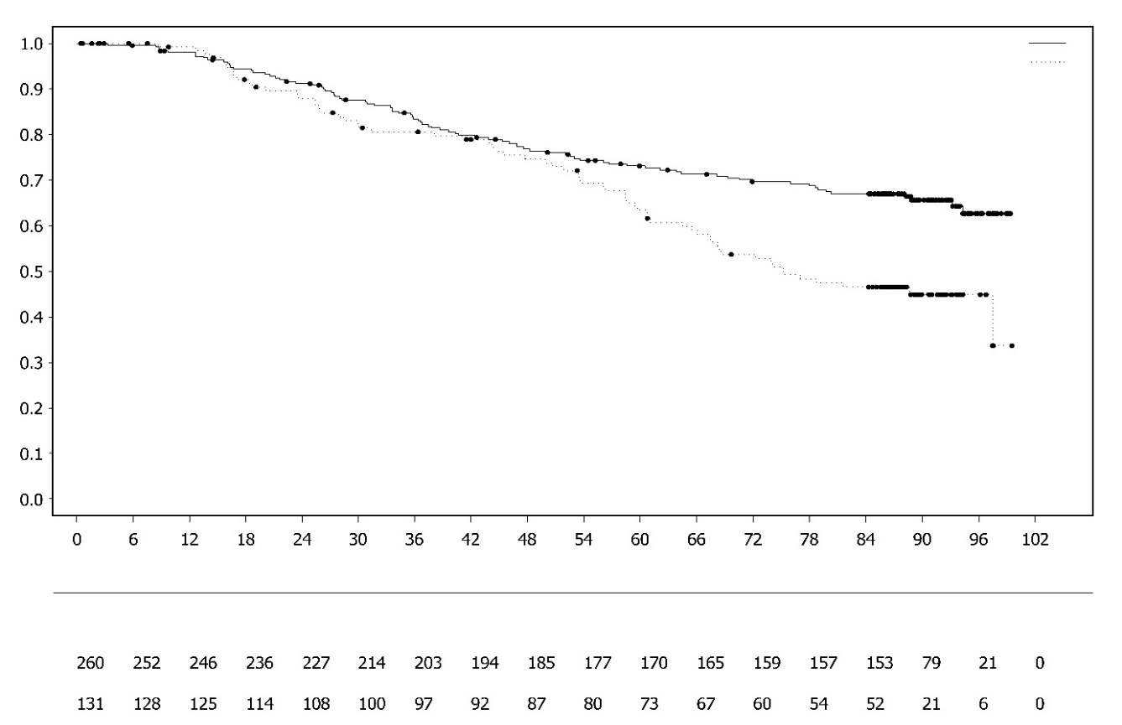
Consistent results were observed in the subgroups of patients by evidence of the disease at study entry. Patients with CR defined by the investigator had HR 0.34 (95% CI 0.24-0.47); median PFS not reached on olaparib vs 15.3 months on placebo. At 24 and 36 months, respectively, 68% and 45% patients remained in CR in the olaparib arm, and 34% and 22% of patients in the placebo arm. Patients with PR at study entry had PFS HR 0.31 (95% CI 0.18, 0.52; median PFS 30.9 months on olaparib vs 8.4 months on placebo). Patients with PR at study entry either achieved CR (15% in olaparib arm and 4% in the placebo arm at 24 months, remained in CR at 36 months) or had further PR/stable disease (43% in olaparib arm and 15% in the placebo arm at 24 months; 17% in olaparib arm and 15% in placebo arm at 36 months). The proportion of patients who progressed within 6 months of the last dose of platinum-based chemotherapy was 3.5% for olaparib and 8.4% for placebo.
Proportion of patients event free

Time from randomisation (months)
Number of patients at risk:
Olaparib 300mg twice daily tablet

Placebo twice daily tablet

Olaparib 300mg twice daily tablet
Placebo twice daily tablet

Maintenance treatment of platinum-sensitive relapsed (PSR) ovarian cancer
SOLO2 Study

The safety and efficacy of olaparib as maintenance therapy were studied in a Phase III randomised, double-blind, placebo-controlled trial in patients with germline BRCA1/2-mutated PSR ovarian, fallopian tube or primary peritoneal cancer. The study compared the efficacy of Lynparza maintenance treatment (300 mg [2 x 150 mg tablets] twice daily) taken until progression with placebo treatment in 295 patients with high-grade serous or endometrioid PSR ovarian cancer (2:1 randomisation: 196 olaparib and 99 placebo) who were in response (CR or PR) following completion of platinum-containing chemotherapy.

Patients who have received two or more platinum-containing regimens and whose disease had recurred >6 months after completion of penultimate platinum-based chemotherapy were enrolled. Patients could not have received prior olaparib or other PARP inhibitor treatment. Patients could have received prior bevacizumab, except in the regimen immediately prior to randomisation.

All patients had evidence of gBRCA1/2m at baseline. Patients with BRCA1/2 mutations were identified either from germline testing in blood via a local test or by central testing at Myriad or from testing a tumour sample using a local test. Large rearrangements in the BRCA1/2 genes were detected in 4.7% (14/295) of the randomised patients.

Demographic and baseline characteristics were generally well balanced between the olaparib and placebo arms. Median age was 56 years in both arms. Ovarian cancer was the primary tumour in >80% of the patients. The most common histological type was serous (>90%), endometrioid histology was reported in 6% of the patients. In the olaparib arm 55% of the patients had only 2 prior lines of treatment with 45% receiving 3 or more prior lines of treatment. In the placebo arm 61% of patients had received only 2 prior lines with 39% receiving 3 or more prior lines of treatment. Most patients were ECOG performance status 0 (81%), there are no data in patients with performance status 2 to 4. Platinum-free interval was >12 months in 60% and >6-12 months in 40% of the patients. Response to prior platinum chemotherapy was complete in 47% and partial in 53% of the patients. In the olaparib and placebo arms, 17% and 20% of patients had prior bevacizumab, respectively.

The primary endpoint was PFS determined by investigator assessment using RECIST 1.1. Secondary efficacy endpoints included PFS2; OS, TDT, TFST, TSST; and HRQoL.

The study met its primary objective demonstrating a statistically significant improvement in investigator assessed PFS for olaparib compared with placebo with a HR of 0.30 (95% CI 0.22-0.41; p<0.0001; median 19.1 months olaparib vs 5.5 months placebo). The investigator assessment of PFS was supported with a blinded independent central radiological review of PFS (HR 0.25; 95% CI 0.18-0.35; p<0.0001; median 30.2 months for olaparib and 5.5 months placebo). At 2 years, 43% olaparib-treated patients remained progression free compared with only 15% placebo-treated patients.

A summary of the primary objective outcome for patients with gBRCA1/2m PSR ovarian cancer in SOLO2 is presented in Table 4 and Figure 3.

Table 4 Summary of primary objective outcome for patients with gBRCA1/2m PSR ovarian cancer in SOLO2
 | Olaparib 300 mg tablet bd | Placebo
PFS (63% maturity)
Number of events: Total number of patients (%) | 107:196 (55) | 80:99 (81)
Median time (months) (95% CI) | 19.1 (16.3-25.7) | 5.5 (5.2-5.8)
HR (95% CI) ª | 0.30 (0.22-0.41)
P value (2-sided) | p<0.0001
ª HR= Hazard Ratio. A value <1 favours olaparib. The analysis was performed using a Cox proportional hazard model including response to previous platinum chemotherapy (CR or PR), and time to disease progression (>6-12 months and >12 months) in the penultimate platinum-based chemotherapy as covariates.
bd Twice daily; PFS progression-free survival; CI confidence interval

Figure 3 SOLO2: Kaplan-Meier plot of PFS in patients with gBRCA1/2m PSR ovarian cancer (63% maturity - investigator assessment)
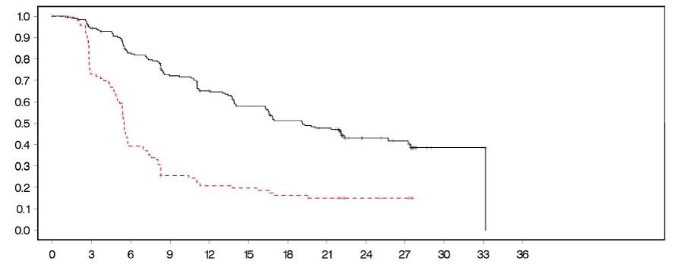
Time from randomisation (months)

- - - - - - - - - Placebo bd --------------Olaparib 300 mg bd
Number of patients at risk:

196 | 182 | 156 | 134 | 118 | 104 | 89 | 82 | 32 | 29 | 3 | 2 | 0 | Olaparib 300 mg bd
99 | 70 | 37 | 22 | 18 | 17 | 14 | 12 | 7 | 6 | 0 | 0 | 0 | Placebo bd

Proportion of patients event free

bd Twice daily; PFS Progression free survival

At the final analysis of OS (61% maturity) the HR was 0.74 (95% CI 0.54-1.00; p=0.0537; median 51.7 months for olaparib vs 38.8 months for placebo) which did not reach statistical significance. The secondary endpoints TFST and PFS2 demonstrated a persistent and statistically significant improvement for olaparib compared with placebo. Results for OS, TFST and PFS2 are presented in Table 5 and Figure 4.

Table 5 Summary of key secondary objective outcomes for patients with gBRCA1/2m PSR ovarian cancer in SOLO2
 | Olaparib 300 mg tablet bd | Placebo
OS (61% maturity)
Number of events: Total number of patients (%) | 116:196 (59) | 65:99 (66)
Median time (95% CI), months | 51.7 (41.5, 59.1) | 38.8 (31.4, 48.6)
HR (95% CI) ª | 0.74 (0.54-1.00)
P value (2-sided) | p=0.0537
TFST (71% maturity)
Number of events: Total number of patients (%) | 139:196 (71) | 86:99 (87)
Median time (months) (95% CI) | 27.4 (22.6-31.1) | 7.2 (6.3-8.5)
HR (95% CI) ª | 0.37 (0.28-0.48)
P value* (2-sided) | p<0.0001
PFS2 (40% maturity)
Number of events: Total number of patients (%) | 70:196 (36) | 49:99 (50)
Median time (months) (95% CI) | NR (24.1-NR) | 18.4 (15.4-22.8)
HR (95% CI) ª | 0.50 (0.34-0.72)
P value (2-sided) | p=0.0002
* Not controlled for multiplicity.
ª HR= Hazard Ratio. A value <1 favours olaparib. The analysis was performed using a Cox proportional hazard model including response to previous platinum chemotherapy (CR or PR), and time to disease progression (>6-12 months and >12 months) in the penultimate platinum-based chemotherapy as covariates.
bd Twice daily; NR not reached; CI confidence interval; PFS2 time from randomisation to second progression or death; TFST Time from randomisation to start of first subsequent therapy or death.

Figure 4 SOLO2: Kaplan-Meier plot of OS in patients with gBRCA1/2m PSR ovarian cancer (61% maturity)

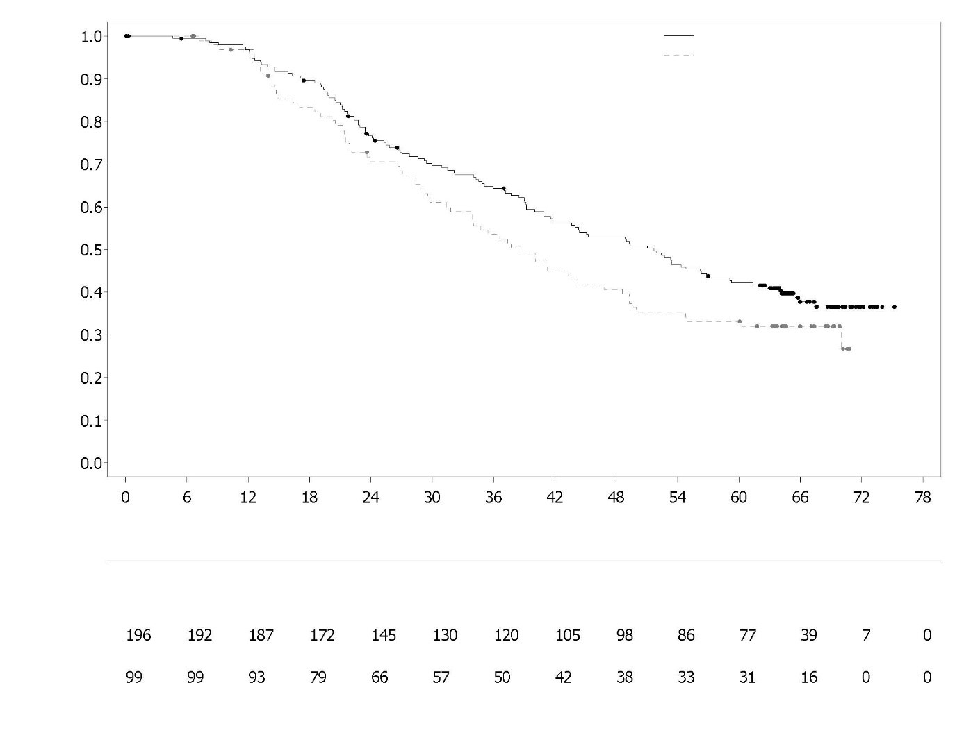
Placebo twice daily tablet

Number of patients at risk:
Olaparib 300mg twice daily tablet

Time from randomisation (months)
Proportion of patients event free

Olaparib 300mg twice daily tablet
Placebo twice daily tablet

Among the patients entering the trial with measurable disease (target lesions at baseline), an objective response rate of 41% was achieved in the Lynparza arm versus 17% on placebo. Of patients treated with Lynparza, who entered the study with evidence of disease (target or non-target lesions at baseline), 15.0% experienced complete response compared with 9.1% of patients on placebo.

At the time of the analysis of PFS the median duration of treatment was 19.4 months for olaparib and 5.6 months for placebo. The majority of patients remained on the 300 mg bd starting dose of olaparib. The incidence of dose interruptions, reductions, discontinuations due to an adverse event was 45.1%,
25.1% and 10.8%, respectively. Dose interruptions occurred most frequently in the first 3 months and dose reductions in the first 3-6 months of treatment. The most frequent adverse reactions leading to dose interruption or dose reduction were anaemia, nausea and vomiting.

Patient-reported outcome (PRO) data indicate no difference for the olaparib-treated patients as compared to placebo as assessed by the change from baseline in the TOI of the FACT-O.

Study 19 (D0810C00019)
The safety and efficacy of olaparib as a maintenance therapy in the treatment of PSR ovarian, including fallopian tube or primary peritoneal cancer patients, following treatment with two or more platinum-containing regimens, were studied in a large Phase II randomised, double-blind, placebo-controlled trial (Study 19). The study compared the efficacy of Lynparza maintenance treatment taken until progression with placebo treatment in 265 (136 olaparib and 129 placebo) PSR high grade serous ovarian cancer patients who were in response (CR or PR) following completion of platinum-containing chemotherapy. The primary endpoint was PFS based on investigator assessment using RECIST 1.0. Secondary efficacy endpoints included OS, disease control rate (DCR) defined as confirmed CR/PR + SD (stable disease), HRQoL and disease related symptoms. Exploratory analyses of TFST and TSST were also performed.

Patients whose disease had recurred >6 months after completion of penultimate platinum-based chemotherapy were enrolled. Enrolment did not require evidence of BRCA1/2 mutation (BRCA mutation status for some patients was determined retrospectively). Patients could not have received prior olaparib or other PARP inhibitor treatment. Patients could have received prior bevacizumab, except in the regimen immediately prior to randomisation. Retreatment with olaparib was not permitted following progression on olaparib.

Patients with BRCA1/2 mutations were identified either from germline testing in blood via a local test or by central testing at Myriad or from testing a tumour sample using a test performed by Foundation Medicine. Large rearrangements in the BRCA1/2 genes were detected in 7.4% (10/136) of the randomised patients.

Demographic and baseline characteristics were generally well balanced between the olaparib and placebo arms. Median age was 59 years in both arms. Ovarian cancer was the primary tumour in 86% of the patients. In the olaparib arm 44% of the patients had only 2 prior lines of treatment with 56% receiving 3 or more prior lines of treatment. In the placebo arm 49% of patients had received only 2 prior lines with 51% receiving 3 or more prior lines of treatment. Most patients were ECOG performance status 0 (77%), there are no data in patients with performance status 2 to 4. Platinum-free interval was > 12 months in 60% and 6-12 months in 40% of the patients. Response to prior platinum chemotherapy was complete in 45% and partial in 55% of the patients. In the olaparib and placebo arms, 6% and 5% of patients had prior bevacizumab, respectively.

The study met its primary objective demonstrating a statistically significant improvement in PFS for olaparib compared with placebo in the overall population with a HR of 0.35 (95% CI 0.25-0.49; p<0.00001; median 8.4 months olaparib vs 4.8 months placebo). At the final OS analysis (data cut off [DCO] 9 May 2016) at 79% maturity, the hazard ratio comparing olaparib with placebo was 0.73 (95% CI 0.55-0.95; p=0.02138 [did not meet pre-specified significance level of <0.0095]; median 29.8 months olaparib versus 27.8 months placebo). In the olaparib-treated group, 23.5% (n=32/136) of patients remained on treatment for ≥2 years as compared with 3.9% (n=5/128) of the patients on placebo. Although patient numbers were limited, 13.2% (n=18/136) of the patients in the olaparib-treated group remained on treatment for ≥5 years as compared with 0.8% (n=1/128) in the placebo group.

Preplanned subgroup analysis identified patients with BRCA1/2-mutated ovarian cancer (n=136, 51.3%; including 20 patients identified with a somatic tumour BRCA1/2 mutation) as the subgroup that derived the greatest clinical benefit from olaparib maintenance monotherapy. A benefit was also observed in patients with BRCA1/2 wild-type/variants of uncertain significance (BRCA1/2 wt/VUS), although of a lesser magnitude. There was no strategy for multiple testing in place for the sub-group analyses.
A summary of the primary objective outcome for patients with BRCA1/2-mutated and BRCA1/2 wt/VUS PSR ovarian cancer in Study 19 is presented in Table 6 and for all patients in Study 19 in Table 6 and Figure 5.
Table 6 Summary of primary objective outcome for all patients and patients with BRCA1/2-mutated and BRCA1/2 wt/VUS PSR ovarian cancer in Study 19
 | All patientsª |  |  | BRCA1/2-mutated |  |  |  | BRCA1/2 wt/VUS
 | Olaparib | Placebo |  | Olaparib |  | Placebo |  | Olaparib |  | Placebo
PFS – DCO 30 June 2010
Number of events: Total number of patients (%) | 60:136 (44) |  | 94:129 (73) |  | 26:74 (35) |  | 46:62 (74) |  | 32:57 (56) |  | 44:61 (72)
Median time (months) (95% CI) | 8.4  (7.4-11.5) |  | 4.8  (4.0-5.5) |  | 11.2  (8.3-NR) |  | 4.3  (3.0-5.4) |  | 7.4  (5.5-10.3) |  | 5.5  (3.7-5.6)
HR (95% CI) ^{b} | 0.35 (0.25-0.49) |  |  |  | 0.18 (0.10–0.31) |  |  |  | 0.54 (0.34-0.85)
P value (2-sided) | p<0.00001 |  |  |  | p<0.00001 |  |  |  | p=0.00745
ª All patients comprises of the following subgroups: BRCA1/2-mutated, BRCA1/2 wt/VUS and BRCA1/2 status unknown (11 patients with status unknown, not shown as a separate subgroup in table).
^{b} HR= Hazard Ratio. A value <1 favours olaparib. The analysis was performed using a Cox proportional hazards model with factors for treatment, ethnic descent, platinum sensitivity and response to final platinum therapy.
PFS progression-free survival; DCO data cut off; CI confidence interval; NR not reached.

Figure 5 Study 19: Kaplan-Meier plot of PFS in the FAS (58% maturity - investigator assessment) DCO 30 June 2010
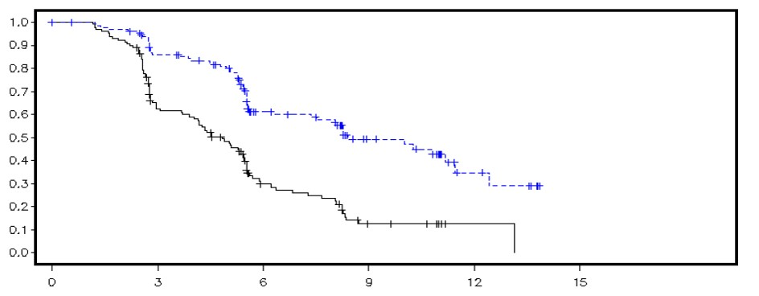
Proportion of patients event free
Time from randomisation (months)

--------------Placebo - - - - - - - - - Olaparib

Number of patients at risk:
136 | 106 | 53 | 24 | 7 | 0 | Olaparib
129 | 72 | 24 | 7 | 1 | 0 | Placebo
DCO Data cut-off; FAS Full analysis set; PFS progression-free survival
A summary of key secondary objective outcomes for patients with BRCA1/2-mutated and BRCA1/2 wt/VUS PSR ovarian cancer in Study 19 is presented in Table 7 and for all patients in Study 19 in Table 7 and Figure 6.
Table 7 Summary of key secondary objective outcomes for all patients and patients with BRCA1/2-mutated and BRCA1/2 wt/VUS PSR ovarian cancer in Study 19
 | All patientsª |  | BRCA1/2-mutated |  | BRCA1/2 wt/VUS
 | Olaparib | Placebo | Olaparib | Placebo | Olaparib | Placebo
OS - DCO 09 May 2016
Number of events: Total number of patients (%) | 98:136 (72) | 112:129 (87) | 49:74 (66) | 50:62 (81) ^{c} | 45:57 (79) | 57:61 (93)
Median time (months) (95% CI) | 29.8  (26.9-35.7) | 27.8  (24.9-33.7) | 34.9  (29.2-54.6) | 30.2  (23.1-40.7) | 24.5  (19.8-35.0) | 26.6  (23.1-32.5)
HR (95% CI)^{b} | 0.73 (0.55–0.95) |  | 0.62 (0.42–0.93) |  | 0.84 (0.57-1.25)
P value* (2-sided) | p=0.02138 |  | p=0.02140 |  | p=0.39749
TFST – DCO 09 May 2016
Number of events: Total number of patients (%) | 106:136 (78) | 124:128 (97) | 55:74 (74) | 59:62 (95) | 47:57 (83) | 60:61 (98)
Median time (months) (95% CI) | 13.3  (11.3-15.7) | 6.7  (5.7-8.2) | 15.6  (11.9-28.2) | 6.2  (5.3-9.2) | 12.9  (7.8-15.3) | 6.9  (5.7-9.3)
HR (95% CI)^{b} | 0.39 (0.30–0.52) |  | 0.33 (0.22-0.49) |  | 0.45 (0.30-0.66)
P value* (2-sided) | p<0.00001 |  | p<0.00001 |  | p=0.00006
* There was no strategy for multiple testing in place for the sub-group analyses or for the all patients TFST.
ª All patients comprises of the following subgroups: BRCA1/2-mutated, BRCA1/2 wt/VUS and BRCA1/2 status unknown (11 patients with status unknown, not shown as a separate subgroup in table).
^{b} HR= Hazard Ratio. A value <1 favours olaparib. The analysis was performed using a Cox proportional hazards model with factors for treatment, ethnic descent, platinum sensitivity and response to final platinum therapy.
^{c} Approximately a quarter of placebo-treated patients in the BRCA-mutated subgroup (14/62; 22.6%) received a subsequent PARP inhibitor.
OS Overall survival; DCO data cut off; CI confidence interval; TFST time from randomisation to start of first subsequent therapy or death.

Figure 6 Study 19: Kaplan Meier plot of OS in the FAS (79% maturity) DCO 09 May 2016
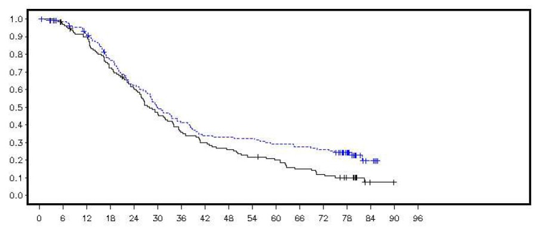
Proportion of patients alive
Time from randomisation (months)

--------------Placebo - - - - - - - - - Olaparib
Number of patients at risk:

Olaparib
Placebo

DCO Data cut off; FAS Full analysis set; OS Overall survival

At the time of the analysis of PFS the median duration of treatment was 8 months for olaparib and 4 months for placebo. The majority of patients remained on the starting dose of olaparib. The incidence of dose interruptions, reductions and discontinuations due to an adverse event was 34.6%, 25.7% and 5.9%, respectively. Dose interruptions and reductions occurred most frequently in the first 3 months of treatment. The most frequent adverse reactions leading to dose interruption or dose reduction were nausea, anaemia, vomiting, neutropenia and fatigue. The incidence of anaemia adverse reactions was 22.8% (CTCAE grade ≥3 7.4%).

Patient-reported outcome (PRO) data indicate no difference for the olaparib-treated patients as compared to placebo as measured by improvement and worsening rates in the TOI and FACT-O total.

OPINION Study

OPINION, a Phase IIIb single arm, multicentre study, investigated olaparib as a maintenance treatment in patients with PSR ovarian, fallopian tube or primary peritoneal cancer following 2 or more lines of platinum based chemotherapy and who did not have a known deleterious or suspected deleterious gBRCA mutation. Patients whose disease was in response (CR or PR) following completion of platinum-based chemotherapy were enrolled. A total of 279 patients were enrolled and received olaparib treatment in this study until disease progression or unacceptable toxicity. Based on central testing 90.7% were confirmed with a non gBRCAm status, in addition 9.7% were identified as sBRCAm.

The primary endpoint was investigator-assessed PFS according to modified RECIST v1.1. Secondary endpoints included OS.
Olaparib, when used as maintenance therapy, demonstrated clinical activity in patients with non-gBRCAm PSR ovarian cancer. At the final overall survival analysis (DCO 17 September 2021), the OS data were 52.3% mature.

A summary of the primary PFS and OS secondary objective outcome for patients with non-gBRCAm PSR ovarian cancer in OPINION is presented in Table 8.

Table 8 Summary of key objective outcome for non-gBRCAm patients with PSR ovarian cancer in OPINION

 | Olaparib tablets 300 mg bd
PFS (75% maturity) (DCO 2 October 2020)
Number of events: total number of patients (%) | 210: 279 (75.3)
Median PFS (95% CI), monthsª | 9.2 (7.6, 10.9)
OS (52.3% maturity) (DCO 17 September 2021)
Number of events: total number of patients (%) | 146: 279 (52.3)
Median OS (95% CI), monthsª | 32.7 (29.5, 35.3)
ª Calculated using the Kaplan-Meier technique.
Confidence intervals for median PFS and OS were derived based on Brookmeyer Crowley method.
bd Twice daily; PFS Progression-free survival; OS Overall survival; DCO Data cut off; CI Confidence interval.

First-line maintenance treatment of HRD positive advanced ovarian cancer
PAOLA-1 Study
PAOLA-1 was a Phase III randomised, double-blind, placebo-controlled, multicentre trial that compared the efficacy and safety of Lynparza (300 mg [2 x 150 mg tablets] twice daily) in combination with bevacizumab (15 mg/kg of body weight given once every 3 weeks as an intravenous infusion) versus placebo plus bevacizumab for the maintenance treatment of advanced (FIGO Stage III-IV) high-grade epithelial ovarian, fallopian tube or primary peritoneal cancer following first-line platinum-based chemotherapy and bevacizumab. Treatment with bevacizumab was for a total of up to 15 months/22 cycles, including the period given with chemotherapy and given as maintenance.

The study randomised 806 patients (2:1 randomisation: 537 olaparib/bevacizumab: 269 placebo/bevacizumab) who had no evidence of disease (NED) due to complete surgical resection, or who were in complete response (CR), or partial response (PR) following completion of first-line platinum-containing chemotherapy and bevacizumab. Patients had completed a minimum of 4 and a maximum of 9 cycles, with the majority (63%) having received 6 cycles of first line platinum-taxane based chemotherapy, including a minimum of 2 cycles of bevacizumab in combination with the 3 last cycles of chemotherapy. The median number of bevacizumab cycles prior to randomisation was 5.

Patients were stratified by first-line treatment outcome (timing and outcome of cytoreductive surgery and response to platinum-based chemotherapy) and tBRCAm status, determined by prospective local testing. Patients continued bevacizumab in the maintenance setting and started treatment with Lynparza after a minimum of 3 weeks and up to a maximum of 9 weeks following completion of their last dose of chemotherapy. Treatment with Lynparza was continued until progression of the underlying disease, unacceptable toxicity or for up to 2 years. Patients who in the opinion of the treating physician could derive further benefit from continuous treatment could be treated beyond 2 years.

Demographic and baseline characteristics were balanced between both arms in the intent to treat (ITT) population and in the biomarker-defined sub-groups by tBRCAm (prospectively and retrospectively defined), GIS and HRD status (defined in this study by a combination of both biomarkers). The median age of patients was 61 years overall. Most patients in both arms were ECOG performance status 0 (70%). Ovarian cancer was the primary tumour in 86% of the patients. The most common histological type was serous (96%) and endometrioid histology was reported in 2% of the patients. Most patients were diagnosed in FIGO stage IIIC (63%). All patients had received first-line platinum-based therapy and bevacizumab. Patients were not restricted by the surgical outcome with 63% having complete cytoreduction at initial or interval debulking surgery and 37% having residual macroscopic disease. Thirty percent (30%) of patients in both arms were tBRCAm at screening. Demographic and baseline characteristics in the biomarker sub-groups were consistent with those in the ITT population. In the HRD-positive subgroup, 65% of patients had complete cytoreduction and 35% of patients had residual macroscopic disease. In the overall patient population enrolled, 30% of patients in both arms were tBRCAm (deleterious/pathogenic mutation) at screening by local testing and for 4% of patients the BRCAm status was unknown. Retrospective analysis of available clinical samples was conducted in 97% of patients to confirm tBRCAm status and investigate genomic instability score as described above. Among non-tBRCAm patients, 29% (19% of the overall population) had positive GIS pre-defined in this study as composite score ≥42. When tBRCAm status and positive GIS were combined, patients with HRD-positive, HRD-negative and HRD unknown status in their tumours represented 48%, 34% and 18% of the overall patient population.
The primary endpoint was progression-free survival (PFS), defined as time from randomisation to progression determined by investigator assessment using modified Response Evaluation Criteria in Solid Tumors (RECIST) 1.1, or death. Secondary efficacy endpoints included time from randomisation to second progression or death (PFS2), overall survival (OS), time from randomisation to first subsequent anti-cancer therapy or death (TFST) and health related quality of life (HRQoL). Patients had RECIST 1.1 tumour assessments at baseline and every 24 weeks (CT/MRI at 12 weeks if clinical or CA 125 progression) for up to 42 months or until objective radiological disease progression.
The study met its primary endpoint in the ITT population demonstrating a statistically significant improvement in investigator assessed PFS for olaparib/bevacizumab compared to placebo/bevacizumab (HR 0.59, 95% CI 0.49-0.72, p<0.0001 with a median of 22.1 months for olaparib/bevacizumab vs 16.6 months for placebo/bevacizumab). This was consistent with a BICR analysis of PFS. However, patients defined as biomarker-positive (tBRCAm, GIS, HRD status positive defined as tBRCAm and/or GIS positive) derived most of the benefit.
Final analysis of PFS2 (DCO 22 March 2020, 53% maturity) in the overall population was statistically significant (HR 0.78, 95% CI 0.64-0.95, p=0.0125 with a median of 36.5 months for olaparib/ bevacizumab vs 32.6 months for placebo/bevacizumab).
At the final analysis of OS (DCO 22 March 2022) in the HRD status positive patients (tBRCAm and/or GIS), there was a numerical improvement in OS with olaparib/bevacizumab arm vs placebo/bevacizumab arm (see Table 9).
In the tBRCAm as randomised subgroup (241/806 patients) median PFS for the olaparib/bevacizumab arm was 37.2 months vs 22.0 months for the placebo/bevacizumab arm (HR=0.34, 95% CI 0.23, 0.51). At the final overall survival analysis (DCO 22 March 2022), the tBRCAm as randomised subgroup demonstrates a numerical reduction in the risk of death for olaparib/bevacizumab compared to placebo/bevacizumab (HR 0.63; 95% CI 0.41, 0.97).

Efficacy results in other biomarkers subgroup analyses based on retrospectively analysed tumour samples are presented in Table 9.
Table 9 Summary of key efficacy findings for patients with homologous recombination deficiency (HRD) positive status defined by either tBRCAm and/or GIS in advanced ovarian cancer patients in PAOLA-1
 | tBRCAm^{*, c}  ^{(n=235)} |  | GIS positive (HRD positive excluding tBRCAm)^{*, d}  (n=152) |  | HRD positive*  (n=387)
 | Olaparib/ bevacizumab | Placebo/ bevacizumab | Olaparib/ bevacizumab | Placebo/ bevacizumab | Olaparib/ bevacizumab | Placebo/ bevacizumab
PFS, investigator assessment (46% maturity) DCO 22 March 2019ª
Number of events: Total number of patients (%) | 44:158 (28) | 52:77 (68) | 43:97 (44) | 40:55 (73) | 87:255 (34) | 92:132 (70)
Median time (months) | 37.2 | 18.8 | 28.1 | 16.6 | 37.2 | 17.7
HR (95%) CI^{b} | 0.28 (0.19, 0.42) |  | 0.43 (0.28, 0.66) |  | 0.33 (0.25, 0.45)
PFS2, investigator assessment (40% maturity) DCO 22 March 2020
Number of events: Total number of patients (%) | 44:158 (28) | 37:77 (48) | 41:97 (42) | 33:55 (60) | 85:255 (33) | 70:132 (53)
Median time (months) | NR | 42.2 | 50.3 | 30.1 | 50.3 | 35.4
HR (95%) CI^{b} | 0.53 (0.34, 0.82) |  | 0.60 (0.38, 0.96) |  | 0.56 (0.41, 0.77)
Final OS (42% maturity) DCO 22 March 2022
Number of events: Total number of patients (%) | 49:158 (31.0) | 37:77 (48.1) | 44:97 (45.4) | 32:55 (58.2) | 93:255 (36.5) | 69:132 (52.3)
Median time (months) | 75.2 | 66.9 | NR | 52.0 | 75.2 | 57.3
HR (95%) CI^{b} | 0.57 (0.37, 0.88) |  | 0.71 (0.45, 1.13) |  | 0.62 (0.45, 0.85)
* Pre-planned subgroup
ª Based on Kaplan-Meier estimates, the proportion of patients that were progression free at 12 and 24 months were 89% and 66% for olaparib/bevacizumab versus 71% and 29% for placebo/bevacizumab.
^{b} A value <1 favours olaparib. The analysis was performed using a Cox proportional hazards model stratified by first line treatment outcome at screening and screening laboratory tBRCA status.
^{c} tBRCAm status by Myriad
^{d} HRD positive excluding tBRCAm was defined as Genomic instability score (GIS) by Myriad ≥42 (pre-specified cut-off)
CI Confidence interval; HR Hazard ratio; NR not reached

Figure 7 PAOLA-1: Kaplan-Meier plot of PFS for patients with advanced ovarian cancer defined as HRD positive in PAOLA-1 (46% maturity - investigator assessment)
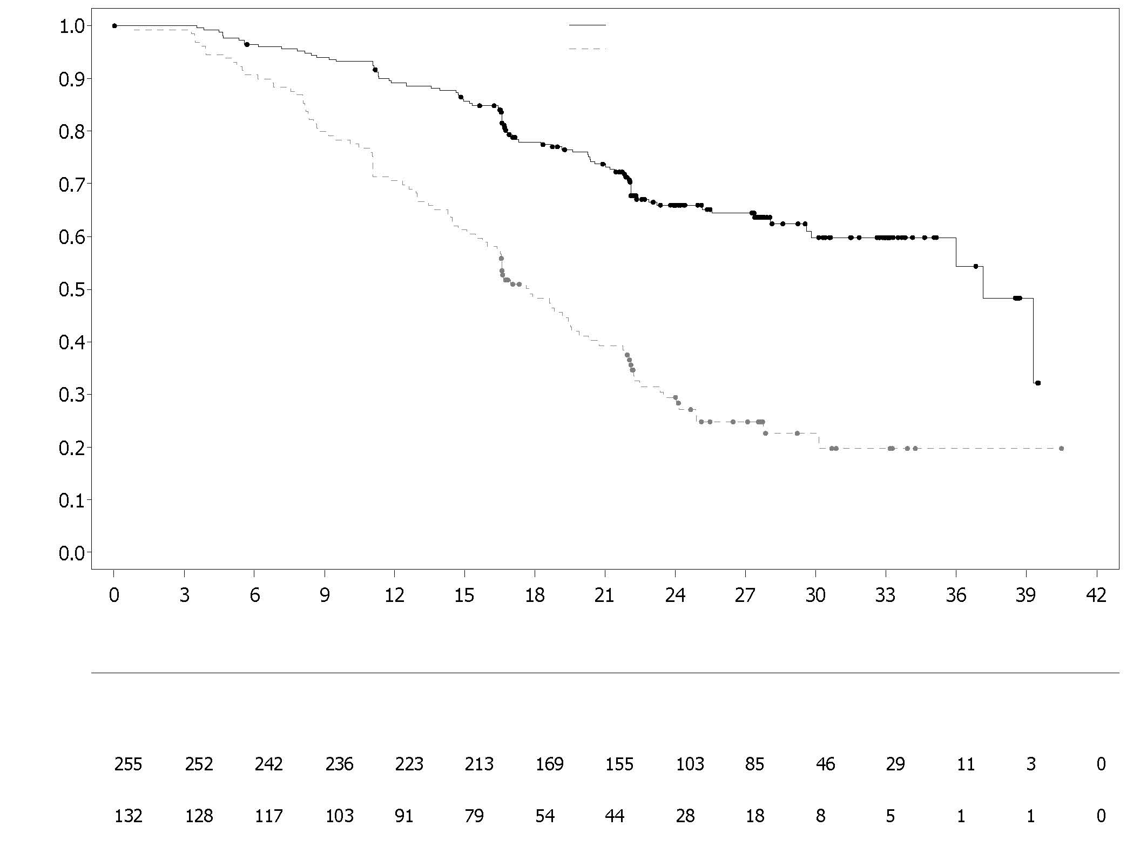
Proportion of patients event free
Placebo + bevacizumab
Olaparib + bevacizumab
Number of patients at risk:
Time from randomisation (months)
Placebo + bevacizumab
Olaparib + bevacizumab
Figure 8 PAOLA-1: Kaplan-Meier Plot, Final Overall Survival by HRD Status Positive (including tBRCAm) (DCO 22 March 2022)
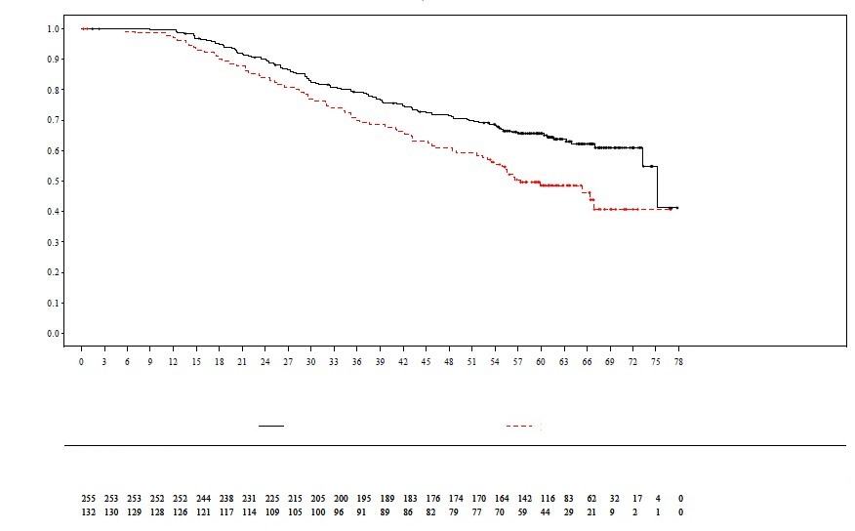
Time from randomisation (months)
Number of patients at risk:
Proportion of patients event free
Olaparib + bevacizumab
Placebo + bevacizumab
Placebo + bevacizumab
Olaparib + bevacizumab

Adjuvant treatment of germline BRCA-mutated high risk early breast cancer
OlympiA

The safety and efficacy of olaparib as adjuvant treatment in patients with germline BRCA1/2 mutations and HER2-negative high risk early breast cancer who had completed definitive local treatment and neoadjuvant or adjuvant chemotherapy was studied in a Phase III randomised, double-blind, parallel group, placebo-controlled, multicentre study (OlympiA). Patients were required to have completed at least 6 cycles of neoadjuvant or adjuvant chemotherapy containing anthracyclines, taxanes or both. Prior platinum for previous cancer (e.g. ovarian) or as adjuvant or neoadjuvant treatment for breast cancer was allowed. High risk early breast cancer patients were defined as follows:

- patients who received prior neoadjuvant chemotherapy: patients with either triple negative breast cancer (TNBC) or hormone receptor positive breast cancer must have had residual invasive cancer in the breast and/or the resected lymph nodes (non-pathologic complete response) at the time of surgery. Additionally, patients with hormone receptor positive breast cancer must have had a CPS&EG score of ≥3 based on pre-treatment clinical and post-treatment pathologic stage (CPS), estrogen receptor (ER) status and histologic grade as shown in Table 10.
Table 10 Early Breast Cancer Stage, Receptor Status and Grade Scoring Requirements for Study Enrolment*

Stage/feature |  | Points
Clinical Stage  (pre-treatment) | I/IIA | 0
Clinical Stage  (pre-treatment) | IIB/IIIA | 1
Clinical Stage  (pre-treatment) | IIIB/IIIC | 2
Pathologic Stage (post-treatment) | 0/I | 0
Pathologic Stage (post-treatment) | IIA/IIB/IIIA/IIIB | 1
Pathologic Stage (post-treatment) | IIIC | 2
Receptor status | ER positive | 0
Receptor status | ER negative | 1
Nuclear grade | Nuclear grade 1-2 | 0
Nuclear grade | Nuclear grade 3 | 1
* Total score of ≥3 required for patients with hormone receptor positive breast cancer.

- patients who have received prior adjuvant chemotherapy: triple negative breast cancer (TNBC) patients must have had node positive disease or node negative disease with a ≥2 cm primary tumour; HR positive, HER2-negative patients must have had ≥4 pathologically confirmed positive lymph nodes.
Patients were randomised (1:1) to either olaparib 300 mg (2 x 150 mg tablets) twice daily (n=921) or placebo (n=915). Randomisation was stratified by hormone receptor status (HR positive/ HER2 negative versus TNBC), by prior neoadjuvant versus adjuvant chemotherapy, and by prior platinum use for current breast cancer (yes versus no). Treatment was continued for up to 1 year, or until disease recurrence, or unacceptable toxicity. Patients with HR positive tumours also received endocrine therapy.

The primary endpoint was invasive disease free survival (IDFS), defined as the time from randomisation to date of first recurrence, where recurrence is defined as invasive loco-regional, distant recurrence, contralateral invasive breast cancer, new cancer or death from any cause. Secondary objectives included OS, distant disease free survival (DDFS, defined as the time from randomisation until evidence of first distant recurrence of breast cancer), the incidence of new primary contralateral breast cancers (invasive and non-invasive), new primary ovarian cancer, new primary fallopian tube cancer and new primary peritoneal cancer, and patient reported outcomes (PRO) using the FACIT-Fatigue and EORTC QLQ-C30 questionnaires.

Central testing at Myriad or local gBRCA testing, if available, was used to establish study eligibility. Patients enrolled based on local gBRCA test results provided a sample for retrospective confirmatory testing. Out of 1836 patients enrolled into OlympiA, 1623 were confirmed as gBRCAm by central testing, either prospectively or retrospectively.

Demographic and baseline characteristics were well balanced between the two treatment arms. The median age was 42 years. Sixty-seven percent (67%) of patients were White, 29% Asian and 2.6% Black. Two patients (0.2%) in the olaparib arm and four patients (0.4%) in the placebo arm were male. Sixty-one percent (61%) of patients were pre-menopausal. Eighty-nine percent (89%) of patients were ECOG performance status 0 and 11% ECOG PS 1. Eighty-two percent (82%) of patients had TNBC and 18% had HR positive disease. Fifty percent (50%) of patients had received prior neoadjuvant and 50% received prior adjuvant chemotherapy. Ninety-four percent (94%) of patients received anthracycline and taxane. Twenty-six percent (26%) of patients overall had received prior platinum for breast cancer. In the olaparib and placebo arms, 87% and 92% of patients with HR positive disease were receiving concomitant endocrine therapy, respectively. Overall, 89.5% of patients with HR positive disease received an endocrine therapy, which included letrozole (23.7%), tamoxifen (40.9%), anastrozole (17.2%), or exemestane (14.8%).

The study met its primary endpoint demonstrating a statistically significant improvement in IDFS in the olaparib arm compared with the placebo arm. Two hundred and eighty-four (284) patients had IDFS events, this represented 12% of patients in the olaparib arm (distant 8%, local/regional 1.4%, contralateral invasive breast cancer 0.9%, non-breast second primary malignancies 1.2%, death 0.2%) and 20% of patients in the placebo arm (distant 13%, local/regional 2.7%, contralateral invasive breast cancer 1.3%, non-breast second primary malignancies 2.3%, death 0%). A statistically significant improvement in DDFS in the olaparib arm compared with the placebo arm was also observed. At the primary OS analysis (10% maturity, DCO 12 July 2021), a statistically significant improvement in OS was observed in the olaparib arm compared with the placebo arm (HR=0.68 [98.5% CI 0.47, 0.97], p-value=0.0091). In a prespecified analysis performed approximately five years after the last patient was randomised, with a median follow–up of 6.2 years in the olaparib arm and 6.1 years in the placebo arm, olaparib continued to demonstrate improved OS compared to placebo. Efficacy results in the FAS are presented in Table 11 and Figures 9 and 10.

Table 11 Efficacy results for adjuvant treatment of patients with germline BRCA-mutated early breast cancer in OlympiA
 |  | Olaparib 300 mg bd  (N=921) |  | Placebo  (N=915)
IDFS (15% maturity) – DCO 27 March 2020
Number of events: Total number of patients (%) |  | 106:921 (12) |  | 178:915 (20)
HR (99.5% CI)ª |  | 0.58 (0.41, 0.82)
P value (2-sided)^{b} |  | 0.0000073
Percentage (95% CI) of patients invasive disease free at 3 years^{c} |  | 86 (83, 88) | 77 (74, 80)
DDFS (13% maturity) – DCO 27 March 2020
Number of events: Total number of patients (%) |  | 89:921 (10) |  | 152:915 (17)
HR (99.5% CI)ª |  | 0.57 (0.39, 0.83)
P value (2-sided)^{b} |  | 0.0000257
Percentage (95% CI) of patients distant disease free at 3 years^{c} |  | 88 (85, 90) | 80 (77, 83)
OS (14% maturity) – DCO 05 June 2024 [5-Year Follow-Up Analysis]
Number of events: Total number of patients (%) |  | 107:921 (12) |  | 143:915 (16)
HR (95% CI)ª |  | 0.72 (0.56, 0.93)
Percentage (95% CI) of patients alive at 3 years^{c} Percentage (95% CI) of patients alive at 4 years^{c}  Percentage (95% CI) of patients alive at 5 years^{c} Percentage (95% CI) of patients alive at 6 years^{c} |  | 93 (91, 94)  90 (88, 92)  89 (87, 91)  88 (85, 90) | 89 (87, 91)  87 (85, 89)  86 (83, 88)  83 (80, 86)
ª Based on the stratified Cox's proportional hazards model, <1 indicates a lower risk with olaparib compared with placebo arm.
^{b} P-value from a stratified log-rank test.
^{c} Percentages are calculated using KM estimates.
bd = twice daily; CI = confidence interval; DCO = data cut off; DDFS = distant disease free survival; HR = hazard ratio; IDFS = invasive disease free survival; KM = Kaplan-Meier; OS = overall survival.

Figure 9 Kaplan-Meier plot of IDFS for adjuvant treatment of patients with germline BRCA-mutated high risk early breast cancer in OlympiA (DCO 27 March 2020)
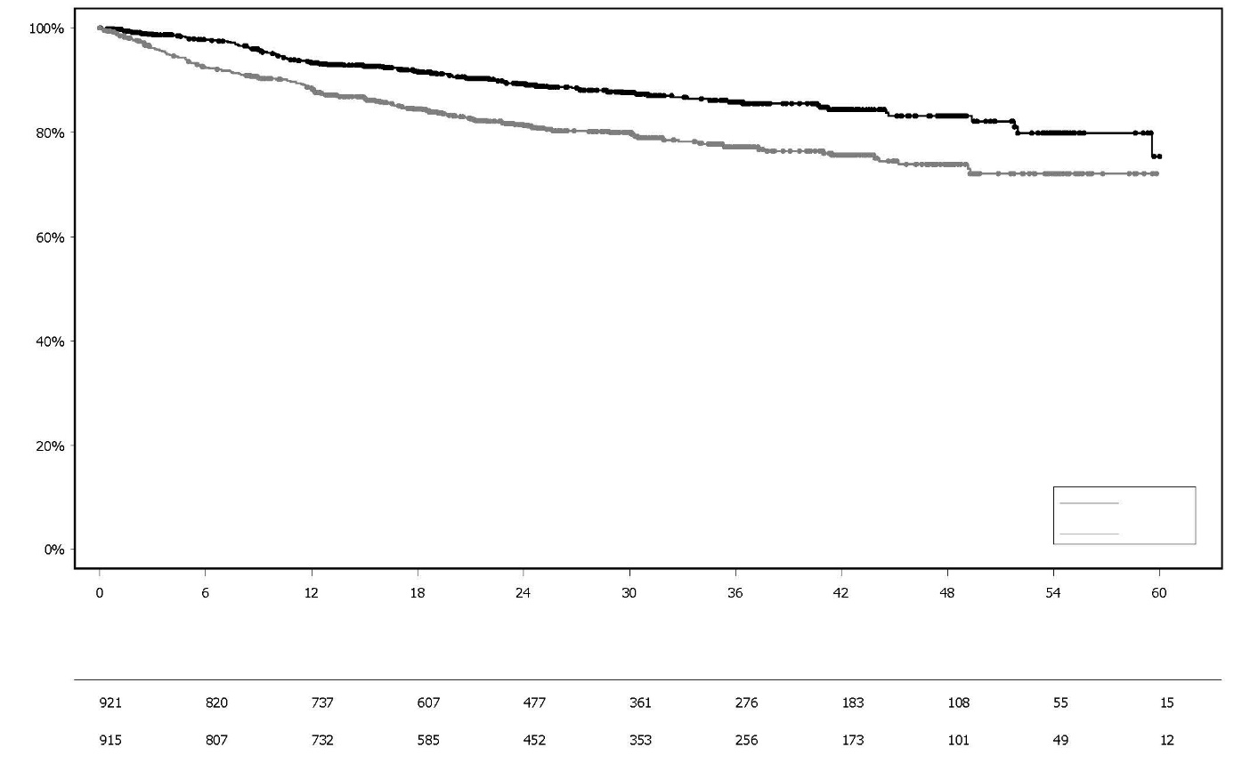
Percentage of patients alive and invasive disease free

Placebo

Olaparib 300 mg bd

Number of patients at risk:
Months since randomisation randomisation (months)
Olaparib
Placebo

Figure 10 Kaplan-Meier plot of OS for adjuvant treatment of patients with germline BRCA-mutated high risk early breast cancer in OlympiA (DCO 05 June 2024)

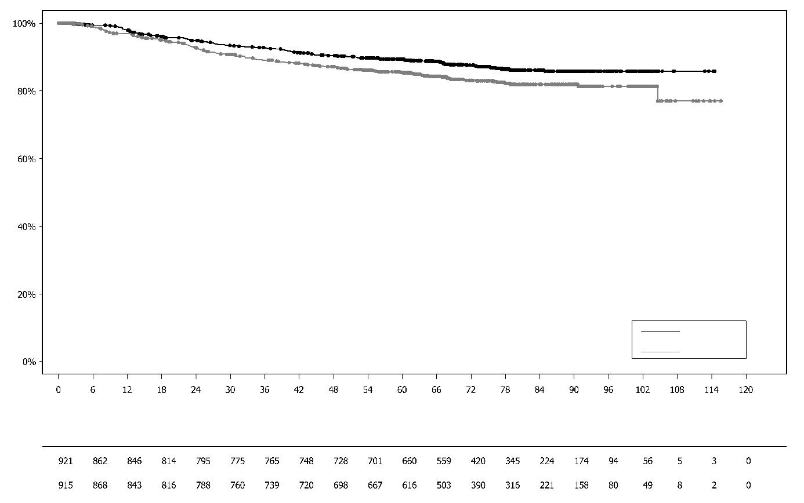
Months since randomisation randomisation (months)
Olaparib
Placebo
Percentage of patients alive

Placebo

Olaparib 300 mg bd

Number of patients at risk:

gBRCA1/2-mutated HER2-negative metastatic breast cancer
OlympiAD (Study D0819C00003)

The safety and efficacy of olaparib in patients with gBRCA1/2-mutations who had HER2-negative metastatic breast cancer were studied in a Phase III randomised, open-label, controlled trial (OlympiAD). In this study 302 patients with a documented deleterious or suspected deleterious gBRCA mutation were randomised 2:1 to receive either Lynparza (300 mg [2 x 150 mg tablets] twice daily) or physician’s choice of chemotherapy (capecitabine 42%, eribulin 35%, or vinorelbine 17%) until progression or unacceptable toxicity. Patients with BRCA1/2 mutations were identified from germline testing in blood via a local test or by central testing at Myriad. Patients were stratified based on: receipt of prior chemotherapy regimens for metastatic breast cancer (yes/no), hormone receptor (HR) positive vs triple negative (TNBC), prior platinum treatment for breast cancer (yes/no). The primary endpoint was PFS assessed by blinded independent central review (BICR) using RECIST 1.1. Secondary endpoints included PFS2, OS, objective response rate (ORR) and HRQoL.

Patients must have received treatment with an anthracycline unless contraindicated and a taxane in either a (neo)adjuvant or metastatic setting. Patients with HR+ (ER and/or PgR positive) tumours must have received and progressed on at least one endocrine therapy (adjuvant or metastatic) or had disease that the treating physician believed to be inappropriate for endocrine therapy. Prior therapy with platinum was allowed in the metastatic setting provided there had been no evidence of disease progression during platinum treatment and in the (neo)adjuvant setting provided the last dose was received at least 12 months prior to randomisation. No previous treatment with a PARP inhibitor, including olaparib, was permitted.

Demographic and baseline characteristics were generally well balanced between the olaparib and comparator arms (see Table 12).

Table 12 Patient demographic and baseline characteristics in OlympiAD

 | Olaparib 300 mg bd  n=205 | Chemotherapy  n=97
Age - year (median) | 44 | 45
Gender (%)
Female | 200 (98) | 95 (98)
Male | 5 (2) | 2 (2)
Race (%)
White | 134 (65) | 63 (65)
Asian | 66 (32) | 28 (29)
Other | 5 (2) | 6 (6)
ECOG performance status (%)
0 | 148 (72) | 62 (64)
1 | 57 (28) | 35 (36)
Overall disease classification
Metastatic | 205 (100) | 97 (100)
Locally advanced | 0 | 0
New metastatic breast cancer (%) | 26 (13) | 12 (12)
Hormone receptor status (%)
HR+ | 103 (50) | 49 (51)
TNBC | 102 (50) | 48 (49)
gBRCA mutation type (%)
gBRCA1 | 117 (57) | 51 (53)
gBRCA2 | 84 (41) | 46 (47)
gBRCA1 and gBRCA2 | 4 (2) | 0
≥2 Metastatic sites (%) | 159 (78) | 72 (74)
Location of the metastasis (%)
Bone only | 16 (8) | 6 (6)
Other | 189 (92) | 91 (94)
Measurable disease by BICR (%) | 167 (81) | 66 (68)
Progressive disease at time of randomization (%) | 159 (78) | 73 (75)
Tumour grade at diagnosis
Well differentiated (G1) | 5 (2) | 2 (2)
Moderately differentiated (G2) | 52 (25) | 23 (24)
Poorly differentiated (G3) | 108 (53) | 55 (57)
Undifferentiated (G4) | 4 (2) | 0
Unassessable (GX) | 27 (13) | 15 (16)
Missing | 9 (4) | 2 (2)
Number of prior lines of chemotherapy for metastatic breast cancer (%)
0 | 68 (33) | 31 (32)
1 | 80 (39) | 42 (43)
2 | 57 (28) | 24 (25)
Previous platinum-based therapy (%) | 55 (27) | 21 (22)
in (neo)adjuvant setting only | 12 (6) | 6 (6)
metastatic setting only | 40 (20) | 14 (14)
in (neo)adjuvant and metastatic setting | 3 (1) | 1 (1)
Previous anthracycline treatment
in (neo) adjuvant setting | 169 (82) | 76 (78)
metastatic setting | 41 (20) | 16 (17)
Previous taxane treatment
in (neo)adjuvant setting | 146 (71) | 66 (68)
metastatic setting | 107 (52) | 41 (42)
Previous anthracycline and taxane treatment | 204 (99.5) | 96 (99)

As subsequent therapy, 0.5% and 8% of patients received a PARP inhibitor in the treatment and comparator arms, respectively; 29% and 42% of patients, respectively, received subsequent platinum therapy.

A statistically significant improvement in PFS, the primary efficacy outcome, was demonstrated for olaparib-treated patients compared with those in the comparator arm (see Table 13 and Figure 11).

Table 13 Summary of key efficacy findings for patients with gBRCA1/2-mutated HER2-negative metastatic breast cancer in OlympiAD
 | Olaparib 300 mg bd | Chemotherapy
PFS (77% maturity) – DCO 09 December 2016
Number of events: Total number of patients (%) | 163:205 (80) | 71:97 (73)
Median time (months) (95% CI) | 7.0 (5.7-8.3) | 4.2 (2.8-4.3)
HR (95% CI) | 0.58 (0.43-0.80)
P value (2-sided)ª | p=0.0009
PFS2 (65% maturity) - DCO 25 September 2017^{b}
Number of events: Total number of patients (%) | 130:205 (63) | 65:97 (67)
Median time (months) (95% CI) | 12.8 (10.9-14.3) | 9.4 (7.4-10.3)
HR (95% CI) | 0.55 (0.39-0.77)
P value (2-sided)ª | p=0.0005
OS (64% maturity) – DCO 25 September 2017
Number of events: Total number of patients (%) | 130:205 (63) | 62:97 (64)
Median time (months) (95% CI) | 19.3 (17.2-21.6)^{c} | 17.1 (13.9-21.9)
HR (95% CI) | 0.90 (0.66-1.23)
P value (2-sided)ª | p=0.5131
Confirmed ORR – DCO 09 December 2016
Number of objective responders: Total number of patients with measurable disease (%) | 87: 167 (52)^{d} | 15:66 (23)
95% CI | 44.2-59.9 | 13.3-35.7
DOR – DCO 09 December 2016
Median, months (95% CI) | 6.9 (4.2, 10.2) | 7.9 (4.5, 12.2)
ª Based on stratified log-rank test.
^{b} Post-hoc analysis.
^{c} The median follow-up time in censored patients was 25.3 months for olaparib versus 26.3 months for comparator.
^{d} Confirmed responses (by BICR) were defined as a recorded response of either CR/PR, confirmed by repeat imaging not less than 4 weeks after the visit when the response was first observed. In the olaparib arm 8% with measurable disease had a complete response versus 1.5% of patients in the comparator arm; 74/167 (44%) of patients in the olaparib arm had a partial response versus 14/66 (21%) of patients in the chemotherapy arm. In the TNBC patient subgroup the confirmed ORR was 48% (41/86) in the olaparib arm and 12% (4/33) in the comparator arm. In the HR+ patient subgroup the confirmed ORR was 57% (46/81) in the olaparib arm and 33% (11/33) in the comparator arm.
bd Twice daily; CI Confidence interval; DOR Duration of response; DCO Data cut off; HR Hazard ratio; HR+ Hormone receptor positive, ORR Objective response rate; OS overall survival; PFS progression-free survival; PFS2 Time to second progression or death, TNBC triple negative breast cancer.

Figure 11 OlympiAD: Kaplan-Meier plot of BICR PFS in patients with gBRCA1/2-mutated HER2-negative metastatic breast cancer (77% maturity) DCO 09 December 2016

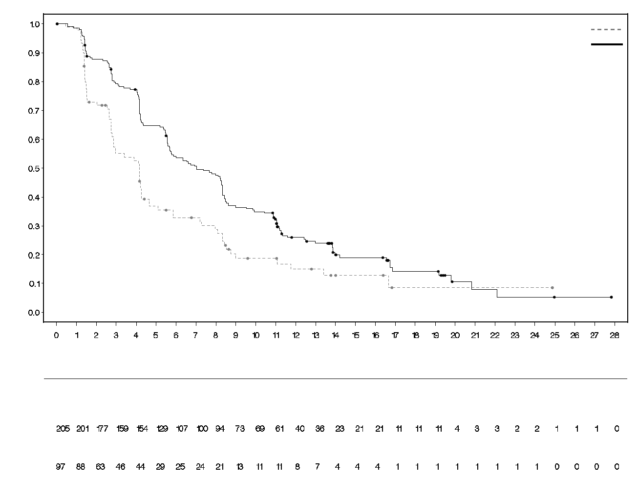
Chemotherapy

Number of patients at risk
Olaparib 300 mg twice daily tablet

Time from randomisation (months)

Chemotherapy (N = 97)
Olaparib 300 mg twice daily (N = 205)

Probability of progression free survival

Consistent results were observed in all predefined patient subgroups (see Figure 12). Subgroup analysis indicated PFS benefit of olaparib versus comparator in TNBC (HR 0.43; 95% CI: 0.29-0.63, n=152) and HR+ (HR 0.82; 95% CI: 0.55-1.26, n=150) patient subgroups.

Figure 12 PFS (BICR), Forest plot, by prespecified subgroup

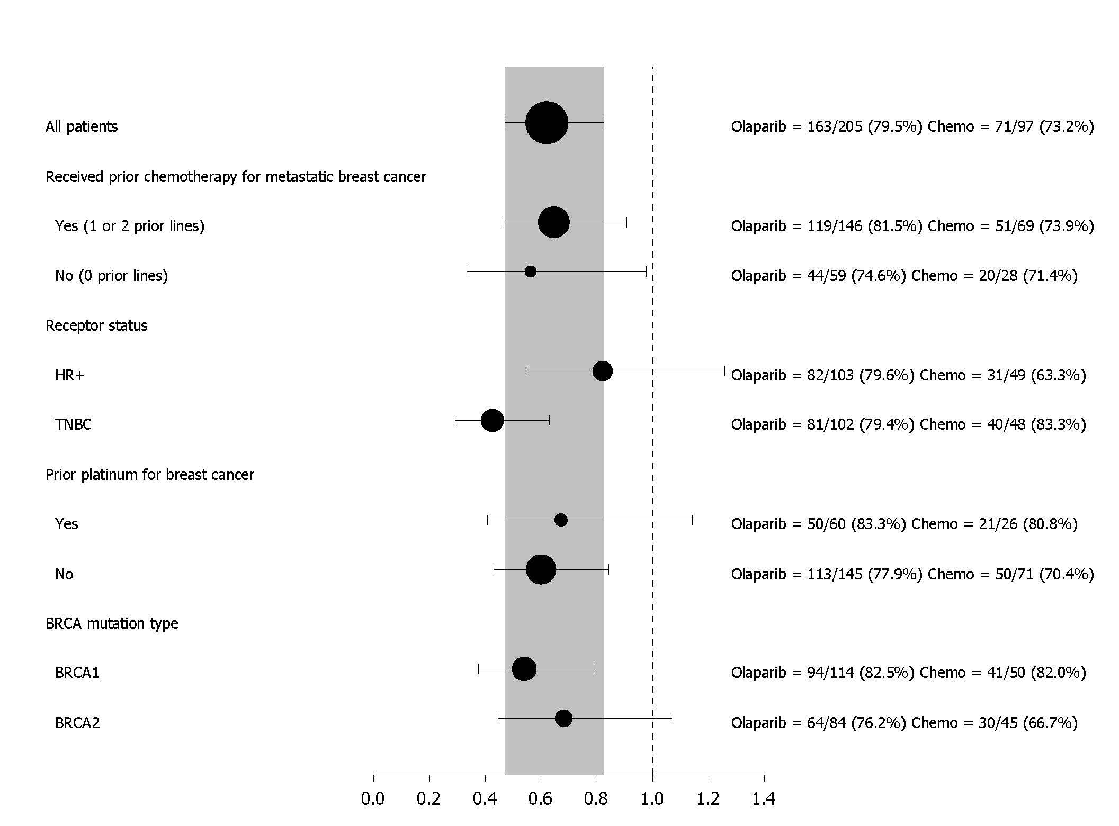

In a post-hoc analysis of the subgroup of patients that had not progressed on chemotherapy other than platinum, the median PFS in the olaparib arm (n=22) was 8.3 months (95% CI 3.1-16.7) and 2.8 months (95% CI 1.4-4.2) in the chemotherapy arm (n=16) with a HR of 0.54 (95% CI 0.24-1.23). However, the number of patients is too limited to make meaningful conclusions on the efficacy in this subgroup.

Seven male patients were randomised (5 olaparib and 2 comparator). At the time of the PFS analysis, 1 patient had a confirmed partial response with a duration of response of 9.7 months in the olaparib arm. There were no confirmed responses in the comparator arm.

Figure 13 OlympiAD: Kaplan-Meier plot of OS in patients with gBRCA1/2-mutated HER2-negative metastatic breast cancer (64% maturity) DCO 25 September 2017

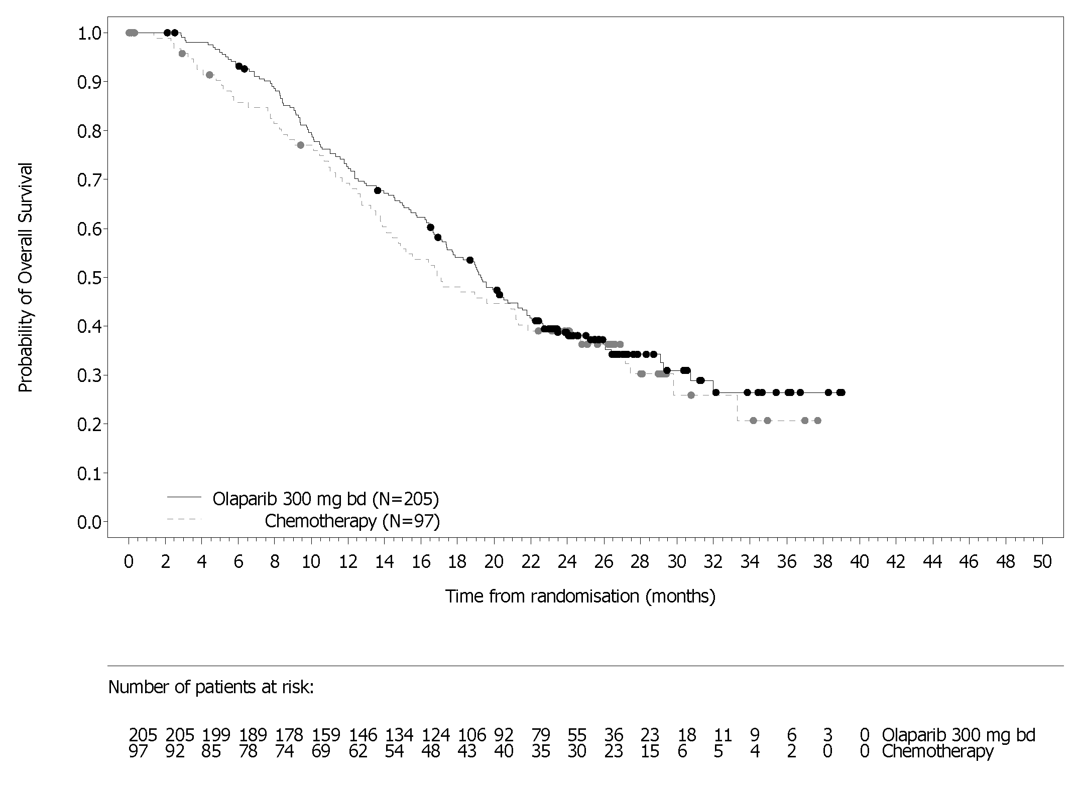OS analysis in patients with no prior chemotherapy for metastatic breast cancer indicated benefit in these patients with a HR of 0.45 (95% CI 0.27-0.77), while for further lines of therapy HR exceeded 1.

Maintenance following first-line treatment of germline BRCA-mutated metastatic adenocarcinoma of the pancreas:
POLO Study

The safety and efficacy of olaparib as maintenance therapy were studied in a randomised (3:2), double-blind, placebo-controlled, multicentre trial in 154 patients with germline BRCA1/2 mutations who had metastatic adenocarcinoma of the pancreas. Patients received either Lynparza 300 mg (2 x 150 mg tablets) twice daily (n=92) or placebo (n=62) until radiological disease progression or unacceptable toxicity. Patients should have not progressed during first-line platinum-based chemotherapy and should have received a minimum of 16 weeks of continuous platinum treatment, which could be discontinued at any time thereafter for unacceptable toxicity while the remaining agents continued according to the planned regimen or unacceptable toxicity for other component(s). Patients who could tolerate complete platinum-containing chemotherapy regimen until progression have not been considered for this study. The maintenance therapy was started 4 to 8 weeks after the last dose of first-line chemotherapy component(s) in the absence of progression and if all toxicities from previous anti-cancer therapy had been resolved to CTCAE grade 1, except for alopecia, grade 3 peripheral neuropathy and Hgb ≥9 g/dL.

Thirty-one percent (31%) of patients with germline BRCA1/2 mutations were identified from prior local testing results and 69% of patients by central testing. In the olaparib arm, 32% of patients carried a germline BRCA1 mutation, 64% a germline BRCA2 mutation and 1% carried both germline BRCA1 and germline BRCA2 mutations. In the placebo arm, 26% of patients carried a germline BRCA1 mutation, 73% a germline BRCA2 mutation and no patients carried both germline BRCA1 and germline BRCA2 mutations. The BRCAm status of all patients identified using prior local testing results was confirmed, where sent, by central testing. Ninety-eight percent (98%) of patients carried a deleterious mutation and 2% carried a suspected deleterious mutation. Large rearrangements in the BRCA1/2 genes were detected in 5.2 % (8/154) of the randomised patients.

Demographic and baseline characteristics were generally well balanced between the olaparib and placebo arms. Median age was 57 years in both arms; 30% of patients in the olaparib arm were ≥65 years compared to 20% in the placebo arm. Fifty-eight per-cent (58%) of patients in the olaparib arm and 50% of patients in the placebo arm were male. In the olaparib arm 89% of patients were White and 11% were non-White; in the placebo arm 95% of patients were White and 5% were non-White. Most patients were ECOG performance status 0 (71% in the olaparib arm and 61% in the placebo arm). Overall, the sites of metastasis prior to chemotherapy were liver 72%, lung 10% and other sites 50%. The median time from original diagnosis to randomisation across both arms was 6.9 months (range 3.6 to 38.4 months).

Overall, 75% of patients received FOLFIRINOX with a median of 9 cycles (range 4-61), 8% received FOLFOX or XELOX, 4% received GEMOX, and 3% received gemcitabine plus cisplatin; the remaining 10% of patients received other chemotherapy regimens. Duration of the first-line chemotherapy for metastatic disease was 4 to 6 months, >6 to <12 months and ≥12 months, respectively, in 77%, 19% and 4% of patients in the olaparib arm and in 80%, 17% and 3% in the placebo arm, with around 1 month from the last dose of the first-line chemotherapy component(s) to the start of study treatment in both arms. As best response on first-line chemotherapy, 7% of olaparib patients and 5% of placebo patients had a complete response, 44% of olaparib patients and 44% of placebo patients had a partial response and 49% of olaparib and 50% of placebo patients had stable disease. At randomisation, measurable disease was reported in 85% and 84% of patients in the olaparib or placebo arms, respectively. The median time from initiation of the first-line platinum-based chemotherapy to randomisation was 5.7 months (range 3.4 to 33.4 months).

At the time of PFS analysis, 33% of patients in the olaparib arm and 13% on the placebo arm remained on study treatment. Forty-nine percent of patients (49%) in the olaparib arm and 74% in the placebo arm received subsequent therapy. Forty-two percent (42%) of patients in the olaparib arm and 55% in the placebo arm received platinum as subsequent therapy. One percent (1%) of patients in the olaparib arm and 15% in the placebo arm received PARP inhibitor as subsequent therapy. Of the 33 (36%) and 28 (45%) of patients who received a first subsequent platinum-containing therapy, in the olaparib and placebo arms, stable disease was reported in 8 vs 6 patients, whereas 1 vs 2 patients had responses, respectively.

The primary endpoint was progression-free survival (PFS), defined as time from randomisation to progression determined by BICR using Response Evaluation Criteria in Solid Tumors (RECIST) 1.1 modified to assess patients with no evidence of disease, or death. Secondary efficacy endpoints included overall survival (OS), time from randomisation to second progression or death (PFS2), time from randomisation to first subsequent anti-cancer therapy or death (TFST), objective response rate (ORR), duration of response (DoR), response rate, time to response and health related quality of life (HRQoL).
The study demonstrated a statistically significant improvement in PFS for olaparib compared to placebo (Table 14). The BICR assessment of PFS was consistent with an investigator assessment.
At final analysis of OS, the percentage of patients that were alive and in follow-up was 28% in the olaparib arm and 18% in the placebo arm.

Table 14 Efficacy results for patients with gBRCAm metastatic adenocarcinoma of the pancreas in POLO
 |  | Olaparib 300 mg bd | Placebo
PFS (68% maturity)^{a,b} (BICR, DCO 15 January 2019)
Number of events: Total number of patients (%) |  | 60:92 (65) | 44:62 (71)
Median time, months (95% CI) |  | 7.4 (4.14-11.01) | 3.8 (3.52-4.86)
HR (95% CI)^{c,d} |  | 0.53 (0.35-0.82)
P value (2-sided) |  | p=0.0038
OS (70% maturity)^{e} (DCO 21 July 2020)
Number of events: Total number of patients (%) |  | 61:92 (66) |  | 47:62 (76)
Median time (months) (95% CI) |  | 19.0 (15.28-26.32) |  | 19.2 (14.32-26.12)
HR (95% CI)^{d} | 0.83 (0.56-1.22)
P value (2-sided) | p=0.3487
ª Based on Kaplan–Meier estimates, the proportion of patients that were alive and progression-free at 12 and 24 months were 34% and 22% for olaparib vs 15% and 10% for placebo.
^{b} For PFS, the median follow-up time for censored patients was 9.1 months in the olaparib arm and 3.8 months in the placebo arm.
^{c} A value <1 favours olaparib.
^{d} The analysis was performed using a log-rank test.
^{e} For OS, the median follow-up time for censored patients was 31.3 months in the olaparib arm and 23.9 months in the placebo arm.
bd Twice daily; CI Confidence interval; HR Hazard Ratio; OS Overall Survival; PFS Progression-free survival.

Figure 14 POLO: Kaplan-Meier plot of PFS for patients with gBRCAm metastatic adenocarcinoma of the pancreas (68% maturity – BICR, DCO 15 January 2019)
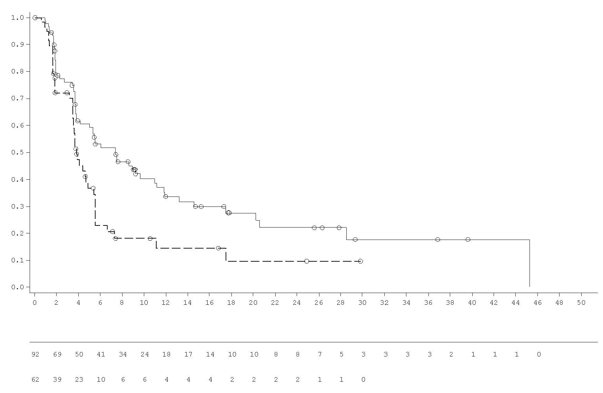
Number of patients at risk:
Olaparib 300 mg twice daily tablet
Time from randomisation (months)
Placebo twice daily tablet
Probability of progression-free survival
___ Olaparib 300 mg twice daily tablet
_ _ _ Placebo twice daily tablet

Figure 15 POLO: Kaplan-Meier plot of OS for patients with gBRCAm metastatic adenocarcinoma of the pancreas (70% maturity, DCO 21 July 2020)
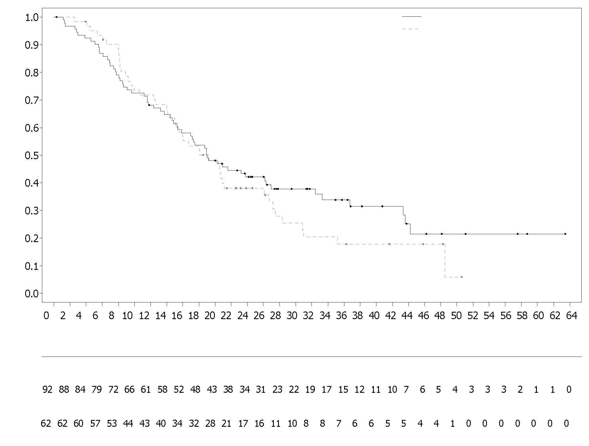
Placebo bid
Olaparib 300 mg bid

Number of patients at risk
Time from randomisation (months)
Olaparib 300 mg bid (N=92)
Placebo bid (N=62)
Probability of overall survival
BRCA1/2-mutated metastatic castration-resistant prostate cancer:
PROfound Study

The safety and efficacy of olaparib were studied in men with metastatic castration-resistant prostate cancer (mCRPC) in a Phase III randomised, open-label, multicentre trial that evaluated the efficacy of Lynparza versus a comparator arm of investigator’s choice of NHA ([new hormonal agent] enzalutamide or abiraterone acetate).

Patients needed to have progressed on prior NHA for the treatment of metastatic prostate cancer and/or CRPC. For inclusion in Cohort A, patients needed to have deleterious or suspected deleterious mutations in either BRCA1 or BRCA2 genes. Patients with ATM mutations were also randomised in Cohort A, but positive benefit-risk could not be demonstrated in this subpopulation of patients. Patients with mutations in other genes were randomised in Cohort B.

In this study 387 patients were randomised 2:1 to receive either olaparib (300 mg [2 x 150 mg tablets] twice daily) or comparator. In Cohort A there were 245 patients (162 olaparib and 83 comparator) and in Cohort B there were 142 patients (94 olaparib and 48 comparator). Patients were stratified by prior taxane use and evidence of measurable disease. Treatment was continued until disease progression. Patients randomised to comparator were given the option to switch to olaparib upon confirmed radiological BICR progression. Patients with BRCA1m, BRCA2m detected in their tumours were enrolled on the basis of prospective central testing, with the exception of 3 patients enrolled using a local test result. Of the 160 patients with a BRCA1 or BRCA2 mutation in PROfound, 114 patients were retrospectively tested to determine if the identified BRCA1/2 mutation was germline or somatic in origin. Within these patients, 63 BRCA1/2 mutations were identified in the germline blood sample and hence were determined to be germline in origin. The remaining 51 patients did not have a tumour detected BRCA1/2 mutation identified in the germline blood sample and hence the BRCA1/2 mutations are determined to be somatic in origin. For the remaining 46 patients, somatic or germline origin is unknown.

Demographics and baseline characteristics were generally well balanced between the olaparib and comparator arms in patients with BRCA1/2 mutations. Median age was 68 years and 67 years in the olaparib and comparator arms, respectively. Prior therapy in the olaparib arm was 71% taxane, 41% enzalutamide, 37% abiraterone acetate and 20% both enzalutamide and abiraterone acetate. Prior therapy in the comparator arm was 60% taxane, 50% enzalutamide, 36% abiraterone acetate and 14% both enzalutamide and abiraterone acetate. Fifty-eight percent (58%) of patients in the olaparib arm and 55% in the comparator arm had measurable disease at study entry. The proportion of patients with bone, lymph node, respiratory and liver metastases was 89%, 62%, 23% and 12%, respectively in the olaparib arm and 86%, 71%, 16% and 17%, respectively in the comparator arm. Most patients in both treatment arms had an ECOG of 0 or 1 (93%). Baseline pain scores (BPI-SF worst pain) were 0-<2 (52%), 2-3 (10%) or >3 (34%) in the olaparib arm and 0-<2 (45%), 2-3 (7%) or >3 (45%) in the comparator arm. Median baseline PSA was 57.48 µg/L in the olaparib arm and 103.95 µg/L in the comparator.
The primary endpoint of the study was radiological progression free survival (rPFS) in Cohort A determined by BICR using RECIST 1.1 (soft tissue) and Prostate Cancer Working Group (PCWG3) (bone). Key secondary endpoints included confirmed objective response rate (ORR) by BICR, rPFS by BICR, time to pain progression (TTPP) and overall survival (OS).
The study demonstrated a statistically significant improvement in BICR assessed rPFS and final OS for olaparib vs comparator in Cohort A.
Results for patients with BRCA1/2 mutations are presented in Table 15. There was a statistically significant improvement in BICR assessed rPFS for olaparib vs the investigators choice of NHA arm in BRCA1/2m patients. The final analysis of OS showed a nominally statistically significant improvement in OS in BRCA1/2m patients randomised to Lynparza vs comparator.
Table 15 Summary of key efficacy findings in patients with BRCA1/2-mutated mCRPC in PROfound
 | Olaparib 300 mg bd  (N=102) | Investigators choice of NHA  (N=58)
rPFS by BICR^{a,b,c} DCO 4 June 2019
Number of events: Total number of patients (%) | 62:102 (61)^{c} | 51:58 (88) ^{c}
Median rPFS (95% CI) [months] | 9.8 (7.6, 11.3) | 3.0 (1.8, 3.6)
HR (95% CI)^{c} | 0.22 (0.15, 0.32)
Confirmed ORR by BICRª
Number of objective responders: Total number of patients with measurable disease at baseline (%) | 25:57 (44) | 0:33 (0)
Odds ratio (95% CI) | NC (NC, NC)
OSª DCO 20 March 2020 ^{c}
Number of events: Total number of patients (%) | 53:102 (52) | 41:58 (71)
Median OS (95% CI) [months] | 20.1 (17.4, 26.8) | 14.4 (10.7, 18.9)
HR (95% CI) | 0.63 (0.42, 0.95)
ª Not controlled for multiplicity
^{b} rPFS 71% maturity
^{c} The HR and CI were calculated using a Cox proportional hazards model that contains terms for treatment, factor and treatment by factor interaction.
bd Twice daily; BICR Blinded independent central review; CI Confidence interval; HR Hazard ratio; NC Not calculable; NHA New hormonal agent; ORR Objective response rate; OS Overall survival; rPFS Radiological progression-free survival

Figure 16 BRCA1/2m patients: Kaplan-Meier plot of rPFS (by BICR)
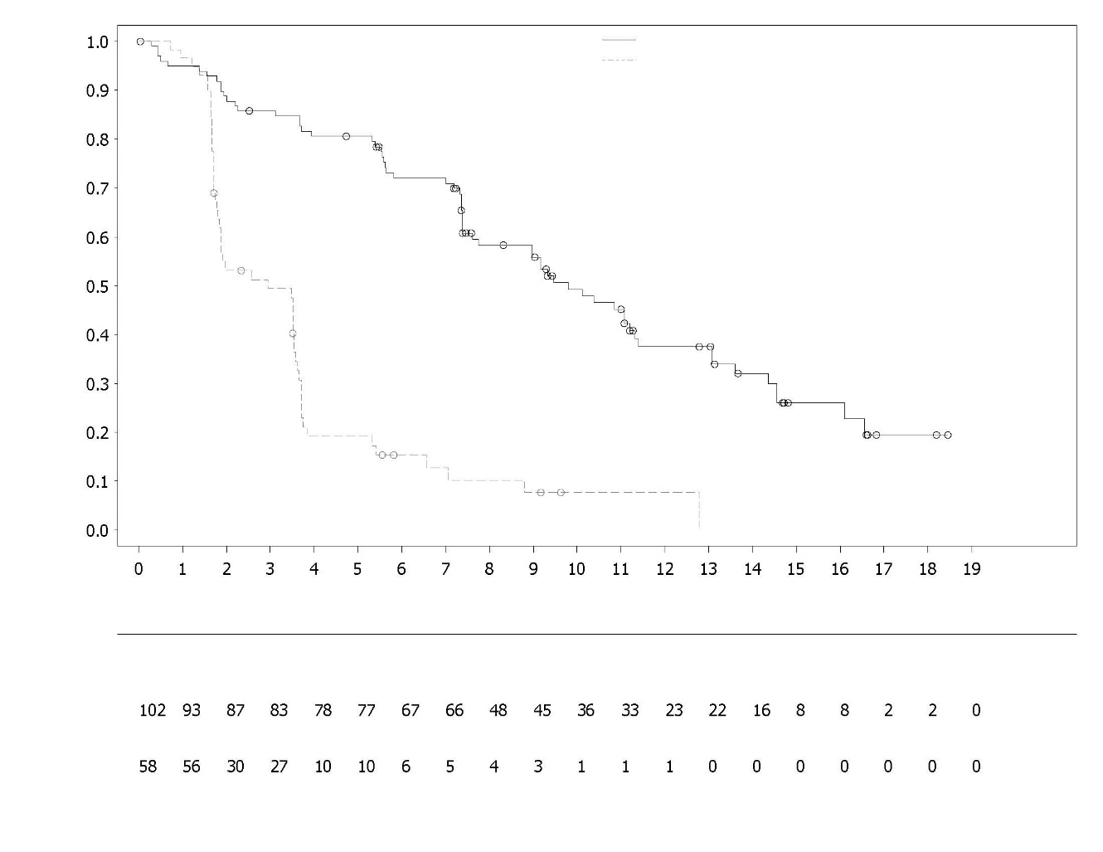
Probability of radiological progression free survival
Investigators choice of NHA
Investigators choice of NHA
Olaparib 300 mg bd
Time from randomisation (months)
Number of patients at risk:
Olaparib 300 mg bd

Figure 17 BRCA1/2m patients: Kaplan-Meier plot of OS
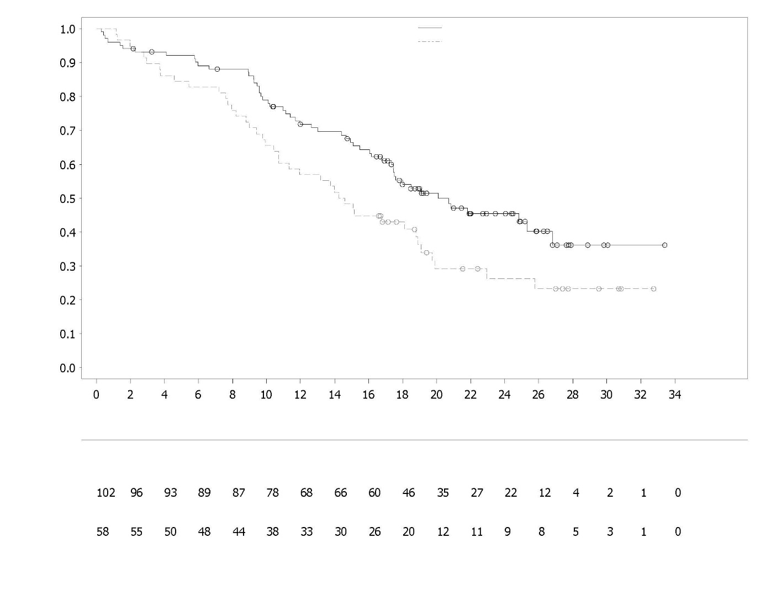
Investigators choice of NHA
Olaparib 300 mg bd
Number of patients at risk:
Investigators choice of NHA
Olaparib 300 mg bd
Probability of overall survival

Time from randomisation (months)

Treatment of patients in the first-line mCRPC setting
PROpel
The safety and efficacy of olaparib were studied in men with metastatic castration-resistant prostate cancer (mCRPC) in a Phase III randomised, double-blind, placebo-controlled, multicentre study that evaluated the efficacy of Lynparza (300 mg [2 x 150 mg tablets] twice daily) in combination with abiraterone (1000 mg [2 x 500 mg tablets] once daily) versus a comparator arm of placebo plus abiraterone. Patients in both arms also received either prednisone or prednisolone 5 mg twice daily.

The study randomised 796 patients (1:1 randomisation; 399 olaparib/abiraterone:397 placebo/ abiraterone) who had evidence of histologically confirmed prostate adenocarcinoma and metastatic status defined as at least one documented metastatic lesion on either a bone or CT/MRI scan and who were treatment naïve with no prior chemotherapy or NHA in the mCRPC setting. Prior to the mCRPC stage, treatment with NHAs (except abiraterone) without PSA progression (clinical or radiological) during treatment was allowed, provided the treatment was stopped at least 12 months before randomisation. Treatment with first-generation antiandrogen agents (e.g., bicalutamide, nilutamide, flutamide) was also allowed, provided there was a washout period of 4 weeks. Docetaxel treatment was allowed during neoadjuvant/adjuvant treatment for localised prostate cancer and at metastatic hormone-sensitive prostate cancer (mHSPC) stage, as long as no signs of disease progression occurred during or immediately after such treatment. All patients received a GnRH analogue or had prior bilateral orchiectomy. Patients were stratified by metastases (bone only, visceral or other) and docetaxel treatment at mHSPC stage (yes or no). Treatment was continued until radiological progression of the underlying disease or unacceptable toxicity.

Demographic and baseline characteristics were balanced between the two treatment arms. The median age of patients was 69 years overall, and the majority (71%) of patients were in the ≥65 years age group. One hundred and eighty-nine patients (24%) had prior docetaxel treatment at mHSPC stage. In total, 434 (55%) patients had bone metastases (metastases in the bone and no other distant site), 105 (13%) patients had visceral metastases (distant soft tissue metastases in an organ e.g., liver, lung) and 257 (32%) patients had other metastases (this could include, for example, patients with bone metastases and distant lymph nodes or patients with disease present only in distant lymph nodes). Most patients in both arms (70%) had an ECOG performance status of 0. There were 103 (25.8%) symptomatic patients in the olaparib group and 80 (20.2%) patients in the placebo group. Symptomatic patients were characterized by Brief Pain Inventory-Short Form (BPI-SF) item #3 score ≥ 4 and/or opiate use at baseline.

Patient enrolment was not based on biomarker status. HRR gene mutation status was assessed retrospectively by ctDNA and tumour tissue tests to assess the consistency of treatment effect from the FAS population. Of the patients tested, 198 and 118 were HRRm as determined by ctDNA and tumour tissue, respectively. The distribution of HRRm patients was well balanced between the two arms.

The primary endpoint was rPFS, defined as time from randomisation to radiological progression determined by investigator assessment based on RECIST 1.1 and PCWG-3 criteria (bone). The key secondary efficacy endpoint was overall survival (OS). Additional secondary endpoints included PFS2, TFST and HRQoL.

The study met its primary endpoint demonstrating a statistically significant improvement in the risk of radiological disease progression or death for olaparib/abiraterone compared to placebo/abiraterone as assessed by the investigator, with HR 0.66; 95% CI 0.54, 0.81; p<0.0001; median rPFS 24.8 months in the olaparib/abiraterone arm vs 16.6 months in the placebo/abiraterone arm. The investigator assessment of rPFS was supported with a blinded independent central radiological (BICR) review. The sensitivity analysis of rPFS by BICR was consistent with the investigator-based analysis with HR 0.61; 95% CI 0.49, 0.74; p<0.0001; median rPFS 27.6 months in the olaparib/abiraterone arm vs 16.4 months in the placebo/abiraterone arm, respectively.

Subgroup results were consistent with the overall results for olaparib/abiraterone compared to placebo/abiraterone in all pre-defined sub-groups, including patients with or without prior taxane at mHSPC stage, patients with different metastatic disease at baseline (bone only vs visceral vs other) and patients with or without HRRm (Figure 20).

Efficacy results are presented in Table 16, Table 17, Figure 18 and Figure 19.

Table 16 Summary of key efficacy findings for treatment of patients with mCRPC in PROpel
 | Olaparib/abiraterone  N = 399 | Placebo/abiraterone  N = 397
rPFS (by investigator assessment) (50% maturity) (DCO 30 July 2021)
Number of events: Total number of patients (%) | 168:399 (42.1) | 226:397 (56.9)
Median time (95% CI) (months) | 24.8 (20.5, 27.6) | 16.6 (13.9, 19.2)
HR (95% CI)ª | 0.66 (0.54, 0.81)
p-value^{b} | <0.0001
Final OS (48% maturity) (DCO 12 October 2022)
Number of events: Total number of patients (%) | 176:399 (44.1) | 205:397 (51.6)
Median time (95% CI) (months) | 42.1 (38.4, NC) | 34.7 (31.0, 39.3)
HR (95% CI)ª | 0.81 (0.67, 1.00)
p-value^{b} | p=0.0544
% Alive at 36 months (95% CI) ^{c} | 56.9 (51.7, 61.7) | 49.5 (44.3, 54.5)
ª The HR and CI were calculated using a Cox proportional hazards model adjusted for the variables selected in the primary pooling strategy: metastases, docetaxel treatment at mHSPC stage. The Efron approach was used for handling ties. A HR <1 favours olaparib 300 mg bd + abiraterone 1000 mg qd.
^{b} The 2-sided p-value was calculated using the log-rank test stratified by the same variables selected in the primary pooling strategy.
^{c} Calculated using the Kaplan-Meier technique.

Table 17 rPFS subgroup analyses by investigator assessment in PROpel (DCO 30 July 2021)
 | Olaparib/abiraterone | Placebo/abiraterone
Radiological Progression-Free Survival (rPFS) by investigator assessment
Aggregate HRRm Subgroup Analyses ª
HRRm | N=111 | N=115
Number of events: Total number of patients (%) | 43:111 (38.7) | 73:115 (63.5)
Median (months) | NC | 13.86
Hazard ratio (95% CI) ^{b} | 0.50 (0.34, 0.73)
Non-HRRm | N=279 | N=273
Number of events: Total number of patients (%) | 119:279 (42.7) | 149:273 (54.6)
Median (months) | 24.11 | 18.96
Hazard ratio (95% CI) ^{b} | 0.76 (0.60, 0.97)
Aggregate BRCAm Subgroup Analyses ª
BRCAm | N=47 | N=38
Number of events: Total number of patients (%) | 14:47 (29.8) | 28:38 (73.7)
Median (months) | NC | 8.38
Hazard ratio (95% CI) ^{b} | 0.23 (0.12, 0.43)
Non-BRCAm | N=343 | N=350
Number of events: Total number of patients (%) | 148:343 (43.1) | 194:350 (55.4)
Median (months) | 24.11 | 18.96
Hazard ratio (95% CI) ^{b} | 0.76 (0.61, 0.94)
ª Aggregate subgroups were derived from ctDNA and tissue-based groupings.
^{b} The analysis was performed using a Cox proportional hazards model including terms for treatment group, the subgroup factor, and a treatment by subgroup interaction. Confidence interval calculated using the profile likelihood method. An HR < 1 favors olaparib 300 mg bd.

Figure 18 PROpel: Kaplan-Meier plot of rPFS (investigator assessed) (50% maturity) DCO 30 July 2021
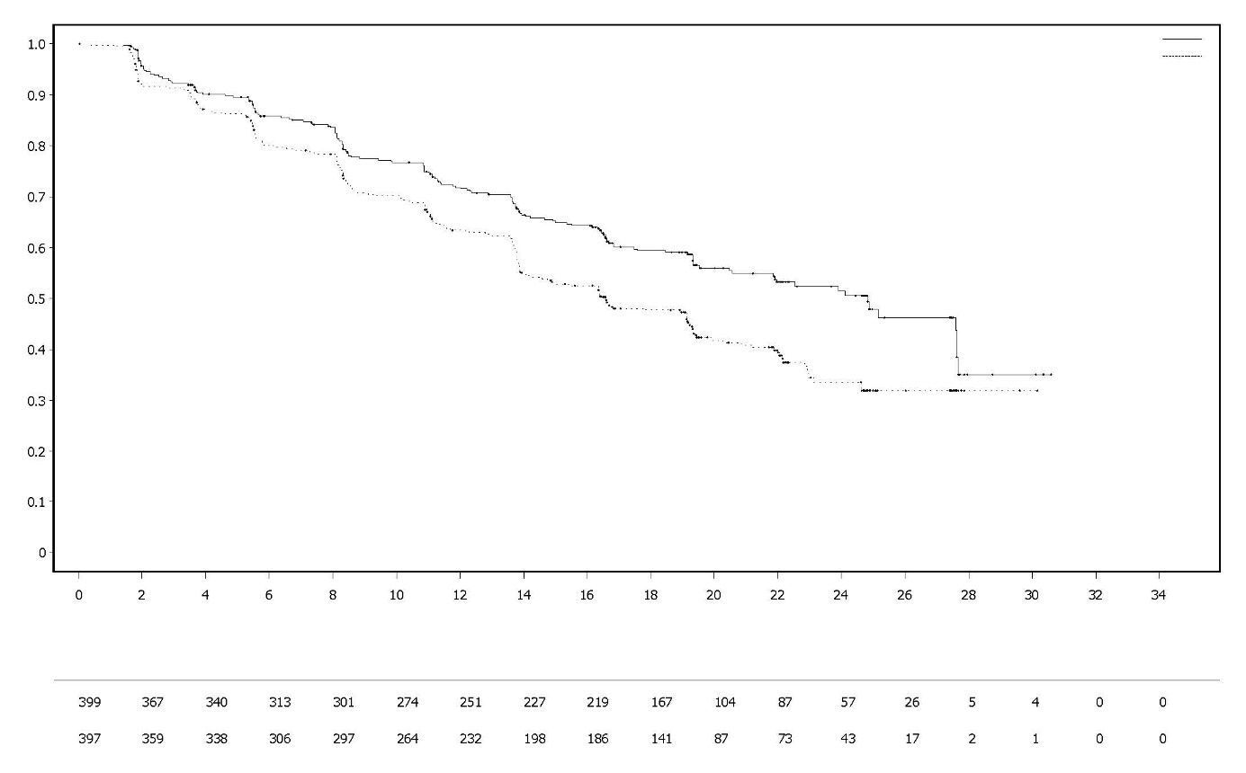
Olaparib 300 mg bd + Abiraterone 1000 mg qd
Time from randomisation (Months)
Probability of Radiographic Progression-free Survival
Olaparib 300 mg bd + Abiraterone 1000 mg qd (N=399)
Placebo bd + Abiraterone 1000 mg qd (N=397)
Number of patients at risk:
Placebo bd + Abiraterone 1000 mg qd
Figure 19 PROpel: Kaplan-Meier plot of OS (48% maturity) DCO 12 October 2022
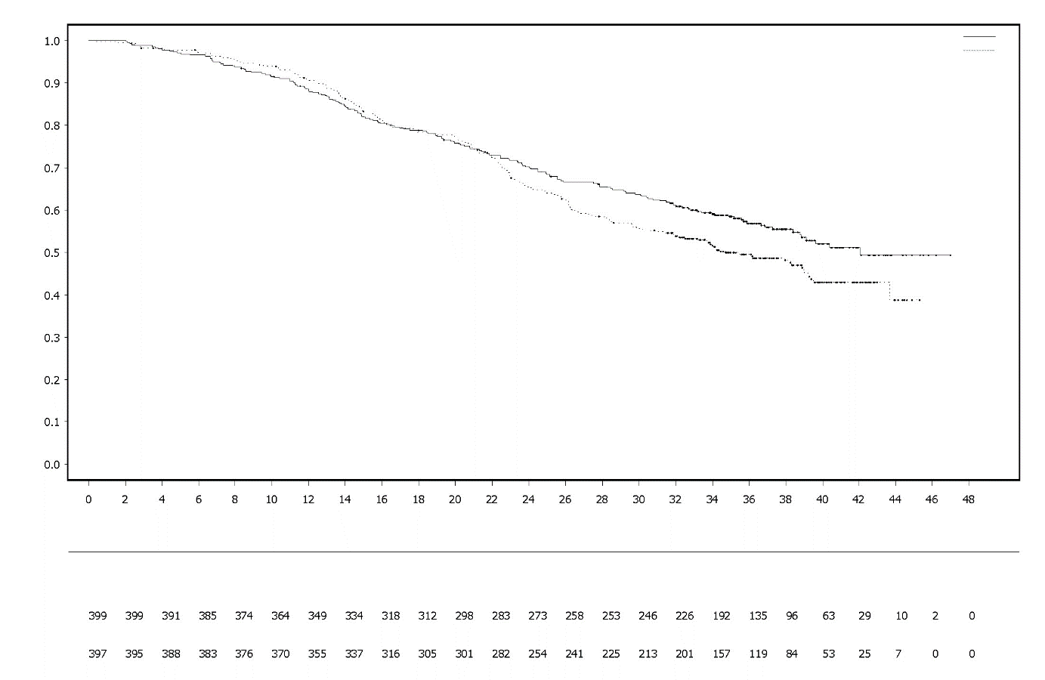

Time from randomisation (Months)
Probability of Overall Survival
Number of patients at risk:
Olaparib 300 mg bd + Abiraterone 1000 mg qd
Placebo bd + Abiraterone 1000 mg qd
Olaparib 300 mg bd + Abiraterone 1000 mg qd (N=399)
Placebo bd + Abiraterone 1000 mg qd (N=397)

Figure 20 PROpel: Forest plot of subgroup analysis of rPFS (investigator assessed) (50% maturity) DCO 30 July 2021
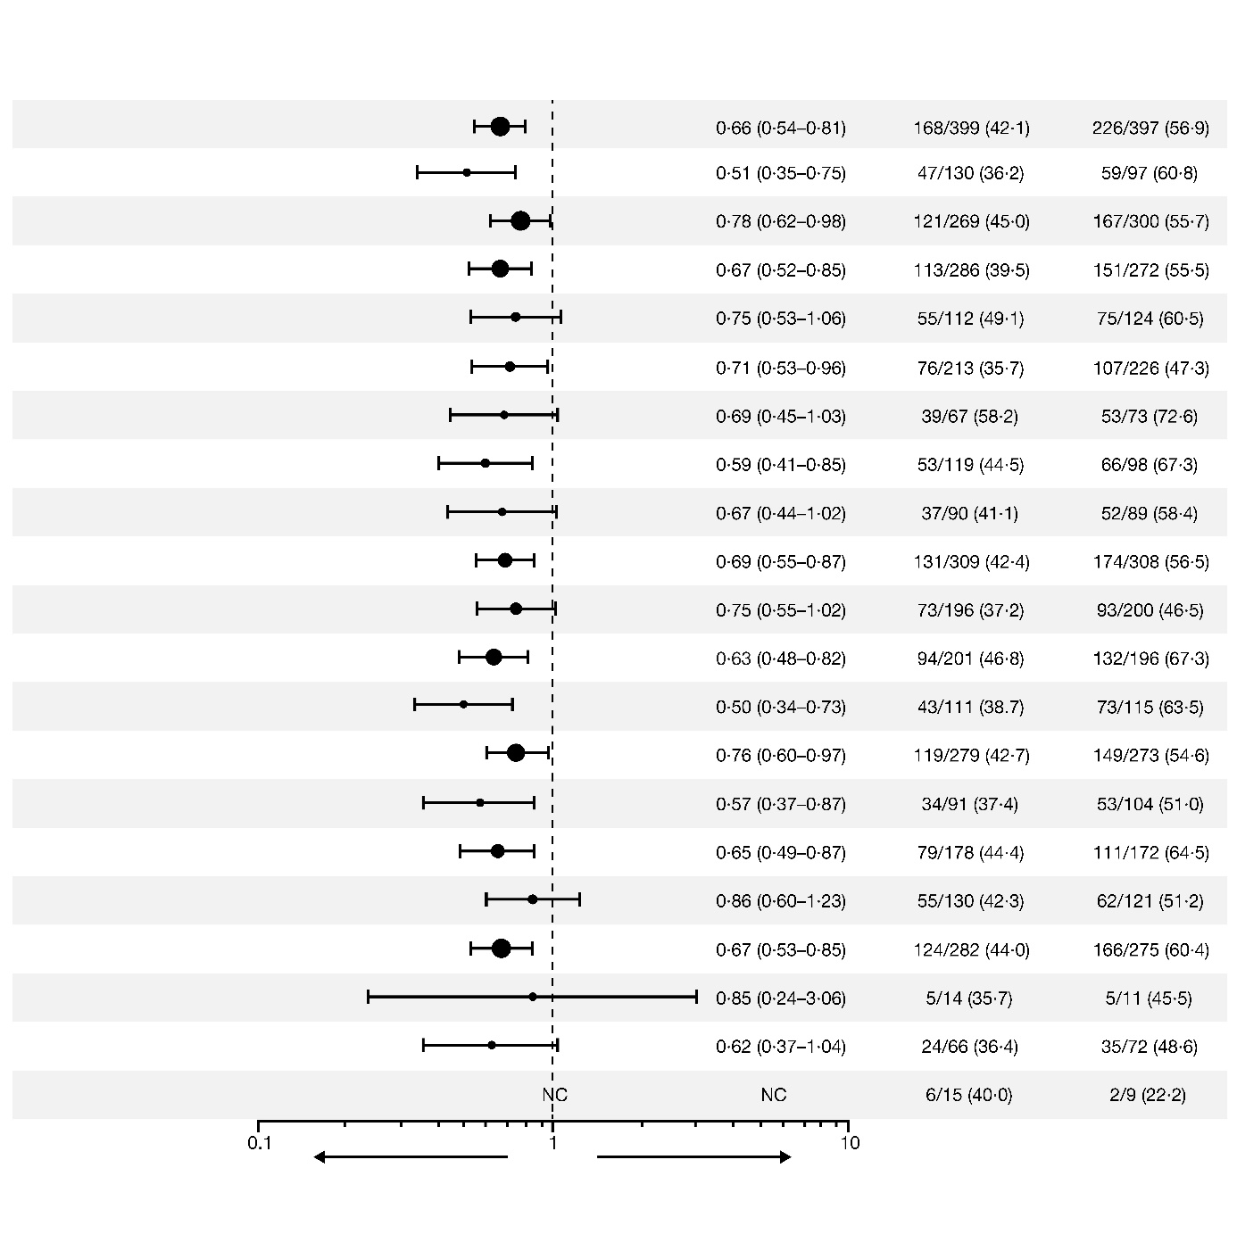Each subgroup analysis was performed using a Cox proportional hazards model that contained a term for treatment, factor, and treatment by factor interaction. A hazard ratio < 1 implies a lower risk of progression on olaparib. The size of a circle is proportional to the number of events. All subgroups in this figure are based upon data from the eCRF.
*Excludes patients with no baseline assessment. CI: confidence interval, ECOG: Eastern Cooperative Oncology Group; HRRm: homologous recombination repair gene mutation; mHSPC: metastatic hormone-sensitive prostate cancer; NC: noncalculable; PSA: prostate-specific antigen.
Abiraterone + Olaparib Better
Abiraterone + Placebo Better
10
1
0.1

NC

ECOG performance status at baseline = 1*
ECOG performance status at baseline = 0*
No docetaxel treatment at mHSPC stage
Hazard Ratio for
Progression or Death
(95% CI)
Number of events / Number of patients (%)
Abiraterone
+ Olaparib
Abiraterone
+ Placebo
Abiraterone + Olaparib Better
Abiraterone + Placebo Better
Baseline PSA: Above or equal to median
baseline PSA*
Baseline PSA: Below median
baseline PSA*
All patients
Age at random assignment: <65yr
Age at random assignment: ≥65yr
Metastasis: Bone only
Metastasis: Visceral
Metastasis: Other
Docetaxel treatment at mHSPC stage
HRRm status (aggregate): HRRm
HRRm status (aggregate): non-HRRm
Asia region
Europe region
Black/African American race
North and South America region
White race
Other race
Asian race

First-line maintenance treatment of mismatch repair proficient (pMMR) advanced or recurrent endometrial cancer

DUO-E Study

DUO-E was a randomised, multicentre, double-blind, placebo-controlled, Phase III study of first-line platinum-based chemotherapy in combination with durvalumab, followed by durvalumab with or without olaparib in patients with advanced or recurrent endometrial cancer. Patients had to have endometrial cancer in one of the following categories: newly diagnosed Stage III disease (measurable disease per RECIST 1.1 following surgery or diagnostic biopsy), newly diagnosed Stage IV disease (with or without disease following surgery or diagnostic biopsy), or recurrence of disease (measurable or non-measurable disease per RECIST 1.1) where the potential for cure by surgery alone or in combination is poor. For patients with recurrent disease, prior chemotherapy was allowed only if it was administered in the adjuvant setting and there was at least 12 months from the date of last dose of chemotherapy administered to the date of subsequent relapse. The study included patients with epithelial endometrial carcinomas of all histologies, including carcinosarcomas. Patients with endometrial sarcoma were excluded.

Randomisation was stratified by tumour tissue’s mismatch repair (MMR) status (proficient versus deficient), disease status (recurrent versus newly diagnosed), and geographic region (Asia versus rest of the world). Patients were randomised 1:1:1 to one of the following arms:

- Platinum-based chemotherapy: Platinum-based chemotherapy (paclitaxel and carboplatin) every 3 weeks for a maximum of 6 cycles with durvalumab placebo every 3 weeks. Following completion of chemotherapy treatment, patients without objective disease progression received durvalumab placebo every 4 weeks and olaparib placebo tablets twice daily as maintenance treatment until disease progression.
- Platinum-based chemotherapy + durvalumab: Platinum-based chemotherapy (paclitaxel and carboplatin) every 3 weeks for a maximum of 6 cycles with 1120 mg durvalumab every 3 weeks. Following completion of chemotherapy treatment, patients without objective disease progression received 1500 mg durvalumab every 4 weeks with olaparib placebo tablets twice daily as maintenance treatment until disease progression.
- Platinum-based chemotherapy + durvalumab + olaparib: Platinum-based chemotherapy (paclitaxel and carboplatin) every 3 weeks for a maximum of 6 cycles with 1120 mg durvalumab every 3 weeks. Following completion of chemotherapy treatment, patients without objective disease progression received 1500 mg durvalumab every 4 weeks with 300 mg olaparib tablets twice daily as maintenance treatment until disease progression.

Patients who discontinued either product (olaparib/placebo or durvalumab/placebo) for reasons other than disease progression could continue treatment with the other product if appropriate based on toxicity considerations and investigator discretion.

Treatment was continued until RECIST v1.1-defined progression of disease or unacceptable toxicity. Assessment of tumour status was performed every 9 weeks for the first 18 weeks relative to randomisation and every 12 weeks thereafter.

The primary endpoint was PFS, defined as time from randomisation to progression determined by investigator assessment using RECIST 1.1, or death. Secondary efficacy endpoints included OS, ORR and DoR.

The study demonstrated a statistically significant improvement in PFS in the ITT population for patients treated with platinum-based chemotherapy + durvalumab + olaparib compared to platinum-based chemotherapy alone (HR 0.55; 95% CI: 0.43, 0.69). At the time of PFS analysis, interim OS data were 28% mature with events in 199 of 718 patients.

Mismatch repair (MMR) status was determined centrally using an MMR immunohistochemistry panel assay. Of a total of 718 patients randomized in the study, 575 (80%) patients had MMR-proficient (pMMR) tumour status and 143 (20%) patients had MMR-deficient (dMMR) tumour status.

Among patients with pMMR tumour status, demographic and baseline characteristics were generally well balanced between the treatment arms. Baseline demographics across all three arms were as follows: median age of 64 years (range: 22 to 86); 48% age 65 or older; 8% age 75 or older; 56% White, 30% Asian, and 6% Black or African American. Disease characteristics were as follows: ECOG PS of 0 (69%) or 1 (31%); 47% newly diagnosed and 53% recurrent disease. The histologic subtypes were endometrioid (54%), serous (26%), carcinosarcoma (8%), mixed epithelial (4%), clear cell (3%), undifferentiated (2%), mucinous (<1%), and other (3%).

Results in patients with pMMR tumour status are summarised in Table 18 and Figure 21. The median follow-up time in censored patients with pMMR tumour status was 15.2 months in the platinum-based chemotherapy + durvalumab + olaparib arm and 12.8 months in the platinum-based chemotherapy arm. At the time of PFS analysis, interim OS data were 29% mature with events in 110 of 383 patients.

Table 18 Summary of efficacy results in patients with advanced or recurrent endometrial cancer in DUO-E (Patients with pMMR tumour status)

 | Platinum-based chemotherapy + durvalumab + olaparib  N=191 |  | Platinum-based chemotherapy  N=192
PFS (by investigator assessment) (DCO 12 April 2023)
Number of events: Total number of patients (%) | 108:191 (56.5) |  | 148:192 (77.1)
Medianª (95% CI), months | 15.0 (12.4, 18.0) |  | 9.7 (9.2, 10.1)
HR (95% CI) | 0.57 (0.44, 0.73)
OS^{b} (DCO 12 April 2023)
Number of events: Total number of patients (%) | 46:191 (24.1) |  | 64:192 (33.3)
Medianª (95% CI), months | NR (NR, NR) |  | 25.9 (25.1, NR)
HR (95% CI) | 0.69 (0.47, 1.00)
Objective response rate^{c} (DCO 12 April 2023)
Number of objective responders: Total number of  patients with measurable disease at baseline (%) | 90:147 (61.2) | 92:156 (59.0)
Duration of Response (DCO 12 April 2023)
Medianª (95% CI), months | 18.7 (10.5, NR) | 7.6 (7.1, 10.2)
ª Calculated using the Kaplan-Meier technique
^{b}Based on first interim analysis
^{c}Response: Best objective response as confirmed complete response or partial response.
CI Confidence interval; DCO Data cutoff; HR Hazard ratio; NR Not reached; OS Overall survival; PFS Progression-free survival

Figure 21 DUO-E: Kaplan-Meier plot of PFS (Patients with pMMR tumour status)
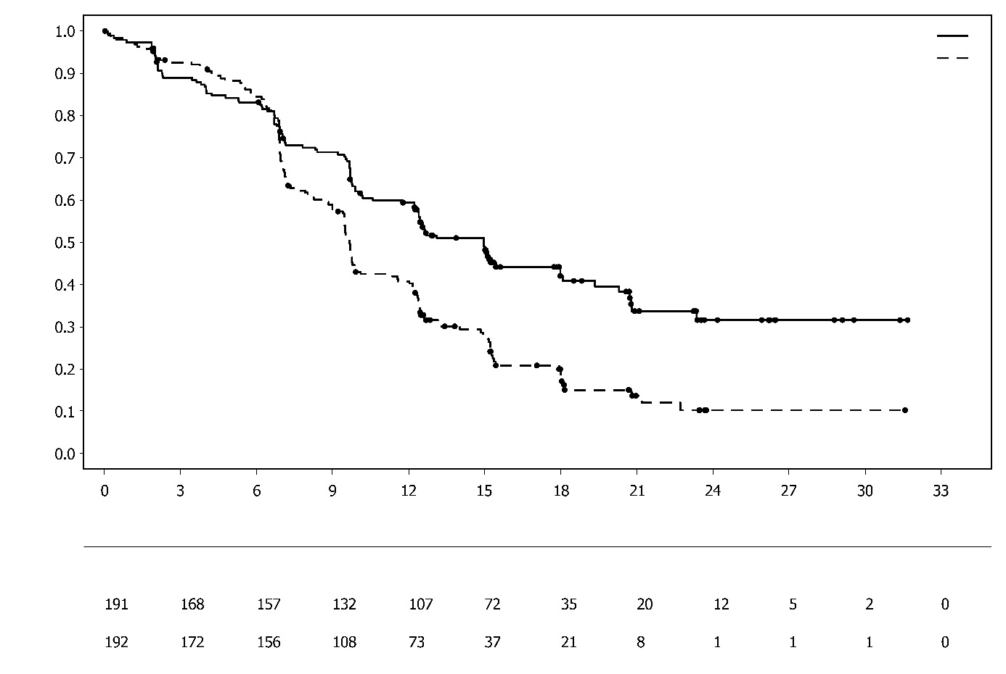
Platinum-based chemotherapy
• Platinum-based chemotherapy

Number of patients at risk:
Platinum-based chemotherapy + durvalumab + olaparib

Time from randomisation (months)
Proportion of patients event free
Platinum-based chemotherapy + durvalumab + olaparib
Platinum-based chemotherapy
Among patients with pMMR tumour status, the PFS HRs were 0.44 (95% CI: 0.31, 0.61) in patients with PD-L1 expression positive status (236/383; 62%) and 0.87 (95% CI: 0.59, 1.28) in patients with PD-L1 expression negative status (140/383; 37%), for the platinum-based chemotherapy + durvalumab + olaparib arm vs the platinum-based chemotherapy arm. PD-L1 expression positive was defined as tumour area positive (TAP) ≥ 1%.
Paediatric population
The European Medicines Agency has waived the obligation to submit the results of studies with Lynparza in all subsets of the paediatric population, in ovarian carcinoma (excluding rhabdomyosarcoma and germ cell tumours) (see section 4.2 for information on paediatric use).

5.2 Pharmacokinetic properties

The pharmacokinetics of olaparib at the 300 mg tablet dose are characterised by an apparent plasma clearance of ~7 L/h, an apparent volume of distribution of ~158 L and a terminal half-life of 15 hours. On multiple dosing, an AUC accumulation ratio of 1.8 was observed and PK appeared to be time-dependent to a small extent.

Absorption
Following oral administration of olaparib via the tablet formulation (2 x 150 mg), absorption is rapid with median peak plasma concentrations typically achieved 1.5 hours after dosing.

Co-administration with food slowed the rate (t_{max} delayed by 2.5 hours and C_{max} reduced by approximately 21%) but did not significantly affect the extent of absorption of olaparib (AUC increased 8%). Consequently, Lynparza may be taken without regard to food (see section 4.2).

Distribution
The in vitro plasma protein binding is approximately 82% at 10 µg/mL which is approximately C_{max}.

In vitro, human plasma protein binding of olaparib was dose-dependent; the fraction bound was approximately 91% at 1 µg/mL, reducing to 82% at 10 µg/mL and to 70% at 40 µg/mL. In solutions of purified proteins, the olaparib fraction bound to albumin was approximately 56%, which was independent of olaparib concentrations. Using the same assay, the fraction bound to alpha-1 acid glycoprotein was 29% at 10 µg/mL with a trend of decreased binding at higher concentrations.

Biotransformation
In vitro, CYP3A4/5 were shown to be the enzymes primarily responsible for the metabolism of olaparib (see section 4.5).

Following oral dosing of ¹⁴C-olaparib to female patients, unchanged olaparib accounted for the majority of the circulating radioactivity in plasma (70%) and was the major component found in both urine and faeces (15% and 6% of the dose, respectively). The metabolism of olaparib is extensive. The majority of the metabolism was attributable to oxidation reactions with a number of the components produced undergoing subsequent glucuronide or sulfate conjugation. Up to 20, 37 and 20 metabolites were detected in plasma, urine and faeces, respectively, the majority of them representing <1% of the dosed material. A ring-opened piperazin-3-ol moiety, and two mono-oxygenated metabolites (each ~10%) were the major circulating components, with one of the mono-oxygenated metabolites also being the major metabolite in the excreta (6% and 5% of the urinary and faecal radioactivity, respectively).

In vitro, olaparib produced little/no inhibition of UGT1A4, UGT1A9, UGT2B7, or CYPs 1A2, 2A6, 2B6, 2C8, 2C9, 2C19, 2D6 or 2E1 and is not expected to be a clinically significant time dependent inhibitor of any of these CYP enzymes. Olaparib inhibited UGT1A1 in vitro, however, PBPK simulations suggest this is not of clinical importance. In vitro, olaparib is a substrate of the efflux transporter P-gp, however, this is unlikely to be of clinical significance (see section 4.5).

In vitro, data also show that olaparib is not a substrate for OATP1B1, OATP1B3, OCT1, BCRP or MRP2 and is not an inhibitor of OATP1B3, OAT1 or MRP2.

Elimination
Following a single dose of ¹⁴C-olaparib, ~86% of the dosed radioactivity was recovered within a 7-day collection period, ~44% via the urine and ~42% via the faeces. Majority of the material was excreted as metabolites.

Special populations
In population based PK analyses, patient age, gender, bodyweight, tumour location or race (including White and Japanese patients) were not significant covariates.

Renal impairment
In patients with mild renal impairment (creatinine clearance 51 to 80 ml/min), AUC increased by 24% and C_{max} by 15% compared with patients with normal renal function. No Lynparza dose adjustment is required for patients with mild renal impairment.

In patients with moderate renal impairment (creatinine clearance 31 to 50 ml/min), AUC increased by 44% and C_{max} by 26% compared with patients with normal renal function. Lynparza dose adjustment is recommended for patients with moderate renal impairment (see section 4.2).

There are no data in patients with severe renal impairment or end-stage renal disease (creatinine clearance <30 ml/min).

Hepatic impairment
In patients with mild hepatic impairment (Child-Pugh classification A), AUC increased by 15% and C_{max} by 13% and in patients with moderate hepatic impairment (Child-Pugh classification B), AUC increased by 8% and C_{max} decreased by 13% compared with patients with normal hepatic function. No Lynparza dose adjustment is required for patients with mild or moderate hepatic impairment (see section 4.2). There are no data in patients with severe hepatic impairment (Child-Pugh classification C).

Paediatric population
No studies have been conducted to investigate the pharmacokinetics of olaparib in paediatric patients.

5.3 Preclinical safety data

Repeat-dose toxicity
In repeat-dose toxicity studies of up to 6 months duration in rats and dogs, daily oral doses of olaparib were well-tolerated. The major primary target organ for toxicity in both species was the bone marrow, with associated changes in peripheral haematology parameters. These changes were reversible within 4 weeks of cessation of dosing. In rats, minimal degenerative effects on gastrointestinal tract were also noted. These findings occurred at exposures below those seen clinically. Studies using human bone marrow cells also showed that direct exposure to olaparib can result in toxicity to bone marrow cells in ex vivo assays.

Genotoxicity
Olaparib showed no mutagenic potential, but was clastogenic in mammalian cells in vitro. When dosed orally to rats, olaparib induced micronuclei in bone marrow. This clastogenicity is consistent with the known pharmacology of olaparib and indicates potential for genotoxicity in man.

Carcinogenicity
Carcinogenicity studies have not been conducted with olaparib.

Reproductive toxicology
In a female fertility study where rats were dosed until implantation, although extended oestrus was observed in some animals, mating performance and pregnancy rate was not affected. However, there was a slight reduction in embryofoetal survival.

In rat embryofoetal development studies, and at dose levels that did not induce significant maternal toxicity, olaparib caused reduced embryofoetal survival, reduced foetal weight and foetal developmental abnormalities, including major eye malformations (e.g. anophthalmia, microphthalmia), vertebral/rib malformation and visceral and skeletal abnormalities.

6. PHARMACEUTICAL PARTICULARS

6.1 List of excipients

Tablet core
Copovidone
Silica, colloidal anhydrous
Mannitol
Sodium stearyl fumarate

Tablet coating
Hypromellose
Macrogol 400
Titanium dioxide (E171)
Iron oxide yellow (E172)
Iron oxide black (E172) (150 mg tablets only)

6.2 Incompatibilities

Not applicable.

6.3 Shelf life

4 years.

6.4 Special precautions for storage

Store in the original package in order to protect from moisture.

This medicinal product does not require any special temperature storage conditions.

6.5 Nature and contents of container

Alu/Alu non-perforated blister containing 8 film-coated tablets.

Pack sizes:
56 film-coated tablets (7 blisters).
Multipack containing 112 (2 packs of 56) film-coated tablets.

Not all pack sizes may be marketed.

6.6 Special precautions for disposal

Any unused medicinal product or waste material should be disposed of in accordance with local requirements.

7. MARKETING AUTHORISATION HOLDER

AstraZeneca AB
SE-151 85 Södertälje
Sweden

8. MARKETING AUTHORISATION NUMBER(S)

EU/1/14/959/002 56 film-coated tablets (100 mg)
EU/1/14/959/003 112 film-coated tablets (2 packs of 56) (100 mg)
EU/1/14/959/004 56 film-coated tablets (150 mg)
EU/1/14/959/005 112 film-coated tablets (2 packs of 56) (150 mg)

9. DATE OF FIRST AUTHORISATION/RENEWAL OF THE AUTHORISATION

Date of first authorisation: 16 December 2014
Date of latest renewal: 1 October 2019

10. DATE OF REVISION OF THE TEXT

Detailed information on this medicinal product is available on the website of the European Medicines Agency http://www.ema.europa.eu.

ANNEX II
A. MANUFACTURER(S) RESPONSIBLE FOR BATCH RELEASE
B. CONDITIONS OR RESTRICTIONS REGARDING SUPPLY AND USE
C. OTHER CONDITIONS AND REQUIREMENTS OF THE MARKETING AUTHORISATION

D. CONDITIONS OR RESTRICTIONS WITH REGARD TO THE SAFE AND EFFECTIVE USE OF THE MEDICINAL PRODUCT

A. MANUFACTURER(S) RESPONSIBLE FOR BATCH RELEASE

Name and address of the manufacturer(s) responsible for batch release

AstraZeneca AB
Gärtunavägen
SE-152 57 Södertälje
Sweden

The printed package leaflet of the medicinal product must state the name and address of the manufacturer responsible for the release of the concerned batch.

B. CONDITIONS OR RESTRICTIONS REGARDING SUPPLY AND USE

Medicinal product subject to restricted medical prescription (see Annex I: Summary of Product Characteristics, section 4.2).

C. OTHER CONDITIONS AND REQUIREMENTS OF THE MARKETING AUTHORISATION

- Periodic safety update reports (PSURs)

The requirements for submission of PSURs for this medicinal product are set out in the list of Union reference dates (EURD list) provided for under Article 107c(7) of Directive 2001/83/EC and any subsequent updates published on the European medicines web-portal.

D. CONDITIONS OR RESTRICTIONS WITH REGARD TO THE SAFE AND EFFECTIVE USE OF THE MEDICINAL PRODUCT

- Risk management plan (RMP)

The marketing authorisation holder (MAH) shall perform the required pharmacovigilance activities and interventions detailed in the agreed RMP presented in Module 1.8.2 of the marketing authorisation and any agreed subsequent updates of the RMP.
An updated RMP should be submitted:
- At the request of the European Medicines Agency;
- Whenever the risk management system is modified, especially as the result of new information being received that may lead to a significant change to the benefit/risk profile or as the result of an important (pharmacovigilance or risk minimisation) milestone being reached.

- Obligation to conduct post-authorisation measures

The MAH shall complete, within the stated timeframe, the below measures:

Description | Due date
Post-authorisation efficacy study (PAES): In order to further confirm the efficacy of olaparib as maintenance treatment after the first-line platinum-containing chemotherapy in patients with BRCA mutated high grade serous ovarian cancer, the MAH should submit the updated PFS2, updated OS and final OS results of the study D0818C00001 (SOLO1), a phase III randomised double-blind placebo-controlled multicentre study.  The clinical study report should be submitted by: | December 2029
Post-authorisation efficacy study (PAES): In order to further characterise the long-term efficacy of olaparib in combination with durvalumab for the maintenance treatment of adult patients with primary advanced or recurrent endometrial cancer that is mismatch proficient (pMMR) whose disease has not progressed on first-line treatment with durvalumab in combination with carboplatin and paclitaxel, the MAH should submit the results of the second interim OS analysis and the final OS analysis from study D9311C00001 (DUO-E), a phase III randomised double-blind placebo-controlled multicentre study. | Second interim OS analysis: December 2025  Final OS analysis: December 2026

ANNEX III

LABELLING AND PACKAGE LEAFLET

A. LABELLING

PARTICULARS TO APPEAR ON THE OUTER PACKAGING

CARTON

1. NAME OF THE MEDICINAL PRODUCT

Lynparza 100 mg film-coated tablets
olaparib

2. STATEMENT OF ACTIVE SUBSTANCE(S)

Each film-coated tablet contains 100 mg of olaparib.

3. LIST OF EXCIPIENTS

4. PHARMACEUTICAL FORM AND CONTENTS

Film-coated tablets
56 film-coated tablets

5. METHOD AND ROUTE(S) OF ADMINISTRATION

Oral use
Read the package leaflet before use.

6. SPECIAL WARNING THAT THE MEDICINAL PRODUCT MUST BE STORED OUT OF THE SIGHT AND REACH OF CHILDREN

Keep out of the sight and reach of children.

7. OTHER SPECIAL WARNING(S), IF NECESSARY

8. EXPIRY DATE

EXP

9. SPECIAL STORAGE CONDITIONS

Store in the original package in order to protect from moisture.

10. SPECIAL PRECAUTIONS FOR DISPOSAL OF UNUSED MEDICINAL PRODUCTS OR WASTE MATERIALS DERIVED FROM SUCH MEDICINAL PRODUCTS, IF APPROPRIATE

Any unused medicinal product or waste material should be disposed of in accordance with local requirements.

11. NAME AND ADDRESS OF THE MARKETING AUTHORISATION HOLDER

AstraZeneca AB
SE-151 85 Södertälje
Sweden

12. MARKETING AUTHORISATION NUMBER(S)

EU/1/14/959/002

13. BATCH NUMBER

Lot

14. GENERAL CLASSIFICATION FOR SUPPLY

15. INSTRUCTIONS ON USE

16. INFORMATION IN BRAILLE

Lynparza 100 mg

17. UNIQUE IDENTIFIER – 2D BARCODE

2D barcode carrying the unique identifier included.

18. UNIQUE IDENTIFIER - HUMAN READABLE DATA

PC
SN
NN

PARTICULARS TO APPEAR ON THE OUTER PACKAGING

CARTON

1. NAME OF THE MEDICINAL PRODUCT

Lynparza 150 mg film-coated tablets
olaparib

2. STATEMENT OF ACTIVE SUBSTANCE(S)

Each film-coated tablet contains 150 mg of olaparib.

3. LIST OF EXCIPIENTS

4. PHARMACEUTICAL FORM AND CONTENTS

Film-coated tablets
56 film-coated tablets

5. METHOD AND ROUTE(S) OF ADMINISTRATION

Oral use
Read the package leaflet before use.

6. SPECIAL WARNING THAT THE MEDICINAL PRODUCT MUST BE STORED OUT OF THE SIGHT AND REACH OF CHILDREN

Keep out of the sight and reach of children.

7. OTHER SPECIAL WARNING(S), IF NECESSARY

8. EXPIRY DATE

EXP

9. SPECIAL STORAGE CONDITIONS

Store in the original package in order to protect from moisture.

10. SPECIAL PRECAUTIONS FOR DISPOSAL OF UNUSED MEDICINAL PRODUCTS OR WASTE MATERIALS DERIVED FROM SUCH MEDICINAL PRODUCTS, IF APPROPRIATE

Any unused medicinal product or waste material should be disposed of in accordance with local requirements.

11. NAME AND ADDRESS OF THE MARKETING AUTHORISATION HOLDER

AstraZeneca AB
SE-151 85 Södertälje
Sweden

12. MARKETING AUTHORISATION NUMBER(S)

EU/1/14/959/004

13. BATCH NUMBER

Lot

14. GENERAL CLASSIFICATION FOR SUPPLY

15. INSTRUCTIONS ON USE

16. INFORMATION IN BRAILLE

Lynparza 150 mg

17. UNIQUE IDENTIFIER – 2D BARCODE

2D barcode carrying the unique identifier included.

18. UNIQUE IDENTIFIER - HUMAN READABLE DATA

PC
SN
NN

PARTICULARS TO APPEAR ON THE OUTER PACKAGING

OUTER CARTON MULTIPACK -including the blue box

1. NAME OF THE MEDICINAL PRODUCT

Lynparza 100 mg film-coated tablets
olaparib

2. STATEMENT OF ACTIVE SUBSTANCE(S)

Each film-coated tablet contains 100 mg of olaparib.

3. LIST OF EXCIPIENTS

4. PHARMACEUTICAL FORM AND CONTENTS

Film-coated tablets
Multipack: 112 (2 packs of 56) film-coated tablets

5. METHOD AND ROUTE(S) OF ADMINISTRATION

Oral use
Read the package leaflet before use.

6. SPECIAL WARNING THAT THE MEDICINAL PRODUCT MUST BE STORED OUT OF THE SIGHT AND REACH OF CHILDREN

Keep out of the sight and reach of children.

7. OTHER SPECIAL WARNING(S), IF NECESSARY

8. EXPIRY DATE

EXP

9. SPECIAL STORAGE CONDITIONS

Store in the original package in order to protect from moisture.

10. SPECIAL PRECAUTIONS FOR DISPOSAL OF UNUSED MEDICINAL PRODUCTS OR WASTE MATERIALS DERIVED FROM SUCH MEDICINAL PRODUCTS, IF APPROPRIATE

Any unused medicinal product or waste material should be disposed of in accordance with local requirements.

11. NAME AND ADDRESS OF THE MARKETING AUTHORISATION HOLDER

AstraZeneca AB
SE-151 85 Södertälje
Sweden

12. MARKETING AUTHORISATION NUMBER

EU/1/14/959/003

13. BATCH NUMBER

Lot

14. GENERAL CLASSIFICATION FOR SUPPLY

15. INSTRUCTIONS ON USE

16. INFORMATION IN BRAILLE

lynparza 100 mg

17. UNIQUE IDENTIFIER – 2D BARCODE

2D barcode carrying the unique identifier included.

18. UNIQUE IDENTIFIER - HUMAN READABLE DATA

PC
SN
NN

PARTICULARS TO APPEAR ON THE OUTER PACKAGING

OUTER CARTON MULTIPACK -including the blue box

1. NAME OF THE MEDICINAL PRODUCT

Lynparza 150 mg film-coated tablets
olaparib

2. STATEMENT OF ACTIVE SUBSTANCE(S)

Each film-coated tablet contains 150 mg of olaparib.

3. LIST OF EXCIPIENTS

4. PHARMACEUTICAL FORM AND CONTENTS

Film-coated tablets
Multipack: 112 (2 packs of 56) film-coated tablets

5. METHOD AND ROUTE(S) OF ADMINISTRATION

Oral use
Read the package leaflet before use.

6. SPECIAL WARNING THAT THE MEDICINAL PRODUCT MUST BE STORED OUT OF THE SIGHT AND REACH OF CHILDREN

Keep out of the sight and reach of children.

7. OTHER SPECIAL WARNING(S), IF NECESSARY

8. EXPIRY DATE

EXP

9. SPECIAL STORAGE CONDITIONS

Store in the original package in order to protect from moisture.

10. SPECIAL PRECAUTIONS FOR DISPOSAL OF UNUSED MEDICINAL PRODUCTS OR WASTE MATERIALS DERIVED FROM SUCH MEDICINAL PRODUCTS, IF APPROPRIATE

Any unused medicinal product or waste material should be disposed of in accordance with local requirements.

11. NAME AND ADDRESS OF THE MARKETING AUTHORISATION HOLDER

AstraZeneca AB
SE-151 85 Södertälje
Sweden

12. MARKETING AUTHORISATION NUMBER

EU/1/14/959/005

13. BATCH NUMBER

Lot

14. GENERAL CLASSIFICATION FOR SUPPLY

15. INSTRUCTIONS ON USE

16. INFORMATION IN BRAILLE

lynparza 150 mg

17. UNIQUE IDENTIFIER – 2D BARCODE

2D barcode carrying the unique identifier included.

18. UNIQUE IDENTIFIER - HUMAN READABLE DATA

PC
SN
NN

PARTICULARS TO APPEAR ON THE IMMEDIATE PACKAGING

INNER CARTON – with no blue box

1. NAME OF THE MEDICINAL PRODUCT

Lynparza 100 mg film-coated tablets
olaparib

2. STATEMENT OF ACTIVE SUBSTANCE(S)

Each film-coated tablet contains 100 mg of olaparib.

3. LIST OF EXCIPIENTS

4. PHARMACEUTICAL FORM AND CONTENTS

Film-coated tablets
56 film-coated tablets
Component of a multipack, not to be sold separately.

5. METHOD AND ROUTE(S) OF ADMINISTRATION

Oral use
Read the package leaflet before use.

6. SPECIAL WARNING THAT THE MEDICINAL PRODUCT MUST BE STORED OUT OF THE SIGHT AND REACH OF CHILDREN

Keep out of the sight and reach of children.

7. OTHER SPECIAL WARNING(S), IF NECESSARY

8. EXPIRY DATE

EXP

9. SPECIAL STORAGE CONDITIONS

Store in the original package in order to protect from moisture.

10. SPECIAL PRECAUTIONS FOR DISPOSAL OF UNUSED MEDICINAL PRODUCTS OR WASTE MATERIALS DERIVED FROM SUCH MEDICINAL PRODUCTS, IF APPROPRIATE

Any unused medicinal product or waste material should be disposed of in accordance with local requirements.

11. NAME AND ADDRESS OF THE MARKETING AUTHORISATION HOLDER

AstraZeneca AB
SE-151 85 Södertälje
Sweden

12. MARKETING AUTHORISATION NUMBER

EU/1/14/959/003

13. BATCH NUMBER

Lot

14. GENERAL CLASSIFICATION FOR SUPPLY

Medicinal product subject to medical prescription.

15. INSTRUCTIONS ON USE

16. INFORMATION IN BRAILLE

lynparza 100 mg

17. UNIQUE IDENTIFIER – 2D BARCODE

18. UNIQUE IDENTIFIER - HUMAN READABLE DATA

PARTICULARS TO APPEAR ON THE IMMEDIATE PACKAGING

INNER CARTON – with no blue box

1. NAME OF THE MEDICINAL PRODUCT

Lynparza 150 mg film-coated tablets
olaparib

2. STATEMENT OF ACTIVE SUBSTANCE(S)

Each film-coated tablet contains 150 mg of olaparib.

3. LIST OF EXCIPIENTS

4. PHARMACEUTICAL FORM AND CONTENTS

Film-coated tablets
56 film-coated tablets
Component of a multipack, not to be sold separately.

5. METHOD AND ROUTE(S) OF ADMINISTRATION

Oral use
Read the package leaflet before use.

6. SPECIAL WARNING THAT THE MEDICINAL PRODUCT MUST BE STORED OUT OF THE SIGHT AND REACH OF CHILDREN

Keep out of the sight and reach of children.

7. OTHER SPECIAL WARNING(S), IF NECESSARY

8. EXPIRY DATE

EXP

9. SPECIAL STORAGE CONDITIONS

Store in the original package in order to protect from moisture.

10. SPECIAL PRECAUTIONS FOR DISPOSAL OF UNUSED MEDICINAL PRODUCTS OR WASTE MATERIALS DERIVED FROM SUCH MEDICINAL PRODUCTS, IF APPROPRIATE

Any unused medicinal product or waste material should be disposed of in accordance with local requirements.

11. NAME AND ADDRESS OF THE MARKETING AUTHORISATION HOLDER

AstraZeneca AB
SE-151 85 Södertälje
Sweden

12. MARKETING AUTHORISATION NUMBER

EU/1/14/959/005

13. BATCH NUMBER

Lot

14. GENERAL CLASSIFICATION FOR SUPPLY

Medicinal product subject to medical prescription.

15. INSTRUCTIONS ON USE

16. INFORMATION IN BRAILLE

lynparza 150 mg

17. UNIQUE IDENTIFIER – 2D BARCODE

18. UNIQUE IDENTIFIER - HUMAN READABLE DATA

MINIMUM PARTICULARS TO APPEAR ON BLISTERS OR STRIPS

BLISTER

1. NAME OF THE MEDICINAL PRODUCT

Lynparza 100 mg tablets
olaparib

2. NAME OF THE MARKETING AUTHORISATION HOLDER

AstraZeneca

3. EXPIRY DATE

EXP

4. BATCH NUMBER

Lot

5. OTHER

MINIMUM PARTICULARS TO APPEAR ON BLISTERS OR STRIPS

BLISTER

1. NAME OF THE MEDICINAL PRODUCT

Lynparza 150 mg tablets
olaparib

2. NAME OF THE MARKETING AUTHORISATION HOLDER

AstraZeneca

3. EXPIRY DATE

EXP

4. BATCH NUMBER

Lot

5. OTHER

B. PACKAGE LEAFLET
Package leaflet: Information for the patient

Lynparza 100 mg film-coated tablets
Lynparza 150 mg film-coated tablets
olaparib

Read all of this leaflet carefully before you start taking this medicine because it contains important information for you.
- Keep this leaflet. You may need to read it again.
- If you have any further questions, ask your doctor, pharmacist or nurse.
- This medicine has been prescribed for you only. Do not pass it on to others. It may harm them, even if their signs of illness are the same as yours.
- If you get any side effects, talk to your doctor, pharmacist or nurse. This includes any possible side effects not listed in this leaflet. See section 4.

What is in this leaflet

1. What Lynparza is and what it is used for
2. What you need to know before you take Lynparza
3. How to take Lynparza
4. Possible side effects
5. How to store Lynparza
6. Contents of the pack and other information

1. What Lynparza is and what it is used for

What Lynparza is and how it works

Lynparza contains the active substance olaparib. Olaparib is a type of cancer medicine called a PARP inhibitor (poly [adenosine diphosphate-ribose] polymerase inhibitor).

PARP inhibitors can destroy cancer cells that are not good at repairing DNA damage. These specific cancer cells can be identified by:
- response to platinum chemotherapy, or
- looking for faulty DNA repair genes, such as BRCA (BReast CAncer) genes.

When Lynparza is used in combination with abiraterone (an androgen receptor signalling inhibitor), the combination may help enhance anti-cancer effect in prostate cancer cells with or without faulty DNA repair genes (e.g., BRCA genes).

What Lynparza is used for

Lynparza is used for the treatment of

- a type of ovarian cancer (BRCA-mutated) that has responded to the first treatment with standard platinum-based chemotherapy.
  - A test is used to find out whether you have BRCA-mutated ovarian cancer.

- ovarian cancer that has come back (recurred). It can be used after the cancer has responded to previous treatment with standard platinum-based chemotherapy.

- a type of ovarian cancer (HRD positive as defined by a BRCA mutation or genomic instability) that has responded to the first treatment with standard platinum-based chemotherapy and bevacizumab. Lynparza is used together with bevacizumab.

- a type of breast cancer (BRCA-mutated, HER2-negative) when the cancer has not spread to other parts of the body and treatment is going to be given after surgery (treatment after surgery is called adjuvant therapy). You should have received chemotherapy medicines before or after surgery. If your cancer is hormone-receptor positive your doctor may also prescribe hormonal treatment.
  - A test is used to find out whether you have BRCA-mutated breast cancer.

- a type of breast cancer (BRCA-mutated, HER2-negative) which has spread beyond the original tumour. You should have received chemotherapy medicines either before or after your cancer has spread.
  - A test is used to find out whether you have BRCA-mutated breast cancer.

- a type of pancreatic cancer (BRCA-mutated) that has responded to the first treatment with standard platinum-based chemotherapy.
  - A test is used to find out whether you have BRCA-mutated pancreatic cancer.

- a type of prostate cancer (BRCA-mutated) which has spread beyond the original tumour and no longer responds to medical or surgical treatment to lower testosterone. You should have received certain hormonal treatments, such as enzalutamide or abiraterone acetate.
  - A test is used to find out whether you have BRCA-mutated prostate cancer.

- a type of prostate cancer that has spread to other parts of the body (metastatic) beyond the original tumour and no longer responds to a medical or surgical treatment that lowers testosterone. Lynparza is used in combination with another anti-cancer medicine called abiraterone, together with the steroid medicine, prednisone or prednisolone.

- a type of uterine cancer (MMR-proficient endometrial cancer) that has spread beyond the original tumour or come back (recurred). Lynparza is used together with durvalumab if the cancer has not progressed after initial treatment with chemotherapy (carboplatin and paclitaxel) in combination with durvalumab.
  - A test is used to find out whether you have MMR-proficient endometrial cancer.

When Lynparza is given in combination with other anti-cancer medicines it is important that you also read the package leaflets of these other medicines. If you have any questions about these medicines, ask your doctor.

2. What you need to know before you take Lynparza

Do not take Lynparza
- if you are allergic to olaparib or any of the other ingredients of this medicine (listed in section 6)
- if you are breast-feeding (see section 2 below for more information).

Do not take Lynparza if any of the above apply to you. If you are not sure, talk to your doctor, pharmacist or nurse before taking Lynparza.

Warnings and precautions
Talk to your doctor, pharmacist or nurse before or during treatment with Lynparza

- if you have low blood cell counts on testing. These may be low counts for red or white blood cells, or low platelet counts. See section 4 for more information about these side effects, including the signs and symptoms you need to look out for (for example, fever or infection, bruising or bleeding). In a small number of patients, these may be a sign of more serious problems with the bone marrow such as ‘myelodysplastic syndrome’ (MDS) or ‘acute myeloid leukaemia’ (AML). When Lynparza is used in combination with another anti-cancer medicine (durvalumab), a low blood cell count could be a sign of ‘pure red cell aplasia’ (PRCA), a condition in which no red blood cells are produced, or ‘auto-immune haemolytic anaemia’ (AIHA), an excessive breakdown of red blood cells.

- if you experience any new or worsening symptoms of shortness of breath, coughing or wheezing. A small number of patients treated with Lynparza reported inflammation of the lungs (pneumonitis). Pneumonitis is a serious condition that can often require hospital treatment.

- if you experience any new or worsening symptoms of pain or swelling in an extremity, shortness of breath, chest pain, breathing that is more rapid than normal or heart beats faster than normal. A small number of patients treated with Lynparza were reported to develop a blood clot in a deep vein, usually in the leg (venous thrombosis), or a clot in the lungs (pulmonary embolism).
- if you notice yellowing of your skin or the whites of your eyes, abnormally dark urine (brown coloured), pain on the right side of your stomach area (abdomen), tiredness, feeling less hungry than usual or unexplained nausea and vomiting contact your doctor immediately as this may indicate problems with your liver.

If you think any of these may apply to you, talk to your doctor, pharmacist or nurse before or during treatment with Lynparza.

Tests and checks
Your doctor will check your blood before and during treatment with Lynparza.
You will have a blood test
- before treatment
- every month for the first year of treatment
- at regular intervals decided by your doctor after the first year of treatment.
If your blood count falls to a low level, you may need to have a blood transfusion (where you are given new blood or blood-based products from a donor).

Other medicines and Lynparza
Tell your doctor, pharmacist or nurse if you are taking, have recently taken or might take any other medicines. This includes medicines obtained without a prescription and herbal medicines. This is because Lynparza can affect the way some other medicines work. Also, some other medicines can affect the way Lynparza works.

Tell your doctor, pharmacist or nurse if you are taking or are planning to take any of the following medicines
- any other anticancer medicines
- a vaccine or a medicine that suppresses the immune system, as you may need to be closely monitored
- itraconazole, fluconazole - used for fungal infections
- telithromycin, clarithromycin, erythromycin - used for bacterial infections
- protease inhibitors boosted with ritonavir or cobicistat, boceprevir, telaprevir, nevirapine, efavirenz - used for viral infections, including HIV
- rifampicin, rifapentine, rifabutin - used for bacterial infections, including tuberculosis (TB)
- phenytoin, carbamazepine, phenobarbital - used as a sedative or to treat fits (seizures) and epilepsy
- herbal remedies containing St John’s Wort (Hypericum perforatum) - used mainly for depression
- digoxin, diltiazem, furosemide, verapamil, valsartan - used to treat heart conditions or high blood pressure
- bosentan - used to treat pulmonary artery hypertension
- statins, for example simvastatin, pravastatin, rosuvastatin - used to lower blood cholesterol levels
- dabigatran – used to thin the blood
- glibenclamide, metformin, repaglinide - used to treat diabetes
- ergot alkaloids - used to treat migraines and headaches
- fentanyl - used to treat cancer pain
- pimozide, quetiapine - used to treat mental health problems
- cisapride - used to treat stomach problems
- colchicine – used to treat gout
- cyclosporine, sirolimus, tacrolimus - used to suppress the immune system
- methotrexate - used to treat cancer, rheumatoid arthritis and psoriasis.

Tell your doctor, pharmacist or nurse if you are taking any of the above or any other medicines. The medicines listed here may not be the only ones that could affect Lynparza.

Lynparza with drink
Do not drink grapefruit juice while you are being treated with Lynparza. It can affect the way the medicine works.

Contraception, pregnancy and breast-feeding
Female patients
- You should not take Lynparza if you are pregnant or might become pregnant. This is because it may harm an unborn baby.
- You should not become pregnant while taking this medicine. If you are having sex, you should use two effective methods of contraception while taking this medicine and for 6 months after taking the last dose of Lynparza. It is not known whether Lynparza may affect the effectiveness of some hormonal contraceptives. Please tell your doctor if you are taking a hormonal contraceptive, as your doctor may recommend the addition of a non-hormonal contraceptive method.
- You should have a pregnancy test before starting Lynparza, at regular times during treatment and 6 months after taking the last dose of Lynparza. If you become pregnant during this time, you must talk to your doctor straight away.
- It is not known whether Lynparza passes into breast milk. Do not breast-feed if you are taking Lynparza and for 1 month after taking the last dose of Lynparza. If you are planning to breast-feed, tell your doctor.
Male patients
- You must use a condom when having sex with a female partner, even if she is pregnant, while taking Lynparza and for 3 months after taking the last dose. It is not known whether Lynparza passes into semen.
- Your female partner must also use a suitable method of contraception.
- You must not donate sperm while taking Lynparza and for 3 months after taking the last dose.

Driving and using machines
Lynparza may influence your ability to drive and use machines. If you feel dizzy, weak or tired while taking Lynparza, do not drive or use tools or machines.

Information on other ingredients in this medicine
This medicine contains less than 1 mmol sodium (23 mg) per 100 mg or 150 mg tablet, that is to say essentially “sodium-free”.

3. How to take Lynparza

Always take this medicine exactly as your doctor, pharmacist or nurse has told you. Check with your doctor, pharmacist or nurse if you are not sure.

How to take
- Swallow Lynparza tablets whole, with or without food.
- Take Lynparza once in the morning and once in the evening.
- Do not chew, crush, dissolve or divide the tablets as this may affect how quickly the medicine gets into your body.

How much to take
- Your doctor will tell you how many tablets of Lynparza to take. It is important that you take the total recommended dose each day. Keep doing so for as long as your doctor, pharmacist or nurse tells you to.
- The usual recommended dose is 300 mg (2 x 150 mg tablets) twice a day - a total of 4 tablets each day.

Your doctor may prescribe a different dose if
- you have problems with your kidneys. You will be asked to take 200 mg (2 x 100 mg tablets) twice a day – a total of 4 tablets each day.
- you are taking certain medicines that may affect Lynparza (see section 2).
- you have certain side effects while you are taking Lynparza (see section 4). Your doctor may lower your dose or stop treatment, either for a short time or permanently.

If you take more Lynparza than you should
If you take more Lynparza than your normal dose, contact your doctor or the nearest hospital straight away.

If you forget to take Lynparza
If you forget to take Lynparza, take your next normal dose at its scheduled time. Do not take a double dose (two doses at the same time) to make up for a forgotten dose.

If you have any further questions on the use of this medicine, ask your doctor, pharmacist or nurse.

4. Possible side effects

Like all medicines, this medicine can cause side effects, although not everybody gets them.

Tell your doctor straight away if you notice any of the following

Side effects reported in clinical studies with patients receiving Lynparza alone:

Very common (may affect more than 1 in 10 people)
- feeling short of breath, feeling very tired, pale skin or fast heart beat – these may be symptoms of a decrease in the number of red blood cells (anaemia).

Uncommon (may affect up to 1 in 100 people)
- allergic reactions (e.g. hives, difficulty breathing or swallowing, dizziness which are signs and symptoms of hypersensitivity reactions).
- itchy rash or swollen, reddened skin (dermatitis).
- serious problems with bone marrow (myelodysplastic syndrome or acute myeloid leukaemia). See section 2 (may affect more than 1 in 100 people over their lifetime).
- inflammation of the lungs, which can cause coughing with a fever and difficulty breathing (pneumonitis).

Other side effects include

Very common (may affect more than 1 in 10 people)
- feeling sick (nausea)
- being sick (vomiting)
- feeling tired or weak (fatigue)
- indigestion or heartburn (dyspepsia)
- loss of appetite
- headache
- changes in taste of foods (dysgeusia)
- feeling dizzy
- cough
- shortness of breath (dyspnoea)
- diarrhoea - if it gets severe, tell your doctor straight away.

Very common side effects that may show up in blood tests
- low white blood cell count (leukopenia or neutropenia) which may decrease your ability to fight infection and may be associated with fever.

Common (may affect up to 1 in 10 people)
- rash
- sore mouth (stomatitis)
- pain in the stomach area under the ribs (upper abdominal pain).
- blood clot in a deep vein, usually in the leg (venous thrombosis) that may cause symptoms such as pain or swelling of the legs, or a clot in the lungs (pulmonary embolism) that may cause symptoms such as shortness of breath, chest pain, breathing that is more rapid than normal or heart beats faster than normal.

Common side effects that may show up in blood tests
- low white blood cell count (lymphopenia) which may decrease your ability to fight infection and may be associated with fever
- decrease in the number of platelets in blood (thrombocytopenia) - you may notice the following symptoms
  - bruising or bleeding for longer than usual if you hurt yourself
- increase in blood creatinine - this test is used to check how your kidneys are working.
- abnormal liver function tests.

Uncommon side effects that may show up in blood tests
- increase in the size of red blood cells (not associated with any symptoms).

Rare (may affect up to 1 in 1,000 people)
- facial swelling (angioedema).
- painful inflammation of the fatty tissue under the skin (erythema nodosum).

Not known (cannot be estimated from available data)
- signs of liver problems, such as yellowing of your skin or the whites of your eyes (jaundice), nausea or vomiting, pain on the right side of your stomach area (abdomen), dark urine (brown coloured), feeling less hungry than usual, tiredness.

Side effects reported in a clinical study with patients receiving Lynparza with durvalumab after initial treatment with chemotherapy (carboplatin and paclitaxel) with durvalumab, that occurred at a higher frequency than in patients receiving Lynparza alone:

Very common (may affect more than 1 in 10 people)
- decrease in the number of platelets in blood (thrombocytopenia) - you may notice the following symptoms
  - bruising or bleeding for longer than usual if you hurt yourself
- rash

Common (may affect up to 1 in 10 patients) side effects when using Lynparza with durvalumab
- allergic reactions (e.g. hives, difficulty breathing or swallowing, dizziness which are signs and symptoms of hypersensitivity reactions).

In addition, the following side effect was reported in patients receiving Lynparza with durvalumab:

Common (may affect up to 1 in 10 patients):
- failure to produce red blood cells (pure red cell aplasia) which can be associated with symptoms of shortness of breath, fatigue, pale skin or fast heart beat.

Your doctor will test your blood every month for the first year of treatment and at regular intervals after that. Your doctor will tell you if there are any changes in your blood test that might need treatment.

If you notice any side effects not listed in this leaflet, please contact your doctor straight away.

Reporting of side effects
If you get any side effects, talk to your doctor, pharmacist or nurse. This includes any possible side effects not listed in this leaflet. You can also report side effects directly via the national reporting system listed in Appendix V. By reporting side effects you can help provide more information on the safety of this medicine.

5. How to store Lynparza

Keep this medicine out of the sight and reach of children.

Do not use this medicine after the expiry date which is stated on the carton and the blister after EXP. The expiry date refers to the last day of that month.

This medicine does not require any special temperature storage conditions.

Store in the original package in order to protect from moisture.

Do not throw away any medicines via wastewater or household waste. Ask your pharmacist how to throw away medicines you no longer use. These measures will help protect the environment.

6. Contents of the pack and other information

What Lynparza contains
The active substance is olaparib.
- Each Lynparza 100 mg film-coated tablet contains 100 mg olaparib.
- Each Lynparza 150 mg film-coated tablet contains 150 mg olaparib.

The other ingredients (excipients) are
- Tablet core: copovidone, silica colloidal anhydrous, mannitol, sodium stearyl fumarate.
- Tablet coating: hypromellose, macrogol 400, titanium dioxide (E171), iron oxide yellow (E172), iron oxide black (E172) (150 mg tablets only).

See section 2 “Information on other ingredients in this medicine”.

What Lynparza looks like and contents of the pack

Lynparza 100 mg tablets are yellow to dark yellow, oval, bi-convex, film-coated tablets, marked with “OP100” on one side and plain on the other.

Lynparza 150 mg tablets are green to green/grey, oval, bi-convex, film-coated tablets, marked with “OP150” on one side and plain on the other.

Lynparza is supplied in packs containing 56 film-coated tablets (7 blisters of 8 tablets each), or multipacks containing 112 (2 packs of 56) film-coated tablets.

Not all pack sizes may be marketed.

Marketing Authorisation Holder
AstraZeneca AB
SE-151 85 Södertälje
Sweden

Manufacturer
AstraZeneca AB
Gärtunavägen
SE-152 57 Södertälje
Sweden

For any information about this medicine, please contact the local representative of the Marketing Authorisation Holder:

 | België/Belgique/Belgien  AstraZeneca S.A./N.V.  Tel: +32 2 370 48 11 | Lietuva  UAB AstraZeneca Lietuva  Tel: +370 5 2660550
 | България  АстраЗенека България ЕООД  Тел.: +359 24455000 | Luxembourg/Luxemburg  AstraZeneca S.A./N.V.  Tél/Tel: +32 2 370 48 11
 | Česká republika  AstraZeneca Czech Republic s.r.o.  Tel: +420 222 807 111 | Magyarország  AstraZeneca Kft.  Tel.: +36 1 883 6500
 | Danmark  AstraZeneca A/S  Tlf.: +45 43 66 64 62 | Malta  Associated Drug Co. Ltd  Tel: +356 2277 8000
 | Deutschland  AstraZeneca GmbH  Tel: +49 40 809034100 | Nederland  AstraZeneca BV  Tel: +31 85 808 9900
 | Eesti  AstraZeneca  Tel: +372 6549 600 | Norge  AstraZeneca AS  Tlf: +47 21 00 64 00
 | Ελλάδα  AstraZeneca A.E.  Τηλ: +30 210 6871500 | Österreich  AstraZeneca Österreich GmbH  Tel: +43 1 711 31 0
España  AstraZeneca Farmacéutica Spain, S.A.  Tel: +34 91 301 91 00 |  | Polska  AstraZeneca Pharma Poland Sp. z o.o.  Tel.: +48 22 245 73 00
France  AstraZeneca  Tél: +33 1 41 29 40 00 |  | Portugal  AstraZeneca Produtos Farmacêuticos, Lda.  Tel: +351 21 434 61 00
Hrvatska  AstraZeneca d.o.o.  Tel: +385 1 4628 000 |  | România  AstraZeneca Pharma SRL  Tel: +40 21 317 60 41
Ireland  AstraZeneca Pharmaceuticals (Ireland) DAC  Tel: +353 1609 7100 |  | Slovenija  AstraZeneca UK Limited  Tel: +386 1 51 35 600
Ísland  Vistor hf.  Sími: +354 535 7000 |  | Slovenská republika  AstraZeneca AB, o.z.  Tel: +421 2 5737 7777
Italia  AstraZeneca S.p.A.  Tel: +39 02 00704500 |  | Suomi/Finland  AstraZeneca Oy  Puh/Tel: +358 10 23 010
Κύπρος  Αλέκτωρ Φαρµακευτική Λτδ  Τηλ: +357 22490305 |  | Sverige  AstraZeneca AB  Tel: +46 8 553 26 000
Latvija
SIA AstraZeneca Latvija
Tel: +371 67377100

This leaflet was last revised in

Other sources of information

Detailed information on this medicine is available on the European Medicines Agency web site: http://www.ema.europa.eu

