This document is the approved product information for Natpar, with the changes since the previous procedure affecting the product information (EMEA/H/C/003861/R/0058) tracked.

For more information, see the European Medicines Agency’s website: https://www.ema.europa.eu/en/medicines/human/epar/natpar

ANNEX I

SUMMARY OF PRODUCT CHARACTERISTICS
This medicinal product is subject to additional monitoring. This will allow quick identification of new safety information. Healthcare professionals are asked to report any suspected adverse reactions. See section 4.8 for how to report adverse reactions.

1. NAME OF THE MEDICINAL PRODUCT

Natpar 25 micrograms/dose powder and solvent for solution for injection
Natpar 50 micrograms/dose powder and solvent for solution for injection
Natpar 75 micrograms/dose powder and solvent for solution for injection
Natpar 100 micrograms/dose powder and solvent for solution for injection

2. QUALITATIVE AND QUANTITATIVE COMPOSITION

Natpar 25 micrograms
Each dose contains 25 micrograms parathyroid hormone (rDNA)* in 71.4 microlitre solution following reconstitution.
Each cartridge contains 350 micrograms parathyroid hormone (rDNA).

Natpar 50 micrograms
Each dose contains 50 micrograms parathyroid hormone (rDNA) in 71.4 microlitre solution following reconstitution.
Each cartridge contains 700 micrograms parathyroid hormone (rDNA).

Natpar 75 micrograms
Each dose contains 75 micrograms parathyroid hormone (rDNA) in 71.4 microlitre solution following reconstitution.
Each cartridge contains 1050 micrograms parathyroid hormone (rDNA).

Natpar 100 micrograms
Each dose contains 100 micrograms parathyroid hormone (rDNA) in 71.4 microlitre solution following reconstitution.
Each cartridge contains 1400 micrograms parathyroid hormone (rDNA).

*Parathyroid hormone (rDNA), produced in E. coli using recombinant DNA technology, is identical to the 84 amino acid sequence of endogenous human parathyroid hormone.

Excipient(s) with known effect
Each dose contains 0.32 mg of sodium.

For the full list of excipients, see section 6.1.

3. PHARMACEUTICAL FORM

Powder and solvent for solution for injection.

The powder is white and the solvent is a clear, colourless solution.

4. CLINICAL PARTICULARS

4.1 Therapeutic indications

Natpar is indicated as adjunctive treatment of adult patients with chronic hypoparathyroidism who cannot be adequately controlled with standard therapy alone.

4.2 Posology and method of administration

General
Treatment should be supervised by a physician or other qualified healthcare professional experienced in the management of patients with hypoparathyroidism.

The goal of treatment with Natpar is to achieve calcaemic control and to reduce symptoms (see also section 4.4). The optimisation of parameters of calcium-phosphate metabolism should be in line with current therapeutic guidelines for the treatment of hypoparathyroidism.

Prior to initiating and during treatment with Natpar:
- Confirm 25-OH vitamin D stores are sufficient.
- Confirm serum magnesium is within the reference range.

Posology

Initiating Natpar
- Initiate treatment with 50 micrograms once daily as a subcutaneous injection in the thigh (alternate thigh every day). If pre-dose serum calcium is >2.25 mmol/L, a starting dose of 25 micrograms can be considered.
- In patients using active vitamin D, decrease the dose of active vitamin D by 50%, if pre-dose serum calcium is above 1.87 mmol/L.
- In patients using calcium supplements, maintain calcium supplement dose.
- Measure pre-dose serum calcium concentration within 2 to 5 days. If pre-dose serum calcium is below 1.87 mmol/L or above 2.55 mmol/L, this measurement should be repeated the following day.
- Adjust dose of active vitamin D or calcium supplement or both based on serum calcium value and clinical assessment (i.e., signs and symptoms of hypocalcaemia or hypercalcaemia). Suggested adjustments to Natpar, active vitamin D and calcium supplements based on serum calcium levels are provided below:

 | Adjust first | Adjust second | Adjust third
Pre-dose serum calcium | Natpar | Active vitamin D forms | Calcium supplement
Above the upper limit of normal (ULN) (2.55 mmol/L)* | Consider reducing or stopping Natpar and re-assess by means of serum calcium measurement | Decrease or discontinue** | Decrease
Greater than 2.25 mmol/L and below the upper limit of normal (2.55 mmol/L)* | Consider reduction | Decrease or discontinue** | No change, or decrease if active vitamin D was already discontinued before this titration step
Less than or equal to 2.25 mmol/L and above 2 mmol/L | No change | No change | No change
Lower than 2 mmol/L | Consider increase after at least 2-4 weeks at a stable dose | Increase | Increase
*The value of ULN may vary by laboratory
**Discontinue in patients receiving the lowest available dose

- Repeat steps 4 and 5 until target pre-dose serum calcium concentration is within the range of 2.0-2.25 mmol/L, active vitamin D has been discontinued and calcium supplementation is sufficient to meet daily requirements.

Natpar dosage adjustments after the initiation period
Serum calcium concentration must be monitored during titration (see section 4.4).

The dose of Natpar may be increased by 25 microgram increments approximately every 2 to 4 weeks, up to a maximum daily dose of 100 micrograms. Downward titration to a minimum of 25 micrograms can occur at any time.

It is recommended to measure the albumin-corrected serum calcium 8-12 hours after dosing Natpar. If post-dose serum calcium is >ULN, then first reduce active vitamin D and calcium supplements and monitor progress. Measurements of pre- and post-dose serum calcium should be repeated and confirmed to be within an acceptable range before titration to a higher dose of Natpar is considered. If post-dose serum calcium remains >ULN, oral calcium supplementation should be further reduced or discontinued (see also adjustment table under Initiating Natpar).

At any dose level of Natpar, if post-dose albumin-corrected serum calcium exceeds the ULN and all active vitamin D and oral calcium have been withheld, or symptoms suggesting hypercalcaemia are present, the dose of Natpar should be reduced (see section 4.4).

Missed dose
In the case of a missed dose, Natpar must be administered as soon as reasonably feasible and additional exogenous sources of calcium and/or active vitamin D must be taken based on symptoms of hypocalcaemia.

Interruption or discontinuation of treatment
Abrupt interruption or discontinuation of Natpar can result in severe hypocalcaemia. Temporary or permanent discontinuation of Natpar treatment must be accompanied by monitoring of serum calcium levels and adjustment, as necessary, of exogenous calcium and/or active vitamin D (see section 4.4).

Special populations
Elderly
See section 5.2.

Renal impairment
No dose adjustment is necessary in patients with mild to moderate renal impairment (creatinine clearance 30 to 80 mL/min). There are no data available in patients with severe renal impairment (see section 4.4).

Hepatic impairment
No dose adjustment is necessary for patients with mild or moderate hepatic impairment (total score of 7 to 9 on the Child-Pugh scale). There are no data available in patients with severe hepatic impairment (see section 4.4).

Paediatric population
The safety and efficacy of Natpar in children less than 18 years of age have not yet been established. No data are available.

Method of administration
Natpar is suitable for patient self-administration. Patients must be trained on the proper injection techniques by the prescriber or nurse, in particular during initial use.

Each dose must be administered as a subcutaneous injection once a day in alternating thighs.

For instructions on reconstitution of the medicinal product before administration and for using the pen injector, see section 6.6 and the instructions included with the package leaflet.

Natpar must not be administered intravenously or intramuscularly.

4.3 Contraindications

Natpar is contraindicated in patients:
- with hypersensitivity to the active substance or to any of the excipients listed in section 6.1
- who are receiving or who have previously received radiation therapy to the skeleton
- with skeletal malignancies or bone metastases
- who are at increased baseline risk for osteosarcoma such as patients with Paget’s disease of bone or hereditary disorders
- with unexplained elevations of bone-specific alkaline phosphatase
- with pseudohypoparathyroidism.

4.4 Special warnings and precautions for use

Traceability
In order to improve the traceability of biological medicinal products, the name and batch number of the administered product should be clearly recorded.

The aim of treatment with Natpar is to achieve a pre-dose serum calcium concentration of 2.0-2.25 mmol/L and an 8-12 hour post-dose serum calcium concentration <2.55 mmol/L.

Monitoring of patients during treatment
Pre-dose and in some cases post-dose serum calcium levels must be monitored during treatment with Natpar (see section 4.2). In a multi-centre clinical trial, albumin-corrected serum calcium (ACSC) values 6-10 hours post-dose were on average 0.25 mmol/L higher than the pre-dose values, with a maximum increase observed of 0.7 mmol/L. Calcium, vitamin D, or Natpar doses may need to be reduced if post-dose hypercalcaemia is observed, even if pre-dose calcium concentrations are acceptable (see section 4.2).

Hypercalcaemia
Hypercalcaemia was reported in clinical trials with Natpar. Hypercalcaemia commonly occurred during the titration period, during which doses of oral calcium, active vitamin D, and Natpar were being adjusted. Hypercalcaemia may be minimised by following the recommended dosing, the monitoring information, and asking patients about any symptoms of hypercalcaemia. If severe hypercalcaemia (>3.0 mmol/L or above upper limit of normal with symptoms) develops, hydration and temporarily stopping Natpar, calcium and active vitamin D should be considered until serum calcium returns to the normal range. Then consider resuming Natpar, calcium and active vitamin D at lower doses (see sections 4.2 and 4.8).

Hypocalcaemia
Hypocalcaemia, a common clinical manifestation of hypoparathyroidism, was reported in clinical trials with Natpar. Most of the hypocalcaemic events occurring in the clinical trials were mild to moderate in severity. In the post-marketing setting, cases of symptomatic hypocalcaemia, including cases that resulted in seizures, have been reported in patients being treated with Natpar. The risk for serious hypocalcaemia is highest after Natpar is withheld, missed or abruptly discontinued, but can occur at any time. Temporary or permanent discontinuation of Natpar must be accompanied by monitoring of serum calcium levels and increase of exogenous calcium and/or active vitamin D sources as necessary. Hypocalcaemia may be minimised by following the recommended dosing, the monitoring information, and asking patients about any symptoms of hypocalcaemia (see sections 4.2 and 4.8).

Concomitant use with cardiac glycosides
Hypercalcaemia of any cause may predispose to digitalis toxicity. In patients using Natpar concomitantly with cardiac glycosides (such as digoxin or digitoxin), monitor serum calcium and cardiac glycoside levels and patients for signs and symptoms of digitalis toxicity (see section 4.5).

Severe renal or hepatic disease
Natpar should be used with caution in patients with severe renal or hepatic disease because they have not been evaluated in clinical trials.

Use in young adults
Natpar should be used with caution in young adult patients with open epiphyses as these patients may be at increased risk for osteosarcoma (see section 4.3).

Use in elderly patients
Clinical studies of Natpar did not include sufficient numbers of subjects aged 65 and over to determine whether response in these subjects is different from younger subjects.

Tachyphylaxis
The calcium-raising effect of Natpar may diminish over time in some patients. The response of serum calcium concentration to administration of Natpar should be monitored at intervals to detect this and the diagnosis of tachyphylaxis considered.

If serum concentration of 25-OH vitamin D is low then appropriate supplementation may restore serum calcium response to Natpar (see section 4.2).

Urolithiasis
Natpar has not been studied in patients with urolithiasis. Natpar should be used with caution in patients with active or recent urolithiasis because of the potential to exacerbate this condition.

Hypersensitivity
There have been post-marketing reports of hypersensitivity reactions in patients taking Natpar. Hypersensitivity reactions can include anaphylaxis, dyspnoea, angioedema, urticaria, rash, etc. If signs or symptoms of a serious hypersensitivity reaction occur, treatment with Natpar should be discontinued and hypersensitivity reaction should be treated according to the standard of care. Patients should be monitored until signs and symptoms resolve (see sections 4.3 and 4.8). If Natpar is to be discontinued, monitoring for hypocalcaemia is necessary (see section 4.2).

Sodium Content
This medicine contains less than 1 mmol sodium (23 mg) per dose, that is to say essentially ‘sodium-free’.

4.5 Interaction with other medicinal products and other forms of interaction

The inotropic effects of cardiac glycosides are affected by serum calcium levels. Combined use of Natpar and cardiac glycosides (e.g., digoxin or digitoxin) may predispose patients to digitalis toxicity if hypercalcaemia develops. No drug-drug interaction study has been conducted with cardiac glycosides and Natpar (see section 4.4).

For any drug that affects serum calcium levels (e.g., lithium, thiazides), patients’ serum calcium levels should be monitored.

Co-administration of alendronic acid and Natpar may lead to a reduction in the calcium sparing effect, which can interfere with the normalisation of serum calcium. Concomitant use of Natpar with bisphosphonates is not recommended.

Natpar is a protein that is not metabolised by and does not inhibit hepatic microsomal drug-metabolising enzymes (e.g., cytochrome P450 isoenzymes). Natpar is not protein bound and has a low volume of distribution.

4.6 Fertility, pregnancy and lactation

Pregnancy
There are no data from the use of Natpar in pregnant women. Animal studies do not indicate direct or indirect harmful effects with respect to reproductive toxicity (see section 5.3).

A risk to the pregnant woman or developing foetus cannot be excluded. A decision must be made whether to initiate or discontinue treatment with Natpar during pregnancy taking into account the known risks of therapy versus the benefit for the woman.

Breast-feeding
It is unknown whether Natpar is excreted in human milk.

Available pharmacology data in animals have shown excretion of Natpar in milk (see section 5.3).

A risk to the newborns/infants cannot be excluded. A decision must be made whether to discontinue breast-feeding or to discontinue therapy with Natpar, taking into account the benefit of breast-feeding for the child and the benefit of therapy for the woman.

Fertility
There are no data on the effects of Natpar on human fertility. Animal data do not indicate any impairment of fertility.

4.7 Effects on ability to drive and use machines

Natpar has no or negligible influence on the ability to drive and use machines. Since neurologic symptoms may be a sign of uncontrolled hypoparathyroidism, patients with disturbances in cognition or attention should be advised to refrain from driving or using machines until symptoms have subsided.

4.8 Undesirable effects

Summary of the safety profile
The most frequent adverse reactions among patients treated with Natpar were hypercalcaemia, hypocalcaemia, and their associated clinical manifestations including headache, diarrhoea, vomiting, paraesthesia, hypoaesthesia and hypercalciuria. In the clinical studies, these reactions were generally mild to moderate in severity and transient, and were managed with adjustments of Natpar, calcium and/or active vitamin D doses (see sections 4.4 and 5.1).

Tabulated list of adverse reactions
Adverse reactions for Natpar-treated patients in the placebo-controlled study and in post-marketing experience are listed below by MedDRA system organ class and frequency. Frequencies are defined as very common (≥1/10), common (≥1/100 to <1/10), and not known (cannot be estimated from the available data). All adverse reactions identified in post-marketing experience are italicised.

System organ class | Very common (≥1/10) | Common (≥1/100 to <1/10) | Not known (cannot be estimated from the available data)
Immune system dysorders |  |  | Hypersensitivity reactions, (dyspnoea, angioedema, urticaria, rash)
Metabolism and nutrition disorders | hypercalcaemia, hypocalcaemia | hypomagnesaemia†, tetany†
Psychiatric disorders |  | anxiety†, insomnia*
Nervous system disorders | headache*,†, hypoaesthesia†, paraesthesia† | somnolence*
Cardiac disorders |  | palpitations*,†
Vascular disorders |  | hypertension*
Respiratory, thoracic and mediastinal disorders |  | cough†
Gastrointestinal disorders | diarrhoea*,†, nausea*, vomiting* | abdominal pain upper*
Musculoskeletal and connective tissue disorders | arthralgia*, muscle spasms† | muscle twitching†, musculoskeletal pain†, myalgia†, neck pain†, pain in extremity
Renal and urinary disorders |  | hypercalciuria*, pollakiuria†
General disorders and administration site conditions |  | asthenia*, chest pain†, fatigue, injection site reactions, thirst*
Investigations |  | anti-PTH antibody positive, blood 25-hydroxycholecalciferol decreased†, vitamin D decreased
*Signs and symptoms potentially associated with hypercalcaemia that were observed in the clinical trials.
†Signs and symptoms potentially associated with hypocalcaemia that were observed in the clinical trials.

Description of selected adverse reactions
Hypercalcaemia and hypocalcaemia were commonly encountered during the dose titration period. The risk for serious hypocalcaemia was greatest after the withdrawal of Natpar. Cases of hypocalcaemia resulting in seizures have been reported post-marketing (see section 4.4).

Injection site reactions
In the placebo-controlled study, 9.5% (8/84) Natpar-treated patients and 15% (6/40) placebo-treated patients experienced an injection site reaction, all of which were mild or moderate in severity.

Immunogenicity
Consistent with the potentially immunogenic properties of medicinal products containing peptides, administration of Natpar may trigger the development of antibodies. In the placebo-controlled study in adults with hypoparathyroidism, the incidence of anti-parathyroid hormone (PTH) antibodies was 8.8% (3/34) and 5.9% (1/17) in patients who received subcutaneous administration of 50 to 100 micrograms Natpar or placebo once daily for 24 weeks, respectively.

Across all clinical studies in patients with hypoparathyroidism following treatment with Natpar for up to 7.4 years, the immunogenicity incidence rate was 16/87 (18.4%) and did not appear to increase over time. These 16 patients had low titre anti-PTH antibodies and, of these, 12 subsequently became antibody negative. The apparent transient nature of antibodies to PTH is likely due to the low titre. Two of these patients had antibodies with neutralising activity; these patients maintained a clinical response with no evidence of immune-related adverse reactions.

Reporting of suspected adverse reactions
Reporting suspected adverse reactions after authorisation of the medicinal product is important. It allows continued monitoring of the benefit/risk balance of the medicinal product. Healthcare professionals are asked to report any suspected adverse reactions via the national reporting system listed in Appendix V.

4.9 Overdose

Overdose can cause hypercalcaemia, the symptoms of which may include heart palpitations, ECG changes, hypotension, nausea, vomiting, dizziness and headache. Severe hypercalcaemia may be a life-threatening condition requiring urgent medical care and careful monitoring (see section 4.4).

5. PHARMACOLOGICAL PROPERTIES

5.1 Pharmacodynamic properties

Pharmacotherapeutic group: Calcium homeostasis, parathyroid hormones and analogues, ATC code: H05AA03

Mechanism of action
Endogenous parathyroid hormone (PTH) is secreted by the parathyroid glands as a polypeptide of 84 amino acids. PTH exerts its action via cell-surface parathyroid hormone receptors, present in bone, kidney and nerve tissue. Parathyroid hormone receptors belong to the family of G-coupled protein receptors.

PTH has a variety of critical physiological functions that include its central role in modulating serum calcium and phosphate levels within tightly regulated levels, regulating renal calcium and phosphate excretion, activating vitamin D, and maintaining normal bone turnover.

Natpar is produced in E. coli using recombinant DNA technology, and is identical to the 84 amino acid sequence of endogenous human parathyroid hormone.

Pharmacodynamic effects
PTH (1-84) is the principal regulator of plasma calcium homeostasis. In the kidney, PTH (1-84) increases renal tubular reabsorption of calcium and promotes phosphate excretion.

The overall effect of PTH is to increase serum calcium concentration, to reduce urinary excretion of calcium and to lower serum phosphate concentration.

Natpar has the same primary amino acid sequence as endogenous parathyroid hormone and may be anticipated to have the same physiological actions.

Clinical efficacy and safety
The safety and clinical efficacy of Natpar in adults with hypoparathyroidism is derived from 1 randomised, placebo-controlled study and an open-label extension study. In these studies, Natpar was self-administered, with daily doses ranging from 25 to 100 micrograms per subcutaneous injection.

Study 1 – REPLACE
The objective of this trial was to maintain serum calcium with Natpar while reducing or replacing oral calcium and active vitamin D. The study was a 24-week, randomised, double-blind, placebo-controlled, multicentre trial. In this trial, patients with chronic hypoparathyroidism receiving calcium and active forms of vitamin D (vitamin D metabolite or analogues) were randomised to Natpar (n=84) or placebo (n=40). The mean age was 47.3 years (range 19 to 74 years); 79% were females. Patients had hypoparathyroidism for an average of 13.6 years.

At randomisation, active forms of vitamin D were reduced by 50% and patients were allocated to Natpar 50 micrograms daily or placebo. Randomisation was followed by a 12-week Natpar titration phase and a 12-week Natpar dose maintenance phase.

Ninety percent of patients who were randomised completed 24 weeks of treatment.

For the efficacy analysis, subjects that fulfilled three components of a three-part response criterion were considered responders. A responder was defined using a composite primary efficacy endpoint of at least a 50% reduction from the baseline active vitamin D dose AND at least a 50% reduction from the baseline oral calcium AND an albumin-corrected total serum calcium concentration maintained or normalised compared with the baseline value (≥1.875 mmol/L) and did not exceed the upper limit of the laboratory normal range.

At the end of treatment, 46/84 (54.8%) patients treated with Natpar achieved the primary endpoint versus 1/40 (2.5%) with placebo (p<0.001).

At Week 24, for patients who completed the study, 34/79 (43%) Natpar patients were independent of active vitamin D treatment and were receiving no more than 500 mg of calcium citrate, compared with 2/33 (6.1%) placebo patients (p<0.001).

Sixty-nine percent (58/84) of subjects randomised to Natpar showed a reduction in oral calcium of ≥50% compared to 7.5% (3/40) of subjects randomised to placebo. The mean percent change from baseline in oral calcium was -51.8% (SD 44.6) in subjects receiving Natpar compared to 6.5% (SD 38.5) in the placebo group (p<0.001). In addition, 87% (73/84) of patients treated with Natpar showed a ≥50% reduction in oral active vitamin D versus 45% (18/40) in the placebo group.

Study 2 – RACE

Study 2 is a six year long-term, open-label extension study of daily subcutaneous dosing of Natpar in hypoparathyroidism subjects who completed prior studies with Natpar.

A total of 49 subjects were enrolled in the study. Subjects received doses of 25 micrograms, 50 micrograms, 75 micrograms or 100 micrograms/day for up to approximately 72 months (mean 2038 days (~5.6 years). The minimum time of exposure to Natpar was 41 days, and the maximum was 2497 days (~6.8 years).

61.2% (30/49) of subjects met the primary efficacy endpoint at end of treatment, defined as albumin-corrected total serum calcium concentration that was normalized or maintained compared to the baseline value and not exceeding the upper limit of normal values; ≥50% reduction from baseline or ≤500 mg of daily calcium supplementation; and ≥50% reduction from baseline or ≤0.25 μg of daily calcitriol supplementation.

The results demonstrate durability of the physiological effects of Natpar over 72 months including maintenance of mean albumin-corrected serum calcium levels (n=49, 2.09 (SD 0.174) mmol/L at baseline; n=38, 2.08 (SD 0.167) mmol/L at 72 months), a decrease in serum phosphate (n=49, 1.56 (SD 0.188) mmol/L at baseline; n=36, 1.26 (SD 0.198) mmol/L at 72 months) and the maintenance of normal calcium phosphate product (<4.4mmol²/L²) for all subjects (n=49 at baseline, n=36 at 72 months).

The long-term effects included a decrease in mean urinary calcium excretion to the normal range (n=48, 8.92 (SD 5.009) mmol/day at baseline; n=32, 5.63 (SD 3.207) mmol/day at 72 months), and stabilization of normal mean serum creatinine levels (n=49, 84.7 (SD 18.16) µmol/L at baseline; n=38, 78.2 (SD 18.52) µmol/L at 72 months). In addition, there was maintenance of normal bone mineral density.

Paediatric population
The European Medicines Agency has deferred the obligation to submit the results of studies with Natpar in one or more subsets of the paediatric population in hypoparathyroidism (see section 4.2 for information on paediatric use).

This medicinal product has been authorised under a so-called ‘conditional approval’ scheme. This means that further evidence on this medicinal product is awaited.

The European Medicines Agency will review new information on this medicinal product at least every year and this SmPC will be updated as necessary.

5.2 Pharmacokinetic properties

The pharmacokinetics of Natpar following subcutaneous administration in the thigh of hypoparathyroidism subjects was consistent with that observed in healthy post-menopausal women who received parathyroid hormone in the thigh and abdomen.

Absorption
Natpar administered subcutaneously had an absolute bioavailability of 53%.

Distribution
Following intravenous administration, Natpar has a volume of distribution of 5.35 L at steady state.

Biotransformation
In vitro and in vivo studies demonstrated that the clearance of Natpar is primarily a hepatic process with a lesser role played by the kidneys.

Elimination
In the liver, parathyroid hormone is cleaved by cathepsins. In the kidney, parathyroid hormone and C-terminal fragments are cleared by glomerular filtration.

Pharmacokinetic/pharmacodynamic relationship
Parathyroid hormone (rDNA) was evaluated in an open-label PK/PD study in which 7 patients with hypoparathyroidism received single subcutaneous doses of 50 and 100 micrograms with a 7-day washout interval between doses.

Peak plasma concentrations (mean T_{max}) of Natpar occur within 5 to 30 minutes and a second usually smaller peak at 1 to 2 hours. The apparent terminal half-life (t_{1/2}) was 3.02 and 2.83 hours for the 50 and 100 micrograms dose, respectively. The maximum mean increases of serum calcium, which occurred at 12 hours, were approximately 0.125 mmol/L and 0.175 mmol/L with the 50 micrograms and 100 micrograms dose, respectively.

Effect on mineral metabolism
Treatment with Natpar increases serum calcium concentration in hypoparathyroidism patients, and this increase occurs in a dose-related manner. After a single injection of parathyroid hormone (rDNA), the mean serum total calcium reached its peak level between 10 and 12 hours. The calcaemic response is sustained for more than 24 hours after administration.

Urinary calcium excretion
Treatment with Natpar produces a decrease in urinary calcium excretion by 13 and 23% (50 and 100 microgram dose, respectively) to a nadir in the 3 to 6 hour time point, which returns to pre-dosing levels by 16 to 24 hours.

Phosphate
Following injection with Natpar, serum phosphate levels decrease proportionally to PTH(1-84) levels over the first 4 hours and persist over 24 hours post-injection.

Active vitamin D
Serum 1,25-(OH)₂D increases following a single dose of Natpar to maximum levels at about 12 hours with a return to near baseline levels by 24 hours. A greater increase in the levels of 1,25-(OH)₂D in serum were observed with the 50 micrograms dose than with the 100 micrograms dose, likely due to direct inhibition of the renal 25-hydroxyvitamin D-1-hydroxylase enzyme by serum calcium.

Special populations

Hepatic impairment
A pharmacokinetic study in non-hypoparathyroidism subjects was conducted in 6 men and 6 women with moderate hepatic impairment (Child-Pugh Classification of 7-9 [Grade B]) as compared with a matched group of 12 subjects with normal hepatic function. Following a single 100 micrograms subcutaneous dose, the mean C_{max} and baseline-corrected C_{max} values were 18% to 20% greater in the moderately impaired subjects than in those with normal function. There were no apparent differences in the serum total calcium concentration-time profiles between the 2 hepatic function groups. No dose adjustment for Natpar is recommended in patients with mild to moderate hepatic impairment. There are no data in patients with severe hepatic impairment.

Renal impairment
Pharmacokinetics following a single 100 micrograms subcutaneous dose of Natpar was evaluated in 16 non-impaired subjects (creatinine clearance (CL_{cr}) >80 mL/min) and 16 subjects with renal impairment. The mean maximum concentration (C_{max}) of PTH following 100 micrograms parathyroid hormone (rDNA) in subjects with mild-to-moderate renal impairment (CL_{cr} 30 to 80 mL/min) was approximately 23% higher than that observed in subjects with normal renal function. Exposure to PTH as measured by AUC_{0-last} and baseline-corrected AUC_{0-last} was approximately 3.9% and 2.5%, respectively, higher than that observed for subjects with normal renal function.

Based on these results, no dose adjustment is necessary in patients with mild-to-moderate renal impairment (CL_{cr} 30 to 80 mL/min). No studies were conducted in patients on renal dialysis. There are no data in patients with severe renal impairment.

Paediatric population
Pharmacokinetic data in paediatric patients are not available.

Elderly
Clinical studies with Natpar did not include sufficient numbers of subjects aged 65 and over to determine whether response in these subjects is different from younger subjects.

Gender
No clinically relevant gender differences were observed in the REPLACE study.

Weight
No dose adjustment is necessary based on weight.

5.3 Preclinical safety data

Non-clinical data reveal no special hazard for humans based on conventional studies of safety pharmacology, mutagenicity, toxicity to fertility and general reproduction, and local tolerance.

Rats treated with daily injections of Natpar for 2 years had dose-dependent exaggerated bone formation and an increased incidence of bone tumours, including osteosarcoma, most probably due to a non-genotoxic mechanism. Due to the differences in bone physiology in rats and humans, the clinical relevance of these findings is unknown. No osteosarcomas have been observed in clinical trials.

Natpar did not adversely affect fertility or early embryonic development in rats, embryo-foetal development in rats and rabbits, or pre/post-natal development in rats. A minimal amount of Natpar is excreted in the milk of lactating rats.

In monkeys receiving daily subcutaneous doses for 6 months, there was an increased occurrence of renal tubular mineralisation at exposure levels 2.7 times the clinical exposure levels at the highest dose.

6. PHARMACEUTICAL PARTICULARS

6.1 List of excipients

Powder
Sodium chloride
Mannitol
Citric acid monohydrate
Sodium hydroxide (for pH adjustment)

Solvent
Metacresol
Water for injections

6.2 Incompatibilities

This medicinal product must not be mixed with other medicinal products.

6.3 Shelf life

3 years.

Reconstituted solution
After reconstitution, chemical and physical in-use stability of the solution has been demonstrated for up to 14 days when stored in a refrigerator (2°C – 8°C) and for up to 3 days when stored outside the refrigerator not above 25°C during the 14-day use period.

Keep the pen containing a reconstituted cartridge tightly closed in order to protect from light.

6.4 Special precautions for storage

Store in a refrigerator (2°C – 8°C).
Do not freeze.
Keep the cartridge within its cartridge holder in the outer carton in order to protect from light.

For storage conditions after reconstitution of the medicinal product, see section 6.3.

6.5 Nature and contents of container

The glass dual-chamber cartridge inside the cartridge holder is made from type I glass with 2 bromobutyl rubber stoppers and a crimp cap (aluminium) with a bromobutyl rubber seal.

Natpar 25 micrograms
Each cartridge in the purple cartridge holder contains 350 micrograms of parathyroid hormone (rDNA) as powder in the first chamber and 1000 microlitres of solvent in the second chamber (corresponding to 14 doses).

Natpar 50 micrograms
Each cartridge in the red cartridge holder contains 700 micrograms of parathyroid hormone (rDNA) as powder in the first chamber and 1000 microlitres of solvent in the second chamber (corresponding to 14 doses).

Natpar 75 micrograms
Each cartridge in the grey cartridge holder contains 1050 micrograms of parathyroid hormone (rDNA) as powder in the first chamber and 1000 microlitres of solvent in the second chamber (corresponding to 14 doses).

Natpar 100 micrograms
Each cartridge in the blue cartridge holder contains 1400 micrograms of parathyroid hormone (rDNA) as powder in the first chamber and 1000 microlitres of solvent in the second chamber (corresponding to 14 doses).

Pack size: Carton containing 2 cartridges.

Carton/cartridge colours are used to indicate the different strengths:

25 micrograms – Purple
50 micrograms – Red
75 micrograms – Grey
100 micrograms – Blue

6.6 Special precautions for disposal and other handling

Parathyroid hormone (rDNA) is injected using the cartridge with a reusable pen. Each pen must be used by only one patient. A new sterile needle must be used for every injection. Use 31 G x 8 mm pen needles. After reconstitution, the liquid must be colourless and practically free of foreign particles; parathyroid hormone (rDNA) must not be used if the reconstituted solution is cloudy, coloured, or contains visible particles.

DO NOT SHAKE during or after reconstitution; shaking may cause denaturation of the active substance.

Read the instructions for use provided in the package leaflet before using the reusable pen.

Any unused medicinal product or waste material should be disposed of in accordance with local requirements.

7. MARKETING AUTHORISATION HOLDER

Takeda Pharmaceuticals International AG Ireland Branch
Block 2 Miesian Plaza
50-58 Baggot Street Lower
Dublin 2
D02 HW68
Ireland
medinfoEMEA@takeda.com

8. MARKETING AUTHORISATION NUMBER(S)

EU/1/15/1078/001
EU/1/15/1078/002
EU/1/15/1078/003
EU/1/15/1078/004

9. DATE OF FIRST AUTHORISATION/RENEWAL OF THE AUTHORISATION

Date of first authorisation: 24 April 2017
Date of latest renewal: 26 February 2025

10. DATE OF REVISION OF THE TEXT

Detailed information on this medicinal product is available on the website of the European Medicines Agency http://www.ema.europa.eu.

ANNEX II

A. MANUFACTURER(S) OF THE BIOLOGICAL ACTIVE SUBSTANCE(S) AND MANUFACTURER(S) RESPONSIBLE FOR BATCH RELEASE

B. CONDITIONS OR RESTRICTIONS REGARDING SUPPLY AND USE

C. OTHER CONDITIONS AND REQUIREMENTS OF THE MARKETING AUTHORISATION

D. conditions or restrictions with regard to the safe and effective use of the medicinal product

E. SPECIFIC OBLIGATION TO COMPLETE POST-AUTHORISATION MEASURES FOR THE CONDITIONAL MARKETING AUTHORISATION

A. MANUFACTURER(S) OF THE BIOLOGICAL ACTIVE SUBSTANCE(S) AND MANUFACTURER(S) RESPONSIBLE FOR BATCH RELEASE

Name and address of the manufacturer(s) of the biological active substance(s)

Boehringer Ingelheim RCV GmbH & Co KG
Dr.-Boehringer-Gasse 5-11
A-1121 Vienna
Austria

Name and address of the manufacturer(s) responsible for batch release

Takeda Pharmaceuticals International AG Ireland Branch
Block 2 Miesian Plaza
50-58 Baggot Street Lower
Dublin 2
D02 HW68
Ireland
medinfoEMEA@takeda.com

B. CONDITIONS OR RESTRICTIONS REGARDING SUPPLY AND USE

Medicinal product subject to restricted medical prescription (see Annex I: Summary of Product Characteristics, section 4.2).

C. OTHER CONDITIONS AND REQUIREMENTS OF THE MARKETING AUTHORISATION

- Periodic safety update reports (PSURs)

The requirements for submission of PSURs for this medicinal product are set out in Article 9 of
Regulation (EC) No 507/2006 and, accordingly, the marketing authorisation holder (MAH) shall submit PSURs every 6 months.

The requirements for submission of PSURs for this medicinal product are set out in the list of Union reference dates (EURD list) provided for under Article 107c(7) of Directive 2001/83/EC and any subsequent updates published on the European medicines web-portal.

The marketing authorisation holder (MAH) shall submit the first PSUR for this product within 6 months following authorisation.

D. CONDITIONS OR RESTRICTIONS WITH REGARD TO THE SAFE AND EFFECTIVE USE OF THE MEDICINAL PRODUCT

- Risk management plan (RMP)

The marketing authorisation holder (MAH) shall perform the required pharmacovigilance activities and interventions detailed in the agreed RMP presented in Module 1.8.2 of the marketing authorisation and any agreed subsequent updates of the RMP.

An updated RMP should be submitted:
- At the request of the European Medicines Agency;
- Whenever the risk management system is modified, especially as the result of new information being received that may lead to a significant change to the benefit/risk profile or as the result of an important (pharmacovigilance or risk minimisation) milestone being reached.

- Obligation to conduct post-authorisation measures

The MAH shall complete, within the stated timeframe, the below measures:

Description | Due date
Non-interventional post-authorisation safety study (PASS): In order to collect long-term data on clinical efficacy and safety, the MAH should submit the results of a study based on data deriving from a registry of patients with hypoparathyroidism and who are treated with NATPAR. The MAH should collect data on clinical hard endpoints (bone, soft tissue calcifications and renal function), together with data on hypercalciuria and quality of life.  The final clinical study report should be submitted by: | The MAH shall plan to include regular progress reports of the registry in the PSUR.  31 December 2035.

E. SPECIFIC OBLIGATION TO COMPLETE POST-AUTHORISATION MEASURES FOR THE CONDITIONAL MARKETING AUTHORISATION

This being a conditional marketing authorisation and pursuant to Article 14a(4) of Regulation (EC) No 726/2004, the MAH shall complete, within the stated timeframe, the following measures:

Description | Due date
In order to further confirm the efficacy and safety of NATPAR in the treatment of patients with chronic hypoparathyroidism who cannot be adequately controlled with standard therapy alone, the MAH should conduct a randomised controlled trial comparing NATPAR to Standard of Care and to alternative dosing according to an agreed protocol.  The clinical study report should be submitted by: | 31 December 2026

ANNEX III

LABELLING AND PACKAGE LEAFLET

A. LABELLING
PARTICULARS TO APPEAR ON THE OUTER PACKAGING

OUTER CARTON

1. NAME OF THE MEDICINAL PRODUCT

Natpar 25 micrograms/dose powder and solvent for solution for injection
Natpar 50 micrograms/dose powder and solvent for solution for injection
Natpar 75 micrograms/dose powder and solvent for solution for injection
Natpar 100 micrograms/dose powder and solvent for solution for injection
Parathyroid hormone (rDNA)

2. STATEMENT OF ACTIVE SUBSTANCE(S)

Each dose contains 25 micrograms parathyroid hormone (rDNA) in 71.4 microlitre solution following reconstitution.
Each cartridge contains 350 micrograms parathyroid hormone (rDNA).

Each dose contains 50 micrograms parathyroid hormone (rDNA) in 71.4 microlitre solution following reconstitution.
Each cartridge contains 700 micrograms parathyroid hormone (rDNA).

Each dose contains 75 micrograms parathyroid hormone (rDNA) in 71.4 microlitre solution following reconstitution.
Each cartridge contains 1050 micrograms parathyroid hormone (rDNA).

Each dose contains 100 micrograms parathyroid hormone (rDNA) in 71.4 microlitre solution following reconstitution.
Each cartridge contains 1400 micrograms parathyroid hormone (rDNA).

3. LIST OF EXCIPIENTS

Sodium chloride, mannitol, citric acid monohydrate, metacresol, sodium hydroxide (for pH adjustment), water for injections.

4. PHARMACEUTICAL FORM AND CONTENTS

Powder and solvent for solution for injection

2 cartridges in their cartridge holders

5. METHOD AND ROUTE(S) OF ADMINISTRATION

Read the package leaflet before use.

Subcutaneous use.

Use with mixing device, Natpar pen, pen needles

6. SPECIAL WARNING THAT THE MEDICINAL PRODUCT MUST BE STORED OUT OF THE SIGHT AND REACH OF CHILDREN

Keep out of the sight and reach of children.

7. OTHER SPECIAL WARNING(S), IF NECESSARY

8. EXPIRY DATE

EXP

Discard mixed cartridge after 14 days.

9. SPECIAL STORAGE CONDITIONS

Store in a refrigerator.
Do not freeze.
Keep the cartridge within its cartridge holder in the outer carton in order to protect from light.

10. SPECIAL PRECAUTIONS FOR DISPOSAL OF UNUSED MEDICINAL PRODUCTS OR WASTE MATERIALS DERIVED FROM SUCH MEDICINAL PRODUCTS, IF APPROPRIATE

11. NAME AND ADDRESS OF THE MARKETING AUTHORISATION HOLDER

Takeda Pharmaceuticals International AG Ireland Branch, Block 2 Miesian Plaza, 50-58 Baggot Street Lower, Dublin 2, D02 HW68, Ireland.

12. MARKETING AUTHORISATION NUMBER(S)

EU/1/15/1078/001
EU/1/15/1078/002
EU/1/15/1078/003
EU/1/15/1078/004

13. BATCH NUMBER

Lot

14. GENERAL CLASSIFICATION FOR SUPPLY

15. INSTRUCTIONS ON USE

16. INFORMATION IN BRAILLE

Natpar 25
Natpar 50
Natpar 75
Natpar 100

17. UNIQUE IDENTIFIER – 2D BARCODE

2D barcode carrying the unique identifier included.

18. UNIQUE IDENTIFIER - HUMAN READABLE DATA

PC
SN
NN

MINIMUM PARTICULARS TO APPEAR ON SMALL IMMEDIATE PACKAGING UNITS

CARTRIDGE HOLDER LABEL

1. NAME OF THE MEDICINAL PRODUCT AND ROUTE(S) OF ADMINISTRATION

Natpar 25 mcg/dose powder for solution for injection
Natpar 50 mcg/dose powder for solution for injection
Natpar 75 mcg/dose powder for solution for injection
Natpar 100 mcg/dose powder for solution for injection
Parathyroid hormone (rDNA)
SC

2. METHOD OF ADMINISTRATION

3. EXPIRY DATE

EXP

4. BATCH NUMBER

Lot

5. CONTENTS BY WEIGHT, BY VOLUME OR BY UNIT

6. OTHER

REMINDER TAB TEXT (included in the pack)

Attach needle before mixing
See Instructions for Use

B. PACKAGE LEAFLET
Package leaflet: Information for the patient

Natpar 25 micrograms/dose powder and solvent for solution for injection
Natpar 50 micrograms/dose powder and solvent for solution for injection
Natpar 75 micrograms/dose powder and solvent for solution for injection
Natpar 100 micrograms/dose powder and solvent for solution for injection
Parathyroid hormone

This medicine is subject to additional monitoring. This will allow quick identification of new safety information. You can help by reporting any side effects you may get. See the end of section 4 for how to report side effects.

Read all of this leaflet carefully before you start using this medicine because it contains important information for you.
- Keep this leaflet. You may need to read it again.
- If you have any further questions, ask your doctor or pharmacist.
- This medicine has been prescribed for you only. Do not pass it on to others. It may harm them, even if their signs of illness are the same as yours.
- If you get any side effects, talk to your doctor or pharmacist. This includes any possible side effects not listed in this leaflet. See section 4.

What is in this leaflet

1. What Natpar is and what it is used for
2. What you need to know before you use Natpar
3. How to use Natpar
4. Possible side effects
5. How to store Natpar
6. Contents of the pack and other information
7. Instructions for use

1. What Natpar is and what it is used for

What is Natpar?

Natpar is a hormone replacement for adults with under-active parathyroid glands, a condition known as ‘hypoparathyroidism’.

Hypoparathyroidism is a disease caused by low levels of parathyroid hormone, which is produced by the parathyroid glands in the neck. This hormone controls the amount of calcium and phosphate in the blood and urine.

If your levels of parathyroid hormone are too low, you can have low blood calcium. Low calcium can cause symptoms in many parts of your body, including the bones, heart, skin, muscles, kidneys, brain and nerves. For a list of symptoms of low calcium, see section 4.

Natpar is a synthetic form of parathyroid hormone that helps you keep calcium and phosphate levels in your blood and urine at a normal level.

2. What you need to know before you use Natpar

Do not use Natpar
- if you are allergic to parathyroid hormone or any of the other ingredients of this medicine (listed in section 6)
- if you are having or have had radiation therapy to the skeleton
- if you have cancer of the bones or other cancer that has spread to your bones
- if you are at increased risk of developing a bone cancer called osteosarcoma (for instance, if you have Paget’s disease or other bone diseases)
- if a blood test shows you have unexplained increases in bone alkaline phosphatase
- if you have pseudohypoparathyroidism, a rare condition where the body does not respond adequately to the parathyroid hormone produced by the body

Warnings and precautions

Talk to your doctor, pharmacist or nurse before using Natpar.

If you are treated with Natpar, you may have side effects related to low or high levels of calcium in your blood (see section 4 for these side effects).

These effects are more likely to occur:
- when first starting Natpar,
- if you change your Natpar dose,
- if you miss one of your daily injections,
- if you stop taking Natpar for a short time or altogether.

You may be given medicines to treat or help prevent these side effects, or you may be asked to stop some of the medicines you are taking. These medicines include calcium or vitamin D.

If your symptoms are severe, your doctor may give you additional medical treatment.

Your doctor will check your calcium levels. You may need to change your Natpar dose or stop the injections for a short time.

Tests and checks
Your doctor will check how you respond to the treatment:
- during the first 7 days of starting treatment and
- if your dose is changed.

This will be done using tests to measure the level of calcium in your blood or urine. Your doctor may tell you to change the amount of calcium or vitamin D you take (in any form, including foods rich in calcium).

Talk to your doctor or pharmacist before using Natpar if you suffer from kidney stones.

Children and adolescents

Natpar should not be used in children or adolescents under 18 years old.

Other medicines and Natpar

Tell your doctor or pharmacist if you are taking, have recently taken or might take any other medicines, including:
- digoxin, also known as digitalis, a heart medicine
- medicines used to treat osteoporosis, called bisphosphonates, such as alendronic acid
- medicines that can affect calcium levels in your blood such as lithium or some medicines used to increase the amount of urine (diuretics).

Pregnancy, breast-feeding and fertility

If you are pregnant or breast-feeding, think you may be pregnant or are planning to have a baby, ask your doctor or pharmacist for advice before taking this medicine. There is limited information on the safety of Natpar in pregnant women. Natpar has been shown to pass into breast milk in rats, but it is not known if Natpar would pass into breast milk in humans.

Your doctor will decide whether to start treatment with Natpar. Your doctor will also decide if you should keep taking this medicine if you become pregnant or start breast-feeding while taking it.

It is not known if Natpar has any effects on fertility.

Driving and using machines

Natpar has no effect on your being able to drive or use machines. However, hypoparathyroidism itself may affect your ability to concentrate. If your ability to concentrate is impaired, you should not drive or use machines until your ability to concentrate is improved.

Natpar contains sodium

This medicine contains less than 1 mmol sodium (23 mg) per dose, that is to say essentially ‘sodium-free’.

3. How to use Natpar

Always use this medicine exactly as your doctor or pharmacist has told you. Check with your doctor or pharmacist if you are not sure. Your doctor or nurse will train you on how to use the Natpar pen.

Natpar is given as a subcutaneous (under the skin) injection every day, using a pen to help you inject your medicine.

The ‘Natpar reusable pen’ is called ‘Natpar pen’ or ‘pen’ in this leaflet.

Dose

The recommended starting dose of Natpar is 50 micrograms per day.
- However, your doctor may start you on 25 micrograms per day based on a blood test result.
- After 2 to 4 weeks, your doctor may adjust the dose.

The dose of Natpar varies from person to person. People may need between 25 and100 micrograms of Natpar per day.

Your doctor may tell you to take other medicines such as calcium supplements or vitamin D while you are taking Natpar. Your doctor will tell you how much you should take each day.

How to use the pen

Read “Section 7. Instructions for use” in this leaflet before you use the pen.

Do not use the pen if the solution is cloudy or coloured or if it contains visible particles.

Before the pen is used for the first time, the medicine has to be mixed.

After you have mixed the medicine, the Natpar pen is ready for use and the medicine can be injected under the skin of your thigh. Inject in the other thigh the following day and continue to alternate between the two.

It is strongly recommended that every time you receive a dose of Natpar, the name and batch number of the product are recorded in order to maintain a record of the batches used.

How long to use

Keep using Natpar for as long as your doctor prescribes it for you.

If you use more Natpar than you should

If, by mistake, you inject more than one dose of Natpar in a day, contact your doctor or pharmacist immediately.

If you forget to use Natpar

If you forget to use Natpar (or cannot inject it at your usual time), use your injection as soon as you can but do not inject more than one dose in the same day.

Take your next dose of Natpar at the usual time the next day. You may need to take more calcium supplements if you have signs of low blood calcium; see section 4 for symptoms.

Do not inject a double dose to make up for a forgotten dose.

If you stop using Natpar

Discuss with your doctor if you want to stop treatment with Natpar.

If you have any further questions on the use of this medicine, ask your doctor or pharmacist.

4. Possible side effects

Like all medicines, this medicine can cause side effects, although not everybody gets them.

Serious side effects

The following potentially serious side effects can occur when using Natpar:
- Very common: high levels of calcium in your blood, which can occur more often when you start treatment with Natpar.
- Very common: low levels of calcium in your blood; this can occur more often if you suddenly stop taking Natpar.

Symptoms related to high or low calcium levels are included in the list below. If you experience any of these side effects, contact your doctor right away.

Other side effects include:

Very common (may affect more than 1 in 10 people):
- headaches*,†
- tingling and numbness of the skin†
- diarrhoea*,†
- nausea and vomiting*
- joint pain*
- muscle spasms†

Common (may affect up to 1 in 10 people):
- feeling nervous or anxious†
- sleep problems (feeling sleepy during the day or having trouble sleeping at night)*
- fast or uneven heart beat*,†
- high blood pressure*
- cough†
- stomach pain*
- muscle twitching or cramping†
- pain in your muscles†
- neck pain†
- pain in your arms and legs
- increased level of calcium in your urine*
- need to pass urine often†
- fatigue and lack of energy*
- chest pain
- redness and pain at injection site
- thirst*
- antibodies (produced by your immune system) to Natpar
- in blood tests, your doctor may see decreased levels of vitamin D and magnesium†

Not known (frequency cannot be estimated from the available data):
- allergic reactions (hypersensitivity), such as: swelling of the face, lips, mouth, or tongue; shortness of breath; itching; rash; hives
- seizures (fits) due to low levels of calcium in your blood†

*These side effects may be related to high level of calcium in your blood.
†These side effects may be related to low level of calcium in your blood.

Reporting of side effects

If you get any side effects, talk to your doctor or pharmacist. This includes any possible side effects not listed in this leaflet. You can also report side effects directly via the national reporting system listed in Appendix V. By reporting side effects you can help provide more information on the safety of this medicine.

5. How to store Natpar

Keep this medicine out of the sight and reach of children.

Do not use this medicine after the expiry date which is stated on the cartridge and carton after EXP. The expiry date refers to the last day of that month.

Before mixing

- Store in a refrigerator (2°C to 8°C).
- Do not freeze.
- Keep the cartridge within its cartridge holder in the outer carton in order to protect from light.

After mixing

- Store in a refrigerator (2°C to 8°C).
- Do not freeze.
- Keep the pen containing a mixed cartridge tightly closed in order to protect from light.
- Do not use this medicine for more than 14 days after it has been mixed.
- Do not use this medicine if it has not been stored correctly.
- Before attaching a new needle to your Natpar pen, check that the solution is clear and colourless. It is common to see small bubbles. Do not use this medicine if it has become cloudy, coloured, or contains visible particles.

Do not throw away any medicines via household waste. Ask your pharmacist how to throw away medicines you no longer use. These measures will help protect the environment.

6. Contents of the pack and other information

What Natpar contains

The active substance is parathyroid hormone (rDNA).
It is available in 4 different strengths of cartridge (each cartridge contains 14 doses):

Natpar 25 micrograms
Each dose contains 25 micrograms parathyroid hormone in 71.4 microlitre solution following reconstitution.

Natpar 50 micrograms
Each dose contains 50 micrograms parathyroid hormone in 71.4 microlitre solution following reconstitution.

Natpar 75 micrograms
Each dose contains 75 micrograms parathyroid hormone in 71.4 microlitre solution following reconstitution.

Natpar 100 micrograms
Each dose contains 100 micrograms parathyroid hormone in 71.4 microlitre solution following reconstitution.

The other ingredients in the cartridge (for all strengths) are:

In the powder:
- sodium chloride
- mannitol
- citric acid monohydrate
- sodium hydroxide (for pH adjustment)

In the solvent:
- metacresol
- water for injections

What Natpar looks like and contents of the pack

Each cartridge of Natpar contains medicine as a powder together with a solvent to make a solution for injection. The cartridge is made of glass, with a rubber seal on top. The cartridge is contained in a plastic cartridge holder.

Natpar is available in a pack with 2 cartridges inside their cartridge holders.

The carton/cartridge colour shows the strength of your Natpar medicine:

Natpar 25 micrograms/dose
Purple cartridge.

Natpar 50 micrograms/dose
Red cartridge.

Natpar 75 micrograms/dose
Grey cartridge.

Natpar 100 micrograms/dose
Blue cartridge.

Marketing Authorisation Holder and Manufacturer

Takeda Pharmaceuticals International AG Ireland Branch
Block 2 Miesian Plaza
50-58 Baggot Street Lower
Dublin 2
D02 HW68
Ireland

For any information about this medicine, please contact the local representative of the Marketing Authorisation Holder:

België/Belgique/Belgien  Takeda Belgium NV  Tél/Tel: +32 2 464 06 11  medinfoEMEA@takeda.com | Lietuva  Takeda, UAB  Tel: +370 521 09 070  medinfoEMEA@takeda.com
България  Такеда България ЕООД  Тел.: +359 2 958 27 36  medinfoEMEA@takeda.com | Luxembourg/Luxemburg  Takeda Belgium NV  Tél/Tel: +32 2 464 06 11  medinfoEMEA@takeda.com
Česká republika  Takeda Pharmaceuticals Czech Republic s.r.o.  Tel: +420 234 722 722  medinfoEMEA@takeda.com | Magyarország  Takeda Pharma Kft.  Tel.: +36 1 270 7030  medinfoEMEA@takeda.com
Danmark  Takeda Pharma A/S  Tlf: +45 46 77 10 10  medinfoEMEA@takeda.com | Malta  Drugsales Ltd  Tel: +356 21419070  safety@drugsalesltd.com
Deutschland  Takeda GmbH  Tel: +49 (0)800 825 3325  medinfoEMEA@takeda.com | Nederland  Takeda Nederland B.V.  Tel: +31 20 203 5492  medinfoEMEA@takeda.com
Eesti  Takeda Pharma OÜ  Tel: +372 6177 669  medinfoEMEA@takeda.com | Norge  Takeda AS  Tlf: +47 800 800 30  medinfoEMEA@takeda.com
Ελλάδα  Τakeda ΕΛΛΑΣ Α.Ε.  Tηλ: +30 210 6387800  medinfoEMEA@takeda.com | Österreich  Takeda Pharma Ges.m.b.H.  Tel: +43 (0) 800-20 80 50  medinfoEMEA@takeda.com
España  Takeda Farmacéutica España, S.A.  Tel: +34 917 90 42 22  medinfoEMEA@takeda.com | Polska  Takeda Pharma Sp. z o.o.  Tel.: +48223062447  medinfoEMEA@takeda.com
France  Takeda France SAS  Tél: + 33 1 40 67 33 00  medinfoEMEA@takeda.com | Portugal  Takeda Farmacêuticos Portugal, Lda.  Tel: + 351 21 120 1457  medinfoEMEA@takeda.com
Hrvatska  Takeda Pharmaceuticals Croatia d.o.o.  Tel: +385 1 377 88 96  medinfoEMEA@takeda.com | România  Takeda Pharmaceuticals SRL  Tel: +40 21 335 03 91  medinfoEMEA@takeda.com
Ireland  Takeda Products Ireland Ltd  Tel: 1800 937 970  medinfoEMEA@takeda.com | Slovenija  Takeda Pharmaceuticals farmacevtska družba d.o.o.  Tel: + 386 (0) 59 082 480  medinfoEMEA@takeda.com
Ísland  Vistor hf.  Sími: +354 535 7000  medinfoEMEA@takeda.com | Slovenská republika  Takeda Pharmaceuticals Slovakia s.r.o.  Tel: +421 (2) 20 602 600  medinfoEMEA@takeda.com
Italia  Takeda Italia S.p.A.  Tel: +39 06 502601  medinfoEMEA@takeda.com | Suomi/Finland  Takeda Oy  Puh/Tel: 0800 774 051  medinfoEMEA@takeda.com
Κύπρος  A.POTAMITIS MEDICARE LTD  Τηλ: +357 22583333  a.potamitismedicare@cytanet.com.cy | Sverige  Takeda Pharma AB  Tel: 020 795 079  medinfoEMEA@takeda.com
Latvija  Takeda Latvia SIA  Tel: +371 67840082  medinfoEMEA@takeda.com | United Kingdom (Northern Ireland)  Takeda UK Ltd  Tel: +44 (0) 3333 000 181  medinfoEMEA@takeda.com

This leaflet was last revised in

This medicine has been given ‘conditional approval’. This means that there is more evidence to come about this medicine.
The European Medicines Agency will review new information on this medicine at least every year and this leaflet will be updated as necessary.

Detailed information on this medicine is available on the European Medicines Agency web site: http://www.ema.europa.eu.
7. Instructions for use

This guide is designed to help you prepare, inject, and store your Natpar pen.

These instructions are divided into 5 stages

Getting to know the parts of your Natpar pen and your Natpar medicine

Preparing and mixing your Natpar

Preparing your Natpar pen

Giving your daily dose

How to store your medicine

If you require assistance at any time, contact your doctor, pharmacist or nurse.
You may also contact Takeda at medinfoEMEA@takeda.com.

What you need to know before getting started
- Do NOT use your Natpar pen until your doctor or nurse has shown you how to use it.
- Use these instructions for use every time you mix your medicine, prepare your pen, or give an injection so you do not forget to do a step.
- A new needle must be attached to the pen every day.
- A new cartridge should be prepared once every 14 days.
- Do NOT use this medicine if you notice that it has become cloudy, coloured, or contain visible particles.
- Always store the cartridge in the refrigerator (at 2°C – 8°C).
- Do NOT freeze your cartridge.
- Do NOT use a cartridge that has been frozen.
- Discard all mixed cartridges older than 14 days.
- Only take your dose once per day.
- To clean your Natpar pen, wipe the outside of the pen with a damp cloth. DO NOT place the pen in water or wash or clean it with any liquid.
- Throw away the used Natpar cartridge and used needles as instructed by your doctor, pharmacist or nurse.
- Your Natpar pen can be re-used for up to 2 years

Getting to know the parts of your Natpar pen and your Natpar medicine

Get to know the Natpar pen components
Parts of your Natpar pen

Note: The rod protector (dummy cartridge) protects the rod during shipment from the factory. Throw away the rod protector when you are ready to use your pen.
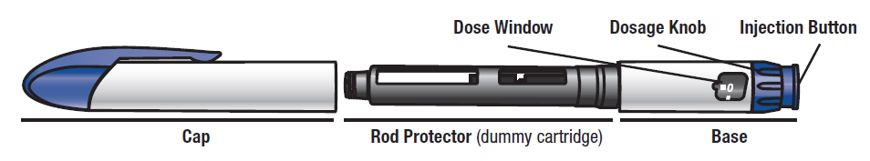

Your Natpar cartridge

Your Natpar cartridge contains medicine powder and solvent to mix the powder with. You must mix the powder and the solvent in the cartridge before using your Natpar pen.
- Each cartridge contains 14 doses.
- The dose indicator shows you the number of doses left in the cartridge.

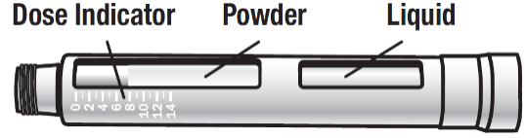

Other supplies that are needed:

Note: The alcohol swabs, injection needles and the puncture resistant container are not included in the pack.
The Medicine Cartridge Tracker is located within this instructions for use.

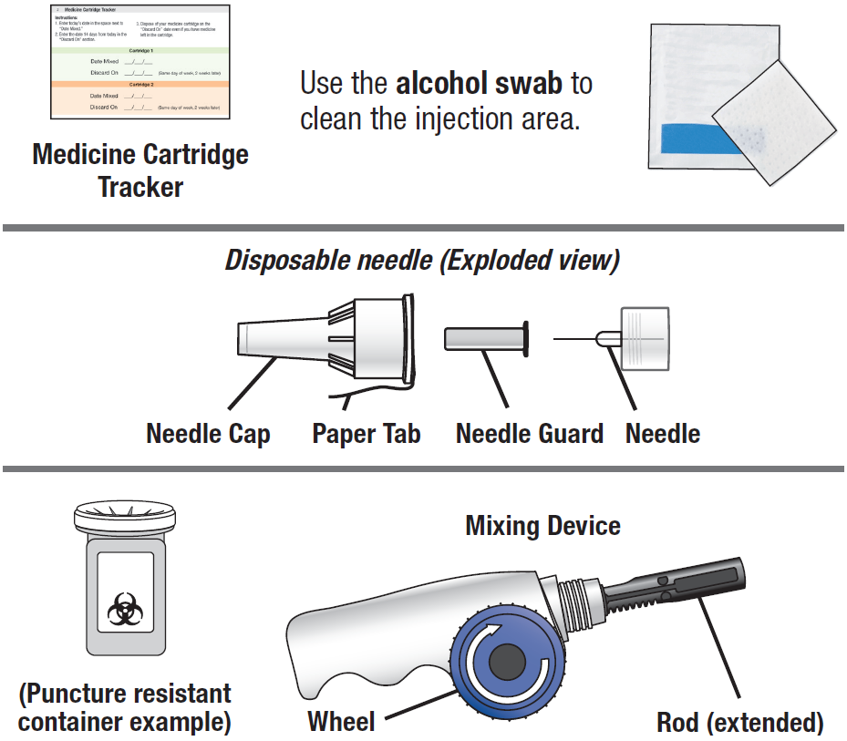

Preparing and mixing your Natpar

You need to mix Natpar before you can use it. Once the medicine is mixed, it can be used for up to 14 injections (14 doses).
If this is your first time using Natpar by yourself, your doctor or nurse will guide you through how to mix your Natpar cartridge.

1. | When preparing to inject a dose, be sure to remove your Natpar cartridge from the refrigerator.  Note: You should store your cartridge in the refrigerator at all times, except when preparing and injecting your medicine. | 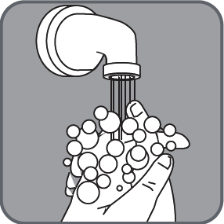
- Wash and dry your hands.
- Gather your supplies, including:
  - Your mixing device
  - New Natpar cartridge from the refrigerator
  - New disposable pen needle
  - Puncture resistant sharps container
  - A pencil or pen to write the dates you mix your cartridge
  - Your medicine cartridge tracker (located within this instructions for use)
  - Your Natpar pen to inject your medicine
  - This instructions for use

2. | Fill in the dates in your medicine cartridge tracker.
Medicine cartridge tracker
Instructions:
- Enter today’s date in the space next to “Date mixed.”
- Enter the date 14 days from today in the space next to “Discard on” (Same day of the week, 2 weeks later).
- Dispose of your cartridge on the “Discard on” date even if you have medicine left in your cartridge. Do not use your cartridge on the “Discard on” date.
- A pen needle must be attached to mix a new cartridge.

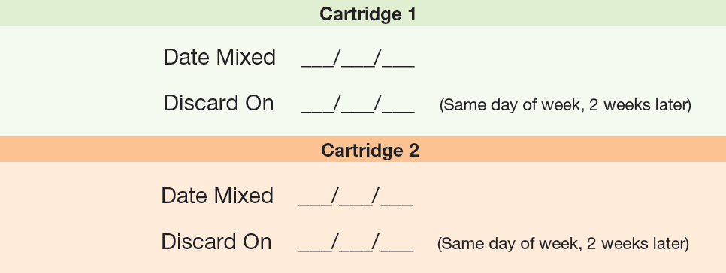

3. | Remove the paper tab from the needle cap. | 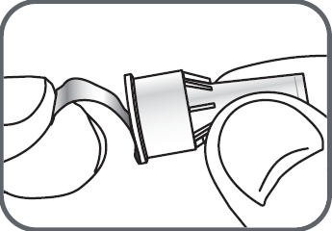
4. | Screw the Pen Needle onto the cartridge in a clockwise direction.  - Ensure the Pen Needle is straight and tight on the cartridge (the wider edge of the needle cap must touch the ‘shoulder’ of the cartridge).  - Do not remove the needle cap or guard until you are ready to give your medicine. | 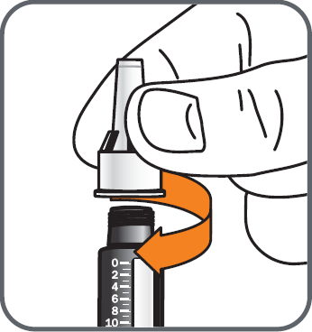
5. | Turn the wheel of the mixing device in a counterclockwise direction to lower the rod if it is not already lowered. | 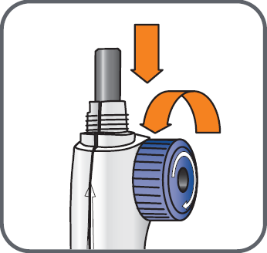
 | - Make sure the rod in the mixing device looks like this (completely retracted). | 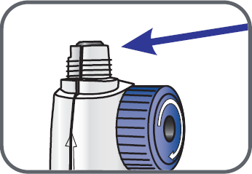
6. | Screw the Natpar cartridge onto your mixing device in a clockwise direction.  - The pen needle must be firmly attached. | 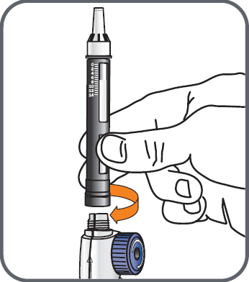
7. | With the needle cap pointing up, turn the wheel slowly in a clockwise direction until the stoppers within the cartridge no longer move and until the wheel turns freely.  - Keep the needle pointing up.  - Do NOT hold the mixing device at an angle. | 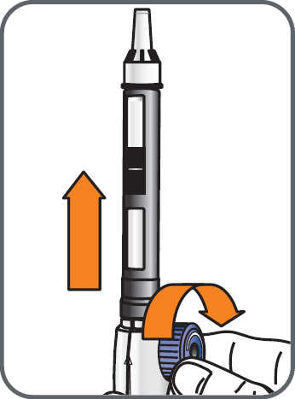
8. | Make sure the stoppers look like this and stay together. | 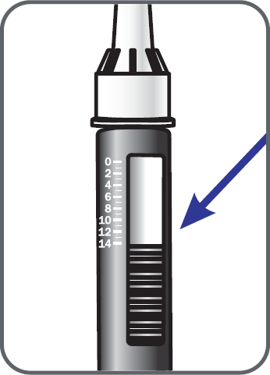
9. | Hold the mixing device with the attached cartridge, with the needle pointed up, and gently move the cartridge from side to side (from 9 o’clock to 3 o’clock) about 10 times to dissolve the powder that is in the cartridge.  - Do NOT shake the cartridge.  - Ensure the needle is pointing up.  - Put the mixing device down with the cartridge attached and wait for 5 minutes to allow complete dissolution of the powder.  Check the solution before giving every daily dose. If the solution is cloudy, contains visible particles, or is not colourless after 5 minutes, do not use this medicine. Contact your doctor, pharmacist or nurse. It is normal to see small bubbles. | 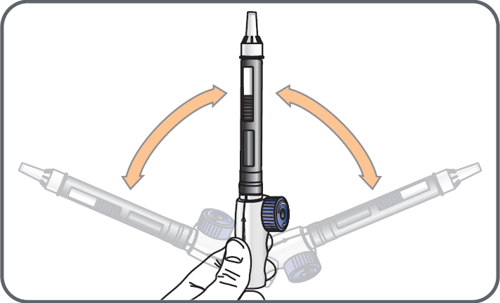
Preparing your Natpar pen

 | You will prepare your Natpar pen once every 14 days.
1. | Pick up your pen and remove the cap. Save the cap for later use. | 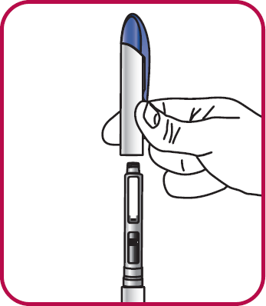
2. | Unscrew the rod protector (dummy cartridge) or the empty medicine cartridge in a counterclockwise direction and throw it in a puncture resistant sharps container. | 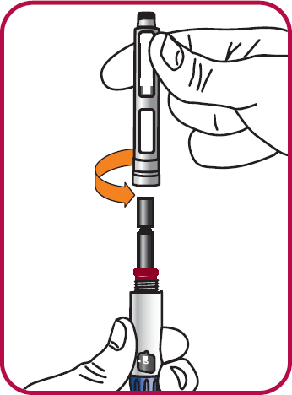
3. | Press the injection button. You should see “0” line up with the notch in the dose window. If you do not see “0” line up, press the injection button until it is lined up. | 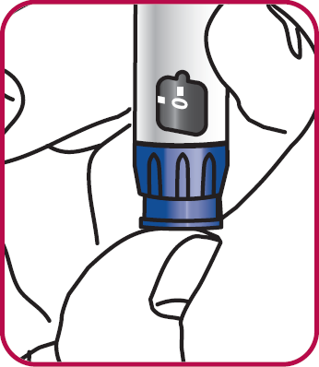
4. | Lower the rod. If the rod is extended, turn the dark red ring counterclockwise to lower it. Do not tighten the ring too much. | 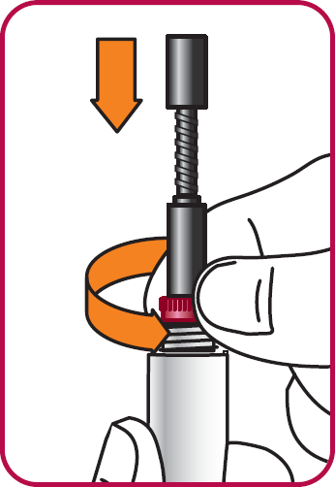
5. | Check the rod. It will have a small gap when done the right way. | 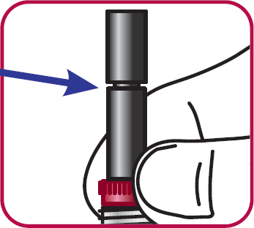
6. | Unscrew the cartridge from the mixing device in a counterclockwise direction and put the mixing device down. | 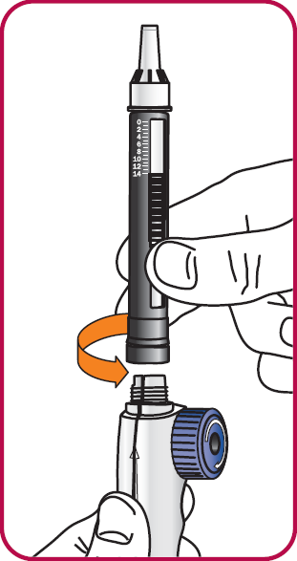
7. | Attach the cartridge to the pen. Pick up the pen base and hold it with the rod pointed upright. | 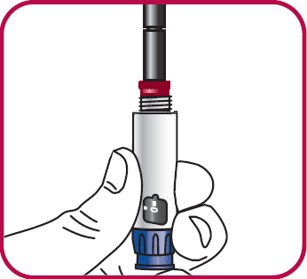
8. | With the needle cap pointing up, screw the cartridge onto the pen in a clockwise direction until there is no space between the cartridge and the pen. | 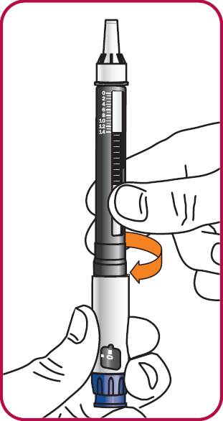
9. | Priming your Natpar pen.  Turn the dosage knob in a clockwise direction until “GO” lines up with the notch in the dose window. | 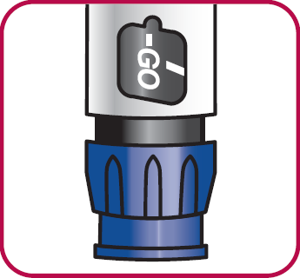
10. | Hold the pen with the needle cap pointing up. | 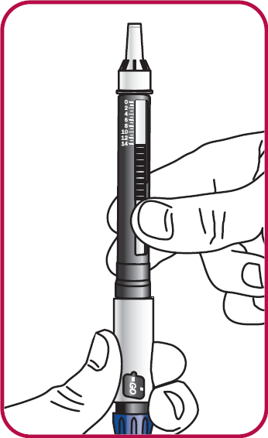
11. | Press the injection button on a flat surface, such as a table top, until the “0” lines up with the notch in the dose window.  - It is normal for 1 or 2 drops of liquid to appear on the needle during this step.  - Do not remove the medicine cartridge from the pen until the “Discard on” date or the cartridge is empty.  - Prime your pen only 1 time for each new cartridge. | 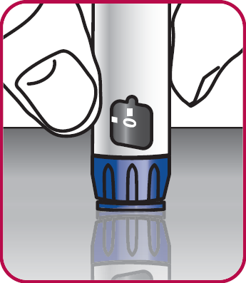

Giving your daily dose

NOTE: If you have just finished mixing your medicine and preparing your pen and the pen needle is on, go straight to “Before injecting your daily dose” (step 6 in this section) for instructions on how to inject using your Natpar pen.
If you need help at any time, ask your doctor or nurse.

1. | Wash and dry your hands.
2. | Gather your supplies, including:  - Your Natpar pen from the refrigerator  - New disposable pen needle  - Puncture resistant sharps container  - Alcohol swab  Note: You should store your mixed cartridge within the pen in the refrigerator at all times, except when preparing and injecting your medicine.
3. |  | Check the cartridge.  Remove the pen cap from your Natpar pen. The mixed cartridge should be inside. | 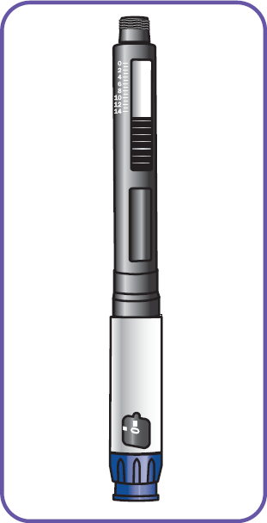
4. |  | Before attaching a new needle to your pen, check:  - If the solution is clear, colourless and free from visible particles. It is normal to see small bubbles.  If the liquid is not clear, colourless or free from visible particles, do not use this medicine. Contact your doctor, pharmacist or nurse.  You will have to prepare a new Natpar cartridge if:  - There are no remaining doses in the pen (dose counter at “0”)  or  - The “Discard on” date has been reached (see medicine tracker).
5. |  | Attaching a new needle.  - Remove the paper tab from the needle cap.  - Firmly hold the Natpar pen upright.  - While keeping the needle cap straight, screw it firmly onto the cartridge in a clockwise direction (the wider edge of the needle cap must touch the ‘shoulder’ of the cartridge).  - Leave the needle cap on. | 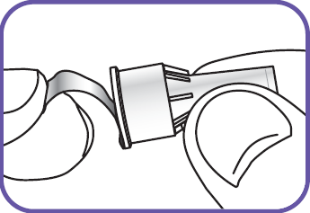  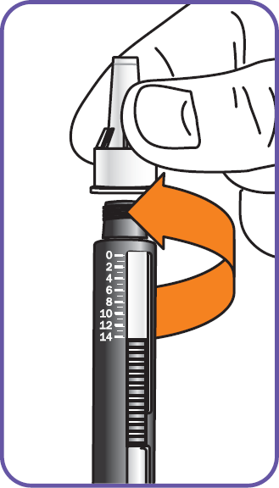
6. |  | Before injecting your daily dose.  - Do NOT use a cartridge that has been frozen.  - Discard all mixed cartridges if the “Discard on” date has been reached (see medicine tracker).
7. |  | Wipe the injection area of your thigh with an alcohol swab. Inject into an alternate thigh each day. |  | 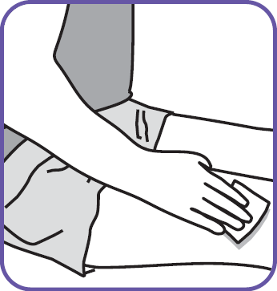
 |  | Make sure the needle cap is pointing downward at all times during step 8 to step 17.
8. |  | Hold the Natpar pen with the needle pointing straight down.  - Keep the needle pointing down until the injection is complete. |  | 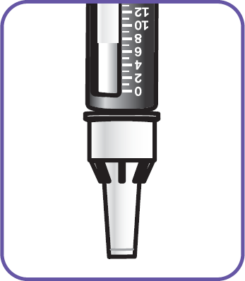
9. |  | Hold the pen so you can see the dose window. |  | 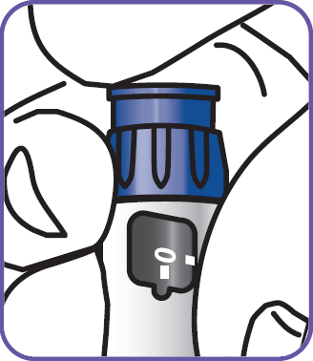
10. |  | Turn the dosage knob until “GO” lines up with the notch in the window. Do not turn the dosage knob past “GO.”  - If the dosage knob is hard to turn, you may not have enough liquid left.  Check the dose indicator on the cartridge to see if there are any doses left or check the “Discard on” date on the medicine cartridge tracker to see if it has been more than 14 days. |  | 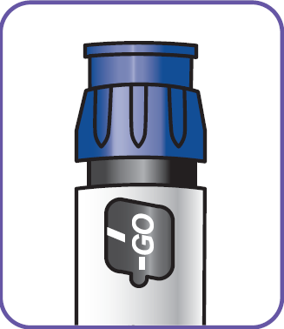
11. |  | Gently tap the cartridge 3 to 5 times. This moves any air bubbles away from the needle. |  | 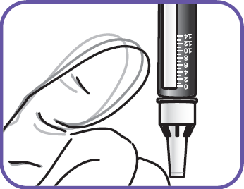
12. |  | Prepare the pen needle for giving the injection.  Without unscrewing,  - Pull the needle cap straight off and set it aside.  - Then pull off the needle guard and discard it. |  | 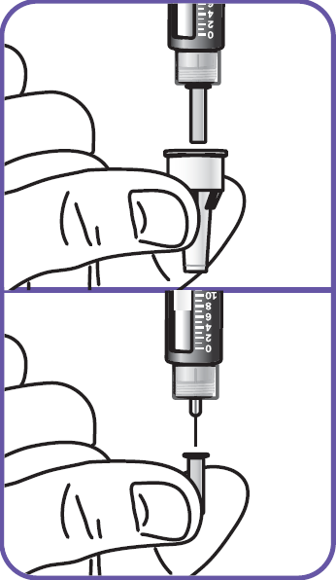
13. |  | Hold the pen so you can see “GO” in the dose window with the pen needle pointing down. |  | 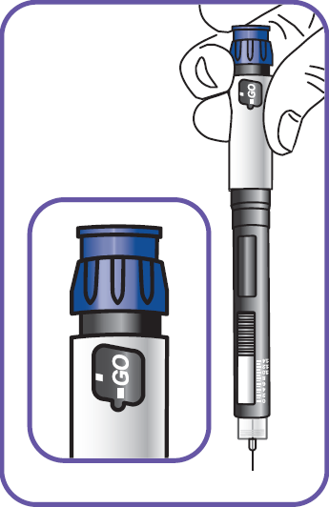
14. |  | Read steps 15, 16, and 17 carefully before you inject the medicine.
15. |  | Insert the needle fully into your thigh (you can pinch a fold of the skin if told by your doctor or nurse). Make sure you can see “GO” in the window. |  | 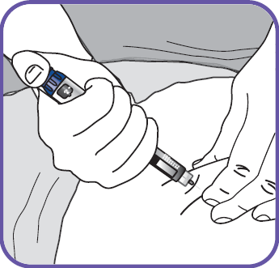
16. |  | Press the injection button until the “0” lines up with the notch in the dose window. You should see and feel the dosage knob turn back to “0.” Slowly count to 10. |  | 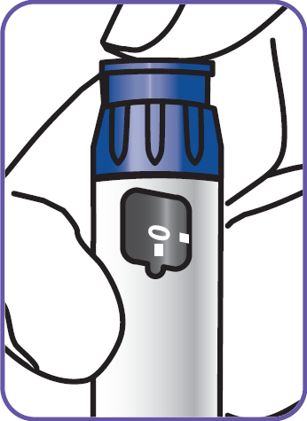
 |  | Important note about injecting:  To avoid under-dosing, you will need to keep the needle in the skin for 10 seconds AFTER pressing the injection button. |  | 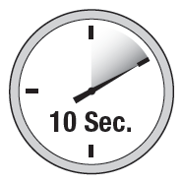
17. |  | Pull the needle straight out of your thigh.  - It is normal to see 1 or 2 drops of liquid appear on the needle during this step.  - If you do not think you received your full dose, do not take another dose. Call your doctor. You may need to take calcium and vitamin D.
18. |  | Carefully recap the exposed needle with the large needle cap by using a scooping technique.  - Make sure that the needle is pressed all the way into the cap. |  | 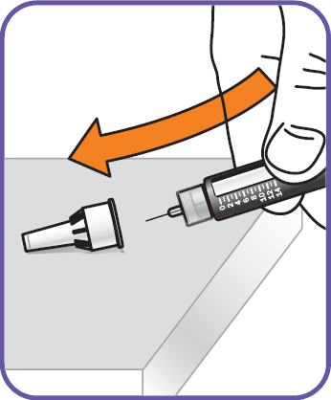
19. |  | Unscrew the needle cap (with the pen needle inside) in a counterclockwise direction while holding the cartridge.  - Do not share your pen or pen needles with anyone else. You may give an infection to them or get an infection from them. |  | 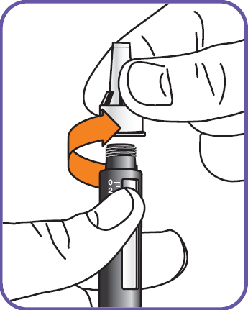
20. |  | Discard the used needle into a puncture resistant container.  Ask your doctor, pharmacist or nurse how to properly dispose of a full puncture resistant container. |  | 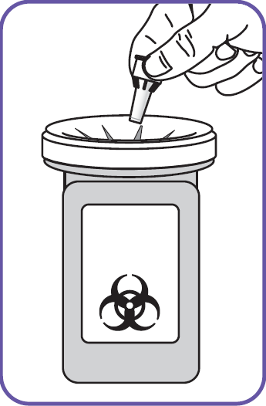
21. |  | Put the cap back on your pen.  - A cartridge must be attached to the pen before you can put the pen cap on.  - Line up the pocket clip of the tab on the pen.  - Press the cap and pen together until you hear it click. |  | 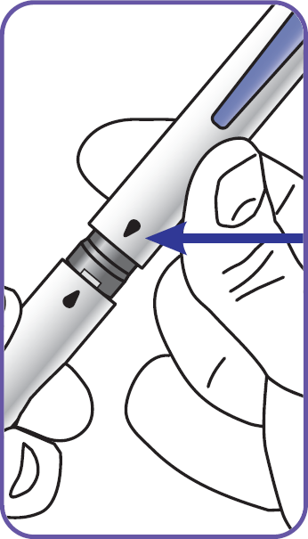
22. |  | Place the Natpar pen in the refrigerator.

How to store your medicine

The Natpar cartridges and any pen that contains a mixed cartridge should always be stored in the refrigerator (2°C – 8°C).

- Do NOT freeze your cartridge. | - Do NOT use a cartridge that has been frozen. | - Discard all mixed cartridges older than 14 days.

