|  |
| --- |
| This document is the approved product information for Nyxoid, with the changes since the previous procedure affecting the product information (EMA/N/0000253983) tracked.  For more information, see the European Medicines Agency’s website: <https://www.ema.europa.eu/en/medicines/human/EPAR/nyxoid> |

**ANNEX I**

**SUMMARY OF PRODUCT CHARACTERISTICS**

**1. NAME OF THE MEDICINAL PRODUCT**

Nyxoid 1.8 mg nasal spray, solution in single‑dose container

**2. QUALITATIVE AND QUANTITATIVE COMPOSITION**

Each nasal spray container delivers 1.8 mg of naloxone (as hydrochloride dihydrate).

For the full list of excipients, see section 6.1.

**3. PHARMACEUTICAL FORM**

Nasal spray, solution in single‑dose container (nasal spray)

Clear, colourless to pale yellow solution

**4. CLINICAL PARTICULARS**

**4.1 Therapeutic indications**

Nyxoid is intended for immediate administration as emergency therapy for known or suspected opioid overdose as manifested by respiratory and/or central nervous system depression in both non‑medical and healthcare settings.

Nyxoid is indicated in adults and adolescents aged 14 years and over.

Nyxoid is not a substitute for emergency medical care.

**4.2 Posology and method of administration**

Posology

*Adults and adolescents aged 14 years and over*

The recommended dose is 1.8 mg administered into one nostril (one nasal spray).

In some cases, further doses may be necessary. The appropriate maximum dose of Nyxoid is situation specific.If the patient does not respond, the second dose should be administered after 2‑3 minutes. If the patient responds to the first administration but then relapses again into respiratory depression, the second dose should be administered immediately. Further doses (if available) should be administered in alternate nostrils and the patient should be monitored whilst awaiting arrival of the emergency services. Emergency services may administer further doses according to local guidelines.

*Paediatric population*

The safety and efficacy of Nyxoid in children below 14 years has not been established. No data are available.

Method of administration

Nasal use.

Nyxoid should be administered as soon as possible to avoid damage to the central nervous system or death.

Nyxoid contains only one dose and therefore it must not be primed or tested prior to administration.

Detailed instructions on how to use Nyxoid are provided in the Package Leaflet and a Quick Start Guide is printed on the back of each blister. In addition, training is provided via a video and a Patient Information Card.

**4.3 Contraindications**

Hypersensitivity to the active substance or to any of the excipients listed in section 6.1.

**4.4 Special warnings and precautions for use**

Instructing patients / users on the proper use of Nyxoid

Nyxoid should only be made available once the suitability and competence of an individual to administer naloxone in the appropriate circumstances has been established. Patients or any other person who might be in a position to administer Nyxoid must be instructed in its proper use and the importance of seeking medical assistance.

Nyxoid is not a substitute for emergency medical care and may be used instead of intravenous injection, when intravenous access is not immediately available.

Nyxoid is intended to be administered as a part of a resuscitation intervention in suspected overdose casualties, where opioid drugs may be involved or suspected, likely in a non‑medical setting. Therefore, the prescriber should take appropriate steps to ensure that the patient and/or any other person who might be in a position to administer Nyxoid thoroughly understands the indications and use of Nyxoid.

The prescriber should describe the symptoms which allow presumptive diagnosis of central nervous system (CNS) / respiratory depression, the indication and the instructions for use with the patient and / or person who might be in a position to administer this product to a patient experiencing a known or suspected opioid overdose event. This should be performed in accordance with the educational guidance for Nyxoid.

Monitoring of the patient for a response

Patients who respond satisfactorily to Nyxoid must be closely monitored. The effect of some opioids can be longer than the effect of naloxone, which could lead to reoccurrence of respiratory depression and therefore further doses of naloxone may be required.

Opioid withdrawal syndrome

Receiving Nyxoid can lead to a rapid reversal of the opioid effect which can cause an acute withdrawal syndrome (see section 4.8). Patients who are receiving opioids for the relief of chronic pain may experience pain and opioid withdrawal symptoms when Nyxoid is administered.

Effectiveness of naloxone

Reversal of buprenorphine‑induced respiratory depression may be incomplete. If an incomplete response occurs, respiration should be mechanically assisted.

Intranasal absorption and efficacy of naloxone can be altered in patients with damaged nasal mucosa and septal defects.

Paediatric population

Opioid withdrawal may be life‑threatening in neonates if not recognised and properly treated and may include the following signs and symptoms: convulsions, excessive crying and hyperactive reflexes.

Excipients

This medicinal product contains less than 1 mmol sodium (23 mg) per dose, that is to say essentially ‘sodium‑free’.

**4.5 Interaction with other medicinal products and other forms of interaction**

Naloxone elicits a pharmacological response due to the interaction with opioids and opioid agonists. When administered to opioid dependent subjects, naloxone can cause acute withdrawal symptoms in some individuals. Hypertension, cardiac arrhythmias, pulmonary oedema and cardiac arrest have been described, more typically when naloxone is used post‑operatively (see sections 4.4 and 4.8).

Administration of Nyxoid may decrease the analgesic effects of opioids used primarily to provide pain relief, due to its antagonist properties (see section 4.4).

When administering naloxone to patients who have received buprenorphine as an analgesic, complete analgesia may be restored. It is thought that this effect is a result of the arch‑shaped dose‑response curve of buprenorphine with decreasing analgesia in the event of high doses. However, reversal of respiratory depression caused by buprenorphine is limited.

**4.6 Fertility, pregnancy and lactation**

Pregnancy

There are no adequate data from the use of naloxone in pregnant women. Studies in animals have shown reproductive toxicity only at maternally toxic doses (see section 5.3). The potential risk for humans is unknown. Nyxoid should not be used during pregnancy unless the clinical condition of the woman requires treatment with naloxone.

In pregnant women who have been treated with Nyxoid, the fetus should be monitored for signs of distress.

In opioid dependent pregnant women,naloxone administration can cause withdrawal symptoms in newborn infants (see section 4.4).

Breast‑feeding

It is unknown whether naloxone is excreted in human breast milk and it has not been established whether infants who are breast‑fed are affected by naloxone. However, as naloxone is practically not orally bioavailable its potential to affect a breast‑fed infant is negligible. Caution should be exercised when naloxone is administered to a breast‑feeding mother but there is no need to discontinue breast‑feeding. Breast‑fed babies from mothers who have been treated with Nyxoid should be monitored to check for sedation or irritability.

Fertility

No clinical data on effects of naloxone on fertility are available, however data from rat studies (see section 5.3) indicate no effects.

**4.7 Effects on ability to drive and use machines**

Patients who have received naloxone to reverse the effects of opioids should be warned not to drive, to operate machinery or to engage in other activities demanding physical or mental exertion for at least 24 hours, since the effect of the opioids may return.

**4.8 Undesirable effects**

Summary of the safety profile

The most common adverse reaction (AR) seen with naloxone administration is nausea (frequency very common). Typical opioid withdrawal syndrome is expected with naloxone which may be caused by the abrupt withdrawal of opioid in persons physically dependent on them.

Tabulated list of adverse reactions

The following adverse reactions have been reported with Nyxoid and/or other naloxone‑containing medicinal products during clinical studies and post marketing experience. ARs are listed below by system organ class and frequency.

Frequency categories are assigned to those adverse reactions considered to be at least possibly causally related to naloxone and are defined as very common: (≥ 1/10); common: (≥ 1/100, < 1/10); uncommon: (≥ 1/1,000, < 1/100); rare: (≥ 1/10,000, < 1/1,000) very rare: (< 1/10,000); not known (cannot be estimated from the available data).

|  |  |
| --- | --- |
|  |  |

*Immune system disorders*

Very rare: Hypersensitivity, Anaphylactic shock

|  |
| --- |
| *Nervous system disorders*  Common Dizziness, Headache  Uncommon Tremor |

|  |
| --- |
| *Cardiac disorders*  Common Tachycardia  Uncommon Arrhythmia, Bradycardia  Very rare Cardiac fibrillation, Cardiac arrest |

|  |
| --- |
| *Vascular disorders*  Common Hypotension, Hypertension |
| *Respiratory, thoracic and mediastinal disorders*  Uncommon Hyperventilation  Very rare Pulmonary oedema |

*Gastrointestinal disorders*

Very common Nausea

Common Vomiting

Uncommon Diarrhoea, Dry mouth

|  |
| --- |
| *Skin and subcutaneous tissue disorders*  Uncommon Hyperhidrosis  Very rare Erythema multiforme |
|  |

*General disorders and administration site conditions*

Uncommon Drug withdrawal syndrome (in patients dependent on opioids)

|  |
| --- |
|  |

Description of selected adverse reactions

*Drug withdrawal syndrome*

Signs and symptoms of drug withdrawal syndrome include restlessness, irritability, hyperaesthesia, nausea, vomiting, gastrointestinal pain, muscle spasms, dysphoria, insomnia, anxiety, hyperhidrosis, piloerection, tachycardia, increased blood pressure, yawning, pyrexia. Behavioural changes including violent behaviour, nervousness and excitement may also be observed.

*Vascular disorders*

In reports on intravenous/intramuscular naloxone: hypotension, hypertension, cardiac arrhythmia (including ventricular tachycardia and fibrillation) and pulmonary oedema have occurred with the postoperative use of naloxone. Adverse cardiovascular effects have occurred more frequently in postoperative patients with a pre‑existing cardiovascular disease or in those receiving other medicinal products that produce similar adverse cardiovascular effects.

Paediatric population

Nyxoid is intended for use in adolescents 14 years and over. Frequency, type and severity of adverse reactions in adolescents are expected to be the same as in adults.

Reporting of suspected adverse reactions

Reporting suspected adverse reactions after authorisation of the medicinal product is important. It allows continued monitoring of the benefit/risk balance of the medicinal product. Healthcare professionals are asked to report any suspected adverse reactions via the national reporting system listed in [Appendix V](http://www.ema.europa.eu/docs/en_GB/document_library/Template_or_form/2013/03/WC500139752.doc).

**4.9 Overdose**

In view of the indication and the broad therapeutic margin, overdose is not to be expected.

**5. PHARMACOLOGICAL PROPERTIES**

**5.1 Pharmacodynamic properties**

Pharmacotherapeutic group: Antidotes, ATC code: V03AB15

Mechanism of action and pharmacodynamic effects

Naloxone, a semisynthetic morphine derivative (N‑allyl‑nor‑oxymorphone), is a specific opioid antagonist that acts competitively at opioid receptors. It reveals very high affinity for the opioid receptor sites and therefore displaces both opioid agonists and partial antagonists. Naloxone does not possess the "agonistic" or morphine‑like properties characteristic of other opioid antagonists. In the absence of opioids or agonistic effects of other opioid antagonists, it exhibits essentially no pharmacologic activity. Naloxone has not been shown to produce tolerance or cause physical or mental dependence.

As the duration of action of some opioid agonists may be longer than that of naloxone, the effects of the opioid agonist may return as the effects of naloxone disappear. This may necessitate repeat doses of naloxone – though the need for repeat naloxone doses is dependent on the quantity, type and route of administration of the opioid agonist that is being treated.

Paediatric population

No data are available.

**5.2 Pharmacokinetic properties**

Absorption

Intranasal administration of naloxone has demonstrated naloxone to be rapidly absorbed, as evidenced by very early appearance (as early as 1 minute after administration) of the active substance in systemic circulation.

A study investigating intranasal naloxone at doses of 1, 2, 4 mg (MR903‑1501) shows that the median (range) tmax associated with intranasal administration of naloxone was 15 (10, 60) minutes for 1 mg, 30 (8, 60) minutes for 2 mg and 15 (10, 60) minutes for 4 mg intranasal doses. Onset of action following intranasal administration can reasonably be expected to occur in each individual before the tmax is reached.

The half value duration (HVD) values for intranasal administration were longer than for intramuscular administration (intranasal, 2 mg, 1.27h, intramuscular, 0.4 mg 1.09h) from which we can infer a longer duration of action of naloxone given by the intranasal rather than the intramuscular route. If the duration of action of the opioid agonist exceeds that of intranasal naloxone, the effects of the opioid agonist may return, necessitating a second intranasal naloxone administration.

A study demonstrated mean absolute bioavailability of 47% and mean half‑lives of 1.4 h from intranasal doses of 2 mg.

Biotransformation

Naloxone is rapidly metabolized in the liver and excreted in the urine. It undergoes extensive hepatic metabolism mainly by glucuronide conjugation. The principal metabolites are naloxone‑3‑glucuronide, 6‑beta‑naloxol and its glucuronide.

Elimination

There are no data available on the excretion of naloxone following intranasal administration, however, the disposition of labelled naloxone following intravenous administration was studied in healthy volunteers and opioid‑dependent patients. Following an intravenous dose of 125 µg, 38% of the dose was recovered in the urine within 6 hours in healthy volunteers compared with 25% of the dose being recovered in opioid‑dependent patients in the same time period. After a period of 72 hours, 65% of the injected dose was recovered in urine in the healthy volunteers compared with 68% of the dose in opiate‑dependent patients.

Paediatric population

No data are available.

**5.3 Preclinical safety data**

Genotoxicity and carcinogenicity

Naloxone was not mutagenic in the bacterial reverse mutation assay, but was positive in mouse lymphoma assay and was clastogenic *in vitro*, however, naloxone was not clastogenic *in vivo*. Naloxone was not carcinogenic following oral administration in a rat 2‑year study or in a 26‑week study in Tg-rasH2 mice. Overall, the weight of evidence indicates that naloxone poses minimal, if any, risk for human genotoxicity and carcinogenicity.

Reproductive and developmental toxicity

Naloxone had no effect on fertility and reproduction in the rat or on early embryonic development of the rat and rabbit. In peri‑post natal rat studies, naloxone produced increased pup deaths in the immediate post‑partum period at the high doses that also caused significant maternal toxicity in rats (e.g. bodyweight loss, convulsions). Naloxone did not affect development or behaviour of surviving pups. Naloxone is therefore not teratogenic in rats or rabbits.

**6. PHARMACEUTICAL PARTICULARS**

**6.1 List of excipients**

Trisodium citrate dihydrate (E331)

Sodium chloride

Hydrochloric acid (E507)

Sodium hydroxide (E524)

Purified water

**6.2 Incompatibilities**

Not applicable.

**6.3 Shelf life**

3 years

**6.4 Special precautions for storage**

Do not freeze.

**6.5 Nature and contents of container**

The immediate container consists of a type I glass vial with siliconised chlorobutyl stopper containing 0.1 ml solution. The secondary packaging (actuator) is comprised of polypropylene and stainless steel.

Each pack contains two single‑dose nasal sprays.

**6.6 Special precautions for disposal**

Any unused medicinal product or waste material should be disposed of in accordance with local requirements.

**7. MARKETING AUTHORISATION HOLDER**

Mundipharma Corporation (Ireland) Limited

United Drug House Magna Drive

Magna Business Park

Citywest Road

Dublin 24

Ireland

**8. MARKETING AUTHORISATION NUMBER(S)**

EU/1/17/1238/001

**9. DATE OF FIRST AUTHORISATION/RENEWAL OF THE AUTHORISATION**

Date of first authorisation: 10 November 2017

Date of latest renewal: 15 September 2022

**10. DATE OF REVISION OF THE TEXT**

Detailed information on this medicinal product is available on the website of the European Medicines Agency <http://www.ema.europa.eu>.

**ANNEX II**

**A. MANUFACTURER(S) RESPONSIBLE FOR BATCH RELEASE**

**B. CONDITIONS OR RESTRICTIONS REGARDING SUPPLY AND USE**

**C. OTHER CONDITIONS AND REQUIREMENTS OF THE MARKETING AUTHORISATION**

**D. CONDITIONS OR RESTRICTIONS WITH REGARD TO THE SAFE AND EFFECTIVE USE OF THE MEDICINAL PRODUCT**

**A. MANUFACTURER(S) RESPONSIBLE FOR BATCH RELEASE**

Name and address of the manufacturer(s) responsible for batch release

Mundipharma DC B.V.

Leusderend 16

3832 RC Leusden

Netherlands

**B. CONDITIONS OR RESTRICTIONS REGARDING SUPPLY AND USE**

Medicinal product subject to medical prescription.

**C. OTHER CONDITIONS AND REQUIREMENTS OF THE MARKETING AUTHORISATION**

• **Periodic safety update reports (PSURs)**

The requirements for submission of PSURs for this medicinal product are set out in the list of Union reference dates (EURD list) provided for under Article 107c(7) of Directive 2001/83/EC and any subsequent updates published on the European medicines web-portal.

**D. CONDITIONS OR RESTRICTIONS WITH REGARD TO THE SAFE AND EFFECTIVE USE OF THE MEDICINAL PRODUCT**

• **Risk management plan (RMP)**

The marketing authorisation holder (MAH) shall perform the required pharmacovigilance activities and interventions detailed in the agreed RMP presented in Module 1.8.2 of the marketing authorisation and any agreed subsequent updates of the RMP.

An updated RMP should be submitted:

• At the request of the European Medicines Agency;

• Whenever the risk management system is modified, especially as the result of new information being received that may lead to a significant change to the benefit/risk profile or as the result of an important (pharmacovigilance or risk minimisation) milestone being reached.

• **Additional risk minimisation measures**

Prior to launch of Nyxoid in each Member State the Marketing Authorisation Holder must agree about the content and format of the educational materials, including communication media, distribution modalities, and any other aspects of the programme, with the National Competent Authority.

Materials approved by the local authority will be posted on the non-promotional website nyxoid.com from where they can be freely downloaded as needed. A QR code on the package and in the patient information leaflet links to nyxoid.com to ensure the site can be reached quickly in case of “just in time” retraining at the time of witnessing an overdose.

The MAH shall ensure that in each MS where Nyxoid is marketed, all relevant health care professionals (HCP) who are expected to prescribe and/or supply Nyxoid are provided with:

• HCP Guidance Document with training delivery instructions

• The patient/carer information card

• Access to a video on how to use Nyxoid

The HCP Guidance Document includes:

• A brief introduction on Nyxoid

• A list of the educational material included in the training program

• Details of what information needs to be shared when training the patient/carer

o how to manage a known or suspected opioid overdosed and how to properly administer Nyxoid

o how to minimise the occurrence and severity of the following risks associated with Nyxoid: reappearance of respiratory depression, precipitation of acute opioid withdrawal effect and lack of efficacy due to medication error

• Instructions that the HCP has to provide the patient/carer with the PIC and to make sure that the patients/carers know they can also view a training video on nyxoid.com, and are encouraged to read the package leaflet included in the medicinal product outer carton, and the quick start guide (QSG) on the inner packaging blister.

The Patient Information Card includes:

• Information about Nyxoid and the fact that it cannot replace provision of basic life support

• Identification of signs of suspected opioid overdose, especially respiratory depression and information on how to check the airways and breathing

• Emphasis on the need to make an immediate emergency call for an ambulance

• Information on how to use the nasal spray to correctly administer Nyxoid

• Information on placing the patient into recovery position and administering the second dose, if required, in this position

• Information on how to manage and monitor the patient until the emergency medical assistance arrives

• Awareness of possible important risks such as opioid withdrawal symptoms and recurrence of respiratory depression

• Reference to the QSG on the back of the product immediate packaging

The Video includes:

• Steps detailing management of a patient which are aligned with information in PIC and package leaflet

• It is available as

o A link for online access in the HPD and PIC

For countries where Nyxoid is not on the market and no educational materials have been approved, nyxoid.com will indicate this under the country link and will provide a link to the approved patient information leaflet for that country which also contains the key information presented in the educational materials on how to identify an overdose and how to use Nyxoid.



**ANNEX III**

**LABELLING AND PACKAGE LEAFLET**

**A. LABELLING**

**PARTICULARS TO APPEAR ON THE OUTER PACKAGING**

**CARTON**

**1. NAME OF THE MEDICINAL PRODUCT**

Nyxoid 1.8 mg nasal spray, solution in single‑dose container

naloxone

**2. STATEMENT OF ACTIVE SUBSTANCE(S)**

Each nasal spray container delivers 1.8 mg of naloxone (as hydrochloride dihydrate)

**3. LIST OF EXCIPIENTS**

Excipients: Trisodium citrate dihydrate (E331), sodium chloride, hydrochloric acid (E507), sodium hydroxide (E524), purified water.

**4. PHARMACEUTICAL FORM AND CONTENTS**

Nasal spray, solution in single‑dose container

2 single‑dose containers

**5. METHOD AND ROUTE(S) OF ADMINISTRATION**

Read the package leaflet before use.

Nasal use.

**6. SPECIAL WARNING THAT THE MEDICINAL PRODUCT MUST BE STORED OUT OF THE SIGHT AND REACH OF CHILDREN**

Keep out of the sight and reach of children.

**7. OTHER SPECIAL WARNING(S), IF NECESSARY**

Do not prime or test before use. Each spray contains only one dose.

For overdose of opioids (such as heroin)

**8. EXPIRY DATE**

EXP

**9. SPECIAL STORAGE CONDITIONS**

Do not freeze.

**10. SPECIAL PRECAUTIONS FOR DISPOSAL OF UNUSED MEDICINAL PRODUCTS OR WASTE MATERIALS DERIVED FROM SUCH MEDICINAL PRODUCTS, IF APPROPRIATE**

**11. NAME AND ADDRESS OF THE MARKETING AUTHORISATION HOLDER**

Mundipharma Corporation (Ireland) Limited

United Drug House Magna Drive

Magna Business Park

Citywest Road

Dublin 24

Ireland

**12. MARKETING AUTHORISATION NUMBER(S)**

EU/1/17/1238/001

**13. BATCH NUMBER**

Lot

**14. GENERAL CLASSIFICATION FOR SUPPLY**

**15. INSTRUCTIONS ON USE**

Video/more information: <QR code included> + www.nyxoid.com

**16. INFORMATION IN BRAILLE**

Nyxoid

**17. UNIQUE IDENTIFIER – 2D BARCODE**

2D barcode carrying the unique identifier included.

**18. UNIQUE IDENTIFIER - HUMAN READABLE DATA**

PC

SN

NN

**MINIMUM PARTICULARS TO APPEAR ON BLISTERS OR STRIPS**

**BLISTERS**

**1. NAME OF THE MEDICINAL PRODUCT**

Nyxoid 1.8 mg nasal spray, solution in single‑dose container

naloxone

**2. NAME OF THE MARKETING AUTHORISATION HOLDER**

Mundipharma Corporation (Ireland) Limited

**3. EXPIRY DATE**

EXP

**4. BATCH NUMBER**

Lot

**5. OTHER**

Single‑dose nasal spray for overdose of opioids (such as heroin)

Do not test before use

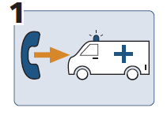

Call an ambulance

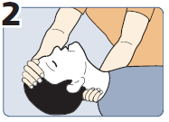

Lay down. Tilt head back.

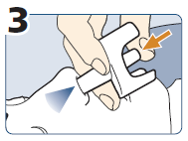

Spray into one nostril.



Lay in recovery position.

Not better? After 2-3 mins, use 2nd spray.

**MINIMUM PARTICULARS TO APPEAR ON SMALL IMMEDIATE PACKAGING UNITS**

**INTRANASAL SPRAY/DEVICE LABEL**

**1. NAME OF THE MEDICINAL PRODUCT AND ROUTE(S) OF ADMINISTRATION**

Nyxoid 1.8 mg nasal spray, solution in single‑dose container

naloxone

Nasal use

**2. METHOD OF ADMINISTRATION**

**3. EXPIRY DATE**

EXP

**4. BATCH NUMBER**

Lot

**5. CONTENTS BY WEIGHT, BY VOLUME OR BY UNIT**

1.8 mg

**6. OTHER**

**B. PACKAGE LEAFLET**

**Package leaflet: Information for the user**

**Nyxoid 1.8 mg nasal spray, solution in single‑dose container**

naloxone

**Read all of this leaflet carefully before you start using this medicine because it contains important information for you.**

- Keep this leaflet. You may need to read it again.

- If you have any further questions, ask your doctor, pharmacist or nurse.

- This medicine has been prescribed for you only. Do not pass it on to others. It may harm them, even if their signs of illness are the same as yours.

- If you get any side effects, talk to your doctor, pharmacist or nurse. This includes any possible side effects not listed in this leaflet. See section 4.

**What is in this leaflet**

1. What Nyxoid is and what it is used for

2. What you need to know before you receive Nyxoid

3. How Nyxoid is to be given

4. Possible side effects

5. How to store Nyxoid

6. Contents of the pack and other information

**1. What Nyxoid is and what it is used for**

This medicine contains the active substance naloxone. Naloxone temporarily reverses the effects of opioids such as heroin, methadone, fentanyl, oxycodone, buprenorphine and morphine.

Nyxoid is a nasal spray used for the emergency treatment of opioid overdose or possible opioid overdose in adults and adolescents over 14 years. Signs of overdose include:

• breathing problems

• severe sleepiness

• not responding to a loud noise or touch.

**If you are at risk of an opioid overdose you should always carry your Nyxoid with you**. Nyxoid works for a short time only to reverse the effects of opioids while you wait for emergency medical attention. It is not a substitute for emergency medical care. Nyxoid is intended for use by appropriately trained individuals.

Always tell your friends and family that you carry Nyxoid with you.

**2. What you need to know before you receive Nyxoid**

**Do not use Nyxoid**

If you are allergic to naloxone or any of the other ingredients of this medicine (listed in section 6).

**Warnings and precautions**

Nyxoid will be supplied to you only after you or your carer have been taught how to use it.

It is to be given right away and does not take the place of emergency medical care.

• **Emergency services should be called if an opioid overdose is suspected**.

The signs and symptoms of an opioid overdose can return after this nasal spray is given. If this happens, further doses may be given after 2 to 3 minutes using a new nasal spray. The patient should be monitored closely until emergency help has arrived after being given this medicine.

**Conditions to look out for**

• If you are physically dependent on opioids or if you have received high doses of opioids (for example heroin, methadone, fentanyl, oxycodone, buprenorphine or morphine). You may get strong withdrawal symptoms with this medicine (see later in section 4 of this leaflet under ‘Conditions to look out for’)

• If you take opioids to control pain. The pain may increase when you receive Nyxoid.

• If you use buprenorphine. Nyxoid may not fully reverse breathing problems.

**Tell your doctor** if you have damage to the inside of your nose as this could affect how Nyxoid works.

**Children and adolescents**

Nyxoid is not for use in children or adolescents under 14 years.

**Receiving Nyxoid close to giving birth**

**Tell your midwife or doctor** if you have **received Nyxoid** close to or during **labour.**

Your baby could suffer from **sudden opioid withdrawal syndrome,** which could be life‑threatening if not treated.

Watch out for the following symptoms in your baby during the first **24 hours** after the baby is born:

• seizures (fits)

• crying more than usual

• increased reflexes.

**Other medicines and Nyxoid**

Tell your doctor or pharmacist if you are taking, have recently taken or might take any other medicines.

**Pregnancy, breast‑feeding and fertility**

If you are pregnant or breast‑feeding, think you may be pregnant or are planning to have a baby, ask your doctor or pharmacist for advice before receiving a supply of this medicine.

If you are given Nyxoid while you are pregnant or breast-feeding, your baby should be closely monitored.

**Driving and using machines**

After taking this medicine, you must not drive, operate machinery or engage in any other physically or mentally demanding activity for at least 24 hours, since the effects of opioids may recur.

**Nyxoid contains sodium**

This medicine contains less than 1 mmol sodium (23 mg) per dose, that is to say essentially ‘sodium-free.

**3. How Nyxoid is to be given**

Always use this medicine exactly as your doctor, pharmacist or nurse has told you. Check with your doctor, pharmacist or nurse if you are not sure.

Training will be provided on how to use Nyxoid before it is supplied to you. Below is a step by step guide.

**Instructions for giving Nyxoid nasal spray**

1. **Check for symptoms and response**.

- **Check for a response, to see if the person is conscious.** You can shout their name, gently shake their shoulders, talk loudly into their ears, rub their breastbone (sternum), pinch their ear or the bed of their fingernail.

- **Check airways and breathing.** Clear the mouth and nose of any blockages. For 10 seconds check for breathing – is the chest moving? Can you hear breathing sounds? Can you feel breath on the cheek?

- **Check for signs of overdose**, such as: no response to touch or sounds, slow uneven breathing or no breathing, snoring, gasping or gulping, blue or purple fingernails or lips, very small pupils.

- **If an overdose is suspected Nyxoid should be given as soon as possible.**

2. **Call for an ambulance.** Nyxoid is not a substitute for emergency medical care.

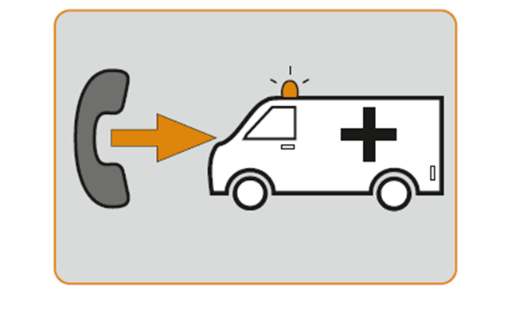

3. **Peel off** the back of the blister from the corner to **remove the nasal spray** from the container. Place the nasal spray within easy reach.

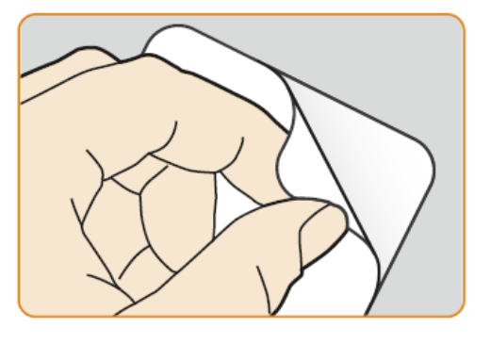

4. Lay the patient on their back. Support the back of the neck and allow the head to tilt back. Clear away anything blocking their nose.

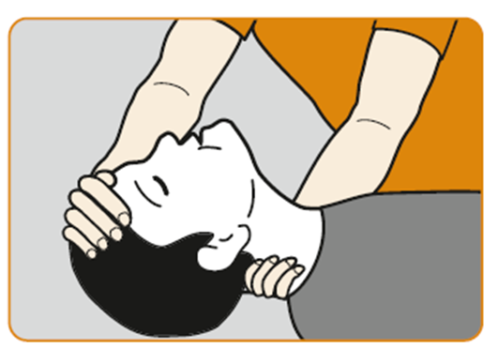

5. Hold the nasal spray with your thumb on the bottom of the plunger and your first and middle fingers on either side of the nozzle. **Do not prime or test the Nyxoid nasal spray before use** as it contains only one dose of naloxone and cannot be reused.

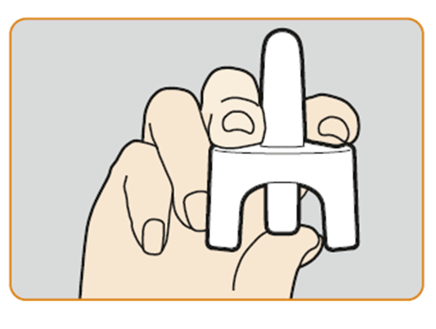

6. Gently insert the device nozzle in **one nostril**. **Press firmly** on the plunger **until it clicks** to give the dose. Remove the nasal spray nozzle from the nostril after giving the dose.

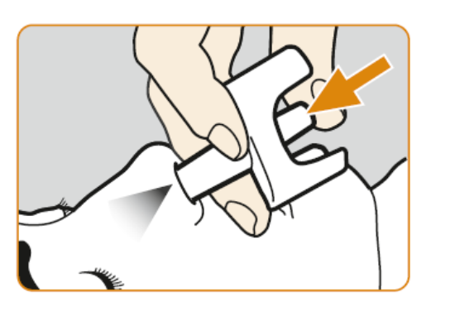

7. Place the patient into the **recovery position** on their side with mouth open pointing towards the ground and stay with the patient until the emergency services arrive. Watch for an improvement in the patient’s breathing level, alertness and response to noise and touch.

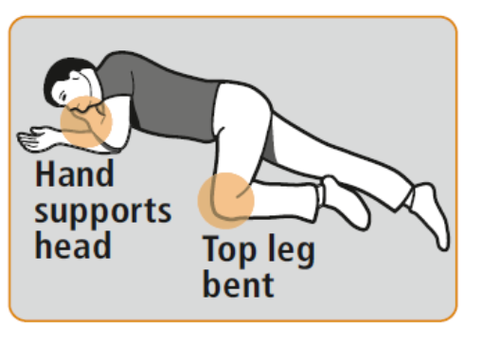

8. If the patient is **no better** within **2-3 minutes**, a **second dose can be given**. Be aware – even if they wake up, they may become unconscious again, and stop breathing. If this happens, a second dose can be given immediately. Give Nyxoid in the other nostril using a new Nyxoid nasal spray. This can be done **while the patient is in the recovery position**.

9. If the patient does not respond to two doses, further doses may be given (if available). Stay with the patient and continue to watch for an improvement until the emergency services arrive who will give further treatment.

In patients who are unconscious and not breathing normally additional life‑saving support should be given if possible.

For more information or video, scan the QR code or visit [www.nyxoid.com](http://www.nyxoid.com)

<QR code> + [www.nyxoid.com](https://nam04.safelinks.protection.outlook.com/?url=http%3A%2F%2Fwww.nyxoid.com%2F&data=05%7C02%7CSampath.Belide.external%40mundipharma-rd.eu%7Cf15e2986a1f14afb9b5a08dcded244a7%7C4674d5b9bf034d67af0b4bcc9f6f6a0f%7C0%7C0%7C638630241881438217%7CUnknown%7CTWFpbGZsb3d8eyJWIjoiMC4wLjAwMDAiLCJQIjoiV2luMzIiLCJBTiI6Ik1haWwiLCJXVCI6Mn0%3D%7C0%7C%7C%7C&sdata=IdRF35e0Bg7A3ZoOo4mVvjgD8Y8M2SU6vgcKiU1uurk%3D&reserved=0)

If you have any further questions on the use of this medicine, ask your doctor or pharmacist.

**4. Possible side effects**

Like all medicines, this medicine can cause side effects although not everyone gets them. The side effects below may happen with this medicine.

**Conditions to look out for**

Nyxoid can cause **acute withdrawal symptoms** if the patient is dependent on opioid drugs. Symptoms can include: drug withdrawal syndrome include restlessness, irritability, hyperaesthesia (increased skin sensitivity), nausea (feeling sick), vomiting (being sick), gastrointestinal pain (stomach cramps), muscle spasms (a sudden tightening of your muscles, body aches), dysphoria (unpleasant or uncomfortable mood), insomnia (difficulty in sleeping), anxiety, hyperhidrosis (excessive sweating), piloerection (goose bumps, shivering or trembling), tachycardia (fast heart rate), increased blood pressure, yawning, pyrexia (fever). Behavioural changes including violent behaviour, nervousness and excitement may also be observed.

Acute withdrawal symptoms occur uncommonly (may affect up to 1 in 100 people).

**Tell your doctor** if you experience any of these symptoms.

Very common: may affect more than 1 in 10 people

• Feeling sick (Nausea)

Common: may affect up to 1 in 10 people

• Dizziness, headache

• Fast heart rate

• High blood pressure, low blood pressure

• Being sick (vomiting)

Uncommon: may affect up to 1 in 100 people

• Tremor

• Slow heart rate

• Sweating

• Irregular heart beat

• Diarrhoea

• Dry mouth

• Rapid breathing

Very rare: may affect up to 1 in 10,000 people

• Allergic reactions such as swelling of the face, mouth, lips or throat, allergic shock

• Life‑threatening irregular heartbeat, heart attack

• Build‑up of fluid in the lungs

• Skin problems such as itching, rash, redness, swelling, severe flaking or peeling of the skin.

**Reporting of side effects**

If you get any side effects, talk to your doctor, pharmacist or nurse. This includes any possible side effects not listed in this leaflet. You can also report side effects directly via the national reporting system listed in [Appendix V](http://www.ema.europa.eu/docs/en_GB/document_library/Template_or_form/2013/03/WC500139752.doc). By reporting side effects you can help provide more information on the safety of this medicine.

**5. How to store Nyxoid**

Keep this medicine out of the sight and reach of children.

Do not use this medicine after the expiry date which is stated on the carton, blister pack and the label after EXP. The expiry date refers to the last day of that month.

Do not freeze.

Do not throw away any medicines via wastewater or household waste. Ask your pharmacist how to dispose of medicines no longer required. These measures will help to protect the environment.

**6. Contents of the pack and other information**

**What Nyxoid contains**

- The active substance is naloxone. Each nasal spray contains 1.8 mg of naloxone (as hydrochloride dihydrate).

- The other ingredients are trisodium citrate dihydrate (E331), sodium chloride, hydrochloric acid (E507), sodium hydroxide (E524) and purified water (see “Nyxoid contains sodium” in section 2).

**What Nyxoid looks like and contents of the pack**

This medicine contains naloxone in 0.1 ml of a clear, colourless to pale yellow solution in a pre‑filled nasal spray, solution in single dose container (nasal spray, solution).

Nyxoid is packed in a carton containing 2 nasal sprays individually sealed in blisters. Each nasal spray contains one single dose of naloxone.

**Marketing Authorisation Holder**

Mundipharma Corporation (Ireland) Limited

United Drug House Magna Drive

Magna Business Park

Citywest Road

Dublin 24

Ireland

**Manufacturer**

Mundipharma DC B.V.

Leusderend 16

3832 RC Leusden

Netherlands

For any information about this medicine, please contact the local representative of the Marketing Authorisation Holder:

|  |  |
| --- | --- |
| **België/Belgique/Belgien**  Mundipharma BV  +32 2 358 54 68  [info@mundipharma.be](mailto:info@mundipharma.be) | **Lietuva**  Mundipharma Corporation (Ireland) Limited  Airija  Tel +353 1 206 3800 |
| **България**  ТП„Мундифарма медикъл ООД“  Тел.: + 359 2 962 13 56  e-mail: [mundipharma@mundipharma.bg](mailto:mundipharma@mundipharma.bg) | **Luxembourg/Luxemburg**  Mundipharma BV  +32 2 358 54 68  [info@mundipharma.be](mailto:info@mundipharma.be) |
| **Česká republika**  Mundipharma Gesellschaft m.b.H.,  organizační složka  Tel: + 420 296 188 338  E-Mail: [office@mundipharma.cz](mailto:office@mundipharma.cz) | **Magyarország**  Medis Hungary Kft  Tel: +36 23 801 028  [medis.hu@medis.com](mailto:medis.hu@medis.com) |
| **Danmark**  Mundipharma A/S  Tlf. +45 45 17 48 00  [nordics@mundipharma.dk](mailto:nordics@mundipharma.dk) | **Malta**  Mundipharma Corporation (Ireland) Limited  L-Irlanda  Tel +353 1 206 3800 |
| **Deutschland**  Mundipharma GmbH  Gebührenfreie Info-Line: +49 69 506029-000  [info@mundipharma.de](mailto:info@mundipharma.de) | **Nederland**  Mundipharma Pharmaceuticals B.V.  Tel: + 31 (0)33 450 82 70  [info@mundipharma.nl](mailto:info@mundipharma.nl) |
| **Eesti**  Mundipharma Corporation (Ireland) Limited  L-Irlanda  Tel +353 1 206 3800 | **Norge**  Mundipharma AS  Tlf: + 47 67 51 89 00  [nordics@mundipharma.dk](mailto:nordics@mundipharma.dk) |
| **Ελλάδα**  Mundipharma Corporation (Ireland) Limited  Ιρλανδία  Tel +353 1 206 3800 | **Österreich**  Mundipharma Gesellschaft m.b.H.  Tel: +43 (0)1 523 25 05  [info@mundipharma.at](mailto:info@mundipharma.at) |
| **España**  Mundipharma Pharmaceuticals, S.L.  Tel: +34 91 3821870  [infomed@mundipharma.es](mailto:infomed@mundipharma.es) | | **Polska**  Mundipharma Polska Sp. z o.o.  Tel: + (48 22) 3824850  [office@mundipharma.pl](mailto:office@mundipharma.pl) |
| **France**  MUNDIPHARMA SAS  +33 1 40 65 29 29  [infomed@mundipharma.fr](mailto:infomed@mundipharma.fr) | | **Portugal**  Mundipharma Farmacêutica Lda  Tel: +351 21 901 31 62 [medinfo@mundipharma.pt](mailto:medinfo@mundipharma.pt) |
| **Hrvatska**  Medis Adria d.o.o.  Tel: + 385 (0) 1 230 34 46  [medis.hr@medis.com](mailto:info@medisadria.hr) | | **România**  Mundipharma Gesellschaft m.b.H., Austria  Tel: +40751 121 222  [office@mundipharma.ro](mailto:office@mundipharma.ro) |
| **Ireland**  Mundipharma Pharmaceuticals Limited  Tel +353 1 206 3800 | | **Slovenija**  Medis, d.o.o.  Tel: +386 158969 00  [medis.si@medis.com](mailto:medis.si@medis.com) |
| **Ísland**  Icepharma hf.  Tlf: + 354 540 8000  [icepharma@icepharma.is](mailto:icepharma@icepharma.is) | | **Slovenská republika**  Mundipharma Ges.m.b.H.-o.z.  Tel: + 4212 6381 1611  [mundipharma@mundipharma.sk](mailto:mundipharma@mundipharma.sk) |
| **Italia**  Mundipharma Pharmaceuticals Srl  Tel: +39 02 3182881  [infomedica@mundipharma.it](mailto:infomedica@mundipharma.it) | | **Suomi/Finland**  Mundipharma Oy  Puh/Tel: + 358 (0)9 8520 2065  [nordics@mundipharma.dk](mailto:nordics@mundipharma.dk) |
| **Κύπρος**  Mundipharma Pharmaceuticals Ltd  Τηλ.: +357 22 815656  [info@mundipharma.com.cy](mailto:info@mundipharma.com.cy) | | **Sverige**  Mundipharma AB  Tel: + 46 (0)31 773 75 30  [nordics@mundipharma.dk](mailto:nordics@mundipharma.dk) |
| **Latvija**  SIA Inovatīvo biomedicīnas tehnoloģiju institūts  Tel: + 37167800810 [anita@ibti.lv](mailto:anita@ibti.lv) | |  |

**This leaflet was last revised in.**

Detailed information on this medicine is available on the European Medicines Agency web site: http://www.ema.europa.eu