This document is the approved product information for Rystiggo, with the changes since the previous procedure affecting the product information (EMEA/H/C/005824/II/0009/G) tracked.

For more information, see the European Medicines Agency’s website:

https://www.ema.europa.eu/en/medicines/human/EPAR/rystiggo

ANNEX I

SUMMARY OF PRODUCT CHARACTERISTICS

This medicinal product is subject to additional monitoring. This will allow quick identification of new safety information. Healthcare professionals are asked to report any suspected adverse reactions. See section 4.8 for how to report adverse reactions.

1. NAME OF THE MEDICINAL PRODUCT

Rystiggo 140 mg/ml solution for injection

2. QUALITATIVE AND QUANTITATIVE COMPOSITION

Each ml of solution for injection contains 140 mg of rozanolixizumab.

One vial of 2 ml contains 280 mg of rozanolixizumab.
One vial of 3 ml contains 420 mg of rozanolixizumab.
One vial of 4 ml contains 560 mg of rozanolixizumab.
One vial of 6 ml contains 840 mg of rozanolixizumab.

Rozanolixizumab is a recombinant, humanised anti-neonatal Fc receptor (FcRn) immunoglobulin G 4P (IgG4P) monoclonal antibody produced in Chinese Hamster Ovary (CHO) by recombinant DNA technology.

Excipient(s) with known effect

Each ml of solution for injection contains 29 mg proline, see section 4.4.
Each ml of solution for injection contains 0.3 mg polysorbate 80, see section 4.4.

For the full list of excipients, see section 6.1.

3. PHARMACEUTICAL FORM

Solution for injection (injection)

Colourless to pale brownish-yellow, clear to slightly opalescent solution, pH 5.6.
Rystiggo has an osmolality of 309-371 mOsmol/kg.

4. CLINICAL PARTICULARS

4.1 Therapeutic indications

Rystiggo is indicated as an add-on to standard therapy for the treatment of generalised myasthenia gravis (gMG) in adult patients who are anti-acetylcholine receptor (AChR) or anti-muscle-specific tyrosine kinase (MuSK) antibody positive.

4.2 Posology and method of administration

Treatment should be initiated and supervised by specialist healthcare professionals experienced in the management of patients with neuromuscular or neuro-inflammatory disorders.

Posology

A treatment cycle consists of 1 dose per week for 6 weeks.

The following table indicates the recommended total weekly dose of rozanolixizumab according to the patient’s body weight. One or more vials might be needed to meet the appropriate volume to be administered, depending on vial size availability.

Body weight | ≥ 35 to <50 kg | ≥ 50 to < 70 kg | ≥ 70 to < 100 kg | ≥ 100 kg
Weekly dose (mg) | 280 mg | 420 mg | 560 mg | 840 mg
Weekly dose (ml) | 2 ml* | 3 ml* | 4 ml* | 6 ml*
* One ml of solution for injection contains 140 mg of rozanolixizumab. Each vial contains excess volume for priming of the infusion line, see “Instructions For Use in the Package leaflet”.

Subsequent treatment cycles should be administered according to clinical evaluation. The frequency of treatment cycles may vary by patient. In the clinical development program, most patients had treatment-free intervals of 4-13 weeks between cycles. From cycle to cycle approximately 10 % of patients had a treatment-free interval of less than 4 weeks.

If a scheduled infusion is missed, rozanolixizumab may be administered up to 4 days after the scheduled time point. Thereafter, the original dosing schedule should be resumed until the treatment cycle is completed.

Special populations

Elderly
No dose adjustment is required (see section 5.2).

Renal impairment
Limited safety and efficacy data is available in patients with mild to moderate renal impairment (eGFR > 45 ml/min/1.73 m²). No data is available in patients with severe renal impairment. No dose adjustment is considered necessary as the pharmacokinetics of rozanolixizumab are unlikely to be affected by renal impairment (see section 5.2).

Hepatic impairment
No data is available in patients with hepatic impairment. No dose adjustment is considered necessary as the pharmacokinetics of rozanolixizumab are unlikely to be affected by hepatic impairment (see section 5.2).

Paediatric population
The safety and efficacy of rozanolixizumab in children and adolescents below the age of 18 years have not been established. No data are available.

Method of administration

For subcutaneous use.

It is recommended that rozanolixizumab is administered subcutaneously preferably into the lower right or lower left part of the abdomen, below the belly button. Infusions should not be given into areas where the skin is tender, erythematous, or indurated.

During administration of the first treatment cycle and administration of the first dose of the second treatment cycle of rozanolixizumab, appropriate treatment for injection and hypersensitivity-related reactions should be readily available (see section 4.4).

For instructions on material specificities for administration, see below and section 6.6.
Before administering rozanolixizumab, the instructions for use must be read carefully, see section 6.6.

Rystiggo can be administered using:
- An infusion pump (also known as syringe pump), or
- By manual push with a syringe

Rystiggo can be self-administered or administered by a caregiver, following the Instructions for Use after proper training by a healthcare professional on how to administer subcutaneous infusions.

Infusion with a pump
Infusion pumps, syringes and infusion sets appropriate for subcutaneous administration of medicinal products should be used (see section 6.6).
If not using a programmable pump, the volume in the syringe should be adjusted to the prescribed dose prior to administration.

Rozanolixizumab administration using an infusion pump should be performed at a constant flow rate up to 20 ml/hr.

Infusion by manual push with a syringe

Syringes and infusion sets appropriate for subcutaneous administration of medicinal products should be used.
The volume in the syringe should be adjusted to the prescribed dose prior to administration.

Rozanolixizumab administration using a syringe should be performed at a flow rate that is comfortable for the patient. In clinical trials, infusion times by manual push ranged from 1 to 30 minutes with a median infusion time of 5 minutes per patient. This range of infusion times may serve as a guide when training the patient or caregiver.

4.3 Contraindications

Hypersensitivity to the active substance(s) or to any of the excipients listed in section 6.1.

4.4 Special warnings and precautions for use

Traceability

In order to improve the traceability of biological medicinal products, the name and the batch number of the administered product should be clearly recorded.

Myasthenic crisis

Treatment with rozanolixizumab in patients with impending or manifest myasthenic crisis has not been studied. The sequence of therapy initiation between established therapies for MG crisis and rozanolixizumab, and their potential interactions, should be considered (see section 4.5).

Aseptic meningitis

Aseptic meningitis (drug induced aseptic meningitis) has been reported following rozanolixizumab treatment. If symptoms consistent with aseptic meningitis (headache, pyrexia, neck stiffness, nausea, vomiting) occur, diagnostic workup and treatment should be initiated as per standard of care.

Infections

As rozanolixizumab causes transient reduction in IgG levels the risk of infections may increase (see section 5.1). Upper respiratory tract infections and herpes simplex infections have been observed with a higher dose of rozanolixizumab. Overall, in phase 3 studies in gMG, infections were reported in 45.2 % of all rozanolixizumab treated patients. No increase in the incidence of infections was observed from cycle to cycle. Serious infections were reported in 4.3 % of patients.
Treatment with rozanolixizumab should not be initiated in patients with a clinically important active infection until the infection resolves or is adequately treated. During treatment with rozanolixizumab, clinical signs and symptoms of infections should be monitored. If a clinically important active infection occurs, withholding rozanolixizumab until the infection has resolved should be considered.

Hypersensitivity

Infusion reactions such as rash or angioedema may occur (see section 4.8). In the clinical trial, these were mild to moderate. Patients should be monitored during treatment with rozanolixizumab and for 15 minutes after the administration is complete for clinical signs and symptoms of hypersensitivity reactions. If a hypersensitivity reaction occurs during administration (see section 4.8), rozanolixizumab infusion should be discontinued and appropriate measures should be initiated if needed. Once resolved, administration may be resumed.

Vaccination

Immunisation with vaccines during rozanolixizumab therapy has not been studied. The safety of immunisation with live or live-attenuated vaccines and the response to immunisation with vaccines are unknown. All vaccines should be administered according to immunisation guidelines and at least 4 weeks before initiation of treatment. For patients that are on treatment, vaccination with live or live-attenuated vaccines is not recommended. For all other vaccines, they should take place at least 2 weeks after the last infusion of a treatment cycle and 4 weeks before initiating the next cycle.

Immunogenicity

In the pooled cyclic treatment data from the phase 3 program, after 1 treatment cycle of 6 rozanolixizumab weekly doses, 27.1 % (42/155) of patients developed antidrug antibodies and 10.3 % (16/155) had antibodies that were classified as neutralising. Upon reinitiating therapy, the proportion of patients who developed antidrug antibodies and neutralising antibodies increased to 65 % (13/20) and 50 % (10/20) respectively, after 5 treatment cycles. Development of neutralising antibodies was associated with a 24 % decrease in overall plasma exposure of rozanolixizumab. There was no apparent impact of immunogenicity on efficacy and safety (see sections 5.1 and 5.2).

Excipients

This medicinal product contains 29 mg of proline in each ml.
The use in patients suffering from hyperprolinaemia should be restricted to cases where no alternative treatment is available.

This medicinal product contains 0.3 mg of polysorbate 80 in each ml.
Polysorbates may cause allergic reactions.

4.5 Interaction with other medicinal products and other forms of interaction

No interaction studies have been performed.

As rozanolixizumab interferes with the FcRn recycling mechanism of immunoglobulin G (IgG), the serum concentrations of IgG-based medicinal products (e.g. monoclonal antibodies and intravenous immunoglobulin [IVIg]) and Fc–peptide fusion proteins are expected to be decreased if administered concomitantly or within 2 weeks after administration of rozanolixizumab. It is recommended to initiate these treatments 2 weeks after administration of rozanolixizumab and to monitor for attenuated efficacy of these medicinal products when administered concomitantly.

Treatment with IV or SC immunoglobulins, PLEX/plasmapheresis and immunoadsorption may reduce circulating levels of rozanolixizumab.

Vaccination during treatment with rozanolixizumab has not been studied and the response to any vaccine is unknown. Because rozanolixizumab causes a reduction in IgG levels, vaccination with live-attenuated or live vaccines is not recommended during treatment with rozanolixizumab (see sections 4.4 and 5.3).

4.6 Fertility, pregnancy and lactation

Pregnancy

There are limited amount of data from the use of rozanolixizumab in pregnant women. In animal studies, offspring from treated dams had very low levels of IgG at birth, as expected by the pharmacological mode of action of rozanolixizumab (see section 5.3). However, animal studies do not indicate direct or indirect harmful effects with respect to pregnancy, embryonic/foetal development, parturition or postnatal development. Treatment of pregnant women with rozanolixizumab should only be considered if the clinical benefit outweighs the risks.

As rozanolixizumab is expected to reduce maternal antibody levels, and is also expected to inhibit the transfer of maternal antibodies to the foetus, reduction in passive protection to the newborn is anticipated. Therefore, risks and benefits of administering live / live attenuated vaccines to infants exposed to rozanolixizumab in utero should be considered (see section 4.4, subsection “Vaccination”).

Breast-feeding

It is unknown whether rozanolixizumab is excreted in human milk. Maternal IgG is known to be excreted in breast milk during the first days after birth, which is decreasing to low concentrations soon afterwards; consequently, a risk to breast-fed infants cannot be excluded during this short period. Afterwards, use of rozanolixizumab could be considered during breast-feeding only if the clinical benefit outweighs the risks.

Fertility

The effect of rozanolixizumab on human fertility is not known. Animal studies do not indicate harmful effects with respect to fertility (see section 5.3).

4.7 Effects on ability to drive and use machines

Rozanolixizumab has no or negligible influence on the ability to drive and use machines.

4.8 Undesirable effects

Summary of the safety profile

The most commonly reported adverse reactions were headache (48.4 %), diarrhoea (25.0 %) and pyrexia (12.5 %).

Tabulated list of adverse reactions

Adverse reactions from clinical studies in gMG are listed in Table 1 below, classified by MedDRA System Organ Class (SOC). Within each SOC, the adverse reactions are ranked by frequency, with the most frequent reactions first.

Frequency categories are defined as follows: Very common (≥ 1/10); Common (≥ 1/100 to < 1/10); Uncommon (≥ 1/1 000 to < 1/100); Rare (≥ 1/10 000 to < 1/1 000); Very rare (< 1/10 000), not known (cannot be estimated from the available data).

Table 1: List of adverse reactions
MedDRA system organ class | Adverse reactions | Frequency category
Infections and infestations | Upper respiratory tract infections¹ | Common
Nervous system disorders | Headache² | Very common
Nervous system disorders | Aseptic meningitis* | Not known
Gastrointestinal disorders | Diarrhoea | Very common
Skin and subcutaneous tissue disorders | Rash³ | Common
Skin and subcutaneous tissue disorders | Angioedema⁴ | Common
Musculoskeletal and connective tissue disorders | Arthralgia | Common
General disorders and administration site conditions | Pyrexia | Very common
General disorders and administration site conditions | Injection site reactions⁵ | Common
¹ Includes cases of nasopharyngitis
² Includes headache and migraine
³ Includes rash, rash papular and rash erythematous
⁴ Includes swollen tongue
⁵ Includes injection site rash, reaction, erythema, inflammation, discomfort, and infusion site erythema, pain
*From spontaneous post-marketing reporting

Description of selected adverse reactions

Headache
In MG0003, headache was the most common reaction reported in 31 (48.4 %) and 13 (19.4 %) of the patients treated with rozanolixizumab and placebo, respectively. Headache occurred most frequently after the first infusion of rozanolixizumab and within 1 to 4 days after infusion. Except for 1 (1.6 %) severe headache, all headaches were either mild (28.1 % [n=18]) or moderate (18.8 % [n=12]) and there was no increase in incidences of headache with repeated cyclic treatment.

Reporting of suspected adverse reactions

Reporting suspected adverse reactions after authorisation of the medicinal product is important. It allows continued monitoring of the benefit/risk balance of the medicinal product. Healthcare professionals are asked to report any suspected adverse reactions via the national reporting system listed in Appendix V.

4.9 Overdose

There are no data on symptoms associated with an overdose. Single subcutaneous dose of up to 20 mg/kg (2 162 mg) and weekly subcutaneous doses of ≈10 mg/kg (1 120 mg) for up to 52 weeks have been administered per protocol in clinical studies without dose limiting toxicity.

In case of overdose, it is recommended that patients are monitored closely for any adverse reactions, and appropriate supportive measures should be instituted immediately.

5. PHARMACOLOGICAL PROPERTIES

5.1 Pharmacodynamic properties

Pharmacotherapeutic group: Immunosuppressants, monoclonal antibodies, ATC code: L04AG16

Mechanism of action

Rozanolixizumab is a humanised IgG4 monoclonal antibody that decreases serum IgG concentration by inhibiting the binding of IgG to FcRn, a receptor that under physiological conditions protects IgG from intracellular degradation and recycles IgG back to the cell surface.

By the same mechanism, rozanolixizumab decreases the concentration of pathogenic IgG autoantibodies associated with gMG. Clinical data with rozanolixizumab have not identified any clinically relevant impact on levels of albumin, which binds at a different site on FcRn.

Pharmacodynamic effects

In a double-blind placebo-controlled study in gMG patients, weekly subcutaneous administration of rozanolixizumab at the recommended dose (see section 4.2) resulted in a rapid and sustained reduction in total IgG serum concentrations, with significant lowering of IgG of 45 % compared to baseline within 1 week, and a maximum decrease of 73 % at about 3 weeks. After stopping administration, IgG concentrations recovered towards baseline levels within approximately 8 weeks. Similar changes were observed during the subsequent cycles of the study.

The reduction in total IgG by rozanolixizumab in neutralising antibody-positive patients was not different from patients who were antidrug antibody-negative (see section 4.4).

Clinical efficacy and safety

The safety and efficacy of rozanolixizumab was evaluated in patients with gMG in the pivotal phase 3 study MG0003. Long-term safety, tolerability and efficacy of rozanolixizumab were evaluated in 2 phase 3 open-label extension (OLE) studies, with 1 OLE (MG0007) administering rozanolixizumab as 6-week treatment cycles based on clinical needs.

Study MG0003

The study MG0003 evaluated 200 patients for up to 18 weeks where patients were randomised to receive weight-tiered doses of rozanolixizumab equivalent to approximately (≈) 7 mg/kg (corresponding to the recommended dose; see section 4.2) or a higher dose, or placebo. Treatment consisted of 1 dose per week for a period of 6 weeks followed by an 8-week observation period.

In this study, patients had to meet the following main criteria at screening:
- at least 18 years of age, had a bodyweight of at least 35 kg
- diagnosis of gMG and had autoantibodies against AChR or MuSK
- a Myasthenia Gravis Foundation of America (MGFA) Class II to IVa,
- an MG-Activities of Daily Living (MG-ADL, a patient reported outcome [PRO] measure) score of at least 3 (with ≥ 3 points from non-ocular symptoms)
- a Quantitative Myasthenia Gravis (QMG) score of at least 11
- if on gMG therapy, to be kept stable prior to baseline and for the duration of the study (except for cholinesterase inhibitors)
- considered for additional treatment such as IVIg and/or PLEX

Patients were not permitted in the study if they had:
- a serum total IgG level ≤ 5.5 g/l or an absolute neutrophil count < 1 500 cells/mm3
- clinically relevant active infection or serious infections, mycobacterial infections, hepatitis B, hepatitis C, HIV infections
- been treated with PLEX, IVIg 1 month and monoclonal antibodies 3 to 6 months prior to starting treatment

The primary endpoint was the change from baseline to day 43 in the MG-ADL score. Secondary efficacy endpoints included a change from baseline to day 43 in MG-C (Myasthenia Gravis Composite) score and QMG score. Response in this study was defined as an at least 2.0-points improvement in MG-ADL at day 43 compared to the treatment cycle baseline.
In general, patient demographics and baseline disease characteristics were balanced across treatment groups. The majority of patients were female (60.5 %), below 65 years of age (75.5 %), were of predominantly White (68.0 %) or Asian (10.5 %) race, and presented with MGFA class II or III gMG (96.0 %). The median age at MG diagnosis was 44.0 years, and the median time since diagnosis was 5.8 years. There was a lower proportion of male patients in the placebo group (29.9 %) than in the rozanolixizumab ≈7 mg/kg dose group (40.9 %). The autoantibody distribution among MG0003 patients were 10.5 % anti-MuSK positive, 89.5 % anti-AChR positive. Overall, 95.5 % of patients received at least one MG baseline medication that continued during the study, including 85.5 % receiving acetylcholinesterase inhibitors, as well as 64.0 % receiving corticosteroids, 50.0 % receiving immunosuppressants, and 35.5 % receiving corticosteroids and immunosuppressants at stable doses.
In the rozanolixizumab and placebo groups, the median MG-ADL total score was 8.0, and the median QMG total score was 15.0.

Results for the primary and secondary efficacy endpoints are provided in Table 2 below. In total, 71.9 % and 31.3 % of patients in the rozanolixizumab and placebo groups, respectively, met MG-ADL responder criteria.

Table 2: Efficacy outcomes change from baseline to day 43
 | Placebo  (N=67) | Rozanolixizumab  ≈7 mg/kg  (N=66)
MG-ADL
Baseline mean | 8.4 | 8.4
Change from baseline  LS mean (SE) | -0.784 (0.488) | -3.370 (0.486)
Difference vs placebo | -2.586
95 % CI for difference | -4.091, -1.249
P-value for difference | < 0.001
MG-C
Baseline mean | 15.6 | 15.9
Change from baseline  LS mean (SE) | -2.029 (0.917) | -5.930 (0.916)
Difference vs placebo | -3.901
95 % CI for difference | -6.634, -1.245
P-value for difference | < 0.001
QMG
Baseline mean | 15.8 | 15.4
Change from baseline  LS mean (SE) | -1.915 (0.682) | -5.398 (0.679)
Difference vs placebo | -3.483
95 % CI for difference | -5.614, -1.584
P-value for difference | < 0.001
≈=approximate dose; CI= confidence interval; N=total number of patients in treatment group; LS=least square; SE=standard error; MG-ADL=MG-Activities of Daily Living; MG-C=Myasthenia Gravis Composite score; QMG= Quantitative Myasthenia Gravis; MG=myasthenia gravis.

For the MuSK+ patients who received rozanolixizumab ≈7 mg/kg and had data available at day 43 (n=5), the results were consistent with the overall group.

No rozanolixizumab-treated patients and 3 placebo-treated patients received rescue therapy during the treatment period. During the course of the observation period, amongst the patients treated with ≈7 mg/kg, one patient received rescue therapy and 19 patients rolled over early to an open label extension study to receive treatment with rozanolixizumab.

In the OLE study MG0007, consistent clinical improvement has been observed following administration of subsequent cycles of rozanolixizumab.

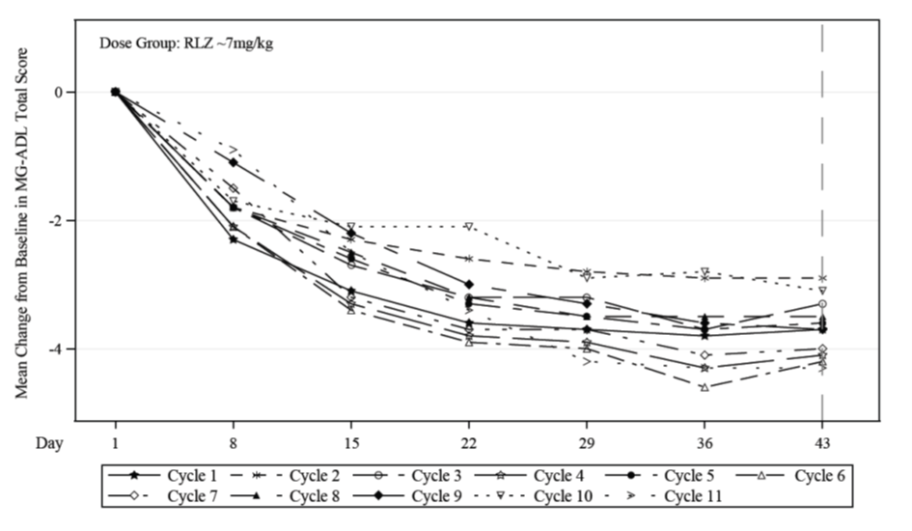

Paediatric population
The European Medicines Agency has deferred the obligation to submit the results of studies with Rystiggo in one or more subsets of the paediatric population in the treatment of myasthenia gravis (see section 4.2 for information on paediatric use).

5.2 Pharmacokinetic properties

Absorption

Following subcutaneous administration of rozanolixizumab, peak plasma levels are achieved after approximately 2 days. The absolute bioavailability of rozanolixizumab after subcutaneous administration was about 70 % as estimated by population pharmacokinetic analysis.

Distribution

The apparent volume of distribution of rozanolixizumab is approximately 7 l estimated by population pharmacokinetic analysis.

Biotransformation

Rozanolixizumab is expected to be degraded into small peptides and amino acids via catabolic pathways in a manner similar to endogenous IgG.

Elimination

The apparent linear clearance for the free active substance is approximately 0.9 l/day. The half-life of rozanolixizumab is concentration-dependent and cannot be calculated. Rozanolixizumab plasma concentrations are undetectable within one week after dosing.

Linearity/non-linearity

Rozanolixizumab exhibited nonlinear pharmacokinetics typical for a monoclonal antibody that undergoes target-mediated drug disposition. At steady-state, maximum plasma concentrations and area under the concentration time curve (AUC) were predicted to be 3-fold and 4-fold higher at weight-tiered doses of ≈10 mg/kg as compared to ≈7 mg/kg, respectively.

Special populations

Age, sex, or race
A population pharmacokinetic analysis did not reveal a clinically significant impact of age, sex or race on the pharmacokinetics of rozanolixizumab.

Renal or hepatic impairment
No dedicated studies have been conducted in patients with renal or hepatic impairment. However, renal or hepatic impairment is not expected to affect the pharmacokinetics of rozanolixizumab. Based on a population pharmacokinetic analysis, renal function (estimated glomerular filtration rate [eGFR] 38-161 ml/min/1.73 m²) or hepatic biochemical and function tests (alanine transaminase [ALT], aspartate transaminase [AST], alkaline phosphatase and bilirubin) had no clinically significant effect on rozanolixizumab apparent linear clearance.

Immunogenicity

Development of neutralising antibodies was associated with a 24 % decrease in overall plasma exposure of rozanolixizumab. There was no apparent impact of immunogenicity on efficacy and safety (see section 4.4).

5.3 Preclinical safety data

Non-clinical data reveal no special hazard for humans based on conventional studies of repeated dose toxicity (including safety pharmacology and fertility endpoints) and toxicity to reproduction and development. Administration to cynomolgus and rhesus monkeys resulted in the expected reduction in IgG. Vaccination during the treatment phase elicited normal IgM levels and a low IgG response due to accelerated IgG degradation. However, boost vaccination after rozanolixizumab clearance resulted in normal IgM and IgG response.

The mutagenic potential of rozanolixizumab has not been evaluated; however, monoclonal antibodies are not expected to alter DNA or chromosomes.
Carcinogenicity studies have not been conducted with rozanolixizumab.

No treatment-related changes were noted in the male and female reproductive organs or male and female fertility parameters of sexually mature animals in 26-week repeated dose toxicity study.
Rozanolixizumab had no effects on embryo-foetal and postnatal development. Offspring from treated dams had very low levels of IgG at birth, as expected from the pharmacology. IgG level recovered to control values or greater within 60 days. There was no impact on immune cell number, lymphoid organ architecture and immune function of the pups of treated mothers as assessed by a T-cell Dependent Antibody Response (TDAR) assay.

6. PHARMACEUTICAL PARTICULARS

6.1 List of excipients

Histidine
Histidine hydrochloride monohydrate
Proline
Polysorbate 80
Water for injections

6.2 Incompatibilities

In the absence of compatibility studies, this medicinal product must not be mixed with other medicinal products for infusion.

6.3 Shelf life

3 years

The chemical and physical in-use stability has been demonstrated for 19 hours at 25 °C. From a microbiological point of view, unless the method of preparation precludes the risks of microbial contamination, the product should be used immediately. If not used immediately, in-use storage times and conditions are the responsibility of the user.

6.4 Special precautions for storage

Store in a refrigerator (2 °C – 8 °C).
Do not freeze.
Keep the vial in the outer carton in order to protect from light.

6.5 Nature and contents of container

Vial (Type I glass) with a stopper (rubber) sealed with a crimp seal and flip off cap. Pack size of 1 vial.

Each single use vial contains 2 ml, 3 ml, 4 ml or 6 ml of solution for injection.
Not all vials may be marketed.

6.6 Special precautions for disposal and other handling

Material specificities

The rozanolixizumab solution for injection can be administered using polypropylene syringes as well as infusion sets containing polyethylene (PE), polypropylene (PP), low density polyethylene (LDPE), polyester, polyvinyl chloride (PVC without DEHP), polycarbonate (PC), fluorinated ethylene polypropylene (FEP), urethane/acrylate, polyurethane, meta-acrylonitrile butadiene styrene (MABS), silicone or cyclohexanone. Do not use administration devices labelled as containing di(2-ethylhexyl)phthalate (DEHP).

Each vial is for single use only. Any unused medicinal product or waste material should be disposed of in accordance with local requirements.

Instructions for use
Before administering Rystiggo, the instructions for use must be read carefully (for further details please refer to the instructions for use included in the patient information leaflet):

Common instructions for infusion with a pump and manual push

- Allow vials to reach room temperature. This may take a minimum of 30 minutes up to 120 minutes. Do not use heating devices.
- Check each vial before using:
- Expiration date: do not use beyond expiration date.
- Colour: the solution should be colourless to pale brownish-yellow, clear to slightly opalescent. Do not use the vial if the liquid looks cloudy, contains foreign particles, or has changed colour.
- Cap: do not use if protective cap of the vial is missing or defective.
- Collect all items for the infusion. In addition to the vial unit(s), collect the following, which are not supplied: syringe (5-10 ml, depending on the prescribed dose), syringe needle (s), transfer needle or vented vial adaptor, alcohol wipe, infusion set, bowl or paper towel, tape or transparent dressing, infusion pump (if applicable) and sharps container.
- In order to avoid potential interruptions in delivery of Rystiggo, the following criteria should be respected:
  - Administration tubing length of 61 cm or shorter is recommended.
An infusion set with a needle of 26 gauge or with a larger diameter should be used.
- Use aseptic technique when preparing and administering this product.
- Use transfer needles with a needle of 18 gauge or with a larger diameter to fill the syringe.
- Extract the entire content of the vial into the syringe. A small amount will remain in the vial and should be discarded.
- For multiple vials, use a fresh needle and repeat previous steps.
- Remove the needle from the syringe and attach the infusion set to the syringe.
- Each vial contains excess volume (to allow priming of the infusion line); therefore, pre-set the pump to deliver the prescribed volume or adjust the volume to be administered by expelling any excess volume.
- Administer immediately after priming the infusion set
- Choose an infusion area: lower right or lower left part of the abdomen, below the belly button. Never infuse into areas where the skin is tender, bruised, red or hard. Avoid infusing into scars or stretch marks.
- Clean the infusion site using alcohol wipe. Allow to dry.
- Insert the infusion set needle into the subcutaneous tissue.
- If necessary, use tape or transparent dressing to hold the needle in place.
- When the infusion is complete, do not flush the infusion line as the volume of infusion has been adjusted taking into account the losses in the line.

When Rystiggo is administered through an infusion pump
- Syringe pump occlusion alarm limits must be set to the maximum setting, if applicable.
- Follow the instructions provided with the infusion pump to prepare the pump and prime the infusion line.

7. MARKETING AUTHORISATION HOLDER

UCB Pharma S.A.
Allée de la Recherche 60
B-1070 Bruxelles
Belgium

8. MARKETING AUTHORISATION NUMBER(S)

EU/1/23/1780/001
EU/1/23/1780/002
EU/1/23/1780/003
EU/1/23/1780/004

9. DATE OF FIRST AUTHORISATION/RENEWAL OF THE AUTHORISATION

Date of first authorisation: 05 January 2024

10. DATE OF REVISION OF THE TEXT

Detailed information on this medicinal product is available on the website of the European Medicines Agency https://www.ema.europa.eu.

ANNEX II

A. MANUFACTURER(S) OF THE BIOLOGICAL ACTIVE SUBSTANCE AND MANUFACTURER(S) RESPONSIBLE FOR BATCH RELEASE

B. CONDITIONS OR RESTRICTIONS REGARDING SUPPLY AND USE

C. OTHER CONDITIONS AND REQUIREMENTS OF THE MARKETING AUTHORISATION

D. CONDITIONS OR RESTRICTIONS WITH REGARD TO THE SAFE AND EFFECTIVE USE OF THE MEDICINAL PRODUCT

A. MANUFACTURER(S) OF THE BIOLOGICAL ACTIVE SUBSTANCE AND MANUFACTURER(S) RESPONSIBLE FOR BATCH RELEASE

Name and address of the manufacturer(s) of the biological active substance(s)

Samsung BioLogics Co. Ltd
300, Songdo bio-daero
Yeonsu-gu
Incheon 21987
Republic of Korea

Name and address of the manufacturer(s) responsible for batch release

UCB Pharma S.A.
Chemin du Foriest
B-1420 Braine l'Alleud
Belgium

B. CONDITIONS OR RESTRICTIONS REGARDING SUPPLY AND USE

Medicinal product subject to restricted medical prescription (see Annex I: Summary of Product Characteristics, section 4.2).

C. OTHER CONDITIONS AND REQUIREMENTS OF THE MARKETING AUTHORISATION

- Periodic safety update reports (PSURs)

The requirements for submission of PSURs for this medicinal product are set out in the list of Union reference dates (EURD list) provided for under Article 107c(7) of Directive 2001/83/EC and any subsequent updates published on the European medicines web-portal.

D. CONDITIONS OR RESTRICTIONS WITH REGARD TO THE SAFE AND EFFECTIVE USE OF THE MEDICINAL PRODUCT

- Risk management plan (RMP)

The marketing authorisation holder (MAH) shall perform the required pharmacovigilance activities and interventions detailed in the agreed RMP presented in Module 1.8.2 of the marketing authorisation and any agreed subsequent updates of the RMP.

An updated RMP should be submitted:
- At the request of the European Medicines Agency;
- Whenever the risk management system is modified, especially as the result of new information being received that may lead to a significant change to the benefit/risk profile or as the result of an important (pharmacovigilance or risk minimisation) milestone being reached.

ANNEX III

LABELLING AND PACKAGE LEAFLET

A. LABELLING

PARTICULARS TO APPEAR ON THE OUTER PACKAGING

OUTER CARTON

1. NAME OF THE MEDICINAL PRODUCT

Rystiggo 140 mg/ml solution for injection
rozanolixizumab

2. STATEMENT OF ACTIVE SUBSTANCE(S)

Each ml of solution for injection contains 140 mg of rozanolixizumab.
One vial of 2 ml contains 280 mg of rozanolixizumab.

3. LIST OF EXCIPIENTS

Excipients: histidine, histidine hydrochloride monohydrate, proline, Polysorbate 80 and water for injections

4. PHARMACEUTICAL FORM AND CONTENTS

Solution for injection
1 vial of 2 ml
280 mg/ 2 ml

5. METHOD AND ROUTE(S) OF ADMINISTRATION

Subcutaneous use
Read the package leaflet before use.

6. SPECIAL WARNING THAT THE MEDICINAL PRODUCT MUST BE STORED OUT OF THE SIGHT AND REACH OF CHILDREN

Keep out of the sight and reach of children.

7. OTHER SPECIAL WARNING(S), IF NECESSARY

8. EXPIRY DATE

EXP

9. SPECIAL STORAGE CONDITIONS

Store in a refrigerator. Do not freeze.
Keep the vial in the outer carton in order to protect from light.

10. SPECIAL PRECAUTIONS FOR DISPOSAL OF UNUSED MEDICINAL PRODUCTS OR WASTE MATERIALS DERIVED FROM SUCH MEDICINAL PRODUCTS, IF APPROPRIATE

For single use only
Any unused product or waste material should be disposed of in accordance with local requirements.

11. NAME AND ADDRESS OF THE MARKETING AUTHORISATION HOLDER

UCB Pharma S.A. (logo)
Allée de la Recherche 60
B-1070 Bruxelles
Belgium

12. MARKETING AUTHORISATION NUMBER(S)

EU/1/23/1780/001

13. BATCH NUMBER

Lot

14. GENERAL CLASSIFICATION FOR SUPPLY

15. INSTRUCTIONS ON USE

16. INFORMATION IN BRAILLE

rystiggo 280 mg

17. UNIQUE IDENTIFIER – 2D BARCODE

2D barcode carrying the unique identifier included.

18. UNIQUE IDENTIFIER - HUMAN READABLE DATA

PC
SN
NN

MINIMUM PARTICULARS TO APPEAR ON SMALL IMMEDIATE PACKAGING UNITS

VIAL LABEL TEXT

1. NAME OF THE MEDICINAL PRODUCT AND ROUTE(S) OF ADMINISTRATION

Rystiggo 140 mg/ml injection
rozanolixizumab
SC

2. METHOD OF ADMINISTRATION

3. EXPIRY DATE

EXP

4. BATCH NUMBER

Lot

5. CONTENTS BY WEIGHT, BY VOLUME OR BY UNIT

280 mg/2 ml

6. OTHER

PARTICULARS TO APPEAR ON THE OUTER PACKAGING

OUTER CARTON

1. NAME OF THE MEDICINAL PRODUCT

Rystiggo 140 mg/ml solution for injection
rozanolixizumab

2. STATEMENT OF ACTIVE SUBSTANCE(S)

Each ml of solution for injection contains 140 mg of rozanolixizumab.
One vial of 3 ml contains 420 mg of rozanolixizumab.

3. LIST OF EXCIPIENTS

Excipients: histidine, histidine hydrochloride monohydrate, proline, Polysorbate 80 and water for injections

4. PHARMACEUTICAL FORM AND CONTENTS

Solution for injection
1 vial of 3 ml
420 mg/ 3 ml

5. METHOD AND ROUTE(S) OF ADMINISTRATION

Subcutaneous use
Read the package leaflet before use.

6. SPECIAL WARNING THAT THE MEDICINAL PRODUCT MUST BE STORED OUT OF THE SIGHT AND REACH OF CHILDREN

Keep out of the sight and reach of children.

7. OTHER SPECIAL WARNING(S), IF NECESSARY

8. EXPIRY DATE

EXP

9. SPECIAL STORAGE CONDITIONS

Store in a refrigerator. Do not freeze.
Keep the vial in the outer carton in order to protect from light.

10. SPECIAL PRECAUTIONS FOR DISPOSAL OF UNUSED MEDICINAL PRODUCTS OR WASTE MATERIALS DERIVED FROM SUCH MEDICINAL PRODUCTS, IF APPROPRIATE

For single use only
Any unused product or waste material should be disposed of in accordance with local requirements.

11. NAME AND ADDRESS OF THE MARKETING AUTHORISATION HOLDER

UCB Pharma S.A. (logo)
Allée de la Recherche 60
B-1070 Bruxelles
Belgium

12. MARKETING AUTHORISATION NUMBER(S)

EU/1/23/1780/002

13. BATCH NUMBER

Lot

14. GENERAL CLASSIFICATION FOR SUPPLY

15. INSTRUCTIONS ON USE

16. INFORMATION IN BRAILLE

rystiggo 420 mg

17. UNIQUE IDENTIFIER – 2D BARCODE

2D barcode carrying the unique identifier included.

18. UNIQUE IDENTIFIER - HUMAN READABLE DATA

PC
SN
NN

MINIMUM PARTICULARS TO APPEAR ON SMALL IMMEDIATE PACKAGING UNITS

VIAL LABEL TEXT

1. NAME OF THE MEDICINAL PRODUCT AND ROUTE(S) OF ADMINISTRATION

Rystiggo 140 mg/ml injection
rozanolixizumab
SC

2. METHOD OF ADMINISTRATION

3. EXPIRY DATE

EXP

4. BATCH NUMBER

Lot

5. CONTENTS BY WEIGHT, BY VOLUME OR BY UNIT

420 mg/3 ml

6. OTHER

PARTICULARS TO APPEAR ON THE OUTER PACKAGING

OUTER CARTON

1. NAME OF THE MEDICINAL PRODUCT

Rystiggo 140 mg/ml solution for injection
rozanolixizumab

2. STATEMENT OF ACTIVE SUBSTANCE(S)

Each ml of solution for injection contains 140 mg of rozanolixizumab.
One vial of 4 ml contains 560 mg of rozanolixizumab.

3. LIST OF EXCIPIENTS

Excipients: histidine, histidine hydrochloride monohydrate, proline, Polysorbate 80 and water for injections

4. PHARMACEUTICAL FORM AND CONTENTS

Solution for injection
1 vial of 4 ml
560 mg/ 4 ml

5. METHOD AND ROUTE(S) OF ADMINISTRATION

Subcutaneous use
Read the package leaflet before use.

6. SPECIAL WARNING THAT THE MEDICINAL PRODUCT MUST BE STORED OUT OF THE SIGHT AND REACH OF CHILDREN

Keep out of the sight and reach of children.

7. OTHER SPECIAL WARNING(S), IF NECESSARY

8. EXPIRY DATE

EXP

9. SPECIAL STORAGE CONDITIONS

Store in a refrigerator. Do not freeze.
Keep the vial in the outer carton in order to protect from light.

10. SPECIAL PRECAUTIONS FOR DISPOSAL OF UNUSED MEDICINAL PRODUCTS OR WASTE MATERIALS DERIVED FROM SUCH MEDICINAL PRODUCTS, IF APPROPRIATE

For single use only
Any unused product or waste material should be disposed of in accordance with local requirements.

11. NAME AND ADDRESS OF THE MARKETING AUTHORISATION HOLDER

UCB Pharma S.A. (logo)
Allée de la Recherche 60
B-1070 Bruxelles
Belgium

12. MARKETING AUTHORISATION NUMBER(S)

EU/1/23/1780/003

13. BATCH NUMBER

Lot

14. GENERAL CLASSIFICATION FOR SUPPLY

15. INSTRUCTIONS ON USE

16. INFORMATION IN BRAILLE

rystiggo 560 mg

17. UNIQUE IDENTIFIER – 2D BARCODE

2D barcode carrying the unique identifier included.

18. UNIQUE IDENTIFIER - HUMAN READABLE DATA

PC
SN
NN

MINIMUM PARTICULARS TO APPEAR ON SMALL IMMEDIATE PACKAGING UNITS

VIAL LABEL TEXT

1. NAME OF THE MEDICINAL PRODUCT AND ROUTE(S) OF ADMINISTRATION

Rystiggo 140 mg/ml injection
rozanolixizumab
SC

2. METHOD OF ADMINISTRATION

3. EXPIRY DATE

EXP

4. BATCH NUMBER

Lot

5. CONTENTS BY WEIGHT, BY VOLUME OR BY UNIT

560 mg/4 ml

6. OTHER

PARTICULARS TO APPEAR ON THE OUTER PACKAGING

OUTER CARTON

1. NAME OF THE MEDICINAL PRODUCT

Rystiggo 140 mg/ml solution for injection
rozanolixizumab

2. STATEMENT OF ACTIVE SUBSTANCE(S)

Each ml of solution for injection contains 140 mg of rozanolixizumab.
One vial of 6 ml contains 840 mg of rozanolixizumab.

3. LIST OF EXCIPIENTS

Excipients: histidine, histidine hydrochloride monohydrate, proline, Polysorbate 80 and water for injections

4. PHARMACEUTICAL FORM AND CONTENTS

Solution for injection
1 vial of 6 ml
840 mg/ 6 ml

5. METHOD AND ROUTE(S) OF ADMINISTRATION

Subcutaneous use
Read the package leaflet before use.

6. SPECIAL WARNING THAT THE MEDICINAL PRODUCT MUST BE STORED OUT OF THE SIGHT AND REACH OF CHILDREN

Keep out of the sight and reach of children.

7. OTHER SPECIAL WARNING(S), IF NECESSARY

8. EXPIRY DATE

EXP

9. SPECIAL STORAGE CONDITIONS

Store in a refrigerator. Do not freeze.
Keep the vial in the outer carton in order to protect from light.

10. SPECIAL PRECAUTIONS FOR DISPOSAL OF UNUSED MEDICINAL PRODUCTS OR WASTE MATERIALS DERIVED FROM SUCH MEDICINAL PRODUCTS, IF APPROPRIATE

For single use only
Any unused product or waste material should be disposed of in accordance with local requirements.

11. NAME AND ADDRESS OF THE MARKETING AUTHORISATION HOLDER

UCB Pharma S.A. (logo)
Allée de la Recherche 60
B-1070 Bruxelles
Belgium

12. MARKETING AUTHORISATION NUMBER(S)

EU/1/23/1780/004

13. BATCH NUMBER

Lot

14. GENERAL CLASSIFICATION FOR SUPPLY

15. INSTRUCTIONS ON USE

16. INFORMATION IN BRAILLE

rystiggo 840 mg

17. UNIQUE IDENTIFIER – 2D BARCODE

2D barcode carrying the unique identifier included.

18. UNIQUE IDENTIFIER - HUMAN READABLE DATA

PC
SN
NN

MINIMUM PARTICULARS TO APPEAR ON SMALL IMMEDIATE PACKAGING UNITS

VIAL LABEL TEXT

1. NAME OF THE MEDICINAL PRODUCT AND ROUTE(S) OF ADMINISTRATION

Rystiggo 140 mg/ml injection
rozanolixizumab
SC

2. METHOD OF ADMINISTRATION

3. EXPIRY DATE

EXP

4. BATCH NUMBER

Lot

5. CONTENTS BY WEIGHT, BY VOLUME OR BY UNIT

840 mg/6 ml

6. OTHER

B. PACKAGE LEAFLET

Package leaflet: Information for the patient

Rystiggo 140 mg/ml solution for injection
rozanolixizumab

This medicine is subject to additional monitoring. This will allow quick identification of new safety information. You can help by reporting any side effects you may get. See the end of section 4 for how to report side effects.

Read all of this leaflet carefully before you start using this medicine because it contains important information for you.
- Keep this leaflet. You may need to read it again.
- If you have any further questions, ask your doctor, pharmacist or nurse.
- This medicine has been prescribed for you only. Do not pass it on to others. It may harm them, even if their signs of illness are the same as yours.
- If you get any side effects, talk to your doctor, pharmacist or nurse. This includes any possible side effects not listed in this leaflet. See section 4.

What is in this leaflet

1. What Rystiggo is and what it is used for
2. What you need to know before you use Rystiggo
3. How to use Rystiggo
4. Possible side effects
5. How to store Rystiggo
6. Contents of the pack and other information

1. What Rystiggo is and what it is used for

What is Rystiggo

Rystiggo contains the active substance rozanolixizumab. Rozanolixizumab is a monoclonal antibody (a type of protein) designed to recognise and attach to FcRn, a protein that keeps the immunoglobulin G (IgG) antibodies in the body for longer.

Rystiggo is used together with standard therapy in adults to treat generalised myasthenia gravis (gMG), an autoimmune disease that causes muscle weakness which can affect multiple muscle groups throughout the body. The condition can also lead to shortness of breath, extreme fatigue and difficulties swallowing. Rystiggo is used in adults with gMG that produces IgG autoantibodies against acetylcholine receptors or muscle-specific kinase.

In generalised myasthenia gravis (gMG), these IgG autoantibodies (proteins of the immune system that attack parts of a person’s own body) attack and damage proteins that are involved in communication between nerves and muscle, called acetylcholine receptors or muscle-specific kinase. By attaching to FcRn, Rystiggo reduces the level of IgG antibodies, including IgG autoantibodies, thereby helping to improve symptom of the disease.

2. What you need to know before you use Rystiggo

Do not use Rystiggo

- If you are allergic to rozanolixizumab or any of the other ingredients of this medicine (listed in section 6).

Warnings and precautions

Talk to your doctor, pharmacist or nurse before using this medicine if any of the following applies to you:

Myasthenic crisis
Your doctor may not prescribe this medicine if you are, or are likely to be, on a ventilator due to gMG muscle weakness (myasthenic crisis).

Inflammation of the membranes that surround the brain and spinal cord (aseptic meningitis)
Aseptic meningitis has been observed in association with this medicine. Seek immediate medical attention if you develop symptoms of aseptic meningitis such as severe headache, fever, stiffness of the neck, nausea, vomiting and/or intolerance to bright light.

Infections
This medicine may reduce your natural resistance to infections. Before starting or during treatment with this medicine, inform your doctor if you have any symptoms of infection (feeling warm, fever, chills or shivering, cough, sore throat or fever blisters may be signs of an infection).

Hypersensitivity (allergic reactions)
This medicine contains a protein that can cause reactions such as rash, swelling or itching in some people. You will be monitored for signs of an infusion reaction during and for 15 minutes after treatment.

Immunisations (vaccinations)
Please inform your doctor if you have received a vaccine in the last 4 weeks, or if you plan to be vaccinated in the near future.

Children and adolescents

Do not give this medicine to children below the age of 18 years because the use of Rystiggo has not been studied in this age group.

Other medicines and Rystiggo

Tell your doctor or pharmacist if you are using, have recently used or might use any other medicines.

Taking Rystiggo with other medicines may decrease the effectiveness of those medicines, including therapeutic antibodies (such as rituximab) or subcutaneous or intravenous immunoglobulins. Other medicines, including subcutaneous or intravenous immunoglobulins, or interventions such as plasmapheresis (a process in which the liquid part of the blood, or plasma, is separated from blood that has been drawn from a person), may impair the effect of Rystiggo. Tell your doctor if you are taking or planning to take other medicines.

Tell your doctor about your treatment with Rystiggo before you have a vaccination. This medicine may impair the effect of vaccines. Vaccination with so-called live-attenuated or live vaccines is not recommended during treatment with Rystiggo.

Pregnancy and breast-feeding

If you are pregnant or breast-feeding, think you may be pregnant or are planning to have a baby, ask your doctor or pharmacist for advice before using this medicine.

The effects of this medicine in pregnancy are not known. You should not use this medicine if you are pregnant or think that you may be pregnant unless your doctor specifically recommends it.

It is not known whether this medicine passes into human milk. Your doctor will help you decide if you should breast-feed and use Rystiggo.

Driving and using machines

Rystiggo is not likely to affect your driving and use of machines.

Rystiggo contains proline

This medicine contains 29 mg of proline in each ml of medicine.
Proline may be harmful for patients with hyperprolinaemia, a rare genetic disorder in which an excess of the amino acid, proline, builds up in the body.
If you have hyperprolinaemia, tell your doctor and do not use this medicine unless your doctor has recommended it.

Rystiggo contains polysorbate 80

This medicine contains 0.3 mg of polysorbate 80 in each ml of medicine. Polysorbates may cause allergic reactions. Tell your doctor if you have any known allergies.

3. How to use Rystiggo

Treatment with Rystiggo will be initiated and supervised by a specialist physician experienced in the management of neuromuscular or neuro-inflammatory disorders.

How much Rystiggo is given and for how long

You will be given Rystiggo in cycles of 1 infusion per week for 6 weeks.
Your doctor will calculate the correct dose for you based on your weight:
- if you weigh at least 100 kg, the recommended dose is 840 mg per infusion (requiring 6 ml per administration)
- if you weigh from 70 kg to less than 100 kg, the recommended dose is 560 mg per infusion (requiring 4 ml per administration)
- if you weigh from 50 kg to less than 70 kg, the recommended dose is 420 mg per infusion (requiring 3 ml per administration)
- if you weigh from 35 kg to less than 50 kg, the recommended dose is 280 mg per infusion (requiring 2 ml per administration)

The frequency of treatment cycles varies for each patient and your doctor will consider if and when a new treatment cycle is appropriate for you.

Your doctor will advise you on how long you should be treated with this medicine.

How Rystiggo is given

Rystiggo will be given to you by a doctor or nurse.
Rystiggo can also be injected by yourself. You and your doctor or nurse will decide if, after training by a healthcare professional, you can inject this medicine yourself. Another person may also give your injections after they have been trained. Do not give yourself or someone else Rystiggo until you have been trained on how to do it.
If you or your caregiver inject Rystiggo, you or your caregiver must carefully read and follow the Instructions for administration at the end of this leaflet (see ‘Instructions for use’).

You will be given this medicine as an infusion under the skin (subcutaneous use). It is usually injected into the lower part of the tummy, below the belly button. Injections should not be given into areas where the skin is tender, bruised, red or hard.

The administration is done using an infusion pump set at a flow rate up to 20 ml/hr.
The administration can also be done manually (by manual push, this means without an infusion pump) at a flow rate that is comfortable for you.

If you receive more Rystiggo than you should

If you suspect that you have been accidentally administered a higher dose of Rystiggo than prescribed, please contact your doctor for advice.

If you forget or miss an appointment to receive Rystiggo

If you miss a dose, please contact your doctor immediately for advice and to schedule another appointment to receive Rystiggo within the next 4 days. Thereafter, the next dose should be given according to the original dosing schedule until the treatment cycle is completed.

If you stop using Rystiggo

Do not stop using this medicine without talking to your doctor first. Interrupting or stopping treatment with Rystiggo may cause your symptoms of generalised myasthenia gravis to come back.

If you have any further questions on the use of this medicine, ask your doctor, pharmacist or nurse.

4. Possible side effects

Like all medicines, this medicine can cause side effects, although not everybody gets them.

The below side effects, presented in order of decreasing frequency, have been observed with Rystiggo:

Very common: may affect more than 1 in 10 people
- Headache (including migraine)
- Diarrhoea
- Fever (pyrexia)

Common: may affect up to 1 in 10 people
- Rapid swelling under the skin in areas such as the face, throat, arms and legs (angioedema)
- Joint pain (arthralgia)
- Skin rash, sometimes with red bumps (rash papular)
- Injection site reaction including injection site rash, redness of the skin (erythema), inflammation, discomfort, and infusion site pain
- Nose and throat infections

- Not known (frequency cannot be estimated from the available data)
- reversible non-infectious inflammation of the protective membranes that surround the brain and spinal cord (aseptic meningitis):
- headache
- fever
- stiffness of the neck
- nausea
- vomiting
- and/or intolerance to bright light

Reporting of side effects

If you get any side effects, talk to your doctor, pharmacist or nurse. This includes any possible side effects not listed in this leaflet. You can also report side effects directly via the national reporting system listed in Appendix V. By reporting side effects you can help provide more information on the safety of this medicine.

5. How to store Rystiggo

Keep this medicine out of the sight and reach of children.

Do not use this medicine after the expiry date which is stated on the vial label and outer carton after EXP. The expiry date refers to the last day of that month.

Store in a refrigerator (2 °C – 8 °C).
Do not freeze.

Keep the vial in the outer carton in order to protect from light.

Each vial of solution for injection must be used only once (single use). Any unused product or waste material should be disposed of in accordance with local requirements.

Do not use this medicine if you notice that the liquid looks cloudy, contains foreign particles, or has changed colour.

Do not throw away any medicines via wastewater or household waste. Ask your pharmacist how to throw away medicines you no longer use. These measures will help protect the environment.

6. Contents of the pack and other information

What Rystiggo contains

- The active substance is rozanolixizumab. Each ml of solution contains 140 mg of rozanolixizumab. Each vial of 2 ml contains 280 mg rozanolixizumab. Each vial of 3 ml contains 420 mg rozanolixizumab. Each vial of 4 ml contains 560 mg rozanolixizumab. Each vial of 6 ml contains 840 mg rozanolixizumab.
- The other ingredients are: histidine, histidine hydrochloride monohydrate, proline, polysorbate 80, and water for injections. See section 2 Rystiggo contains proline and Rystiggo contains polysorbate 80.

What Rystiggo looks like and contents of the pack

Rystiggo is a solution for injection. Each carton contains 1 vial of 2 ml, 3 ml, 4 ml or 6 ml solution for injection.
Not all vials may be marketed.

The solution is colourless to pale brownish-yellow, clear to slightly opalescent (pearly white).
The devices used for administration should be procured separately.

Marketing Authorisation Holder

UCB Pharma S.A., Allée de la Recherche 60, B-1070 Bruxelles, Belgium

Manufacturer

UCB Pharma S.A., Chemin du Foriest, B-1420 Braine-l’Alleud, Belgium.

For any information about this medicine, please contact the local representative of the Marketing Authorisation Holder:

België/Belgique/Belgien  UCB Pharma S.A./NV  Tél/Tel: + 32 / (0)2 559 92 00 | Lietuva  UAB Medfiles  Tel: + 370 5 246 16 40
България  Ю СИ БИ България ЕООД  Teл.: + 359 (0) 2 962 30 49 | Luxembourg/Luxemburg  UCB Pharma S.A./NV  Tél/Tel: + 32 / (0)2 559 92 00 (Belgique/Belgien)
Česká republika  UCB s.r.o.  Tel: + 420 221 773 411 | Magyarország  UCB Magyarország Kft.  Tel.: + 36-(1) 391 0060
Danmark  UCB Nordic A/S  Tlf.: + 45 / 32 46 24 00 | Malta  Pharmasud Ltd.  Tel: + 356 / 21 37 64 36
Deutschland  UCB Pharma GmbH  Tel: + 49 /(0) 2173 48 4848 | Nederland  UCB Pharma B.V.  Tel: + 31 / (0)76-573 11 40
Eesti  OÜ Medfiles  Tel: + 372 730 5415 | Norge  UCB Nordic A/S  Tlf: + 47 / 67 16 5880
Ελλάδα  UCB Α.Ε.  Τηλ: + 30 / 2109974000 | Österreich  UCB Pharma GmbH  Tel: + 43-(0)1 291 80 00
España  UCB Pharma, S.A.  Tel: + 34 / 91 570 34 44 | Polska  UCB Pharma Sp. z o.o. / VEDIM Sp. z o.o.  Tel.: + 48 22 696 99 20
France  UCB Pharma S.A.  Tél: + 33 / (0)1 47 29 44 35 | Portugal  UCB Pharma (Produtos Farmacêuticos), Lda  Tel: + 351 21 302 5300
Hrvatska  Medis Adria d.o.o.  Tel: +385 (0) 1 230 34 46 | România  UCB Pharma Romania S.R.L.  Tel: + 40 21 300 29 04
Ireland  UCB (Pharma) Ireland Ltd.  Tel: + 353 / (0)1-46 37 395 | Slovenija  Medis, d.o.o.  Tel: + 386 1 589 69 00
Ísland  UCB Nordic A/S  Sími: + 45 / 32 46 24 00 | Slovenská republika  UCB s.r.o., organizačná zložka  Tel: + 421 (0) 2 5920 2020
Italia  UCB Pharma S.p.A.  Tel: + 39 / 02 300 791 | Suomi/Finland  UCB Pharma Oy Finland  Puh/Tel: + 358 9 2514 4221
Κύπρος  Lifepharma (Z.A.M.) Ltd  Τηλ: + 357 22 056300 | Sverige  UCB Nordic A/S  Tel: + 46 / (0) 40 294 900
Latvija
Medfiles SIA
Tel: + 371 67 370 250

This leaflet was last revised in .

Other sources of information

Detailed information on this medicine is available on the European Medicines Agency web site: https://www.ema.europa.eu. There are also links to other websites about rare diseases and treatments.

--------------------------------------------------------------------------------------------------------------------------

INSTRUCTIONS FOR USE

Rystiggo (rozanolixizumab)
Rystiggo 140 mg/ml solution, for subcutaneous use

Single-Use Vial

Read all of these instructions before using Rystiggo. A doctor or nurse will show you how to give yourself Rystiggo before you use it for the first time. Another person may also give your infusions after they have been trained. Do not give yourself or someone else Rystiggo until you have been shown how to do it. This information does not replace talking to your healthcare provider about your medical condition or treatment.

If you are using an infusion pump (also known as a syringe pump) to give yourself Rystiggo, please read the instructions provided by your doctor or nurse on how to set up the pump.

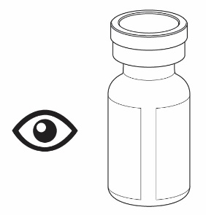
! Important information you need to know before giving yourself or someone else Rystiggo
- For under the skin (subcutaneous) use only.
- Use each vial only once.
- Check your dose – you may need more than 1 vial to
prepare your prescribed dose.
- Do not use Rystiggo if the expiry date has passed.
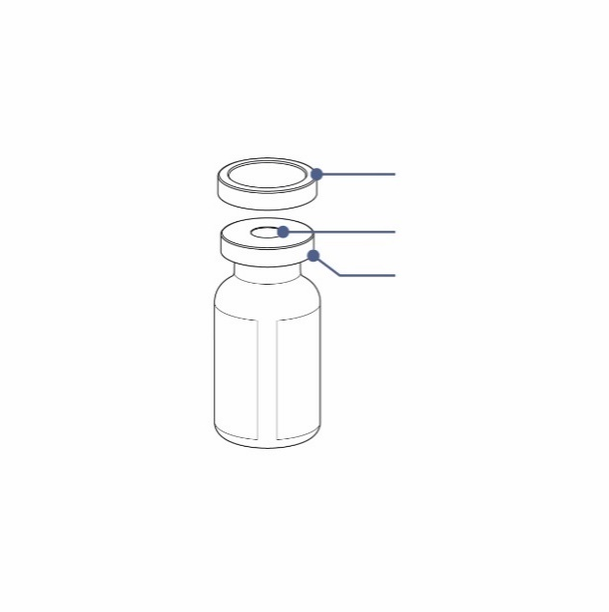
- Before using Rystiggo, check if the dose on the box(es) is the same as your prescribed dose. Do not use if the dose is not the same as your prescription. Contact your doctor or nurse for next steps.
Protective Cap
Rubber Stopper
Aluminium Shield
- Do not use the vial if the liquid has particles you can see. The medicine should be colourless to pale brownish-yellow, clear to slightly opalescent (pearly white).
- Do not shake the vial.
- Do not use the vial if the protective cap is missing or broken. If any of the vials are broken or do not have a cap, report and return them to the pharmacy.
- If you are using a non-programmable pump, please refer to the manufacturer’s instructions for use and your nurse’s guidance on how to fill the infusion line and set the dose.

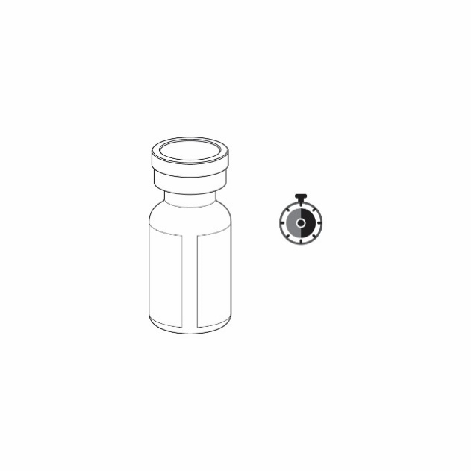
How to store Rystiggo
30 – 120 minutes
- Store in a fridge (2 °C - 8 °C).
- Do not freeze.
- Keep Rystiggo in the original box to protect it from light.
- Remove the box from the fridge before your infusion. For a more comfortable infusion, let the vial reach room temperature before you use this medicine. This may take 30 to 120 minutes. Do not warm in any other way.

! Keep this medicine out of the sight and reach of children.

What is in the box
- 1 vial of Rystiggo - 2 ml, 3 ml, 4 ml or 6 ml depending on your prescribed dose.
- Rystiggo Package Leaflet which includes the Instructions for Use.

Step-by-step instructions

1. Get ready
Step 1: Gather all the supplies you will need on a clean and flat work surface:
- Included in the Rystiggo box(es):
  - Rystiggo vial.
  - Rystiggo Package Leaflet.

! Check your dose – you may need more than 1 vial to
prepare your prescribed dose.

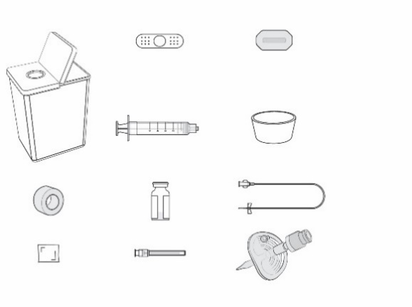
- Not included in the Rystiggo box:
Adhesive Bandage
See-Through Dressing
Bowl
  - Syringe (5 -10 ml depending on your prescribed dose).
  - Transfer needle with 18G needle or larger diameter or a vented vial adaptor.
  - Infusion line with a 26G needle or larger diameter. The infusion line should be 61 cm in length or shorter.
Sharps Container
Syringe
  - Alcohol wipes.
Infusion Line
  - Tape or see-through dressing.
Vial
Tape
  - Adhesive bandage.
  - Sharps container.
Alcohol Wipe
Transfer Needle
  - Bowl or paper towel to collect extra liquid when filling the infusion line.
Vented Vial Adaptor
  - Syringe pump – if you are using a pump.

! The supplies above are for illustration only. Your specific supplies may look different.

Step 2: Clean your work surface and hands
- Clean your work surface with disinfectant and wash your hands carefully with soap and water or use a hand sanitiser. Dry them on a clean towel.

2. Prepare the vial(s) and syringe

! Check your dose – you may need more than 1 vial to prepare your prescribed dose.

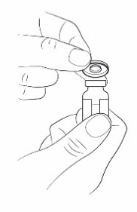
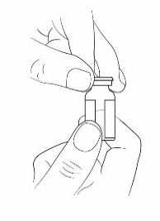
Step 3: Remove the protective cap from the vial(s)
- Take the protective cap off the vial(s) by holding the edge and lifting upwards.
- Clean the rubber stopper with an alcohol wipe. Allow to air-dry.
- Leave the aluminium shield in place.
- Check your dose - if you need more than one vial to prepare your prescribed dose, remove all the caps and clean the stoppers.

! If you are using a vented vial adaptor instead of a transfer needle, you can skip directly to Step 7.

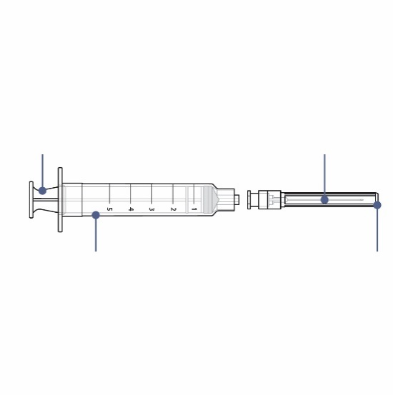
Step 4: Attach the transfer needle to the syringe
Syringe
Syringe Plunger
Transfer Needle
Needle Cap
- Remove the plastic covers from the syringe and transfer needle. Do not touch the tip of the syringe or the base of the needle to avoid germs.
- With the needle cap still on, gently push or twist the transfer needle onto the syringe until it is firmly connected.
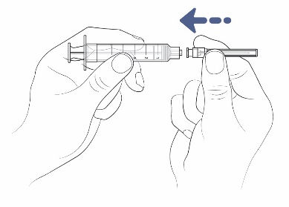

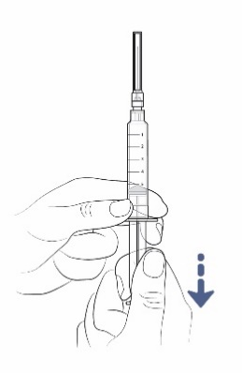

Step 5: Draw air into the syringe
- Slowly pull down on the syringe plunger to draw air into the syringe.
- Fill the syringe with about the same amount of air as the amount of medicine in the vial.
- Keep the needle cap on while you are doing this.

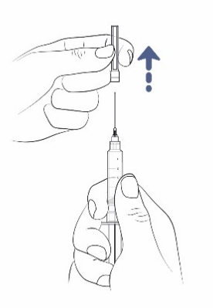
Step 6: Remove the needle cap from the transfer needle
- Hold the syringe with one hand.
- With your other hand, hold the transfer needle cap and pull it straight off the needle
- Place the cap on the table to throw away later.
- Do not touch the needle tip.
- Do not let the needle tip touch anything after you remove the cap.

Step 7: Insert the transfer needle or vented vial adaptor directly into the vial

Follow the instructions for the infusion method you are using:

Using transfer needle
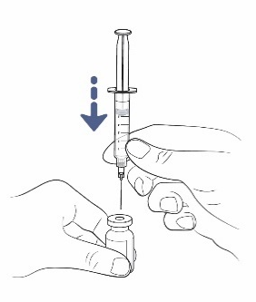
- Place the vial on the table and insert the transfer needle straight through the rubber stopper.

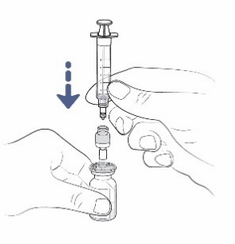
Using vial adaptor
- Place the vial on the table and insert the vial adaptor straight through the rubber stopper.
- Attach the syringe to the vented vial adaptor.

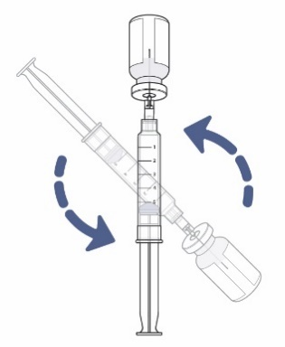
Step 8: Turn the vial and syringe
- Now turn the vial and syringe upside-down.
- Keep the transfer needle or vented vial adaptor inside the vial.

! If you are using a vented vial adaptor, you can skip directly to Step 11.

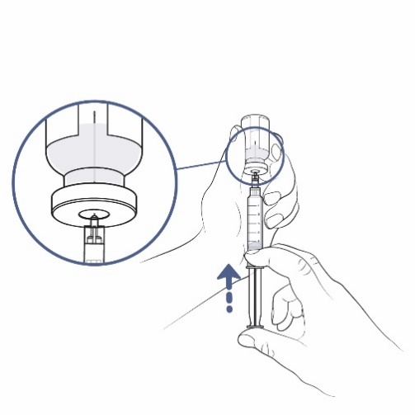
Step 9: Push air from the syringe into the vial
Needle is above medicine
- Check that the transfer needle now points upwards and make sure the needle tip is in the space above the medicine.
- Slowly push the syringe plunger upwards to push all the air from the syringe into the vial. Keep your thumb pressed on the syringe plunger the whole time – so you do not let air into the syringe.
- Keep the needle tip in the space above the medicine the whole time.
- Do not push air into the medicine as this can create bubbles.

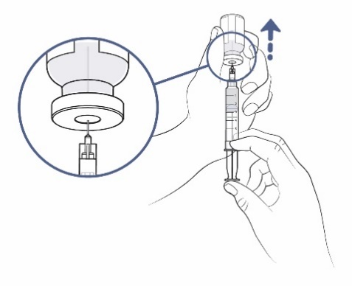
Step 10: Get ready to fill the syringe
- Keep your thumb pushed on the syringe plunger. With your other hand, pull the vial slowly and carefully upwards so the needle tip is fully covered by the liquid medicine.

Step 11: Fill the syringe with as much medicine as possible

! Check your dose – you may need more than 1 vial to prepare your prescribed dose.

- Now slowly pull the syringe plunger down and fill the syringe with medicine.

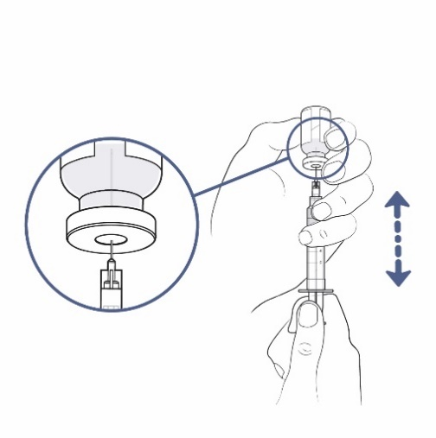
If you are using a transfer needle to fill the syringe, do the following:
Needle is in medicine
  - Keep pulling the vial slowly and carefully upwards to keep the tip of the needle fully covered by the liquid.
  - Adjust the needle tip to keep it in the liquid. This will help you to take as much medicine out of the vial(s) as possible.
- You should now have more medicine in the syringe than your prescribed dose. You will adjust this later.

! There will also be a very small amount of the medicine that you cannot take out of the vial. You will throw this away with the vial later.

! If you are using a vented vial adaptor, detach the syringe from the vented vial adaptor. Leave the vented vial adaptor in the vial. You can throw this away at the end of the infusion. You can now skip directly to Step 14.

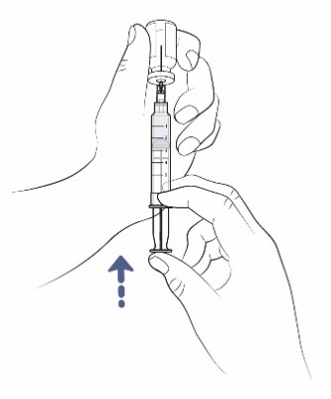
Step 12: Remove air from the syringe
- If there is any space between the liquid in the syringe and the top of the syringe, slowly push the plunger to push air back into the vial.

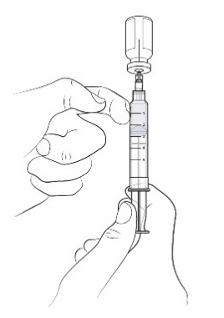
- If you see air bubbles in the syringe, you can remove them by tapping gently on the syringe with your index finger. Now slowly push the plunger to push air back into the vial.

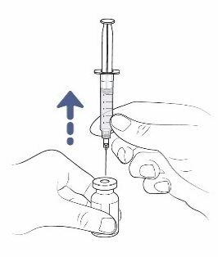
Step 13: Remove the transfer needle from the vial and the syringe
- Turn the vial and syringe over and put the vial on the work surface.
- Remove the transfer needle and syringe from the vial by pulling straight up on the syringe.

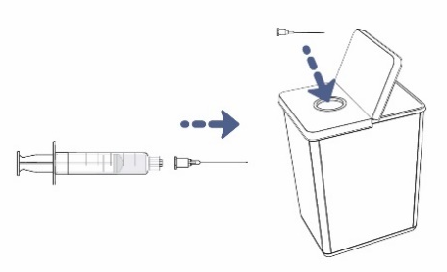
- Remove the transfer needle from the syringe by pulling or twisting carefully on the base of the needle.
- Do not touch the needle. Do not put the needle cap back on.
- Throw the needle away in the sharps container.
- If you are using a vented vial adaptor instead of a needle, it is not necessary to remove the vented vial adaptor from the vial before throwing them away.

Step 14: Re-check your dose
- If you need to use another vial to prepare your prescribed dose, repeat Steps 4-13 with the same syringe and a new transfer needle or vented vial adaptor to avoid contamination.

3. Prepare for infusion
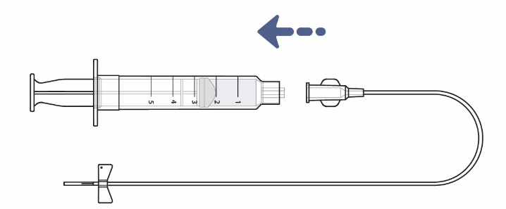
Step 15: Attach the infusion line onto the syringe
- Place the syringe on the clean work surface while you are preparing the infusion line.
- Remove the infusion line from the protective pouch.
- Remove the cap from the end of the infusion line by twisting it off. Place the cap on the work surface to throw away later.
- Attach the infusion line onto the syringe until firmly connected. Do not touch the tip of the syringe or the base of the infusion line to avoid germs.
- Do not remove the needle cap from the infusion line needle.

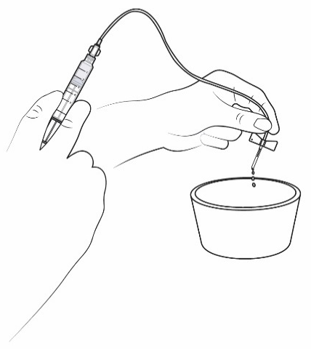
Step 16: Fill the infusion line with medicine
- Make sure you have a bowl or paper towel in front of you – you can use it to collect any medicine from the infusion line that is not needed.
- Keep the cap on the infusion line needle and hold it over the bowl. Now hold the syringe in a vertical position and fill the infusion line with medicine by pushing gently on the syringe plunger.
- The amount of liquid left in the syringe must match your prescribed dose.
- If you are using a syringe pump, please read the manufacturer’s instructions on how to set up and operate the pump and fill the infusion line.
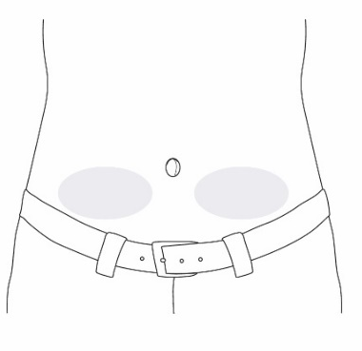
Step 17: Choose and prepare the infusion site
- Choose an infusion site to the lower left or lower right side of the tummy (abdomen), below the level of the belly button.
  - Do not use an area of skin which:
    - is tender, bruised, red or hard
    - has scars or stretch marks.
- Prepare the infusion site:
  - Clean the infusion area with an alcohol wipe and allow it to air-dry.

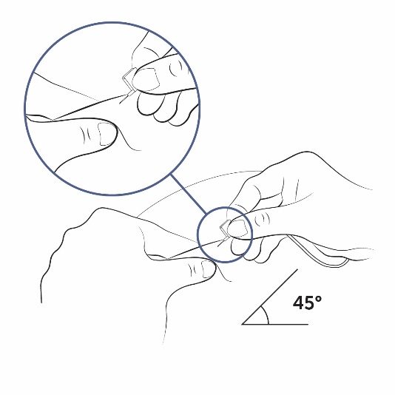
Step 18: Insert the infusion line needle

- Carefully remove the needle cap from the infusion line needle.
- Fold the butterfly wings together and hold them with your thumb and index finger of one hand.
- With your other hand, pinch the skin between 2 fingers to make a fold.
- Push the needle into the middle of the skin and push it under the skin.
- The needle should go in easily. If it is difficult, you can pull the needle out slightly.
- You may be using an infusion line without a butterfly-type needle at the end. Your nurse or doctor will explain to you how to insert the needle.

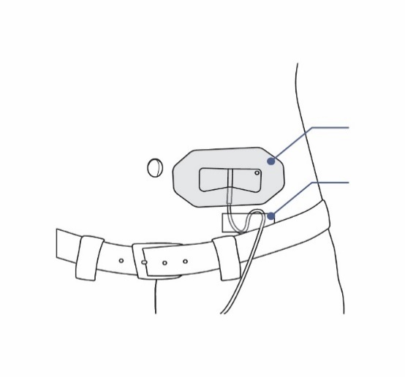
See-Through Dressing
Tape
Step 19: Secure the infusion line needle
- Use a see-through dressing to hold the needle in place. Some infusion sets have a built-in adhesive.
- You can use tape to hold the infusion line on your skin.

4. Infuse and finish
Step 20: Start the infusion

Follow the instructions for the infusion method you are using:

Manual push
  - Sit back comfortably and push firmly on the syringe plunger to infuse the medicine.
  - You should infuse the medicine at a speed that feels comfortable to you. Keep pushing until there is no more medicine left in the syringe.
  - Before and during the infusion, make sure that the infusion line does not twist or bend. If this happens, the flow of medicine can be interrupted. In this case, correct the bend in the infusion line and try again.
  - If it feels uncomfortable or if any of the medicine flows back into the infusion line, you can push more slowly.

Syringe pump
- Before you use a syringe pump, make sure that you understand the following:
  - How to set up your syringe pump (set an infusion rate of up to 20 ml per hour).
  - How to set the occlusion alarm to maximum setting.
  - How to start the syringe pump.
  - What the various syringe pump sounds and alarms mean and how to manage them.
  - How to stop the syringe pump.
- When you are ready to infuse:
  - Place the syringe in the syringe holder and start the pump by following the pump instructions.
  - Sit back comfortably while the pump gives you the medicine.
  - Before and during the infusion, make sure that the infusion line does not twist or bend. If this happens, the flow of medicine can be interrupted. In this case, correct the bend in the infusion line and try again.
  - Once it has finished, stop the pump by following the pump instructions.
  - Take the syringe out of the syringe pump.

! Note: There will be some medicine left in the infusion line. This is normal and you can throw it away in the sharps container.

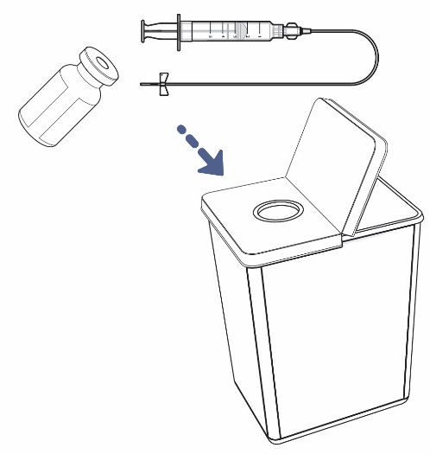
Step 21: Finish the infusion and clean up
- After you finish the infusion, do not try to take the dressing off the needle. Remove them both from your skin together and throw them away with the syringe in the sharps container.
- There may be a drop or two of liquid at the infusion site after you take out the needle. This is normal.
- Throw away any used vial(s) and leftover medicine into the sharps container.
- Cover the infusion site with a clean dressing, such as an adhesive bandage.
- Throw away any other used supplies in your household waste.

! Always keep the sharps container out of the sight and reach of children.

