This document is the approved product information for Toujeo, with the changes since the previous procedure affecting the product information (EMEA/H/C/000309/N/0131) tracked.

For more information, see the European Medicines Agency’s website: <https://www.ema.europa.eu/en/medicines/human/epar/toujeo>

ANNEX I

**SUMMARY OF PRODUCT CHARACTERISTICS**

**1. NAME OF THE MEDICINAL PRODUCT**

Toujeo 300 units/ml SoloStar, solution for injection in a pre-filled pen

Toujeo 300 units/ml DoubleStar, solution for injection in a pre-filled pen

**2. QUALITATIVE AND QUANTITATIVE COMPOSITION**

Each ml contains 300 units insulin glargine* (equivalent to 10.91 mg).

SoloStar pen

Each pencontains 1.5 ml of solution for injection, equivalent to 450 units.

DoubleStar pen

Each pen contains 3 ml of solution for injection, equivalent to 900 units.

* Insulin glargine is produced by recombinant DNA technology in *Escherichia coli*.

For the full list of excipients, see section 6.1.

**3. PHARMACEUTICAL FORM**

Solution for injection (injection).

Clear colourless solution.

**4. CLINICAL PARTICULARS**

**4.1 Therapeutic indications**

Treatment of diabetes mellitus in adults, adolescents and children from the age of 6 years.

**4.2 Posology and method of administration**

Posology

Toujeo is a basal insulin for once‑daily administration at any time of the day, preferably at the same time every day.

The dose regimen (dose and timing) should be adjusted according to individual response.

In type 1 diabetes mellitus, Toujeo must be combined with short-/rapid‑acting insulin to cover mealtime insulin requirements.

In patients with type 2 diabetes mellitus, Toujeo can also be given together with other anti‑hyperglycaemic medicinal products.

The potency of this medicinal product is stated in units. These units are exclusive to Toujeo and are not the same as IU or the units used to express the potency of other insulin analogues (see section 5.1).

*Flexibility in dosing time*

When needed, patients can administer Toujeo up to 3 hours before or after their usual time of administration (see section 5.1).

Patients who forget a dose, should be advised to check their blood sugar and then resume their usual once‑daily dosing schedule. Patients should be informed not to inject a double dose to make up for a forgotten dose.

*Initiation*

*Patients with type 1 diabetes mellitus*

Toujeo is to be used once‑daily with meal‑time insulin and requires individual dose adjustments.

*Patients with type 2 diabetes mellitus*

The recommended daily starting dose is 0.2 units/kg followed by individual dose adjustments.

*Switch between insulin glargine 100 units/ml and Toujeo*

Insulin glargine 100 units/ml and Toujeo are not bioequivalent and are not directly interchangeable.

- When switching from insulin glargine 100 units/ml to Toujeo, this can be done on a unit‑to‑unit basis, but a higher Toujeo dose (approximately 10-18%) may be needed to achieve target ranges for plasma glucose levels.

- When switching from Toujeo to insulin glargine 100 units/ml, the dose should be reduced (approximately by 20%) to reduce the risk of hypoglycaemia.

Close metabolic monitoring is recommended during the switch and in the initial weeks thereafter.

*Switch from other basal insulins to Toujeo*

When switching from a treatment regimen with an intermediate or long‑acting insulin to a regimen with Toujeo, a change of the dose of the basal insulin may be required and the concomitant anti‑hyperglycaemic treatment may need to be adjusted (dose and timing of additional regular insulins or fast‑acting insulin analogues or the dose of non‑insulin anti‑hyperglycaemic medicinal products).

- Switching from once‑daily basal insulins to once‑daily Toujeo can be done unit‑to‑unit based on the previous basal insulin dose.

- Switching from twice‑daily basal insulins to once‑daily Toujeo, the recommended initial Toujeo dose is 80% of the total daily dose of basal insulin that is being discontinued.

Patients with high insulin doses because of antibodies to human insulin may experience an improved insulin response with Toujeo.

Close metabolic monitoring is recommended during the switch and in the initial weeks thereafter.

With improved metabolic control and resulting increase in insulin sensitivity a further adjustment in dose regimen may become necessary. Dose adjustment may also be required, for example, if the patient's weight or life‑style changes, if there is a change in the timing of insulin dose or if other circumstances arise that increase susceptibility to hypo‑or hyperglycaemia (see section 4.4).

*Switch from Toujeo to other basal insulins*

Medical supervision with close metabolic monitoring is recommended during the switch and in the initial weeks thereafter.

Please refer to the prescribing information of the medicinal product to which the patient is switching.

*Special populations*

Toujeo can be used in elderly people, renal and hepatic impaired patients, and children and adolescents from the age of 6 years.

*Elderly population (≥65 years old)*

In the elderly, progressive deterioration of renal function may lead to a steady decrease in insulin requirements (see section 4.8 and 5.1).

*Renal impairment*

In patients with renal impairment, insulin requirements may be diminished due to reduced insulin metabolism (see section 4.8).

*Hepatic impairment*

In patients with hepatic impairment, insulin requirements may be diminished due to reduced capacity for gluconeogenesis and reduced insulin metabolism.

*Paediatric population*

Toujeo can be used in adolescents and children from the age of 6 years based on the same principles as for adult patients (see sections 5.1and 5.2). When switching basal insulin to Toujeo, dose reduction of basal and bolus insulin needs to be considered on an individual basis, in order to minimise the risk of hypoglycaemia (see section 4.4).

The safety and efficacy of Toujeo in children below 6 years of age have not been established. No data are available.

Method of administration

Toujeo is for subcutaneous use only.

Toujeo is administered subcutaneously by injection in the abdominal wall, the deltoid or the thigh.

Injection sites must be rotated within a given injection area from one injection to the next in order to reduce the risk of lipodystrophy and cutaneous amyloidosis (see section 4.4 and 4.8).

Toujeo must not be administered intravenously. The prolonged duration of action of Toujeo is dependent on its injection into subcutaneous tissue. Intravenous administration of the usual subcutaneous dose could result in severe hypoglycaemia.

Toujeo must not be used in insulin infusion pumps.

Toujeo is available in two pre-filled pens. The dose window shows the number of units of Toujeo to be injected. The Toujeo SoloStar and Toujeo DoubleStar pre-filled pens have been specifically designed for Toujeo and no dose re-calculation is required for either pen.

Before using Toujeo SoloStar pre-filled pen or Toujeo DoubleStar pre-filled pen, the instructions for use included in the package leaflet must be read carefully (see section 6.6).

With Toujeo SoloStar pre-filled pen, a dose of 1-80 units per single injection, in steps of 1 unit, can be injected.

With Toujeo DoubleStar pre-filled pen a dose of 2-160 units per single injection, in steps of 2 units, can be injected.

When changing from Toujeo SoloStar to Toujeo DoubleStar, if the patient’s previous dose was an odd number (e.g. 23 units) then the dose must be increased or decreased by 1 unit (e.g. 24 or 22 units).

Toujeo DoubleStar prefilled pen is recommended for patients requiring at least 20 units per day. (see section 6.6).

Toujeo must not be drawn from the cartridge of the Toujeo SoloStar pre-filled pen or Toujeo DoubleStar pre-filled pen into a syringe or severe overdose can result (see section 4.4, 4.9 and 6.6).

A new sterile needle must be attached before each injection. Re-use of needles increases the risk of blocked needles which may cause underdosing or overdosing (see section 4.4 and 6.6).

To prevent possible transmission of disease, insulin pens should never be used for more than one person, even when the needle is changed (see section 6.6).

* 1. **Contraindications**

Hypersensitivity to the active substance or to any of the excipients listed in section 6.1.

4.4 Special warnings and precautions for use

Traceability

In order to improve the traceability of biological medicinal products, the name and the batch number

of the administered product should be clearly recorded.

Toujeo is not the insulin of choice for the treatment of diabetic ketoacidosis. Instead, regular insulin administered intravenouslyis recommended in such cases.

In case of insufficient glucose control or a tendency to hyper‑ or hypoglycaemic episodes, the patient's adherence to the prescribed treatment regimen, injection sites and proper injection technique and all other relevant factors must be reviewed before dose adjustment is considered.

Patients must be instructed to perform continuous rotation of the injection site to reduce the risk of developing lipodystrophy and cutaneous amyloidosis. There is a potential risk of delayed insulin absorption and worsened glycaemic control following insulin injections at sites with these reactions. A sudden change in the injection site to an unaffected area has been reported to result in hypoglycaemia. Blood glucose monitoring is recommended after the change in the injection site, and dose adjustment of antidiabetic medications may be considered.

Hypoglycaemia

The time of occurrence of hypoglycaemia depends on the action profile of the insulins used and may, therefore, change when the treatment regimen is changed.

Particular caution should be exercised, and intensified blood glucose monitoring is advisable in patients in whom hypoglycaemic episodes might be of particular clinical relevance, such as in patients with significant stenosis of the coronary arteries or of the blood vessels supplying the brain (risk of cardiac or cerebral complications of hypoglycaemia) as well as in patients with proliferative retinopathy, particularly if not treated with photocoagulation (risk of transient amaurosis following hypoglycaemia).

Patients should be aware of circumstances where warning symptoms of hypoglycaemia are diminished. The warning symptoms of hypoglycaemia may be changed, be less pronounced or be absent in certain risk groups. These include patients:

- in whom glycaemic control is markedly improved,

- in whom hypoglycaemia develops gradually,

- who are elderly,

- after transfer from animal insulin to human insulin,

- in whom an autonomic neuropathy is present,

- with a long history of diabetes,

- suffering from a psychiatric illness,

- receiving concurrent treatment with certain other medicinal products (see section 4.5).

Such situations may result in severe hypoglycaemia (and possibly loss of consciousness) prior to the patient's awareness of hypoglycaemia.

The prolonged effect of insulin glargine may delay recovery from hypoglycaemia.

If normal or decreased values for glycated haemoglobin are noted, the possibility of recurrent, unrecognised (especially nocturnal) episodes of hypoglycaemia must be considered.

Adherence of the patient tothe dose and dietary regimen, correct insulin administration and awareness of hypoglycaemia symptoms are essential to reduce the risk of hypoglycaemia. Factors increasing the susceptibility to hypoglycaemia require particularly close monitoring and may necessitate dose adjustment. These factors include:

- change in the injection area,

- improved insulin sensitivity (e.g., by removal of stress factors),

- unaccustomed, increased or prolonged physical activity,

- intercurrent illness (e.g. vomiting, diarrhoea),

- inadequate food intake,

- missed meals,

- alcohol consumption,

- certain uncompensated endocrine disorders, (e.g. in hypothyroidism and in anterior pituitary or adrenocortical insufficiency),

- concomitant treatment with certain other medicinal products (see section 4.5).

Switch between insulin glargine 100 units/ml and Toujeo

Since insulin glargine 100 units/ml and Toujeo are not bioequivalent and are not interchangeable, switching may result in the need for a change in dose and should only be done under strict medical supervision (see section 4.2).

Switch between other insulins and Toujeo

Switching a patient between another type or brand of insulin and Toujeo should be done under strict medical supervision. Changes in strength, brand (manufacturer), type (regular, NPH, lente, long-acting, etc.), origin (animal, human, human insulin analogue) and/or method of manufacture may result in the need for a change in dose (see section 4.2).

Intercurrent illness

Intercurrent illness requires intensified metabolic monitoring. In many cases urine tests for ketones are indicated, and often it is necessary to adjust the insulin dose. The insulin requirement is often increased. Patients with type 1 diabetes must continue to consume at least a small amount of carbohydrates on a regular basis, even if they are able to eat only little or no food, or are vomiting etc. and they must never omit insulin entirely.

Insulin antibodies

Insulin administration may cause insulin antibodies to form. In rare cases, the presence of such insulin antibodies may necessitate adjustment of the insulin dose in order to correct a tendency to hyper‑or hypoglycaemia.

Combination of Toujeo with pioglitazone

Cases of cardiac failure have been reported when pioglitazone was used in combination with insulin, especially in patients with risk factors for development of cardiac heart failure. This should be kept in mind if treatment with the combination of pioglitazone and Toujeo is considered. If the combination is used, patients should be observed for signs and symptoms of heart failure, weight gain and oedema. Pioglitazone should be discontinued if any deterioration in cardiac symptoms occurs.

Medication errors prevention

Medication errors have been reported in which other insulins, particularly rapid‑acting insulins, have been accidentally administered instead of long‑acting insulins. Insulin label must always be checked before each injection to avoid medication errors between Toujeo and other insulins (see section 6.6).

To avoid dosing errors and potential overdose, the patients must be instructed to never use a syringe to remove Toujeo (insulin glargine 300 units/ml) from the Toujeo SoloStar pre‑filled pen or Toujeo DoubleStar pre-filled pen (see section 4.9 and 6.6).

A new sterile needle must be attached before each injection. Patients must also be instructed to not re‑use needles. Re‑use of needles increases the risk of blocked needles which may cause underdosing or overdosing. In the event of blocked needle, the patients must follow the instructions described in Step 3 of the Instructions for Use accompanying the package leaflet (see section 6.6).

Patients must visually verify the number of selected units on the dose counter of the pen. Patients who are blind or have poor vision should be instructed to get help/assistance from another person who has good vision and is trained in using the insulin device.

See also section 4.2 under “Method of administration”.

Excipients

This medicinal product contains less than 1 mmol (23 mg) sodium per dose, i.e. it is essentially ‘sodium‑free’.

**4.5 Interaction with other medicinal products and other forms of interaction**

A number of substances affect glucose metabolism and may require dose adjustment of insulin glargine.

Substances that may enhance the blood-glucose-lowering effect and increase susceptibility to hypoglycaemia include anti-hyperglycaemic medicinal products, angiotensin converting enzyme (ACE) inhibitors, disopyramide, fibrates, fluoxetine, monoamine oxidase (MAO) inhibitors, pentoxifylline, propoxyphene, salicylates and sulfonamide antibiotics.

Substances that may reduce the blood-glucose-lowering effect include corticosteroids, danazol, diazoxide, diuretics, glucagon, isoniazid, oestrogens and progestogens, phenothiazine derivatives, somatropin, sympathomimetic medicinal products (e.g. epinephrine [adrenaline], salbutamol, terbutaline), thyroid hormones, atypical antipsychotic medicinal products (e.g. clozapine and olanzapine) and protease inhibitors.

Beta‑blockers, clonidine, lithium salts or alcohol may either potentiate or weaken the blood‑glucose‑lowering effect of insulin. Pentamidine may cause hypoglycaemia, which may sometimes be followed by hyperglycaemia.

In addition, under the influence of sympatholytic medicinal products such as beta‑blockers, clonidine, guanethidine and reserpine, the signs of adrenergic counter‑regulation may be reduced or absent.

**4.6 Fertility, pregnancy and lactation**

###### Pregnancy

There is no clinical experience with use of Toujeo in pregnant women.

For insulin glargine no clinical data on exposed pregnancies from controlled clinical studies are available. A large amount of data on pregnant women (more than 1,000 pregnancy outcomes with a medicinal product containing insulin glargine 100 units/ml) indicate no specific adverse effects on pregnancy and no specific malformative nor feto/neonatal toxicity of insulin glargine.

Animal data do not indicate reproductive toxicity.

The use of Toujeo may be considered during pregnancy, if clinically needed.

It is essential for patients with pre‑existing or gestational diabetes to maintain good metabolic control throughout pregnancy to prevent adverse outcomes associated with hyperglycaemia. Insulin requirements may decrease during the first trimester and generally increase during the second and third trimesters. Immediately after delivery, insulin requirements decline rapidly (increased risk of hypoglycaemia). Careful monitoring of glucose control is essential.

###### Breast‑feeding

It is unknown whether insulin glargine is excreted in human milk. No metabolic effects of ingested insulin glargine on the breast‑fed newborn/infant are anticipated since insulin glargine as a peptide is digested into aminoacids in the human gastrointestinal tract.

Breast‑feeding women may require adjustments in insulin dose and diet.

Fertility

Animal studies do not indicate direct harmful effects with respect to fertility.

**4.7 Effects on ability to drive and use machines**

The patient's ability to concentrate and react may be impaired as a result of hypoglycaemia or hyperglycaemia or, for example, as a result of visual impairment. This may constitute a risk in situations where these abilities are of special importance (e.g. driving a car or using machines).

Patients should be advised to take precautions to avoid hypoglycaemia whilst driving. This is particularly important in those who have reduced or absent awareness of the warning symptoms of hypoglycaemia or have frequent episodes of hypoglycaemia. It should be considered whether it is advisable to drive or use machines in these circumstances.

**4.8 Undesirable effects**

Summary of the safety profile

The following adverse reactions were observed during clinical studies conducted with Toujeo (see section 5.1) and during clinical experience with insulin glargine 100 units/ml.

Hypoglycaemia, in general the most frequent adverse reaction of insulin therapy, may occur if the insulin dose is too high in relation to the insulin requirement.

Tabulated list of adverse reactions

The following related adverse reactions from clinical investigations are listed below by system organ class and in order of decreasing incidence (very common: ≥1/10; common: ≥1/100 to <1/10; uncommon: ≥1/1,000 to <1/100; rare: ≥1/10,000 to <1/1,000; very rare: <1/10,000; not known: cannot be estimated from the available data).

Within each frequency grouping, adverse reactions are presented in order of decreasing seriousness.

| **MedDRA system organ classes** | **Very common** | **Common** | **Uncommon** | **Rare** | **Very rare** | **Not known** |
| --- | --- | --- | --- | --- | --- | --- |
| Immune system disorders |  |  |  | Allergic reactions |  |  |
| Metabolism and nutrition disorders | Hypoglycaemia |  |  |  |  |  |
| Nervous system disorders |  |  |  |  | Dysgeusia |  |
| Eyes disorders |  |  |  | Visual impairment  Retinopathy |  |  |
| Skin and subcutaneous tissue disorders |  | Lipohypertrophy | Lipoatrophy |  |  | Cutaneous amyloidosis |
| Musculoskeletal and connective tissue disorders |  |  |  |  | Myalgia |  |
| General disorders and administration site conditions |  | Injection site reactions |  | Oedema |  |  |

Description of selected adverse reactions

#### *Metabolism and nutrition disorders*

Severe hypoglycaemic attacks, especially if recurrent, may lead to neurological damage. Prolonged or severe hypoglycaemic episodes may be life‑threatening.

In many patients, the signs and symptoms of neuroglycopenia are preceded by signs of adrenergic counter-regulation. Generally, the greater and more rapid the decline in blood glucose, the more marked is the phenomenon of counter-regulation and its symptoms.

### *Immune system disorders*

Immediate-type allergic reactions to insulin are rare. Such reactions to insulin (including insulin glargine) or the excipients may, for example, be associated with generalised skin reactions, angio‑oedema, bronchospasm, hypotension and shock, and may be life-threatening. In Toujeo clinical studies in adult patients, the incidence of allergic reactions was similar in Toujeo‑treated patients (5.3%) and insulin glargine 100 units/ml‑treated patients (4.5%).

### *Eyes disorders*

A marked change in glycaemic control may cause temporary visual impairment, due to temporary alteration in the turgidity and refractive index of the lens.

Long-term improved glycaemic control decreases the risk of progression of diabetic retinopathy. However, intensification of insulin therapy with abrupt improvement in glycaemic control may be associated with temporary worsening of diabetic retinopathy. In patients with proliferative retinopathy, particularly if not treated with photocoagulation, severe hypoglycaemic episodes may result in transient amaurosis.

### *Skin and subcutaneous tissue disorders*

Lipodystrophy and cutaneous amyloidosis may occur at the injection site and delay local insulin absorption. Continuous rotation of the injection site within the given injection area may help to reduce or prevent these reactions (see section 4.4).

*General disorders and administration site conditions*

Injection site reactions include redness, pain, itching, hives, swelling, or inflammation. Most minor reactions to insulins at the injection site usually resolve in a few days to a few weeks. In Toujeo clinical studies in adult patients, the incidence of injection site reactions was similar in Toujeo‑treated patients (2.5%) and insulin glargine 100 units/ml‑treated patients (2.8%).

Rarely, insulin may cause oedema particularly if previously poor metabolic control is improved by intensified insulin therapy.

#### Paediatric population

Safety and efficacy of Toujeo have been demonstrated in a study in children aged 6 to less than 18 years. The frequency, type and severity of adverse reactions in the paediatric population do not indicate differences to the experience in the general diabetes population (see section 5.1). Clinical study safety data are not available for children under 6 years.

Other special populations

Based on the results from clinical studies, the safety profile of Toujeo in elderly patients and in patients with renal impairment was similar to that of the overall population (see section 5.1).

Reporting of suspected adverse reactions

Reporting suspected adverse reactions after authorisation of the medicinal product is important. It allows continued monitoring of the benefit/risk balance of the medicinal product. Healthcare professionals are asked to report any suspected adverse reactions via the national reporting system listed in [Appendix V](http://www.ema.europa.eu/docs/en_GB/document_library/Template_or_form/2013/03/WC500139752.doc).

**4.9 Overdose**

Symptoms

Insulin overdose may lead to severe and sometimes long-term and life-threatening hypoglycaemia.

Management

Mild episodes of hypoglycaemia can usually be treated with oral carbohydrates. Adjustments in dose of the medicinal product, meal patterns, or physical activity may be needed.

More severe episodes with coma, seizure, or neurologic impairment may be treated with intramuscular/subcutaneous glucagon or concentrated intravenous glucose. Sustained carbohydrate intake and observation may be necessary because hypoglycaemia may recur after apparent clinical recovery.

**5. PHARMACOLOGICAL PROPERTIES**

**5.1 Pharmacodynamic properties**

Pharmacotherapeutic group: Drugs used in diabetes, insulins and analogues for injection, long-acting. ATC Code: A10A E04.

Mechanism of action

The primary activity of insulin, including insulin glargine, is regulation of glucose metabolism. Insulin and its analogues lower blood glucose levels by stimulating peripheral glucose uptake, especially by skeletal muscle and fat, and by inhibiting hepatic glucose production. Insulin inhibits lipolysis in the adipocyte, inhibits proteolysis and enhances protein synthesis.

Pharmacodynamic effects

Insulin glargine is a human insulin analogue designed to have a low solubility at neutral pH. At pH 4, insulin glargine is completely soluble. After injection into the subcutaneous tissue, the acidic solution is neutralised leading to formation of a precipitate from which small amounts of insulin glargine are continuously released.

As observed in euglycaemic clamp studies in patients with type 1 diabetes, the glucose lowering effect of Toujeo was more stable and prolonged in comparison with insulin glargine 100 units/ml after subcutaneous injection. Figure 1 shows results from a cross-over study in 18 patients with type 1 diabetes conducted for a maximum of 36 hours after injection. The effect of Toujeo was beyond 24 hours (up to 36 hours) at clinically relevant doses.

The more sustained release of insulin glargine from the Toujeo precipitate compared to insulin glargine 100 units/ml is attributable to the reduction of the injection volume by two thirds that results in a smaller precipitate surface area.

Figure 1: Activity profile at steady state in patients with type 1 diabetes in a 36‑hour euglycaemic clamp study

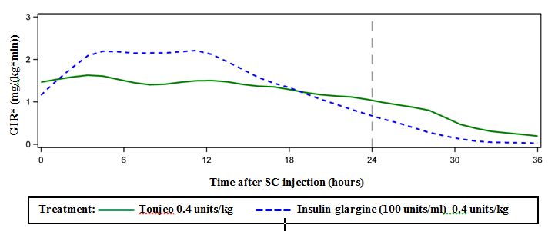

*GIR: Glucose infusion rate: determined as amount of glucose infused to maintain constant plasma glucose levels (hourly mean values). The end of the observation period was 36 hours.

Insulin glargine is metabolised into 2 active metabolites M1 and M2 (see section 5.2).

Insulin receptor binding: *In vitro* studies indicate that the affinity of insulin glargine and its metabolites M1 and M2 for the human insulin receptor is similar to the one of human insulin.

IGF‑1 receptor binding: The affinity of insulin glargine for the human IGF‑1 receptor is approximately 5 to 8‑fold greater than that of human insulin (but approximately 70 to 80‑fold lower than the one of IGF‑1), whereas M1 and M2 bind the IGF‑1 receptor with slightly lower affinity compared to human insulin.

The total therapeutic insulin concentration (insulin glargine and its metabolites) found in type 1 diabetic patients was markedly lower than what would be required for a half maximal occupation of the IGF‑1 receptor and the subsequent activation of the mitogenic‑proliferative pathway initiated by the IGF‑1 receptor. Physiological concentrations of endogenous IGF‑1 may activate the mitogenic‑proliferative pathway; however, the therapeutic concentrations found in insulin therapy, including in Toujeo therapy, are considerably lower than the pharmacological concentrations required to activate the IGF‑1 pathway.

In a clinical pharmacology study, intravenous insulin glargine and human insulin have been shown to be equipotent when given at the same doses.

As with all insulins, the time course of action of insulin glargine may be affected by physical activity and other variables.

Clinical efficacy and safety

The overall efficacy and safety of Toujeo (insulin glargine 300 units/ml) once‑daily on glycaemic control was compared to that of once-daily insulin glargine 100 units/ml in open‑label, randomised, active-control, parallel studies of up to 26 weeks of duration, including 546 patients with type 1 diabetes mellitus and 2,474 patients with type 2 diabetes mellitus (Table 1 and 2).

Results from all clinical trials with Toujeo indicated that reductions in HbA1c from baseline to end of trial were non-inferior to insulin glargine 100 units/ml. Plasma glucose reductions at the end of the trial with Toujeo were similar to insulin glargine 100 units/ml with a more gradual reduction during the titration period with Toujeo. Glycaemic control was similar when Toujeo was administered once daily in the morning or in the evening.

Improvement in HbA1C was not affected by, gender, ethnicity, age, diabetes duration (<10 years and ≥10 years), HbA1c value at baseline (<8% or ≥8%) or baseline body mass index (BMI).

At the end of these treat-to-target trials, depending on the patient population and concomitant therapy, a 10-18% higher dose was observed in the Toujeo group than in the comparator group (Table 1 and 2).

Results from clinical trials demonstrated that the incidence of confirmed hypoglycaemia (at any time of the day and nocturnal) was lower in patients treated with Toujeo compared to insulin glargine 100 units/ml-treated patients, in patients with type 2 diabetes treated in combination with either non‑insulin anti-hyperglycaemic medicinal product or mealtime insulin.

The superiority of Toujeo over insulin glargine 100 units/ml in lowering the risk of confirmed nocturnal hypoglycaemia was shown in patients with type 2 diabetes treated with basal insulin in combination with either non‑insulin anti‑hyperglycaemic medicinal product (18% risk reduction) or mealtime insulin (21% risk reduction) during the period from week 9 to end of study period.

Overall, these effects on hypoglycaemia risk were consistently observed whatever the age, gender, BMI and duration of diabetes (<10 years and ≥10 years) in Toujeo-treated patients compared to insulin glargine 100 units/ml-treated patients.

In patients with type 1 diabetes, the incidence of hypoglycaemia was similar in patients treated with Toujeo compared to insulin glargine 100 units/ml-treated patients (Table 3).

Table 1: Results from clinical trials in type 1 diabetes mellitus

| 26 weeks of treatment | | |
| --- | --- | --- |
|  | Toujeo | IGlar |
| Treatment in combination with | Meal-time insulin analogue | |
| Number of subjects treated (mITTa) | 273 | 273 |
| **HbA1c** | | |
| Baseline mean | 8.13 | 8.12 |
| Adjusted Mean change from baseline | -0.40 | -0.44 |
| Adjusted Mean differenceb | 0.04 [-0.098 to 0.185] | |
| **Basal insulin dosec (U/kg)** | | |
| Baseline mean | 0.32 | 0.32 |
| Mean change from baseline | 0.15 | 0.09 |
| **Body weightd (kg)** | | |
| Baseline mean  Mean change from baseline | 81.89  0.46 | 81.80  1.02 |
| IGlar: Insulin glargine 100 units/ml   1. mITT: Modified intention-to-treat 2. Treatment difference: Toujeo– insulin glargine 100 units/ml; [95% Confidence Interval] 3. Change from baseline to Month 6 (observed case) 4. Change from baseline to Last main 6-month on-treatment value | | |

Table 2: Results from clinical trials in type 2 diabetes mellitus

|  |  |  |  |  |  |  |
| --- | --- | --- | --- | --- | --- | --- |
| 26 weeks of treatment | | | | | | |
|  | Patients previously treated with basal insulin | | Patients previously treated with basal insulin | | Previously insulin naive patients | |
| Treatment in combination with | Meal-time insulin analog+/-metformin | | Non-insulin anti-hyperglycaemic medicinal products | | | |
|  | **Toujeo** | **IGlar** | **Toujeo** | **IGlar** | **Toujeo** | **IGlar** |
| Number of patients treateda | 404 | 400 | 403 | 405 | 432 | 430 |
| **HbA1c** | | | | | | |
| Baseline mean  Adjusted mean change from baseline | 8.13  -0.90 | 8.14  -0.87 | 8.27  -0.73 | 8.22  -0.70 | 8.49  -1.42 | 8.58  -1.46 |
| Adjusted mean differenceb | -0.03  [-0.144 to 0.083] | | -0.03  [-0.168 to 0.099] | | 0.04  [-0.090 to 0.174] | |
| **Basal insulin dosec (U/kg)** | | | | | | |
| Baseline mean  Mean change from baseline | 0.67  0.31 | 0.67  0.22 | 0.64  0.30 | 0.66  0.19 | 0.19  0.43 | 0.19  0.34 |
| **Body weightd (kg)** | | | | | | |
| Baseline mean  Mean change from baseline | 106.11  0.93 | 106.50  0.90 | 98.73  0.08 | 98.17  0.66 | 95.14  0.50 | 95.65  0.71 |
| IGlar: Insulin glargine 100 units/ml   1. mITT: Modified intention-to-treat 2. Treatment difference: Toujeo– insulin glargine 100 units/ml; [95% Confidence Interval] 3. Change from baseline to Month 6 (observed case) 4. Change from baseline to Last main 6-month on-treatment value | | | | | | |

Table 3 ­ Summary of the hypoglycaemic episodes of the clinical study in patients with type 1 and type 2 diabetes mellitus

| *Diabetic population* | *Type 1 diabetes mellitus*  Patients previously treated with basal insulin | | *Type 2 diabetes mellitus*  Patients previously treated with basal insulin | | *Type2 diabetes mellitus*  *Patients previously Insulin naive or on basal insulin* | |
| --- | --- | --- | --- | --- | --- | --- |
| Treatment in combination with | Meal-time insulin analog | | Meal-time insulin analog+/-metformin | | Non-insulin anti-hyperglycaemic medicinal products | |
|  | **Toujeo** | **IGlar** | **Toujeo** | **IGlar** | **Toujeo** | **IGlar** |
| **Incidence (%) of severea hypoglycaemia (n/Total N)** | | | | | | |
| Entire study periodd | 6.6  (18/274) | 9.5  (26/275) | 5.0  (20/404) | 5.7  (23/402) | 1.0  (8/838) | 1.2  (10/844) |
| *RR*: 0.69 [0.39;1.23]* | | *RR: 0.87 [0.48;1.55]* | | *RR: 0.82 [0.33;2.00]* | |
| **Incidence (%) of confirmedb hypoglycaemia (n/Total N)** | | | | | | |
| Entire study period | 93.1  (255/274) | 93.5  (257/275) | 81.9  (331/404) | 87.8  (353/402) | 57.6  (483/838) | 64.5  (544/844) |
| *RR: 1.00 [0.95;1.04]* | | *RR: 0.93 [0.88; 0.99]* | | *RR: 0.89 [0.83; 0.96]* | |
| **Incidence (%) of confirmed nocturnalc hypoglycaemia (n/Total N)** | | | | | | |
| From week 9 to end of study period | 59.3  (162/273) | 56.0  (153/273) | 36.1  (146/404) | 46.0  (184/400) | 18.4  (154/835) | 22.5  (188/835) |
| *RR: 1.06 [0.92;1.23]* | | *RR: 0.79 [0.67;0.93]* | | *RR: 0.82 [0.68;0.99]* | |
| IGlar: Insulin glargine 100 units/ml  a Severe hypoglycaemia: Episode requiring assistance of another person to actively administer carbohydrate, glucagon, or other resuscitative actions.  b Confirmed hypoglycaemia:Any severe hypoglycaemia and/or hypoglycaemia confirmed by plasma glucose value ≤3.9 mmol/l.  c Nocturnal hypoglycaemia: Episode that occurred between 00:00 and 05:59 hours  d 6-month treatment period  *RR: estimated risk ratio; [95% Confidence Interval] | | | | | | |

*Flexibility in dosing time*

The safety and efficacy of Toujeo administered with a fixed or flexible dosing time were also evaluated in 2 randomized, open-label clinical studies for 3 months. Type 2 diabetic patients (n=194) received Toujeo once daily in the evening, either at the same time of the day (fixed time of administration) or within 3 hours before or after the usual time of administration (flexible dosing time). Administration with a flexible dosing time had no effect on glycaemic control and the incidence of hypoglycaemia.

*Antibodies*

Results from studies comparing Toujeo and insulin glargine 100 units/ml did not indicate any difference in term of development of anti-insulin antibodies, on efficacy, safety or dose of basal insulin between Toujeo and insulin glargine 100 units/ml.

*Body weight*

Mean change in body weight of less than 1 kg at the end of the 6‑month period was observed in Toujeo‑treated patients (see Table 1 and 2).

*Results from a study on progression of diabetic retinopathy*

Effects of insulin glargine 100 units/ml (once daily) on diabetic retinopathy were evaluated in an open-label 5 year NPH-controlled study (NPH given bid) in 1024 type 2 diabetic patients in which progression of retinopathy by 3 or more steps on the Early Treatment Diabetic Retinopathy Study (ETDRS) scale was investigated by fundus photography. No significant difference was seen in the progression of diabetic retinopathy when insulin glargine100 units/ml was compared to NPH insulin.

*Long term efficacy and safety outcome study*

The ORIGIN (Outcome Reduction with Initial Glargine INtervention) study was a multicenter, randomized, 2x2 factorial design study conducted in 12,537 participants at high cardiovascular (CV) risk with impaired fasting glucose (IFG) or impaired glucose tolerance (IGT) (12% of participants) or type 2 diabetes mellitus (treated with ≤1 antidiabetic oral agent) (88% of participants). Participants were randomized (1:1) to receive insulin glargine 100 units/ml (n=6264), titrated to reach FPG ≤95 mg/dl (5.3 mM), or standard care (n=6273).

The first co‑primary efficacy outcome was the time to the first occurrence of CV death, nonfatal myocardial infarction (MI), or nonfatal stroke, and the second co‑primary efficacy outcome was the time to the first occurrence of any of the first co‑primary events, or revascularisation procedure (coronary, carotid, or peripheral), or hospitalisation for heart failure.

Secondary endpoints included all‑cause mortality and a composite microvascular outcome.

Insulin glargine 100 units/ml did not alter the relative risk for CV disease and CV mortality when compared to standard of care. There were no differences between insulin glargine and standard care for the two co‑primary outcomes; for any component endpoint comprising these outcomes; for all‑cause mortality; or for the composite microvascular outcome.

Mean dose of insulin glargine 100 units/ml by study end was 0.42 U/kg. At baseline, participants had a median HbA1c value of 6.4% and median on-treatment HbA1c values ranged from 5.9 to 6.4% in the insulin glargine 100 units/ml group, and 6.2% to 6.6% in the standard care group throughout the duration of follow‑up.

The rates of severe hypoglycaemia (affected participants per 100 participant years of exposure) were 1.05 for insulin glargine 100 units/ml and 0.30 for standard care group and the rates of confirmed non‑severe hypoglycaemia were 7.71 for insulin glargine 100 units/ml and 2.44 for standard care group. Over the course of this 6‑year study, 42% of the insulin glargine 100 units/ml group did not experience any hypoglycaemia.

At the last on‑treatment visit, there was a mean increase in body weight from baseline of 1.4 kg in the insulin glargine 100 units/ml group and a mean decrease of 0.8 kg in the standard care group.

Pediatric population

The efficacy and safety of Toujeo have been studied in a 1:1 randomized controlled open label clinical trial in children and adolescents with type 1 diabetes mellitus for a period of 26 weeks (n=463). Patients in the Toujeo arm included 73 children aged <12 years and 160 children aged ≥12 years. Toujeo dosed once daily showed similar reduction in HbA1c and FPG from baseline to week 26 compared to insulin glargine 100 units/ml.

The dose-response analysis showed that following the initial titration phase, the body weight adjusted doses in pediatric patients are higher than in adult patients at steady state.

Overall the incidence of hypoglycaemia in patients in any category was similar in both treatment groups, with 97.9% of patients in the Toujeo group and 98.2% in the insulin glargine 100 units/ml group reporting at least one event. Similarly, nocturnal hypoglycaemia was comparable in the Toujeo and insulin glargine 100 units/ml treatment groups. The percentage of patients reporting severe hypoglycaemia was lower in patients in the Toujeo group as compared to patients in the insulin glargine 100 units/ml group, 6% and 8.8% respectively. The percentage of patients with hyperglycaemic episodes with ketosis was lower for Toujeo versus insulin glargine 100 units/ml, 6.4% and 11.8%, respectively. No safety issues were identified with Toujeo with respect to adverse events and standard safety parameters. Antibody development was sparse and had no clinical impact. Efficacy and safety data for paediatric patients with type 2 diabetes mellitus have been extrapolated from data for adolescent and adult patients with type 1 diabetes mellitus and adult patients with type 2 diabetes mellitus. Results support the use of Toujeo in paediatric patients with type 2 diabetes mellitus.

**5.2 Pharmacokinetic properties**

Absorption and distribution

In healthy subjects and diabetic patients, insulin serum concentrations indicated a slower and more prolonged absorption resulting in a flatter time‑concentration profile after subcutaneous injection of Toujeo in comparison to insulin glargine 100 units/ml.

Pharmacokinetic profiles were consistent with the pharmacodynamic activity of Toujeo.

Steady state level within the therapeutic range is reached after 3‑4 days of daily Toujeo administration.

After subcutaneous injection of Toujeo, the intra-subject variability, defined as the coefficient of variation for the insulin exposure during 24 hours was low at steady state (17.4%).

Biotransformation

After subcutaneous injection of insulin glargine, insulin glargine is rapidly metabolized at the carboxyl terminus of the Beta chain with formation of two active metabolites M1 (21A‑Gly‑insulin) and M2 (21A‑Gly‑des‑30B‑Thr‑insulin). In plasma, the principal circulating compound is the metabolite M1. The exposure to M1 increases with the administered dose of insulin glargine. The pharmacokinetic and pharmacodynamic findings indicate that the effect of the subcutaneous injection with insulin glargine is principally based on exposure to M1. Insulin glargine and the metabolite M2 were not detectable in the vast majority of subjects and, when they were detectable their concentration was independent of the administered dose and formulation of insulin glargine.

Elimination

When given intravenously the elimination half-life of insulin glargine and human insulin were comparable.

The half-life after subcutaneous administration of Toujeo is determined by the rate of absorption from the subcutaneous tissue. The half-life of Toujeo after subcutaneous injection is 18-19 hours independent of dose.

Paediatric population

Population pharmacokinetic analysis was conducted for Toujeo based on concentration data of its main metabolite M1 using data from 75 pediatric subjects (6 to <18 years of age) with type 1 diabetes. Body weight affects the clearance of Toujeo in a nonlinear way. As a consequence, exposure (AUC) in pediatric patients is slightly lower as compared to adult patients when receiving the same body weight adjusted dose.

**5.3 Preclinical safety data**

Non-clinical data reveal no special hazard for humans based on conventional studies of safety pharmacology, repeated dose toxicity, genotoxicity, carcinogenic potential, toxicity to reproduction.

**6. PHARMACEUTICAL PARTICULARS**

**6.1 List of excipients**

Zinc chloride  
Metacresol  
Glycerol  
Hydrochloric acid (for pH adjustment)  
Sodium hydroxide (for pH adjustment)  
Water for injections.

**6.2 Incompatibilities**

Toujeo must not be mixed or diluted with any other insulin or other medicinal products.

Mixing or diluting Toujeo changes its time/action profile and mixing causes precipitation.

**6.3 Shelf life**

Toujeo SoloStar

30 months.

Toujeo DoubleStar

36 months.

Shelf life after first use of the pen

The medicinal product may be stored for a maximum of 6 weeks below 30°C and away from direct heat or direct light. Pens in use must not be stored in the refrigerator. The pen cap must be put back on the pen after each injection in order to protect from light.

**6.4 Special precautions for storage**

Before first use

Store in a refrigerator (2°C-8°C).

Do not freeze or place next to the freezer compartment or a freezer pack.

Keep the pre-filled pen in the outer carton in order to protect from light.

After first use or if carried as a spare

For storage conditions after first opening of this medicinal product, see section 6.3.

**6.5 Nature and contents of container**

SoloStar pen

Cartridge (type 1 colourless glass) with a grey plunger (bromobutyl rubber) and a flanged cap (aluminium) with a stopper (laminate of isoprene and bromobutyl rubber).The cartridge is sealed in a disposable pen injector. Each cartridge contains 1.5 ml solution.

Packs of 1, 3, 5 and 10 pens are available. Not all pack sizes may be marketed.

Needles are not included in the pack.

DoubleStar pen

Cartridge (type 1 colourless glass) with a black plunger (bromobutyl rubber) and a flanged cap (aluminium) with a stopper (laminate of isoprene and bromobutyl rubber).The cartridge is sealed in a disposable pen injector. Each cartridge contains 3 ml solution.

Packs of 1, 3, 6 (2 packs of 3), 9 (3 packs of 3) and 10 pens are available. Not all pack sizes may be marketed.

Needles are not included in the pack.

**6.6 Special precautions for disposal and other handling**

Before first use, the pen must be stored at room temperature at least 1 hour before use.

Before using Toujeo SoloStar or Toujeo DoubleStar pre-filled pen, the Instructions for Use included in the package leaflet must be read carefully. Toujeo pre-filled pens have to be used as recommended in these Instructions for Use (see section 4.2). Instruct patients to perform a safety test as described in Step 3 of the Instructions for Use. If they don’t, the full dose might not be delivered. If this occurs, patients should increase the frequency of checking their blood glucose levels and might need to administer additional insulin.

The cartridge should be inspected before use. It must only be used if the solution is clear, colourless, with no solid particles visible, and if it is of water-like consistency. Since Toujeo is a clear solution, it does not require resuspension before use.

Insulin label must always be checked before each injection to avoid medication errors between Toujeo and other insulins. The strength “300” is highlighted in honey gold on the label (see section 4.4).

Patients should be informed that the dose counter of Toujeo SoloStar or Toujeo DoubleStar pre-filled pen shows the number of units of Toujeo to be injected. No dose re-calculation is required.

* The Toujeo SoloStar pen contains 450 units of Toujeo. It delivers doses of 1-80 units per injection, in steps of 1 unit.
* The Toujeo DoubleStar pen contains 900 units of Toujeo. It delivers doses of 2-160 units per injection, in steps of 2 units.
* To reduce potential underdose, Toujeo DoubleStar is recommended for patients requiring at least 20 units per day.
* If safety tests are not performed before the first use of a new pen, insulin underdose can occur.

A syringe must never be used to withdraw Toujeo from the cartridge of the pre‑filled pen or severe overdose can result (see section 4.2, 4.4 and 4.9).

A new sterile needle must be attached before each injection. Needles must be discarded immediately after use. Needles must not be re‑used. Re‑use of needles increases the risk of blocked needles which may cause underdosing or overdosing. Using a new sterile needle for each injection also minimizes the risk of contamination and infection. In the event of blocked needle, the patients must follow the instructions described in Step 3 of the Instructions for Use accompanying the package leaflet (see section 4.2 and 4.4).

Used needles should be thrown away in a puncture resistant container or disposed of in accordance with local requirements.

Empty pens must never be reused and must be properly discarded.

To prevent possible transmission of disease, insulin pen should never be used by for more than one person, even when the needle is changed (see section 4.2).

**7. MARKETING AUTHORISATION HOLDER**

Sanofi-Aventis Deutschland GmbH, D-65926 Frankfurt am Main, Germany

**8. MARKETING AUTHORISATION NUMBER(S)**

EU/1/00/133/033

EU/1/00/133/034

EU/1/00/133/035

EU/1/00/133/036

EU/1/00/133/037

EU/1/00/133/038

EU/1/00/133/039

EU/1/00/133/040

EU/1/00/133/041

**9. DATE OF FIRST AUTHORISATION/RENEWAL OF THE AUTHORISATION**

Date of first authorisation: 27 June 2000

Date of latest renewal: 17 February 2015

**10. DATE OF REVISION OF THE TEXT**

Detailed information on this medicinal product is available on the website of the European Medicines Agency http://www.ema.europa.eu

**ANNEX II**

**A. MANUFACTURER OF THE BIOLOGICAL ACTIVE**

SUBSTANCE AND MANUFACTURERS RESPONSIBLE FOR BATCH RELEASE

1. **CONDITIONS OR RESTRICTIONS REGARDING SUPPLY AND USE**
2. **OTHER CONDITIONS AND REQUIREMENTS OF THE MARKETING AUTHORISATION**
3. **CONDITIONS OR RESTRICTIONS WITH REGARD TO THE SAFE AND EFFECTIVE USE OF THE MEDICINAL PRODUCT**

**A. MANUFACTURER OF THE BIOLOGICAL ACTIVE SUBSTANCE AND MANUFACTURERS RESPONSIBLE FOR BATCH RELEASE**

Name and address of the manufacturer of the biological active substance

Sanofi-Aventis Deutschland GmbH

Industriepark Höchst

Brüningstraße 50

D-65926 Frankfurt / Main

Germany

#### Name and address of the manufacturers responsible for batch release

Sanofi-Aventis Deutschland GmbH

Industriepark Höchst

Brüningstraße 50

D-65926 Frankfurt / Main

Germany

**B. CONDITIONS OR RESTRICTIONS REGARDING SUPPLY AND USE**

Medicinal product subject to medical prescription.

**C. OTHER CONDITIONS AND REQUIREMENTS OF THE MARKETING AUTHORISATION**

* **Periodic safety update reports (PSURs)**

The requirements for submission of PSURs for this medicinal product are set out in the list of Union reference dates (EURD list) provided for under Article 107c(7) of Directive 2001/83/EC and any subsequent updates published on the European medicines web‑portal.

**D. CONDITIONS OR RESTRICTIONS WITH REGARD TO THE SAFE AND EFFECTIVE USE OF THE MEDICINAL PRODUCT**

* **Risk management plan (RMP)**

The marketing authorisation holder (MAH) shall perform the required pharmacovigilance activities and interventions detailed in the agreed RMP presented in Module 1.8.2 of the Marketing Authorisation and any agreed subsequent updates of the RMP.

An updated RMP should be submitted:

* At the request of the European Medicines Agency;
* Whenever the risk management system is modified, especially as the result of new information being received that may lead to a significant change to the benefit/risk profile or as the result of an important (pharmacovigilance or risk minimisation) milestone being reached.
* **Additional risk minimisation measures**

Prior to launch of Toujeo 300 units/ml in each Member State the MAH must agree the content and format of the educational programme, including communication media, distribution modalities, and any other aspects, with the National Competent Authority.

The MAH shall ensure that in each Member State where Toujeo 300 units/ml is marketed, all healthcare professionals (HCPs) who are expected to prescribe or dispense Toujeo 300 units/ml, as well as all patients or their carers who are expected to use Toujeo 300 units/ml, are provided with educational material to address the risk(s) of Medication error (switching between 100 units/ml and 300 units/ml without dose adjustment).

The educational materials consist of:

* Guide for healthcare professionals
* Patient/carer guide (patient brochure)

The educational materials for healthcare professionals shall contain the following key elements:

* Details on how to minimize the safety concern addressed by the additional risk minimization measures through appropriate monitoring and management:
* That insulin glargine 100 units/ml and insulin glargine 300 units/ml (Toujeo SoloStar and Toujeo DoubleStar) are not bioequivalent and are therefore not interchangeable without dose adjustment.
* That dose adjustment is needed when patients are switched from one to the other strength:
* After titration, on average a 10-18% higher basal insulin dose are needed to achieve target ranges for plasma glucose levels when using the 300 units/ml formulation compared to the 100 units/ml formulation.
* Switching from the 300 units/ml to the 100 units/ml concentration results in an increased risk of hypoglycaemic events, mainly in the first week after the switch. To reduce the risk of hypoglycaemia, patients who are changing their basal insulin regimen from an insulin regimen with once daily Toujeo (insulin glargine 300 units/ml) to a once daily regimen with insulin glargine 100 units/ml should reduce their dose by 20%;
* When switching from a treatment regimen with an intermediate or long-acting insulin product to a regimen with Toujeo, a change of the dose of the basal insulin may be required and the concomitant anti-hyperglycaemic treatment may need to be adjusted. Close metabolic monitoring is recommended during the switch and in the initial weeks thereafter;
* Key messages to convey in patients counselling:
* Patients need to be instructed that insulin glargine 100 units/ml products and Toujeo are not interchangeable and dose adjustments need to be made;
* Blood glucose monitoring by patients is needed during the switch and the initial weeks thereafter;
* Instructions on how to report medication errors or adverse events: Details for national reporting added at country level.
* Other: The Guide for healthcare professionals is also highlighting the distinction between the different Toujeo presentations:
* That insulin glargine 300 units/ml is available in two different presentations: Toujeo SoloStar (1.5 ml prefilled pen/450 units) and Toujeo DoubleStar (3 ml prefilled pen/900 units).
* The dose increment in Toujeo SoloStar is one unit and the dose increment in Toujeo DoubleStar is 2 units.
* The dose delivered is the one shown in the dose window.

The educational material for patient/carer guide (patient brochure) shall contain the following key elements:

* Detailed description of the modalities used for the self-administration of insulin glargine:
* That insulin glargine 100 units/ml and insulin glargine 300 units/ml (Toujeo SoloStar and Toujeo DoubleStar) are not bioequivalent and are therefore not interchangeable without dose adjustment.
* That the switch from one insulin therapy to another should only be done when prescribed by their healthcare provider;
* That the dose newly recommended by their healthcare provider should always be followed;
* That blood glucose need to be closely monitored during the switch and the initial weeks thereafter;
* That they should consult their healthcare provider for further information;
* That they should report medication errors or any side effects. Details for national reporting added at country level;
* That insulin glargine 300 units/ml is available in two different presentations: Toujeo SoloStar (1.5 ml prefilled pen/450 units) and Toujeo DoubleStar (3 ml prefilled pen/900 units). The dose increment in Toujeo SoloStar is one unit and the dose increment in Toujeo DoubleStar is 2 units. The dose delivered is the one shown in the dose window.

The target audience and the modalities for distribution of all of these materials are to be agreed at Member State Level. The MAH shall agree the final text and the context of the educational material for HCPs and patients together with a communication plan, with the National Competent Authority in each Member State prior to launch of the medicinal product.

**ANNEX III**

**LABELLING AND PACKAGE LEAFLET**

A. LABELLING

|  |
| --- |
| **PARTICULARS TO APPEAR ON THE OUTER PACKAGING**  **OUTER CARTON** |

|  |
| --- |
| **1. NAME OF THE MEDICINAL PRODUCT** |

Toujeo 300 units/ml SoloStar solution for injection in a pre-filled pen

Toujeo 300 units/ml DoubleStar solution for injection in a pre-filled pen

insulin glargine

|  |
| --- |
| **2. STATEMENT OF ACTIVE SUBSTANCE(S)** |

Each ml contains 300 units (10.91 mg) insulin glargine.

SoloStar pen:

Each pencontains 1.5 ml of solution, equivalent to 450 units.

DoubleStar pen:

Each pen contains 3 ml of solution, equivalent to 900 units.

|  |
| --- |
| **3. LIST OF EXCIPIENTS** |

Zinc chloride, metacresol, glycerol, hydrochloric acid / sodium hydroxide (for pH adjustment), water for injections.

|  |
| --- |
| **4. PHARMACEUTICAL FORM AND CONTENTS** |

Solution for injection in a pre-filled pen.

SoloStar pen:

1 pen

3 pens

5 pens

10 pens

DoubleStar pen:

1 pen

3 pens

10 pens

|  |
| --- |
| **5. METHOD AND ROUTE(S) OF ADMINISTRATION** |

SoloStar pen

1 step=1 unit

DoubleStar pen:

1 step= 2 units

Read the package leaflet before use.

Open here

Subcutaneous use

|  |
| --- |
| **6. SPECIAL WARNING THAT THE MEDICINAL PRODUCT MUST BE STORED OUT OF THE SIGHT AND REACH OF CHILDREN** |

Keep out of the sight and reach of children.

|  |
| --- |
| **7. OTHER SPECIAL WARNING(S), IF NECESSARY** |

Use only in this pen or severe overdose can result.

Always use a new needle for each injection.

For single patient use only.

Use only clear and colourless solutions.

450 units per pen (SoloStar pen)

900 units per pen (DoubleStar pen)

|  |
| --- |
| **8. EXPIRY DATE** |

EXP

|  |
| --- |
| **9. SPECIAL STORAGE CONDITIONS** |

Before first use

Store in a refrigerator.

Do not freeze or placenext to the freezer compartment or a freezer pack.

Keep the pre-filled pen in the outer carton in order to protect from light.

After first use

The product may be stored for a maximum of 6 weeks below 30°C. Do not refrigerate. Put the pen cap back on the pen after each injection in order to protect from light.

|  |
| --- |
| **10. SPECIAL PRECAUTIONS FOR DISPOSAL OF UNUSED MEDICINAL PRODUCTS OR WASTE MATERIALS DERIVED FROM SUCH MEDICINAL PRODUCTS, IF APPROPRIATE** |

|  |
| --- |
| **11. NAME AND ADDRESS OF THE MARKETING AUTHORISATION HOLDER** |

Sanofi-Aventis Deutschland GmbH

D-65926 Frankfurt am Main,

Germany

|  |
| --- |
| **12. MARKETING AUTHORISATION NUMBER(S)** |

EU/1/00/133/033 1 pen (SoloStar)

EU/1/00/133/034 3 pens (SoloStar)

EU/1/00/133/035 5 pens (SoloStar)

EU/1/00/133/036 10 pens (SoloStar)

EU/1/00/133/037 1 pen (DoubleStar)

EU/1/00/133/038 3 pens (DoubleStar)

EU/1/00/133/041 10 pens (DoubleStar)

|  |
| --- |
| **13. BATCH NUMBER** |

Lot

|  |
| --- |
| **14. GENERAL CLASSIFICATION FOR SUPPLY** |

|  |
| --- |
| **15. INSTRUCTIONS ON USE** |

|  |
| --- |
| **16. INFORMATION IN BRAILLE** |

Toujeo 300 SoloStar

Toujeo 300 DoubleStar

|  |
| --- |
| **17. UNIQUE IDENTIFIER – 2D BARCODE** |

2D barcode carrying the unique identifier included.

|  |
| --- |
| **18. UNIQUE IDENTIFIER - HUMAN READABLE DATA** |

PC:

SN:

NN:

**PARTICULARS TO APPEAR ON THE OUTER PACKAGING**

**OUTER CARTON Multipack (contains Blue Box)**

**1. NAME OF THE MEDICINAL PRODUCT**

Toujeo 300 units/ml DoubleStar solution for injection in a pre-filled pen

insulin glargine

**2. STATEMENT OF ACTIVE SUBSTANCE(S)**

Each ml contains 300 units (10.91 mg) insulin glargine.

Each pen contains 3 ml of solution, equivalent to 900 units.

**3. LIST OF EXCIPIENTS**

Zinc chloride, metacresol, glycerol, hydrochloric acid / sodium hydroxide (for pH adjustment), water for injections.

**4. PHARMACEUTICAL FORM AND CONTENTS**

Solution for injection in a pre-filled pen.

Multipack: 6 (2 packs of 3) pens

Multipack: 9 (3 packs of 3) pens

**5. METHOD AND ROUTE(S) OF ADMINISTRATION**

1 step= 2 units

Read the package leaflet before use.

Subcutaneous use

Open here

**6. SPECIAL WARNING THAT THE MEDICINAL PRODUCT MUST BE STORED OUT OF THE SIGHT AND REACH OF CHILDREN**

Keep out of the sight and reach of children.

**7. OTHER SPECIAL WARNING(S), IF NECESSARY**

Use only in this pen or severe overdose can result.

Always use a new needle for each injection.

For single patient use only.

Use only clear and colourless solutions.

900 units per pen

**8. EXPIRY DATE**

EXP

**9. SPECIAL STORAGE CONDITIONS**

Before first use

Store in a refrigerator.

Do not freeze or placenext to the freezer compartment or a freezer pack.

Keep the pre-filled pen in the outer carton in order to protect from light.

After first use

The product may be stored for a maximum of 6 weeks below 30°C. Do not refrigerate. Put the pen cap back on the pen after each injection in order to protect from light.

**10. SPECIAL PRECAUTIONS FOR DISPOSAL OF UNUSED MEDICINAL PRODUCTS OR WASTE MATERIALS DERIVED FROM SUCH MEDICINAL PRODUCTS, IF APPROPRIATE**

**11. NAME AND ADDRESS OF THE MARKETING AUTHORISATION HOLDER**

Sanofi-Aventis Deutschland GmbH

D-65926 Frankfurt am Main,

Germany.

**12. MARKETING AUTHORISATION NUMBER(S)**

EU/1/00/133/039 6 pens (2 packs of 3)

EU/1/00/133/040 9 pens (3 packs of 3)

**13. BATCH NUMBER**

Lot

**14. GENERAL CLASSIFICATION FOR SUPPLY**

**15. INSTRUCTIONS ON USE**

**16. INFORMATION IN BRAILLE**

Toujeo 300 DoubleStar

**17. UNIQUE IDENTIFIER – 2D BARCODE**

2D barcode carrying the unique identifier included.

**18. UNIQUE IDENTIFIER - HUMAN READABLE DATA**

PC:

SN:

NN:

**PARTICULARS TO APPEAR ON THE OUTER PACKAGING**

**INNER CARTON without Blue Box**

**1. NAME OF THE MEDICINAL PRODUCT**

Toujeo 300 units/ml DoubleStar solution for injection in a pre-filled pen

insulin glargine

**2. STATEMENT OF ACTIVE SUBSTANCE(S)**

Each ml contains 300 units (10.91 mg) insulin glargine.

Each pen contains 3 ml of solution, equivalent to 900 units.

**3. LIST OF EXCIPIENTS**

Zinc chloride, metacresol, glycerol, hydrochloric acid / sodium hydroxide (for pH adjustment), water for injections.

**4. PHARMACEUTICAL FORM AND CONTENTS**

Solution for injection in a pre-filled pen.

6 pens

9 pens

Component of a multipack, can’t be sold separately.

**5. METHOD AND ROUTE(S) OF ADMINISTRATION**

1 step=2 units

Read the package leaflet before use.

Subcutaneous use

Open here

**6. SPECIAL WARNING THAT THE MEDICINAL PRODUCT MUST BE STORED OUT OF THE SIGHT AND REACH OF CHILDREN**

Keep out of the sight and reach of children.

**7. OTHER SPECIAL WARNING(S), IF NECESSARY**

Use only in this pen or severe overdose can result.

Always use a new needle for each injection.

For single patient use only.

Use only clear and colourless solutions.

900 units per pen.

**8. EXPIRY DATE**

EXP

**9. SPECIAL STORAGE CONDITIONS**

Before first use

Store in a refrigerator.

Do not freeze or placenext to the freezer compartment or a freezer pack.

Keep the pre-filled pen in the outer carton in order to protect from light.

After first use

The product may be stored for a maximum of 6 weeks below 30°C. Do not refrigerate. Put the pen cap back on the pen after each injection in order to protect from light.

**10. SPECIAL PRECAUTIONS FOR DISPOSAL OF UNUSED MEDICINAL PRODUCTS OR WASTE MATERIALS DERIVED FROM SUCH MEDICINAL PRODUCTS, IF APPROPRIATE**

**11. NAME AND ADDRESS OF THE MARKETING AUTHORISATION HOLDER**

Sanofi-Aventis Deutschland GmbH

D-65926 Frankfurt am Main,

Germany.

**12. MARKETING AUTHORISATION NUMBER(S)**

EU/1/00/133/039 6 pens (2 packs of 3)

EU/1/00/133/040 9 pens (3 packs of 3)

**13. BATCH NUMBER**

Lot

**14. GENERAL CLASSIFICATION FOR SUPPLY**

**15. INSTRUCTIONS ON USE**

**16. INFORMATION IN BRAILLE**

Toujeo 300 DoubleStar

**17. UNIQUE IDENTIFIER – 2D BARCODE**

2D barcode carrying the unique identifier included.

**18. UNIQUE IDENTIFIER - HUMAN READABLE DATA**

PC:

SN:

NN:

|  |
| --- |
| **MINIMUM PARTICULARS TO APPEAR ON SMALL IMMEDIATE PACKAGING UNITS** PEN LABEL |

|  |
| --- |
| **1. NAME OF THE MEDICINAL PRODUCT AND ROUTE(S) OF ADMINISTRATION** |

Toujeo 300 units/ml SoloStar injection

Toujeo 300 units/ml DoubleStar injection

insulin glargine

Subcutaneous use

|  |
| --- |
| **2. METHOD OF ADMINISTRATION** |

Use only in this pen or severe overdose can result.

|  |
| --- |
| **3. EXPIRY DATE** |

EXP

|  |
| --- |
| **4. BATCH NUMBER** |

Lot

|  |
| --- |
| **5. CONTENTS BY WEIGHT, BY VOLUME OR BY UNIT** |

1.5 ml (SoloStar)

3 ml (DoubleStar)

|  |
| --- |
| **6. OTHER** |

SoloStar pen1 step=1 unit

DoubleStar pen

1 step=2 units

B. PACKAGE LEAFLET

Package leaflet: information for the user

Toujeo 300 units/ml SoloStar solution for injection in a pre-filled pen

Insulin glargine

Each SoloStar pen delivers 1-80 units in steps of 1 unit.

**Read all of this leaflet carefully before you start using this medicine because it contains important information for you.**

* Keep this leaflet. You may need to read it again.
* If you have any further questions, ask your doctor, pharmacist or nurse.
* This medicine has been prescribed for you only. Do not pass it on to others. It may harm them,

even if their signs of illness are the same as yours.

* If you get any side effects, talk to your doctor or pharmacist. This includes any possible side

effects not listed in this leaflet. See section 4.

**What is in this leaflet**

1. What Toujeo is and what it is used for

2. What you need to know before you use Toujeo

3. How to use Toujeo

4. Possible side effects

5. How to store Toujeo

6. Contents of the pack and other information

**1. What Toujeo is and what it is used for**

Toujeo is a type of long-acting insulin called ‘insulin glargine’.

* It is very similar to human insulin.
* It
* contains 3 times more insulin in 1 ml than standard insulin, which contains 100 unit/ml.
* It lowers your blood sugar steadily over a long period of time.
* It is injected once a day.
* You can change the time of your injection if you need to (for more information see section 3).

is used to treat diabetes mellitus (diabetes) in adults, adolescents and children from the age of 6 years. This is an illness where your body does not make enough insulin to control your blood sugar.

**2. What you need to know before you use Toujeo**

**Do not use Toujeo**

* if you are allergic to insulin glargine or to any of the other ingredients of this medicine (listed in section 6).

**Warnings and precautions**

Talk to your doctor, pharmacist or nurse before using Toujeo. Closely follow your doctors instructions for how much Toujeo to use, how to monitor your blood and urine, your diet and physical activity levels and injection technique.

**Important:**

* If your blood sugar is too low (hypoglycaemia) – see ‘what to do if you have low blood sugar’ at the end of this leaflet.
* Switching insulin - If you switch from another type, brand or manufacturer of insulin your dose may need to be changed.
* Pioglitazone used together with insulin can cause serious problems – see ‘Pioglitazone’ below.
* Make sure you use the right type of insulin – always check the insulin label before each injection to avoid mix-ups with other insulins, particularly between long-acting insulins and short-acting insulins.
* Never use a syringe to remove Toujeo from your pen. This is to avoid dosing errors and potential overdose which may lead to low blood sugar.
* If you are blind or have poor eyesight, do not use the pre‑filled pen without help. This is because you will not be able to read the dose window on the pen. Get help from a person with good eyesight who is trained in using the pen.

**Skin changes where the injection is given**

Change where you inject regularly. This is to prevent skin changes such as thickening, shrinking or lumps. The insulin may not work well if you inject into a lumpy area.

* Tell your doctor, pharmacist or nurse if you are currently injecting into a lumpy area before you start injecting in a different area.

Your doctor may tell you to check your blood sugar more closely, and to adjust the dose of your insulin or other anti-diabetic medications.

**Illnesses and injuries**

You may need to check your blood and urine more carefully to manage your diabetes if:

* you are ill or have a major injury. Your blood sugar level may increase - hyperglycaemia.
* you are not eating enough. Your blood sugar level may get too low - hypoglycaemia.

Tell a doctor as soon as you feel ill or get an injury.

If you have Type 1 diabetes and you have an illness or injury:

* do not stop your insulin
* keep eating enough carbohydrates.

Always tell people who are caring or treating you, that you have diabetes.

**Insulin antibodies**

Insulin treatment can cause the body to produce antibodies to insulin (substances that act against insulin). However, only very rarely, this will require a change to your insulin dose.

**Travel and Toujeo**

If you are going abroad, travelling over time zones may affect your insulin needs and the timing of your injections. Talk to your doctor before travelling. You may need to talk about:

* If your type of insulin is available in the country you are visiting.
* How to arrange the supply of insulin, needles and other items.
* How to correctly store your insulin while travelling.
* The time you eat meals and use your insulin.
* The possible effects of changing to different time zones.
* Any health risks in the countries you will visit.
* What you should do in an emergency situation if you feel unwell or become ill.

**Children and adolescents**

Do not give this medicine to children under 6 years of age. This is because there is no experience with Toujeo in children of this age.

**Other medicines and Toujeo**

Tell your doctor, pharmacist or nurse if you are taking, have recently taken or might take any other medicines. Your doctor will tell you if your insulin dose has to change.

Listed below are the most common medicines which may affect your insulin treatment:

**Your blood sugar level may fall** (hypoglycaemia) if you take:

* any other medicine for diabetes
* disopyramide – for some heart problems
* fluoxetine – for depression
* pentamidine – for some parasitic infections. This may cause too low blood sugar which is sometimes followed by too high blood sugar
* sulfonamide antibiotics – for infection
* fibrates – for lowering high levels of fat in the blood
* monoamine oxidase inhibitors (MAOIs) – for depression
* pentoxifylline, propoxyphene and salicylates (such as aspirin) – for pain and mild fever
* angiotensin converting enzyme (ACE) inhibitors – for heart problems or high blood pressure.

**Your blood sugar level may rise** (hyperglycaemia) if you take:

* danazol – for endometriosis
* diazoxide – for high blood pressure
* glucagon – for very low blood sugar
* isoniazid – for tuberculosis
* somatropin – a growth hormone
* thyroid hormones – for thyroid gland problems
* oestrogens and progestogens – such as in the contraceptive pill, for birth control
* corticosteroids such as cortisone – for inflammation
* protease inhibitors – for HIV
* diuretics – for high blood pressure or fluid retention
* clozapine, olanzapine and phenothiazine derivatives – for mental health problems
* sympathomimetics such as epinephrine (adrenaline), salbutamol and terbutaline – for asthma.

**Your blood sugar level may either rise or fall** if you take:

* beta‑blockers or clonidine – for high blood pressure.
* lithium salts – for mental health problems.

**Beta‑blockers**

* Beta-blockers like other “Sympatholytic medicines” (such as clonidine, guanethidine , reserpine– for high blood pressure) can hide or stop the signs of your blood sugar being too low (hypoglycaemia) or may make it harder to recognise warning signs.

**Pioglitazone**

Some patients with long‑standing type 2 diabetes mellitus and heart disease or previous stroke treated with pioglitazone and insulin developed heart failure.

* Tell your doctor straight away if you have signs of heart failure – such as feeling unusually short of breath, rapid weight gain or localised swelling.

If any of the above apply to you, or you are not sure, talk to your doctor, pharmacist or nurse before using Toujeo.

**Toujeo with alcohol**

Your blood sugar level may rise or fall if you drink alcohol – you will need to check your blood sugar level more often than usual.

**Pregnancy and breast‑feeding**

If you are pregnant or breast‑feeding, think you might be pregnant or are planning to have a baby, ask your doctor, pharmacist or nurse for advice before using this medicine:

* you may need to change your insulin dose during pregnancy and after giving birth, or both insulin dose and diet during breast-feeding
* to protect your baby it is very important to control your diabetes and prevent low blood sugar.

**Driving and using machines**

Having too low or too high blood sugar or sight problems can affect your ability to drive, use tools or machines. Your concentration may be affected. This could be dangerous to yourself and others. Ask your doctor, pharmacist or nurse whether you can drive, use tools or machines if:

* you often get low
* blood sugar
* you find it hard to recognise your low blood sugar.

**Toujeo contains sodium**

This medicine contains less than 1 mmol (23 mg) sodium per dose, that is to say essentially ‘sodium-free’.

**3. How to use Toujeo**

Always use this medicine exactly as your doctor has told you. Check with your doctor, pharmacist or nurse if you are not sure.

Toujeo and insulin glargine 100 units/ml are not interchangeable, even though they contain same active substance. The switch from one insulin therapy to another requires medical prescription, medical supervision and blood glucose monitoring. Talk to your doctor for further information.

**How much to use**

The Toujeo SoloStar pre‑filled pen can provide a dose of 1 to 80 units in one injection, in steps of 1 unit. The dose window of the SoloStar pen shows the number of units of Toujeo to be injected and no dose re-calculation is required.

doctor will decide:

* how much Toujeo you need each day and at what time
* when to check your blood sugar level and if you need to carry out urine tests
* when you may need a higher or lower dose.

These are based on your life-style, your blood sugar (glucose) tests and your insulin use in the past.

Talk to your doctor as you may need a lower dose if:

* you are 65 years or older
* you have kidney or liver problems.

Toujeo is a long‑acting insulin. Your doctor may tell you to use it with a short‑acting insulin, or with other medicines for high blood sugar.

Make sure you use the right type of insulin.

* Always check the insulin label before each injection to avoid mix-ups with other insulins, particularly between long-acting insulins and short-acting insulins .
* The strength “300” is highlighted in honey gold on the label of your Toujeo SoloStar pre‑filled pen. Ask your doctor or pharmacist if you are not sure.

Many factors may affect your blood sugar level – learn what these are and what to do if your blood sugar level changes. This will help stop it becoming too high or too low. See ‘hyperglycaemia and hypoglycaemia’ at the end of this leaflet for more information.

**When to use Toujeo**

* Use Toujeo once a day, preferably at the same time every day.
* You can inject it up to 3 hours before or after the usual time that you use it.

**Before injecting Toujeo**

* Read the instructions for use that come with this package leaflet.
* If you do not follow all the instructions, you may get too much or too little insulin.

**How to inject**

* Inject Toujeo under the skin. This is called ‘subcutaneous use’ or ‘SC’.
* Inject it into the front of your thighs, upper arms or the front of your waist (abdomen).
* Change the place within the area where you inject each day – to reduce the risk of skin shrinking or thickening (see section 4).
* Always use a new sterile needle for each injection – to reduce the risk of infection and blocked needles which can lead to you getting too much or too little insulin.
* Throw away the used needle in a puncture resistant container, or as instructed by your pharmacist.
* Do not share your insulin pen with anyone else, even when the needle is changed – to prevent spreading disease.
* Do not use a syringe to remove Toujeo from your pen – to avoid potential overdose.

**Do not use Toujeo**:

* in a vein – this changes the way it works and may cause your blood sugar to become too low.
* in an insulin infusion pump.
* if there are particles in the insulin – the liquid should be clear, colourless and water‑like

Throw the pen away and use a new one if:

* you notice that your blood sugar control is unexpectedly getting worse
* the pen is damaged or has not been stored correctly.

Talk to your doctor, pharmacist or nurse if you are not sure your pen is working properly.

**If you use more Toujeo than you should**

If you use too much of this medicine, your blood sugar level may get too low – see ‘low blood sugar’ at the end of this leaflet for advice.

**If you forget to use Toujeo**

* If you forget a dose, inject the missed dose within 3 hours of the time you usually inject it.
* If you remember when more than 3 hours have passed, do not inject the missed dose – check your blood sugar and then inject your next dose at the usual time the next day.
* Do not inject a double dose to make up for a forgotten dose.
* If you miss a dose of Toujeo or if you have not injected enough insulin, your blood sugar level may get too high – see ‘high blood sugar (hyperglycaemia)’ at the end of this leaflet for advice.

##### **If you stop using Toujeo**

Do not stop using this medicine without talking to your doctor. If you stop using this medicine, this could lead to very high blood sugar and a build‑up of acid in the blood called ‘ketoacidosis’, see ‘high blood sugar’ at the end of this leaflet for advice.

If you have any further questions on the use of this medicine, ask your doctor, pharmacist or nurse.

**4. Possible side effects**

Like all medicines, this medicine can cause side effects, although not everybody gets them.

**Serious side effects**

Tell your doctor, pharmacist or nurse straight away if you notice any of the following serious side effects – you may need urgent medical treatment:

**Low blood sugar (hypoglycaemia)** – very common: may affect more than 1 in 10 people

* If your blood sugar falls too much, you may pass out.
* Serious low blood sugar may cause brain damage and may be life-threatening.

If you have signs of low blood sugar, try to increase your blood sugar level straight away. See advice in ‘low blood sugar’ at the end of this leaflet.

The signs of **severe allergic reactions** (rare: may affect up to 1 in 1,000 people) may include:

* feeling short of breath
* swelling of the skin or mouth
* rash and itching all over the body
* feeling faint with fast heartbeat and sweating.

Tell your doctor, pharmacist or nurse straight away as severe allergic reactions may become life‑threatening.

**Other side effects**

Tell your doctor, pharmacist or nurse if you notice any of the following side effects:

**Skin changes where the injection is given**

If you inject insulin too often at the same place, the skin may change which include:

* skin shrinking (lipoatrophy) (may affect up to 1 in 100 people)
* skin thickening (lipohypertrophy) (may affect up to 1 in 10 people)
* lumps under the skin may also be caused by build-up of a protein called amyloid (cutaneous amyloidosis; how often this occurs is not known). The insulin may not work very well if you inject into a lumpy area.

Change the area where the injection is given regularly to prevent skin changes.

**Common:** may affect up to 1 in 10 people

* skin and allergic reactions where the injection is given, The signs may include reddening, unusually intense pain when injecting, itching, hives, swelling or inflammation. This can spread around the injection site. Most minor reactions to insulins usually disappear within a few days to a few weeks.

**Rare:** may affect up to 1 in 1,000 people

* eye problems – a large change in your blood sugar control, getting better or worse, can disturb your vision. If you have a diabetic eye disorder called “proliferative retinopathy”, very low blood sugar attack may cause temporary loss of vision.
* swelling in the calves and ankles – due to your body keeping more water than it should.

**Very rare:** may affect up to 1 in 10,000 people

* changes in taste (dysgeusia).
* muscular pain (myalgia).

Tell your doctor, pharmacist or nurse if you notice any of the side effects above.

**Reporting of side effects**

If you get any side effects, talk to your doctor or pharmacist. This includes any possible side effects not listed in this leaflet.You can also report side effects directly via the national reporting system listed in [Appendix V](http://www.ema.europa.eu/docs/en_GB/document_library/Template_or_form/2013/03/WC500139752.doc). By reporting side effects you can help provide more information on the safety of this medicine.

**5. How to store Toujeo**

Keep this medicine out of the sight and reach of children.

Do not use this medicine after the expiry date which is stated on the carton and on the label of the pen after “EXP”. The expiry date refers to the last day of that month.

**Before first use**

* Store in a refrigerator, **2°C - 8°C**.
* Do not freeze or place next to the freezer compartment or a freezer pack.
* Keep the pen in the outer carton in order to protect from light.

**After first use or if carried as a spare**

* Do not store the pen in a refrigerator.
* The pen may be stored for up to 6 weeks at room temperature - **below 30°C** and away from direct heat or direct light. Discard the pen after this time period.
* Do not leave your insulin in a car on a very warm or cold day.
* Always keep the cap on the pen when you are not using it in order to protect from light.

Do not throw away any medicines via wastewater or household waste. Ask your pharmacist how to throw away medicines you no longer used. These measures will help protect the environment.

**6. Contents of the pack and other information**

###### **What Toujeo contains**

* The active substance is insulin glargine. Each ml of the solution contains 300 units of insulin glargine (equivalent to 10.91 mg). Each pen contains 1.5 ml of solution for injection, equivalent to 450 units.
* The other ingredients are: zinc chloride, metacresol, glycerol, water for injections, and sodium hydroxide (see section 2 ‘ Toujeo contains sodium’) and hydrochloric acid (for pH adjustment).

###### **What Toujeo looks like and contents of the pack**

* Toujeo is a clear and colourless solution.
* Each pen contains 1.5 ml of solution for injection (equivalent to 450 units).
* Packs of 1, 3, 5 and 10 pre‑filled pens.
* Not all pack sizes may be marketed.

###### **Marketing Authorisation Holder and Manufacturer**

Sanofi-Aventis Deutschland GmbH, D-65926 Frankfurt am Main, Germany.

For any information about this medicine, please contact the local representative of the Marketing Authorisation Holder.

|  |  |
| --- | --- |
| **België/Belgique/Belgien**  Sanofi Belgium  Tél/Tel: +32 (0)2 710 54 00 | **Lietuva**  Swixx Biopharma UAB  Tel: +370 5 236 91 40 |
| **България**  Swixx Biopharma EOOD  Тел.: +359 (0)2 4942 480 | **Luxembourg/Luxemburg**  Sanofi Belgium  Tél/Tel: +32 (0)2 710 54 00 (Belgique/Belgien) |
| **Česká republika**  Sanofi s.r.o.  Tel: +420 233 086 111 | **Magyarország**  sanofi-aventis zrt., Magyarország  Tel.: +36 1 505 0050 |
| **Danmark**  Sanofi A/S  Tlf: +45 45 16 70 00 | **Malta**  Sanofi S.r.l. Tel: +39 02 39394275 |
| **Deutschland**  Sanofi-Aventis Deutschland GmbH  Tel: 0800 52 52010  Tel : aus dem Ausland +49 69 305 21 131 | **Nederland**  Sanofi B.V.  Tel: +31 20 245 4000 |
| **Eesti**  Swixx Biopharma OÜ  Tel: +372 640 10 30 | **Norge**  sanofi-aventis Norge AS  Tlf: +47 67 10 71 00 |
| **Ελλάδα**  Sanofi-Aventis Μονοπρόσωπη AEBE  Τηλ: +30 210 900 16 00 | **Österreich**  sanofi-aventis GmbH  Tel: +43 1 80 185 – 0 |
| **España**  sanofi-aventis, S.A.  Tel: +34 93 485 94 00 | **Polska**  Sanofi Sp. z o.o.  Tel.: +48 22 280 00 00 |
| **France**  Sanofi Winthrop Industrie  Tél: 0 800 222 555  Appel depuis l’étranger : +33 1 57 63 23 23 | | **Portugal**  Sanofi - Produtos Farmacêuticos, Lda  Tel: +351 21 35 89 400 |
| **Hrvatska**  Swixx Biopharma d.o.o.  Tel: +385 1 2078 500 | **România**  Sanofi Romania SRL  Tel: +40 (0) 21 317 31 36 |
| **Ireland**  sanofi-aventis Ireland Ltd. T/A SANOFI  Tel: +353 (0) 1 403 56 00 | **Slovenija**  Swixx Biopharma d.o.o.  Tel: +386 1 235 51 00 |
| **Ísland**  Vistor ehf.  Sími: +354 535 7000 | **Slovenská republika**  Swixx Biopharma s.r.o.  Tel: +421 2 208 33 600 |
| **Italia**  Sanofi S.r.l.  Tel: 800 13 12 12 (domande di tipo tecnico)  +39 800 536389 (altre domande e chiamate dall'estero) | **Suomi/Finland**  Sanofi Oy  Puh/Tel: +358 (0) 201 200 300 |
| **Κύπρος**  C.A. Papaellinas Ltd.  Τηλ: +357 22 741741 | **Sverige**  Sanofi AB  Tel: +46 (0)8 634 50 00 |
| **Latvija**  Swixx Biopharma SIA  Tel: +371 6 616 47 50 |  |

**This leaflet was last revised in**

**Other source of information**

Detailed information on this medicine is available on the European Medicines Agency web site: https://www.ema.europa.eu/

|  |
| --- |
| **Hyperglycaemia and hypoglycaemia**  **If you take insulin, you should always carry the following things with you:**   * Sugar (at least 20 grams). * Information so that others know you have diabetes.   **High blood sugar (hyperglycaemia)**  **Warning signs of high blood sugar:**   * feeling thirsty, needing to urinate more often * feeling tired or dry skin, reddening of the face, loss of appetite * low blood pressure, fast heartbeat * glucose and ketone bodies in urine * stomach pain, fast and deep breathing, feeling sleepy or passing out (becoming unconscious) may be signs of a serious condition (ketoacidosis) resulting from lack of insulin.   **What to do if you have high blood sugar**   * Test your blood sugar level and your urine for ketones as soon as you notice any of the above signs. * Contact your doctor straight away if you have severe hyperglycaemia or ketoacidosis. This must always be treated by a doctor, normally in a hospital.   **High blood sugar can happen if:**   * you have not injected your insulin or not injected enough. * your insulin is not working properly – this could be because it was not stored properly. * your insulin pen does not work properly. * you do less exercise than usual. * you are under stress – such as emotional distress or excitement. * you have an injury, infection or fever or have had an operation. * you take or have taken some other medicines, see section 2 – ‘Other medicines and Toujeo’.   **Low blood sugar (hypoglycaemia)**  Very low blood sugar may make you pass out (unconscious), cause a heart attack or brain damage and be life-threatening. Learn to recognise the signs when your blood sugar is falling – and what to do to stop it getting worse.  **Warning signs of low blood sugar**  The first signs may be in your body generally:   * feeling sweaty * having clammy skin * feeling anxious * fast or irregular heartbeat, high blood pressure, palpitations   Other signs in your brain may come slightly later:   * headache, trembling, feeling dizzy * changes in your sight * feeling very hungry, feeling sick (nausea) or vomiting * changes in behaviour, aggression, depression * feeling tired or sleepy, sleeping problems, feeling restless * difficulty concentrating, confusion, slowed reactions or difficulty speaking (sometimes total loss of speech) * not being able to move (paralysis), tingling in hands or arms, feeling numb and tingling often around the mouth * loss of self-control, being unable to look after yourself, fits or passing out.   **What to do if you have low blood sugar**   1. Do not inject insulin. 2. Take about 10 to 20 grams sugar straight away - such as glucose, sugar cubes or a sugary-drink. Do not drink or eat foods that contain artificial sweeteners (such as diet drinks). They do not help treat low blood sugar. 3. Then eat something such as bread or pasta that will raise your blood sugar over a longer time. Ask your doctor or nurse if you are not sure which foods you should eat. With Toujeo, it may take longer to recover from low blood sugar because it is long‑acting. 4. If the low blood sugar comes back again, take another 10 to 20 grams of sugar. 5. Speak to a doctor straight away if you are not able to control the low blood sugar - or if it comes back.   **What other people should do if you have low blood sugar**   * Tell your relatives, friends and close colleagues to get medical help straight away if you are not able to swallow or if you pass out (become unconscious). * You will require an injection of glucose or glucagon (a medicine which increases blood sugar). These injections should be given even if it is not certain that you have hypoglycaemia. * You should test your blood sugar straight away after taking glucose to check that you really have hypoglycaemia.   **Low blood sugar can happen if:**   * you inject too much insulin. * you miss meals or eat late. * you do not eat enough, or eat food containing less sugar than normal – artificial sweeteners are not sugars. * you drink alcohol – especially when you have not eaten much. * you are sick (vomit) or have diarrhoea. * you do more exercise than usual or a different type of physical activity. * you are recovering from an injury, operation or other stress. * you are recovering from an illness or from fever. * you take or have taken some other medicines, see section 2 – ‘Other medicines and Toujeo’.   **Low blood sugar is more likely to happen if:**   * you have just started insulin treatment or changed to another insulin – if low blood sugar occurs, it may be more likely to happen in the morning. * your blood sugar levels are almost normal or are unstable. * you change the area of body where you inject insulin, for example from the thigh to the upper arm. * you have severe kidney or liver disease, or some other disease such as hypothyroidism.   **Signs of low blood sugar may be different, less clear or missing if:**   * you are elderly * you have had diabetes for a long time. * you have a nervous disease called “diabetic autonomic neuropathy”. * you have recently had too low blood sugar, for example the day before. * your low blood sugar comes on slowly. * your low blood sugar is always around “normal” or your blood sugar has got much better. * you have recently changed from an animal insulin to a human insulin, like Toujeo. * you take or have taken some other medicines, see section 2, ‘Other medicines and Toujeo’.   In such cases, you may get very low blood sugar and even pass out before you know what is happening. Know your warning signs. You may need to test your blood sugar more often - to help you spot low blood sugar. If you find it difficult to spot your warning signs, you should avoid situations (such as driving a car) in which you or others would be put at risk by low blood sugar. |

**Toujeo 300 units/ml solution for injection in a pre-filled pen (SoloStar)**

**INSTRUCTIONS FOR USE**

**Read this first**

**Toujeo SoloStar contains 300 units/ml insulin glargine** in a1.5 ml disposable prefilled pen

* **Never re-use needles.** If you do you might not get your dose (underdosing) or get too much (overdosing) as the needle could block.
* **Never use a syringe to remove insulin from your pen.** If you do you will get too much insulin. The scale on most syringes is made for non‑concentrated insulin only.

**Important information**

CrossNever share your pen – it is only for you.

CrossNever use your pen if it is damaged or if you are not sure that it is working properly.

CheckmarkAlways perform a safety test

CheckmarkAlways carry a spare pen and spare needles in case they got lost or stop working.

**Learn to inject**

* Talk with your doctor, pharmacist or nurse about how to inject, before using your pen.
* Ask for help if you have problems handling the pen, for example if you have problems with your sight.
* Read all of these instructions before using your pen. If you do not follow all of these instructions, you may get too much or too little insulin.

**Need help?**

If you have any questions about your pen or about diabetes, ask your doctor, pharmacist or nurse or call Sanofi number on the front of this leaflet.

**Extra items you will need:**

* a new sterile needle (see STEP 2).
* a puncture resistant container for used needles and pens.

**Places to inject**

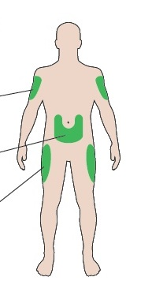

Upper arms

Thighs

Stomach

**Get to know your pen**

Cartridge holder

Plunger*

Dose pointer

Dose window

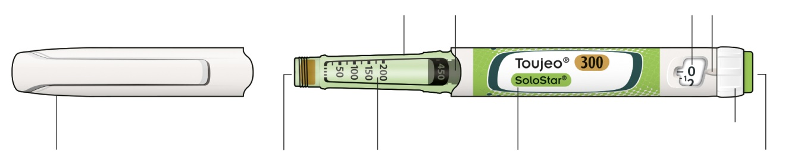

Dose selector

Injection button

Insulin name

Insulin scale

Rubber seal

Pen cap

* You will not see the plunger until you have injected a few doses.

**STEP 1: Check your pen**

CheckmarkTake a new pen out of the fridge at least 1 hour before you inject. Cold insulin is more painful to inject.

**A Check the name and expiration date on the label of your pen.**

* Make sure you have the correct insulin. This is especially important if you have other injector pens.
* Never use your pen after the expiration date.

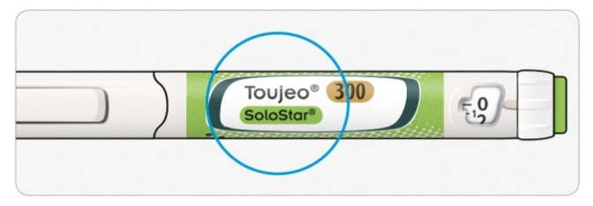

**B Pull off the pen cap.**

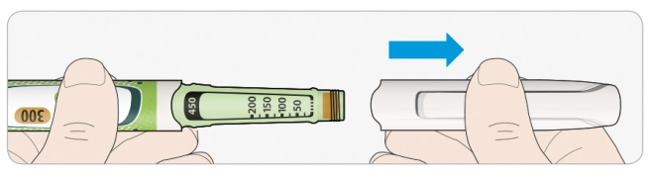

**C Check that the insulin is clear.**

* Do not use the pen if the insulin looks cloudy, coloured or contains particles.

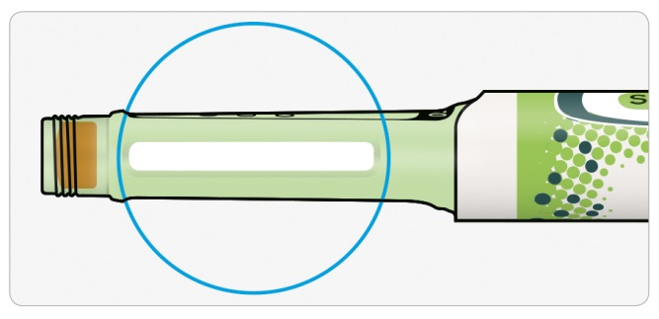

**STEP 2: Attach a new needle**

CheckmarkCheckmarkAlways use a new sterile needle for each injection. This helps stop blocked needles, contamination and infection.

Only use needles that are compatible for use with Toujeo (e.g. needles from BD, Ypsomed, Artsana or Owen Mumford).

**A Take a new needle and peel off the protective seal.**

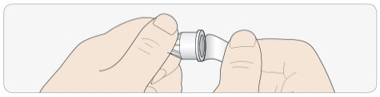

**B Keep the needle straight and screw it onto the pen until fixed. Do not overtighten.**

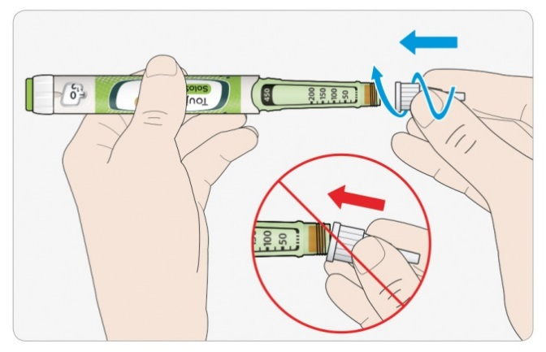

**C Pull off the outer needle cap. Keep this for later.**

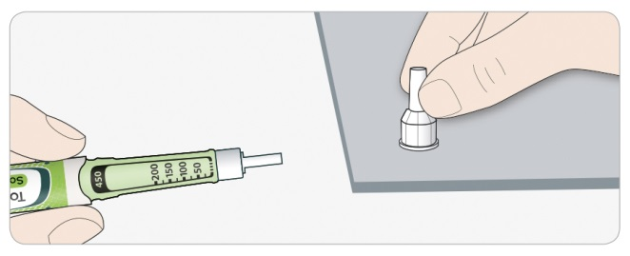

**D Pull off the inner needle cap and throw away.**

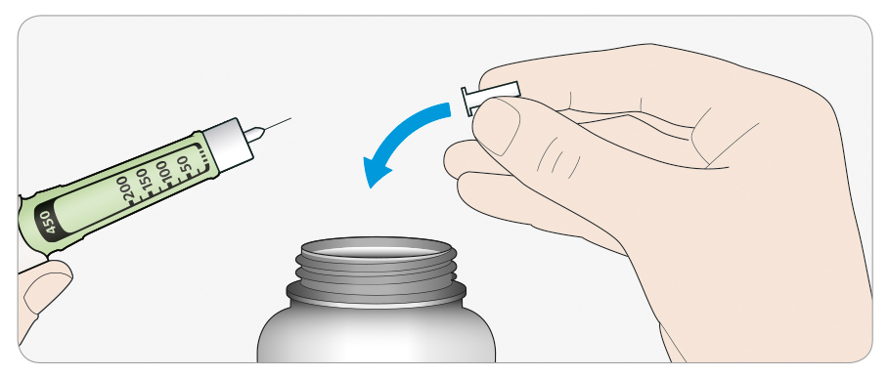

Information**Handling needles**

* Take care when handling needles – this is to prevent needle injury and cross-infection.

**STEP 3: Do a safety test**

Checkmark

Always do a safety test before each injection – this is to:

* check your pen and the needle are working properly.
* make sure that you get the correct insulin dose.

**A Select 3 units by turning the dose selector until the dose pointer is at the mark between 2 and 4.**

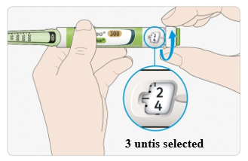

**B Press the injection button all the way in.**

* When insulin comes out of the needle tip, your pen is working correctly.

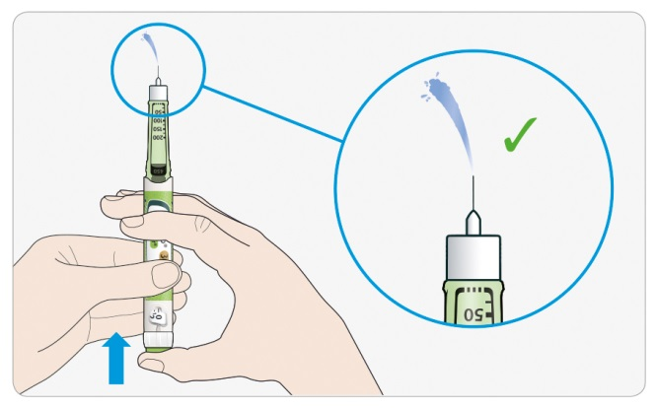

**If no insulin appears:**

* You may need to repeat this step up to 3 times before seeing insulin.
* If no insulin comes out after the third time, the needle may be blocked. If this happens:
* change the needle (see STEP 6 and STEP 2),
* then repeat the safety test (STEP 3).
* Do not use your pen if there is still no insulin coming out of the needle tip. Use a new pen.
* Never use a syringe to remove insulin from your pen.

Information**If you see air bubbles**

* You may see air bubbles in the insulin. This is normal, they will not harm you.

**STEP 4: Select the dose**

CrossNever select a dose or press the injection button without a needle attached. This may damage your pen.

**A Make sure a needle is attached and the dose is set to ‘0’.**

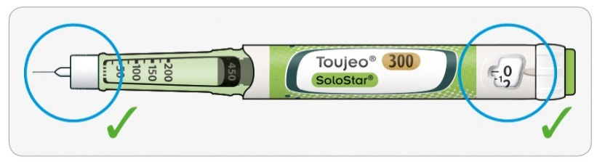

**B Turn the dose selector until the dose pointer lines up with your dose.**

* If you turn past your dose, you can turn back down.
* If there are not enough units left in your pen for your dose, the dose selector will stop at the number of units left.
* If you cannot select your full prescribed dose, split the dose into two injections or use a new pen.

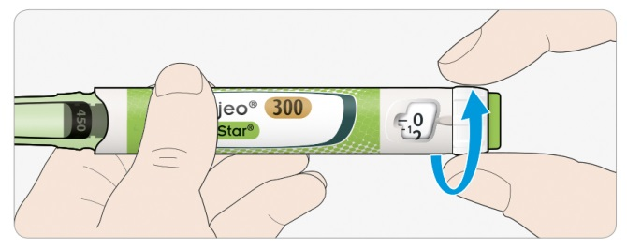

**How to read the dose window**

Even numbers are shown in line with the dose pointer:

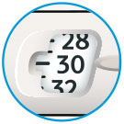

**30 units selected**

Odd numbers are shown as a line between even numbers:

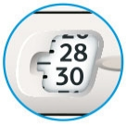

**29 units selected**

Information**Units of insulin in your pen**

* Your pen contains a total of 450 units of insulin. You can select doses from 1 to 80 units in steps of 1 unit. Each pen contains more than one dose.
* You can see roughly how many units of insulin are left by looking at where the plunger is on the

insulin scale.

**STEP 5: Inject your dose**

Cross

InformationIf you find it hard to press the injection button in, do not force it as this may break your pen. See the section below for help.

**A Choose a place to inject as shown in the picture**

**B Push the needle into your skin as shown by your doctor, pharmacist or nurse.**

* Do not touch the injection button yet.

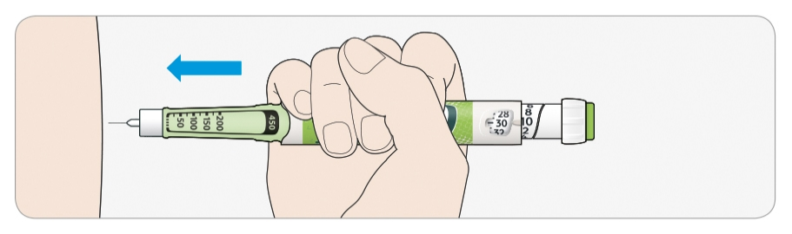

**C Place your thumb on the injection button. Then press all the way in and hold.**

* Do not press at an angle – your thumb could block the dose selector from turning.

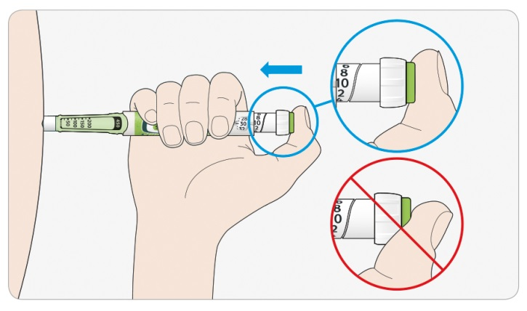

**D Keep the injection button held in and when you see "0" in the dose window, slowly count to 5.**

* This will make sure you get your full dose.

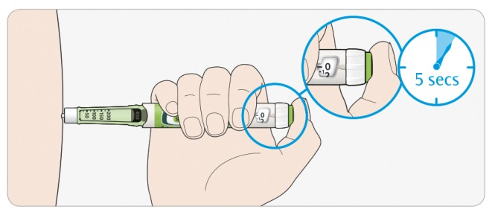

**E After holding and slowly counting to 5, release the injection button. Then remove the needle from your skin.**

Information**If you find it hard to press the button in:**

* Change the needle (see STEP 6 and STEP 2) then do a safety test (see STEP 3).
* If you still find it hard to press in, get a new pen.
* Never use a syringe to remove insulin from your pen.

**STEP 6: Remove the needle**

CheckmarkTake care when handling needles – this is to prevent needle injury and cross-infection.

CrossNever put the inner needle cap back on.

**A Put the outer needle cap back on the needle, and use it to unscrew the needle from the pen**.

* To reduce the risk of accidental needle injury, never replace the inner needle cap.
* If your injection is given by another person, or if you are giving an injection to another person, special caution must be taken by this person when removing and disposing of the needle.
* Follow recommended safety measures for removal and disposal of needles (contact your doctor, pharmacist or nurse) in order to reduce the risk of accidental needle injury and transmission of infectious diseases.

**B Throw away the used needle in a puncture resistant container, or as told by your pharmacist or local authority.**

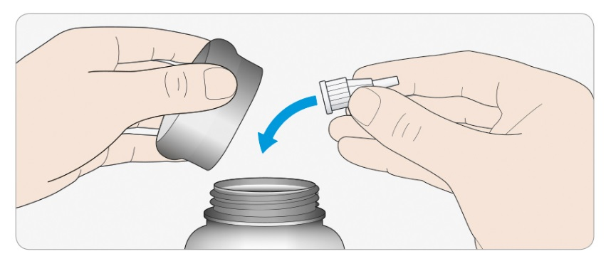

**C Put the pen cap back on.**

* Do not put the pen back in the fridge.

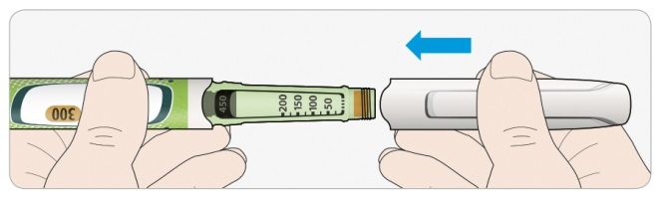

**Use by**

* Only use your pen for up to 6 weeks after its first use.

**How to store your pen**

**Before first use**

* Keep new pens in a fridge, at **2°C to 8°C**.
* Do not freeze.

**After first use**

* Keep your pen at room temperature, **below 30°C.**
* Never put your pen back in the fridge.
* Never store your pen with the needle attached.
* Store your pen with the pen cap on.

**How to care for your pen**

**Handle your pen with care**

* Do not drop your pen or knock it against hard surfaces.
* If you think that your pen may be damaged, do not try to repair it, use a new one.

**Protect your pen from dust and dirt**

* You can clean the outside of your pen by wiping it with a damp cloth. Do not soak, wash or lubricate your pen – this may damage it.

**Throwing your pen away**

* Remove the needle before throwing your pen away.
* Throw away your used pen as told by your pharmacist or local authority.

Package leaflet: information for the user

Toujeo 300 units/ml DoubleStar solution for injection in a pre-filled pen

Insulin glargine

Each DoubleStar pen delivers 2-160 units in steps of 2 units

**Read all of this leaflet carefully before you start using this medicine because it contains important information for you.**

* Keep this leaflet. You may need to read it again.
* If you have any further questions, ask your doctor, pharmacist or nurse.
* This medicine has been prescribed for you only. Do not pass it on to others. It may harm them, even if their signs of illness are the same as yours.
* If you get any side effects, talk to your doctor or pharmacist. This includes any possible side effects not listed in this leaflet. See section 4.

**What is in this leaflet**

1. What Toujeo is and what it is used for

2. What you need to know before you use Toujeo

3. How to use Toujeo

4. Possible side effects

5. How to store Toujeo

6. Contents of the pack and other information

**1. What Toujeo is and what it is used for**

Toujeo is a type of long-acting insulin called ‘insulin glargine’.

* It is very similar to human insulin.
* It
* contains 3 times more insulin in 1 ml than standard insulin, which contains 100 unit/ml.
* It lowers your blood sugar steadily over a long period of time.
* It is injected once a day.
* . (for more information see section 3).

is used to treat diabetes mellitus (diabetes) in adults, adolescents and children from the age of 6 years. This is an illness where your body does not make enough insulin to control your blood sugar.

**2. What you need to know before you use Toujeo**

**Do not use Toujeo**

* If you are allergic to insulin glargine or to any of the other ingredients of this medicine (listed in section 6).

**Warnings and precautions**

Talk to your doctor, pharmacist or nurse before using Toujeo. Closely follow your doctors instructions for how much Toujeo to use, how to monitor your blood and urine, your diet and physical activity levels and injection technique.

**Important:**

* If your blood sugar is too low (hypoglycaemia) – see ‘what to do if you have low blood sugar’ at the end of this leaflet.
* Switching insulin - If you switch from another type, brand or manufacturer of insulin your dose may need to be changed.
* Pioglitazone used together with insulin can cause serious problems – see ‘Pioglitazone’ below.
* Make sure you use the right type of insulin – always check the insulin label before each injection to avoid mix-ups with other insulins, particularly between long-acting insulins and short-acting insulins.
* Never use a syringe to remove Toujeo from your pen. This is to avoid dosing errors and potential overdose which may lead to low blood sugar
* To avoid an insulin underdose, perform safety tests before the first use of a new pen and also before every use of the pen (see Step 3 of the Instructions for use). Please, see also section 3.
* If you are blind or have poor eyesight, do not use the pre‑filled pen without help. This is because you will not be able to read the dose window on the pen. Get help from a person with good eyesight who is trained in using the pen.

**Skin changes where the injection is given**

Change where you inject regularly. This is to prevent skin changes such as thickening, shrinking or lumps. The insulin may not work well if you inject into a lumpy area.

* Tell your doctor, pharmacist or nurse if you are currently injecting into a lumpy area before you

start injecting in a different area.

Your doctor may tell you to check your blood sugar more closely, and to adjust the dose of your insulin or other anti-diabetic medications.

**Illnesses and injuries**

You may need to check your blood and urine more carefully to manage your diabetes if:

* you are ill or have a major injury. Your blood sugar level may increase - hyperglycaemia.
* you are not eating enough. Your blood sugar level may get too low - hypoglycaemia.

Tell a doctor as soon as you feel ill or get an injury.

If you have Type 1 diabetes and you have an illness or injury:

* do not stop your insulin
* keep eating enough carbohydrates.

Always tell people who are caring or treating you, that you have diabetes.

**Insulin antibodies**

Insulin treatment can cause the body to produce antibodies to insulin (substances that act against insulin). However, only very rarely, this will require a change to your insulin dose.

**Travel and Toujeo**

If you are going abroad, travelling over time zones may affect your insulin needs and the timing of your injections. Talk to your doctor before travelling. You may need to talk about:

* If your type of insulin is available in the country you are visiting.
* How to arrange the supply of insulin, needles and other items.
* How to correctly store your insulin while travelling.
* The time you eat meals and use your insulin.
* The possible effects of changing to different time zones.
* Any health risks in the countries you will visit.
* What you should do in an emergency situation if you feel unwell or become ill.

**Children and adolescents**

Do not give this medicine to children under 6 years of age. This is because there is no experience with Toujeo in children of this age.

**Other medicines and Toujeo**

Tell your doctor, pharmacist or nurse if you are taking, have recently taken or might take any other medicines. Your doctor will tell you if your insulin dose has to change.

Listed below are the most common medicines which may affect your insulin treatment:

**Your blood sugar level may fall** (hypoglycaemia) if you take:

* any other medicine for diabetes
* disopyramide – for some heart problems
* fluoxetine – for depression
* pentamidine – for some parasitic infections. This may cause too low blood sugar which is sometimes followed by too high blood sugar
* sulfonamide antibiotics – for infection
* fibrates – for lowering high levels of fat in the blood
* monoamine oxidase inhibitors (MAOIs) – for depression
* pentoxifylline, propoxyphene and salicylates (such as aspirin) – for pain and mild fever
* angiotensin converting enzyme (ACE) inhibitors – for heart problems or high blood pressure.

**Your blood sugar level may rise** (hyperglycaemia) if you take:

* danazol – for endometriosis
* diazoxide – for high blood pressure
* glucagon – for very low blood sugar
* isoniazid – for tuberculosis
* somatropin – a growth hormone
* thyroid hormones – for thyroid gland problems
* oestrogens and progestogens – such as in the contraceptive pill, for birth control
* corticosteroids such as cortisone – for inflammation
* protease inhibitors – for HIV
* diuretics – for high blood pressure or fluid retention
* clozapine, olanzapine and phenothiazine derivatives – for mental health problems
* sympathomimetics such as epinephrine (adrenaline), salbutamol and terbutaline – for asthma.

**Your blood sugar level may either rise or fall** if you take:

* beta‑blockers or clonidine – for high blood pressure.
* lithium salts – for mental health problems.

**Beta‑blockers**

* Beta-blockers like other “Sympatholytic medicines” (such as clonidine, guanethidine , reserpine– for high blood pressure) can hide or stop the signs of your blood sugar being too low (hypoglycaemia) or may make it harder to recognise warning signs.

**Pioglitazone**

Some patients with long‑standing type 2 diabetes mellitus and heart disease or previous stroke treated with pioglitazone and insulin developed heart failure.

* Tell your doctor straight away if you have signs of heart failure – such as feeling unusually short of breath, rapid weight gain or localised swelling.

If any of the above apply to you, or you are not sure, talk to your doctor, pharmacist or nurse before using Toujeo.

**Toujeo with alcohol**

Your blood sugar level may rise or fall if you drink alcohol – you will need to check your blood sugar level more often than usual.

**Pregnancy and breast‑feeding**

If you are pregnant or breast‑feeding, think you might be pregnant or are planning to have a baby, ask your doctor, pharmacist or nurse for advice before using this medicine:

* you may need to change your insulin dose during pregnancy and after giving birth, or both insulin dose and diet during breast-feeding
* to protect your baby it is very important to control your diabetes and prevent low blood sugar.

**Driving and using machines**

Having too low or too high blood sugar or sight problems can affect your ability to drive, use tools or machines. Your concentration may be affected. This could be dangerous to yourself and others. Ask your doctor, pharmacist or nurse whether you can drive, use tools or machines if:

* you often get low blood sugar
* you find it hard to recognise your low blood sugar.

**Toujeo contains sodium**

This medicine contains less than 1 mmol (23 mg) sodium per dose, that is to say essentially ‘sodium-free’

**3. How to use Toujeo**

Always use this medicine exactly as your doctor has told you. Check with your doctor, pharmacist or nurse if you are not sure.

Toujeo and insulin glargine 100 units/ml are not interchangeable, even though they contain same active substance. The switch from one insulin therapy to another requires medical prescription, medical supervision and blood glucose monitoring. Talk to your doctor for further information.

**How much to use**

The Toujeo DoubleStar pre‑filled pen can provide a dose of 2 to 160 units per injection, in steps of 2 units. The pen is recommended for patient who need at least 20 units of insulin per day (see also section 2).dose window of the DoubleStar pen shows the number of units of Toujeo to be injected and no dose re-calculation is required.

Your doctor will decide:

* how much Toujeo you need each day and at what time
* when to check your blood sugar level and if you need to carry out urine tests
* when you may need a higher or lower dose.

These are based on your life-style, your blood sugar (glucose) tests and your insulin use in the past.

Talk to your doctor as you may need a lower dose if:

* you are 65 years or older
* you have kidney or liver problems.

Toujeo is a long‑acting insulin. Your doctor may tell you to use it with a short‑acting insulin, or with other medicines for high blood sugar.

Make sure you use the right type of insulin.

* Always check the insulin label before each injection to avoid mix-ups with other insulins, particularly between long-acting insulins and short-acting insulins .
* The strength “300” is highlighted in honey gold on the label of your Toujeo DoubleStar pre‑filled pen. Ask your doctor or pharmacist if you are not sure.

Many factors may affect your blood sugar level – learn what these are and what to do if your blood sugar level changes. This will help stop it becoming too high or too low. See ‘hyperglycaemia and hypoglycaemia’ at the end of this leaflet for more information.

**When to use Toujeo**

* Use Toujeo once a day, preferably at the same time every day.
* You can inject it up to 3 hours before or after the usual time that you use it.

**Before injecting Toujeo**

* Read the instructions for use that come with this package leaflet.
* If you do not follow all the instructions, you may get too much or too little insulin.
* Perform a safety test as described in Step 3 of the Instructions for Use. If you don’t, your full dose will not be delivered. If this occurs, you should increase the frequency of checking your blood sugar level and might need to administer additional insulin. Please, also see section 2.

**How to inject**

* Inject Toujeo under the skin. This is called ‘subcutaneous use’ or ‘SC’.
* Inject it into the front of your thighs, upper arms or the front of your waist (abdomen).
* Change the place within the area where you inject each day – to reduce the risk of skin shrinking or thickening (see section 4).
* Always use a new sterile needle for each injection – to reduce the risk of infection and blocked needles which can lead to you getting too much or too little insulin.
* Throw away the used needle in a puncture resistant container, or as instructed by your pharmacist.
* Do not share your insulin pen with anyone else, even when the needle is changed – to prevent spreading disease.
* Do not use a syringe to remove Toujeo from your pen – to avoid potential overdose.

**Do not use Toujeo**:

* in a vein – this changes the way it works and may cause your blood sugar to become too low.
* in an insulin infusion pump.
* if there are particles in the insulin – the liquid should be clear, colourless and water‑like

Throw the pen away and use a new one if:

* you notice that your blood sugar control is unexpectedly getting worse
* the pen is damaged or has not been stored correctly.

Talk to your doctor, pharmacist or nurse if you are not sure your pen is working properly.

**If you use more Toujeo than you should**

If you use too much of this medicine, your blood sugar level may get too low – see ‘low blood sugar’ at the end of this leaflet for advice.

**If you forget to use Toujeo**

* If you forget a dose, inject the missed dose within 3 hours of the time you usually inject it.
* If you remember when more than 3 hours have passed, do not inject the missed dose – check your blood sugar and then inject your next dose at the usual time the next day.
* Do not inject a double dose to make up for a forgotten dose.
* If you miss a dose of Toujeo or if you have not injected enough insulin, your blood sugar level may get too high – see ‘high blood sugar (hyperglycaemia)’ at the end of this leaflet for advice.

##### **If you stop using Toujeo**

Do not stop using this medicine without talking to your doctor. If you stop using this medicine, this could lead to very high blood sugar and a build‑up of acid in the blood called ‘ketoacidosis’, see ‘high blood sugar’ at the end of this leaflet for advice.

If you have any further questions on the use of this medicine, ask your doctor, pharmacist or nurse.

**4. Possible side effects**

Like all medicines, this medicine can cause side effects, although not everybody gets them.

**Serious side effects**

Tell your doctor, pharmacist or nurse straight away if you notice any of the following serious side effects – you may need urgent medical treatment:

**Low blood sugar (hypoglycaemia)** – very common: may affect more than 1 in 10 people

* If your blood sugar falls too much, you may pass out.
* Serious low blood sugar may cause brain damage and may be life-threatening.

If you have signs of low blood sugar, try to increase your blood sugar level straight away. See advice in ‘low blood sugar’ at the end of this leaflet.

The signs of **severe allergic reactions** (rare: may affect up to 1 in 1,000 people) may include:

* feeling short of breath
* swelling of the skin or mouth
* rash and itching all over the body
* feeling faint with fast heartbeat and sweating.

Tell your doctor, pharmacist or nurse straight away as severe allergic reactions may become life‑threatening.

**Other side effects**

Tell your doctor, pharmacist or nurse if you notice any of the following side effects:

**Skin changes where the injection is given**

If you inject insulin too often at the same place, the skin may change which include:

* skin shrinking (lipoatrophy) (may affect up to 1 in 100 people)
* skin thickening (lipohypertrophy) (may affect up to 1 in 10 people)
* lumps under the skin may also be caused by build-up of a protein called amyloid (cutaneous amyloidosis; how often this occurs is not known). The insulin may not work very well if you inject into a lumpy area.

Change the area where the injection is given regularly to prevent skin changes.

**Common:** may affect up to 1 in 10 people

* skin and allergic reactions where the injection is given, The signs may include reddening, unusually intense pain when injecting, itching, hives, swelling or inflammation. This can spread around the injection site. Most minor reactions to insulins usually disappear within a few days to a few weeks.

**Rare:** may affect up to 1 in 1,000 people

* eye problems – a large change in your blood sugar control, getting better or worse, can disturb your vision. If you have a diabetic eye disorder called “proliferative retinopathy”, very low blood sugar attack may cause temporary loss of vision.
* swelling in the calves and ankles – due to your body keeping more water than it should.

**Very rare:** may affect up to 1 in 10,000 people

* changes in taste (dysgeusia).
* muscular pain (myalgia).

Tell your doctor, pharmacist or nurse if you notice any of the side effects above.

**Reporting of side effects**

If you get any side effects, talk to your doctor or pharmacist. This includes any possible side effects not listed in this leaflet.You can also report side effects directly via the national reporting system listed in [Appendix V](http://www.ema.europa.eu/docs/en_GB/document_library/Template_or_form/2013/03/WC500139752.doc). By reporting side effects you can help provide more information on the safety of this medicine.

**5. How to store Toujeo**

Keep this medicine out of the sight and reach of children.

Do not use this medicine after the expiry date which is stated on the carton and on the label of the pen after “EXP”. The expiry date refers to the last day of that month.

**Before first use**

* Store in a refrigerator, 2°C - 8°C.
* Do not freeze or place next to the freezer compartment or a freezer pack.
* Keep the pen in the outer carton in order to protect from light.

**After first use or if carried as a spare**

* Do not store the pen in a refrigerator.
* The pen may be stored for up to 6 weeks at room temperature - **below 30°C** and away from direct heat or direct light.
* Do not leave your insulin in a car on a very warm or cold day.

Do not throw away any medicines via wastewater or household waste. Ask your pharmacist how to throw away medicines you no longer used. These measures will help protect the environment.

**6. Contents of the pack and other information**

###### **What Toujeo contains**

* The active substance is insulin glargine. Each ml of the solution contains 300 units of insulin glargine (equivalent to 10.91 mg). Each DoubleStar pen contains 3 ml of solution for injection, equivalent to 900 units.
* The other ingredients are: zinc chloride, metacresol, glycerol, water for injections, and sodium hydroxide (see section 2 ‘ Toujeo contains sodium’) and hydrochloric acid (for pH adjustment).

###### **What Toujeo looks like and contents of the pack**

* Toujeo is a clear and colourless solution.
* Each DoubleStar pencontains 3 ml of solution for injection (equivalent to 900 units).
* Packs of 1, 3, 6 (2 packs of 3), 9 (3 packs of 3) and 10 pre‑filled pens.
* Not all pack sizes may be marketed.

###### **Marketing Authorisation Holder and Manufacturer**

Sanofi-Aventis Deutschland GmbH, D-65926 Frankfurt am Main, Germany.

For any information about this medicine, please contact the local representative of the Marketing Authorisation Holder.

|  |  |
| --- | --- |
| **België/Belgique/Belgien**  Sanofi Belgium  Tél/Tel: +32 (0)2 710 54 00 | **Lietuva**  Swixx Biopharma UAB  Tel: +370 5 236 91 40 |
| **България**  Swixx Biopharma EOOD  Тел.: +359 (0)2 4942 480 | **Luxembourg/Luxemburg**  Sanofi Belgium  Tél/Tel: +32 (0)2 710 54 00 (Belgique/Belgien) |
| **Česká republika**  Sanofi s.r.o.  Tel: +420 233 086 111 | **Magyarország**  sanofi-aventis zrt., Magyarország  Tel.: +36 1 505 0050 |
| **Danmark**  Sanofi A/S  Tlf: +45 45 16 70 00 | **Malta**  Sanofi S.r.l. Tel: +39 02 39394275 |
| **Deutschland**  Sanofi-Aventis Deutschland GmbH  Tel : 0800 52 52010  Tel. aus dem Ausland: +49 69 305 21 131 | **Nederland**  Sanofi B.V.  Tel: +31 20 245 4000 |
| **Eesti**  Swixx Biopharma OÜ  Tel: +372 640 10 30 | **Norge**  sanofi-aventis Norge AS  Tlf: +47 67 10 71 00 |
| **Ελλάδα**  Sanofi-Aventis Μονοπρόσωπη AEBE  Τηλ: +30 210 900 16 00 | **Österreich**  sanofi-aventis GmbH  Tel: +43 1 80 185 – 0 |
| **España**  sanofi-aventis, S.A.  Tel: +34 93 485 94 00 | **Polska**  Sanofi Sp. z o.o.  Tel.: +48 22 280 00 00 |
| **France**  Sanofi Winthrop Industrie  Tél: 0 800 222 555  Appel depuis l’étranger : +33 1 57 63 23 23 | | **Portugal**  Sanofi - Produtos Farmacêuticos, Lda  Tel: +351 21 35 89 400 |
| **Hrvatska**  Swixx Biopharma d.o.o.  Tel: +385 1 2078 500 | **România**  Sanofi Romania SRL  Tel: +40 (0) 21 317 31 36 |
| **Ireland**  sanofi-aventis Ireland Ltd. T/A SANOFI  Tel: +353 (0) 1 403 56 00 | **Slovenija**  Swixx Biopharma d.o.o.  Tel: +386 1 235 51 00 |
| **Ísland**  Vistor ehf.  Sími: +354 535 7000 | **Slovenská republika**  Swixx Biopharma s.r.o.  Tel: +421 2 208 33 600 |
| **Italia**  Sanofi S.r.l.  Tel: 800 13 12 12 (domande di tipo tecnico)  +39 800 536389 (altre domande e chiamate dall'estero) | **Suomi/Finland**  Sanofi Oy  Puh/Tel: +358 (0) 201 200 300 |
| **Κύπρος**  C.A. Papaellinas Ltd.  Τηλ: +357 22 741741 | **Sverige**  Sanofi AB  Tel: +46 (0)8 634 50 00 |
| **Latvija**  Swixx Biopharma SIA  Tel: +371 6 616 47 50 |  |

**This leaflet was last revised in**

**Other source of information**

Detailed information on this medicine is available on the European Medicines Agency web site: <https://www.ema.europa.eu/>

|  |  |
| --- | --- |
| **Hyperglycaemia and hypoglycaemia**  **If you take insulin, you should always carry the following things with you:**   * Sugar (at least 20 grams). * Information so that others know you have diabetes.   **High blood sugar (hyperglycaemia)**  **Warning signs of high blood sugar:**   * feeling thirsty, needing to urinate more often * feeling tired or dry skin, reddening of the face, loss of appetite * low blood pressure, fast heartbeat * glucose and ketone bodies in urine * stomach pain, fast and deep breathing, feeling sleepy or passing out (becoming unconscious) may be signs of a serious condition (ketoacidosis) resulting from lack of insulin.   **What to do if you have high blood sugar**   * Test your blood sugar level and your urine for ketones as soon as you notice any of the above signs * Contact your doctor straight away if you have severe hyperglycaemia or ketoacidosis. This must always be treated by a doctor, normally in a hospital.   **High blood sugar can happen if:**   * you have not injected your insulin or not injected enough. * your insulin is not working properly – this could be because it was not stored properly. * your insulin pen does not work properly. * you do less exercise than usual. * you are under stress – such as emotional distress or excitement. * you have an injury, infection or fever or have had an operation. * you take or have taken some other medicines, see section 2 – ‘Other medicines and Toujeo’.   **Low blood sugar (hypoglycaemia)**  Very low blood sugar may make you pass out (unconscious), cause heart attack or brain damage and be life-threatening. Learn to recognise the signs when your blood sugar is falling – and what to do to stop it getting worse.  **Warning signs of low blood sugar**  The first signs may be in your body generally:   * feeling sweaty * having clammy skin * feeling anxious * fast or irregular heartbeat, high blood pressure, palpitations   Other signs in your brain may come slightly later:   * headache, trembling, feeling dizzy * changes in your sight * feeling very hungry, feeling sick (nausea) or vomiting * changes in behaviour, aggression, depression * feeling tired or sleepy, sleeping problems, feeling restless * difficulty concentrating, confusion, slowed reactions or difficulty speaking (sometimes total loss of speech) * not being able to move (paralysis), tingling in hands or arms, feeling numb and tingling often around the mouth * loss of self-control, being unable to look after yourself, fits or passing out.   **What to do if you have low blood sugar**   1. Do not inject insulin. 2. Take about 10 to 20 grams sugar straight away - such as glucose, sugar cubes or a sugary-drink. Do not drink or eat foods that contain artificial sweeteners (such as diet drinks). They do not help treat low blood sugar. 3. Then eat something such as bread or pasta that will raise your blood sugar over a longer time. Ask your doctor or nurse if you are not sure which foods you should eat. With Toujeo, it may take longer to recover from low blood sugar because it is long‑acting. 4. If the low blood sugar comes back again, take another 10 to 20 grams of sugar. 5. Speak to a doctor straight away if you are not able to control the low blood sugar - or if it comes back.   **What other people should do if you have low blood sugar**   * Tell your relatives, friends and close colleagues to get medical help straight away if you are not able to swallow or if you pass out (become unconscious). * You will require an injection of glucose or glucagon (a medicine which increases blood sugar). These injections should be given even if it is not certain that you have hypoglycaemia. * You should test your blood sugar straight away after taking glucose to check that you really have hypoglycaemia.   **Low blood sugar can happen if:**   * you inject too much insulin. * you miss meals or eat late. * you do not eat enough, or eat food containing less sugar than normal – artificial sweeteners are not sugars. * you drink alcohol – especially when you have not eaten much. * you are sick (vomit) or have diarrhoea. * you do more exercise than usual or a different type of physical activity. * you are recovering from an injury, operation or other stress. * you are recovering from an illness or from fever. * you take or have taken some other medicines, see section 2 – ‘Other medicines and Toujeo’.   **Low blood sugar is more likely to happen if:**   * you have just started insulin treatment or changed to another insulin – if low blood sugar occurs, it may be more likely to happen in the morning. * your blood sugar levels are almost normal or are unstable. * you change the area of body where you inject insulin, for example from the thigh to the upper arm. * you have severe kidney or liver disease, or some other disease such as hypothyroidism.   **Signs of low blood sugar may be different, less clear or missing if:**   * you are elderly. * you have had diabetes for a long time. * you have a nervous disease called “diabetic autonomic neuropathy”. * you have recently had too low blood sugar, for example the day before. * your low blood sugar comes on slowly. * your low blood sugar is always around “normal” or your blood sugar has got much better. * you have recently changed from an animal insulin to a human insulin, like Toujeo. * you take or have taken some other medicines, see section 2, ‘Other medicines and Toujeo’.   In such cases, you may get very low blood sugar and even pass out before you know what is happening. Know your warning signs. You may need to test your blood sugar more often - to help you spot low blood sugar. If you find it difficult to spot your warning signs, you should avoid situations (such as driving a car) in which you or others would be put at risk by low blood sugar. | |

**Toujeo 300 units/ml solution for injection in a pre-filled pen (DoubleStar)**

**INSTRUCTIONS FOR USE**

**Read this first**

**Toujeo DoubleStar contains 300 units/ml insulin glargine** in a **3** ml disposable prefilled pen

* **Never re-use needles.** If you do you might not get your dose (underdosing) or get too much (overdosing) as the needle could block.
* **Never use a syringe to remove insulin from your pen.** If you do you will get too much insulin. The scale on most syringes is made for non‑concentrated insulin only.
* The dose selector of your Toujeo DoubleStar pen dials in steps of **2 units**.

**Important information**

CrossNever share your pen – it is only for you.

CrossNever use your pen if it is damaged or if you are not sure that it is working properly.

**CheckmarkAlways perform a safety test before you use a new pen for the first time until you see**

**insulin coming out of the needle tip** (see STEP 3). If you see insulin coming out the

needle tip, the pen is ready to use. If you do not see insulin coming out before taking

your dose, you could get an underdose or no insulin at all. This could cause high

blood sugar

**CheckmarkTo ensure the pen and needle are working, always perform the safety test until you**

**see insulin coming out the needle tip before each injection** (see STEP 3). If you do not perform the safety test before each injection, you may get too little insulin.

CheckmarkAlways carry a spare pen and spare needles in case they get lost or stop working.

**Learn to inject**

* Talk with your doctor, pharmacist or nurse about how to inject, before using your pen.
* This pen is not recommended for use by people who are blind or have visual impairments without the assistance of a person trained in the proper use of the product.
* Read all of these instructions before using your pen. If you do not follow all of these instructions, you may get too much or too little insulin.

**Need help?**

If you have any questions about your pen or about diabetes, ask your doctor, pharmacist or nurse or call Sanofi number on the front of this leaflet.

**Extra items you will need:**

* a new sterile needle (see STEP 2).
* a puncture resistant container for used needles and pens.

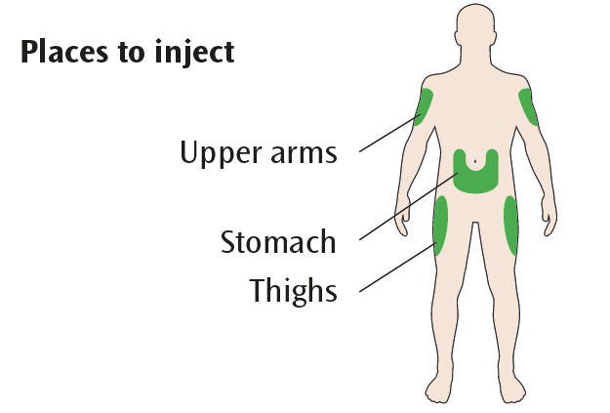

**Get to know your pen**

Dose window

Dose pointer

Plunger*

Cartridge holder

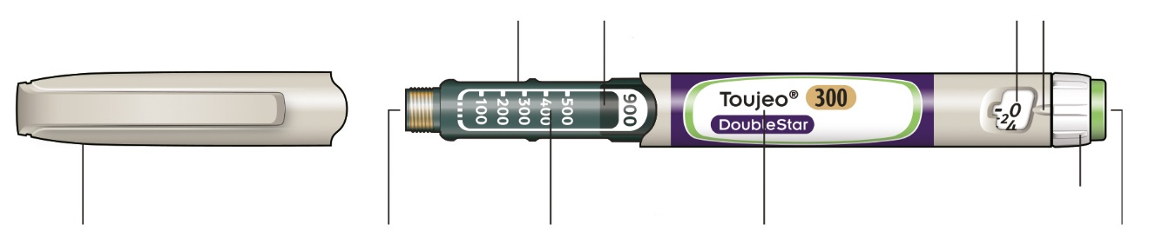

Injection button

Dose selector

Insulin name

Insulin scale

Rubber seal

Pen cap

* You will not see the plunger until you have injected a few doses.

**STEP 1: Check your pen**

CheckmarkTake a new pen out of the fridge at least 1 hour before you inject. Cold insulin is more painful to inject.

**A Check the name and expiration date on the label of your pen.**

* Make sure you have the correct insulin. This is especially important if you have other injector pens.
* Never use your pen after the expiration date.

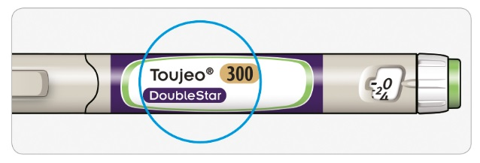

**B Pull off the pen cap.**

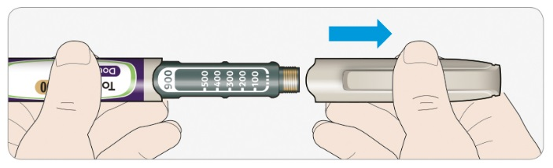

**C Check that the insulin is clear.**

* Do not use the pen if the insulin looks cloudy, coloured or contains particles.

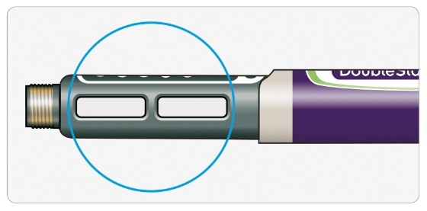

**STEP 2: Attach a new needle**

CheckmarkAlways use a new sterile needle for each injection. This helps stop blocked needles, contamination and infection.

CheckmarkOnly use needles that are compatible for use with Toujeo DoubleStar (e.g. needles from BD, Ypsomed, Artsana or Owen Mumford) that are 8 mm long or shorter.

**A Take a new needle and peel off the protective seal.**

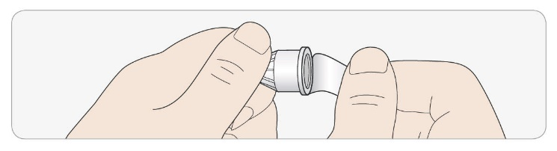

**B Keep the needle straight and screw it onto the pen until fixed. Do not overtighten.**

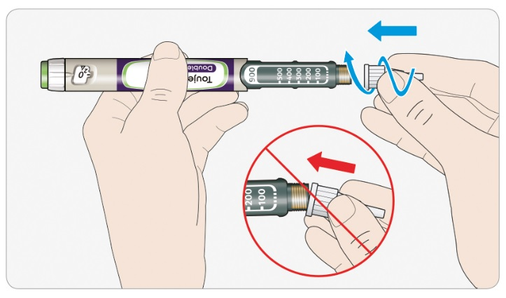

**C Pull off the outer needle cap. Keep this for later.**

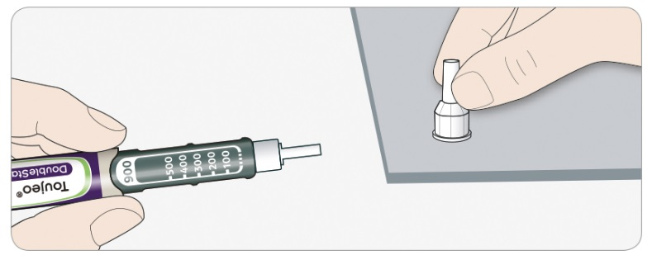

**D Pull off the inner needle cap and throw away.**

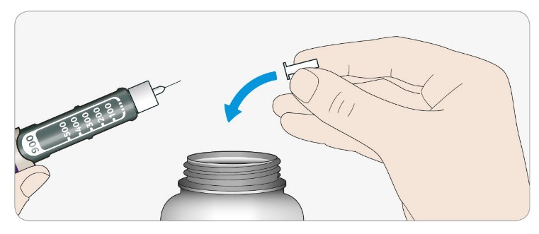

Information**Handling needles**

* Take care when handling needles – this is to prevent needle injury and cross-infection.

**STEP 3: Do a safety test**

Checkmark

**Always do a safety test before each injection** – this is to:

* check your pen and the needle are working properly.
* make sure that you get the correct insulin dose.

Checkmark

**If the pen is new, you must perform safety tests before you use the pen for the first**

**time until you see insulin coming out of the needle tip.** If you see insulin coming out

of the needle tip, the pen is ready to use. If you do not see insulin coming out before

taking your dose, you could get an underdose or no insulin at all. This could cause

high blood sugar.

**A Select 4 units by turning the dose selector until the dose pointer is at the 4 mark.**

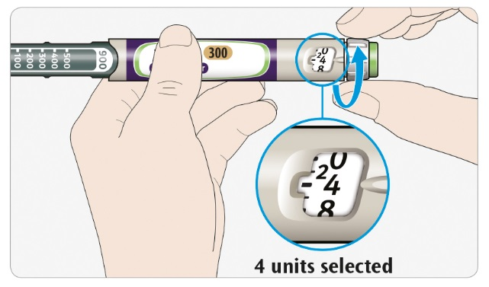

**B Press the injection button all the way in.**

* When insulin comes out of the needle tip, your pen is working correctly.

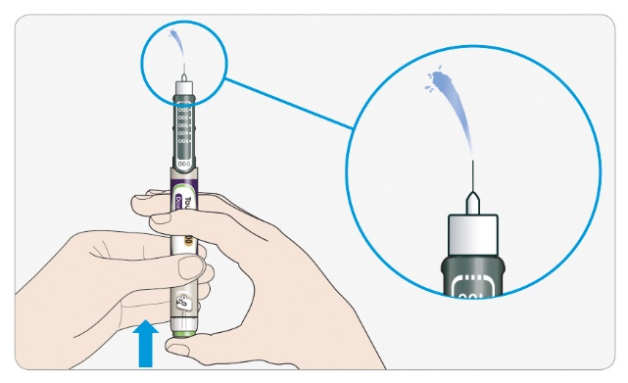

**C Repeat this step if no insulin appears:**

* **If you are using a new pen for the first time**, you may have to repeat this step **up to 6 times** before seeing insulin.
* Do not use your pen if there is still no insulin coming out of the needle tip. Use a new pen.
* **For all injections**, if no insulin comes out, the needle may be blocked. If this happens:
* change the needle (see STEP 6 and STEP 2),
* then repeat the safety test (STEP 3A and STEP 3 B).
* Do not use your pen if there is still no insulin coming out of the needle tip. Use a new pen.
* Never use a syringe to remove insulin from your pen.

Information**If you see air bubbles**

* You may see air bubbles in the insulin. This is normal, they will not harm you.

**STEP 4: Select the dose**

CrossNever select a dose or press the injection button without a needle attached. This may damage your pen.

Toujeo DoubleStar is made to deliver the number of insulin units that your doctor prescribed. Do not perform any dose re-calculation.

**A Make sure a needle is attached and the dose is set to ‘0’.**

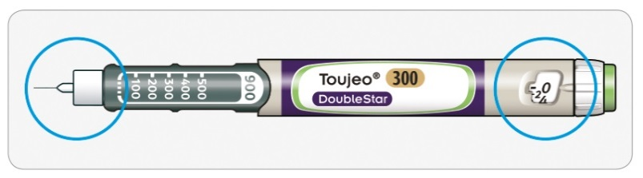

**B Turn the dose selector until the dose pointer lines up with your dose.**

* Set the dose by turning the dose selector to a line in the dose window. Each line equals 2 units
* The dial clicks as you turn it
* **Do not dial your dose by counting the clicks.** You may dial the wrong dose. This may lead to you getting too much insulin or not enough insulin.
* Always check the number in the dose window to make sure you dialled the correct dose
* If you turn past your dose, you can turn back down.
* If there are not enough units left in your pen for your dose, the dose selector will stop at the number of units left.
* If you cannot select your full prescribed dose, split the dose into two injections or use a new pen. If you use a new pen, perform a safety test (see STEP 3).

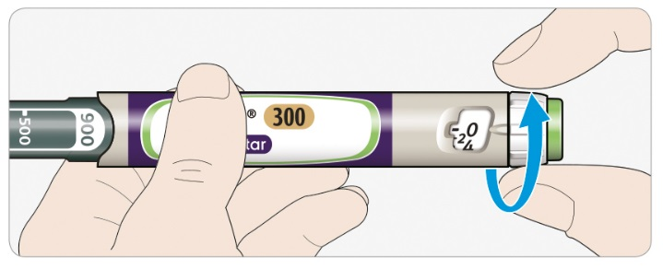

**How to read the dose window**

The dose selector adjusts in steps of 2 units.

Each line in the dose window is an even number:

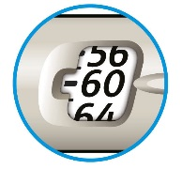

**60 units selected**

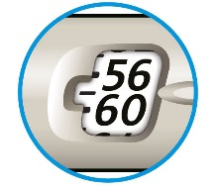

**58 units selected**

Information**Units of insulin in your pen**

* Your pen contains a total of 900 units of insulin. You can select doses from 2 to 160 units in steps of 2 units at a time. Each pen contains more than one dose.
* You can see roughly how many units of insulin are left by looking at where the plunger is on the insulin scale.

**STEP 5: Inject your dose**

Cross

InformationIf you find it hard to press the injection button in, do not force it as this may break your pen. See the section below for help.

**A Choose a place to inject as shown in the picture labelled “Places to inject”**

**B Push the needle into your skin as shown by your doctor, pharmacist or nurse.**

* Do not touch the injection button yet.

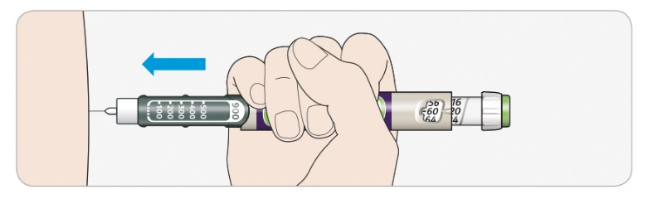

**C Place your thumb on the injection button. Then press all the way in and hold.**

* Do not press at an angle – your thumb could block the dose selector from turning.

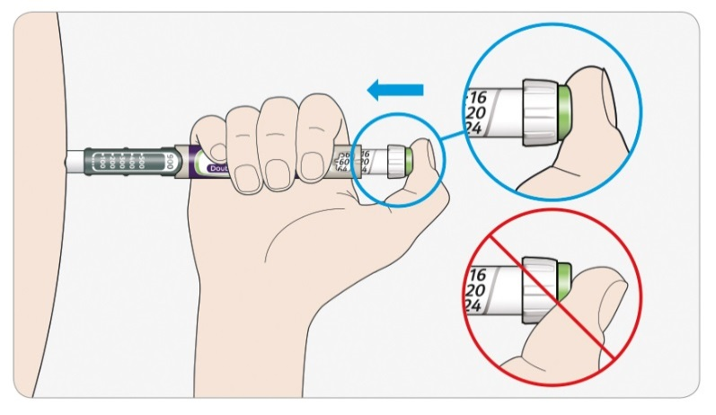

**D Keep the injection button held in and when you see "0" in the dose window, slowly count to 5.**

* This will make sure you get your full dose.

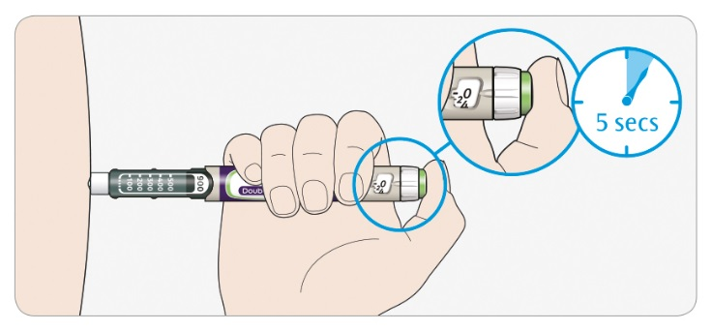

**E After holding and slowly counting to 5, release the injection button. Then remove the needle from your skin.**

Information**If you find it hard to press the button in:**

* Change the needle (see STEP 6 and STEP 2) then do a safety test (see STEP 3).
* If you still find it hard to press in, get a new pen.
* Never use a syringe to remove insulin from your pen.

**STEP 6: Remove the needle**

CheckmarkTake care when handling needles – this is to prevent needle injury and cross-infection.

CrossNever put the inner needle cap back on.

**A Put the outer needle cap back on the needle, and use it to unscrew the needle from the pen**.

* To reduce the risk of accidental needle injury, never replace the inner needle cap.
* If your injection is given by another person, or if you are giving an injection to another person, special caution must be taken by this person when removing and disposing of the needle.
* Follow recommended safety measures for removal and disposal of needles (contact your doctor, pharmacist or nurse) in order to reduce the risk of accidental needle injury and transmission of infectious diseases.

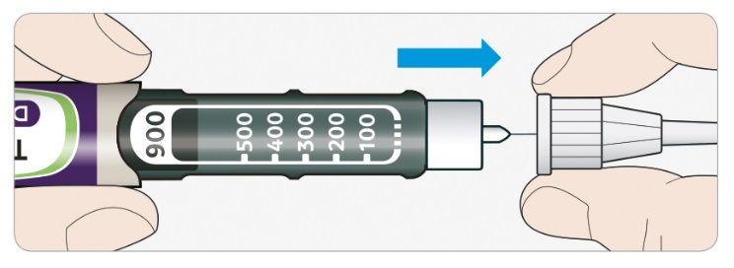

**B Throw away the used needle in a puncture resistant container, or as told by your pharmacist or local authority.**

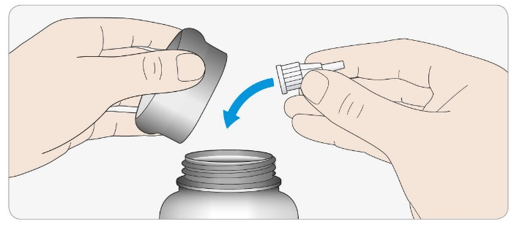

**C Put the pen cap back on.**

* Do not put the pen back in the fridge.

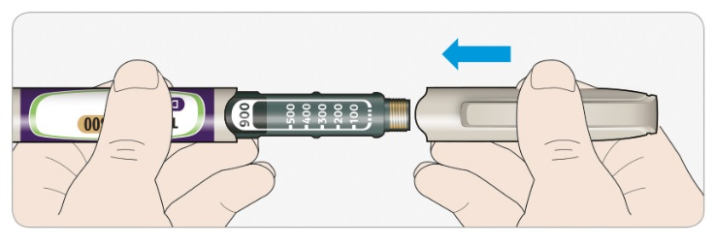

**Use by**

* Only use your pen for up to 6 weeks after its first use.

**How to store your pen**

**Before first use**

* Keep new pens in a fridge, at **2°C to 8°C**.
* Do not freeze.

**After first use**

* Keep your pen at room temperature, **below 30°C.**
* Never put your pen back in the fridge.
* Never store your pen with the needle attached.
* Store your pen with the pen cap on.
* Keep your pen and needles out of the sight and reach of children

**How to care for your pen**

**Handle your pen with care**

* Do not drop your pen or knock it against hard surfaces.
* If you think that your pen may be damaged, do not try to repair it, use a new one.

**Protect your pen from dust and dirt**

* You can clean the outside of your pen by wiping it with a damp cloth. Do not soak, wash or lubricate your pen – this may damage it.

**Throwing your pen away**

* Remove the needle before throwing your pen away.
* Throw away your used pen as told by your pharmacist or local authority.