This document is the approved product information for Victoza, with the changes since the previous procedure affecting the product information (EMEA/H/C/PSUSA/00001892/202312) tracked.

For more information, see the European Medicines Agency’s website:
https://www.ema.europa.eu/en/medicines/human/epar/victoza

ANNEX I

SUMMARY OF PRODUCT CHARACTERISTICS

1. NAME OF THE MEDICINAL PRODUCT

Victoza 6 mg/ml solution for injection in pre-filled pen

2. QUALITATIVE AND QUANTITATIVE COMPOSITION

1 ml of solution contains 6 mg of liraglutide*. One pre-filled pen contains 18 mg liraglutide in 3 ml.

* human glucagon-like peptide-1 (GLP-1) analogue produced by recombinant DNA technology in Saccharomyces cerevisiae.

For the full list of excipients, see section 6.1.

3. PHARMACEUTICAL FORM

Solution for injection.
Clear and colourless or almost colourless, isotonic solution; pH=8.15.

4. CLINICAL PARTICULARS

4.1 Therapeutic indications

Victoza is indicated for the treatment of adults, adolescents and children aged 10 years and above with insufficiently controlled type 2 diabetes mellitus as an adjunct to diet and exercise
• as monotherapy when metformin is considered inappropriate due to intolerance or contraindications
• in addition to other medicinal products for the treatment of diabetes.
For study results with respect to combinations, effects on glycaemic control and cardiovascular events, and the populations studied, see sections 4.4, 4.5 and 5.1.

4.2 Posology and method of administration

Posology

To improve gastro-intestinal tolerability, the starting dose is 0.6 mg liraglutide daily. After at least one week, the dose should be increased to 1.2 mg. Some patients are expected to benefit from an increase in dose from 1.2 mg to 1.8 mg and based on clinical response, after at least one week, the dose can be increased to 1.8 mg to further improve glycaemic control. Daily doses higher than 1.8 mg are not recommended.

When Victoza is added to a sulfonylurea or insulin, a reduction in the dose of sulfonylurea or insulin should be considered to reduce the risk of hypoglycaemia (see section 4.4). Combination therapy with sulfonylurea is only valid for adult patients.

Self-monitoring of blood glucose is not needed in order to adjust the dose of Victoza. Blood glucose self-monitoring is necessary to adjust the dose of sulfonylurea and insulin, particularly when Victoza therapy is started and insulin is reduced. A stepwise approach to insulin dose reduction is recommended.

Special populations

Elderly patients (>65 years old)
No dose adjustment is required based on age (see section 5.2).

Renal impairment
No dose adjustment is required for patients with mild, moderate or severe renal impairment. There is no therapeutic experience in patients with end-stage renal disease, and Victoza is therefore not recommended for use in these patients (see sections 5.1 and 5.2).

Hepatic impairment
No dose adjustment is recommended for patients with mild or moderate hepatic impairment. Victoza is not recommended for use in patients with severe hepatic impairment (see section 5.2).

Paediatric population
No dose adjustment is required for adolescents and children aged 10 years and above. No data are available for children below 10 years of age (see sections 5.1 and 5.2).

Method of administration

Victoza must not be administered intravenously or intramuscularly.

Victoza is administered once daily at any time, independent of meals, and can be injected subcutaneously in the abdomen, in the thigh or in the upper arm. The injection site and timing can be changed without dose adjustment. However, it is preferable that Victoza is injected around the same time of the day, when the most convenient time of the day has been chosen. Injection sites should
always be rotated in order to reduce the risk of injection site amyloid deposits (see section and 4.8). For further instructions on administration, see section 6.6.

4.3 Contraindications

Hypersensitivity to the active substance or to any of the excipients listed in section 6.1.

4.4 Special warnings and precautions for use

Liraglutide should not be used in patients with type 1 diabetes mellitus or for the treatment of diabetic ketoacidosis.

Liraglutide is not a substitute for insulin. Diabetic ketoacidosis has been reported in insulin-dependent patients after rapid discontinuation or dose reduction of insulin (see section 4.2).

There is no therapeutic experience in patients with congestive heart failure New York Heart Association (NYHA) class IV, and liraglutide is therefore not recommended for use in these patients.

There is limited experience in patients with inflammatory bowel disease and diabetic gastroparesis. Use of liraglutide is not recommended in these patients since it is associated with transient gastrointestinal adverse reactions, including nausea, vomiting and diarrhoea.

Aspiration in association with general anaesthesia or deep sedation

Cases of pulmonary aspiration have been reported in patients receiving GLP-1 receptor agonists undergoing general anaesthesia or deep sedation. Therefore, the increased risk of residual gastric content due to delayed gastric emptying (see section 4.8) should be considered prior to performing procedures with general anaesthesia or deep sedation.

Acute pancreatitis

Acute pancreatitis has been observed with the use of GLP-1 receptor agonists. Patients should be informed of the characteristic symptoms of acute pancreatitis. If pancreatitis is suspected, liraglutide should be discontinued; if acute pancreatitis is confirmed, liraglutide should not be restarted (see sections 4.8 and 5.1).

Thyroid disease

Thyroid adverse events, such as goitre, have been reported in clinical trials and in particular in patients with pre-existing thyroid disease. Liraglutide should therefore be used with caution in these patients.

Hypoglycaemia

Patients receiving liraglutide in combination with a sulfonylurea or insulin may have an increased risk of hypoglycaemia (see section 4.8). The risk of hypoglycaemia can be lowered by a reduction in the dose of sulfonylurea or insulin.

Dehydration

Signs and symptoms of dehydration, including renal impairment and acute renal failure, have been reported in patients treated with liraglutide. Patients treated with liraglutide should be advised of the potential risk of dehydration in relation to gastrointestinal side effects and take precautions to avoid fluid depletion.

Excipients

Victoza contains less than 1 mmol sodium (23 mg) per dose, therefore the medicinal product is essentially ‘sodium-free’.

Traceability

In order to improve the traceability of biological medicinal products, the name and the batch number of the administered product should be clearly recorded.

4.5 Interaction with other medicinal products and other forms of interaction

In vitro, liraglutide has shown very low potential to be involved in pharmacokinetic interactions with other active substances related to cytochrome P450 and plasma protein binding.

The small delay of gastric emptying with liraglutide may influence absorption of concomitantly administered oral medicinal products. Interaction studies did not show any clinically relevant delay of absorption and therefore no dose adjustment is required. Few patients treated with liraglutide reported at least one episode of severe diarrhoea. Diarrhoea may affect the absorption of concomitant oral medicinal products.

Warfarin and other coumarin derivatives

No interaction study has been performed. A clinically relevant interaction with active substances with poor solubility or with narrow therapeutic index such as warfarin cannot be excluded. Upon initiation of liraglutide treatment in patients on warfarin or other coumarin derivatives, more frequent monitoring of INR (International Normalised Ratio) is recommended.

Paracetamol

Liraglutide did not change the overall exposure of paracetamol following a single dose of 1000 mg. Paracetamol C_{max} was decreased by 31% and median t_{max} was delayed up to 15 min. No dose adjustment for concomitant use of paracetamol is required.

Atorvastatin

Liraglutide did not change the overall exposure of atorvastatin to a clinically relevant degree following single dose administration of atorvastatin 40 mg. Therefore, no dose adjustment of atorvastatin is required when given with liraglutide. Atorvastatin C_{max} was decreased by 38% and median t_{max} was delayed from 1 h to 3 h with liraglutide.

Griseofulvin

Liraglutide did not change the overall exposure of griseofulvin following administration of a single dose of griseofulvin 500 mg. Griseofulvin C_{max} increased by 37% while median t_{max} did not change. Dose adjustments of griseofulvin and other compounds with low solubility and high permeability are not required.

Digoxin

A single dose administration of digoxin 1 mg with liraglutide resulted in a reduction of digoxin AUC by 16%; C_{max} decreased by 31%. Digoxin median t_{max} was delayed from 1 h to 1.5 h. No adjustment of digoxin dose is required based on these results.

Lisinopril

A single dose administration of lisinopril 20 mg with liraglutide resulted in a reduction of lisinopril AUC by 15%; C_{max} decreased by 27%. Lisinopril median t_{max} was delayed from 6 h to 8 h with liraglutide. No dose adjustment of lisinopril is required based on these results.

Oral contraceptives

Liraglutide lowered ethinyloestradiol and levonorgestrel C_{max} by 12 and 13%, respectively, following administration of a single dose of an oral contraceptive product. T_{max} was delayed by 1.5 h with liraglutide for both compounds. There was no clinically relevant effect on the overall exposure of either ethinyloestradiol or levonorgestrel. The contraceptive effect is therefore anticipated to be unaffected when co-administered with liraglutide.

Insulin

No pharmacokinetic or pharmacodynamic interactions were observed between liraglutide and insulin detemir when administering a single dose of insulin detemir 0.5 U/kg with liraglutide 1.8 mg at steady state in patients with type 2 diabetes.

Paediatric Population

Interaction studies have only been performed in adults.

4.6 Fertility, pregnancy and lactation

Pregnancy

There are no adequate data from the use of liraglutide in pregnant women. Studies in animals have shown reproductive toxicity (see section 5.3). The potential risk for humans is unknown.

Liraglutide should not be used during pregnancy, and the use of insulin is recommended instead. If a patient wishes to become pregnant, or pregnancy occurs, treatment with Victoza should be discontinued.

Breast-feeding

It is not known whether liraglutide is excreted in human milk. Animal studies have shown that the transfer of liraglutide and metabolites of close structural relationship into milk is low. Non-clinical studies have shown a treatment-related reduction of neonatal growth in suckling rat pups (see section 5.3). Because of lack of experience, Victoza should not be used during breast-feeding.

Fertility

Apart from a slight decrease in the number of live implants, animal studies did not indicate harmful effects with respect to fertility.

4.7 Effects on ability to drive and use machines

Victoza has no or negligible influence on the ability to drive and use machines.
Patients should be advised to take precautions to avoid hypoglycaemia while driving and using machines, in particular when Victoza is used in combination with a sulfonylurea or insulin.

4.8 Undesirable effects

Summary of the safety profile

In five large long-term clinical phase 3a trials over 2,500 adult patients have received treatment with Victoza alone or in combination with metformin, a sulfonylurea (with or without metformin) or metformin plus rosiglitazone.

The most frequently reported adverse reactions during clinical trials were gastrointestinal disorders: nausea and diarrhoea were very common, whereas vomiting, constipation, abdominal pain, and dyspepsia were common. At the beginning of the therapy, these gastrointestinal adverse reactions may occur more frequently. These reactions usually diminish within a few days or weeks on continued treatment. Headache and nasopharyngitis were also common. Furthermore, hypoglycaemia was common, and very common when liraglutide is used in combination with a sulfonylurea. Severe hypoglycaemia has primarily been observed when combined with a sulfonylurea.

Tabulated list of adverse reactions

Table 1 lists adverse reactions reported in long-term phase 3a controlled trials, the LEADER trial (a long-term cardiovascular outcome trial) and spontaneous (post-marketing) reports. Frequencies for all events have been calculated based on their incidence in phase 3a clinical trials.
Frequencies are defined as: Very common (≥1/10); common (≥1/100 to <1/10); uncommon (≥1/1,000 to <1/100); rare (≥1/10,000 to <1/1,000); very rare (<1/10,000); not known (cannot be estimated from the available data). Within each frequency grouping, adverse reactions are presented in order of decreasing seriousness.

Table 1 Adverse reactions from long-term controlled phase 3a trials, the long-term cardiovascular outcome trial (LEADER) and spontaneous (post-marketing) reports

MedDRA  system organ  classes | Very common | Common | Uncommon | Rare | Very rare | Not known
Infections and infestations |  | Nasopharyngitis  Bronchitis
Immune system disorders |  |  |  | Anaphylactic reactions
Metabolism and nutrition disorders |  | Hypoglycaemia  Anorexia  Appetite decreased | Dehydration
Nervous system disorders |  | Headache  Dizziness | Dysgeusia
Cardiac disorders |  | Increased heart rate
Gastrointestinal disorders | Nausea  Diarrhoea | Vomiting  Dyspepsia  Abdominal pain upper  Constipation  Gastritis  Flatulence  Abdominal distension  Gastroesophageal reflux disease  Abdominal discomfort  Toothache | Delayed gastric emptying | Intestinal obstruction | Pancreatitis (including necrotising pancreatitis)
Hepatobiliary disorders |  |  | Cholelithiasis  Cholecystitis
Skin and subcutaneous tissue disorder |  | Rash | Urticaria  Pruritus |  |  | Cutaneous amyloidosis
Renal and urinary disorders |  |  | Renal impairment  Renal failure acute
General disorders and administration site conditions |  | Fatigue  Injection site reactions | Malaise
Investigations |  | Increased lipase*  Increased amylase*
* From controlled phase 3b and 4 clinical trials only where they were measured.

Description of selected adverse reactions

In a clinical trial with liraglutide as monotherapy, rates of hypoglycaemia reported with liraglutide were lower than rates reported for patients treated with active comparator (glimepiride). The most frequently reported adverse reactions were gastrointestinal disorders, infections and infestations.

Hypoglycaemia
Most episodes of confirmed hypoglycaemia in clinical trials were minor. No episodes of severe hypoglycaemia were observed in the trial with liraglutide used as monotherapy. Severe hypoglycaemia may occur uncommonly and has primarily been observed when liraglutide is combined with a sulfonylurea (0.02 events/patient year). Very few episodes (0.001 events/patient year) were observed with administration of liraglutide in combination with oral antidiabetics other than sulfonylureas. The risk of hypoglycaemia is low with combined use of basal insulin and liraglutide (1.0 events per patient year, see section 5.1). In the LEADER trial, severe hypoglycaemic episodes were reported at a lower rate with liraglutide vs placebo (1.0 vs 1.5 events per 100 patient years; estimated rate ratio 0.69 [0.51 to 0.93]) (see section 5.1). For patients treated with premix insulin at baseline and at least for the following 26 weeks, the rate of severe hypoglycaemia for both liraglutide and placebo was 2.2 events per 100 patient years.

Gastrointestinal adverse reactions
When combining liraglutide with metformin, 20.7% of patients reported at least one episode of nausea, and 12.6% of patients reported at least one episode of diarrhoea. When combining liraglutide with a sulfonylurea, 9.1% of patients reported at least one episode of nausea and 7.9% of patients reported at least one episode of diarrhoea. Most episodes were mild to moderate and occurred in a dose-dependent fashion. With continued therapy, the frequency and severity decreased in most patients who initially experienced nausea.

Patients >70 years may experience more gastrointestinal effects when treated with liraglutide.
Patients with mild and moderate renal impairment (creatinine clearance 60–90 ml/min and 30–59 ml/min, respectively) may experience more gastrointestinal effects when treated with liraglutide.

Cholelithiasis and cholecystitis
Few cases of cholelithiasis (0.4%) and cholecystitis (0.1%) have been reported during long-term, controlled phase 3a clinical trials with liraglutide. In the LEADER trial, the frequency of cholelithiasis and cholecystitis was 1.5% and 1.1% for liraglutide and 1.1% and 0.7% for placebo, respectively (see section 5.1).

Cutaneous amyloidosis
Cutaneous amyloidosis may occur at the injection site (See section 4.2)”

Withdrawal
The incidence of withdrawal due to adverse reactions was 7.8% for liraglutide-treated patients and 3.4% for comparator-treated patients in the long-term controlled trials (26 weeks or longer). The most frequent adverse reactions leading to withdrawal for liraglutide-treated patients were nausea (2.8% of patients) and vomiting (1.5%).

Injection site reactions
Injection site reactions have been reported in approximately 2% of patients receiving Victoza in long-term (26 weeks or longer) controlled trials. These reactions have usually been mild.

Pancreatitis
Few cases of acute pancreatitis (<0.2%) have been reported during long-term, controlled phase 3 clinical trials with Victoza. Pancreatitis was also reported from marketed use. In the LEADER trial, the frequency of acute pancreatitis confirmed by adjudication was 0.4% for liraglutide and 0.5% for placebo, respectively (see sections 4.4 and 5.1).

Allergic reactions
Allergic reactions including urticaria, rash and pruritus have been reported from marketed use of Victoza.
Few cases of anaphylactic reactions with additional symptoms such as hypotension, palpitations, dyspnoea and oedema have been reported with marketed use of Victoza. Few cases (0.05%) of angioedema have been reported during all long-term clinical trials with Victoza.

Paediatric population
Overall, frequency, type and severity of adverse reactions in adolescents and children aged 10 years and above were comparable to that observed in the adult population. Rate of confirmed hypoglycaemic episodes was higher with liraglutide (0.58 events/patient year) compared to placebo (0.29 events/patient year). In patients treated with insulin prior to a confirmed hypoglycaemic episode the rate was higher with liraglutide (1.82 events/patient year) compared to placebo (0.91 events/patient years). No severe hypoglycaemic episodes occurred in the liraglutide treatment group.

Reporting of suspected adverse reactions

Reporting suspected adverse reactions after authorisation of the medicinal product is important. It allows continued monitoring of the benefit/risk balance of the medicinal product. Healthcare professionals are asked to report any suspected adverse reactions via the national reporting system listed in Appendix V.

4.9 Overdose

From clinical trials and marketed use, overdoses have been reported of up to 40 times (72 mg) the recommended maintenance dose. Events reported included severe nausea, vomiting, diarrhoea and severe hypoglycaemia.
In the event of overdose, appropriate supportive treatment should be initiated according to the patient’s clinical signs and symptoms. The patient should be observed for clinical signs of dehydration and blood glucose should be monitored.

5. PHARMACOLOGICAL PROPERTIES

5.1 Pharmacodynamic properties

Pharmacotherapeutic group: Drugs used in diabetes, glucagon-like peptide-1 (GLP-1) analogues. ATC code: A10BJ02

Mechanism of action

Liraglutide is a GLP-1 analogue with 97% sequence homology to human GLP-1 that binds to and activates the GLP-1 receptor. The GLP-1 receptor is the target for native GLP-1, an endogenous incretin hormone that potentiates glucose-dependent insulin secretion from the pancreatic beta cells. Unlike native GLP-1, liraglutide has a pharmacokinetic and pharmacodynamic profile in humans suitable for once daily administration. Following subcutaneous administration, the protracted action profile is based on three mechanisms: self-association, which results in slow absorption; binding to albumin; and higher enzymatic stability towards the dipeptidyl peptidase -4 (DPP-4) and neutral endopeptidase (NEP) enzymes, resulting in a long plasma half-life.

Liraglutide action is mediated via a specific interaction with GLP-1 receptors, leading to an increase in cyclic adenosine monophosphate (cAMP). Liraglutide stimulates insulin secretion in a glucose-dependent manner. Simultaneously, liraglutide lowers inappropriately high glucagon secretion, also in a glucose-dependent manner. Thus, when blood glucose is high, insulin secretion is stimulated and glucagon secretion is inhibited. Conversely, during hypoglycaemia liraglutide diminishes insulin secretion and does not impair glucagon secretion. The mechanism of blood glucose lowering also involves a minor delay in gastric emptying. Liraglutide reduces body weight and body fat mass through mechanisms involving reduced hunger and lowered energy intake, GLP-1 is a physiological regulator of appetite and food intake, but the exact mechanism of action is not entirely clear.

In animal studies, peripheral administration of liraglutide led to uptake in specific brain regions involved in regulation of appetite, where liraglutide via specific activation of the GLP-1 receptor (GLP-1R) increased key satiety and decreased key hunger signals, thereby leading to lower body weight.

GLP-1 receptors are also expressed in specific locations in the heart, vasculature, immune system, and kidneys. In mouse models of atherosclerosis, liraglutide prevented aortic plaque progression and reduced inflammation in the plaque. In addition, liraglutide had a beneficial effect on plasma lipids. Liraglutide did not reduce the plaque size of already established plaques.

Pharmacodynamic effects

Liraglutide has 24-hour duration of action and improves glycaemic control by lowering fasting and postprandial blood glucose in patients with type 2 diabetes mellitus.

Clinical efficacy and safety

Both improvement of glycaemic control and reduction of cardiovascular morbidity and mortality are an integral part of the treatment of type 2 diabetes.

Five double-blind, randomised, controlled clinical phase 3a adult trials were conducted to evaluate the effects of liraglutide on glycaemic control (Table 2). Treatment with liraglutide produced clinically and statistically significant improvements in glycosylated haemoglobin A_{1c} (HbA_{1c}), fasting plasma glucose and postprandial glucose compared with placebo.

These trials included 3,978 exposed patients with type 2 diabetes mellitus (2,501 patients treated with liraglutide), 53.7% men and 46.3% women, 797 patients (508 treated with liraglutide) were ≥65 years of age and 113 patients (66 treated with liraglutide) were ≥75 years of age.

Additional trials were conducted with liraglutide that included 1,901 patients in four unblinded, randomised, controlled clinical trials (including 464, 658, 323 and 177 patients per trial) and one double-blind, randomised, controlled clinical trial in patients with type 2 diabetes mellitus and moderate renal impairment (279 patients).

A large cardiovascular outcomes trial (the LEADER trial) was also conducted with liraglutide in 9,340 patients with type 2 diabetes mellitus at high cardiovascular risk.

• Glycaemic control
Monotherapy
Liraglutide monotherapy for 52 weeks resulted in statistically significant and sustained reductions in HbA_{1c} compared with glimepiride 8 mg (-0.84% for 1.2 mg, -1.14% for 1.8 mg vs -0.51% for comparator) in patients previously treated with either diet and exercise or OAD monotherapy at no more than half-maximal dose (Table 2).

Combination with oral antidiabetics
Liraglutide in combination therapy, for 26 weeks, with metformin, glimepiride or metformin and rosiglitazone or SGLT2i ± metformin resulted in statistically significant and sustained reductions in HbA_{1c} compared with patients receiving placebo (Table 2).

Table 2 Liraglutide clinical phase 3 trials in monotherapy (52 weeks) and in combination with oral antidiabetics (26 weeks)

 | N | Mean baseline HbA_{1c} (%) | Mean HbA_{1c} change from baseline (%) | Patients (%) achieving HbA_{1c}<7% | Mean baseline weight (kg) | Mean weight change from baseline (kg)
Monotherapy
Liraglutide 1.2 mg | 251 | 8.18 | -0.84* | 42.8¹, 58.3³ | 92.1 | -2.05**
Liraglutide 1.8 mg | 246 | 8.19 | -1.14** | 50.9¹, 62.0³ | 92.6 | -2.45**
Glimepiride 8 mg/day | 248 | 8.23 | -0.51 | 27.8¹, 30.8³ | 93.3 | 1.12
Add-on to metformin (2,000 mg/day)
Liraglutide 1.2 mg | 240 | 8.3 | -0.97† | 35.3¹, 52.8² | 88.5 | -2.58**
Liraglutide 1.8 mg | 242 | 8.4 | -1.00† | 42.4¹, 66.3² | 88.0 | -2.79**
Placebo | 121 | 8.4 | 0.09 | 10.8¹, 22.5² | 91.0 | -1.51
Glimepiride 4 mg/day | 242 | 8.4 | -0.98 | 36.3¹, 56.0² | 89.0 | 0.95
Add-on to glimepiride (4 mg/day)
Liraglutide 1.2 mg | 228 | 8.5 | -1.08** | 34.5¹, 57.4² | 80.0 | 0.32**
Liraglutide 1.8 mg | 234 | 8.5 | -1.13** | 41.6¹, 55.9² | 83.0 | -0.23**
Placebo | 114 | 8.4 | 0.23 | 7.5¹, 11.8² | 81.9 | -0.10
Rosiglitazone 4 mg/day | 231 | 8.4 | -0.44 | 21.9¹, 36.1² | 80.6 | 2.11
Add-on to metformin (2,000 mg/day) + rosiglitazone (4 mg twice daily)
Liraglutide 1.2 mg | 177 | 8.48 | -1.48 | 57.5¹ | 95.3 | -1.02
Liraglutide 1.8 mg | 178 | 8.56 | -1.48 | 53.7¹ | 94.9 | -2.02
Placebo | 175 | 8.42 | -0.54 | 28.1¹ | 98.5 | 0.60
Add-on to metformin (2,000 mg/day) + glimepiride (4 mg/day)
Liraglutide 1.8 mg | 230 | 8.3 | -1.33* | 53.1¹ | 85.8 | -1.81**
Placebo | 114 | 8.3 | -0.24 | 15.3¹ | 85.4 | -0.42
Insulin glargine⁴ | 232 | 8.1 | -1.09 | 45.8¹ | 85.2 | 1.62
Add-on to SGLT2i⁵ ± metformin (≥1500 mg/day)
Liraglutide 1.8 mg | 203 | 8.00 | -1.02*** | 54.8*** | 91.0 | -2.92
Placebo | 100 | 7.96 | -0.28 | 13.9 | 91.4 | -2.06
*Superiority (p<0.01) vs active comparator; **Superiority (p<0.0001) vs active comparator; ***Superiority (p<0.001) vs active comparator, †Non-inferiority (p<0.0001) vs active comparator
¹all patients; ²previous OAD monotherapy; ³previous diet treated patients
⁵Victoza add-on to SGLT2i was investigated at all approved doses of SGLT2i
⁴the dosing of insulin glargine was open-labelled and was applied according to Guideline for titration of insulin glargine. Titration of the insulin glargine dose was managed by the patient after instruction by the investigator:

Guideline for titration of insulin glargine
Self-measured FPG | Increase in insulin glargine dose (IU)
≤5.5 mmol/l (≤100 mg/dl) Target | No adjustment
>5.5 and <6.7 mmol/l (>100 and <120 mg/dl) | 0–2 IUª
≥6.7 mmol/l (≥120 mg/dl) | 2 IU
ª According to the individualised recommendation by the investigator at the previous visit, for example depending on whether the patient has experienced hypoglycaemia.

Combination with insulin
In a 104-week clinical trial, 57% of patients with type 2 diabetes treated with insulin degludec in combination with metformin achieved a target HbA_{1c} <7% and the remaining patients continued in a 26-week open label trial and were randomised to add liraglutide or a single dose of insulin aspart (with the largest meal). In the insulin degludec + liraglutide arm, the insulin dose was reduced by 20% in order to minimize the risk of hypoglycaemia. Addition of liraglutide resulted in a statistically significantly greater reduction of HbA_{1c} (-0.73% for liraglutide vs -0.40% for comparator) and body weight (-3.03 vs 0.72 kg). The rate of hypoglycaemic episodes (per patient year of exposure) was statistically significantly lower when adding liraglutide compared to adding a single dose of insulin aspart (1.0 vs 8.15; ratio: 0.13; 95% CI: 0.08 to 0.21).

In a 52-week clinical trial, the addition of insulin detemir to liraglutide 1.8 mg and metformin in patients not achieving glycaemic targets on liraglutide and metformin alone resulted in a HbA_{1c} decrease from baseline of 0.54%, compared to 0.20% in the liraglutide 1.8 mg and metformin control group. Weight loss was sustained. There was a small increase in the rate of minor hypoglycaemic episodes (0.23 versus 0.03 events per patient years).

In the LEADER trial, (see subsection Cardiovascular evaluation), 873 patients were on premix insulin (with or without OAD(s)) at baseline and at least for the following 26 weeks. The mean HbA_{1c} at baseline was 8.7% for liraglutide and placebo. At week 26, the estimated mean change in HbA_{1c} was -1.4% and -0.5% for liraglutide and placebo, respectively, with an estimated treatment difference of -0.9 [-1.00; -0.70]_{95% CI}. The safety profile of liraglutide in combination with premix insulin was overall comparable to that observed for placebo in combination with premix insulin (see section 4.8).

Use in patients with renal impairment
In a double-blind trial comparing the efficacy and safety of liraglutide 1.8 mg versus placebo as add-on to insulin and/or OAD in patients with type 2 diabetes and moderate renal impairment, liraglutide was superior to placebo treatment in reducing HbA_{1c} after 26 weeks (-1.05% vs -0.38%). Significantly more patients achieved HbA_{1c} below 7% with liraglutide compared with placebo (52.8% vs 19.5%). In both groups a decrease in body weight was seen: -2.4 kg with liraglutide vs -1.09 kg with placebo. There was a comparable risk of hypoglycaemic episodes between the two treatment groups. The safety profile of liraglutide was generally similar to that observed in other studies with liraglutide.

• Proportion of patients achieving reductions in HbA_{1c}
Liraglutide alone resulted in a statistically significant greater proportion of patients achieving HbA_{1c} ≤6.5% at 52 weeks compared with patients receiving glimepiride (37.6% for 1.8 mg and 28.0% for 1.2 mg vs 16.2% for comparator).

Liraglutide in combination with metformin, glimepiride, metformin and rosiglitazone or SGLT2i ± metformin resulted in a statistically significant greater proportion of patients achieving an HbA_{1c} ≤6.5% at 26 weeks compared with patients receiving these agents alone.

• Fasting plasma glucose
Treatment with liraglutide alone and in combination with one or two oral antidiabetic drugs resulted in a reduction in fasting plasma glucose of 13–43.5 mg/dl (0.72–2.42 mmol/l). This reduction was observed within the first two weeks of treatment.

• Postprandial glucose
Liraglutide reduced postprandial glucose across all three daily meals by 31–49 mg/dl (1.68–2.71 mmol/l).

• Beta-cell function
Clinical trials with liraglutide indicate improved beta-cell function based on measures such as the homeostasis model assessment for beta-cell function (HOMA-B) and the proinsulin to insulin ratio. Improved first and second phase insulin secretion after 52 weeks treatment with liraglutide was demonstrated in a subset of patients with type 2 diabetes (n=29).

• Body weight
Treatment with liraglutide in combination with metformin, metformin and glimepiride, metformin and rosiglitazone or SGLT2i with or without metformin was associated with a sustained weight reduction in the range from 0.86 kg to 2.62 kg compared with placebo.

Larger weight reduction was observed with increasing body mass index (BMI) at baseline.

• Cardiovascular evaluation
Post-hoc analysis of serious major adverse cardiovascular events (cardiovascular death, myocardial infarction, stroke) from all intermediate and long-term phase 2 and 3 trials (ranging from 26 and up to 100 weeks duration) including 5,607 patients (3,651 exposed to liraglutide), showed no increase in cardiovascular risk (incidence ratio of 0.75 (95% CI 0.35; 1.63)) for liraglutide versus all comparators.

The Liraglutide Effect and Action in Diabetes Evaluation of Cardiovascular Outcome Results (LEADER) trial, was a multicentre, placebo-controlled, double-blind clinical trial. 9,340 patients were randomly allocated to either liraglutide (4,668) or placebo (4,672), both in addition to standards of care for HbA_{1c} and cardiovascular (CV) risk factors. Primary outcome or vital status at end of trial was available for 99.7% and 99.6% of participants randomised to liraglutide and placebo, respectively. The duration of observation was a minimum of 3.5 years and up to a maximum of 5 years. The study population included patients ≥65 years (n=4,329) and ≥75 years (n=836) and patients with mild (n=3,907), moderate (n=1,934) or severe (n=224) renal impairment. The mean age was 64 years and the mean BMI was 32.5 kg/m². The mean duration of diabetes was 12.8 years.

The primary endpoint was the time from randomisation to first occurrence of any major adverse cardiovascular events (MACE): CV death, non-fatal myocardial infarction or non-fatal stroke. Liraglutide was superior in preventing MACE vs placebo (Figure 1). The estimated hazard ratio was consistently below 1 for all 3 MACE components.

Liraglutide also significantly reduced the risk of expanded MACE (primary MACE, unstable angina pectoris leading to hospitalisation, coronary revascularisation, or hospitalisation due to heart failure) and other secondary endpoints (Figure 2).

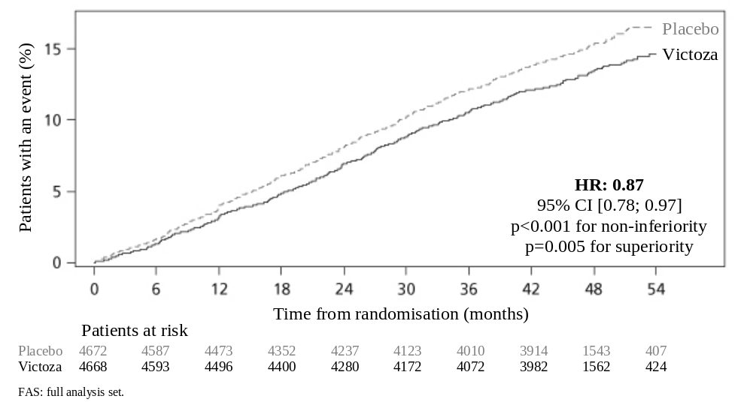
Figure 1: Kaplan Meier plot of time to first MACE – FAS population

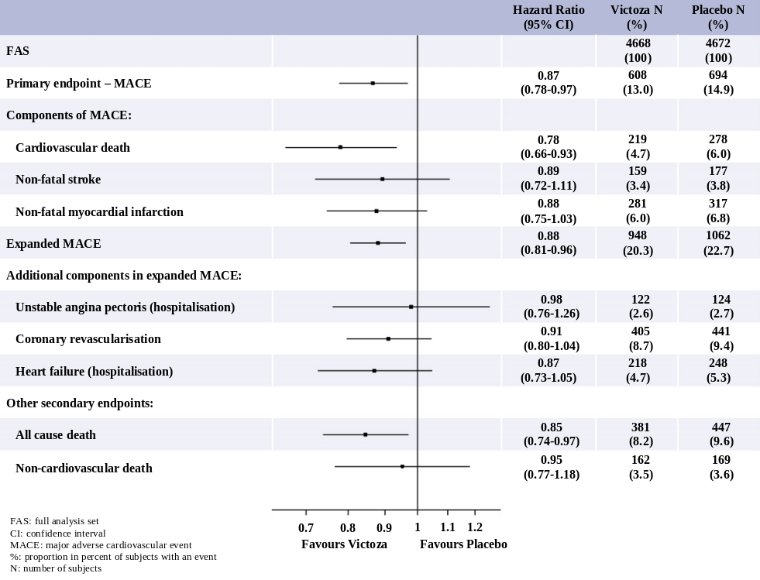
Figure 2: Forest plot of analyses of individual cardiovascular event types – FAS population

A significant and sustained reduction in HbA_{1c} from baseline to month 36 was observed with liraglutide vs placebo, in addition to standard of care (-1.16% vs -0.77%; estimated treatment difference [ETD] -0.40% [-0.45; -0.34]). The need for treatment intensification with insulin was reduced by 48% with liraglutide vs placebo in insulin-naive patients at baseline (HR 0.52 [0.48; 0.57]).

• Blood pressure and heart rate
Over the duration of the phase 3a trials, liraglutide decreased the systolic blood pressure on average of 2.3 to 6.7 mmHg from baseline and compared to active comparator the decrease was 1.9 to 4.5 mmHg.
A mean increase in heart rate from baseline of 2 to 3 beats per minute has been observed with liraglutide in long-term clinical trials including LEADER. In the LEADER trial, no long-term clinical impact of increased heart rate on the risk of cardiovascular events was observed.

• Microvascular evaluation
In the LEADER trial, microvascular events comprised nephropathy and retinopathy outcomes. The analysis of time to first microvascular event for liraglutide vs placebo had a HR of 0.84 [0.73, 0.97]. The HR for liraglutide vs placebo was 0.78 [0.67, 0.92] for time to first nephropathy event and 1.15 [0.87, 1.52] for time to first retinopathy event.

• Immunogenicity
Consistent with the potentially immunogenic properties of medicinal products containing proteins or peptides, patients may develop anti-liraglutide antibodies following treatment with liraglutide. On average, 8.6% of patients developed antibodies. Antibody formation has not been associated with reduced efficacy of liraglutide.

Paediatric population

In a double-blind study comparing the efficacy and safety of Victoza 1.8 mg versus placebo as add-on to metformin ± insulin in adolescents and children aged 10 years and above with type 2 diabetes, Victoza was superior to placebo treatment in reducing HbA_{1c} after 26 weeks (-1.06, [-1.65, 0.46]). The treatment difference in HbA_{1c} was 1.3% after additional 26 weeks of open label extension, confirming the sustained glycaemic control with Victoza.

The efficacy and safety profile of Victoza was comparable to that observed in the adult population treated with Victoza. Based on adequate glycaemic control or tolerability, 30% of trial subjects remained on a dose of 0.6 mg, 17% escalated to a dose of 1.2 mg and 53% escalated to a dose of 1.8 mg.

Other clinical data

In an open label trial comparing the efficacy and safety of liraglutide (1.2 mg and 1.8 mg) and sitagliptin (a DPP-4 inhibitor, 100 mg) in patients inadequately controlled on metformin therapy (mean HbA_{1c} 8.5%), liraglutide at both doses was statistically superior to sitagliptin treatment in reducing HbA_{1c} after 26 weeks (-1.24%, -1.50% vs -0.90%, p<0.0001). Patients treated with liraglutide had a significant decrease in body weight compared to that of patients treated with sitagliptin (-2.9 kg and -3.4 kg vs -1.0 kg, p<0.0001). Greater proportions of patients treated with liraglutide experienced transient nausea vs patients treated with sitagliptin (20.8% and 27.1% for liraglutide vs 4.6% for sitagliptin). The reductions in HbA_{1c} and superiority vs sitagliptin observed after 26 weeks of liraglutide treatment (1.2 mg and 1.8 mg) were sustained after 52 weeks of treatment (-1.29% and -1.51% vs -0.88%, p<0.0001). Switching patients from sitagliptin to liraglutide after 52 weeks of treatment resulted in additional and statistically significant reduction in HbA_{1c} (-0.24% and -0.45%, 95% CI: -0.41 to -0.07 and -0.67 to -0.23) at week 78, but a formal control group was not available.

In an open label trial comparing the efficacy and safety of liraglutide 1.8 mg once daily and exenatide 10 mcg twice daily in patients inadequately controlled on metformin and/or sulfonylurea therapy (mean HbA_{1c} 8.3%), liraglutide was statistically superior to exenatide treatment in reducing HbA_{1c} after 26 weeks (-1.12% vs -0.79%; estimated treatment difference: -0.33; 95% CI: -0.47 to -0.18). Significantly more patients achieved HbA_{1c} below 7% with liraglutide compared with exenatide (54.2% vs 43.4%, p=0.0015). Both treatments resulted in mean body weight loss of approximately 3 kg. Switching patients from exenatide to liraglutide after 26 weeks of treatment resulted in an additional and statistically significant reduction in HbA_{1c} (-0.32%, 95% CI: -0.41 to -0.24) at week 40, but a formal control group was not available. During the 26 weeks, there were 12 serious events in 235 patients (5.1%) using liraglutide, whereas there were 6 serious adverse events in 232 patients (2.6%) using exenatide. There was no consistent pattern with respect to system organ class of events.

In an open label trial comparing the efficacy and safety of liraglutide 1.8 mg with lixisenatide 20 mcg in 404 patients inadequately controlled on metformin therapy (mean HbA_{1c} 8.4%), liraglutide was superior to lixisenatide in reducing HbA_{1c} after 26 weeks of treatment (-1.83% vs -1.21%, p<0.0001). Significantly more patients achieved HbA_{1c} below 7% with liraglutide compared to lixisenatide (74.2% vs 45.5%, p<0.0001), as well as the HbA_{1c} target below or equal 6.5% (54.6% vs 26.2%, p<0.0001). Body weight loss was observed in both treatment arms (-4.3 kg with liraglutide and -3.7 kg with lixisenatide). Gastrointestinal adverse events were more frequently reported with liraglutide treatment (43.6% vs 37.1%).

5.2 Pharmacokinetic properties

Absorption

The absorption of liraglutide following subcutaneous administration is slow, reaching maximum concentration 8–12 hours post dosing. Estimated maximum liraglutide concentration was 9.4 nmol/l (mean body weight approximately 73 kg) for a subcutaneous single dose of liraglutide 0.6 mg. At 1.8 mg liraglutide, the average steady state concentration of liraglutide (AUC_{τ/24}) reached approximately 34 nmol/l (mean body weight approximately 76 kg). The exposure of liraglutide decreases with increasing body weight. Liraglutide exposure increased proportionally with dose. The intra-subject coefficient of variation for liraglutide AUC was 11% following single dose administration.
Absolute bioavailability of liraglutide following subcutaneous administration is approximately 55%.

Distribution

The apparent volume of distribution after subcutaneous administration is 11–17 l. The mean volume of distribution after intravenous administration of liraglutide is 0.07 l/kg. Liraglutide is extensively bound to plasma proteins (>98%).

Biotransformation

During 24 hours following administration of a single radiolabelled [³H]-liraglutide dose to healthy subjects, the major component in plasma was intact liraglutide. Two minor plasma metabolites were detected (≤9% and ≤5% of total plasma radioactivity exposure). Liraglutide is metabolised in a similar manner to large proteins without a specific organ having been identified as major route of elimination.

Elimination

Following a [³H]-liraglutide dose, intact liraglutide was not detected in urine or faeces. Only a minor part of the administered radioactivity was excreted as liraglutide-related metabolites in urine or faeces (6% and 5%, respectively). The urine and faeces radioactivity was mainly excreted during the first 6–8 days, and corresponded to three minor metabolites, respectively.

The mean clearance following subcutaneous administration of a single dose liraglutide is approximately 1.2 l/h with an elimination half-life of approximately 13 hours.

Special populations

Elderly patients
Age had no clinically relevant effect on the pharmacokinetics of liraglutide based on the results from a pharmacokinetic study in healthy subjects and population pharmacokinetic data analysis of patients (18 to 80 years).

Gender
Gender had no clinically meaningful effect on the pharmacokinetics of liraglutide based on the results of population pharmacokinetic data analysis of male and female patients and a pharmacokinetic study in healthy subjects.

Ethnic origin
Ethnic origin had no clinically relevant effect on the pharmacokinetics of liraglutide based on the results of population pharmacokinetic analysis which included patients of White, Black, Asian and Hispanic groups.
Obesity
Population pharmacokinetic analysis suggests that body mass index (BMI) has no significant effect on the pharmacokinetics of liraglutide.

Hepatic impairment
The pharmacokinetics of liraglutide was evaluated in patients with varying degree of hepatic impairment in a single-dose trial. Liraglutide exposure was decreased by 13–23% in patients with mild to moderate hepatic impairment compared to healthy subjects.
Exposure was significantly lower (44%) in patients with severe hepatic impairment (Child Pugh score >9).

Renal impairment
Liraglutide exposure was reduced in patients with renal impairment compared to individuals with normal renal function. Liraglutide exposure was lowered by 33%, 14%, 27% and 26% in patients with mild (creatinine clearance, CrCl 50–80 ml/min), moderate (CrCl 30–50 ml/min), and severe (CrCl <30 ml/min) renal impairment and in end-stage renal disease requiring dialysis, respectively.

Similarly, in a 26-week clinical trial, patients with type 2 diabetes and moderate renal impairment (CrCL 30–59 ml/min, see section 5.1) had 26% lower liraglutide exposure when compared with a separate trial including patients with type 2 diabetes with normal renal function or mild renal impairment.

Paediatric population
Pharmacokinetic properties were assessed in clinical studies in the paediatric population with type 2 diabetes aged 10 years and above. The liraglutide exposure in adolescents and children was comparable to that observed in the adult population.

5.3 Preclinical safety data

Non-clinical data reveal no special hazards for humans based on conventional studies of safety pharmacology, repeat-dose toxicity or genotoxicity.

Non-lethal thyroid C-cell tumours were seen in 2-year carcinogenicity studies in rats and mice. In rats, a no observed adverse effect level (NOAEL) was not observed. These tumours were not seen in monkeys treated for 20 months. These findings in rodents are caused by a non-genotoxic, specific GLP-1 receptor-mediated mechanism to which rodents are particularly sensitive. The relevance for humans is likely to be low but cannot be completely excluded. No other treatment-related tumours have been found.

Animal studies did not indicate direct harmful effects with respect to fertility but slightly increased early embryonic deaths at the highest dose. Dosing with Victoza during mid-gestation caused a reduction in maternal weight and foetal growth with equivocal effects on ribs in rats and skeletal variation in the rabbit. Neonatal growth was reduced in rats while exposed to Victoza, and persisted in the post-weaning period in the high dose group. It is unknown whether the reduced pup growth is caused by reduced pup milk intake due to a direct GLP-1 effect or reduced maternal milk production due to decreased caloric intake.

6. PHARMACEUTICAL PARTICULARS

6.1 List of excipients

Disodium phosphate dihydrate
Propylene glycol
Phenol
Hydrochloric acid (for pH adjustment)
Sodium hydroxide (for pH adjustment)
Water for injections

6.2 Incompatibilities

Substances added to Victoza may cause degradation of liraglutide. In the absence of compatibility studies, this medicinal product must not be mixed with other medicinal products.

6.3 Shelf life

30 months.

After first use: 1 month.

6.4 Special precautions for storage

Store in a refrigerator (2°C–8°C).
Do not freeze.
Store away from the freezer compartment.

After first use: Store below 30°C or store in a refrigerator (2°C–8°C). Do not freeze.

Keep the cap on the pen in order to protect from light.

6.5 Nature and contents of container

Cartridge (type 1 glass) with a plunger (bromobutyl) and a laminate rubber sheet (bromobutyl/polyisoprene) contained in a pre-filled multidose disposable pen made of polyolefin and polyacetal.

Each pen contains 3 ml solution, delivering 30 doses of 0.6 mg, 15 doses of 1.2 mg or 10 doses of 1.8 mg.

Pack sizes of 1, 2, 3, 5 or 10 pre-filled pens.

Not all pack sizes may be marketed.

6.6 Special precautions for disposal and other handling

Victoza should not be used if it does not appear clear and colourless or almost colourless.
Victoza should not be used if it has been frozen.

Victoza can be administered with needles up to a length of 8 mm and as thin as 32G. The pen is designed to be used with NovoFine or NovoTwist disposable needles.
Needles are not included.
The patient should be advised to discard the injection needle in accordance with local requirements after each injection and store the pen without an injection needle attached. This prevents contamination, infection and leakage. It also ensures that the dosing is accurate.

7. MARKETING AUTHORISATION HOLDER

Novo Nordisk A/S
Novo Allé
DK-2880 Bagsværd
Denmark

8. MARKETING AUTHORISATION NUMBERS

EU/1/09/529/001-005

9. DATE OF FIRST AUTHORISATION/RENEWAL OF THE AUTHORISATION

Date of first authorisation: 30 June 2009
Date of last renewal: 11 April 2014

10. DATE OF REVISION OF THE TEXT

Detailed information on this medicinal product is available on the website of the European Medicines Agency http://www.ema.europa.eu.

ANNEX II

A. MANUFACTURER OF THE BIOLOGICAL ACTIVE SUBSTANCE AND MANUFACTURER RESPONSIBLE FOR BATCH RELEASE

B. CONDITIONS OR RESTRICTIONS REGARDING SUPPLY AND USE

C. OTHER CONDITIONS AND REQUIREMENTS OF THE MARKETING AUTHORISATION

D. CONDITIONS OR RESTRICTIONS WITH REGARD TO THE SAFE AND EFFECTIVE USE OF THE MEDICINAL PRODUCT

A. MANUFACTURER OF THE BIOLOGICAL ACTIVE SUBSTANCE AND MANUFACTURER RESPONSIBLE FOR BATCH RELEASE

Name and address of the manufacturer of the biological active substance

Novo Nordisk A/S
Hallas Allé
DK-4400 Kalundborg
Denmark

Name and address of the manufacturer responsible for batch release

Novo Nordisk A/S
Novo Allé
DK-2880 Bagsværd
Denmark

B. CONDITIONS OR RESTRICTIONS REGARDING SUPPLY AND USE

Medicinal product subject to medical prescription.

C. OTHER CONDITIONS AND REQUIREMENTS OF THE MARKETING AUTHORISATION

• Periodic safety update reports (PSURs)

The requirements for submission of PSURs for this medicinal product are set out in the list of Union reference dates (EURD list) provided for under Article 107c(7) of Directive 2001/83/EC and any subsequent updates published on the European medicines web-portal.

D. CONDITIONS OR RESTRICTIONS WITH REGARD TO THE SAFE AND EFFECTIVE USE OF THE MEDICINAL PRODUCT

• Risk management plan

The marketing authorisation holder (MAH) shall perform the required pharmacovigilance activities and interventions detailed in the agreed Risk Management Plan (RMP) presented in Module 1.8.2 of the marketing authorisation and any agreed subsequent updates of the RMP.

An updated RMP should be submitted:
• At the request of the European Medicines Agency;
• Whenever the risk management system is modified, especially as the result of new information being received that may lead to a significant change to the benefit/risk profile or as the result of an important (pharmacovigilance or risk minimisation) milestone being reached.

ANNEX III

LABELLING AND PACKAGE LEAFLET

A. LABELLING

PARTICULARS TO APPEAR ON THE OUTER PACKAGING

CARTON

1. NAME OF THE MEDICINAL PRODUCT

Victoza 6 mg/ml solution for injection in pre-filled pen
liraglutide

2. STATEMENT OF ACTIVE SUBSTANCE

1 ml contains 6 mg of liraglutide. One pre-filled pen contains 18 mg liraglutide

3. LIST OF EXCIPIENTS

Disodium phosphate dihydrate, propylene glycol, phenol, hydrochloric acid, sodium hydroxide and water for injections.

4. PHARMACEUTICAL FORM AND CONTENTS

Solution for injection.

1 pen
2 pens
3 pens
5 pens
10 pens

Each pen contains 3 ml solution, delivering 30 doses of 0.6 mg, 15 doses of 1.2 mg or 10 doses of 1.8 mg.

5. METHOD AND ROUTE OF ADMINISTRATION

Read the package leaflet before use.
Subcutaneous use

Victoza pen is designed to be used with NovoFine or NovoTwist disposable needles.
Needles are not included.

6. SPECIAL WARNING THAT THE MEDICINAL PRODUCT MUST BE STORED OUT OF THE SIGHT AND REACH OF CHILDREN

Keep out of the sight and reach of children.

7. OTHER SPECIAL WARNINGS, IF NECESSARY

Do not store the pen with a needle attached.
For use by one person only

8. EXPIRY DATE

EXP

Discard pen 1 month after first use.

9. SPECIAL STORAGE CONDITIONS

Store in a refrigerator. Do not freeze.
After first use of the pen, store below 30°C or in a refrigerator. Do not freeze.
Keep the pen cap on in order to protect from light.

10. SPECIAL PRECAUTIONS FOR DISPOSAL OF UNUSED MEDICINAL PRODUCTS OR WASTE MATERIALS DERIVED FROM SUCH MEDICINAL PRODUCTS, IF APPROPRIATE

11. NAME AND ADDRESS OF THE MARKETING AUTHORISATION HOLDER

Novo Nordisk A/S
Novo Allé
DK-2880 Bagsværd
Denmark

12. MARKETING AUTHORISATION NUMBERS

EU/1/09/529/001 1 x 3 ml
EU/1/09/529/002 2 x 3 ml
EU/1/09/529/003 3 x 3 ml
EU/1/09/529/004 5 x 3 ml
EU/1/09/529/005 10 x 3 ml

13. BATCH NUMBER

Batch

14. GENERAL CLASSIFICATION FOR SUPPLY

15. INSTRUCTIONS ON USE

16. INFORMATION IN BRAILLE

Victoza

17. UNIQUE IDENTIFIER – 2D BARCODE

2D barcode carrying the unique identifier included.

18. UNIQUE IDENTIFIER – HUMAN READABLE DATA

PC
SN
NN

MINIMUM PARTICULARS TO APPEAR ON SMALL IMMEDIATE PACKAGING UNITS

PRE-FILLED PEN LABEL

1. NAME OF THE MEDICINAL PRODUCT AND ROUTE OF ADMINISTRATION

Victoza 6 mg/ml injection
liraglutide
Subcutaneous use

2. METHOD OF ADMINISTRATION

3. EXPIRY DATE

EXP

4. BATCH NUMBER

Batch

5. CONTENTS BY WEIGHT, BY VOLUME OR BY UNIT

3 ml

6. OTHER

Novo Nordisk A/S

B. PACKAGE LEAFLET

Package leaflet: Information for the user

Victoza 6 mg/ml solution for injection in pre-filled pen
liraglutide

Read all of this leaflet carefully before you start using this medicine because it contains important information for you.
– Keep this leaflet. You may need to read it again.
– If you have any further questions, ask your doctor, pharmacist or nurse.
– This medicine has been prescribed for you only. Do not pass it on to others. It may harm them, even if their signs of illness are the same as yours.
– If you get any side effects, talk to your doctor, pharmacist or nurse. This includes any possible side effects not listed in this leaflet. See section 4.

What is in this leaflet

1. What Victoza is and what it is used for
2. What you need to know before you use Victoza
3. How to use Victoza
4. Possible side effects
5. How to store Victoza
6. Contents of the pack and other information

1. What Victoza is and what it is used for

Victoza contains the active substance liraglutide. It helps your body reduce your blood sugar level only when blood sugar is too high. It also slows food passage through your stomach and can help prevent heart disease.

Victoza is used on its own if your blood sugar is not properly controlled by diet and exercise alone, and you cannot use metformin (another diabetes medicine).

Victoza is used with other medicines for diabetes when they are not enough to control your blood sugar levels. These may include:
• oral antidiabetics (such as metformin, pioglitazone, sulfonylurea, sodium-glucose cotransporter 2 inhibitor (SGLT2i)) and/or insulin.

2. What you need to know before you use Victoza

Do not use Victoza
– if you are allergic to liraglutide or any of the other ingredients of this medicine (listed in section 6).

Warnings and precautions
Talk to your doctor, pharmacist or nurse:
• before using Victoza.
• if you have or have had a disease of the pancreas.

If you know that you are due to have surgery where you will be under anesthesia (sleeping), please tell your doctor that you are taking victoza.

This medicine should not be used if you have type 1 diabetes (your body does not produce any insulin) or diabetic ketoacidosis (a complication of diabetes with high blood sugar and increase in effort to breathe). It is not an insulin and should therefore not be used as a substitute for insulin.

The use of Victoza is not recommended if you are on dialysis.
The use of Victoza is not recommended if you have severe liver disease.
The use of Victoza is not recommended if you have severe heart failure.

This medicine is not recommended if you have a severe stomach or gut problem which results in delayed stomach emptying (called gastroparesis), or inflammatory bowel disease.

If you have symptoms of acute pancreatitis, such as persistent, severe stomach ache, you should consult your doctor immediately (see section 4).

If you have thyroid disease including thyroid nodules and enlargement of the thyroid gland, consult your doctor.

When initiating treatment with Victoza, you may in some cases experience loss of fluids/dehydration, e.g. in case of vomiting, nausea and diarrhoea. It is important to avoid dehydration by drinking plenty of fluids. Contact your doctor if you have any questions or concerns.

Children and adolescents
Victoza can be used in adolescents and children aged 10 years and above. No data are available in children below 10 years of age.

Other medicines and Victoza
Please tell your doctor, pharmacist or nurse if you are taking, have recently taken or might take any other medicines.

In particular, tell your doctor, pharmacist or nurse if you are using medicines containing any of the following active substances:
• Sulfonylurea (such as glimepiride or glibenclamide) or insulin. You may get hypoglycaemia (low blood sugar) when using Victoza together with a sulfonylurea or insulin, as sulfonylureas and insulin increase the risk of hypoglycaemia. When you first start using these medicines together, your doctor may tell you to lower the dose of the sulfonylurea or insulin. Please see section 4 for the warning signs of low blood sugar. If you are also taking a sulfonylurea (such as glimepiride or glibenclamide) or insulin, your doctor may tell you to test your blood sugar levels. This will help your doctor to decide if the dose of the sulfonylurea or insulin needs to be changed.
• If you are using insulin, your doctor will tell you how to reduce the dose of insulin and will recommend you to monitor your blood sugar more frequently, in order to avoid hyperglycaemia (high blood sugar) and diabetic ketoacidosis (a complication of diabetes that occurs when the body is unable to break down glucose because there is not enough insulin).
• Warfarin or other oral anti-coagulation medicines. More frequent blood testing to determine the ability of your blood to clot may be required.

Pregnancy and breast-feeding
Tell your doctor if you are, you think you might be, or are planning to become pregnant. Victoza should not be used during pregnancy because it is not known if it may harm your unborn child.

It is not known if Victoza passes into breast milk, therefore do not use this medicine if you are breast-feeding.

Driving and using machines
Low blood sugar (hypoglycaemia) may reduce your ability to concentrate. Avoid driving or using machines if you experience signs of hypoglycaemia. Please see section 4 for the warning signs of low blood sugar. Please consult your doctor for further information on this topic.

Important information about some of the ingredients of Victoza
This medicine contains less than 1 mmol sodium (23 mg) per dose. This means that it is essentially ‘sodium free’.

3. How to use Victoza

Always use this medicine exactly as your doctor has told you. Check with your doctor, pharmacist or nurse if you are not sure.

• The starting dose is 0.6 mg once a day, for at least one week.
• Your doctor will tell you when to increase it to 1.2 mg once a day.
• Your doctor may tell you to further increase the dose to 1.8 mg once a day, if your blood glucose is not adequately controlled with a dose of 1.2 mg.
Do not change your dose unless your doctor has told you to.

Victoza is given as an injection under the skin (subcutaneous). Do not inject it into a vein or muscle. The best places to give yourself the injection are the front of your thighs, the front of your waist (abdomen), or your upper arm. Change the place where you inject each day to reduce the risk of developing lumps.

You can give yourself the injection at any time of the day, regardless of meals. When you have found the most convenient time of the day it is preferred that you inject Victoza around the same time of the day.

Before you use the pen for the first time, your doctor or nurse will show you how to use it.
Detailed instructions for use are provided on the other side of this leaflet.

If you use more Victoza than you should
If you use more Victoza than you should, talk to your doctor straight away. You may need medical treatment. You may experience nausea, vomiting, diarrhoea or low blood sugar (hypoglycaemia). Please refer to section 4 for warning signs of low blood sugar.

If you forget to use Victoza
If you forget a dose, use Victoza as soon as you remember.
However, if it is more than 12 hours since you should have used Victoza, skip the missed dose. Then take your next dose as usual the following day.
Do not take an extra dose or increase the dose on the following day to make up for the missed dose.

If you stop using Victoza
Do not stop using Victoza without talking to your doctor. If you stop using it, your blood sugar levels may increase.

If you have any further questions on the use of this medicine, ask your doctor, pharmacist or nurse.

4. Possible side effects

Like all medicines, this medicine can cause side effects, although not everybody gets them.

Serious side effects
Common: may affect up to 1 in 10 people
• Hypoglycaemia (low blood sugar). The warning signs of low blood sugar may come on suddenly and can include: cold sweat, cool pale skin, headache, fast heartbeat, feeling sick, feeling very hungry, changes in vision, feeling sleepy, feeling weak, nervous, anxious, confused, difficulty concentrating, shaking (tremor). Your doctor will tell you how to treat low blood sugar and what to do if you notice these warning signs. This is more likely to happen if you also take a sulfonylurea or insulin. Your doctor may reduce your dose of these medicines before you start using Victoza.

Rare: may affect up to 1 in 1,000 people
• A severe form of allergic reaction (anaphylactic reaction) with additional symptoms such as breathing problems, swelling of throat and face, fast heartbeat, etc. If you experience these symptoms you should seek immediate medical help and inform your doctor as soon as possible.
• Bowel obstruction. A severe form of constipation with additional symptoms such as stomach ache, bloating, vomiting etc.

Very rare: may affect up to 1 in 10,000 people
• Cases of inflammation of the pancreas (pancreatitis). Pancreatitis can be a serious, potentially life-threatening medical condition. Stop taking Victoza and contact a doctor immediately if you notice any of the following serious side effects:

Severe and persistent pain in the abdomen (stomach area) which might reach through to your back, as well as nausea and vomiting, as it could be a sign of an inflamed pancreas (pancreatitis).

Other side effects
Very common: may affect more than 1 in 10 people
• Nausea (feeling sick). This usually goes away over time.
• Diarrhoea. This usually goes away over time.

Common
• Vomiting.

When initiating treatment with Victoza, you may in some cases experience loss of fluids/dehydration, e.g. in case of vomiting, nausea and diarrhoea. It is important to avoid dehydration by drinking plenty of fluids.

• Headache
• Indigestion
• Inflamed stomach (gastritis). The signs include stomach ache, nausea and vomiting.
• Gastro-oesophageal reflux disease (GORD). The signs include heartburn.
• Painful or swollen tummy (abdomen)
• Abdominal discomfort
• Constipation
• Wind (flatulence)
• Decreased appetite
• Bronchitis
• Common cold
• Dizziness
• Increased pulse
• Tiredness
• Toothache
• Injection site reactions (such as bruising, pain, irritation, itching and rash)
• Increase of pancreatic enzymes (such as lipase and amylase).

Uncommon: may affect up to 1 in 100 people
• Allergic reactions like pruritus (itching) and urticaria (a type of skin rash)
• Dehydration, sometimes with a decrease in kidney function
• Malaise (feeling unwell)
• Gallstones
• Inflamed gallbladder
• Change in how things taste
• A delay in the emptying of the stomach.

Not known: frequency cannot be estimated from the available data
• Lumps under the skin may be caused by build-up of a protein called amyloid (cutaneous
amyloidosis; how often this occurs is not known).

Reporting of side effects
If you get any side effects, talk to your doctor, pharmacist or nurse. This includes any possible side effects not listed in this leaflet. You can also report side effects directly via the national reporting system listed in Appendix V. By reporting side effects you can help provide more information on the safety of this medicine.

5. How to store Victoza

Keep this medicine out of the sight and reach of children.

Do not use this medicine after the expiry date which is stated on the pen label and carton after ‘EXP’. The expiry date refers to the last day of that month.

Before opening:
Store in a refrigerator (2˚C–8˚C). Do not freeze. Keep away from the freezer compartment.

During use:
You can keep the pen for 1 month when stored at a temperature below 30˚C or in a refrigerator (2˚C–8˚C), away from the freezer compartment. Do not freeze.
When you are not using the pen, keep the pen cap on in order to protect from light.

Do not use this medicine if the solution is not clear and colourless or almost colourless.

Do not throw away any medicines via wastewater or household waste. Ask your pharmacist how to throw away medicines you no longer use. These measures will help protect the environment.

6. Contents of the pack and other information

What Victoza contains
– The active substance is liraglutide. 1 ml solution for injection contains 6 mg liraglutide. One pre-filled pen contains 18 mg liraglutide.
– The other ingredients are disodium phosphate dihydrate, propylene glycol, phenol, hydrochloric acid (for pH adjustment), sodium hydroxide (for pH adjustment) and water for injections.

What Victoza looks like and contents of the pack
Victoza is supplied as a clear, and colourless or almost colourless, solution for injection in a pre-filled pen. Each pen contains 3 ml of solution, delivering 30 doses of 0.6 mg, 15 doses of 1.2 mg or 10 doses of 1.8 mg.

Victoza is available in packs containing 1, 2, 3, 5 or 10 pens. Not all pack sizes may be marketed.
Needles are not included.

Marketing Authorisation Holder and Manufacturer

Novo Nordisk A/S
Novo Allé
DK-2880 Bagsværd
Denmark

This leaflet was last revised in

Other sources of information

Detailed information on this medicine is available on the European Medicines Agency website: http://www.ema.europa.eu

INSTRUCTIONS FOR USING THE VICTOZA PEN  Please read these instructions carefully before using your pen.  Your pen comes with 18 mg of liraglutide. You can select doses of 0.6 mg, 1.2 mg and 1.8 mg.  The pen is designed to be used with NovoFine or NovoTwist disposable injection needles up to a length of 8 mm and as thin as 32G (0.25/0.23 mm). | 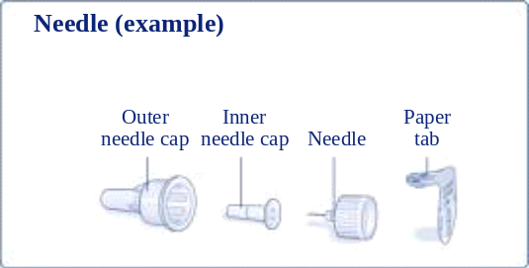
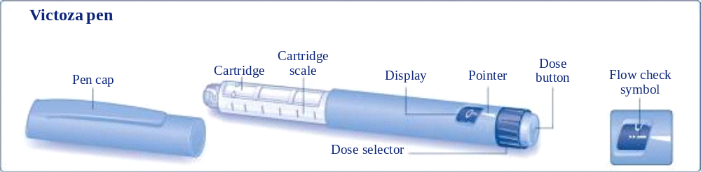
Prepare your pen  Check the name and coloured label of your pen to make sure that it contains liraglutide. Using the wrong medicine could cause severe harm.  Pull off the pen cap. | 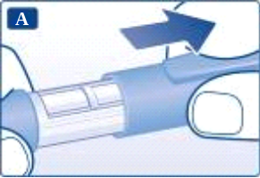
Pull off the paper tab from a new disposable needle. Screw the needle straight and tightly onto your pen. | 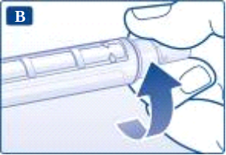
Pull off the outer needle cap and keep it for later. | 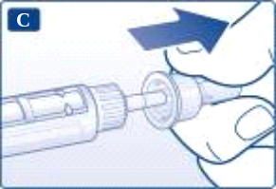
Pull off the inner needle cap and dispose of it. | 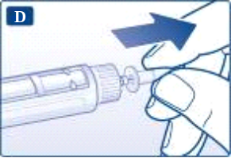
Always use a new needle for each injection. This reduces the risk of contamination, infection, leakage of liraglutide, blocked needles and inaccurate dosing.
Be careful not to bend or damage the needle.
Never try to put the inner needle cap back on the needle. You may stick yourself with the needle.
Caring for your pen
• Do not try to repair your pen or pull it apart.
• Keep your pen away from dust, dirt and all kinds of liquids.
• Clean the pen with a cloth moistened with a mild detergent.
• Do not try to wash, soak or lubricate it – this can harm the pen.
Important information
• Do not share your pen or needles with anyone else.
• Keep your pen out of the reach of others, especially children.
• Change the place where you inject each day to reduce the risk of developing lumps.
With each new pen, check the flow  Check the flow before your first injection with each new pen. If your pen is already in use, go to ‘Select your dose’, step H.  Turn the dose selector until the flow check symbol lines up with the pointer. | 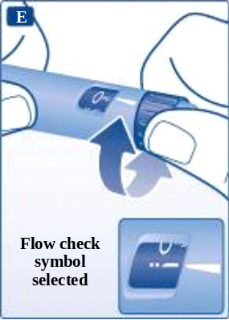
Hold the pen with the needle pointing up. Tap the cartridge gently with your finger a few times. This will make any air bubbles collect at the top of the cartridge. | 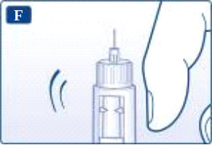
Keep the needle pointing up and press the dose button until 0 mg lines up with the pointer.  A drop of liraglutide should appear at the needle tip. If no drop appears, repeat steps E to G up to four times.  If there is still no drop of liraglutide, change the needle and repeat steps E to G once more.  Do not use the pen if a drop of liraglutide still does not appear. This indicates the pen is defective and you must use a new one. | 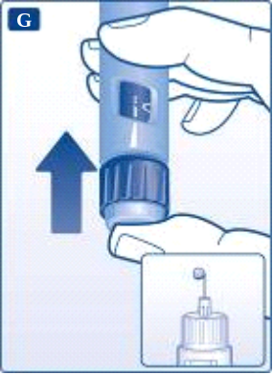
If you have dropped your pen against a hard surface or suspect that something is wrong with it, always put on a new disposable needle and check the flow before you inject.
Select your dose  Always check that the pointer lines up with 0 mg.  Turn the dose selector until your needed dose lines up with the pointer (0.6 mg, 1.2 mg or 1.8 mg).  If you selected a wrong dose by mistake, simply change it by turning the dose selector backwards or forwards until the right dose lines up with the pointer.  Be careful not to press the dose button when turning the dose selector backwards, as liraglutide may come out.  If the dose selector stops before your needed dose lines up with the pointer, there is not enough liraglutide left for a full dose. Then you can either:  Split your dose into two injections:  Turn the dose selector in either direction until 0.6 mg or 1.2 mg lines up with the pointer. Inject the dose. Then prepare a new pen for injection and inject the remaining number of mg to complete your dose.  You may only split your dose between your current pen and a new pen if trained or advised by your healthcare professional. Use a calculator to plan the doses. If you split the dose wrong, you may inject too much or too little liraglutide.  Inject the full dose with a new pen:  If the dose selector stops before 0.6 mg lines up with the pointer, prepare a new pen and inject the full dose with the new pen. | 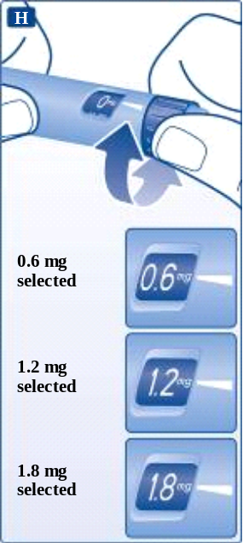
Do not try to select other doses than 0.6 mg, 1.2 mg or 1.8 mg. The numbers in the display must line up precisely with the pointer to ensure that you get the correct dose.
The dose selector clicks when you turn it. Do not use these clicks to select your dose.
Do not use the cartridge scale to measure how much liraglutide to inject – it is not accurate enough.
Inject your dose  Insert the needle into your skin using the injection technique shown by your doctor or nurse. Then follow the instructions below:  Press the dose button to inject until 0 mg lines up with the pointer. Be careful not to touch the display with your other fingers or press the dose selector sideways when you inject. This is because it may block the injection.  Keep the dose button pressed down and leave the needle under the skin for at least 6 seconds. This is to make sure that you get your full dose. | 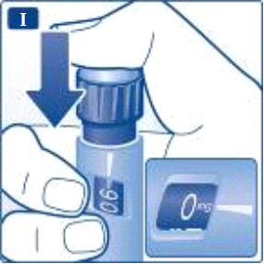
Pull out the needle.  After that, you may see a drop liraglutide at the needle tip.  This is normal and does not affect your dose. | 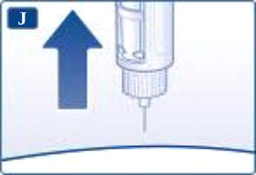
Guide the needle tip into the outer needle cap without touching the needle or the outer needle cap. | 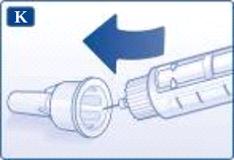
When the needle is covered, carefully push the outer needle cap completely on. Then unscrew the needle. Dispose of it carefully and put the pen cap back on.  When the pen is empty, carefully dispose of it without a needle attached. Please dispose of the pen and needle in accordance with local requirements. | 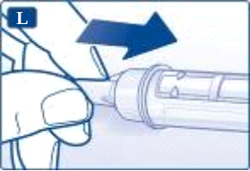
Always remove the needle after each injection, and store your pen without a needle attached.
This reduces the risk of contamination, infection, leakage of liraglutide, blocked needles and inaccurate dosing.
Caregivers must be very careful when handling used needles – to prevent needle injury and cross-infection.

