This document is the approved product information for VYDURA, with the changes since the previous procedure affecting the product information (EMA/VR/0000254589) tracked.

For more information, see the European Medicines Agency’s website: https://www.ema.europa.eu/en/medicines/human/EPAR/vydura

ANNEX I

SUMMARY OF PRODUCT CHARACTERISTICS

This medicinal product is subject to additional monitoring. This will allow quick identification of new safety information. Healthcare professionals are asked to report any suspected adverse reactions. See section 4.8 for how to report adverse reactions.

1. NAME OF THE MEDICINAL PRODUCT

VYDURA 75 mg oral lyophilisate

2. QUALITATIVE AND QUANTITATIVE COMPOSITION

Each oral lyophilisate contains rimegepant sulfate, equivalent to 75 mg rimegepant.

For the full list of excipients, see section 6.1.

3. PHARMACEUTICAL FORM

Oral lyophilisate

The oral lyophilisate is white to off-white, circular, diameter 14 mm and debossed with the symbol .

4. CLINICAL PARTICULARS

4.1 Therapeutic indications

VYDURA is indicated for the
- Acute treatment of migraine with or without aura in adults;
- Preventive treatment of episodic migraine in adults who have at least 4 migraine attacks per month.

4.2 Posology and method of administration

Posology

Acute treatment of migraine
The recommended dose is 75 mg rimegepant, as needed, once daily.

Prophylaxis of migraine
The recommended dose is 75 mg rimegepant every other day.

The maximum dose per day is 75 mg rimegepant.

VYDURA can be taken with or without meals.

Concomitant medicinal products
Another dose of rimegepant should be avoided within 48 hours when it is concomitantly administered with moderate inhibitors of CYP3A4 or with strong inhibitors of P-gp (see section 4.5).

Special populations

Elderly (aged 65 and over)
There is limited experience with rimegepant in patients aged 65 years or older. No dose adjustment is required as the pharmacokinetics of rimegepant are not affected by age (see section 5.2).

Renal impairment
No dose adjustment is required in patients with mild, moderate, or severe renal impairment. Severe renal impairment resulted in a > 2-fold increase in unbound AUC but less than a 50% increase in total AUC (see section 5.2). Caution should be exercised during frequent use in patients with severe renal impairment. Rimegepant has not been studied in patients with end-stage renal disease and in patients on dialysis. Use of rimegepant in patients with end-stage renal disease (CLcr < 15 ml/min) should be avoided.

Hepatic impairment
No dose adjustment is required in patients with mild (Child-Pugh A) or moderate (Child-Pugh B) hepatic impairment. Plasma concentrations (unbound AUC) of rimegepant were significantly higher in subjects with severe (Child-Pugh C) hepatic impairment (see section 5.2). The use of rimegepant in patients with severe hepatic impairment should be avoided.

Paediatric population
The safety and efficacy of VYDURA in paediatric patients (< 18 years of age) have not been established. No data are available.

Method of administration

VYDURA is for oral use.

The oral lyophilisate should be placed on the tongue or under the tongue. It will disintegrate in the mouth and can be taken without liquid.

Patients should be advised to use dry hands when opening the blister and referred to the package leaflet for complete instructions.

4.3 Contraindications

Hypersensitivity to the active substance or to any of the excipients listed in section 6.1.

4.4 Special warnings and precautions for use

Hypersensitivity reactions, including dyspnoea and rash, have occurred in less than 1% of patients treated with rimegepant in clinical studies (see section 4.8). Hypersensitivity reactions, including serious hypersensitivity such as anaphylactic reaction, have been reported in the clinical and post-marketing settings (see section 4.8). Some hypersensitivity reactions can occur days after administration. If a hypersensitivity reaction occurs, rimegepant should be discontinued and appropriate therapy should be initiated.

VYDURA is not recommended:
- in patients with severe hepatic impairment (see section 4.2);
- in patients with end-stage renal disease (CLcr < 15 ml/min) (see section 4.2);
- for concomitant use with strong inhibitors of CYP3A4 (see section 4.5);
- for concomitant use with strong or moderate inducers of CYP3A4 (see section 4.5).

Medication overuse headache (MOH)
Overuse of any type of medicinal products for headaches can make them worse. If this situation is experienced or suspected, medical advice should be obtained, and treatment should be discontinued. The diagnosis of MOH should be suspected in patients who have frequent or daily headaches despite (or because of) the regular use of medicinal products for acute headache.

4.5 Interaction with other medicinal products and other forms of interaction

Rimegepant is a substrate of CYP3A4, P-glycoprotein (P-gp) and breast cancer resistance protein (BCRP) efflux transporters (see section 5.2).

CYP3A4 inhibitors

Inhibitors of CYP3A4 increase plasma concentrations of rimegepant. Concomitant administration of rimegepant with strong CYP3A4 inhibitors (e.g., clarithromycin, itraconazole, ritonavir) is not recommended (see section 4.4). Concomitant administration of rimegepant with itraconazole resulted in a significant increase in rimegepant exposure (AUC by 4-fold and C_{max} 1.5-fold).

Concomitant administration of rimegepant with medicinal products that moderately inhibit CYP3A4 (e.g., diltiazem, erythromycin, fluconazole) may increase exposure to rimegepant. Concomitant administration of rimegepant with fluconazole resulted in increased exposures of rimegepant (AUC by 1.8-fold) with no relevant effect on C_{max}. Another dose of rimegepant within 48 hours should be avoided when it is concomitantly administered with moderate inhibitors of CYP3A4 (e.g., fluconazole) (see section 4.2).

CYP3A4 inducers

Inducers of CYP3A4 decrease plasma concentrations of rimegepant. Concomitant administration of VYDURA with strong CYP3A4 inducers (e.g., phenobarbital, rifampicin, St John’s wort (Hypericum perforatum)) or moderate CYP3A4 inducers (e.g., bosentan, efavirenz, modafinil) is not recommended (see section 4.4). The effect of CYP3A4 induction may last for up to 2 weeks after discontinuation of the strong or moderate CYP3A4 inducer. Concomitant administration of rimegepant with rifampicin resulted in a significant decrease (AUC reduced by 80% and C_{max} by 64%) in rimegepant exposure, which may lead to loss of efficacy.

P-gp and BCRP only inhibitors

Inhibitors of P-gp and BCRP efflux transporters may increase plasma concentrations of rimegepant. Another dose of VYDURA within 48 hours should be avoided when it is concomitantly administered with strong inhibitors of P-gp (e.g., cyclosporine, verapamil, quinidine) (see section 4.2). Concomitant administration of rimegepant with cyclosporine (a potent P-gp and BCRP inhibitor) or with quinidine (a selective P-gp inhibitor) resulted in a significant increase of similar magnitude in rimegepant exposure (AUC and C_{max} by > 50%, but less than two-fold).

4.6 Fertility, pregnancy and lactation

Pregnancy

There are limited data from the use of rimegepant in pregnant women. Animal studies demonstrate that rimegepant is not embryocidal, and no teratogenic potential has been observed at clinically relevant exposures. Adverse effects on embryo-foetal development (decreased foetal body weight and increased skeletal variations in rats) were only observed at exposure levels associated with maternal toxicity (approximately 200 times greater than clinical exposures) following administration of rimegepant during pregnancy (see section 5.3). As a precautionary measure, it is preferable to avoid the use of VYDURA during pregnancy.

Breast-feeding

In a single center study of 12 breast-feeding women treated with a single dose of rimegepant 75 mg, minimal concentrations of rimegepant were observed in breast milk. The relative percentage of a maternal dose estimated to reach the infant is less than 1%. There are no data on the effects on milk production. The developmental and health benefits of breast-feeding should be considered along with the mother’s clinical need for VYDURA and any potential adverse reactions on the breastfed infant from rimegepant or from the underlying maternal condition.

Fertility

Animal studies showed no clinically relevant impact on female and male fertility (see section 5.3)

4.7 Effects on ability to drive and use machines

VYDURA has no or negligible influence on the ability to drive and use machines.

4.8 Undesirable effects

Summary of the safety profile

The most common adverse reaction was nausea for acute treatment (1.2%) and for migraine prophylaxis (1.4%). Most of the reactions were mild or moderate in severity. Hypersensitivity, including dyspnoea and severe rash, occurred in less than 1% of patients treated.

Tabulated list of adverse reactions

Adverse reactions are listed by MedDRA system organ class in Table 1. The corresponding frequency category for each drug reaction is based on the following convention (CIOMS III): very common (≥1/10); common (≥1/100 to <1/10); uncommon (≥1/1,000 to <1/100); rare (≥1/10,000 to <1/1,000); very rare (<1/10,000).

Table 1 : List of Adverse Reactions
System Organ Class | Adverse Reaction | Frequency
Acute Treatment
Immune system disorders | Anaphylactic reactionª  Hypersensitivity, including dyspnoea and severe rash | Uncommon  Uncommon
Gastrointestinal disorders | Nausea | Common
Prophylaxis
Immune system disorders | Anaphylactic reactionª  Hypersensitivityª | Not known  Not known
Gastrointestinal disorders | Nausea | Common
ª Adverse Drug Reactions (ADR) identified post-marketing.

Long-term safety
Long-term safety of rimegepant was assessed in two one year, open-label extensions; 1662 patients received rimegepant for at least 6 months and 740 received rimegepant for 12 months for acute or prophylactic treatment.

Description of selected adverse reactions

Hypersensitivity reactions
Hypersensitivity, including dyspnoea and severe rash, occurred in less than 1% of patients treated in clinical studies. Hypersensitivity reactions can occur days after administration, and delayed serious hypersensitivity has occurred.

Reporting of suspected adverse reactions

Reporting suspected adverse reactions after authorisation of the medicinal product is important. It allows continued monitoring of the benefit/risk balance of the medicinal product. Healthcare professionals are asked to report any suspected adverse reactions via the national reporting system listed in Appendix V.

4.9 Overdose

There is limited clinical experience with rimegepant overdose. No overdose symptoms have been reported. Treatment of an overdose of rimegepant should consist of general supportive measures including monitoring of vital signs and observation of the clinical status of the patient. No specific antidote for the treatment of rimegepant overdose is available. Rimegepant is unlikely to be significantly removed by dialysis because of high serum protein binding.

5. PHARMACOLOGICAL PROPERTIES

5.1 Pharmacodynamic properties

Pharmacotherapeutic group: Analgesics, calcitonin gene-related peptide (CGRP) antagonists, ATC code: N02CD06

Mechanism of action

Rimegepant selectively binds with high affinity to the human calcitonin gene-related peptide (CGRP) receptor and antagonizes CGRP receptor function.

The relationship between pharmacodynamic activity and the mechanism(s) by which rimegepant exerts its clinical effects is unknown.

Clinical efficacy: acute treatment

The efficacy of VYDURA for the acute treatment of migraine with and without aura in adults was studied in three randomized, double-blind, placebo-controlled trials (Studies 1-3). Patients were instructed to treat a migraine of moderate to severe headache pain intensity. Rescue medicinal products (i.e., NSAIDs, paracetamol, and/or an antiemetic) was allowed 2 hours after the initial treatment. Other forms of rescue medicinal products such as triptans were not allowed within 48 hours of initial treatment. Approximately 14% of patients were taking preventive medicinal products for migraine at baseline. None of the patients in Study 1 were on concomitant preventive medicinal products that act on the calcitonin gene-related peptide pathway.

The primary efficacy analyses were conducted in patients who treated a migraine with moderate to severe pain. Pain freedom was defined as a reduction of moderate or severe headache pain to no headache pain, and most bothersome symptom (MBS) freedom was defined as the absence of the self-identified MBS (i.e., photophobia, phonophobia, or nausea). Among patients who selected an MBS, the most commonly selected symptom was photophobia (54%), followed by nausea (28%), and phonophobia (15%).

In Study 1, the percentage of patients achieving headache pain freedom and MBS freedom at 2 hours after a single dose was statistically significantly greater in patients who received VYDURA compared to those who received placebo (Table 2). In addition, statistically significant effects of VYDURA compared to placebo were demonstrated for the additional efficacy endpoints of pain relief at 2 hours, sustained pain freedom from 2 to 48 hours, use of rescue medication within 24 hours, and ability to function normally at 2 hours after dosing. Pain relief was defined as a reduction in migraine pain from moderate or severe severity to mild or none. Pivotal single attack, double-blind, placebo-controlled studies 2 & 3 were conducted in patients with migraine who received one 75 mg rimegepant bioequivalent dosage form.

Table 2: Migraine Efficacy Endpoints for Acute Treatment Studies
 | Study 1 |  | Study 2 |  | Study 3
 | VYDURA 75 mg | Placebo | Rimegepant 75 mg | Placebo | Rimegepant 75 mg | Placebo
Pain Free at 2 hours
n/N* | 142/669 | 74/682 | 105/537 | 64/535 | 104/543 | 77/541
% Responders | 21.2 | 10.9 | 19.6 | 12.0 | 19.2 | 14.2
Difference compared to placebo (%) | 10.3 |  | 7.6 |  | 4.9
p-value |  | <0.0001 ª |  | 0.0006ª |  | 0.0298 ª
MBS Free at 2 hours
n/N* | 235/669 | 183/682 | 202/537 | 135/535 | 199/543 | 150/541
% Responders | 35.1 | 26.8 | 37.6 | 25.2 | 36.6 | 27.7
Difference compared to placebo (%) | 8.3 |  | 12.4 |  | 8.9
p-value |  | 0.0009 ª |  | <0.0001 ª |  | 0.0016 ª
Pain Relief at 2 hours
n/N* | 397/669 | 295/682 | 312/537 | 229/535 | 304/543 | 247/541
% Responders | 59.3 | 43.3 | 58.1 | 42.8 | 56.0 | 45.7
Difference compared to placebo | 16.1 |  | 15.3 |  | 10.3
p-value |  | <0.0001ª |  | <0.0001ª |  | 0.0006ª
Sustained Pain Freedom 2 to 48 hours
n/N* | 90/669 | 37/682 | 53/537 | 32/535 | 63/543 | 39/541
% Responders | 13.5 | 5.4 | 9.9 | 6.0 | 11.6 | 7.2
Difference compared to placebo (%) | 8.0 |  | 3.9 |  | 4.4
p-value |  | <0.0001ª |  | 0.0181^{b} |  | 0.0130^{b}
*n=number of responders/N=number of patients in that treatment group
ª Significant p-value in hierarchical testing
^{b} Nominal p-value in hierarchical testing
MBS: most bothersome symptom

Figure 1 presents the percentage of patients achieving migraine pain freedom within 2 hours following treatment in Study 1.

Figure 1: Percentage of Patients Achieving Pain Freedom within 2 Hours in Study 1
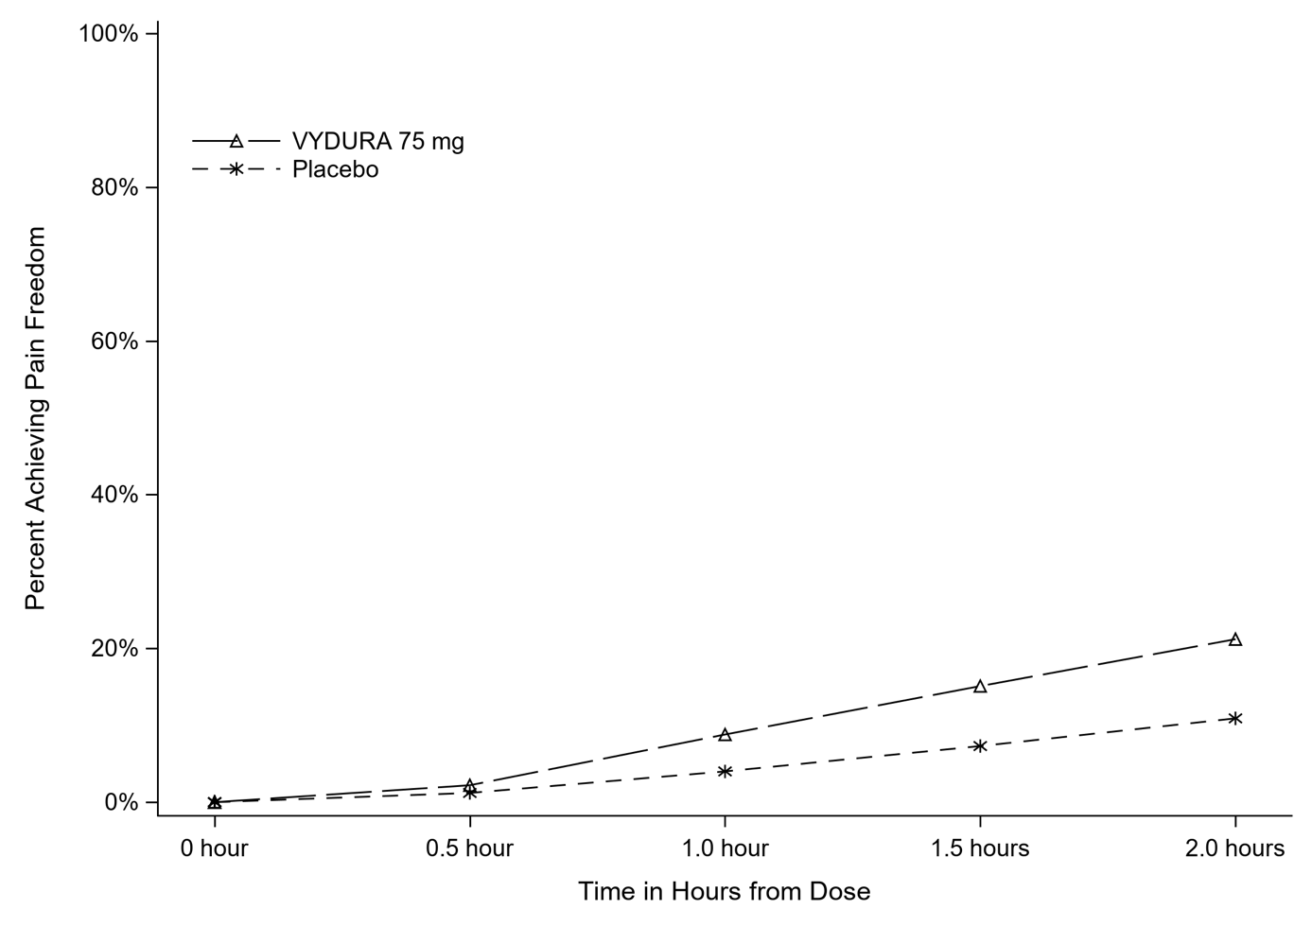

Figure 2 presents the percentage of patients achieving MBS freedom within 2 hours in Study 1.

Figure 2: Percentage of Patients Achieving MBS Freedom within 2 Hours in Study 1
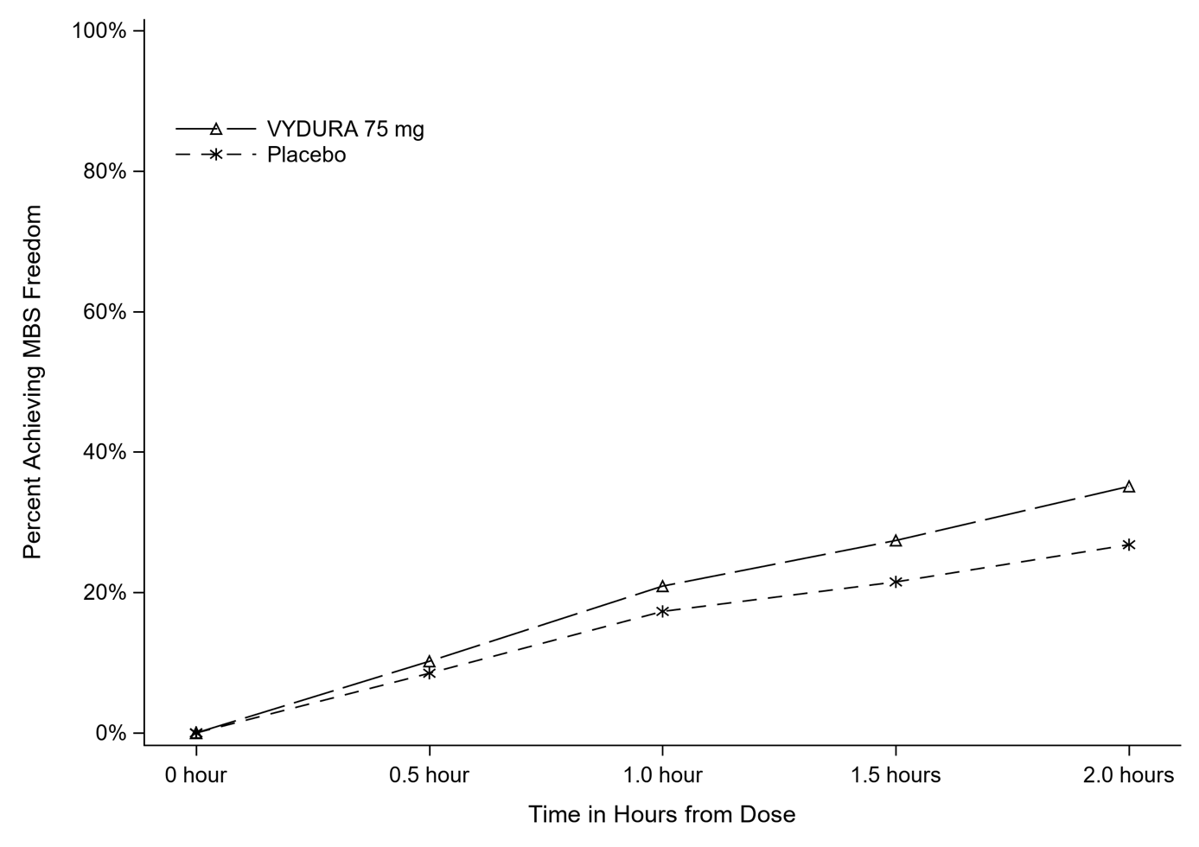

The incidence of photophobia and phonophobia was reduced at 2 hours following administration of VYDURA 75 mg as compared to placebo in all 3 studies.

Clinical efficacy: prophylaxis

The efficacy of rimegepant was evaluated as a prophylactic treatment of migraine in a randomized, double-blind, placebo-controlled study (Study 4).

Study 4 included male and female adults with at least a 1-year history of migraine (with or without aura). Patients had a history of 4 to 18 migraine attacks of moderate to severe pain intensity per 4-week period within the 12 weeks prior to the screening visit. Patients experienced an average of 10.9 headache days during the 28-day observational period, which included an average of 10.2 migraine days, prior to randomization into the study. The study randomized patients to receive rimegepant 75 mg (N=373) or placebo (N=374) for up to 12 weeks. Patients were instructed to take randomized treatment once every other day (EOD) for the 12-week treatment period. Patients were allowed to use other acute treatments for migraine (e.g., triptans, NSAIDs, paracetamol, antiemetics) as needed. Approximately 22% of patients were taking preventive medicinal products for migraine at baseline. Patients were allowed to continue in an open-label extension study for an additional 12 months.

The primary efficacy endpoint for Study 4 was the change from baseline in the mean number of monthly migraine days (MMDs) during Weeks 9 through 12 of the double-blind treatment phase. Secondary endpoints included the achievement of a ≥ 50% reduction from baseline in monthly moderate or severe migraine days.

Rimegepant 75 mg dosed EOD demonstrated statistically significant improvements for key efficacy endpoints compared to placebo, as summarized in Table 3 and shown graphically in Figure 3.

Table 3: Key Efficacy Endpoints for Study 4
 | Rimegepant  75 mg EOD | Placebo  EOD
Monthly Migraine Days (MMD) Weeks 9 through 12 | N=348 | N=347
Change from baseline | -4.3 | -3.5
Change compared to placebo | -0.8
p-value | 0.010ª
≥ 50% Reduction in Moderate or Severe MMDs Weeks 9 through 12 | N=348 | N=347
% Responders | 49.1 | 41.5
Difference compared to placebo | 7.6
p-value | 0.044ª
ª Significant p-value in hierarchical testing

Figure 3: Change from Baseline in Monthly Migraine Days in Study 4
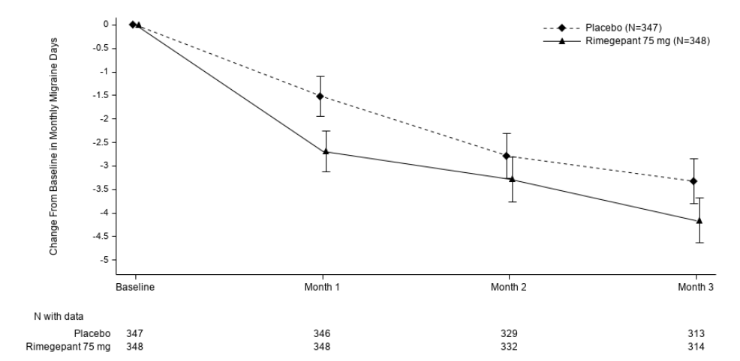

Long-term efficacy
Patients participating in Study 4 were allowed to continue in an open-label extension study for an additional 12 months. Efficacy was sustained for up to 1 year in an open-label study extension in which patients received rimegepant 75 mg every other day plus as needed on non-scheduled dosing days (Figure 4). A portion composed of 203 patients assigned to rimegepant completed the overall 16-month treatment period. In these patients, the overall mean reduction from baseline in the number of MMDs averaged over the 16-month treatment period was 6.2 days.

Figure 4: Longitudinal Plot of the Change in Mean Number of Monthly Migraine Days (MMDs) from the Observation Period Over Time during Double-Blind Treatment (Months 1 to 3) and during Treatment with Open-label Rimegepant (Months 4 to 16)

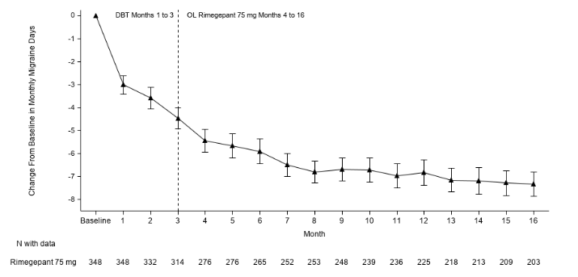

Paediatric population

The European Medicines Agency has waived the obligation to submit the results of studies with VYDURA in all subsets of the paediatric population in the prophylactic treatment of migraine headaches (see section 4.2 for information on paediatric use).

The European Medicines Agency has deferred the obligation to submit the results of studies with VYDURA in one or more subsets of the paediatric population in the acute treatment of migraine (see section 4.2 for information on paediatric use).

5.2 Pharmacokinetic properties

Absorption

Following oral administration, rimegepant is absorbed with the maximum concentration at 1.5 hours. Following a supratherapeutic dose of 300 mg, the absolute oral bioavailability of rimegepant was approximately 64%.

Effects of food
Following administration of rimegepant under fed conditions with a high-fat or low-fat meal, T_{max} was delayed by 1 to 1.5 hours. A high-fat meal reduced C_{max} by 41 to 53% and AUC by 32 to 38%. A low-fat meal reduced C_{max} by 36% and AUC by 28%. Rimegepant was administered without regard to food in clinical safety and efficacy studies.

Distribution

The steady state volume of distribution of rimegepant is 120 l. Plasma protein binding of rimegepant is approximately 96%.

Biotransformation

Rimegepant is primarily metabolized by CYP3A4 and to a lesser extent by CYP2C9. Rimegepant is the primary form (~77%) with no major metabolites (i.e., > 10%) detected in plasma.

Based on in vitro studies, rimegepant is not an inhibitor of CYP1A2, 2B6, 2C8, 2C9, 2C19, 2D6, or UGT1A1 at clinically relevant concentrations. However, rimegepant is a weak inhibitor of CYP3A4 with time-dependent inhibition. Rimegepant is not an inducer of CYP1A2, CYP2B6, or CYP3A4 at clinically relevant concentrations.

Elimination

The elimination half-life of rimegepant is approximately 11 hours in healthy subjects. Following oral administration of [¹⁴C]-rimegepant to healthy male subjects, 78% of the total radioactivity was recovered in feces and 24% in urine. Unchanged rimegepant is the major single component in excreted feces (42%) and urine (51%).

Transporters
In vitro, rimegepant is a substrate of P-gp and BCRP efflux transporters. Inhibitors of P-gp and BCRP efflux transporters may increase plasma concentrations of rimegepant (see section 4.5).

Rimegepant is not a substrate of OATP1B1 or OATP1B3. Considering its low renal clearance, rimegepant was not evaluated as a substrate of the OAT1, OAT3, OCT2, MATE1, or MATE2-K.

Rimegepant is not an inhibitor of P-gp, BCRP, OAT1, or MATE2-K at clinically relevant concentrations. It is a weak inhibitor of OATP1B1 and OAT3.

Rimegepant is an inhibitor of OATP1B3, OCT2, and MATE1. Concomitant administration of rimegepant with metformin, a MATE1 transporter substrate, resulted in no clinically significant impact on either metformin pharmacokinetics or on glucose utilization. No clinical drug interactions are expected for rimegepant with OATP1B3 or OCT2, at clinically relevant concentrations.

Linearity/non-linearity

Rimegepant exhibits greater than dose proportional increases in exposure following single oral administration, which appears to be related to a dose-dependant increase in bioavailability.

Age, sex, weight, race, ethnicity

No clinically significant differences in the pharmacokinetics of rimegepant were observed based on age, sex, race/ethnicity, body weight, migraine status, or CYP2C9 genotype.

Renal impairment

In a dedicated clinical study comparing the pharmacokinetics of rimegepant in subjects with mild (estimated creatinine clearance [CLcr] 60-89 ml/min), moderate (CLcr 30-59 ml/min), and severe (CLcr 15-29 ml/min) renal impairment to that with normal subjects (healthy pooled control), a less than 50% increase in total rimegepant exposure was observed following a single 75 mg dose. The unbound AUC of rimegepant was 2.57-fold higher in subjects with severe renal impairment. VYDURA has not been studied in patients with end-stage renal disease (CLcr < 15 ml/min).

Hepatic impairment

In a dedicated clinical study comparing the pharmacokinetics of rimegepant in subjects with mild, moderate, and severe hepatic impairment to that with normal subjects (healthy matched control), the exposure of rimegepant (unbound AUC) following a single 75 mg dose was 3.89-fold higher in subjects with severe impairment (Child-Pugh class C). There were no clinically meaningful differences in the exposure of rimegepant in subjects with mild (Child-Pugh class A) and moderate hepatic impairment (Child-Pugh class B) compared to subjects with normal hepatic function.

5.3 Preclinical safety data

Non-clinical data reveal no special hazard for rimegepant in humans based on conventional studies of safety pharmacology, repeat-dose toxicity, genotoxicity, phototoxicity, reproduction or development, or carcinogenic potential.

Rimegepant-related effects at higher doses in repeat-dose studies included hepatic lipidosis in mice and rats, intravascular hemolysis in rats and monkeys, and emesis in monkeys. These findings were observed only at exposures considered sufficiently in excess of the maximum human exposure indicating little relevance to clinical use (≥ 12 times [mice] and ≥ 49 times [rats] for hepatic lipidosis, ≥ 95 times [rats] and ≥ 9 times [monkeys] for intravascular hemolysis, and ≥ 37 times for emesis [monkeys]).

In a fertility study in rats, rimegepant-related effects were noted only at the high dose of 150 mg/kg/day (decreased fertility and increased pre-implantation loss) that produced maternal toxicity and systemic exposures ≥ 95 times the maximum human exposure. Oral administration of rimegepant during organogenesis resulted in foetal effects in rats but not rabbits. In rats, decreased foetal body weight and increased incidence of foetal variations were observed only at the highest dose of 300 mg/kg/day that produced maternal toxicity at exposures approximately 200 times the maximum human exposure. Additionally, rimegepant had no effects on pre- and postnatal development in rats at doses up to 60 mg/kg/day (≥ 24 times the maximum human exposure) or on growth, development, or reproductive performance of juvenile rats at doses up to 45 mg/kg/day (≥ 14 times the maximum human exposure).

6. PHARMACEUTICAL PARTICULARS

6.1 List of excipients

gelatin
mannitol (E421)
mint flavour
sucralose

6.2 Incompatibilities

Not applicable.

6.3 Shelf life

4 years

6.4 Special precautions for storage

Do not store above 30 °C.
Store in the original package in order to protect from moisture.

6.5 Nature and contents of container

Unit dose blisters made of polyvinyl chloride (PVC), oriented polyamide (OPA) and aluminium foil and sealed with a peelable aluminum foil.

Pack sizes:
Unit dose 2 x 1 oral lyophilisates.
Unit dose 8 x 1 oral lyophilisates.
Unit dose 16 x 1 oral lyophilisates.

Not all pack sizes may be marketed.

6.6 Special precautions for disposal

No special requirements for disposal.

Any unused medicinal product or waste material should be disposed of in accordance with local requirements.

7. MARKETING AUTHORISATION HOLDER

Pfizer Europe MA EEIG
Boulevard de la Plaine 17
1050 Bruxelles
Belgium

8. MARKETING AUTHORISATION NUMBER(S)

EU/1/22/1645/001
EU/1/22/1645/002
EU/1/22/1645/003

9. DATE OF FIRST AUTHORISATION/RENEWAL OF THE AUTHORISATION

Date of first authorisation: 25 April 2022

10. DATE OF REVISION OF THE TEXT

Detailed information on this medicinal product is available on the website of the European Medicines Agency https://www.ema.europa.eu.

ANNEX II

A. MANUFACTURER(S) RESPONSIBLE FOR BATCH RELEASE

B. CONDITIONS OR RESTRICTIONS REGARDING SUPPLY AND USE

C. OTHER CONDITIONS AND REQUIREMENTS OF THE MARKETING AUTHORISATION

D. CONDITIONS OR RESTRICTIONS WITH REGARD TO THE SAFE AND EFFECTIVE USE OF THE MEDICINAL PRODUCT

A. MANUFACTURER(S) RESPONSIBLE FOR BATCH RELEASE

Name and address of the manufacturer(s) responsible for batch release

HiTech Health Limited
5-7 Main Street
Blackrock
Co. Dublin
A94 R5Y4
Ireland

Millmount Healthcare Limited
Block-7, City North Business Campus
Stamullen
Co. Meath
K32 YD60
Ireland

Pfizer Ireland Pharmaceuticals Unlimited Company
Little Connell
Newbridge
Co. Kildare
W12 HX57
Ireland

The printed package leaflet of the medicinal product must state the name and address of the manufacturer responsible for the release of the concerned batch.

B. CONDITIONS OR RESTRICTIONS REGARDING SUPPLY AND USE

Medicinal product subject to medical prescription.

C. OTHER CONDITIONS AND REQUIREMENTS OF THE MARKETING AUTHORISATION

- Periodic safety update reports (PSURs)

The requirements for submission of PSURs for this medicinal product are set out in the list of Union reference dates (EURD list) provided for under Article 107c(7) of Directive 2001/83/EC and any subsequent updates published on the European medicines web-portal.

The marketing authorisation holder (MAH) shall submit the first PSUR for this product within 6 months following authorisation.

D. CONDITIONS OR RESTRICTIONS WITH REGARD TO THE SAFE AND EFFECTIVE USE OF THE MEDICINAL PRODUCT

- Risk management plan (RMP)

The marketing authorisation holder (MAH) shall perform the required pharmacovigilance activities and interventions detailed in the agreed RMP presented in Module 1.8.2 of the marketing authorisation and any agreed subsequent updates of the RMP.

An updated RMP should be submitted:
- At the request of the European Medicines Agency;
- Whenever the risk management system is modified, especially as the result of new information being received that may lead to a significant change to the benefit/risk profile or as the result of an important (pharmacovigilance or risk minimisation) milestone being reached.

ANNEX III

LABELING AND PACKAGE LEAFLET

A. LABELLING

PARTICULARS TO APPEAR ON THE OUTER PACKAGING

CARTON / 75 MG

1. NAME OF THE MEDICINAL PRODUCT

Vydura 75 mg oral lyophilisate
rimegepant

2. STATEMENT OF ACTIVE SUBSTANCE(S)

Each oral lyophilisate contains rimegepant sulfate, equivalent to 75 mg rimegepant.

3. LIST OF EXCIPIENTS

4. PHARMACEUTICAL FORM AND CONTENTS

2 x 1 oral lyophilisates
8 x 1 oral lyophilisates
16 x 1 oral lyophilisates

5. METHOD AND ROUTE(S) OF ADMINISTRATION

For oral use.

Use dry hands, peel back the foil backing of one blister and gently remove the oral lyophilisate. Do not push the oral lyophilisate through the foil. Immediately place it under or on top of the tongue where it will dissolve in seconds. No drink or water is needed.
Read the package leaflet before use.

6. SPECIAL WARNING THAT THE MEDICINAL PRODUCT MUST BE STORED OUT OF THE SIGHT AND REACH OF CHILDREN

Keep out of the sight and reach of children.

7. OTHER SPECIAL WARNING(S), IF NECESSARY

8. EXPIRY DATE

EXP

9. SPECIAL STORAGE CONDITIONS

Do not store above 30 °C.
Store in the original package in order to protect from moisture.

10. SPECIAL PRECAUTIONS FOR DISPOSAL OF UNUSED MEDICINAL PRODUCTS OR WASTE MATERIALS DERIVED FROM SUCH MEDICINAL PRODUCTS, IF APPROPRIATE

11. NAME AND ADDRESS OF THE MARKETING AUTHORISATION HOLDER

Pfizer Europe MA EEIG
Boulevard de la Plaine 17
1050 Bruxelles
Belgium

12. MARKETING AUTHORISATION NUMBER(S)

EU/1/22/1645/001 (2 pack)
EU/1/22/1645/002 (8 pack)
EU/1/22/1645/003 (16 pack)

13. BATCH NUMBER

Lot

14. GENERAL CLASSIFICATION FOR SUPPLY

15. INSTRUCTIONS ON USE

16. INFORMATION IN BRAILLE

VYDURA 75 mg

17. UNIQUE IDENTIFIER – 2D BARCODE

<2D barcode carrying the unique identifier included.>

18. UNIQUE IDENTIFIER - HUMAN READABLE DATA

PC
SN
NN

MINIMUM PARTICULARS TO APPEAR ON BLISTERS OR STRIPS

BLISTERS / 75 MG

1. NAME OF THE MEDICINAL PRODUCT

Vydura 75 mg oral lyophilisate
rimegepant

2. NAME OF THE MARKETING AUTHORISATION HOLDER

Pfizer (logo)

3. EXPIRY DATE

EXP

4. BATCH NUMBER

Lot

5. OTHER

Peel

B. PACKAGE LEAFLET
Package leaflet: Information for the patient

VYDURA 75 mg oral lyophilisate
rimegepant

This medicine is subject to additional monitoring. This will allow quick identification of new safety information. You can help by reporting any side effects you may get. See the end of section 4 for how to report side effects.

Read all of this leaflet carefully before you start taking this medicine because it contains important information for you.
- Keep this leaflet. You may need to read it again.
- If you have any further questions, ask your doctor or pharmacist.
- This medicine has been prescribed for you only. Do not pass it on to others. It may harm them, even if their signs of illness are the same as yours.
- If you get any side effects, talk to your doctor or pharmacist. This includes any possible side effects not listed in this leaflet. See section 4.

What is in this leaflet

1. What VYDURA is and what it is used for
2. What you need to know before you take VYDURA
3. How to take VYDURA
4. Possible side effects
5. How to store VYDURA
6. Contents of the pack and other information

1. What VYDURA is and what it is used for

VYDURA contains the active ingredient rimegepant, that stops the activity of a substance in the body called calcitonin gene-related peptide (CGRP). People with migraine may have increased levels of CGRP. Rimegepant attaches to the receptor for CGRP, reducing the ability of CGRP to also attach to the receptor. This reduces the activity of CGRP and has two effects:
1) it can stop an active migraine attack, and
2) it can decrease the number of migraine attacks that occur when taken preventively.

VYDURA is used to treat and prevent migraine attacks in adults.

2. What you need to know before you take VYDURA

Do not take VYDURA
- if you are allergic to rimegepant or any of the other ingredients of this medicine (listed in section 6).

Warnings and precautions
Talk to your doctor or pharmacist before taking VYDURA, if any of the following applies to you:
- if you have severe liver problems
- if you have reduced kidney function or are on kidney dialysis

During treatment with VYDURA, stop taking this medicine and tell your doctor immediately:
- if you experience any symptoms of an allergic reaction (e.g., trouble breathing, severe rash, swelling of tongue, mouth or face, trouble swallowing, throat tightness, or hoarseness). These symptoms can occur several days after administration.

Children and adolescents
VYDURA should not be given to children and adolescents under 18 years of age because it has not yet been studied in this age group.

Other medicines and VYDURA
Tell your doctor or pharmacist if you are taking, have recently taken or might take any other medicines. This is because some medicines may affect the way VYDURA works or VYDURA may affect how other medicines work.

The following is a list of examples of medicines that should be avoided when taking VYDURA:
- itraconazole and clarithromycin (medicines used to treat fungal or bacterial infections).
- ritonavir and efavirenz (medicines to treat HIV infections).
- bosentan (a medicine used to treat high blood pressure).
- St. John’s wort (a herbal remedy used to treat depression).
- phenobarbital (a medicine used to treat epilepsy).
- rifampicin (a medicine used to treat tuberculosis).
- modafinil (a medicine used to treat narcolepsy).

Do not take VYDURA more than once every 48 hours with:
- fluconazole and erythromycin (medicines used to treat fungal or bacterial infections).
- diltiazem, quinidine, and verapamil (medicines used to treat an abnormal heart rhythm, chest pain (angina) or high blood pressure).
- cyclosporin (a medicine used to prevent organ rejection after an organ transplant).

Pregnancy and breast-feeding
If you are pregnant, think you may be pregnant or are planning to have a baby, ask your doctor or pharmacist for advice before taking this medicine. It is preferable to avoid the use of VYDURA during pregnancy as the effects of this medicine in pregnant women are not known.

If you are breast-feeding or are planning to breast-feed, talk to your doctor or pharmacist before using this medicine. You and your doctor should decide if you will use VYDURA while breast-feeding.

Driving and using machines
VYDURA is not expected to affect your ability to drive or use machines.

3. How to take VYDURA

Always take this medicine exactly as your doctor or pharmacist has told you. Check with your doctor or pharmacist if you are not sure.

How much to take
For prevention of migraine, the recommended dose is one oral lyophilisate (75 mg rimegepant) every other day.

For treatment of a migraine attack once it has started, the recommended dose is one oral lyophilisate (75 mg rimegepant) as needed, not more than once daily.

The maximum daily dose is one oral lyophilisate (75 mg rimegepant) per day.

How to take this medicine
VYDURA is for oral use.
The oral lyophilisate can be taken with or without food or water.

Instructions:
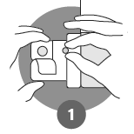 | Use dry hands when opening. Peel back the foil covering of one blister and gently remove the oral lyophilisate. Do not push the oral lyophilisate through the foil.
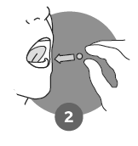 | As soon as the blister is opened, remove the oral lyophilisate and place it on or under the tongue, where it will dissolve. No drink or water is needed.  Do not store the oral lyophilisate outside the blister for future use.

If you take more VYDURA than you should
Talk to your doctor or pharmacist or go to a hospital straight away. Take the medicine pack and this leaflet with you.

If you forget to take VYDURA
If you take VYDURA for the prevention of migraine and you miss a dose, just take the next dose at the usual time. Do not take a double dose to make up for a forgotten dose.

If you have any further questions on the use of this medicine, ask your doctor or pharmacist.

4. Possible side effects

Like all medicines, this medicine can cause side effects, although not everybody gets them.

Stop using VYDURA and contact your doctor straight away if you have signs of an allergic reaction (such as severe rash or shortness of breath) or signs of a severe allergic reaction known as ‘anaphylaxis’ (such as swelling of tongue, mouth or face, trouble swallowing or breathing, throat tightness, or hoarseness). Allergic reactions, including anaphylaxis, with VYDURA are uncommon (may affect up to 1 in 100 people).

A common side effect (may affect up to 1 in 10 people) is nausea.

Reporting of side effects
If you get any side effects, talk to your doctor or pharmacist. This includes any possible side effects not listed in this leaflet. You can also report side effects directly via the national reporting system listed in Appendix V. By reporting side effects you can help provide more information on the safety of this medicine.

5. How to store VYDURA

Keep this medicine out of the sight and reach of children.

Do not use this medicine after the expiry date which is stated on the carton and the blister after EXP. The expiry date refers to the last day of that month.

Do not store above 30 °C. Store in the original blister in order to protect from moisture.

Do not throw away any medicines via wastewater or household waste. Ask your pharmacist how to throw away medicines you no longer use. These measures will help protect the environment.

6. Contents of the pack and other information

What VYDURA contains
- The active substance is rimegepant. Each oral lyophilisate contains 75 mg rimegepant (as sulfate).
- The other ingredients are: gelatin, mannitol, mint flavour, and sucralose.

What VYDURA looks like and contents of the pack
VYDURA 75 mg oral lyophilisates are white to off-white, circular, and debossed with the symbol .

Pack sizes:
- 2 x 1 oral lyophilisate perforated unit dose blisters.
- 8 x 1 oral lyophilisate perforated unit dose blisters.
- 16 x 1 oral lyophilisate perforated unit dose blisters.

Not all pack sizes may be marketed.

Marketing Authorisation Holder
Pfizer Europe MA EEIG
Boulevard de la Plaine 17
1050 Bruxelles
Belgium

Manufacturer
HiTech Health Limited
5-7 Main Street
Blackrock
Co. Dublin
A94 R5Y4
Ireland

Millmount Healthcare Limited
Block-7, City North Business Campus
Stamullen
Co. Meath
K32 YD60
Ireland

Pfizer Ireland Pharmaceuticals Unlimited Company
Little Connell
Newbridge
Co. Kildare
W12 HX57
Ireland

For any information about this medicine, please contact the local representative of the Marketing Authorisation Holder:

België/Belgique/Belgien  Luxembourg/Luxemburg  Pfizer NV/SA  Tél/Tel: +32 (0)2 554 62 11 | Lietuva  Pfizer Luxembourg SARL filialas Lietuvoje  Tel. +370 5 251 4000
България  Пфайзер Люксембург САРЛ, Клон България  Тел: +359 2 970 4333 | Magyarország  Pfizer Kft.  Tel.: + 36 1 488 37 00
Česká republika  Pfizer, spol. s r.o.  Tel: +420 283 004 111 | Malta  Vivian Corporation Ltd.  Tel.: +356 21344610
Danmark  Pfizer ApS  Tlf.: +45 44 20 11 00 | Nederland  Pfizer bv  Tel: +31 (0) 800 63 34 636
Deutschland  PFIZER PHARMA GmbH  Tel: +49 (0)30 550055-51000 | Norge  Pfizer AS  Tlf: +47 67 52 61 00
Eesti  Pfizer Luxembourg SARL Eesti filiaal  Tel: +372 666 7500 | Österreich  Pfizer Corporation Austria Ges.m.b.H.  Tel: +43 (0)1 521 15-0
Ελλάδα  Pfizer Ελλάς Α.Ε.  Τηλ.: +30 210 6785800 | Polska  Pfizer Polska Sp. z o.o.  Tel.: +48 22 335 61 00
España  Pfizer, S.L.  Tel: +34 91 490 99 00 | Portugal  Laboratórios Pfizer, Lda.  Tel: +351 21 423 5500
France  Pfizer  Tél: +33 (0)1 58 07 34 40 | România  Pfizer Romania S.R.L.  Tel: +40 (0) 21 207 28 00
Hrvatska  Pfizer Croatia d.o.o.  Tel: +385 1 3908 777 | Slovenija  Pfizer Luxembourg SARL  Pfizer, podružnica za svetovanje s področja farmacevtske dejavnosti, Ljubljana  Tel.: +386 (0)1 52 11 400
Ireland  Pfizer Healthcare Ireland Unlimited Company  Tel: +1800 633 363 (toll free)  Tel: +44 (0)1304 616161 | Slovenská republika  Pfizer Luxembourg SARL, organizačná zložka  Tel: + 421 2 3355 5500
Ísland  Icepharma hf.  Sími: +354 540 8000 | Suomi/Finland  Pfizer Oy  Puh/Tel: +358 (0)9 430 040
Italia  Pfizer S.r.l.  Tel: +39 06 33 18 21 | Sverige  Pfizer AB  Tel: +46 (0)8 550 520 00
Κύπρος
Pfizer Ελλάς Α.Ε. (Cyprus Branch)
Τηλ.: +357 22817690

Latvija
Pfizer Luxembourg SARL filiāle Latvijā
Tel: + 371 670 35 775

This leaflet was last revised in .

Other sources of information

Detailed information on this medicine is available on the European Medicines Agency web site: https://www.ema.europa.eu.

