EMA/283362/2012
Human Medicines Division
Version 8

Paediatric investigation plan (PIP) - Key elements form (KEF)
<Active substance(s)>
<Case number> - Include case number before uploading this document (e.g. EMA/PE/0000123456)

General guidance
Delete general guidance, screenshots and drafting notes from your submitted version
Do not amend titles or the name of the key element tables in the left column in the pages below. Delete the table(s) if the study/plan is not applicable or repeat in case of several studies.
Note for re-submission after clock-stop:
Where key elements have only been submitted in IRIS before, if possible, please complete and submit this form including the changes (not mandatory). Alternatively, you may indicate the changes to the relevant sections in the response document instead.

Guidance related to key elements in IRIS
Currently the key element section is mandatory in IRIS but high-level information is sufficient to include. Please only add “Refer to KEF” where possible.
Proceed as demonstrated below:
- List all the study types and identifiers in Scientific Information tab by pressing “Add new study/measure” button:
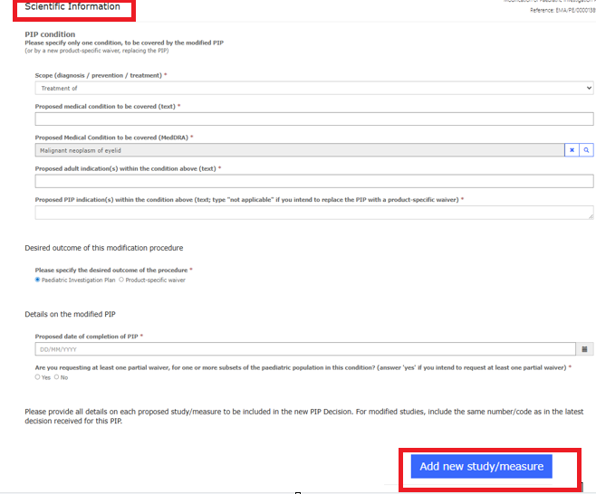

- A pop-up dialog box will appear with Study identification and Timelines and deferral title
- Complete Type of PIP study/measure (e.g. Clinical study)
- Complete Study identifier with study number and/or identification code (e.g. Study 1 – PA-02345)
- Add “Refer to KEF” in the rest of the fields then go to Point 3
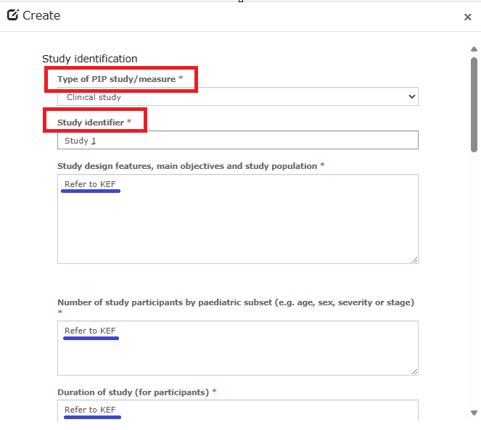

- Continue filling in the dialog box as above until Timelines and deferral then:
- Include dates or milestones
- Answer Yes or No regarding deferrals
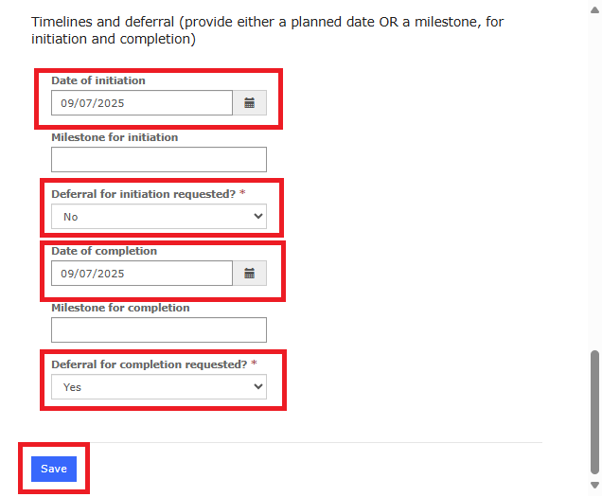

- List of studies will be summarised as shown below. It is possible to edit or delete.
- Check that all studies are listed with their high-level information and deferral timelines and press Save and Return.
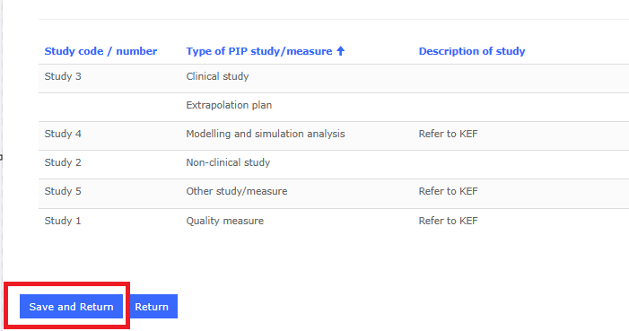

- Details of the proposed measures
  - Measures to be performed according to the specified timelines
    - Quality-related studies
Study identifier | Include study identifier or put “Not available”
Study description and objectives | Describe objective of quality study using wording analogous to the examples provided below, e.g. “Development of <pharmaceutical form, e.g. granules> <an age-appropriate formulation”  Refer to EDQM for standard terms  - Specify liquid or solid for oral form if known  - Specify route of administration (if known) (e.g. oral use, intravenous use, gastroenteral use)  - Include only age-appropriate formulation planned to be developed  Examples of wording:  - Development of new route of administration: <..><for use in children from age x to age y>  - Development of a <preservative-free eye / ethanol-free> pharmaceutical form> <not containing <certain excipients>  - Development of <lower strength appropriate to the paediatric population> <vial containing less than 10-fold of the lowest dose for adults> <scored tablet> of <existing dose form>  Development of a medical administration device <with suitable graduation to be added to the liquid formulation><development of an appropriate dispensing device for granules>
Date of completion | Add a date or include a milestone  The completion date should correspond, in principle, to the completion of the PIP. However, the formulation is usually expected to be available at the time of the relevant clinical study – this is reflected in the respective KEs for the clinical study(ies).  In cases where the date must be different to the date of completion of the PIP, a date, or optionally a milestone, if measure is not deferred and it is not the last study must be included.  Example of wording for milestone:  <Before submission of the MAA for adults for <condition>>  Select the appropriate sentence:  <The completion of this study is deferred.>  <The completion of this study is not deferred.>
    - Non-clinical studies
Study identifier | Include study identifier or put “Not available”
Study description, objectives and outcome measures | In principle only the objective, species, and duration should be mentioned in this field.  There is no need for the age of the animals at study start – it is sufficient to say “juvenile”.  Add outcome if specific: e.g., histopathology of brain.  Add control group if specific.
Test system/species (age of the animal) | - Species and/or model  - Age of the animals at study start  It is not necessary to include the number of animals.
Duration of dosing | Include duration of dosing and, if applicable, recovery period in this field.
Route of administration | Include route of administration
Date of initiation | Add a date or include a milestone  Examples of wording for milestone:  Must be initiated before submission of the regulatory application for condition x  Select the appropriate sentence:  <The initiation of this study is deferred.>  <The initiation of this study is not deferred.>
Date of completion (final study report signed) | Add a date or include a milestone  There must be a date, or optionally a milestone, if measure is not deferred and it is not the last study.  The completion date should correspond, in principle, to the completion of the PIP. However, the formulation is usually expected to be available at the time of the relevant clinical study.  Example of wording for milestone:  Before submission of the MAA for adults for <condition>  When completion is required for a paediatric clinical trial, specify this as initiation requirement in the concerned trial.  Select the appropriate sentence:  <The completion of this study is deferred.>  <The completion of this study is not deferred.>
    - Clinical studies
In cases where specific key elements cannot be fully defined at the time of submission, a milestone should be added to specify how and when the element will be determined. This may include for example: “to be agreed with the PDCO within (x) months after completion of non-clinical study (title/no), or results from a specific study in adults, or results/data from a study in a different paediatric population or a different condition” (include study identifiers if known).
Study identifier | Include study identifier or put “Not available”
Study design features, main objectives and study population | Short summary of the study design features and study population  Age (from birth/x weeks-months-years of age to less than y weeks-months-years of age, sex and condition and any other study population details to be included (e.g. specific eligibility criteria such as ‘diagnosis of glaucoma and intraocular pressure above 21mmHg’) as considered necessary.  - Do not mention:  - study phase (e.g., I, II, or IIIb)  - patient numbers  - abbreviations (expand)  - concept of ‘efficacy’ trial - if it is e.g. an open, uncontrolled trial, use ‘activity’  - Do mention (as applicable, based on the information available at the time the PIP is submitted):  - the design and the objective, the estimand briefly, add-on, in combination  - periods such as “with x-month open-label extension to evaluate safety”  - population to be included: brief qualification e.g. naive, experienced, phenotype, grade of severity, criteria for diagnosis other key inclusion criteria  - age groups or other subsets (e.g. “from 8 years to less than 18 years of age”, “post-menarcheal girls”)  - if comparator-controlled, use the INN of the comparator. (Exceptionally it can be an invented name if otherwise too long, e.g. with vaccines.)  - Follow the examples of wording below as much as possible (order of elements, etc.)  <Open-label>, <double-blind>, <randomised>, <assessor-blind>, <single/multiple dose>, <active/placebo> <external/concurrent/historical> <controlled> trial to evaluate> <pharmacokinetics>, <safety>, <activity>, <efficacy>, <acceptability/palatability>,<immunogenicity> of <active substance(s)> <as add-on to best standard of care/X> <compared to Y> in children from <age> to less than <age> <years> <months> of age with <broad definition of the population or other subsets>  Additionally, select from the objectives below, and add others if relevant. There is no need to repeat in detail objectives/outcomes as they will be listed separately below.  in terms of <superiority of X over placebo/control>, <reduction of Y> <non-inferiority of X as compared to Y with respect to Z> <estimation of treatment effects> and <to provide <PK/PD data, exposure/response data to support the extrapolation of efficacy from other populations  Cross-reference clinical studies that have extrapolation as an objective to section 1.1.6, as necessary  <to contribute to modelling of the PK/PD/exposure/dose-response relationship> in children from age to age < (and adults)> with <broad population definition>, <with extension study to evaluate safety>
Number of study participants by paediatric subset (e.g. age, sex, severity or stage) | Include randomisation and number per subset including age subsets as appropriate using the format ‘at least’.  Depending on the type of study, e.g. for PK, the sample size should be precisely defined. In other cases where many elements are not yet known (e.g. the effect size in adults) or are difficult to define, it may be appropriate to define the sample size in the most vulnerable groups (e.g. very young children) as a proportion of the overall sample size.  At least x patients/participants evaluable for the primary analysis (or enrolled, randomised, followed up until x etc. as appropriate)  A condition can be added here if a sample size cannot be defined, according to the examples of wording below:  <Number of participants to be recruited/randomised/evaluable for the primary analysis> <to be agreed by the PDCO before initiation of the study> <to be estimated to achieve at least xx% power for an effect size of x in the primary analysis to demonstrate superiority/non-inferiority> <using a two-sided hypothesis test at 5% error level/with at least 95% probability using Bayesian decision-making> and add further assumptions, e.g. power, significance level, expected treatment effect, variance response if known, based on data from ongoing adult programme, augmenting/incorporating prior information from external data
Duration of study (for participants) | Please use bullet points for each study period.  - Treatment duration: must be planned for at least x days/weeks/years in protocol  e.g. one year (including 12-week double-blind and 9-month open-extension)  In cases where the duration of study participation cannot be defined at the time of agreement of the PIP, a condition can be added, e.g. in line with adult efficacy and safety studies, or milestone agreed for PDCO discussion/agreement. It may be appropriate to define a minimum duration in certain cases.  Indicate if a staggered enrolment is planned (usually starting with the older cohorts), if so, provide criteria for the initiation of the different cohorts.  - Follow-up duration (part of completion of this study): must be planned for at least x days/weeks/years in protocol  In this section a bullet point can be included for long-term follow-up studies if appropriate, specifying that this is not part of the PIP.  - Long-term follow-up study/duration><<not> part of the PIP
Dosage, treatment regimen and route of administration | Mention exact doses to be studied only if known in this field. Otherwise, if dose not known, describe on what basis the dose will be selected (e.g. based on results from the PK study x and/or modelling and simulation study y)  Specify if multiple doses are tested.  If add-on design, describe add-on therapy  <using pharmaceutical form developed in study x> <once-daily/twice-weekly/…>, <route of administration>, <dose>/<dose to be based on results of study x>
Control | Include placebo or active comparator (INN/other name e.g. for vaccines, dosage, route of administration)  If external control, exact description including source of data (including study identifier, if applicable)  In cases where a control cannot be defined at the time of agreement of the PIP:  - a condition can be included, e.g. ‘the control must be agreed with the PDCO once data from study X are available’  - or the control could be a class of products  - or it must match the control used in adult studies
External Data Safety Monitoring Board | Chose the correct statement:  <Required>  <Not required>  If a data monitoring board is instituted for reasons other than safety monitoring, members affiliated with the sponsor might be included, if justified, e.g. at early stages of the development. These data monitoring boards should be mentioned in the section “Other”.
Key evaluations and outcomes | Please use bullet points.  List with time point(s) of assessment as applicable.  This section should include only the critical evaluations and outcomes important for establishing the paediatric indication but it should also include the range of the assessments to show the effect of the product on different aspects of the disease as well as consequences of the treatment (important efficacy and safety end-points, QoL, PD, biomarkers, PROs). End-points which are necessary to support extrapolation, e.g. to other subsets should also be included.  In cases where a primary endpoint cannot be defined it may be acceptable to include a primary objective here, e.g. to collect efficacy information and further details on the primary endpoint to be added following a certain milestone (e.g. from a study in adults, or an earlier phase study in children). For small open-label studies it may be appropriate to not define endpoints as primary or secondary, as such studies are not powered for the primary endpoint.  When secondary endpoints are required to be included in the opinion but only the most relevant should be added here. This is not intended to be a copy of all endpoints included in the protocol but a summary of those considered most relevant to support the overall objective of the study and to provide the range of the assessments (see above).  Occasionally exploratory endpoints are considered very important (e.g. important endpoints to advance the field on a specific issue).  Primary endpoint:  <text>  Secondary endpoints (to give the full range of the end points including biomarkers):  <text>  Safety end points:  <text>  Important exploratory end points:  <text>  <Generation of data on acceptability and palatability during the clinical trial(s) with the target population> - delete if not applicable  Examples of wording for evaluation of PK:  <Pharmacokinetic parameters including, e.g., C_{max}, AUC, t_{1/2}, C_{steadystate}, C_{trough}> <using <number> samples per participant> <using sparse sampling>
Statistical plan | Please list in bullet point as appropriate:  - The primary endpoint including summary measure on which the success criterion is based upon.  - Null hypothesis to be tested (superiority, non-inferiority incl. non-inferiority margin)  - Primary statistical procedure (brief description of the statistical test/estimation function/confidence interval method) (frequentist or Bayesian method)  - Significance level for a frequentist method, characterisation of type-1 error rate in case of a Bayesian method:  - Power  - Number and timing of interim analyses  If applicable, list the following in bullet points below:  - Formal statistical success criteria (if not specified above):  - Use of the clinical/PD/PK data in the extrapolation approach:  - Sub-group analyses:
Other | E.g. information if internal experts are considered necessary to participate to a data safety monitoring board, for example to safe-guard patients in a first in child study.
Date of initiation | Add a date or a milestone  Either a date of initiation or milestone must be proposed, but the PDCO will decide whether this date should be specified in the adopted opinion; in most cases it will not be specified.  Examples of wording for milestone:  To be initiated only after the completion of the development of the age-appropriate formulation (PIP study 1…)  To be initiated only after the completion of non-clinical PIP study number 2…  To be initiated within x months after completion of adult study XX  To be initiated only after consultation with relevant academic consortia confirming a clinically relevant effect size estimate observed in study X warranting pivotal development in an identified target population  Select the appropriate sentence:  <The initiation of this study is deferred.>  <The initiation of this study is not deferred.>
Date of completion | Add a date or a milestone  There must be a date, or optionally a milestone, if measure is not deferred, and it is not the last study.  Examples of wording for milestone:  Before submission of the MAA for adults for <condition>  x months after completion of study y  When completion is required for another paediatric clinical trial, specify this as initiation requirement in the concerned trial.  Select the appropriate sentence:  <The completion of this study is deferred.>  <The completion of this study is not deferred.>
    - Modelling and simulation analyses

Population pharmacokinetic (PopPK) model and pharmacokinetic/pharmacodynamic PK/PD analysis
Study identifier | Include study identifier or put “Not available”
Study description and objectives | - Use of PopPK to predict initial paediatric doses to be used in further clinical studies.  - Use of PopPK to analyse (sparse) PK data collected in paediatric studies to inform dosing recommendation in paediatric participants.  - Use of PopPK to confirm or modify the paediatric posology compared to the regimen used in clinical trials.  - Use of PopPK to simulate PK in paediatric participants, to be used as a basis for extrapolation and choice of paediatric posology from age <X> to age <Y>.  - Use of PopPK to extrapolate PK outside the studied age range to inform dosing recommendation for paediatric participants.  - Other
Model type | Add  <Population (Pop-PK) model>  Or  <PK/PD analysis>
Data to be used to build the model | Specify PK and PD data sources for paediatric PK (and PD) data, e.g. study identifier or number of studies or type of study, number of participants.  Specify data sources for adult PK (and PD) data.  Explain if adult and paediatric data will be pooled or if separate adult and pediatric models will be developed.
Methodology | The general approach to the population PK modelling will start with the adult popPK model and update the model using the paediatric dataset.  The model can be updated several times as data become available and should in the end be updated using all paediatric data.  A pre-specified modelling plan should be provided. More detail can be found in the CHMP Guideline on reporting the results of population pharmacokinetic analyses.  Modelling and simulation: questions and answers | European Medicines Agency (EMA)  Example of wordings:  Description (e.g. Pop-PK model based on adult data to be updated with emerging data from paediatric patients to determine x to characterize the PK profile of y/to describe z
Covariates | Body weight based allometric scaling using fixed exponents (0,75 for CL and 1 for Vd) should be included a priori, unless justified otherwise.  Strategy regarding ontogeny/maturation should be stated.  Examples of wording:  Body weight based allometric scaling using fixed exponents will be included a priori.  Additional covariates to be tested will include at least: age, sex, race, etc. (chose as appropriate)  A maturation function from literature (reference) will be included in the model / since a waiver below x years is applicable, maturation is not expected to affect PK.
Model evaluation /qualification | Model evaluation should be based on standard methods and would normally include at least goodness of fit plots, final parameter estimates and prediction corrected visual predictive check (VPC). VPCs stratified according to age and/or weight groups, as appropriate. More detail can be found in the CHMP Guideline on reporting the results of population pharmacokinetic analyses and in Modelling and simulation: questions and answers | European Medicines Agency (EMA)  Examples of wording:  Standard methods will be used and will include:  Goodness of fit plots  Visual predictive checks  Assessment of plausibility of parameter estimates  Assessment of parameter uncertainty estimation
Date of completion | Should be aligned to the objective, e.g. before study initiation if initial paediatric dose is required.  Add a date or a milestone  Example of wording for milestone:  Before submission of the MAA for adults for <condition>  Select the appropriate sentence:  <The completion of this study is deferred.>  <The completion of this study is not deferred.>

Physiologically based pharmacokinetic model (PBPK)
Study identifier | Include study identifier or put “Not available”
Study description and objectives | Please note that the use of PBPK to predict drug interaction in children is out of scope; this should be discussed in the scientific document.  Choose one or more of the following:  - Use of PBPK to predict initial paediatric doses to be used in further clinical studies.  - Use of PBPK to analyse (sparse) PK data collected in paediatric studies to inform dosing recommendation in paediatric participants.  - Use of PBPK to confirm or modify the paediatric posology compared to the regimen used in clinical trials.  - Use of PBPK to simulate PK in paediatric participants, to be used as a basis for extrapolation and choice of paediatric posology from age <X> to age <Y>  - Use of PB-PK to extrapolate PK outside the studied age range to inform dosing recommendation for paediatric participants.  - Other
Data to be used to build the model | The model should be updated several times as paediatric data become available and should be updated using all paediatric data after completion of the paediatric study(ies)  Specify PK data in adults as well as PK data in older children to be used, e.g. study identifier or number of studies or type of study. It is important to mention source/reference for the input parameters/data. Use examples of wording below.  Adult  Paediatric data  And  Age/ weight subsets providing data
Methodology | Description of PB-PK platform:  Describe the PB-PK model and platform where ontogeny and age (weight) related changes are incorporated (if relevant for the age group, e.g. for metabolising enzymes and drug transporters, or renal clearance).  Specify if the PBPK platform (system model) is qualified for the objective (if needed).
Population and physiological parameters (PBPK model) | Paediatric patients from <X> <years/months/days> to <Y> <years/months/days> of age <with the following characteristic: Z>  Specify which mechanistic assumptions, pertinent physiological and population parameters are included in the model.
Model evaluation / qualification | Qualification is mainly relevant for objectives 3 and 4 in the field of “Model description and objectives”.  Here the section should be split into 2 sections:  - Platform qualification of the system model  As a general rule, qualification is required where the regulatory impact of the model is high, therefore this is dependent on the objective as stated above. This is particularly important where the model is used for extrapolation.  However, to predict initial dose(s) for a paediatric trial, no PBPK platform qualification is needed.  Posology recommendations in paediatric patients that are supported by only sparse clinical exposure/PK data and heavily rely on PBPK modelling are considered to be high regulatory impact applications and thus require platform qualification in the following cases (see 1. and 2.)  - When sparse exposure data are available in that age range, the platform qualification could consist of a minimum of two compounds with similar ADME properties with PK data in the particular age range.  - When PBPK modelling is used without PK data from a selected age range, the platform qualification needs to meet additional requirements including a larger number of similar compounds and to also consider ontogeny, if relevant (see Guideline on the reporting of physiologically-based pharmacokinetic (PBPK) modelling and simulation Reporting of physiologically based pharmacokinetic (PBPK) modelling and simulation - Scientific guideline | European Medicines Agency (EMA)).  Examples of drugs useful for qualification packages are amikacin for renal clearance or digoxin for clearance by P-glycoprotein (Pgp).  No PBPK qualification needed since PBPK platform will be used to predict initial dose(s) for a paediatric trial.  Or  PBPK platform qualification of <product name> in <intended use> using data from <compound(s)  - Substance model evaluation  The adult PBPK model should be evaluated comparing the observed vs predicted PK data. Sensitivity analyses for uncertain parameters should be performed.  Evaluation of the drug PBPK model to be performed comparing data from study <X> versus predicted data.  The paediatric PB-PK model should be evaluated against PK data in children, when available, comparing observed vs predicted PK data. Sensitivity analyses for uncertain parameters used to inform the paediatric model should be performed. Figures and tables should be provided as appropriate in the scientific document.  The following can be added if considered necessary:  Outcome of the evaluation to be presented using:  - Plots of the comparison of the simulated and the observed plasma concentration-time data using linear and semi-log plots and as tabulations  - Visual predictive plots  - Other
Date of completion | Should be aligned to the objective, e.g. before study initiation if initial paediatric dose is required.  Add a date or a milestone  Example of wording for milestone:  Before submission of the MAA for adults for <condition>  Select the appropriate sentence:  <The completion of this study is deferred.>  <The completion of this study is not deferred.>
    - Other studies
Use this section in case additional study(ies) beyond the clinical and modelling and simulation study(ies) are considered necessary to further substantiate the extrapolation plan, e.g. literature review on disease similarity, or a certain biomarker equally applicable across populations.
Study identifier | Include study identifier or put “Not available”
Study description and objectives | Add additional details as relevant.  Examples of wording for study description:  Analysis of e.g. existing <in house>, and/or <external clinical> and <literature> data on <mechanism of action of>, <active substance(s)>, <class of medicines> on <condition definition to demonstrate <objective>  Examples of wording for study objectives:  <To provide data in support of efficacy assumptions in the paediatric population as per extrapolation concept, <evidence synthesis of different data sources> e.g. via meta-analysis, <including some specificities, e.g.>, from <source population>  <To present data supporting the assumption that the outcome of treatment is likely to be similar in paediatric subsets by age and by any other relevant characteristics compared to adults by providing an analysis of <define>  <Target population: paediatric <patients> <participants> from age to age>  <If external control data is used to contextualize the data, exact description including source of data and matching criteria>
Methodology | Examples of wording:  <Short description (max 40 words) of the methods of the analysis/study>  <matching criteria> including age, weight, key specifications if applicable
Study population and stratification | Examples of wording:  <Disease/population description included in the analysis as source of data> - add specificities according to the objectives  <Studies: reference to adult/paediatric studies included in the analysis>  <Registries: product or disease registry used for source of data> - description (minimal sample size, etc)  <Other data sources: >- description (minimal sample size, etc)
Date of completion | Add a date or a milestone  Example of wording for milestone:  Before submission of the MAA for adults for <condition>  Select the appropriate sentence:  <The completion of this study is deferred.>  <The completion of this study is not deferred.>
    - Extrapolation plan
Cross-refer to the study(ies) that are part of the agreed extrapolation plan, i.e. all studies (clinical, M&S and/or others) with the objective to support the extrapolation of efficacy as per the summary.
<Study(ies) XYZ, <are> <is> part of the extrapolation plan of efficacy data from <adult> <adolescents> <paediatric patients> to the paediatric population <from birth to less than 18 years of age> <the paediatric population from birth / xx months / xx years to less than yy years of age> / <preterm newborn infants> / <term newborn infants from birth to less than 28 days of age> <infants and toddlers from 28 days to less than 24 months of age> <children from 2 years to less than 12 years of age> <adolescents from 12 years to less than 18 years of age> <other subset(s)> with condition XYZ.>

Version 7 is also accepted in submissions, changes in Version 8 only related to guidance: screenshots have been replaced with higher resolution and better explanation.

