PAES assessment report sub-template for type II variations

If considered appropriate, please copy-paste the following section into the variation assessment report template and use it to describe and assess the results of the PAES. Not all subheadings have to be used/one can use only the relevant sub-headings.
- Post-Authorisation efficacy study (PAES) results
In case of Request for Supplementary Information (RSI), the scientific discussion should be updated upon assessment of the responses as appropriate with the relevant information. However, the full detailed assessment of the responses to the RSI is provided in the relevant section of the variation assessment report.
  - <Title of Study>

<Study description>
    - Methods

Study participants

Treatments

Objectives

Outcomes/endpoints

Sample size

Randomisation

Blinding (masking)

Statistical methods

    - Results

Participant flow

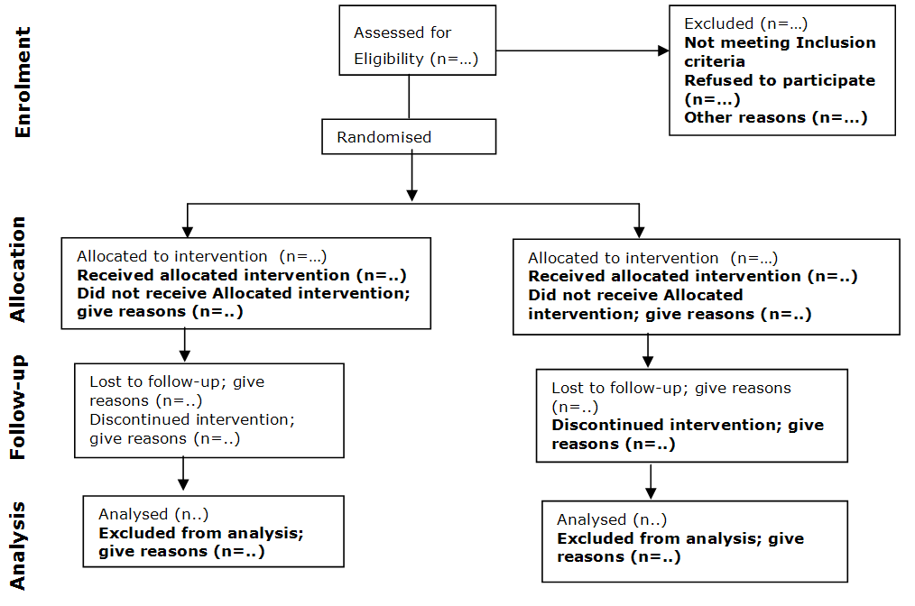

Recruitment

Conduct of the study

Baseline data

Numbers analysed

Outcomes and estimation

Ancillary analyses

  - Discussion

<Design and conduct of clinical studies>

<Efficacy data and additional analyses>

    - <Conclusions >
Submission of PAES results through a variation would often lead to deletion of an Annex II condition. In case an Annex II condition is being deleted:
The following obligation has been fulfilled, and therefore it is recommended that it be deleted from the Annex II to the Opinion:
In case the Annex II condition is being modified or a new condition, which is key to the benefit-risk, is being imposed:
The following measures are considered necessary to address issues related to efficacy:
Any measure identified as a condition needs to be well motivated in the CHMP AR, notably the need for a condition should be explained in the context of a positive benefit/risk balance.

