<insert full date>
<Doc ref.> [only at the time of CHMP adoption]
Committee for Medicinal Products for Human Use (CHMP) [only at the time of CHMP adoption]
<<Co->Rapporteur’s><Joint Rapporteurs’><CHMP> assessment report on the significant clinical benefit in comparison with existing therapies in accordance with Article 14(11) of Regulation (EC) No 726/2004

Invented name:

<International non-proprietary name:>or<Common name>

Procedure No. EMEA/H/C/0000/00/00/00

<Applicant><Marketing authorisation holder (MAH)>:

- Introduction
In accordance with the provisions of Article 14(11) of Regulation (EC) No 726/2004, the <Marketing Authorisation Holder (MAH)> <Applicant> has applied for an additional one year marketing protection period in the framework of the <product name> procedure (<procedure number>).
The request was based on the <applicant’s><MAH’s> position that <product name> represents a significant clinical benefit in the <new indication> in comparison with existing therapies.
- Justification of significant clinical benefit as presented by the <MAH><Applicant>
  - Demonstration of new therapeutic indication

  - Details of existing therapies

  - <Significant clinical benefit based on improved efficacy>

  - <Significant clinical benefit based on improved safety>

  - <Significant clinical benefit based on major contribution to patient care>

- Assessment of the <MAH’s><Applicant’s> justification of significant clinical benefit
The elements which are key to drive the conclusion (listed below) should be assessed in the hierarchical fashion shown in Annex I to this template.
  - Demonstration of new therapeutic indication

In this context a new indication would normally include the following:
- a new target disease,
- different stages or severity of a disease
- an extended target population for the same disease, e.g. based on a different age range or other intrinsic (e.g. renal impairment) or extrinsic (e.g. concomitant product) factors
- change from the first line treatment to second line treatment (or second line to first line treatment), or from combination therapy to monotherapy, or from one combination therapy (e.g. in the area of cancer) to another combination,
- change from treatment to prevention or diagnosis of a disease.
- change from treatment to prevention of progression of a disease or to prevention of relapses of a disease.
- change from short-term treatment to long-term maintenance therapy in chronic disease.
  - Details of existing therapies

These include satisfactory methods of diagnosis, prevention or treatment of the disease, e.g. authorised medicinal products in the proposed therapeutic indication in one or more Member States at the time of the opinion, non-pharmacological approaches (e.g. such as surgical interventions, radiological techniques, diet, psychotherapy, physical means, and other specific and other ‘state of the art’ therapeutic methods in the Union).
Off-label use of medicinal products is not to be considered as existing therapies.
Assessors should state whether the MAH review is complete and agreed upon or not. Were any methods omitted? Were any methods characteristics and value inaccurately reviewed? Are there any references (literature, treatment guidelines) provided in support of the applicant/MAH’s claim?
If no other existing therapies currently exist, this should be stated.
  - <Significant clinical benefit based on improved efficacy>

Efficacy greater than that of an authorised medicinal product should be assessed using clinically meaningful endpoint(s) in adequate and well-controlled clinical trial(s).
Superiority in terms of efficacy should be demonstrated over existing methods. Referring to the absolute positive benefit-risk of the medicinal product in the new indication is not sufficient, if other methods of treatment exist.
Direct comparative clinical trial(s) would generally be expected and are preferred. However, indirect comparison(s) may be sufficient if duly justified. Appropriate justification must be provided by the applicant/MAH and should be requested during the assessment if missing or be subject of questions if considered not satisfactory. Indirect comparison(s) must be critically assessed in terms of their methodological and reporting validity (e.g. discussing the population and trial characteristics across studies).
Regardless of the methodology (i.e. direct or indirect comparison) used, applicants should justify by relevant scientific literature, CHMP guidelines, or scientific advice from competent authorities the choice and acceptability of the comparator(s) in view of existing satisfactory method(s), as described in 3.2 – assessors should discuss this choice. When multiple satisfactory methods exist, assessors should discuss how the available comparative data presented may justify the absence (or the less robust methodology) of the comparisons with some of them.
Assessors should discuss the clinical meaningfulness of the claimed advantage(s) over existing therapies. Referring to the absolute clinical relevance of the medicinal product is not sufficient.
When significant clinical benefit is based on improved efficacy, no important reduction in safety should be observed thereby making less favourable the overall benefit risk balance.]
In case there is more than one existing therapy, the claims must be assessed independently for each existing therapy.
In case there is a least one existing therapy and at least one claim based on improved efficacy, please use the following table to summarise the status for this ground for each comparator.
Existing therapies | <Product name>
Existing therapies | Improved efficacy
<Comparator 1> | <Yes> <No> <Not applicable>
<Comparator 2> | <Yes> <No> <Not applicable>
<Comparator 3> | <Yes> <No> <Not applicable>

<Having considered the data submitted by the <MAH><Applicant>, the CHMP <does not> consider<s> that the claimed indication for <product name> brings a significant clinical benefit over existing therapie(s) based on an improved efficacy <compared to[Mention the concerned comparator(s)]>.>
In case there is no existing therapy
In the absence of existing therapy for the above-mentioned new indication, the CHMP considers that there is significant clinical benefit on efficacy for <product name> in the targeted population.
  - <Significant clinical benefit based on improved safety>

Since a certain level of exposure is required to characterise the safety profile of a medicinal product in the relevant indication(s), assessors should check if a claim of significant clinical benefit based on improved safety is clearly justified by large and robust data showing an advantage on key safety aspects.
The most robust evidence for a claim of significant clinical benefit based on improved safety would be a large comparative study, but indirect evidence could be accepted if duly justified. Please refer to section 3.1 for guidance on the choice of the comparator(s). Appropriate justification must be provided by the applicant/MAH and should be requested during the assessment if missing or be subject of questions if considered not satisfactory.
Assessors should discuss the clinical meaningfulness of the claimed advantage(s) over existing therapies. Referring to the absolute clinical relevance of the medicinal product is not sufficient.
When significant clinical benefit is based on improved safety, while a certain reduction in efficacy may be acceptable, assessors should check that this loss in efficacy is not important, thereby making less favourable the overall benefit risk balance.
In case there is more than one existing therapy, the claims must be assessed independently for each existing therapy.
In case there is a least one existing therapy and at least one claim based on improved safety, please use the following table to summarise the status for this ground for each comparator.
Existing therapies | <Product name>
Existing therapies | Improved safety
<Comparator 1> | <Yes> <No> <Not applicable>
<Comparator 2> | <Yes> <No> <Not applicable>
<Comparator 3> | <Yes> <No> <Not applicable>

<Having considered the data submitted by the <MAH><Applicant>, the CHMP <does not> consider<s> that the claimed indication for <product name> brings a significant clinical benefit over existing therapie(s) based on an improved safety <compared to [Mention the concerned comparator(s)]>.>
In case there is no existing therapy
In the absence of existing therapy for the above-mentioned new therapeutic indication, the CHMP is of the opinion that no significant clinical benefit on safety for <product name> can be identified at this present time.
  - <Significant clinical benefit based on major contribution to patient care>

Even without showing greater efficacy or greater safety, a medicinal product having shown a benefit risk balance at least similar to existing therapies could be considered of significant clinical benefit if it acts through a different principal mechanism of action and thus provides a treatment alternative, or it produces a response different from other treatments in a substantial part of the targeted population [e.g. clinically relevant changes that result in differences to contraindications, warnings or clinically significant adverse reactions such that the population able to benefit from the medicinal product is significantly different; clinically relevant changes that allow the medicinal product to be used in a wider patient population within the current indication or previously excluded sub-groups (e.g. the medicinal product is to be used in the patient population which previously was excluded due to significant safety concern(s) or lack of efficacy).
A claim of significant clinical benefit based on major contribution to patient care can be grounded on a new mode or route of administration as well. In this case, the assessors should critically evaluate the justification of the applicant/MAH regarding the benefit of the proposed mode or route of administration taking into account the disease, the setting in which the medicinal product is to be used and the current treatment modalities.
A claim of significant clinical benefit based on major contribution to patient care can be grounded also based on more favorable pharmacokinetic properties resulting in demonstrable clinical advantage(s) compared to existing therapies (e.g. beneficial changes to the dosing frequency or in drug:drug interactions).
Independently of the specific ground(s) on which a significant clinical benefit based on major contribution to patient care is based, a benefit is normally expected to be shown in comparative data from a direct (or indirect, if justified) study. Please refer to section 3.1 for guidance on the choice of the comparator(s). Appropriate justification must be provided by the applicant/MAH and should be requested during the assessment if missing or be subject of questions if considered not satisfactory.
Assessors should discuss the clinical meaningfulness of the claimed advantage(s) over existing therapies. Referring to the absolute clinical relevance of the medicinal product is not sufficient.
In addition, the applicant/MAH is asked to provide evidence (preferably direct, or indirect if duly justified) of an overall benefit/risk not worse than with the existing methods.]
In case there is more than one existing therapy, the claims must be assessed independently for each existing therapy.
In case there is a least one existing therapy and at least one claim based on major contribution to patient care, please use the following table to summarise the status for this ground for each comparator.
Existing therapies | <Product name>
Existing therapies | Major contribution to patient care
<Comparator 1> | <Yes> <No> <Not applicable>
<Comparator 2> | <Yes> <No> <Not applicable>
<Comparator 3> | <Yes> <No> <Not applicable>

<Having considered the data submitted by the <MAH><Applicant>, the CHMP <does not> consider<s> that the claimed indication for <product name> brings a significant clinical benefit over existing therapie(s) based on a major contribution to patient care <compared to[Mention the concerned comparator(s)]>.>
In case there is no existing therapy
In the absence of existing therapy for the above-mentioned new indication, the CHMP considers <does not> consider<s> that <product name> brings in this indication a significant clinical benefit based on a major contribution to patient care.
- Conclusion

Briefly state the conclusion referencing to the ground(s) for acceptance/refusal of significant clinical benefit (if positive, please specify for which of the points under 3.3, 3.4 or 3.5, or for the absence of pre-existing satisfactory methods).
In case there is more than one existing therapy, the claims must be assessed independently for each existing therapy.
In case there is a least one existing therapy, please use the following table to summarise all claim(s) for each comparator. At least one claim for each comparator needs to be fulfilled in order for the medicinal product to be granted the additional year of market protection.
Existing therapies | <Product name>
Existing therapies | Improved efficacy | Improved safety | Major contribution to patient care
<Comparator 1> | <Yes> <No> <Not applicable> | <Yes> <No> <Not applicable> | <Yes> <No> <Not applicable>
<Comparator 2> | <Yes> <No> <Not applicable> | <Yes> <No> <Not applicable> | <Yes> <No> <Not applicable>
<Comparator 3> | <Yes> <No> <Not applicable> | <Yes> <No> <Not applicable> | <Yes> <No> <Not applicable>

Having considered the data submitted by the <MAH><Applicant>, the CHMP <by consensus / by a majority of x votes out of x> considers that the <product name> in the claimed indication:
- <brings a significant clinical benefit over existing therapie(s) based on <an improved efficacy <compared to[Mention the concerned comparator(s)]>> <and> <an improved safety <compared to[Mention the concerned comparator(s)]>> <and> <a major contribution to patient care <compared to[Mention the concerned comparator(s)]>>.>
- <does not bring a significant clinical benefit over existing therapie(s) based on <an improved efficacy <compared to[Mention the concerned comparator(s)]>> <and> <an improved safety <compared to[Mention the concerned comparator(s)]>> <and> <a major contribution to patient care <compared to[Mention the concerned comparator(s)]>>.>
In case there is no existing therapy
In the absence of existing therapy for the above-mentioned new indication and having considered the data submitted by the <MAH><Applicant>, the CHMP <by consensus / by a majority of x votes out of x> considers that the <product name> in the claimed indication brings a significant clinical benefit based on improved efficacy <and on a major contribution to patient care>.
- Recommendation
In case there is no existing therapy
The CHMP reviewed the data submitted by the applicant taking into account the provisions of Article 14(11) of Regulation (EC) No. 726/2004, and taking into account the provisions of the Guidance on elements required to support the significant clinical benefit in comparison with existing therapies of a new therapeutic indication in order to benefit from an extended (11-year) marketing protection period, considered that the <product name> in the new therapeutic indication is held to bring significant clinical benefit in the absence of existing therapies.
In case there is only one existing therapy, at least one claim (improved efficacy or improved safety or major contribution to patient care) need to be fulfilled in order for the medicinal product to be granted the additional year of market protection.
In case there is more than one existing therapy, at least one claim (improved efficacy or improved safety or major contribution to patient care) for each comparator need to be fulfilled in order for the medicinal product to be granted the additional year of market protection.
The CHMP reviewed the data submitted by the <MAH><Applicant>, taking into account the provisions of Article 14(11) of Regulation (EC) No 726/2004 and the “Guidance on elements required to support the significant clinical benefit in comparison with existing therapies of a new therapeutic indication in order to benefit from an extended (11-year) marketing protection period”, and <does not> consider<s> <by consensus / by a majority of x votes out of x> that the <product name> in the new therapeutic indication brings a significant clinical benefit in comparison with existing therapies.

Annex I – Decision tree
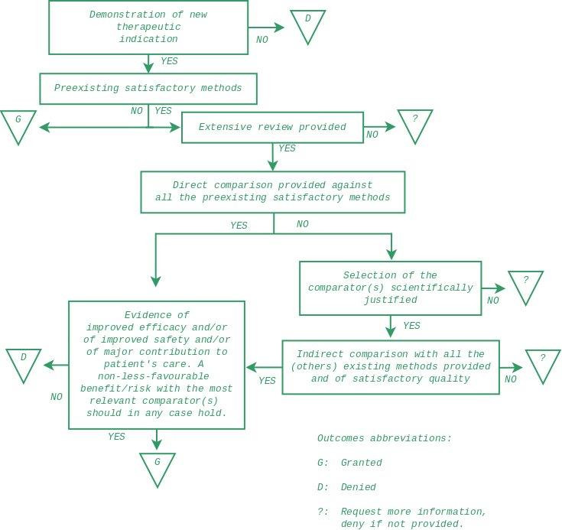

In accordance with the Guidance on elements required to support the significant clinical benefit in comparison with existing therapies of a new therapeutic indication in order to benefit from an extended (11-year) marketing protection period.
For papers to be referenced to in the assessment of an indirect comparisons assessors may consider to use: Jansen JP et al., ‘Indirect Treatment Comparison/Network Meta-Analysis Study Questionnaire to Assess Relevance and Credibility to Inform Health Care Decision Making: An ISPOR-AMCP-NPC Good Practice Task Force Report’, Value Health. 2014 and Mills EJ et al., ‘Demystifying trial networks and network meta-analysis’, BMJ 2013.

